Bony breathlessness: Reversible pulmonary hypertension in Melnick-Needles syndrome using non-invasive ventilation

Cockbain, B.C., Price, LC. Hind, M.

Information about a real patient is presented in stages (boldface type) to expert clinicians (Drs Price and Hind), who respond to the information and share their reasoning with the reader (regular type). A discussion by the authors follows.

Patient presentation: A 48-year-old woman with Melnick-Needles Syndrome (MNS, a congenital bony dysplasia) was referred due to progressive breathlessness and exertional presyncope.

She described twelve months of progressive exertional dyspnea with reduced exercise tolerance. She could walk just 10m on the flat and was unable to manage her office-based job. There were features of exertional pre-syncope but no collapse. There was no chest pain, cough, or palpitations. She was unable to sleep supine, reported nocturia, morning headaches and poor quality, unrefreshing sleep.

Snoring had been present since childhood, improving following micrognathia surgery in her 20s. Smoking history was modest; a three pack-year exposure quitting a decade earlier. There was minimal alcohol consumption and no recreational drug use. She took no regular medication and reported no recent foreign travel.

Aside from MNS, there was no other history of note.

Dr. Price: Progressive breathlessness has a broad differential, including cardiac, respiratory and neurological causes. In this patient, notable features include exertional presyncope, suggestive of an underlying cardiac pathology. Arrhythmias, coronary artery disease, structural abnormalities including hypertrophic obstructive cardiomyopathy, and, importantly, pulmonary hypertension (PH) can all lead to exertional presyncope. In the case of PH, an abnormal exercise-induced response which can lead to an elevation in pulmonary vascular resistance leads to right ventricular (RV) dysfunction, elevation of RV end diastolic pressure, thereby impeding venous return. With a drop in venous return, hypoxia and hypotension thus ensue and, at the extreme, syncope can occur related to decreased flow across the abnormal pulmonary vasculature. Exertional syncope (and presyncope), can also follow compression of left heart chambers by a dilated RV, and leading to a precipitous fall in left sided cardiac output thereby cerebral perfusion pressure. Chest pain was notably absent, and left main stem extrinsic coronary compression (by severely enlarged proximal pulmonary arteries, as seen in some cases of pulmonary arterial hypertension (PAH)) as a rare but important cause of a coronary syndrome was thought to be unlikely.

Dr. Hind: MNS is a rare X-linked dominant bony dysplasia caused by mutation of the FLNA gene on chromosome Xq28, coding for the cytoskeletal protein filamin A.[1] Usually lethal in males, MNS causes characteristic skeletal changes including micrognathia, limb curvatures and rib flattening. Micrognathia increases the likelihood of obstructive sleep apnoea (OSA), as suggested by snoring, disturbed sleep and nocturia. Nocturnal hypoventilation causes hypercapnia, often presenting as early morning headaches. Difficulties sleeping supine may relate to discomfort from spinal bony abnormalities or worsening of sleep disordered breathing in this position.

Patient presentation (continued): Clinical examination revealed a raised jugular venous pressure, pulsatile hepatomegaly and a prominent P2 on cardiac auscultation. There was mild kyphoscoliosis, micrognathia, a normal palate and reduced symmetrical chest expansion. 12-lead ECG demonstrated a sinus tachycardia (100bpm), p pulmonale, T wave inversion in III and V1-V2 but no ischemic changes (Figure 1).

Resting oxygen saturation was 84% on air, with hypoxia confirmed on arterial blood gas (ABG): PaO₂ 39.6mmHg (5.28kPa), PCO₂ 42.8mmHg (5.71kPa), pH 7.43, bicarbonate 26.9mmol/L and base excess 4.2mEq/L.

Blood tests showed an erythrocytosis (hemoglobin 16.8g/dL, packed cell volume 50%), with normal iron studies. C-reactive protein, renal and liver function tests were normal. Brain natriuretic peptide was elevated at 61ng/L (normal <20ng/L). Serology for autoimmune markers of vasculitides and blood-borne viruses was negative.

The six-minute walk test (6MWT) was 300m, with oxygen desaturation to 58% and an increase in heart rate (101bpm to 139bpm). Her BORG breathlessness score at rest was 0, increasing to 5 on exertion.
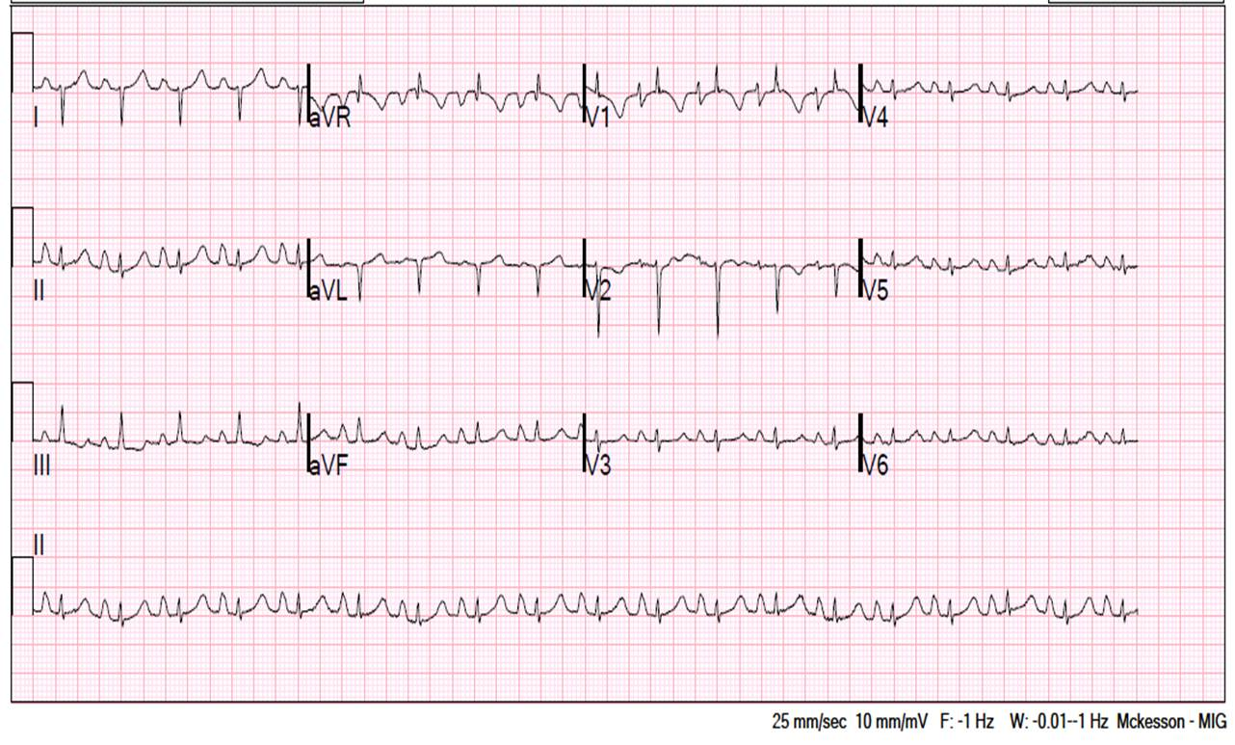
Figure 1: ECG at presentation

Dr. Price: Her cardiac examination and ECG changes are consistent with RV pressure overload due to PH and RV dysfunction. The etiology of RV pressure overload i.e. PH, could relate to PAH, left-sided heart disease e.g. mitral stenosis, pulmonary thromboembolic disease (acute or chronic pulmonary emboli), or chronic respiratory disease, including sleep disordered breathing. The prominent P2 and resting tachycardia suggest PH, but are not PH subtype specific. Her micrognathia and rib abnormalities are characteristic of MNS.

Dr. Hind: The ABG is consistent with hypoxic respiratory failure. A raised base excess and bicarbonate, indicates compensatory metabolic alkalosis, often seen in patients with nocturnal hypoventilation and chronic respiratory acidosis.

The exertional desaturation suggests a respiratory cause for her presentation with either V/Q mismatch or intra-cardiac or intrapulmonary shunting. Serological tests screened for known causes of PAH including chronic liver disease, HIV and connective tissue disorders, known to cause severe pre-capillary remodeling of the pulmonary vessels, were all negative.

Patient presentation (continued): Chest radiography demonstrated a small and scoliotic thoracic cage (Figure 2). CT pulmonary angiography (CTPA) highlighted the thoracic anatomy; there were no pulmonary emboli to the level of the subsegmental pulmonary vessels, however, there was enlargement of the main pulmonary arteries (Figure 2). A nuclear ventilation-perfusion scan revealed no mismatch.

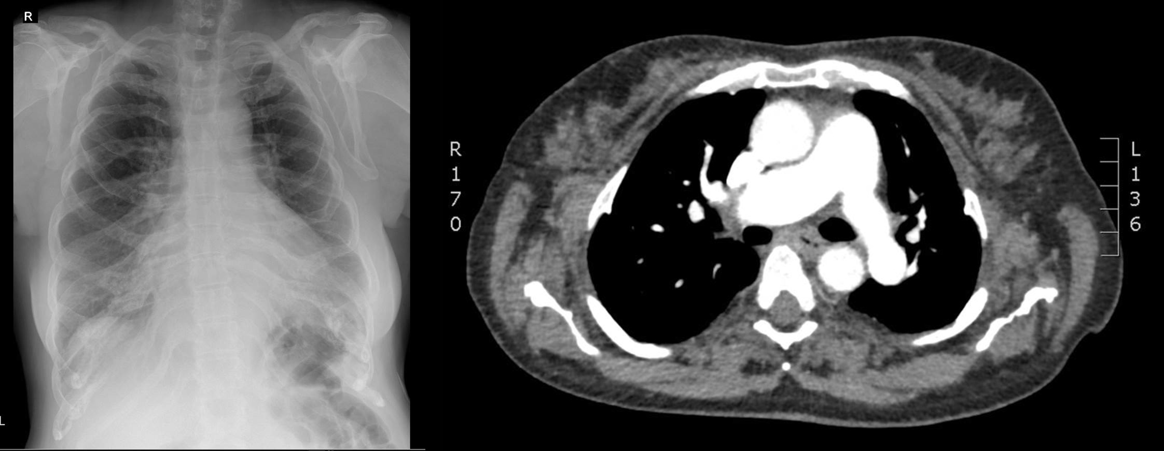

Figure 2: Thoracic imaging at time of presentation: chest radiography (left) and CT pulmonary angiography with dilated pulmonary artery visible (right).

Pulmonary function tests (PFTs) demonstrated dramatic reduction in spirometry with FEV₁ 600ml (26% predicted) and FVC 800ml, (30% predicted) TLC was reduced at 1.88L (44% predicted). DLCO was low (29% predicted), however gas transfer corrected for alveolar volumes (KCO) was normal.

The echocardiogram suggested severe PH, with moderate to severe tricuspid regurgitation, later confirmed by right heart catheterisation (mean pulmonary artery pressure 60mmHg). No shunt was identified on echocardiography (Figure 4).

Dr. Hind: The disordered skeletal anatomy causes markedly reduced lung volumes. The absence of ventilation-perfusion mismatch and no visible clot on the CTPA remove thromboembolic disease from the differential. The CT suggests PH as the cross-sectional diameter of the main pulmonary artery is larger than the ascending aorta at the same level.

Dr. Price: The echocardiographic findings of a raised RV end systolic pressure and severe tricuspid regurgitation suggest severe PH, requiring prompt invasive hemodynamic assessment. Right heart catheterization (RHC) indeed confirmed PH. Invasive assessment is important to confirm echocardiographic findings, which are useful to assess the RV, but can both under- and over-estimate PH. RHC can accurately measure pulmonary pressures, cardiac output, and the nature of PH (pre vs. post capillary) according to the pulmonary capillary wedge pressure (PCWP) measurement. A baseline RHC showed right atrial pressure (RAP) 17mmHg, mean pulmonary arterial pressure (mPAP) 60mmHg, PCWP 5mmHg, cardiac output 3.2 l/min (Indirect Fick) and pulmonary vascular resistance (PVR) 14 Wood units (WU). This is severe, pre-capillary group 3 PH, indeed much more severe PH than that usually associated with lung diseases. If left untreated, PH in this setting carries significant morbidity and mortality.[3]

Patient presentation (continued): Overnight oximetry and transcutaneous (Tc) capnography (Figure 3) demonstrated episodes of oxygen desaturation to a nadir of 60% together with hypercapnia to peak TcCO₂ 71.3 mmHg (9.5 kPa). Mean oxygen saturations were 92% and mean TcCO₂ 51.8 mmHg (6.9 kPa).
In view of documented respiratory failure she commenced overnight non-invasive ventilation (NIV).
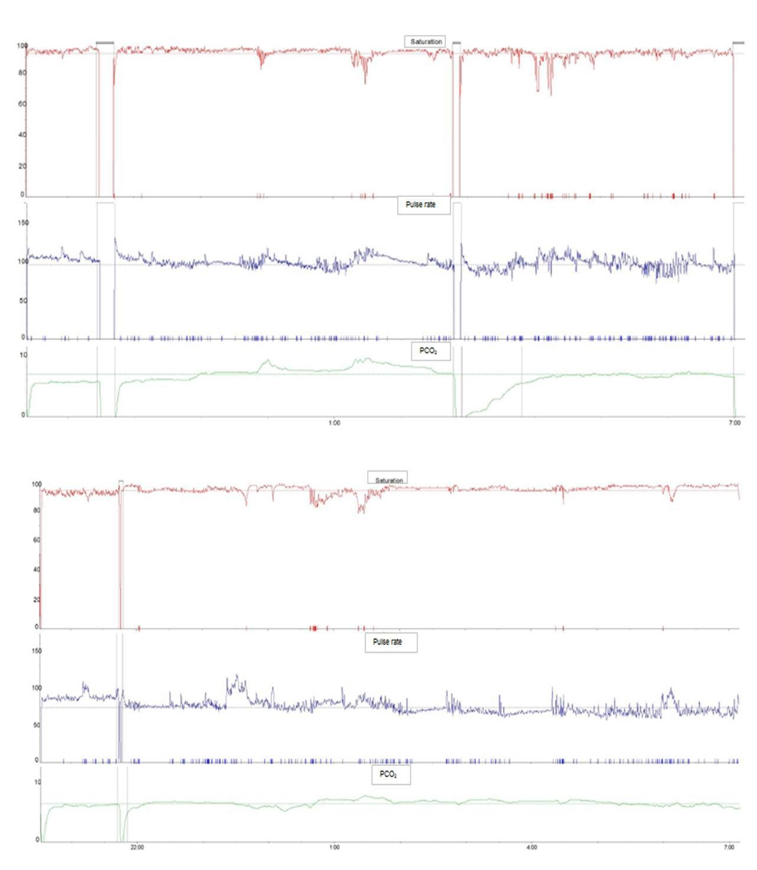

Figure 3: Overnight oximetry (red), pulse (blue) and transcutaneous capnography in kPa (green) traces: at presentation (top) and following initiation of NIV (bottom).

Dr. Hind: Full polysomnography was not required as limited respiratory polygraphy, with overnight oximetry and transcutaneous capnography, demonstrated nocturnal hypoventilation. Optimal ventilation is finely balanced and dependent on function of the respiratory muscle pump, the load on the respiratory system and the central drive to breathe. Any condition that upsets this balance either by reducing capacity, increasing the load on the respiratory muscles or reducing the central ventilatory response can result in respiratory failure. These abnormalities are most obvious in sleep where subtle alterations in each of these factors can result in a degree of nocturnal hypoventilation, as suggested by her early morning headaches. Her difficulties with breathing overnight may be due to upper airway obstruction given the history of snoring and micrognathism, or ventilatory dysfunction associated with a restrictive thoracic cage. Such difficulties, in particular with supine ventilation, are seen in other restrictive chest wall conditions including kyphoscoliosis, neuromuscular disorders and obesity. For such patients, overnight respiratory support with four hours or more of NIV can be transformative, abolishing hypoxia and resolving hypercapnia, reducing symptoms of daytime somnolence and morning headaches.[2] Nocturnal NIV not only provides positive end expiratory pressure to splint the upper airways, as is commonly used with nocturnal continuous positive airway pressure (CPAP) in patients with obstructive sleep apnoea (OSA), but also unloads the respiratory muscles and increases ventilatory capacity. Nocturnal NIV has been shown to ‘reset’ the blunted hypercapnic ventilatory response and improve daytime breathlessness in patients with restrictive lung conditions.[2]

Patient presentation (continued): In view of the severity of her PH and associated RV dysfunction with exertional presyncope, she was started on sildenafil as well as NIV.

Dr Price: The World Pulmonary Hypertension Symposium classifies PH into five groups.[3] Group 1, or PAH, associated with severe remodeling of pre-capillary pulmonary vessels; group 2 due to left heart disease; group 3 due to chronic hypoxia and/or underlying lung disease; group 4 due to chronic thromboembolic disease and group 5 due to other causes including metabolic disorders and sarcoidosis. In this patient, echocardiography demonstrated a normal left heart, confirmed by a low PCWP at RHC, and both CTPA and V/Q excluded thromboembolic disease, ruling out group 2 and 4 PH respectively. She had clear ventilation abnormalities, grouping her as group 3 PH. More usually, but not always, the severity of group 3 PH is in keeping with that of the underlying lung disease. Even though lung restriction was severe, the hemodynamics were extreme, possibly suggesting an additional PAH-like component. It was notable that her low gas transfer corrected for alveolar volumes, which would not be the case in PAH. In most cases, group 3 PH improves with treatment of the lung disease. In some severe cases, PAH therapies are considered, but this is on a case-by-case basis at expert centers, and not routine practice. Current PH guidelines suggest the treatment for group 3 PH is to optimize underlying lung disease, in this case with overnight NIV. The mechanism includes improvement in both hypoxia and hypercarbia reducing the PVR. However, the hemodynamic severity was such that her mortality risk was so high that the PH multidisciplinary team decided to add sildenafil, a type 5 phosphodiesterase-5 inhibitor with anti-remodeling effects licensed for the treatment of PAH.[4] If this was considered to be PAH without the lung disease component (rather than group 3 PH) with such severe pulmonary hemodynamics, a patient would be initiated on at least combination oral PAH therapy, and may be considered for systemic prostacyclin therapy. At review, she had evidence for clinical and echocardiographic improvement. Given the more likely etiology of PH being secondary to hypoventilation rather than PAH-like; sildenafil was therefore stopped at this point.

Patient presentation (continued): Three months after starting NIV, sleepiness, headaches and breathlessness had improved substantially and she returned to work. Daytime ABGs normalized. PaO₂ 80.3mmHg (10.7kPa), PaCO₂ 41.3mmHg (5.15kPa), pH 7.44, bicarbonate 25.8mmol/L, and base excess 1.7mEq/L. Repeat overnight transcutaneous capnography improved, mean TcCO₂ 39.9mmHg (5.32kPa) and maximum TcCO₂ 51.0mmHg (6.8kPa) (Figure 3). A repeat 6MWT demonstrated improvements in distance covered (390m), exertional desaturation (oxygen saturations 95% pre-exercise and 92% after), resting tachycardia (heart rate 85 bpm pre-exercise and 121 bpm after) and post-exertional BORG score (2, pre-exertion remained 0).

Dr Hind: The improvement in daytime ABG measurements and overnight gas exchange is well documented in patients with nocturnal hypoventilation using NIV. Optimal nocturnal ventilation improves respiratory drive, exercise tolerance and breathlessness and may improve pulmonary vascular resistance.

Patient presentation (continued): Repeat RHC and echocardiography 3 months after the introduction of overnight NIV revealed significant improvements in all parameters assessed, with mPAP falling to 35mmHg, PCWP 15mmHg, CO 3.51L/min (Indirect Fick) and PVR 5.4WU (Indirect Fick). Echocardiography showed only mild tricuspid regurgitation with RVSP 44mmHg and now normal sized right heart chambers (Figure 4). The emphasis-10 PH-specific quality of life score had improved from 32 to 19/50.

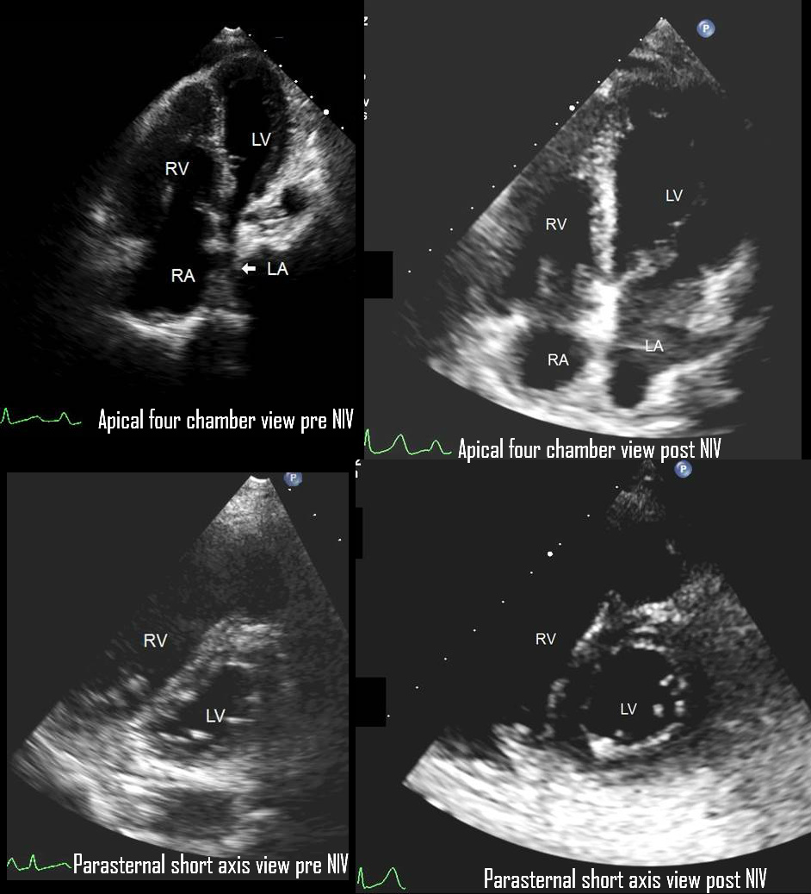

Figure 4: Echocardiography: at time of presentation (left) and following initiation of NIV (right). Echocardiographic images at presentation show a small left ventricular cavity size with significant septal flattening consistent with signs of increased right heart pressure and volume overload. Right ventricle severely dilated (base: 5.3cm, mid: 3.7cm, length: 7.1cm). Echocardiographic images following initiation of NIV show normalisation of both left and right ventricular cavity size.

The marked and ongoing improvement in pulmonary hemodynamics was thought related to introduction of overnight respiratory support with NIV rather than sildenafil, which was stopped. Follow-up echocardiography showed resolution of RV dysfunction. She continues with domiciliary nocturnal NIV.

Discussion: Introducing NIV ameliorated invasively-assessed PH, improving RV function, exercise tolerance and PH-specific quality of life.

Improvements in PH have been reported using NIV in other causes of sleep-disordered breathing, including obesity hypoventilation syndrome (OHS). Recent work by Corral and others found PH, left ventricular hypertrophy and left ventricular mass improved in patients with OHS using NIV, but not CPAP.[5]

The causes of nocturnal respiratory failure in this case are likely two-fold: OSA due to an abnormal upper airway and micrognathism and a restrictive ventilatory defect due to her small scoliotic thoracic cage. Indeed, OSA-associated PH has been previously described in patients with MNS, although NIV use appears uncommon.

By including overnight respiratory polygraphy in PH investigations, reversible causes of PH, including OSA, can be identified and appropriately treated, reducing the significant PH-associated morbidity and mortality. [2]

Conclusion: Nocturnal NIV successfully reversed MNS-associated PH. Although MNS is rare, this case illustrates how NIV use dramatically improved not only the pulmonary vasculature but also the patient’s symptoms and quality of life.

Acknowledgements: the authors would like to thank Dr. Wei Li, Consultant Cardiologist, Royal Brompton Hospital, and Dr. Hatem Soliman Aboumarie, Clinical Fellow Adult Intensive Care, Royal Brompton Hospital, for their provision and interpretation of echocardiographic images.

References (up to 5)

- Eggli, K., Giudici, M., Ramer, J., Easterbrook, J., Madewell, J., ‘Melnick-Needles Syndrome. Four new cases’, Pediatric Radiology (1992) 22: 257

- Nickol AH, Hart N, Hopkinson NS, Moxham J, Simonds, A, Polkey MI, ‘Mechanisms of improvement of respiratory failure in patients with restrictive thoracic disease treated with non-invasive ventilation’, Thorax 2005;60:754-760.

- Simonneau G, Gatzoulis MA, Adatia I, Celermajer D, Denton C, Ghofrani A, Gomez Sanchez MA, Krishna Kumar R, Landzberg M, Machado RF, Olschewski H, Robbins IM, Souza R. ‘Updated clinical classification of pulmonary hypertension’, J Am Coll Cardiol 2013; 62:D34–D41

- Galiè N, Ghofrani HA, Torbicki A, Barst RJ, Rubin LJ, Badesch D, Fleming T, Parpia T, Burgess G, Branzi A, Grimminger F, Kurzyna M, Simonneau G; Sildenafil Use in Pulmonary Arterial Hypertension (SUPER) Study Group., ‘Sildenafil citrate therapy for pulmonary arterial hypertension’, N Engl J Med. 2005 Nov 17;353(20):2148-57

- Corral J, Mogollon MV, Sánchez-Quiroga MÁ, Gómez de Terreros J, Romero A, Caballero C, Teran-Santos J, Alonso-Álvarez ML, Gómez-García T, González M, López-Martínez S, de Lucas P, Marin JM, Romero O, Díaz-Cambriles T, Chiner E, Egea C, Lang RM, Mokhlesi B, Masa JF; Spanish Sleep Network, ‘Echocardiographic changes with non-invasive ventilation and CPAP in obesity hypoventilation syndrome’, Thorax. 2018 Apr; 73(4):361-368. doi: 10.1136/thoraxjnl-2017-210642. Epub 2017 Nov 16.

