Abstract
What are the things that we think matter morally, and how do societal factors influence this? To date, research has explored several individual-level and historical factors that influence the size of our ‘moral circles’. There has, however, been less attention focused on which societal factors play a role. We present the first multi-national exploration of moral expansiveness – that is the size of people’s moral circles across countries. We found low generalized trust, greater perceptions of a breakdown in the social fabric of society, and greater perceived economic inequality were associated with smaller moral circles. Generalized trust also helped explain the effects of perceived inequality on lower levels of moral inclusiveness. Other inequality indicators (i.e., Gini coefficients) were, however, unrelated to moral expansiveness. These findings suggest societal factors, especially those associated with generalized trust, may influence the size of our moral circles.

Keywords: Moral circles, moral expansiveness, economic inequality, trust, anomie
Moral expansiveness around the world: The role of societal factors across 36 countries
Turn on any news channel and the message is clear—it seems we live in a world characterized by crime, war, and disaster. Yet evidence suggests we are living in the most peaceable times in human history; we are far less violent and care more about those around us compared with any other period in time (Bloom, 2010; Pinker, 2011; Singer, 1981). This increase in concern for distant others represents an expansion of our moral circle—the metaphorical boundary drawn around the entities we believe do and do not deserve our moral concern (Singer, 1981). To date, several studies have shown how a variety of individual differences relate to more restricted or expanded moral circles (Crimston et al., 2016; Waytz et al., 2019). However, little is known about the societal factors that shape our moral worlds. The current study thus aims to explore the role of generalized trust, economic inequality, and perceptions of anomie on the expansion of our moral circles.
The Moral Circle
Compared with pre-modern humans, our moral circle has expanded across history in unprecedented ways. Our hunter-gatherer ancestors are thought to have only cared for their kin and their tribe, and engaged in brutal warfare against those deemed to be outsiders (Meyer et al., 2015; Pinker, 2011; Saladié & Rodríguez-Hidalgo, 2017). The change from a hunter-gatherer lifestyle to agriculture was coupled with a fivefold reduction of violent death, and our allegiances expanded beyond small tribes to members of entire cities (Pinker, 2011). This trend accelerated between the Middle Ages and the 20th century, with a 10- to 50-fold drop in the number of people dying by violence in Europe. In modern times, human violence has reached an all-time low, and this has coincided with a considerable expansion in our moral concern for others (Bloom, 2010; Crimston et al., 2016, 2018b; Pinker, 2011; Singer, 1981). For many, our moral concern extends beyond those in our immediate environment—we feel an obligation to protect people in faraway countries, animals, and the physical environment from harm.
For decades, the expansion of our moral circles over time has been of great philosophical interest (Singer, 1981). However, the capacity to scientifically measure this aspect of moral cognition was developed only recently. Crimston and colleagues (2016) developed the Moral Expansiveness Scale (MES) where individuals indicate the entities they include in or exclude from their moral circle, ranging from family and ingroup members, to villains and animals. The greater the number of entities placed within one’s moral circles, the greater a person’s moral expansion. Scores on the MES predict many prosocial outcomes, such as a greater desire to sacrifice the self for others and volunteering behavior (Crimston et al., 2016, 2018b, 2018a).
The growth of our moral concern throughout history is thought to be due, at least in part, to an increasing capacity for reason and rationality (Bloom, 2010; Pinker, 2011; Singer, 1981). Although this trend is evident over time, there are still remarkable disagreements between people in the 21st century over who and what is deemed worthy of moral concern. For example, there are significant differences between individuals in the placement of nature and animals within their moral circles (Crimston et al., 2016). Moreover, we see variation in the extent to which individuals value nature versus outgroups, with some ascribing greater moral worth to human outgroups, whereas others ascribe greater moral worth to animals and ecosystems (Rottman et al., 2021). There are also differences in moral expansion between those with left- and right-wing ideologies, with more restricted moral circles associated with conservative values as well as moral foundations of loyalty and purity (Crimston et al., 2018a; Graham et al., 2011).
Societal Factors and Moral Expansiveness
Research to date has provided important insights that advance our understanding of moral circles. However, this work has focused on individual-level factors (Crimston et al., 2016, 2018b; Waytz et al., 2019), or factors that have changed across human history such as a growing capacity for reason and other enlightenment values (Pinker, 2011). To our knowledge, little to no research has analyzed the current societal factors that may relate to differences in the expansion of our moral world. The size of moral circles may depend on the strength of the social ties between people, which can be captured by two concepts in particular: generalized trust and anomie. Trust is often defined as the intention to accept vulnerability based on positive expectations or beliefs regarding the intentions or behavior of another person or other people in general (Rotter, 1967; Rousseau et al., 1998), whereby the latter refers to generalized trust (Nannestad, 2008; Van Lange, 2015). The second concept, anomie, extends beyond the basic notion of trust. Anomie refers to the collective perception that the social fabric and leadership of a society is breaking down (Sprong et al., 2019; Teymoori et al., 2017). A breakdown in social fabric is characterized by low trust and a perception that there are few shared moral standards among people. Moreover, a breakdown in leadership occurs when leaders are perceived to be illegitimate and ineffective. A breakdown in social fabric and leadership are critical to achieve a state of anomie, and each fuels the other (Teymoori et al., 2017). Anomie, thus, reflects societies with low generalized trust, but it goes beyond this by capturing other perceptions of society (e.g., ineffective leadership and a lack of shared moral standards).
Both anomie and low generalized trust reflect environments with fractured social ties, and this, in turn, may influence the size of moral circles. Research has found that both high anomie and low generalized trust are linked to reduced concern for entities such as outgroup members. For example, higher generalized trust is related to positive treatment, attitudes, and emotions directed toward minorities (Umemura, 2017). Similarly, anomie is thought to result in a contraction of the social self in response to weaker social ties in the environment, drawing individuals toward smaller, safer groups (Teymoori et al., 2017). This can result in tribalism, where a substantial concern for one’s ingroup is coupled with less concern for the outgroup (Heydari et al., 2014). These findings suggest high anomie and low generalized trust may result in a contraction of our moral world and those deemed worthy of our moral concern. However, weaker social ties do not occur in isolation; they are affected in important ways by societal factors such as economic inequality.
Economic inequality, where a majority of wealth is concentrated in the hands of a minority of the population, has been linked to the erosion of social ties between individuals (Wilkinson & Pickett, 2009), due in part to greater competition and social comparison (Jetten et al., 2017; Sánchez-Rodríguez et al., 2018). To date, numerous studies have charted a robust link between high economic inequality and reduced generalized trust (e.g., Elgar, 2010; Oishi et al., 2011; Uslaner & Brown, 2005). Recent work has also found that high inequality enhances perceptions of anomie (Sprong et al., 2019). Thus, economic inequality may be linked to more contracted moral circles, and this relationship may be explained by a reduction in generalized trust and an increase in perceptions of anomie.
The Current Study
The current study aims to examine the relationship between the strength of social ties (i.e., generalized trust and perceptions of anomie) and the expansion of moral concern in a large, cross-national dataset. We also aim to examine whether the broader societal factor of economic inequality is linked to reduced moral expansiveness. Specifically, we hypothesized that high inequality will be related to smaller moral circles, and this relationship will be mediated by both low generalized trust and greater perceptions of anomie.
Method
The current study drew on data from an existing multinational dataset. Hypotheses were preregistered prior to analyzing the data and the analysis code has been placed on the Open Science Framework (https://osf.io/jzpba/?view_only=7c096b2f1c674a90b07944e1839ec61e). Data will be available upon request by contacting the corresponding author via email. See Supplementary Materials 1 for departures from preregistration.
Participants
Data were collected between 2018 and 2019. Participants were recruited from 41 universities spanning 36 countries: Australia, Belgium, Brazil, Canada (English-speaking), Canada (French-speaking), Chile, China, Colombia, Costa Rica, England, Estonia, France, Germany, Hong Kong, Italy, Japan, Latvia, Macedonia, Malaysia, Netherlands, New Zealand, Nigeria, Northern Ireland, Pakistan, Peru, Philippines, Poland, Portugal, Scotland, Singapore, Slovakia, South Africa, South Korea, Spain, Thailand, Turkey, Uganda, Ukraine, United States (North), United States (South) and Wales. In total, 6,665 participants (M = 21.59 years, SD = 5.72 years) completed the questionnaire and approximately 63% of participants identified as female. See Supplementary Materials 2 for information regarding sample size, data exclusion, and data collection.
Measures
The individual measures included in the current study were taken from a larger multinational survey (Supplementary Materials 3), and country-level measures were taken from existing online databases (Supplementary Materials 4).
Moral Expansiveness Scale. Participants were shown an image of concentric circles and they were informed that each circle represents the amount of moral concern they have for a particular entity (see Figure 1; Crimston et al., 2016). Using this circle, participants were asked to indicate how much moral concern they have for 30 entities, grouped into 10 categories: family/friends, in-group members, revered members of society, stigmatized individuals, out-group members, villains, high sentient animals, low sentient animals, the environment, and plants. Responses to each entity were coded as: (3) the inner circle of moral concern, (2) the outer circle of moral concern, (1) the fringes of moral concern and (0) outside the moral boundary. The score of each of the 30 entities was summed to achieve an MES score between (0) least morally expansive and (90) most morally expansive (α = .92). Additional information about the psychometric information for our scales as well as the nomological network for the MES can be seen in Supplementary Materials 6 and 7, respectively. Likewise, details of measurement invariance for our scales can be found in Supplementary Materials 8.
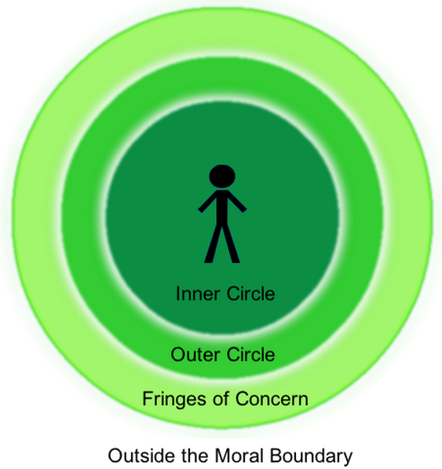
Figure 1. Image shown to participants for the MES.
Economic inequality. We measured inequality in three different ways: Gini coefficient (country-level), perceived Gini coefficient (individual-level), and perceived wealth gap between the rich and poor (individual-level). We first examined the effect of country-level inequality with the Gini coefficient from the World Bank (The World Bank, 2019b). The Gini coefficient measures the degree to which wealth is evenly or unevenly spread across a particular population. Scores for the Gini coefficient can vary between 0 (perfectly equal) and 1 (perfectly unequal; Westfall, 2020).
In addition, we examined subjective perceptions of inequality. A person’s experience of economic inequality is likely somewhat reflective of actual inequality. Nonetheless, individuals may not have the precise knowledge of how unequal their country actually is (Oshio & Urakawa, 2014). For example, while in reality, the top quintile in the United States owns 84% of the wealth, individuals estimate they own approximately 58% (Norton & Ariely, 2011; Starmans et al., 2017). Moreover, individuals within a country may have very different experiences of inequality; living in a low inequality U.S. state, such as West Virginia (Gini = .37) is very different from living in a high inequality U.S. state such as the District of Colombia (Gini = .51; Frank, 2014). More granular measures may better reflect an individual’s actual experience of inequality but these are often unavailable. Instead, measures of an individual’s perception of inequality may best capture experiences of the socio-economic environment. Sprong et al. (2019) provided evidence for the value of individual-level perceptions; perceived high inequality was related to increased views that the participant’s country needed a strong leader.
We measured perceived inequality in two ways. First, the perceived wealth gap between the rich and the poor was assessed with the following question: “We would like you to think of the poorest and the wealthiest people in <country>. Overall, how large is the wealth gap between the poorest and the wealthiest people?” Responses were coded from (1) very small to (7) very large. Second, we measured inequality based on the entire distribution of wealth using a quasi-Gini coefficient (Sprong et al., 2019). Participants were asked to imagine 100 citizens in their country, and how many of these 100 they believe are ‘very poor’, ‘poor’, ‘average in wealth’, ‘wealthy’ and ‘very wealthy’. The perceived Gini measure was calculated in a similar way to the country-level Gini coefficient (see Supplementary Materials 5 for Gini calculations). Scores could range from (0) most equal to (1) most unequal.
Generalized trust. We assessed generalized trust with one item, “I completely trust most other people.” Responses were coded from (1) completely disagree to (7) completely agree, with higher scores representing higher levels of generalized trust.
Anomie. Perceptions of anomie were assessed using 12 items developed by Teymoori et al. (2017), with six items measuring breakdown in the social fabric of society, for example, “People think that there are no clear moral standards to follow” and six items measuring breakdown in leadership, for example, “Some laws are not fair.” Responses were assessed on a scale from (1) strongly disagree to (7) strongly agree, with higher scores indicating greater perceptions of anomie. A total anomie score was obtained (α = .83), as well as a score for a breakdown in the social fabric of society (α = .77) and breakdown in leadership (α = .81).
Control variables. We controlled for several variables that may be related to the MES and perceptions of inequality. First, we included several individual-level measures. Liberals and conservatives tend to differ in their expansion of moral concern (Waytz et al., 2019), and liberals perceive greater levels of inequality compared to conservatives (Norton & Ariely, 2011). To control for this, we included economic and social conservatism as control variables. Responses to both questions were coded from (1) left/liberal to (7) right/conservative.
Relative to males, females typically exhibit greater moral concern for diverse entities (Waytz et al., 2019) and males also tend to perceive greater levels of inequality compared with females (Norton & Ariely, 2011). To account for this, gender was measured as (1) male or (2) female. Age was measured on a continuous scale in years. Finally, socioeconomic status has been found to shape perceptions of the distribution of wealth (Knell & Stix, 2020; Norton & Ariely, 2011). We therefore controlled for social status using the MacArthur Scale of Subjective Social Status (Glei et al., 2018; Goodman et al., 2001; Singh-Manoux et al., 2003). Participants were shown a 10-rung ladder and asked to indicate where they felt they fit on the ladder relative to others, and this was coded from (1) bottom rung/worst off in society, to (10) top rung/best off in society.‬‬‬‬‬‬‬‬‬
In addition, several country-level measures were controlled for. First, we accounted for the overall prosperity of each country using the Legatum Prosperity Index (Legatum Institute, 2019). This measure collates variables signaling quality of life and was measured from (0) least prosperous to (100) most prosperous. We controlled for this as a decent quality of life may be necessary before individuals can expand their moral worlds. We also accounted for the wealth of each country by including a measure of Gross Domestic Product at Purchasing Power Parity (GDP PPP) per capita from the World Bank in international dollars (The World Bank, 2019a).
Democracy in a country gives individuals more freedom compared with those run by authoritarian rule. In democracies, differences in opinions serve as a foundation for the political system, and this may give citizens the freedom to care for greater numbers of entities. To account for this, we included the Democracy Index collated by the Economist Intelligence Unit that ranks countries between (0) most authoritarian to (10) most democratic (Economist Intelligence Unit, 2019). In addition, high levels of threat and crime within an environment may lead individuals to have restricted moral circles, and threat and crime have been associated with higher inequality (Wilkinson & Pickett, 2009). We included the homicide rate per 100,000 inhabitants from the United Nations Office on Drugs and Homicide (United Nations Office on Drugs and Crime, 2019).
Method of Analysis
In the current study, data were collected from 41 samples and the nested nature of this data was accounted for by using a series of linear mixed models (LMM), with a random intercept of country. In each model, the within-country (country mean-centered) and between-country (grand mean-centered for country averages) estimate for each predictor variable was included, and all control variables were added as fixed effects. The analyses were conducted in R studio (R Core Team, 2008) with the lme4 package to estimate Linear Mixed Models (Bates et al., 2015). The United States (North and South), Canada (French speaking and English speaking) and United Kingdom (England, Northern Ireland, Scotland and Wales) samples were collected from different locations and were treated as separate countries for the sake of analyses.
Results
See Supplementary Materials 9 for full results for all models reported below. Based on the intraclass correlation, approximately 4.0% of the variance in moral expansiveness can be explained at the country level (see Figure 2). A likelihood ratio test established the variance between countries was greater than zero, χ²(40) = 295.53, p < .001. An ordinary least squares ANOVA provided converging evidence for this with a significant main effect of country on MES scores, F(40, 6520) = 7.51, p < .001, η_{p}² = .044. Collapsing across all countries, the average MES score was on the midpoint of the scale (M = 45.93, SD = 13.20). To establish the relationship between the control variables and MES, an LMM was conducted. As shown in Table 1, females (M = 46.20, SD = 12.86) reported greater moral expansiveness compared to males (M = 44.83, SD = 13.58). In addition, greater moral expansiveness was witnessed with increased age and in those who reported lower levels of economic conservatism.
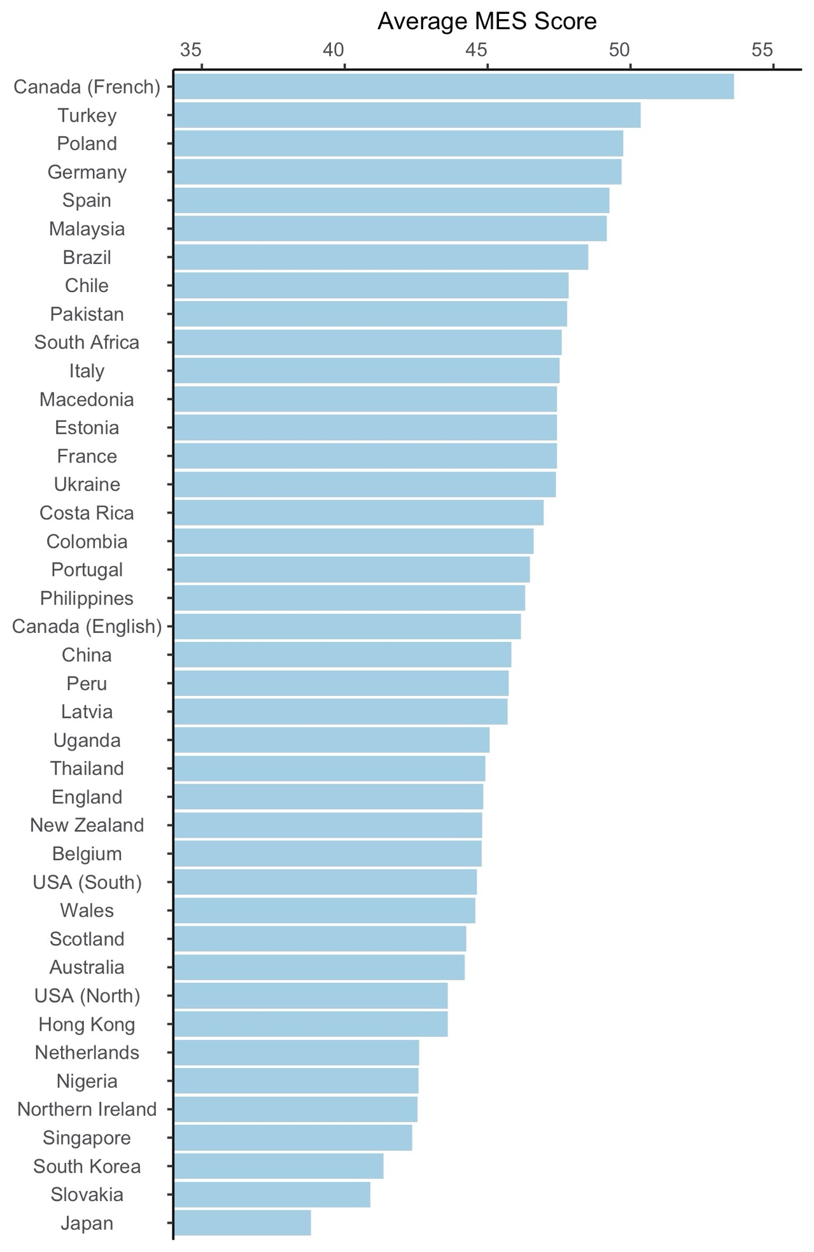
Figure 2. Average MES scores per country. Higher numbers indicate greater moral expansiveness.
Table 1
Linear Mixed Model Examining the Effect of Control Variables on Moral Expansiveness
 | Moral Expansiveness
Predictors | Estimates | 95% CI | p
(Intercept) | 44.76 | 43.81, 45.71 | <.001***
Country-Level Controls
GDP PPP per capita | -0.56 | -2.26, 1.14 | .521
Prosperity | -0.32 | -2.90, 2.25 | .807
Democracy | 0.22 | -1.38, 1.82 | .791
Homicide | 0.37 | -0.86, 1.60 | .557
Individual-Level Controls
Gender (female) | 1.34 | 0.59, 2.09 | <.001***
Age | 0.60 | 0.22, 0.97 | .002**
Subjective social status | 0.22 | -0.12, 0.55 | .209
Social conservativism | -0.34 | -0.74, 0.07 | .102
Economic conservativism | -0.99 | -1.39, -0.60 | <.001***
Random Effects
Residual | 161.86
Country (intercept) | 5.24
ICC | .03
N _{Country} | 41
Observations | 5992
Marginal R² / Conditional R² | .018 / .049
Note: Gender was coded as male (1) and female (2). Marginal R² refers to fixed effects only and Conditional R² refers to the entire model.
* p < .05 ** p < .01 *** p < .001
We then conducted four additional LMMs to examine the effect of generalized trust and anomie (total and for each subscale) on moral expansiveness, with control variables included in the models. As seen in Table 2, higher generalized trust, and reduced perceptions of a breakdown in the social fabric within-countries were associated with higher MES scores. Since the relationship between anomie (total score) as well as breakdown within leadership and moral expansiveness were not significant, we will not consider these variables in further analyses.
Table 2
Linear Mixed Models Examining the Effect of Generalized Trust and Anomie on Moral Expansiveness Scores.
 | Moral Expansiveness
 | Within-country effects |  |  | Between-country effects
Model | b | 95% CI | p |  | b | 95% CI | p
Generalized trust | 0.88 | 0.56, 1.21 | <.001*** |  | 0.25 | -0.70, 1.20 | .611
Anomie | -0.31 | -0.63, 0.02 | .065 |  | -0.06 | -1.07, 0.96 | .914
Breakdown in social fabric | -0.36 | -0.68, -0.03 | .032* |  | 0.10 | -1.00, 1.20 | .854
Breakdown in leadership | -0.15 | -0.47, 0.18 | .372 |  | -0.11 | -1.04, 0.82 | .816
* p < .05 ** p < .01 *** p < .001
We ran Spearman’s rank correlations to assess the relationship between our three inequality indicators (see Supplementary Materials 10 for other correlations). There was a small correlation between our wealth gap measure and both the perceived Gini coefficient (r = .09, p < .001), and the country-level Gini coefficient (r = .14, p < .001). The perceived Gini coefficient was moderately correlated with the country-level Gini coefficient (r = .35, p < .001). We then conducted nine separate LMMs to examine the effect of each inequality predictor (perceived wealth gap, perceived Gini, and country-level Gini) on (a) moral expansiveness, (b) generalized trust, and (c) breakdown in social fabric. As demonstrated in Table 3, a higher perceived wealth gap between the rich and the poor was associated with reduced moral expansiveness (within-countries), lower generalized trust (within- and between-countries), and greater perceptions of breakdown in the social fabric (within- and between-countries). In addition, a higher perceived Gini coefficient was related to greater perceptions of a breakdown in the social fabric (within-countries). Based on these findings, we examined the hypothesized mediation effect for perceived wealth gap only, with generalized trust and breakdown in the social fabric as potential mediators.

Table 3
Linear Mixed Models Examining the Effect of the Inequality Predictors on Moral Expansiveness, Generalized Trust and Breakdown in the Social Fabric of Society.
 |  | Within-country effects |  |  | Between-country effects
Independent variables | Dependent variables | b | 95% CI | p | b | 95% CI | p
Perceived wealth gap | Moral expansiveness | -0.53 | -0.86, -0.20 | .002** | 0.78 | -0.09, 1.64 | .088
 | Generalized trust | -0.09 | -0.13, -0.05 | <.001*** | -0.15 | -0.26, -0.05 | .007**
 | Breakdown in social fabric | 0.09 | 0.07, 0.11 | <.001*** | 0.19 | 0.09, 0.30 | <.001***
Perceived Gini | Moral expansiveness | 0.10 | -0.24, 0.43 | .574 | -0.35 | -1.94, 1.24 | .671
 | Generalized trust | -0.01 | -0.05, 0.03 | .645 | 0.09 | -0.11, 0.29 | .386
 | Breakdown in social fabric | 0.05 | 0.03, 0.08 | <.001*** | 0.07 | -0.14, 0.28 | .526
Country-level Gini | Moral expansiveness | – | – | – | 1.08 | -0.70, 2.86 | .242
 | Generalized trust | – | – | – | -0.02 | -0.24, 0.20 | .846
 | Breakdown in social fabric | – | – | – | 0.22 | 0.00, 0.44 | .063
* p < .05 ** p < .01 *** p < .001

We analyzed whether generalized trust and a breakdown in the social fabric mediated the effect between perceived wealth gap (separately for within- and between-country effects) and moral expansiveness in a multi-level mediation model. In line with predictions, the indirect effect of perceived wealth gap (within-countries) via generalized trust on moral expansiveness was significant (see Figure 3). Likewise, the indirect effect of perceived wealth gap (between-countries) via generalized trust on moral expansiveness was also significant. However, the indirect effect of perceived wealth gap (within-countries) via a breakdown in the social fabric on moral expansiveness was non-significant, b = −0.03, 95% CI = [−0.07, 0.00]. Likewise, the indirect effect of perceived wealth gap (between-countries) via a breakdown in the social fabric on moral expansiveness was also non-significant, b = −0.07, 95% CI = [−0.16, 0.00]. See Supplementary Materials 11 for the full results of this mediation analysis and Supplementary Materials 12 for scatterplots. We ran several alternative models to assess the robustness of our findings and we largely replicated the general pattern of results (Supplementary Materials 13–18).
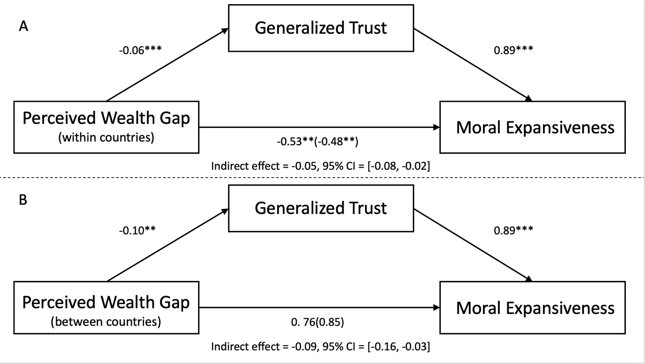
Figure 3. Mediation model of the relationship between perceived wealth gap (panel A: within-countries, panel B: between-countries) and moral expansiveness, via generalized trust. Unstandardized coefficients are given.﻿ Indirect effects were calculated for each of 1000 bootstrapped samples, with the 95% confidence intervals calculated for the 2.5th and 97.5th percentiles. The value outside parentheses on the lower path is the total effect, and the direct effect is the value inside parentheses. *p < .05, ** p < .01, ***p < .001
Discussion
In the 21st century, we include more entities in our moral circles on average compared with any other time in history, but there are still significant differences observed between people in how narrow or broad their moral circles are. Until now, it has been unclear how societal factors relate to these differences. Here, we aimed to establish the relationship between societal factors (i.e., economic inequality, generalized trust and perceptions of anomie) and the expansion of our moral world in a multinational dataset. Our work has revealed three novel insights. First, more generalized trust and lower perceptions of a breakdown in the social fabric, but not a breakdown in leadership, were related to greater moral expansiveness. Second, a greater perceived wealth gap between the rich and the poor was linked to more restricted moral circles, and this was mediated by lower generalized trust, but not perceptions of breakdown in the social fabric. Finally, moral expansiveness was only directly predicted by variables within-countries and not between-countries.
We found a clear link between greater generalized trust and increased moral expansiveness within-countries. Although we cannot be certain of causality, it may be that since trust is the glue that binds relationships, generalized trust may therefore be a necessary ingredient before one can care for strangers and more distant entities. Furthermore, while perceptions of breakdown within leadership (i.e., that government is ineffective and illegitimate) was not predictive of the scope of moral expansiveness, greater perceptions of breakdown in social fabric (e.g., low trust and no shared moral standards) was linked to reduced MES scores. Together this suggests that the relationships between individuals in a society relate to the size of moral circles as opposed to perceptions of those in power.
Low generalized trust was found to mediate the relationship between a higher perceived wealth gap among the rich and the poor and reduced moral expansiveness both within- and between-countries. Prior research has established that high economic inequality is related to reduced generalized trust (Oishi et al., 2011; Uslaner & Brown, 2005; Wilkinson & Pickett, 2007). This is the first work to show it may also be related to how we construct our moral world. However, experimental evidence or support from longitudinal data is needed before we can be certain about directionality. In contrast, perceptions of the breakdown in social fabric did not mediate the relationship between a higher perceived wealth gap among the rich and the poor and reduced moral expansiveness. Although a breakdown in social fabric is characterized by lower generalized trust between citizens, the social fabric concept also encompasses the perception that a shared moral standard among people is lacking (Teymoori et al., 2017). It thus appears to be the specific element of trust, rather than a breakdown in the social fabric more broadly, that mediates the relationship between the perceived wealth gap and moral expansiveness. Although we found a similar mediation effect at both levels of analysis, there was a non-significant tendency for a higher estimate of the wealth gap between countries to be related to greater moral expansiveness. It is also noteworthy that all direct relationships with moral expansiveness were only found within countries, suggesting that differences between countries in trust and perceptions of inequality may not be directly relevant for the size of peoples’ moral worlds. This also highlights the importance of partitioning out within- and between-country effects when analyzing multinational data as these effects may not always be consistent (Bryan & Jenkins, 2016; Na et al., 2010).
It is worth noting that the mediation effect (perceived wealth gap on MES scores, via generalized trust) emerged only when exploring one form of inequality—the perceived wealth gap between the rich and the poor. The perceived Gini and the country-level Gini coefficient did not relate to MES or generalized trust. This may be because the three inequality measures are not identical constructs; while country-level Gini and perceived Gini were moderately correlated, the relationship between those two variables and the perceived wealth gap was small. The perceived wealth gap variable defines inequality as the comparison of the wealth owned by the richest to the poorest but ignores the middle class. Instead, both Gini coefficients calculate inequality based on the entire wealth distribution. It may be specifically the distance between the poorest and richest that matters most for trust in society and the size of people’s moral worlds. In addition, people may not accurately or easily estimate how wealth is distributed in society using numerals (Phillips et al., 2020), and instead judging the gap between the rich and the poor may be more intuitive for participants compared with distribution estimates (i.e., the Gini coefficient).
The current work is a novel and important step in our understanding of how societal factors may affect human morality. Past work has discussed how moral circles may have expanded historically, and this may be due to a rise in our capacity for reason and enlightenment ideals (Pinker, 2011; Singer, 1981). Recent empirical work has also suggested more expansive moral circles are related to liberal political orientations (Waytz et al., 2019), as well as enhanced empathy and more prosocial behavior (Crimston et al., 2016). However, until now, little work has established how perceptions of societal factors relate to differences between moral circles in current times. In addition, we have also presented the first cross-national analysis of the expansion of our moral world in a large and diverse multinational dataset, allowing us to have more confidence that our results are generalizable beyond WEIRD (Western, Educated, Industrialized, Rich, Democratic) samples (Henrich et al., 2010).
Despite these strengths, the current study has several shortcomings. First, the findings are correlational, making it difficult to establish causality. In the absence of experimental work, it remains plausible that having a larger moral circle makes one more likely to trust others and be more aware of inequality in the environment. Prior research has successfully manipulated inequality (Côté et al., 2015; Sánchez-Rodríguez et al., 2018; Sprong et al., 2019), and future work should explore whether these manipulations affect moral expansiveness. In addition, we examined overall levels of moral expansiveness, and this approach does not reveal variations in concern for specific types of entities. That is, our analysis does not speak to which entities one cares for and how this may be affected by societal factors. Future work may wish to examine how these factors affect moral concern for specific entities, such as outgroup members, criminals, or the environment.
There are also several aspects of the MES scale that may affect how participants respond. For one, the image of the concentric circles may result in participants making judgments of moral concern about each entity relative to their judgment of other entities. Likewise, there are only four types of moral concern participants can categorize the 30 entities under. It remains unclear how responding might change if participants made absolute judgments of their moral concern for each entity and had a wider range of categories of concern. In addition, our findings may be driven by another third variable that relates to perceptions of inequality. To diminish this possibility, we controlled for variables that may be influencing perceptions of inequality, but our findings may still be affected by some other variable not accounted for. Finally, while we collected data from diverse cultures, the samples were obtained from university pools and disproportionately represented higher income countries. The current findings should be replicated in future research with more culturally representative and heterogeneous samples.
Throughout history, our concern has extended to other entities in ways that are otherwise unprecedented in the animal kingdom. However, until now, little research has explored what kinds of societal factors may influence differences between moral circles in modern times. Here, our aim was to examine how some of these factors, including generalized trust, anomie, and inequality, affect the size of our moral worlds. We found a novel link between lower generalized trust and reduced moral expansiveness. Moreover, we have provided initial evidence that due to its relationship with lower generalized trust, economic inequality may reduce the size of our moral worlds, but more work is needed to determine causality. The current study represents an important step in our understanding of how our societies may shape human morality.

References
Bates, D., Mächler, M., Bolker, B. M., & Walker, S. C. (2015). Fitting linear mixed-effects models using lme4. Journal of Statistical Software, 67(1), 1–48. https://doi.org/10.18637/jss.v067.i01
Bloom, P. (2010). How do morals change? Nature, 464(7288), 490. https://doi.org/10.1038/464490a
Bryan, M. L., & Jenkins, S. P. (2016). Multilevel modelling of country effects: A cautionary tale. European Sociological Review, 32(1), 3–22. https://doi.org/10.1093/esr/jcv059
Côté, S., House, J., & Willer, R. (2015). High economic inequality leads higher-income individuals to be less generous. Proceedings of the National Academy of Sciences, 112(52), 15838–15843. https://doi.org/10.1073/pnas.1511536112
Crimston, C. R., Bain, P. G., Hornsey, M. J., & Bastian, B. (2016). Moral expansiveness: Examining variability in the extension of the moral world. Journal of Personality and Social Psychology, 111(4), 636–653. https://doi.org/10.1037/pspp0000086
Crimston, C. R., Hornsey, M. J., Bain, P. G., & Bastian, B. (2018a). Moral expansiveness short form: Validity and reliability of the MESx. PLoS ONE, 13(10), 1–10. https://doi.org/10.1371/journal.pone.0205373
Crimston, C. R., Hornsey, M. J., Bain, P. G., & Bastian, B. (2018b). Toward a psychology of moral expansiveness. Current Directions in Psychological Science, 27(1), 14–19. https://doi.org/10.1177/0963721417730888
Economist Intelligence Unit. (2019). Democracy Index 2019. https://www.eiu.com/topic/democracy-index
Elgar, F. J. (2010). Income inequality, trust, and population health in 33 countries. American Journal of Public Health, 100(11), 2311–2315. https://doi.org/10.2105/AJPH.2009.189134
Frank, M. W. (2014). A new state-level panel of annual inequality measures over the period 1916-2005. Journal of Business Strategies, 31(1), 241–263.
Glei, D. A., Goldman, N., & Weinstein, M. (2018). Perception has its own reality: Subjective versus objective measures of economic distress. Population and Development Review, 44(4), 695–722. https://doi.org/10.1111/padr.12183
Goodman, E., Adler, N. E., Kawachi, I., Frazier, A. L., Huang, B., & Colditz, G. A. (2001). Adolescents’ perceptions of social status: Development and evaluation of a new indicator. Pediatrics, 108(2), 1–8. https://doi.org/10.1542/peds.108.2.e31
Graham, J., Nosek, B. A., Haidt, J., Iyer, R., Koleva, S., & Ditto, P. H. (2011). Mapping the moral domain. Journal of Personality and Social Psychology, 101(2), 366–385. https://doi.org/10.1037/a0021847
Henrich, J., Heine, S. J., & Norenzayan, A. (2010). The weirdest people in the world? Behavioral and Brain Sciences, 33(2–3), 61–83. https://doi.org/10.1017/S0140525X0999152X
Heydari, A., Teymoori, A., Haghish, E. F., & Mohamadi, B. (2014). Influential factors on ethnocentrism: The effect of socioeconomic status, anomie, and authoritarianism. Social Science Information, 53(2), 240–254. https://doi.org/10.1177/0539018413517521
Jetten, J., Wang, Z., Steffens, N. K., Mols, F., Peters, K., & Verkuyten, M. (2017). A social identity analysis of responses to economic inequality. Current Opinion in Psychology, 18, 1–5. https://doi.org/10.1016/j.copsyc.2017.05.011
Knell, M., & Stix, H. (2020). Perceptions of inequality. European Journal of Political Economy, 65, 101927. https://doi.org/10.1016/j.ejpoleco.2020.101927
Legatum Institute. (2019). Legatum Prosperity Index. https://www.prosperity.com/rankings
Meyer, C., Lohr, C., Gronenborn, D., & Alt, K. W. (2015). The massacre mass grave of Schöneck-Kilianstädten reveals new insights into collective violence in Early Neolithic Central Europe. Proceedings of the National Academy of Sciences of the United States of America, 112(36), 11217–11222. https://doi.org/10.1073/pnas.1504365112
Na, J., Grossmann, I., Varnum, M. E. W., Kitayama, S., Gonzalez, R., & Nisbett, R. E. (2010). Cultural differences are not always reducible to individual differences. Proceedings of the National Academy of Sciences of the United States of America, 107(14), 6192–6197. https://doi.org/10.1073/pnas.1001911107
Nannestad, P. (2008). What have we learned about generalized trust, if anything? Annual Review of Political Science, 11, 413–436. https://doi.org/10.1146/annurev.polisci.11.060606.135412
Norton, M. I., & Ariely, D. (2011). Building a better America-one wealth quintile at a time. Perspectives on Psychological Science, 6(1), 9–12. https://doi.org/10.1177/1745691610393524
Oishi, S., Kesebir, S., & Diener, E. (2011). Income inequality and happiness. Psychological Science, 22(9), 1095–1100. https://doi.org/10.1177/0956797611417262
Oshio, T., & Urakawa, K. (2014). The association between perceived income inequality and subjective well-being: Evidence from a social survey in Japan. Social Indicators Research, 116(3), 755–770. https://doi.org/10.1007/s11205-013-0323-x
Phillips, L. T., Tepper, S. J., Goya-Tocchetto, D., Davidai, S., Ordabayeva, N., Mirza, M. . U., Szaszi, B., Day, M. V., Hauser, O. P., & Jachimowicz, J. M. (2020). Inequality in People’s Minds. PsyArXiv. https://doi.org/10.31234/osf.io/vawh9
Pinker, S. (2011). The better angels of our nature: Why violence has declined. Viking.
R Core Team. (2008). R: A Language and Environment for Statistical Computing. Vol. 739. In R Foundation for Statistical Computing. https://doi.org/http://dx.doi.org/10.1007/978- 3-540-74686-7
Rotter, J. B. (1967). A new scale for the measurement of interpersonal trust. Journal of Personality, 35(4), 651–665. https://doi.org/10.1111/j.1467-6494.1967.tb01454.x
Rottman, J., Crimston, C. R., & Syropoulos, S. (2021). Tree‐huggers versus human‐lovers: Anthropomorphism and dehumanization predict valuing mature over outgroups. Cognitive Science, 45(4), 1–37. https://doi.org/10.1111/cogs.12967
Rousseau, D. M., Sitkin, S. B., Burt, R. S., & Camerer, C. (1998). Not so different after all: A cross-discipline view of trust. Academy of Management Review, 23(3), 393–404. https://doi.org/10.5465/AMR.1998.926617
Saladié, P., & Rodríguez-Hidalgo, A. (2017). Archaeological evidence for cannibalism in prehistoric Western Europe: from Homo antecessor to the Bronze Age. Journal of Archaeological Method and Theory, 24(4), 1034–1071. https://doi.org/10.1007/s10816-016-9306-y
Sánchez-Rodríguez, Á., Willis, G. B., Jetten, J., & Rodríguez-Bailón, R. (2018). Economic inequality enhances inferences that the normative climate is individualistic and competitive. European Journal of Social Psychology, 49(6), 1114–1127. https://doi.org/10.1002/ejsp.2557
Singer, P. (1981). The expanding circle: Ethics and sociobiology. Farrar, Straus & Giroux.
Singh-Manoux, A., Adler, N. E., & Marmot, M. G. (2003). Subjective social status: Its determinants and its association with measures of ill-health in the Whitehall II study. Social Science and Medicine, 56(6), 1321–1333. https://doi.org/10.1016/S0277-9536(02)00131-4
Sprong, S., Jetten, J., Wang, Z., Peters, K., Mols, F., Verkuyten, M., Bastian, B., Ariyanto, A., Autin, F., Ayub, N., Badea, C., Besta, T., Butera, F., Costa-Lopes, R., Cui, L., Fantini, C., Finchilescu, G., Gaertner, L., Gollwitzer, M., … Wohl, M. J. A. (2019). “Our country needs a strong leader right now”: Economic inequality enhances the wish for a strong leader. Psychological Science, 30(11), 1625–1637. https://doi.org/10.1177/0956797619875472
Starmans, C., Sheskin, M., & Bloom, P. (2017). Why people prefer unequal societies. Nature Human Behaviour, 1(4), 1–7. https://doi.org/10.1038/s41562-017-0082
Teymoori, A., Bastian, B., & Jetten, J. (2017). Towards a psychological analysis of anomie. Political Psychology, 38(6), 1009–1023. https://doi.org/10.1111/pops.12377
The World Bank. (2019a). GDP per capita, PPP (current international $). https://data.worldbank.org/indicator/NY.GDP.PCAP.PP.CD?end=2019&name_desc=false&start=1990&view=chart
The World Bank. (2019b). Gini index (World Bank estimate). https://data.worldbank.org/indicator/SI.POV.GINI
Umemura, T. (2017). Attitudes toward ingroups versus outgroups as unique distinctions between political trust and generalized social trust: A study of ethnically diverse youth in the Czech Republic. Ceskoslovenska Psychologie, 61(5), 433–448.
United Nations Office on Drugs and Crime. (2019). Victims of intentional homicide, 1990-2018. https://dataunodc.un.org/content/data/homicide/homicide-rate
Uslaner, E. M., & Brown, M. (2005). Inequality, trust, and civic engagement. American Politics Research, 33(6), 868–894. https://doi.org/10.1177/1532673X04271903
Van Lange, P. A. M. (2015). Generalized trust: Four lessons from genetics and culture. Current Directions in Psychological Science, 24(1), 71–76. https://doi.org/10.1177/0963721414552473
Waytz, A., Iyer, R., Young, L., Haidt, J., & Graham, J. (2019). Ideological differences in the expanse of the moral circle. Nature Communications, 10(1). https://doi.org/10.1038/s41467-019-12227-0
Westfall, P. (2020). Gini Index. Investopedia. https://www.investopedia.com/terms/g/gini-index.asp
Wilkinson, R. G., & Pickett, K. E. (2007). The problems of relative deprivation: Why some societies do better than others. Social Science and Medicine, 65(9), 1965–1978. https://doi.org/10.1016/j.socscimed.2007.05.041
Wilkinson, R. G., & Pickett, K. E. (2009). The spirit level: Why more equal societies almost always do better. Allen Lane.

When testing the nomological network of the MES scale (Supplementary Materials 7), we found several significant between-country predictors. This suggests there may be other between-country variables (external to our goals in this paper) that can predict differences in moral expansiveness.

