An auxetic thermo-responsive nanoplasmonic optical switch

Ye Ma¹, Debabrata Sikdar^{1,2}, Aleksandra Fedosyuk¹, Leonora Velleman¹, Minggang Zhao³, Longhua Tang^{1,4}, Alexei A. Kornyshev^{*1}, Joshua B. Edel^{*1}

¹Department of Chemistry, Imperial College London, SW7 2AZ London, United Kingdom
²Department of Electronics and Electrical Engineering, Indian Institute of Technology Guwahati, Guwahati-781039, India
³School of Materials Science and Engineering, Ocean University of China, 266100 Qingdao, PR China
⁴State Key Laboratory of Modern Optical Instrumentation, School of Optical Science and Engineering, Zhejiang University, Hangzhou 310027, China

Correspondence: joshua.edel@imperial.ac.uk; A.Kornyshev@imperial.ac.uk

Abstract
Development and use of metamaterials have been gaining prominence in large part due to the possibility of creating platforms with ‘disruptive’ and unique optical properties. However, to date the majority of such systems produced using micro or nanotechnology, are static and can only perform certain target functions. Next-generation multifunctional smart optical metamaterials are expected to have tuneable elements with the possibility of controlling the optical properties in real time via variation in parameters such as pressure, mechanical stress, voltage, or through non-linear optical effects. Here, we address this challenge by developing a thermally controlled optical switch, based on the self-assembly of poly(N-isopropylacrylamide)-functionalised gold nanoparticles on a planar macroscale gold substrate. We show that such meta-surfaces can be tuned to exhibit substantial changes in the optical properties both in terms of wavelength and intensity, through the temperature-controlled variation of the interparticle distance within the nanoparticle monolayer as well as its separation from the substrate. This change is based on temperature induced auxetic expansion and contraction of the functional ligands. Such a system has potential for numerous applications, ranging from thermal sensors to regulated light harnessing.
KEYWORDS: auxetic, thermo-responsive, metasurface, nanoplasmonic, gold nanoparticle

Introduction
Tuneable metamaterials are at the forefront of the expanding area of photonics.¹⁻⁴ Their programable and responsive nature has resulted in the fabrication of exceptionally versatile platforms with applications in sensors⁵⁻⁷, displays⁸, and cloaking⁹ amongst others. Nanoparticles (NPs) on metallic substrates (NPoMS), holds promise for achieving tunability. The coupling between dissipating localized plasmons of NPs and surface plasmons on the metallic substrate can be tuned statically by the size, shape and materials of the two components.¹⁰ However, as important but often neglected is the significance of the substrate-to-NP array distance which contributes heavily to their spectral properties. Furthermore, if such parameters can be controlled dynamically, it becomes possible to tune the optical response in real-time.^{11, 12} For example, it has been shown that tuning optical properties can be achieved via piezo actuation¹³ or mechanical stretching/shrinking of elastic quasi-2d-films.^{14, 15} Another example is the voltage controlled assembly and disassembly of NP arrays at electrochemical liquid/liquid or solid/liquid interfaces.^{16, 17} It was shown that one can reversibly assemble and disassemble NP arrays when the potential of the substrate is switched. This could also be used to tune the interparticle distance and as a result the reflectance spectra.¹⁷ Similarly, assembly/disassembly of NPs at an electrochemical interface of two immiscible electrolytic solutions, can be used to build an electro-switchable mirror /window metasurface.¹⁶ Alternatively by oxidizing or charging the spacer between NPs and substrate, researchers also confirmed that the gap width can induce intriguing changes in the scattering¹¹ and Raman¹⁸ signals. Theoretical calculation have estimated that these plasmonic effects could be further enhanced by tuning both the interparticle distance within a NP array and the gap width between the NP array and the substrate, at the same time.¹⁹ However, fast real-time control of these optical ‘switches’ remains a challenge.

Alternative plasmonic switches, providing similar function, are based on a nontrivial, thermo-auxetic mechanism, which has relatively fast response times. Its key component is Poly(N-isopropylacrylamide) (pNIPAM), which is a water-soluble thermo-responsive polymer that had been widely used for various sensors and actuators, due to its desired operating temperature and sharp transition (within ~5 °C) and good reversibility around its lower critical solution temperature (LCST).^{20, 21} Below the LCST (~ 32 °C), the hydrogen bonds between the water molecules and the C=O and N-H groups on pNIPAM dominate, rendering the chains of pNIPAM extended (Figure 1a-i).²² Above the LCST, the hydrogen bonds break, and the interaction of hydrophobic methyl groups and the main-chain hydrocarbons with each other results in a more coiled conformation.²² By functionalizing NPs or substrates with pNIPAM, a temperature dependent change in ligand length can be achieved resulting in an excellent means for auxetically tuning the structure and the resultant optical properties. Typical strategies involve utilizing this polymer to anchor plasmonic NPs randomly into another polymer matrix²³, on micro-gel²⁴ or in bulk solutions²⁵. The optical signal can be manipulated when a three-dimensional change of thermo-responsive polymer reduces/increases the interparticle distance, though the relatively rough control over the coupling between NPs could induce peak broadening or restricting tunability.^{23, 26-29} Another more versatile approach is to coat the NPs with pNIPAM^{20, 30} and even use them at a liquid-liquid interface.³¹ To date there have been no works reported where both the interparticle and gap-to-substrate distance within a monolayer array of thermally responsive NPs has been used to tune to the optical properties.

Below we propose and explore the properties of such a switch that relies on the coupling between NPs within the array as well as between NP’s and the substrate. As a result, an exceptional optical phenomenon is obtained that is not achievable by linearly adding the optical signals from the two cases individually. A monolayer of pNIPAM-Au NPs is allowed to self-assemble on a planar Au substrate, with the temperature controlled by a Peltier heating/cooling element. We show thermo-responsive behaviour whereby we can continuously tune the optical properties of such metasurfaces, producing a shift in the dip of the plasmon resonance between 562-596 nm. By comparing theses experimental spectra with effective medium theory (EMT)¹⁹ and simulations, we show that it is possible to control the average distance between NPs and substrate by shrinking/expanding the NIPAM shell within the range of 1.8 – 4.0 nm.

Results and discussions
Initially 16 ± 1 nm citrate stabilized Au NPs were synthesized and further functionalized by incubating with amine terminated pNIPAM (see Figure S1 for TEM images and Raman spectrum). The NPs were then made to self-assemble at a water | 1,2-dichloroethane interface followed by transferring onto octane-thiol functionalized 125 nm thick Au substrates (see methods for details). The substrate was immersed in pure water and the temperature modulated between 20 and 50 °C using a closed loop PID controller and a Peltier heating/cooling element. A fibre coupled optical reflection probe was used to collect the spectra (Figure S2).

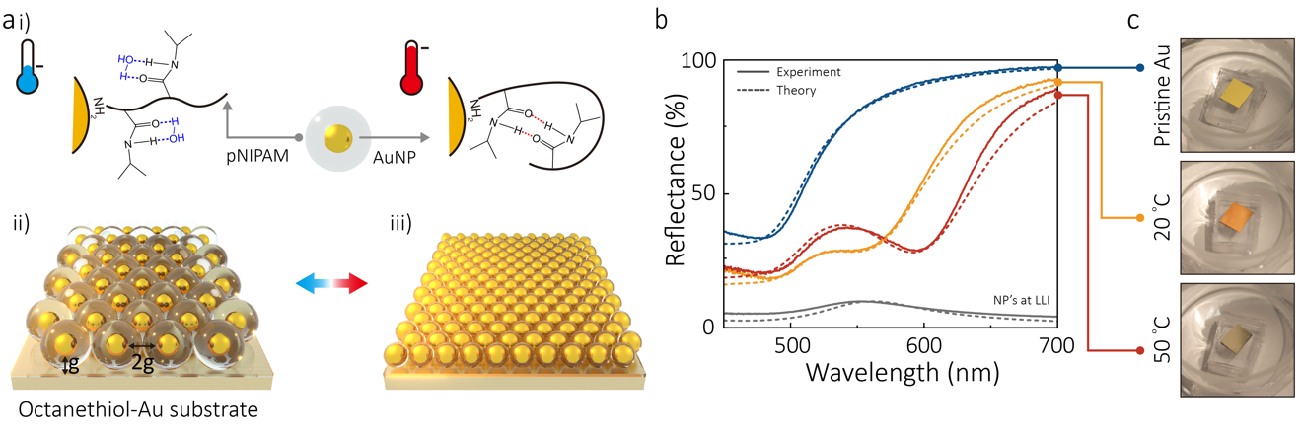

Figure 1 Working principles of the thermo-responsive meta-surface. (a) Molecular scale (i) and nanoscale (ii & iii) scheme of the swelling (left, cold)/shrinking (right, hot) of pNIPAM-NP array on gold substrate. The pNIPAM shell around the gold NPs gives the gap width between NP array and substrate as g and interparticle distance as 2g (ii). (b) Experimental (solid) and theoretical fitted (dashed) reflectance spectra of pristine gold substrate, pNIPAM NP array on gold substrates at low/high temperature and pNIPAM NP array on a liquid-liquid interface (LLI). (c) Digital camera photos of pristine Au substrate, pNIPAM-NP arrays on Au substrates at low/high temperature.

First, the optical properties of the pNIPAM-NP array on the gold substrate were examined prior to thermal experiments. Compared to pristine gold, it is not hard to notice the emergence of a reflectance dip in the green-yellow region at both 20 and 50 °C (Figure 1b) for the NP array on substrate. However, the 16 nm Au NP array alone without a substrate (such as at a liquid-liquid interface) produces a reflectance peak.^{16, 19} This non-linear effect is directly due to the proximity between NPs and distance between NP array and substrate. We have previously studied this theoretically using EMT and have explained that the dip originates from coupling of plasmon excitations between individual NPs with each other in the array, and between the substrate and the array (dashed lines in Figure 1c).¹⁹ Optical images clearly show direct evidence of this effect, Figure 1c. This is also the reason that the wavelength of the dip for the array-on-substrate sample is significantly red-shifted when compared to the peak absorbance maxima in the bulk NP solution (Figure S3).

The thickness or length of the ligand is denoted by g, therefore, the gap distance between NP and substrate can be denoted as g + 1 /nm (with 1 nm being the approximate thickness for a monolayer of octanethiol), whilst the interparticle spacing within the array can be defined as 2g, Figure 1a-ii. At low temperature (20 °C, Figure 1a left), g is large and corresponds to the ‘swollen’ state of pNIPAM which is manifested in the bluer reflectance dip (~562 nm, Figure 1b). Whereas at higher temperature (50 °C, Figure 1a right) the pNIPAM shell decreases in g, resulting in a decrease in interparticle distance and the array-substrate gap, and hence a red-shift in the reflectance dip (~596 nm, Figure 1b). This spectral change can be directly observed from the macroscale photos of the samples (Figure 1c). Although scanning electron microscopy (SEM) imaging requires dehydration of the sample and cannot be used to calculate g, such images are helpful to confirm the successful assembly of NP array on substrate and to visualize whether a monolayer or alternatively multilayer is obtained, Figure S4.

Many reports have demonstrated that a superlattice of NP clusters could generate very interesting optical signals.^{32, 33} The long range plasmonic coupling of ordered NP clusters could induce secondary optical peaks apart from the main peaks. However, in our case, we construct a continuous NP array on a metallic substrate, not the discontinuous ordered NP clusters as in the above-mentioned literature, thus, no secondary peaks could be and were observed. Our theory shows that in the case of substantial dispersion of the gap distance between NPs, the dip in reflectivity will be substantially broader and less deep, with the maximum position not located where it is currently seen, rather shifted to red.^{17, 19} Here, we see a different picture, where the measurements correspond to close to ideally structured hexagonal NP arrays.

Temperature dependence on reflectivity
To better understand the thermal response of this system, we examined reflectance spectra at varying temperatures. Although the visible response of the metasurface to temperature change takes minutes, we first maintained each designated temperature for 30 min to ensure that the system fully reaches equilibrium. As shown in Figure 2a, the spectra red-shifts with increasing temperature. This can be clearly seen in Figure 2b where the wavelength at 50% reflectance is plotted as well as the reflectivity at 600 nm. Impressively a shift of up to 36 nm could be obtained and was most pronounced around the LCST where the drastic change of the conformation of pNIPAM molecules induces the most significant swelling/shrinking rates ; for free pNIPAM in solution this takes place at 32 °C.²⁰

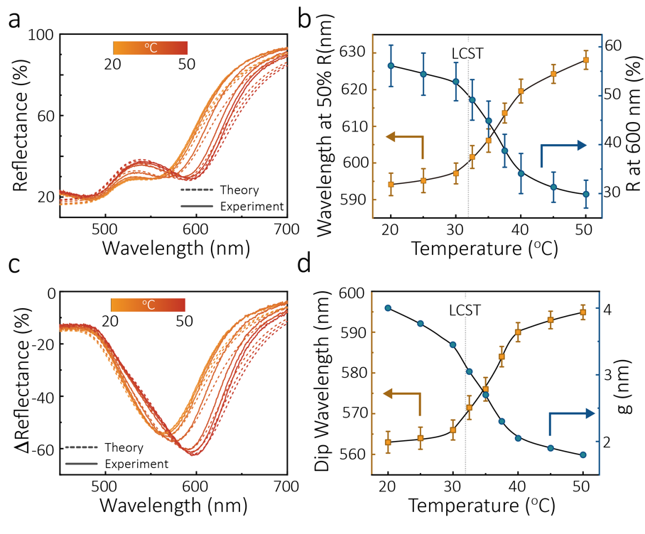
Figure 2 Static temperature dependent responses of pNIPAM NP array on gold substrate. (a) Static experimental (solid) reflectance spectra and theoretical fits (dashed lines) at different temperatures. (b) Wavelength at 50% reflectance and the reflectance at 600 nm [both from panel (a)] at different temperatures. (c) Static spectra of experimental change of reflectance (ΔReflectance, solid) and theoretical fits (dashed) at different temperatures vs pristine Au substrate. (d) Dip wavelength extracted from panel (c) and pNIPAM thickness, g, calculated from theory.
.

By subtracting the reflectance signal from that of the pristine gold substrate, the change of reflectance is shown in Figure 2c. Plotting the data in this format enables a better understanding of the change in optical properties due to the swelling/shrinking of pNIPAM. Importantly, there is an excellent match between the theoretical simulations (based on the effective medium theory of Ref.^{17, 19} using only one fitting parameter g to the wavelength of the dip in the first iteration, followed by fitting the fraction of NP array on the substrate surface (coverage fraction) in the second iteration to reproduce the depth of the dip; all other parameters are ‘known’, see Methods). Due to excellent agreement with experimental data, these fits could be used to unambiguously determine g. For example, at 20 °C, g was determined to be ~4 nm (Figure 2d) and hence the NPs had an interparticle spacing of 8 nm and array-substrate gap of 5 nm. Increasing the temperature to 50 °C resulted in a g of ~1.8 nm and hence interparticle spacing of 3.6 nm (corresponding to 55% change between the two temperature states) and array-substrate gap of 2.8 nm. This shrinking ratio is similar to what has been reported by other researches utilizing core/shell structure of Au NPs/pNIPAM.^{24, 30, 31}

Accompanied by the drop in interparticle distance, the temperature change has another important influence on the surface coverage of the NP array on the substrate as the number of NPs on the substrate are fixed throughout the whole experiments. Thus, the shrinkage of the NP array during the heating is expected to induce the increase of open spaces (bare Au substrate). This nanoscale change can be seen in the optical reflectance spectra shown in Figure 2c: Although the interparticle distance and gap width was reduced by more than half, the change of reflectance only decreased by 10 %, indicating the more reflective bare Au substrate fraction contributed to this higher value of the reflectance, Figure S6. Note that the shift in dip wavelength caused by the thermo-auxetic response can be as large as 34 nm (c.f. Figure 2d) which is larger than previous systems, e.g. shift of absorption peak Δλ = 9-28 nm in nanorods coated pNIPAM microgel²⁴; Δλ = 10 nm in thermoresponsive cross-linked nanocapsules³⁴ and Δλ = 20 nm in dense Ag NP aggregates²⁷.

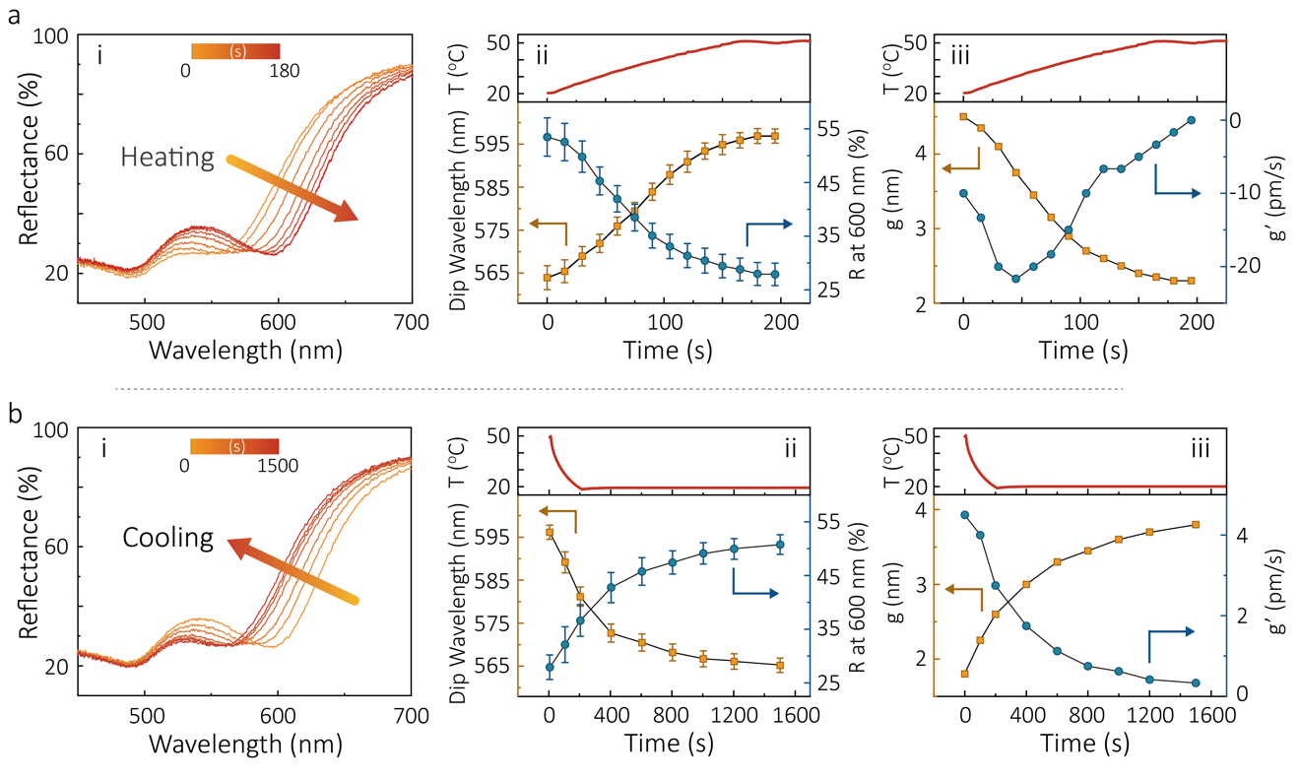
Figure 3 Kinetic responses of pNIPAM NP array on gold substrate. (a) Heating process from 20 °C to 50 °C. (b) Cooling process from 50 °C to 20 °C. (i) the time dependent reflectance spectra; (ii) temperature profiles (top) and the corresponding dip wavelength and reflectance at 600 nm (bottom), extracted from panels (i). (iii) the calculated values of g and its time derivative g’=dg/dt.

Kinetic response to thermal stimuli
To assess the kinetic response, the substrate was heated from 20 °C to 50 °C in 3 min, Figure 3-iitop. This was the fastest rate possible within our current configuration and its speed was limited by the volume of the water and the heating power which in turn governs the uniformity of the temperature within the bath. Figure 3a-i shows the typical kinetic evolution of the reflectance spectra during the heating whilst Figure 3b-i shows the same but in the cooling process. Trends in both the reflectance and dip wavelength were analogous to the static set of curves. At the end of the heating process, the dip wavelength reaches 596 nm, a value that is consistent with the static data (Figure 3a-ii). By fitting these time dependent reflectance curves, thickness g can be calculated at different times, as shown in Figure 3a-iii, indicating the interparticle distances within the array and the gap width between the array and the substrate are reducing accordingly.

In the plot of the rate of change of g, an interesting phenomenon is observed: the rate, g’ initially increases to a peak value (at ~50 s) then decreases to almost zero. After correlating the time to the local temperature (Figure 3a-iii), we found that the maximum rate lies at approximately 32 °C, the LCST of pNIPAM where the polymer experiences the phase transition. The changing rates of the dip wavelength follow the similar trend (Figure S8). As a control, the cell was filled with 50 °C water after which equilibrium of the NP array was reached in 2 s (Figure S9). This suggests that the structural rearrangement of the polymer is not the rate limiting step in the current temperature controlling setup. This also implies that the system could in principle be further optimized for even more rapid switching.

To access the cooling process, the temperature was decreased from 50 °C to 20 °C in 3 min followed by maintaining a 20 °C temperature for 20 min (Figure 3b-ii, top). Although the spectra gradually converged to that expected case, it took over 8 times longer when compared to the heating cycle. A closer look at the change of reflectance at 600 nm and dip wavelength (Figure 3b-ii) reveals a different pattern compared with the heating kinetics. A quick change of the optical signal is witnessed during the first 200 s. This can be easily understood since it is within this time that the temperature drops to 20 °C. However, there is a 17 nm red-shift in the dip wavelength when compared to the static case for the same temperature. Similar thermal hysteresis effects have been previously observed.²⁹ It took a further 20 min at 20 °C to bring the dip back to the expected value. Hence, a latency is observed during the swelling of pNIPAM and the expansion of the NP array. g and g’ further imply that the swelling of pNIPAM is much slower than its shrinking process (Figure 3b-iii). A likely explanation is that above the phase transition coiled hydrophobic junctions ( -CH(CH₃)₂) among pNIPAM molecules could inhibit the reformation of hydrogen bonds between pNIPAM (-CO-NH-) and water.

Reversible optical switching
Reversibility is critical for any future applications. To examine this, we cycled the heating (3 min) and cooling (30 min) between 20 °C and 50 °C. Shown in Figure 4a, due to the auxetic behaviour of the optical switch, the red letters “IC” (stands for Imperial College) reflected from the metasurface exhibit noticeable changes between the cold and hot states. The reflectance spectra at low/high temperature (Figure 4b) can recover their shapes without much noticeable change after multiple cycles, indicating pNIPAM NP arrays on gold substrates acts as a robust platform, Figure 4b and Figure S10. A slight red-shift of the spectra and reduction of the g at low temperature can be observed after four cycles (Figure 4c). As we discussed previously, we attribute this mainly to the latency of the recovery of g and coverage at nanoscale due to the hysteresis of pNIPAM polymer.

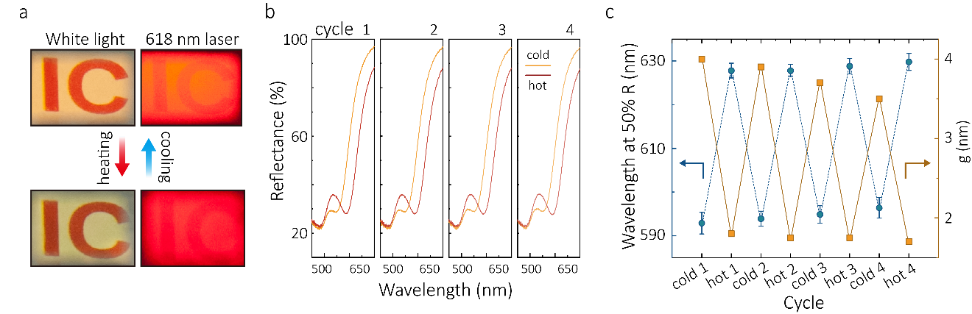
Figure 4 Thermal reversibility of the pNIPAM NP array on gold substrate. (a) The digital camera photos of the cold and hot states of reflected image of “IC” (abbreviation of “Imperial College”); the letters are drawn on A4 paper in red and are illuminated by white light (left) and 618 nm laser (right). The difference in the color and intensity of the letters under cold/hot conditions corresponds to the obtained red-shift of the dip in reflection. (b) Reflectance spectra of multiple cycles at cold (20 °C) and hot (50 °C) conditions; (c) The wavelength at 50% reflectance value and g for multiple cycles at cold (20 °C) and hot (50 °C) conditions.

Conclusions
We constructed a novel thermal responsive meta-surface based on a nanoplasmonic NPs on metallic substrate system. By heating or cooling the system, the thermally responsive pNIPAM shell surrounding each NP shrink or expand accordingly. The resultant structural changes both the interparticle distance among NPs in the array and the distance between NPs and metallic substrate. We show that both this directly influences the intensity and wavelength of its reflectance spectra. This is also confirmed by the excellent match between experiment and theoretical calculation. The kinetic experiments demonstrated that the optical response during the cooling process is slower than that during the heating, which implies a thermal hysteresis that may be due to the hydrophobic interactions among the pNIPAM molecules or between the pNIPAM and the substrate. Future applications of this system could be for nanoplasmonic rulers, thermal sensors, and self-regulated light harvesting and thermal dissipations in solar cells.

Methods
pNIPAM capped gold nanoparticles. A solution of 500 ml 0.01 wt% HAuCl4 was heated to boilling followed by the injection of 10 ml 1 wt% sodium citrate solution. The solution was refluxed for 30 min with vigorous stirring. After naturally cooling down to room temperature, amine terminated pNIPAM (Mn = 2500) was added to achieve a final concentration of 0.01 wt% and was kept for 12 hours. Excess pNIPAM was removed by centrifugation at 6000 rcf for 30 min.

Au substrate and octanethiol SAM. A 125 nm thick Au film was deposited through sputter coating (Quorum Tech, Q150T) on a silicon wafer with a 10 nm Titanium interlayer. The substrates were washed vigorously by acetone, ethanol and DI water before and after the deposition. The substrates were soaked into a 1 wt% octane thiol solution in ethanol for 1 hour to form a self-assembled monolayer of octane thiol and washed by ethanol and DI water for later use. There are three main reasons for introducing an octane-thiol SAM on the Au substrate. 1. The SAM prevents the NPs and substrate from touching each other. This interlayer provides unique possibilities to study plasmonic coupling between the NPs array and the metallic substrates. 2. A bare gold surface is generally vulnerable to non-specific absorption on the surface. This could cause a problem, if one wants to precisely control the distance between NP array and the substrate. Octane-thiol SAM passivates the gold substrate, which helps to solve this problem and improves the overall stability of the system. 3. The SAM prevents NP aggregation on the substrate and hence helps to ensure the system is reversible. The hydrophobic interactions between the octane-thiol on the substrate and the pNIPAM on the NPs are very helpful to keep the NPs stable and resilient on the gold substrate.

pNIPAM-NP on Au substrate. The pNIPAM-NP array was first formed at a LLI and then transferred to the Au substrate. Initially, 10 ml as prepared pNIPAM Au NPs solution was mixed with 4 ml 1,2-dichloroethane in a PTFE jar. After 60 s vigorous shaking on a vortex machine, NPs spontaneously assembled at the LLI due to the capillary force and the hydrophobicity of pNIPAM. Allowing the top DCE layer to evaporate, a shining golden mirror of pNIPAM-NP could be seen atop of the water phase. Then a dried Au substrate with octane thiol SAM was carefully stamped onto this NP array and quickly removed from the solution. Before immersing the NP assembly on substrate into the temperature-controlled cell, the excessive NP solution on the surface of the substrates was washed away with water.

Thermal-optical setup and measurements. As shown in Figure 1A, the NP/Au substrate is placed at the bottom of a cell containing water. A 1 cm thick glass spacer is intentionally inserted between the substrate and the bottom of the cell to ensure that the substrate feels a uniform temperature field. A thermal probe connected to PID controller (PR-59, Laird Technologies) was placed near the substrate in the cell to monitor the local temperature and send it to the controller. Beneath the cell, a Peltier module was employed to heat or cool the cell at the command of the controller which is connected to the computer. The close loop between the sensor, controller and Peltier module can facilitate the system to reach and maintain the designated temperature without any manual interference. A reflection probe (Ocean Optics) with a focal length of 2 mm was vertically aligned to the substrate. The white light emitted by a tungsten halogen lamp (Ocean Optics) was transmitted through a multimode fibre in the probe, hit the substrate and was collected by an Andor 163 spectrograph fitted with an iDus charge-coupled device. All the optical references are derived from a Thorlabs silver mirror. After setting the target temperature from the computer, the PID controller sends heating/cooling commands to the Peltier module after receiving the feedback from the thermal probe. Simultaneously, the synchronised spectrometer collected the reflected signals from the substrate.

Theory of reflection spectra. A five-layer stack model¹⁹ (carefully tested against COMSOL simulations¹⁹ and later with the experimental data on the electro-optical signals of voltage induced assembly of nanoparticles at metallic electrode in electrochemical cell¹⁷) was adopted to calculate optical reflectance spectra. The media that the light passes through, including the NP array, as slabs, were characterised by frequency dependent dielectric constants. In order, light interacts with the electrolyte solution (medium 1), nanoparticle array (medium 2), medium 3 located between the array and interface (can be also electrolyte or a layer of ligands, acting as ‘spacer’ layer), and the conductive film (medium 4) coating the semi-infinite electrode (medium 5). We considered the NP surrounding medium (layers 1 and 3) to be frequency-independent ($ϵ_{1}≡ϵ_{3}$). On the other hand, the Au NP layer (layer 2) and the substrate layers (layers 4 and 5) were characterised by frequency-dependent dielectric constants. In using the five-layer stack model, the critical step is to describe the optical frequency-dependent, normal and longitudinal dielectric constants of the NP layer using our effective medium theory approach. It starts with the effective quasi-static polarizability of individual NPs described in dipolar approximation and then accounts for effective interaction of induced dipoles of NPs in a two-dimensional, hexagonal array, with each other and with its images in the substrate metal (for details see Ref.¹⁹). Once the dielectric response of the effective layer is specified, the rest is just an application of the multi-layer Fresnel reflection theory. For arrays of nanoparticles smaller than 40 nm in diameter this simple theory works amazingly well for calculation of reflection, absorption and transmission.^{19, 35} In this work both the interparticle distance between NPs in the array and the gap between the NPs and the metallic substrate are simultaneously fitted via only one fitting parameter. Indeed, due to the thermo-auxetic contraction of the ligands the change of the gap from the substrate is twice as small as of the inter-particle distance. In fitting, we did not need to consider any dispersion in the interparticle distances as the calculated spectral profiles adequately matched the experimental reflectance curves. The used theory^{17, 19} shows that in the case of substantial dispersion of the gap distance between NPs, the dip in reflectivity will be substantially broader and less deep, with the maximum position not located where it is currently seen, rather shifted to red (c.f. Figure S6 in Ref¹⁷). We obviously see a different picture, which speaks in favour of achieving close to ideally structured NP arrays.

Associated content
Supporting Information
Detailed information about NPs diameter, experimental setup, UV-vis of bulk NP solutions, SEM, NP array coverage, extra static, kinetic and reversibility data can be found in the Supporting Information. This material is available free of charge via the Internet at http://pubs.acs.org.

Author information
Correspondence:
Joshua B. Edel: Joshua.Edel@imperial.ac.uk;
Alexei A. Kornyshev: A.Kornyshev@imperial.ac.uk
Department of Chemistry, Imperial College London, SW7 2AZ, United Kingdom

Acknowledgements
The work was supported by an Engineering and Physical Sciences Research Council grant, ‘Electrotuneable Molecular Alarm’, EP/L02098X/1. J.B.E. also acknowledges receipt of European Research Council consolidator grant (NanoPD). Y.M. has been supported in part by a China Scholarship Council-Imperial Scholarship (201506320194). M.Z. acknowledges the support from Natural Science Foundation of China (51602298). L.V. and D.S. acknowledge the support of Marie Skłodowska-Curie fellowships, N-SHEAD and S-OMMs, respectively.

References
(1). Zheludev, N. I., The Road Ahead for Metamaterials. Science 2010, 328 (5978), 582-583.
(2). Edel, J. B.; Kornyshev, A. A.; Kucernak, A. R.; Urbakh, M., Fundamentals and Applications of Self-Assembled Plasmonic Nanoparticles at Interfaces. Chem. Soc. Rev. 2016, 45 (6), 1581-1596.
(3). Scanlon, M. D.; Smirnov, E.; Stockmann, T. J.; Peljo, P., Gold Nanofilms at Liquid–Liquid Interfaces: An Emerging Platform for Redox Electrocatalysis, Nanoplasmonic Sensors, and Electrovariable Optics. Chem. Rev. 2018, 118 (7), 3722-3751.
(4). Zhao, Y.; Sun, M.; Ma, W.; Kuang, H.; Xu, C., Biological Molecules-Governed Plasmonic Nanoparticle Dimers with Tailored Optical Behaviors. J. Phys. Chem. Lett. 2017, 8 (22), 5633-5642.
(5). Abbas, A.; Linman, M. J.; Cheng, Q. A., New Trends in Instrumental Design for Surface Plasmon Resonance-based Biosensors. Biosens. Bioelectron. 2011, 26 (5), 1815-1824.
(6). Xu, L.; Sun, M.; Cheng, P.; Gao, R.; Wang, H.; Ma, W.; Shi, X.; Xu, C.; Kuang, H., 2D Chiroptical Nanostructures for High-Performance Photooxidants. Adv. Funct. Mater. 2018, 28 (18), 1707237.
(7). Zhao, X.; Xu, L.; Sun, M.; Ma, W.; Wu, X.; Xu, C.; Kuang, H., Tuning the Interactions between Chiral Plasmonic Films and Living Cells. Nat. Commun. 2017, 8 (1), 2007.
(8). Xiong, K.; Emilsson, G.; Maziz, A.; Yang, X.; Shao, L.; Jager, E. W. H.; Dahlin, A. B., Plasmonic Metasurfaces with Conjugated Polymers for Flexible Electronic Paper in Color. Adv. Mater. 2016, 28 (45), 9956-9960.
(9). Cai, W. S.; Chettiar, U. K.; Kildishev, A. V.; Shalaev, V. M., Optical Cloaking with Metamaterials. Nat. Photonics 2007, 1 (4), 224-227.
(10). Ciracì, C.; Hill, R. T.; Mock, J. J.; Urzhumov, Y.; Fernández-Domínguez, A. I.; Maier, S. A.; Pendry, J. B.; Chilkoti, A.; Smith, D. R., Probing the Ultimate Limits of Plasmonic Enhancement. Science 2012, 337 (6098), 1072-1074.
(11). Mock, J. J.; Hill, R. T.; Tsai, Y.-J.; Chilkoti, A.; Smith, D. R., Probing Dynamically Tunable Localized Surface Plasmon Resonances of Film-Coupled Nanoparticles by Evanescent Wave Excitation. Nano Lett. 2012, 12 (4), 1757-1764.
(12). Yu, Y.; Yu, D.; Orme, C. A., Reversible, Tunable, Electric-Field Driven Assembly of Silver Nanocrystal Superlattices. Nano Lett. 2017, 17 (6), 3862-3869.
(13). Hui, Y.; Gomez-Diaz, J. S.; Qian, Z.; Alù, A.; Rinaldi, M., Plasmonic piezoelectric nanomechanical resonator for spectrally selective infrared sensing. 2016, 7, 11249.
(14). Si, K. J.; Sikdar, D.; Chen, Y.; Eftekhari, F.; Xu, Z.; Tang, Y.; Xiong, W.; Guo, P.; Zhang, S.; Lu, Y.; Bao, Q.; Zhu, W.; Premaratne, M.; Cheng, W., Giant Plasmene Nanosheets, Nanoribbons, and Origami. ACS Nano 2014, 8 (11), 11086-11093.
(15). Guo, P.; Sikdar, D.; Huang, X.; Si, K. J.; Su, B.; Chen, Y.; Xiong, W.; Yap, L. W.; Premaratne, M.; Cheng, W., Large-Scale Self-Assembly and Stretch-Induced Plasmonic Properties of Core–Shell Metal Nanoparticle Superlattice Sheets. J. Phys. Chem. Chem. Phys. 2014, 118 (46), 26816-26824.
(16). Montelongo, Y.; Sikdar, D.; Ma, Y.; McIntosh, A. J. S.; Velleman, L.; Kucernak, Anthony R.; Edel, J. B.; Kornyshev, A. A., Electrotunable Nanoplasmonic Liquid Mirror. Nat. Mater. 2017, 16, 1127-1135.
(17). Ma, Y.; Zagar, C.; Klemme, D. J.; Sikdar, D.; Velleman, L.; Montelongo, Y.; Oh, S.-H.; Kucernak, A. R.; Edel, J. B.; Kornyshev, A. A., A Tunable Nanoplasmonic Mirror at an Electrochemical Interface. ACS Photonics 2018, 5 (11), 4604-4616.
(18). Di Martino, G.; Turek, V. A.; Lombardi, A.; Szabó, I.; de Nijs, B.; Kuhn, A.; Rosta, E.; Baumberg, J. J., Tracking Nanoelectrochemistry Using Individual Plasmonic Nanocavities. Nano Lett. 2017, 17 (8), 4840-4845.
(19). Sikdar, D.; Hasan, S. B.; Urbakh, M.; Edel, J. B.; Kornyshev, A. A., Unravelling the Optical Responses of Nanoplasmonic Mirror-on-Mirror Metamaterials. Phys. Chem. Chem. Phys. 2016, 18 (30), 20486-20498.
(20). Roy, D.; Brooks, W. L. A.; Sumerlin, B. S., New Directions in Thermoresponsive Polymers. Chem. Soc. Rev. 2013, 42 (17), 7214-7243.
(21). Karg, M.; Hellweg, T., New “Smart” Poly(NIPAM) Microgels and Nanoparticle Microgel Hybrids: Properties and Advances in Characterisation. Curr. Opin. Colloid Interface Sci. 2009, 14 (6), 438-450.
(22). Futscher, M. H.; Philipp, M.; Müller-Buschbaum, P.; Schulte, A., The Role of Backbone Hydration of Poly(N-isopropyl acrylamide) Across the Volume Phase Transition Compared to its Monomer. Sci. Rep. 2017, 7 (1), 17012.
(23). Wang, C.; Flynn, N. T.; Langer, R., Controlled Structure and Properties of Thermoresponsive Nanoparticle-Hydrogel Composites. Adv. Mater. 2004, 16 (13), 1074-1079.
(24). Karg, M.; Pastoriza-Santos, I.; Perez-Juste, J.; Hellweg, T.; Liz-Marzan, L. M., Nanorod-Coated PNIPAM Microgels: Thermoresponsive Optical Properties. Small 2007, 3 (7), 1222-1229.
(25). Xu, H.; Xu, J.; Jiang, X.; Zhu, Z.; Rao, J.; Yin, J.; Wu, T.; Liu, H.; Liu, S., Thermosensitive Unimolecular Micelles Surface-Decorated with Gold Nanoparticles of Tunable Spatial Distribution. Chem. Mater. 2007, 19 (10), 2489-2494.
(26). Samai, S.; Qian, Z.; Ling, J.; Guye, K. N.; Ginger, D. S., Optical Properties of Reconfigurable Polymer/Silver Nanoprism Hybrids: Tunable Color and Infrared Scattering Contrast. ACS Appl. Mater. Interfaces 2018, 10 (10), 8976-8984.
(27). Lewandowski, W.; Fruhnert, M.; Mieczkowski, J.; Rockstuhl, C.; Górecka, E., Dynamically Self-assembled Silver Nanoparticles as a Thermally Tunable Metamaterial. Nat. Commun. 2015, 6, 6590.
(28). Fernández-López, C.; Polavarapu, L.; Solís, D. M.; Taboada, J. M.; Obelleiro, F.; Contreras-Cáceres, R.; Pastoriza-Santos, I.; Pérez-Juste, J., Gold Nanorod–pNIPAM Hybrids with Reversible Plasmon Coupling: Synthesis, Modeling, and SERS Properties. 2015, 7 (23), 12530-12538.
(29). Kim, D.; Kim, H.; Lee, E.; Jin, K. S.; Yoon, J., Programmable Volume Phase Transition of Hydrogels Achieved by Large Thermal Hysteresis for Static-Motion Bilayer Actuators. Chem. Mater. 2016, 28 (23), 8807-8814.
(30). Alvarez-Puebla, R. A.; Contreras-Caceres, R.; Pastoriza-Santos, I.; Perez-Juste, J.; Liz-Marzan, L. M., Au@pNIPAM Colloids as Molecular Traps for Surface-Enhanced, Spectroscopic, Ultra-Sensitive Analysis. Angew. Chem.-Int. Edit. 2009, 48 (1), 138-143.
(31). Ding, T.; Rudrum, A. W.; Herrmann, L. O.; Turek, V.; Baumberg, J. J., Polymer-Assisted Self-Assembly of Gold Nanoparticle Monolayers and Their Dynamical Switching. Nanoscale 2016, 8 (35), 15864-15869.
(32). Yan, B.; Thubagere, A.; Premasiri, W. R.; Ziegler, L. D.; Dal Negro, L.; Reinhard, B. M., Engineered SERS Substrates with Multiscale Signal Enhancement: Nanoparticle Cluster Arrays. ACS Nano 2009, 3 (5), 1190-1202.
(33). Hentschel, M.; Saliba, M.; Vogelgesang, R.; Giessen, H.; Alivisatos, A. P.; Liu, N., Transition from Isolated to Collective Modes in Plasmonic Oligomers. Nano Lett. 2010, 10 (7), 2721-2726.
(34). Wu, T.; Ge, Z.; Liu, S., Fabrication of Thermoresponsive Cross-Linked Poly(N-isopropylacrylamide) Nanocapsules and Silver Nanoparticle-Embedded Hybrid Capsules with Controlled Shell Thickness. Chem. Mater. 2011, 23 (9), 2370-2380.
(35). Sikdar, D.; Kornyshev, A. A., Theory of Tailorable Optical Response of Two-Dimensional Arrays of Plasmonic Nanoparticles at Dielectric Interfaces. Sci. Rep. 2016, 6, 33712.

TOC Image

