Relative motion flexion following zone I-III flexor tendon repair: concepts, evidence, and practice

Abstract
We reviewed the existing literature to explore the rationale for using relative motion flexion orthoses as an early active mobilization strategy for patients after zone I-III flexor tendon repairs. Positioning the affected finger(s) in relatively more metacarpophalangeal joint flexion is hypothesized to reduce the tension through the repaired flexor digitorum profundus by the quadriga effect. It is also hypothesized that altered patterns of co-contraction and co-inhibition may further reduce flexor digitorum profundus tension, and confer protection to flexor digitorum superficialis.

We report published outcomes of the clinical use of relative motion flexion orthoses with early active motion, implemented as the primary rehabilitation approach after zone I-III flexor digitorum repairs. We also discuss our own experience of using this rehabilitation strategy, and share routinely collected data from our practice. We explore orthosis fabrication, rehabilitation exercises and functional hand use. Finally, we conclude by highlighting key areas for future research and describe a current pragmatic randomized controlled trial.

Introduction
The concept of relative motion has gained wide acceptance and popularity, particularly through the use of the relative motion extension (RME) orthosis for the management of extensor tendon injuries (1–7). More recently, relative motion flexion (RMF) orthoses have been reported as a potential rehabilitation strategy for patients following zone I-III flexor tendon repair (8–10).

Many rehabilitation approaches have been described in the management of flexor tendon repairs, however, there is currently insufficient high-quality evidence to support any single approach over another (11). What has been agreed is that early active mobilization strategies are associated with better clinical outcomes compared with passive mobilization (11). Relative motion orthoses offer the opportunity for earlier functional use of the hand during flexor tendon rehabilitation(4), which could, in theory, aid faster recovery and earlier return to work.

The concept of relative motion can be applied to tendons that share a common muscle belly, namely, extensor digitorum communis (EDC) and flexor digitorum profundus (FDP) (12). The central premise is that by using differential positioning of the metacarpophalangeal (MCP) joints, tendon excursion can be reduced to off-load the repaired or injured tendon (7,12). Positioning the MCP joint in relatively greater extension compared to the other MCP joints reduces the excursion of the EDC tendon to that digit (13). Similarly, positioning the MCP joint in relatively more flexion theoretically reduces the excursion of the FDP tendon for that digit (14).

Relative motion orthoses are typically fabricated using a customized finger-based design and require three elements: (i) the MCP joints of the affected finger(s) are held in greater extension or flexion than the unaffected fingers; (ii) the orthosis is used to deliver early active motion; and (iii) the position of relative MCP joint flexion or extension must be maintained throughout a wide arc of finger movement (12).

This article explores how the relative motion orthosis and early active mobilization approach has been applied to the management of flexor tendon injuries, including the anatomical and kinesiological rationale. We also discuss the clinical and functional outcomes reported in the existing literature and from our own practice. Finally, we highlight areas for future research.

Relative motion flexion orthosis design and reasoning
The RME orthosis, uses a customized 3-4 finger-based design fabricated around the proximal phalanges (5–7,15). This pattern has been reversed for the RMF orthosis (8) (Figures 1 and 2). As discussed above, the application of the relative motion principle to flexor tendon rehabilitation requires the MCP joint of the repaired digits to be positioned in more flexion than the unaffected digits. This relative position needs to be maintained throughout range with early active mobilization.

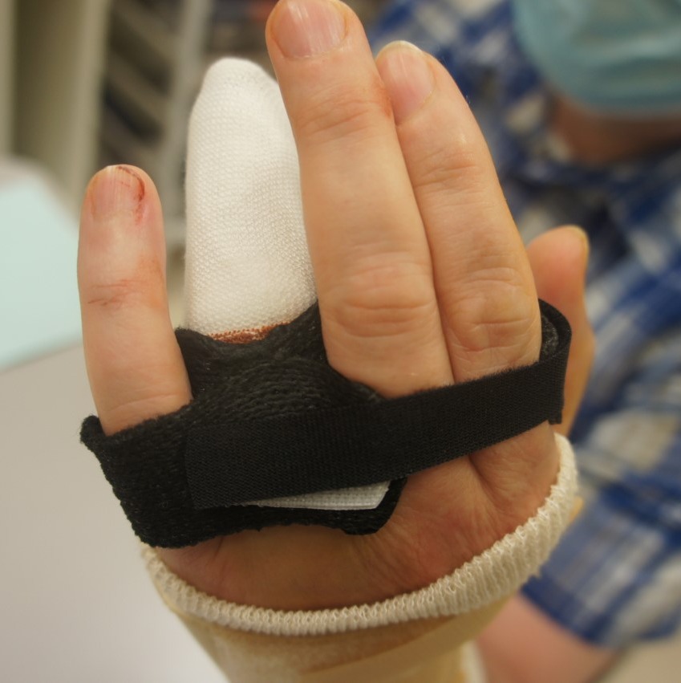 | 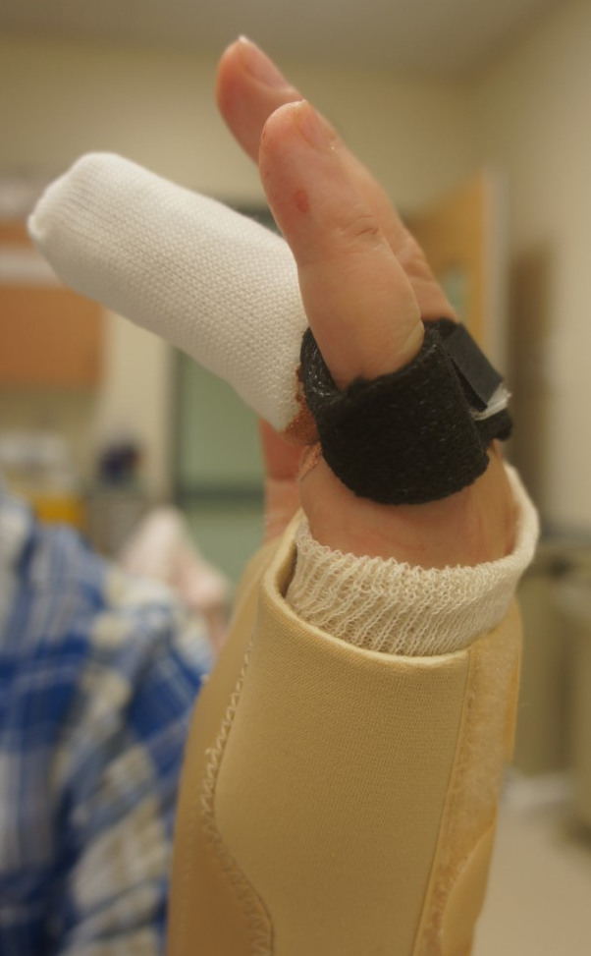

Figure 1. Relative motion flexion orthosis on a patient with a ring finger zone II flexor digitorum profundus repair
Images – Katie Horton, Pulvertaft Hand Centre, UK.

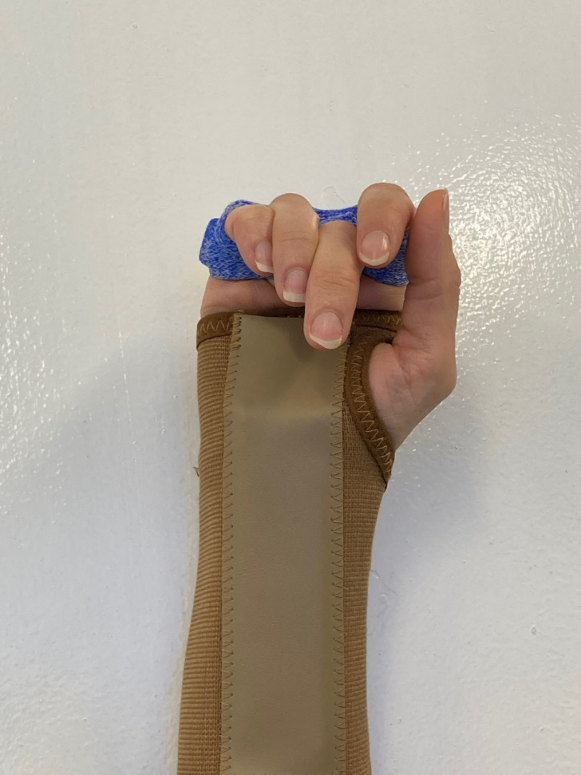
Figure 2. Example of a relative motion flexion orthosis for the middle finger
Image – Lisa Newington, Guy’s and St Thomas’ NHS Foundation Trust, UK

The primary kinesiological reasoning for these requirements is one of tension transference exploiting the quadriga effect (7). As the four FDP tendons share a common muscle belly, the position of relative MCP joint flexion limits active tension through the repaired tendon during composite finger flexion. The position of relative flexion also limits tendon excursion during composite extension, reducing passive tension through the repaired tendon (14). An assessment of intact and repaired FDP tendons in a cadaver model found that the RMF orthosis reduced tendon elongation in the involved digit and reduced gapping at the repair site (14).

An additional kinesiological rationale for using an RMF orthosis after flexor tendon repair is that it confers a biomechanical advantage for interphalangeal (IP) joint extension (16). The RMF orthosis optimizes the position of the intrinsic muscles and EDC to act on IP joint extension (12). This is similar to the exercise comprising active IP joint extension while positioned in MCP joint flexion, which is a common component of other early active flexor tendon rehabilitation approaches (17,18). Preventing the development of IP joint fixed flexion deformities is an important element of rehabilitation after flexor tendon repair. Anecdotally this is a frequent issue following zone I and II repairs, but it is difficult to assess the true incidence because range of movement outcomes are typically reported as a composite measure, such as the Strickland and Glogovac classification (11,19).

Metacarpophalangeal joint differential flexion
A critical question is how much MCP joint flexion differential is required to protect the repaired tendon? With too little flexion, relative to the unaffected digits, there may be the risk of excessive tension through the repair leading to rupture. Conversely, too much flexion relative to the unaffected digits may prohibit active movement and tendon gliding. To date, only four small studies have published data on the use of RMF orthoses after flexor tendon repair, and MCP joint differential flexion ranged from 15-40° (8,10,14,20).

A cadaver study by Chung et al., examined zone III repairs in four middle fingers using an RMF orthosis with 15-25° differential flexion (14). A retrospective case series (n=10), included zone I and II repairs and positioned the MCP joint of the affected fingers in 30-40° differential flexion (8). This position was replicated in a prospective case series of 14 patients who underwent zone I or II repairs, however rehabilitation commenced with a long dorsal blocking splint and the RMF orthosis was used only from the third week (10). Finally, a cross-sectional evaluation of flexor tendon rehabilitation guidelines across UK hand therapy departments identified one RMF guideline, which advocated a minimum of 20° differential flexion (20).

Savage et al. assessed FDP performance in 10 healthy volunteers using a dorsal blocking splint that permitted three MCP joint positions (15°, 30° and 45°) (21). They found that FDP strength decreased with increased MCP joint differential flexion, but not uniformly across all fingers. Greatest strength loss was seen in the middle, ring and small fingers. Similarly, FDP excursion decreased as differential flexion increased, with the largest loss of excursion identified in the ring finger (21).

Greater differential flexion may be required for the small finger in comparison with the middle finger due to the differences in hand posture associated with the transverse arches (22). This may also depend on the RMF orthosis design, for example whether the orthosis conforms with the transverse metacarpal arch or has a flatter arrangement (23). Interestingly, none of the identified RMF studies reported different differential flexion targets for individual fingers (8,10,14,20).

The optimal position of differential flexion remains unknown and warrants further investigation (24). Clinically, we find it challenging to consistently achieve 30-40° differential flexion and suggest that future research should record the amount of differential flexion achieved, in addition to the amount desired.

Wrist position
Both studies that described RMF as a primary rehabilitation strategy for flexor tendon repair also included a separate wrist orthosis. In the retrospective case series, the wrist was positioned between 20° flexion and 20° extension (8). Henry and Howell describe positioning in wrist flexion for their first three patients, before switching to the extended position, which they now advocate (8). In the single RMF rehabilitation guideline identified in the UK, the advocated wrist position was 0-15° extension (20).

Wrist position impacts flexor tendon gliding and work of flexion. Savage found that the combination of wrist extension with MCP joint flexion was associated with lower work of flexion when compared to a neutral or flexed wrist (25). This principle is also utilized in the Manchester short splint approach (17).

Without a wrist orthosis, there is the theoretical risk of inadvertent forced wrist and digit extension leading to rupture of the repair. A wrist orthosis was initially used as part of the RME approach after extensor repair, but recent research suggests that it is not required as standard (3,26). Use of the RME orthosis alone was associated with early return to movement and function, and increased patient satisfaction when compared with a wrist-hand orthosis with the PIP joints free move; there were no ruptures (26). It is possible that the wrist component may not be routinely required following flexor tendon repair. Anecdotally, several of our patients recalled discarding the wrist orthosis at an early stage of their rehabilitation without ill-effect; however, in the absence of any research, this does not form part of our current clinical practice or recommendations.

Exercise programs and hand function
Early active mobilization is a core component of the relative motion approach (7). This can be achieved through movement exercises and functional hand use.

Reported exercise programs, timescales and recommended hand function vary. Patients in the study by Henry and Howell were advised by their surgeon to complete (i) passive combined IP joint flexion, (ii) passive IP joint extension with the MCP joint in flexion and (iii) active range of movement, all within the RMF orthosis (8). Exercise dosage (frequency and repetitions) were not reported, and any other specific exercises were prescribed as required. The authors recommended that in future, removal of the RMF orthosis for exercise would be beneficial. Patients were encouraged to use the affected hand for light function during the first three weeks, but cautioned not to lift or grip strenuously. After this, both hands could be used to lift a ‘light’ bag, and ‘at risk’ activities such as jogging were permitted. Bilateral hand use to the equivalent of 3.5 kg was allowed from six weeks postoperatively. Full function hand-use was advised 8-10 weeks after surgery.

Öksüz et al. followed a standard controlled active motion protocol within a dorsal-blocking wrist-hand-finger orthosis (WHFO) for the first three weeks (10). After this, an RMF orthosis was provided, with similar active and passive exercises to those described above. Hand function was permitted up to 4.5kg. The orthosis was removed for range of movement exercises from week four and removed for all but heavy hand function (>20kg) during weeks 7-9.

An important consideration of any exercise program is the time burden for patients. Newington et al. calculated the approximate daily duration of exercises reported in UK flexor tendon treatment guidelines and this ranged from 7-90 minutes (20). The calculation was based on an estimated 5 seconds per finger or wrist exercise repetition and did not include time for scar management or other more proximal mobilization exercises. This calculation is therefore likely to underestimate the true time burden, however it does highlight the potential benefit of orthotic designs such as the RMF orthosis and the Manchester short splint, which enable light functional hand use early in the rehabilitation process. Hand function may facilitate more frequent movement than prescribed exercises, while also reducing the exercise burden. Tang suggests that 60-80 cycles of active flexion should be performed in each flexor tendon exercise session at a frequency of 4-6 times per day (27). This equates to 20-40 minutes per day for a single exercise using the same calculation method described above (20). Instead of solely focusing on isolated exercises, patients can also achieve active tendon gliding cycles of non-intentional exercise during functional activities. Future research should explore whether functional hand use during flexor tendon rehabilitation improves patient satisfaction, in addition to clinical outcomes.

Surgical considerations for relative motion flexion splinting

Included digits
The protective mechanism of RMF orthoses is theoretically based on the commonality of the FDP muscle belly. This enables the FDP of the more flexed digit to remain slack as tension is transferred through the other FDP tendons when the muscle contracts. While the FDP for the ulnar three digits has a shared muscle belly, the segment to the index finger can be partially separate allowing some independent flexion of the index finger distal interphalangeal (DIP) joint (28). Savage et al. found that when the index finger MCP joint was positioned in more flexion, this was associated with a smaller reduction in flexion strength when compared with differential flexion of the middle, ring or small finger (21). With this reasoning, the relative motion flexion approach may not be appropriate for all index finger FDP injuries. However, the RME orthosis has been found to be effective not only for extensor digitorum communis tendons, but also extensor indices and extensor digiti minimi tendons, which have separate muscle bellies (2). It is therefore suggested that relative motion orthoses may also function due to the kinesiological effects of co-contraction and co-inhibition, in addition to the anatomical feature of a shared muscle belly. Electromyographic studies have shown that all extrinsic digital extensors co-activate when voluntary contraction force exceeds 50% of maximum (29). Similar neuromuscular interdependence has been reported using electromyography of the FDP muscle, identifying substantial co-activation of all parts of the FDP muscle with active flexion of a single finger (30); however this has not been specifically assessed with differential flexion of the MCP joint.

Existing studies have used RMF orthoses after FDP repairs to the index finger, but there is very limited data available for this digit. Henry and Howell’s cohort included one patient with an index finger repair. This individual achieved grip strength comparable to the unaffected side and excellent range of movement using the Strickland and Glogovac classification, as assessed eight months after surgery (8,19). A prospective service evaluation conducted at the Pulvertaft Hand Centre in the UK (reported below), included six patients with index finger FDP repairs (33% of the cohort). One was lost to follow-up, one ruptured after the orthosis was removed overnight, and the remaining four achieved excellent (n=1), good (n=2), and fair (n=1) range of movement (Strickland and Glogovac), as assessed three months after surgery. Our clinical experience suggests that RMF is suitable for index finger FDP repairs, but we welcome further anatomical and clinical research to assess this in detail.

Number of repairs
Another important surgical consideration is the number of flexor tendon repairs that can be safely included in an RMF orthosis. After extensor tendon repair, the RME orthosis is not suitable if there are tendon injuries to all four fingers because this prohibits the relative positioning of the MCP joints (1). The initial description of RME advised that 1-3 extensor repairs could be included (1), however to date, studies of RMF use after flexor tendon repairs have only included single digit repairs (8,10). Theoretically, the RMF orthosis could be used to protect up to three FDP repairs, as long as these fingers can be positioned in an adequate amount of MCP joint flexion relative to the remaining finger(s). In practice, it may be simpler to fabricate the orthosis and ensure appropriate MCP joint differential flexion for only one or two fingers.

Zone of injury
Existing clinical studies of RMF have only included patients with zone I or II FDP repairs (8,10); the identified treatment guidelines also applied to these zones (20). Öksüz et al. also included associated flexor digitorium superficialis (FDS) repairs, but as mentioned previously, the RMF orthosis was only used after an initial rehabilitation period in a dorsal-blocking WHFO (10). Digital nerve repairs were not a contraindication to use of the RMF orthosis in any of the existing studies.

Zone II flexor tendon injuries are notorious for their complexity and therefore it is unsurprising that advances in treatment have focused on this zone (31). Interestingly, the single cadaveric study assessed zone III injuries (14), but we were unable to find literature reporting outcomes for the clinical application of RMF orthoses for this zone. Concomitant injuries to the lumbricals and interossei muscles need to be considered in zone III, in particular relating to MCP joint position (21). In practice, hand therapists may be less concerned with clinical outcomes following zone III repairs, as anecdotally there appear to be fewer issues with tendon adhesions or joint contractures (32). This may create less of a drive to explore alternative rehabilitation strategies.

As alluded to above, RMF orthoses may also be suitable for rehabilitation of isolated or combined flexor digitorum superficialis (FDS) repair in zone II or III using the principles of co-contraction and inhibition. However, this is not something we have experience of using in practice and we welcome further research to explore these potential applications.

Type of repair
Flexor tendon repairs involving four- or six-strand core sutures are widely recommended for early active mobilization rehabilitation (33–35). Four-strand repairs were used in the existing RMF studies (8,10) and were a requirement in the identified RMF treatment guideline (20). Four-strand repairs were also used in the initial evaluation of the Manchester short splint (17). These rehabilitation programs all included early functional hand use and reported no issues with tendon rupture (8,10,17).

Pulley venting is widely endorsed, with the aim of optimizing tendon gliding at the repair site (31,36). This can be best assessed when the surgery is performed wide-awake or under light sedation, so that the patient can actively flex the finger and the surgeon can directly visualize tendon gliding and assess for repair gapping (37). This may also enable individualized assessment of the required MCP joint flexion differential to facilitate optimal gliding without excessive tension through the repair (24).

We recommend that the type and quality of the repair and the extent of pulley venting is clearly documented as part of the operation record. This will inform hand therapists’ discussions with their patients regarding the options for orthoses and rehabilitation and enable audit and service evaluation using routinely collected data.

Time from surgery to start of rehabilitation
Hand therapy commenced, or was recommended, within a week of surgery in all existing studies (8,10,20). This fits with the available evidence endorsing early active mobilization (11,38). RMF was used as both the primary rehabilitation strategy (8,20) and as an adjunct to a traditional long dorsal-blocking WHFO and controlled early active motion regime (10). We follow the former strategy and suggest that the finger-based RMF orthosis and separate WHO may be appropriate from the initial appointment, without need for an additional dorsal-blocking WHFO.

Relative motion flexion orthosis fabrication
A typical relative motion orthosis requires a strip of material that is approximately 240mm by 25mm. This could be a single layer of 3.2mm low-temperature thermoplastic or equivalent, with double layers used for thinner materials. RMF orthoses use less material and require less time to fabricate than other flexor tendon orthoses, which has potential environmental and economic benefits (39). In practice, the RMF orthosis can often be made using off-cuts from the fabrication of other orthoses. It is important to note, that for both the RME and RMF orthoses, there is a tradeoff between thickness/rigidity and comfort. Careful customization is necessary to provide adequate protection, enable sufficient proximal interphalangeal (PIP) joint movement, and avoid skin irritation. The RMF orthosis design also needs to consider the location of the wound and any dressing requirements. This may be a particular issue for zone II flexor tendon repairs, especially in the index and small fingers where the thermoplastic loops circumferentially around these digits. Henry and Howell describe using open loop designs in these scenarios (8), and we have found these useful in practice (Figure 3).

For the wrist component, over-the-counter orthoses can achieve the desired position. Again, this reduces therapist time and cost. Alternatively, a custom-made thermoplastic orthosis could be fabricated in the desired wrist position.

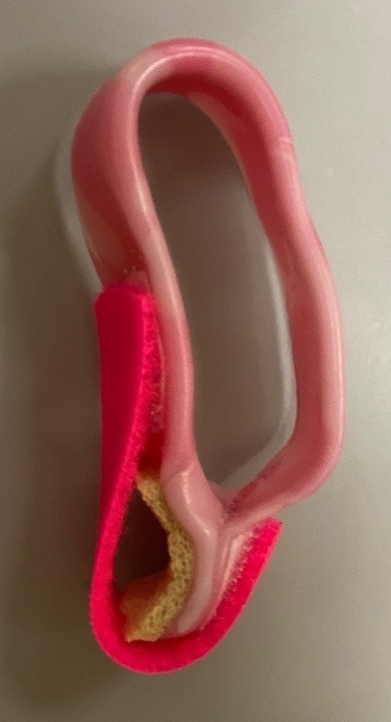 | 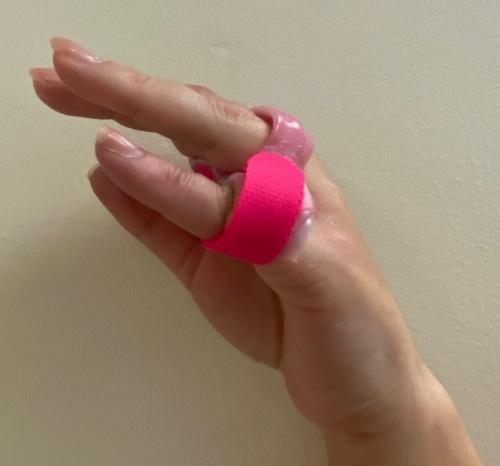

Figure 3. Relative motion flexion orthosis showing an open loop design for a small finger zone II repair.
Images – Emma Bamford, Pulvertaft Hand Centre, UK.

Exploration of current therapy practice and clinical outcomes
A scoping survey carried out by the Pulvertaft Hand Centre (UK) in 2019, suggested that the RMF orthosis had not been routinely adopted in clinical practice. Twenty-four hand therapy departments responded from 64 invitations (38% response rate). For zone II flexor tendon repairs, therapy departments predominately advocated a controlled early active motion approach with either a long dorsal-blocking WHFO (52%) or the Manchester short splint (44%). The remaining approaches involved immobilization (4%). For zone III repairs, 84% recommended using the long dorsal-blocking WHFO, compared with 16% for the Manchester short splint. None of the departments reported using a RMF approach.

The hand therapy team at Pulvertaft Hand Centre have experience of using RMF as the primary orthotic strategy after zone I and II flexor tendon repair. To supplement the retrospective data published by Henry and Howell (8), we present the findings of a sequentially recruited prospective case series of 18 patients who underwent FDP repair between June 2020 and January 2022. Inclusion criteria were: single digit flexor tendon repairs in zone I or II; and surgeon approval to use the RMF orthosis. The latter was primarily based on confidence in the strength of their repair and willingness to trial the RMF approach, which had not previously been used within the department. Individuals with associated FDS and digital nerve repairs were not purposively excluded, however none presented during the period of data collection. Patients were recruited with local approval (University Hospitals of Derby and Burton Clinical Audit Department) as part of an ongoing service evaluation using routinely collected data.

Tendons repairs were either four or six-strand and surgery was predominantly under general anesthetic, as this is the local practice.

All patients were provided with a custom-made finger-based RMF orthosis, with the affected MCP joint positioned in 30° more flexion, and a pre-fabricated wrist-hand orthosis (WHO) in approximately 15° wrist extension (Figure 1 and 2). Hand therapy commenced within seven days of surgery. Patients were instructed to wear the RMF orthosis at all times for a total of five weeks and then at night and during vulnerable situations for a further week. The WHO was worn fulltime for three weeks, although removed for tenodesis exercises, and then worn at night and for protection for a further three weeks. These timescales were shorter than those reported by Henry and Howell, who advised RMF orthosis wear for 8-10 weeks after surgery (8). This was a deliberate strategy to create equivalence with other flexor tendon rehabilitation approaches.

Patients were provided with a home exercise program to perform hourly during waking hours. The specific program was personalized based on the needs of the individual, however the program generally comprised passive composite flexion of all digits, active IP joint extension with the MCP joints held in maximum flexion, gentle (~50% effort) active composite flexion and active wrist/finger tenodesis. Outcomes were assessed 12 weeks after surgery, or on final appointment if discharged prior to this (Table 1). Unfortunately, two patients were lost to follow-up after three weeks and therefore their outcome data are not available. Loss to follow-up is a common issue after flexor tendon repair (17), and affects studies using routinely collected data as well as interventional research. Electronic data collection and virtual range of motion assessments could potentially improve outcome data collection for this population (40).

Table 1. Clinical outcomes ≤ 12 weeks after zone I/II flexor digitorum profundus repair and relative motion flexion rehabilitation

 | Sex | Age (years) | Finger | Zone | Mechanism of injury | PIPJ AROM | DIPJ AROM | Total active motion (%) | Strickland Classification | Grip strength  (% of unaffected side) | Quick DASH
1 | Male | 75 | Middle | I | Saw | 14 / 70 | 0 / 4 | 34 | Poor | NR | NR
2 | Female | 49 | Small | II | Knife | 4 / 72 | 0 / 60 | 73 | Good | 85.1 | 4.5
3 | Male | 26 | Small | I | Sharp metal | 0 / 90 | 0 / 54 | 82 | Good | NR | 9.1
4 | Female | 34 | Small | I | Knife | 0 / 100 | 0 / 38 | 79 | Good | 84.1 | 9.0
5 | Female | 38 | Small | II | Knife | NR | NR | NR | NR | NR | NR
6 | Male * | 60 | Small | I | Knife | NA | NA | NA | NA | NA | NA
7 | Male | 41 | Index | I | Saw | 0 / 82 | 18 / 36 | 57 | Fair | NR | NR
8 | Male | 60 | Small | II | Knife | 4 / 70 | 0 / 10 | 43 | Poor | NR | NR
9 | Male | 34 | Index | I | Knife | 0 / 90 | 0 / 42 | 75 | Good | 79.7 | 20.5
10 | Male ~ | 50 | Small | II | Sharp metal | 16 / 30 | 0 / 4 | 10 | Poor | 20.8 | 48
11 | Male | 64 | Middle | I | Ceramic | 12 / 96 | 0 / 34 | 67 | Fair | NR | NR
12 | Male | 39 | Middle | I | Knife | 0 / 100 | 0 / 84 | 105 | Excellent | NR | NR
13 | Male * | 30 | Index | II | Sharp metal | NA | NA | NA | NA | NA | NA
14 | Male | 40 | Middle | II | Crush | 12 / 72 | 0 / 28 | 50 | Fair | NR | NR
15 | Male | 29 | Index | I | Knife | NR | NR | NR | NR | NR | NR
16 | Male | 62 | Small | I | Knife | 12 / 70 | 0 / 10 | 39 | Poor | 88.1 | NR
17 | Male | 51 | Index | I | Knife | 0 / 84 | 2 / 40 | 70 | Good | 73.4 | NR
18 | Male | 53 | Index | II | Knife | 0 / 88 | 0/80 | 96 | Excellent | NR | 27.3

AROM active range of movement; DASH Disabilities of the Arm, Shoulder and Hand; DIPJ distal interphalangeal joint; PIPJ proximal interphalangeal joint; NA not applicable; NR not reported; Strickland Classification: <50% poor, 50-69% fair, 70-84% good, 85-100% excellent (19); * tendon rupture; ~ subsequent tenolysis procedure.
In this cohort, three patients experienced surgical complications (41): two patients experienced tendon rupture and one proceeded to require tenolysis. The ruptures occurred in index and small fingers. The index finger rupture occurred three weeks after surgery, potentially due to removal of the RMF orthosis at night, which highlights the importance of continued orthosis wear. The cause of the second rupture was unknown and occurred approximately two weeks after surgery. The position of MCP joint differential flexion for the small finger requires consideration, due to the increased mobility of the MCP and carpometacarpal joints. In addition, the small finger may be more vulnerable to accidental catching during function.

Rupture after tendon repair is always a concern for hand surgeons and hand therapists. A review of patients with acute repair rupture following zone I and II flexor tendon repairs suggested that half of ruptures “followed acts of stupidity” (42) p275. While the article makes uncomfortable reading due to the paternalistic narrative, it does raise important points regarding information sharing, and what constitutes safe functional hand use. Used appropriately, RMF orthoses may be a tool to facilitate regular finger motion and tendon gliding, and could potentially reduce the incidence of tendon adhesions and secondary surgeries. Our impression is that patients are less likely to remove their orthosis, and more likely to mobilize their fingers, if they are aware of the balance of risks of tendon rupture or adhesions. This requires personalized advice about safe functional hand use.

The clinical outcomes reported in this prospective case series were inferior to those previously published by Henry and Howell, who had retrospective data for eight patients. Henry and Howell reported no ruptures or secondary surgeries, and mean grip strength was 90% of the unaffected side (8). This compares with 72% for the six patients with grip strength data in the current evaluation. Furthermore, 63% of Henry and Howell’s participants achieved excellent or good Strickland range of movement classifications (19), compared with 39% in the current evaluation. Notably, five patients (36%) in the current evaluation had >5° degrees extension deficit at the PIP joint, while all patients achieved full extension in the series reported by Henry and Howell. The presence of PIP joint extension deficits reported in the current evaluation are interesting given the hypothesized benefit of RMF orthoses in optimizing IP joint extension. However, direct comparison between the two patient populations is not appropriate due to the marked differences in the timing of data collection. All data in the current evaluation was collected ≤12 weeks after surgery, compared with five months to six years after surgery in the study by Henry and Howell (8). Furthermore, differences in cohort demographics, such as the mechanism and complexity of injury, age, and occupation, may all have an impact on outcomes (43).

An additional study was presented at the International Federation of Societies for Hand Therapy 2022 Congress. Hauri et al. compared outcomes for eight patients using the Manchester short splint, three using the RMF orthosis and eight using a dorsal-blocking WHFO (44). There were equivalent functional outcomes and no ruptures. Interestingly, the RMF group reported greater satisfaction recorded at 13 weeks after surgery (8.5/10 compared with 7/10 for the short orthosis and 6.6/10 for the longer orthosis) (44).

The small sample sizes and high rates of missing data in the existing RMF studies make it inappropriate to establish definitive clinical guidance based on the available evidence. We welcome strategies to consistently collect patient reported outcome measures and ensure documentation of contra-lateral movement and strength assessments, such as the electronic system reported by Selles et al. (45).

Conclusions and future research
RMF orthoses with early active mobilization are a rehabilitation option following zone I and II flexor tendon repairs. The proposed benefits include early functional hand use, reduced tendon adhesions and joint contractures, and smaller, less costly orthoses. We have discussed the kinesiological rationale, which centers on both the quadriga effect of shared muscle bellies and patterns of co-activation and inhibition during functional movement.

There is currently no high-quality, appropriately powered research assessing clinical and patient reported outcomes after flexor tendon rehabilitation using an RMF orthosis. We are comfortable using this rehabilitation strategy as part of a shared decision-making process with our patients (46), particularly given the limited evidence for any particular flexor tendon rehabilitation approach (11). To address this lack of evidence, a UK-based multi-center randomized controlled trial has been established to compare three different orthoses after zone I or II flexor tendon repair: long dorsal-blocking (WHFO), short dorsal-blocking (Manchester short splint), and RMF including the wrist component (47). The trial commenced in Fall 2022, with an anticipated end date of June 2025.

References
1. Merritt WH, Howell J, Tune R, Saunders S, Hardy M. Achieving immediate active motion by using relative motion splinting after long extensor repair and sagittal band ruptures with tendon subluxation. Oper Tech Plast Reconstr Surg. 2000;7(1):31–7.
2. Hirth MJ, Howell JW, O’Brien L. Relative motion orthoses in the management of various hand conditions: A scoping review. J Hand Ther. 2016;29(4):405–32.
3. Hirth MJ, Howell JW, Feehan LM, Brown T, O’Brien L. Postoperative hand therapy management of zones V and VI extensor tendon repairs of the fingers: An international inquiry of current practice. J Hand Ther. 2021;34(1):58–75.
4. Hirth MJ, Bennett K, Mah E, Farrow HC, Cavallo A V., Ritz M, et al. Early return to work and improved range of motion with modified relative motion splinting: A retrospective comparison with immobilization splinting for zones V and VI extensor tendon repairs. Hand Ther. 2011;16(4):86–94.
5. Howell JW, Merritt WH, Robinson SJ. Immediate controlled active motion following zone 4-7 extensor tendon repair. J Hand Ther. 2005;18(2):182–90.
6. Burns MC, Derby B, Neumeister MW. Wyndell Merritt immediate controlled active motion (ICAM) protocol following extensor tendon repairs in zone IV-VII: Review of literature, orthosis design, and case study-a multimedia article. Hand. 2013;8(1):17–22.
7. Merritt WH. Relative motion splint: Active motion after extensor tendon injury and repair. J Hand Surg Am. 2014;39(6):1187–94.
8. Henry SL, Howell JW. Use of a relative motion flexion orthosis for postoperative management of zone I/II flexor digitorum profundus repair: A retrospective consecutive case series. J Hand Ther. 2020;33(3):296–304.
9. Newington L, Ross R, Howell JW. Relative motion flexion splinting for the rehabilitation of flexor tendon repairs: A systematic review. Hand Ther. 2021;26(3):102–12.
10. Öksüz Ç, Arslan ÖB, Baş CE, Ayhan E. Early active movement with relative motion flexion splint for the management of zone 1-2 flexor tendon repairs: Case series. Physiother Theory Pract. 2022;Online:DOI:10.1080/09593985.2022.2073574.
11. Peters SE, Jha B, Ross M. Rehabilitation following surgery for flexor tendon injuries of the hand. Cochrane Database Syst Rev. 2021;1:CD012479.
12. Merritt WH, Howell JW. Relative motion orthoses: The concepts and application to hand therapy management of finger extensor tendon zone III and VII repairs, acute and chronic Boutonniere deformity, and sagittal band injury. In: Skirven T, Osterman A, Fedorczyk J, Amadio P, Feldscher S, Shin E, editors. Rehabilitation of the Hand and Upper Extremity. 7th ed. Philadelphia: Elsevier; 2021. p. 1496–510.
13. Sharma J V., Liang NJ, Owen JR, Wayne JS, Isaacs JE. Analysis of Relative Motion Splint in the Treatment of Zone VI Extensor Tendon Injuries. J Hand Surg Am. 2006;31(7):1118–22.
14. Chung B, Chiu DTW, Thanik V. Relative Motion Flexion Splinting for Flexor Tendon Lacerations: Proof of Concept. Hand. 2019;14(2):193–6.
15. Howell JW, Peck F. Rehabilitation of flexor and extensor tendon injuries in the hand: Current updates. Injury. 2013;44(3):397–402.
16. Merritt WH, Jarrell K. A Paradigm Shift in Managing Acute and Chronic Boutonniere Deformity: Anatomic Rationale and Early Clinical Results for the Relative Motion Concept Permitting Immediate Active Motion and Hand Use. Ann Plast Surg. 2020;84(Suppl 2):S141–50.
17. Peck FH, Roe AE, Ng CY, Duff C, McGrouther DA, Lees VC. The Manchester short splint: A change to splinting practice in the rehabilitation of zone II flexor tendon repairs. Hand Ther. 2014;19(2):47–53.
18. Higgins A, Lalonde DH. Flexor tendon repair postoperative rehabilitation: The Saint John protocol. Plast Reconstr Surg - Glob Open. 2016;4(11):1–3.
19. Strickland JW, Glogovac SV. Digital function following flexor tendon repair in Zone II: A comparison of immobilization and controlled passive motion techniques. J Hand Surg Am. 1980;5(6):537–43.
20. Newington L, Lane JC, Holmes DG, Gardiner MD. Variation in patient information and rehabilitation regimens after flexor tendon repair in the United Kingdom. Hand Ther. 2022;27(2):49–57.
21. Savage R, Pritchard MG, Thomas M, Newcombe RG. Differential splintage for flexor tendon rehabilitation: An experimental study of its effect on finger flexion strength. J Hand Surg Am. 2005;30(2):168–74.
22. Tubiana R, Thomine J-M, Mackin E. The arches of the hand. In: Examination of the Hand and Wrist. 2nd ed. Martin Dunitz Ltd; 1998. p. 9–15.
23. Howell JW, Hirth M. Relative motion orthoses. In: Jacobs M, Austin N, editors. Orthotic intervention for the hand and upper extremity. 3rd ed. Wolters Kluwer; 2021. p. 138–49.
24. Howell JW, Hirth MJ. Relative motion flexion splints in the management of finger flexor tendon repairs: an update [Internet]. Vol. 127, Fingerprint: Australian Hand Therapy Association. 2021 [cited 2022 Oct 25]. p. 24–8. Available from: https://issuu.com/ahta/docs/ahta_fingerprint_-_june_2021_v8_wr
25. Savage R. The influence of wrist position on the minimum force required for active movement of the interphalangeal joints. J Hand Surg [Br]. 1988;13(3):262–8.
26. Collocott SJF, Kelly E, Foster M, Myhr H, Wang A, Ellis RF. A randomized clinical trial comparing early active motion programs: Earlier hand function, TAM, and orthotic satisfaction with a relative motion extension program for zones V and VI extensor tendon repairs. J Hand Ther. 2019;33(1):13–24.
27. Tang JB. Rehabilitation after flexor tendon repair and others: a safe and efficient protocol. J Hand Surg Eur Vol. 2021;46(8):813–7.
28. Salmons S. Muscles. In: Williams P, editor. Gray’s Anatomy: The anatomical basis of medicine and surgery. 38th ed. Churchill Livingstone; 1995. p. 848.
29. van Duinen H, Yu WS, Gandevia SC. Limited ability to extend the digits of the human hand independently with extensor digitorum. J Physiol. 2009;587(20):4799–810.
30. Reilly KT, Schieber MH. Incomplete functional subdivision of the human multitendoned finger muscle flexor digitorum profundus: An electromyographic study. J Neurophysiol. 2003;90(4):2560–70.
31. Tang JB, Lalonde D, Harhaus L, Sadek AF, Moriya K, Pan ZJ. Flexor tendon repair: recent changes and current methods. J Hand Surg [Eur]. 2022;47(1):31–9.
32. Tobler-Ammann B, Beckmann-Fries V, Calcagni M, Kampfen A, Schrepfer L, Vogelin E. Outcomes after zone 3 primary finger flexor tendon repair: a retrospective matched case-control study with zone 2. J Hand Surg [Eur]. 2022;47(Suppl 1):S64-65.
33. Ayhan E, Tuna Z, Oksuz C. Getting better results in flexor tendon surgery and therapy. Plast Reconstr Surg - Glob Open. 2021;9:e3432.
34. British Society for Surgery of the Hand. Lacerations with flexor tendon involvement [Internet]. 2014 [cited 2021 Oct 12]. Available from: https://www.bssh.ac.uk/_userfiles/pages/files/professionals/Trauma standards/3 Flexor tendon final.pdf
35. Tang JB. Recent evolutions in flexor tendon repairs and rehabilitation. J Hand Surg [Eur]. 2018;43(5):469–73.
36. Tang JB. New developments are improving flexor tendon repair. Plast Reconstr Surg. 2018;141(6):1427–37.
37. Lalonde DH. Latest Advances in Wide Awake Hand Surgery. Hand Clin. 2019;35(1):1–6.
38. Johnson SP, Kelley BP, Waljee JF, Chung KC. Effect of Time to Hand Therapy following Zone II Flexor Tendon Repair. Plast Reconstr Surg - Glob Open. 2020;8:e3278.
39. Hirth MJ, Howell JW, Brown T, O’Brien L. Relative motion extension management of zones V and VI extensor tendon repairs: Does international practice align with the current evidence? J Hand Ther. 2021;34(1):76–89.
40. Johnson D, Barradas R, Newington L. Inter-rater and intra-rater reliability of finger goniometry measured from screenshots taken via video consultation. J Hand Sugery [Eur]. 2022;In press.
41. Dy C, Hernandez-Soria A, Ma Y, Roberts T, Daluiski A. Complications after flexor tendon repair: a systematic review and meta-analysis. J Hand Sugery [Am]. 2012;37(3):543–51.
42. Harris SB, Harris D, Foster AJ, Elliot D. The aetiology of acute rupture of flexor tendon repairs in zones 1 and 2 ofthe fingers during early mobilization. J Hand Surg [Br]. 1999;24 B(3):275–80.
43. Zhou Y, Krishna S, Sharplin PK. Management and outcomes of flexor tendon repairs at a peripheral hospital: a New Zealand case series study. ANZ J Surg. 2022;92(7–8):1668–74.
44. Hauri T, Vogelin E, Tobler B. First results of patients after flexor tendon injuries in zone I and II treated with the “Manchester Short Splint” and “Relative Motion Flexion” compared to the “Controlled Active Motion” protocol. J Hand Surg [Eur]. 2022;47(Suppl 1):S102.
45. Selles RW, Wouters RM, Poelstra R, Van Der Oest MJW, Porsius JT, Hovius SER, et al. Routine Health Outcome Measurement: Development, Design, and Implementation of the Hand and Wrist Cohort. Plast Reconstr Surg. 2020;146(2):343–54.
46. Hutting N, Caneiro JP, Ong’wen OM, Miciak M, Roberts L. Patient-centered care in musculoskeletal practice: Key elements to support clinicians to focus on the person. Musculoskelet Sci Pract. 2022;57:102434.
47. Bamford E, Drummond A, Selby A, Thokala P, Beale S, Johnson N, et al. Prospective randomised controlled trial comparing three splints for finger flexor tendon repairs (FIRST) [Internet]. 2022 [cited 2022 Jun 1]. Available from: https://fundingawards.nihr.ac.uk/award/NIHR133582

