The carbon credentials of hydrogen gas networks and supply chains
Paul Balcombe^{a,b*}, Jamie Speirs^{b,c}, Erin Johnsonª, Jeanne Martin^{b}, Nigel Brandon^{b,c}, Adam Hawkes^{a,b}

ª Chemical Engineering, Imperial College London, SW7 2AZ
^{b} Sustainable Gas Institute, Imperial College London, 11 Prince’s Gardens, SW7 1NA
^{c} Earth and Atmospheric Science, Imperial College London, SW7 2BP
* Corresponding author: p.balcombe@imperial.ac.uk

Highlights
- Quantification and analysis of various hydrogen production supply chains
- The range of emissions is extremely large, from -371 to 642 gCO₂eq/kWh_{H2}
- Fossil routes must include CCS to lower emissions compared to current gas grids
- Supply chains are major contributors to emissions and large variations across routes
- Only lowest carbon hydrogen routes compete with low carbon electricity heat pumps

Keywords
Hydrogen production; supply chain emissions; greenhouse gas emissions; gas network decarbonisation

Abstract
Projections of decarbonisation pathways have typically involved reducing dependence on natural gas grids via greater electrification of heat using heat pumps or even electric heaters. However, many technical, economic and consumer barriers to electrification of heat persist. The gas network holds value in relation to flexibility of operation, requiring simpler control and enabling less expensive storage. There may be value in retaining and repurposing gas infrastructure where there are feasible routes to decarbonisation. This study quantifies and analyses the decarbonisation potential associated with the conversion of gas grids to deliver hydrogen, focusing on supply chains. Routes to produce hydrogen for gas grids are categorised as: reforming natural gas with (or without) carbon capture and storage (CCS); gasification of coal with (or without) CCS; gasification of biomass with (or without) CCS; electrolysis using low carbon electricity. The overall range of emissions across routes is extremely large, from -371 to 642 gCO₂eq/kWh_{H2}. Therefore, when including supply chain emissions, hydrogen can have a range of carbon intensities and cannot be assumed to be low carbon. Emissions estimates for natural gas reforming with CCS lie in the range of 23 – 150 g/kWh_{H2}, with CCS typically reducing CO₂ emissions by 75%. Hydrogen from electrolysis ranges from 24 - 178 gCO₂eq/kWh_{H2} for renewable electricity sources, where wind electricity results in the lowest CO₂ emissions. Solar PV electricity typically exhibits higher emissions and varies significantly by geographical region. The emissions from upstream supply chains is a major contributor to total emissions and varies considerably across different routes to hydrogen. Biomass gasification is characterised by very large negative emissions in the supply chain and very large positive emissions in the gasification process. Therefore, improvements in total emissions are large if even small improvements to gasification emissions can be made, either through process efficiency or CCS capture rate.

Abbreviations
ATR Autothermal reforming
CCS Carbon capture and storage
GHG Greenhouse gas
HHV Higher heating value
POX Partial oxidation
SMR Steam methane reforming
Syngas Synthesis gas

Introduction
Natural gas networks have historically been a relatively lower carbon route to heat or electricity generation, because combustion emissions are lower than other fossil fuels: approximately 50 gCO₂/MJ HHV heat, compared to 90 gCO₂/MJ for coal. However, meeting 1.5 - 2°C climate targets requires much deeper decarbonisation. Extensive natural gas infrastructure exists in many countries, resulting from many years of investment. If nations are to contribute to climate stabilisation, these gas networks must either be decarbonised or become stranded assets.
Decarbonisation pathways have typically involved reducing dependence on gas grids via greater electrification of heat using heat pumps or even electric heaters. However, there are several technical, economic and consumer related barriers to electrification of heat [e.g. 1, 2, 3]. Additionally, the gas network may hold significant value in relation to its flexibility of operation and supply, requiring simpler control and enabling less expensive storage [4]. Therefore, there could be value in retaining and repurposing gas infrastructure if there are feasible routes to decarbonisation. There are several options for decarbonisation, including blending or replacing natural gas with hydrogen [5].
Hydrogen can be used as an alternative to natural gas for heat, electricity or transport and unlike natural gas, hydrogen combustion produces no CO₂ emissions. Nevertheless, the supply chain associated with hydrogen production and delivery is likely to be more complicated compared to natural gas, which may result in emissions and/or a loss in efficiency. Additionally, some infrastructure changes are required to replace hydrogen with natural gas due to the difference in physical properties, which will result in additional costs and system shutdown periods while the transition is made.
This study investigates the greenhouse gas impacts associated with the conversion of gas grids to deliver hydrogen. This review builds upon on an extensive evidence-based assessment produced by the Sustainable Gas Institute [6]. The paper focuses on the options associated with decarbonising the source gas within the network rather than reducing demand or decarbonising at the point of use. Previous studies have estimated GHG emissions associated with hydrogen production via specific feedstocks and production processes, whilst a few have reviewed a selection of processes in aggregate [7-11]. This study goes further by reviewing a large range of production options and supply chains, combining fossil and renewable feedstocks, including renewable electrolysis and biomass gasification, the use of carbon capture and storage, as well as the most important current and prospective production processes. Particular focus is on emissions associated with the upstream supply chain, in order to understand the contribution to the large range of emissions seen in the literature and give insight into how emissions may be reduced in the future.
The following first describes the options, current status and potential for producing hydrogen via various feedstocks and processes. For each option, Section 3 reviews the evidence on associated GHG emissions. Section 4 discusses the importance of supply chain emissions associated with the different routes. The potential to reduce emissions is described in Section 5 prior to concluding remarks in Section 6.

The routes to hydrogen production
Broadly, hydrogen may be used similarly to that of natural gas in that it may be combusted in gas boilers to provide thermal energy. Additionally, it may be used as a feed for fuel cells. But whilst hydrogen may meet the demand previously associated with natural gas, there are several key differences between the fuels which results in some required changes on an infrastructural and consumer appliance level. Table 1 gives a summary of the properties of hydrogen and methane for comparison. Key differences between the physical properties of hydrogen and methane are their energy density, flame speed and molecular size. Hydrogen has an energy density approximately a third of that of natural gas on a volume basis [12]. Consequently, greater volumetric throughput is required to deliver the same heat duty. The flame speed of hydrogen is higher than methane, meaning that the flow rate of hydrogen to a burner must be higher to prevent upstream flame propagation (applicable where air is mixed upstream). The molecular size of hydrogen is smaller than methane, resulting in greater propensity for leaks through equipment seals and connections.
Table 1. Physical and chemical properties of methane and hydrogen. Relevant conditions are measured at Normal temperature and pressure: 20 °C and 1 bar absolute pressure
Property | Methane | Hydrogen
Chemical formula | CH₄ | H₂
Molecular weight (g/ moly) | 16 | 2
Density (kg/ m³) | 0.668 | 0.084
Energy density (MJ/ kg) | 55.5 | 142
Energy density (MJ/ m³) | 37.3 | 12.0
Maximum flame speed (m/ s) | 0.39 | 3.06
Low flammability limit (% vol) | 5.3% | 4%
High flammability limit (% vol) | 15% | 75%
Flame temperature (adiabatic) (°C) | 1,953 | 2,107
Flame colour | Blue | None
Source: [13]
There are several options to produce hydrogen from different feedstocks, such as:
- Reforming natural gas to hydrogen with (or without) carbon capture and storage (CCS)
- Gasification of coal to hydrogen with (or without) CCS
- Gasification of biomass to hydrogen with (or without) CCS
- Electrolysis to hydrogen using low carbon electricity
These options are depicted in Figure 1 and described in the following section, in terms of their technical and process characteristics.
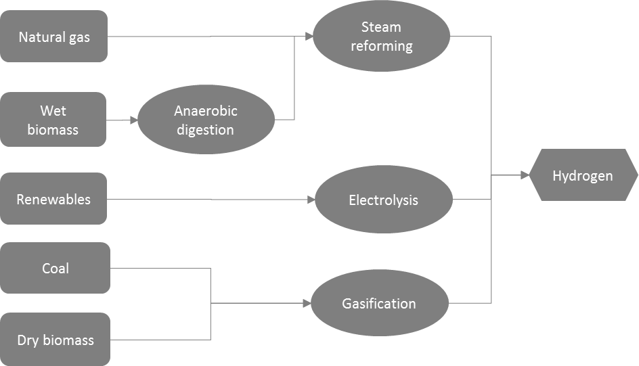
Figure 1. Routes to hydrogen production

Reforming natural gas with CCS
Hydrogen production from the reforming of natural gas is the most common form of bulk hydrogen production, representing approximately 48% of global production (with 30% from oil reforming, 18% from coal gasification and 4% from electrolysis) [14-17]. The steam methane reforming (SMR) process initially involves a reaction between methane, the main constituent of natural gas, and steam at 800 C and 30 bar [18, 19]. Hydrogen and carbon monoxide, known as synthesis gas (syngas), is formed by the following reaction:
$H_{2}O+CH_{4} →CO+3H_{2}$ $ΔH_{298K}=+206\frac{kJ}{mol}$
A water-gas-shift reaction then reacts the carbon monoxide with steam to produce more hydrogen as well as carbon dioxide by the following reactions:
$H_{2}O+CO → CO_{2}+ H_{2}$ $ΔH_{298K}=-41\frac{kJ}{mol}$
Production capacities are in the order of 150-250 MW (as embodied heat energy in hydrogen product). Total process efficiencies are typically estimated to be 70%, although a range between 60 and 90% has been cited [5, 18, 20-26]. This range is likely to be due to different estimation methods and scope boundaries rather than real efficiency differences. Only marginal improvements in system efficiencies are expected with this mature process, for instance with improved waste heat recovery [27].
A number of alternative processes to convert methane to hydrogen have been developed to varying degrees of maturity, including partial oxidation, autothermal reforming, dry reforming, autocatalytic decomposition or methane pyrolysis [28, 29]. In particular methane pyrolysis presents a promising prospect as instead of generating CO2, solid carbon is produced. This results in less gaseous separation and no CO2 transport or storage requirements albeit at the expense of potentially lower hydrogen yield [29]. However, several technical, economic, catalytic and efficiency related barriers prevail with these alternative methods and thus far they have not been shown to be commercially viable.
Low carbon hydrogen is only produced from SMR processes if CO₂ is separated via carbon capture and storage (CCS) or utilisation (CCU). Two categories of capture processes are considered in conjunction with syngas production, namely pre-combustion and post-combustion.
Pre-combustion is the capture of high-concentration CO₂ prior to burning fuel in the furnace (and therefore before fuel has been mixed with air to lower concentration) using physical absorbents such as glycol. Figure 2 shows the natural gas reforming process with pre-combustion carbon capture.
Methane
SMR + gas shift
Pressure swing absorption
CO₂ capture
Steam
H₂
CO₂
CH₄, CO₂ & H₂
Reformer furnace
Membrane separation
Figure 2: The stages of producing hydrogen from stream methane reforming with pre-combustion carbon capture and storage.
‘Post-combustion’ is used to separate CO₂ from the flue gas stream (hence post-combustion) which has a low-concentration of CO₂ as it has been diluted with air [30]. Whilst the final product (hydrogen) has not been combusted in the SMR process, post-combustion capture could be used in the flue gas stream from the fuel used to heat the SMR unit (Figure 3). CO₂-lean flue gases at low pressures are suitable for a chemical solvent such as amine to strip CO₂ from the rest of the gas mixture in an exothermic reaction [5]. The reacted amine is then sent to a heated regenerator tower, converting the reacted amine and CO₂ back into their original states. The former is sent back to the absorber tower, where it is reused.
Reformer furnace
Methane
SMR + gas shift
Pressure swing absorption
CO₂ capture
Steam
H₂
CO₂
CH₄, CO₂ & H₂
Flue gas
Figure 3: The stages of producing hydrogen from steam methane reforming with post-combustion carbon capture and storage.
The preferred capture technology depends upon specific process parameters and desired capture rate. Typically pre-combustion gives a higher capture fraction, but post-combustion may be preferable as a retrofit solution. It is estimated that between 71% and 92% of the CO₂ may be effectively captured from the syngas stream [5, 31].
Once captured, the CO₂ stream must be dehydrated and compressed for transport and storage. A significant number of studies examine transportation and storage of CO₂, relating to the CO₂ captured in power generation [30, 32, 33]. The additional energy penalty and product loss associated with the incorporation of CCS is estimated via a total efficiency loss of 5 - 14% [34-36]. However, it has been suggested that excess steam generated from the reforming and shift processes can largely meet the capture heat demand [5]. This is further discussed in section 3.1.

Potential for hydrogen from SMR with CCS
The potential for hydrogen from SMR with CCS to replace natural gas is governed by:
- availability of the natural gas feedstock;
- efficiency and cost of reforming/CCS; and
- availability of CO₂ transport infrastructure and storage location.
The efficiency loss associated with converting natural gas to hydrogen with CCS would increase total gas demand by between 15% and 66% [5, 18, 20-25, 37-39]. There are several ways to increase SMR process energy efficiency, for example enhancing reforming by the addition of calcium oxide or replacing the furnace with a chemical looping combustion process. This would lead to the natural separation of CO₂ from the tail gas stream, with one study suggesting a possible increase in the efficiency of hydrogen production to around 85.5% [37].
The storage capacity of CO₂ is also a factor that affects the potential for hydrogen from natural gas reforming with CCS and should be considered when planning the location and development of SMR with CCS. Global CO₂ storage capacity is estimated to be 10 times larger than the size of discovered fossil fuel reservoirs [40]. However, this does not take any economic, regulatory or local factors into account, which would significantly lower the estimation of economically viable storage sites.
A modelling exercise examining the sensitivity of CCS to the availability of CO₂ storage sites found that halving estimates of global CO₂ storage capacity had little impact on global CCS deployment rates but had an important effect on regional CCS deployment rates [41]. For example, the storage capacity of Japan fell from 13 GtCO₂ in the reference scenario to two GtCO₂, and China risked running out of storage space after 2050 [41]. The geological storage CO₂ is not yet well established [42, 43]. Therefore, large-scale storage demonstrations are needed if CCS is to play a meaningful role in the decarbonisation of gas networks.

Coal gasification with CCS
Coal gasification is a mature process with over 100 plants in operation and a combined capacity of 43,000 MW [44]. Gasification produces syngas, which consists mainly of hydrogen, carbon monoxide and CO₂. Syngas can be used for electricity production in integrated gasification and combined cycle (IGCC) power generation plants.
Conventional gasification techniques are based on high temperature redox reactions of solid carbonaceous material. The total process includes: combustion to add heat; drying to remove moisture; pyrolysis to produce tar and char; cracking to reduce the hydrocarbon chain lengths; and reduction to partially reverse combustion and increase calorific value. The main reactions involved are:
$C+{CO}_{2}\underset{⇔}{} 2CO$ $ΔH_{298K}=+164.9\frac{kJ}{mol}$
$C+H_{2}O\underset{⇔}{} CO+ H_{2}$ $ΔH_{298K}=+122.6\frac{kJ}{mol}$
There are a host of other reactions which also occur, which are driven by temperature, pressure and input composition [45]. To increase the concentration of hydrogen, the water-gas shift process described previously with the natural gas SMR process is typically employed. Syngas is currently used as a feedstock for many industrial chemical and fuel production processes such as methanol and ammonia and is used as an intermediate energy fuel [46]. Typical gasification thermodynamic efficiencies may be 60-75% not including hydrogen purification [44, 47] and is governed by operational temperature, coal composition and particle size [44].
Table 2: Typical syngas compositions
Compound | Composition (mass %)
Carbon monoxide | 30-60
Hydrogen | 25-30
Methane | 0-5
Carbon dioxide | 5-15
Other compounds | ~
Notes: Other compounds include water vapour, smaller amounts of the sulphur compounds, e.g. hydrogen sulphide (H₂S), carbonyl sulphide (COS), and finally some ammonia and other trace contaminants. More detailed discussion on syngas production and composition can be found at [48].
Due to the high carbon intensity of coal, this option is considered environmentally unfavourable compared to alternatives. However, the impact of CCS on total emissions alongside a low coal cost increases its favourability. Depending on the specific gasification process, additional equipment and processes may include an air separation unit to provide oxygen to the gasifier, an acid gas separation unit and a ‘Claus’ plant to remove and purify sulphurous compounds, and a pressure swing adsorption process to purify the hydrogen [49].
The potential contribution of coal with CCS to hydrogen production may be very large. Coal currently is the primary energy source for 18% of hydrogen production, and global reserves of coal are abundant and relatively cheap [50]. Restrictions on the use of coal is likely to be based on carbon budget restrictions, due to the high carbon intensity of coal. Typical gasification plant sizes may be up to 250 – 500 MW for integrated gasification combined cycle plants for electricity generation [51].

Biomass gasification with or without CCS
An alternative option is to use solid biomass such as wood and dried municipal solid waste for the same gasification process [52]. Gasification of biomass follows broadly the same process as gasification of coal, where biomass is treated with steam and oxygen under high temperatures (typically 700 - 1200 °C) [52]. There are several examples of plants switching from coal to co-fired coal and biomass gasification [49, 50, 52]. Efficiencies of biomass gasification vary widely, with one study estimating gasification thermodynamic efficiency ranges between 60 and 80%. Efficiencies depend on operating temperatures, moisture content and feedstock compositions [53], as well as build up of tar, which may be reduced via a number of design modifications [54].
Biomass gasification of municipal solid waste has the additional benefit of providing a low carbon source of energy, while providing a waste disposal alternative to landfill [55]. This also provides biomass routes to decarbonised gas with a significant resource, significantly increasing the resource constrained potential [e.g. 56].
However, the formation of tar during the gasification of biomass is a significant issue that has been investigated in recent years [e.g. 52, 57]. Tars are a thick liquid hydrocarbon that are formed during gasification and may be transferred to downstream processes. It can cause blockages and reduce the efficiency of equipment and the quality of the product gas. There are various methods to reduce tar production, such as reforming or cracking or incorporating catalysts, but all add complexity and cost to the process.
The incorporation of CCS with biomass gasification is one route toward negative GHG emissions, given that the cultivation of biomass removes CO₂ from the atmosphere [58]. The potential contribution of biomass to hydrogen production may be large, dependent on availability of biomass resources. Biomass is also distributed across different regions, currently providing around 10% of the world’s primary energy supply [59]. However, there are significant and multifaceted limitations to resource usage for biomass, including competing service demands.

Electrolysis with low carbon electricity
Approximately 4% of global hydrogen production is from electrolysis processes [8, 60], typically small-scale production. Electrolysis of water dissociates hydrogen and oxygen by the application of electricity using an electrolysis cell. The cell is composed of an anode, cathode, electrolyte and membrane. The specific make-up of the cell depends on the type of electrolyser, of which there are three main types: alkaline; proton exchange membrane (PEM); and solid oxide electrolysers (SOE). Details of the main electrolysis technologies are presented in Table 3 and Figure 4. Generally, PEM electrolysers are more suited to a variable electricity supply associated with intermittent renewable electricity generation [61]. Higher temperature SOEs are suited to being combined with nuclear power or other thermal plants with large waste heat production.
Table 3: Details of the three main electrolysis technologie.s Source: [8, 60, 62-67]
 | Alkaline | Proton Exchange Membrane | Solid Oxide Electrolysis
Electrolyte | Potassium hydroxide (KOH) of typically 25 - 35% w/w | Thin (0.2 mm) polymer, such as perfluorosulfonic acid (PFSA) polymers | ZrO2 doped with 8 mol% of Y2O3 (YSZ)
Operating pressure | 35 Bar | 10-30 Bar | 10 bar
Operating Temperature | 80 - 140 °C | 20 - 80 °C | 650 - 1000 °C
Output capacity | Up to 2.5 MW | 100kW (1.5 MW proposed) | Up to 150 kW

Figure 4: Net electrolyser efficiencies (total energy input/ hydrogen HHV output), taken from various sources. Note, some sources do not define the type of efficiency, thus net energy output to input is assumed.
Sources: [8-10, 15, 21, 60-62, 64, 68, 69].
The efficiencies of electrolysers are variable and are dependent on factors such as temperature, capacity and the age/condition of electrolyser. Estimates of electrolyser efficiency (i.e. hydrogen energy output versus heat and electricity inputs) are shown in Figure 4, ranging from 50% to 90%. Variation in efficiencies reflect differences in technologies, system boundaries and the type of efficiency estimated. However, system efficiency must also allow for the energy and resource requirements of the ancillary equipment and processes, for example water purification, gas/liquid separation and gas compression equipment (Figure 5). This total efficiency is likely to be towards the lower end of the presented range.
The lifetime of electrolysers may be highly variable, with some studies suggesting that PEM electrolysers have a short lifespan of a few years using typical materials and conditions [15] , or 5,000 – 20,000 hr operational life [70]. Electrolyser manufacturer ITM Power suggest that PEM electrolyser stacks may last 10 years on continuous load before replacement (from personal correspondence, 2017). Alkaline electrolysers may have a lifespan, in the order of 10 – 15 years [61], but may be reduced by variable loads. Since SOE are not commercially available, their lifespan is unknown. However, given the high temperature of SOE operation, the lifespan as well as the maintenance requirement are likely to be important technical factors.
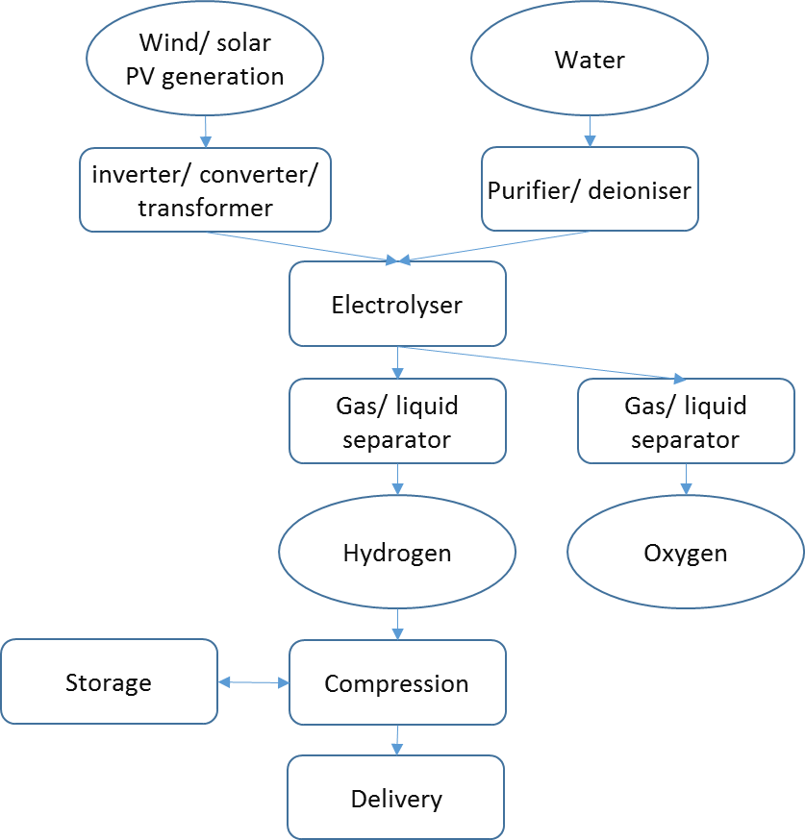
Figure 5. Typical unit flow diagram for an electrolysis system. Source: [69]

Electrolysis supply potential
Feasible limits to hydrogen electrolysis are likely to be governed by economic costs and constraints on building electricity generating capacity. To supply the quantities of hydrogen equivalent to meet residential gas demand for example, significant amounts of electricity must be generated, dependent on the efficiency of hydrogen production. Estimates of conversion efficiency of hydrogen production from electrolysis are between 50% and 90% [8-10, 15, 21, 38, 39, 60-62, 64, 68, 69].
There is potential to supply hydrogen from electrolysis via power-to-gas (PtG) systems, which utilise electricity at times when electricity supply is surplus to demand, thus providing a system balancing role and using a potentially low (or zero) cost power source. PtG systems also may include the conversion of hydrogen into methane (by a methanation process using CO or CO₂) to directly feed into the natural gas grid, although this additional process would result in a system efficiency (and cost) penalty [71]. The resource potential of the use of would-be curtailed electricity is potentially large but is governed by the proportion of intermittent renewables in the electricity mix and the correlation with demand.

Greenhouse gas emissions
Several estimates of GHG emissions for the mature routes of hydrogen production were found, from natural gas methane reforming [5, 7, 8, 10, 22-24, 31, 72-74], coal gasification [7, 8, 31, 75, 76], electrolysis from renewables [7-10, 73], biomass gasification [8, 77, 78] and nuclear [7, 8]. Estimates of overall life cycle GHG emissions are given in Figure 6 for each category, given in gCO₂eq/kWh higher heating value (HHV) of hydrogen production. The current carbon intensity of natural gas for heating is approximately 230 - 318 gCO₂eq/kWh and is also shown in the figure.

Figure 6: Ranges of estimates of total GHG emissions associated with hydrogen production from different technologies and feedstocks, expressed in gCO₂eq/kWh H₂ produced. Grey bars represent the mean emission across the literature for each category.
Source: [5, 7-10, 22-24, 31, 72-78]
The studies examined in this paper were from a wide spectrum of literature sources and therefore have a variety of different estimation methods, study boundaries, product qualities and feedstocks and thus cause a large variation in the results. These differences are described in the following sections for each technological category.
The overall range of emissions across the technologies is extremely large, from -371 to 642 gCO₂eq/kWh_{H2}. The highest and most variable estimates are associated with natural gas and coal based hydrogen production without the use of CCS. The lowest estimates are typically associated with electrolysis using wind generation and biomass gasification with CCS. As shown in Figure 6, reductions in GHG emissions from existing gas networks can only occur with hydrogen production using a low carbon source and/or with CCS. However, many estimates associated with supposedly low carbon systems give only a 40% reduction, which alone is unlikely to contribute sufficient emissions reductions to meet climate targets.

Natural gas reforming
Estimates of GHG emissions associated with hydrogen production from natural gas reforming are 23 – 401 gCO₂eq/kWh_{H2} as shown in Figure 7, although estimates below 71 gCO₂eq/kWh_{H2} exclude supply chain emissions [24, 72]. Estimates are 23 to 150 gCO₂eq/kWh_{H2} for reformers with CCS, or 288-347 gCO₂eq/kWh_{H2} for those without CCS. The average impact of CCS is to reduce total emissions by approximately 75%. These estimates assume carbon capture rates of 71% – 92% [5, 8, 23, 31].

Figure 7. Individual estimates of total GHG emissions associated with hydrogen production from natural gas reforming. Grey bars represent the mean emission across the literature for each category.
Source: [5, 7, 8, 10, 22-24, 31, 72-74]
For estimates that do not include CCS, emissions are typically 75% from the reforming operation and 25% from the natural gas supply chain. As the fuel used to obtain the temperatures and pressures required is sourced from the natural gas itself, the efficiency is a key parameter, expressed as the energy contained within the hydrogen product versus the energy contained within the natural gas input. Estimates of efficiency are between 60% and 90% for all reforming technologies [21, 22, 24] and depend on: the technological reforming option considered; assumptions regarding the exporting of excess steam generation; and whether CCS is included.
There are a number of technological options within this reforming category, which are steam reforming, partial oxidation, autothermal and autocatalytic decomposition. Almost all emissions estimates are for the most mature and commercialised system, steam reforming. Efficiencies for steam reforming are typically slightly higher at 60 - 90%, compared to 60 - 75% for the others [5, 21-23, 25].
Overall in the reforming and gas shift processes, excess steam is produced. The steam may be used for another process, in which case this may be an 'avoided burden' by off-setting another steam-raising duty. Given that the associated emissions from the avoided steam production have been negated, this is effectively a negative emission. The suitability of this duty is site specific and dependent on other process requirements, but may account for approximately 7 gCO₂eq/kWh_{H2} according to Spath and Mann [22]. The H21 report suggests that an efficiency gain of up to 11.2% can be made by using excess steam [5]. A conservative assumption would be to assume this steam is wasted (i.e. zero avoided burden), whereas the best environmental result is where the excess steam is fully utilised and replaces a high emitter (e.g. coal or liquid fuels).
An obvious route to use excess steam is for a CCS heat requirement. The H21 report [5] indicates that the excess steam is sufficient to satisfy the heat requirements of the capture process, although specific figures are not mentioned. When CCS is included in emissions estimations, total emissions are reduced by approximately 75%, with SMR and CCS emissions representing approximately 50% of the total, with upstream emissions contributing 40% and hydrogen transport and storage contributing the remaining 10% [5, 8, 23, 31]. Adding carbon capture to a reforming process may represent only a small efficiency loss due to the use of excess steam.
There is likely to be a trade-off in the CO₂ capture process between maximizing capture rate and minimising energy penalty. Capture rates are typically assumed to be 85 – 90% [30, 79], but most CCS projects have lower capture rates [80]. For example, the Quest project aims at retrofitting three SMRs with CCS, and capturing 80% of their CO₂ emissions, or around one million tCO₂ per year [81]. Higher capture rates can be achieved by greater absorption/adsorption rates or multiple stages, but this increases the energy penalty. The energy penalty of CCS on SMRs was estimated to be 5-14% [34-36]. Future CO₂ capture plants are expected to capture up to 95% of CO₂ emitted [42]. No research was found that investigates the effect of capture rate and energy penalties on life cycle GHG emissions and cost, but this would be needed to determine optimum cost/environmental impacts.

Hydrogen from electrolysis
Estimates of GHG associated with electrolysis are widely variable, between 24 and 788 gCO₂eq/kWh_{H2} [7-10]. However, the upper limit is an estimate using grid electricity (using a German/ UCTE grid mix from 2012 [8]). When only low carbon sources are considered, the range is reduced to 24 - 178 gCO₂eq/kWh_{H2} as shown in Figure 8 below.
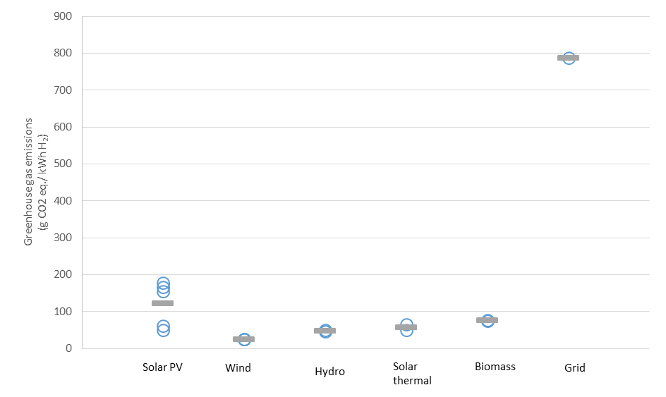
Figure 8: Individual estimates of total GHG emissions associated with hydrogen production from electrolysis using different sources of electricity. The grid value refers to the German/ UCTE 2012 grid mix. Grey bars represent the mean emission across the literature for each category. Source: [7-10]
GHG emissions associated with electrolysis are most influenced by the electricity source and the electrolysis efficiency [82]. The highest estimate used a relatively carbon intensive electricity grid mix in 2012 with average emissions of 630 gCO2eq./kWh_{H2} [8, 83] due to the reliance on fossil generation. Whilst carbon intensities of many national grid mixes have lowered in recent years, electrolysis can only deliver low carbon hydrogen from low carbon electricity sources.
There is also a large difference between GHG emissions estimates for electrolysis using solar PV and wind electricity, with wind consistently at the lowest end of estimates. Emissions associated with solar PV electrolysis are highly variable due to the difference in insolation rates in different regions, as well as varying panel efficiencies. Wind electrolysis estimates are approximately 25 gCO₂eq/kWh_{H2}, whereas solar PV estimates are 51 - 178 gCO₂eq/kWh_{H2}. Note that wind electrolysis estimates are all derived from the same inventory [68], hence the lack of variation.
Emissions in renewable electrolysis typically arise in the manufacturing stage of the renewable generation technologies, including process energy requirements and the embodied emissions in raw materials [10]. The use of lower carbon fuel sources during the production of raw materials and manufacturing to replace electricity and diesel usage is likely to reduce supply chain emissions significantly.
The production emissions may be intensified when the output of hydrogen is low, hence the dependence of system efficiency on life cycle emissions. The efficiency of electrolysis differs across the technologies, with estimates of 50 - 85% for alkaline, 48 - 83% for PEM and 60 - 90% for SOE [8-10, 15, 21, 60, 62, 64, 68, 69]. However, efficiency, as well as life span, of electrolysers may be significantly affected using an intermittent electricity supply, where PEM electrolysers are more suited to variable loads, but lifespans are limited.
Estimates of GHG emissions typically only consider alkaline electrolysers with different types of renewable electricity generation, primarily solar PV or wind. No sufficiently detailed environmental life cycle assessments on hydrogen production using PEM or SOE from renewables were found. Therefore, there is no useful comparison of emissions from different electrolysers. The efficiency, use of exotic catalysts and life span of the electrolyser may have a significant impact on environmental emissions and should be investigated further. Currently, data on the resource requirements for different electrolysers are very poor. Only two studies were found which detailed an inventory of resource for electrolyser manufacture [68, 84].

Hydrogen from coal and biomass gasification
Given that gasification of coal and biomass represent similar processes and may also be mixed together, they are considered in the same section here. Estimates of coal gasification emissions are 50 - 642 gCO₂eq/kWh_{H2} [7, 8, 31, 76]. The largest comes from whether CCS is accounted for: estimates are 50 – 180 gCO₂eq/kWh_{H2} with CCS and 270 - 642 gCO₂eq/kWh_{H2} without.

Figure 9. Greenhouse gas emission estimates of hydrogen from coal and biomass gasification. Grey bars represent the mean emission across the literature for each category.
Source: [7, 8, 31, 58, 76-78, 85-92]
Given that there is no environmental benefit associated with hydrogen production from coal without CCS, only coal gasification with CCS is considered here. GHG emissions arise from coal extraction (methane and CO₂), fuel usage during gasification and residual CO₂ emissions that are not captured. Deep-mined coal extraction yields greater methane emissions than for surface-mined coal, contributing to total GHG emissions. Emissions associated with coal gasification with CCS are comparable to those from reforming natural gas with CCS (50 - 180 gCO₂eq/kWh_{H2} versus 29 – 151 gCO₂eq/kWh_{H2} from natural gas).
Estimates of GHG emissions from biomass gasification are lower but more variable, –-371 - 504 gCO₂eq/kWh_{H2} [58, 77, 78, 85-94]. Key factors associated with emissions estimates are the source of the biomass feedstock, how the carbon sink associated with biomass growth is included, as well as whether CCS is within the scope. Much of the source of CO₂ emission from the gasification and upstream processes is biogenic, in that carbon dioxide was taken from the atmosphere to grow the biomass. Consequently, combustion of the biomass yields low overall emissions. Some studies account for the carbon-sink, whereas others account for different levels of soil carbon uptake [95].
Combined with the allowance of biogenic carbon, incorporating CCS should yield net-negative emissions. Indeed, this is the motivation behind research into the use of electricity from bioenergy with carbon capture and storage (BECCS). Hydrogen from biomass gasification using CCS is one route to produce negative life cycle GHG emissions in gas production. One study provides an estimate of hydrogen production from biomass gasification using CCS of -371 gCO₂eq/kWh_{H2} [58]. This estimate is comparable to estimates for electricity generation from biomass combustion with CCS, suggesting that hydrogen production from biomass with CCS will be relevant in the second half of this century, when negative emissions become increasingly important [96].
The impact of biomass gasification depends largely on the source of the biomass feedstock, in particular the energy density of the biomass and whether it is a residue or an energy crop [94]. Waste products are likely to yield significantly better environmental credentials as there are no associated agricultural impacts. However, waste is likely to give limited potential in terms of providing enough hydrogen to significantly reduce national emission profiles. Land-Use Change (LUC) also impacts GHG emissions of decarbonised gas where energy crop biomass is used as feedstock. These issues are discussed in the proceeding section.

Reducing GHG emissions and the importance of supply chain emissions
All routes to gas decarbonisation exhibit emissions associated with their respective supply chains. These emissions vary significantly and have a range of different relative impacts on total GHG emissions estimates. Table 4 presents the balance of supply chain and hydrogen production or methane combustion emissions for many hydrogen production methods.

 | Supply chain emissions (gCO2 eq./ kWh_{H2}) | H₂ production/ methane combustion (gCO2 eq./ kWh_{H2}) | Total (gCO2 eq./ kWh_{H2}) | H₂ production efficiency (Energy output/input)
Natural gas | 47 - 135 | 184 | 230-318 | NA
Natural gas SMR + CCS | 37 - 41 | 40 - 77 | 23 – 150 | 60-90%
Renewables electrolysis | 25 - 178 | 0 | 25-178 | 50-90%
Biomass gasification | -786 - -288 | 571 - 786 | -45 – 504 | 50-85%
Biomass gasification + CCS | -832 | 461 | -371 | 50-85%
Coal gasification | 8 – 30 | 278 – 684 | 279 – 642 | 55 – 62%
Coal gasification + CCS | 8 – 30 | 40 - 162 | 50 – 181 | 55 – 60%
Table 4: Comparison of supply chain emissions, hydrogen production/methane combustion emissions and total system efficiency of gas delivered to consumers for different routes to hydrogen production. Sources: [5, 7-10, 15, 21, 22, 24, 31, 53, 58, 60-62, 64, 68, 69, 72, 73, 77, 78, 85-87, 89, 97-99].
Note: Estimates in “Total” column represent total estimates in literature and not the sum of estimates for supply chain emissions and hydrogen production/methane combustion. Lowest total SMR + CCS emissions estimates do not include supply chain emissions. Biomass gasification + CCS based on single study, with the increased supply chain emissions reflecting the energy penalty of CCS.
There are significant differences in the sources of supply chain emissions between the different routes to hydrogen. Emissions in natural gas boilers or the SMR with CCS supply chain arise due to CO₂ and methane emissions in the production and transportation of natural gas. The supply chain emissions in electrolysis arise due to the carbon intensity of electricity and the embodied emissions arising from the manufacturing of electricity generation technologies (e.g. solar panel or wind turbine manufacture). Biomass routes to hydrogen involve supply chain emissions from the cultivation of crops, transportation of biomass and potentially emissions resulting from LUC. Additionally there are several methodological aspects that contribute to variation in estimates, relating to the boundary of the study, the production region, the product quality and pressure and end-use is considered [100].
Only two studies present disaggregated data for SMR with CCS showing supply chain emissions of 36.5 [5] and 41.2 gCO_{2eq}./kWh_{H2} [31]. This range is significantly lower than existing estimates of natural gas supply chain emissions, presented here as 47 – 135 gCO_{2eq}./kWh_{H2} [97]. Emissions estimates for SMR with CCS could therefore be underestimated in the literature reviewed here.
On examining the impact of supply chain emissions there are two important issues:
- The majority of emissions associated with hydrogen from SMR with CCS arise in the natural gas supply chain, in particular methane emissions. These emissions are highly variable and are amplified by the efficiency loss and energy penalty associated with SMR and CCS processes. Given this amplification, minimising methane emissions is an increasingly important aspect in minimising total emissions.
- Supply chain emissions have a disproportionately large impact on total emissions for electrolysis routes to hydrogen, given the lack of emissions in the hydrogen production stage. This gives rise to some of the counterintuitively large emissions seen in some electrolysis estimates.

There is scope for reduction of supply chain emissions for all technologies. Production and transportation emissions in gas are reducing over time in response to environmental regulation. The CO₂ intensity of electricity is expected to decrease as penetrations of low carbon generation increase, feeding back to the embodied energy in manufacturing these generation technologies.
Whilst supply chain emissions decrease under future decarbonisation scenarios, embodied emissions in imported generating technologies will be dependent on the emissions of the exporting country. Since decarbonisation pathways vary significantly across regions, the country of origin will become an important factor in determining life cycle emissions of decarbonised gas routes.
The scope to reduce supply chain emissions for biomass gasification is less clear given variation in feedstock and feedstock processing. The emissions from biomass gasification (with and without CCS) are characterised by significant negative emissions in the supply chain due carbon uptake in biomass cultivation and significant positive emissions in the gasification process. As a result, relatively small percentage improvements in aspects such as CCS capture rate or process efficiency will have relatively large impacts on total emissions. The large range of supply chain emissions is heavily influenced by the biomass source, and as such there is relatively less potential to improve supply chain emissions without limiting resource availability.
Reforming natural gas to hydrogen with CCS would produce embodied emissions to 23 - 150 gCO₂eq/kWh_{H2}, compared to 230 – 318 gCO₂eq/kWh_{H2} for natural gas condensing boilers. However, small methane leaks across the supply chain can cause carbon intensities to increase significantly. Reforming efficiency and CCS capture rates are important factors in reducing emissions further.
A remaining question is how does this carbon intensity compare to other decarbonisation options, and how sensitive is this to methane leakage, CCS capture rate and consumer appliance efficiency. Figure 10 presents the carbon intensity of heat from hydrogen (boiler efficiency 90%) generated using SMR with CCS as it varies with both the CCS capture efficiency and the leakage rate of methane across the natural gas supply chain. This is compared to the GHG emissions of heat from a natural gas boiler (efficiency 90%) as well as the carbon intensity of heat from a heat pump (SPF 2.5) running on electricity with a 100 and 50g/kWh carbon intensity (the CCC 2030 goal for power generation) [101].
Given that typical capture rates are 80-90% and methane emissions between 0.5 and 2% of gas production, GHG intensity of SMR with CCS may be between 80 and 160 gCO_{2eq}./kWh. This is a reduction compared to current gas boilers, but is significantly higher than hypothetical emissions associated with low carbon electricity-driven heat pumps. While hydrogen boilers may deliver significant carbon reductions relative to current gas boilers, only with the highest capture rates and lowest methane emissions do emissions from SMR+CCS approach what is achievable through low carbon electricity with relatively efficient heat pumps. Note that this is a relatively simplistic calculation and further work is required to test the sensitivity of these parameters on total system-level GHG emissions.
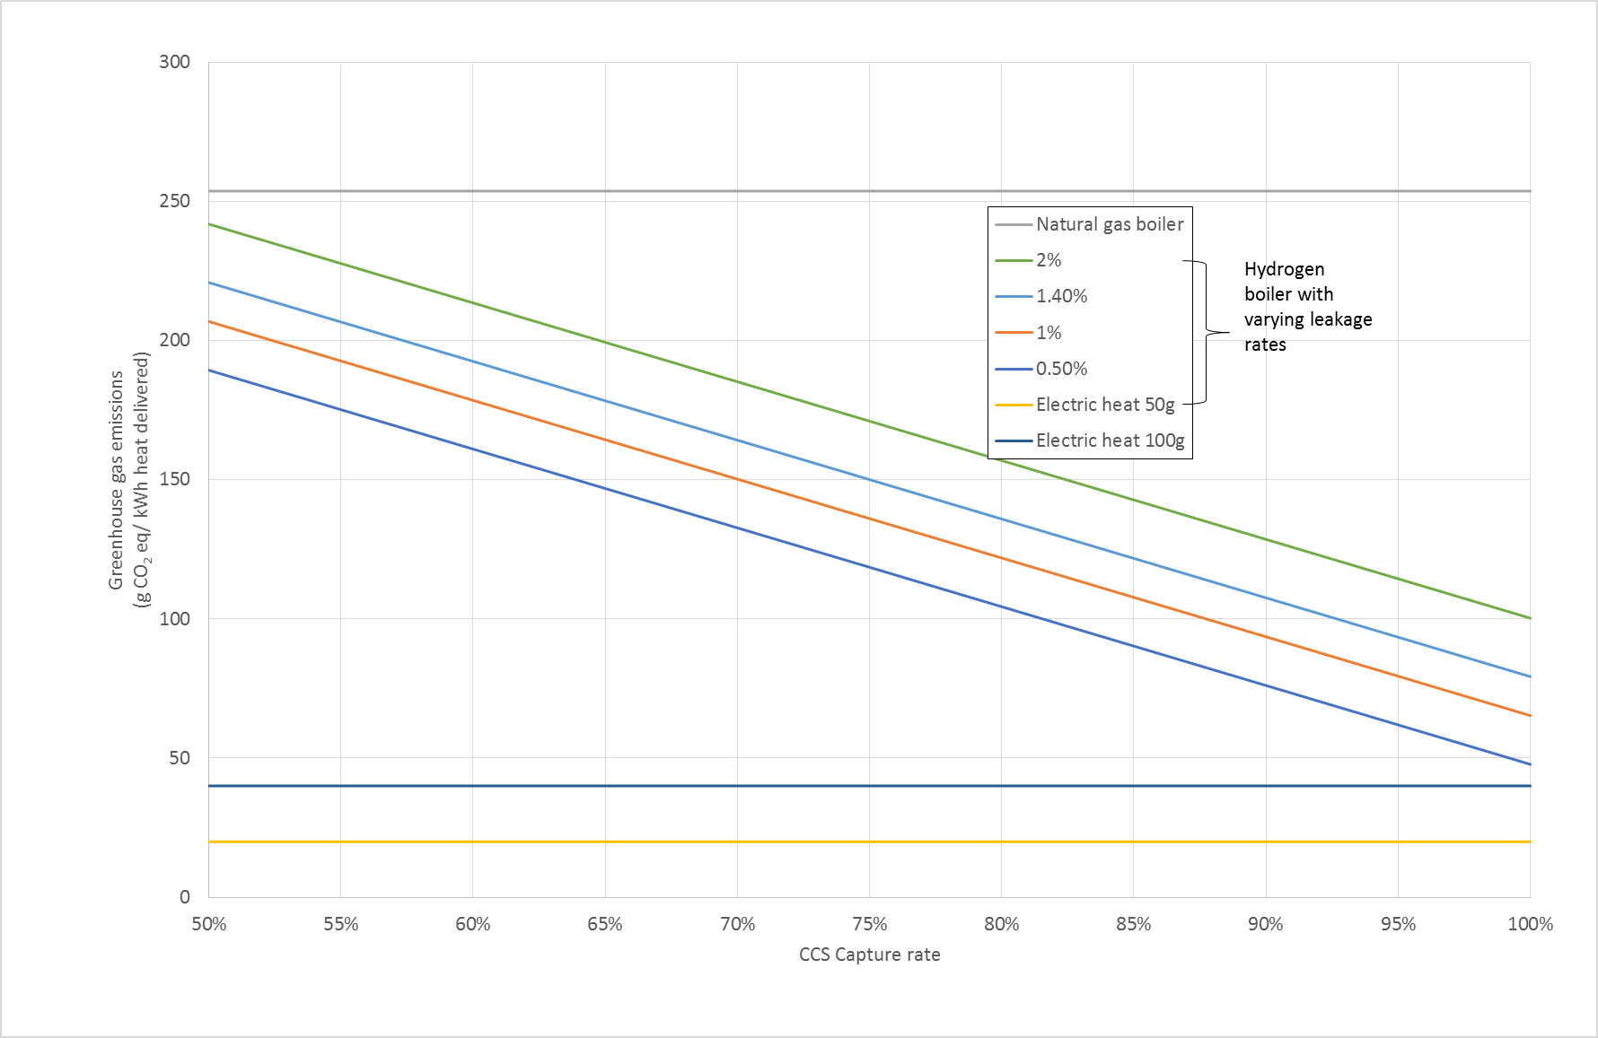
Figure 10: The carbon intensity per kWh of heat delivered by hydrogen from SMR with CCS as it varies with carbon capture rate and methane leakage rate in the SMR supply chain, compared to the CO₂ intensity of heat from natural gas boilers, and heat from and electric heat pump (SPF2.5) with electricity CO₂ intensity of 50-100 g/kWh. Note, natural gas and hydrogen boiler efficiency assumed 90%. 1.4% leakage rate based on [97]. 50 - 100 gCO₂/kWh intensity based on [101].
In terms of capture rate, there are clear benefits to maximising capture rate for the total emissions of SMR based hydrogen gas network. Increasing capture efficiency from 90% to 94% could reduce the carbon intensity of hydrogen based heat by over 10%. Figure 10 also presents the impact of increasing methane leakage in the SMR supply chain. This suggests that increasing leakage rates by 1% of gas demand might increase carbon emissions by 37%. This highlights the importance of minimising methane leakage given the very high climate forcing impacts of this gas relative to CO₂.
Other methods of hydrogen production offer similar life cycle emissions, such as coal gasification with CCS, solar PV electrolysis and biomass gasification without CCS. Each have different emissions profiles and vary significantly based on regional variations and conversion efficiencies. However, wind electrolysis, biomass gasification with CCS and reforming biogas with CCS can deliver significantly better greenhouse gas emissions, below 36 gCO₂eq/kWh_{H2} and in the case of some biofuel processes, negative emissions.
Such low carbon intensities will become increasingly important later in this century with the need to move the global energy system towards net zero emissions [102]. However, the resource availability of biomass and the costs of scaling up electrolysis may limit the contribution that these technologies can make to future decarbonisation. Hydrogen via electrolysis is often assumed to be among the lowest carbon routes to decarbonised gas, particularly when renewable energy is used. However, this assumption is highly sensitive to the type and location of electricity generation. As presented in Figure 8 the carbon intensity of hydrogen from solar electricity, for example, ranges from 50g/kWh_{H2} to 178g/kWh_{H2}, with average carbon intensity of 122g/kWh_{H2}. This is significantly more carbon intensive than estimates of future electric routes to heat in the UK.
Using electricity from wind generation could reduce emissions significantly, with an average carbon intensity of available estimates at 25g/kWh_{H2}. At this carbon intensity, and assuming a hydrogen boiler efficiency of 90%, the resultant output would have a carbon intensity of 28g/kWh_{H2}, competitive with electric heat pumps using 50 - 100g/kWh electricity and a heat pump efficiency SPF 2.5. Future efficiency of electrolysis may improve carbon intensity over time, and the impact of supply chain emissions in the manufacture of renewable technology is likely to reduce in line with decarbonisation of electricity. Future quantification of potential hydrogen gas systems will require forward-looking estimates of hydrogen technology performance and supply chain emissions to better capture these issues.

Conclusions
This paper presents a review of the options of feedstocks and processes to produce hydrogen to replace natural gas networks. There are many options utilising fossil and renewable resource, spanning an extremely wide range of estimated emissions. Therefore we must not simply assume that conversion from natural gas to hydrogen will yield low carbon results.
The overall range of emissions across technologies is extremely large, from -371 to 642 gCO₂eq/kWh_{H2}. The variation arises from a number of process and methodological factors, including the different production routes, feedstocks, region of production and boundary limits of the study. The lowest GHG impacts arise from wind electrolysis and biomass gasification with CCS, which may even yield negative emissions due to the storage of biogenic carbon. Solar electrolysis, biomass gasification without CCS and natural gas reforming with CCS exhibit similar average emissions, although with high variability. The highest and most variable emissions come from fossil fuels routes to hydrogen without CCS, with average carbon intensities greater than current gas networks. Fossil routes to hydrogen production must therefore include CCS, without which a hydrogen system will have a higher carbon intensity than the natural gas system it replaces.
Emissions estimates for SMR with CCS lie in the range of 23 – 150 g/kWh_{H2} including supply chain emissions, with CCS typically reducing CO₂ emissions by 75%. The CO₂ emissions from electrolysis range from 24 - 178 gCO₂eq/kWh_{H2} for renewable electricity sources. Electrolysis from solar PV electricity defines the upper end of this range, approximately 72 - 144 gCO₂eq/kWh_{H2} and varies significantly by geographical region, with less efficient regional PV conditions resulting in greater CO₂ emissions per unit of hydrogen produced. Wind electricity to hydrogen results in the lowest CO₂ emissions at approximately 25 gCO₂eq/kWh_{H2}.
The carbon intensity estimates for hydrogen production can be compared to electricity and heat pumps. The UK for example, is likely to seek carbon intensity of electricity of around 50 – 100 g/kWh in order to meet system level carbon targets. If this electricity is used in heat pumps the CO₂ intensity of the resulting heat will be in the order of 20 – 40 g/kWh. This is significantly lower than most estimates for decarbonised gas network options, besides wind electrolysis or biomass gasification with CCS.
The impact of supply chain emissions is a significant factor in total emissions estimates and varies considerably across different routes to hydrogen. Given the relatively low emissions in hydrogen production from both SMR with CCS (40 - 77 gCO₂eq/kWh_{H2}) and electrolysis (0 gCO₂eq/kWh_{H2}) the range of potential supply chain emissions is a significant proportion of total emissions.
Biomass gasification is characterised by very large negative emissions in the supply chain and very large positive emissions in the gasification process. This suggests that improvements in total emissions could be relatively large if even relatively small improvements to gasification emissions can be made, either through process efficiency or CCS capture rate.

Acknowledgments
The authors would like to acknowledge the funding from the Sustainable Gas Institute, which was
founded by Imperial College London and BG Group (now part of Royal Dutch Shell). Funding for the
Sustainable Gas Institute is gratefully received from Royal Dutch Shell, Enagas SA and the
Newton/NERC/FAPESP Sustainable Gas Futures project NE/N018656/1.

Note that funding bodies were not involved in the design, implementation or reporting of this study.

References
[1] Howard R, Bengherbi Z. Too Hot to Handle? How to decarbonise domestic heating. London: Policy Exchange; 2016.
[2] KPMG. 2050 Energy Scenarios: The UK Gas Networks role in a 2050 whole energy system. London: KPMG; 2016.
[3] Committee on Climate Change (CCC). Next steps for UK heat policy. London: Committee on Climate Change; 2016.
[4] Dodds PE, McDowall W. The future of the UK gas network. Energy Policy. 2013;60:305-16.
[5] Sadler D, Cargill A, Crowther M, Rennie A, Watt J, Burton S, et al. H21 Leeds City Gate. London: Northern Gas Networks; 2016.
[6] Speirs J, Balcombe P, Johnson E, Martin J, Brandon N, Hawkes A. A Greener Gas Grid: What are the Options? In: Sustainable Gas Institute, editor. White Paper Series. London: Imperial College London; 2017. p. 1-132.
[7] Cetinkaya E, Dincer I, Naterer GF. Life cycle assessment of various hydrogen production methods. International Journal of Hydrogen Energy. 2012;37:2071-80.
[8] Bhandari R, Trudewind CA, Zapp P. Life cycle assessment of hydrogen production via electrolysis – a review. Journal of Cleaner Production. 2014;85:151-63.
[9] Dufour J, Serrano DP, Galvez JL, Gonzalez A, Soria E, Fierro JLG. Life cycle assessment of alternatives for hydrogen production from renewable and fossil sources. International Journal of Hydrogen Energy. 2012;37:1173-83.
[10] Koroneos C, Dompros A, Roumbas G, Moussiopoulos N. Life cycle assessment of hydrogen fuel production processes. International Journal of Hydrogen Energy. 2004;29:1443-50.
[11] Dincer I, Acar C. Review and evaluation of hydrogen production methods for better sustainability. International Journal of Hydrogen Energy. 2015;40:11094-111.
[12] Crowther M, Orr G, Thomas J, Stephens G, Summerfield I. Safety Issues Surrounding Hydrogen as an Energy Storage Vector. Energy Storage Component Research & Feasibility Study Scheme HyHouse: Kiwa; 2015. p. 96.
[13] Perry RH, Green DW. Perry's chemical engineers' handbook. New York: McGraw-Hill; 2008.
[14] Kalamaras CM, Efstathiou AM. Hydrogen Production Technologies: Current State and Future Developments. Conference Papers in Energy. 2013;2013:9.
[15] Ursua A, Gandia LM, Sanchis P. Hydrogen Production From Water Electrolysis: Current Status and Future Trends. Proceedings of the IEEE. 2012;100:410-26.
[16] Muradov NZ, Veziroǧlu TN. From hydrocarbon to hydrogen–carbon to hydrogen economy. International Journal of Hydrogen Energy. 2005;30:225-37.
[17] Kothari R, Buddhi D, Sawhney RL. Comparison of environmental and economic aspects of various hydrogen production methods. Renewable and Sustainable Energy Reviews. 2008;12:553-63.
[18] Speight J. Handbook of Industrial Hydrocarbon Processes. Elsevier; 2011.
[19] Molburg J, Doctor R. Hydrogen from Steam-Methane Reforming with CO2 Capture. 20th Annual International Pittsburgh Coal Conference. Pittsburgh, US: Argonne National Laboratory 2003.
[20] US Department of Energy. Hydrogen Analysis Resource Center. Available from: http://hydrogen.pnl.gov/hydrogen-data/hydrogen-production: US Department of Energy, Energy Efficiency & Renewable Energy,; 2017.
[21] Holladay JD, Hu J, King DL, Wang Y. An overview of hydrogen production technologies. Catalysis Today. 2009;139:244-60.
[22] Spath PL, Mann MK. Life Cycle Assessment of Hydrogen Production via Natural Gas Steam Reforming. Boulder, Colorado: National Renewable Energy Laboratory; 2001. p. 1 - 33.
[23] Tock L, Maréchal F. H2 processes with CO2 mitigation: Thermo-economic modeling and process integration. International Journal of Hydrogen Energy. 2012;37:11785-95.
[24] Tock L, Maréchal F. CO2 Mitigation in Thermo-Chemical Hydrogen Processes: Thermo-Environomic Comparison and Optimization. Energy Procedia. 2012;29:624-32.
[25] Haryanto A, Fernando S, Murali N, Adhikari S. Current Status of Hydrogen Production Techniques by Steam Reforming of Ethanol: A Review. Energy & Fuels. 2005;19:2098-106.
[26] Hart D, Howes J, Lehner F, Dodds PE, Hughes N, Fais B, et al. Scenarios for deployment of hydrogen in contribution to meeting carbon budgets and the 2050 target E4Tech; UCL Energy Institute; Kiwa Gastec; 2015.
[27] Hajjaji N, Pons M-N, Houas A, Renaudin V. Exergy analysis: An efficient tool for understanding and improving hydrogen production via the steam methane reforming process. Energy Policy. 2012;42:392-9.
[28] Sengodan S, Lan R, Humphreys J, Du D, Xu W, Wang H, et al. Advances in reforming and partial oxidation of hydrocarbons for hydrogen production and fuel cell applications. Renewable and Sustainable Energy Reviews. 2018;82:761-80.
[29] Serrano DP, Botas JÁ, Pizarro P, Gómez G. Kinetic and autocatalytic effects during the hydrogen production by methane decomposition over carbonaceous catalysts. International Journal of Hydrogen Energy. 2013;38:5671-83.
[30] Leung DYC, Caramanna G, Maroto-Valer MM. An overview of current status of carbon dioxide capture and storage technologies. Renewable and Sustainable Energy Reviews. 2014;39:426-43.
[31] Ruether J, Ramezan M, Grol E. Life-Cycle Analysis of Greenhouse Gas Emissions for Hydrogen Fuel Production in the United States from LNG and Coal In: Department of Energy U, editor.: National Energy Technology Laboratory; 2005.
[32] Shackley S, Gough C. Carbon capture and its storage: an integrated assessment. Hampshire: Ashgate Publishing Ltd; 2006.
[33] de Coninck H, Benson SM. Carbon Dioxide Capture and Storage: Issues and Prospects. Annual Review of Environment and Resources. 2014;39:243-70.
[34] Jansen D, Gazzani M, Manzolini G, Dijk Ev, Carbo M. Pre-combustion CO2 capture. International Journal of Greenhouse Gas Control. 2015;40:167-87.
[35] Mueller-Langer F, Tzimas E, Kaltschmitt M, Peteves S. Techno-economic assessment of hydrogen production processes for the hydrogen economy for the short and medium term. International Journal of Hydrogen Energy. 2007;32:3797-810.
[36] Rubin ES, Mantripragada H, Marks A, Versteeg P, Kitchin J. The outlook for improved carbon capture technology. Progress in Energy and Combustion Science. 2012;38:630-71.
[37] Zhu L, Li L, Fan J. A modified process for overcoming the drawbacks of conventional steam methane reforming for hydrogen production: Thermodynamic investigation. Chemical Engineering Research and Design. 2015;104:792-806.
[38] Eurostat. Electricity production, consumption and market overview. Eurostat Statistics Explained; 2016.
[39] Jones D, Dufour M, Gaventa J. Europe’s declining gas demand trends and facts on european gas consumption. E3G; 2015.
[40] Budinis S, Krevor S, Brandon N, Hawkes A. Can technology unlock 'unburnable carbon'? London: Sustainable Gas Institute; 2016.
[41] Koelbl BS, van den Broek MA, van Ruijven BJ, Faaij APC, van Vuuren DP. Uncertainty in the deployment of Carbon Capture and Storage (CCS): A sensitivity analysis to techno-economic parameter uncertainty. International Journal of Greenhouse Gas Control. 2014;27:81-102.
[42] Metz B, Davidson O, De Coninck H, Loos M, Meyer L. IPCC special report on carbon capture and storage. In: Intergovernmental Panel on Climate Change WGI, editor.2005.
[43] de Coninck H, Flach T, Curnow P, Richardson P, Anderson J, Shackley S, et al. The acceptability of CO2 capture and storage (CCS) in Europe: An assessment of the key determining factors: Part 1. Scientific, technical and economic dimensions. International Journal of Greenhouse Gas Control. 2009;3:333-43.
[44] Liu K, Cui Z, Fletcher TH. Coal Gasification. Hydrogen and Syngas Production and Purification Technologies: John Wiley & Sons, Inc.; 2009. p. 156-218.
[45] FAO. Wood gas as engine fuel 1986.
[46] Abbess J. Renewable Gas: The Transition to Low Carbon Energy Fuels: Springer; 2015.
[47] Duan T, Lu C, Xiong S, Fu Z, Zhang B. Evaluation method of the energy conversion efficiency of coal gasification and related applications. International Journal of Energy Research. 2016;40:168-80.
[48] National Energy Technology Laboratory (NETL). Syngas composition.
[49] Muresan M, Cormos C-C, Agachi P-S. Techno-economical assessment of coal and biomass gasification-based hydrogen production supply chain system. Chemical Engineering Research and Design. 2013;91:1527-41.
[50] Prins MJ, Ptasinski KJ, Janssen FJJG. From coal to biomass gasification: Comparison of thermodynamic efficiency. Energy. 2007;32:1248-59.
[51] Cau G, Cocco D, Serra F. Energy and cost analysis of small-size integrated coal gasification and syngas storage power plants. Energy Conversion and Management. 2012;56:121-9.
[52] Sikarwar VS, Zhao M, Clough P, Yao J, Zhong X, Memon MZ, et al. An overview of advances in biomass gasification. Energy & Environmental Science. 2016.
[53] Ptasinski KJ. Thermodynamic efficiency of biomass gasification and biofuels conversion. Biofuels, Bioproducts and Biorefining. 2008;2:239-53.
[54] Trninić M, Stojiljković D, Jovović A, Jankes G. Biomass gasification technology: The state of the art overview. 2016 4th International Symposium on Environmental Friendly Energies and Applications (EFEA)2016. p. 1-8.
[55] Grid N. The future of gas: Supply of renewable gas. 2016.
[56] Welfle A. Balancing growing global bioenergy resource demands - Brazil's biomass potential and the availability of resource for trade. Biomass and Bioenergy. 2017;105:83-95.
[57] Tursun Y, Xu S, Wang G, Wang C, Xiao Y. Tar formation during co-gasification of biomass and coal under different gasification condition. Journal of Analytical and Applied Pyrolysis. 2015;111:191-9.
[58] Susmozas A, Iribarren D, Zapp P, Linβen J, Dufour J. Life-cycle performance of hydrogen production via indirect biomass gasification with CO2 capture. International Journal of Hydrogen Energy. 2016;41:19484-91.
[59] World Energy Council. Bioenergy | 2016. World Energy Resources. Accessed from: www.worldenergy.org/wp-content/uploads/2017/03/WEResources_Bioenergy_2016.pdf: World Energy Council; 2016. p. 1-62.
[60] Zeng K, Zhang D. Recent progress in alkaline water electrolysis for hydrogen production and applications. Progress in Energy and Combustion Science. 2010;36:307-26.
[61] Koponen J. Review of water electrolysis technologies and design of renewable hydrogen production systems [Masters']: Lappeenranta University of Technology; 2015.
[62] Gahleitner G. Hydrogen from renewable electricity: An international review of power-to-gas pilot plants for stationary applications. International Journal of Hydrogen Energy. 2013;38:2039-61.
[63] Laguna-Bercero MA. Recent advances in high temperature electrolysis using solid oxide fuel cells: A review. Journal of Power Sources. 2012;203:4-16.
[64] Ferrero D, Gamba M, Lanzini A, Santarelli M. Power-to-Gas Hydrogen: Techno-economic Assessment of Processes towards a Multi-purpose Energy Carrier. Energy Procedia. 2016;101:50-7.
[65] Markillie R. 1.5 MW Electrolyser Deployment in Scotland. News. ITM Power: ITM Power; 2016.
[66] Sunfire GmbH. Sunfire takes significant steps to clean energy on demand using solid oxide technology. Fuel Cells Bulletin. 2016;2016:12-4.
[67] Yang Z, Coutinho D, Feng F, Ferraris JP, Kenneth J. Balkus Jr. Novel inorganic/organic hybrid electrolyte membranes. Prepr Pap-Am Chem Soc, Div Fuel Chem 2004;49:599.
[68] Spath PL, Mann MK. Life Cycle Assessment of Renewable Hydrogen Production via Wind/Electrolysis. Milestone Completion Report. Colorado, US: National Renewable Energy Laboratory; 2004. p. 1 - 13.
[69] Matzen M, Alhajji M, Demirel Y. Technoeconomics and Sustainability of Renewable Methanol and Ammonia Productions Using Wind Power-based Hydrogen. Journal of Advanced Chemical Engineering. 2015;5.
[70] Smolinka T. PEM Water Electrolysis- Present Status of Research and Development. 18th World Hydrogen Energy Conderence 2010. Essen, Germany: Fraunhofer Institut fur Solare Energiesysteme ISE; 2010.
[71] Liu W, Wen F, Xue Y. Power-to-gas technology in energy systems: current status and prospects of potential operation strategies. Journal of Modern Power Systems and Clean Energy. 2017;5:439-50.
[72] Stromman AH, Hertwich E. Hybrid Life Cycle Assessment of Large Scale Hydrogen Production Facilities. In: Programme IE, editor. Trondheim, Norway: Norwegian University of Science and Technology; 2004. p. 1 - 33.
[73] Dufour J, Serrano DP, Gálvez JL, Moreno J, González A. Hydrogen Production from Fossil Fuels: Life Cycle Assessment of Technologies with Low Greenhouse Gas Emissions. Energy & Fuels. 2011;25:2194-202.
[74] Dufour J, Serrano DP, Moreno J, G·lvez JL. Life Cycle Assessment of Hydrogen Production Processes: Steam Reforming of Natural Gas, Ethanol and Bioethanol. In: Stolten D, Grube T, editors. 18th World Hydrogen Energy Conference 2010. Essen, Germany2010.
[75] Ruether J, Ramezan M, Balash P. Greenhouse Gas Emissions from Coal Gasification Power Generation Systems. Journal of Infrastructure Systems. 2004;10.
[76] Burmistrz P, Chmielniak T, Czepirski L, Gazda-Grzywacz M. Carbon footprint of the hydrogen production process utilizing subbituminous coal and lignite gasification. Journal of Cleaner Production. 2016;139:858-65.
[77] Susmozas A, Iribarren D, Dufour J. Assessing the Life-Cycle Performance of Hydrogen Production via Biofuel Reforming in Europe. Resources. 2015;4:398.
[78] Kalinci Y, Hepbasli A, Dincer I. Life cycle assessment of hydrogen production from biomass gasification systems. International Journal of Hydrogen Energy. 2012;37:14026-39.
[79] Budinis S, Krevor S, MacDowell N, Brandon N, Hawkes A. Can Technology Unlock 'Unburnable Carbon'? White Paper Series. London, UK: Sustainable Gas Institute, Imperial College London; 2016. p. 1 - 87.
[80] Massachussets Institute of Technologies. Carbon capture & sequestration technologies 2016.
[81] Shell. The Quest for less CO₂: Learning from CCS implementation in Canada. 2015.
[82] Carlson EJ, P. K. JS, Sriramulu S, Yang YA. Cost Analysis of PEM Fuel Cell Systems for Transportation. Cambridge, Massachusetts: National Renewable Energy Laboratory; 2005. p. 109.
[83] Itten R, Frischknecht R, Stucki M. Life Cycle Inventories of Electricity Mixes and Grid. Version 13. Uster, Switzerland: Paul Scherrer Institute; 2014.
[84] Maack M. Generation of the energy carrier hydrogen in context with electricity buffering generation through fuel cells. In: NEEDS, editor.: Icelandic New Energy; 2008.
[85] Susmozas A, Iribarren D, Dufour J. Life-cycle performance of indirect biomass gasification as a green alternative to steam methane reforming for hydrogen production. International Journal of Hydrogen Energy. 2013;38:9961-72.
[86] Moreno J, Dufour J. Life cycle assessment of hydrogen production from biomass gasification. Evaluation of different Spanish feedstocks. International Journal of Hydrogen Energy. 2013;38:7616-22.
[87] Martín-Gamboa M, Iribarren D, Susmozas A, Dufour J. Delving into sensible measures to enhance the environmental performance of biohydrogen: A quantitative approach based on process simulation, life cycle assessment and data envelopment analysis. Bioresource Technology. 2016;214:376-85.
[88] Valente A, Iribarren D, Dufour J. Harmonised life-cycle global warming impact of renewable hydrogen. Journal of Cleaner Production. 2017;149:762-72.
[89] Iribarren D, Susmozas A, Petrakopoulou F, Dufour J. Environmental and exergetic evaluation of hydrogen production via lignocellulosic biomass gasification. Journal of Cleaner Production. 2014;69:165-75.
[90] Weinberg J, Kaltschmitt M. Life cycle assessment of mobility options using wood based fuels – Comparison of selected environmental effects and costs. Bioresource Technology. 2013;150:420-8.
[91] Wulf C, Kaltschmitt M. Life cycle assessment of biohydrogen production as a transportation fuel in Germany. Bioresource Technology. 2013;150:466-75.
[92] Wulf C, Kaltschmitt M. Life cycle assessment of hydrogen supply chain with special attention on hydrogen refuelling stations. International Journal of Hydrogen Energy. 2012;37:16711-21.
[93] Poeschl M, Ward S, Owende P. Environmental impacts of biogas deployment - Part II: life cycle assessment of multiple production and utilization pathways. Journal of Cleaner Production. 2012;24:184-201.
[94] Whiting A. Bioenergy in the United Kingdom: an environmental and economic sustainability assessment: University of Manchester; 2014.
[95] Bühle L, Stülpnagel R, Wachendorf M. Comparative life cycle assessment of the integrated generation of solid fuel and biogas from biomass (IFBB) and whole crop digestion (WCD) in Germany. Biomass and Bioenergy. 2011;35:363-73.
[96] Fajardy M, Mac Dowell N. Can BECCS deliver sustainable and resource efficient negative emissions? Energy & Environmental Science. 2017.
[97] Balcombe P, Anderson K, Speirs J, Brandon N, Hawkes A. The Natural Gas Supply Chain: The Importance of Methane and Carbon Dioxide Emissions. ACS Sustainable Chemistry & Engineering. 2017;5:3-20.
[98] Bertuccioli L, Chan A, Hart D, Lehner F, Madden B, Standen E. Development of Water Electrolysis in the European Union. Lausanne, Switzerland: E4tech with Element Energy Ltd; 2014.
[99] Rajvanshi A. Biomass Gasification: CRC Press; 1986.
[100] Valente A, Iribarren D, Dufour J. Life cycle assessment of hydrogen energy systems: a review of methodological choices. Int J Life Cycle Assessment. 2017;22:346-63.
[101] Committee on Climate Change (CCC). The fifth carbon budget – the next step towards a low-carbon economy. Committee on Climate Change; 2015.
[102] Committee on Climate Change (CCC). UK climate action following the Paris Agreement. Committee on Climate Change; 2016.

Appendix
The following table categorises the literature based on the hydrogen production route for reference:
Production route | References
Coal gasification without CCS | [7, 8, 31, 76]
Coal gasification with CCS | [8, 31, 76]
Natural gas SMR without CCS | [5, 7, 8, 10, 22, 23, 31, 72, 74]
Natural gas SMR with CCS | [8, 9, 24, 31, 72, 73]
Biomass gasification without CCS | [10, 78, 85-89]
Biomass gasification with CCS | [58, 88]
Nuclear thermo splitting | [7, 8]
Solar PV electrolysis | [7-10]
Wind electrolysis | [7, 8, 10]

184 gCO₂/kWh from combustion, plus 30 – 75 gCO₂/kWh supply chain CO₂ emissions, plus 17 – 58 gCO₂eq/kWh supply chain methane emissions (0.8 – 2.6% of total production)
Based on a methane leakage rate of 1.4%
Based on 90% CCS capture efficiency.

