Supporting information

Huimin Zhouª, Ting Liuª*, Nigel Graham^{b}, Kening Sunª, Wenzheng Yu^{c}*

ª School of Chemistry and Chemical Engineering, Beijing Key Laboratory for Chemical Power Source and Green Catalysis, Beijing Institute of Technology, Beijing 100081, China
^{b} Department of Civil and Environmental Engineering, Imperial College London, South Kensington Campus, London SW7 2AZ, UK
^{c} Key Laboratory of Drinking Water Science and Technology, Research Center for Eco-Environmental Sciences, Chinese Academy of Sciences, Beijing 100085, China

* Corresponding author
Email addresses: liuting@bit.edu.cn; wzyu@rcees.ac.cn.

Table S1. Zeta potential of surface waters from the BIT Lake and the ZGC River in the four seasons
Water samples | Summer | Autumn | Winter | Spring
BIT Lake | −9.81 ± 0.12 | −8.03 ± 0.13 | −4.55 ± 0.11 | −7.36 ± 0.13
ZGC River | −7.97 ± 0.12 | −6.94 ± 0.12 | −3.94 ± 0.13 | −6.32 ± 0.13

(a) | (b) | (c) | (d)
(e) | (f) | (h) | (g)
Figure S1. Molecular weight distributions of feed and treated solutions for kaolin membrane and PES UF membrane: BIT lake of four seasons (a-d), ZGC river of four seasons (e-g).

Table S2. Conductivity of surface waters from the BIT Lake and the ZGC River in the four seasons
Water samples | BIT Lake |  |  |  | ZGC River
Water samples | Summer | Autumn | Winter | Spring | Summer | Autumn | Winter | Spring
Conductivity (μs/cm) | 1223.2 ± 7.8 | 1387.6 ± 6.5 | 1523.0 ± 12.3 | 1467.7 ± 5.9 | 247.7 ± 5.6 | 282.7 ± 4.7 | 386.1 ± 8.7 | 301.1 ± 6.2

(a) | (b)
(c) | (d)
Figure S2. The rejection rates of the kaolin membrane and PES membranes for protein-like (T1 & T2) and fulvic-/humic-like (C & A) substances in the four seasonal BIT Lake samples: summer (a); autumn (b); winter (c); spring (d) (determined from EEM spectra).

(a) | (b)
(c) | (d)
Figure S3. The rejection rates of the kaolin membrane and PES membranes for protein-like (T1 & T2) and fulvic-/humic-like (C & A) substances in the four seasonal ZGC River samples: summer (a); autumn (b); winter (c); spring (d) (determined from EEM spectra).

Table S3. The P values of the contact angles of the membranes after filtering the water samples from the BIT Lake and the ZGC River in the four seasons.
Membranes | Water samples | P values (%) ª
Membranes | Water samples | Summer vs Autumn | Summer vs Winter | Summer vs Spring | Autumn vs Winter | Spring vs Winter | Autumn vs Spring
Kaolin | BIT Lake | 0.09 | 0.19 | 0.001 | 2.18 | 0.005 | 6.92
Kaolin | ZGC River | 2.31 | 1.40 | 2.85 | 4.60 | 2.22 | 34.35
PES | BIT Lake | 0.91 | 0.39 | 0.80 | 0.07 | 0.44 | 41.68
PES | ZGC River | ~ 0 | 0.12 | 2.24 | 0.91 | 2.02 | 11.80
ª P values (%) ˂ 5%: significant difference; P values (%) > 5%: no significant difference

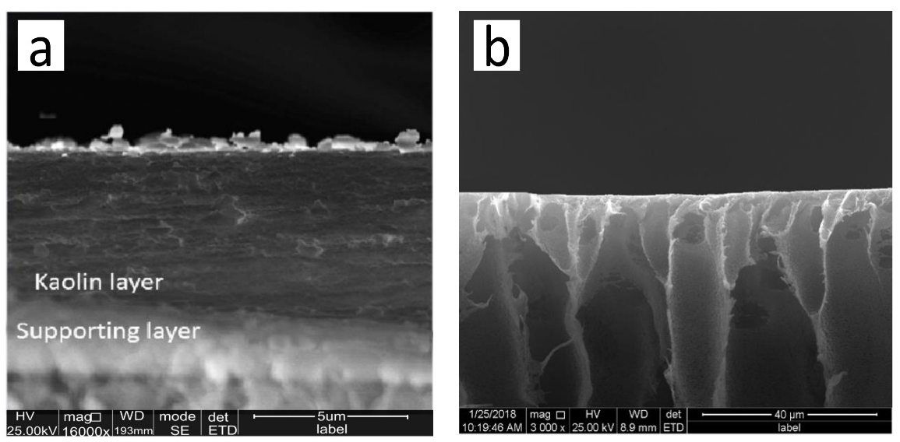
Figure S4. SEM image of the cross-sections of the two membranes: (a) the kaolin membrane; (b) the PES membrane ¹.

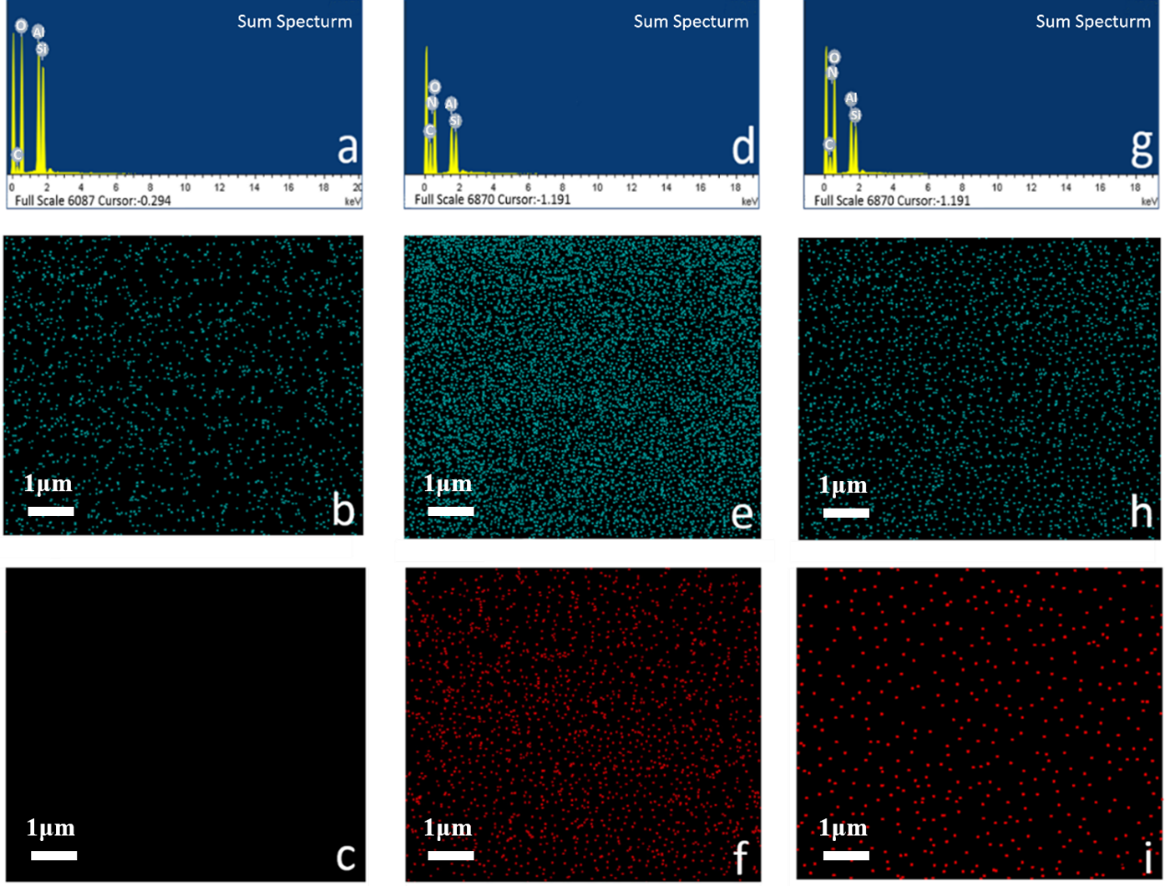
Figure S5. Element analysis and EDX mapping showing the Carbon (b, e, h) and Nitrogen (c, f, i) distribution pattern on the kaolin membrane: (a-c) virgin kaolin membrane, (d-f) kaolin membrane after filtration of BIT Lake sample obtained in summer, (g-i) kaolin membrane after filtration of ZGC River sample obtained in summer.

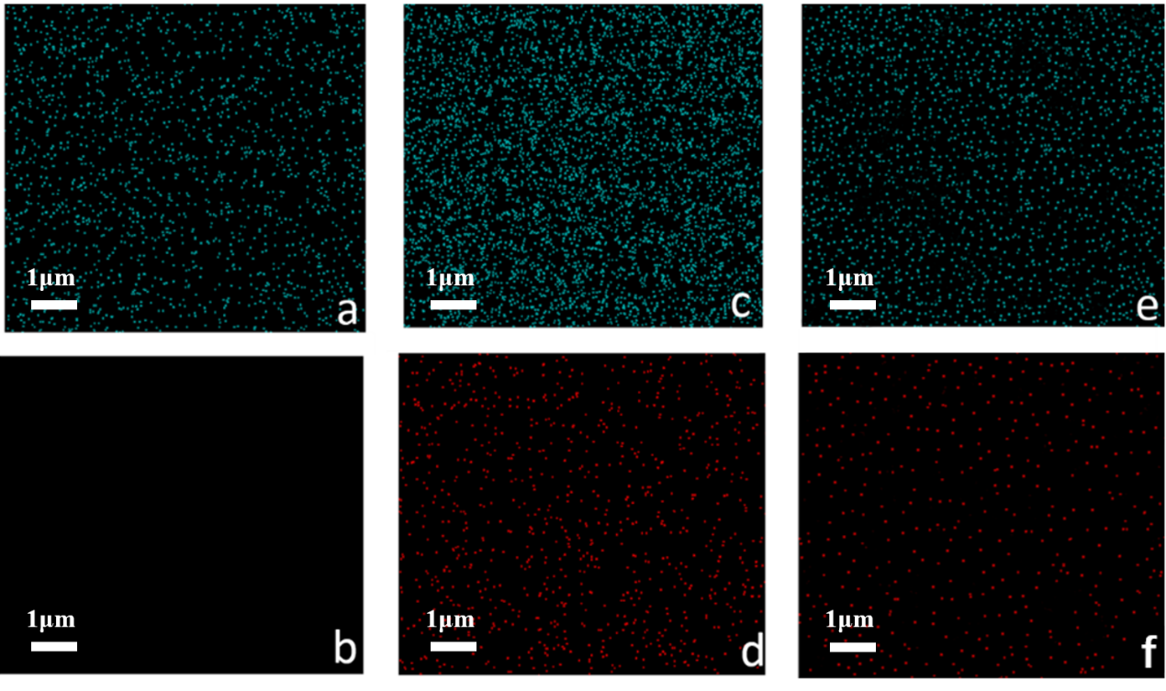
Figure S6. Element analysis and EDX mapping showing the Carbon (a, c, e) and Nitrogen (b, d, f) distribution pattern on the kaolin membrane: (a-b) virgin kaolin membrane, (c-d) kaolin membrane after filtration of BIT Lake sample obtained in autumn, (e-f) kaolin membrane after filtration of ZGC River sample obtained in autumn.

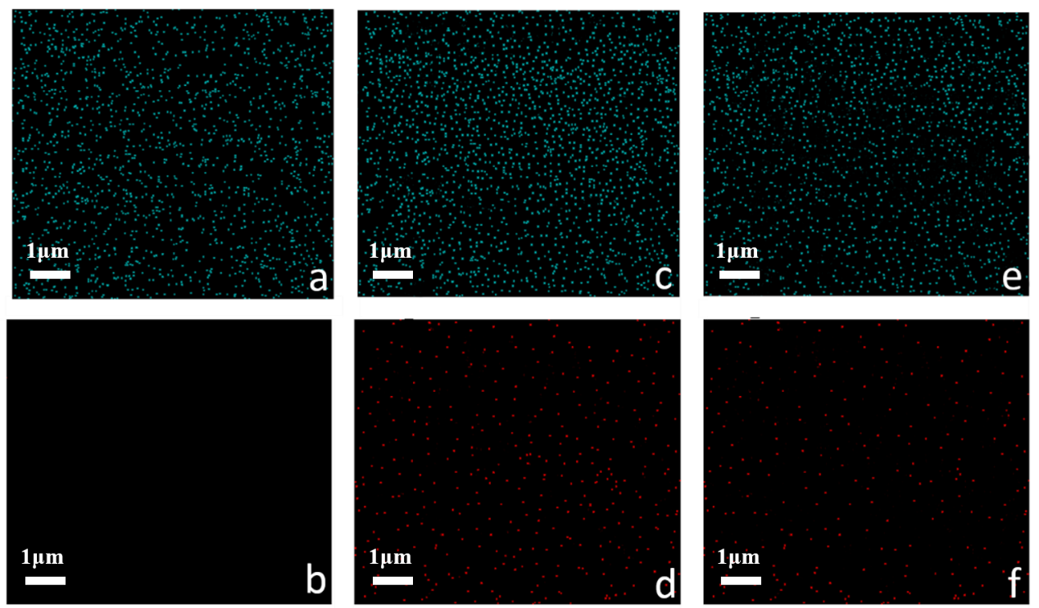
Figure S7. Element analysis and EDX mapping showing the Carbon (a, c, e) and Nitrogen (b, d, f) distribution pattern on the kaolin membrane: (a-b) virgin kaolin membrane, (c-d) kaolin membrane after filtration of BIT Lake sample obtained in winter, (e-f) kaolin membrane after filtration of ZGC River sample obtained in winter.

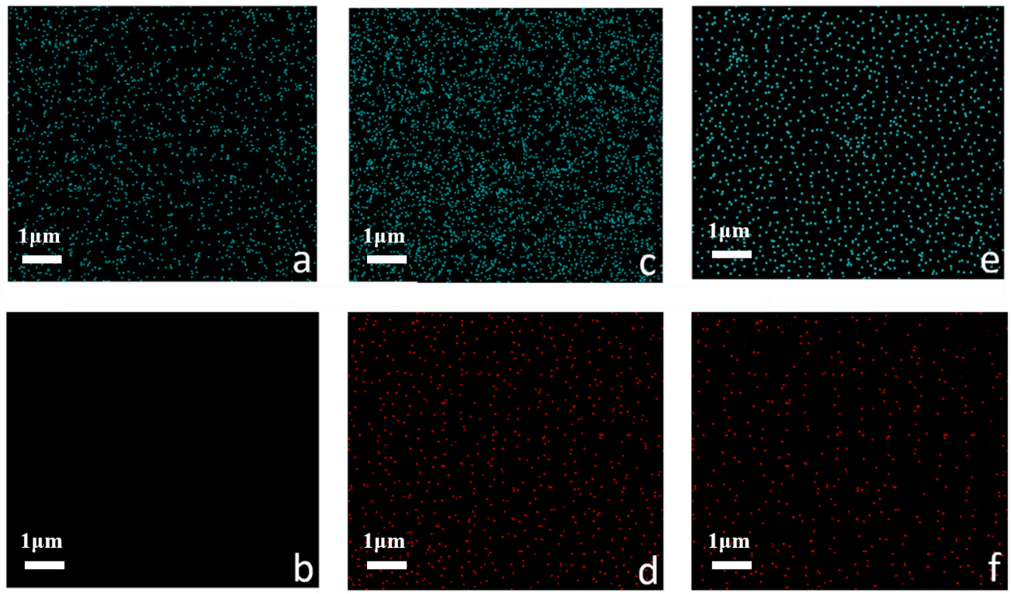
Figure S8. Element analysis and EDX mapping showing the Carbon (a, c, e) and Nitrogen (b, d, f) distribution pattern on the kaolin membrane: (a-b) virgin kaolin membrane, (c-d) kaolin membrane after filtration of BIT Lake sample obtained in spring, (e-f) kaolin membrane after filtration of ZGC River sample obtained in spring.

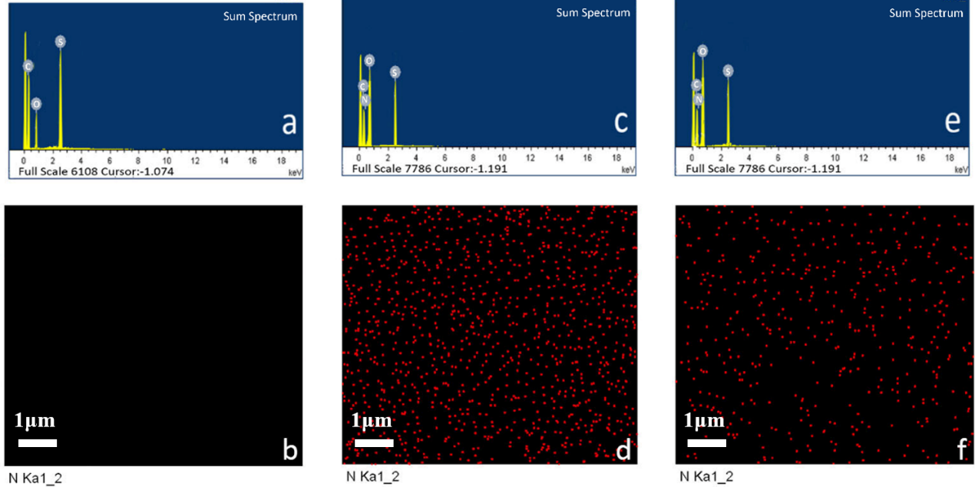
Figure S9. Element analysis and EDX mapping showing the Nitrogen distribution pattern on the PES membrane: (a-b) virgin PES membrane, (c-d) PES membrane after filtration of BIT Lake sample obtained in summer, (e-f) PES membrane after filtration of ZGC River sample obtained in summer.

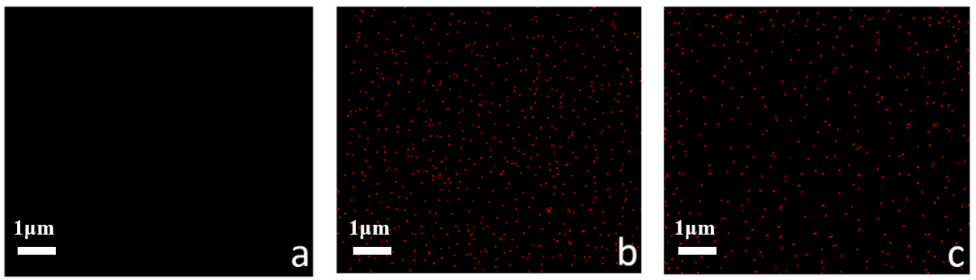
Figure S10. Element analysis and EDX mapping showing the Nitrogen distribution pattern on the PES membrane: (a) virgin PES membrane, (b) PES membrane after filtration of BIT Lake sample obtained in autumn, (c) PES membrane after filtration of ZGC River sample obtained in autumn.

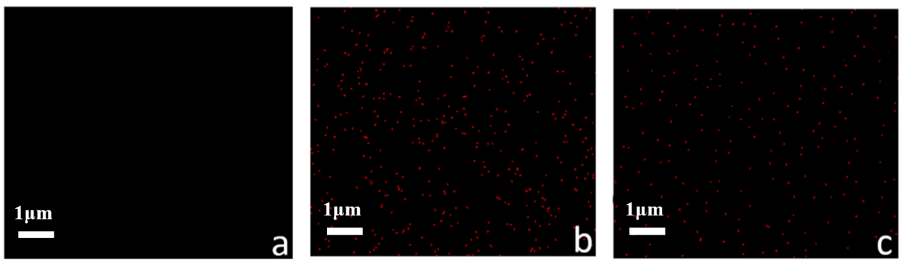
Figure S11. Element analysis and EDX mapping showing the Nitrogen distribution pattern on the PES membrane: (a) virgin PES membrane, (b) PES membrane after filtration of BIT Lake sample obtained in winter, (c) PES membrane after filtration of ZGC River sample obtained in winter.

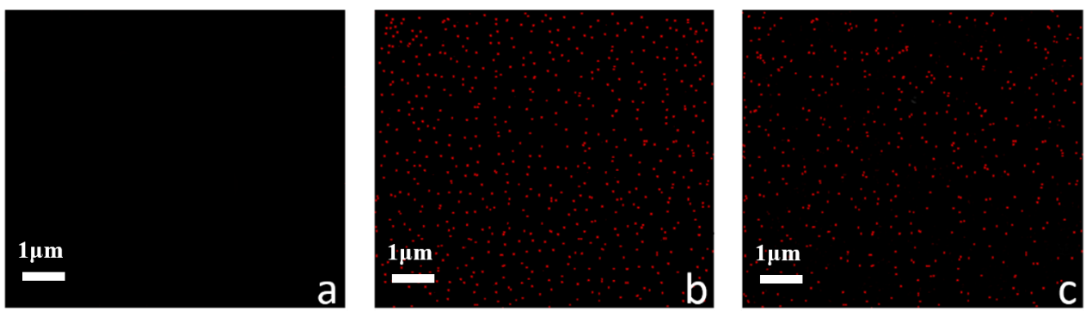
Figure S12. Element analysis and EDX mapping showing the Nitrogen distribution pattern on the PES membrane: (a) virgin PES membrane, (b) PES membrane after filtration of BIT Lake sample obtained in spring, (c) PES membrane after filtration of ZGC River sample obtained in spring.

References
(1) Liu, T.; Zhou, H.; Graham, N.; Yu, W.; Sun, K. 2D Kaolin Ultrafiltration Membrane with Ultrahigh Flux for Water Purification. Water Research 2019, 156, 425–433.

