Abstract

Objectives
To assess the impact of Public Health England’s recent ‘Be clear on cancer: Blood in the pee’ mass media campaign on suspected cancer referral burden and new cancer diagnosis.

Methods
A retrospective cohort study design was used; for two distinct time periods, August 2012 to May 2013 and August 2013 to May 2014, all referrals deemed to be at risk of urological cancer by the referring primary health care physician to Imperial College NHS Healthcare Trust were screened. Data points collected were: age and sex, whether the referral was for visible haematuria, non-visible haematuria or other suspected urological cancer. In addition to referral data, hospital episode data of all new renal cell, and upper and lower tract transitional cell carcinoma for the same time periods was obtained.

Results
Over campaign period and the subsequent three months the number of haematuria referrals increased by 92% (p=0.013) when compared to the same period a year earlier. This increase in referrals was not associated with a significant corresponding rise in cancer diagnosis; instead changes of 26.8% (p=0.56) and -3.3% (p=0.84) were seen in renal and transitional cell carcinomas respectively.

Conclusion
This study has demonstrated that the ‘Be clear on cancer: Blood in pee’ mass media campaign significantly increased the number of new suspected cancer referrals with no significant effect on the diagnosis of target cancers across a large catchment. In the future similar mass media campaigns should have a step of pre-planned assessment, in the form of a well-designed prospective study, to ensure that they confer a rise in cancer diagnosis and public awareness. In addition they should be preceded by the dissemination of information to primary physicians and secondary care providers to educate them regarding the management of the pathology, and to allow appropriate preparation for the increased referral burden.

Key words: haematuria; renal cell carcinoma; transitional cell carcinoma; public health; cancer; campaign

Introduction

Public health campaigns are a corner stone of secondary prevention and have repeatedly been shown to reduce cancer mortality [1]. Historically these campaigns have focused on behaviour modification, aiming to mitigate for the ill effects of specific behaviours deemed to be detrimental to health. Recently Public Health England has embarked on a number of short duration, mass media public health campaigns. In contrast to more traditional public heath drives these campaigns have had the intention of increasing patient numbers seeking medical opinion when exhibiting symptom specific ‘red flag’ symptoms. These mass media public health campaigns offer significant potential benefits, namely that they are able to deliver focused messages, to large audiences, repeatedly, at a relatively low cost per head [2]. Despite the potential benefits, the evidence underpinning the use of mass media campaigns is both limited and mixed [2–4].

One of the most recent of Public Health England’s ‘Be clear on cancer’ mass media campaigns targeted the attendance of patients to primary care with visible haematuria (Figure 1). This national campaign was run across England between October and November 2013 and was comprised of billboard, television and radio advertisements. Up to 20% of patients with visible haematuria will be found to have an underlying malignancy [5,6] using protocol driven investigation including urinary tract ultrasound, CT urogram and flexible cystoscopy [7]; the combination of which has been shown to have high specificity and sensitivity for both renal and transitional cell carcinoma detection [5,7]. Transitional and renal cell carcinomas represent a significant cancer burden, with approximately 10,000 new cancer diagnoses of each in the UK per year [8]. These factors combined make visible haematuria and the malignancies that underlie it, an ideal target for a mass media public health campaign. The primary objective of this paper was to assess the impact and longevity of the ‘Be clear on cancer: blood in pee’ campaign on cancer diagnosis and referral burden.

Methods

A retrospective cohort study design was used; for two distinct time periods, August 2012 to May 2013 and August 2013 to May 2014, all referrals deemed to be at risk of urological cancer by the referring primary health care physician to Imperial College NHS Healthcare Trust (ICHT) were screened. Data points collected were: age and sex of the patient, whether the referral was for visible haematuria, non-visible haematuria or another non-haematuria related suspected urological cancer. In addition to referral data, hospital episode data of all new renal cell, and upper and lower tract transitional cell carcinoma for the same time periods was obtained, this second dataset set comprised all diagnoses for the periods in question including those not identified through the ‘suspected cancer’ pathway.

The 2012-13 time period was used as the comparator group to allow assessment of the impact of the ‘Be clear on cancer: blood in pee’ public health campaign that ran from October to November 2013.

A comparison of the August to May time periods (2012-13 versus 2013-14) was used to gain an understanding of the longevity of effect. When undertaking comparisons to establish its efficacy the data was limited to the periods of the campaign plus an additional three months (October to February (2012-13 versus 2013-14), in order to restrict the comparison to the months of maximal potential efficacy.

Study approval was obtained from the hospital’s ethical review body (Number 1671).

Statistical Analysis
All statistical analysis was performed in Graphpad Prism (GraphPad Software Inc., La Jolla, California, USA). When comparing the time periods in question t-tests were used for continuous data (paired and unpaired as appropriate) and the Chi-squared test was used for for the categorical data, to establish the level of statistical significance. Pearson’s correlation coefficients (r) were also calculated to establish the relationship between cancer diagnosis and the number of referrals made over the time period examined.

Results
Overall Referrals
Over the course of the campaign an increase in all urological cancer referrals was observed (Figures 2 and 3) and was maintained for a period of approximately three months at which point it appeared to return to its baseline (Figure 2).

In total 579 haematuria referrals were made between August 2013 and May 2014 representing a significant increase of 53.2% (p = 0.009) compared with the same time period a year earlier (Figure 2). The majority of this increase was seen in the period of, and immediately following (October ‘13 to Feburary ‘14), the ‘blood in pee’ campaign with a 92% increase in haematuria referrals during this period (p = 0.013, Table 1).

Visible, Non-Visible and suspected cancer referrals
The increase in number of referrals was made up largely of visible and non-visible haematuria referrals with respective increases of 102.9% (p = 0.038) and 79.2% (p < 0.001) in the October to February time period (Table 1). A significant increase was also seen in the number of other suspected urological cancer referrals made during the same period (51% increase, p = 0.009, Table 1).

Cancer Diagnosis
This significant increase in referrals was not associated with a statistically significant corresponding rise in cancer diagnosis; instead an insignificant increase of 26.8% (p = 0.56) was seen in the number of renal cell carcinomas diagnosed (Table 2), while an insignificant decrease of 3.3% (p = 0.84) was seen in the diagnosis of transitional cell carcinomas.

With regards to other urological cancers no significant increase was seen in the number of testicular or prostate cancer in the periods examined (p = 0.35 and 0.71, respectively, Table 2)

When assessing the relationship between the number of renal and transitional cell carcinoma diagnoses and the number of haematuria referrals a strong positive correlation between the two variables (r = 0.78) was seen for the 2012-13 time period in comparison to a weak negative correlation in the 2013-14 time period (r = -0.36).
Population Demographics
As can be seen in Table 3, when comparing the demographic data collected on the populations is question no statistically significant difference was seen in age or sex for haematuria overall, and this remained true when substratifying by visible and non-visible haematuria.

Discussion

Mass media public health campaigns are both expensive to run and have been shown to increase cancer specific referrals [3,4], for these costs to be worthwhile they need to be offset by a positive and sustained change in the target health benefit. This study has demonstrated that the recent ‘Be clear on cancer: Blood in pee’ mass media campaign significantly increased the number of new suspected cancer referrals with no significant effect on the diagnosis of target cancers across a large catchment area of more than two million for cancer specific services. In addition to an increase in the number of patients referred the effect of the campaign seems to have been relatively short lived with referral numbers appearing to return to a baseline level less than six months after the cessation of the campaign, suggesting an fairly short lived increase in public awareness.

To date there is only a small evidence base examining the efficacy of these short duration mass media campaigns [2]. In previous studies examining the effects of similar campaigns targeted at bowel cancer analogous findings to those observed here were seen, with an increase in referrals lasting approximately three months, with no concurrent increase in cancer diagnosis [3,4]. When looking at mass media campaigns outside of the UK the majority relate to cervical cancer screening programmes [2,9,10]. The findings of these studies again tally with those seen here demonstrating only a short-term increase in the uptake of cancer screening investigations following the campaign in question.

Although the findings here failed to show a statistically significant difference in the numbers of cancers diagnosed, un-peer reviewed data published by Public Health England from their pilot data demonstrated a 22% increase in cancer pick up [11]. This same document also reports that the number of patients referred increased by between 25-26% over the course of the study period [11], significantly less than the 92% increase in haematuria related referrals seen during, and in the three months after the campaign in North West London. These data were collected after running pilot campaigns, similar in both content and delivery to the campaign examined in this study, in three areas in England.

Without the ability to examine these data in detail it is difficult to hypothesise the reasons behind this difference, but there are a number of factors that could potentially contribute. Firstly, the population examined in North West London may be different from those populations examined in the pilot studies undertaken by Public Health England prior to the wider roll out of the campaign. Although this may be the case, previous studies comparing the effects of a mass media cancer related campaigns on different socio-economic groups have found the effects of socio-economic factors to be non-significant [10].

The referral criteria for visible haematuria are relatively straight forward with all patients exhibiting this symptom requiring referral to secondary care [7]. This implies that the increase in referrals relates to an increase in the number of patients presenting to their GP reporting visible haematuria. Within the existing literature the conversion rate of a patient presenting with visible haematuria to a urological cancer diagnosis has been approximately 20% [5,6]. If those patients prompted into presentation by the campaign had this risk profile for urological malignancy a corresponding increase in new cancer diagnoses should have been seen. However, despite a significant increase in referrals a corresponding surge in transitional cell carcinoma diagnosis was not seen.

The fact that this rise in transitional cell carcinoma diagnosis was not observed suggests that increased awareness amongst the population served only to increase the number of patients without oncological pathology being referred to secondary care. The reasons behind this dichotomy remain a question for debate but may relate to a lowering of the populations barrier for presentation, due to the campaigns success in increasing background awareness of ‘red flag’ symptoms. This increased concern, driven by the campaign, may also be reflected in the referrals made by the primary care physicians, who may be unnecessarily referring patients in order to mitigate their concern. Whatever the reasons behind the increase in referrals of the ‘worried well’ there is a risk that patients are unnecessarily being subjected to the risks of screening investigations with no mitigating increase in cancer detection rates.

Although the efficacy of the campaign, with regards its effect on cancer pickup, is subject for debate the primary objective, namley prompting those people with visible haematuria into presentation, seems to have been met with the number of people presenting increasing by 102.9%. As well as increasing the awareness and expectations of the general population the results of this study infer an additional increased awareness for uro-oncology more generally amongst primary care physicians. This manifested itself as increase in referrals for non-visible haematuria, perhaps suggesting a lowering of the secondary care referral barrier or alternatively an increase in primary care screening for non-visible haematuria. This increase in the referrals for non-visible haematuria is perhaps unsurprising, however the concurrent increase in referrals for other suspected uro-oncology is, and suggest a transient increase in awareness for all uro-oncology associated with a public health campaign targeting a system specific symptom rather than a single pathology. Interestingly, once again, this increase in referrals did not lead to a significant increase in other urological cancer (testicular and prostate) diagnoses.

When looking for differences in the demographic markers of age and sex between the pre and peri campaign populations being referred to secondary care, none was seen. This suggests that the campaign had little effect on the demographics of the population presenting, succeeding in avoiding increased presentation of the lower risk populations (i.e women and those under 50) but also failing to promote the presentation of those more at risk, older men [12].

Although this paper has demonstrated an apparent increase in cancer specific urological referrals, probably attributable to the ‘Be clear on cancer: Blood in the pee’ campaign, with no tangible increase in cancer diagnosis, it is not without its limitations. First and foremost is the potential under-powering of the dataset with regards to cancer pick up. In addition the study only examined the population of North West London and as such any extrapolation of the specific findings of this study to the wider population both within and outside of the UK must be exercised with caution. This point is particularly pertinent considering the starkly different results found by Public Health England when assessing its pilot campaigns.

Aside from the limitations specific to the dataset, limitations also exist resulting from the retrospective nature of the data collection, specifically the granularity demographic data. Ideally the demographic parameters would have been extended to examine in more detail the characteristics of the population prompted into presentation, specifically the socio-economic and smoking status, in addition to race distribution, would have been of interest.

Conclusions

A successful public health campaign must meet similar criteria to those laid out by Wilson in 1968 for screening campaigns [13]. In addition it must also provide an increase in the diagnosis and public awareness of the target pathology. All of these criteria need to be balanced against the direct and indirect costs of the campaign. In the case of the mass media campaign in question the data presented would suggest that the campaign was only a partial success, managing to achieve an increase in awareness amongst health care professionals and the public, but crucially failing to convert this increased awareness into a concurrent increase in the diagnosis of the target pathologies.

In the future similar mass media campaigns should have a step of pre-planned assessment, in the form of a well-designed prospective study, to ensure that they confer a sustained rise in cancer diagnosis and public awareness. The information gleaned from this data collection exercise can then be published in the peer-reviewed literature allowing the respective successes and failures of a given campaign to be learnt from by the wider public health community. In addition they should be preceded by the dissemination of information to primary physicians and secondary care providers to educate them regarding the management of the pathology, and to allow appropriate preparation for the increased referral burden.

References
1 Marseille E, Jiwani A, Raut A, et al. Scaling up integrated prevention campaigns for global health: costs and cost-effectiveness in 70 countries. BMJ Open 2014;4:e003987. doi:10.1136/bmjopen-2013-003987
2 Wakefield M, Loken B, Hornik RC. Use of mass media campaigns to change health behaviour. Lancet 2010;376:1261–71. doi:10.1016/S0140-6736(10)60809-4
3 Bethune R, Marshall MJ, Mitchell SJ, et al. Did the “Be Clear on Bowel Cancer” public awareness campaign pilot result in a higher rate of cancer detection? Postgrad Med J 2013;89:390–3. doi:10.1136/postgradmedj-2012-131014
4 Peacock O, Clayton S, Atkinson F, et al. “Be Clear on Cancer”: the impact of the UK National Bowel Cancer Awareness Campaign. Colorectal Dis 2013;15:963–7. doi:10.1111/codi.12220
5 Edwards TJ, Dickinson AJ, Natale S, et al. A prospective analysis of the diagnostic yield resulting from the attendance of 4020 patients at a protocol-driven haematuria clinic. BJU Int 2006;97:301–5; discussion 305. doi:10.1111/j.1464-410X.2006.05976.x
6 Khadra MH, Pickard RS, Charlton M, et al. A prospective analysis of 1,930 patients with hematuria to evaluate current diagnostic practice. J Urol 2000;163:524–7.
7 Rodgers M, Nixon J, Hempel S, et al. Diagnostic tests and algorithms used in the investigation of haematuria. Health Technol Assess (Rockv) 2006;10.
8 Cancer Statistics. Cancer Res. UK. 2014.http://www.cancerresearchuk.org/cancer-info/cancerstats/ (accessed 27 Oct2014).
9 Mullins R, Wakefield M, Broun K. Encouraging the right women to attend for cervical cancer screening: results from a targeted television campaign in Victoria, Australia. Health Educ Res 2008;23:477–86. doi:10.1093/her/cym021
10 Anderson JO, Mullins RM, Siahpush M, et al. Mass media campaign improves cervical screening across all socio-economic groups. Health Educ Res 2009;24:867–75. doi:10.1093/her/cyp023
11 Duffy S. Be Clear on Cancer evaluation update. London: 2014.
12 Danaei G, Hoorn S Vander, Lopez AD, et al. Causes of cancer in the world : comparative risk assessment of nine behavioural and environmental risk factors. Lancet 2005;366:1784–93.
13 Wilson JM, Jungner YG. Principles and practice of mass screening for disease. WHO Chron World Heal Organ 1968;22:473.
Conflicts of Interest
Archie Hughes-Hallett: No conflicts of interest to declare
Daisy Browne: No conflicts of interest to declare
Elsie Mensah: No conflicts of interest to declare
Justin Vale: No conflicts of interest to declare
Erik Mayer: No conflicts of interest to declare

 | Oct ’12 – Feb ‘13 | Oct ’13 – Feb ‘14 | % Increase | p-value
Haematuria | 181 | 349 | 92 | 0.013
VH | 104 | 211 | 102.9 | 0.038
NVH | 77 | 138 | 79.2 | 0.001
Other | 233 | 352 | 51 | 0.009
Table 1 – Number of suspected cancer referrals made by presenting complaint in the period during and immediately following the ‘Be clear on cancer: Blood in the pee’ campaign.
VH = Visible haematuria, NVH= Non-visible haematuria, Other = Non-haematuria related suspected urological cancer referrals

 | Oct ‘12 – Feb ‘13 | Oct ‘13 – Feb ‘14 | % Increase | p-value
Total | 133 | 141 | 6.0 | 0.71
TCC | 92 | 89 | -3.3 | 0.84
RCC | 41 | 52 | 26.8 | 0.56
Prostate | 192 | 226 | 17.8 | 0.35
Testicular | 16 | 13 | -18.8 | 0.71
Table 2 – Number of new cancer diagnoses in the period during and immediately following the ‘Be clear on cancer: Blood in the pee’ campaign
TCC – Transitional cell carcinoma, RCC = Renal cell carcinoma

 | Oct ’12 – Feb ‘13 | Oct ’13 – Feb ‘14 | p-value
Mean Age
Haematuria | 65.53 ± 14.28 | 63.83 ± 15.93 | 0.86
VH | 64.84 ± 16.70 | 61.97 ± 17.17 | 0.20
NVH | 66.88 ± 11.34 | 67.10 ± 11.69 | 0.88
% Male
Haematuria | 62.15 | 65.15 | 0.66
VH | 70.32 | 77.66 | 0.18
NVH | 55.70 | 42.60 | 0.08
Table 3 – Demographic differences between the periods during and immediately following the ‘Be clear on cancer blood in the pee’ campaign
VH = Visible haematuria, NVH= Non-visible haematuria

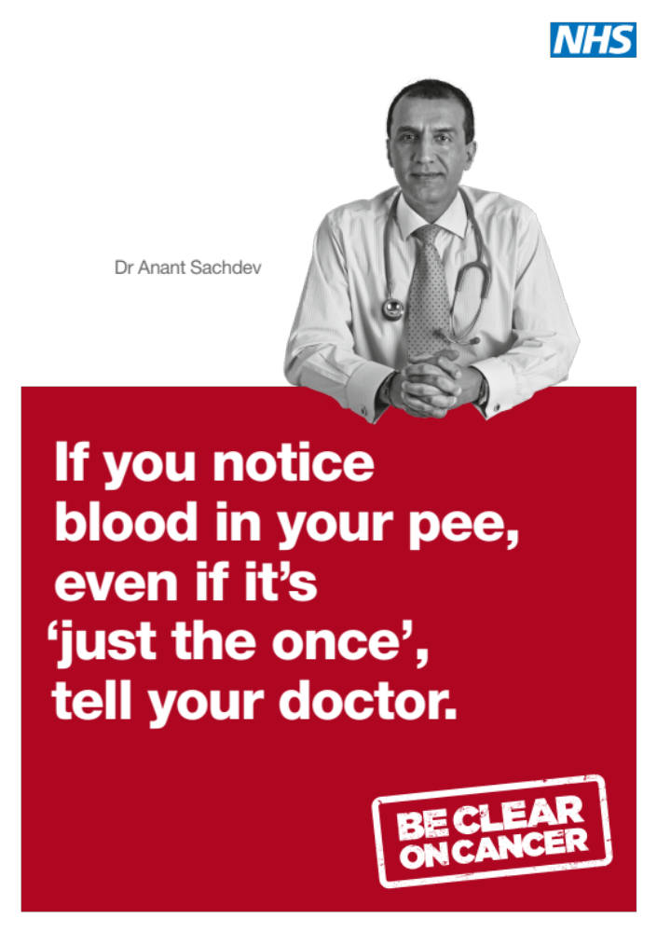
Figure 1. Campaign Poster

Figure 2. Number of transitional and renal cell carcinoma diagnoses and referrals month-by-month. Area highlighted represents the duration of the ‘blood in pee’ campaign.

Visible haematuria
Non-Visible Haematuria
Other

Figure 3. Month-by-month suspected cancer referrals by type for the two time periods examined. The highlighted period represents duration of the campaign

