Peer reviewed version of the manuscript published in final form at DOI: 10.1021/acsnano.6b05975

Controlled sub-nanometer epitope spacing in a three dimensional self-assembled peptide hydrogel

E. Thomas Pashuck,† ‡,§ Benoît J.R. Duchet‡, Catharine S. Hansel†⊥, Stephanie A. Maynard†, Lesley W. Chow†‡,§||, Molly M. Stevens*,†,‡,§
†Department of Materials, ‡Department of Bioengineering, §Institute of Biomedical Engineering,⊥ Department of Chemistry, Imperial College London, London, United Kingdom. ||Current address: Department of Materials Science and Engineering and Bioengineering Program, Lehigh University, Bethlehem, PA 18015, USA

ABSTRACT

Cells in the body use a variety of mechanisms to ensure the specificity and efficacy of signal transduction. One way that this is achieved is through tight spatial control over the position of different proteins, signaling sequences, and biomolecules within and around cells. For instance, the extracellular matrix protein fibronectin presents RGDS and PHSRN sequences that synergistically bind the α₅β₁ integrin when separated by 3.2 nm but are unable to bind when this distance is >5.5 nm.1 Building biomaterials to controllably space different epitopes with subnanometer accuracy in a three-dimensional (3D) hydrogel is challenging. Here, we synthesized peptides that self-assemble into nanofiber hydrogels utilizing the β-sheet motif, which has a known regular spacing along the peptide backbone. By modifying specific locations along the peptide, we are able to controllably space different epitopes with subnanometer accuracy at distances from 0.7 nm to over 6 nm, which is within the size range of many protein clusters. Endothelial cells encapsulated within hydrogels displaying RGDS and PHSRN in the native 3.2 nm spacing showed a significant upregulation in the expression of the alpha 5 integrin subunit compared to those in hydrogels with a 6.2 nm spacing, demonstrating the physiological relevance of the spacing. Furthermore, after 24 h the cells in hydrogels with the 3.2 nm spacing appeared to be more spread with increased staining for the α₅β₁ integrin. This self-assembling peptide system can controllably space multiple epitopes with subnanometer accuracy, demonstrating an exciting platform to study the effects of ligand density and location on cells within a synthetic 3D environment.
KEYWORDS: Self-assembly, peptides, cell-material interactions, hydrogels, integrins, fibronectin, synergy sequence.

Materials designed for regenerative therapies often try to recreate the native or developmental environment that surrounds cells in vivo.(2) Mimicking factors that are important in controlling the behavior of specific cell types is difficult as cells can detect differences in temporal and spatial expression of proteins and other biomolecules.(3) An area of increasing importance is the physical location of various proteins and bioactive groups in the cell, on the cell surface, and in the extracellular matrix.(4) The physical spacing of bioactivity is accomplished through a variety of mechanisms including lipid raft domains(5) on the cell surface that sequester specific proteins,(6) scaffold proteins that bind and organize multiple proteins,(6) and large proteins having several spatially arranged binding domains.(7) The ability to utilize different combinations of proteins allows for increased signal fidelity and increases the possible signaling permutations with a smaller set of proteins.(8, 9)
The extracellular matrix (ECM) that surrounds cells contains a multitude of biomolecules that assemble into a complex network that provides mechanical support for cells and tissue-specific signaling moieties.(10) One of these proteins, fibronectin, contains a variety of spatially organized bioactive sequences,(11) including an RGDS loop and a PHSRN “synergy sequence” that are separated by 3.2 nm.(1) These two peptide sequences simultaneously bind the α₅β₁ integrin, and their spacing within the fibronectin is stabilized through β-sheets in fibronectin,(11) The activation of the α₅β₁ integrin depends on the distance between the RGDS and PHSRN sequences, with distances >5.5 nm greatly reducing the ability to simultaneously bind the integrin.(1) Materials incorporating the RGDS and PHSRN epitopes have largely relied on random mixtures of the two epitopes with mixed results.(12, 13) Polyglycine spacers(14-17) and fibronectin fragments(18) have also been utilized in attempts to control the distance between the epitopes. It has also been shown that the alternating serine-glycine spacer sequences between the RGDS and PHSRN lead to stronger α₅β₁ integrin binding than either serine or glycine spacers alone.(19) While these systems have yielded insights into the nature of the synergy sequence, integrin specificity, and shown the ability to support cell viability, they have been typically used as two-dimensional substrates.
Controlling the spacing of bioactive groups in a synthetic three-dimensional (3D) biomaterial is challenging, as most of the methods employed by cells are difficult to controllably recreate in vitro. A variety of mechanisms have been used to control the spacing of functional groups in two dimensions, from molecular building blocks(20) to DNA nanotechnology.(21-23) However, we can draw inspiration from nature and utilize the β-sheet motif, which has a regular and well-characterized structure. β-sheets have been used heavily in the field of peptide self-assembly to create hydrogels that are injectable, can encapsulate cells, and are easily modified with biological epitopes or functional groups. Alternating hydrophilic–hydrophobic sequences have been extensively used to induce peptide self-assembly into high aspect ratio nanostructures. The Zhang lab developed alternating charged hydrophobic peptides.(24) This alternating motif has been used with hairpin peptides to form hydrogels,(25, 26) which have been used to encapsulate cells into shear-thinning, injectable hydrogels.(25) These β-sheets can also be synthesized with complete control over the amino acid sequence, providing a wide variety of possible modifications at any point along the peptide. In this work, we utilized this strategy to controllably place cyclic RGDS and PHSRN epitopes at different locations along a β-sheet peptide, which self-assembled into nanofibers that form a hydrogel. When these epitopes are spaced at the correct synergy spacing (3.2 nm apart) found in fibronectin, there is an upregulation of the α₅ and β₁ integrin genes compared to a spacing of 6.2 nm. Microscopy also indicates an increase in cell spreading and increased staining for the α₅β₁ integrin. This suggests that the β-sheet motif is an effective way to controllably present multiple bioactive epitopes and improve the bioactivity of synthetic hydrogels through spatial orientation.

RESULTS AND DISCUSSION

Design of Peptide Hydrogel with Controlled Epitope Spacing

Peptide self-assembly is a well-studied area that often uses a β-sheet secondary structure to induce short peptides to assemble into one-dimensional nanostructures that are capable of forming a hydrogel. However, the exact arrangement of β-sheets within a nanostructure can vary widely, and we sought to design a system where the position of any particular amino acid side group can be known a priori. We chose a modified form of the multidomain peptides as a model system based on previous work from the Hartgerink laboratory.(27, 28) These peptides feature alternating hydrophilic–hydrophobic amino acid sequences flanked by charged residues that self-assemble into β-sheet bilayers, as depicted in Figure 1A.

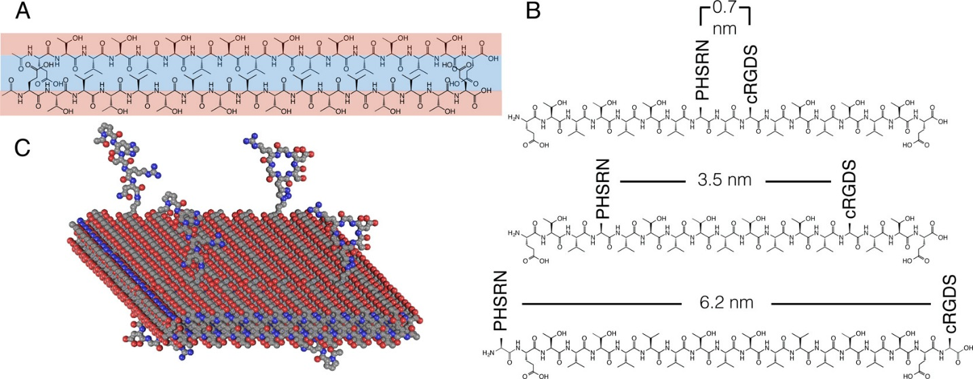
Figure 1. (A) An alternating hydrophobic–hydrophilic peptide sequences form a bilayer with the hydrophobic amino acids on the interior. (B) The regular geometry of the peptide backbone allows for controlled subnanometer spacings between site-specific modifications of the PHSRN and cyclic RGDS peptides. Peptides with 0.7, 3.5, and 6.2 nm spacings were designated as “near”, “correct”, and “far”, respectively. (C) Unfunctionalized β-sheet peptides, denoted as the “backbone” peptides, were mixed with 2% functionalized peptides that form 3D hydrogels.

In our system, we utilize an alternating threonine-valine sequence since both valine and threonine have high propensities to form β-sheets(29, 30) with a negatively charged glutamic acid on either end of this sequence. These carboxylated amino acids allow for charge neutralization of the peptide through the addition of cations, in this case Ca²⁺, and which has the dual role of reducing Coulombic interactions and helps to form calcium bridges between two inward facing glutamic acids on either side of the hydrophobic domain. These self-assembling peptides form long, twisted one-dimensional nanofibers with the hydrophobic amino-acid side groups of valine on the interior of the nanofiber and the hydrophilic amino acids (threonine) exposed on the exterior and are referred to in this work as the “backbone” peptides. The axial distance between adjacent residues in a β-sheet is 0.35 nm, and the amino acid side chains alternate from which side of the plane of the β-sheet they project. Thus, in the β-sheet arrangement shown in Figure 1, every other amino acid would project onto the same side of the β-sheet, which would space each of these side chains apart by roughly 0.7 nm. Since these peptides are synthesized through solid-phase peptide synthesis, there is complete control over the peptide sequence, and it is possible to place a particular amino acid or functional group at any point along the peptide backbone. These structures feature alternating hydrophilic–hydrophobic peptides that form bilayers, and there is good evidence that the hydrophilic amino acids are on the exterior of the nanostructure so any modifications done on these hydrophilic amino acids should be displayed on the surface of the nanostructure. In this work, we were interested in mimicking the synergy sequence found on the extracellular matrix protein fibronectin where an RGDS peptide loop is located approximately 3.2 nm from a PHSRN peptide sequence. These sequences simultaneously bind the α₅β₁ integrin at the 3.2 nm distance but should be unable to bind at a longer 5.5 nm distance, according to computer simulations.(1)
Synthesizing complex peptides can be technically challenging, and in this work we developed an optimized solid-phase peptide synthesis route, detailed in the Supporting Information. This utilized pseudoproline residues, which help to inhibit aggregation during synthesis, and 2-chlorotrityl chloride solid-phase resins, which allowed for the peptides to be cleaved from the resin under mild acidic conditions with the pseudoprolines intact, which aided in the purification of the peptides. Afterward we used click chemistry to add cyclic RGDS epitopes to the azido-lysine residues present on the self-assembling peptide. This allowed us to create a series of peptide systems that have the cyclic RGDS and PHSRN epitopes spaced at 0.7, 3.5, or 6.2 nm distances, as shown in Figure 1B. These peptides are labeled as “near” for the 0.7 nm spacing, “correct” for the 3.5 nm spacing, and “far” for the 6.2 nm spacing. Control peptides with PHSRN or cyclic RGDS alone and backbone only were also studied. These functionalized peptides were mixed with the backbone peptide, which lack the functional groups, to form nanofibers that are 98 mol % backbone and 2 mol % functionalized peptides, as illustrated in Figure 1C. This proportion was selected to reduce the chances of two functionalized peptides being near each other along the length of the nanofiber. The distance between peptides in a β-sheet is approximately 0.5 nm, so at 2 mol % the functionalized peptides should be an average of 25 nm apart from each other, which is sufficient distance to ensure that two peptides will not often be within 3.5 nm of each other. However, the density of RGD adhesion ligands in hydrogels can be important biologically,(31, 32) and we have optimized our system to study the effects of synergy spacing on cell adhesion and integrin expression. These self-assembled nanofibers form hydrogels in water at 10 mM concentration, and the hydrogel is strengthened with the addition of a divalent cation such as Ca²⁺ that neutralizes the negative charge of the peptide. These hydrogels are entirely comprised of peptides and can be gelled in the presence of cells.

Electron Microscopy of Self-Assembled Nanofibers
Electron microscopy was performed on the self-assembling peptides and showed that they self-assembled into long, twisted nanofibers that form 3D networks. The backbone peptide is responsible for the self-assembly of the system, and the various functionalized peptides comprise only 2 mol % of the peptides in the modified gels, so it was expected that the morphology would be similar across samples.
By scanning electron microscopy (SEM), the gels with the backbone alone (Figure 2A) and the correct peptide (Figure 2B) formed similar 3D networks of nanofibers, showing that the presence of the RGDS and PHSRN epitopes on 2% of the peptides had little to no effect on the network structure. It is worth noting that the nanofibrous network formed by these self-assembling peptides resembles the morphology of the ECM that surrounds cells in vivo. This system therefore mimics both the controlled placement of bioactive peptide sequences and the morphology of the native ECM. Further SEM on the other labeled peptides showed no noticeable difference between gels (Figure S1). Transmission electron microscopy (TEM) conducted on the fibers provided a better view of their nanostructure. As shown in Figure 2C, the backbone peptide forms twisted nanoribbons approximately 4–6 nm in width, similar to what has been previously reported with similar structures,(27) and a pitch of approximately 20 nm. Similar morphologies were seen for nanofibers that contain 2% of the peptide with the correct spacing (Figure 2D) as well as all other peptide systems (Figure S2). Given that these self-assembled nanostructures have dimensions that are consistent with a twisted β-sheet bilayer, there is good evidence that functional groups on the hydrophilic side of the peptide β-sheet are exposed on the nanofiber surface.

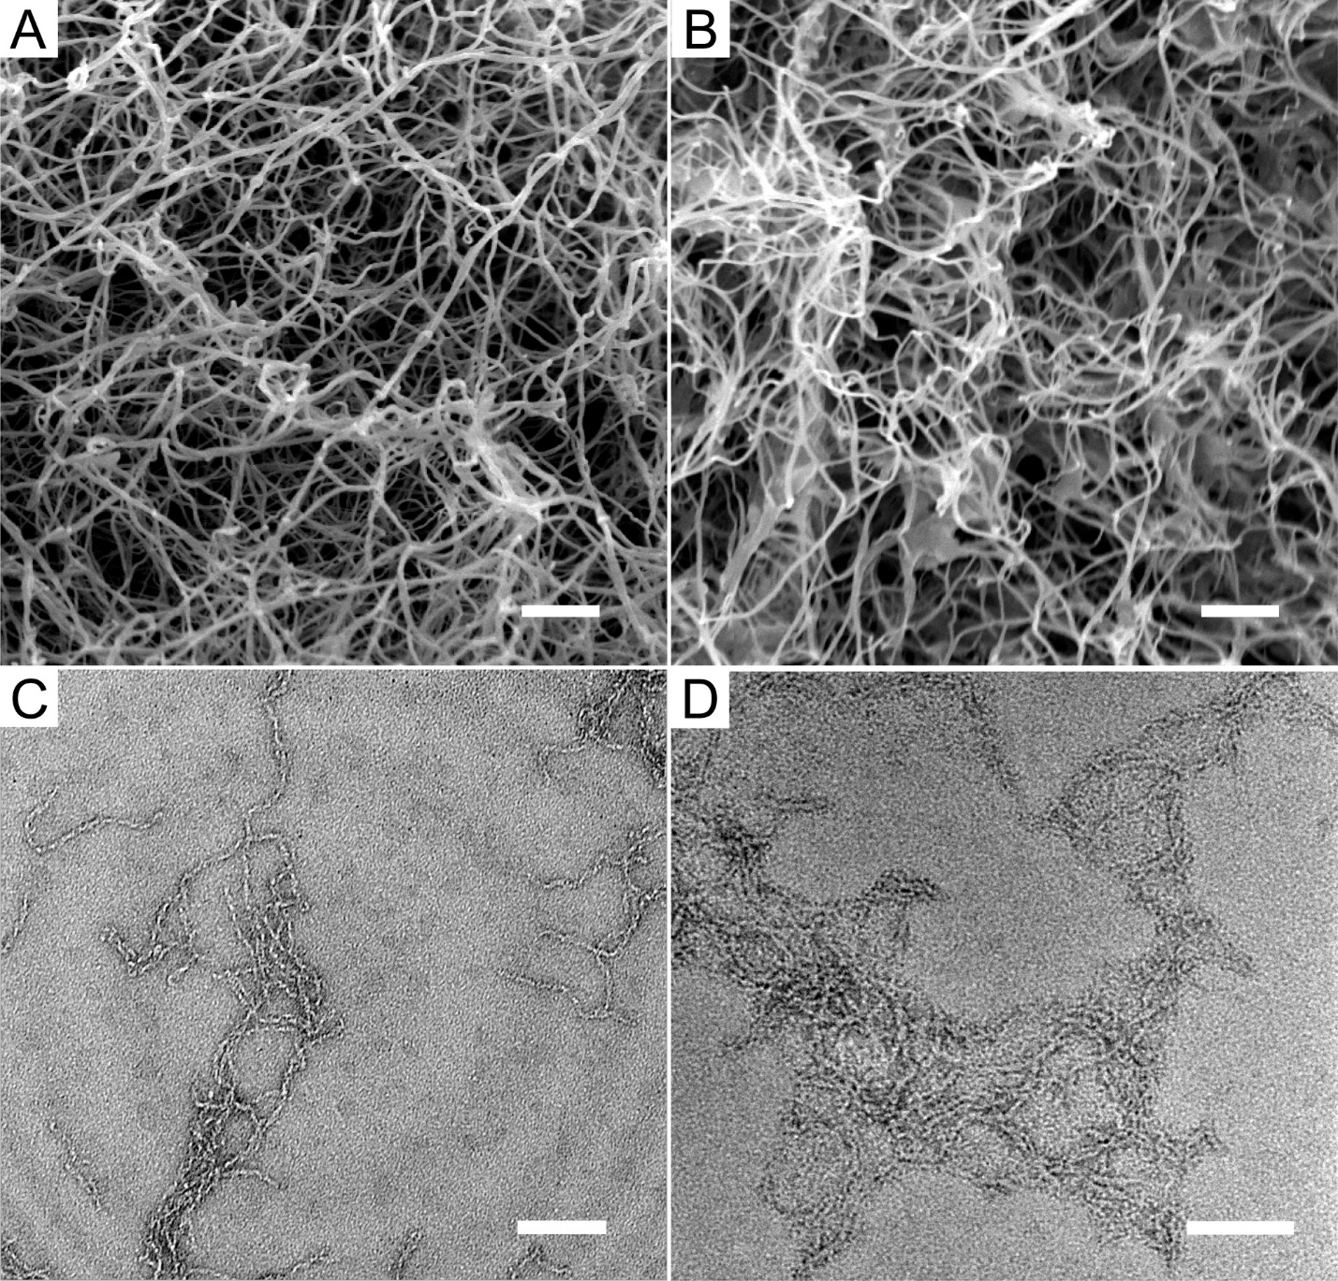
Figure 2. Peptides form nanofibers with or without the presence of the synergy peptides. SEM of the hydrogel shows that the nanofibers form a 3D network with the backbone (A) alone or (B) with 2% correct peptide. The nanofibers are twisted and roughly 4–6 nm across for both the backbone (C) alone or (D) with 2% correct peptide, as seen by TEM. Scale bar is 500 nm for the SEM in (A) and (B) and 100 nm for the TEM in (C) and (D).

Spectroscopic and Mechanical Characterization of the Hydrogels

We studied the peptide secondary structure in the hydrogel using circular dichroism (CD), which indicated that all peptides form β-sheets (Figure 3A). The maxima and minima of the CD spectra are similar across samples, indicating that the β-sheets in the hydrogels have a similar amount of twist and distortions along the length of the β-sheets.(33) Rheology was done to study the mechanical properties of the peptide hydrogels (Figure 3B–C) and revealed that, interestingly, the backbone peptide can form hydrogels at 10 mM in water without any added gelators, possessing storage moduli of approximately 300–400 Pa (Figure S3). The gel becomes significantly stiffer with the addition of 20 mM CaCl₂, having storage moduli over 1 kPa, with little difference between the mechanical properties of the various hydrogels. The hydrogels all have mechanical properties that were largely unaffected by the frequency of the oscillatory strain in a frequency sweep (Figure 3B) and maintained the majority of their mechanical properties out to 5% strain in a strain sweep (Figure 3C). One benefit of using a system in which a small percentage of the peptides are functionalized is that the mechanical properties of the hydrogel can be optimized independently of the bioactive epitopes. Studies have shown that the stiffness of self-assembled peptide hydrogels can be tuned by selecting amino acids with stronger or weaker preference for forming β-sheets,(33) and these shear-thinning hydrogels can be delivered noninvasively with minimal loss of cell viability in the injected hydrogels.(25)

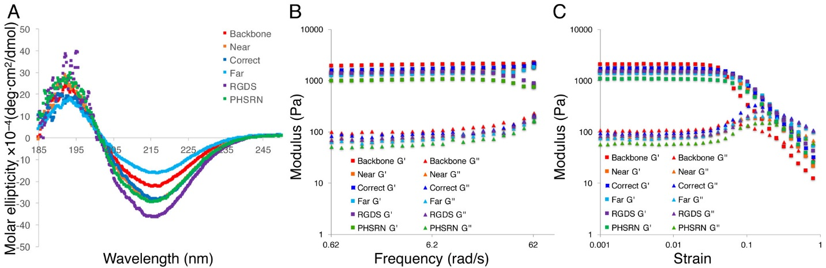
Figure 3. Characterization of the peptide hydrogels. (A) CD confirmed β-sheet formation, and rheology indicated that mechanical properties were similar across (B) frequency and (C) strain.

Cellular Response to Spacing in Hydrogels

To better understand the biological implications of spacing the RGDS and PHSRN epitopes, we used human umbilical vein endothelial cells (HUVECs), which express the α₅β₁ integrin. 40,000 HUVECs were seeded in a 40 μL 10 mM hydrogel, and their spreading behavior was monitored over 24 h. Four h after seeding, the cells in the gels had yet to spread in response to the different spacings between RGDS and PHSRN, although some spreading was seen in the correct condition (Figure 4).

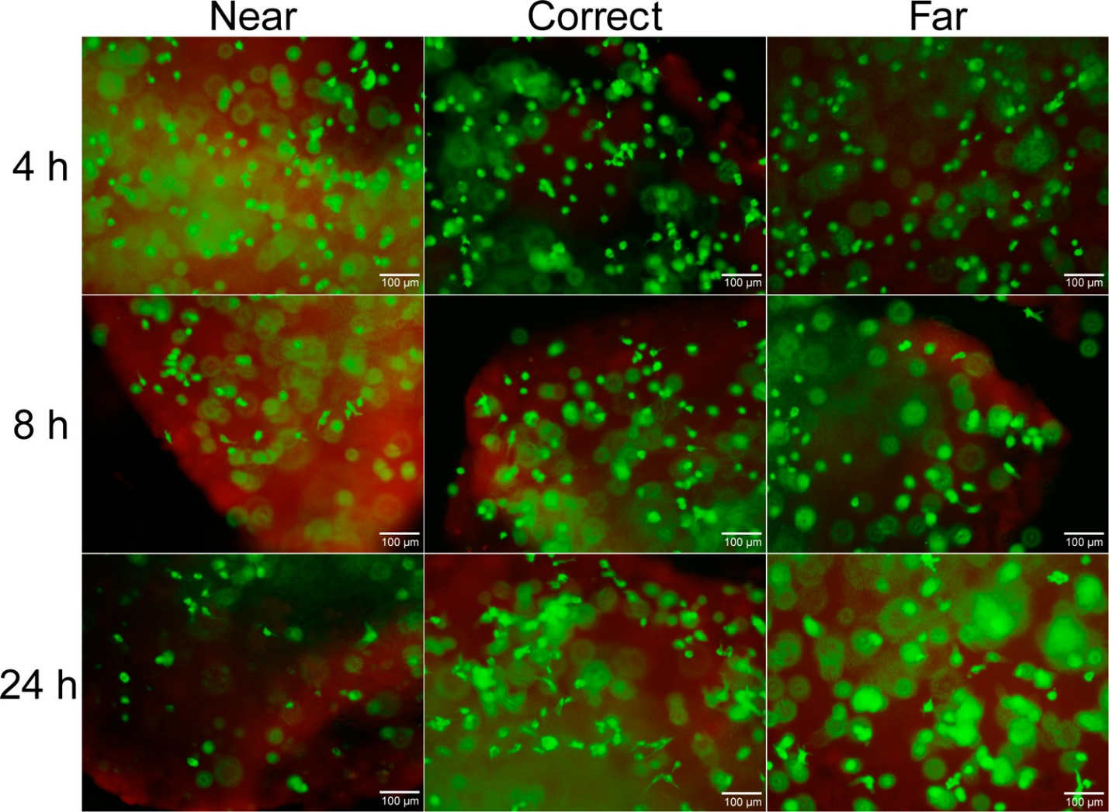
Figure 4. Staining for living (green) and dead (red) cells in hydrogels with near, correct, and far spacings at 4, 8, and 24 h, showing high cell viability and increased spreading by 24 h in hydrogels with the correct synergy spacing. Scale bar is 100 μm.

By 8 h, some lamellipodia are seen in the near, correct, and far hydrogels with less in the far hydrogels compared to the correct and near. By 24 h, most cells in the correct hydrogel had visible spreading, with visibly less in the near and far systems. Calcein and ethidium homodimer staining indicate that most cells were viable at all time points (Figure S4). Staining of cells in the backbone, RGDS, and PHSRN hydrogels all showed notably less spreading than the synergy gels and also appeared to demonstrate an overall decrease in cell viability (Figures S5 and S6).
Polymerase chain reaction (PCR) was performed on samples at each time point to determine the impact of the epitope spacing on the gene expression of the different integrin subunits. For this, three genes were selected: the α₅ subunit, the β₁ subunit, and the αv subunit, which is the other major α integrin subunit for endothelial cells in vivo.(34) The α₅ protein only forms dimers with the β₁ subunit, while the β₁ integrin is more promiscuous with α subunits. HUVECs also express the α_{V}β₃ integrin pair, which binds fibronectin(35) but does not synergistically bind the RGDS and PHSRN epitopes and is not sensitive to their spacing.(36)
After 4 h in the hydrogels, expression of the α₅ subunits was significantly higher (p < 0.05) in the correct hydrogel than the far, RGDS, or PHSRN and also higher than the near and backbone gels, although the difference was not significant (Figure 5). The correct gels also had the highest expression of the gene for the β₁ subunit, with significance against the near and RGDS hydrogels. At 4 h, none of the gels had a statistically significant difference in expression of the α_{V} subunit. PCR performed at 8 h and at 24 h did not show a statistically significant increase in α5 integrin subunit expression in the correct gel versus the other conditions (Figure S7 and Figure S8).

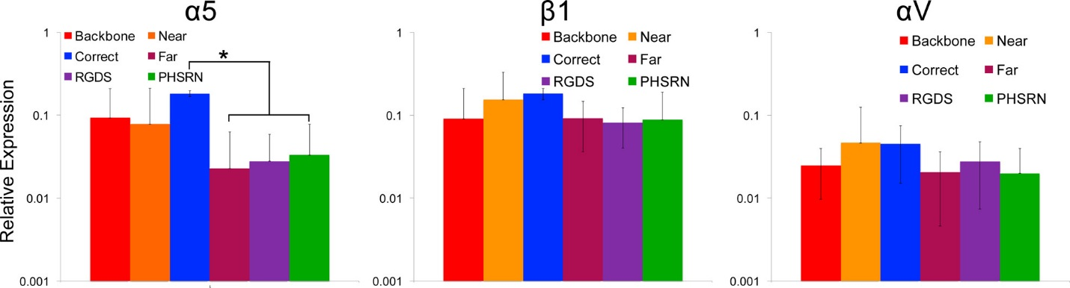
Figure 5. PCR was used to study ITGA5 (α5), ITGB1(β1), and ITGA5 (α5) gene expression relative to GAPDH at 4 h (n = 4; Student–Newman–Keuls posthoc test with * denoting p < 0.05).

Immunocytochemistry conducted on the hydrogels enabled a better visualization of the α₅β₁ integrin in the different microenvironments. After 24 h, HUVECs cultured in hydrogels with the correct synergy spacing (Figure 6B) appeared more spread and stained more strongly for the α₅β₁ integrin compared to the other conditions (Figure 6). The samples which included both RGDS and PHSRN epitopes in the same hydrogel (Figure 6A–C) also appeared to stain more strongly for the α₅β₁ integrin than those which did not have both sequences (Figure 6D–F). This supports the evidence from the calcein staining, which suggested that the presence of both epitopes increases cell spreading at earlier time points. The PCR and staining experiments indicated that the HUVEC cells spread more quickly and to a greater extent in hydrogels that displayed the cyclic RGDs sequence and even more in gels with both the cyclic RGDS and PHSRN sequences. Interestingly, compared to the far gels, the near gels seemed to have increased spreading, α₅β₁ integrin staining, and elevated α₅ and β₁ integrin expression, although the difference was not statistically significant. To date, most work investigating the spacing between the RGDS and PHSRN sequence has looked at extended distances between the two and rather than proximal spacings. It is possible that the α₅β₁ integrin is more amenable to closer distances than further ones.

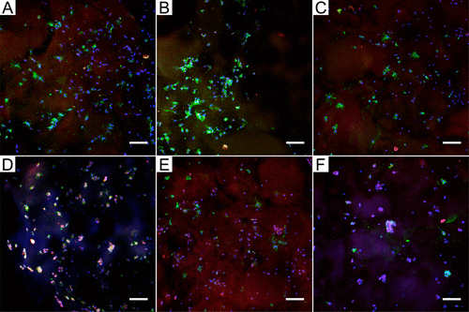
Figure 6. Immunocytochemistry of HUVECs in the hydrogels after 24 h. (A) Near, (B) correct, (C) far, (D) backbone, (E) RGDS, and (F) PHSRN. DAPI is shown in blue, actin in red, and the α₅β₁ integrin in green, with the correct hydrogel showing an increase in α₅β₁ staining. Scale bar is 100 μm.

CONCLUSIONS
Here, we show that β-sheet peptide sequences can be simultaneously utilized in biomaterials to both induce self-assembly and as a spacing motif for biological ligands within a 3D hydrogel. Twisted nanofibrous β-sheet bilayers are capable of controllably spacing different biological peptide sequences from <1 nm to over 6 nm with subnanometer accuracy. These peptides form hydrogels that are capable of supporting HUVECs cells, and hydrogels with cyclic RGDS and PHSRN at the correct distance had increased α₅ integrin gene expression compared to those with the epitopes at greater distances. Cells in gels with the correct synergy spacing also appear more spread and had greater staining for the α₅β₁ integrin. Finally, these results show that a synthetic bottom-up approach for controlled presentation of epitopes in a 3D environment is both possible and valuable for increasing the specificity in targeting cell surface proteins.

EXPERIMENTAL METHODS
All peptide synthesis reagents were purchased from AGTC Bioproducts unless otherwise noted. Peptides were synthesized on 2-chlorotrityl chloride resin. The resin was stored under nitrogen, contact with air was minimized, and the resin was solvated in DCM when needed. The first amino acid (0.3 mmol of amino acid per gram of resin) was dissolved in dichloromethane (DCM) and added to the resin in a shaker vessel. Five equiv of diisopropylamine (DIPEA) was then added, and after 5 min of shaking another 1.5 equiv of DIPEA was added. After 1 h the unreacted 2-chlorotrityl chloride resin was capped with an excess of methanol for 30 min.

Backbone Synthesis
All amide couplings were done using O-(6-chlorobenzotriazol-1-yl)-N,N,N′,N′-tetramethyluronium hexafluorophosphate (HCTU) unless otherwise noted. For each coupling the amino acid, HCTU, and DIPEA were added in a 4:4:6 ratio to the peptide. It should be noted that for the threonine couplings, Fmoc-Thr(Trt)-OH (Chem-Impex International) was used, and the Fmoc-Thr(Trt)-OH:HCTU:DIEA ratio was 2:2:3. For each peptide two pseudoprolines (Fmoc-l-Val-l-Thr[PSI(Me,Me)Pro]-OH, Iris Biotech) were used to help break up aggregation. For these additions HATU ((1-[bis(dimethylamino)methylene]-1H-1,2,3-triazolo[4,5-b]pyridinium 3-oxid hexafluorophosphate), GenScript) was used in place of HCTU in a 2:2:3 ratio for pseudoproline:HATU:DIPEA in dimethylformamide (DMF). For all peptide synthesis, a ninhydrin test (Cambridge Biosciences) was performed after every addition to test for the presence of free amines. Upon a positive test, the coupling was replicated until the test was negative. A capping step was then performed with acetic anhydride (Sigma-Aldrich) in a 10:5:100 acetic anhydride:DIPEA:DMF solution twice for 5 min, and then a ninhydrin test was performed to check for complete capping of the free amines. After successful coupling, the Fmoc group was removed, washing the resin with 20% piperidine in DMF twice for 5 min. A ninhydrin test was performed to check for a positive result. For the backbone peptide the N-terminus was capped upon completion of the amino acid couplings.
After capping the resin was washed 3× with DMF and 3× with DCM. The peptide was then cleaved from the resin in 5% trifluouroacetic acid (TFA) (Sigma-Aldrich) and 2.5% triisopropylsilane (TIS) (Sigma-Aldrich) in DCM. This was done to cleave the peptide from the resin and remove the trityl groups from the threonines, but keep the pseudoprolines. The cleavage solution was added until the resin turned dark red, emptied into a round-bottomed flask, and washed 2× with extra cleavage solution. The resin was then washed 3× with 15 mL of DCM, and then a 2× excess of DIPEA (compared to TFA) was slowly added to the round-bottomed flask to neutralize the TFA. The solution was removed using rotary evaporation, and then the product was crashed out in ice-cold diethyl ether (Sigma-Aldrich), giving the structure seen in Figure S12. This molecule was then dried under vacuum and dissolved in 20% acetonitrile (ACN), 80% water with the pH adjusted to 9. It was purified using high-pressure liquid chromatography (HPLC) under basic conditions. A gradient was run from 80% ACN/20% H₂O to 95% ACN/5% H₂O with 0.1% NH₄OH at 20 mL/min was run on a 150 × 30 mm Phenomenex C18 Gemini NX column. The column featured a 5 μm particle size and a 110 Å pore size. Upon purification, the acetonitrile was removed using rotary evaporation, the solution was frozen, and the ice removed with lyophilization.
To synthesize the cyclic RGDS peptide, Fmoc propargylglycine (Chem-Impex International) was first loaded onto the 2-chlorotrityl chloride resin using the previously described resin-loading procedure. Fmoc-Asp(OtBu)-Ser(psiMe,Mepro)-OH (Merck) was then added to aid with the cyclization process, followed by glycine, arginine, and glycine. After cleavage of the N-terminal Fmoc on the peptide was cleaved using the same conditions as the backbone. The linear RGDS peptide was dissolved in DMF at 1 mg/mL, and a 2× excess of HCTU was added, followed by a 3-fold excess of DIPEA for cyclization. The solution was stirred for 1 min and then allowed to stand at room temperature (RT) for 6 h. The DMF was removed using rotary evaporation, and the solution was precipitated in diethyl ether. The sample was then dissolved in 20% acetonitrile/80% H₂O with 0.1% TFA and purified using the same HPLC conditions as previously described, except with 0.1% TFA added in place of NH₄OH. After purification, the acetonitrile was removed with rotary evaporation, and then the samples were frozen, and water was removed with lyophilization, yielding the protected cyclic peptide seen in Figure S13A.
The purified peptide, with protecting groups still attached, was then cleaved in a round-bottomed flask containing 95% TFA, 2.5% TIS, and 2.5% H₂O for 2 h. The cleavage solution was removed with rotary evaporation and crashed out in diethyl ether, giving the product seen in Figure S13B.
A protected PHSRN peptide was synthesized using normal solid-phase techniques on a 2-chlorotrityl resin. The N-terminus was capped with acetic anhydride, and it was cleaved in 2% TFA, 2% triisopropylsilane, and 96% DCM. The cleavage solution was collected in a round-bottomed flask and neutralized with DIPEA, and the DCM was removed with rotary evaporation. The remaining residue was precipitated in diethyl ether and then concentrated with centrifugation. It was then dried and dissolved in 50% ACN/50% H₂O and purified to a powder using the same conditions as the backbone, yielding the molecule seen in Figure S14.
Fmoc-Lys(Boc)-OH was added to a round-bottomed flask and dissolved in neat TFA to remove the Boc group. The TFA was then removed through rotary evaporation, and then the remaining solution was precipitated in ice-cold diethyl ether. The remaining ether was removed under vacuum, and the solution was dissolved in water and neutralized with 1 M NH₄OH. Protected PHSRN, HCTU, and DIEA were dissolved in DMF at a 1:1:1.5 ratio in a round-bottomed flask, Fmoc-Lys(NH₂) was added, and the solution was stirred at RT for 2 h. The solution was precipitated in diethyl ether, dissolved in 20% ACN/80% H₂O with 0.1% NH₄OH, and purified under the same basic conditions as the protected PHSRN, giving the structure shown in Figure S15.

Fmoc Lys(N₃) Synthesis
Fmoc Lys(N₃) was synthesized based on a previously published protocol.(37) An azide transfer reagent (imidazole-1-sulfonyl azide hydrochloride)(38) was synthesized by adding 8.05 mL (100 mM) of sulfuryl chloride (Sigma-Aldrich) to a suspension of sodium azide (6.5 g, 100 mM) in 100 mL of acetonitrile on ice. The solution was allowed to warm to RT and stirred overnight. The solution was cooled to 0 °C, and imidazole (190 mM, 12.95 g) was added slowly over 20 min. The solution was allowed to return to RT and stirred for 3 h. It was then diluted with 200 mL of ethyl acetate (Sigma), washed with water (2 × 200 mL) and a saturated NaHCO₃ solution (2 × 200 mL), and then dried with magnesium sulfate. Dry ethanol was cooled to 0 °C, and acetyl chloride (9.68 mL, 150 mM, Merck) was added slowly to generate HCl in ethanol. This was then slowly added to the azide transfer solution, and the colorless needles were collected by filtration and washed 3× with ethyl acetate.
Fmoc-Lys(NH₂)-OH (5.5 g, 14.93 mM) was dissolved in 80 mL of a 1:1 water:MeOH solution. 3.75 g (17.9 mM) of Imidazole-1-sulfonyl azide hydrochloride, NaHCO₃ (8.11 g, 96.54 mM), and CuSO₄ (37.3 mg, 0.149 mM) were added, and the mixture was stirred overnight in a round-bottomed flask. The solution was concentrated to 50 mL with rotary evaporation and then acidified to pH 2 with HCl. The aqueous phase was extracted with ethyl acetate (3 × 50 mL), and the ethyl acetate was removed with rotary evaporation. The product was then dissolved in 80% water/20% ACN with 0.1% TFA and purified under the same conditions as the backbone peptide.
RGDS Backbone Synthesis
The RGDS peptide backbone was synthesized in a similar manner to the previously described backbone peptide. However, the second threonine was replaced with the Fmoc-Lys(N₃)-OH and coupled with HATU:Fmoc-Lys(N₃)-OH:DIPEA in a 2:2:3 ratio (with respect to the peptide) for 2 h. The seventh lysine was substituted for an Fmoc-Lys(MTT)-OH, and the N-terminus was not capped with acetic anhydride. Upon cleavage from the resin, it has the structure shown in Figure S16.

Synthesis of Synergy Peptide Backbones
For the “correct” peptide, the Fmoc-Lys(MTT)-OH was replaced with the synthesized Fmoc-Lys(PHSRN)-OH, which was added with an Fmoc-Lys(PHSRN)-OH:HATU:DIPEA ratio of 1:1:1.5, and allowed to react for 3 h, and then subsequence couplings were done with a 0.5:0.5:0.75 ratio until the ninhydrin test for free amines was negative, giving the structure seen in Figure S17A. For the “near” peptide, the fourth threonine was replaced with a Fmoc-Lys(N₃), and the fifth threonine was replaced with a Fmoc-Lys(PHSRN)-OH, as seen in Figure S17B. For the “far” peptide, a Fmoc-Lys(N₃) was loaded onto the resin before the first glutamic acid, and the Fmoc-Lys(PHSRN)-OH was added after the final glutamic acid, depicted in Figure S17C. They were purified by HPLC under basic conditions used for the backbone peptide.
Upon purification, a fraction of the “correct” peptide backbone, depicted in Figure S17A, was cleaved with 95% TFA/2.5% triisopropylsilane/2.5% H₂O. This is the PHSRN control peptide, as shown in Figure S18.
For the RGDS control, near, correct, and far peptides, 1 equiv of peptide was dissolved in dimethyl sulfoxide (DMSO, Sigma-Aldrich) with 1.5 equiv of deprotected cyclic RGDS peptide, 1 equiv of CuSO₄ (Sigma-Aldrich), and 2 equiv of sodium ascorbate (Sigma-Aldrich). The reaction was done overnight at 40 °C in a stirred round-bottomed flask. It was then mixed 1:1 with DMF, added dropwise to ice-cold diethyl ether to precipitated the peptide, and centrifuged. The supernatant was removed, and the pellet was dried and purified by HPLC under acidic conditions, giving the structures seen in Figure S19. Due to difficulties analyzing the completely deprotected peptides by either electrospray ionization (ESI) or matrix-assisted laser desorption ionization (MALDI), liquid chromatography-mass spectroscopy (LCMS) was done on the semideprotected peptides, as depicted in Figure S19.
Upon purification, the peptides were dissolved in 95% TFA, 2.5% TIS, and 2.5% H₂O for 3 h at RT. The TFA was removed with rotary evaporation, and the peptides were precipitation in cold diethyl ether. They were then dried, dissolved in 0.1 M NH₄OH, and lyophilized.

Preparation of Peptide Mixtures
Once the peptides were purified and deprotected, they were dissolved in TFA at 100 mg/mL, and 2 mol % of the bioactive peptides were mixed in with the backbone peptide. The TFA was removed with a nitrogen stream, and then the peptides were placed under vacuum. The samples were then dissolved in DMSO at 20 mg/mL, placed in dialysis tubing (6–8 kDa MWCO, Spectrapor), and dialyzed over 24 h against water with four water changes. The solutions were pH adjusted to 9 with 1 M NH₄OH and lyophilized.

Rheological Studies
For rheological studies, the peptide solutions were dissolved at 10 mM, 40 μL was pipetted onto the rheometer (TA AR-2000), 4 μL of a 200 mM CaCL₂ solution was pipetted into the peptide solution, and an 8 mm parallel plate was lowered to a 0.5 mm gap distance. The solutions were allowed to gel for 30 min before the frequency sweep was performed, followed by a 30 min wait before the strain sweep was performed. A strain of 1% was used for the frequency sweep, and a frequency of 6.28 rad/s for the strain sweep.

Circular Dichroism Measurements
For CD measurements the peptides were dissolved at 10 mM in ultrapure water and placed between quartz plates with a 0.01 cm gap distance. Three scans were taken from 190–250 nm at 25 °C and averaged on the spectrometer (Jasco J-810) for the final spectrum.

Cell Culture
HUVECs (from Lonza) were passaged in Endothelial Growth Medium (EGM) according to the instructions provided by Lanza and used at passage 9. Cells were treated with 0.025% trypsin/EDTA for 2 min and centrifuged, and the pellet was resuspended in EGM at 2,000 cells/μL. All peptides were dissolved at 4 weight% in D₂O and were mixed 1:1 with the cell solution. 40 μL of the cell-peptide solution was pipetted onto a 12 mm glass coverslip in a 24-well plate and gelled with 4 μL of a 200 mM CaCl₂ solution. This was placed in an incubator for 30 min, and then 600 μL of media was placed on top.

Fluorescent Staining
Staining for living and dead cells within the hydrogels was done using a LIVE/DEAD kit (Invitrogen). The hydrogels were washed once with PBS, followed by a 30-minute incubation in PBS with 1:500 dilutions of calcein AM and ethidium homodimer and then imaged. For staining studies, the gels were washed with PBS and then fixed for 15 min in 4% paraformaldehyde. They were then washed twice and incubated with the primary antibody for the α₅β₁ integrin (Abcam ab75472) diluted 1:1000 in 1% bovine serum albumin (BSA) and 0.25% Triton X-100 in PBS overnight at 4C. They were then washed twice with PBS and incubated with the secondary Goat Anti-Mouse IgG3 heavy chain (FITC) (Abcam ab97259) 1:400, DAPI at 1:10,000, and Rhodamine Phalloidin (Thermofisher Scientific) 1:100 in PBS with 0.25% Triton X-100 and 1% BSA. The samples were then washed twice with PBS, and the PBS was removed. A 15 μL drop of Prolong Gold (Thermofisher) was placed on a microscope slide, and the coverslip was inverted and placed on top of the Prolong Gold droplet. After letting the antifade reagent set for at least 24 hours, the samples were imaged using a Zeiss LSM-810 inverted confocal microscope. The confocal image stacks were converted in a single 2D image using the FIJI plugin for the ImageJ image processing software.

Polymerase Chain Reaction
For PCR studies, each of the hydrogels were placed into 1 mL of Trizol (ThermoScientific) and incubated for 5 min. 200 μL of chloroform was added, and the samples were vortexed and incubated for another 5 min. They were centrifuged at 12,000 × g for 15 min at 4 °C, and then the clear aqueous phase was placed into a new tube. 500 μL of isopropanol was added to the aqueous phase to precipitate the RNA at RT for 15 min. The samples were then centrifuged at 12,000 × g for 10 min at 4 °C. The supernatant was removed, and the pellet was washed with 75% ethanol/25% H₂O and spun at 7600 × g for 5 min at 4 °C.
The RNA was reverse transcribed into DNA using QuantiTect Reverse Transcription Kit (Qiagen). Briefly, the pellet was redissolved in 12 μL of DNase/RNase free water with 2 μL gDNA wipeout buffer added. It was incubated at 42 °C for 2 min then placed on ice. The reverse transcription reaction components (1 μL RT master mix, 4 μL RT buffer, 1 μL RT primer mix) were added to each well and allowed to incubate at 42 °C for 15 min. The samples were then incubated at 95 °C for 3 min and placed in a −20 °C freezer until needed.
For PCR, the Express SYBR GreenER qPCR Supermix with premixed ROX kit was used (ThermoFisher Scientific). Twenty μL of cDNA was diluted into 80 μL using DNA/RNase free water. Four μL of cDNA was added to 1 μL of primers at a 500 nM concentration and 5 μL of SYBR green. The plate was run on a QuantStudio6 Real-Time PCR system (ThermoFisher) with an annealing temperature of 58 °C and a melting temperature of 95 °C. The primers used are shown in Table 1S.

ACKNOWLEDGEMENT
E.T.P. was supported by Marie Curie actions FP7 through the Intra-European Marie Curie Fellowship “Peptide Osteogel” under grant agreement no. 275433. C.S.H. was supported by a Ph.D. studentship of the EPSRC Centre for Doctoral Training under the Institute of Chemical Biology, Imperial College London (EP/L015498/1). S.A.M. was supported by a Ph.D. studentship within Biomedicine and Bioengineering in Osteoarthritis, Imperial College London. L.W.C. and M.M.S. were supported by the Medical Engineering Solutions in the Osteoarthritis Centre of Excellence, funded by the Wellcome Trust and the Engineering and Physical Sciences Research Council (088844). Raw data is available on request from m.stevens@imperial.ac.uk.

REFERENCES
- Krammer, A.; Craig, D.; Thomas, W. E.; Schulten, K.; Vogel, V.A Structural Model for Force Regulated Integrin Binding to Fibronectin’s RGD-Synergy Site Matrix Biol. 2002, 21, 139– 147, DOI: 10.1016/S0945-053X(01)00197-4
- Place, E. S.; Evans, N. D.; Stevens, M. M.Complexity in Biomaterials for Tissue Engineering Nat. Mater. 2009, 8, 457– 470, DOI: 10.1038/nmat2441
- Kinney, M. A.; Hookway, T. A.; Wang, Y.; McDevitt, T. C.Engineering Three-Dimensional Stem Cell Morphogenesis for the Development of Tissue Models and Scalable Regenerative Therapeutics Ann. Biomed. Eng. 2014, 42, 352, DOI: 10.1007/s10439-013-0953-9
- Kim, S. H.; Turnbull, J.; Guimond, S.Extracellular Matrix and Cell Signalling: the Dynamic Cooperation of Integrin, Proteoglycan and Growth Factor Receptor J. Endocrinol. 2011, 209, 139– 151, DOI: 10.1530/JOE-10-0377
- Lingwood, D.; Simons, K.Lipid Rafts as a Membrane-Organizing Principle Science 2010, 327, 46– 50, DOI: 10.1126/science.1174621
- Langeberg, L. K.; Scott, J. D.Signalling Scaffolds and Local Organization of Cellular Behaviour Nat. Rev. Mol. Cell Biol. 2015, 16, 232, DOI: 10.1038/nrm3966
- Schwarzbauer, J. E.; DeSimone, D. W.Fibronectins, Their Fibrillogenesis, and in Vivo Functions Cold Spring Harbor Perspect. Biol. 2011, 3, a005041, DOI: 10.1101/cshperspect.a005041
- Cebecauer, M.; Spitaler, M.; Sergé, A.; Magee, A. I.Signalling Complexes and Clusters: Functional Advantages and Methodological Hurdles J. Cell Sci. 2010, 123, 309– 320, DOI: 10.1242/jcs.061739
- Nussinov, R.The Spatial Structure of Cell Signaling Systems Phys. Biol. 2013, 10, 045004, DOI: 10.1088/1478-3975/10/4/045004
- Mouw, J. K.; Ou, G.; Weaver, V. M.Extracellular Matrix Assembly: a Multiscale Deconstruction Nat. Rev. Mol. Cell Biol. 2014, 15, 771– 785, DOI: 10.1038/nrm3902
- Singh, P.; Carraher, C.; Schwarzbauer, J. E.Assembly of Fibronectin Extracellular Matrix Annu. Rev. Cell Dev. Biol. 2010, 26, 397, DOI: 10.1146/annurev-cellbio-100109-104020
- Nakaoka, R.; Hirano, Y.; Mooney, D. J.; Tsuchiya, T.; Matsuoka, A.Study on the Potential of RGD- and PHSRN-Modified Alginates as Artificial Extracellular Matrices for Engineering Bone J. Artif. Organs 2013, 16, 284– 293, DOI: 10.1007/s10047-013-0703-7
- Ochsenhirt, S.; Kokkoli, E.; McCarthy, J.; Tirrell, M.Effect of RGD Secondary Structure and the Synergy Site PHSRN on Cell Adhesion, Spreading and Specific Integrin Engagement Biomaterials 2006, 27, 3863– 3874, DOI: 10.1016/j.biomaterials.2005.12.012
- Benoit, D.; Anseth, K.The Effect on Osteoblast Function of Colocalized RGD and PHSRN Epitopes on PEG Surfaces Biomaterials 2005, 26, 5209– 5220, DOI: 10.1016/j.biomaterials.2005.01.045
- Petrie, T. A.; Capadona, J. R.; Reyes, C. D.; García, A. J.Integrin Specificity and Enhanced Cellular Activities Associated with Surfaces Presenting a Recombinant Fibronectin Fragment Compared to RGD Supports Biomaterials 2006, 27, 5459– 5470, DOI: 10.1016/j.biomaterials.2006.06.027
- Schmidt, D. R.; Kao, W. J.Monocyte Activation in Response to Polyethylene Glycol Hydrogels Grafted with RGD and PHSRN Separated by Interpositional Spacers of Various Lengths J. Biomed. Mater. Res., Part A 2007, 83A, 617– 625, DOI: 10.1002/jbm.a.31270
- Shroff, K.; Rexeisen, E. L.; Arunagirinathan, M. A.; Kokkoli, E.Fibronectin-Mimetic Peptide-Amphiphile Nanofiber Gels Support Increased Cell Adhesion and Promote ECM Production Soft Matter 2010, 6, 5064– 5072, DOI: 10.1039/c0sm00321b
- Brown, A. C.; Rowe, J. A.; Barker, T. H.Guiding Epithelial Cell Phenotypes with Engineered Integrin-Specific Recombinant Fibronectin Fragments Tissue Eng., Part A 2011, 17, 139– 150, DOI: 10.1089/ten.tea.2010.0199
- Craig, J. A.; Rexeisen, E. L.; Mardilovich, A.; Shroff, K.; Kokkoli, E.Effect of Linker and Spacer on the Design of a Fibronectin-Mimetic Peptide Evaluated via Cell Studies and AFM Adhesion Forces Langmuir 2008, 24, 10282– 10292, DOI: 10.1021/la702434p
- Grill, L.; Dyer, M.; Lafferentz, L.; Persson, M.; Peters, M. V.; Hecht, S.Nano-Architectures by Covalent Assembly of Molecular Building Blocks Nat. Nanotechnol. 2007, 2, 687– 691, DOI: 10.1038/nnano.2007.346
- Zhang, D. Y.; Seelig, G.Dynamic DNA Nanotechnology Using Strand-Displacement Reactions Nat. Chem. 2011, 3, 103– 113, DOI: 10.1038/nchem.957
- Tikhomirov, G.; Hoogland, S.; Lee, P. E.; Fischer, A.; Sargent, E. H.; Kelley, S. O.DNA-Based Programming of Quantum Dot Valency, Self-Assembly and Luminescence Nat. Nanotechnol. 2011, 6, 485– 490, DOI: 10.1038/nnano.2011.100
- Stephanopoulos, N.; Freeman, R.; North, H. A.; Sur, S.; Jeong, S. J.; Tantakitti, F.; Kessler, J. A.; Stupp, S. I.Bioactive DNA-Peptide Nanotubes Enhance the Differentiation of Neural Stem Cells Into Neurons Nano Lett. 2015, 15, 603– 609, DOI: 10.1021/nl504079q
- Zhang, S.; Holmes, T.; Lockshin, C.; Rich, A.Spontaneous Assembly of a Self-Complementary Oligopeptide to Form a Stable Macroscopic Membrane Proc. Natl. Acad. Sci. U. S. A. 1993, 90, 3334– 3338, DOI: 10.1073/pnas.90.8.3334
- Haines-Butterick, L.; Rajagopal, K.; Branco, M.; Salick, D.; Rughani, R.; Pilarz, M.; Lamm, M. S.; Pochan, D. J.; Schneider, J. P.Controlling Hydrogelation Kinetics by Peptide Design for Three-Dimensional Encapsulation and Injectable Delivery of Cells Proc. Natl. Acad. Sci. U. S. A. 2007, 104, 7791– 7796, DOI: 10.1073/pnas.0701980104
- Schneider, J. P.; Pochan, D. J.; Ozbas, B.; Rajagopal, K.; Pakstis, L.; Kretsinger, J.Responsive Hydrogels From the Intramolecular Folding and Self-Assembly of a Designed Peptide J. Am. Chem. Soc. 2002, 124, 15030– 15037, DOI: 10.1021/ja027993g
- Dong, H.; Paramonov, S. E.; Aulisa, L.; Bakota, E. L.; Hartgerink, J. D.Self-Assembly of Multidomain Peptides: Balancing Molecular Frustration Controls Conformation and Nanostructure J. Am. Chem. Soc. 2007, 129, 12468– 12472, DOI: 10.1021/ja072536r
- Aulisa, L.; Dong, H.; Hartgerink, J. D.Self-Assembly of Multidomain Peptides: Sequence Variation Allows Control Over Cross-Linking and Viscoelasticity Biomacromolecules 2009, 10, 2694– 2698, DOI: 10.1021/bm900634x
- Kim, C. A.; Berg, J. M.Thermodynamic |[Beta]| -Sheet Propensities Measured Using a Zinc-Finger Host Peptide Nature 1993, 362, 267– 270, DOI: 10.1038/362267a0
- Levitt, M.Conformational Preferences of Amino Acids in Globular Proteins Biochemistry 1978, 17, 4277– 4285, DOI: 10.1021/bi00613a026
- Storrie, H.; Guler, M. O.; Abu-Amara, S. N.; Volberg, T.; Rao, M. S.; Geiger, B.; Stupp, S. I.Supramolecular Crafting of Cell Adhesion Biomaterials 2007, 28, 4608– 4618, DOI: 10.1016/j.biomaterials.2007.06.026
- Enemchukwu, N. O.; Cruz-Acuña, R.; Bongiorno, T.; Johnson, C. T.; García, J. R.; Sulchek, T.; García, A. J.Synthetic Matrices Reveal Contributions of ECM Biophysical and Biochemical Properties to Epithelial Morphogenesis J. Cell Biol. 2016, 212, 113, DOI: 10.1083/jcb.201506055
- Pashuck, E. T.; Cui, H.; Stupp, S. I.Tuning Supramolecular Rigidity of Peptide Fibers Through Molecular Structure J. Am. Chem. Soc. 2010, 132, 6041– 6046, DOI: 10.1021/ja908560n
- van der Flier, A.; Badu-Nkansah, K.; Whittaker, C. A.; Crowley, D.; Bronson, R. T.; Lacy-Hulbert, A.; Hynes, R. O.Endothelial A5 and Av Integrins Cooperate in Remodeling of the Vasculature During Development Development 2010, 137, 2439– 2449, DOI: 10.1242/dev.049551
- Mao, Y.; Schwarzbauer, J. E.Accessibility to the Fibronectin Synergy Site in a 3D Matrix Regulates Engagement of A 5β 1 Versus A Vβ 3 Integrin Receptors Cell Commun. Adhes. 2006, 13, 267– 277, DOI: 10.1080/15419060601072215
- Bachman, H.; Nicosia, J.; Dysart, M.; Barker, T. H.Utilizing Fibronectin Integrin-Binding Specificity to Control Cellular Responses Advances in Wound Care 2015, 4, 501, DOI: 10.1089/wound.2014.0621
- Chapman, R.; Jolliffe, K. A.; Perrier, S. B.Synthesis of Self-Assembling Cyclic Peptide-Polymer Conjugates Using Click Chemistry Aust. J. Chem. 2010, 63, 1169, DOI: 10.1071/CH10128
- Goddard-Borger, E. D.; Stick, R. V.An Efficient, Inexpensive, and Shelf-Stable Diazotransfer Reagent: Imidazole-1-Sulfonyl Azide Hydrochloride Org. Lett. 2007, 9, 3797– 3800, DOI: 10.1021/ol701581g

