Role of Optimisation Method on Kinetic Inverse Modelling of Biomass Pyrolysis at the Microscale
Dwi M J Purnomo, Franz Richter, Matthew Bonner, Ravi Vaidyanathan, Guillermo Rein*
Department of Mechanical Engineering, Imperial College London, London SW7 2AZ, United Kingdom
Abstract
Biomass pyrolysis is important to biofuel production and fire safety. Inverse modelling is an increasingly used technique to find values for the kinetic parameters that control pyrolysis. The quality of kinetic inverse modelling depends on, in order of importance, the quality of the experimental data, the kinetic model, and the optimisation method used. Unlike the two former components, the optimisation method chosen, i.e. the combination of algorithm and objective function, is rarely discussed in the literature. This work compares the accuracy and efficiency of five commonly used advanced algorithms (Genetic Algorithm, AMALGAM, Shuffled Complex Evolution, Cuckoo Search, and Multi-Start Nonlinear Program) and a simple algorithm (a Random Search) to find the kinetic parameters for cellulose and wood pyrolysis at the microscale. These algorithms are combined with seven objective functions comprising concentrated and dispersed functions. The results show that for cellulose (simple chemistry) the use of an advanced optimisation algorithm is unnecessary, since a simple algorithm achieves similarly high accuracy with higher efficiency. However, for wood (complex chemistry) a combination of an advanced algorithm and a concentrated function greatly improve accuracy. Among the 25 possible combinations we investigated, Shuffled Complex Evolution with mean square error objective function performed best with 0.91% error in mass loss rate and 0.88 × 10¹³ CPU time. These findings can guide the selection of the best optimisation method to use in inverse modelling of kinetic parameters and ensuring both accuracy and efficiency.

Nomenclature
$F$ = cost or fitness function
$m$ = mass
$\dot{m}$ = mass loss rate
$v$ = yield coefficient
$N_{p}$ = number of data
$γ$ = weight
$T$ = Temperature
$X$ = char fraction
$t$ = time
$k$ = reaction rate
$A$ = pre-exponential factor
$E$ = activation energy
$R$ = universal gas constant
$ε_{i}$ = Error at point $i$
$T_{p}$ = Temperature at peak mass loss rate of experimental data

$ε_{p}$ = Temperature error at peak mass loss rate
$\exp_{i}$ = mass or mass loss rate at point $i$ of the experimental data
$n$ = reaction order
$y$ = ambient gas fraction
$δ$ = ambient gas reaction order
$β$ = heating rate
$σ$ = experimental standard deviation

Superscripts
$exp$ = measured data
$pred$ = predicted data

Subscripts
$k$ = species
$j$ = reaction

- Introduction
Pyrolysis is a simultaneous physical and chemical change due to heating in the absence of oxygen [1]. Pyrolysis is the first step in biomass combustion which significantly affects biofuel production and the fire safety of high-rise timber buildings [2, 3]. Researchers study chemistry of pyrolysis mostly by using thermogravimetric analysis (TGA) [4]. They measure the residual masses and temperature histories of microscale (order of mg-sample) samples under controlled heating and atmosphere [4]. The experimental data obtained from TGA are used to find the values of the kinetic parameters that control the chemical kinetics of pyrolysis [5].
Approaches to find these kinetic parameter values can be classified into three categories: model free, model fitting, and data-based. The model free approach employs isoconversional, meaning that they commonly employ a one-step reaction scheme, but the rate equation is found a posteriori [6, 7]. The kinetic parameters in this approach vary with the mass conversion, and have to be translated into invariant kinetic parameters before being useable in large-scale combustion models. On the other hand, the model fitting approach utilises a more flexible reaction scheme, with an a priori defined rate equation, which are represented in the kinetic model to find the kinetic parameters. The kinetic parameters in this approach remain constant with respect to the mass conversion. Combining both the model-free and model fitting approach has achieved good accuracy but only for single heating rate data and one-step reaction scheme, and is, therefore, not considered here [8].
Data-based approaches use machine learning, most commonly artificial neural networks (ANNs), to predict the kinetic parameters of a material based on parameters found for previously studied materials and the content percentage of each constituent of those materials (for biomass, these are cellulose, hemicellulose, and lignin) [9, 10]. Since data-based approach relies on the pattern of the kinetic parameters from the previous works, this approach cannot approximate the underlying physical phenomena and unsuitable for fuels which do not belong to well-understood material classes e.g. combination of polymers and flame retardants for fire safety purposes. Therefore, the model fitting approach which can estimate the underlying physical phenomena during pyrolysis and is able to deal with complex reaction schemes and multiple heating rates, is used here.
The model fitting approach optimises the kinetic parameter values to fit a particular kinetic model’s predictions of experimental data with true experimental data. This approach is a subset of inverse modelling, and in this paper we will refer to the model fitting approach as kinetic inverse modelling (KIM). Kinetic inverse modelling has widespread use for coupling the experimental data and computational pyrolysis. Many different inverse modelling methods have been developed which are summarised in Table 1. Previous studies have found that the quality of the experimental data and the validity of the kinetic model significantly affect the quality of the inverse modelling [4, 11, 12]. Compared to both of these factors, the choice optimisation method used in inverse modelling is poorly understood.
An optimisation process involves passing particular solutions through an objective function, and trying to maximise or minimise the result. The objective function represents the difference between the kinetic model predictions and the experimental data. Algorithms used to optimises this function can vary in complexity [1, 13, 14], from simple algorithms, which are computationally inexpensive, to more complex algorithms, which require greater computational power.
In previous studies [1, 5, 13], the choice of objective function and optimisation algorithm used varies significantly and were not justified. This raises the question of what effect this will have on the quality of the prediction for the kinetic parameters. Once the quality of experimental data and the validity of kinetic model are ensured, the optimisation process could lead to three different outcomes: Firstly, the chosen optimisation method (combination of optimisation algorithm and objective function) is poor, which will lead to inaccurate prediction. Secondly, the chosen optimisation method predicts the parameters well, but it is unnecessarily complex and a computational redundancy is encountered. Thirdly, an optimisation method is chosen that is both sufficiently accurate and computationally efficient, which is the desired outcome.

Table 1. Previous works in kinetic inverse modelling for biomass pyrolysis and smouldering.
Authors | Scale | Algorithm | Materials | Main findings
Varhegyi & Antal, 1989 [18] | Micro | Simplex | Cellulose, hemicellulose, bagasse | Complex fuel need multireaction scheme
Varhegyi et al., 1997 [14] | Micro | Manual | Cellulose, hemicellulose, lignin, bagasse | The kinetic of the lignocellulosic material
Miller & Bellan, 1997 [19] | Micro/Meso | Manual | Beech, lignin, maple, and 7 other biomass | The micro and meso scale model
Rein et al., 2005 [20] | Micro | GA | PU Foam | GA perform well for KIM
Branca et al., 2005 [21] | Micro | Direct Method | Beech | The modified model for high heating rate
Rein et al., 2006 [1] | Micro | GA | Cellulose, PU Foam | GA perform well for KIM
Lautenberger et al., 2006 [22] | Micro/Meso | GA | Redwood, Red oak, PP | The parameters are unique to a model
Lee, 2006 [23] | Meso | Manual | Red Oak, PMMA, Foam | Wood kinetic model need more variables
Matala et al., 2008 [24] | Micro | GA | Birch, hemicellulose, PVC, PMMA | The parameters are model dependent
Lautenberger & Pello, 2009 [25] | Micro/Meso | GA | Pine, PMMA, PU, intumesc. | Generalised model for pyrolysis
Lautenberger & Pello, 2009 [26] | Meso | GA | Pine slab | The environment independent properties
Chaos et al., 2010 [27] | Meso | SCE, GA | PMMA, corrugated, CPVC | SCE is accurate, robust and efficient
Lautenberger & Pello, 2011 [15] | Meso | GA, GASA, SHC, SCE | Synthetic data | SCE is the most accurate and efficient
Anca-Couce et al., 2012 [2] | Micro | Manual | Cellulose, pine | Validated kinetic parameters
Huang & Rein, 2014, [28] | Micro | GA | Peat | Suitable kinetic model for peat
Hasalova et al., 2016 [16] | Micro | SCE | Beech | Compensation effect in a powerful SCE
Richter & Rein, 2017 [5] | Micro | AMALGAM | Cellulose | Balance of iso and non-isothermal KIM
Adenson et al., 2017 [13] | Micro | GA, SA, PSO, MS-NLP | Cellulose | Global optimum solution using MS-NLP
Yang et al., 2019 [29] | Micro/Meso | SCE | PMMA | Standardized inverse modelling
Ding et al., 2019 [17] | Micro | GA, PSO | Beech | PSO is more accurate and faster than GA
Ding et al., 2019 [11] | Micro | SCE | Beech | Second tar reaction improve the model
Burra & Gupta, 2019 [30] | Micro | NSGA | Cardboard, paper, pine, rice husk, manure | Reveal the minimum step in kinetic model

A previous comparison [15] of 4 different optimisation algorithms (see Table 1) found that Shuffled Complex Evolution (SCE) to be most accurate and efficient for fire science. This work which used a mesoscale sample, however, did not consider the effect of objective function. Adenson et al. [13] found that different objective function could lead to different optimal solution. Previous works which used a microscale sample [13, 16, 17], have employed several evolutionary and gradient-based algorithms with several different objective functions. Each author found their combination to be of good accuracy with acceptable computational cost. These works, however, have not considered the effect of objective function and the complexity of fuel chemistry on the optimisation accuracy and efficiency.
This work attempts to quantify the effect of both the choice of algorithm and the choice of objective function on the accuracy and efficiency of kinetic parameter predictions for microscale samples. We considered how these effects change based on the complexity of the fuel being studied. Within this study, we compared five commonly used optimisation algorithms (Genetic Algorithms, AMALGAM, Shuffled Complex Evolution, Cuckoo Search, and Multi-Start Nonlinear Programming (MS-NLP)) and compared these to a simple algorithm, Random Search. These algorithms are combined with seven different objective functions, comprising of both concentrated (one objective) and dispersed (two objectives) functions.
- Method
In this study, we applied the process of kinetic inverse modelling (KIM) to 2 different fuels (wood and cellulose) using 6 different optimisation algorithms and 7 different objective functions, in order to compare the accuracy and computational efficiency of different optimisation methods. Our methodology is outlined in Fig. 1.
2.1 Acquiring experimental data
The first step was to acquire two, high-quality sets of thermogravimetric analysis (TGA) data. The first set (taken from [13]) was for cellulose, a fuel with a simple chemistry and, therefore, few kinetic parameters to be optimised (2 kinetic parameters). The second set (taken from [2]) was for wood, a fuel with a more complex chemistry and more kinetic parameters to optimise (12 kinetic parameters). The TGA experiments used 5 mg of 20 μm cellulose powder and 5 mg of 0.2 mm pine wood powder, respectively. Both sets of data were obtained from experiments with three different heating rates in an inert atmosphere, i.e. in the absence of O₂. The heating rates in the cellulose experiments are 1, 10, and 50 K/min, whereas in the wood experiments they are 2.5, 5, and 10 K/min.
2.2 Selecting a kinetic model
The second step was to select an appropriate reaction scheme for each fuel type. In this work, the kinetics of cellulose are modelled as a single-step reaction scheme [13]. The kinetics of wood are modelled as a combination of individual reactions for each of the three main components of wood: cellulose, hemicellulose, and lignin. In the models, each individual component degrades to become char and gas when heated. This reaction scheme was chosen following the work of [2].
The rate equation is formulated as in Eq. 1 to Eq. 4 [4]. Eq. 1 formulates the mass loss rate of species $k$. In Eq. 1, $m_{k}$, $A_{j}$, $E_{j}$, $R$, and $T$ represent the mass of species $k$, pre-exponential factor, activation energy, universal gas constant, and temperature of reaction $j$ respectively. Meanwhile, $n_{kj}$ is the reaction order of species $k$ in reaction $j$. Eq. 2 and Eq. 3 are used to sum each species’ mass and mass loss rate respectively. In Eq. 4 the initial and boundary conditions are defined with $β$ represents the heating rate and $T_{d}$ represents the desired operating temperature.
$\frac{dm_{k}}{dt}=A_{j}\exp\left(\frac{-E_{j}}{RT}\right)m_{k}^{n_{kj}}$ (1)
$m(t)=\sum_{k}{m_{k}(t)}$ (2)
$\frac{dm(t)}{dt}=-\sum_{k}{\frac{dm_{k}}{dt}(t)}$ (3)
$\begin{matrix}\begin{matrix}T(0)=T_{0} \\ T\left(t\right)=T_{0}+βt→T<T_{d}\end{matrix} \\ T\left(t\right)=T_{d}→T≥T_{d}\end{matrix}$ (4)
The kinetic parameters to be optimised are the pre-exponential factor ($A$), activation energy ($E$), and reaction order ($n$). In the reaction scheme for cellulose, there is only one reaction and the reaction order is set to be one to reduce the complexity based on [14, 31]. Therefore, there are only 2 kinetic parameters to be optimised. Meanwhile, in the reaction scheme for wood, there are 3 reactions and 3 additional parameters that define the fraction of each component. Therefore, there are a total of 12 kinetic parameters to be optimised. The ranges of the kinetic parameters were defined to be 34 to 310 kJ/mol and 0.3 to 20 s⁻¹ for activation energy and pre-exponential factor (in log scale) respectively, whereas for reaction order and initial component mass fraction were from 0.1 to 5 and from 0 to 1 respectively, following the literature review [1, 5, 14, 16, 19, 28, 32]
2.3 Selecting an objective function
The third step was to select a suitable objective function for optimisation. An objective function defines, quantitatively, the objective that is to be maximised or minimised. For inverse modelling of kinetic parameters, the objective function depends on the difference between the kinetic model predictions and the experimental data, and will therefore be a function of residual mass ($m$), mass loss rate ($\dot{m}$), number of data ($N_{p}$), and weight ($γ$). Weight determines the fraction of mass loss rate and residual mass errors in the function.

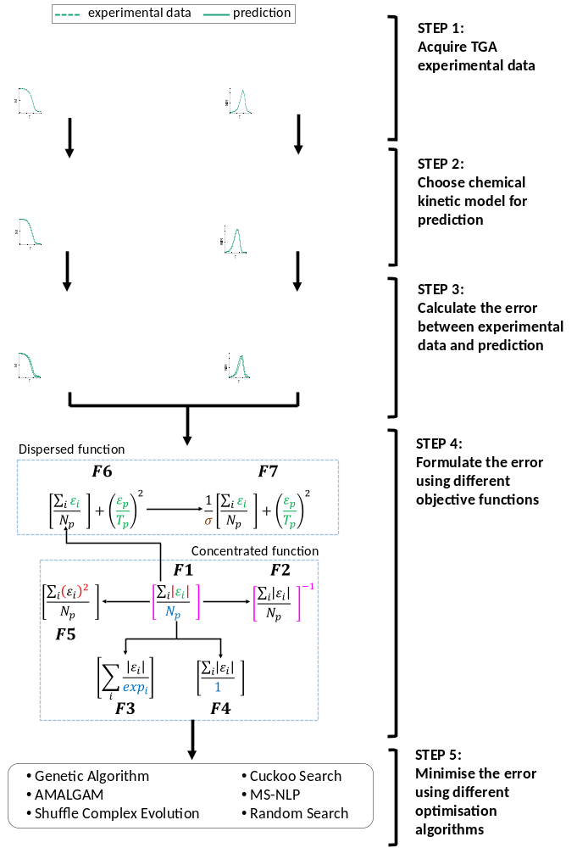
Figure 1. Overview of the method used in this paper. The method comprises acquiring the experimental data, building the chemical kinetic model, finding and formulating the errors, and minimising the errors using different algorithms.
In this study, we compared seven different objective functions. The schematic of the objective functions formulation is shown in Fig. 1 (step 4). In Fig. 1, there is a function at the centre which is connected to the other functions. This function is the base function, shown in $F1$ (Eq. 5) which is similar to the function used in [5], from which the other functions are formulated. The base function is a mean absolute error (MAE) from both residual mass and mass loss rate and was selected as a base function due to its simplicity and common use.
The other objective functions are formulated by changing the structure of the base function to capture the effect of the function structure on the performance of the optimisation. The elements of the function structure that can be altered are numerator, denominator, optimisation target i.e. minimising or maximising, and adding an additional objective which also resemble the functions used in previous works. In $F2$ (Eq. 6) which has similar structure with the function in [1], instead of being minimised, this function is to be maximised. This function is the base function but to the power of -1. $F3$ (Eq. 7), which [28] also used, replaces the denominator in $F1$ with mass loss rate and residual mass. Meanwhile, the denominator in $F4$ (Eq. 8) is changed to unity, similar to the function in [13]. In $F5$ (Eq. 9), the numerator in $F1$ is changed from the absolute value of the difference to the difference squared, which was also used in [14]. All the above functions ($F1$ to $F5$) focus on only one objective, i.e. to minimise the difference of each point between all of the experimental data and the predictions. Therefore, we categorised them as concentrated objective functions.
On the other hand, $F6$ (Eq. 10) adds an additional objective to $F1$. The additional objective is the temperature error at peak mass loss rate between the predictions and experimental data which is firstly addressed in [30]. This addition aims to give extra importance to predicting the peak mass loss rate accurately, as it is often the most important part of the pyrolysis process. Meanwhile, $F7$ (Eq. 11) takes into account the natural variability in experimental results. This variability is defined as the standard deviation of the experimental results. This standard deviation is included as a denominator to the objective function (i.e $F6$). The standard deviations used are from Grønli’s work [33]. Since $F6$ and $F7$ have more than one objective, we categorised them as dispersed objective functions.
$F1=γ_{B}\sum_{i=1}^{N_{p}}{\frac{\left|{\dot{m}}_{i}^{exp}-{\dot{m}}_{i}^{pred}\right|}{N_{p}}}+\left(1-γ_{B}\right)\sum_{i=1}^{N_{p}}{\frac{\left|m_{i}^{exp}-m_{i}^{pred}\right|}{N_{p}}}$ (5) $F2=γ_{F}{\left(\sum_{i=1}^{N_{p}}{\frac{\left|{\dot{m}}_{i}^{exp}-{\dot{m}}_{i}^{pred}\right|}{N_{p}}}\right)}^{-1}+\left(1-γ_{F}\right){\left(\sum_{i=1}^{N_{p}}{\frac{\left|m_{i}^{exp}-m_{i}^{pred}\right|}{N_{p}}}\right)}^{-1}$ (6) $F3=γ_{D}\left(\sum_{i=1}^{N_{p}}{\frac{\left|{\dot{m}}_{i}^{exp}-{\dot{m}}_{i}^{pred}\right|}{{\dot{m}}_{i}^{exp}}}\right)+\left(1-γ_{D}\right)\left(\sum_{i=1}^{N_{p}}{\frac{\left|m_{i}^{exp}-m_{i}^{pred}\right|}{m_{i}^{exp}}}\right)$ (7) $F4=γ_{D}\left(\sum_{i=1}^{N_{p}}{\left|{\dot{m}}_{i}^{exp}-{\dot{m}}_{i}^{pred}\right|}\right)+\left(1-γ_{D}\right)\left(\sum_{i=1}^{N_{p}}{\left|m_{i}^{exp}-m_{i}^{pred}\right|}\right)$ (8)
$F5=γ_{A}\left(\sum_{i=1}^{N_{p}}{\frac{{\left({\dot{m}}_{i}^{exp}-{\dot{m}}_{i}^{pred}\right)}^{2}}{N_{p}}}\right)+\left(1-γ_{A}\right)\left(\sum_{i=1}^{N_{p}}{\frac{{\left(m_{i}^{exp}-m_{i}^{pred}\right)}^{2}}{N_{p}}}\right)$ (9)
$F6=\left\{{\left(\frac{T_{p}^{exp}-T_{p}^{pred}}{T_{p}^{exp}}\right)}^{2}+{\left(\frac{m_{f}^{exp}-m_{f}^{pred}}{m_{f}^{exp}}\right)}^{2}\right\}$
$+\left\{γ_{1}\sum{\frac{\left|m_{i}^{exp}-m_{i}^{pred}\right|}{N_{p}}+γ_{2}\sum{\frac{\left|{\dot{m}}_{i}^{exp}-{\dot{m}}_{i}^{pred}\right|}{N_{p}}}}\right\}$ (10)
$F7=\left\{{\left(\frac{T_{p}^{exp}-T_{p}^{pred}}{T_{p}^{exp}}\right)}^{2}+{\left(\frac{m_{f}^{exp}-m_{f}^{pred}}{m_{f}^{exp}}\right)}^{2}\right\}$
$+\frac{γ_{1}}{σ_{1}}\sum{\frac{\left|m_{i}^{exp}-m_{i}^{pred}\right|}{N_{p}}+\frac{γ_{2}}{σ_{2}}\sum{\frac{\left|{\dot{m}}_{i}^{exp}-{\dot{m}}_{i}^{pred}\right|}{N_{p}}}}$ (11)
2.4 Selecting and optimisation algorithm
The fourth step was to select an algorithm to optimise the chosen objective functions. In this study, we compared five advanced and one simple optimisation algorithms. These algorithms were selected based on their use in previous studies involving the inverse modelling of biomass pyrolysis (see Table 1). The first advanced algorithm considered was Genetic Algorithm which is the most prominent optimisation algorithm for kinetic inverse modelling. As shown in Table 1, Genetic Algorithm is the first advanced algorithm used for kinetic inverse modelling by [20] and have been used in more than 10 other works. The second algorithm considered was AMALGAM which is a recently proposed algorithm that combines 4 different algorithms [5]. Therefore, AMALGAM gives a broader range of application than other algorithms tested here. The third algorithm was Shuffled Complex Evolution (SCE) which is the state of the art algorithm [15, 16]. The fourth algorithm was multi-start non-linear program (MS-NLP) which represents an alternative, gradient-based optimisation approach [13]. The final advanced algorithm considered was Cuckoo Search which had never been used for kinetic inverse modelling before but compares well to the other evolutionary algorithms [34]. Meanwhile, for the simple algorithm we considered Random Search since this approach is undoubtedly the simplest possible optimisation algorithm.
Each of these algorithms was also compared to the baseline optimisation approach of a Trial and Error. In this method, all possible solutions within the search domain are considered, up to a particular degree of resolution. The resolution of the pre-exponential factor, activation energy, reaction order, and component fraction were 0.01 (log scale), 0.1, 0.1, and 0.01, respectively. For cellulose, the search domain contained 5.4 × 10⁶ possible combinations. Meanwhile, for wood, the search domain contained 1.9 × 10³¹ possible combinations. Therefore, Trial and Error was not implemented for wood, as the number of combinations means that for wood it would take 3 × 10²⁴ times longer than cellulose. This means that when it takes one second (later on it is found to take 70 h) for cellulose to finish, it will take 9 × 10¹⁴ centuries for wood.
2.4 Comparing predictions with experimental data
The final step (in Fig. 1) was to compare the predictions from each optimisation method to the experimental results and compare their relative performance. To measure each optimisation method’s performance we calculated their accuracy and CPU time. The accuracy was evaluated based on mean square error (MSE) between the predictions, which were repeated 4 times to capture uncertainties, and the experimental data. This MSE was chosen because by using Trial and Error for the seven objective functions, we found that the solution found from Trial and Error with $F5$, which resembles MSE, has the lowest peak mass loss rate temperature deviation from the experimental data (see Fig. A1 (b) in appendix). The errors are calculated based on the total error summation across three different heating rates, i.e. 2.5, 5, and 10 K/min. The CPU time was evaluated based on the required clock cycles which represent number of instructions that need to be processed of one algorithm (included repeated evaluations of the chosen objective function) to finish. Therefore, the type and specification of the computer do not affect the evaluated CPU time.
3. Results and Discussions
Fig. 2 shows that for cellulose, a fuel with simple chemistry, a simple algorithm such as Random Search is sufficient to find the optimum kinetic parameters. Both Random Search (Fig. 2b) and the more advanced Cuckoo Search (Fig. 2a) fit the experiments very well. The accuracy from all the algorithms (including Random Search) were similar, with the errors ranged from 0.37% to 0.42%. However, while the Random Search required 0.6×10¹³ CPU time, the advanced algorithms constituting Genetic Algorithm, AMALGAM, SCE, Cuckoo Search, and MS-NLP required 0.84×10¹³, 0.85×10¹³, 1.2×10¹³, 1.4×10¹³, and 2.7×10¹³ CPU time respectively.
For wood, a fuel with more complex chemistry, the choice of algorithm does matter. Advanced algorithms improve the fit between predictions and experiments by up to a magnitude of 10 (Cuckoo search error: 0.7 %, Random search error: 10.1 %), as shown in Fig 2 c and d. Within the advanced algorithms the errors vary between 0.7 to 3.1 % which required 1.1×10¹³ to 6.8×10¹³ CPU time. In other words, the choice of algorithm is important for complex fuels to get the best possible accuracy, and therefore, we will no longer include Random Search for complex fuels in the following discussion. It is important to note that the results above are only from the combination with $F3$.
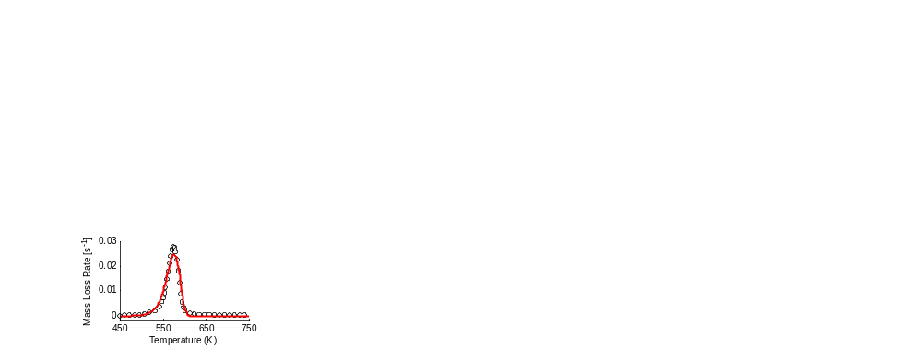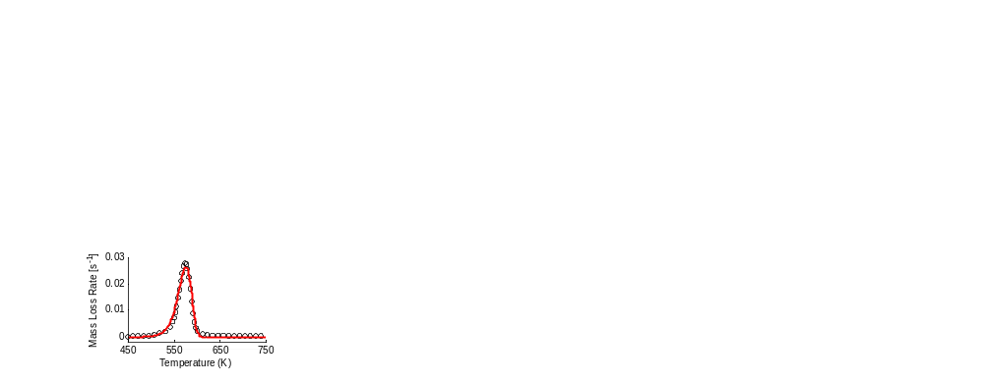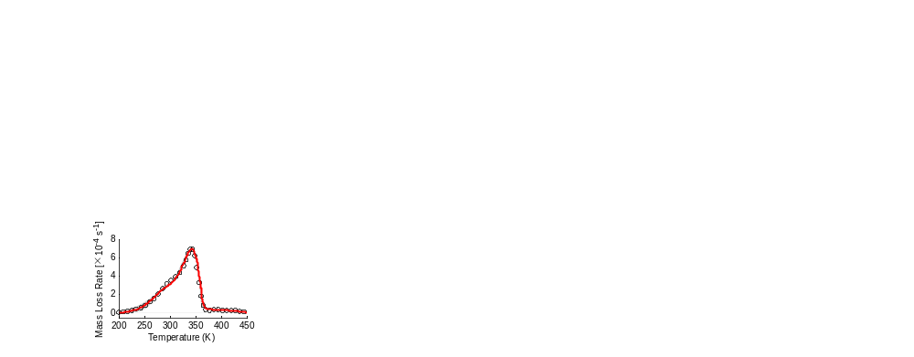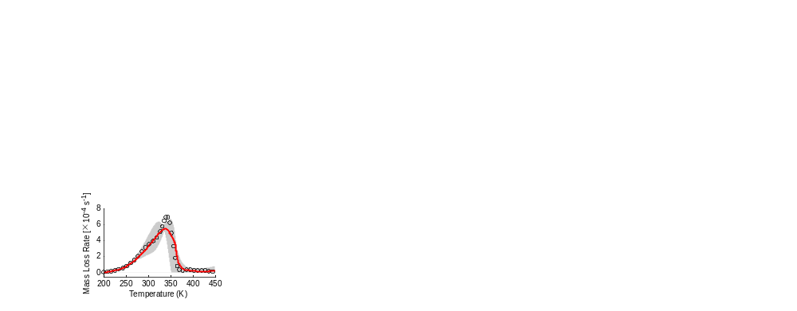
Experiment
Prediction
Variations
a. Cuckoo Search for cellulose
b. Random Search for cellulose
c. Cuckoo Search for wood
d. Random Search for wood
CPU time = 1.4 × 10¹³
β = 1 K/min
CPU time = 2.1 × 10¹³
β = 2.5 K/min
CPU time = 0.6 × 10¹³
β = 1 K/min
CPU time = 0.63 × 10¹³
β = 2.5 K/min
Figure 2. Mass loss rate curve of cellulose (a and b) and wood (c and d) pyrolysis in inert atmosphere. The symbol represents experimental data, the red line represents computer simulation, and the grey shade represents optimisation result variations.
The choice of objective function can significantly influence the accuracy and computational efficiency of an optimisation depending on the chosen algorithm. For example, objective functions $F6$ and $F7$ performed poorly (see Fig. A1 (a) in appendix) across all the algorithms, with an error between 23 % and 66 % for wood, that we conclude one should only use concentrated objective functions ($F1$ to $F5$). In terms of computational efficiency, we observed a little difference for GA, AMALGAM, and Cuckoo Search varying at most by 10 % (Fig 3). For SCE and MS-NLP, on the other hand, the choice of objective function is critical as their CPU time varies by up to 38% and 96% respectively (Fig 3). Significant differences in the accuracy of each algorithm, depending on the objective function, were also found across concentrated objective functions. For example, MS-NLP showed an average error of 0.57% for $F4$, but an average error of 25.95% for $F5$ (Fig. 4). Similarly, all other algorithms showed a difference in error of at least 5% between objective $F1$ to $F5$. Therefore, it is important to choose the right combination of algorithm and objective function.
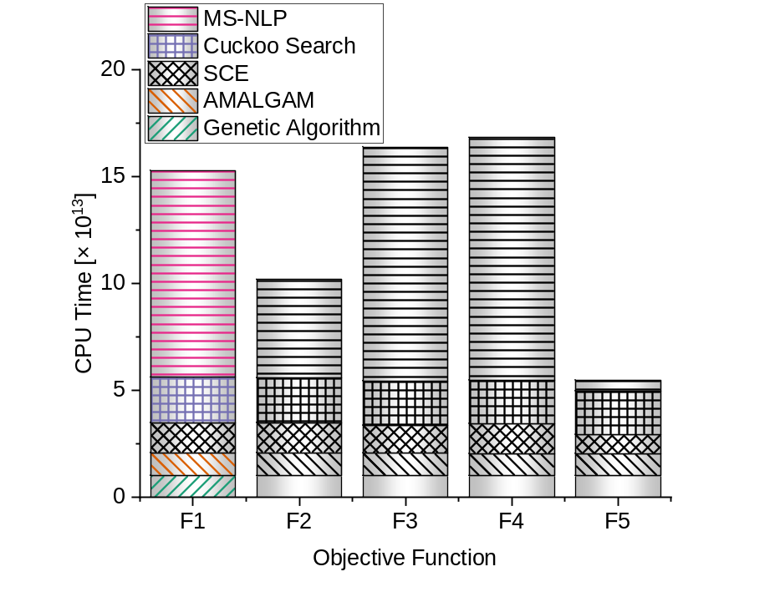
Figure 3. CPU time comparison of algorithms with different objective functions for wood case. Each coloured pattern represents a different optimisation algorithm, while each bar represents a different objective function being optimised.
These results are expected for MS-NLP which is a gradient-based algorithm. This is because $F1$ to $F4$ use the absolute function, which is non-differentiable at $x=0$. An objective function not being continuous and differentiable everywhere is likely to require more complex logic from a gradient based algorithm, and so will slow down the execution time. For the evolutionary algorithms, the differences are smaller, as their logic does not require the function to be continuous and differentiable in the same way. These algorithm rely on the combination and modification of good solutions, and are therefore able to approach a global minimum with lower CPU time even if that minimum is poorly defined.
The accuracy which depends on the objective function comply with our finding from Trial and Error for cellulose. From the results of Trial and Error (see Fig. A1 (b) in appendix), we found that by using different objective function, the solutions found are different. This finding indicates that when using different objective functions the optimisation algorithm takes different path toward the solution, meaning their global optimum have accuracy differences.
While the choice of objective function is important, we found the choice of algorithm even more significant for both accuracy and CPU time. For example, SCE and Cuckoo Search required 1.5 and 2.1 times higher CPU time than GA and AMALGAM, representing around twice longer simulation time. The accuracy is also significantly affected, as SCE outperforms GA by 6% to 88% for 4 of 5 objective functions and AMALGAM by 30% to 35% % for 3 of 5 objective functions (Fig. 4). The objective function indeed affects the accuracy and efficiency of the algorithm, however, unlike on a gradient-based MS-NLP, the effect is less significant on evolutionary algorithms. That makes MS-NLP more dependent on the objective function, as discusses above. For $F4$, MS-NLP which outperforms in accuracy all other algorithms by at least 37%, required at least 5 times higher CPU time. For $F5$, the reverse is true. Therefore, we recommend the use of evolutionary algorithms, as they guarantee acceptable results and are less volatile. The best choice of evolutionary algorithm depends on the problem and will be discussed next.
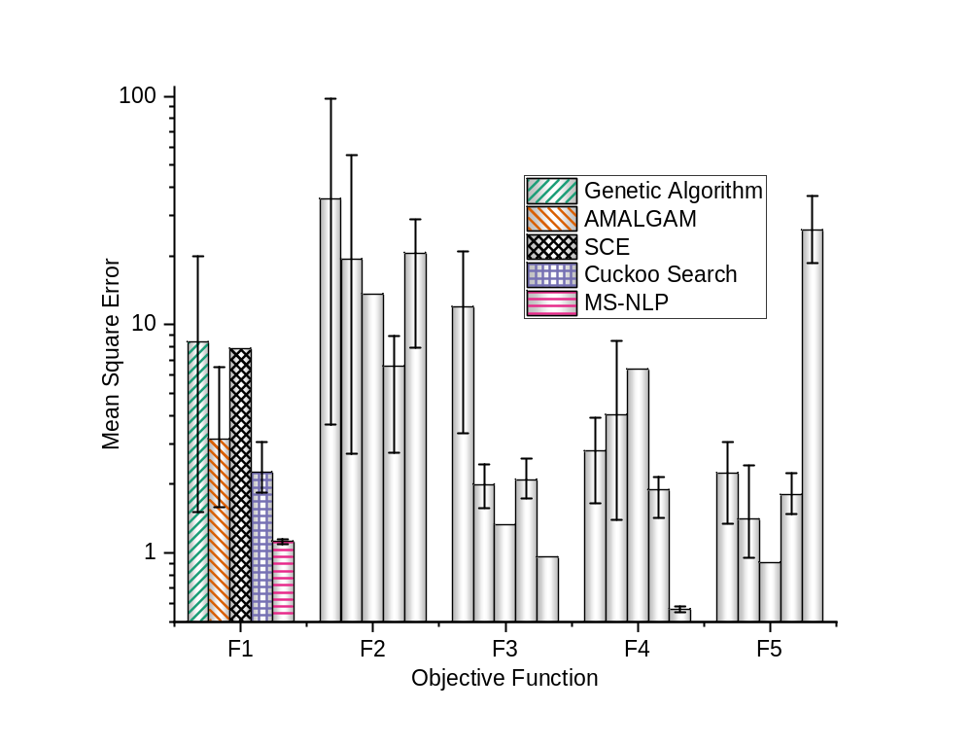
Figure 4. Accuracy comparison, based on the error summation from 3 heating rates, of results from combination of 5 algorithms and 5 objective functions for wood case. Each coloured pattern represents the result from one algorithm combined with one objective function. Meanwhile, the black line is the optimisation result variations of 4 identical repetitions.
When all the performance criteria in the multi-objective optimisation are combined, it is less likely to find the ideal method which perform best on every criterion. For example, in the previous discussion, one of MS-NLP result has the lowest error, however, this algorithm suffer from a huge CPU time. To overcome this problem, trade-offs of the multi objectives can be defined. These trade-offs are quantified by using Pareto optimality [40]. Pareto optimality is a state of solutions distribution of which an improvement in an objective is accompanied with deteriorations of other objectives [40]. Therefore, this Pareto optimal solutions create a boundary i.e. Pareto front, for 2 objectives cases, or Pareto surface, for more than 2 objectives cases, from which the user choose one best solution based on particular criteria.
We found that SCE with $F5$ offers the optimal balance between computational efficiency and accuracy. This finding is confirmed by a multi-objective analysis. Fig. 5 shows the performance of different optimisation methods (from this paper and others) with each point a balance between accuracy (y-axis) and computational efficiency (x-axis). The black dash line represents the Pareto front, along which the optimal solutions lie, i.e. no solution along the Pareto front is superior to another and the final optimal solution is the choice of the user. We assigned equal importance to accuracy and CPU time, which makes the SCE with $F5$ the optimal solution (with 0.91% error and 0.88×10¹³ CPU time) as it is the solution at the tip of the Pareto front. In Fig. A1 c we averaged the results from all concentrated objective functions of each algorithm to identify which algorithm on average performs best. With the equal importance of accuracy and efficiency, the optimal balance is, again, provided by the SCE with an error of 1.2 % and a CPU time of 1.25×10¹³. SCE with $F5$ is therefore the optimal optimisation method for inverse modelling of kinetic parameters when considering only one objective function.

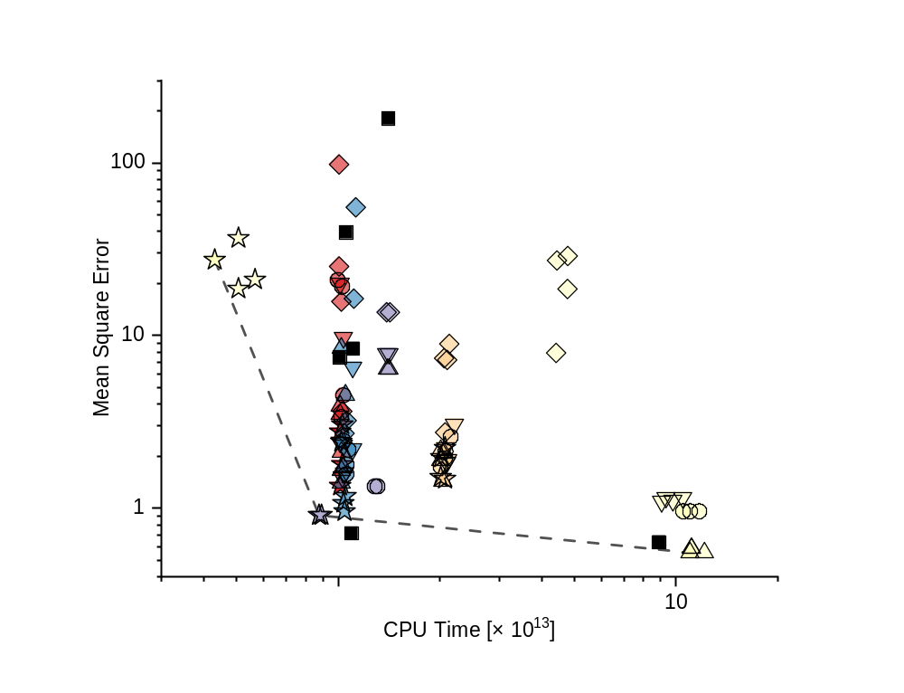
$$F1$$
$$F2$$
$$F3$$
$$F4$$
$$F5$$
Genetic Algorithm
AMALGAM
SCE
Cuckoo Search
MS-NLP
Pareto Front
Previous Works
Ding (PSO) [17]
Ding (SCE) [11]
Adenson (MS-NLP) [13]
Rein (GA) [1]
Huang (GA) [28]
Richter (AMALGAM) [5]
Figure 5. Multi-objective comparison of combination of 5 algorithms and 5 objective functions for wood case optimisation. Each coloured symbol and represents the result from one algorithm combined with one objective function of one repetition. Meanwhile, the black dash line represents the Pareto front.
Our results agree well with the literature. As shown in Fig 5, our optimisation performs similar to other optimisations in the literature [1, 5, 11, 13, 17, 28] in terms of accuracy and computational efficiency. Previous comparisons of optimisation algorithm in fire science also found SCE to be the optimal optimisation algorithm [15]. However, when the optimisation method in [11] which used SCE and different form of objective function is implemented in this study, the SCE performed poorly. The objective function in [11] can be minimised by minimising the numerator or maximising the denominator that resembles dispersed function, therefore, this result complies with our finding. Adenson et al. [13] firstly addressed this issue but they did not resolve the issue of what objective function and algorithm to use, and only recommend to use one that avoids local minimum. Therefore, our findings align well with theirs and expand significantly on their recommendations.
One of the main limitations of this paper is the small amount of fuels studied. However, we believe that our conclusions will hold for the majority of fuels, as reaction schemes beyond 3 steps are still uncommon in fire science and large combustion models. Although not presented here, the performances of the optimisation methods compared here are similar to their performances on the pyrolysis of beech from [19] and another cellulose from [14] which strengthen our conclusion. However, in biofuel production the introduction of a catalyst adds additional complexity to the inverse modelling [41]. The increase in complexity is on the addition of intermediate species in the reaction scheme which decomposes in the secondary reaction [14, 18]. This additional complexity is likely to only amplify the issues of using simple algorithms and higher CPU time. Therefore, when increasing the complexity of fuel beyond that of wood, all the identified recommendation within this paper should still be followed.
4. Conclusions
In this work, we investigated the role of the optimisation method, comprising objective function and optimisation algorithm, on the performance of kinetic inverse modelling. Six different optimisation algorithms, seven different objective functions, and two different fuels were tested. For a simple fuel, we found that the choice of algorithm is irrelevant. For a complex fuel, however, one should use SCE with objective function $F5$ (with 0.91% error and 0.88 × 10¹³ CPU time). Other evolutionary algorithms perform similarly well, but the performance of gradient based algorithms depends highly on the choice of objective function. Gradient-based algorithms perform on average worse than evolutionary algorithms, and we therefore recommend to use SCE and objective function $F5$ (mean squared error). This result compliment with the result from the average algorithm’s performance across the concentrated objective functions which also found SCE, with 1.26% error and 1.25 × 10¹³ CPU time, to be the best performer. This algorithm was also the best performer in previous comparison [15] done at the mesoscale. These findings can guide the selection of appropriate objective functions and optimisation algorithms in future studies involving the inverse modelling of biomass pyrolysis.
Acknowledgements
This research was partly sponsored by European Research Council (ERC) Consolidator Grant HAZE (682587), Indonesian Endowment Fund for Education (LPDP), Department of Mechanical Engineering Imperial College London, and Engineering and Physical Sciences Research Council (EPSRC).
Declarations of interest: none

Appendix A Supplementary Results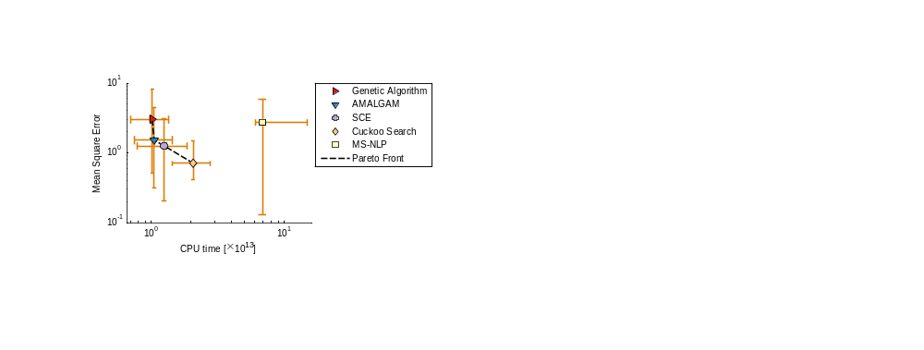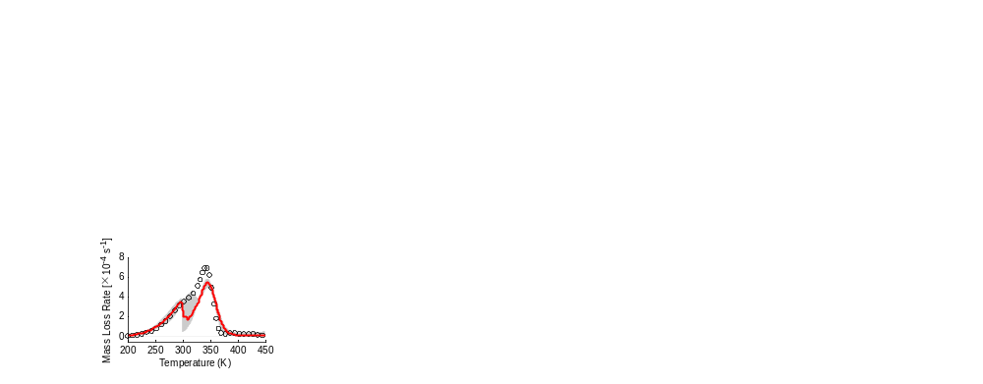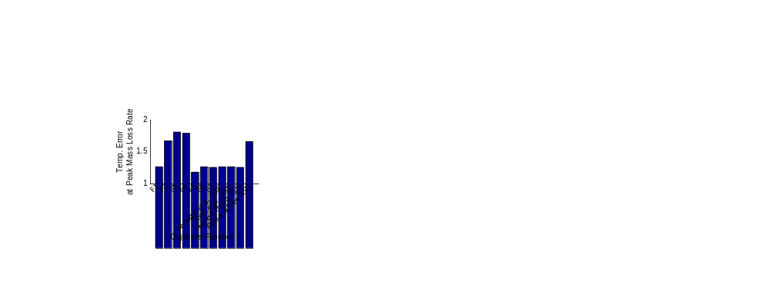
Experiment
Prediction
Variations
a. Cuckoo Search with $F6$ for wood
b. Trial and Error for cellulose
c. Advanced algorithms for wood
CPU time = 2.1 × 10¹³
β = 2.5 K/min
Genetic Algorithm

AMALGAM

SCE

Cuckoo Search

MS-NLP

Pareto Front

Result Variations

Figure A1. (a) Mass loss rate curve of wood pyrolysis, and Cuckoo Search with $F6$ prediction. The symbol, red line, and grey shade represent experimental data, prediction, and variations respectively. (b) Trial and Error for cellulose using 11 objective functions. (c) Multi-objective comparison of advanced algorithms for wood case when averaged across 5 objective functions.
Appendix B. Supplementary literature review
Genetic Algorithm
Genetic Algorithm follows biological theory of survival-of-the-fittest proposed by Darwin [34]. This algorithm was developed by John Holland [35] and become the foundation of modern evolutionary computing [34]. Genetic algorithm employs multiple potential solutions (called population) to optimise the problem. In the optimisation process, the vectors of solutions (population of kinetic parameters) are represented in binary numbers. Theses binary numbers are represented in decimal number in pre and post processing.
Genetic algorithm contains three fundamental operations: crossover, mutation, and selection. In crossover operation, several digits from one solution are swapped with the digits from other solutions. Few digits from the updated solutions are reversed (i.e. from 0 to 1 or vice versa) in mutation operation. The best solutions are selected and chosen as the associated kinetic parameters.
AMALGAM
Multi-algorithm, genetically adaptive multi-objective (AMALGAM) was developed by Vrugt and Robinson in 2007 [36]. This algorithm combines several algorithms to optimise one case. All the included algorithm were run in parallel to find the best solution. In this study, the algorithms included in AMALGAM are Genetic Algorithm, Particle Swarm Optimisation (PSO), Differential Evolution, and Adaptive Metropolis Hasting.
Shuffled Complex Evolution
Shuffle Complex Evolution (SCE) was developed by Duan et al [37]. This algorithm incorporates deterministic and stochastic approaches. SCE follows the concept of clustering, systematic evolution of complex, and competitive evolution [37]. The vectors of solutions (sets of kinetic parameters) are clustered in a fixed number of complexes. The values of the vectors of solutions on each cluster are updated using competitive complex evolution (CCE) [37]. Each member in each complex cluster is a potential parent to evolve. However, the probability of evolutions from better parents is made higher than those from worse parents [37]. In this study, triangular probability distribution is employed as systematic evolution of the complexes (simplex method) [38].
Multi-Start Non-Linear Program (MS-NLP)
Multi-Start Non-Linear Program (MS-NLP) is a global optimisation tool package in MATLAB that can be used to optimise non-linear problem. There are many algorithms available in MS-NLP package in MATLAB. Each algorithm has different applications. In this study, the problem is to optimise the objective functions while maintaining the solutions to be within a certain range. This type of problem is defined as a constrained non-linear problem. Therefore, the most suitable algorithm in MS-NLP package is sequential quadratic programming (SQP).
SQP is a gradient based optimisation in which the derivation is implemented in the Lagrangian function of the problem. This Lagrangian function is the summation of the objective function and the constraint functions. These constraint functions are multiplied by a coefficients named Lagrange multipliers.
The Lagrangian function is derived and set to be zero. This operation is undertaken using steepest descend method to update both the solutions and the Lagrange multipliers. This procedure is repeated with new initial guesses to avoid the local optimum. The number of start (multi-start) determines the number of the repetition.
Cuckoo Search
Cuckoo Search was developed by Yang in 2009 and one of the latest nature-inspired meta-heuristic algorithms [34, 39]. Cuckoo search mimics the brood parasitism behaviour of cuckoo bird species that employ other bird’s nest to put their eggs [34]. One egg in cuckoo search represents one vector of solutions (i.e. one set of kinetic parameters). The eggs are contained in nests. In this study, one nest contains only one egg. The vectors of solutions (eggs in each nest) are updated by following 2 operations. Firstly, the probability of cuckoo’s egg disposal that follows random walk [34]. Secondly, each egg is updated to satisfy Lévy flights [34].
The 5 advanced algorithms are also compared with Random Search which represents a simple algorithm. Trial and Error method is also used in the investigation to find the best objective function which becomes an assessor for the comparison.
Random Search
Random search is used to represent a simple algorithm. This algorithm utilises random guesses within the search domain to find the best solutions. The number of guesses are defined as the number of function evaluations which are the same as in the advanced algorithms function evaluations. These guesses are spread across the search domain at which each possible solution has a specific probability to be selected. In this work, there is no pre-dominant solution in the domain search. Therefore, uniformly distributed probability is used.
References
[1] | G. Rein, C. Lautenberger, A. C. Fernandez-Pello, J. L. Torero and D. L. Urban, “Application of genetic algorithms and thermogravimetry to determine the kinetics of polyurethane foam in smoldering combustion,” Combustion and Flame, vol. 146, p. 95–108. https://doi.org/10.1016/j.combustflame.2006.04.013, 2006.
[2] | A. Anca-Couce, N. Zobela, A. Bergerb and F. Behrendt, “Smouldering of pine wood: kinetics and reaction heats,” Combustion and Flame, vol. 159, no. 4, pp. 1708-1719. https://doi.org/10.1016/j.combustflame.2011.11.015, 2012.
[3] | F. Richter, A. Atreya and P. Kotsovinos, “The effect of chemical composition on the charring of wood across scales,” Proceeding of Combustion Institute, 2018.
[4] | F. Richter and G. Rein, “The Role of Heat Transfer Limitations in Polymer Pyrolysis at the Microscale,” Frontier in Mechanical Engineering, vol. 4, 2018.
[5] | F. Richter and G. Rein, “Pyrolysis kinetics and multi-objective inverse modelling of cellulose at the microscale,” Fire Safety Journal, vol. 91, pp. 191-199. http://dx.doi.org/10.1016/j.firesaf.2017.03.082, 2017.
[6] | H. L. Friedman, “Kinetics of thermal degradation of char-forming plastics from thermogravimetry: application to Phenolic Plastic,” Journal of Polymer Science Part C, vol. 6, pp. 183-195. https://doi.org/10.1002/polc.5070060121, 1964.
[7] | S. Vyazovkin and C. A. Wight, “Kinetics in solids,” Annual Review of Physical Chemistry, vol. 48, pp. 125-149. https://doi.org/10.1146/annurev.physchem.48.1.125, 1997.
[8] | S. Vyazovkin, A. K. Burnham, J. M. Criado, L. A. Pérez-Maqueda, C. Popescu and N. Sbirrazzuoli, “ICTAC Kinetics Committee recommendations for performing kinetic computations on thermal analysis data,” Thermochimica Acta, vol. 520, pp. 1-19, 2011.
[9] | S. Sunphorka, B. Chalermsinsuwan and P. Piumsomboon, “Artificial neural network model for the prediction of kinetic parameters of biomass pyrolysis from its constituents,” Fuel, vol. 193 , p. 142–158, 2017.
[10] | M. Aghbashlo, M. Tabatabaei, M. H. Nadian, V. Davoodniae and S. Soltanian, “Prognostication of lignocellulosic biomass pyrolysis behavior using ANFIS model tuned by PSO algorithm,” Fuel, vol. 253 , p. 189–198, 2019.
[11] | Y. Ding, J. Zhang, Q. He, B. Huang and S. Mao, “The application and validity of various reaction kinetic models on woody biomass pyrolysis,” Energy, vol. 179 , pp. 784-791, 2019.
[12] | F. Richter and G. Rein, “Heterogeneous kinetics of timber charring at the microscale,” Journal of Analytical and Applied Pyrolysis, vol. 138, pp. 1-9, 2019.
[13] | M. O. Adenson, M. D. Kelley, O. O. Elkelany, J. J. Biernacki and Y.-W. Liu, “Kinetics of Cellulose Pyrolysis: Ensuring Optimal Outcomes,” The Canadian Journal of Chemical Engineering, vol. 96, no. 4, pp. 926-935. https://doi.org/10.1002/cjce.23060, 2017.
[14] | G. Varhegyi, M. J. Antal Jr., E. Jakab and P. Szabo, “Kinetic modeling of biomass pyrolysis,” J. Analytical and Applied Pyrolysis, vol. 42, pp. 73 – 87. https://doi.org/10.1016/S0165-2370(96)00971-0, 1997.
[15] | C. Lautenberger and C. Fernandez-Pello, “Optimization Algorithms for Material Pyrolysis Property Estimation,” in Fire Safety Science-Proceedings of the TenthInternational Symposium, 2011.
[16] | L. Hasalová, J. Ira and M. Jahoda, “Practical observations on the use of Shuffled Complex Evolution (SCE) algorithm for kinetic parameters estimation in pyrolysis modeling,” Fire Safety, vol. 80, pp. 71 - 82. https://doi.org/10.1016/j.firesaf.2016.01.007, 2016.
[17] | Y. Ding, W. Zhang, L. Yu and K. Lu, “The accuracy and efficiency of GA and PSO optimization schemes on estimating reaction kinetic parameters of biomass pyrolysis,” Energy , vol. 176, pp. 582-588, 2019.
[18] | G. Varhegyi and M. J. Antal, “Kinetics of the Thermal Decomposition of Cellulose, Kinetics of the Thermal Decomposition of Cellulose,,” Energy & Fuels, vol. 3, pp. 329-335, 1989.
[19] | R. S. Miller and J. Bellan, “A Generalized Biomass Pyrolysis Model Based on Superimposed Cellulose, Hemicellulose and Liqnin Kinetics,” Combustion Science and Technology, vol. 126, p. 97–137. https://doi.org/10.1080/00102209708935670, 1997.
[20] | G. Rein, C. Lautenberger and A. and Fernandez-Pello, “Using Genetic Algorithms to Derive the Parameters of Solid-Phase Combustion from Experiments,” in 20th International Colloquium on the Dynamics of Explosions and Reactive Systems, 2005.
[21] | C. Branca, A. Albano and C. Di Blasi, “Critical evaluation of global mechanisms of wood devolatilization,” Thermochimica Acta, vol. 429 , p. 133–141, 2005.
[22] | C. Lautenberger, G. Rein and A. Fernandez-Pello, “The Application of a Genetic Algorithm to Estimate Material Properties for Fire Modeling from Bench-Scale Fire Test Data,” Fire Safety Journal, vol. 41, pp. 204-214, 2006.
[23] | S. Lee, “Material Property Estimation Method Using a Thermoplastic Pyrolysis Model,” Department of Fire Protection Engineering, Worcester Polytechnic Institute, Worcester, MA, Worcester, MA, 2006.
[24] | A. Matala, “Estimation of solid phase reaction parameters for fire simulation,” Helsinki University of Technology, Espoo, Finland, 2008.
[25] | C. Lautenberger and A. Fernandez-Pello, “Generalized Pyrolysis Model for Combustible Solids,” Fire Safety Journal, vol. 44, pp. 819-839, 2009.
[26] | C. Lautenberger and A. Fernandez-Pello, “A Model for the Oxidative Pyrolysis of Wood,” Combustion and Flame, vol. 156, pp. 1503-1513, 2009.
[27] | M. Chaos, M. Khan, N. Krishnamoorthy, J. de Ris and S. Dorofeev, “Evaluation of optimization schemes and determination of solid fuel properties for CFD fire models using bench-scale pyrolysis tests,” in Proceedings of the Combustion Institute 33, 2010.
[28] | X. Huang and G. Rein, “Smouldering combustion of peat in wildfires: Inverse modelling of the drying and the thermal and oxidative decomposition kinetics,” Combustion and Flame, vol. 161, p. 1633–1644. http://dx.doi.org/10.1016/j.combustflame.2013.12.013, 2014.
[29] | F. Yang, C. Rippe, J. Hodges and B. Lattimer, “Methodology for material property determination,” Fire and Materials, p. 1–13, 2019.
[30] | K. R. G. Burra and A. K. Gupta, “Modeling of biomass pyrolysis kinetics using sequential multi-step reaction model,” Fuel , vol. 237, p. 1057–1067, 2019.
[31] | N. Bal and G. Rein, “Relevant model complexity for non-charring polymer pyrolysis,” Fire Safety, vol. 61, pp. 36-44, 2013.
[32] | C. Di Blasi, “Modeling Chemical and Physical Processes of Wood and Biomass Pyrolysis,” Progress in Energy and Combustion Science, vol. 34, pp. 47-90. https://doi.org/10.1016/j.pecs.2006.12.001, 2008.
[33] | M. Grønli, M. J. Antal Jr. and G. Várhegyi, “A Round-Robin Study of Cellulose Pyrolysis Kinetics by Thermogravimetry,” Industrial & Engineering Chemistry Research, vol. 38, pp. 2238-2244. https://doi.org/10.1021/ie980601n, 1999.
[34] | X.-S. Yang, Nature-Inspired Optimization Algorithm, 1 ed., London: Elsevier, 2014.
[35] | J. Holland, “Adaptation in Natural and Artificial Systems,” MIT Press, Cambridge, 1975.
[36] | J. A. Vrugt and B. A. Robinson, “Improved evolutionary optimization from genetically adaptive multimethod search,” PNAS, vol. 104, pp. 708-711, 2007.
[37] | Q. Y. Duan, V. K. Gupta and S. Sorooshian, “Shuffled Complex Evolution Approach for Effective and Efficient Global Minimization,” Journal of Optimization Theory and Applications, vol. 76, no. 3, pp. 501-521. https://doi.org/10.1007/BF00939380, 1993.
[38] | J. A. Nelder and R. Mead, “A Simplex Method for Function Minimization,” Computer, vol. 7, pp. 308-313. https://doi.org/10.1093/comjnl/7.4.308, 1965.
[39] | X. S. Yang and S. Deb, “Cuckoo Search via Lévy Flights,” in 2009 World Congress on Nature & Biologically Inspired Computing (NaBIC), USA, 2009.
[40] | J. H. Van Sickel, P. Venkatesh and K. Y. Lee, “Analysis of the pareto ront of a multi-objective optimization problem for a fossil fuel power plant,” in 2008 IEEE Power and Energy Society General Meeting, 2008.
[41] | A. Imran, E. A. Bramer, K. Seshan and G. Brem, “An overview of catalysts in biomass pyrolysis for production of biofuels,” Biofuel Research Journal, vol. 20, pp. 872-885, 2018.

