Immunoglobulin free light chains in the pathogenesis of lung disorders

Esmaeil Mortaz^{1,2,3}, Ian M Adcock^{4,5}, Hamidreza Jamaati⁶, Adnan Khosravi⁶, Masoud Movassaghi⁷, Johan Garssen^{3, 8}, Mostafa Alavi Mogadam⁶, Frank A. Redegeld³

¹Department of Immunology, Medical School, Shahid Beheshti University of Medical Sciences, Tehran, Iran; ²Clinical Tuberculosis and Epidemiology Research Center, National Research Institute of Tuberculosis and Lung Diseases (NRITLD), Shahid Beheshti University of Medical Sciences, Tehran, Iran; ³Division of Pharmacology, Utrecht Institute for Pharmaceutical Sciences, Faculty of Science, Utrecht University, Utrecht, The Netherlands; ⁴Cell and Molecular Biology Group, Airways Disease Section, National Heart and Lung Institute, Imperial College London, Dovehouse Street, London, UK; ⁵Priority Research Centre for Healthy Lungs, Hunter Medical Research Institute, The University of Newcastle, Newcastle, New South Wales, Australia; ⁶Chronic Respiratory Disease Research Center and National Research Institute of Tuberculosis and Lung Disease (NRITLD), Masih Daneshvari Hospital, Shahid Beheshti University of Medical Sciences, Tehran, Iran; ⁷Department of Pathology and Laboratory Medicine, University of California, Los Angeles (UCLA), USA; ⁸Nutricia Research Centre for Specialized Nutrition, Utrecht, The Netherlands.

Corresponding author:
Frank Redegeld, PhD;
Division of Pharmacology,
Utrecht Institute for Pharmaceutical Sciences,
Faculty of Science,
Utrecht University,
Utrecht,
The Netherlands.
Tel: (+316) 2025 2139;
Email: f.a.m.redegeld@uu.nl
Abstract
Inflammation is an important component of numerous cancers and chronic diseases and many inflammatory mediators have been shown to have potential prognostic roles. Tumor-infiltrating mast cells can promote tumor growth and angiogenesis, but the mechanism of mast cell activation is unclear. Early studies have shown that immunoglobulin free light chains (FLC) can trigger mast cell activation in an antigen-specific manner. Increased expression of FLC is observed within the stroma of many human cancers including those of breast, colon, lung, pancreas, kidney and skin. These overexpressed FLCs are co-localized to areas of mast cell infiltration. Importantly, FLC expression is associated with basal-like cancers with an aggressive phenotype. Moreover, FLCλ is expressed in areas of inflammatory cell infiltration and its expression is significantly associated with poor clinical outcome. In addition, serum and bronchoalveolar fluid FLC concentrations are increased in patients with idiopathic pulmonary fibrosis (IPF) and hypersensitivity pneumonitis (HP) compared to control subjects. We provide an update on the role of FLC in the pathogenesis of several lung disorders and indicate how this may contribute to new therapeutic opportunities.

Introduction
Many of the pathological mechanisms that mediate inflammatory- and immune-related disorders in the lung ranging from allergy to cancer are still poorly understood and are the subject of extensive research. Mast cells and neutrophils are recognized as critical players in the sensitization and effector phase of chronic inflammatory immune responses of the lungs [1]. Immunoglobulins form the backbone of the adaptive humoral immune response and recognition of a specific antigen can initiate various immune responses directed at the removal or neutralization of potential threats [2]. It has been long recognized that B cells not only produce and secrete tetrameric immunoglobulins, but also secrete a substantial quantity of free immunoglobulin light chains (FLC). In the mammalian immune system, two isotypes of FLC are produced: κ and λ [3]. The ratio in which both types are produced varies significantly among species. For instance, in humans, 50-60% of the FLC produced are κ isotype whereas this increases to 95% in mice [4,5].
FLCs are found in virtually all body fluids and tissues and can initiate inflammation by antigen-specific activation of mast cells [6-9]. FLC can also exert other biological activities including binding to intracellular and extracellular proteins and modulation of cellular interactions [6]. The presence of Ig-FLC in both atopic and non-atopic diseases may provide an alternative approach to the treatment of such diseases. The highly selective FLC antagonist (F-991) has demonstrated remarkable biological activity in a number of animal models of allergic diseases, and holds promise for the potential treatment of allergic diseases in humans [10].
Currently, serum FLCs are mainly used to monitor plasma-cell dyscrasia [11]. However, a growing body of studies suggests that serum FLC could be useful biomarkers in immunopathological conditions as they reflect polyclonal B-cell activation. For example, serum FLC levels are elevated in lupus [12], rheumatoid arthritis and Sjögren syndrome [13-15] and changes in their levels are associated with disease activity. Serum FLC has also recently been reported as biomarkers of systemic sclerosis activity and severity [16]. In addition, B-cell activation markers including serum FLC, beta2-microglobulin and BAFF correlate with disease severity and activity (Fig. 1). It is likely, therefore, that serum FLC levels may alter in various pulmonary disorders and that this will provide insights into disease mechanisms. In this review, we will discuss the possible role of FLC in allergic and non-allergic inflammatory lung diseases and highlight the potential FLC antagonist as a therapeutic option for several lung disorders.

Chronic obstructive lungs diseases (COPD)
Chronic obstructive pulmonary disease (COPD) is characterized by an irreversible, progressive airflow limitation which is associated with an abnormal inflammatory response of the lungs to noxious particles or gases, most commonly cigarette smoke and other indoor pollutants such as biomass fuels [17, 18]. Neutrophils, monocytes/macrophages, T cells and mast cells are the inflammatory cells implicated playing role in COPD pathophysiology [19-25]. Interestingly, FLC are able to prolong the life of neutrophils [26] suggesting that they could contribute to the chronic neutrophilia associated with COPD. In support of this concept, Braber et al. described elevated serum and lung FLC levels in COPD patients compared with healthy volunteers. This increase in FLCs was associated with increased neutrophils both in humans and an animal model of COPD [27]. FLC binding to neutrophils increased the release of CXCL8, which is a major chemokine for neutrophil recruitment into the airways, suggesting that FLCs may act in a feed-forward manner to enhance neutrophilia in COPD [27]. The enhanced expression of FLCs in COPD lung tissue and serum correlates with airflow limitation [28] and suggests that FLC may play a pro-inflammatory role in COPD pathogenesis. It will be important to test this hypothesis in animal models of COPD.

Allergic lung diseases including asthma
Allergic diseases are a serious health problem in the developed world. IgE interacting with its high-affinity receptor, FcεRI, is a major driver of most types of allergies. However, a subgroup of allergic patients display similar symptoms but without elevated levels of total serum IgE and/or antigen-specific IgE. Asthma is a relatively common disorder manifested by airway inflammation that leads to bronchoconstriction and respiratory symptoms. Approximately 50% of adults with this disorder are atopic with IgE-mediated tissue sensitization and Th2 helper cell responses leading to eosinophilia [29, 30]. However, an equal percentage of asthmatic patients are non-atopic as evidenced by negative skin-prick test as well as by normal serum IgE levels and eosinophil counts [29, 30]. This suggests that other causative factors may be involved in the etiology of this type of asthma. Analysis of FLC levels in non-atopic subjects should be initiated.
Increased FLC levels can be detected in patients suffering from a number of immunological disorders. For example, it has been shown that antigen-specific FLCs mediate hypersensitivity-like responses. Importantly, these hypersensitivity-like responses in the lung could be initiated by adoptive transfer of allergen-specific FLC. This suggests that these FLC may be important in the pathophysiology of asthma as well as other non-IgE-mediated inflammatory diseases. Furthermore, the FLC antagonist, F991, completely inhibited both the early- and late-phase of DNFB-induced pulmonary hypersensitivity in a mouse model of non-atopic asthma [10, 31]. The role of IgE and FLCs in allergic and non-allergic disease has been extensively reviewed [3, 32, 60] and underlines a possible role for targeting FLC biology in the development of novel therapeutic approaches in these diseases. Since F991 has demonstrated remarkable biological activity in several animal models of disease this needs to be translated into human clinical trials [32].

Lung Sarcoidosis
Sarcoidosis is a chronic disorder that affects virtually all organ systems in the body. Histologically, it is characterized by the presence of T lymphocytes, mononuclear phagocytes and non-caseating granulomas with 90% of the reported cases involving the lungs. Sarcoidosis is defined as an inflammatory, granulomatous, multisystem disorder of unclear etiology [33, 34] which highlights the fact that although the lungs are predominantly involved, other organs such as the skin, lymphatics, heart, musculoskeletal, neurological, and gastrointestinal systems are also targeted [35]. Granulomatous inflammation in sarcoidosis is believed to be caused by the host response to a persistent poorly degradable antigen. This antigenic stimulus can arise from non-infectious or infectious sources. Various non-infective agents have been suspected primarily because of their epidemiologic association; however, these have not stood the test of time [37].
Increased concentrations of serum FLC in sarcoidosis was initially reported 30 years ago [38] and have subsequently been associated with active sarcoidosis and to reflect disease activity [39]. This link to disease activity is also seen in sero-positive RA patients [39]. Recently, we demonstrated the increased levels of FLC in serum of pulmonary sarcoidosis patients [40]. Further studies are required to determine the role of FLCs in the etiology of sarcoidosis and the use of F991 in disease models may help address this question.

Lung cancer
A modest increase in serum FLCs was also observed in patients with lung cancer [38]. The expression of FLCs is also associated with the progression of other human cancers indicating its possible use a prognostic biomarker of cancer generally [41]. Lung cancer is the leading cause of the cancer-related deaths worldwide. Non-small cell lung cancer (NSCLC) is the most frequent type of lung cancer and is usually only diagnosed at more advanced stages accounting for much of the poor prognosis. A biomarker is urgently needed to capable of aiding the diagnosis of lung neoplasms at an early stage or even help to clarify the pathogenesis of lung cancer.

Hypersensitivity Pneumonitis and Idiopathic Pulmonary Fibrosis
Interstitial lung diseases (ILD) comprise a diverse group of disorders affecting the lung parenchyma that are classified together because they share similar clinical, radiographic, and physiologic features [42]. Idiopathic pulmonary fibrosis (IPF) and hypersensitivity pneumonitis (HP) are two important complex diseases within the ILD group. IPF is a chronic fibrosing interstitial pneumonia of unknown etiology, restricted to the lungs and associated with the histopathologic pattern of usual interstitial pneumonia (UIP) [43]. It is characterized by alveolar epithelial cell injury and activation, expansion of the fibroblast/myofibroblast population forming the so-called fibroblastic foci and the exaggerated accumulation of extracellular matrix [44, 45]. The disease is usually progressive and there are no effective therapies that reverse the disease [46-48]. One of the major issues surrounding IPF is that its diagnosis is by elimination of other diseases and it may represent several distinct phenotypes due to divergent pathological causes [49]. This makes the development of an effective therapy difficult without the means of defining these sub-phenotypes of patients at an early stage. HP consists of a group of lung disorders resulting from exposure to a wide variety of organic particles causing an immunopathological reaction of the lungs in susceptible individuals [50]. One of the most frequent etiologies of HP is the inhalation of bird-derived proteins that provoke the so-called pigeon breeders’ disease (PBD). The clinical behavior is heterogeneous and may present as acute, sub-acute or chronic forms, often with overlap between these interrelated categories [51]. Importantly, chronic HP may evolve into interstitial fibrosis, and in advanced stages may be very difficult to distinguish from IPF/UIP [52, 53]. Strong evidence indicates that sub-acute and chronic HP are primarily a T-cell-mediated hypersensitivity [54]. However, less is known about the involvement of B lymphocytes although their potential role is indicated in sub-acute cases by the presence of high titers of circulating specific antibodies and the presence of plasma cells in the bronchoalveolar lavage [55, 56].
FLC concentrations are increased in the serum and bronchoalveolar fluid of IPF and HP patients and they are present within affected lung tissue [57]. Further studies are needed to investigate whether FLCs may make effective diagnostic markers of disease or may even be involved in mediating the pathology of both diseases.

Future perspective
The Biology of FLCs provides evidence for a role in several inflammatory and immune diseases as well as a number of cancers. The measurement of total and antigen-specific FLC might be of primary interest and indicate a causal role in several lung diseases (Fig, 2). Their measurement may be useful as a diagnostic marker of lung disorders such as allergic reactivity, ILDs, sarcoidosis and hypersensitivity pneumonitis. However, co-morbidities may affect the specificity of these measurements since FLC are also reported as potential prognostic markers in autoimmune diseases such as rheumatoid arthritis and multiple sclerosis [14, 58, 59]. Future studies are warranted to further understand their role in the pathogenesis of lung disorders in which mast cells and B cells are implicated in the disease pathophysiology.
Figure Legends:
Figure 1. Comparison of serum FLC (sFLC) levels between systemic sclerosis (SSc) patients and healthy controls.¹³ FLC; Free Light chain.
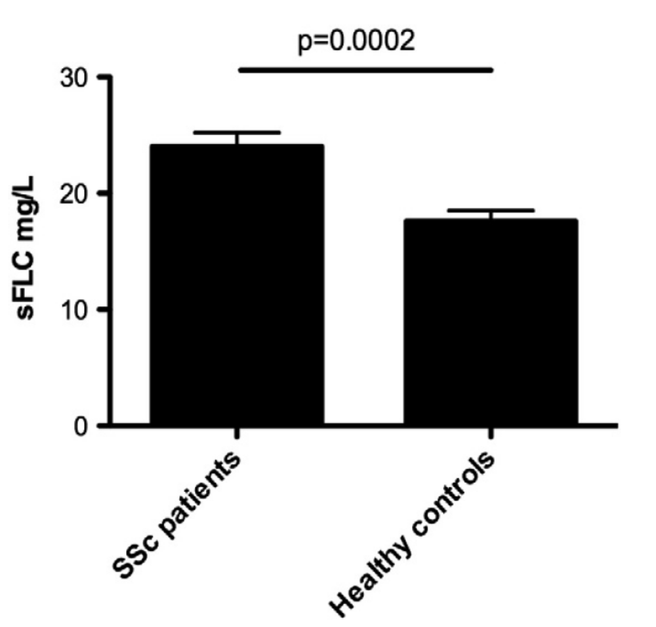

Figure 2. The putative role of FLC in inflammatory diseases. Figure modified from Redegeld et al, Mayo Clin Proc. 2012 (60).
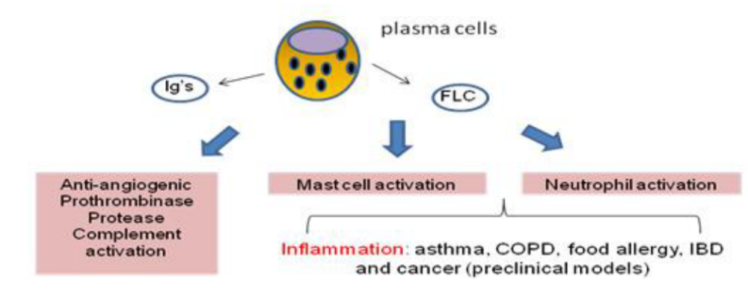

CONFLICT OF INTERESTS:
The authors claim has not any conflict of interest in this paper.

References
1) Dudeck A, Dudeck J, Scholten J, et al. Mast Cells Are Key Promoters of Contact Allergy that Mediate the Adjuvant Effects of Haptens. Immunity 2011; 34(6): 973-84.
2) Christopher Chiu and Peter J Openshaw. Antiviral B cell and T cell immunity in the lungs. Nat Immunol. 2015; 16(1):18-26.
3) Redegeld FA, Nijkamp FP. Immunoglobulin free light chains and mast cells: pivotal role in T-cell-mediated immune reactions? Trends Immunol 2003;24:181–185.
4) Katzmann JA, Clark RJ, Abraham RS, Bryant S, Lymp JF, Bradwell AR, Kyle RA. Serum reference intervals and diagnostic ranges for freekappa and free lambda immunoglobulin light chains: relative sensitivity for detection of monoclonal light chains. ClinChem 2002;48:1437–1444.
5) Woloschak GE, Krco CJ.Regulation of kappa/lambda immunoglobulin light chain expression in normal murine lymphocytes. Mol Immunol 1987;24:751–757.
6) Thio M, Blokhuis BR, Nijkamp FP, Redegeld FA . Free immunoglobulin light chains: a novel target in the therapy of inflammatory diseases. Trends Pharmacol Sci 2008; 29: 170–174.
7) Matsumori A, Shimada M, Jie X, Higuchi H, Groot Kormelink T, et al. Effects of free immunoglobulin light chains on viral myocarditis. Circ Res 2010; 106:1533–1540.
8) Rijnierse A, Redegeld FA, Blokhuis BR, Van der Heijden MW, TeVelde AA, etal. Ig-free light chains play a crucial role in murine mast cell-dependent colitis and are associated with human inflammatory bowel diseases. J Immunol 2010; 185: 653–659.
9) Schouten B, van Esch BC, van Thuijl AO, Blokhuis BR, Groot Kormelink T, et al.. Contribution of IgE and immunoglobulin free light chain in the allergic reaction to cow’s milk proteins. J Allergy Clin Immunol 2010; 125: 1308–1314.
10) Redegeld FA, van der Heijden MW, Kool M, Heijdra BM, Garssen J, Kraneveld AD, Van Loveren H, Roholl P, Saito T, Verbeek JS, Claassens J, Koster AS, Nijkamp FP Immunoglobulin-free light chains elicit immediate hypersensitivity-like responses Nat Med. 2002 ;8(7):694-701.
11) Larsen JT, Kumar SK, Dispenzieri A, et al. Serum free light chain ratio as a biomarker for high-risk smoldering multiple myeloma. Leukemia 2013; 27:941–6.
12) Jolly M, Francis S, Aggarwal R, et al. Serum free light chains, interferon-alpha, and interleukins in systemic lupus erythematosus. Lupus 2014; 23:881–8.
13) Groot Kormelink T, Tekstra J, Thurlings RM, Boumans MH, Vos K, Tak PP, Bijlsma JW, Lafeber FP, Redegeld FA, van Roon JA. Decrease in immunoglobulin free light chains in patients with rheumatoid arthritis upon rituximab (anti-CD20) treatment correlates with decrease in disease activity. Ann Rheum Dis. 2010 ;69(12):2137-44.
14) Gottenberg JE, Aucouturier F, Goetz J, et al. Serum immunoglobulin free light chain assessment in rheumatoid arthritis and primary Sjogren's syndrome. Ann Rheum Dis 2007;66:23–7.
15) Gottenberg JE, Seror R, Miceli-Richard C, et al. Serum levels of beta2-microglobulin and free light chains of immunoglobulins are associated with systemic disease activity in primary Sjogren's syndrome. Data at enrollment in the prospective ASSESS cohort. PLoS One 2013;8:e59868.
16) Aurélia Lanteri , Vincent Sobanski , Carole Langlois , Guillaume Lefèvre , Carine Hauspie , Sébastien Sanges , Marc Lambert , Sandrine Morell-Dubois , Pierre-Yves Hatron , Eric Hachulla , David Launay , Sylvain Dubucquoi, Serum free light chains of immunoglobulins as biomarkers for systemic sclerosis characteristics, activity and severity. Autoimmunity Reviews2014; 13 ,974–980.
17) Rabe KF, Hurd S, Anzueto A, Barnes PJ, Buist SA, Calverley P, Fukuchi Y, Jenkins C, Rodriguez-Roisin R, van Weel C, et al. Global strategy for the diagnosis, management, and prevention of chronic obstructive pulmonary disease: GOLD executive summary. Am J Respir Crit Care Med 2007;176:532–555,
18) Global Initiative for Chronic Obstructive Lung Disease (GOLD). Global strategy for diagnosis, management, and prevention of chronic obstructive pulmonary disease [Internet; updated 2009]. NHLBI/ WHO workshop report. Available from: www.goldcopd.org.
19) Barnes PJ.Cellular and molecular mechanisms of chronic obstructive pulmonary disease. Clin Chest Med. 2014 ;35(1):71-86.
20) Mortaz E, Folkerts G, Redegeld F. Mast cells and COPD. Pulm Pharmacol Ther. 2011 Aug;24(4):367-72.
21) Mortaz E, Folkerts G, Nijkamp FP, Henricks PA. ATP and the pathogenesis of COPD. Eur J Pharmacol. 2010; 25;638(1-3):1-4.
22) Mortaz E, Folkerts G, Engels F, Nijkamp FP, Redegeld FA. Cigarette smoke suppresses in vitro allergic activation of mouse mast cells. Clin Exp Allergy. 2009 ;39(5):679-87.
23) Mortaz E, Adcock IM, Ito K, Kraneveld AD, Nijkamp FP, Folkerts G. Cigarette smoke induces CXCL8 production by human neutrophils via activation of TLR9 receptor. Eur Respir J. 2010;36(5):1143-54.
24) Barnes PJ. Mechanisms in COPD: differences from asthma. Chest 2000; 117:10S–14S.
25) Pesci A, BalbiB,Majori M, Cacciani G, Bertacco S, Alciato P, Donner CF. Inflammatory cells and mediators in bronchial lavage of patients with chronic obstructive pulmonary disease. Eur Respir J 1998;12:380–386.
26) Cohen G, Rudnicki M, Deicher R, Horl WH. Immunoglobulin light chains modulate polymorphonuclear leucocyte apoptosis. Eur J Clin Invest 2003;33:669–676.
27) Saskia Braber , Marco Thio , Bart R. Blokhuis, Paul A. J. Henricks, Pim J. Koelink, Tom Groot Kormelink, Gillina F. G. Bezemer, Huib A. M. Kerstjens, Dirkje S. Postma, Johan Garssen, Aletta D. Kraneveld1, Frank A. Redegeld, and Gert Folkerts. An Association between Neutrophils and Immunoglobulin Free Light Chains in the Pathogenesis of Chronic Obstructive Pulmonary Disease. Am J Respir Crit Care Med 2012 , 185. 8, 817–824.
28) Zhang M, Tao HC, Li YQ, Pei HS, Zhu SY, Chen B, Zhou RJ, Zhang MW. Expression and significance of immunoglobulin free light chains in serum and lung tissues from patients with chronic obstructive pulmonary disease. ZhonghuaJie He He Hu Xi ZaZhi. 2013 ;36(12):945-9.
29) Pearce, N., Pekkanen, J. & Beasly, R. How much asthma is really attributable to atopy? Thorax 1999; 54, 268–272.
30) Douwes, J., Gibson, P., Pekkanen, J. & Pearce, N. Non-eosinophilic asthma: importance and possible mechanisms Thorax 2002; 57, 643–648.
31) Aletta D. Kraneveld, Mirjam Kool, Anneke H. van Houwelingen, Paul Roholl, Alan Solomon, Dirkje S. Postma, Frans P. Nijkamp, and Frank A. Redegeld. Elicitation of allergic asthma by immunoglobulin free light chains. PNAS 2005,102, 1578–1583.
32) Frank A Redegeld, Cornelis H Wortel. IgE and immunoglobulin free light chains in allergic disease: New therapeutic opportunities. Current Opinion in Investigational Drugs 2008; 9(11):1185-91.
33) Statement on sarcoidosis,” American Journal of Respiratory and Critical Care Medicine, 1999; 160, 2, 736–755.
34) Rossi G, Cavazza A, Colby TV. Pathology of Sarcoidosis. Clin Rev Allergy Immunol. 2015;12.
35) N. Hamzeh, “Sarcoidosis,” Medical Clinics of North America, 2011;. 95,. 1223–1234.
36) V. Vardhanabhuti, N. Venkatanarasimha, G. Bhatnagar et al., “Extra-pulmonary manifestations of sarcoidosis,” Clinical Radiology, 2012; 67, 3, 263–276.
37) Mortaz E, Masjedi MR, Tabarsi P, Pourabdollah M, Adcock IM. Immunopathology of sarcoidosis. Iran J Allergy Asthma Immunol. 2014 ;13(5):300-6
38) Romer, F.K. and Solling, K. Repeated measurements of serum immunoglobulin-free light chains in early sarcoidosis. Eur. J. Respir. Dis.1984; 65, 292–295.
39) Sølling K, Sølling J, Rømer FK. Free light chains of immunoglobulins in serum from patients with rheumatoid arthritis, sarcoidosis, chronic infections and pulmonary cancer. Acta Med Scand. 1981;209(6):473-7.
40) Esmaeil Mortaz, Hale Abdoli Sereshki, Atefeh Abedini, Arda Kiani, Mehdi Mirsaeidi, Dina Soroush, Johan Garssen, Aliakbar Velayati, Frank A Redegeld, Ian M Adcock Alternation of serum TNF-alpha, IL-8 and free light chain with HLA-DR B alleles expression in pulmonary and extra-pulmonary sarcoidosis. Inflammation Journal, March 2015.
41) Groot Kormelink G¹, Powe DG, Kuijpers SA, Abudukelimu A, Fens MH, Pieters EH, Kassing van der Ven WW, Habashy HO, Ellis IO, Blokhuis BR, Thio M, Hennink WE, Storm G, Redegeld FA, Schiffelers RM. Immunoglobulin free light chains are biomarkers of poor prognosis in basal-like breast cancer and are potential targets in tumor-associated inflammation. Oncotarget. 2014; 30;5(10):3159-67.
42) Selman M Idiopathic interstitial pneumonias. In: Mason R, Broaddus V, eds. Murray & Nadal’s Textbook of Respiratory Medicine. Philadelphia: Elsevier Inc.2010; 1356–1397.
43) American Thoracic Society, European Respiratory Society (2002) American thoracic Society/European respiratory society international multidisciplinary consensus classification of the idiopathic interstitial pneumonias. this joint statement of the American Thoracic Society (ATS), and the European Respiratory Society (ERS) was adopted by the ATS board of directors, june 2001 and by the ERS executive committee, . Am J Respir Crit Care Med 2001; 165(2): 277–304.
44) Selman M, King TE, Pardo A Idiopathic pulmonary fibrosis: Prevailing and evolving hypotheses about its pathogenesis and implications for therapy. Ann Intern Med 2001; 134(2): 136–51.
45) Gross TJ, Hunninghake GW , Idiopathic pulmonary fibrosis. N Engl J Med 2001; 345(7): 517–525.
46) Bjoraker JA, Ryu JH, Edwin MK, Myers JL, Tazelaar HD, et al. Prognostic significance of histopathologic subsets in idiopathic pulmonary fibrosis. Am J Respir Crit Care Med 1998;157(1): 199–203.
47) King TE Jr, Bradford WZ, Castro-Bernardini S, Fagan EA, Glaspole I, Glassberg MK, Gorina E, Hopkins PM, Kardatzke D, Lancaster L, Lederer DJ, Nathan SD, Pereira CA, Sahn SA, Sussman R, Swigris JJ, Noble PW; ASCEND Study Group. A phase 3 trial of pirfenidone in patients with idiopathic pulmonary fibrosis.
N Engl J Med. 2014; 29;370(22):2083-92
48) Idiopathic Pulmonary Fibrosis Clinical Research Network, Martinez FJ, de Andrade JA, Anstrom KJ, King TE Jr, Raghu G. Randomized trial of acetylcysteine in idiopathic pulmonary fibrosis.N Engl J Med. 2014; 29;370(22):2093-101.
49) Fernandez IE, Eickelberg O. New cellular and molecular mechanisms of lung injury and fibrosis in idiopathic pulmonary fibrosis. Lancet. 2012; 18;380(9842):680-8.
50) Selman M , Hypersensitivity pneumonitis: A multifaceted deceiving disorder. Clin Chest Med 2004; 25(3): 531–47.
51) Fink JN, Ortega HG, Reynolds HY, Cormier YF, Fan LL, et al. (2005) Needs and opportunities for research in hypersensitivity pneumonitis. Am J Respir Crit Care Med 2005; 171(7): 792–798.
52) Akashi T, Takemura T, Ando N, Eishi Y, Kitagawa M, et al. Histopathologic analysis of sixteen autopsy cases of chronic hypersensitivity pneumonitis and comparison with idiopathic pulmonary fibrosis/usual interstitial pneumonia. Am J Clin Pathol 2009;131(3): 405–415.
53) Churg A, Muller NL, Flint J, Wright JL . Chronic hypersensitivity pneumonitis. Am J Surg Pathol 2006; 30(2): 201–208.
54) Barrera L, Mendoza F, Zuniga J, Estrada A, Zamora AC, et al. Functional diversity of T-cell subpopulations in subacute and chronic hypersensitivity pneumonitis. Am J Respir Crit Care Med 2008; 177(1): 44–55.
55) Drent M, Wagenaar S, van Velzen-Blad H, Mulder PG, Hoogsteden HC, et al. Relationship between plasma cell levels and profile of bronchoalveolar lavage fluid in patients with subacute extrinsic allergic alveolitis. Thorax 1993; 48(8): 835–9.
56) McSharry C. B lymphocytes in allergic alveolitis. Clin Exp Allergy 2003; 33(2): 159–162.
57) Tom Groot Kormelink1, Annie Pardo2, Karen Knipping1,3, Ivette Buendı´a-Rolda´n4, Carolina Garcı´a-de- Alba4, Bart R. Blokhuis1, Moises Selman4, Frank A. Redegeld Immunoglobulin Free Light Chains Are Increased in Hypersensitivity Pneumonitis and Idiopathic Pulmonary Fibrosis. PLoS ONE, 2011 , 6 , 9 ;e25392.
58) Rinker II JR, Trinkaus K, Cross AH. Elevated CSF free kappa light chains correlate with disability prognosis in multiple sclerosis. Neurology 2006; 67:1288–90.
59) Presslauer S, Milosavljevic D, Brucke T, Bayer P, Hubl W. Elevated levels of kappa free light chains in CSF support the diagnosis of multiple sclerosis. J Neurol 2008 ;255(10):1508-14.
60) Redegeld FA, Thio M, Groot Kormelink T. Polyclonal immunoglobulin free light chain and chronic inflammation. Mayo Clin Proc. 2012 Oct;87(10):1032.

