Sequence Selective Polymerization Catalysis: A New Route to ABA Block Copoly(Ester-b-Carbonate-b-Ester)
Shyeni Paul, Charles Romain, John Shaw, Charlotte K. Williams*
Department of Chemistry, Imperial College London, London, SW7 2AZ
Corresponding author: c.k.williams@imperial.ac.uk

Abstract
The preparation of ABA type block copoly(ester-b-carbonate-b-ester), from a mixture of ε-caprolactone, cyclohexene oxide and carbon dioxide monomers and using a single catalyst is presented. By using a dinuclear zinc catalyst both the ring-opening polymerization of ε-caprolactone and the ring-opening copolymerization of cyclohexene oxide and carbon dioxide are achieved. The catalyst shows high selectivity, activity and control in the ring-opening copolymerization, yielding poly(cyclohexene carbonate) polyols, i.e. α,ω-dihydroxyl end-capped polycarbonates. It also functions efficiently under immortal conditions and, in particular, the addition of various equivalents of water enables the selective preparation of polyols and control over the polymers’ molecular weights and dispersities. The catalyst is also active for the ring-opening polymerization of ε-caprolactone, but only in the presence of epoxide, generating α,ω-dihydroxyl-terminated polycaprolactones. It is also possible to combine the two polymerization pathways and by controlling the chemistry of the growing polymer chain-metal end group, to direct a particular polymerization pathway. Thus, in the presence of all three monomers, the selective ring-opening copolymerization occurs to yield poly(cyclohexene carbonate). Upon removal of the carbon dioxide, the polymerization cycle switches to ring-opening polymerization and a triblock copoly(caprolactone-b-cyclohexene carbonate-b-caprolactone) is produced. The ABA type block copolymer is fully characterized, including using various spectroscopic techniques, size exclusion chromatography and differential scanning calorimetry. The copolymers can be solvent cast to give transparent films. The copolymers show controllable glass transition temperatures from –54 to 34 °C, which are dependent on the block compositions.

Introduction
Aliphatic polycarbonates and polyesters are important polymers for both commodity and medical applications.¹⁻¹⁸ Combining both carbonate and ester linkages into copolymers is an attractive means to moderate macroscopic properties and widen the range of applications. In this context, block copolymers are particularly desirable due to the ability to use their chemistry and composition to precisely control the morphology on the nano- and micrometre-scales. Block copolymers are useful products in fields spanning microelectronics, advanced plastics, controlled release and as engineering materials.¹⁹⁻²² Recent successes from the groups of Yang and Hedrick have demonstrated the potential for aliphatic polycarbonates, and related copolymers, in a range of important bio-medical applications, including as vectors for the delivery of drugs, as antimicrobial surfaces or as materials for cell proliferation/growth.²³⁻³³
The preparation of multi-block copolymers is best accomplished using controlled polymerization methods. In the context of polyesters and -carbonates, controlled polymerizations include the metal catalyzed ring-opening polymerization (ROP) of cyclic esters^{14,34-38} or cyclic carbonates³⁹⁻⁴² and the ring-opening copolymerization (ROCOP) of epoxides and anhydrides or epoxides and CO₂.^{1-11,43} Although a range of different catalysts have been reported for both polymerizations, there is very little overlap between the catalysts applied and the few homogeneous complexes that can catalyse both processes, almost always do so independently.^{3,44-48} There are three previous reports of combing lactone, epoxide and carbon dioxide monomers, using three different types of catalyst: i) heterogeneous zinc glutarate, ii) homogeneous β-diketiminate zinc catalysts or iii) homogeneous tri-zinc complexes, however, the means by which these catalysts incorporate monomers differ from our catalysts.⁴⁹⁻⁵² Indeed, even using tandem catalysts and intermediate purification steps there are only a handful of copolymers prepared by combining ROP and ROCOP processes.⁵³⁻⁵⁵ Our research group reported ABA triblock copoly(lactide-b-cyclohexene carbonate-b-lactide) using a di-zinc catalyst for ROCOP to prepare poly(cyclohexene carbonate) followed by polymer purification and subsequent lactide ROP, initiated from the di-hydroxyl polymer chain ends using an yttrium catalyst.⁵³ Darensbourg and Lu produced AB and ABA block copoly(ester carbonates), by combining epoxide/CO₂ ROCOP, catalysed by cobalt(III) salen complexes, followed by lactide ROP, catalysed by DBU (1,8-Diazabicycloundec-7-ene).^{56,57} In 2014, we reported a sequence selective di-zinc catalyst which was active for both ROP and ROCOP.⁵⁸ This previous work demonstrated the principle of a single catalyst switching between two distinct catalytic cycles, however, the product contained mixtures of both AB diblock and ABA triblock copolymers. Here, a related di-zinc catalyst is investigated for combined ROP and ROCOP, this catalyst shows improved selectivity, and enables the production and full characterization of ABA triblock copolymers.

Results and Discussion
We have previously reported that a di-zinc bis(trifluoro acetate) complex, 1, is a highly effective homogeneous catalyst for CO₂/epoxide ROCOP and shows high selectivity for the formation of dihydroxyl end-capped polycarbonates.⁵³ Here, the ability to exploit this end-group selectivity and to apply the catalyst for both ROP and ROCOP is explored as a route to selectively prepare ABA type triblock copolymer. The structures of the monomers, catalyst and polymers to be investigated are shown in Figure 1.
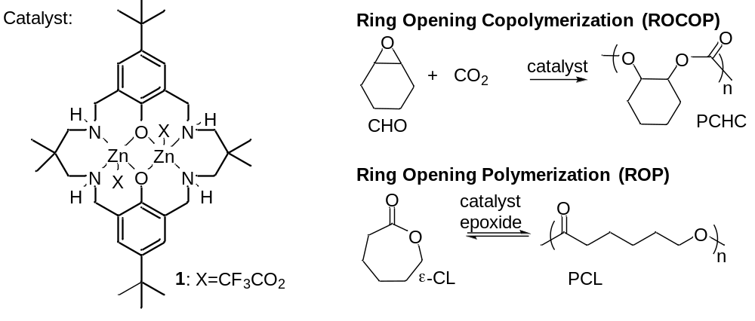
Figure 1: Illustrates the ring opening copolymerization (ROCOP) of cyclohexene oxide (CHO) and carbon dioxide to produce polycyclohexene carbonate (PCHC) and the ring opening polymerization (ROP) of ε-caprolactone (ε-CL) to produce polycaprolactone (PCL). The structure of the dinuclear zinc catalyst, 1, is also illustrated, its synthesis was previously reported (see ESI).⁵³
The catalyst LZn₂(O₂C(CF₃))₂, 1, was prepared according to literature procedures (see ESI)⁵³ and was applied for the ROCOP of cyclohexene oxide and carbon dioxide (Table 1) under various conditions.
Table 1: Shows the data obtained for poly(cyclohexene carbonate) (PCHC) produced by the ring opening copolymerization (ROCOP) of cyclohexene oxide (CHO) and CO₂.
Run # | Catalyst 1:CHO (eq) | ε-CL  (eq) | Toluene | [Cat] / mM | % conversion of CHO ^{a)} | TON ^{b)} | TOF /  h^{-1 c)} | M_{n} /  g mol⁻¹  (Ð) ^{d)}
1 | 1:1000 | - | N | 10 | 59 | 590 | 33 | 4830 (1.20)
2 | 1:500 | - | Y | 10 | 44 | 220 | 12 | 2910 (1.20)
3 | 1:500 | 400 | Y | 8 | 16 | 80 | 5 | 1670 (1.20)
Ring opening copolymerization runs were carried out at 80 °C, under 1 atm of CO₂ for 18 h, with 1.1 mL of toluene added to runs 2-3. a) determined by ¹H NMR spectroscopy by comparing the normalised integrals for the CH signals at 3.05 ppm (CHO) and at 4.58 ppm (PCHC) b) TON = mol of epoxide consumed/mol of catalyst. c) TOF = TON/h. d) determined by SEC, in THF, using narrow molecular weight polystyrene standards to calibrate the instrument.

Catalyst 1 is a good catalyst for cyclohexene oxide/CO₂ ROCOP, either in neat CHO or using toluene as the reaction solvent, with the TOF being slightly reduced when toluene is applied, due to the catalyst concentration being reduced. Under both conditions, 1 yields polymers with a high selectivity for carbonate linkages (>99%), as evidenced by a lack of any signal in the ¹H NMR spectrum assigned to ether linkages (see Fig. S1, such a signal would be expected at ~3.45 ppm). The catalyst also showed a very high selectivity for polymer formation (~93% in toluene and ~98% in neat epoxide), with only minimal formation of cyclic carbonate by-product. The polymer molecular weights are controllable and show narrow dispersities. The molar masses increase linearly with the conversion of CHO, but are much lower than the theoretical values (Figure S2). Such discrepancies are commonly observed in epoxide/CO₂ copolymerisation and have been attributed to the presence of contaminating water or other protic compounds. ^{8,59}The polycarbonate was also analysed using MALDI-ToF mass spectrometry which revealed that only a single series of chains are produced: the α,ω-dihydroxyl end-capped polycarbonates. This ability to form polyols without the addition of dihydroxyl containing compounds appears to be unique to the trifluoroacetate coligand.^{53,56} Other ROCOP catalysts typically require the addition of dihyroxyl containing compounds in order to produce polyols.^{57,60-64} A representative mass spectrum and an illustration of the polymer structures are provided in Figure 2. The formation of polycarbonate polyols was re-enforced by ¹⁹F{¹H} NMR spectroscopic analysis of the polymer which did not show any resonances, consistent with a lack of trifluoroacetate end groups being present. Darensbourg and co-workers, inspired by the selectivity observed for 1, investigated a series of chromium salen trifluoroacetate catalysts for CO₂/PO ROCOP and also observed the selective formation of polycarbonate polyols using the trifluoroacetate initiating group.⁵⁶ On the basis of ESI mass spectra, they proposed that the trifluoroacetate polymer end-groups react with hydroxide groups, formed by reactions between the catalyst and water, to produce exclusively dihydroxyl end-capped polymer chains.⁵⁶ It is plausible that the same rationale may be applied to explain the selectivity observed using catalyst 1.
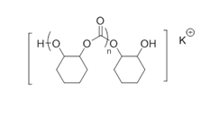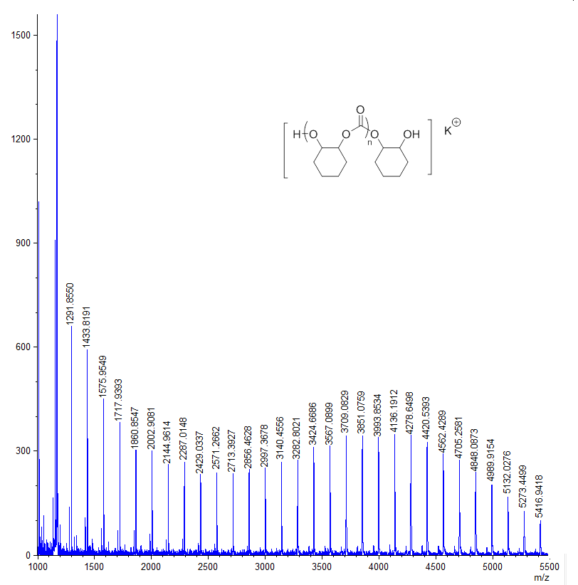
Figure 2: Expanded region of the MALDI-ToF spectrum of PCHC (prepared according to conditions for Table 1, Run 2). The spectrum shows a single series corresponding to the polycarbonate polyol (the structure of which is illustrated), the repeat unit can be represented as [(C₇H₁₂O₃)_{n}+C₆H₁₁O₂+H+K]⁺ = [(142.15)_{n}+115.15+ 1.01+39.1]

Table 2: Shows the data obtained for polymers produced by the ring opening copolymerization (ROCOP) of CHO and CO₂, with the addition of water as a chain transfer agent.
Run # | Mol % H₂O ^{a)} | M_{n} g mol⁻¹ (Ð) ^{b)}
1 | 0 | 5,700 (1.17)
2 | 0.1 | 5,200 (1.15)
3 | 0.2 | 4,600 (1.12)
4 | 0.4 | 3,300 (1.11)
5 | 0.8 | 2,500 (1.10)
6 | 1.6 | 1,800 (1.10)
7 | 3.2 | 800 (1.09)
The polymerizations were conducted at 80 °C, under 1 atm of CO₂ for 18 h, using a loading of 1:1000 catalyst 1: CHO. a) Shows the mole % (vs. epoxide) of water present, catalyst is present at 0.1 mol% loading. b) Determined by SEC, in THF, using narrow molecular weight polystyrene standards to calibrate the instrument.

The ROCOP of CHO/CO₂ is also possible under immortal conditions, that is with the addition of a protic chain transfer agent (CTA) such as water. Table 2 illustrates the results of seven polymerizations in which progressively greater quantities, versus the catalyst, of water were added. Water is an attractive chain transfer agent due to its abundance and low cost. The addition of water, up to 32 mole equivalents vs. catalyst, resulted in efficient polymerizations in all cases. The molecular weights are reduced with increasing amounts of CTA, however, the polymerizations remain well-controlled as shown by the narrow dispersities (Figure 3). A representative example of a MALDI-ToF spectrum of the obtained polymer shows that only a single series of polycarbonate polyol chains is formed (Fig. S3).
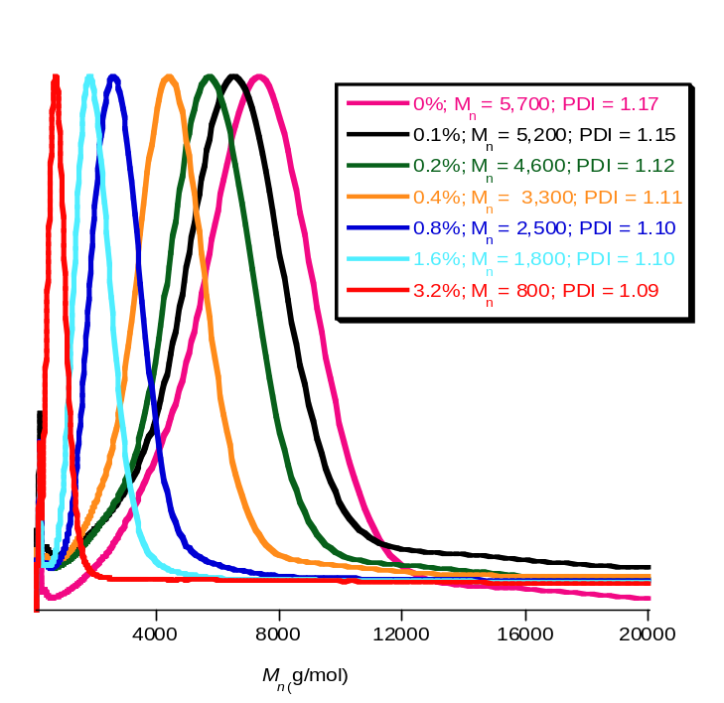
Figure 3: Illustrates the SEC traces for the PCHC formed in Table 2. The SEC measurements were conducted using THF as the eluent, with narrow molecular weight polystyrene calibrants.
Given the target is to selectively polymerize mixtures of epoxide, lactone and carbon dioxide, it was important to establish the feasibility of ROCOP in the presence of ε-caprolactone (ε-CL) (Table 1, Run 3). Under these conditions, the sole product was polycarbonate PCHC, although the catalyst activity was reduced, presumably due to the increased catalyst dilution as was also observed for the polymerizations conducted in toluene. The ¹H NMR spectrum of the crude polymer confirms the exclusive formation of polycarbonate (Fig. S4); there are also signals observable for residual ε-caprolactone, but there is no evidence for any polycaprolactone formation. As the polymerizations are run for a fixed time period, the lower activity results in a lower conversion and concomitant reduction in the molecular weight of the polycarbonate (1700 g mol⁻¹), whilst maintaining a narrow dispersity. The MALDI-ToF spectrum (Fig. S5) shows that the only products were polycarbonate polyols, containing 0-4 ether linkages, respectively. Such low concentrations of ether linkages are not detected by ¹H NMR spectroscopy, as the signal partially overlaps with polycarbonate endgroup signal (3.45 pm and 3.55 pm, respectively), but can be observed by signals at 77.8 ppm in the ¹³C{¹H} NMR spectrum (d₆- DMSO) (Fig. S6). The formation of ether linkages is likely due to the decreased solubility of carbon dioxide in toluene.
In order to understand the observed selectivity for polycarbonate production, even in the presence of ε-caprolactone, it was of interest to investigate whether 1 could initiate ring-opening polymerization (ROP) (Figure 1, Table 3). The reaction between catalyst 1 and caprolactone, in toluene, failed to yield any polyester (Table 3, Run 1). However, the reaction between catalyst 1, ε-CL and epoxide (CHO) led to an active and selective catalyst system, forming only polycaprolactone (PCL) in every case (Table 3, Runs 3-9). Furthermore, the polymerizations occurred rapidly and with control of the PCL molecular weights (Figure 4).
Table 3: The ring opening polymerizations (ROP) of ε-caprolactone, using catalyst 1.
Run # | 1: ε-CL:CHO: CTA | % conversion  ε-CL^{a)} | M_{n} (Ð)^{b)}  / g mol⁻¹ | M_{n} calc.^{c)}  / g mol⁻¹
1 | 1:400:0:0 | - | - | -
2 | 1:400:0:10 | - | - | -
3 | 1:200:500:0 | >99% | 14,200 (1.33) | 11,400
4 | 1:400:500:0 | >99% | 18,500 (1.40) | 22,800
5 | 1:600:500:0 | >99% | 24,600 (1.33) | 34,200
6 | 1:800:500:0 | >99% | 29,100 (1.31) | 45,600
7 | 1:400:500:0^{d)} | >99% | 17,000 (1.39) | 22,800
8 | 1:400:500:5 | >99% | 7,320 (1.35) | 9120
9 | 1:400:500:10 | >99% | 3,400 (1.47) | 4560
10 | 1:400:40:0* | >99% | 42,000 (1.09) | 22,800
All polymerizations were conducted in toluene, using 4 mM catalyst concentrations (1.6 M concentration of ε-CL), at 80 °C for 1 h. * Polymerisation carried out at 7mM catalyst concentration at 80°C for 2 h. The chain transfer agent (CTA) is iso-propyl alcohol. a) Determined by ¹H NMR spectroscopy by comparing the normalized integrals of the signals at 4.05 ppm (methylene protons of PCL) vs. 4.15 ppm (methylene protons of ε-CL). b) Determined by SEC, in THF, using narrow molecular weight polystyrene standards to calibrate the instrument. A correction factor of 0.56 was applied, as described by Penczek and co-workers.⁶⁵ c) The theoretical molar mass was determined according to: [{(#moles ε-CL converted) / 2(#moles catalyst 1)} x 114], assuming both trifluoroacetate groups on the catalyst initiate polymerization. When iso-propyl alcohol is present: [{(#moles ε-CL converted) / (#moles iso-propyl alcohol)} x 114]. d) Polymerization conducted using a solution that was pre-saturated with carbon dioxide.
Figure 4: Shows plots of molecular weight and dispersity vs. [ε-CL]/[1]. The polymerizations were conducted according to the conditions described in Table 3.

All the ROP reactions conducted with the addition of epoxide, were successful and resulted in the rapid formation of PCL. Figure 4 shows that the polymerizations were quite well controlled and showed a linear increase in molecular weight vs [ε-CL]/[1] and reasonable agreement between theoretical and experimental molecular weights. MALDI-ToF mass spectrometry showed a single series of chains containing PCL repeat units and a single cyclohexane diol unit, consistent with the polymerizations being initiated from ring-opened cyclohexene oxide (Figure 5, for a representative example). It should be noted, that using the MALDI-ToF spectrum alone, the possibility that there are chains due to hydroxyl end-capped PCL cannot be excluded. However, the ¹H NMR spectrum showed the exclusive formation of PCL and the presence of cyclohexylene resonances in the expected relative integrals for the major species being chains initiated from cyclohexadiol (Fig. S7). Furthermore, there were no signals observable in the ¹H NMR spectrum for ether linkages (see Fig. S7). Furthermore, at lower loadings of 1 : ε-CL, the spectra show low intensity signals consistent with the presence of two different types of cyclohexylene end-groups. These signals have been previously assigned to: i) chains initiated from both hydroxyl groups of the cyclohexylene unit and ii) chains end-capped by cyclohexan-ol units.⁶⁶ Thus, the microstructure of the PCL formed using the dinuclear zinc bis(trifluoracetate) catalyst in the presence of cyclohexene oxide, is proposed to include chains initiated from and end-capped by the cyclohexylene group, a proposed pathway by which polymerization proceeds is illustrated in Fig. S8. The formation of two different chain end groups occurs due to relatively slower rates of initiation of polymerizations, compared to the rates of propagation.⁶⁶
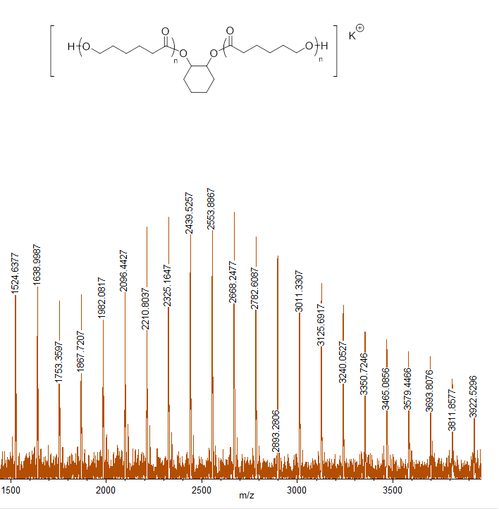
Figure 5: Selected region of the MALDI ToF spectrum obtained for the PCL prepared according to the conditions described in Table 4, Run 7 (only one of the chain structures is illustrated). The polyester polyol series are represented by: [(C₆H₁₀O₂)_{m}+C₆H₁₂O₂+K]⁺ = [(114.08)_{m}+116.16+39.1]⁺.

Furthermore, in the same way as was demonstrated for ROCOP, it was shown that the catalyst was also active for immortal ring-opening polymerization, whereby the addition of a chain transfer agent reduces the molar mass of the polymers. Thus, experiments conducted with the catalyst, epoxide and iso-propyl alcohol, as the chain transfer agent, led to the production of polyesters of predictable M_{n} (Table 3, Runs 8-9). The MALDI-ToF spectra show series attributable to both PCL polyols and PCL end-capped by iso-propyl ester groups (Fig. S10).
It is important to note that control experiments conducted without any added epoxide, but using catalyst and isopropyl alcohol alone, failed to lead to any polymerization. Thus, the epoxide plays a central role in ‘switching’ on the ROP process using catalyst 1. A similar ‘switch on’ behaviour was observed for a di-zinc bis(acetate) catalyst, coordinated by the same macrocyclic ancillary ligand.⁵⁸ It was also previously observed, using in situ ATR-IR spectroscopy, that the di-zinc catalyst reacts only once with the epoxide, even in the presence of excess epoxide, to generate a dizinc alkoxide complex.⁶⁷ Such a di-zinc alkoxide can, in turn, react with ε-CL to initiate the ring-opening polymerization and produce a new propagating zinc alkoxide complex.

In order to investigate whether any residual, dissolved carbon dioxide would affect the ROP of ε-CL, a polymerization was conducted in a solution which had been pre-saturated with carbon dioxide for 1 h (Table 3, Run 7). The mixture was heated (80 °C) and the carbon dioxide removed by 3 cycles of vacuum/nitrogen. Although, the ROP took longer (2 h) to reach full conversion (TOF = 100 h⁻¹) it led to the exclusive production of PCL and showed a reasonable agreement between experimental and calculated values for the molar mass.

In summary, catalyst 1 in combination with epoxide is effective for the ROP of ε-caprolactone. In the absence of any epoxide, no polymerization occurs. However, in the presence of epoxide, efficient and controlled polymerizations result. With the discoveries that 1 is an efficient catalyst for either ROCOP or ROP, the next step is to investigate its application as a catalyst to different mixtures of these monomers and in particular to investigate whether the catalyst will exert any monomer sequence selectivity (Figure 6).

Combined Polymerization Pathways Using a Single Catalyst
As already noted, the polymerization of a mixture of catalyst 1, cyclohexene oxide, caprolactone and carbon dioxide resulted only in the selective production of PCHC (Table 1, Run 3). This selectivity can be exploited to produce a series of ABA copoly(ester-b-carbonate-b-ester) materials. Thus, the polymerization was conducted in the presence of all three monomers, resulting in selective polycarbonate polyol production (ROCOP), as shown by an in situ ATR-IR spectroscopic analysis (Figure 6). Figure 6 shows the change in intensity of the IR absorption at 1010 cm⁻¹, which is assigned to poly(cyclohexene carbonate). The assignment was made from a control experiment on CHO/CO₂ ROCOP. During the terpolymerizations, at the same time as the absorptions assigned to PCHC increase, those assigned to ε-caprolactone remain unchanged, as evidenced by the signals at 694 cm⁻¹. Once again, the signals for ε-CL/PCL were unambiguously assigned from control experiments on ε-caprolactone ROP. In the terpolymerizations, ROCOP occurs selectively over the first 16 h, leading to slow conversion to a polycarbonate polyol. After 16 h, the carbon dioxide was removed from the mixture, by using six rapid cycles of vacuum-nitrogen. It should be noted that the loss of any residual monomers/solvents at this stage was minimal, but that carbon dioxide was efficiently removed, as evidenced by the sharp decrease in intensity of its signal at 2340 cm⁻¹. Once the carbon dioxide was removed from the reaction, ε-CL ring-opening polymerization occurred resulting in the production of poly(ester-b-carbonate-b-ester). This is demonstrated by the rapid decrease in intensity of the signal assigned to ε-caprolactone at 694 cm⁻¹. At the same time the signal assigned to polycaprolactone grows rapidly in intensity (see Fig. S11, for the other absorptions). Thus the IR spectroscopic data confirms the formation of a copoly(ester carbonate), proposed to have an ABA type structure (vide infra).

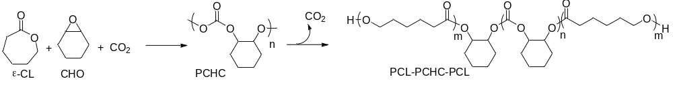Figure 6: Illustrates a plot showing the changes in the intensity of specific IR resonances (normalized and with arbitrary units) during the copolymerization (Table 4, Run 1). The reaction was monitored using ATR-IR spectroscopy. The bands at 1010 and 935 cm⁻¹ are assigned to PCHC, at 1190 cm⁻¹ to PCL and that at 694 cm⁻¹ to ε-CL.

In order to investigate this catalysis in more detail, a series of reactions were run targeting different copolymer molecular weights and compositions (Table 4).

Table 4: Shows the data for polymerizations conducted using catalyst 1, ε-CL, CHO and CO₂ leading to the formation of ABA type PCL-PCHC-PCL triblock copolymers.
# | 1:CHO:ε-CL | % CHO convn.^{a)} (time) | M_{n}^{b)}  PCHC  / g mol⁻¹ (Ð) | % ε-CL convn.^{a)} (time) | M_{n}^{b)}  PCL-PCHC-PCL  / g mol⁻¹  (Ð) | Molar Ratio carbonate: ester linkages^{c)}
1 | 1:2000:200 | 6  (16 h) | 1,880 (1.08) | 68  (5 h) | 4,000 (1.33) | 1:1
2 | 1:1000:400^{d)} | 9  (18 h) | 900  (1.07) | 81  (2h) | 3,300 (1.41) | 1:6
3 | 1:500:200^{e)} | 15  (18 h) | 2,600 (1.16) | 69  (1.5 h) | 6,500 (1.48) | 1:2
4 | 1:500:400^{f)} | 15  (18 h) | 2,200 (1.12) | 78  (1.5 h) | 12,800 (1.49) | 1:6
5 | 1:500:400^{e)} | 15  (25 h) | 2,200 (1.08) | 70  (1.5 h) | 13,800 (1.43) | 1:4
6 | 1:500:100 | 17  (18 h) | 4,500 (1.08) | 53  (1.5 h) | 6,600 (1.35) | 1:0.5
7 | 1:500:600 | 6  (18 h) | 2,900 (1.19) | 51  (1.5 h) | 12,500 (1.29) | 1:10
Polymerization conditions: 80 °C, under 1 atm CO₂ pressure for a fixed time period, after which the carbon dioxide was removed by six cycles of vacuum-nitrogen and the polymerization allowed to progress for a further time period. a) Determined by ¹H NMR spectroscopy, the CHO conversion was determined from the normalised integrals for the CH signals at 3.05 ppm (CHO) and 4.58 ppm (PCHC). The ε-CL conversion was determined from the normalised integrals for the signals at 4.05 ppm (PCL) vs. 4.15 ppm (ε-CL). b) Determined by SEC, with THF as the eluent, using polystyrene standards to calibrate the instrument. c) Determined by ¹H NMR spectroscopy by comparison of the normalised integrals for the PCHC CH signals at 4.58 ppm and the PCL CH₂ signals at 4.05 ppm. Reactions conducted with added toluene: d) 3.5 mL e) 4.45 mL. f) 2.2 mL.

Table 4 shows that a range of different copoly(ester carbonates) were prepared with controllable compositions over a range of different molar masses (~4000-14,000 g mol⁻¹), and all showing moderate/narrow dispersities (Ð = 1.10-1.50). In all cases, and regardless of the relative compositions of the mixture of monomers, the polymerization first occurred by selective ROCOP, leading to a low molecular weight polycarbonate block, of narrow dispersity. After removal of the carbon dioxide, the ROP of ε-CL occurred leading to copolymers of higher M_{n} and, in some cases, by a slight broadening of dispersity. This increase in dispersity is proposed to arise due to a relatively slower rate of initiation of ε-caprolactone by the polymer end-capped cyclohexylene alkoxide (a secondary alkoxide) compared to propagation from the ε-caproyl alkoxide (a primary alkoxide) leading to complex polymerization propagation kinetics. It is not proposed to result from significant contamination of the polymers by PCHC homopolymer (vide infra). The relative ratio of carbonate:ester linkages in the copolymers can be deduced by comparing the integrals for the main chain ester vs. carbonate resonances in the ¹H NMR spectra (e.g. at 4.05 ppm for the PCL vs. 4.65 ppm for the PCHC). Thus, the ratio can be controlled over the range 1:1 through to 1:15, with a reasonable agreement between the experimental results and those expected on the basis of polymerization conversion and corresponding to weight fractions of PCL from 26 to 72%.
The molecular weights all show clear increases from the polycarbonate to the copoly(ester-carbonate), consistent with block copolymer formation. The M_{n} values obtained by SEC are calibrated against narrow molar mass polystyrene standards, and as such are relative rather than absolute values. Despite this estimation, it is apparent that the M_{n} obtained for both the polycarbonate and copoly(ester carbonates) are lower than would be expected on the basis of reagent stoichiometry and conversion. Typically the copolymer molecular weights are 3-4 times lower than would be expected, consistent with the presence of chain transfer agents. It has previously been observed, using a range of different catalysts and processes for ROCOP of CO₂/CHO, that the polymer molar masses are frequently lower than would be expected.^{11,45,46,62,68-81} It is proposed that cyclohexanediol, formed by side-reactions between the epoxide and any residual water, functions as a telechelic chain transfer agent, leading to the formation of polyols.^{59,67}

Previous reports of terpolymerisation catalysts combining lactone, epoxide and carbon dioxide, result in the formation of random co-polymers, rather than defined block structures. When the heterogenous catalyst zinc glutarate is applied, using propylene oxide, ε-CL and CO₂, the resulting polymer is mostly comprised of polycarbonate blocks with random incorporation of short polyester blocks or even single ester linakges.^{49,50} Increasing the molar ratio of ε-CL in the feed ratio led to slightly greater ester block lengths, however, the copolymers remained rather ill-defined (Ð = 1.5-4.0). The homogeneous β-diketiminate zinc catalysts were also investigated for the terpolymerisation of lactide, cyclohexene oxide and carbon dioxide.⁵¹ The structures of the copolymers are not discussed, although both carbonate and ester linkages are present. Curiously, using excess epoxide (CHO), the ratio of carbonate:ester linkages remains rather similar, despite decreasing the quantity of lactide in the monomer feed. Using the schiff base tri-zinc catalyst with cyclohexene oxide, ε-caprolacte, results in a tapered block terpolymer, although it should be noted significant quantities of cyclic carbonate are also formed.⁵² Increasing the quantity of ε-CL in the feedstock, increases the proportion of ether linkages and cyclic carbonate formed both of which are by-products of ROCOP. A detailed study was carried out into the polymerization and it was discovered that these trizinc catalysts showed faster caprolactone polymerization, with the first blocks being mostly polyester in composition, followed by tapered incorporation of carbonate units; this is interesting as it is quite different to the findings using the current di-zinc catalyst.⁵² Compared to these previous catalysts and processes, the di-zinc catalyst leads to the selective preparation of ABA block copolymers of well-defined structures. By varying the amount of ε-CL in the monomer feed, it is possible to control the molar ratio of carbonate to ester linkages in the resulting polymer.

ABA Block Copolymers
The switch catalysis is an efficient method to prepare block copolymers, however, the structures, compositions and homogeneity of the copolymers also needed to be examined. Analysis of the polymers by SEC gives confidence that a single polymer has been produced as there is an increase in molecular weight after polymerization of the ester block (Figure 7).
Figure 7: Illustrates the evolution of the molar mass (M_{n}) as the polymerization proceeds. Polymerisation carried out according to the conditions describe in Table 4, Run 1. Initially PCHC is the only product, with a M_{n} of 1800 g mol⁻¹, after the removal of carbon dioxide, the polymerization leads to the production of poly(ester carbonate). The crude SEC of this product is shown by the trace in blue, where the M_{n} has increased to 4000 g mol⁻¹ (Ð = 1.30). The SEC measurements were conducted using THF as the eluent, with narrow molar mass polystyrene calibrants. (See Fig. S12 for the raw data).

An aliquot taken during the first phase of polymerization, when PCHC was produced, was analysed by SEC and showed an M_{n} of 1800 g mol⁻¹ (Ð= 1.08). After this point, the carbon dioxide was removed and the ROP of ε-CL occurred leading to the production of a block copoly(ester carbonate) (Figure 7). An aliquot removed from the polymerization mixture was analysed after 16 h. The SEC analysis of this sample, showed the signal illustrated in Figure 7, blue, with the polymer M_{n} increasing to 4000 g mol⁻¹ (Ð= 1.30). The crude polymer could be purified, by fractionation using THF and MeOH, resulting in a slight increase in the sample M_{n} (6000 g mol⁻¹, Ð = 1.20).
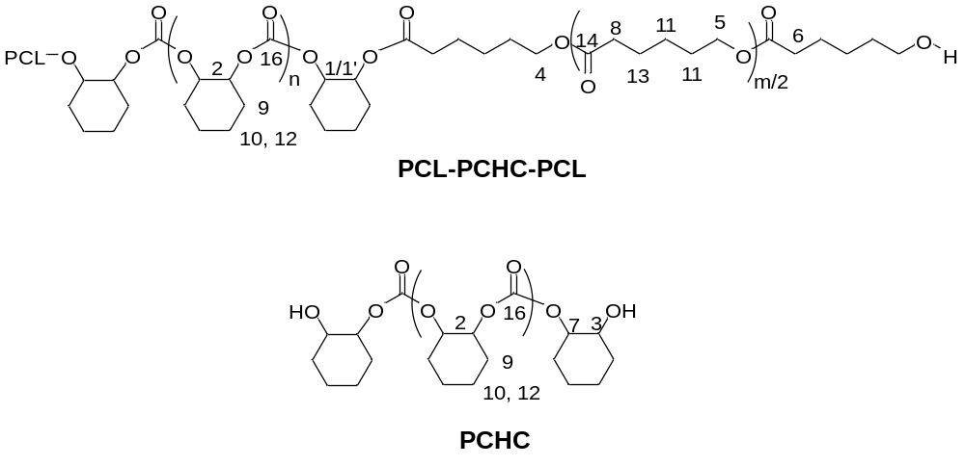
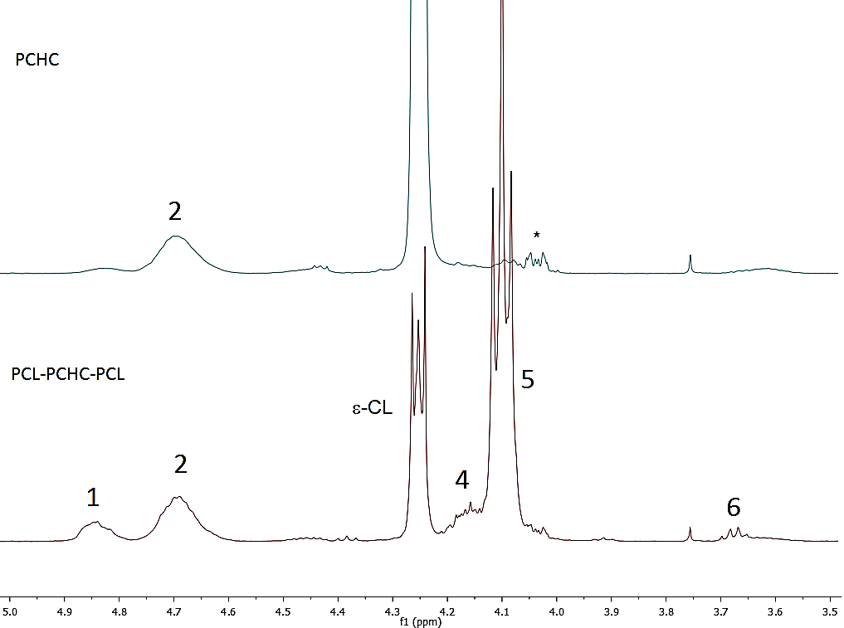
1/1’
Figure 8: Selected regions of the ¹H NMR spectra of the polymer aliquots removed during the polymerization (conditions as per Table 4, Run 5). For the full spectra (in each case) see Fig. S10. The top spectrum corresponds to the first aliquot taken after 25 h, and shows only polycarbonate (PCHC). The bottom spectrum shows the aliquot taken after 26.5 h and corresponds to the copoly(ester carbonate). The proposed structure for the triblock copolymer is illustrated above, with the appropriate numbering scheme.* is the signal for cyclic carbonate.

¹H NMR spectroscopy was also used to characterize the aliquots and confirmed the IR spectroscopic analysis with the first aliquot (25 h) showing signals attributed to polycarbonate, with the ε-CL remaining unreacted. The relative integrals of the signals assigned to main chain methyne resonances [4.65 ppm, assigned to H²)] against those assigned to the end groups [cyclohexanediol at 4.41 (H³) and 3.57 (H⁷) ppm] can be used to estimate the molar mass, resulting in a value of 1420 g mol⁻¹ corresponding well with that obtained by SEC and indicating that approximately 8 chains grow per catalyst due to the presence of chain transfer agents (cyclohexanediol). The second polymerization aliquot was removed at 26.5 h and corresponds to the triblock copolymer, the ¹H NMR spectrum is shown in Figure 8 and Fig. S13. The spectrum shows resonances for both carbonate and ester portions, with the relative integrals enabling an estimation of the overall proportions of each unit in the copolymer. Thus, the carbonate:ester integral ratio is 1:4 which corresponds well with those expected on the basis of monomer conversions and loadings (predicted ratio = 1: 4). The ¹H NMR spectrum of the purified copolymer also shows low intensity signals assigned to polymer end-groups (Figure 8). There is good evidence supporting the formation of a triblock copolymer by the signal at 3.64 ppm which is assigned to the methylene unit of terminal caprolacyl units (labelled H⁶). Further support for the formation of a block copolymer is obtained from the signals assigned to junction units, which would not be present if mixtures of homopolymers were formed. Thus, new signals at 4.78 and 4.11 ppm are assigned to cyclohexylene methyne (labelled H^{1/1’}) and caproyl methylene groups (labelled H⁴) at the junction units; these signals are not observed in the ¹H NMR spectra of either PCHC or PCL alone. The linkage unit signals are assigned on the basis of their ¹³C{¹H} (Fig. S15), DEPT 135 (Fig. S16) and HSQC/HSBC NMR spectra (Fig. S17). Using DEPT 135, the signals correspond to ¹³C resonances at 73.4 (cyclohexyl) and 67.8 (caproyl) ppm, respectively. One curious finding is that the relative intensities of the junction units for the carbonate linkages are greater than would be expected on the basis of reagent conversions and polymer molar masses. For example, the ratio of carbonate junction units: carbonate main chain peaks (the integrals of H_{1/1’}:H₂) is observed to be 1:2, against a calculated value of 1:4, regardless of the solvent applied or the relaxation time (from t₁ 2.2-25 s). The ratio of ester junction units: ester main chain peaks (the integrals of H₄:H₅) is 1:20, which is in line with the value expected. Again this remains constant with longer relaxation times. The ratio of the carbonate junctions:ester junctions (the integrals of peaks H_{1/1’}:H₄) is expected to be 1:1 for an ABA type block copolymer, however a values of 2:1 was consistently obtained. It is very unlikely that any putative contamination by AB type polymer would shift the integrals in this direction, rather if such contaminants were present the ratio of carbonate:ester junctions would be expected to be 1:2. Taken as a whole, these findings imply that for the carbonate blocks, the ‘junction unit’ resonances in the ¹H NMR spectra actually correspond to two cyclohexene carbonate repeat units at each of the junctions, in contrast for the ester blocks the junction corresponds to the expected single caproyl repeat unit which is directly connected to the carbonate block.
The ¹³C{¹H} NMR spectrum provides further support for the formation of a block copolymer: there are only two peaks observed in the carbonyl region of the spectrum, assigned to carbonate and ester blocks, respectively. This finding implies there is little/no chain scrambling, i.e. there is limited trans-esterification/carbonylation between the blocks.
The block copolymer was purified to remove any unreacted ε-CL, by precipitation from a THF solution into methanol (Table 4, Run 1). This purification results in some polymer fractionation and a slight increase in the molar mass (from 4,000 to 6,200 g mol⁻¹, Ð = 1.21). In order to understand whether there were any residual homopolymers present in the washings/purification steps, the spectra of the filtrate and purified polymer were compared. For the purified triblock copolymer there is little change to the relative ratios of integrals for junction units or to the carbonate:ester ratio, indicating that the composition of the polymer has not significantly changed on purification. The ¹H NMR spectrum of the filtrate (after solvent removal) shows that it contains signals attributed to a material containing both PCHC and PCL blocks. There are no signals due to PCL homopolymers in either the crude polymer or the filtrate. Whilst the formation of small quantities of AB type copolymers cannot be completely ruled out, it is likely that the major products have ABA compositions.
DOSY NMR spectroscopy of the triblock copolymer shows that all the signals have the same diffusion coefficients (D = 9.25 x 10⁻¹¹ m²/s, R_{H} = 4.4 x 10⁻⁹ m). In contrast, the DOSY spectrum of a mixture of isolated samples of PCHC and PCL (of comparable molecular weights to the composition of the block copolymer) shows the expected presence of two different species, with different diffusion coefficients and hydrodynamic radii (D = 4.6 x 10⁻¹⁰ m²/s, R_{H} = 8.8 x10⁻¹⁰ m; D= 6.8 x 10⁻¹⁰ m²/s, R_{H}=5.9 x 10⁻¹⁰ m). These findings also support the formation of a block copolymer, with minimal contamination by homopolymers.

Figure 9: Left: The DOSY NMR spectrum of the copoly(ester-b-carbonate-b-ester) (Table 4, run 5) Right: The DOSY NMR spectrum of a mixture of PCL and PCHC.
Furthermore, analysis of the filtrate obtained on purification (vide supra), by DOSY spectroscopy does show the presence of several species (see Fig. S18) but each species contains signals for both carbonate and ester groups, consistent with the filtrate containing low molar mass copolymers resulting from fractionation rather than any separated homopolymers.

Copolymer Thermal Properties
The triblock copolymers were characterized using DSC so as to enable comparisons of their thermal properties against those of the homopolymers and mixtures (Table 5).
Table 5: Shows the thermal properties of the triblock copolymers compared to mixtures of the polymers.
# | Polymer | M_{n} /  g mol^{-1 a)} | T_{g} /  °C ^{b)} | T_{m} /  °C | T_{c} /  °C | Molar ratio carbonate: ester linkages ^{c)}
1 | PCHC | 920 | 108 | - | - | 1:0
2 | PCL | 1350 | - | 53* | - | 0:1
3 | Mixture of PCL and  PCHC | 1350  920 | -41  100 | 12 | - | 1:1
4 | PCL-PCHC-PCL  (Table 4, run 6) | 6,600 | 34 | - | - | 1:0.5
5 | PCL-PCHC-PCL  (Table 4, run 1) | 4,000 | -13 | - | - | 1:1
6 | PCL-PCHC-PCL  (Table 4, run 3) | 6,500 | -37 | - | - | 1:2
7 | PCL-PCHC-PCL  (Table 4, run 2) | 3,300 | -54 | 27  (χ_{c} = 22%) | -4 | 1:6
8 | PCL-PCHC-PCL  (Table 4, run 5) | 13,800 | -53 | 38  (χ_{c} = 28%) | -8 | 1:4
9 | PCL-PCHC-PCL  (Table 4, run 4) | 12,800 | -54 | 40  (χ_{c} = 30%) | -10 | 1:6
10 | PCL-PCHC-PCL  (Table 4, run 7) | 12,500 | -51 | 43  (χ_{c} = 48%) | 23 | 1:10
* The crystallinity of this sample was too high for the glass transition to be observed.
a) Determined by SEC with THF as the eluent, using polystyrene standards to calibrate the instrument b) The T_{g} was calculated from the third heating cycle of the DSC measurement and was heated at 10 °C/minute from -100 to 130 °C (# 1-3, 5-8) or 40 °C/minute from -80 to 100 °C(# 4, 9-10) c) Determined by ¹H NMR spectroscopy by comparison of the normalised integrals for the PCHC CH signals at 4.58 ppm and the PCL CH₂ signals at 4.05 ppm .
The values for the glass transition temperatures observed for the independent, control, samples of polycarbonate and polyester are slightly lower than those reported previously in the literature (PCHC: 117 and PCL: 60 °C).^{82,83} This is likely due to the lower molecular weights of the polymers. A 1:1 mixture of the two homo polymers showed the expected T_{g} for the PCHC portion but suppression of the crystallinity of PCL, as observed by a significant reduction in the T_{m}. The ABA copolymers show controllable glass transition and melting temperatures, dependent on the composition and MW of the polymers. At 1:1 compositions of ester: carbonate, a single T_{g} is observed at -13 °C. For a 1:0.5 composition, a single T_{g} is also observed but at a higher temperature 34 °C. This suggests that the PCHC inhibits the crystallinity of the PCL, a finding which has previously been observed by Xaio and Meng who studied a series of rather less well defined terpoly(caprolactone-cyclohexene carbonates).⁵² As the proportion of ester blocks increases beyond 1:2, the glass transition temperature decreases, consistent with the increased content of PCL. Once the composition of ester exceeds 1:4, then crystallization of the PCL block can is observed, resulting in both melting and crystallization peaks (Table 5, runs 7-10). The temperatures at which these processes occur are lower than for pure PCL, indicative of smaller crystalline domains due to the block copolymer structure. The χ_{c} (% crystallinity) of the samples can be determined for those materials exhibiting a T_{m};⁸⁴ overall, the χ_{c} increases quite significantly and values in the range 22-48% are observed (Table 5, runs 7-10). In comparison, the terpolymers prepared by Xiao and Meng showed higher crystallinities (χ_{c} 80-90%), which may relate to the different chain repeat unit structures as the materials were not ABA type block copolymers.⁵² For the polymers prepared in this study, glass transition temperatures were also observed in all cases. The Fox-Flory equation can be used to predict the T_{g} values for miscible polymers, however, for these copolymers the calculated values are not in close agreement with the experimental values, particularly at higher ester contents, indicative of poor miscibility between the blocks, a similar finding as was also observed for the blends (Table 5, run 3). Thus, it seems that for these block copolymers, at higher carbonate loadings the crystallinization of the ester block is suppressed and at lower carbonate loadings, the crystallinity of the ester block is reduced.
As part of a preliminary evaluation of such copolymers, thin films were spin coated, from tetrahydrofuran solutions, onto glass slides. Figure 10 shows photographs of the glass slides (with images/text behind) which demonstrate the transparency of the films.
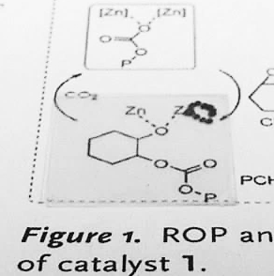
Figure 10: Illustrates films of block poly(carbonate-ester) (Table 3, Run 5) spin-coated onto glass slides, placed on top of text/chemical images so as to demonstrate the transparency of the films.

Conclusions
A di-zinc catalyst is reported showing good activity for both ring-opening copolymerization of cyclohexene oxide/carbon dioxide and for the ring-opening polymerization of ε-caprolactone. In both polymerizations, the catalyst exerts a high selectivity for the formation of polyols, i.e. di-hydroxyl terminated polymers. Furthermore, in both cases the polymerization control is good as shown by the controllable molecular weights and narrow dispersities. The catalyst also functions for copolymerizations in the presence of excess water as a chain transfer agent. The same catalyst can also be used to synthesise ABA type block copoly(ester-b-carbonate-b-esters) in one-pot from mixtures of the three monomers. In the terpolymerizations, the ring-opening copolymerization of epoxide/CO₂ occurs first to produce a polycarbonate polyol, followed, after removal of the carbon dioxide, by the selective ring-opening polymerization of ε-caprolactone to produce the triblock copolymers. The copolymer compositions and structures were investigated using SEC, NMR spectroscopy and by DSC. NMR spectroscopy showed that a block copolymer is produced, with the presence of junction units between the ester and carbonate blocks and single diffusion coefficient being observed by DOSY NMR spectroscopy. Purification of the copolymer does not result in any separation of homopolymers but does fractionate the copolymers and increase the molar mass. By modifying the composition of the copolymer, for example at low ester content, it is possible to prevent the crystallisation of the caprolactone blocks. At higher ester compositions, the crystallization of the caprolactone blocks occurs, albeit with a lower melting temperature, and crystallinity, compared to the homopolymer. The copolymers can be spin-coated to produce transparent films.
Thus, the catalyst selectivity for both ROCOP and ROP is demonstrated using a catalyst which selectively produces di-hydroxyl end-capped polymers. This selectivity is exploited to selectively prepare ABA type triblock copolymers. The catalyst selectivity is very unusual, yet the understanding gained from this study suggests it may be more generally applied, for example to other monomers and even to other catalysts. Given the importance of oxygenated polymers and multi-block copolymers, future studies will be directed to exploring the range of copolymers that can be prepared using this method.

Acknowledgements
The authors wish to acknowledge the Engineering and Physical Sciences Research Council EPSRC (EP/K035274/1, EP/K014070/1, EP/H046380, EP/L017393/1), Imperial College London and Econic technologies (CASE award to SP) for financial support.

Supporting Information Available
The supporting information includes Figures S1-S19 and full experimental details. This information is available free of charge via the Internet at http://pubs.acs.org/.

References
(1) Childers, M. I.; Longo, J. M.; Van Zee, N. J.; LaPointe, A. M.; Coates, G. W. Chem. Rev. 2014, 114, 8129.
(2) Brule, E.; Guo, J.; Coates, G. W.; Thomas, C. M. Macromol. Rapid Commun. 2011, 32, 169.
(3) Moore, D. R.; Cheng, M.; Lobkovsky, E. B.; Coates, G. W. Angew. Chem. Int. Ed. 2002, 41, 2599.
(4) Darensbourg, D. J.; Yeung, A. D. Polym. Chem. 2014, 5, 3949.
(5) Lu, X.-B.; Darensbourg, D. J. Chem. Soc. Rev. 2012, 41, 1462.
(6) Darensbourg, D. J. Inorg. Chem 2010, 49, 10765.
(7) Darensbourg, D. J. Chem. Rev. 2007, 107, 2388.
(8) Kember, M. R.; Buchard, A.; Williams, C. K. Chem. Comm. 2011, 47, 141.
(9) Korashvili, R.; Noernberg, B.; Bornholdt, N.; Borchardt, E.; Luinstra, G. A. Chem. Ing. Tech. 2013, 85, 437.
(10) Luinstra, G. A. Polym. Rev. 2008, 48, 192.
(11) Klaus, S.; Lehenmeier, M. W.; Anderson, C. E.; Rieger, B. Coord. Chem. Rev. 2011, 255, 1460.
(12) Thomas, C. M. Chem. Soc. Rev. 2010, 39, 165.
(13) Williams, C. K. Chem. Soc. Rev. 2007, 36, 1573.
(14) Ajellal, N.; Carpentier, J. F.; Guillaume, C.; Guillaume, S. M.; Helou, M.; Poirier, V.; Sarazin, Y.; Trifonov, A. Dalton Trans. 2010, 39, 8363.
(15) Guillaume, S. M.; Carpentier, J.-F. Catal. Sci Technol. 2012, 2, 898.
(16) Albertsson, A. C.; Varma, I. K. Biomacromolecules 2003, 4, 1466.
(17) Okada, M. Prog. Polym. Sci 2002, 27, 87.
(18) Dijkstra, P. J.; Du, H.; Feijen, J. Polym. Chem. 2011, 2, 520.
(19) Lendlein, A.; Neuenschwander, P.; Suter, U. W. Macromol. Chem. Phys 1998, 199, 2785.
(20) Bates, F. S.; Hillmyer, M. A.; Lodge, T. P.; Bates, C. M.; Delaney, K. T.; Fredrickson, G. H. Science 2012, 336, 434.
(21) Martello, M. T.; Schneiderman, D. K.; Hillmyer, M. A. ACS Sustainable Chem. Eng. 2014, 2, 2519.
(22) Meng, F.; Zhong, Z.; Feijen, J. Biomacromolecules 2009, 10, 197.
(23) Lee, A. L. Z.; Venkataraman, S.; Sirat, S. B. M.; Gao, S. J.; Hedrick, J. L.; Yang, Y. Y. Biomaterials 2012, 33, 1921.
(24) Ray, W. C.; Grinstaff, M. W. Macromolecules 2003, 36, 3557.
(25) Zhang, X. J.; Mei, H. J.; Hu, C.; Zhong, Z. L.; Zhuo, R. X. Macromolecules 2009, 42, 1010.
(26) Ding, X.; Yang, C.; Lim, T. P.; Hsu, L. Y.; Engler, A. C.; Hedrick, J. L.; Yang, Y. Y. Biomaterials 2012, 33, 6593.
(27) Kim, S. H.; Tan, J. P. K.; Fukushima, K.; Nederberg, F.; Yang, Y. Y.; Waymouth, R. M.; Hedrick, J. L. Biomaterials 2011, 32, 5505.
(28) Qiao, Y.; Yang, C.; Coady, D. J.; Ong, Z. Y.; Hedrick, J. L.; Yang, Y. Y. Biomaterials 2012, 33, 1146.
(29) Liu, S. Q.; Yang, C.; Huang, Y.; Ding, X.; Li, Y.; Fan, W. M.; Hedrick, J. L.; Yang, Y. Y. Adv. Mater. 2012, 24, 6484.
(30) Fukushima, K.; Tan, J. P. K.; Korevaar, P. A.; Yang, Y. Y.; Pitera, J.; Nelson, A.; Maune, H.; Coady, D. J.; Frommer, J. E.; Engler, A. C.; Huang, Y.; Xu, K. J.; Ji, Z. K.; Qiao, Y.; Fan, W. M.; Li, L. J.; Wiradharma, N.; Meijer, E. W.; Hedrick, J. L. ACS Nano 2012, 6, 9191.
(31) Ke, X. Y.; Ng, V. W. L.; Gao, S. J.; Tong, Y. W.; Hedrick, J. L.; Yang, Y. Y. Biomaterials 2014, 35, 1096.
(32) Lee, A. L. Z.; Ng, V. W. L.; Gao, S. J.; Hedrick, J. L.; Yang, Y. Y. Adv. Funct. Mater. 2014, 24, 1538.
(33) Chan, J.; Ke, X. Y.; Sardon, H.; Engler, A. C.; Yang, Y. Y.; Hedrick, J. L. Chem. Sci. 2014, 5, 3294.
(34) Platel, R. H.; Hodgson, L. M.; Williams, C. K. Polym. Rev. 2008, 48, 11.
(35) Dijkstra, P. J.; Du, H. Z.; Feijen, J. Polym. Chem. 2011, 2, 520.
(36) Thomas, C. M.; Lutz, J. F. Angew.Chem. Int. Ed. 2011, 50, 9244.
(37) O'Keefe, B. J.; Hillmyer, M. A.; Tolman, W. B. Dalton Trans. 2001, 2215.
(38) Dechy-Cabaret, O.; Martin-Vaca, B.; Bourissou, D. Chem. Rev. 2004, 104, 6147.
(39) Rokicki, G. Prog. Polym. Sci 2000, 25, 259.
(40) Tempelaar, S.; Mespouille, L.; Coulembier, O.; Dubois, P.; Dove, A. P. Chem. Soc. Rev. 2013, 42, 1312.
(41) Suriano, F.; Coulembier, O.; Hedrick, J. L.; Dubois, P. Polym. Chem. 2011, 2, 528.
(42) Diallo, A. K.; Guerin, W.; Slawinski, M.; Brusson, J.-M.; Carpentier, J.-F.; Guillaume, S. M. Macromolecules 2015.
(43) Paul, S.; Zhu, Y.; Romain, C.; Brooks, R.; Saini, P. K.; Williams, C. K. Chem. Commun. 2015, 51, 6459.
(44) Chamberlain, B. M.; Cheng, M.; Moore, D. R.; Ovitt, T. M.; Lobkovsky, E. B.; Coates, G. W. J. Am. Chem. Soc. 2001, 123, 3229.
(45) Cheng, M.; Moore, D. R.; Reczek, J. J.; Chamberlain, B. M.; Lobkovsky, E. B.; Coates, G. W. J. Am. Chem. Soc. 2001, 123, 8738.
(46) Coates, G. W.; Moore, D. R. Angew. Chem. Int. Ed. 2004, 43, 6618.
(47) Aida, T.; Inoue, S. Acc. Chem. Res. 1996, 29, 39.
(48) Ikpo, N.; Barbon, S. M.; Drover, M. W.; Dawe, L. N.; Kerton, F. M. Organometallics 2012, 31, 8145.
(49) Hwang, Y.; Jung, J.; Ree, M.; Kim, H. Macromolecules 2003, 36, 8210.
(50) Hwang, Y.; Kim, H.; Ree, M. Mac. Symp. 2005, 224, 227.
(51) Kröger, M.; Folli, C.; Walter, O.; Döring, M. Adv. Synth. Catal. 2006, 348, 1908.
(52) Xu, Y.; Wang, S.; Lin, L.; Xiao, M.; Meng, Y. Polym. Chem. 2015, 6, 1533.
(53) Kember, M. R.; Copley, J.; Buchard, A.; Williams, C. K. Polym. Chem. 2012, 3, 1196.
(54) Zhou, J.; Wang, W.; Villarroya, S.; Thurecht, K. J.; Howdle, S. M. Chem. Comm. 2008, 5806.
(55) Zhang, J. F.; Ren, W. M.; Sun, X. K.; Meng, Y.; Du, B. Y.; Zhang, X. H. Macromolecules 2011, 44, 9882.
(56) Darensbourg, D. J.; Wu, G.-P. Angew. Chem. Int. Ed. 2013, 125, 10796.
(57) Wu, G. P.; Darensbourg, D. J.; Lu, X. B. J. Am. Chem. Soc. 2012, 134, 17739.
(58) Romain, C.; Williams, C. K. Angew. Chem. Int. Ed. 2014, 53, 1607.
(59) Jutz, F.; Buchard, A.; Kember, M. R.; Fredrickson, S. B.; Williams, C. K. J. Am. Chem. Soc. 2011, 133, 17395.
(60) Cyriac, A.; Lee, S. H.; Varghese, J. K.; Park, E. S.; Park, J. H.; Lee, B. Y. Macromolecules 2010, 43, 7398.
(61) Sugimoto, H.; Ohtsuka, H.; Inoue, S. J. Polym. Sci., Part A: Polym. Chem. 2005, 43, 4172.
(62) Nakano, K.; Kamada, T.; Nozaki, K. Angew. Chem. Int. Ed. 2006, 45, 7274.
(63) Hilf, J.; Schulze, P.; Seiwert, J.; Frey, H. Macromol. Rapid Commun. 2014, 35, 198.
(64) Langanke, J.; Wolf, A.; Hofmann, J.; Bohm, K.; Subhani, M. A.; Muller, T. E.; Leitner, W.; Gurtler, C. Green Chemistry 2014, 16, 1865.
(65) Kowalski, A.; Duda, A.; Penczek, S. Macromolecules 1998, 31, 2114.
(66) Zhu, Y.; Romain, C.; Poirier, V.; Williams, C. K. Macromolecules 2015, 48, 2407.
(67) Buchard, A.; Jutz, F.; Kember, M. R.; White, A. J. P.; Rzepa, H. S.; Williams, C. K. Macromolecules 2012, 45, 6781.
(68) Darensbourg, D. J. In Synthetic Biodegradable Polymers; Rieger, B., Kunkel, A., Coates, G. W., Reichardt, R., Dinjus, E., Zevaco, T. A., Eds. 2012; Vol. 245, p 1.
(69) van Meerendonk, W. J.; Duchateau, R.; Koning, C. E.; Gruter, G. J. M. Macromolecules 2005, 38, 7306.
(70) Nakano, K.; Nakamura, M.; Nozaki, K. Macromolecules 2009, 42, 6972.
(71) Wu, G.-P.; Ren, W.-M.; Luo, Y.; Li, B.; Zhang, W.-Z.; Lu, X.-B. J. Am. Chem. Soc. 2012, 134, 5682.
(72) Lu, X.-B.; Ren, W.-M.; Wu, G.-P. Acc. Chem. Res. 2012, 45, 1721.
(73) Dean, R. K.; Dawe, L. N.; Kozak, C. M. Inorg. Chem 2012, 51, 9095.
(74) Ren, W.-M.; Zhang, X.; Liu, Y.; Li, J.-F.; Wang, H.; Lu, X.-B. Macromolecules 2010, 43, 1396.
(75) Sugimoto, H.; Kuroda, K. Macromolecules 2008, 41, 312.
(76) Xiao, Y. L.; Wang, Z.; Ding, K. L. Macromolecules 2006, 39, 128.
(77) Bok, T.; Yun, H.; Lee, B. Y. Inorg. Chem 2006, 45, 4228.
(78) Xiao, Y. L.; Wang, Z.; Ding, K. L. Chem. Eur. J. 2005, 11, 3668.
(79) Darensbourg, D. J.; Mackiewicz, R. M.; Billodeaux, D. R. Organometallics 2005, 24, 144.
(80) Darensbourg, D. J.; Mackiewicz, R. M. J. Am. Chem. Soc. 2005, 127, 14026.
(81) Darensbourg, D. J.; Mackiewicz, R. M.; Rodgers, J. L.; Fang, C. C.; Billodeaux, D. R.; Reibenspies, J. H. Inorg. Chem 2004, 43, 6024.
(82) Tang, M.; Purcell, M.; Steele, J. A. M.; Lee, K.-Y.; McCullen, S.; Shakesheff, K. M.; Bismarck, A.; Stevens, M. M.; Howdle, S. M.; Williams, C. K. Macromolecules 2013, 46, 8136.
(83) Mang, S.; Cooper, A. I.; Colclough, M. E.; Chauhan, N.; Holmes, A. B. Macromolecules 2000, 33, 303.
(84) Crescenzi, V.; Manzini, G.; Calzolari, G.; Borri, C. Eur. Polym. J. 1972, 8, 449.

For Table of Contents Use Only
Sequence Selective Polymerization Catalysis: A New Route to ABA Block Copoly(Ester-b-Carbonate-b-Ester)
Shyeni Paul, Charles Romain, John Shaw, Charlotte K. Williams*

