Sampling and diversity of Escherichia coli from the enteric microbiota in patients with Escherichia coli bacteraemia

Mia Mosavie, Oliver Blandy, Elita Jauneikaite, Isabel Caldas, Matthew J. Ellington, Neil Woodford, Shiranee Sriskandan.

Supplementary Data File

Table S1 Page 1
Table S2 Page 2
Figure S1 Page 3
Figure S2 Page 4

Table S1 Primers used in this study

Primer |  | Sequence | Reference
Detection of E. coli
gadA | Forward | 5' GATGAAATGGCGTTGGCGCAAG 3' | Doumith 2010
 | Reverse | 5' GGCGGAAGTCCCAGACGATATCC 3'
RAPD PCR
 | Primer 1 | 5’ GGTGCGGGAA | Radu 1998
 | Primer 5 | 5’ AACGCGCAAC

Table S2 – Frequency of different RAPD patterns in each patient sample.
 |  | Number of colonies tested from each sample
 |  | 5 | 10 | 15 | 20
 | Individual patient ID | Number of different RAPD patterns observed among E. coli colonies selected |  |  |  | Maximum no. of RAPD patterns observed per patient sample
E. coli bacteraemia (receiving antibiotics) | A | 1 | 1 | 1 | 1 | 1
E. coli bacteraemia (receiving antibiotics) | B | 1 | 2 | 3 | 2 | 3
E. coli bacteraemia (receiving antibiotics) | C | 1 | 1 | 1 | 1 | 1
E. coli bacteraemia (receiving antibiotics) | D | 1 | 1 | 1 | 1 | 1
E. coli bacteraemia (receiving antibiotics) | E | na | 2 | na | 2 | 2
Control inpatients  (not receiving antibiotics) | F | 1 | 1 | 1 | 1 | 1
Control inpatients  (not receiving antibiotics) | G | 1 | 1 | 2 | 2 | 2
Control inpatients  (not receiving antibiotics) | H | 1 | 1 | 2 | 1 | 2
Control inpatients  (not receiving antibiotics) | I | 2 | 2 | 2 | 2 | 2
Control inpatients  (not receiving antibiotics) | J | 3 | 4 | 4 | 4 | 4
na, not available as insufficient colonies from sample

Figure S1 Sample recruitment for study. Enteric samples were sought from every patient with confirmed Gram negative bacteraemia, provided the patient had been admitted to one of the participating hospitals. Enteric samples were only accepted if provided within 72h of bacteraemia onset. Samples comprised rectal swabs that were obtained as part of routine screening for carbapenem-resistant organisms or stool. Samples were initially screened for the presence of viable E. coli by plating on chromogenic agar without enrichment; purple colonies (10 per sample) were then subcultured onto LB agar and viable colonies tested by RAPD-PCR. The number of samples tested by RAPD-PCR was 74 (from 168 E. coli bacteraemia patient samples); 42 (from 144 non-E. coli Gram negative bacteraemia patients); and 70 (from 150 control in-patients not receiving antibiotics).

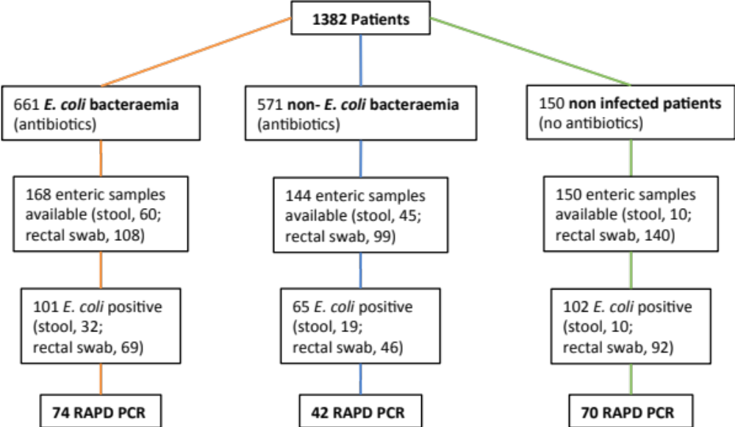

Figure S2 E. coli diversity in rectal swab and stool samples. Number of RAPD patterns detected in each enteric sample from patients with E. coli bacteraemia (ECB); patients with other non-E coli Gram negative bacteraemias (non-ECB); and control in-patients (CON) who were not receiving antibiotics. Results for stool samples and rectal swabs are shown separately in each group. Plots show median (horizontal bar) and interquartile range. Differences between rectal swab and stool samples were not significant

