Cost-effectiveness analysis of natriuretic peptide testing and specialist outreach in patients with suspected acute heart failure
ABSTRACT
Aims
To determine the cost-effectiveness of natriuretic peptide (NP) testing and specialist outreach in acute heart failure patients residing off the cardiology ward.
Methods
We used a Markov model to estimate costs and quality-adjusted life years (QALYs) for patients presenting to hospital with suspected acute heart failure (AHF). We examined diagnostic work-up with and without the NP test in suspected new cases; and we examined the impact of specialist heart failure outreach in all suspected cases. Inputs for the model were derived from systematic reviews, the UK national heart failure audit, RCTs, expert consensus from a NICE guideline development group, and a national online survey. The main benefit from specialist care (cardiology ward and specialist outreach) was the increased likelihood of discharge on disease modifying drugs for people with left ventricular systolic dysfunction, which improve mortality and reduce readmissions due to worsened heart failure (associated with lower utility). Costs included diagnostic investigations, admissions, pharmacological therapy, and follow-up heart failure care.
Results
NP testing and specialist outreach are both higher cost, higher QALY, cost effective strategies (ICERs of £11,656 and £2,883 per QALY gained, respectively). Combining NP and specialist outreach is the most cost effective strategy. This result was robust to both univariate deterministic and probabilistic sensitivity analyses.
Conclusions
NP testing for the diagnostic work-up of new suspected AHF is cost effective. The use of specialist heart failure outreach for AHF inpatients residing off the cardiology ward is cost effective. Both interventions will help improve outcomes for this high risk group.
INTRODUCTION
A diagnosis of acute heart failure (AHF) is challenging and is confirmed in only 40-50% of suspected cases.¹ Symptoms and signs are often non-specific and may overlap with a number of alternative diagnoses. Mortality in patients following a period of hospitalisation for heart failure is high at 25% over one year,² so it is important to examine where changes to diagnosis and treatment strategies might lead to improvement. The measurement of plasma natriuretic peptide (NP) levels has been recommended in international guidelines for the diagnosis of heart failure with the aim of excluding the diagnosis of heart failure at an early stage to allow targeted, clinically appropriate and resource efficient investigation.^{3, 4} However adoption of NP in acute care settings in some countries (e.g. the UK) has been limited, in part due to the additional costs but also uncertainty in the incremental benefit and cost effectiveness. While economic evaluations suggest NP testing is cost effective in the acute setting,⁵⁻⁸ these did not examine its impact on health-related quality of life (HRQoL), a preferred measure of benefit for inclusion in economic evaluation.⁹ Management of patients hospitalised with acute heart failure by specialist multi-disciplinary teams is associated with reduced in-hospital mortality and an increase in use of proven medical therapies.² Currently there is significant regional variation in the degree of specialist involvement in in-hospital management of heart failure.^{2, 10} We are not aware of any previous cost effectiveness analysis of specialist care arrangements for AHF.
This combined evaluation was conducted as part of the National Institute for Health and Care Excellence (NICE) guideline on diagnosing and managing AHF (CG187).¹¹ In a diagnostic analysis we report the cost effectiveness of the NP test for the diagnostic work-up of suspected new AHF cases compared to standard clinical investigations (physical examination, electrocardiography, chest radiography, and routine blood tests). And in an analysis of care management in all suspected cases, we report the cost effectiveness of specialist heart failure outreach compared to no outreach in a multi-ward arrangement typical of many hospitals in the UK and elsewhere.
METHODS
Modelling approach and structure
We conducted a cost-utility analysis in Microsoft® Excel 2010 to determine the cost-effectiveness of NP in a diagnostic analysis, and specialist outreach in a care management analysis. Four strategies combined the two analyses:
- Standard clinical investigations, and no specialist outreach
- NP test and no specialist outreach
- Standard clinical investigations, and specialist outreach
- NP test and specialist outreach
Base case costs, life-years, and quality-adjusted life years (QALYs) are calculated over a time-horizon of four years. This was the available follow-up period for patients included in the national heart failure audit at the time of analysis, and was accepted by expert clinical consensus as long enough to capture most important differences in costs or outcomes between strategies. The evaluation perspective is that of the health system payer of England and Wales, costs are reported in 2013 GBP, and future costs and benefits are discounted at 3.5% per year.¹² The modelled population is patients suspected of AHF presenting to the emergency department with dyspnoea and no clear alternative diagnosis. Inputs for the analyses have been obtained from a range of sources, and where required we selected the most conservative of available alternatives i.e. least favourable to NP and specialist outreach. Table 1 summarises key assumptions and presents the input parameters used in the base case.
The model structure is a decision tree into a Markov chain. The decision tree (Figure 1) deals with differences in true condition within the starting population, the diagnostic work-up, and the subsequent nature of care. The starting cohort proceed firstly through two epidemiological chance nodes to sort by true underlying disease and underlying cause. Two further chance nodes then divide by outcome of diagnostic work-up, and in the case of false negatives, the likelihood of identification and corrective action. The care management strategies are then conceived by a division into those who receive specialist care (by virtue of residing on a cardiology ward, or involvement of an outreach team), and those who receive standard care. The resultant subgroups are passed into a subsequent Markov chain with three-month transition cycles (Figure 2). A survival analysis informs the probability of death within each cycle, given the patients true condition, cause, diagnostic work-up and subsequent care. Patients remaining alive are in chronic heart failure (CHF) and are at risk-of readmission from worsening of their condition.
Work-up diagnosis
The starting cohort are 47% true for AHF and 65% true for left ventricular systolic dysfunction (LVSD) as the predominant underlying cause.^{13, 14} Fifty-six per cent are male, for whom the entry age is 75 years, and women enter at 80 years, reflecting the typical ages of people presenting with AHF in the UK.² The sensitivity and specificity of work-up diagnosis using standard clinical investigations is extracted from the physician only receiver operating characteristic (ROC) curve (apex) of the Breathing Not Properly multi-national study. The accuracy of the NP test is drawn from a systematic review and meta-analysis using recognised cut-offs (100 ng/L for B type natriuretic peptide and 300 ng/L for NTproBNP).^{13,15} Eighty per cent of false negative work-ups are corrected during admission (expert consensus) resulting in a short non-detrimental delay in discharge. The remaining twenty per cent have an increase in risk of death and readmission equal to untreated LVSD, plus two additional days of hospitalisation. Patients with a false positive work-up receive echocardiography so are presumed to be identified early.
Care management
Patients can either receive care which includes specialist heart failure input or receive standard care, in which there is no heart failure specialist involvement during acute admission. Negative work-ups in all strategies receive standard care on general medical wards. Positive work-ups in all strategies are divided into half who receive standard care on general medical wards and half who receive specialist care on cardiology wards, as is the national picture.² However, in specialist outreach strategies, patients residing on general wards receive additional heart failure specialist care from an outreach team, and are attributed the same health benefits from specialist care as received by patients residing on cardiology wards. In respect to resource use, 20% of patients on cardiology wards also receive input from a non-cardiologist (expert consensus).
Benefit of specialist care
There is good evidence that ACE inhibitors, angiotensin receptor blockers, beta blockers, and aldosterone antagonists/ mineralocorticoid receptor antagonists improve outcomes for people with heart failure due to LVSD.^{16, 17} Therefore we attribute reduced mortality and risk of readmission to AHF patients with LVSD, following discharge, according to the likelihood being discharged with these drugs. The proportion of people receiving these interventions, according to whether or not a specialist nurse or physician was involved in acute care, is based on a secondary analysis of the most recent year of data from the national heart failure audit which adjusted for potential confounders using logistic regression propensity modelling (Table 1).¹⁴
Four year survival and readmission curves were plotted (Figure 3) using hazard ratios (Table 2) applied to baseline rates sourced directly from the national audit (supplementary material B Figure 8). For the ten-year scenario analysis, subsequent years were based on a Weibull parametric extrapolation (supplementary material A Figure S1). Cardiovascular mortality baseline risk is based on those who survived beyond discharge with no recorded discharge HF medication.¹⁴ The baseline risk of readmission due to worsened heart failure is based on a study of UK CHF patients who received minimal treatment relative to current recommendations.¹⁸ Hazard ratios are calculated from risk ratios produced from meta-analyses of drug effect sizes from RCTs identified in a pre-specified search protocol (Table 2. Also see supplementary material A Figure S2 for meta-analysis forest plots). In the absence of suitable systematic reviews, we pooled together the results of large (n≥1,000) placebo controlled RCTs of ACEi/ARAs, BBs and MRAs in a chronic LVSD population, which reported cardiovascular mortality. We excluded trials that focused on an acute MI population.
In addition to benefits based on prescribing patterns we apply a lower in-hospital mortality at 15 days for patients receiving specialist management, based on a confounder adjusted analysis of patients with LVSD from the national audit (supplementary material B, Figures 3 and 5).¹⁴ Conservatively, we have not attributed any health benefit from specialist care to patients who did not have LVSD, whilst including these populations in the cost summation.
Health-related quality of life
The HRQoL of patients who are stable post-discharge (CHF health state) is calculated using the NYHA functional class utilities taken from a sample of UK heart failure patients.¹⁹ A single weighted average is derived according to the class distribution observed in a representative UK cohort.²⁰ To account for worsened heart failure associated with hospital admission, a utility decrement is applied over a six week period around readmissions, including the index admission. This is calculated from EQ-5D data collected in the Systolic Heart failure treatment with the lf inhibitor ivabradine Trial (SHIfT, unpublished data provided by Servier Laboratories Ltd, 2014).
Costs
Utilised resources include the NP test (where strategized, £28.13), echocardiograms (indicated whenever a diagnosis of new AHF is sought), staffing of hospital teams, occupancy of inpatient beds, and follow-up community based care. The time requirement of a specialist heart failure outreach team, comprising a specialist consultant physician and a heart failure specialist nurse, is based on our online survey of role-based patient-related activity by ward setting in acute providers of England and Wales. Standard sources inform unit costs of staffing, which include the cost of specialist training.²¹ The cost of the average inpatient bed stay is calculated using the NHS daily cost of bed occupancy weighted for complication rate, and the national median length of stay for episodes of AHF.^{2, 22} Follow-on costs accrued in CHF include LVSD drug acquisition, hospital outpatient visits, GP visits, and community specialist nurse. The probability of being successfully referred to follow-on services is increased if specialist care was received.² Expert opinion has been elicited to inform the intensity of health system contacts.
Analysis
The model was run both deterministically (i.e. based on the point estimates of all input parameters) and probabilistically (i.e. based on a distribution for each input). The main results are based on the probabilistic analysis, which allowed the calculation of 95% confidence intervals. Distributions were defined according to the nature of the data (for example hazard ratios are lognormally distributed) and parameterised using standard error estimates from data sources, or where absent, were set to equal the mean divided by four. Incremental findings were recomputed after each simulation and appeared to have become stable by the 1,000th simulation. We also tested the robustness of the model by individually varying potentially sensitive model inputs in the deterministic analysis by 10%, and we tested pre-selected structural uncertainty by applying plausible alternatives using literature sources or expert clinical opinion. The incremental cost effectiveness ratio (ICER) was used for pair-wise strategy comparison and the net monetary benefit (NMB) for comparison across all four strategies. For a particular cost-effectiveness threshold the NMB is calculated by multiplying the total QALYs for a comparator by the threshold cost per QALY and then subtracting the total strategy cost. The comparator with the highest NMB is the most cost-effective option at the specified threshold because it provides the highest number of QALYs at an acceptable cost.
RESULTS
Diagnostic outcomes
The higher sensitivity and lower specificity of work-up diagnosis using the NP test, compared to standard clinical investigations, results in fewer false negatives (2.3% versus 9.4%) and more frequent false positive work-ups (19.8% versus 12.2%). A consequence of this is an increased demand for echocardiography (668 versus 592 echocardiograms per 1,000 patients). A detailed breakdown of the diagnostic accuracy can be found in supplementary material A Table S1.
Health outcomes
Survival curves for patients with LVSD and non-LVSD AHF are shown in Figure 3. Patients with LVSD who have an incorrect work-up at the index admission have the poorest survival (30% alive at 4-years). Patients receiving care from a specialist have a higher likelihood of survival than those who do not (36% alive at 4-years versus 31%). They also have a lower probability of worsened heart failure and consequent readmission. Overall the NP test and specialist outreach increase the average health of the modelled population in terms of increased life-years as well as QALYs gained (Table 3). Optimal QALY gain is achieved in the strategy combining the NP test and specialist outreach.
Costs
Strategies utilising the NP test have higher diagnostic work-up costs, index admission costs, drug acquisition and follow-up care costs than non-NP strategies; but costs arising from readmission are lower (Table 3). Similarly, specialist outreach strategies are more costly in the short-run but are effective in reducing long-term costs. Over four years the individual cost of NP testing and specialist outreach is higher than standard strategies, but the difference is small at the individual patient level. The impact on the cost and time-requirement of staff can be found in supplementary material A Table S2.
Cost effectiveness
NP testing was cost effective versus no test, with an ICER of £11,656 per QALY gained [95% CI: £4,641, £23,774], and specialist outreach was cost effective compared to no outreach, the ICER £2,883 per QALY gained [95% CI: £2,103, £4,324]. Combining these two strategies was cost effective, the ICER £4,350 per QALY gained [95% CI: £2,976, £6,788]. Introducing NP testing where specialist outreach already exists is also cost effective, the ICER £7,914 per QALY gained [95% CI: £4,007, £14,554]. The combination of specialist outreach with NP testing was convincingly cost effective, being the most cost effective of all strategies in more than 99% of the probabilistic simulations. Univariate sensitivity analysis found specialist outreach to be cost effective compared to no outreach in all tests. NP testing was cost effective in all tests except in a scenario where in-hospital mortality benefit linked to specialist involvement is nullified and specialist outreach is not offered (see supplementary material A Table S3 for results of all sensitivity analyses).
DISCUSSION
We have conducted a cost utility analysis in order to estimate costs and QALYs associated with the diagnosis and management of suspected AHF in patients presenting to an acute hospital with dyspnoea. Individually, strategies of NP testing and specialist outreach were more costly but also more cost effective than standard investigations and standard management respectively. The combined strategy of NP testing and specialist outreach was a cost effective strategy (£7,914 per QALY gained) but also the optimum strategy in terms of net monetary benefit. The adoption of the combined strategy in acute care settings has the potential to improve morbidity and mortality in a group of patients who have a high risk of readmission and mortality following an acute hospital admission.
There have been no previous evaluations of the cost effectiveness of arrangements of specialist care for AHF, at the time of writing this is the first evaluation of specialist outreach. However, there are previous European and US cost effectiveness analyses of NP in AHF. These have found that NP testing produces a net saving whereas we have found there is a marginal increase in overall cost.⁵⁻⁸ If we test higher sensitivity and lower specificity in work-up using standard investigations then we too find a cost saving from fewer false negative cases, but we expect clinicians in this situation to maximise specificity in order to increase the certainty of ruling-out AHF.
Where possible we have made conservative choices around structural aspects of model design in the management analysis: no benefit from specialist care is given to patients with non-LVSD heart failure even though the cost of the additional specialist time was included; specialist care attracts additional outpatient and community costs; and we exclude potential benefits associated with specialist care such as those from cost-effective implantation of devices.¹¹ Also, the selected time horizon is shown to be conservatively short since extrapolation of the survival analysis to ten years reveals uncaptured low cost QALYs beyond four years. However, the pivotal evidence informing effect size in the management analysis – although the most contemporary and relevant - is non-randomised. Our literature review did identify two cohort studies as alternative sources of resource-related mortality. Auerbach et al prospectively examined costs and clinical outcomes of patients admitted with congestive heart failure cared for by cardiologists, versus patients cared for by generalists in five US hospitals between 1989 and 1994 (n=1,298).⁴ Cardiologist care was associated with greater costs and resource use and no difference in survival at 30 days of follow-up. Lowe et al (2000) conducted a similar smaller study in a single hospital in Australia (n=275).²³ The use of cardiac drugs and investigations was similar in the two groups; the generalists' patients had a longer length of hospital stay; and the cardiologists' patients had a higher mortality during the early follow-up period. The authors noted confounding in that patients under the generalist were older, had greater co-morbidity, but appeared to have less severe cardiac disease than those under the cardiologist. Therefore these cohort studies are open to the same sources of confounding as the unadjusted national audit, but are less applicable to current heart failure care in the modelled setting. The 2012/13 UK national heart failure audit is approximately a 60% sample, included returns from 145 NHS Trusts and Health Boards in Wales (97%) and included 43,894 heart failure coded discharges or deaths. To tackle inevitable confounding in the key statistic we used logistic regression to calculate the propensity of a hospitalised AHF patient being prescribed LVSD drugs according to whether or not the care received included input from a specialist, adjusting for 13 potentially confounding covariates including NYHA class. It is conceivable that there is residual confounding that could result in an over-estimation of the impact of specialist care but our conservative assumptions will diminish this effect. Going further, even if the mortality benefit of specialist input over the period of admission is excluded, a strategy of specialist outreach remains cost effective compared to standard care in which there is no outreach.

In the diagnostic analysis we can have some confidence in the parameters informing the accuracy of the NP test, since the estimate is from a meta-analysis of 37 unique study cohorts.¹⁵ However the estimate of accuracy of emergency department physician work-up using standard clinical investigations is derived from the ROC curve of a single trial.¹³ Although in sensitivity testing using alternative plausible estimates the result was unchanged.¹⁵ But important to the context of our finding, sensitivity and specifically estimates for approaches are based on populations of suspected AHF which include previously known cases. Therefore in our analysis of suspected new cases the model may potentially over-estimate the cost effectiveness of NP, since the proportion of true cases amongst new ones would be relatively lower and therefore the number detected will be smaller as a proportion of the whole. Equally the test’s cost effectiveness may be under-estimated because the ability of the physician using standard investigations to accurately identify true cases amongst only new cases is likely to be poorer. Also because when applied in clinical practice, physicians may choose to use the NP test more selectively where there is diagnostic uncertainty, rather than in every new patient. Finally, we assume no health loss for false positives, which are more frequent with the test. To do so may reduce cost effectiveness but given that positive work-ups typically proceed to echocardiography in clinical practice any negative health impact will be limited.
Conclusion
Natriuretic peptide testing of suspected new cases of AHF, and the adoption of specialist outreach teams for those patients residing off the cardiology ward, may improve outcomes for patients with AHF in a cost effective manner. Adoption of these approaches in similar health care systems may provide further incremental benefit to the outcomes of patients presenting acutely with heart failure.

References
1. Moe GW, Howlett J, Januzzi JL, Zowall H. N-terminal pro-B-type natriuretic peptide testing improves the management of patients with suspected acute heart failure: primary results of the Canadian prospective randomized multicenter IMPROVE-CHF study. Circulation 2007;115(24):3103-10.
2. Cleland J, Dargie H, Hardman S, McDonagh T, Mitchell P. National Heart Failure Audit. April 2012 - March 2013. In. London: National Institute for Cardiovascular Outcomes Research (NICOR); 2013.
3. Investigators TB. A Trial of the Beta-Blocker Bucindolol in Patients with Advanced Chronic Heart Failure. New England Journal of Medicine 2001;344(22):1659-1667.
4. Auerbach AD, Hamel MB, Davis RB, et al. Resource use and survival for patients hospitalized with congestive heart failure: differences in care by specialty of the attending physician. Annals of Internal Medicine 2000;132(3):191-200.
5. Rutten JH, Steyerberg EW, Boomsma F, et al. N-terminal pro-brain natriuretic peptide testing in the emergency department: beneficial effects on hospitalization, costs, and outcome. American heart journal 2008;156(1):71-7.
6. Siebert U, Januzzi JL, Jr., Beinfeld MT, Cameron R, Gazelle GS. Cost-effectiveness of using N-terminal pro-brain natriuretic peptide to guide the diagnostic assessment and management of dyspneic patients in the emergency department. The American journal of cardiology 2006;98(6):800-5.
7. Mueller C, Laule-Kilian K, Schindler C, et al. Cost-effectiveness of B-type natriuretic peptide testing in patients with acute dyspnea. Archives of internal medicine 2006;166(10):1081-7.
8. AHTA. B-type natriuretic peptide assays in the diagnosis of heart failure. Part A: in the hospital emergency setting. Part B: in the non-hospital setting. Adelaide Health Technology Assessment (AHTA) 2007;2007(MSAC Application 1087).
9. National Institute for H, Clinical E. The guidelines manual. London: National Institute for Health and Clinical Excellence; 2012.
10. Health, Social Care information C. Hospital Episode Statistics (HES), Admitted Patient Care (Diagnosis), England 2012-13. http://www.hscic.gov.uk/catalogue/PUB12566 (2014/08/19/; date last accessed).
11. NICE. Acute Heart Failure: Diagnosing and Managing Acute Heart Failure in Adults. London: National Clinical Guideline Centre, 2014.; 2014.
12. National Institute for H, Clinical E. Guide to the methods of technology appraisal. London: National Institute for Health and Clinical Excellence; 2008.
13. McCullough PA, Nowak RM, McCord J, et al. B-type natriuretic peptide and clinical judgment in emergency diagnosis of heart failure: analysis from Breathing Not Properly (BNP) Multinational Study. Circulation 2002;106(4):416-422.
14. National Institute for Cardiology Outcomes R. Secondary analysis of the National Heart Failure Audits of England and Wales 2009 - 2013 (unpublished; refer to supplementary material B). In; 2014.
15. Roberts E, Ludman AJ, Dworzynski K, et al. The diagnostic accuracy of the natriuretic peptides in heart failure: systematic review and diagnostic meta-analysis in the acute care setting. BMJ 2015;350:h910.
16. National Clinical Guideline C. Chronic heart failure: the management of chronic heart failure in adults in primary and secondary care. NICE clinical guideline 108. In. London: National Clinical Guideline Centre; 2010.
17. McMurray JJ, Adamopoulos S, Anker SD, et al. ESC Guidelines for the diagnosis and treatment of acute and chronic heart failure 2012: The Task Force for the Diagnosis and Treatment of Acute and Chronic Heart Failure 2012 of the European Society of Cardiology. Developed in collaboration with the Heart Failure Association (HFA) of the ESC. European Heart Journal 2012;33(14):1787-1847.
18. Cowie MR, Fox KF, Wood DA, et al. Hospitalization of patients with heart failure: a population-based study. European Heart Journal 2002;23(11):877-885.
19. Sutcliffe P, Connock M, Pulikottil-Jacob R, et al. Clinical effectiveness and cost-effectiveness of second- and third-generation left ventricular assist devices as either bridge to transplant or alternative to transplant for adults eligible for heart transplantation: systematic review and cost-effectiveness model. Health technology assessment (Winchester, England) 2013;17(53):1-499, v-vi.
20. Lainchbury JG, Troughton RW, Strangman KM, et al. N-terminal pro-B-type natriuretic peptide-guided treatment for chronic heart failure: results from the BATTLESCARRED (NT-proBNP-Assisted Treatment To Lessen Serial Cardiac Readmissions and Death) trial. Journal of the American College of Cardiology 2009;55(1):53-60.
21. Curtis L. Unit costs of health and social care 2013. Canterbury: Personal Social Services Research Unit, University of Kent; 2013.
22. Department of H. NHS reference costs 2012-13. https://www.gov.uk/government/uploads/system/uploads/attachment_data/file/261154/nhs_reference_costs_2012-13_acc.pdf (14/03/17/; date last accessed).
23. Lowe J. Specialist or generalist care? : a study of the impact of a selective admitting policy for patients with cardiac failure. International Journal for Quality in Health Care 2000;12(4):339-345.
24. Office for National S. Interim mid-2011 population estimates: England and Wales; estimated resident population by single year of age and sex; based on the results of the 2011 Census: Table 3. http://www.ons.gov.uk/ons/publications/re-reference-tables.html?edition=tcm%3A77-262039 (2014/03/14/; date last accessed).
25. Office for National S. Deaths registered in England and Wales 2011: table 5.9. www.ons.gov.uk/ons/rel/vsob1/mortality-statistics--deaths-registered-in-england-and-wales--series-dr-/2011/dr-table5-2011.xls (2014/03/14/; date last accessed).
26. Pitt B, Poole-Wilson PA, Segal R, et al. Effect of losartan compared with captopril on mortality in patients with symptomatic heart failure: randomised trial--the Losartan Heart Failure Survival Study ELITE II. Lancet 2000;355(9215):1582-1587.
27. Young JB, Dunlap ME, Pfeffer MA, et al. Mortality and morbidity reduction with Candesartan in patients with chronic heart failure and left ventricular systolic dysfunction: results of the CHARM low-left ventricular ejection fraction trials. Circulation 2004;110(17):2618-2626.
28. Cohn JN, Tognoni G. A randomized trial of the angiotensin-receptor blocker valsartan in chronic heart failure. New England Journal of Medicine 2001;345(23):1667-1675.
29. The SI. Effect of enalapril on survival in patients with reduced left ventricular ejection fractions and congestive heart failure. The SOLVD Investigators. New England Journal of Medicine 1991;325(5):293-302.
30. Investigators C-I, Health Economics G. Reduced costs with bisoprolol treatment for heart failure: an economic analysis of the second cardiac insufficiency bisoprolol study (CIBIS-II). European Heart Journal 2001;22(12):1021-1031.
31. Group M-HS. Effect of metoprolol CR/XL in chronic heart failure: Metoprolol CR/XL Randomised Intervention Trial in Congestive Heart Failure (MERIT-HF). Lancet 1999;353(9169):2001-2007.
32. Packer M, Fowler MB, Roecker EB, et al. Effect of carvedilol on the morbidity of patients with severe chronic heart failure: results of the carvedilol prospective randomized cumulative survival (COPERNICUS) study. Circulation 2002;106(17):2194-2199.
33. Zannad F, McMurray JJ, Krum H, et al. Eplerenone in patients with systolic heart failure and mild symptoms. New England Journal of Medicine 2011;364(1):11-21.
Figure 1
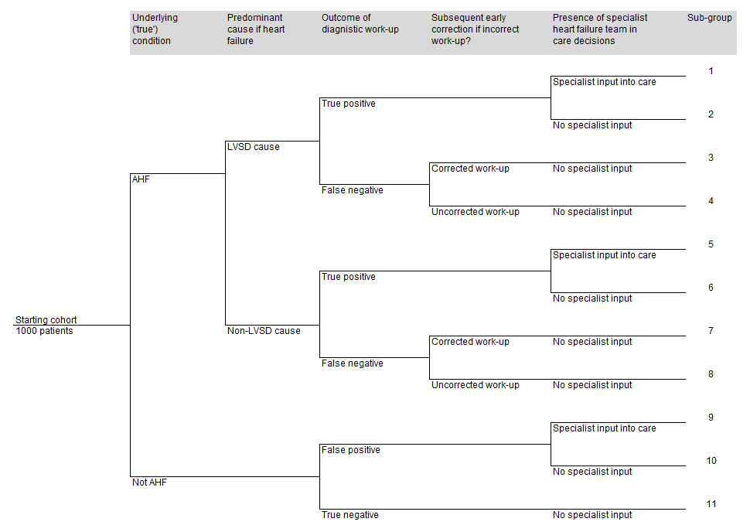

Figure 1. The decision tree of the diagnostic analysis
Abbreviations: AHF = Acute heart failure; LVSD = Left ventricular systolic disfunction.

Figure 2
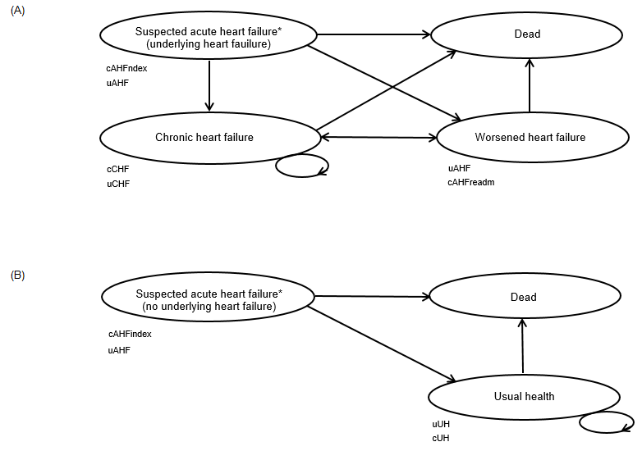

Figure 2. Schematic diagram of Markov model. (A) Patients heart failure, (B) Patients with other conditions.
States of the model are represented by ovals and allowed transitions between states are represented by arrows. Circular arrows indicate that patients may remain in the state for consecutive cycles. Quality of life weights (or utilities, u) and costs (c) are specific for each health state. Patients who are not alive do not accrue costs and have zero utility. The cost of AHF is different according to whether suspected (cAHFindex) or worsened leading to readmission (cAHFreadm).
Abbreviations: AHF = Acute Heart Failure; CHF = Chronic heart failure; UH = Usual health.

Figure 3
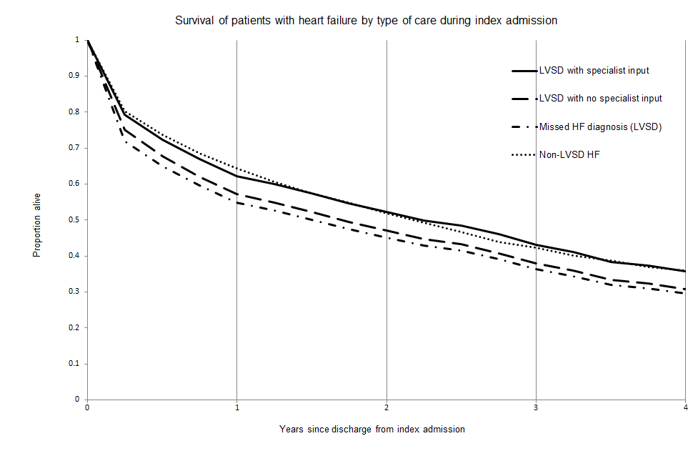

Figure 3. Four year survival curve for patients admitted with acute heart failure
Abbreviations: FN = False negative (work-up); LVSD = Left ventricular systolic dysfunction; TP = True positive (work-up).

TABLES
Table 1 Summary of assumptions and inputs used in the base case model
Assumption | Impact |  | Applied population and period
A false positive initial work-up is not harmful since it will be followed-up with an early echocardiogram | None |  | All false positive patients
A false negative initial work-up prolongs hospitalisation | 2 days extra in hospital |  | All false negative patients; applied to the index admission only
A prolonged misdiagnosis of AHF reduces survival | No treatment and benefit from ACEi/ARA, BB or MRA |  | All false negatives with LVSD which are not corrected during index admission; 3 months only
A prolonged misdiagnosis of AHF increases risk of readmission | Risk of readmission increases to 1/3
Input parameter description | Point estimate | Distribution parameters used in probabilistic analysis | Source
Diagnosis parameters – Beta distributions
Prevalence of AHF in patients presenting to emergency department with acute dyspnoea suspected of AHF | 47% | α = 722, β = 864 | Breathing Not Properly multinational study¹³
Prevalence of LVSD in patients with true underlying AHF | 65% | α = 18628, β = 10030 | Secondary analysis of the National Heart Failure Audits of England and Wales 2009-2013 (from 2012/13 data) ¹⁴
Sensitivity of working diagnosis without NP test | 80% | α = 578, β = 144 | Breathing Not Properly multinational study¹³ (Thresholds of 100 ng/L for B type natriuretic peptide and 300 ng/L for NTproBNP)
Specificity of working diagnosis without NP test | 77% | α = 556, β = 166
Sensitivity of working diagnosis with BNP test | 95.1% | α = 3560590, β = 182278 | Systematic review and diagnostic meta-analysis in the acute care setting¹⁵
Specificity of working diagnosis with BNP test | 62.7% | α = 299152, β = 177813
Probability of correction of a false work-up in a patient with AHF | 80% | α = 2.4, β = 0.6 | Consensus of expert clinical opinion
Baseline mortality – Beta distributions
In-hospital mortality with specialist input: LVSD | 3.3% | α = 372, β = 10905 | Secondary analysis of the National Heart Failure Audits of England and Wales 2009-2013¹⁴
In-hospital mortality: Non-LVSD | 5.3% | α = 205, β = 3667
In-hospital mortality without specialist input: LVSD | 6.3% | N/a | Calculated
Annual all-cause mortality in age and gender adjusted population | 4.6% | N/a | National heart failure audit 2012/13,² and Office for National Statistics^{24, 25}
Ratio of CV to all-cause deaths | 0.796 | α = 1253, β = 321 | ELITE II study²⁶
Ratio of heart failure to all-cause readmissions | 0.459 | α = 294, β = 495 | ELITE II study²⁶
Treatment effect – LogNormal distributions
Hazard ratio in-hospital mortality, Specialist vs no specialist: LVSD | 1.94 | se(LnHR) = 0.09 | Secondary analysis of the National Heart Failure Audits of England and Wales 2009-2013 (from 2012/13 data¹⁴
Hazard ratio in-hospital mortality, Specialist vs no specialist: Non-LVSD | 1.95 | se(LnHR) = 0.11
Hazard ratio post-discharge CV mort ACEi/ARA vs placebo | 0.898 | se(LnHR) = 0.04 | CHARM(LLEF),²⁷ Val-HEFT,²⁸ SOLVD-T²⁹
Risk ratio post-discharge HF readm ACEi/ARA vs placebo | 0.800 | se(LnHR) = 0.03 | CHARM(LLEF),²⁷ Val-HEFT,²⁸ SOLVD-T²⁹
Hazard ratio post-discharge CV mortality BB vs placebo | 0.738 | se(LnHR) = 0.12 | BEST,³ CIBIS-2,³⁰ MERIT-HF³¹
Risk ratio post-discharge HF readmission BB vs placebo | 0.760 | se(LnHR) = 0.06 | BEST,³ CIBIS-2,³⁰ COPERNICUS³²
Hazard ratio post-discharge CV mort MRA vs placebo | 0.788 | se(LnHR) = 0.04 | EMPHASIS³³
Risk ratio post-discharge HF readm MRA vs placebo | 0.650 | se(LnHR) = 0.02 | EMPHASIS³³
Treatment effect – Beta distributions
Probability of ACEi or ARB treatment: Specialist team | 78% | α =4285 , β = 1208 | Secondary analysis of the National Heart Failure Audits of England and Wales 2009-2013 (from 2012/13 data)*¹⁴
Probability of ACEi or ARB treatment: General medical team | 61% | α = 887, β = 575
Probability of BB treatment: Specialist input | 87% | α = 4676, β = 723
Probability of BB treatment: No specialist input | 59% | α = 840, β = 593
Probability of MRA treatment: Specialist input | 38% | α = 2042, β = 3345
Probability of MRA treatment: No specialist input | 18% | α = 258, β = 1186
Resource parameters – Gamma distributions
Mins/pt/week Cardiologist on a cardiology ward | 20 | se = 2.92 | Online survey conducted by the National Institute for Cardiology Outcomes Research (NICOR), November 2013 (unpublished)
Mins/pt/week Cardiologist on a non-cardiology ward | 20 | se = 2.8
Mins/pt/week Non-cardiologist on a cardiology ward | 15 | se = 4.15
Mins/pt/week Non-cardiologist on a non-card ward | 23 | se = 2.68
Mins/pt/week HFSN on a cardiology ward | 30 | se = 7.53
Mins/pt/week HFSN on a non-card ward | 30 | se = 7.06
Proportion of cardiology ward patients seen by a non-cardiologist | 0.2 | se = 0.05 | Consensus of expert clinical opinion
Median length of index stay (days) | 8.0 | se = 2 | National heart failure audit 2012/13²
Length of stay penalty for false working diagnoses (days applied to initial stay, only) | 2.0 | se = 0.5 | Consensus of expert clinical opinion
Other Resource inputs
Prob. outpatient f/up when care from cardiology ward | 71% | N/a | National heart failure audit 2012/13²
Prob. community f/up when care from cardiology ward | 68% | N/a | National heart failure audit 2012/13²
Prob. outpatient f/up when care from non-card ward | 22% | N/a | National heart failure audit 2012/13²
Prob. community f/up when care from non-card ward | 23% | N/a | National heart failure audit 2012/13²
Prob. outpatient f/up when care by outreach team | 50% | N/a | National heart failure audit 2012/13²
Prob. community f/up when care by outreach team | 71% | N/a | National heart failure audit 2012/13²
Cardiology outpatient follow-ups in first year | 2 | N/a | Consensus of expert clinical opinion
Cardiology outpatient follow-ups in subsequent years | 1 | N/a | Consensus of expert clinical opinion
Community HFSN follow-ups per annum | 4 | N/a | Consensus of expert clinical opinion
Annual GP visits when without community support | 7 | N/a | Consensus of expert clinical opinion
Annual GP visits when receiving community support | 3 | N/a | Consensus of expert clinical opinion
Unit cost parameters (£) – Gamma distributions
Echocardiogram | 63.60 | se = 15.65 | NHS Reference costs schedule 2012-13
Bed day | 232.09 | se = 58.02 | NHS Reference costs schedule 2012-13
Natriuretic peptide test (BNP) | 28.13 | se = 7.03 | Personal correspondence, St Georges Healthcare NHS Trust
Consultant hour (Cardiologist/General Physician) | 132 | se = 33.00 | Personal Social Services Research Unit Handbook 2013²¹
HFSN hour | 52 | se = 13.00 | Personal Social Services Research Unit Handbook 2013²¹
GP visit | 37 | N/a | Personal Social Services Research Unit Handbook 2013²¹
Community HFSN visit | 42 | N/a | Personal Social Services Research Unit Handbook 2013²¹
Hospital outpatient visit | 131 | N/a | NHS Reference costs schedule 2012-13²¹
ACE inhibitor/Angiotensin receptor antagonist (day) | 0.11 | N/a | Prescription cost analysis England 2012¹⁰
Beta blocker (day) | 0.07 | N/a | Prescription cost analysis England 2012¹⁰
Mineralocorticoid receptor antagonist (day) | 0.20 | N/a | Prescription cost analysis England 2012¹⁰
Dis-utility parameters – Gamma distribution
Dis-utility for 3-months in AHF | 0.064 | se = 0.016 | Unpublished data from the SHIfT trial, supplied by Servier Laboratories Ltd
Utility parameters – Beta distribution
Chronic heart failure | 0.752 | α = 966, β = 318 | BATTLESCARRED trial,²⁰ and health technology assessment¹⁹
Usual health (non-heart failure) | 0.752 | N/a | BATTLESCARRED trial,²⁰ and health technology assessment¹⁹
Suspected acute/Worsened heart failure | 0.688 | N/a | Calculated
Abbreviations: MRA = Mineralocorticoid receptor antagonist (Aldosterone antagonist); ACEi = Angiotensin converting enzyme inhibitor; AHF = Acute heart failure; ARB = Angiotensin receptor antagonist; BNP = B-type natriuretic peptide; CV = Cardiovascular; HF = Heart failure; HFSN = Heart failure specialist nurse; LVSD = Left ventricular systolic dysfunction; NP = Natriuretic peptide.*The included factors were: systolic blood pressure; haemoglobin; NHYA class; urea; creatinine; serum sodium; serum potassium; age; gender; previous chronic obstructive pulmonary disease; previous myocardial infarction; previous ischemic heart disease; previous vascular disease.

Table 2 Hazard ratios of gold standard interventions for left ventricular systolic dysfunction. Results of meta-analysis. 95% confidence intervals in parenthesis.
LVSD medication | Cardiovascular mortality | Readmission due to worsened HF
ACEi/ARBs versus placebo | 0.91 [0.83, 1.00] | 0.80 [0.75, 0.86]
BBs versus placebo | 0.75 [0.61, 0.93] | 0.76 [0.66, 0.87]
AA/MRAs versus placebo | 0.80 [0.65, 0.98] | 0.65 [0.54, 0.78]
Abbreviations: AA = Aldosterone antagonist / mineralocorticoid receptor antagonist; ACEi = Angiotensin converting enzyme inhibitor; ARB = Angiotensin receptor blocker; BB = Beta blocker
Table 3 Life-years, QALYs and disaggregated per patient costs by strategy
Strategy | Life years | QALYs | Diag-nostic work-up | Index admission | Re-admissions | Drugs and visits | Total patient cost
SCI and no SPO | 3.154 | 2.212 | £36 | £2,027 | £316 | £274 | £2,654
NP and no SPO | 3.159 | 2.216 | £69 | £2,035 | £308 | £285 | £2,698
SCI and SPO | 3.178 | 2.229 | £36 | £2,047 | £305 | £315 | £2,703
NP and SPO | 3.188 | 2.236 | £69 | £2,060 | £296 | £334 | £2,759
Abbreviations: NP = Natriuretic peptide test; SCI = standard clinical investigations; SPO = Specialist outreach

