Epithelium-derived cystatin SN inhibits house dust mite protease activity in allergic asthma

Lei Yao¹, Xijing Yuan¹, Heng Fu¹, Qinxing Guo¹, Yunhui Wu¹, Shurui Xuan¹, Nazanin Zounemat Kermani², Ian M. Adcock³, Xiaoning Zeng¹, Yi Liu^{4,5}, Min Xie⁶, Xin Yao¹

¹Department of Respiratory and Critical Care Medicine, The First Affiliated Hospital of Nanjing Medical University, Nanjing, China
²Data Science Institute, Department of Computing, Imperial College London, London, UK
³Airway Disease Section, Faculty of Medicine, National Heart and Lung Institute, Imperial College London, London, UK
⁴Department of Allergy, Pulmonary and Critical Care Medicine, Shandong Provincial Hospital Affiliated to Shandong First Medical University, Jinan, China
⁵Shandong Key Laboratory of Infections Respiratory Disease, Medical Science and Technology Innovation Center, Shandong First Medical University and
Shandong Academy of Medical Sciences, Jinan, China
⁶Department of Respiratory and Critical Care Medicine, Tongji Hospital, Tongji Medical College, Huazhong University of Science and Technology, Wuhan, China

Lei Yao and Xijing Yuan are co-authors and contributed equally to this work.

Correspondence
Yi Liu, Department of Allergy, Pulmonary and Critical Care Medicine, Shandong Provincial Hospital Affiliated to Shandong First Medical University, Jinan, China.
Email: liuyishanyi@email.sdu.edu.cn

Min Xie, Department of Respiratory and Critical Care Medicine, Tongji Hospital, Tongji Medical College, Huazhong University of Science and Technology, Wuhan, China.
Email: xie_m@126.com

Xin Yao, Department of Respiratory and Critical Care Medicine, The First Affiliated Hospital of Nanjing Medical University, 300 Guangzhou Road, Nanjing 210029, China.
Email: yaoxin@njmu.edu.cn

Funding information
Jiangsu Province Capability Improvement Project through Science, Technology and Education; National Natural Science Foundation of China

Abstract
Background: Allergen source-derived proteases are a critical factor in the formation and development of asthma. The cysteine protease activity of house dust mite (HDM) disrupts the epithelial barrier function. The expression of cystatin SN (CST1) is elevated in asthma epithelium. CST1 inhibits the cysteine protease activity. We aimed to elucidate the role of epithelium-derived CST1 in the development of asthma caused by HDM.
Methods: CST1 protein levels in sputum supernatants and serum of patients with asthma and healthy volunteers were measured by ELISA. The ability of CST1 protein to suppress HDM-induced bronchial epithelial barrier function was examined in vitro. The effects of exogenous CST1 protein on abrogating HDM-induced epithelial barrier function and inflammation were examined in mice in vivo.
Results: CST1 protein levels were higher in sputum supernatants (142.4 ± 8.95 vs 38.87 ± 6.85 ng/mL, P < 0.0001) and serum (1129 ± 73.82 vs 703.1 ± 57.02 pg/ mL, P = 0.0035) in patients with asthma than in healthy subjects. The levels were significantly higher in patients with not well-and very poorly controlled asthma than those with well-controlled asthma. Sputum and serum CST1 protein levels were negatively correlated with lung function in asthma. CST1 protein levels were significantly lower in the serum of HDM-specific IgE (sIgE)-positive asthmatics than in sIgE-negative asthmatics. The HDM-induced epithelial barrier function disruption was suppressed by recombinant human CST1 protein (rhCST1) in vitro and in vivo.
Conclusion: Our data indicated that human CST1 protein suppresses asthma symptoms by protecting the asthmatic bronchial epithelial barrier through inhibiting allergenic protease activity. CST1 protein may serve as a potential biomarker for asthma control.

KEYWORDS
asthma, CST1, epithelial barrier function, HDM

Abbreviations:
ACT, asthma control test;
AECs, airway epithelial cells;
AJ, adherens junction;
ALI, air–liquid interface;
ATF3, activating transcription factor 3;
BALF, bronchoalveolar lavage fluid;
CST1, cystatin SN;
CSTA, cystatin A;
DEGs, differentially expressed genes;
Der f, Dermatophagoides farina;
Der p, Dermatophagoides pteronyssinus;
Des, desmosome;
FEV1, forced expiratory volume in one second;
FITC, fluorescein isothiocyanate;
FVC, forced vital capacity;
GEO, Gene Expression Omnibus;
HDM, house dust mite;
i.n, intranasal administration;
JC, Japanese cedar;
Mch, methacholine;
NSCLC, non-small-cell lung cancer;
PEF, peak expiratory flow;
rhCST1, recombinant human CST1;
TACs, transcriptome-associated clusters;
TEER, transepithelial electrical resistance;
Th2, T-helper cell type 2;
TJ, tight junction;
T2, type 2;
U-BIOPRED, Unbiased Biomarkers for the Prediction of Respiratory Disease Outcomes;
WB, Western blotting;
ZO, Zonula Occludens;
16HBE, human bronchial epithelial cell line.

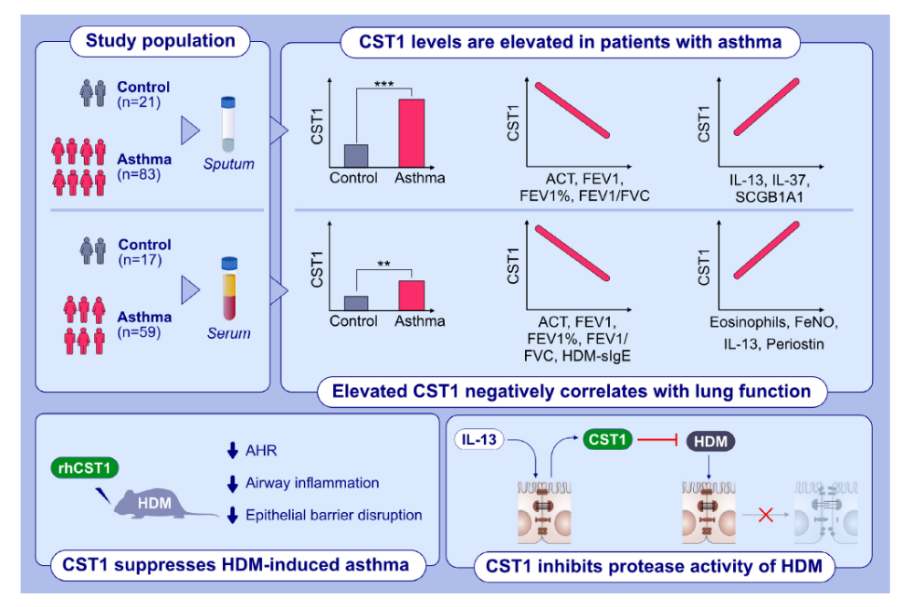GRAPHICAL ABSTRACT
Sputum and serum CST1 protein levels are elevated in asthma and negatively correlated with lung function. IL-13 induces upregulation of CST1 in 16HBE, whereas rhCST1 protein inhibits protease activity of HDM. HDM-induced epithelial barrier function disruption is suppressed by rhCST1 protein in vitro. Intranasal administration of rhCST1 reduces AHR, inflammation, and epithelial barrier function in mice.
Abbreviations: ACT, asthma control test; AHR, airway hyperresponsiveness; CST1, cystatin SN; FeNO, fractional exhaled nitric oxide; FEV1, forced expiratory volume in one second; FVC, forced vital capacity; HDM, house dust mite; IL, interleukin; rhCST1, recombinant human CST1; SCGB1A1, secretoglobin family 1A member 1; sIgE, specific immunoglobulin E; 16HBE, human bronchial epithelial cell line.

1 INTRODUCTION
Bronchial asthma, a disease involving chronic airway inflammation, is prevalent worldwide and has been increasing in incidence in recent years. Nearly 330 million people have asthma worldwide, thus posing a heavy healthcare burden.¹ Among the structural cells involved in asthmatic airway inflammation, airway epithelial cells (AECs) are located at the interface between the external environment and the interior of the body. They closely pack and form the bronchial epithelial barrier, the body's first line of defense against external risk factors.^{2–4}
People with asthma have epithelial barrier dysfunction. This impaired bronchial mucosa barrier function is associated with epithelial cell destruction and even shedding,^{5,6} and leads to increased epithelial barrier permeability.⁷ Allergens triggering asthma, such as pollen, house dust mite (HDM), cockroach extracts, and fungi contain a variety of protease components that directly disrupt intercellular junctions, impair epithelial barrier function, and facilitate the entry of allergens into the subepithelium.^{8–11}
The allergic immune response of the respiratory epithelium to allergens is driven primarily by means of an adaptive T-cell response. In allergic patients, the balance between the T helper cell response of type 1 (T1) and type 2 (T2) is shifted in favor of the T-helper cell type 2 (Th2) cells.¹² IL-13 is a pleiotropic T2 cytokine that is implicated in the pathogenesis of asthma.¹³ Epithelial cells also play active roles in the immune response to allergens, orchestrated by the T1 and T2 key cytokines IFN-γ and IL-4.¹⁴
Cystatin SN (CST1 protein) belongs to the type 2 cystatin family of secreted proteins and is encoded by the CST1 gene.¹⁵ CST1 protein is expressed in normal salivary glands and is secreted into the saliva, and is involved in maintaining oral homeostasis.^{16,17} C ST1 has been well studied in allergic diseases of the upper airways, and there is a positive correlation between CST1 mRNA expression levels in nasal polyps and the severity of eosinophilic chronic rhinosinusitis.^{18–20}
Recombinant CST1 protein (rhCST1) inhibits Japanese cedar (JC) protease activity and attenuates protease-induced disruption of tight junctions in the nasal epithelium. Signs of JC induced rhinitis sneezing and tight junction disruption were also suppressed in hCST1-Tg mice.²¹ CST1 mRNA levels are higher in bronchial epithelial cells in patients with asthma than in healthy controls.²² However, the role and mechanism of action of CST1 in the airway epithelium of asthma are unclear.
Cysteine proteases are widely expressed proteolytic enzymes with roles in inflammatory tissue destruction.²³ CST1 protein inhibits the protease activity of cysteine protease family proteins such as papain, and cathepsin B, C, H, and L, by forming tightly reversible complexes.²⁴ As an important component in asthmatic allergens,²⁵ HDM has been shown to contain a cysteine protease active component that directly disrupts tight junctions and impairs epithelial barrier function.²⁶ Inhibition of HDM cysteine protease activity can decrease damage to bronchial epithelial barrier function.²⁷ Whether CST1 protein inhibits the cysteine protease component of HDM has not yet been reported, and its role and mechanism in regulating bronchial epithelium function in asthma have not yet been investigated. In this study, we aimed to explore the expression of CST1 in bronchial epithelial cells, induced sputum supernatants, and serum of patients with asthma, and elucidate the role of epithelium-derived CST1 in the development of asthma caused by HDM.

2 METHODS
2.1 Screening of differentially expressed genes (DEGs)
GEO2R (http://www.ncbi.nlm.nih.gov/geo/geo2r/) was applied to compare and screen DEGs between patients with asthma and healthy individuals. A Venn diagram was used to analyze the overlap of DEGs in bronchial epithelial cells between groups.²⁸ The common differential genes were defined as candidate DEGs, and the website platform Sangerbox 3.0 (http://vip.sange rbox.com/) was used to produce a heatmap.

2.2 Patients' sputum supernatant, serum, and lung tissue collection
Human sputum supernatant and serum samples were collected from outpatients with asthma at the First Affiliated Hospital of Nanjing Medical University and from community-based healthy volunteers. Lung tissues were obtained from participants after surgical resection for lung cancer. The clinical and demographic characteristics of the patients are shown in Tables S1–S4.

2.3 Animal experiments
Mice were divided into three groups: control, HDM (Stallergenes Greer, Lenoir, USA), and HDM+ rhCST1 (R&D Systems, Minneapolis, MN, USA). BALB/c mice (6–8 weeks old, female) were sensitized on Day 0, challenged on Days 7, 8, 9, 10, and 11 intranasally, and then sacrificed on Day 14, as previously described.^{21,29} Bronchoalveolar lavage fluid (BALF) was collected, and BALF cells were counted and analyzed. Hematoxylin and eosin–stained, fixed lung tissue sections were used to assess inflammation.

2.4 Enzyme-linked immunosorbent assay (ELISA)
The levels of CST1, IL-4, IL-13, IL-17, IFN-γ, SCGB1A1, and IL-37 protein in human sputum supernatants, the levels of human CST1, IL-13, periostin, IgE, and HDM-sIgE in serum, and the levels of mouse IL-4, IL-13, and IFN-γ in BALF were measured with ELISA kits, according to the manufacturer's instructions. Further details are in the online data supplement.

2.5 Cell culture
The human bronchial epithelial cell line (16HBE) was obtained from the Beijing Tumor Center. Cells were cultured in RPMI 1640 medium (Gibco, NY, USA) with 10% FBS (Gibco, NY, USA) and 1% penicillin/streptomycin (Gibco, NY, USA) in a humidified atmosphere containing 5% CO2 at 37°C. The 16HBE cells were serially passaged and used for experiments until passage six and seeded in cell culture plates at a density of 2 × 10⁵ cells/cm².

2.6 Quantitative real-time PCR and Western blotting (WB)
The mRNA and proteins were analyzed as described in the online data supplement.

2.7 Immunofluorescence and immunohistochemistry
Paraffin sections of human and mouse lung tissues and 16HBE cells were fixed with 4% paraformaldehyde. Additional details are provided in the online data supplement.

2.8 Measurement of HDM protease activity
Protease activity of HDM and inhibition by rhCST1 were measured²¹ according to the manufacturer's instructions (R&D, Minneapolis, MN, USA).

2.9 Transmission electron microscopy
Ultra-thin sections of mouse lung tissue were prepared as described previously³⁰ and p hotographed under a transmission e lectron microscope (HT7700, Hitachi, Tokyo, Japan). The images were examined for the width of the intercellular contacts at the level of the tight junction (TJ), the adherens junction (AJ), and the desmosomes (Des). Measurements were conducted with Image J Version 1.54 at the widest spot each for at least six cell–cell contacts per animal, as previously described.³¹

2.10 Measurement of transepithelial electrical resistance (TEER) and epithelial permeability
The TEER of the 16HBE cells was measured daily with a Millicell-ERS system (Millipore Co., Bedford, MA, USA). Paracellular flux across the epithelium was measured with fluorescein isothiocyanate (FITC)-labeled 4-kD dextran.

2.11 Eosinophil extraction
Human eosinophils were isolated from heparinized venous blood and then were isolated by negative selection with magnetic beads (eosinophil isolation kit, Miltenyi Biotec, Bergisch Gladbach, Germany) according to the manufacturer's protocol.³² The purity of the isolated eosinophils was determined using flow cytometry (Figure S1).

2.12 | Statistical analysis
All data were presented as mean ± standard error mean (SEM), and P less than 0.05 was considered significant. The statistical analyses were performed in GraphPad Prism software v9.0 (Graphpad software, San Diego, USA). Comparisons between two groups were performed with an unpaired Student's test for normally distributed parameters or Mann–Whitney test for nonnormally distributed parameters. Experiments with multiple comparisons were evaluated with one-way ANOVA followed by Tukey's post hoc test or Brown-Forsythe and Welch ANOVA tests followed by Dunnett's T3 multiple comparisons test (for normally distributed parameters) and the Kruskal–Wallis test (for non-normally distributed parameters) for multiple data sets. Correlations were determined using Spearman analysis.

3 RESULTS
3.1 Screening and confirmation of DEGs
Bronchial epithelial cells are well known to play key roles in the occurrence and development of asthma. Therefore, we explored DEGs in the bronchial epithelium in healthy controls and patients with asthma. GSE63142, GSE64913, GSE67472, GSE85567, GSE89809, and GSE104472 datasets were selected from the Gene Expression Omnibus (GEO) database (https://www.ncbi.nlm.nih.gov/geo/) with search terms including ‘asthma’, ‘airway epithelia’, or ‘bronchial epithelia’. Bioinformatics analysis of these six asthma bronchial epithelial cell GEO datasets identified CST1 as the only consistent DEG between asthma and healthy controls (Figure S2). We analyzed the relative expression of airway epithelial CST1 in healthy controls and patients with asthma by using data available in the GEO datasets. In all six GEO datasets, airway epithelial CST1 mRNA levels were significantly higher in patients with asthma than in healthy controls (Figure S2).

3.2 Expression and mechanism of regulation of CST1 in bronchial epithelial cells
We collected lung tissues from nine healthy controls and eight patients with asthma for immunohistochemical staining. Both healthy controls and patients with asthma underwent lung resection due to the presence of lung cancer. CST1 protein expression was significantly higher in the bronchial epithelium in patients with asthma than in healthy control participants (Figure 1A,B). We used Limma to examine the expression of CST1 mRNA in severe asthma using the Unbiased Biomarkers for the Prediction of Respiratory Disease Outcomes (U-BIOPRED) bronchial brushings array data.³³
It showed that bronchial epithelial CST1 mRNA expression levels were widely expressed in asthma and significantly increased in patients with severe nonsmoking asthma compared with healthy volunteers (Figure 1C). A T2 bronchial epithelial gene signature, the 3-gene mean, has been described based on the expression of three IL-13–inducible genes (periostin [POSTN]; serpin family B member 2 [SERPINB2]; and chloride channel, calcium-activated, family member 1 [CLCA1]).³⁴ GSE67472 classified patients with asthma into T2 high and T2 low asthma according to the expression of these three genes. The airway CST1 expression levels of patients with T2 high asthma were significantly greater than those of T2 low asthma (Figure 1D). All asthma airway CST1 gene expression levels in this database were positively correlated with CLCA1 (Figure 1E), SERPINB2 (Figure 1F), and POSTN (Figure 1G) levels.
In support of this, the expression of CST1 mRNA in U-BIOPRED bronchial brushings was significantly greater in patients with T2 high compared to T2 low asthma (P = 7.34 × 10⁻¹⁰, Figure 1H). We therefore hypothesized that CST1 is a gene closely associated with T2 asthma. Next, we explored the regulatory mechanism of CST1 expression in bronchial epithelial cells. DEGs with P-values <0.05 and |log2FC ≥1| were screened in GSE37693, including 342 genes in primary culture AECs grown at the air–liquid interface (ALI), treated with or without IL-13 for 21 days. Figure 1I shows a heat map of the top 20 DEGs obtained by screening the dataset. In this dataset, the only up-regulated cysteine family gene was CST1. IL-13 stimulation of 16HBE cells resulted in a significant increase in CST1 mRNA (Figure 1J) and CST1 protein (Figure 1K,L) levels. Analysis of the GSE78914, GSE10240, and GSE185200 datasets indicated no significant changes in CST1 mRNA level after stimulation of bronchial epithelial cells with IL-4 (Figure S3), IL-17 (Figure S3), or IFN-γ (Figure S3). These results were confirmed by RT-PCR for CST1 mRNA (Figure S3) and by WB (Figure S3) for CST1 protein. These data suggested that IL-13 induces upregulation of CST1 in human bronchial epithelial cells.

3.3 Elevated CST1 protein expression in sputum supernatants of patients with asthma is negatively correlated with lung function
CST1 protein concentrations in sputum supernatants were significantly induced in patients with asthma (142.4 ± 8.95 ng/mL) in contrast to normal participants (38.87 ± 6.85 ng/mL) (Figure 2A). CST1 protein concentrations were elevated regardless of the degree of asthma control: well-controlled group, 129.9 ± 12.3 ng/mL; poorly controlled group, 132.9 } 16.55 ng/mL; and very poorly controlled group, 176.5 ± 20.19 ng/mL (Figure 2B). CST1 protein levels in sputum supernatants were negatively correlated with asthma control test (ACT) scores (Figure 2C) and lung function (FEV1, FEV1% predicted, and FEV1/FVC) as a measure of airway obstruction (Figure 2D–F) in patients with asthma. The CST1 protein levels in supernatants of induced sputum in patients with asthma were positively correlated with the protein levels of the Th2 inflammatory factor IL-13 (Figure 2H), but were not significantly correlated with the protein levels of IL-4 (Figure 2G), IL-17 (Figure 2I), and IFN-γ (Figure 2J). In addition, the levels of CST1 protein in induced sputum supernatants of patients with asthma were positively correlated with anti-inflammatory factors^{35,36} IL-37 (Figure 2K) and SCGB1A1 (Figure 2L).
In recent years, three transcriptome-associated clusters (TACs) have been defined,³⁷ and TAC1 showed the highest enrichment of gene signatures for IL-13/Th2 and innate lymphoid cell type 2. U-BIOPRED induced sputum related data showed that the levels of CST1 mRNA in induced sputum of patients with asthma in TAC1 group were significantly higher than that in healthy control group, TAC2 group, and TAC3 group (Figure 2M). CST1 mRNA levels in induced sputum of non-smoking patients with severe asthma were positively correlated with IL-13 (Figure 2O) and SCGB1A1 (Figure 2P) mRNA levels, but not with IL-4 (Figure 2N). In summary, CST1 appears to be particularly associated with Th2 asthma.

3.4 Elevated CST1 protein expression in the serum of patients with asthma positively correlates with peripheral blood eosinophils, FeNO, serum IL-13, and periostin, and negatively correlates with HDM-sIgE levels
The serum levels of CST1 protein in patients with asthma (1129 ± 73.8 pg/mL) were significantly higher than that in healthy control participants (703.1 ± 57.02 pg/mL) (Figure 3A), and successively increased in well-controlled (827.2 ± 47.68 pg/mL), poorly controlled (1242 ± 96.02 pg/mL), and very poorly controlled asthma (1865 ± 241.4 pg/mL) (Figure 3B). CST1 protein levels in the serum were negatively associated with ACT scores (Figure 3C) and lung function (FEV1, FEV1% predicted, and FEV1/FVC) (Figure 3D–F) in patients with asthma. Patients with asthma were divided into high/low peripheral blood eosinophil groups according to whether the peripheral blood eosinophils exceeded 200 cells/μL.³⁸ Serum CST1 protein levels were higher in the high peripheral blood eosinophil group (1264 ± 100 pg/mL) than in the low peripheral blood eosinophil group (929 ± 118 pg/mL) (Figure 3G). A composite biomarker composed of FeNO, blood eosinophil count, and serum periostin has been used as an indicator of T2-high asthma.³⁹ Serum CST1 protein levels positively correlated with peripheral blood eosinophil count (Figure 3H), percentage (Figure 3I) and FeNO (Figure 3J) in patients with asthma. Moreover, serum CST1 protein levels positively correlated with the elevated serum IL-13 (Figure 3K,L) and serum periostin (Figure 3M,N) expression in asthma but were not associated with IgE irrespective of IgE status (Figure 3O,P) in patients with asthma.
However, serum CST1 protein levels were significantly higher in participants with HDM-sIgE-negative asthma than in HDM-sIgE-positive asthma (Figure 3Q). Serum HDM-sIgE levels were negatively correlated with serum CST1 protein levels in asthmatics (Figure 3R). These results indicated that patients with high HDM-sIgE have low peripheral blood CST1 protein levels, suggesting that systemic CST1 protein may play a protective role in HDM-induced asthma.

3.5 rhCST1 protein inhibits protease activity in HDM
CST1 protein inhibits cysteine proteases such as papain and cathepsins B, C, H, and L.²⁴ To investigate the inhibitory activity of rhCST1 protein against the proteases in HDM, we performed an in vitro protease activity assay using the synthetic substrates Boc-QAR-AMC and Z-LR-AMC as the protease targets in HDM.²¹ HDM was pretreated with or without rhCST1 protein, then incubated with the synthetic substrates. The fluorescence intensity of the released 7-amino-4-methyl coumarin from the synthetic substrates gradually increased over time. Moreover, rhCST1 protein significantly inhibited HDM-induced increases in fluorescence levels (Figure 4A,B).

3.6 HDM-induced epithelial barrier function disruption is suppressed by rhCST1 protein in vitro
Epithelial cell dysfunction is the major driver of asthma development. Loss of epithelial junctions not only results in increased susceptibility towards pathogens and allergens, but also propagates pro-inflammatory responses.⁴⁰ To examine the effect of rhCST1 protein on HDM-induced epithelial barrier disruption, we treated 16HBE cells, a human bronchial epithelial cell line, with 50 μg/mL HDM,^{41,42} incubated with or without 0.1 μg/mL rhCST1 protein^{18,43} for 24 h. Tight junction protein Zonula Occludens (ZO)-1 and adherens junction protein E-cadherin expression was significantly lower in 16HBE cells treated with HDM than in control cells, and rhCST1 protein inhibited the HDM-induced decreases in E-cadherin and ZO-1 expression determined by both immunofluorescence (Figure 4C–E) and Western blotting (Figure 4F–H).
Greater paracellular transport of FITC-dextran (Figure 4I) and lower TEER (Figure 4J) was observed in HDM-treated 16HBE cells than in control cells indicating that epithelial barrier function was compromised by HDM. rhCST1 protein abrogated HDM-induced increases in epithelial permeability. Moreover, rhCST1 protein abrogated HDM-induced migration of eosinophils across the epithelium (Figure 4K,L). Activating transcription factor 3 (ATF3) is a crucial protective stress transcription factor that plays a critical role in maintaining the integrity of the epithelial barrier.^{44,45} Moreover, in asthma, ATF3 is upregulated and functions as a negative regulator of allergic lung inflammation.^{46,47}
In vitro studies have revealed that bronchial epithelial cells exhibit elevated ATF3 expression in response to allergens (such as HDM) and viral stimuli.^{27,48} Thus, we investigated the effects of CST1 on ATF3. Our results (Figure S4) indicated that CST1 inhibited ATF3 mRNA and protein expression in epithelial cells exposed to HDM. Overall, rhCST1 protein prevented HDM-induced epithelial barrier disruption by suppressing HDM protease activity.

3.7 rhCST1 protein abrogates HDM-induced airway hyperresponsiveness and airway inflammation in vivo
Experiments in vitro showed that HDM-induced epithelial barrier function disruption was suppressed by rhCST1. However, protein rhCST1 alone had no significant effect on epithelial barrier function compared with the control group. Next, we explored whether rhCST1 protein abrogated HDM-induced airway inflammation in vivo (Figure 5A). HDM sensitization and challenge increased airway resistance following methacholine (Mch) challenge compared with control, and this was reversed by intranasal rhCST1 (Figure 5B). BALF cell counts indicated that rhCST1 protein, compared with HDM alone, significantly suppressed the total number of cells in BALF (Figure 5C) as well as the number (Figure 5D) and percentage (Figure 5E) of eosinophils. Evidence of inflammatory cell infiltration was demonstrated by H&E staining of lung tissue sections. HDM significantly enhanced peribronchial inflammatory cell infiltration, but this effect was significantly attenuated by rhCST1 treatment (Figure 5F,G). In addition, rhCST1 reduced the protein levels of I IL-4 (Figure 5H) and IL-13 (Figure 5I), not IFN-γ (Figure 5J) in BALF.

3.8 rhCST1 protein abrogates HDM-induced epithelial barrier function disruption in vivo
The airway epithelium represents the initial line of defense against inhaled insults, making it a critical barrier. In asthma, airway epithelial barrier dysfunction is a common occurrence. This defect can increase the susceptibility of the epithelium in asthmatic individuals to environmental stimuli, further exacerbating the condition. HDM disrupts tight junctions and adherens junction both in vivo⁴⁹ and in vitro,²⁷ and leads to epithelial barrier dysfunction in asthma.⁵⁰
Our immunofluorescence results from the whole lung tissues (Figure 6A,C) revealed that HDM significantly decreased the expression of the ZO-1 and the E-cadherin in AECs (Figure 6B,D), whereas rhCST1 partially attenuated the reduction in these junction proteins induced by HDM (Figure 6F,G). Junctions between neighboring cells were first discovered using electron microscopy and appeared as apposing strands that eliminate the intercellular space.⁵¹ Our electron microscopy results revealed that rhCST1 protein decreased the disruption of the junctional structure (Figure 6E) and the width of intercellular distances at tight junction and adherens junction caused by HDM (Figure 6H–I); however, the desmosomes did not change significantly (Figure 6J). The above in vivo results suggested that rhCST1 protein, at least in part, attenuates the disruption of epithelial barrier function by HDM.

4 DISCUSSION
In our study, bioinformatics analysis of six asthma bronchial epithelial cell GEO datasets identified CST1 as the only consistent DEG between asthma and healthy controls. This is the first report on the epithelial expression and role of human CST1 on asthma epithelial barrier function. CST1 protein expression was elevated in the bronchial epithelium, sputum supernatants and the serum of patients with asthma compared with healthy controls. Sputum and serum CST1 protein levels were negatively correlated with lung function and ACT scores in asthma. These indicated that patients with higher CST1 levels had poorer asthma control.
The state of bronchial epithelial functional impairment in asthma reflects the clinical condition of asthma,³⁰ and AECs are potentially important cellular sources of biomarkers of asthma⁵²: 50% cases of mild to moderate asthma are T2-high.⁵³ Allergic asthma is caused and/or triggered by allergens and is primarily driven by T2 immune responses,^{33,54} characterized by eosinophil infiltration and elevated levels of cytokines such as IL-4, IL-5, and IL-13. CST1 is closely related to other allergic diseases, particularly T2 inflammation. Previous research on CST1 focused on upper airway inflammatory diseases,^{18,20,55} with no studies on its role in lower airway inflammatory diseases. CST1 overexpression is associated with more severe allergic airway disease in children sensitized to dog dander, leading to lower FEV1, increased bronchial hyperreactivity, pronounced eosinophilia, and higher basophil allergen threshold sensitivity.²⁰
Epithelial CST1 expression is positively correlated with tissue eosinophil percentages and FeNO levels in patients with eosinophilic chronic rhinosinusitis with nasal polyps.⁴³ We demonstrated that the Th2 inflammatory factor IL-13, but not Th1 or Th17 inflammatory factors, upregulated the expression of CST1 in bronchial epithelial cells. AECs express several IL-4- or IFN-γ-induced genes that are antagonized by IFN-γ and IL-4, respectively. Our data are consistent with the previous study⁵⁶ in that IL-4 and IFN-γ have no regulatory effect on the release of CST1 from bronchial epithelial cells. This may be related to the distinct regulatory mechanism of IL-13.
In addition, peripheral blood eosinophil counts and percentages, FeNO, serum IL-13, and periostin levels were positively correlated with serum CST1 expression levels in patients with asthma. Consistent with our findings, Diver and co-workers also found that CST1 mRNA expression was closely associated with T2 inflammation in an observational study.⁵⁷
The allergic asthmatic response to allergen exposure is associated with IgE-mediated mast cell activation, resulting in the accumulation of leukocytes such as eosinophils and Th2 lymphocytes in the airway.⁵⁸ We found that serum CST1 protein levels were not correlated with serum total IgE, but were negatively correlated with HDM-sIgE. Serum IgE levels reflect the allergic state of the body and may be associated with multiple allergens. Moreover, an increase in the level of HDM-sIgE is an indicator of the presence of sensitization to HDM. This occurrence indicates that the body has developed an immune response to the HDM allergen, resulting in an increase in specific IgE antibodies against it. The increased expression of CST1 may antagonize the allergic reaction by HDM, resulting in a decrease in HDM-sIgE levels. Matrix proteins in the serum have been demonstrated to correlate with IgE.^{59,60} During HDM-induced inflammation in T2 asthma, extracellular matrix protein production is increased.⁶¹ Serum CST1 levels in asthma were positively correlated with levels of the matrix protein periostin, which is associated with T2 inflammation. It would be worthwhile to investigate whether CST1 can affect the HDM induced changes in other matrix proteins, such as COL4A3.
SCGB1A1 has a protective effect in chronic airway inflammation and can partially inhibit the regulatory effect of HDM on some genes in epithelium.⁶² Other studies have shown that IL-37 controls allergic airway inflammation underlying the development of asthma.⁶³ We indicated that the CST1 protein levels in induced sputum supernatants were positively correlated with pro-inflammatory cytokine IL-13, anti-inflammatory cytokines SCGB1A1 and IL-37. Moreover, CST1 expression in epithelial cells increased in the inflammatory state of patients with T2 asthma, thus potentially representing a host defense mechanism of the body.
Asthma allergens such as pollen, HDM, cockroach extracts, and fungi contain a variety of protease components that directly disrupt intercellular junctions, thus impairing epithelial barrier function and facilitating the entry of allergens into the subepithelium.⁶⁴ Dermatophagoides pteronyssinus (Der p) 1 and Dermatophagoides farina (Der f) 1 are the main components of HDM, which contain cysteine protease structures and belong to the cysteine protease family, similarly to papain.⁶⁵ Inhibition of HDM cysteine protease activity alleviates the damage to bronchial epithelial barrier function.^{27,49,66}
CST1 has been shown to bind tightly to the cysteine protease, papain, which is a potent allergen, and to inhibit the cysteine protease activity of papain. Takai et al. discovered that cystatin A (CSTA), a protein belonging to the cystatin family, can bind to and block the cysteine protease activity of Der p 1 and Der f 1. Furthermore, CSTA partially inhibits the binding of IgE to Der f 1 and Der p 1.⁶⁷ CSTA shares conserved amino acid residues with other family-2 proteins, such as CST1.⁶⁸ Therefore, we hypothesized that the increased expression of CST1 in the bronchial epithelium of asthma could resist the epithelial damage caused by exogenous cysteine proteins. To the best of our knowledge, this is the first report to demonstrate that recombinant CST1 protein attenuates the protease activity of HDM. In our study, we found that the HDM-induced epithelial barrier function disruption as measured by TEER, paracellular transport of FITC-dextran, eosinophil migration and by ZO-1 and E-cadherin expression in 16HBE cells. These HDM-induced changes were abrogated by rhCST1 in vitro, and similar effects on ZO-1 and E-cadherin expression were seen in vivo. Thus, CST1 upregulation may protect against allergen-induced epithelial barrier disruption and serve as a T2 asthma biomarker.
This study has several limitations. One of the major limitations is that experiments in vitro were carried out with 16HBE cells in submerged culture rather than primary HBECs grown at ALI. Another limitation is the need to confirm CST1 protein expression in sputum supernatants and/or serum in another larger cohort of asthmatic subjects and measure the relationship of CST1 levels with other T2 biomarkers. Unlike the most widely used approach, which involves increasing the concentration from 3% to 4% to 5%.³⁶ We utilized a method for inducing sputum with 4% hypertonic saline. This approach has been shown to be convenient, equally safe and reliable in our previous studies.^{69,70} Moreover, studies have demonstrated that CST1 can be used as a predictive marker of lung cancer and its expression in tissue is upregulated by the disease.^{71,72} We report similar percentages of non-small-cell lung cancer (NSCLC) patients in subjects who provided lung tissue in the asthma (6/8) and non-asthma control (8/9) groups. In addition, lung tissues in our study were isolated from more than 5 cm away from the tumor border. However, the effect of lung cancer on CST1 expression cannot be completely ruled out.

5 CONCLUSIONS
Our study suggests that CST1 may serve as a potential biomarker for asthma control and may be closely associated with T2 asthma. Human CST1 protein suppresses asthma symptoms by protecting the asthmatic bronchial epithelial barrier through inhibition of allergenic protease activity. Prophylactic use of CST1 protein may provide a novel therapeutic strategy against protease allergens, such as HDM-induced asthma.

AUTHOR CONTRIBUTIONS
Lei Yao, Xijing Yuan, Xin Yao, Xiaoning Zeng, and Ian M Adcock designed this study. Lei Yao, Xijing Yuan, and Heng Fu performed the animal experiments. Lei Yao performed the ex vivo experiments. Lei Yao, Qinxing Guo, Yunhui Wu, and Shurui Xuan recruited the patients. Lei Yao, Xijing Yuan, and Qinxing Guo collected samples. Lei Yao and Xijing Yuan performed the analysis of data and interpretation. Nazanin Zounemat Kermani analyzed the data from the U-BIOPRED asthma cohort. Lei Yao wrote the manuscript. Yi Liu assisted in collecting lung tissue specimens. Min Xie helped recruit a subset of healthy controls and asthma patients, and provided technical help with sputum collection and processing. Xin Yao and Ian M Adcock critically revised the manuscript. All the authors read and approved the final paper.

ACKNOWLEDGMENTS
This work was supported by the National Natural Science Foundation of China [grant numbers 82170040, 81870039]; the Jiangsu Province Capability Improvement Project through Science, Technology and Education [grant number CXZX202206]. We wish to thank Jiangsu Province Hospital Core Facility Center for technical support.

CONFLICT OF INTEREST STATEMENT
All the authors declare no commercial or financial conflict of interest.

SUPPORTING INFORMATION
Additional supporting information can be found online in the Supporting Information section at the end of this article.

REFERENCES
- Lin CH. Treatment of hypertension in patients with asthma. N Engl J Med. 2019;381(23):2278-2279.
- Gao W, Li L, Wang Y, et al. Bronchial epithelial cells: the key effector cells in the pathogenesis of chronic obstructive pulmonary disease? Respirology. 2015;20(5):722-729.
- Hammad H, Lambrecht BN. Barrier epithelial cells and the control of type 2 immunity. Immunity. 2015;43(1):29-40.
- Roan F, Obata-Ninomiya K, Ziegler SF. Epithelial cell-derived cytokines: more than just signaling the alarm. J Clin Invest. 2019;129(4):1441-1451.
- Kaminska M, Foley S, Maghni K, et al. Airway remodeling in subjects with severe asthma with or without chronic persistent airflow obstruction. J Allergy Clin Immunol. 2009;124(1):45-51.
- Yoshihara S, Yamada Y, Abe T, Linden A, Arisaka O. Association of epithelial damage and signs of neutrophil mobilization in the airways during acute exacerbations of paediatric asthma. Clin Exp Immunol. 2006;144(2):212-216.
- Xiao C, Puddicombe SM, Field S, et al. Defective epithelial barrier function in asthma. J Allergy Clin Immunol. 2011;128(3):549-556.
- Hammad H, Lambrecht B. The basic immunology of asthma. Cell. 2021;184(9):2521-2522.
- Tai HY, Tam MF, Chou H, et al. Pen ch 13 allergen induces secretion of mediators and degradation of occludin protein of human lung epithelial cells. Allergy. 2006;61(3):382-388.
- Wan H, Winton HL, Soeller C, et al. Der p 1 facilitates transepithelial allergen delivery by disruption of tight junctions. J Clin Invest. 1999;104(1):123-133.
- Antony AB, Tepper RS, Mohammed KA. Cockroach extract antigen increases bronchial airway epithelial permeability. J Allergy Clin Immunol. 2002;110(4):589-595.
- Jakwerth CA, Ordovas-Montanes J, Blank S, Schmidt-Weber CB, Zissler UM. Role of respiratory epithelial cells in allergic diseases. Cells. 2022;11(9):1387.
- Lambrecht BN, Hammad H, Fahy JV. The cytokines of asthma. Immunity. 2019;50(4):975-991.
- Frey A, Lunding LP, Ehlers JC, Weckmann M, Zissler UM, Wegmann M. More than just a barrier: the immune functions of the airway epithelium in asthma pathogenesis. Front Immunol. 2020;11:761.
- de Sousa-Pereira P, Amado F, Abrantes J, Ferreira R, Esteves PJ, Vitorino R. An evolutionary perspective of mammal salivary peptide families: cystatins, histatins, statherin and PRPs. Arch Oral Biol. 2013;58(5):451-458.
- Dickinson D, Thiesse M, Hicks M. Expression of type 2 cystatin genes CST1-CST5 in adult human tissues and the developing submandibular gland. DNA Cell Biol. 2002;21(1):47-65.
- Dai DN, Li Y, Chen B, et al. Elevated expression of CST1 promotes breast cancer progression and predicts a poor prognosis. J Mol Med (Berl). 2017;95(8):873-886.
- Kato Y, Takabayashi T, Sakashita M, et al. Expression and functional analysis of CST1 in intractable nasal polyps. Am J Respir Cell Mol Biol. 2018;59(4):448-457.
- Wu D, Yan B, Wang Y, Wang C, Zhang L. Prognostic and pharmacologic value of cystatin SN for chronic rhinosinusitis with nasal polyps. J Allergy Clin Immunol. 2021;148:450-460.
- Käck U, Einarsdottir E, van Hage M, et al. Nasal upregulation of CST1 in dog-sensitised children with severe allergic airway disease. ERJ Open Res. 2021;7(2):00917-02020.
- Fukuoka A, Matsushita K, Morikawa T, et al. Human cystatin SN is an endogenous protease inhibitor that prevents allergic rhinitis. J Allergy Clin Immunol. 2019;143(3):1153-1162. e1112.
- Tsai YH, Parker JS, Yang IV, Kelada SNP. Meta-analysis of airway epithelium gene expression in asthma. Eur Respir J. 2018;51(5):1701962.
- Pislar A, Jewett A, Kos J. Cysteine cathepsins: their biological and molecular significance in cancer stem cells. Semin Cancer Biol. 2018;53:168-177.
- Tseng CC, Tseng CP, Levine MJ, Bobek LA. Differential effect toward inhibition of papain and cathepsin C by recombinant human salivary cystatin SN and its variants produced by a baculovirus system. Arch Biochem Biophys. 2000;380(1):133-140.
- Calderón M, Linneberg A, Kleine-Tebbe J, et al. Respiratory allergy caused by house dust mites: what do we really know? J Allergy Clin Immunol. 2015;136(1):38-48.
- Reithofer M, Jahn-Schmid B. Allergens with protease activity from house dust mites. Int J Mol Sci. 2017;18(7):1368.
- Post S, Nawijn MC, Hackett TL, et al. The composition of house dust mite is critical for mucosal barrier dysfunction and allergic sensitisation. Thorax. 2012;67(6):488-495.
- Bardou P, Mariette J, Escudié F, Djemiel C, Klopp C. jvenn: an interactive Venn diagram viewer. BMC Bioinformatics. 2014;15(1):293.
- Kool M, Willart MA, van Nimwegen M, et al. An unexpected role for uric acid as an inducer of T helper 2 cell immunity to inhaled antigens and inflammatory mediator of allergic asthma. Immunity. 2011;34(4):527-540.
- Jia M, Yan X, Jiang X, et al. Ezrin, a membrane cytoskeleton cross-linker protein, as a marker of epithelial damage in asthma. Am J Respir Crit Care Med. 2019;199(4):496-507.
- Obermüller B, Frisina N, Meischel M, et al. Examination of intestinal ultrastructure, bowel wall apoptosis and tight junctions in the early phase of sepsis. Sci Rep. 2020;10(1):11507.
- Matsuyama W, Mitsuyama H, Ono M, et al. Discoidin domain receptor 1 contributes to eosinophil survival in an NF-kappaB-dependent manner in Churg-Strauss syndrome. Blood. 2007;109(1):22-30.
- Pavlidis S, Takahashi K, Ng Kee Kwong F, et al. "T2-high" in severe asthma related to blood eosinophil, exhaled nitric oxide and serum periostin. Eur Respir J. 2019;53(1):1800938.
- Woodruff PG, Modrek B, Choy DF, et al. T-helper type 2-driven inflammation defines major subphenotypes of asthma. Am J Respir Crit Care Med. 2009;180(5):388-395.
- Schröder A, Lunding LP, Zissler UM, et al. IL-37 regulates allergic inflammation by counterbalancing pro-inflammatory IL-1 and IL-33. Allergy. 2022;77(3):856-869.
- Zissler UM, Jakwerth CA, Guerth F, et al. Allergen-specific immunotherapy induces the suppressive secretoglobin 1A1 in cells of the lower airways. Allergy. 2021;76(8):2461-2474.
- Kuo CS, Pavlidis S, Loza M, et al. T-helper cell type 2 (Th2) and non-Th2 molecular phenotypes of asthma using sputum transcriptomics in U-BIOPRED. Eur Respir J. 2017;49(2):1602135.
- George L, Taylor A, Esteve-Codina A, et al. Blood eosinophil count and airway epithelial transcriptome relationships in COPD versus asthma. Allergy. 2020;75(2):370-380.
- Heaney LG, Djukanovic R, Woodcock A, et al. Research in progress: Medical Research Council United Kingdom refractory asthma stratification Programme (RASP-UK). Thorax. 2016;71(2):187-189.
- Heijink IH, Kuchibhotla VNS, Roffel MP, et al. Epithelial cell dysfunction, a major driver of asthma development. Allergy. 2020;75(8):1902-1917.
- Collison A, Hatchwell L, Verrills N, et al. The E3 ubiquitin ligase midline 1 promotes allergen and rhinovirus-induced asthma by inhibiting protein phosphatase 2A activity. Nat Med. 2013;19(2):232-237.
- Zhang R, Dong H, Zhao H, Zhou L, Zou F, Cai S. 1,25-Dihydroxyvitamin D(3) targeting VEGF pathway alleviates house dust mite (HDM)-induced airway epithelial barrier dysfunction. Cell Immunol. 2017;312:15-24.
- Yan B, Lou H, Wang Y, et al. Epithelium-derived cystatin SN enhances eosinophil activation and infiltration through IL-5 in patients with chronic rhinosinusitis with nasal polyps. J Allergy Clin Immunol. 2019;144(2):455-469.
- Shan Y, Akram A, Amatullah H, et al. ATF3 protects pulmonary resident cells from acute and ventilator-induced lung injury by preventing Nrf2 degradation. Antioxid Redox Signal. 2015;22(8):651-668.
- Zhou J, Edgar BA, Boutros M. ATF3 acts as a rheostat to control JNK signalling during intestinal regeneration. Nat Commun. 2017;8:14289.
- Gilchrist M, Henderson WR Jr, Clark AE, et al. Activating transcription factor 3 is a negative regulator of allergic pulmonary inflammation. J Exp Med. 2008;205(10):2349-2357.
- Roussel L, Robins S, Schachter A, Bérubé J, Hamid Q, Rousseau S. Steroids and extracellular signal-regulated kinase 1/2 activity suppress activating transcription factor 3 expression in patients with severe asthma. J Allergy Clin Immunol. 2011;127(6):1632-1634.
- Vroling AB, Jonker MJ, Breit TM, Fokkens WJ, van Drunen CM. Comparison of expression profiles induced by dust mite in airway epithelia reveals a common pathway. Allergy. 2008;63(4):461-467.
- Saito T, Ichikawa T, Numakura T, et al. PGC-1α regulates airway epithelial barrier dysfunction induced by house dust mite. Respir Res. 2021;22(1):63.
- Steelant B, Farré R, Wawrzyniak P, et al. Impaired barrier function in patients with house dust mite-induced allergic rhinitis is accompanied by decreased occludin and zonula occludens-1 expression. J Allergy Clin Immunol. 2016;137(4):1043-1053. e1045.
- Furuse M. Molecular basis of the core structure of tight junctions. Cold Spring Harb Perspect Biol. 2010;2(1):a002907.
- Yang Y, Jia M, Ou Y, Adcock IM, Yao X. Mechanisms and biomarkers of airway epithelial cell damage in asthma: a review. Clin Respir J. 2021;15(10):1027-1045.
- Fahy JV. Type 2 inflammation in asthma—present in most, absent in many. Nat Rev Immunol. 2015;15(1):57-65.
- von Mutius E, Smits HH. Primary prevention of asthma: from risk and protective factors to targeted strategies for prevention. Lancet. 2020;396(10254):854-866.
- Imoto Y, Tokunaga T, Matsumoto Y, et al. Cystatin SN upregulation in patients with seasonal allergic rhinitis. PloS One. 2013;8(8):e67057.
- Zissler UM, Chaker AM, Effner R, et al. Interleukin-4 and interferon-γ orchestrate an epithelial polarization in the airways. Mucosal Immunol. 2016;9(4):917-926.
- Diver S, Sridhar S, Khalfaoui LC, et al. Feno differentiates epithelial gene expression clusters: exploratory analysis from the MESOS randomized controlled trial. J Allergy Clin Immunol. 2022;150:830-840.
- Owen CE. Immunoglobulin E: role in asthma and allergic disease: lessons from the clinic. Pharmacol Ther. 2007;113(1):121-133.
- Weckmann M, Bahmer T, Sand JM, et al. COL4A3 is degraded in allergic asthma and degradation predicts response to anti-IgE therapy. Eur Respir J. 2021;58(6):2003969.
- Tajiri T, Matsumoto H, Gon Y, et al. Utility of serum periostin and free IgE levels in evaluating responsiveness to omalizumab in patients with severe asthma. Allergy. 2016;71(10):1472-1479.
- Weckmann M, Bahmer T, Bülow Sand JM, et al. COL4A3 degradation is increased in severe, type 2 exacerbating asthmatics. ERJ Open Res. 2021;7(suppl 6):10.
- Mootz M, Jakwerth CA, Schmidt-Weber CB, Zissler UM. Secretoglobins in the big picture of immunoregulation in airway diseases. Allergy. 2022;77(3):767-777.
- Schroeder A, Lunding L, Vock C, et al. IL-37 ameliorates experimental asthma by inhibiting IL-1. Eur Respir J. 2018;52(suppl 62):OA1647.
- Matsumura Y. Role of allergen source-derived proteases in sensitization via airway epithelial cells. J Allergy. 2012;2012:903659.
- Takai T, Kato T, Sakata Y, et al. Recombinant Der p 1 and Der f 1 exhibit cysteine protease activity but no serine protease activity. Biochem Biophys Res Commun. 2005;328(4):944-952.
- Winton HL, Wan H, Cannell MB, et al. Class specific inhibition of house dust mite proteinases which cleave cell adhesion, induce cell death and which increase the permeability of lung epithelium. Br J Pharmacol. 1998;124(6):1048-1059.
- Takai T, Kato T, Hatanaka H, et al. Modulation of allergenicity of major house dust mite allergens Der f 1 and Der p 1 by interaction with an endogenous ligand. J Immunol. 2009;183(12):7958-7965.
- Ochieng J, Chaudhuri G. Cystatin superfamily. J Health Care Poor Underserved. 2010;21(1 Suppl):51-70.
- Yao X, Yin K. The application of inhaling 4% saline in asthmatic sputum induction. Acta Unversitatis Medicinalis Nanjing. 1999;3:198-199.
- Yao X, Yin K, Huang M, et al. The implication of concentration of NO2-/NO3-in induced sputum of asthmatics. Clin J Respir Crit Care Med. 2002;1(3):151-153.
- Lai Y, Wang Y, Wu Y, et al. Identification and validation of serum CST1 as a diagnostic marker for differentiating early-stage non-small cell lung cancer from pulmonary benign nodules. Cancer Control. 2022;29:10732748221104661.
- Cao X, Li Y, Luo R, et al. Expression of cystatin SN significantly correlates with recurrence, metastasis, and survival duration in surgically resected non-small cell lung cancer patients. Sci Rep. 2015;5:8230.

Figure and Figure legends
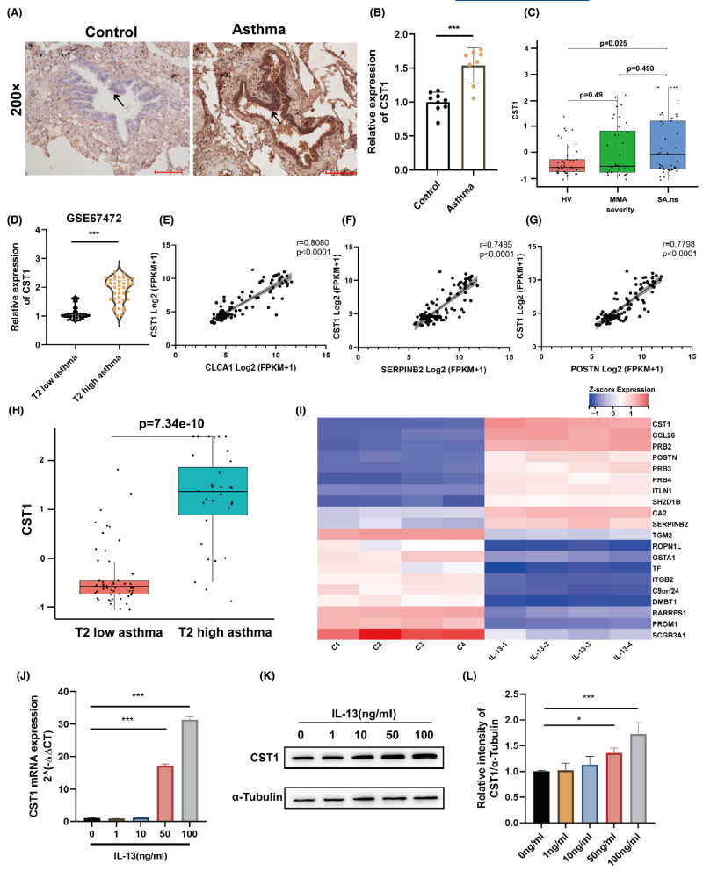FIGURE 1 Expression and regulation mechanism of CST1 in bronchial epithelial cells. (A) Representative images showing induced CST1 protein immunostaining (brown color) in patients with asthma (n = 8) compared with that seen in healthy subjects (n = 9). (B) CST1 protein relative expression was analyzed by Image-proplus 6.0 and presented graphically. Data were presented as mean ± SEM using Welch's test. ***P < 0.001. (C) The expression of CST1 mRNA in U-BIOPRED bronchial brushings array data was shown after log2 transformation and normalization. The data were analyzed using Kruskal–Wallis test. HV, healthy volunteers; MMA, mild/moderate nonsmoking asthma; SA.ns, severe asthma nonsmokers. (D) Relative expression of CST1 mRNA in T2 low asthma, and T2 high asthma patients in the GSE67472 dataset. The data were shown through the violin plots and were analyzed using Kruskal–Wallis test. ***P < 0.001. (E–G) Correlation analysis of CLCA1, SERPINB2 and POSTN gene levels with CST1 gene levels in airway mucosal biopsy tissue. The data were analyzed using Nonparametric Spearman correlation. (H) The expression of CST1 mRNA in U-BIOPRED bronchial brushings array data was shown after log2 transformation and normalization. The data were analyzed using Kruskal–Wallis test. (I) Heatmap of candidate DEGs in GSE37693 dataset. Red represents upregulated DEGs, and blue represents downregulated DEGs. (J) 16HBE cells were treated with IL-13 for 24 h, and CST1 mRNA expression was measured by quantitative RT-PCR. (K, L) The effects of IL-13 on CST1 protein expression after 24 h in 16HBE cells were measured by Western blotting. The data were analyzed using one-way ANOVA followed by Tukey's post hoc test. *P < 0.05 and ***P < 0.001.

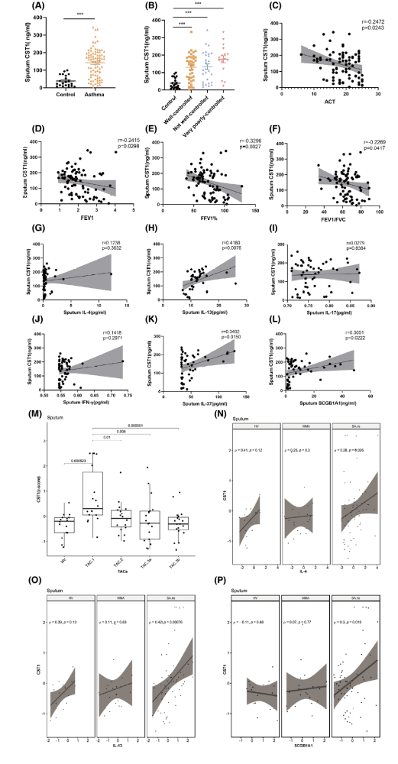
FIGURE 2 CST1 protein expression was increased in sputum supernatants of patients with asthma and negatively correlated with lung function. (A) CST1 protein expression in sputum supernatant samples from asthma patients (n = 83) and healthy control (n = 21) volunteers was detected by ELISA. (B, C) Increased levels of sputum CST1 protein were associated with the degree of asthma symptom control according to Global Initiative for Asthma (GINA) guidelines and asthma control test (ACT) scores. (D–F) Sputum CST1 protein levels were negatively correlated with lung function as determined by FEV1, FEV1% predicted, and FEV1/FVC. (G–L) Correlation analysis of CST1 protein levels in sputum supernatants with IL-4, IL-13, IL-17, IFN-γ, IL-37, and SCGB1A1 protein levels in sputum supernatants. (M) CST1 mRNA expression was increased in the sputum of patients with TAC1 asthma in U-BIOPRED data. (N–P) Correlation analysis of CST1 mRNA level in sputum with IL-4, IL-13, and SCGB1A1 mRNA levels in U-BIOPRED data. The data were quantified and expressed as mean ±} SEM. The data were analyzed using Mann–Whitney test (A), Kruskal–Wallis test (B), and Nonparametric Spearman correlation (C–L). ***P < 0.001. HV, healthy volunteers; MMA, mild/moderate nonsmoking asthma; SA.ns, severe asthma nonsmokers; TAC, transcriptome-associated cluster.

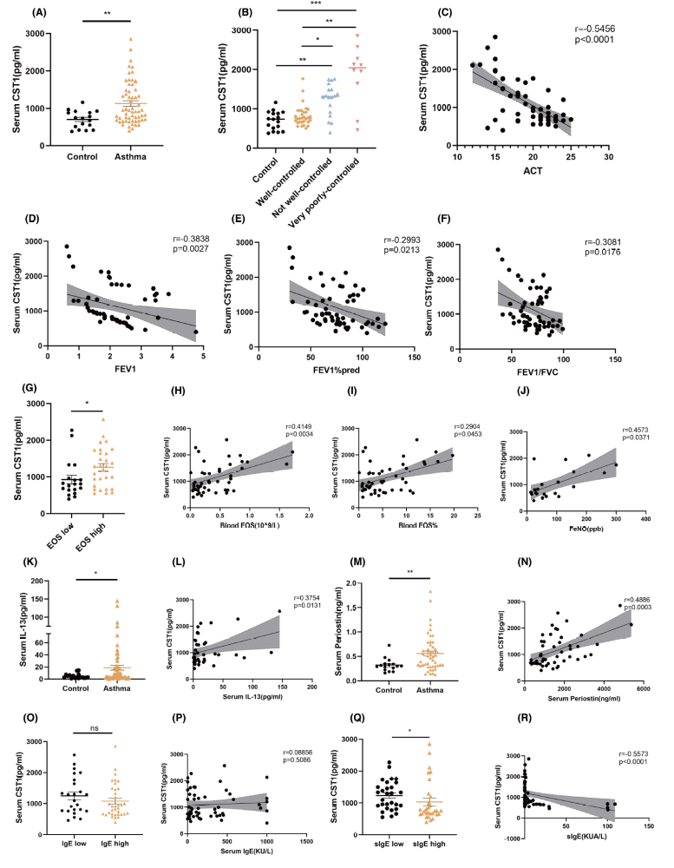
FIGURE 3 CST1 protein expression was increased in the serum of asthma patients and negatively correlated with lung function. Serum CST1 protein expression was positively correlated with peripheral blood eosinophils, FeNO, serum IL-13, serum periostin, and negatively correlated with HDM-sIgE levels. (A) CST1 protein expression in serum samples from 59 asthma patients and 17 healthy control volunteers was detected by ELISA. (B-C) Increased levels of serum CST1 protein were associated with the degree of asthma symptom control according to ACT scores. (D–F) Serum CST1 levels were negatively correlated with lung function as determined by FEV1, FEV1% predicted, and FEV1/FVC. (G) CST1 expression levels in the high peripheral blood eosinophil group (blood eosinophil >200 cells/μL) were higher than in the low peripheral blood eosinophil group (blood eosinophil ≤200 cells/μL). (H–J) Serum CST1 protein levels were positively correlated with peripheral blood eosinophil count, peripheral blood eosinophil percentage and FeNO. (K–R) Serum CST1 protein levels were positively correlated with serum IL-13 and periostin, and negatively correlated with HDM-sIgE levels, although not related to IgE. The data were quantified and expressed as mean ± SEM. The data were analyzed using Mann–Whitney test (A, G, K, M, O, Q), Kruskal–Wallis test (B), and Nonparametric Spearman correlation (C–F, H-J, L, N, P, R). *P < 0.05, **P < 0.01 and ***P < 0.001. EOS, Eosinophil; ns, not significant.

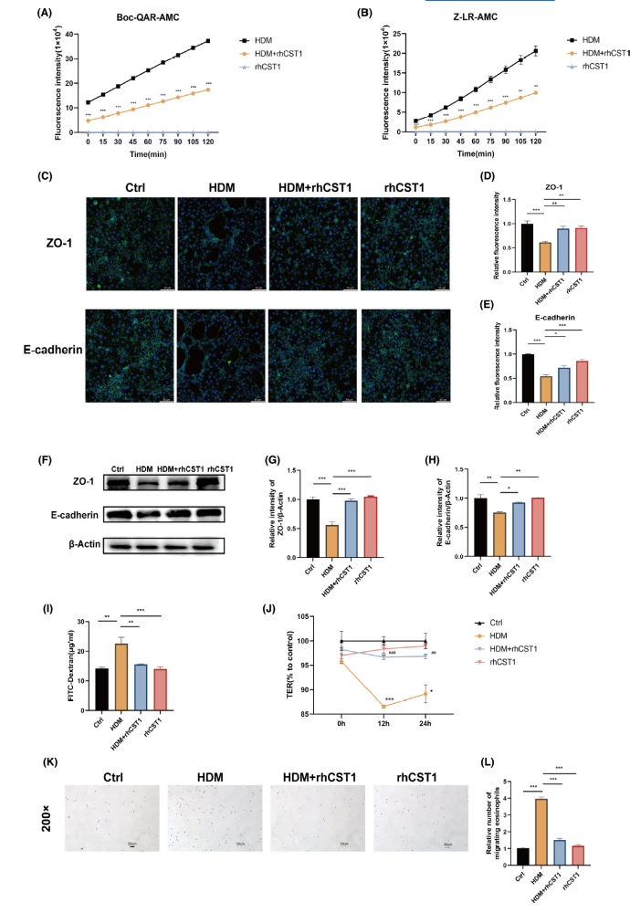
FIGURE 4 HDM-induced epithelial barrier function disruption was suppressed by rhCST1 protein. (A, B) HDM was incubated with rhCST1 protein and then incubated with the substrates Boc-QAR-AMC or Z-LR-AMC. The fluorescence intensity of released 7-amino-4-methylcoumarin was measured. The data were quantified and expressed as mean ± SEM using one-way ANOVA followed by Tukey's post hoc test. **P < 0.01 and ***P < 0.001 (HDM vs. HDM + rhCST1). (C–E) Monolayer 16HBE cells were treated with 50 μg/mL HDM for 24 h with or without rhCST1 protein. ZO-1 and E-cadherin protein production were determined after treatment by immunofluorescence. Quantified fluorescence intensity of ZO-1 and E-cadherin (relative to control). (F–H) Monolayer 16HBE cells were treated with HDM with or without rhCST1 protein. ZO-1 and E-cadherin protein production were determined after treatment by Western blotting. The data were presented as mean ± SEM of three independent experiments using one-way ANOVA followed by Tukey's post hoc test. *P < 0.05, **P < 0.01 and ***P < 0.001 (D-E, G-H). (I, J) Assessment of the permeability of the bronchial epithelium based on fluorescein isothiocyanate (FITC)–dextran and transepithelial electrical resistance (TEER) in control media (Ctrl), HDM, HDM + rhCST1 and rhCST1 groups. The data were presented as mean ± SEM and analyzed using one-way ANOVA followed by Tukey's post hoc test. **P < 0.01 and ***P < 0.001(I); *P < 0.05 and ***P < 0.001 (HDM vs. control), ##P < 0.01 and ###P < 0.001 (HDM vs. HDM + rhCST1) (J). (K-L) rhCST1 protein abrogated HDM-induced migration of eosinophils across the epithelium and relative number of migrating eosinophils. The data were quantified and expressed as mean ± SEM using one-way ANOVA followed by Tukey's post hoc test. ***P < 0.001.

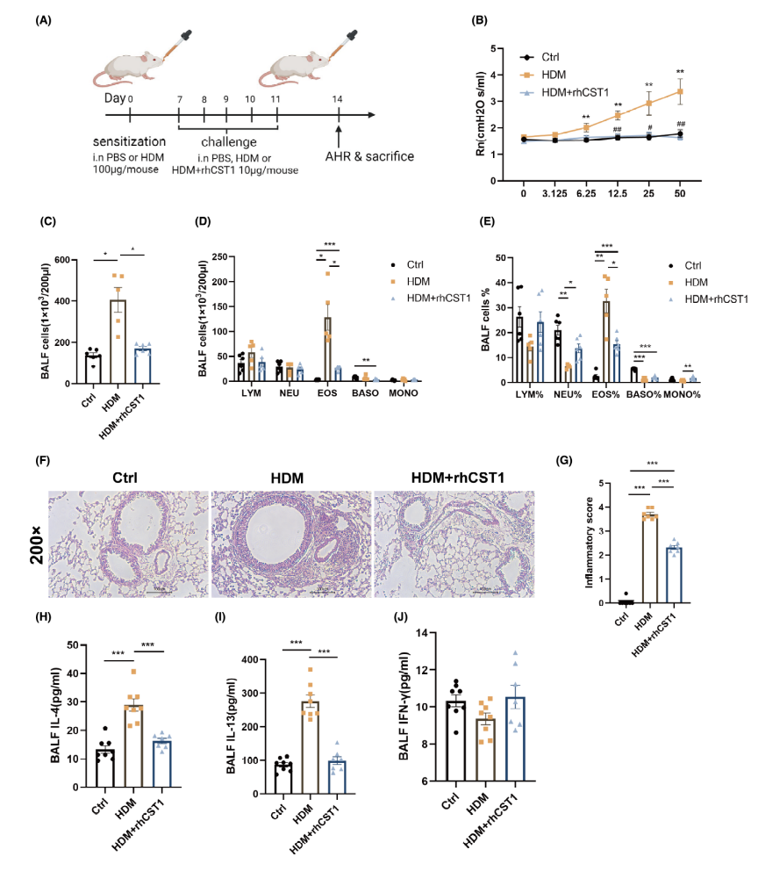
FIGURE 5 rhCST1 protein abrogated HDM-induced airway hyperresponsiveness and airway inflammation. (A) Development of the mouse model for acute asthma and rhCST1 protein treatment. (B) Controls (Ctrl), HDM-sensitized and challenged mice and HDM + rhCST1 protein groups were exposed to increasing doses (3.125–50 mg/mL) of nebulized methacholine (Mch). Airway resistance in response to Mch was measured by the resistance of the central airways (Rn) (n = 7–8 per group). The data were presented as mean ± SEM and analyzed using one-way ANOVA followed by Tukey's post hoc test or Kruskal-Wallis test. **P < 0.01 (HDM vs. control), #P < 0.05 and ##P < 0.01 (HDM vs. HDM + rhCST1). (C–E) The total and differential cell counts in bronchoalveolar lavage fluid (BALF) are shown (n = 5–6 per group). (F) Representative H&E staining showing the effect of rhCST1 protein on HDM-induced inflammatory cell infiltration (original magnification x 200, scale bar 100 μm). (G) An overall inflammatory score was calculated to indicate the degree of inflammatory cell infiltration (n = 8 per group). (H–J) The concentrations of IL-4 (H), IL-13 (I), and IFN-γ (J) in BALF of Ctrl, HDM, and HDM + rhCST1 protein groups were measured by ELISA. The data were presented as mean ± SEM and analyzed using one-way ANOVA followed by Tukey's post hoc test (G–J) or Brown-Forsythe test (C–E). *P < 0.05, **P < 0.01 and ***P < 0.001. AHR, airway hyperresponsiveness; BASO, basophil; EOS, Eosinophil; i.n, intranasal administration; LYM, lymphocyte; MONO, monocyte; NEU, neutrophil.

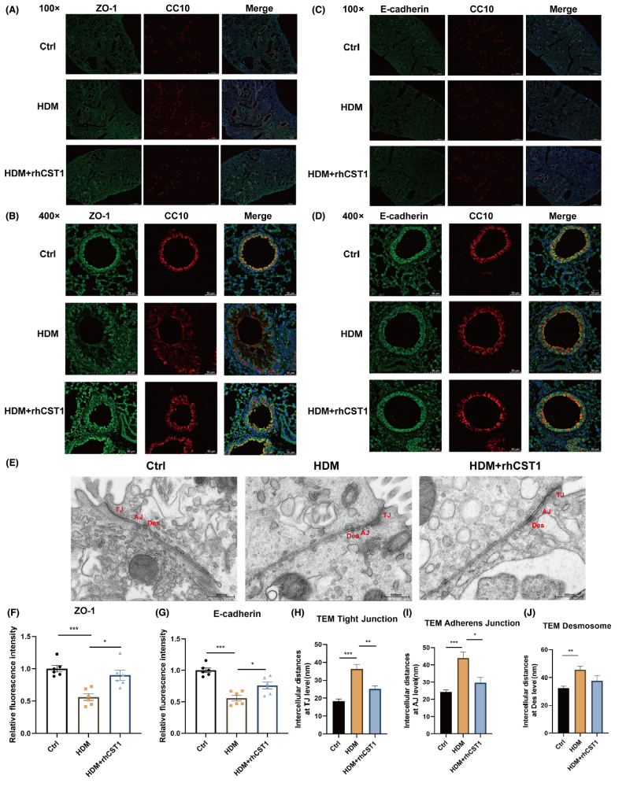
FIGURE 6
rhCST1 protein abrogated HDM-induced epithelial barrier function disruption in vivo. (A, B) Representative images of immunofluorescence of ZO-1 in the whole lung tissues and bronchial epithelial cells in control media (Ctrl), HDM, and HDM + rhCST1 protein groups. Blue: DAPI; Green: ZO-1; Red: CC10 (n = 6 per group). (C, D) Representative images of immunofluorescence of E-cadherin in the whole lung tissues and bronchial epithelial cells in control media (Ctrl), HDM, and HDM + rhCST1 protein groups. Blue: DAPI; Green: E-cadherin; Red: CC10 (n = 6 per group). (E) rhCST1 protein abrogated HDM-induced enlargement of the epithelial intercellular cell junction destruction. Epithelial intercellular epithelial cell junctions were determined by electron microscopy. (F) Quantified fluorescence intensity ZO-1 (relative to control). (G) Quantified fluorescence intensity E-cadherin (relative to control). (H–J) Intercellular distances at AJ (H), TJ (I) and Desmosome (J) levels were determined by electron microscopy. The data were presented as mean ± SEM and analyzed using one-way ANOVA followed by Tukey's post hoc test (F–J). *P < 0.05, **P < 0.01 and ***P < 0.001. AJ, adherens junction; CC10, club cell protein 10; Des, desmosome; TJ, tight junction.

