Socioeconomic and ethnic inequalities in exposure to air and noise pollution in London

Cathryn Tonne¹, Carles Milà¹, Daniela Fecht², Mar Alvarez¹, John Gulliver², James Smith³, Sean Beevers³, H Ross Anderson^{3,4}, Frank Kelly³
¹ ISGlobal, Universitat Pompeu Fabra, CIBER Epidemiología y Salud Pública, Barcelona, Spain
² UK Small Area Health Statistics Unit, MRC-PHE Centre for Environment and Health, Imperial College London, London, UK
³ Environmental Research Group, MRC-PHE Centre for Environment and Health, King’s College London, London, UK
⁴ Population Health Research Institute, St George´s, University of London

Corresponding author:
Cathryn Tonne
Cathryn.tonne@isglobal.org
+34 93 214 7361
ISGlobal
Doctor Aiguader, 88
08003 Barcelona

Running title: Inequalities in air and noise pollution

Keywords: air pollution, transport, noise, inequalities, personal exposure, quantile regression

Acknowledgements: This work was supported by the UK Natural Environment Research Council, Medical Research Council, Economic and Social Research Council, Department of Environment, Food and Rural Affairs, and Department of Health (NE/I007806/1, NE/I00789X/1, NE/I008039/1) through the cross-research council Environmental Exposures & Health Initiative. The work of the UK Small Area Health Statistics Unit is funded by Public Health England as part of the MRC-PHE Centre for Environment and Health, funded also by the UK Medical Research Council. CT was funded through a Ramón y Cajal fellowship (RYC-2015-17402) awarded by awarded by the Spanish Ministry of Economy and Competitiveness.

The authors declare they have no actual or potential competing financial interests.
Abstract
Background: Transport-related air and noise pollution, exposures linked to adverse health outcomes, varies within cities potentially resulting in exposure inequalities. Relatively little is known regarding inequalities in personal exposure to air pollution or transport-related noise.
Objectives: Our objectives were to quantify socioeconomic and ethnic inequalities in London in 1) air pollution exposure at residence compared to personal exposure; and 2) transport-related noise at residence from different sources.
Methods: We used individual-level data from the London Travel Demand Survey (n=45,079) between 2006-2010. We modeled residential (CMAQ-urban) and personal (London Hybrid Exposure Model) particulate matter <2.5 microns and nitrogen dioxide (NO₂), road-traffic noise at residence (TRANEX) and identified those within 50dB noise contours of railways and Heathrow airport. We analyzed relationships between household income, area-level income deprivation and ethnicity with air and noise pollution using quantile and logistic regression.
Results: We observed inverse patterns in inequalities in air pollution when estimated at residence versus personal exposure with respect to household income (categorical, 8 groups). Compared to the lowest income group (< £10,000), the highest group (>£75,000) had lower residential NO₂ (-1.3 (95% CI -2.1, -0.6) µg/m³ in the 95th exposure quantile) but higher personal NO₂ exposure (1.9 (95% CI 1.6, 2.3) µg/m³ in the 95th quantile), which was driven largely by transport mode and duration. Inequalities in residential exposure to NO₂ with respect to area-level deprivation were larger at lower exposure quantiles (e.g. estimate for NO₂ 5.1 (95% CI 4.6, 5.5) at quantile 0.15 versus 1.9 (95% CI 1.1, 2.6) at quantile 0.95), reflecting low-deprivation, high residential NO₂ areas in the city centre. Air pollution exposure at residence consistently overestimated personal exposure; this overestimation varied with age, household income, and area-level income deprivation. Inequalities in road traffic noise were generally small. In logistic regression models, the odds of living within a 50dB contour of aircraft noise were highest in individuals with the highest household income, white ethnicity, and with the lowest area-level income deprivation. Odds of living within a 50dB contour of rail noise were 19% (95% CI 3, 37) higher for black compared to white individuals.
Conclusions: Socioeconomic inequalities in air pollution exposure were different for modeled residential versus personal exposure, which has important implications for environmental justice and confounding in epidemiology studies. Exposure misclassification was dependent on several factors related to health, a potential source of bias in epidemiological studies. Quantile regression revealed that socioeconomic and ethnic inequalities in air pollution are often not uniform across the exposure distribution.

Introduction
Transport-related air and noise pollution, environmental exposures linked to a range of adverse health outcomes,(Health Effects Institute, 2009; WHO Europe, 2011) varies within cities. This variation may result in exposure inequalities: different socioeconomic and ethnic groups being more exposed than others.(European Commission, 2016) Socioeconomic and ethnic inequalities in health are well established.(Shiels et al., 2017; Stringhini et al., 2017) The unequal distribution of environmental exposures may contribute to these health inequalities where exposures are higher in individuals or communities with lower socioeconomic position or in specific ethnic groups.
Studies from the US show a fairly consistent relationship between individuals or communities of lower socioeconomic position and increased exposure to air pollution.(Hajat et al., 2015) Evidence from Europe is mixed,(Temam et al., 2017) with some studies indicating non-linear relationships or high exposures in city centres with concentrations of individuals with high socioeconomic position.(Goodman et al., 2011; Havard et al., 2009) Within Europe, areas with a high proportion of non-white residents have also been observed to have higher air pollution exposures.(Fecht et al., 2015) However, nearly all studies have considered exposure inequalities based on residential exposures, with very few examples based on personal exposure,(Jantunen et al., 2000; Rotko et al., 2001) or exposures experienced during commuting.(Rivas et al., 2017) In addition, most studies have investigated environmental inequalities at the neighborhood or area-level, while few have investigated exposure inequalities using individual-level socioeconomic or ethnicity data.(Hajat et al., 2015; Temam et al., 2017)
Compared to air pollution, fewer studies have investigated inequalities in transport-related noise and most have focused on road-traffic, rather than rail or aircraft noise.(European Commission, 2016) The available evidence is inconsistent. Several studies have observed positive associations between road-traffic noise and deprivation;(Dale et al., 2015; Havard et al., 2009; Nega et al., 2013) while others have observed the reverse,(Havard et al., 2011) or no association.(Halonen et al., 2015) A small number of studies in Europe have investigated the relationship between different metrics of deprivation and aircraft noise.(Huss et al., 2010; Pelletier et al., 2013). A recent small-area study reported inequalities in environmental noise according to area-level race, racial segregation, and socioeconomic characteristics across the US, but did not differentiate between anthropogenic sources.(Casey et al., 2017)
We aim to fill this gap in the literature by considering air pollution exposure inequalities both at residence and using modeled personal exposure as well as noise exposures from multiple sources. Our objectives were to quantify socioeconomic and ethnic inequalities in 1) air pollution exposure at residence compared to personal exposure; and 2) transport-related noise at residence from different sources. Rather than focus only on inequalities in mean exposures, we consider inequalities across the full exposure distribution, providing a more complete picture of inequalities in transport-related environmental exposures than previous studies.
Methods
Study population The study population was based on individuals who responded to the London Travel Demand Survey (LTDS), conducted by Transport for London to capture data on travel patterns and modal share.(Transport for London, 2015) The survey sampled approximately 8,000 households per year on a rolling basis and was based on a random sample of households. Data were collected through a face-to-face interview in participants’ homes. Respondents were asked about their activities on the previous day and how typical this was of their normal day. Transport for London adjusted the sample for sampling weights and non-response to generate a sample representative of London overall as well as sub-regions of the city. We used LTDS data from 45,079 individuals (20,542 households) who responded to the survey between years 2006-2010, after excluding 4,969 individuals (11%) with missing residential postcode, demographic or trip (origin or destination) data (S Table 1).
Air pollution data The London Hybrid Exposure Model (LHEM) was used to estimate exposure to air pollution (particulate matter <2.5 microns [PM_{2.5}], nitrogen dioxide [NO₂]) of individuals included in the LTDS based on their residential location, trips, mode of transport, and time spent in non-residential locations between trips. The model is described in detail elsewhere.(Smith et al., 2016) Briefly, trip start and end coordinates, times of trips, and transport mode are taken from the LTDS. The route between origin and destination was simulated using methods appropriate for each travel mode. Exposure to outdoor air pollution was estimated using the Community Multiscale Air Quality Modeling System (CMAQ-urban), described below.(Beevers et al., 2012) To account for penetration of outdoor air indoors, in-building exposures were estimated by applying indoor/outdoor ratios for domestic buildings estimated for each London postcode to the CMAQ-urban estimates.(Taylor et al., 2014) In-vehicle exposures were estimated in LHEM using mass-balance equations. Microenvironmental exposures for trips on the London Underground were estimated based on measured concentrations in the London or Paris metro system. Exposures while walking and cycling were estimated based on the CMAQ-urban estimates for the time and location of the trip. Although the model does not fully capture personal exposure from all sources in all microenvironments, for ease of interpretability, we refer to LHEM as an estimate of personal exposure to ambient pollution.
We used CMAQ-urban to predict ambient air pollution concentrations at place of residence. CMAQ-urban couples the Weather Research and Forecasting meteorological model with the Atmospheric Dispersion Modeling System roads model. We generated annual average concentrations of PM_{2.5} and NO₂ for each hour of the day for the year 2011 at 20m x 20m resolution.(Taylor et al., 2014) Residential air pollution estimates are based on the 24hr mean concentration (S-Figure 1).
Road traffic noise Annual road traffic noise for years 2003-10 was modeled at the geometric centroid for all ~190,000 London postcodes using the TRAffic Noise EXposure (TRANEX) model.(Gulliver et al., 2015) Briefly, the model uses detailed information on traffic flows and speeds for each year, land cover, and heights of individual buildings. We used L_{Aeq},_{24hr} (average over the hours 0:00 to23:59), because it covers the same time period as the residential air pollution estimates; however, Spearman correlations with other noise metrics including L_{night} and L_{Aeq,16hr} were greater than 0.99. Individuals were assigned the modeled noise levels for their postcode (approximately 12 households per postcode). Less than 1% of postcodes were outside of the TRANEX model domain and could not be linked.
Rail and airport noise We identified individuals whose residential postcode was within the 50dB noise contours of over-ground railways and Heathrow airport. Noise contours came from strategic noise mapping under the first round of the Environmental Noise Directive. Data for over-ground railways were from Department for Environment, Food and Rural Affairs, supplied by Extrium Ltd. Aircraft noise from Heathrow airport was derived from annual average contours (2001) supplied by the Civil Aviation Authority.
Sociodemographic data Self-reported age, household income, and ethnicity were available from the LTDS. Ethnicity was collapsed into four ethnic groups: white (white – British, white – Irish, other white), Asian (Asian or Asian British – Bangladeshi, Asian or Asian British – Indian, Asian or Asian British - other Asian background, Asian or Asian British – Pakistani, Chinese), black (black or black British – African, black or black British – Caribbean, black or black British - other black background), and other (mixed - white and black Caribbean, mixed - other mixed background, mixed - white and black African, other ethnic group, mixed - white and Asian). For purposes of comparing exposure inequalities with household income, we used Lower Layer Super Output Area (on average 1500 people)-level deprivation data from the 2010 Index of Multiple Deprivation (IMD), a composite measure of area-level deprivation (S-Figure 2).(Communities and Local Governments, 2011) For better comparability with household income, we focused our analysis on the income domain of IMD, which is based on the proportion of households receiving income support. Area-level income deprivation was linked to individuals based on their residential postcode location. The distribution of participants’ ethnicity by household income and area-level income deprivation is presented in S-Figure3.
Statistical Analysis All regression analyses took account of the hierarchical data structure: participants clustered within households (on average 2.2 participants per household). We explored bivariate relationships of continuous exposures with household income, ethnicity and area-level income deprivation with summary statistics and quantile regression. Quantile regression estimates conditional quantile functions, i.e. models in which the quantiles of the conditional distribution of the outcome are expressed as functions of the observed covariates. Quantile regression does not assume a distribution for the errors and is robust to extreme observations. More importantly, it is useful to describe complex relationships where the covariate effects are expected to be heterogeneous across the outcome distribution and thus associations based on the mean do not provide a complete picture. (Koenker, 2005) We used quantile regression because of the complex nature of the relationships we aimed to study and the highly skewed and heteroscedastic distributions for LHEM and TRANEX exposures. For example, estimates from the quantile regression at a given quantile of the distribution with household income as the single categorical covariate, represent the sample quantiles conditional on household income categories. We fit separate models for each exposure at 0.05 quantile intervals and used bootstrapping to estimate standard errors and confidence intervals, accounting for the hierarchical data structure. We tested for the presence of spatial autocorrelation in variograms of the residuals from the quantile regressions.
We explored whether exposure misclassification using ambient air pollution at residence rather than personal exposure differed according to age, socioeconomic and ethnic groups. We assumed that personal exposure estimates were a closer approximation to true personal exposure and fit models to the difference between residence and personal concentration. Models included the following covariates: age, age², ethnicity, household income, area-level income deprivation, and a random effect for household. We report exposure misclassification for variables with statistically significant associations with difference between residence and personal concentration.
To explore bivariate relationships for dichotomous exposures to rail and aircraft noise, we fit logistic models with separate models for household income, ethnicity, and area-level income deprivation using bootstrapping to estimate standard errors and confidence intervals. Statistical analysis were performed with R-3.3.2,(R Core Team, 2016) including packages: tidyverse (data manipulation), ggplot2 (figures), quantreg (quantile regression), and lme4 (mixed models).(Koenker, 2016; Bates 2015; Wickham, 2016)
Results
The mean age of the study population was 37 years (sd 23). Distributions of residential and personal PM_{2.5} and NO₂ as well as residential road traffic noise are presented in Figure 1 and S-Table 2. Personal exposure was generally lower than ambient residential exposure for both air pollutants, largely reflecting low penetration of outdoor air pollution indoors (Smith et al., 2016). Table 1 presents mean air pollution, road-traffic noise, and percentage exposed to rail or aircraft noise according to household income, individual-level ethnicity, and area-level income deprivation (medians included in S-Table 3). Absolute and relative differences between the highest and lowest mean exposures to air pollution and road traffic noise according to household income were small and the correlations were weak (Table 2). Nonetheless, trends in air pollution exposure by household income were in different directions for residential and personal exposure. Trends in residential air pollution by household income were not monotonic; exposures generally decreased with increasing household income except for the highest income category (Table 1). Exposure gradients by area-level income deprivation were largest for NO₂, which is more spatially variable than PM_{2.5}. Participants living in the most deprived areas had the highest exposures for residential PM_{2.5} and NO₂ as well as for personal NO₂, but not for personal PM_{2.5} or road traffic noise. Similarly, increasing household income was only weakly correlated with lower residential air pollution, whereas increasing area-level deprivation was more strongly correlated with higher residential air pollution. (Table 2).

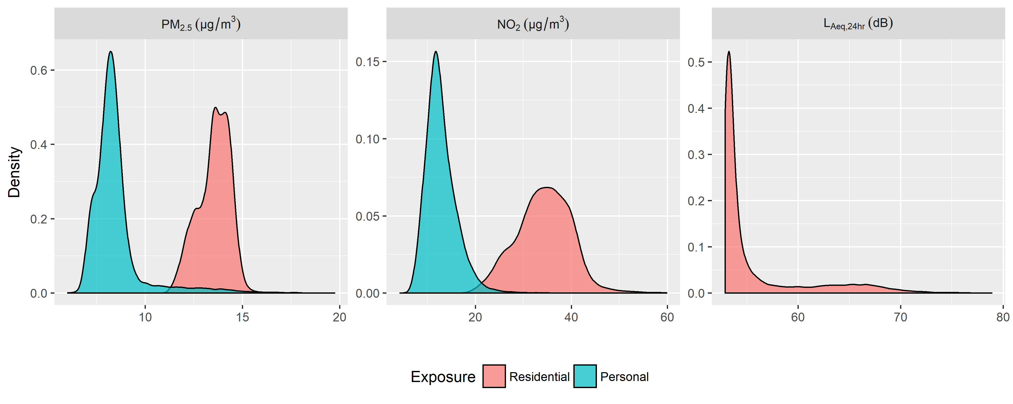
Figure 1. Probability density of residential and personal exposure to PM_{2.5} and NO₂ and residential road traffic noise. Values greater than 20 µg/m³ for PM_{2.5} and 60 µg/m³ for NO₂ (<0.1% of data) removed for purposes of visualization.
Table 1. Mean air pollution, road traffic noise, and percentage exposed to rail and aircraft noise by household income, ethnicity and area-level income deprivation
Means | N | Residential  PM_{2.5} (µg/m³) | Personal  PM_{2.5} (µg/m³) | Residential  NO₂ (µg/m³) | Personal  NO₂ (µg/m³) | Residential  road traffic noise  (L_{Aeq},_{24hr} dB) | Rail noise  (%) | Heathrow  noise  (%)
Income (£)
Under 10000 | 8,327 | 13.63 | 8.29 | 35.13 | 12.48 | 56.11 | 12.7 | 11.4
10000 - 14999 | 4,762 | 13.55 | 8.33 | 34.61 | 12.57 | 55.87 | 12.9 | 11.6
15000 - 19999 | 4,318 | 13.56 | 8.44 | 34.79 | 12.89 | 55.96 | 12.4 | 13.2
20000 - 24999 | 3,883 | 13.54 | 8.50 | 34.37 | 13.01 | 55.79 | 12.0 | 10.7
25000 - 34999 | 5,760 | 13.50 | 8.53 | 34.02 | 12.92 | 55.79 | 14.3 | 12.3
35000 - 49999 | 6,464 | 13.48 | 8.59 | 33.79 | 13.07 | 55.81 | 12.3 | 13.2
50000 - 74999 | 5,573 | 13.46 | 8.64 | 33.67 | 13.18 | 55.80 | 11.3 | 13.3
Over 75000 | 5,992 | 13.51 | 8.62 | 34.18 | 13.22 | 55.57 | 11.4 | 16.7
Ethnicity
White | 29,479 | 13.49 | 8.47 | 33.90 | 12.81 | 55.75 | 12.0 | 13.8
Asian | 7,592 | 13.61 | 8.60 | 34.87 | 13.05 | 56.15 | 12.7 | 10.5
Black | 5,214 | 13.61 | 8.42 | 35.35 | 13.10 | 55.88 | 13.9 | 11.9
Other | 2,516 | 13.70 | 8.50 | 35.69 | 13.16 | 56.08 | 13.4 | 10.5
Income deprivation quintiles
1 (least deprived) | 9,782 | 13.30 | 8.40 | 32.33 | 12.41 | 55.62 | 11.1 | 18.0
2 | 8,737 | 13.45 | 8.52 | 33.64 | 12.84 | 55.96 | 12.6 | 14.8
3 | 8,146 | 13.57 | 8.54 | 34.51 | 12.98 | 55.91 | 12.1 | 13.9
4 | 9,118 | 13.62 | 8.49 | 35.11 | 13.07 | 55.89 | 11.7 | 10.1
5 (most deprived) | 8,128 | 13.73 | 8.49 | 36.12 | 13.19 | 55.83 | 14.5 | 7.0

Table 2. Spearman correlation coefficients between air pollution and road traffic noise exposures and household income and area-level income deprivation

Spearman correlation | Residential  PM_{2.5} (µg/m³) | Personal  PM_{2.5} (µg/m³) | Residential  NO₂ (µg/m³) | Personal  NO₂ (µg/m³) | Residential  L_{Aeq},_{24hr} (dB)
Household income | -0.06 | 0.06 | -0.07 | 0.07 | -0.03
Income deprivation | 0.19 | 0.08 | 0.25 | 0.11 | 0.07

Figure 2(a) presents the results of quantile regression exploring the relationship between air pollution and road traffic noise exposures with household income (models fit separately for each exposure). The intercept represents the level of exposure at each quantile (e.g. 0.05 to 0.95) of exposure among participants with household income below £10,000. For example in this household income strata, exposure quantiles for residential NO₂ varied from 25.2 to 43.5 µg/m³, while quantiles for personal PM_{2.5} varied from 7.1 to 9.5 µg/m³. For each quantile of exposure, residential NO₂ was approximately 1 µg/m³ lower in the highest household income group relative to the lowest household income group (reference group, indicated as intercept), a difference that was statistically significant across all quantiles. Differences in residential PM_{2.5} across income groups were small, consistent with the limited spatial variation in ambient PM_{2.5} within the city. In contrast to residential NO₂, personal NO₂ was greater in higher income groups compared to the reference group at exposure quantiles 0.25 and above. Personal NO₂ was 1.9 (95% CI 1.6; 2.3) µg/m³ higher in the 0.95 exposure quantile. In other words, the difference in exposure between the highest and lowest household income group did not depend on the level of exposure for residential NO₂, but for personal NO₂ the difference ranged between 0 and 1.9 µg/m³ depending on the level of exposure. Personal PM_{2.5} in the highest income group was indistinguishable from that in the lowest household income group until the 0.75 quantile, above which personal PM_{2.5} was significantly higher in the highest household income group (2.8 (95%CI 2.4, 3.2) µg/m³ difference in the 0.95 exposure quantile). Quantile regression results for each exposure adjusting for household income along with age and travel duration by mode are presented in S-Figure 4. Differences in personal exposure according to household income were largely explained by travel duration and mode.
In the lowest household income strata, residential road traffic noise was approximately 53 dB until the 0.75 quantile, where it increased to nearly 70 dB in the 0.95 quantile. Differences in road traffic noise between the highest and lowest household income strata were negligible until the 0.75 exposure quantile. Above the 0.75 quantile, confidence intervals around the effect of household income on noise were wide, but the data suggest high household income was associated with lower noise exposure (e.g. -2.2 (95% CI -3.7,-0.8) dB at the 0.85 quantile).

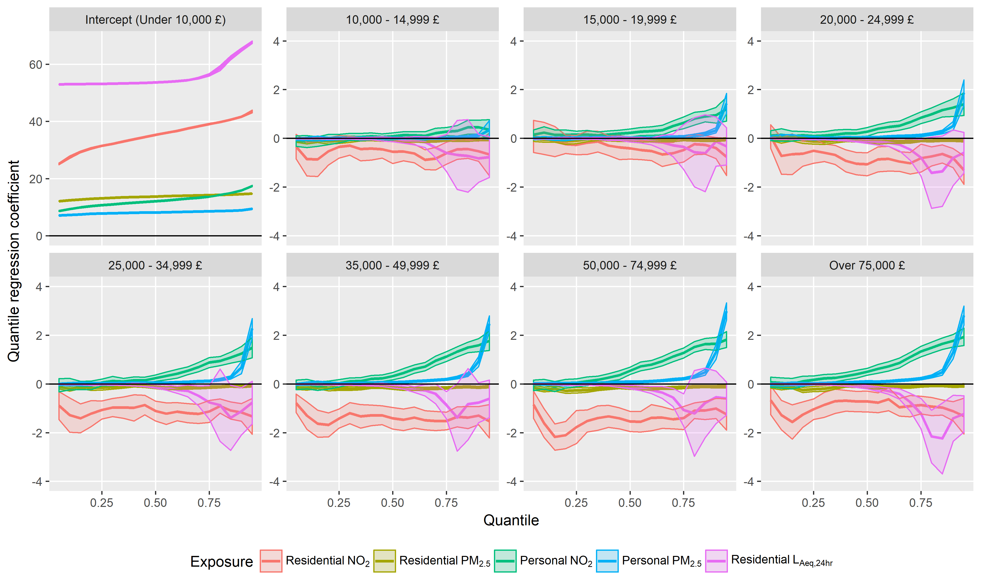
(a)
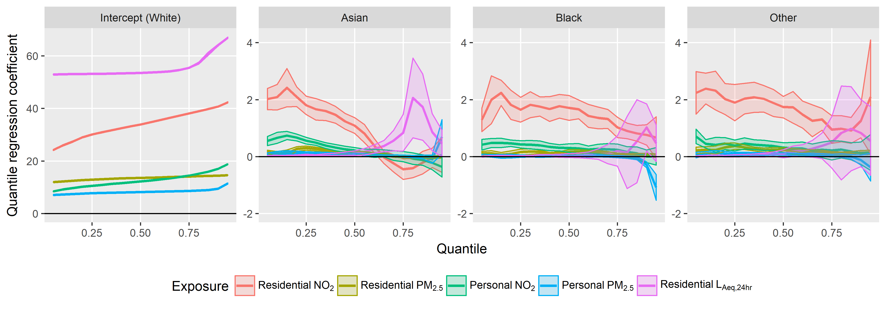
(b)
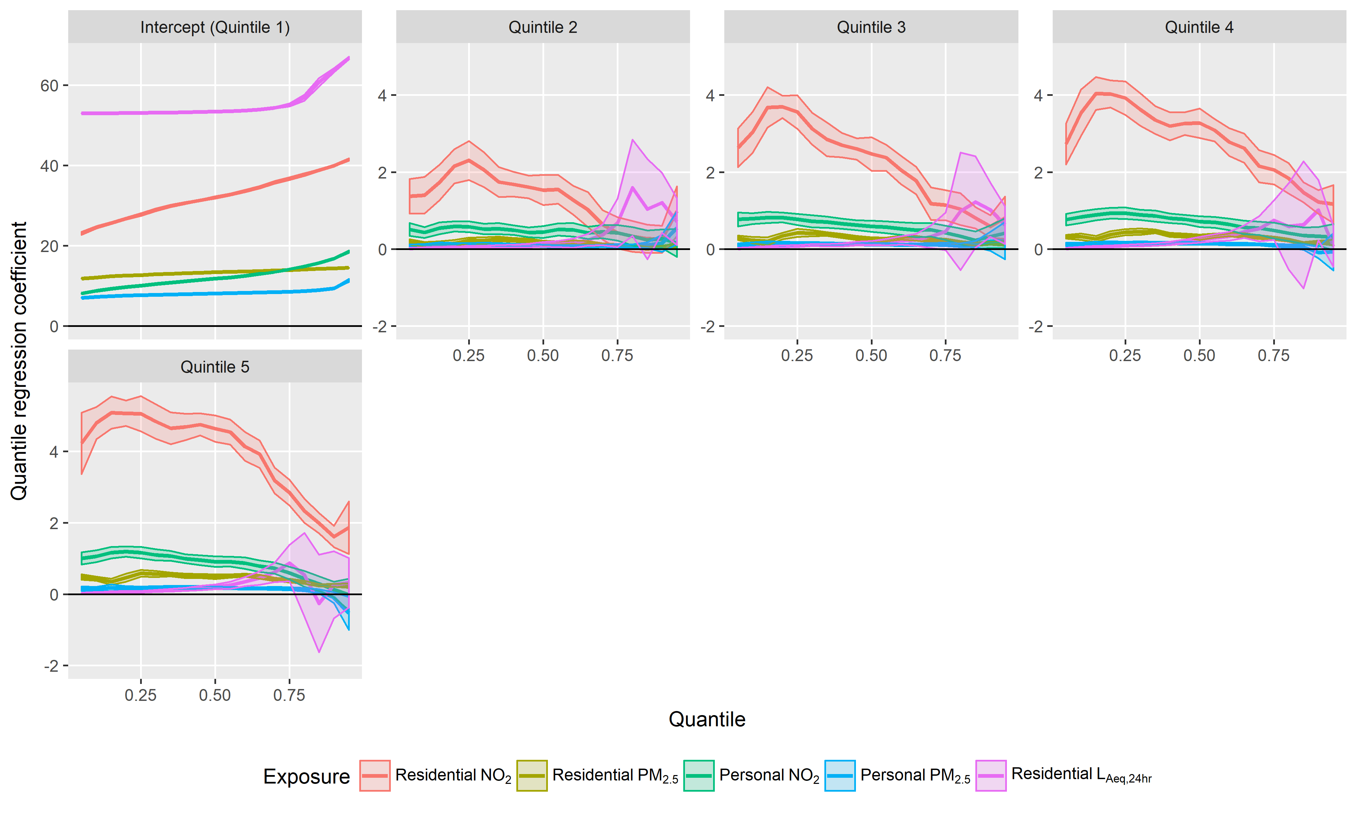
(c)
Figure 2. Quantile regression coefficients (line) and 95% confidence intervals (shading) for residential and personal air pollution and residential road traffic noise according to (a) household income (b) ethnicity and (c) area-level income deprivation. Each exposure modelled separately.

The relationships between air pollution and road traffic noise exposures with ethnicity were complex (Figure 2(b). Asians had higher residential NO₂ compare to whites below, but not above, the 0.6 quantile of exposure. Residential and personal exposures to PM_{2.5} were similar for Asians and whites. Black and other ethnic groups had consistently higher residential NO₂ compared to whites. Maps of ambient NO₂ concentrations used to estimate residential exposure overlaid with participants’ ethnicity at borough level show similar patterns (S-Figure 5): while both Asian and whites were present in mid and high-range NO₂, participants other than whites were far less likely to live in locations with low NO₂. Asian ethnicity was associated with higher road traffic noise compared to whites above the 0.75 quantile of exposure.
The largest exposure differences according to quintiles of area-level income deprivation were for residential NO₂ (Figure 2(c)). However, differences were variable across the exposure range, with the largest differences at low residential NO₂ levels. In other words, low residential NO₂ consistently occurred in low income deprivation areas; however, high residential NO₂ occurred in both high and low income deprivation areas, for example in parts of Central London (S-Figures 1 and 2).
Assuming estimated personal exposure to ambient pollution is a closer proxy for true personal exposure, we observed differences in the degree to which residential exposure overestimated personal exposure according to age, household income, and area-level income deprivation (Figure 3). Differences according to ethnicity (adjusted for covariates) were small. The largest differences were seen for participants typically outside of the working age range (shown in figure for 10 and 70 year olds), whereas the lowest misclassification occurred for working age adults. The extent of overestimation by residential exposure generally increased with decreasing household income and increasing area-level income deprivation.

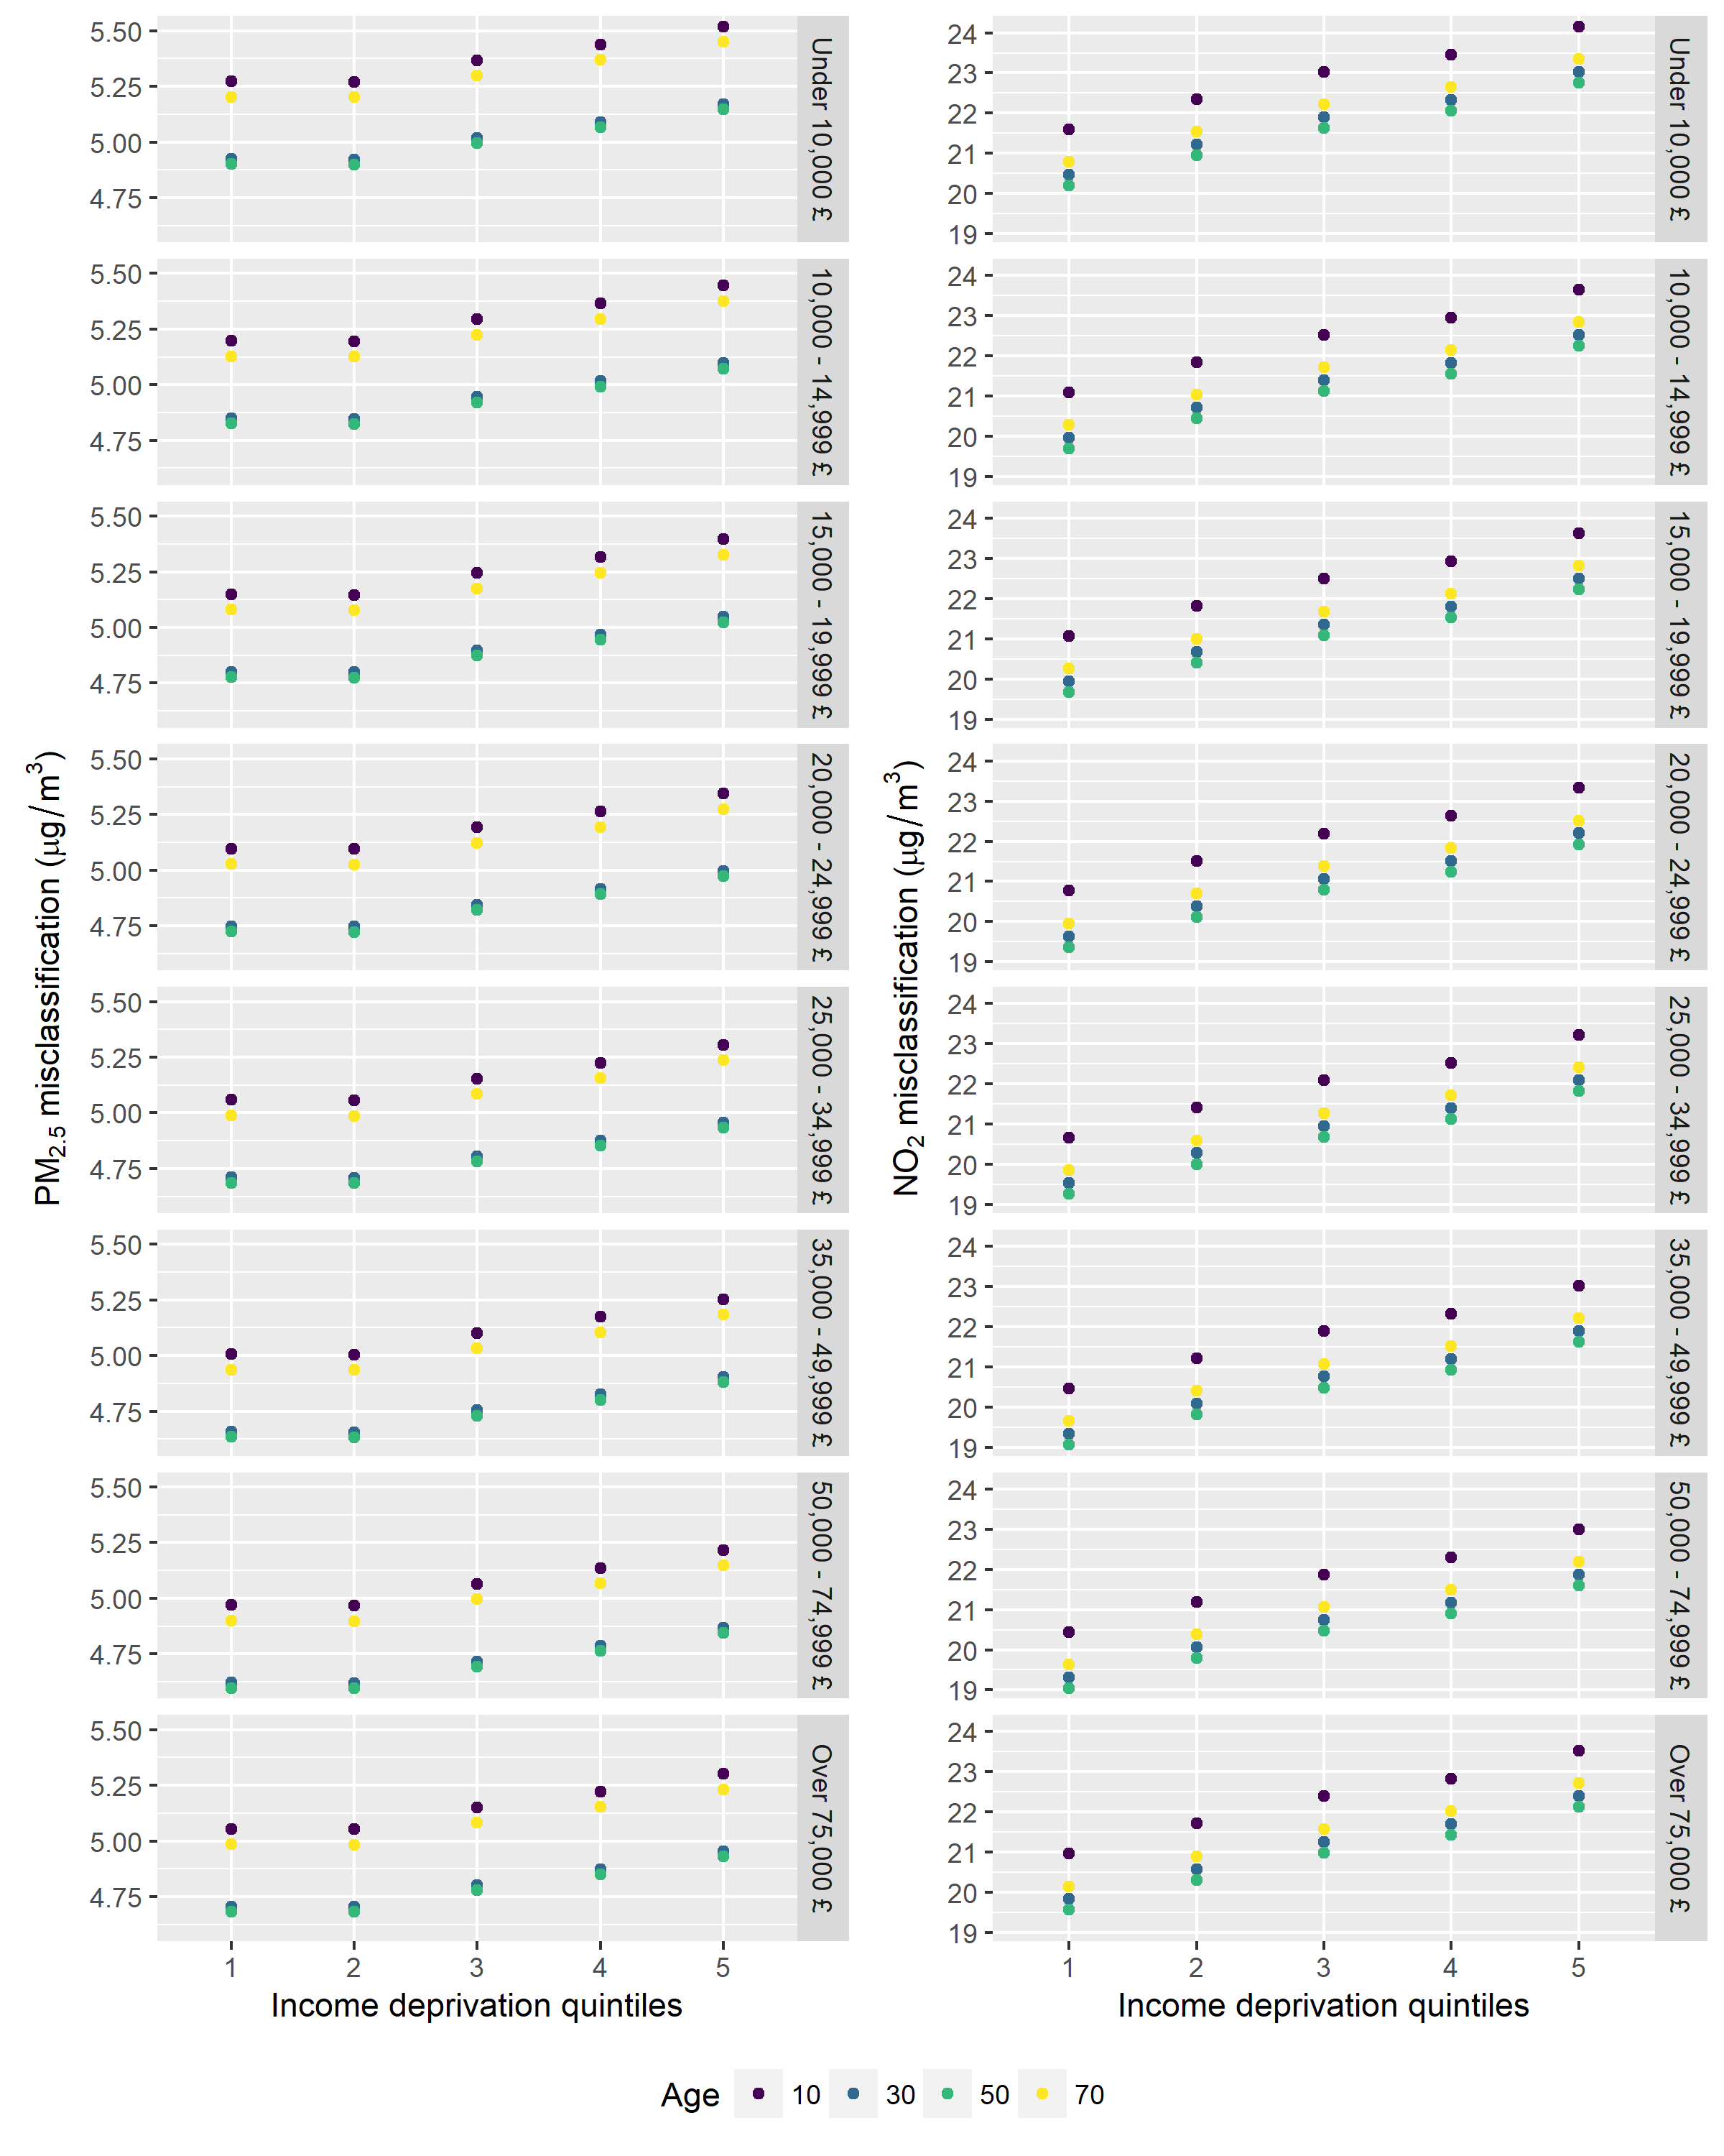
Figure 3. Exposure misclassification (µg/m³) using residential compared to personal air pollution according to age (shown for select ages), household income, and area-level income deprivation. Estimates mutually adjusted and adjusted for ethnicity and household.

Individuals in the highest household income group had higher odds of living within a 50dB contour of aircraft noise from Heathrow airport (OR 1.55 (95% CI 1.32, 1.82)) compared to the lowest income group (Figure 4a). Individuals with Asian (OR 0.73 (95% CI 0.64, 0.84) and other ethnicity (OR 0.74 (95%CI 0.58, 0.93) had significantly lower odds of exposure to aircraft noise compared to whites (Figure 4b). For rail noise, no trend with household income was evident; however, the odds of living within a 50dB contour of rail noise was higher in black participants compared to whites (OR 1.19 (95%CI 1.03, 1.37)) (Figure 4b). The odds of exposure to aircraft noise steadily decreased with increasing area-level income deprivation (Figure 4c)). In contrast, the odds of exposure to rail noise were higher in the most deprived compared to least deprived quintile: OR 1.36 (95%CI 1.18, 1.58).
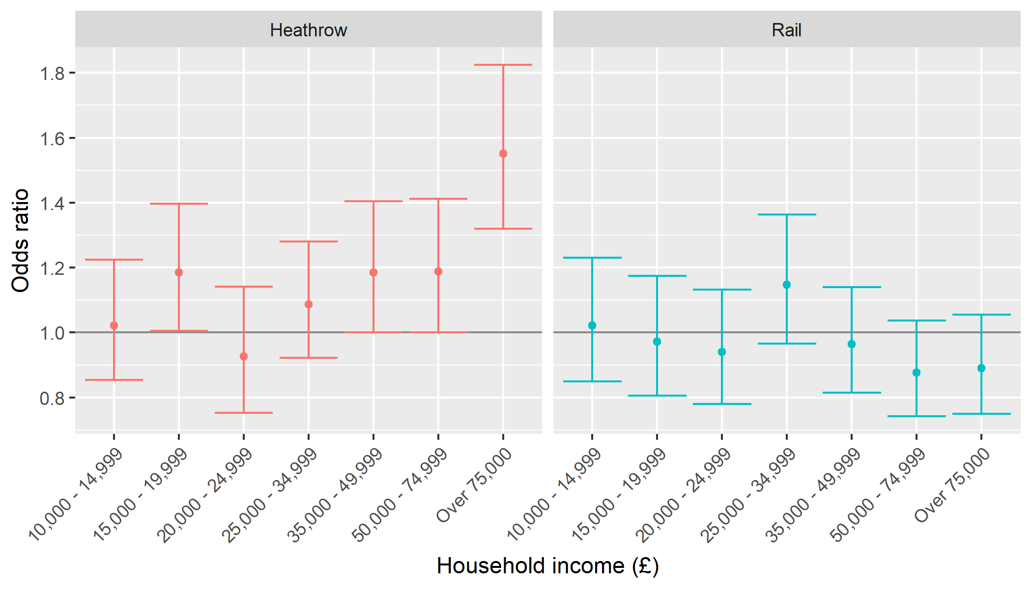
(a)
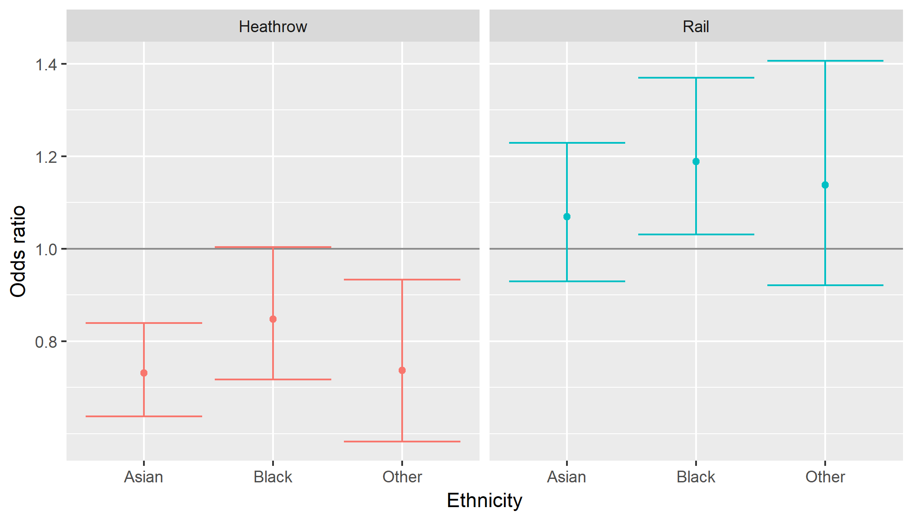
(b)
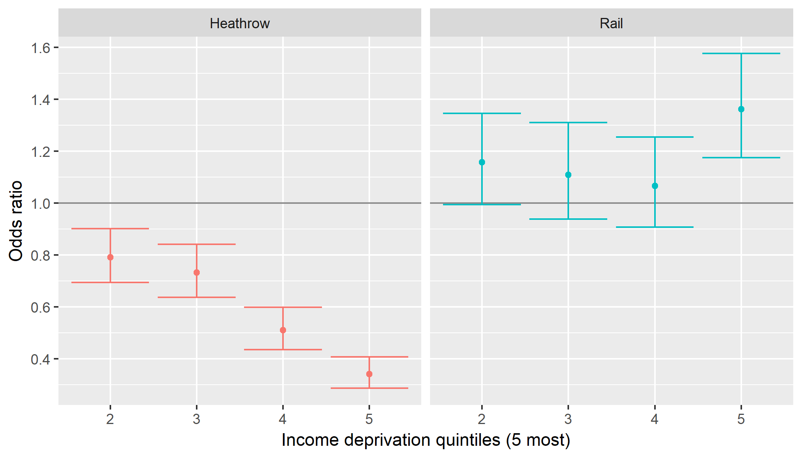
(c)
Figure 4. Exposure odds ratios (95% CI) to Heathrow airport and rail noise at residence according to (a) household income (reference: < 10,000 £) (b) ethnicity (reference: White) and (c) area-level income deprivation (reference: Quintile 1).

Discussion
Using a large dataset including individual-level data on household income and ethnicity, we observed a complex pattern of socioeconomic and ethnic inequalities in exposure to transport-related air and noise pollution in a large European city. In relation to our first objective, we observed inverse patterns in inequalities in air pollution when estimated at residence versus personal exposure. Compared to the lowest household income group, the highest household income group had consistently lower residential NO₂; however, most (from 0.25 quantile) participants in the highest household income group had higher personal NO₂ exposure. Air pollution exposure at residence consistently overestimated personal exposure with clear differences according to age, household income, and area-level income deprivation. These variables are often predictive of health status, which may lead to bias from differential exposure misclassification in epidemiological studies. In relation to our second objective, we observed socioeconomic and ethnic differences in the likelihood of exposure to aircraft and rail noise. Participants in the highest household income, white ethnicity, and lowest income deprivation groups were most likely to be exposed to aircraft noise from Heathrow airport, while participants in the group with the most area-level income deprivation were most likely to be exposed to rail noise. Socioeconomic and ethnic inequalities in road traffic noise were less pronounced.
We observed the highest personal air pollution exposure among participants with high household income, which was largely driven by differences in trip mode and duration by income level. Within the LTDS, increasing household income was associated with increasing number of trips per day and travel mode dominated by car, rail, and underground compared to bus and walking.(Transport for London, 2015) Car trips travelled the longest distances of all modes, and along with bus travel, had the longest travel times.(Transport for London, 2015) Similarly, the number of trips was highest for working age adults (25-59 years) and lowest for adults ≥65 years.(Transport for London, 2015) This is supported by our adjusted results (S-Figure 4), in which differences in personal exposure according to household income were minimal after adjusting for trip mode and duration.
Differences in PM_{2.5} exposure on the scale of the socioeconomic inequalities observed here (up to 3 µg/m³) have been associated with a range of adverse health outcomes in the London population, suggesting that the observed exposure inequalities could contribute to health inequalities. For example, a 1.1 µg/m³ difference in PM_{2.5} estimated using a similar model as the model used to generate the residential exposures in our study was associated with a decline in some measures of cognitive function in older adults.(Tonne et al., 2014) Similarly, a 2.2 µg/m³ difference in PM_{2.5} (from a similar exposure model) was associated with increased odds of low birth weight.(Smith et al., 2017) Long-term exposure to NO₂ has been linked to respiratory morbidity and mortality;(Health Canada, 2016; Faustini et al., 2014) although the expected health impacts from exposure differences on the scale observed in our study (up to 2 µg/m³) are likely to be fairly small. A previous small-area study reported significant associations between aircraft noise from Heathrow and cardiovascular hospital admissions for exposures above 60dB compared to those below 50dB (Hansell et al., 2013); however, direct comparisons with our observed differences based on a binary exposure indicator are difficult.
Few previous studies of socioeconomic inequalities in air pollution exposure have focused on personal (modeled or measured) exposure. A recent study in London comparing measured air pollution in twelve typical commutes with origins with different area-level income deprivation and a single central London destination did not observe systematic differences in measured air pollution by deprivation.(Rivas et al., 2017) The highest particle exposures were observed for the commute originating in an area with high income deprivation; however, similar to our results (Table 1), the relationship between particle exposure and area-level income deprivation was not monotonic. Transport mode had a large impact on measured air pollution, with the highest levels of black carbon (BC) and PM of various size fractions (< 0.1 µm, 1 µm, 2.5 µm, 10 µm) measured during trips taken by underground and bus. Our results are broadly consistent with a modeling study based on a population in Flanders, Belgium that modeled personal exposure to BC according to household income.(Dons et al., 2014) The personal BC model took into account time-activity patterns, high spatial and temporal resolution ambient concentrations, in-traffic exposures during trips, and time spent indoors. BC exposure was higher at residence for individuals with lower household income, but higher household income individuals had more trips that were predominantly by car in traffic peak hours, and therefore had higher exposures while travelling.(Dons et al., 2014)
The direction of inequalities in noise exposures in our study was highly dependent on the sociodemographic indicator and noise source. There was an indication that road traffic noise was lowest among participants with highest household income and lowest area income deprivation, but confidence intervals were often wide. However, there was a clearer indication that Asian participants had higher road traffic noise exposures compared to whites, likely because they live closer to high traffic roads. On the other hand, white individuals, those with high household income, and living in low income deprivation areas were more likely to be exposed to aircraft noise from Heathrow, while individuals in high income deprivation areas were more likely exposure to rail noise.
Other studies have similarly found sensitivity in the direction and magnitude of inequalities to noise according to indicator of socioeconomic position and noise source. A survey of German adults (n=7100) found higher frequency of self-reported road traffic and neighborhood noise annoyance among individuals with lower disposable income, although, associations were sensitive to specific indicators of social status.(Laußmann et al., 2013) Only a weak association was observed between income and aircraft noise. A non-linear association between census block level deprivation index and road traffic noise was associated with the highest exposures in an intermediate deprivation group in Marseille, France.(Bocquier et al., 2013) In Montreal, Canada, environmental noise (largely from transportation and industry) was correlated (Pearson) with area-level deprivation for a range of deprivation metrics.(Dale et al., 2015) In contrast, a study of road traffic noise in the city of Paris observed people living in socially advantaged neighborhoods in terms of education, dwelling value, and country of citizenship were exposed to higher noise compared to more deprived counterparts.(Havard et al., 2011) Results showed sensitivity to the definition of non-French citizenship: more refined analyses taking into account the level of development of the country of citizenship showed higher noise levels among people living in neighborhoods with a higher proportion of citizens from advantaged countries.(Havard et al., 2011)
Socioeconomic inequalities in air pollution have been found to be sensitive to analytical methods and the use of individual versus area-level socioeconomic data.(Hajat et al., 2015) Our analysis also highlights other factors to which results are sensitive. We observed different results when considering inequalities based on residential versus personal air pollution exposure. We also observed that socioeconomic and ethnic inequalities are often not uniform across the exposure distribution. Our analysis shows the value of quantile regression, frequently used in economic analyses of inequality but, to our knowledge, not previously applied to inequalities in environmental exposures.(Martins and Pereira, 2004) Analyses based on traditional regression methods modeling only the mean would not have captured the full extent of exposure inequalities in our data. Our data indicate inequalities in personal air pollution according to household income at high, but not low exposures. Similarly, differences in residential NO₂ according to area-level income deprivation are greatest at the lowest exposures, but disappear at the highest exposures. This pattern is consistent with our previous research in London, indicating different correlations between air pollution and area-level income deprivation across the air pollution exposure range: correlations between exhaust-related primary PM_{2.5} and deprivation were 0.16, 0.24, 0.12 and −0.17 according to increasing exposure category. (Halonen et al., 2016)
While using personal rather than outdoor residential air pollution is attractive due to reduced exposure misclassification, there may be a trade-off with more potential for residual confounding in epidemiological studies.(Weisskopf and Webster, 2017) Our data are consistent with the causal model proposed by Weisskopf and Webster (S-Figure 6), which identifies the potential for confounding by factors associated with both residential and personal air pollution. Residential air pollution was associated with area-level deprivation; however, the extent of confounding by area-level deprivation will also depend on the strength of association between deprivation and health, conditional on other covariates. Personal exposure was influenced by personal behaviors in our data, namely travel mode and duration, as well as age. Participants with active travel modes had lower personal exposure,(Smith et al., 2016) and active travel has been associated with a number of health benefits,(Celis-Morales et al., 2017) indicating that travel mode could be an important confounder of associations based on personal exposure. Our data do not suggest that household income would be a strong confounder of associations between personal PM_{2.5} and health outcomes, although confounding is somewhat more likely with personal NO₂. Although the quantile regression results indicate stronger associations between household income and personal exposure at high exposures, epidemiological estimates are typically based on mean exposure and would be less affected. For example, mean personal PM_{2.5} corresponds roughly with the 70th percentile of the exposure distribution (60th percentile for personal NO₂) where differences according to household income are small (Figure 2), particularly after adjusting for other covariates (S-Figure 4).
The main strengths of our analysis are the large dataset including information on household income, individual-level ethnicity, and travel behavior from a representative sample of the London population. These data are combined with estimates of personal exposure, which take into account travel behavior and penetration of outdoor air pollution indoors at locations between trips. In addition, we used data on residential noise exposure to multiple transport sources, contributing to the currently small literature on noise inequalities. Our analysis uses quantile regression, which is well suited for, but not widely used in research of environmental inequalities.
A limitation of our analysis is that the residential, personal air pollution and road traffic noise data were based on models rather than direct measurements. While models allowed us to estimate exposures for a large sample, comparisons between residential and personal air pollution may be affected by differences in the models’ performance. Sensitivity of the model of personal exposure has been evaluated by Smith and colleagues: model estimates were most sensitive to the parameterization of penetration of outdoor air indoors.(Smith et al., 2016) Notably, the model did not account for occupational exposures or indoor sources, which may be higher for individuals with lower socioeconomic position.(Jantunen et al., 2000) Evaluation of the model for road traffic noise against measurements is reported by Gulliver and colleagues.(Gulliver et al., 2015) The relatively small inequalities in road traffic noise we observed are within the range of model error and should be interpreted with caution. We did not account for spatial autocorrelation in residential air pollution (no autocorrelation was present for other exposures), which may have led to artificially small standard errors in the regression estimates. We explored methods that take into account the spatial structure of the data in the context of quantile regression (e.g. adjusting for spatial units with fixed or random effects, or spatial smooth effects). While these methods addressed the spatial autocorrelation, they explained much of the variability of the response variable and shrunk the inequality effects, which are also clustered in space. We therefore report non-spatially adjusted results given that our focus was not on hypothesis testing. Also, we combined data from a number of sources, resulting in some temporal mismatch in the data (S-Table 1). This is most relevant for the aircraft noise from Heathrow airport, which was from year 2001. The inequalities observed with respect to Heathrow airport, a single source, are likely specific to the particular geography of London. However, we observed complex patterns in inequalities that varied by air pollution exposure estimation method and noise transport source; the presence of complexity and need for analytical methods to more fully characterize this complexity is likely to be widely generalizable across cities.
In conclusion, all transport sources were associated with some form of exposure inequalities, although the patterns were complex and the direction of inequalities was not consistent across exposure metrics. Analysis based on individual-level socioeconomic data and personal exposure provide a more accurate picture of which groups of individuals are most exposed, which can be notably different than the picture based on more aggregated data. Finally, quantile regression, a common tool in economic analysis of inequalities, is a useful approach for more fully characterizing environmental exposure inequalities across the full range of exposures. Socioeconomic and ethnic inequalities in integrated measures of multiple environmental stressors warrant further investigation.
References
Bates D, Mächler M, Bolker B, Walker S 2015. Fitting linear mixed-effect models using lme4. J Stat Software. 67(1).doi: 10.18637/jss.v067.i01
Beevers SD, Kitwiroon N, Williams ML, Carslaw DC, 2012. One way coupling of CMAQ and a road source dispersion model for fine scale air pollution predictions. Atmos. Environ. 59, 47–58. doi:10.1016/j.atmosenv.2012.05.034
Bocquier A, Cortaredona S, Boutin C, David A, Bigot A, Chaix B., et al. 2013. Small-area analysis of social inequalities in residential exposure to road traffic noise in Marseilles, France. Eur. J. Public Health 23, 540–546. doi:10.1093/eurpub/cks059
Casey JA, Morello-Frosch R, Mennitt DJ, Fristrup K, Ogburn EL, James P. 2017. Race/Ethnicity, Socioeconomic
Status, Residential Segregation, and Spatial Variation in Noise Exposure in the Contiguous United States.
Environ. Health Perspect. 125:77017; doi:10.1289/EHP898.
Celis-Morales CA, Lyall DM, Welsh P, Anderson J, Steell L, Guo Y, et al. 2017. Association between active
commuting and incident cardiovascular disease, cancer, and mortality: prospective cohort study. BMJ 357.
doi:10.1136/bmj.j1456
Communities and Local Governments, 2011. The English Indices of Deprivation 2010
https://www.gov.uk/government/uploads/system/uploads/attachment_data/file/6871/1871208.pdf
Dale LM, Goudreau S, Perron S, Ragettli MS, Hatzopoulou M, Smargiassi A. 2015. Socioeconomic status and environmental noise exposure in Montreal, Canada. BMC Public Health 15, 205. doi:10.1186/s12889-015-1571-2
Dons E, Kochan B, Bellemans T, Wets G, Panis LI. 2014. Modeling Personal Exposure to Air Pollution with AB2C: Environmental Inequality. Procedia Comput. Sci. 32, 269–276. doi:http://dx.doi.org/10.1016/j.procs.2014.05.424
European Commission, 2016. In-Depth Report 13: Links between noise and air pollution and socioeconomic status. http://ec.europa.eu/environment/integration/research/newsalert/pdf/air_noise_pollution_socioeconomic_status_links_IR13_en.pdf
Faustini, A., Rapp, R., Forastiere, F., 2014. Nitrogen dioxide and mortality: review and meta-analysis of long-
term studies. Eur. Respir. J. 44, 744–753. doi:10.1183/09031936.00114713
Fecht D, Fischer P, Fortunato L, Hoek G, de Hoogh K, Marra M, et al. 2015. Associations between air pollution and socioeconomic characteristics, ethnicity and age profile of neighborhoods in England and the Netherlands. Environ. Pollut. 198, 201–210. doi:10.1016/j.envpol.2014.12.014
Goodman A, Wilkinson P, Stafford M, Tonne, C. 2011. Characterising socio-economic inequalities in exposure to air pollution: a comparison of socio-economic markers and scales of measurement. Heal. Place 17, 767–74. doi:10.1016/j.healthplace.2011.02.002
Gulliver J, Morley D, Vienneau D, Fabbri F, Bell M, Goodman P, et al. 2015. Development of an open-source road traffic noise model for exposure assessment. Environ. Model. Softw. 44. doi:10.1016/j.envsoft.2014.12.022
Hajat A, Hsia C, O’Neill M.S., 2015. Socioeconomic Disparities and Air Pollution Exposure: a Global Review. Curr. Environ. Heal. Reports 2, 440–450. doi:10.1007/s40572-015-0069-5
Halonen JI, Blangiardo M, Toledano MB, Fecht D, Gulliver J, Ghosh, R, et al. 2016. Is long-term exposure to traffic pollution associated with mortality? A small-area study in London. Environ. Pollut. 208, Part, 25–32. doi:http://doi.org/10.1016/j.envpol.2015.06.036
Halonen JI, Hansell AL, Gulliver J, Morley D, Blangiardo, M, Fecht, et al. 2015. Road traffic noise is associated with increased cardiovascular morbidity and mortality and all-cause mortality in London. Eur. Heart J. 36, 2653–61. doi:10.1093/eurheartj/ehv216
Hansell, A.L., Blangiardo, M., Fortunato, L., Floud, S., de Hoogh, K., Fecht, D., et al. 2013. Aircraft noise and
cardiovascular disease near Heathrow airport in London: small area study. BMJ 347. doi:10.1136/bmj.f5432
Havard S, Deguen S, Zmirou-Navier, D., Schillinger, C., Bard, D., 2009. Traffic-related air pollution and socioeconomic status: a spatial autocorrelation study to assess environmental equity on a small-area scale. Epidemiology 20, 223–30. doi:10.1097/EDE.0b013e31819464e1
Havard S, Reich BJ, Bean K, Chaix B. 2011. Social inequalities in residential exposure to road traffic noise: an environmental justice analysis based on the RECORD cohort study. Occup Env Med 68. doi:10.1136/oem.2010.060640
Health Canada. 2016. Human Health Risk Assessment for Ambient Nitrogen Dioxide.
http://publications.gc.ca/collections/collection_2016/sc-hc/H114-31-2016-eng.pdf
Health Effects Institute, 2009. Traffic-Related Air Pollution: a critical review of the literature on emissions, exposures, and health effects, Health (San Francisco). Boston, MA.
Huss A, Spoerri A, Egger M, Roosli M, 2010. Aircraft noise, air pollution, and mortality from myocardial infarction. Epidemiology 21, 829–836. doi:10.1097/EDE.0b013e3181f4e634
Jantunen M, Rotko T, Koistinen K, Ha O, 2000. Sociodemographic descriptors of personal exposure to fine particles. J Expo Anal Environ Epidemiol. 385–393.
Koenker, R., 2016. quantreg: Quantile Regression. https://cran.r-project.org/web/packages/quantreg/index.html
Koenker, R., 2005. Quantile regression. Cambridge University Press.
Laußmann, D, Haftenberger M, Lampert T, Scheidt-Nave C, 2013. Soziale Ungleichheit von Lärmbelästigung und Straßenverkehrsbelastung. Bundesgesundheitsblatt - Gesundheitsforsch. - Gesundheitsschutz 56, 822–831. doi:10.1007/s00103-013-1668-7
Martins PS, Pereira PT. 2004. Does education reduce wage inequality? Quantile regression evidence from 16 countries. Labour Econ. 11, 355–371.
Nega, TH, Chihara L, Smith K, Jayaraman M, 2013. Traffic noise and inequality in the twin cities, Minnesota. Hum. Ecol. Risk Assess. An Int J 19. doi:10.1080/10807039.2012.691409
Pelletier A, Ribeiro C, Mietlicki F, Kauffmann A, Lalloué B, Isnard H, et al. 2013. Environmental pollution (air, noise) exposure and social deprivation around the major Ile-de-France airport. InterNoise Conference Paper. http://www.noiseineu.eu/%27%27/3026-a/homeindex/file?objectid=2790&objecttypeid=0
R Core Team, 2016. R: A Language and Environment for Statistical Computing.
Rivas I, Kumar P, Hagen-Zanker A, 2017. Exposure to air pollutants during commuting in London: Are there inequalities among different socio-economic groups? Environ. Int. doi:http://dx.doi.org/10.1016/j.envint.2017.01.019
Rotko T, Kousa A, Alm S, Jantunen M. 2001. Exposures to nitrogen dioxide in EXPOLIS-Helsinki: microenvironment, behavioral and sociodemographic factors. J Expo Anal Env. Epidemiol 11, 216–223.
Shiels MS, Chernyavskiy P, Anderson WF, Best AF, Haozous EA, Hartge P, et al. 2017. Trends in premature mortality in the USA by sex, race, and ethnicity from 1999 to 2014: an analysis of death certificate data. Lancet 389, 1043–1054. doi:10.1016/S0140-6736(17)30187-3
Smith JD, Mitsakou C, Kitwiroon N, Barratt BM, Walton HA, Taylor JG, et al. 2016. London Hybrid Exposure Model: Improving Human Exposure Estimates to NO2 and PM2.5 in an Urban Setting. Environ. Sci. Technol. 50, 11760–11768. doi:10.1021/acs.est.6b01817
Smith, RB, Fecht, D, Gulliver, J, Beevers, SD, Dajnak, D, Blangiardo, M, et al. 2017. Impact of London’s
road traffic air and noise pollution on birth weight: retrospective population based cohort study. BMJ 359.
doi:10.1136/bmj.j5299
Stringhini, S., Carmeli, C., Jokela, M., Avendaño, M., Muennig, P., Guida, F., et al. Socioeconomic status and the 25x25 risk factors as determinants of premature mortality: a multicohort study and meta-analysis of 1.7 million men and women. Lancet 389, 1229–1237. doi:10.1016/S0140-6736(16)32380-7
Taylor J, Shrubsole C, Davies M, Biddulph P, Das P, Hamilton I, et al. 2014. The modifying effect of the building envelope on population exposure to PM2.5 from outdoor sources. Indoor Air 24, 639–651. doi:10.1111/ina.12116
Temam, S., Burte, E., Adam, M., Antó, J.M., Basagaña, X., Bousquet, J., et al. 2017. Socioeconomic position and outdoor nitrogen dioxide (NO2) exposure in Western Europe: A multi-city analysis. Environ. Int. 101, 117–124. doi:http://dx.doi.org/10.1016/j.envint.2016.12.026
Tonne, C., Elbaz, A., Beevers, S., Singh-Manoux, A., 2014. Traffic-related air pollution in relation to cognitive function in older adults. Epidemiology 25(5): 674-81.
Transport for London. 2015. London Travel Demand Survey. http://content.tfl.gov.uk/london-travel-demand-survey-report.pdf
Weisskopf MG, Webster TF. 2017. Trade-offs of personal vs. more proxy exposure measures in environmental epidemiology. Epidemiology. doi:DOI: 10.1097/EDE.0000000000000686
WHO Europe, 2011. Burden of disease from environmental noise. http://www.euro.who.int/__data/assets/pdf_file/0008/136466/e94888.pdf
Wickham, H., 2016. tidyverse: Easily Install and Load “Tidyverse” Packages. https://cran.r-project.org/web/packages/tidyverse/index.html

Supplementary information
S-Table 1. Summary of spatial resolution and time period covered by data sources
Data | Source/Model | Resolution | Date
Age, sex, trips, travel model, trip duration, household income, ethnicity | London Travel Demand Survey from Transport for London; https://tfl.gov.uk/corporate/publications-and-reports/london-travel-demand-survey | Residential postcode centroid (in England on average 12 households per postcode) | 2006-2010
Personal PM_{2.5}, NO₂ exposure | London Hybrid Exposure Model (Smith et al., 2016) | Residential postcode centroid | Annual average 2011
Outdoor PM_{2.5}, NO₂ exposure | CMAQ-Urban (Beevers et al., 2012) | 20m x 20m surface linked to residential postcode centroid | 2011
Road traffic noise | TRAffic Noise EXposure model (TRANEX) (Gulliver et al., 2015) | Residential postcode centroid | Annual average 2003-2010
Rail noise (binary indicator of location within 50dB L_{DAY} noise contour) | UK Department for Environment, Food and Rural Affairs; Environmental Noise Directive – Noise Mapping | Residential postcode centroid | Annual average 2006
Aircraft noise from Heathrow airport (binary indicator of location within 50dB L_{DAY} noise contour) | Civil Aviation Authoritiy; UK civil aircraft noise contour model (ANCON) | Residential postcode centroid | Annual average 2001
Neighbourhood-level income deprivation | 2010 Index of Multiple Deprivation – Income Domain(ref) | Lower Layer Super Output Areas (LSOAs): on average 1500 residents | 2008

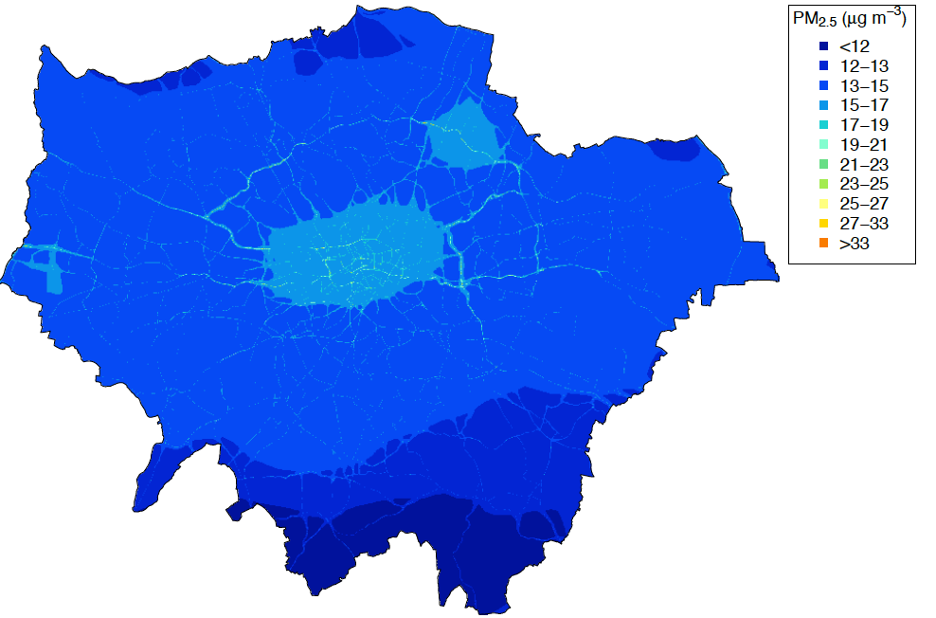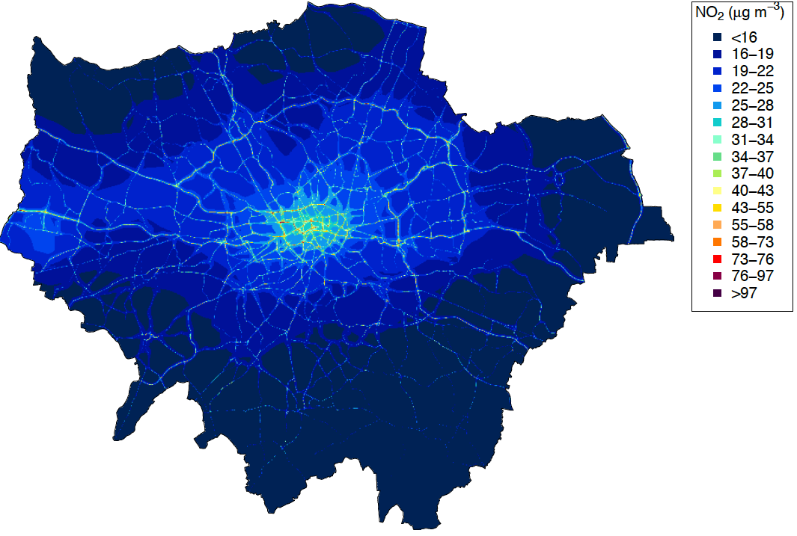

S-Figure 1. PM_{2.5} and NO₂ concentrations (interpolated from 20x20m grid) used to estimated residential exposures

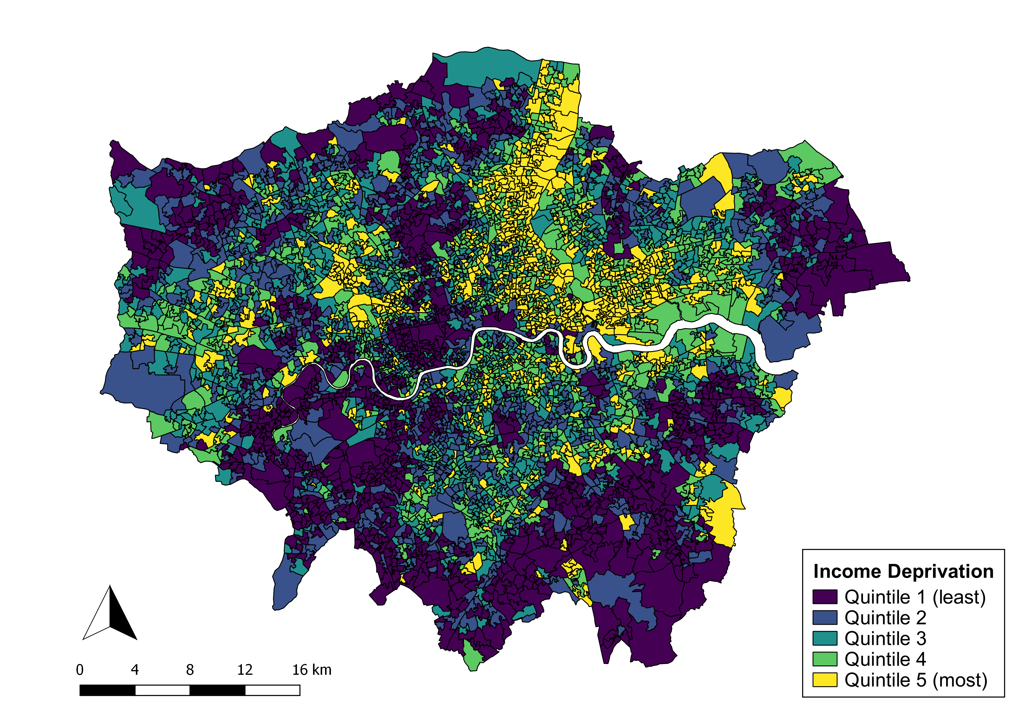
S-Figure 2. Quintiles (based on sample) of Lower Layer Super Output Area level income deprivation (2010)

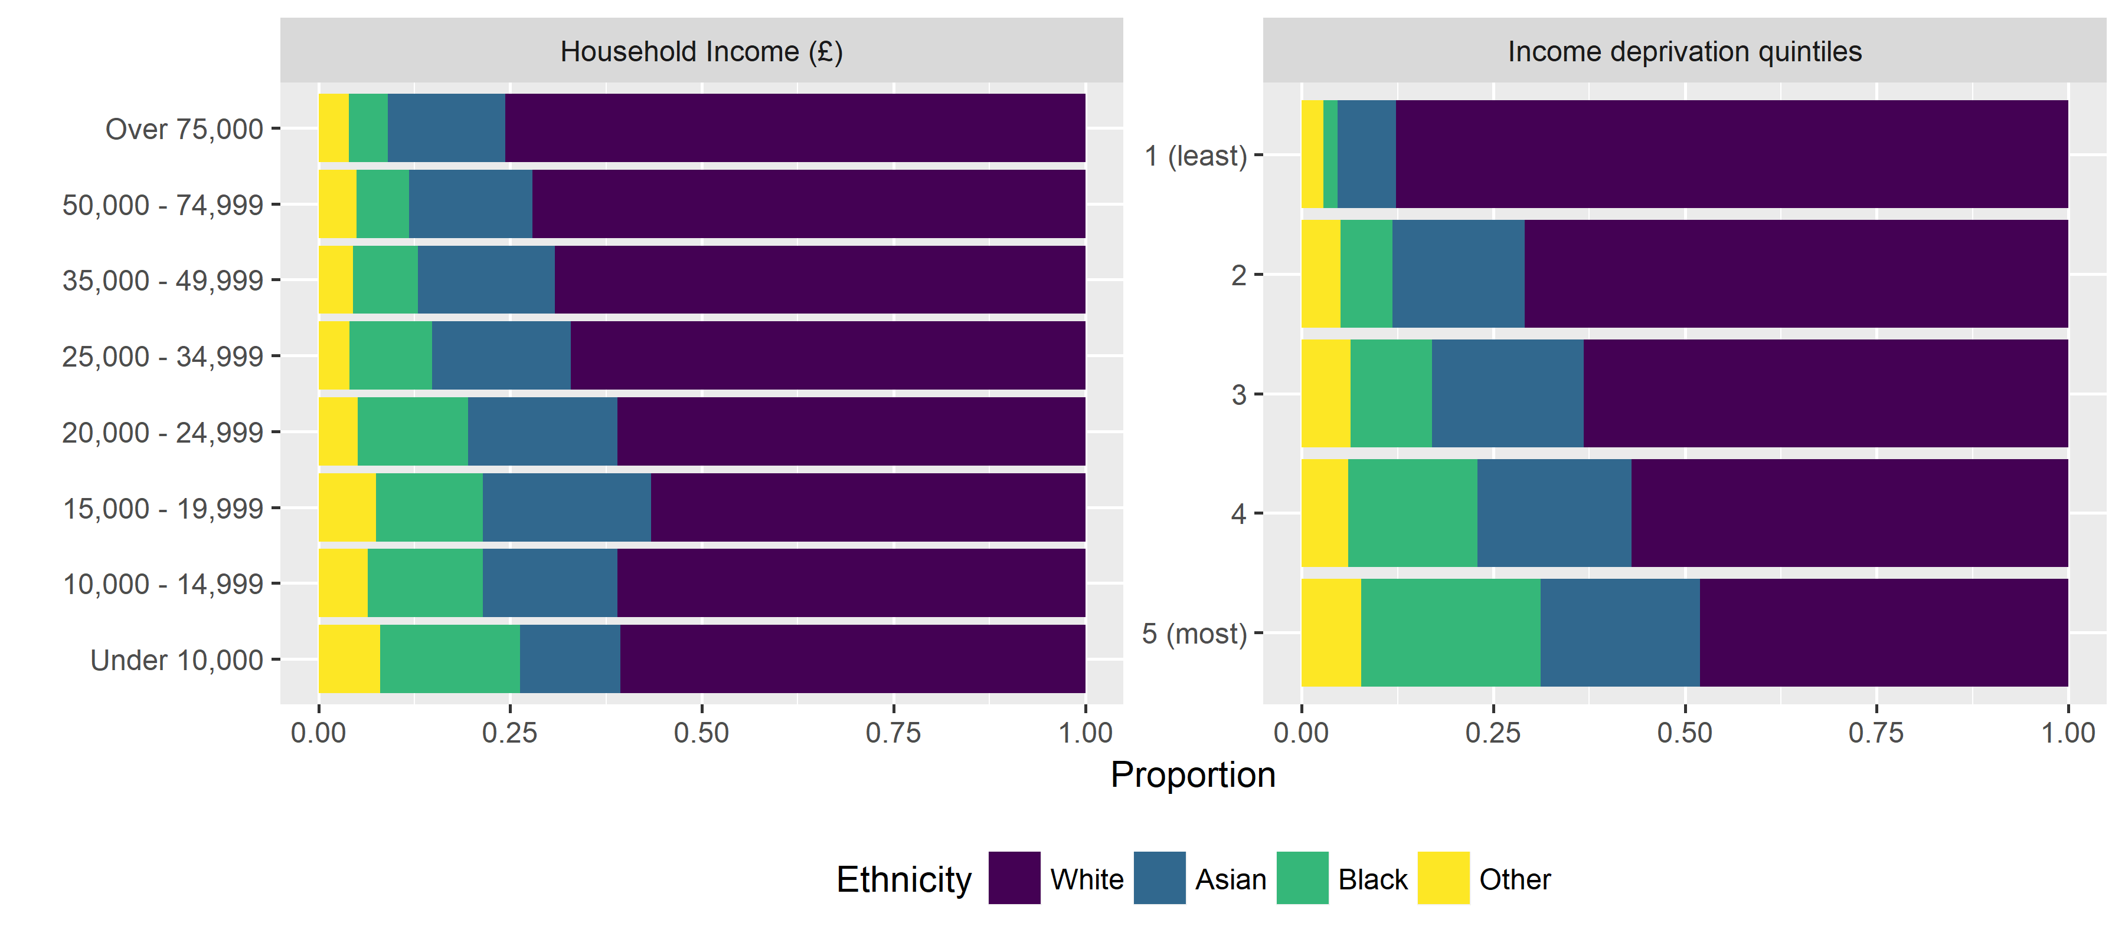S-Figure 3. Proportion of ethnicity of participants according to household income and area-level income deprivation

S-Table 2. Summary statistics for air pollution exposures and road traffic noise
Model | n | mean | sd | min | Q1 | median | Q3 | max
Residential PM_{2.5} | 45,079 | 13.5 | 0.8 | 11.2 | 13.0 | 13.6 | 14.2 | 20.0
Personal PM_{2.5} | 45,079 | 8.5 | 1.4 | 6.0 | 7.8 | 8.2 | 8.7 | 32.2
Residential NO₂ | 45,079 | 34.3 | 5.8 | 17.8 | 30.7 | 34.5 | 38.3 | 88.1
Personal NO₂ | 45,079 | 12.9 | 3.3 | 4.3 | 10.8 | 12.3 | 14.5 | 55.3
Noise L_{Aeq},_{24hr} | 44,974 | 55.9 | 4.7 | 52.9 | 53.2 | 53.6 | 55.6 | 78.9

S-Table 3. Median air and noise pollution by household income, ethnicity and area-level income deprivation
Medians | N | Residential  PM_{2.5} (µg/m³) | Personal  PM_{2.5} (µg/m³) | Residential  NO₂ (µg/m³) | Personal  NO₂ (µg/m³) | Residential road traffic noise  (L_{Aeq},_{24hr} dB)
Income (£)
Under 10000 | 8,327 | 13.73 | 8.18 | 35.30 | 12.10 | 53.63
10000 - 14999 | 4,762 | 13.66 | 8.20 | 34.77 | 12.18 | 53.58
15000 - 19999 | 4,318 | 13.67 | 8.21 | 34.91 | 12.32 | 53.58
20000 - 24999 | 3,883 | 13.59 | 8.22 | 34.24 | 12.37 | 53.51
25000 - 34999 | 5,760 | 13.59 | 8.23 | 34.19 | 12.34 | 53.53
35000 - 49999 | 6,464 | 13.56 | 8.25 | 33.89 | 12.42 | 53.55
50000 - 74999 | 5,573 | 13.56 | 8.26 | 33.76 | 12.64 | 53.51
Over 75000 | 5,992 | 13.61 | 8.27 | 34.58 | 12.60 | 53.50
Ethnicity
White | 29,479 | 13.56 | 8.20 | 33.91 | 12.24 | 53.52
Asian | 7,592 | 13.72 | 8.29 | 35.00 | 12.46 | 53.64
Black | 5,214 | 13.73 | 8.22 | 35.62 | 12.54 | 53.56
Other | 2,516 | 13.82 | 8.29 | 35.66 | 12.56 | 53.62
Income deprivation quintiles
1 (least deprived) | 9,782 | 13.40 | 8.12 | 32.00 | 11.78 | 53.41
2 | 8,737 | 13.56 | 8.20 | 33.53 | 12.22 | 53.53
3 | 8,146 | 13.64 | 8.24 | 34.47 | 12.37 | 53.56
4 | 9,118 | 13.71 | 8.27 | 35.27 | 12.49 | 53.65
5 (most deprived) | 8,128 | 13.89 | 8.30 | 36.63 | 12.69 | 53.61

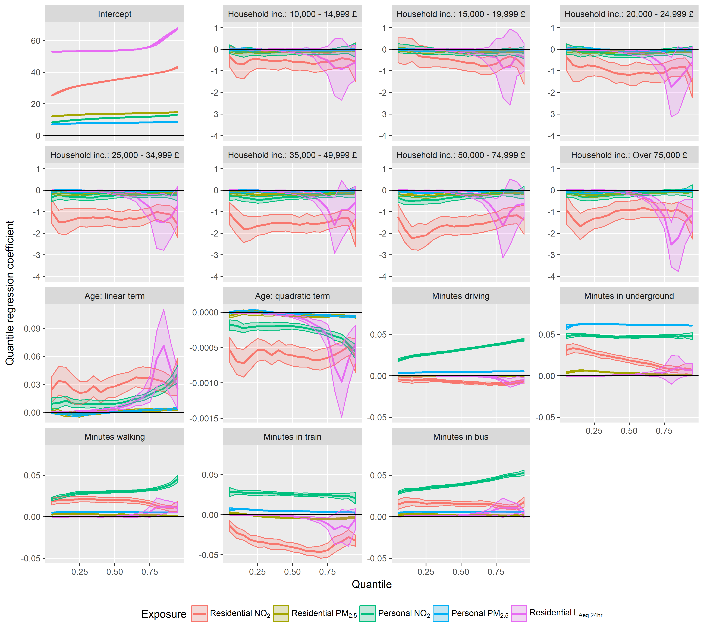
S-Figure 4. Quantile regression coefficients and 95% confidence intervals for residential and personal air pollution and residential road traffic noise according to household income. Each exposure fit separately to a model including household income, travel duration by mode, and age simultaneously.

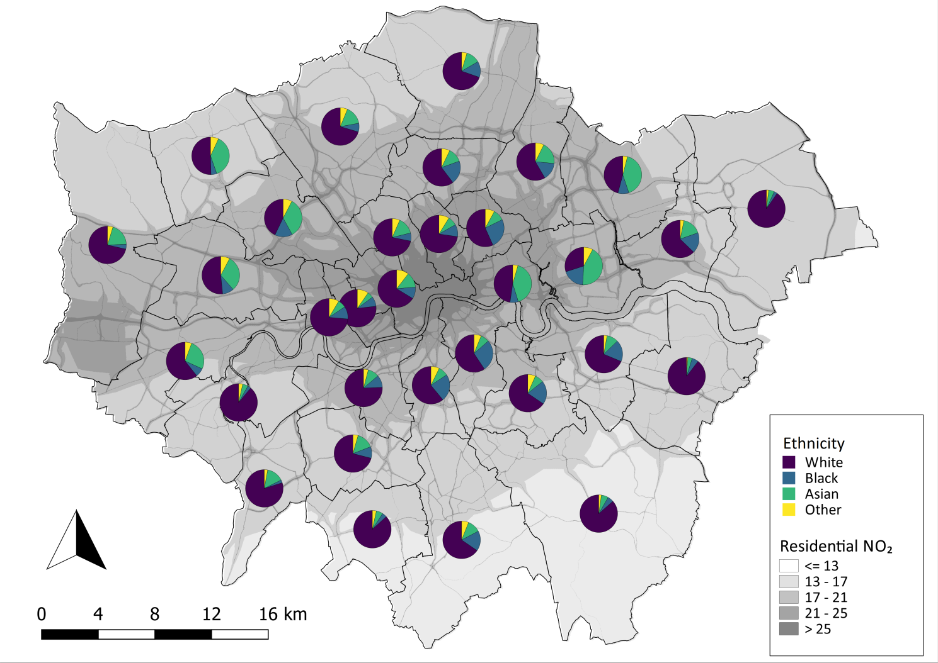
S-Figure 5. Residential NO₂ concentrations overlaid with ethnicity of participants within each borough

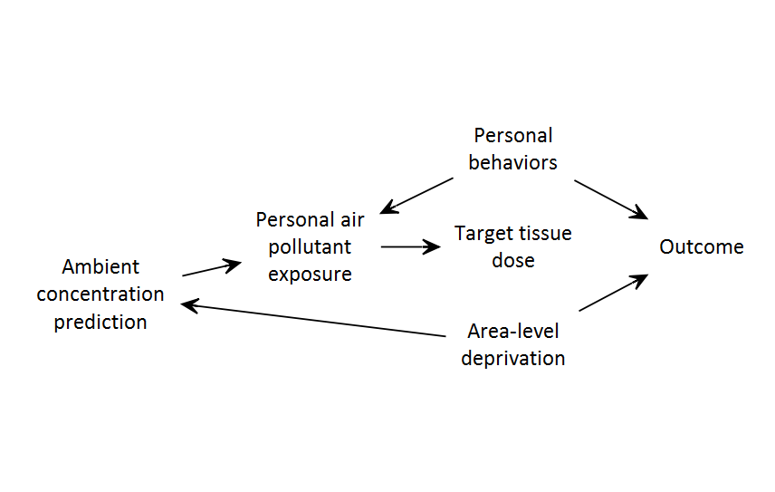
S-Figure 6. Causal diagram illustrating confounding of ambient and personal exposure to air pollution in relation to a health outcome (adapted from Weisskopf and Webster)(Weisskopf and Webster, 2017).

