Primary Tumors of the Aorta and Pulmonary Arteries: Insights from Cardiovascular Magnetic Resonance

Monika Arzanauskaite MD^{1,3}, Vassilios S Vassiliou MD, PhD^{1,4}, Jan Lukas Robertus MD, PhD², Raad Hashem Mohiaddin MD, PhD¹
¹Cardiovascular Magnetic Resonance Unit, Royal Brompton Hospital, London
²Department of Histopathology, Royal Brompton Hospital, London
³ Radiology and Imaging Department, Liverpool Heart and Chest Hospital, Liverpool
⁴ Norwich Medical School, University of East Anglia, Norwich

Address for correspondence
Professor Raad H Mohiaddin
Cardiovascular Magnetic Resonance Unit, Royal Brompton Hospital
Sydney Street
London, United Kingdom
SW3 6NP
Email: R.Mohiaddin@rbht.nhs.uk
Tel: +442073518800 Fax: +44202073518816

Introduction
As the access to advanced cardiac imaging grows, primary cardiovascular tumors are increasingly encountered despite being very rare (1). Primary tumors of the aorta and pulmonary arteries have non-specific clinical manifestations which often lead to a late diagnosis. These tumors are most commonly mesenchymal – with various types of sarcomas most frequently seen (2). Primary great artery sarcomas are rare and have been reported arising most frequently from the pulmonary artery trunk (2). Vascular location of a myxoma is extremely rare. Cardiovascular magnetic resonance (CMR) is an advanced imaging modality, which together with an efficient study protocol and expert analysis gives a timely accurate diagnosis or reduces the differential diagnosis entities. We reviewed the imaging findings of 10 patients with histologically proven primary tumors of the pulmonary arteries and the aorta who had CMR studies at our institution on a 1.5T Avanto, Siemens, with breath-holding and ECG-triggering technique.

Figure 1, Supplementary Video 1. Aortic myxoma. A 47 year old man presented with acute leg ischemia and was treated by embolectomy. On computed tomography, an aortic dissection and thrombus were suspected. CMR showed a large irregular intraluminal mobile mass arising from the posterior wall of the descending aorta (orange arrows), mildly hyperintense to the skeletal muscle on cine (A, Supplementary Video 1), T1-weighted (B), hyperintense on T2-STIR (C) with significant enhancement in late gadolinium phase (E) compared to the early phase (D). Histology of the viscous material from the embolectomy confirmed this to be a myxoma. Myxoma is the most common primary cardiac tumor, typically seen in the left atrium, attached to the septum. It usually varies in size, has smooth or lobulated contours and is slightly mobile. It does not cross tissue planes; usually, there is no pericardial involvement.
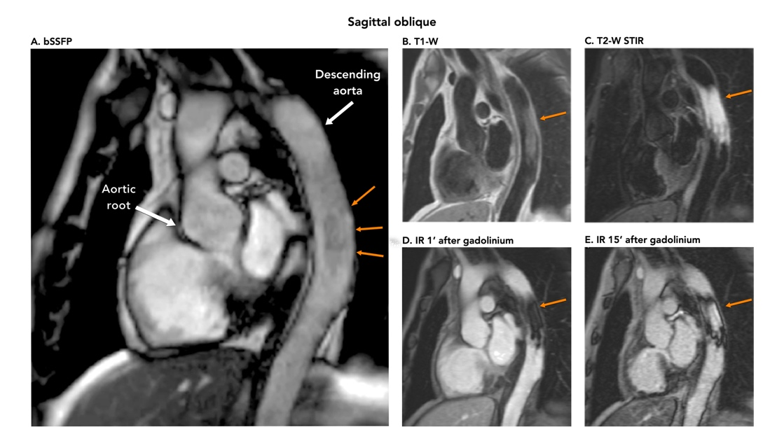
Figure 2. Aortic leyomyosarcoma. A 66 year old man presented with chest pain. In the inferior part of the visceral mediastinal compartment, there was a mass encasing the distal descending aorta (orange arrows). It was mildly heterogeneous on cine (A), T1-weighted (B) and hyperintense on T2-W STIR (C) images. There was some enhancement of the tumor on arterial phase of MR angiography (D), which was more evident on early and late phase gadolinium-enhanced images in the cross-cut plane (E, F). Leiomyosarcoma with spindle and pleomorphic cells, arranged in sheets and fascicles was seen on histology (G). Leiomyosarcoma is a malignant mesenchymal neoplasm containing smooth muscle reminiscent spindle cells and collagenous background; it is most commonly found arising from the uterus or gastrointestinal tract. Vascular leiomyosarcomas are rare and usually affect the inferior vena cava; the aortic location is extremely rare. The tumor is sessile, solid and usually solitary.
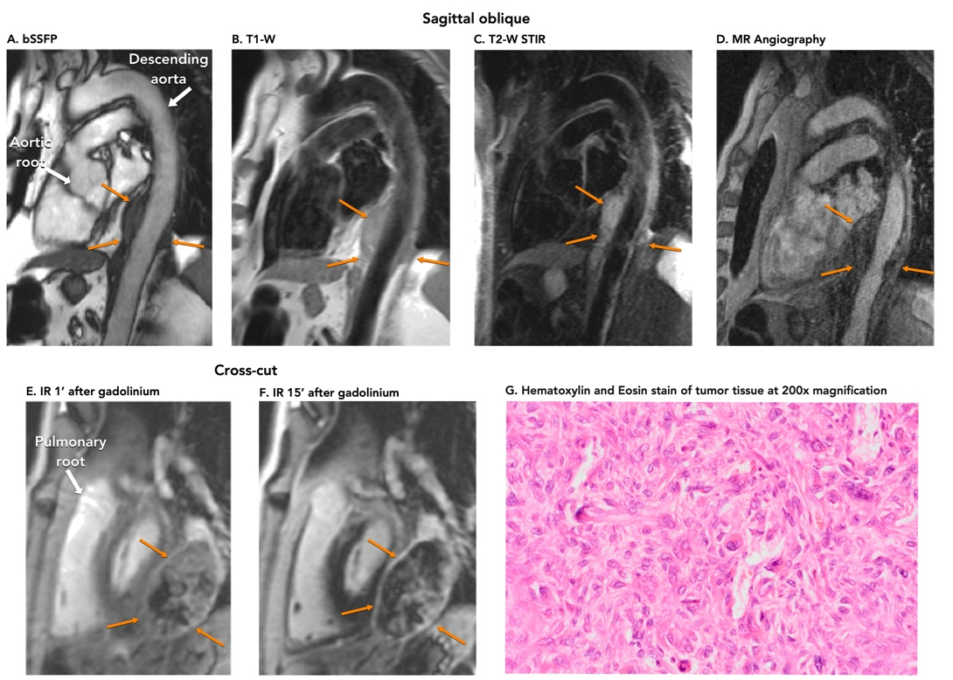

Figure 3. Angiosarcoma of the right pulmonary artery (RPA). A 21 year old man with constriction of RPA seen on CT was referred to CMR. Axial (top panel) and cross-cut (mid panel) planes showed a lesion arising from the inferior and posterior walls of the right pulmonary artery with mildly hyperintense signal on T1-W images (A, D) and high signal on T2-W STIR images (B, E), orange arrows. On the late gadolinium phase (D, F) the lesion showed dense enhancement with an area of hypointense signal, suggestive of a thrombotic/necrotic component. There was segmental occlusion on pulmonary arterial phase of MR angiography (G, blue arrow). On through-plane velocity mapping study, there was flow acceleration in the RPA with peak recorded velocity of 1.6m/s (orange arrows in magnitude and phase images, H-I). Angiosarcoma, the most common primary cardiovascular malignancy, is a high grade sarcoma with prominent neo-vascularization and aggressive spread through tissue planes.
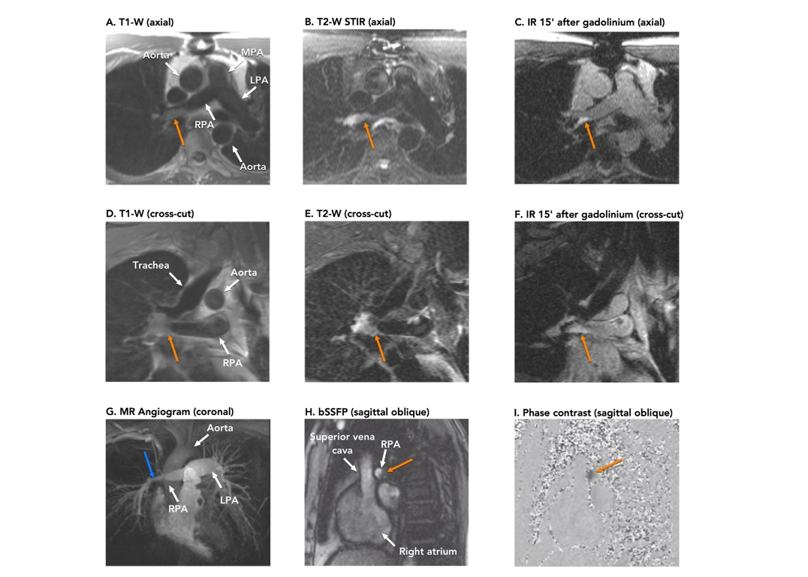
Figure 4. Spindle cell sarcoma of pulmonary arteries. A 70 year old woman with suspected leiomyosarcoma was referred to CMR to assess the extent of the mass. Intraluminal masses (orange arrows) within the MPA, RPA (top panel) and LPA (mid panel) were seen on CMR. The masses were hyperintense on T2 STIR (C, H) images and showed heterogeneous enhancement with areas of low signal intensity, suggesting thrombotic and/or necrotic changes on early (D, I) and late gadolinium phases (E, J). MRA was acquired to assess the anatomy of the affected pulmonary tree (K). On histology, pulmonary artery sarcoma showed spindle cells arranged in short fascicles with strong hyperchromatic and atypical nuclei (K). Spindle cell sarcoma of pulmonary arteries is often referred to as intimal sarcoma and usually has very similar imaging appearances to pleomorphic sarcoma: intraluminal heterogeneous mass spreading along the vessel’s wall with obvious contrast enhancement and necrotic areas.
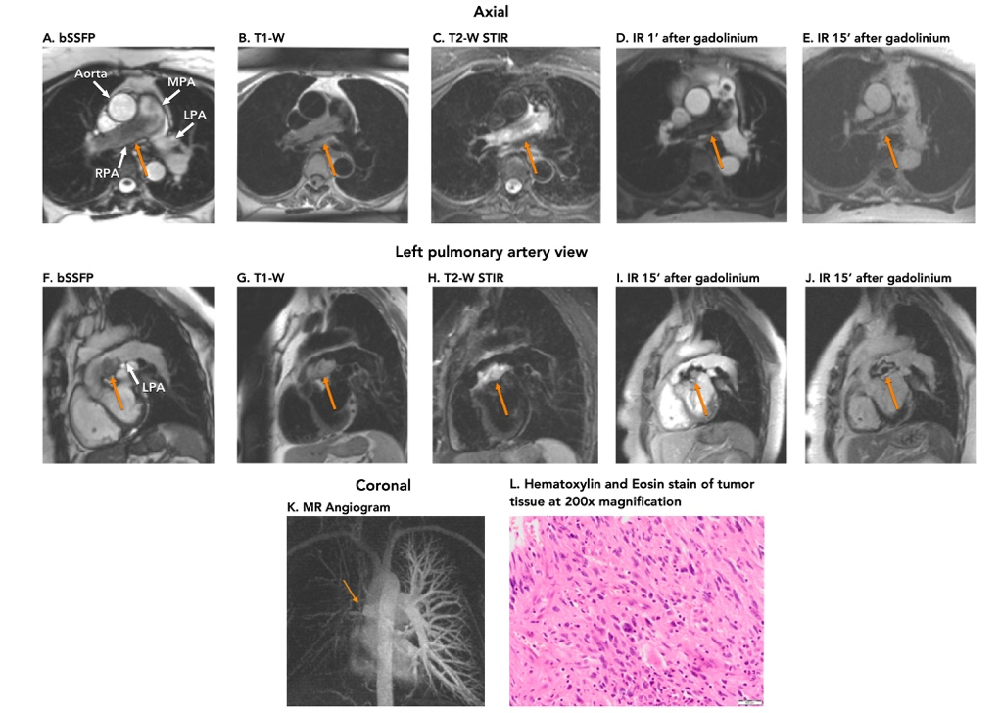
Figure 5. Malignant peripheral nerve sheath tumor (MPNST). A 41 year old man presented with chest pain and breathlessness. A lobulated heterogeneous mass between the aortic root, pulmonary arteries and left atrium (orange arrows) was seen on CMR (axial plane in top panel, vertical long axis plane in bottom panel). It was mildly heterogeneous on T1-weighted and bSSFP images (A, C) and hyperintense as well as heterogeneous on T2-weighted images (B). The enhancement pattern on late phase inversion recovery image (D) indicates a fluid-filled necrotic component. The location suggests it may have originated from the pulmonary plexus. Previously known as malignant schwannoma, neurogenic sarcoma, and neurofibrosarcoma, malignant peripheral nerve sheath tumor is a neoplasm of peripheral neural origin and is often associated with neurofibromatosis type I.
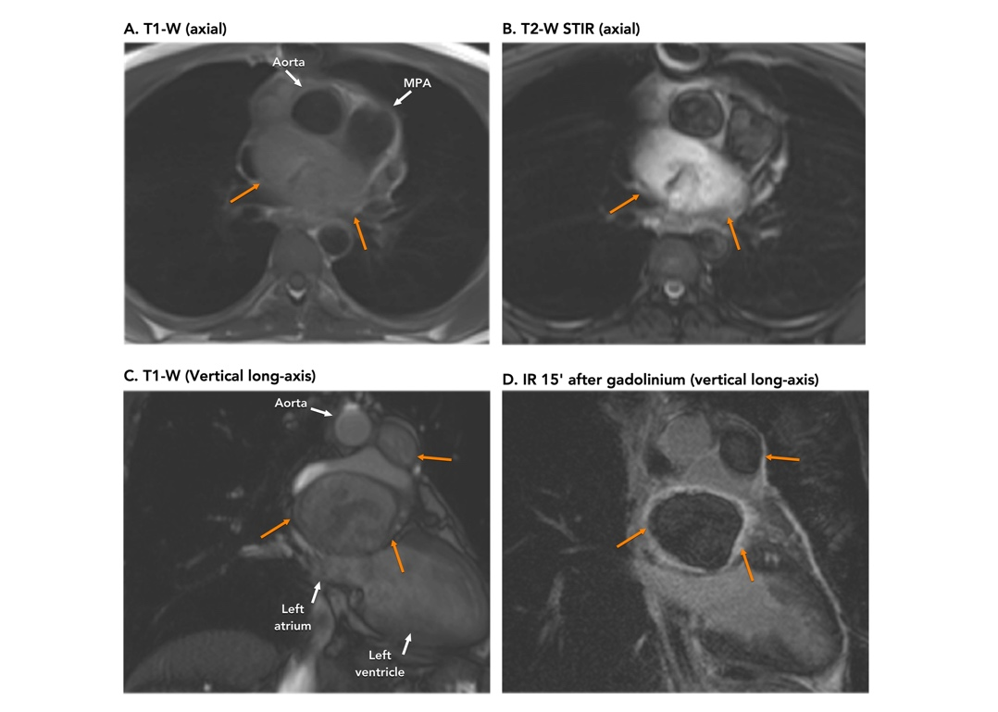

Figure 6. Table with a summary of the histological diagnosis, location of tumor, morphology and CMR tissue characteristics. Both of the two primary aortic tumors were located in the mid-descending aorta. The location of the primary tumors of the pulmonary arteries was variable, nevertheless most of them (5/8) were found in the right pulmonary artery. The majority of the tumors (8/10) had an intraluminal component. All of the tumors had high signal intensity of T2-STIR images and enhanced late after contrast administration. Four patients had small pleural effusions. Of note, none of the ten patients had evidence of pericardial effusion.
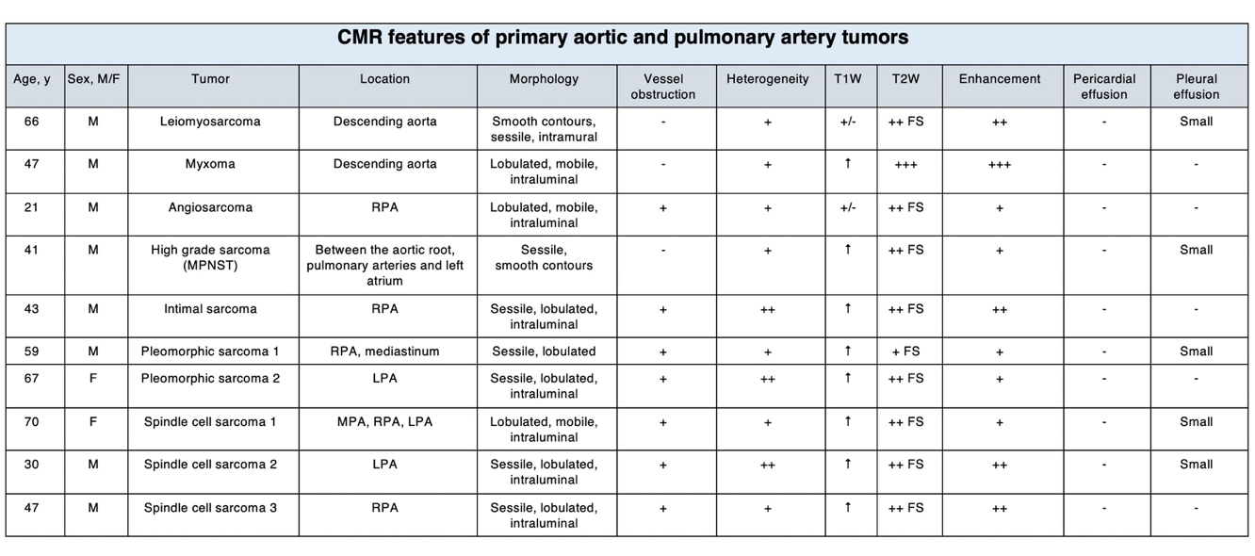
Conclusion
Primary tumors of the aorta and pulmonary arteries are rare, usually mesenchymal and have non-specific clinical manifestations. In our study, 9 out of 10 tumors were malignant with aortic myxoma being the only benign tumor. Dedicated cardiovascular magnetic resonance imaging with expert analysis helps to achieve a timely diagnosis.

References
1. Lam KY, Dickens P, Chan AC. Tumors of the heart. A 20-year experience with a review of 12,485 consecutive autopsies. Arch Pathol Lab Med. 1993 Oct;117(10):1027–31.
2. Burke AP, Virmani R. Sarcomas of the great vessels. A clinicopathologic study. Cancer. 1993 Mar 1;71(5):1761–73.

