Mitigation of NOM Fouling of Ultrafiltration Membranes by Pre-deposited Heated Aluminum Oxide Particles with Different Crystallinity
Ting Liu^{1,2}, Bing Yang¹, Nigel Graham², Yuanlong Lian¹, Wenzheng Yu²*, Kening Sun¹*

¹ School of Chemistry and Chemical Engineering, Beijing Institute of Technology, Beijing 100081, China
² Department of Civil and Environmental Engineering, Imperial College London, South Kensington Campus, London SW7 2AZ, UK
Abstract: A major cause of ultrafiltration (UF) membrane fouling in surface water treatment is natural organic matter (NOM). Some studies have reported that heated aluminum oxide particles (HAOPs), prepared by boiling a suspension containing precipitates of the common coagulant alum, can remove substantial amounts of NOM and reduce fouling when they were pre-deposited on UF membranes. However, the influence of the size and structure of the HAOPs in mitigating NOM membrane fouling has not been fully explored so far. This work has investigated the change in microstructure of the HAOPs during the heating process and the subsequent effect on the performance of the membrane process, and especially on the mitigation of fouling. As the heating time increased, the structure of the HAOPs transformed gradually from an amorphous nature to a semi-crystal, and then to a microcrystalline phase. It was found that this micro-crystallization process played a key role in affecting the structural properties of the nano-scale particles and the membrane filtration performance. During the crystalline transition, a change of particle size distribution occurred and the average particle size was found to decrease gradually owing to a dehydration reaction. The smaller particle size of the HAOPs provides a denser pre-filtration layer for NOM separation, and their more rigid structure reduces layer compression and hydraulic resistance during operation. Optimization of the pre-heating condition and surface loading can effectively enhance the performance of the HAOPs layer in reducing NOM fouling in the UF membrane system.
Keywords: heated aluminum oxide particles; pre-deposition; microcrystalline; ultrafiltration membrane; NOM fouling

1. Introduction
Membrane technology is considered to be one of the most promising technologies in the future for drinking water supply [1]. However, its application continues to be constrained by the deleterious effects of membrane fouling, and natural organic matter (NOM), which is ubiquitous in surface waters, is a major contributor to membrane fouling in water treatment processes [2-4]. In microfiltration (MF) and ultrafiltration (UF) applications, NOM in the raw water can aggravate both reversible and irreversible fouling and lead to more frequent backwashing and chemical cleaning, which increases energy consumption and reduces membrane life [5-8]. Therefore, it is a high priority to find efficient and cost-effective approaches to remove NOM from the influent water and mitigate NOM fouling in MF and UF membrane systems [9-11].
Adsorption or coagulation is often used as a pretreatment method either upstream of, or directly in combination with, membrane filtration for NOM removal from the feed water [12-15]. The adsorbent used in most studies of hybrid adsorption/membrane processes is powdered activated carbon (PAC), which can adsorb and remove a significant fraction of NOM in the feed water and thereby reduce fouling [16, 17]. In some cases, however, it has been reported that PAC adsorbed non-foulant molecules preferentially over foulant molecules and this sometimes exacerbated membrane fouling [18, 19]. In particular, fouling developed more rapidly when the feed together with PAC entered a membrane system than when the PAC was added into the feed and then removed before entering the membrane system, which could be attributed to the formation of a PAC layer on the membrane surface [20, 21]. In addition, it has been recognized that NOM can be effectively removed from the feed by coagulation with aluminum and iron salts, which are the most commonly used coagulants [22, 23]. Under normal water treatment conditions, a portion of NOM can be adsorbed onto the precipitated metal hydroxides and separated from the feed water. Although coagulation presumably reduces the potential for direct fouling by NOM, the overall effect on fouling can not be accurately predicted [21]. Some studies have reported that the precipitated metal hydroxides aggravated fouling since they formed gel layers at the membrane surface and blocked the membrane pores [24]. Hence, although the addition of coagulants and adsorbents invariably removes a portion of the NOM, their performance in fouling control has been inconsistent, sometimes having little effect or even exacerbating fouling [20, 25].
Hydrous oxides of aluminum (III) and iron (III) play a large part in environmental processes and in the action of coagulants used in water treatment [26]. Benjamin and co-workers applied heated aluminum or iron oxide particles (HAOPs or HIOPs) as novel and inexpensive adsorbents in hybrid adsorption/membrane systems [27-31]. HAOPs or HIOPs were prepared by a facile approach of heating the suspension containing precipitates of alum or FeCl₃, which are the most common coagulants. They reported that the deposition of a thin layer of the particles on MF or UF membrane surface prior to delivery of the feed could lead to an excellent performance with respect to both NOM removal and fouling reduction. In addition, HAOPs were found to perform similarly or slightly better than HIOPs, and the benefits of using the deposited particles could be observed with membranes made from a variety of materials (cellulose acetate, PVDF, PES, etc.) [29]. Membrane fouling can be greatly alleviated by using HAOPs or HIOPs as a pre-deposition layer on MF or UF membranes, with the following proposed mechanisms: (i) the HAOPs and HIOPs act as adsorbents and preferentially remove foulant over non-foulant NOM molecules [31]; (ii) the HAOPs or HIOPs layer acts as a shallow, packed bed with steadily less foulant removed in each successive layer of particles [30].
Although the performance of HAOPs as pre-deposited adsorbents in removing both bulk NOM and key foulants has been demonstrated in some studies [28-31], the morphology and structure of the particles at the nano-scale and their variation during the heating process are poorly understood but of great significance, and so require to be further explored. In this study, we have investigated the variation of shape, size distribution, average size, composition and structural properties of the HAOPs with heating time, and their effects on membrane fouling control in the UF membrane system. As humic substances, proteins and polysaccharides are three principal types of NOM foulants that are commonly present in natural surface waters, we employed humic acid (HA), bovine serum albumin (BSA) and sodium alginate (SA), respectively, to represent these naturally derived foulants; these substances have been used widely in other investigations of NOM fouling [15, 32-34]. A thin layer of HAOPs with different heating times was deposited on the membrane surface and the dynamic change of the permeate flux was detected. The HAOPs were analyzed by several characterization methods to better understand their properties as pre-deposited material, and to contribute to the study of the mechanisms of membrane fouling and the development of superior, novel materials in combination with membranes for water treatment.

2. Materials and methods
2.1 Synthetic raw water. All chemicals were analytical reagents except where specifically referred to. Deionized (DI) water (Millipore Milli-Q) was used to prepare stock solutions. Humic acid (HA, sodium salt, Aldrich, Cat:H1, 675-2HA, MW<10 kDa) was dissolved in DI water followed by centrifuging at 5000 revolutions per minute for 5 min. Bovine serum albumin (BSA, MW 30~60 kDa) and sodium alginate (SA, MW>100 kDa) (Sinopharm Chemical Reagent Co., Ltd, China) were obtained as reagent grade chemicals. Stock solutions of HA, SA and BSA were prepared at a concentration of 3 g/L, stored in the dark at 4 ºC, and were brought to room temperature prior to use in the subsequent tests. Final solutions of 10 mg/L HA, SA or BSA were prepared and the pH was adjusted to 7.0 using either 0.1 M NaOH or 0.1 M HCl, before feeding the solution to the membrane system.
2.2 Heated aluminum oxide particles (HAOPs). The HAOPs were synthesized by heating freshly precipitated aluminum hydroxide using the following procedure [28]. A quantity of aluminum sulfate hydrate (alum, Al₂(SO₄)₃·18H₂O) was dissolved in DI water to obtain a stock solution of 0.1 M as Al, and then further diluted to solutions of 2 mM and 10 mM as Al. A volume of 100 ml of each solution was neutralized to pH 7.0 with 0.1 M NaOH to produce the suspension of aluminum hydroxide. Then the suspension was filtered and the retained HAOPs were added to boiling DI water. Heating was maintained for different times of 0, 1, 5, 10, 30 min and the boiling point of the suspension was 100±0.5ºC. After subsequent cooling to room temperature, the HAOPs were deposited on the UF membranes by filtering the suspensions at the beginning of each filtration experiment. A low surface loading of 4.5 g/m² and a high surface loading of 22.5 g/m² (as Al₂O₃) were used in the filtration experiments, corresponding to 100 ml Al₂(SO₄)₃ solutions of 2 mM and 10 mM (as Al), respectively; the high surface loading corresponded approximately to that used in the study of Malczewska et al.²⁹ It should be noted that, in this study, the heating time of the HAOPs indicates the boiling time and the designation of HAOPs with 0 min heating refers to unheated particles, i.e. Al(OH)₃ precipitates.
2.3 UF experiments. The flat-sheet UF membranes used in the tests were 76-mm-diameter, polyether sulfone (PES) disks with a nominal molecular weight cutoff of 100 kDa (Shanghai Mosu Technology Co., Ltd., China). Each membrane was soaked in DI water for at least 24 h to remove impurities and production residues. The permeate flux of the membrane was determined by an electronic balance (ML4002, Mettler-Toledo International Inc., USA) connected to a computer for continuous data logging at timed intervals. Each membrane was operated with a flow of DI water until it reached a stable permeate flux before pre-deposition of HAOPs. A thin layer of the HAOPs was pre-deposited on the membrane by passing a small volume of the suspension of HAOPs. Normalized flux J/J₀ (initial flux J₀) was used to show flux decline as a function of time using a UF stirred cell (Millipore, Amicon 8400, USA) under a constant nitrogen pressure of 0.1 MPa. Membrane fouling was indicated by the temporal decline in flux with feed waters of dilute HA, SA or BSA.
2.4 Characterization. Dissolved organic carbon (DOC) concentrations (Method Detection Limit 0.1 mg/L) of raw water and membrane effluent were determined with a total organic carbon (TOC) analyzer (TOC-V_{CPH}, Shimadzu, Japan). The pre-deposited HAOPs layer on the membrane surface was scraped off with a plastic sheet before UF experiments and collected for characterization. The morphology of the HAOPs was characterized by scanning electron microscope (SEM, QUANTA FEG 250, FEI, USA) after air-drying for 48 hours. In addition, the HAOPs were freeze-dried and then characterized by Fourier transform infrared spectroscopy (FT-IR, BRUKER, ALPHA-P, USA) and X-ray diffraction (XRD, Rigaku Ultima IV, Cu-Κα radiation, 45 kV, 50 mA, Japan). Thermogravimetric differential thermal analysis (TG-DTA 6200, SII Nano Technology Inc., Japan) was conducted in a corundum crucible with a heating rate of 20 ºC/min from 50 to 800ºC in nitrogen atmosphere to determine the weight loss of the freeze-dried HAOPs.

3. Results and discussion
3.1 NOM Removal and Flux variation in UF Experiments. In general, the UF process alone can remove little NOM of low MW (<20 kDa), but significant portions of high MW (>20 kDa) NOM which may cause severe membrane fouling. In this work, the DOC values of influent and UF effluents for the three types of NOM with different heating times of the HAOPs were determined. While in previous studies HAOPs were prepared by heating the aluminium hydroxide precipitates at 110ºC for 24 h [28-30], a maximum heating time of 30 min for the HAOPs was applied in this work since longer heating times (> 30 min) were found (results not included here) to achieve the same organic matter removal as 24 hours; in practical terms, this substantial reduction in heating time represents a significant potential saving in energy. In order to investigate the effect of surface loading of HAOPs on NOM removal, two different loadings (4.5 and 22.5 g/m², as Al₂O₃) were deposited on the membrane surface. The results summarized in Table 1 and Figure S1 showed that there was a similar HA removal regardless of boiling time of the HAOPs, and the HA removals achieved were approximately 86% and 88% at the low and high HAOPs loadings, respectively. HA has a relatively low MW (<10 kDa) compared to the MW cutoff of the UF membrane (~100 kDa), suggesting that the HA was removed mainly by adsorption (electrostatic adherence, hydrogen-bond interaction or surface complexation) arising from the large quantity of adsorption sites in the HAOPs layer. Moreover, the BSA (MW 30~60 kDa) removals reached more than 90% and a longer heating time of the HAOPs induced a slightly higher BSA removal. For the BSA removals, the removal mechanism could be both adsorption and sieving by the HAOPs layer of the enhanced membrane system. For the NOM with the highest MW, SA (MW>100 KDa), although the removal efficiency was ~84% by the membrane alone, it was greater (~90%) for the HAOPs-enhanced UF system, and the removal efficiency increased with extension of boiling time of the HAOPs. In this case, the HAOPs layer contributed greatly to the maintenance of water flux and reduction of membrane fouling (Figure 1), mainly by sieving. It is noted that the removal efficiencies of SA were only slightly affected by the surface loading of the HAOPs. In summary, the removals of the three types of NOM were all relatively high in this study but involved different mechanisms. The high degree of removal of total NOM and different fractions of NOM in the HAOPs-deposited UF systems have also been reported in previous studies [28-31].
Table 1. DOC values of influent and UF effluents for the three types of NOM with different heating times of HAOPs.
DOC  (mg/L) | Influent | Effluent  (membrane alone) | Effluent (low loading) |  |  |  |  | Effluent (high loading)
DOC  (mg/L) | Influent | Effluent  (membrane alone) | 0 minª | 1 min | 5 min | 10 min | 30 min | 0 minª | 1 min | 5 min | 10 min | 30 min
HA | 3.87±0.18 | 3.55±0.14 | 0.88±0.06 | 0.54±0.05 | 0.51±0.07 | 0.53±0.06 | 0.55±0.07 | 0.56±0.06 | 0.47±0.03 | 0.45±0.05 | 0.46±0.04 | 0.44±0.05
BSA | 4.04±0.15 | 2.45±0.18 | 0.54±0.06 | 0.42±0.06 | 0.38±0.06 | 0.36±0.02 | 0.35±0.04 | 0.49±0.06 | 0.38±0.02 | 0.38±0.02 | 0.33±0.03 | 0.32±0.02
SA | 4.13±0.21 | 0.65±0.09 | 0.48±0.06 | 0.44±0.08 | 0.41±0.03 | 0.35±0.06 | 0.32±0.05 | 0.46±0.06 | 0.42±0.03 | 0.38±0.03 | 0.35±0.05 | 0.30±0.04
ª HAOPs with 0 min heating refers to unheated particles (Al(OH)₃ precipitates).

Furthermore, we investigated the effect of pre-deposited HAOPs with different heating times on the development of membrane fouling as indicated by flux decline in the UF system. Initial fluxes (J₀) for all UF experiments were in the range of 210±12 L/m²h (LMH) as shown in Figure S2. Figures 1A and 1B show the temporal flux decline caused by HA fouling at the two HAOPs loadings with different heating times. The results show clearly that the permeate flux decline was inversely related to heating time. Thus, for the longer heating time (≥10 min) the UF system displayed the least flux decline, and thus the least fouling, for both surface loadings. In addition, for the same heating time of 10 min, the J/J₀ value decreased to only 0.97 after 600 s of filtration at the lower surface loading, while the corresponding value was 0.87 at the higher surface loading. This indicated that the membrane with the lower HAOPs loading exhibited a more favorable performance compared to that with the higher loading. For the second raw water type, BSA, the flux behaviour was similar to the HA, with the flux decline least with the 10-min and 30-min HAOPs and at the lower surface loading (Figures 1C and 1D). The results for the SA solution are given in Figures 1E and 1F, which showed that the membrane system with the 30-min HAOPs had the lowest flux decline; however, in this case the decline in the J/J₀ values after 600 s for the higher loading was slightly less than that for the lower loading. It is noted that applying the higher surface loading of HAOPs caused a similar or lower fouling reduction, although it removed relatively more organic matter, suggesting an insensitivity of fouling reduction to the surface loading of the pre-deposited particles, and this aspect will be discussed later. Furthermore, a comparison of flux decline for the three types of NOM with the HAOPs prepared in this work and the similar loading of HAOPs prepared in a previous study [25] was conducted. The results show that the fouling reduction performance of the two studies (30 min-heated HAOPs in this work, cf. 24 h for previous study) were similar, as shown in Figure S3, which represents a potentially important saving in energy costs. However, a shorter heating time of only 10 min appeared be sufficient to achieve the least flux decline.
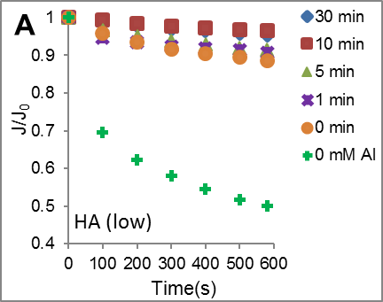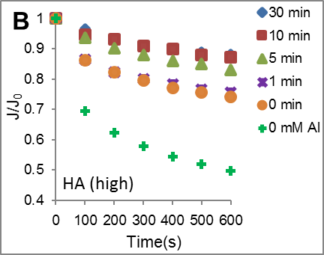
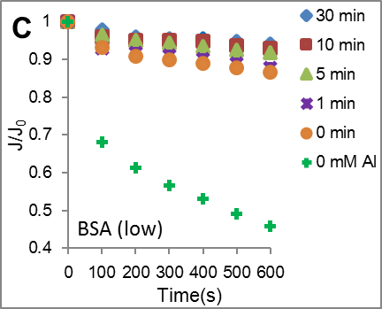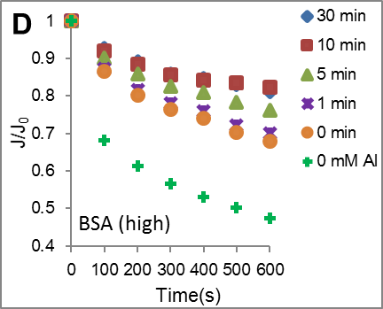
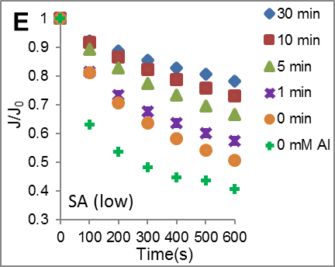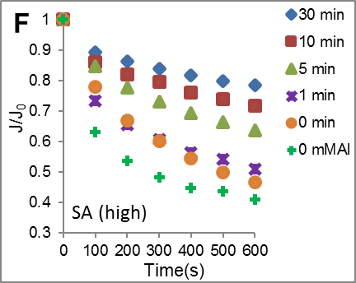
Figure 1. Temporal variation of normalized flux J/J₀ (initial flux J₀) for UF membranes pre-deposited by HAOPs at different heating times (0 min refers to unheated Al(OH)₃ precipitates) and without pre-deposition (0 mM Al) at pH 7. (A) 10 mg/L HA at low loading, (B) 10 mg/L HA at high loading, (C) 10 mg/L BSA at low loading, (D) 10 mg/L BSA at high loading, (E) 10 mg/L SA at low loading and (F) 10 mg/L SA at high loading. (low loading 4.5 g/m² and high loading 22.5 g/m² as Al₂O₃).
3.2 Morphology and Structure of HAOPs. In order to investigate the mechanism of fouling reduction caused by the pre-deposited HAOPs, the nature of the primary particles of the HAOPs at the nano-scale was examined by SEM (Figure 2). The size distribution and average size of the primary particles are of great importance to understanding the fouling process since they have a significant impact on the filtration characteristics of the pre-deposition layer on the membrane surface. The SEM images showed that the precipitates before and after heating had an aggregated morphology and their appearances were similar on the whole. For all the HAOPs, with their different heating times (Figures 2A-2E), the large and compact aggregates were composed of a large quantity of distinct and relatively uniform nanometer-sized spherical particles. This indicated that the nanometer-sized particles were formed initially, and then aggregated, before forming the pre-deposition layer on the membrane surface; previous studies have shown rapid aggregation of precipitated nano-particles (e.g. [23]). The size distribution of the primary particles was analyzed by a statistical method using the ‘Smile View’ software [35]. It was evident that the size distribution of the particles gradually changed with increasing heating time from 0 to 30 min. The average size of the primary particles decreased from larger than 60 nm before heating, to approximately 30 nm after 10 min heating and 25 nm after 30 min heating, corresponding to almost one half of the original size of the primary particles. In comparison to the membrane pore size of 5-10 nm, the heated particle size was still greater than the membrane pores. As a consequence of the decrease in the average size of the HAOPs, the pre-deposition layer has smaller and narrower pores and channels between the particles, which could be conducive to sieving of the large NOM foulants. The HAOPs were found to possess a high aggregation tendency of the primary particles to form small aggregates or clusters. Li et al. also reported that the primary nanoparticles of iron oxyhydroxide tended to aggregate and coalesce into clusters where they interacted in close proximity for sufficient periods of time by oriented attachment, which is consistent with our results for the primary nanoparticles of the HAOPs [36].
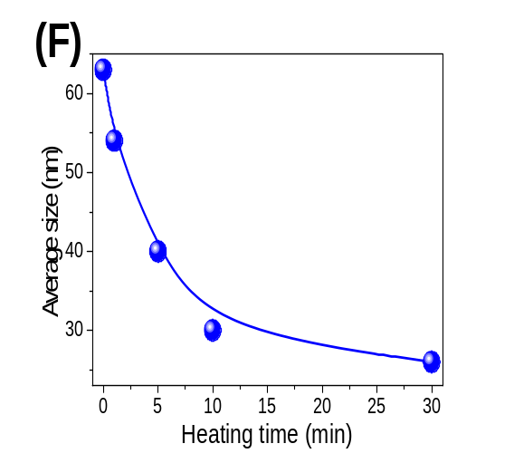
Figure 2. Effect of heating time on the size of HAOPs: (i) SEM images (A) 0 min, (B) 1 min, (C) 5min, (D) 10 min, (E) 30 min. Inserts are statistical results (100 particle samples) of size distribution of HAOPs by ‘Smile View’ software; (ii) Average size of HAOPs with different heating times (F).
In order to explore the effect of heating time on the structure of the HAOPs, the compressibility of the particles was evaluated in this work. The particles with heating times of 0, 1 and 10 min were pre-deposited respectively on the membrane surface at the high loading of 22.5 g/m² and hydraulic UF tests were conducted with DI influent water. The results summarized in Figure 3 show that the rate of flux decline decreased with prolonged heating time of the particles, i.e. the particles with 10 min heating showed the lowest rate among the three, which corresponded to the lowest resistance of the particle layer. Since the DI water cannot induce membrane fouling during the filtration processes, the different resistance can be attributed to the different compressive deformation of the particles under the same fluid pressure. Therefore, the results indicated that the heating process changed the microstructure of the HAOPs and the particles became less compressible with the prolonged heating time. Moreover, Chen et al. have reported that when crystallites are of only nanometre dimensions, the resulting amorphous-nanocrystalline composite actually has greater strength than the original amorphous material, which is consistent with the results of this work [37].
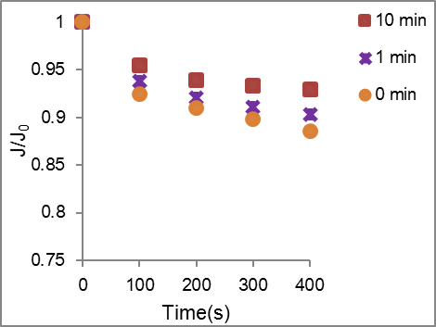
Figure 3. Temporal variation of normalized flux J/J₀ (initial flux J₀) with DI influent water for UF membranes pre-deposited by HAOPs at heating times of 0, 1 and 10 min. (HAOPs loading 22.5 g/m² as Al₂O₃, J₀ = 240~245 LMH)

3.3 Composition Analysis of HAOPs. In order to identify the chemical composition of the HAOPs prepared with different heating times, XRD characterizations were carried out (Figure 4). XRD analysis of the HAOPs before heating indicated the presence of an amorphous Al(OH)₃ phase with low intensity, broad peaks characteristic of a poorly ordered structure (Figure 4A). The increasing intensity and sharpening of peaks with the increase of heating time suggested that crystallization of the particles occurred, with the particles changing from an amorphous phase to more ordered phases (Figure 4B-E). The XRD pattern of the HAOPs after heating for 30 min (Figure 4E) displayed diffraction peaks centered at 14.5º, 28.2º, 38.4º, 49.3º and 65.0º, corresponding to the typical (020), (120), (031), (200) and (002) planes. The positions and the relative intensities of the XRD patterns match well with the boehmite (γ-AlOOH) crystal phase (JCPDS No. 21-1307) [38-40]. Moreover, it was reported that a size-dependent change can strongly influence the ratio between the crystallographic planes of γ-AlOOH nanoparticles, which suggested that the spherical particles between 25 and 55 nm in size in this study might have some different structural and surficial characteristics compared with γ-AlOOH nanoparticles of other sizes and shapes [41]. In Figure 4B-D, boehmite of semi-crystalline phase formed with lower X-ray diffraction maxima than that of Figure 4E. Thus, the crystallinity and microstructure of the particles changed with prolonged heating time, which involved a process of amorphous-to-crystalline transition. It is suggested that the HAOPs after sufficient heating have a well-organized and stable inherent microcrystalline structure with a high enough compressive strength to maintain the pores and channels in the particle layer.
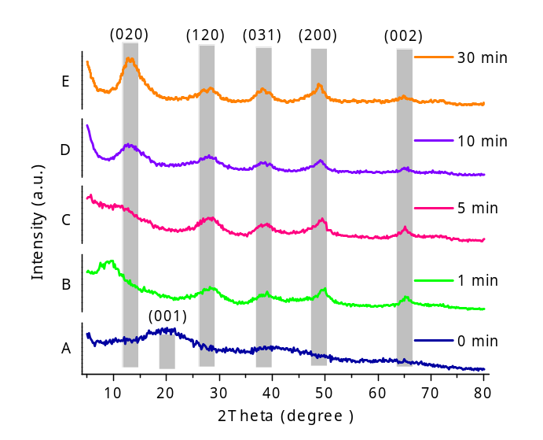
Figure 4. XRD patterns of HAOPs with different heating times: (A) 0 min, (B) 1 min, (C) 5 min, (D) 10 min, (E) 30 min.
FT-IR analysis was performed to further characterize the particle structure. Figure 5 shows FI-IR spectra of the HAOPs with different heating times. The presence of bands at around 3380 cm⁻¹ in the spectra can be ascribed to the asymmetric (ν_{as}(Al)O–H) stretching vibrations of OH groups in the HAOPs particles [42]. In addition, the absorption bands at around 1640 cm⁻¹ were assigned to the H–O–H angle bending vibration mode of weakly bound molecular water [43]. The bands at around 1090 cm⁻¹ were also observed in the spectra of the samples, corresponding to Al−O−H bending vibrations [44]. There were distinct differences in the absorption bands between the spectra in the range of 400-650 cm⁻¹. The principal absorption band in the spectra of the HAOPs with 0 min heating was at 536 cm⁻¹, which was attributed to the Al−O stretching modes in the spectra [45]. A red shift of the band from 536 cm⁻¹ to 474 cm⁻¹ occurred gradually with increasing heating time from 0 to 30 min. In addition, a band at around 610 cm⁻¹ became increasingly obvious in the spectrum with increasing heating time. The two bands observed at 610 cm⁻¹ and 474 cm⁻¹ for 30 min heating were characteristic AlOOH bands of stretching and bending vibrations of AlO₆, respectively [42, 46]. The FT-IR results illustrate the variation in composition of the HAOPs and the formation of AlOOH during the heating process; this is in good agreement with the XRD results.
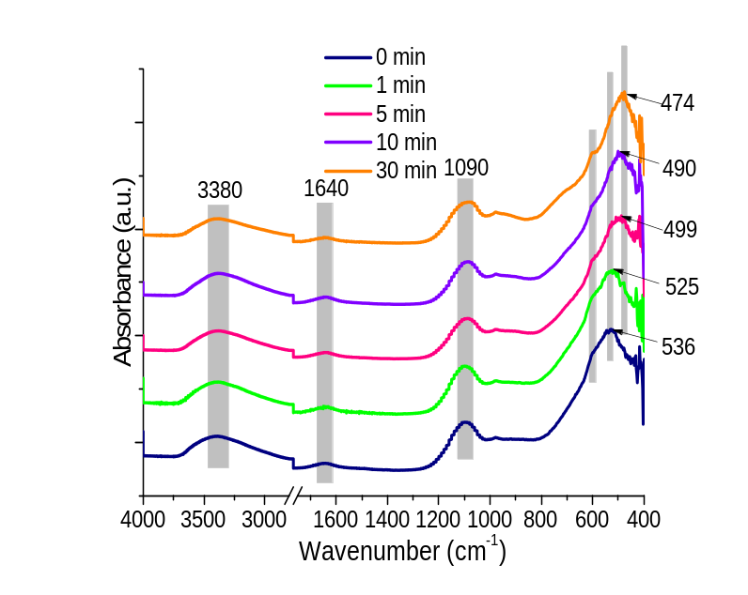
Figure 5. FT-IR spectra of HAOPs with different heating times.
Since XRD and FT-IR can only provide a qualitative analysis of the samples, TG-DTA was utilized to further characterize and quantify the HAOPs (Figure 6). TG curves showing weight loss, and derivative TG (DTG) curves showing weight loss rate, were obtained for the HAOPs over a temperature range of 50-800 ºC. All samples displayed distinct weight loss over a broad range of temperature, indicating dehydration and/or dehydroxylation processes at different temperatures. TG-DTA results revealed that the maximum weight loss of the particles without heating (0 min) was 43.4wt%, while that of the particles with 1, 3, 5 and 10 min heating was 40.7wt%, 34.0wt%, 33.2wt% and 27.3wt%, respectively. All of the HAOPs samples showed a higher weight loss than the theoretical loss (∼15 wt %) that was expected for the transformation of AlOOH to Al₂O₃ (product after TGA, Figure S4), which suggested that these particles carried a relatively high water content and hydroxyl groups. In Figure 6B, the DTG curves of the HAOPs of 0 and 1 min heating, showed only one peak corrsponding to a rapid weight loss at 100-150 ºC, which can be attributed to the desorption of adsorbed water. There were two peaks in the DTG curves of 3, 5 and 10 min heating, where the second peak at around 400 ºC indicated the weight loss due to the dehydroxylation [47]. The DTG curves confirmed the occurrence of microcrystalline AlOOH with the heating time greater than 3 min [48]. The 10-min HAOPs showed a much higher percent of weight loss caused by dehydroxylation, arising from their relatively higher crystallinity. The TGA data were consistent with the XRD data, and further indicated the transformation of the particles from amorphous to microcrystalline phases due to the effects of heating. Banfield et al. also reported that crystal growth in natural iron oxyhydroxide is accomplished by eliminating water molecules at interfaces and forming iron-oxygen bonds [49]. Therefore, the crystallization of the HAOPs played a key role in affecting the microstructure development and characteristics of the pre-deposited particles.
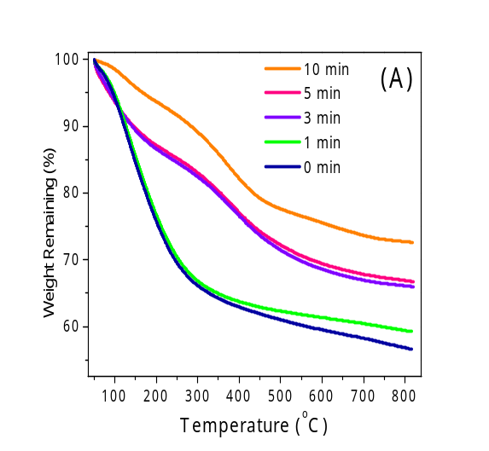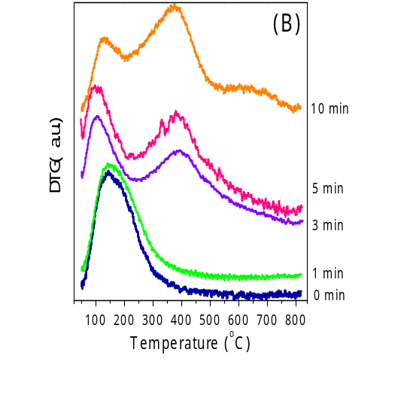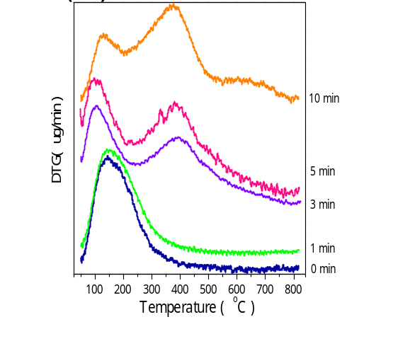
Figure 6. (A) Comparison of weight remaining percentages (TG) of HAOPs with different heating times. (B) Derivative weight loss curves (DTG) of HAOPs with different heating times.
3.4 Mechanisms of Fouling Mitigation by Pre-deposited HAOPs. With the heating time increasing from 0 (unheated) to 30 min, the HAOPs pre-deposition layer provided increasing protection of the UF membrane as indicated by the reduced decline in flux, which was consistent with the three representative kinds of NOM foulants with different MW ranges. This superior performance in terms of fouling control was demonstrated to have a close relationship with the properties of the HAOPs as a functional pre-deposited layer on the membrane. There are two main mechanisms of fouling mitigation proposed in this study. Firstly, the NOM removals were achieved by adsorption (small MW) and sieving (large MW) of the HAOPs layer on the membrane surface. The average particle size at nano-scale of the HAOPs was observed to decrease systematically from ~60 nm to ~25 nm with increasing heating time up to 30 min, which indicated that the pores and channels between the particles became smaller and narrower. In this case, the HAOPs layer would enhance the sieving efficiency of NOM, especially the large substances such as SA, and prevent them reaching the membrane surface. Secondly, it was confirmed that the heating process induced a transformation of the particles from amorphous Al(OH)₃ precipitates into microcrystalline γ-AlOOH, which enhanced the ability of the particles to resist deformation and maintain a high porosity within the granular layer, and thus achieve a high membrane flux. Therefore, the moderate heating-induced crystallization of the HAOPs led to a nano-scaled granular layer of smaller and more rigid particles on the membrane surface, which gave a superior performance in terms of NOM retention and fouling mitigation.
The three types of NOM with different MW ranges in this study showed different fouling behaviors on the HAOPs layer, which can be explained using the proposed mechanisms. The removal of HA (MW<10kDa) was mainly achieved by adsorption within the HAOPs layer rather than retention by the UF membrane, owing to the low MW of the HA. Since the HA is unlikely to block the particle layer and UF membrane, it is believed that the flux decline would not be particularly sensitive to heating time of the HAOPs, especially at the low loading, as confirmed by the results. For the BSA (MW 30~60kDa; median size 7-8 nm [49]), although both adsorption and sieving contributed to the NOM removal, adsorption still dominated the removal, especially at the low HAOPs loading. In contrast, for the NOM with high MW, SA (MW>100kDa; median size 17 nm [49]) can form a gel layer on the membrane surface and/or block the membrane pores to aggravate membrane fouling. The longer-period heating of the HAOPs enhanced the sieving efficiency and removal of SA, which was mainly achieved by the size reduction of the HAOPs, and hence the flux decline for SA was more sensitive to heating time of the HAOPs.
The results in this study have found that a higher surface loading of HAOPs (i.e. larger thickness of the HAOPs layer) led to similar or less fouling mitigation. The absence of any significant increase in fouling mitigation with higher HAOPs loading implies that the conventional fouling mechanism of NOM penetration to the membrane surface may not be dominant in the HAOPs-deposited UF systems. This suggests that the pores and channels in the HAOPs layer become smaller or block so that the HAOPs layer itself induces additional external fouling. In this case, the NOM in the raw water is mainly captured by the upper sections of the HAOPs layer, which therefore foul at the same rate regardless of the deposit thickness. Cai et al. also reported a similar behavior, in which they found the fouling reduction was insensitive to the surface loading of two kinds of adsorbents with small particle size [50]. Furthermore, the adverse effect of the higher surface loading on fouling reduction could be attributed to the fact that the larger thickness of the HAOPs layer, which was composed of compressible particles, caused higher hydraulic resistance owing to particle deformation under the same fluid pressure. Therefore, the surface loading of the HAOPs is an important factor influencing the fouling control performance of the HAOPs pre-deposited UF systems. In addition, the results of composition analysis showed that the HAOPs of 30-min heating have a higher crystallization degree than those of 10-min heating. Nevertheless, the results of flux variations showed that the efficiency of fouling mitigation of the 30-min heated HAOPs was slightly greater than that of the 10-min heated particles when treating SA solution, while it was almost the same for the both HAOPs when treating HA and BSA solutions regardless of the surface loading. The different MW ranges and removal mechanisms of the three types of NOM resulted in different fouling behaviors in each case. Although the HAOPs became increasingly crystalline after 30-min heating, their performances on the UF surface for NOM removal and fouling reduction were similar, or slightly superior, to that of 10-min heating, respectively, which implies a lower efficiency of 30-min heating in terms of energy consumption.
Figure 7 shows a schematic depiction of the fouling mitigation mechanisms of the HAOP_{S} as a functional pre-deposited layer on the membrane. As indicated in Figure 7A, the HAOPs that have received no, or insufficient heating time (e.g. 0 and 1 min), are larger and have a lower degree of micro-crystallinity than HAOPs heated for a longer time (e.g. 10 min or more). After the membrane system was operated for a period of time, it is expected that the layer of unheated or insufficiently heated HAOPs would compress due to deformation of the relatively amorphous particles under fluid pressure, thereby decreasing the layer porosity and increasing the hydraulic resistance. In comparison, the reduced size and more rigid structure of the longer-heated nanoparticles can sieve the larger NOM more efficiently, and retain (because of the more rigid structure) a low resistance to flow (Figure 7B). Thus, an appropriate degree of crystallization of the HAOPs as the pre-deposited layer, through the effect of pre-heating, is a valuable approach for enhancing the UF performance by mitigating fouling; optimization of the HAOPs layer depends on the heating time and the mass loading on the membrane.
Figure 7. Schematic of fouling mitigation of HAOPs pre-deposited on UF membrane: (A) unheated or short-period heating; (B) longer-period heating.

4. Conclusions
In this study we have considered the influence of heating time on the nature of HAOPs and their performance as a membrane pre-deposit layer in order to reduce the fouling caused by specific types of NOM, namely HA, SA and BSA. The principal findings of the study are as follows:
1. The addition of HAOPs can provide a protective layer for UF membranes, whereby NOM foulants (HA, SA and BSA molecules) are largely removed by sieving and adsorption within the pre-coated HAOPs layer, resulting in lower flux decline.
2. The results indicate that the size of HAOPs lie within a range of about 20~60 nm, and that increasing boiling/heating time reduces the size of particles. This in turn leads to smaller pore sizes in the HAOPs layer, and thus a greater capability to remove organic substancess by adsorption and filtration mechanism.
3. With increasing heating time (0~30 min), the structure of the HAOPs transformed gradually from an amorphous nature to a semi-crystal, and then to a microcrystalline phase. The transformation from compressible, amorphous particles to smaller, less compressible, more crystalline particles resulted in a greater performance of NOM removal and reduced membrane fouling. A heating time of only 10 min was found to be sufficient to achieve a high degree of fouling control (reduction in flux decline) and organic matter removal.

Associated content
Supporting Information
Additional information as mentioned in the text.

Author information
Corresponding Author
* Tel: +44 2075946121, Fax: +44 2075945934, e-mail: w.yu@imperial.ac.uk (W.Y.); bitkeningsun@163.com (K.S.).

Acknowledgements
This work was financially supported by the National Natural Science Foundation of China (51308043) and Marie Curie International Incoming Fellowship (FP7-PEOPLE-2012-IIF-328867) for Dr Wenzheng Yu.

References
[1]. Shannon M. A., Bohn P. W., Elimelech M., Georgiadis J. G., Marinas B. J., Mayes A. M., 2008. Science and technology for water purification in the coming decades. Nature 452(7185), 301-310.
[2]. Howe K. J., Marwah A., Chiu K. P., Adham S. S., 2006. Effect of coagulation on the size of MF and UF membrane foulants. Environ Sci Technol 40(24), 7908-7913.
[3]. Liu T., Chen Z. L., Yu W. Z., You S. J., 2011. Characterization of organic membrane foulants in a submerged membrane bioreactor with pre-ozonation using three-dimensional excitation-emission matrix fluorescence spectroscopy. Water Res 45(5), 2111-2121.
[4]. Harris B. D., Brown T. A., McGehee J. L., Houserova D., Jackson B. A., Buchel B. C., Krajewski L. C., Whelton A. J., Stenson A. C., 2015. Characterization of Disinfection By-Products from Chromatographically Isolated NOM through High-Resolution Mass Spectrometry. Environ Sci Technol 49(24), 14239-14248.
[5]. Howe K. J., Clark M. M., 2002. Fouling of microfiltration and ultrafiltration membranes by natural waters. Environ Sci Technol 36(16), 3571-3576.
[6]. Costa A. R., de Pinho M. N., Elimelech M., 2006. Mechanisms of colloidal natural organic matter fouling in ultrafiltration. J Membrane Sci 281(1-2), 716-725.
[7]. Schafer A. I., Schwicker U., Fischer M. M., Fane A. G., Waite T. D., 2000. Microfiltration of colloids and natural organic matter. J Membrane Sci 171(2), 151-172.
[8]. Taniguchi M., Kilduff J. E., Belfort G., 2003. Modes of natural organic matter fouling during ultrafiltration. Environ Sci Technol 37(8), 1676-1683.
[9]. Jermann D., Pronk W., Meylan S., Boller M., 2007. Interplay of different NOM fouling mechanisms during ultrafiltration for drinking water production. Water Res 41(8), 1713-1722.
[10]. Lavonen E. E., Gonsior M., Tranvik L. J., Schmitt-Kopplin P., Kohler S. J., 2013. Selective Chlorination of Natural Organic Matter: Identification of Previously Unknown Disinfection Byproducts. Environ Sci Technol 47(5), 2264-2271.
[11]. Huang H. O., Cho H. H., Jacangelo J. G., Schwab K. J., 2012. Mechanisms of Membrane Fouling Control by Integrated Magnetic Ion Exchange and Coagulation. Environ Sci Technol 46(19), 10711-10717.
[12]. Liu T., Chen Z. L., Yu W. Z., Shen J. M., Gregory J., 2011. Effect of two-stage coagulant addition on coagulation-ultrafiltration process for treatment of humic-rich water. Water Res 45(14), 4260-4268.
[13]. Huang H., Schwab K., Jacangelo J. G., 2009. Pretreatment for Low Pressure Membranes in Water Treatment: A Review. Environ Sci Technol 43(9), 3011-3019.
[14]. Kim J., Deng Q. R., Benjamin M. M., 2008. Simultaneous removal of phosphorus and foulants in a hybrid coagulation/membrane filtration system. Water Res 42(8-9), 2017-2024.
[15]. Ma B. W., Yu W. Z., Liu H. J., Qu J. H., 2014. Effect of low dosage of coagulant on the ultrafiltration membrane performance in feedwater treatment. Water Res 51, 277-283.
[16]. Mozia S., Tomaszewska M., 2004. Treatment of surface water using hybrid processes adsorption on PAC and ultrafiltration. Desalination 162(1-3), 23-31.
[17]. Yu W. Z., Xu L., Qu J. H., Graham N., 2014. Investigation of pre-coagulation and powder activate carbon adsorption on ultrafiltration membrane fouling. J Membrane Sci 459, 157-168.
[18]. Lin C. F., Huang Y. J., Hao I. J., 1999. Ultrafiltration processes for removing humic substances: Effect of molecular weight fractions and PAC treatment. Water Res 33(5), 1252-1264.
[19]. Kang S. K., Choo K. H., 2010. Why does a mineral oxide adsorbent control fouling better than powdered activated carbon in hybrid ultrafiltration water treatment? J Membrane Sci 355(1-2), 69-77.
[20]. Li C. W., Chen Y. S., 2004. Fouling of UF membrane by humic substance: Effects of molecular weight and powder-activated carbon (PAC) pre-treatment. Desalination 170(1), 59-67.
[21]. Zhang M. M., Li C., Benjamin M. M., Chang Y. J., 2003. Fouling and natural organic matter removal in adsorben/membrane systems for drinking water treatment. Environ Sci Technol 37(8), 1663-1669.
[22]. Ma B. W., Yu W. Z., Liu H. J., Qu J. H., 2014. Comparison of iron (III) and alum salt on ultrafiltration membrane fouling by alginate. Desalination 354, 153-159.
[23]. Yu W. Z., Graham N., Liu H. J., Qu J. H., 2013. Comparison of FeCl3 and alum pre-treatment on UF membrane fouling. Chem Eng J 234, 158-165.
[24]. Bergamasco R., Konradt-Moraes L. C., Vieira M. F., Fagundes-Klen M. R., Vieira A. M. S., 2011. Performance of a coagulation-ultrafiltration hybrid process for water supply treatment. Chem Eng J 166(2), 483-489.
[25]. Cai Z. X., Kim J. S., Benjamin M. M., 2008. NOM removal by adsorption and membrane filtration using heated aluminum oxide particles. Environ Sci Technol 42(2), 619-623.
[26]. Yu W. Z., Gregory J., Graham N., 2016. Regrowth of Broken Hydroxide Flocs: Effect of Added Fluoride. Environ Sci Technol.
[27]. Chang Y. J., Benjamin M. M., 1996. Iron oxide adsorption and UF to remove NOM and control fouling. J Am Water Works Ass 88(12), 74-88.
[28]. Cai Z. X., Benjamin M. M., 2011. NOM Fractionation and Fouling of Low-Pressure Membranes in Microgranular Adsorptive Filtration. Environ Sci Technol 45(20), 8935-8940.
[29]. Malczewska B., Liu J., Benjamin M. M., 2015. Virtual elimination of MF and UF fouling by adsorptive pre-coat filtration. J Membrane Sci 479, 159-164.
[30]. Kim J., Cai Z. X., Benjamin M. M., 2010. NOM fouling mechanisms in a hybrid adsorption/membrane system. J Membrane Sci 349(1-2), 35-43.
[31]. Kim J. S., Cai Z. X., Benjamin M. M., 2008. Effects of adsorbents on membrane fouling by natural organic matter. J Membrane Sci 310(1-2), 356-364.
[32]. Katsoufidou K., Yiantsios S. G., Karabelas A. J., 2007. Experimental study of ultrafiltration membrane fouling by sodium alginate and flux recovery by backwashing. J Membrane Sci 300(1-2), 137-146.
[33]. Susanto H., Arafat H., Janssen E. M. L., Ulbricht M., 2008. Ultrafiltration of polysaccharide-protein mixtures: Elucidation of fouling mechanisms and fouling control by membrane surface modification. Sep Purif Technol 63(3), 558-565.
[34]. Jermann D., Pronk W., Boller M., 2008. Mutual Influences between Natural Organic Matter and Inorganic Particles and Their Combined Effect on Ultrafiltration Membrane Fouling. Environ Sci Technol 42(24), 9129-9136.
[35]. Yu W. Z., Graham N., Yang Y. J., Zhou Z. Q., Campos L. C., 2015. Effect of sludge retention on UF membrane fouling: The significance of sludge crystallization and EPS increase. Water Res 83, 319-328.
[36]. Li D. S., Nielsen M. H., Lee J. R. I., Frandsen C., Banfield J. F., De Yoreo J. J., 2012. Direction-Specific Interactions Control Crystal Growth by Oriented Attachment. Science 336(6084), 1014-1018.
[37]. Chen H., He Y., Shiflet G. J., Poon S. J., 1994. Deformation-induced nanocrystal formation in shear bands amorphous alloys. Nature 367, 541-543.
[38]. Tang Z., Liu Y. Q., Li G. C., Hu X. F., Liu C. G., 2012. Ionic liquid assisted hydrothermal fabrication of hierarchically organized gamma-AlOOH hollow sphere. Mater Res Bull 47(11), 3177-3184.
[39]. Zhang L., Zhu Y. J., 2008. Microwave-Assisted Solvothermal Synthesis of AlOOH Hierarchically Nanostructured Microspheres and Their Transformation to gamma-Al2O3 with Similar Morphologies. J Phys Chem C 112(43), 16764-16768.
[40]. Bai X., Caputo G., Hao Z. D., Freitas V. T., Zhang J. H., Longo R. L., Malta O. L., Ferreira R. A. S., Pinna N., 2014. Efficient and tuneable photoluminescent boehmite hybrid nanoplates lacking metal activator centres for single-phase white LEDs. Nat Commun 5.
[41]. Auffan M., Rose J., Bottero J. Y., Lowry G. V., Jolivet J. P., Wiesner M. R., 2009. Towards a definition of inorganic nanoparticles from an environmental, health and safety perspective. Nat Nanotechnol 4(10), 634-641.
[42]. Gao C., Yu X. Y., Xu R. X., Liu J. H., Huang X. J., 2012. AIOOH-Reduced Graphene Oxide Nanocomposites: One-Pot Hydrothermal Synthesis and Their Enhanced Electrochemical Activity for Heavy Metal Ions. Acs Appl Mater Inter 4(9), 4672-4682.
[43]. Gangwar J., Gupta B. K., Tripathi S. K., Srivastava A. K., 2015. Phase dependent thermal and spectroscopic responses of Al2O3 nanostructures with different morphogenesis. Nanoscale 7(32), 13313-13344.
[44]. IngramJones V. J., Slade R. C. T., Davies T. W., Southern J. C., Salvador S., 1996. Dehydroxylation sequences of gibbsite and boehmite: Study of differences between soak and flash calcination and of particle-size effects. J Mater Chem 6(1), 73-79.
[45]. Vandana, Batra N., Gope J., Singh R., Panigrahi J., Tyagi S., Pathi P., Srivastava S. K., Rauthan C. M. S., Singh P. K., 2014. Effect of low thermal budget annealing on surface passivation of silicon by ALD based aluminum oxide films. Phys Chem Chem Phys 16(39), 21804-21811.
[46]. Rajan Y. C., Inbaraj B. S., Chen B. H., 2015. Synthesis and characterization of poly(gamma-glutamic acid)-based alumina nanoparticles with their protein adsorption efficiency and cytotoxicity towards human prostate cancer cells. Rsc Adv 5(20), 15126-15139.
[47]. Sun B. B., Ji Z. X., Liao Y. P., Wang M. Y., Wang X., Dong J. Y., Chang C. H., Li R. B., Zhang H. Y., Nel A. E., Xia T., 2013. Engineering an Effective Immune Adjuvant by Designed Control of Shape and Crystallinity of Aluminum Oxyhydroxide Nanoparticles. Acs Nano 7(12), 10834-10849.
[48]. Berkowitz J., Anderson M. A., Graham R. C., 2005. Laboratory investigation of aluminum solubility and solid-phase properties following alum treatment of lake waters. Water Res 39(16), 3918-28.
[49]. Banfield J. F., Welch S. A., Zhang H. Z., Ebert T. T., Penn R. L., 2000. Aggregation-based crystal growth and microstructure development in natural iron oxyhydroxide biomineralization products. Science 289(5480), 751-754.
[50]. Cai Z. X., Wee C., Benjamin M. M., 2013. Fouling mechanisms in low-pressure membrane filtration in the presence of an adsorbent cake layer. J Membrane Sci 433, 32-38.

Supporting Information

Mitigation of NOM Fouling of Ultrafiltration Membranes by Pre-deposited Heated Aluminum Oxide Particles with Different Crystallinity
Ting Liu^{1,2}, Bing Yang¹, Nigel Graham², Yuanlong Lian¹, Wenzheng Yu²*, Kening Sun¹*

¹ School of Chemistry and Chemical Engineering, Beijing Institute of Technology, Beijing 100081, China
² Department of Civil and Environmental Engineering, Imperial College London, South Kensington Campus, London SW7 2AZ, UK

Number of Figures: S1-S4

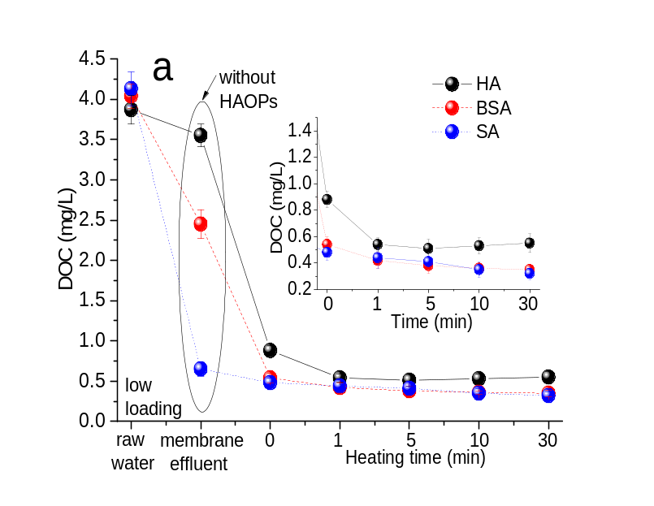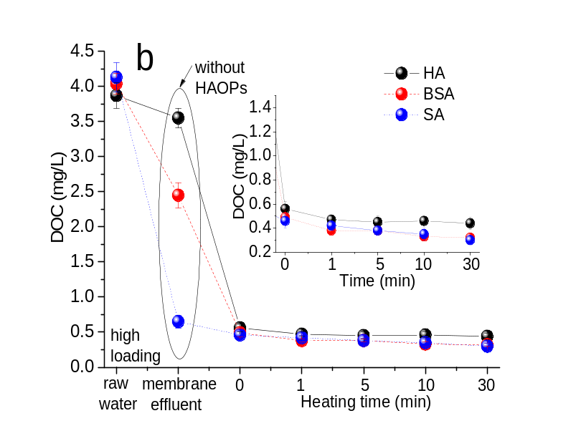
Figure S1 DOC values of influent and UF effluents for the three types of NOM with different heating times of HAOPs: a) low surface loading of HAOPs, b) high surface loading of HAOPs

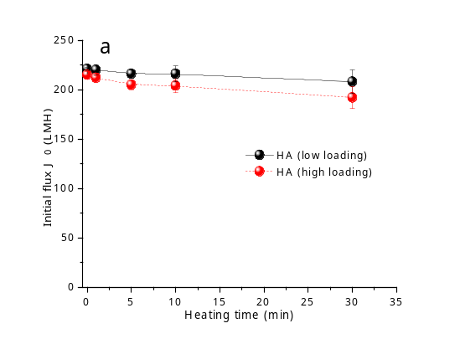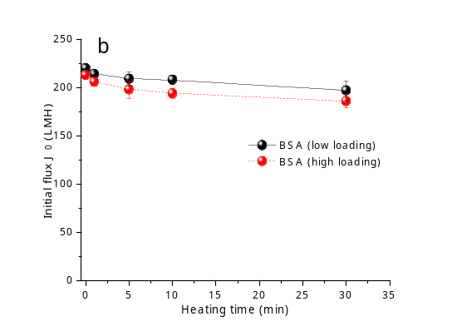

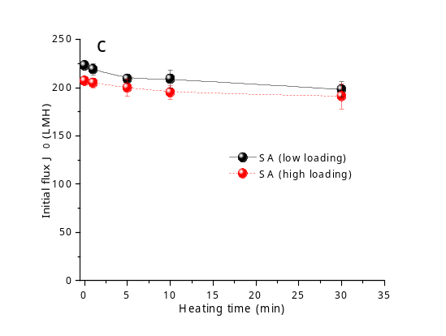

Figure S2. Initial flux J₀ for each UF test of the HAOPs with different heating times (a) HA (b) BSA (c) SA (low loading 4.5 g/m² and high loading 22.5 g/m² as Al₂O₃)

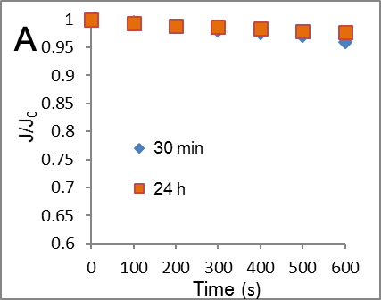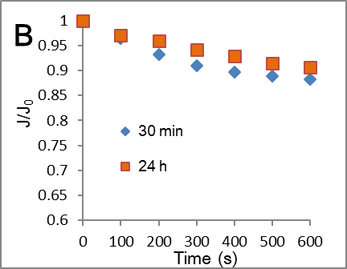
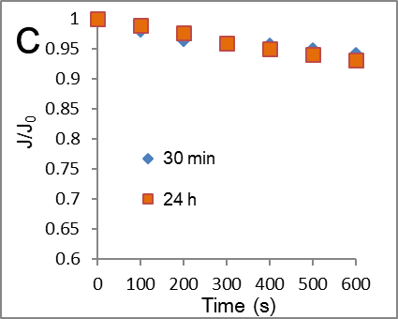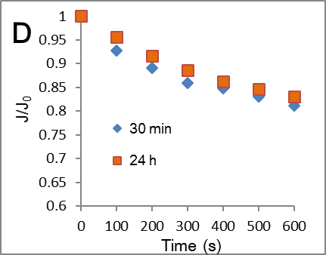
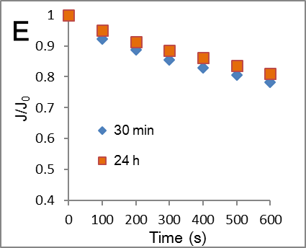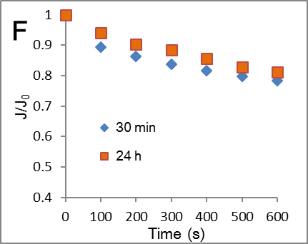

Figure S3. Temporal variation of normalized flux J/J₀ (initial flux J₀) for UF membranes pre-deposited by HAOPs at 30 min and 24 h at pH 7. (A) 10 mg/L HA at low loading, (B) 10 mg/L HA at high loading, (C) 10 mg/L BSA at low loading, (D) 10 mg/L BSA at high loading, (E) 10 mg/L SA at low loading and (F) 10 mg/L SA at high loading. (low loading 4.5 g/m² and high loading 22.5 g/m² as Al₂O₃; J₀=210±10 LMH).

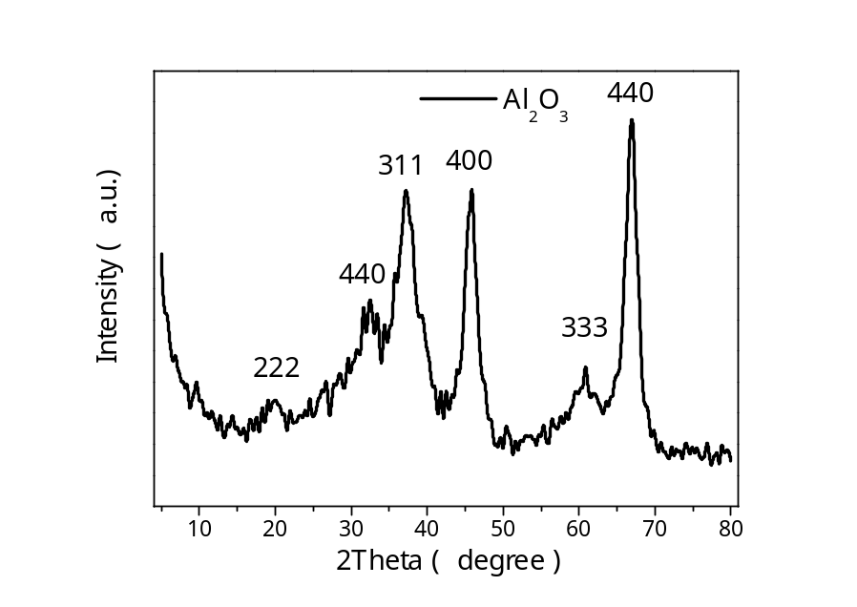
Figure S4. XRD patterns of HAOPs after calcining at 800 ºC (JCPDS No.77-0396).

