Should the Dilated Ascending Aorta be repaired at the time of
Bicuspid Aortic Valve Replacement?

Authors:
Tsuyoshi Kaneko, M.D. ‡
Prem Shekar, M.D. ‡
Vladimir Ivkovic, Ph.D. ‡
Nicholas T. Longford, Ph.D. §
Chuan-Chin Huang, D.Sc. *
Martin Sigurdsson, M.D., Ph.D. *
Robert C. Neely, M.D. ^
Maroun Yammine, M.D. ‡
Julius Ejilofor, M.D., M.P.H. ‡
Vanessa Montiero Vieira, B.S. *
Jasmine T. Shahram, B.S. *
Karam M. Habchi, M.S. *
Gregory W. Malzberg, B.A. *
Jordan Bloom, M.D. †
Eric M. Isselbacher, M.D., M.Sc. ††
J. Daniel Muehlschlegel, M.D., M.M.Sc. *
Bicuspid Aortic Valve Consortium (BAVCon)
Thoralf M. Sundt III, M.D. †
Simon C. Body, M.B.,Ch.B., M.P.H. *

Word Count:

Departments and Institutions:
* Department of Anesthesiology, Perioperative and Pain Medicine
Brigham and Women’s Hospital
75 Francis St
Boston, MA 02115

† Division of Cardiac Surgery
Massachusetts General Hospital
55 Fruit St
Boston, MA 02115

‡ Division of Cardiac Surgery
Brigham and Women’s Hospital
75 Francis St
Boston, MA 02115

^ Department of Surgery
Columbia University Medical Center
177 Fort Washington Avenue
New York, NY 10032

§ Department of Medicine
Imperial College
Chelsea and Westminster Hospital Campus
369 Fulham Road
London SW10 9NH, UK

†† Cardiology Division
Massachusetts General Hospital
55 Fruit St
Boston, MA 02114

Grants: This work was supported by NIH grant R01HL114823 (SCB)
Address for correspondence:
Dr. Simon C Body, M.B.,Ch.B., M.P.H., F.A.H.A.
Department of Anesthesiology, Perioperative and Pain Medicine
Brigham and Women’s Hospital
75 Francis St
Boston, MA 02115
Tel: 617-732-7330
Fax: 617-730-2813
E-mail: sbody@partners.org

ABSTRACT
Background
Objectives
Methods
Results
Conclusions.

INTRODUCTION
Bicuspid aortic valve (BAV) is the most common congenital valvular abnormality, with an overall prevalence of 0.5–2% [1]. Patients with BAV often present with accelerated calcific aortic valve disease (CAVD) requiring aortic valve replacement (AVR), more frequently and earlier than do patients with a tricuspid aortic valve [2,3]. Of patients with echocardiographic diagnosis of BAV, 50% will eventually require AVR [4].
The incidence of ascending aortic dissection in patients with BAV is estimated to be eight times higher than that in the general population [4]. Yet, single-center studies focusing on the long-term risk for dissection after isolated AVR in patients with BAV have yielded conflicting findings [5-8]. The indications for concomitant intervention on the thoracic aorta at the time of AVR are therefore controversial [9-11]. Performing concurrent aortic repair to avoid thoracic aortic aneurysm and dissection (TAAD) has been debated, and the Guideline recommendations (Class of recommendation, IIa; Level of evidence, C-Expert Opinion) for surgical replacement of the ascending aorta based on aortic size that currently state “Replacement of the ascending aorta is reasonable in patients with BAV undergoing AVR because of severe aortic stenosis or aortic regurgitation when the diameter of the ascending aorta is greater than 4.5 cm” [12]. However, the evidence supporting this recommendation is not definitive [6,10,11,13,14] and such an aggressive surgical treatment strategy of BAV-associated aortopathy has been questioned [5,15-17].
Although patient size, or morphometry, is associated with aortic dimensions in patients with bicuspid and tricuspid aortic valves [18-21], normalized aortic dimensions have not been used in Guidelines’ recommendations for surgery. Thus we wanted to examine whether prediction of clinical outcomes would be improved by use of normalized aortic dimensions, therefore assessing the value of accounting for differences in patient morphometry in future Guidelines.
We sought to test the central hypothesis that concurrent repair of dilated or aneurysmal aortic disease during AVR in patients with BAV substantially improves morbidity and mortality outcomes, and that there is an aortic dimension, above which aortic repair yields improved patient outcomes. We tested this hypothesis by comparing long-term outcomes of mortality and reoperation, for adult patients with BAV undergoing primary AVR, with or without concomitant aortic repair over ranges of aortic dimension and age, while accounting for other causes of mortality and reoperation in an observational two-institution study.

METHODS
Patient Selection
From the medical records of Brigham and Women’s Hospital (BWH) and Massachusetts General Hospital (MGH) and with Institutional Review Board approval, 2,148 adults with a BAV undergoing their first aortic valve surgery between 1/1/2002 – 6/30/2014 were identified from institutional Society of Thoracic Surgeons and hospital databases.
Exclusion criteria were age <18 or ≥90 years, documented connective tissue disease, previous aortic valve replacement or repair, previous thoracic aortic surgery including coarctation repair, congenital heart disease other than BAV, native tricuspid aortic valve and patients who underwent transcatheter or transapical aortic valve replacement were excluded from further analysis. Patients undergoing aortic valve replacement for endocarditis, aortic dissection or aortic resection for a calcified aorta were also excluded from analysis. Patients with imaging that was inadequate to distinguish whether the aortic valve was bicuspid or tricuspid, or with inadequate imaging or reporting of the aortic root and ascending aortic diameters were also excluded. After inclusion and exclusion criteria were applied, 1,879 BAV patients were available for analysis (CONSORT diagram, Figure 1).

Data Collection
Patient characteristics and in-hospital outcomes of the index surgery were collected at the time of presentation and extracted from the patients’ electronic medical records. Patient demographics and hospital outcomes were coded and defined according to the Society for Thoracic Surgeons Adult Cardiac Surgery database specifications, version 2.73 [22]. Text searches and individual review of hospital discharge summaries, surgical records and transthoracic and transesophageal echocardiogram reports were performed for diagnosis of BAV. Deciles of income estimated by Zip code of residence [23,24] and comorbidity assessed by modified Elixhauser score [25] derived from ICD-9 codes occurring between 5 years and 30 days prior to the date of surgery and calculated using R [26]. Long-term mortality data were obtained from routine institutional follow-up protocols, from our internal research data repository, and the Massachusetts Department of Public Health and the U.S. Social Security Death Indices. The composite outcome of interest was a composite of all-cause mortality or reoperation upon the aortic valve or ascending aorta. The time to a long-term event was calculated from the date of first surgery to the first documented qualifying event or to 6/30/2015, if none occurred. Patients were followed for a median (10-90%’ile) of 4.3 (1.0 – 9.2) years.

Analysis Plan
To test the central hypothesis that concurrent repair of dilated or aneurysmal aortic disease during AVR in patients with BAV substantially improves morbidity and mortality outcomes, we performed separate analyses on each of two partially-overlapping patient populations. First, we examined only those patients undergoing AVR-only surgery who had a largest aortic dimension ≥35mm, compared to patients undergoing AVR with aortic resection (AVR-AR) who had a largest aortic dimension ≥40mm. These dimensions were chosen because it was assumed that patients with aortic dimensions smaller than these would not be informative to the primary hypothesis but allowed matching using a 5mm difference in aortic dimensions. We used the largest aortic dimension even though there is normal anatomical variation in aortic dimensions between root and tubular aorta because the Guidelines only provide a single value for their recommendation. From the 1,879 patient cohort, 1,325 patients with aortic dimension greater than these cutoffs were included in subsequent analyses. We performed analyses based upon the largest dimension measured at the levels of the sinuses of Valsalva and ascending aorta of each patient independent of anatomical norms, as the current Guidelines do not account for anatomical variation [27,28]. Aortic dimensions in excess of 60mm (n=46) were trimmed to 60 as it was felt that dimensions greater than 60mm would make little additional difference in surgical decision-making.
As normal aortic dimensions are associated with age, gender and body size, we additionally normalized aortic dimensions to Z-scores using a robust population-based algorithm that provides separate estimations for both the sinuses of Valsalva and the ascending aorta and provided a more attractive option for combining dimensions across the length of the ascending aorta [18]. The Z-scores for individuals’ dimensions were calculated and the largest Z-score present for any portion of the aorta was used for analysis [18]. From the 1,879 patient cohort, we examined those patients undergoing AVR-only surgery who had a largest aortic Z-score ≥ 1.0, compared to patients undergoing AVR -AR who had a largest aortic Z-score ≥ 1.96 [19]. 1141 patients with Z-scores above these cutoffs were included in subsequent analyses. Z-scores of 1.96 [19] and 3.0 [29] were used as cut-point values for further examination of outcomes.

Statistical Analysis
Normally distributed variables are summarized by their means and standard deviations. Normality of continuous data was determined by the Kolmogorov-Smirnov test. Non-normally distributed continuous variables are summarized by medians with 10 – 90 percentiles. Group differences in variables were compared by Fisher’s exact test, Student’s t-test or Mann-Whitney’s U test, as appropriate. All statistical tests were 2-sided and a p value <0.05 was considered statistically significant.
We performed both proportional hazards regression modeling and applied the potential outcomes framework (POF) upon the composite outcome of mortality or reoperation. Each analysis method was used on two overlapping patient sets derived from measurements of largest aortic dimension and Z-score (Figure 1).

Proportional Hazards Regression Modeling
A joint outcome of mortality or time to reoperation was analyzed by Kaplan-Meier and a backward stepwise Cox proportional hazards regression. For these analyses we selected variables based on their clinical significance, variation between study cohorts, and known contributions to life expectancy. They included age, chronic obstructive pulmonary disease, hypertension, renal failure, cancer, peripheral vascular disease, diseased coronary vessels, left ventricular ejection fraction, and largest aortic size, amongst others. For exposure and each potential confounder, we first performed univariate analyses, followed by multivariate analysis including all potential confounders with a univariate P value < 0.05. Age, gender, aortic size or Z-score and institution were forced into the model, along with testing for interaction of age with aortic size. The proportional hazards assumption was tested using scaled Schoenfeld residuals. Potential colinearity was examined by reintroducing each omitted variable into the model. Results are presented as hazard ratios (HR) with 95% confidence intervals (CI).

Matching using Potential Outcomes Framework
We conducted a matched pairs analysis comparing AVR-only patients to AVR-AR patients using POF [30-32] to estimate the causal effect of AVR-AR on mortality rate and reoperation, compared to AVR-only. We did this as POF has fewer model assumptions and is better able to account for large differences in many covariates, where assumptions of proportional hazards models are difficult to verify. The background variables were split into three groups according to their perceived importance of matching. For the primary matching variables, pairs were matched on aorta size ± 5mm, age ± 5 years, year of surgery ± 2 years. The secondary matching variables were Elixhauser score ± 2 points, gender and institution. Ages below 40 years were trimmed at 40 years and Elixhauser score was trimmed from below at 1 and from above at 7. Tertiary predictors were selected based on literature review, known confounding covariates for the outcomes of interest, differences between the AVR-only and AVR-AR cohorts and clinical judgment, yielding 49 variables. Next, we defined a distance for every pair of patients based on the individuals’ values of the matching and tertiary background variables. In this distance, each tertiary variable has the same influence, each secondary variable has twice as strong influence and each primary variable has 5 times as strong influence as a tertiary variable. We then applied nearest neighbor matching based on within-pair distance, and selected the nearest unused neighbor to create pairs of patients for comparison. The quality of the match for the two matched groups was assessed by a balance plot, which contrasts the differences of the proportions for categorical variables and the differences of the means for the continuous variables in the entire dataset with their counterparts for the matched pairs (Supplementary Figure 1).
To implement POF, for each matched pair we established which patient (AVR-only
or AVR-AR) had a better composite outcome of mortality or aortic reoperation during the observation period. We were unable to estimate a function of aorta size on age for which the choice between the two treatments is in balance [33]. In order to examine the primary hypothesis, we explored whether there are any particular configurations of age and largest aortic dimension for which deviation from the average treatment effect is substantial, suggesting that AVR-AR should, or should not, be performed. We also performed the same analyses using largest aortic Z-score to determine if there are substantial improvements in predictive value from using normalized aortic dimensions to account for morphological differences.

RESULTS
Whole Cohort Characteristics
Characteristics of the source cohort comprising 1,879 BAV individuals are described in Tables 1 and 2. Distributions of patients’ characteristics at the two institutions were similar (Supplementary Table 1). Some characteristics differed, in part due to systematic differences in data recording depending on STS database version such as seen for medications, NYHA class, prior stroke and the presence of coronary artery disease.
Differences in patient characteristics and aortic dimensions at the time of operation between operative cohorts (AVR-only vs. AVR-AR) were observed (Table 1). The AVR-only cohort was generally older and with a higher prevalence of risk factors for CAVD such as hyperlipidemia, renal failure, diabetes and hypertension than the AVR-AR cohort (Table 1). Patients undergoing AVR-AR were less likely to have coronary artery disease, heart failure, left ventricular dysfunction, and to have undergone prior cardiac surgery. As expected, the AVR-AR cohort had larger average aortic dimensions at operation than the AVR-only cohort (Table 1). The AVR-AR cohort had less severe aortic stenosis but had increased likelihood of aortic regurgitation secondary to aortic root dilation, indicating that both aortic valve dysfunction and aortic dilation drove the propensity towards aortic resection. Patients with prior or concurrent coronary artery bypass grafting or mitral valve surgery during the current surgery were less likely to undergo AVR-AR (Table 1). No patient presented for secondary surgery with ascending aortic dissection.

Study Cohort Characteristics
There was significant subject overlap between the aortic dimension and aortic Z-score cohorts. Of the 1325 patients in the aortic dimension based cohort (AVR-only surgery with largest aortic dimension ≥35mm and AVR-AR surgery with largest aortic dimension ≥40mm) and the 1141 patients in the aortic Z-score based cohort (AVR-only surgery with largest aortic Z-score ≥ 1.0 and AVR -AR with largest aortic Z-score ≥ 1.96), 1115 patients were common to both cohorts (Figure 1). Distributions of patients’ characteristics at the two institutions were similar (Supplementary Tables 2 and 3).
For the cohort of 648 patients with BAV who underwent AVR-only with a largest aortic dimension ≥35 mm and 641 patients with BAV who underwent AVR-AR with a largest aortic dimension ≥40 mm, we observed differences in patient characteristics, aortic valve function and aortic dimensions (Table 2). The AVR-only group was generally younger, and had a higher prevalence of risk factors for CAVD including diabetes, dyslipidemia, hypertension, renal dysfunction and peripheral vascular disease, than did the AVR-AR cohort. They were also more likely to have coronary disease and undergo concomitant coronary artery bypass surgery. Patients in the AVR-AR cohort had larger overall aortic dimensions and Z-scores, but had less severe aortic stenosis. Patients in the AVR-only cohort had smaller aortic valve areas and higher trans-valvular gradients than patients in the AVR-AR cohort who had larger aortic dimensions and greater severity of aortic regurgitation. The AVR-only cohort also had a higher prevalence of moderate or severe mitral regurgitation and concurrent mitral valve surgery.
For the cohorts of 505 patients who underwent AVR-only with a largest aortic Z-score ≥1.0 and 636 patients who underwent AVR-AR with a largest aortic Z-score greater ≥1.96, we observed differences in patient characteristics and in aortic valve function and aortic dimensions (Table 3) that generally resembled those seen in the comparison of cohorts based upon aortic dimensions.

Patient Outcomes
There were no significant differences between the two cohorts in reoperation or mortality outcomes by surgeon, hospital or the operation performed (Table 4 and Supplementary Tables 4 and 5). Event rates were low, with rates of reoperation and death within one year of only 1.8% and 5.4%, respectively. There was no aortic dissection reported during follow-up. There were too few re-operations to permit proportional hazards modeling of re-operative risk alone, therefore the death and reoperation outcomes were combined for all analyses.
Within the observation period, the dimension-based and Z-score based analyses had similar associations with the composite outcome as assessed by logistic regression (Tables 4 and 5). Older age, smoking, cancer and coronary artery disease and its risk factors were associated with the composite outcome. More urgent operations with accompanying CABG were also associated with the outcome. There was no significant association between aortic dimension, type of operation or an interaction term of these two predictors, with outcome occurrence (Tables 4 and 5) except at the 5-year time point where there was a statistically significant excess of events in the AVR group. Censoring events occurred more frequently in the elderly, and in patients with COPD, renal failure, cancer and those with low left ventricular ejection fraction (Table 4). Surprisingly, hypertension was protective for these outcomes, perhaps because it was recognized as a risk factor for aortic dissection and well-treated.
Overall, there was no significant difference in outcomes between the AVR-only and AVR-AR procedures, nor across aortic dimensions or Z-scores (Table 6) when assessed using Cox proportional hazards. The highest hazard ratios were observed for increased age and the use of dialysis preoperatively (Table 6). Although the frequency of events was greater for patients with larger aortic dimensions, this did not reach statistical significance in multivariable analysis for either aortic dimension or Z-scores. The proportional hazards assumption held in the final multivariate models (P=0.18 for dimension-based analysis and P=0.26 for Z-score based analysis).

Analysis using the potential outcomes framework
POF was applied to the cohorts defined by aortic dimension and Z-score in separate analyses. By applying a combination of caliper and nearest-neighbor matching, we obtained 292 matched pairs of patients, one patient from each surgical group in each pair. In 21 of these pairs the AVR-only patient had a superior outcome to his or her AVR-AR match, and in 15 pairs the AVR-AR patient had a superior outcome (P=0.30); see Supplementary Figure 2, where their values of aortic dimension and age can be compared informally.
The results of the POF analysis of event-free survival over the study period in the cohort classified using aortic dimensions are shown as a 'heat map' (Figures 3A and B). Preference for one operation over the other is shown in Figure 3A; a smoothed representation of Supplementary Figure 2, with the same axes (age and aortic dimension). The effective sample size shows the effective sample size, interpreted as level of precision for the configurations of age and aortic dimension is shown in Figure 3B. The greatest statistical power was achieved for ages 55-80 years and an aortic dimension around 45mm (Figure 3B), but in this range neither operation performed substantially better than the other (Figure 3A).
After transforming aortic dimensions to Z-scores, there was no important overall difference in outcomes and no change in the conclusion that AVR-AR is not associated with improvement in outcomes for any aortic dimension or age group. Analysis of specific Z-score subgroups showed no advantage for patients with a Z-score between 1.96 – 3.0, or for a Z score ≥3 (Supplementary Figure 3).

DISCUSSION
This observational study compared mortality and aortic reoperation in adults with BAV who underwent AVR with a dilated aortic root or ascending aorta in a large two-institution study with tertiary expertise in aortic surgery to determine the effect of concurrent aortic resection upon a composite mortality and aortic reoperation outcome. Our aims were to determine ages and aortic dimensions that concurrent repair of dilated or aneurysmal aortic disease during AVR in patients with BAV, substantially improves morbidity and mortality outcomes. We performed two separate statistical analyses, each with their own strengths, in order to assess the relative value of each operation over a range of ages and assessing aortic size by largest aortic dimension and by largest dimensionless Z-score estimated using a population-based algorithm that accounts for differences in normal aortic dimensions in the aortic root and ascending aorta.
Our principal findings were: (1) There was a very low incidence of mortality and reoperation after both operations, leading a conclusion that both operations are reasonable choices for patients. (2) We were unable to identify an age or aortic dimension, or combination thereof associated with better or worse outcomes after each operation. Even though this study encompassed a 12-year experience at two major tertiary care institutions, the incidence of mortality and reoperation was too low to allow analysis of age or aortic dimension subgroups. (3) Use of Z-scores to account for patient morphometry did not provide improved association of aortic size with outcomes. Although it is likely that this finding is due to the low incidence of events, there was no apparent trend for improvement in prediction when accounting for patient morphometry. These findings lead us to the conclusions that both operations are safe and have utility over a wide range of age and aortic sizes.
Complexity in Decision-Making
The decision if and when to operate on the dilated bicuspid ascending aorta is one of the more complex in medicine. There are conflicting facts in play when making the decision. (1) The risk of aortic dissection is probably higher in patients with BAV. (2) The absolute rate of aortic dissection is low. (3) Even though the relative risk of aortic dissection increases with increased aortic size, the majority of aortic dissections occur at low dimensions. (4) Reoperation upon the ascending aorta is more difficult and carries more risk than primary aortic repair, therefore favoring concurrent operation. (5) There is variability in the rate of aortic dilation amongst individuals, both before and after AVR, which cannot be accurately foretold for an individual patient.

Absolute and Relative Risk of Aortic Dissection
The principal rationale for performing aortic replacement concurrently with surgical AVR in patients with BAV is to prevent subsequent aortic dissection and to reduce the need for later reoperative surgery for aortic aneurysm. The relative overabundance of aortic dilation, aneurysm and aortic dissection in patients with BAV, compared to those with TAV is well recognized [34-37] but not uniformly supported [8,38,39]. However, it is far from clear whether the absolute risk of aortic rupture or dissection mandates a different surgical approach compared to the tricuspid aortic valve. Early studies indicated a 16% aortic dissection or aortic aneurysm operation rate over 20 years of follow-up in patients with BAV [11] and that freedom from reoperation for aortic replacement was reduced in patients with larger initial aortic dimensions [10]. In contrast, in one of the largest studies [7], there was a reported 1% aortic dissection rate and a 10% rate of progressive aortic enlargement over a 12-year follow-up period, well below that previously reported. One of the most difficult aspects of preventing thoracic aortic dissection in BAV is that the majority of aortic dissections occur at an aortic dimension <55mm [40], even though the relative risk is much higher as the aorta dilates. Furthermore, it is now recognized that the aortic size measured at dissection is considerably larger than present prior to dissection, thus prior studies may have over-estimated aortic size and ascribed increased risk to much larger aortic dimensions than present pre-dissection [41].
Thus, it appears that the absolute rate of aortic dissection is very low, especially over the last decade [4,6-8,42]. These conflicting findings have brought considerable debate and recent revision of Guidelines. The debate is further fueled by Guidelines that do not take into account other patient characteristics, such as age, untreated hypertension, renal or cardiac disease, family history or genetic findings. Given such a low rate of dissection, the operative risk must be low in order to justify resection.

Does the Non-resected Aorta Dilate Disproportionately
Some individuals with BAV have progressive aortic dilation after AVR and are likely to have an increasing risk of aortic dissection over time or to progress above a Guideline dimension for aortic resection, thus indicating a reoperation. Confounding surgical decision-making, several studies have shown that disproportionate aortic dilation does [43-45], or does not [6,42,46-49], occur after resection of a diseased BAV. It seems likely that mean aortic size does increase, but not disproportionate to the general population, after accounting for age and body habitus. However, some individuals in all studies dilate at rate in excess of the population average, whether or not the BAV is resected [50,51].
To date, there is no valid prediction index for aortic dilation [48,50,52]. In the absence of a reasonable method for predicting those who will have disproportionate aortic dilation, there are strong patient and physician forces favoring resection at lower aortic dimensions, especially given the now low surgical risks of aortic resection we, and others, have observed.

Limitations
Retrospective cohort study design has inherent limitations but is the only feasible method to assess long-term BAV outcomes. Patients were not randomly assigned to undergo concurrent aortic resection, thus there is considerable opportunity for bias by clinical presentation or surgical practices that are possibly unaccounted for in this study. Although both statistical techniques used in this study are designed to reduce systematic bias in retrospective observational studies, they are unable to account for unmeasured confounders.
We used all-cause rather than cardiac-specific mortality in all analyses, which can be disadvantageous as it includes mortality that is not due the primary disease. However, it does allow for a more complete accounting of mortality and accounts for competing risks of death and potential biases observed in cause-of-death reporting. We are unable to identify reoperations that occurred at other institutions or aortic dissection not causing mortality outside our network. This may result in systematic under-reporting but it unlikely to bias study findings towards favoring either operation.
There are known systematic differences in methods of aortic dimension measurement between imaging modalities and use of anatomical landmarks for estimating aortic dimension. These differences were probably small and unlikely to have affected surgical decision-making as surgical decision-making is usually based on reported aortic dimensions.
Although this study covers more than 12-years experience at two major tertiary care institutions, only 1,325 patients with complete data were identified and the follow-up period was relatively short. Thus, there is a clear need for lifelong outcomes studies with detailed longitudinal imaging of the aorta to establish strong, well-supported conclusions that are best approached by longitudinal consortium studies.

CONCLUSIONS
Our results do not provide support for the 45mm aortic dimension recommended in the current Guidelines for aortic resection while performing AVR [12]. Although there are strong patient and provider forces favoring aortic resection at relatively low aortic dimensions to avoid a need for reoperation or aortic dissection, this study reports a very low rate of reoperation for aortic dilation. Of course, the low risk of reoperation in the AVR-only group needs to be balanced against the similarly-low risk of undergoing concomitant aortic replacement at the time of AVR. The findings of this study do not support either approach and thus does not establish an aortic dimensional threshold to guide decision-making for an individual patient within the range of 40-60mm. Rather, they support a research direction that decisions about operative management of aortic disease should not only be based upon aortic dimensions. Additional patient-specific decision-making may benefit from development of 4D-flow magnetic resonance imaging, molecular imaging of the aorta, enhanced intraoperative surgical observation including perception of aortic wall integrity, preoperative genotyping and biomarker studies, and intraoperative histological findings. Advances in surgical and less-invasive techniques may alter the risk-benefit analysis in the future. The use of TAVR in lower risk populations may reduce the impetus for concurrent aortic resection, as the chest doesn’t have to be opened for TAVR.

PERSPECTIVES
Competency in Medical Knowledge: Patients with bicuspid aortic valve (BAV) disease have a low but still increased risk of aortic root and ascending aortic aneurysm and dissection compared to the general population. Repair of the aortic root or ascending aorta during aortic valve surgery has very low risk but does not have significant mortality or reoperation advantage compared to aortic valve replacement surgery alone.
Competency in Patient Care: There is no support from this study for Guideline recommendations supporting aortic repair above a certain aortic dimension between the range of 40-60mm while performing concurrent aortic valve replacement. Patient-specific treatment decisions should take patient factors into account, in addition to aortic dimension.
Translational Outlook 1: Fundamental limitations to observational studies mandate prospective, longitudinal consortium-based studies to examine the importance of aortic dimensions and other detailed patient phenotyping upon long-term outcomes.

Table 1. Demographic, medical and surgical characteristics and aortic dimensions of 1,879 patients without exclusion criteria, undergoing aortic valve replacement, with or without ascending aortic aneurysm repair.
 | Spacer | AVR only (N=1229) | Spacer | AVR and AAA (N=650) | Spacer | P value
Preoperative data
Age at AVR (years; N/%)
< 50 |  | 127 (10%) |  | 49 (8%) |  | 0.0004
50-59 |  | 194 (16%) |  | 106 (16%) |  | 0.0004
60-69 |  | 327 (27%) |  | 160 (25%) |  | 0.0004
70-79 |  | 347 (28%) |  | 242 (37%) |  | 0.0004
≥80 |  | 234 (19%) |  | 93 (14%) |  | 0.0004
Gender (Female; N/%) |  | 379 (31%) |  | 159 (24%) |  | 0.003
Race (Caucasian; N/%) |  | 1158 (94%) |  | 624 (96%) |  | 0.092
Height (cm; mean/SD) |  | 172 (10) |  | 174 (10) |  | <0.0001
Weight (kg; mean/SD) |  | 84 (19) |  | 86 (18) |  | 0.096
BSA (m2; mean/SD) |  | 1.96 (0.24) |  | 2.00 (0.23) |  | 0.004
BMI (kg/m2; mean/SD) |  | 28 (6) |  | 28 (5) |  | 0.7
BMI>30 kg/m2 (N/%) |  | 390 (32%) |  | 194 (30%) |  | 0.4
Income decile (N/%)
0-4 |  | 84 (7%) |  | 44 (7%) |  | 0.89
5-7 |  | 168 (14%) |  | 85 (13%) |  | 0.89
8-10 |  | 943 (79%) |  | 509 (80%) |  | 0.89
Elixhauser score (N/%)
0-4 |  | 888 (72%) |  | 422 (66%) |  | 0.0001
5-6 |  | 341 (28%) |  | 224 (34%) |  | 0.0001
>6 |  | 0 (0%) |  | 4 (1%) |  | 0.0001
Smoker past or current (N/%) |  | 448 (36%) |  | 208 (32%) |  | 0.053
COPD (N/%) |  | 158 (13%) |  | 60 (9%) |  | 0.017
Diabetes (N/%) |  | 212 (17%) |  | 43 (7%) |  | <0.0001
Dyslipidemia (N/%) |  | 826 (67%) |  | 339 (52%) |  | <0.0001
Hypertension (N/%) |  | 753 (61%) |  | 357 (55%) |  | 0.007
Preop creatinine (mean/SD) |  | 1.10 (0.53) |  | 1.04 (0.44) |  | 0.011
Preop dialysis (N/%) |  | 8 (1%) |  | 4 (1%) |  | 0.93
Cancer (N/%) |  | 202 (16%) |  | 83 (13%) |  | 0.03
Prior stroke (N/%) |  | 81 (7%) |  | 31 (5%) |  | 0.11
Peripheral vascular disease (N/%) |  | 92 (7%) |  | 107 (16%) |  | <0.0001
Medications
Beta blocker (N/%) |  | 179 (15%) |  | 127 (20%) |  | 0.0002
ACEI/ARB (N/%) |  | 96 (8%) |  | 37 (6%) |  | 0.0008
Lipid lowering (N/%) |  | 348 (31%) |  | 153 (24%) |  | <0.0001
Prior Cardiac Status
NYHA class (N/%)
I or II |  | 289 (56%) |  | 226 (73%) |  | <0.0001
III |  | 183 (36%) |  | 71 (23%) |  | <0.0001
IV |  | 40 (8%) |  | 14 (5%) |  | <0.0001
Heart failure (N/%) |  | 227 (18%) |  | 97 (15%) |  | 0.051
Prior CABG surgery (N/%) |  | 48 (6%) |  | 3 (1%) |  | <0.0001
Prior non-aortic valve surgery (N/%) |  | 29 (3%) |  | 9 (2%) |  | 0.16
Spacer
Coronary and Valve Disease
Coronary artery disease (N/%) |  | 639 (52%) |  | 232 (36%) |  | <0.0001
Diseased coronary vessels (N/%)
0 |  | 813 (66%) |  | 528 (81%) |  | <0.0001
1 |  | 195 (16%) |  | 63 (10%) |  | <0.0001
2 |  | 119 (10%) |  | 31 (5%) |  | <0.0001
3 |  | 102 (8%) |  | 28 (4%) |  | <0.0001
Aortic insufficiency (N/%)
None, Trace or Mild |  | 843 (69%) |  | 376 (58%) |  | <0.0001
Moderate |  | 215 (17%) |  | 178 (27%) |  | <0.0001
Severe |  | 171 (14%) |  | 96 (15%) |  | <0.0001
Aortic valve area (cm2; mean/SD) |  | 0.78 (0.28) |  | 0.91 (0.38) |  | <0.0001
Ao valve mean gradient (mmHg; mean/SD) |  | 50 (19) |  | 44 (19) |  | <0.0001
Mitral incompetence (N/%)
None, Trace or Mild |  | 1024 (83%) |  | 571 (88%) |  | 0.024
Moderate |  | 151 (12%) |  | 55 (8%) |  | 0.024
Severe |  | 54 (4%) |  | 23 (4%) |  | 0.024
LV ejection fraction (N/%)
<30% |  | 69 (6%) |  | 17 (3%) |  | 0.0004
30-49% |  | 132 (11%) |  | 60 (9%) |  | 0.0004
≥50% |  | 1012 (83%) |  | 562 (88%) |  | 0.0004
Aortic measurements (mm)
Aortic root dimension (mean; SD; N) |  | 34.1 / 5.9 / 507 |  | 39.5 / 7.1 / 376 |  | <0.0001
median (10-90% CI) |  | 34 (27 - 42) |  | 39 (31 - 49) |  | <0.0001
Sinotubular junction dimension (mean; SD; N) |  | 30.2 / 5.7 / 726 |  | 36.7 / 7.1 / 382 |  | <0.0001
median (10-90% CI) |  | 30 (24 - 38) |  | 36 (29 - 47) |  | <0.0001
Ascending aorta dimension (mean; SD; N) |  | 36.9 / 6.2 / 825 |  | 47.7 / 5.6 / 634 |  | <0.0001
median (10-90% CI) |  | 37 (30 - 46) |  | 47 (42 - 54) |  | <0.0001
Largest aortic dimension (mean; SD; N) |  | 35.8 / 6.4 / 1229 |  | 48.4 / 5.2 / 650 |  | <0.0001
median (10-90% CI) |  | 35 (28 - 44) |  | 48 (43 - 55) |  | <0.0001
Aortic measurements (Z-score)
Aortic root Z-score (mean; SD; N) |  | -0.62 / 1.84 / 507 |  | 0.97 / 1.96 / 375 |  | <0.0001
median (10-90% CI) |  | -0.69 (-2.71 - 1.84) |  | 0.80 (-1.34 - 3.54) |  | <0.0001
Z-score > 1.96 (N, %) |  | 44 (15%) |  | 105 (28%) |  | <0.0001
Z-score > 3.0 (N, %) |  | 15 (5%) |  | 56 (15%) |  | <0.0001
STJ Asc Ao Z-score (mean; SD; N) |  | 0.86 / 1.72 / 998 |  | 3.77 / 1.12 / 643 |  | <0.0001
median (10-90% CI) |  | 0.86 (-1.34 - 2.91) |  | 3.77 (2.46 - 5.08) |  | <0.0001
Z-score > 1.96 (N, %) |  | 243 (24%) |  | 625 (97%) |  | <0.0001
Z-score > 3.0 (N, %) |  | 91 (9%) |  | 488 (76%) |  | <0.0001
Largest aortic Z-score (mean; SD; N) |  | 0.58 / 1.86 / 1229 |  | 3.81 / 1.08 / 650 |  | <0.0001
median (10-90% CI) |  | 0.70 (-1.83 - 2.84) |  | 3.81 (2.50 - 5.08) |  | <0.0001
Z-score > 1.96 (N, %) |  | 267 (22%) |  | 636 (98%) |  | <0.0001
Z-score > 3.0 (N, %) |  | 101 (8%) |  | 499 (77%) |  | <0.0001
Spacer
Operation
Hospital
BWH |  | 433 (35%) |  | 293 (45%) |  | <0.0001
MGH |  | 796 (65%) |  | 357 (55%) |  | <0.0001
Year of operation (N/%)
2002-2003 |  | 121 (10%) |  | 37 (6%) |  | 0.0005
2004-2005 |  | 143 (12%) |  | 74 (11%) |  | 0.0005
2006-2007 |  | 207 (17%) |  | 94 (14%) |  | 0.0005
2008-2009 |  | 225 (18%) |  | 160 (25%) |  | 0.0005
2010-2011 |  | 248 (20%) |  | 151 (23%) |  | 0.0005
2012-2013 |  | 285 (23%) |  | 134 (21%) |  | 0.0005
Urgency (N/%)
Elective |  | 961 (78%) |  | 557 (86%) |  | <0.0001
Not elective |  | 268 (22%) |  | 93 (14%) |  | <0.0001
CABG performed (N/%) |  | 316 (26%) |  | 106 (16%) |  | <0.0001
DHCA used (N/%) |  | 5 (0%) |  | 360 (56%) |  | <0.0001
Operation (N/%)
AVR only |  | 1229 (100%) |  | - |  | -
AVR & Asc Ao |  | - |  | 650 (100%) |  | -
Aortic valve implant type (N/%)
Mechanical |  | 210 (21%) |  | 149 (26%) |  | 0.0009
Bioprosthesis |  | 910 (79%) |  | 430 (74%) |  | 0.0009
Mitral valve repair or replacement (N/%) |  | 82 (7%) |  | 21 (3%) |  | 0.0012

Table 2. Demographic, medical and surgical characteristics and aortic dimensions of 1,325 patients without exclusion criteria and with aortic dimensions ≥35mm (for the aortic valve replacement cohort) or 40mm (for the aortic valve replacement with ascending aortic aneurysm repair cohort).
 |  | AVR only (N=648) |  | AVR and AAA (N=641) |  | P value
Preoperative data
Age at AVR (years; N/%)
< 50 |  | 38 (6%) |  | 47 (7%) |  | <0.0001
50-59 |  | 81 (12%) |  | 104 (16%) |  | <0.0001
60-69 |  | 151 (22%) |  | 159 (25%) |  | <0.0001
70-79 |  | 225 (33%) |  | 239 (37%) |  | <0.0001
≥80 |  | 189 (28%) |  | 92 (14%) |  | <0.0001
Gender (Female; N/%) |  | 148 (22%) |  | 155 (24%) |  | 0.27
Race (Caucasian; N/%) |  | 642 (94%) |  | 618 (96%) |  | 0.041
Height (cm; mean/SD) |  | 174 (10) |  | 174 (10) |  | 0.52
Weight (kg; mean/SD) |  | 86 (18) |  | 86 (18) |  | 0.66
BSA (m2; mean/SD) |  | 2.01 (0.23) |  | 2.01 (0.23) |  | 0.95
BMI (kg/m2; mean/SD) |  | 28 (6) |  | 28 (5) |  | 0.35
BMI>30 kg/m2 (N/%) |  | 208 (30%) |  | 192 (30%) |  | 0.86
Income decile (N/%)
0-4 |  | 44 (7%) |  | 44 (7%) |  | 0.94
5-7 |  | 92 (14%) |  | 84 (13%) |  | 0.94
8-10 |  | 526 (79%) |  | 501 (80%) |  | 0.94
Elixhauser score (N/%)
0-4 |  | 483 (71%) |  | 414 (65%) |  | 0.005
5-6 |  | 201 (29%) |  | 223 (35%) |  | 0.005
>6 |  | 0 (0%) |  | 4 (1%) |  | 0.005
Smoker past or current (N/%) |  | 236 (35%) |  | 206 (32%) |  | 0.38
COPD (N/%) |  | 84 (12%) |  | 58 (9%) |  | 0.06
Diabetes (N/%) *NIDDM or IDDM |  | 112 (16%) |  | 43 (7%) |  | <0.0001
Dyslipidemia (N/%) |  | 454 (66%) |  | 335 (52%) |  | <0.0001
Hypertension (N/%) |  | 414 (61%) |  | 352 (55%) |  | 0.039
Preop creatinine (mean/SD) |  | 1.12 (0.61) |  | 1.04 (0.44) |  | 0.0069
Preop dialysis (N/%) |  | 5 (1%) |  | 4 (1%) |  | 0.99
Cancer (N/%) |  | 108 (16%) |  | 82 (13%) |  | 0.14
Prior stroke (N/%) |  | 45 (7%) |  | 31 (5%) |  | 0.19
Peripheral vascular disease (N/%) |  | 48 (7%) |  | 107 (17%) |  | <0.0001
Spacer
Medications
Beta blocker (N/%) |  | 112 (16%) |  | 127 (20%) |  | 0.002
ACEI/ARB (N/%) |  | 55 (8%) |  | 36 (6%) |  | 0.0004
Lipid lowering (N/%) |  | 214 (31%) |  | 153 (24%) |  | 0.002
Spacer
Prior Cardiac Status
NYHA class (N/%)
I or II |  | 270 (58%) |  | 225 (73%) |  | 0.001
III |  | 100 (34%) |  | 70 (23%) |  | 0.001
IV |  | 21 (7%) |  | 14 (5%) |  | 0.001
Heart failure (N/%) |  | 136 (20%) |  | 97 (15%) |  | 0.025
Prior CABG surgery (N/%) |  | 29 (6%) |  | 3 (1%) |  | <0.0001
Prior non-aortic valve surgery (N/%) |  | 14 (3%) |  | 9 (2%) |  | 0.41
Coronary and Valve Disease
Coronary artery disease (N/%) |  | 342 (50%) |  | 230 (36%) |  | <0.0001
Diseased coronary vessels (N/%)
0 |  | 465 (68%) |  | 520 (81%) |  | <0.0001
1 |  | 97 (14%) |  | 62 (10%) |  | <0.0001
2 |  | 64 (19%) |  | 31 (5%) |  | <0.0001
3 |  | 58 (8%) |  | 28 (4%) |  | <0.0001
Aortic insufficiency (N/%)
None, Trace or Mild |  | 452 (66%) |  | 370 (58%) |  | 0.0001
Moderate |  | 121 (18%) |  | 175 (27%) |  | 0.0001
Severe |  | 111 (16%) |  | 96 (15%) |  | 0.0001
Aortic valve area (cm2; mean/SD) |  | 0.80 (0.30) |  | 0.92 (0.39) |  | <0.0001
Ao valve mean gradient (mmHg; mean/SD) |  | 50 (19) |  | 44 (19) |  | <0.0001
Mitral incompetence (N/%)
None, Trace or Mild |  | 569 (83%) |  | 563 (88%) |  | 0.045
Moderate |  | 86 (13%) |  | 55 (9%) |  | 0.045
Severe |  | 29 (4%) |  | 23 (4%) |  | 0.045
LV ejection fraction (N/%)
<30% |  | 45 (7%) |  | 17 (3%) |  | 0.0013
30-49% |  | 75 (11%) |  | 60 (10%) |  | 0.0013
≥50% |  | 554 (82%) |  | 553 (88%) |  | 0.0013
Aortic measurements (mm)
Aortic root dimension (mean; SD; N) |  | 37.3 / 5.3 / 289 |  | 39.6 / 7.1 / 367 |  | <0.0001
median (10-90% CI) |  | 37 (31-44) |  | 39 (31-49) |  | <0.0001
Sinotubular junction dimension (mean; SD; N) |  | 32.8 / 5.8 / 396 |  | 36.8 / 7.1 / 373 |  | <0.0001
median (10-90% CI) |  | 32 (26-41) |  | 36 (29-47) |  | <0.0001
Ascending aorta dimension (mean; SD; N) |  | 39.8 / 5.0 / 559 |  | 47.9 / 5.5 / 625 |  | <0.0001
median (10-90% CI) |  | 39 (35-46) |  | 47 (42 - 54) |  | <0.0001
Largest aortic dimension (mean; SD; N) |  | 40.3 / 4.5 / 684 |  | 48.5 / 5.1 / 641 |  | <0.0001
median (10-90% CI) |  | 39 (35-46) |  | 48 (43 - 55) |  | <0.0001
Aortic measurements (Z-score)
Aortic root Z-score (mean; SD; N) |  | 0.23 / 1.68 / 289 |  | 0.98 / 1.97 / 367 |  | <0.0001
median (10-90% CI) |  | 0.22 (-1.9-2.41) |  | 0.81 (-1.33 - 3.58) |  | <0.0001
Z-score > 1.96 (N, %) |  | 44 (15%) |  | 104 (28%) |  | <0.0001
Z-score > 3.0 (N, %) |  | 15 (5%) |  | 56 (15%) |  | <0.0001
STJ Asc Ao Z-score (mean; SD; N) |  | 1.81 / 1.23 / 604 |  | 3.79 / 1.11 / 634 |  | <0.0001
median (10-90% CI) |  | 1.73 (0.45 - 3.39) |  | 3.79 (2.49 - 5.08) |  | <0.0001
Z-score > 1.96 (N, %) |  | 243 (40%) |  | 619 (98%) |  | <0.0001
Z-score > 3.0 (N, %) |  | 91 (15%) |  | 487 (77%) |  | <0.0001
Largest aortic Z-score (mean; SD; N) |  | 1.75 / 1.23 / 684 |  | 3.84 / 1.07 / 641 |  | <0.0001
median (10-90% CI) |  | 1.67 (0.34-3.37) |  | 3.83 (2.53 - 5.11) |  | <0.0001
Z-score > 1.96 (N, %) |  | 267 (39%) |  | 630 (98%) |  | <0.0001
Z-score > 3.0 (N, %) |  | 101 (15%) |  | 498 (78%) |  | <0.0001
Spacer
Operation
Hospital
BWH |  | 246 (36%) |  | 291 (45%) |  | 0.0005
MGH |  | 438 (64%) |  | 350 (55%) |  | 0.0005
Year of operation (N/%)
2002-2003 |  | 61 (9%) |  | 36 (6%) |  | <0.0001
2004-2005 |  | 74 (11%) |  | 73 (11%) |  | <0.0001
2006-2007 |  | 131 (19%) |  | 93 (15%) |  | <0.0001
2008-2009 |  | 111 (16%) |  | 156 (24%) |  | <0.0001
2010-2011 |  | 128 (19%) |  | 150 (23%) |  | <0.0001
2012-2013 |  | 179 (26%) |  | 133 (21%) |  | <0.0001
Urgency (N/%)
Elective |  | 553 (81%) |  | 549 (86%) |  | 0.019
Not elective |  | 131 (19%) |  | 92 (14%) |  | 0.019
CABG performed (N/%) |  | 160 (23%) |  | 105 (16%) |  | 0.002
DHCA used (N/%) |  | 1 (0%) |  | 357 (56%) |  | <0.0001
Operation (N/%)
AVR only |  | 684 (100%) |  | - |  | -
AVR & Asc Ao |  | - |  | 641 (100%) |  | -
Aortic valve implant type (N/%)
Mechanical |  | 129 (21%) |  | 148 (26%) |  | 0.038
Bioprosthesis |  | 489 (79%) |  | 422 (74%) |  | 0.038
Mitral valve repair or replacement (N/%) |  | 47 (7%) |  | 21 (3%) |  | 0.004

Table 3. Demographic, medical and surgical characteristics and aortic dimensions of 1,141 patients without exclusion criteria and with aortic Z-scores ≥1 (for the aortic valve replacement cohort) or 1.96 (for the aortic valve replacement with ascending aortic aneurysm repair cohort).
 |  |  | AVR only (N=505) |  | AVR and AAA (N=636) |  | P value
Preoperative data
Age at AVR (years; N/%)
< 50 |  |  | 48 (10%) |  | 49 (8%) |  | 0.0006
50-59 |  |  | 73 (14%) |  | 105 (17%) |  | 0.0006
60-69 |  |  | 111 (22%) |  | 158 (25%) |  | 0.0006
70-79 |  |  | 153 (30%) |  | 233 (37%) |  | 0.0006
≥80 |  |  | 120 (24%) |  | 91 (14%) |  | 0.0006
Gender (Female; N/%) |  |  | 130 (26%) |  | 158 (25%) |  | 0.73
Race (Caucasian; N/%) |  |  | 471 (93%) |  | 612 (96%) |  | 0.024
Height (cm; mean/SD) |  |  | 172 (10) |  | 174 (10) |  | 0.015
Weight (kg; mean/SD) |  |  | 82 (18) |  | 85 (18) |  | 0.013
BSA (m2; mean/SD) |  |  | 1.95 (0.23) |  | 1.99 (0.23) |  | 0.005
BMI (kg/m2; mean/SD) |  |  | 28 (5) |  | 28 (5) |  | 0.17
BMI>30 kg/m2 (N/%) |  |  | 131 (26%) |  | 185 (29%) |  | 0.26
Income decile (N/%)
0-4 |  |  | 37 (8%) |  | 44 (7%) |  | 0.94
5-7 |  |  | 66 (14%) |  | 83 (13%) |  | 0.94
8-10 |  |  | 386 (79%) |  | 497 (80%) |  | 0.94
Elixhauser score (N/%)
0-4 |  |  | 359 (71%) |  | 415 (65%) |  | 0.014
5-6 |  |  | 146 (29%) |  | 217 (34%) |  | 0.014
>6 |  |  | 0 (0%) |  | 4 (1%) |  | 0.014
Smoker past or current (N/%) |  |  | 163 (32%) |  | 202 (32%) |  | 0.85
COPD (N/%) |  |  | 55 (11%) |  | 56 (9%) |  | 0.23
Diabetes (N/%) *NIDDM or IDDM |  |  | 69 (14%) |  | 40 (6%) |  | <0.0001
Dyslipidemia (N/%) |  |  | 299 (59%) |  | 327 (51%) |  | 0.01
Hypertension (N/%) |  |  | 279 (55%) |  | 346 (54%) |  | 0.75
Preop creatinine (mean/SD) |  |  | 1.10 (0.62) |  | 1.04 (0.44) |  | 0.038
Preop dialysis (N/%) |  |  | 3 (1%) |  | 4 (1%) |  | 0.94
Cancer (N/%) |  |  | 71 (14%) |  | 81 (13%) |  | 0.51
Prior stroke (N/%) |  |  | 36 (7%) |  | 30 (5%) |  | 0.097
Peripheral vascular disease (N/%) |  |  | 30 (6%) |  | 106 (17%) |  | <0.0001
Spacer
Medications
Beta blocker (N/%) |  |  | 72 (14%) |  | 125 (20%) |  | <0.0001
ACEI/ARB (N/%) |  |  | 39 (7%) |  | 36 (6%) |  | <0.0001
Lipid lowering (N/%) |  |  | 140 (28%) |  | 148 (23%) |  | 0.1
Spacer
Prior Cardiac Status
NYHA class (N/%)
I or II |  |  | 116 (59%) |  | 223 (73%) |  | 0.005
III |  |  | 64 (33%) |  | 69 (23%) |  | 0.005
IV |  |  | 16 (8%) |  | 14 (5%) |  | 0.005
Heart failure (N/%) |  |  | 82 (16%) |  | 94 (15%) |  | 0.51
Prior CABG surgery (N/%) |  |  | 18 (5%) |  | 3 (1%) |  | <0.0001
Prior non-aortic valve surgery (N/%) |  |  | 13 (4%) |  | 9 (2%) |  | 0.01
Coronary and Valve Disease
Coronary artery disease (N/%) |  |  | 232 (4627 |  | 225 (35%) |  | 0.0003
Diseased Coronary Vessels (N/%)
0 |  |  | 364 (72%) |  | 518 (81%) |  | 0.001
1 |  |  | 63 (11%) |  | 61 (10%) |  | 0.001
2 |  |  | 47 (9%) |  | 31 (5%) |  | 0.001
3 |  |  | 31 (6%) |  | 26 (4%) |  | 0.001
Aortic insufficiency (N/%)
None, Trace or Mild |  |  | 313 (62%) |  | 366 (58%) |  | 0.003
Moderate |  |  | 98 (19%) |  | 176 (27%) |  | 0.003
Severe |  |  | 94 (19%) |  | 94 (15%) |  | 0.003
Aortic valve area (cm2; mean/SD) |  |  | 0.81 (0.33) |  | 0.92 (0.39) |  | 0.0002
Ao valve mean gradient (mmHg; mean/SD) |  |  | 50 (20) |  | 44 (19) |  | <0.0001
Mitral incompetence (N/%)
None, Trace or Mild |  |  | 426 (84) |  | 558 (88%) |  | 0.22
Moderate |  |  | 59 (12%) |  | 55 (9%) |  | 0.22
Severe |  |  | 20 (4%) |  | 23 (4%) |  | 0.22
LV ejection fraction (N/%)
<30% |  |  | 14 (5%) |  | 16 (3%) |  | 0.043
30-49% |  |  | 47 (9%) |  | 58 (9%) |  | 0.043
≥50% |  |  | 422 (85%) |  | 551 (88%) |  | 0.043
Aortic measurements (mm)
Aortic root (mean; SD; N) |  |  | 37.8 / 6.3 / 188 |  | 39.6 / 7.1 / 365 |  | 0.003
median (10-90% range) |  |  | 38 (29 - 46) |  | 39 (31 - 49) |  | 0.025
Sinotubular junction (mean; SD; N) |  |  | 33.3 / 6.0 / 307 |  | 36.7 / 7.2 / 372 |  | <0.0001
median (10-90% range) |  |  | 33 (26 - 41) |  | 36 (29 - 47) |  | <0.0001
Ascending aorta (mean; SD; N) |  |  | 40.7 / 5.1 / 448 |  | 47.9 / 5.6 / 621 |  | <0.0001
median (10-90% range) |  |  | 40 (36 - 47) |  | 47 (42 - 54) |  | <0.0001
Largest aortic dimension (mean; SD; N) |  |  | 41.4 / 4.7 / 505 |  | 48.5 / 5.09 / 636 |  | <0.0001
median (10-90% range) |  |  | 41 (36 - 48) |  | 48 (43 - 55) |  | <0.0001
Aortic measurements (Z-score)
Aortic root (mean; SD; N) |  |  | 0.5 / 1.9 / 188 |  | 1.0 / 1.94 / 365 |  | 0.004
median (10-90% range) |  |  | 0.7 (-2.1 - 2.9) |  | 0.8 (-1.3 - 3.6) |  | 0.030
Z-score > 1.96 (N, %) |  |  | 44 (23%) |  | 105 (29%) |  | 0.19
Z-score > 3.0 (N, %) |  |  | 15 (8%) |  | 56 (15%) |  | 0.015
STJ Asc Ao (mean; SD; N) |  |  | 2.2 / 1.1 / 479 |  | 3.8 / 1.1 / 629 |  | <0.0001
median (10-90% range) |  |  | 2.0 (1.1 - 3.7) |  | 3.8 (2.5 - 5.1) |  | <0.0001
Z-score > 1.96 (N, %) |  |  | 243 (94%) |  | 625 (99%) |  | <0.0001
Z-score > 3.0 (N, %) |  |  | 91 (35%) |  | 488 (78%) |  | <0.0001
Largest aortic Z score (mean; SD; N) |  |  | 2.2 / 1.0 / 505 |  | 3.9 / 1.04 / 636 |  | <0.0001
median (10-90% range) |  |  | 2.0 (1.2 - 3.7) |  | 3.8 (2.6 - 5.1) |  | <0.0001
Z-score > 1.96 (N, %) |  |  | 267 (53%) |  | 636 (100%) |  | <0.0001
Z-score > 3.0 (N, %) |  |  | 101 (20%) |  | 499 (78%) |  | <0.0001
Spacer
Operation
Hospital
BWH |  |  | 164 (33%) |  | 341 (67%) |  | <0.0001
MGH |  |  | 289 (45%) |  | 347 (55%) |  | <0.0001
Year of operation (N/%)
2002-2003 |  |  | 44 (9%) |  | 36 (6%) |  | 0.0001
2004-2005 |  |  | 52 (10%) |  | 72 (11%) |  | 0.0001
2006-2007 |  |  | 96 (19%) |  | 93 (15%) |  | 0.0001
2008-2009 |  |  | 78 (15%) |  | 157 (25%) |  | 0.0001
2010-2011 |  |  | 102 (20%) |  | 149 (23%) |  | 0.0001
2012-2013 |  |  | 133 (26%) |  | 129 (20%) |  | 0.0001
Urgency (N/%)
Elective |  |  | 410 (81%) |  | 546 (86%) |  | 0.036
Urgent or more |  |  | 95 (19%) |  | 90 (14%) |  | 0.036
CABG performed (N/%) |  |  | 104 (21%) |  | 102 (16%) |  | 0.048
DHCA used (N/%) |  |  | 0 (0%) |  | 355 (56%) |  | <0.0001
Operation (N/%)
AVR only |  |  | 505 (100%) |  | - |  | -
AVR & Asc Ao |  |  | - |  | 636 (100%) |  | -
Aortic valve implant type (N/%)
Mechanical |  |  | 100 (22%) |  | 147 (26%) |  | 0.17
Bioprosthesis |  |  | 350 (78%) |  | 419 (74%) |  | 0.17
Mitral valve repair or replacement (N/%) |  |  | 32 (6%) |  | 21 (3%) |  | 0.016

Table 4. Reoperation and mortality outcomes of 1,325 patients without exclusion criteria and with aortic dimensions ≥35mm (for the aortic valve replacement cohort) or 40mm (for the aortic valve replacement with ascending aortic aneurysm repair cohort).
 |  |  | AVR only (N=648) |  | AVR and AAA (N=641) |  | P value
Postoperative outcomes
Duration of followup (years; median (10-90% CI)) |  |  | 5.5 (2.1 - 10.7) |  | 5.6 (2.2 - 10.2) |  | 0.61
Operative mortality (N/%) |  |  | 8 (1%) |  | 6 (1%) |  | 1.00
Death or aortic reoperation
1-year (N / %) |  |  | 68 / 674 |  | 51 / 628 |  | 0.25
5-year (N / %) |  |  | 37 / 377 |  | 20 / 369 |  | 0.03
10-year (N / %) |  |  | 1 / 88 |  | 1 / 71 |  | 1.00
Second operation type
Aortic repair or replacement |  |  | 0 (0%) |  | 2 (20%) |  | 1.00
AVR and Aortic repair or replacement |  |  | 2 (17%) |  | 6 (60%) |  | 1.00

Table 5. Reoperation and mortality outcomes of 1,141 patients without exclusion criteria and with aortic Z-scores ≥1.0 (for the aortic valve replacement cohort) or 1.96 (for the aortic valve replacement with ascending aortic aneurysm repair cohort).
 |  |  | AVR only (N=485) |  | AVR and AAA (N=630) |  | P value
Postoperative outcomes
Duration of followup (years; median (10-90% CI)) |  |  | 5.4 (2.2 - 10.4) |  | 5.6 (2.2 - 10.2) |  | 0.8425
Operative mortality (N/%) |  |  | 8 (1%) |  | 6 (1%) |  | 1.00
Death or aortic reoperation
1-year (N / %) |  |  | 47 / 479 |  | 50 / 614 |  | 0.34
5-year (N / %) |  |  | 26 / 261 |  | 19 / 364 |  | 0.03
10-year (N / %) |  |  | 1 / 58 |  | 1 / 71 |  | 1.00
Second operation type
Aortic repair or replacement |  |  | 0 (0%) |  | 2 (20%) |  | 1.00
AVR and Aortic repair or replacement |  |  | 2 (17%) |  | 6 (60%) |  | 1.00

Table 6. Cox proportional hazard model of the reoperation and mortality outcomes of 1,325 patients without exclusion criteria and with aortic dimensions ≥35mm (for the aortic valve replacement cohort) or 40mm (for the aortic valve replacement with ascending aortic aneurysm repair cohort) compared to outcomes observed for a Z-score based analysis of 1,141 patients without exclusion criteria and with aortic Z-scores ≥1.0 (for the aortic valve replacement cohort) or 1.96 (for the aortic valve replacement with ascending aortic aneurysm repair cohort).
 |  | Univariate analysis |  |  |  | Multivariate aortic dimension based analysis (N=1325) |  |  |  | Multivariate aortic Z-score based analysis (N=1141)
 |  | HR (95% CI) | P-values | Overall P value |  | HR (95% CI) | P-values | Overall P value |  | HR (95% CI) | P-values | Overall P value
Preoperative data
Age at AVR (years)
< 50 |  | 1 | - | <0.0001 |  | 1 |  | <0.0001 |  |  |  | <0.0001
50-59 |  | 1.62 (0.87-3.02) | 0.13 |  |  | 1.28 (0.68-2.41) | 0.45 |  |  | 1.25 (0.65-2.43) | 0.5
60-69 |  | 2.25 (1.24-4.08) | 0.007 |  |  | 1.39 (0.75-2.58) | 0.30 |  |  | 1.30 (0.68-2.50) | 0.43
70-79 |  | 5.31 (2.96-9.51) | <0.00001 |  |  | 2.88 (1.52-5.47) | 0.001 |  |  | 2.84 (1.45-5.56) | 0.002
≥80 |  | 8.10 (3.95-16.6) | <0.00001 |  |  | 4.63 (2.14-10.0) | <0.0001 |  |  | 4.25 (1.84-9.79) | 0.0007
Gender (Female) |  | 1.01 (0.69-1.49) | 0.95
Race (Caucasian) |  | 1.16 (0.54-2.50) | 0.69
Height (cm) |  | 1.00 (0.98-1.01) | 0.66
Weight (kg) |  | 0.99 (0.99-1.00) | 0.26
BSA (m2) |  | 0.66 (0.32-1.34) | 0.25
BMI (kg/m2) |  | 0.98 (0.95-1.01) | 0.24
BMI>30 kg/m2 |  | 0.82 (0.56-1.20) | 0.30
Income decile
0-4 |  | 1 | - | 0.51
5-7 |  | 0.89 (0.43-1.84) | 0.76
8-10 |  | 0.74 (0.40-1.37) | 0.30
Elixhauser score
0-4 |  | 1 | - | 0.017
5-8 |  | 1.85 (1.32-2.58) | 0.0003
9-11 |  | 2.75 (0.38-19.8) | 0.31
Smoker past or current |  | 1.73 (1.25-2.41) | 0.0011
COPD |  | 3.14 (2.13-4.61) | <0.00001 |  |  | 2.2 (1.46-3.3) | 0.0002 |  |  | 1.55 (0.95-2.54) | 0.079
Diabetes *NIDDM or IDDM |  | 1.90 (1.22-2.94) | 0.0043
Dyslipidemia |  | 0.84 (0.60-1.18) | 0.31
Hypertension |  | 0.44 (0.30-0.63) | <0.0001 |  |  | 0.63 (0.42-0.93) | 0.021 |  |  | 0.64 (0.42-0.97) | 0.036
Preop creatinine (mg/dL) |  | 1.45 (1.26-1.68) | <0.0001
Preop dialysis |  | 6.43 (2.37-17.4) | 0.0003 |  |  | 6.58 (2.31-18.7) | 0.0004 |  |  | 6.98 (2.09-23.3) | 0.0016
Cancer |  | 2.34 (1.61-3.40) | <0.0001 |  |  | 1.58 (1.06-2.35) | 0.025 |  |  | 1.71 (1.11-2.63) | 0.015
Prior stroke |  | 1.46 (0.77-2.77) | 0.25
Peripheral vascular disease |  | 1.58 (1.04-2.40) | 0.032 |  |  | 1.68 (1.07-2.61) | 0.023 |  |  | 1.45 (0.89-2.38) | 0.13
Spacer
Medications
Beta blocker |  | 0.73 (0.47-1.12) | 0.15
ACEI/ARB |  | 0.83 (0.44-1.59) | 0.58
Lipid lowering |  | 1.33 (0.93-1.92) | 0.12
Spacer
Prior Cardiac Status
NYHA class (N=600)
I or II |  | 1 |  | 0.0048
III |  | 2.14 (1.29-3.56) | 0.0034
IV |  | 2.83 (1.17-6.82) | 0.021
Heart failure |  | 3.11 (2.17-4.47) | <0.0001 |  |  | 1.98 (1.33-2.95) | 0.0008 |  |  | 2.03 (1.28-3.24) | 0.0027
Prior CABG or non-aortic valve surgery |  | 2.84 (1.66-4.85) | 0.0001
Prior MI |  | 3.31 (2.21-4.95) | <0.0001
Prior CVA |  | 1.46 (0.77-2.77) | 0.25
Coronary and Valve Disease
Coronary artery disease |  | 2.41 (1.73-3.35) | <0.0001
Diseased coronary vessels
0 |  | 1 | - | <0.0001
1 |  | 1.82 (1.14-2.89) | 0.011
2 |  | 2.53 (1.55-4.13) | 0.0002
3 |  | 3.58 (2.24-5.75) | <0.0001
Aortic insufficiency
None, Trace or Mild |  | 1 |  | 0.002
Moderate |  | 0.72 (0.48-1.10) | 0.13
Severe |  | 0.40 (0.22-0.73) | 0.0029
Aortic valve area (cm2) |  | 1.09 (0.59-1.99) | 0.79
Ao valve mean gradient (mmHg) |  | 0.99 (0.98-1.00) | 0.25
Mitral incompetence
None, Trace or Mild |  | 1 |  | 0.001
Moderate |  | 2.12 (1.38-3.26) | 0.0006
Severe |  | 2.26 (1.14-4.46) | 0.019
LV ejection fraction
<30% |  | 3.42 (2.09-5.59) | <0.0001 | <0.0001
30-49% |  | 2.02 (1.29-3.15) | 0.002
≥50% |  | 1
Aortic measurements
Largest aortic dimension (mm)
35-39 |  | 1 |  | 0.56 |  | 1 |  | 0.26 |  | -
40-44 |  | 0.74 (0.46-1.18) | 0.20 |  |  | 0.91 (0.55-1.49) | 0.70 |  |  | -
45-49 |  | 0.99 (0.64-1.53) | 0.95 |  |  | 1.39 (0.78-2.47) | 0.27 |  |  | -
>=50 |  | 0.95 (0.61-1.48) | 0.82 |  |  | 1.59 (0.86-2.96) | 0.14 |  |  | -
Largest aortic Z-score
<1.96 |  | 1 |  | 0.85 |  | - |  |  |  | 1 |  | 0.64
1.96 - 2.99 |  | 0.97 (0.58-1.64) | 0.92 |  |  | - |  |  |  | 1.07 (0.6-1.9) | 0.82
≥3.0 |  | 0.89 (0.56-1.41) | 0.62 |  |  | - |  |  |  | 1.25 (0.67-2.35) | 0.49
Operation
Hospital
BWH |  | 1 | -
MGH |  | 0.93 (0.66-1.30) | 0.68
Year of operation
2002-2003 |  | 1 | - | 0.58
2004-2005 |  | 1.65 (0.89-3.06) | 0.11
2006-2007 |  | 1.67 (0.90-3.10) | 0.11
2008-2009 |  | 1.37 (0.71-2.68) | 0.35
2010-2011 |  | 1.31 (0.63-2.74) | 0.47
2012-2013 |  | 1.33 (0.58-3.05) | 0.50
Urgency
Elective |  | 1 |  |  |  | 1 |  |  |  | 1
Urgent or more |  | 2.80 (1.99-3.92) | <0.0001 |  |  | 1.74 (1.18-2.57) | 0.0054 |  |  | 1.82 (1.18-2.81) | 0.0068
CABG performed |  | 2.72 (1.95-3.79) | <0.0001 |  |  | 1.63 (1.14-2.34) | 0.008 |  |  | 1.76 (1.18-2.64) | 0.006
DHCA used |  | 1.30 (0.92-1.84) | 0.13
Operation
AVR only |  | 1 |  |  |  | 1
AVR & Asc Ao |  | 0.94 (0.68-1.30) | 0.70 |  |  | 0.98 (0.6-1.61) | 0.95 |  |  | 1.12 (0.68-1.85) | 0.64
Aortic valve implant type
Mechanical |  | 1
Bioprosthesis |  | 2.43 (1.46-4.06) | 0.0007
Mitral valve repair or replacement |  | 1.41 (0.74-2.69) | 0.29

Figure 1. CONSORT Diagram
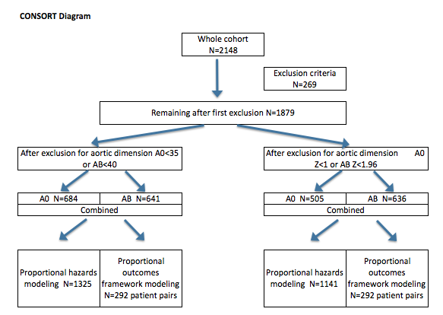
Figure 2. Kaplan-Meier plots of the composite reoperation and mortality outcomes of 1,325 patients without exclusion criteria and with aortic dimensions ≥35mm (for the aortic valve replacement cohort) or 40mm (for the aortic valve replacement with ascending aortic aneurysm repair cohort) compared to outcomes observed for a Z-score based analysis of 1,141 patients without exclusion criteria and with aortic Z-scores ≥1.0 (for the aortic valve replacement cohort) or 1.96 (for the aortic valve replacement with ascending aortic aneurysm repair cohort).

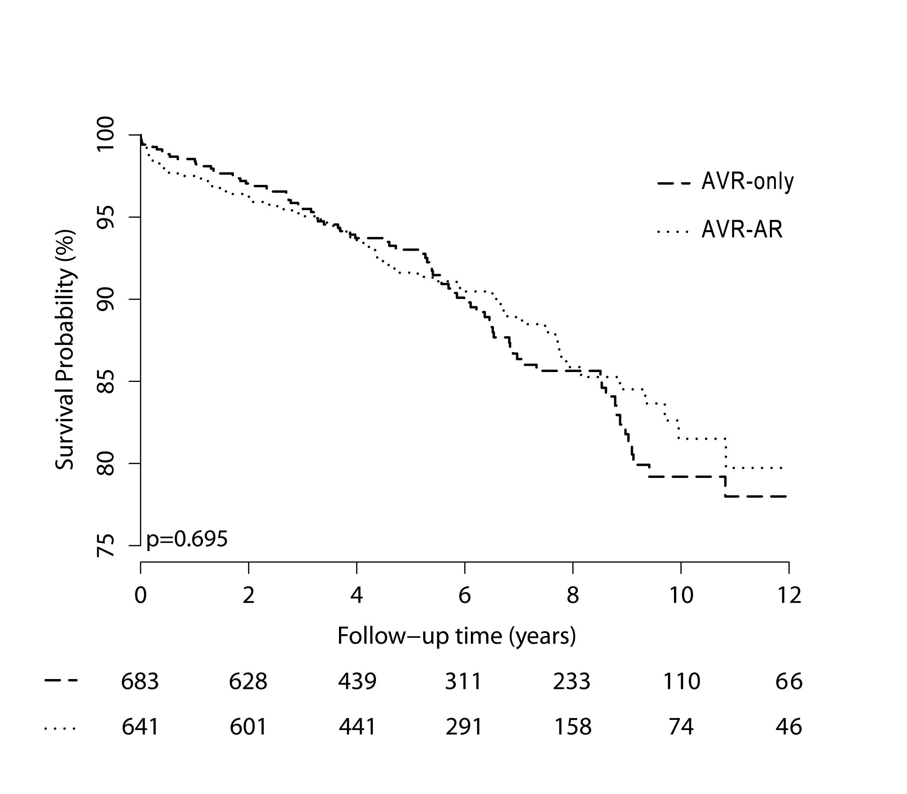

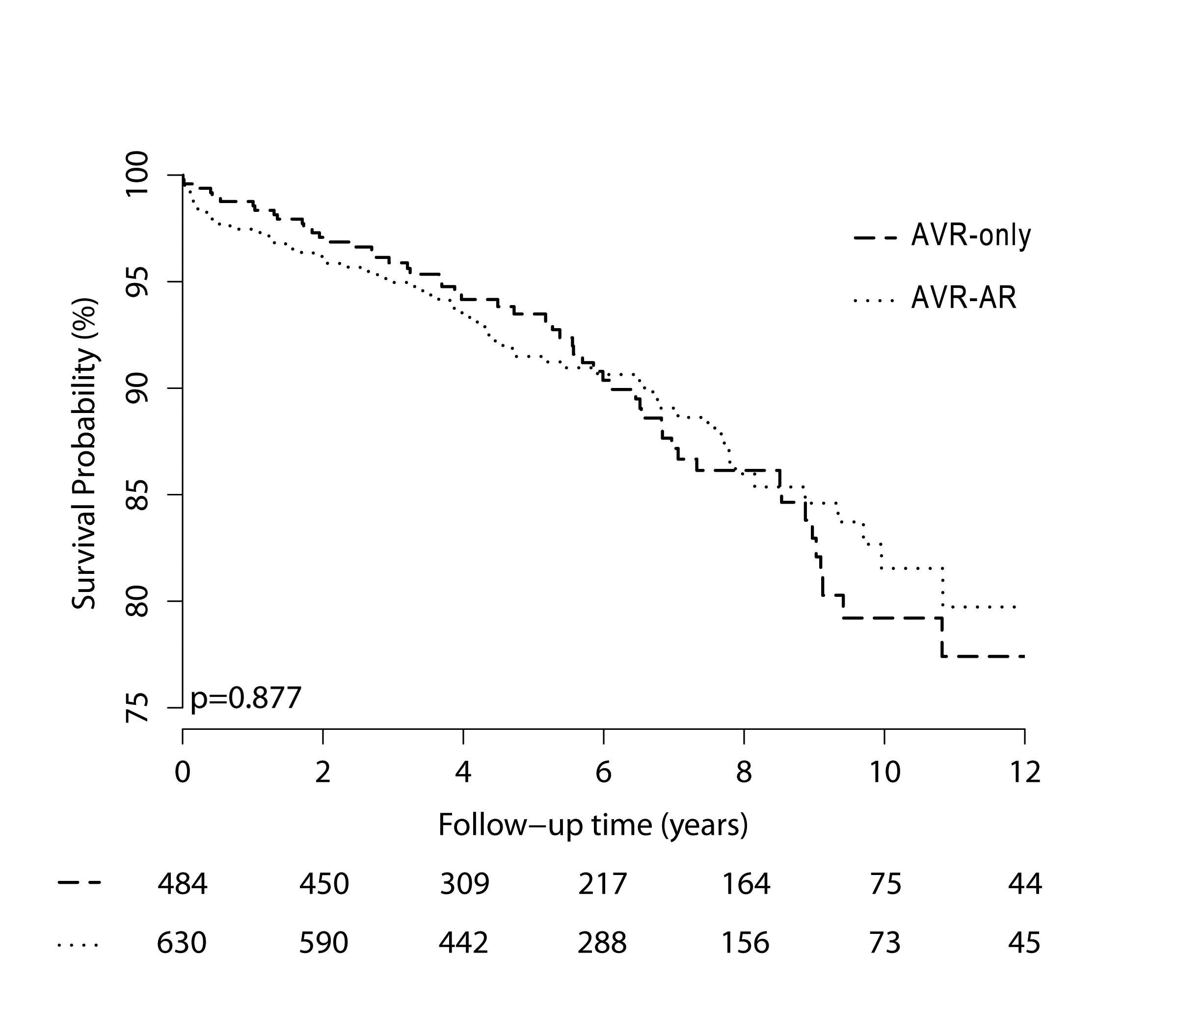
Figure 3: Analysis of event-free survival over the study period in the cohort classified using aortic dimensions. There was no difference in outcomes when examined across the five subgroups shown in the figure (P=0.70). Figure 3A shows a self-scaling smoothed heat map of the relative advantage of AVR-AR over AVR-only, over the range of aortic size and age. White color is used for superiority of AVR-AR over AVR-only, black for superiority of AVR-only, and shades of gray are for neither procedure having an advantage. Figure 3B shows a self-scaling smoothed heat map of effective sample size over the range of aortic size and age, with white areas showing better sample size than black areas.

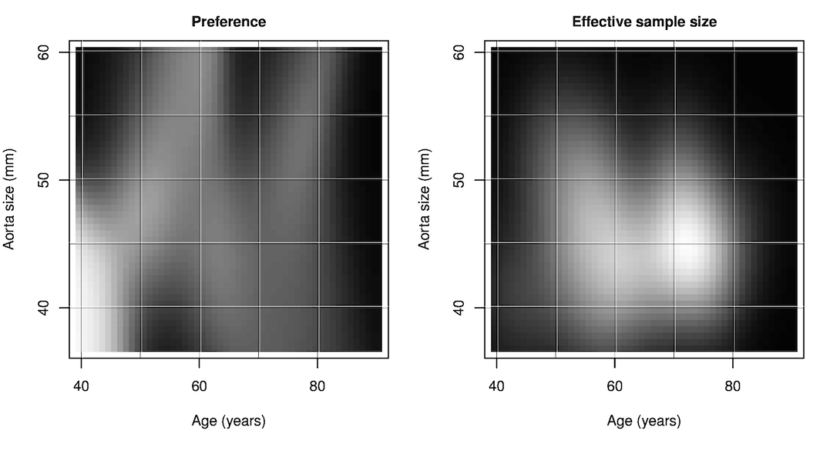

Figure 4: Analysis of event-free survival over the study period in the cohort classified using aortic Z-scores. There was no difference in outcomes when examined across the four subgroups shown in the figure (P=0.62). Figure 4A shows a self-scaling smoothed heat map of the relative advantage of AVR-AR over AVR-only, over the range of aortic size and age. White color is used for superiority of AVR-AR over AVR-only, black for superiority of AVR-only, and shades of gray are for neither procedure having an advantage. Figure 4B shows a self-scaling smoothed heat map of effective sample size over the range of aortic size and age, with white areas showing better sample size than black areas.
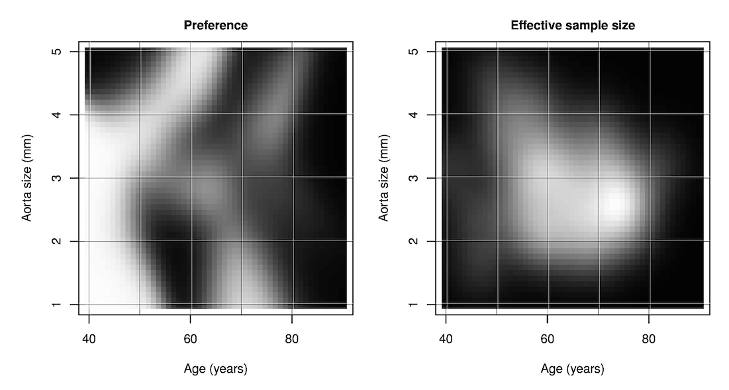

REFERENCES
1. Della Corte, A.; Body, S.C.; Booher, A.M.; Schaefers, H.J.; Milewski, R.K.; Michelena, H.I.; Evangelista, A.; Pibarot, P.; Mathieu, P.; Limongelli, G., et al. Surgical treatment of bicuspid aortic valve disease: Knowledge gaps and research perspectives. J Thorac Cardiovasc Surg 2014, 147, 1749-1757, 1757 e1741.
2. Michelena, H.I.; Desjardins, V.A.; Avierinos, J.F.; Russo, A.; Nkomo, V.T.; Sundt, T.M.; Pellikka, P.A.; Tajik, A.J.; Enriquez-Sarano, M. Natural history of asymptomatic patients with normally functioning or minimally dysfunctional bicuspid aortic valve in the community. Circulation 2008, 117, 2776-2784.
3. Roberts, W.C.; Ko, J.M. Frequency by decades of unicuspid, bicuspid, and tricuspid aortic valves in adults having isolated aortic valve replacement for aortic stenosis, with or without associated aortic regurgitation. Circulation 2005, 111, 920-925.
4. Michelena, H.I.; Khanna, A.D.; Mahoney, D.; Margaryan, E.; Topilsky, Y.; Suri, R.M.; Eidem, B.; Edwards, W.D.; Sundt, T.M., 3rd; Enriquez-Sarano, M. Incidence of aortic complications in patients with bicuspid aortic valves. Jama 2011, 306, 1104-1112.
5. Girdauskas, E.; Disha, K.; Borger, M.A.; Kuntze, T. Long-term prognosis of ascending aortic aneurysm after aortic valve replacement for bicuspid versus tricuspid aortic valve stenosis. J Thorac Cardiovasc Surg 2014, 147, 276-282.
6. Svensson, L.G.; Kim, K.H.; Blackstone, E.H.; Rajeswaran, J.; Gillinov, A.M.; Mihaljevic, T.; Griffin, B.P.; Grimm, R.; Stewart, W.J.; Hammer, D.F., et al. Bicuspid aortic valve surgery with proactive ascending aorta repair. J Thorac Cardiovasc Surg 2011, 142, 622-629, 629 e621-623.
7. McKellar, S.H.; Michelena, H.I.; Li, Z.; Schaff, H.V.; Sundt, T.M., 3rd. Long-term risk of aortic events following aortic valve replacement in patients with bicuspid aortic valves. Am J Cardiol 2010, 106, 1626-1633.
8. Kim, J.B.; Spotnitz, M.; Lindsay, M.E.; MacGillivray, T.E.; Isselbacher, E.M.; Sundt, T.M., 3rd. Risk of aortic dissection in the moderately dilated ascending aorta. J Am Coll Cardiol 2016, 68, 1209-1219.
9. Svensson, L.G.; Kim, K.H.; Lytle, B.W.; Cosgrove, D.M. Relationship of aortic cross-sectional area to height ratio and the risk of aortic dissection in patients with bicuspid aortic valves. J Thorac Cardiovasc Surg 2003, 126, 892-893.
10. Borger, M.A.; Preston, M.; Ivanov, J.; Fedak, P.W.; Davierwala, P.; Armstrong, S.; David, T.E. Should the ascending aorta be replaced more frequently in patients with bicuspid aortic valve disease? J Thorac Cardiovasc Surg 2004, 128, 677-683.
11. Russo, C.F.; Mazzetti, S.; Garatti, A.; Ribera, E.; Milazzo, A.; Bruschi, G.; Lanfranconi, M.; Colombo, T.; Vitali, E. Aortic complications after bicuspid aortic valve replacement: Long-term results. Ann Thorac Surg 2002, 74, S1773-1776; discussion S1792-1779.
12. ACCF/AHA/AATS/ACR/ASA/SCA/SCAI/SIR/STS/SVM Guidelines For The, D.; Management Of Patients With Thoracic Aortic Disease Representative, M.; Hiratzka, L.F.; Creager, M.A.; Isselbacher, E.M.; Svensson, L.G.; Aha/Acc Guideline For The Management Of Patients With Valvular Heart Disease Representative, M.; Nishimura, R.A.; Bonow, R.O.; Guyton, R.A., et al. Surgery for aortic dilatation in patients with bicuspid aortic valves: A statement of clarification from the american college of cardiology/american heart association task force on clinical practice guidelines. Circulation 2015.
13. Park, C.B.; Greason, K.L.; Suri, R.M.; Michelena, H.I.; Schaff, H.V.; Sundt, T.M., 3rd. Fate of nonreplaced sinuses of valsalva in bicuspid aortic valve disease. J Thorac Cardiovasc Surg 2011, 142, 278-284.
14. Yasuda, H.; Nakatani, S.; Stugaard, M.; Tsujita-Kuroda, Y.; Bando, K.; Kobayashi, J.; Yamagishi, M.; Kitakaze, M.; Kitamura, S.; Miyatake, K. Failure to prevent progressive dilation of ascending aorta by aortic valve replacement in patients with bicuspid aortic valve: Comparison with tricuspid aortic valve. Circulation 2003, 108 Suppl 1, Ii291-294.
15. Disha, K.; Rouman, M.; Secknus, M.A.; Kuntze, T.; Girdauskas, E. Are normal-sized ascending aortas at risk of late aortic events after aortic valve replacement for bicuspid aortic valve disease? Interact Cardiovasc Thorac Surg 2016, 22, 465-471.
16. Patel, H.J. Comparison of long-term risk of thoracic aortic aneurysm and dissection in patients with bicuspid aortic valve and marfan syndrome after aortic valve replacement. J Am Coll Cardiol 2015, 65, 2370-2371.
17. Sundt, T.M., 3rd. Replacement of the ascending aorta in bicuspid aortic valve disease: Where do we draw the line? J Thorac Cardiovasc Surg 2010, 140, S41-44; discussion S45-51.
18. Campens, L.; Demulier, L.; De Groote, K.; Vandekerckhove, K.; De Wolf, D.; Roman, M.J.; Devereux, R.B.; De Paepe, A.; De Backer, J. Reference values for echocardiographic assessment of the diameter of the aortic root and ascending aorta spanning all age categories. Am J Cardiol 2014, 114, 914-920.
19. Devereux, R.B.; de Simone, G.; Arnett, D.K.; Best, L.G.; Boerwinkle, E.; Howard, B.V.; Kitzman, D.; Lee, E.T.; Mosley, T.H., Jr.; Weder, A., et al. Normal limits in relation to age, body size and gender of two-dimensional echocardiographic aortic root dimensions in persons >/=15 years of age. Am J Cardiol 2012, 110, 1189-1194.
20. Saura, D.; Dulgheru, R.; Caballero, L.; Bernard, A.; Kou, S.; Gonjilashvili, N.; Athanassopoulos, G.D.; Barone, D.; Baroni, M.; Cardim, N., et al. Two-dimensional transthoracic echocardiographic normal reference ranges for proximal aorta dimensions: Results from the eacvi norre study. Eur Heart J Cardiovasc Imaging 2016.
21. Biaggi, P.; Matthews, F.; Braun, J.; Rousson, V.; Kaufmann, P.A.; Jenni, R. Gender, age, and body surface area are the major determinants of ascending aorta dimensions in subjects with apparently normal echocardiograms. J Am Soc Echocardiogr 2009, 22, 720-725.
22. Jacobs, J.P.; Shahian, D.M.; Prager, R.L.; Edwards, F.H.; McDonald, D.; Han, J.M.; D'Agostino, R.S.; Jacobs, M.L.; Kozower, B.D.; Badhwar, V., et al. Introduction to the sts national database series: Outcomes analysis, quality improvement, and patient safety. Ann Thorac Surg 2015, 100, 1992-2000.
23. Kim, C.; Diez Roux, A.V.; Hofer, T.P.; Nallamothu, B.K.; Bernstein, S.J.; Rogers, M.A. Area socioeconomic status and mortality after coronary artery bypass graft surgery: The role of hospital volume. American heart journal 2007, 154, 385-390.
24. Hanchate, A.D.; Schwamm, L.H.; Huang, W.; Hylek, E.M. Comparison of ischemic stroke outcomes and patient and hospital characteristics by race/ethnicity and socioeconomic status. Stroke; a journal of cerebral circulation 2013, 44, 469-476.
25. van Walraven, C.; Austin, P.C.; Jennings, A.; Quan, H.; Forster, A.J. A modification of the elixhauser comorbidity measures into a point system for hospital death using administrative data. Med Care 2009, 47, 626-633.
26. Wasey, J. Tools for working with icd-9 codes, and finding comorbidities. https://github.com/jackwasey/icd9 (4-21-2015),
27. Hiratzka, L.F.; Bakris, G.L.; Beckman, J.A.; Bersin, R.M.; Carr, V.F.; Casey, D.E., Jr.; Eagle, K.A.; Hermann, L.K.; Isselbacher, E.M.; Kazerooni, E.A., et al. 2010 accf/aha/aats/acr/asa/sca/scai/sir/sts/svm guidelines for the diagnosis and management of patients with thoracic aortic disease: A report of the american college of cardiology foundation/american heart association task force on practice guidelines, american association for thoracic surgery, american college of radiology, american stroke association, society of cardiovascular anesthesiologists, society for cardiovascular angiography and interventions, society of interventional radiology, society of thoracic surgeons, and society for vascular medicine. Circulation 2010, 121, e266-369.
28. Nishimura, R.A.; Otto, C.M.; Bonow, R.O.; Carabello, B.A.; Erwin, J.P., 3rd; Guyton, R.A.; O'Gara, P.T.; Ruiz, C.E.; Skubas, N.J.; Sorajja, P., et al. 2014 aha/acc guideline for the management of patients with valvular heart disease: Executive summary: A report of the american college of cardiology/american heart association task force on practice guidelines. Circulation 2014, 129, 2440-2492.
29. van Kimmenade, R.R.; Kempers, M.; de Boer, M.J.; Loeys, B.L.; Timmermans, J. A clinical appraisal of different z-score equations for aortic root assessment in the diagnostic evaluation of marfan syndrome. Genet Med 2013, 15, 528-532.
30. Rubin, D. For objective causal inference, design trumps analysis. Annals of Applied Statistics 2004, 2, 808-840.
31. Holland, P. Statistics and causal inference. J Am Statistical Association 1986, 81, 945-960.
32. Imbens, G.W.; Rubin, D.B. Causal inference for statistics, social, and biomedical sciences. An introduction.
. Cambridge University Press: New York, 2015.
33. Gu, X.; Rosenbaum, P. Comparison of multivariate matching methods: Structures, distances, and algorithms. Journal of Computational and Graphical Statistics 1993, 2, 405-420.
34. Keane, M.G.; Wiegers, S.E.; Plappert, T.; Pochettino, A.; Bavaria, J.E.; Sutton, M.G. Bicuspid aortic valves are associated with aortic dilatation out of proportion to coexistent valvular lesions. Circulation 2000, 102, III35-39.
35. Pachulski, R.T.; Weinberg, A.L.; Chan, K.L. Aortic aneurysm in patients with functionally normal or minimally stenotic bicuspid aortic valve. Am J Cardiol 1991, 67, 781-782.
36. Guntheroth, W. Risk of aortic dissection in patients with bicuspid aortic valves. Am J Cardiol 2011, 107, 958.
37. Etz, C.D.; von Aspern, K.; Hoyer, A.; Girrbach, F.F.; Leontyev, S.; Bakhtiary, F.; Misfeld, M.; Mohr, F.W. Acute type a aortic dissection: Characteristics and outcomes comparing patients with bicuspid versus tricuspid aortic valve. Eur J Cardiothorac Surg 2015, 48, 142-150.
38. Davies, R.R.; Kaple, R.K.; Mandapati, D.; Gallo, A.; Botta, D.M., Jr.; Elefteriades, J.A.; Coady, M.A. Natural history of ascending aortic aneurysms in the setting of an unreplaced bicuspid aortic valve. Ann Thorac Surg 2007, 83, 1338-1344.
39. La Canna, G.; Ficarra, E.; Tsagalau, E.; Nardi, M.; Morandini, A.; Chieffo, A.; Maisano, F.; Alfieri, O. Progression rate of ascending aortic dilation in patients with normally functioning bicuspid and tricuspid aortic valves. Am J Cardiol 2006, 98, 249-253.
40. Pape, L.A.; Tsai, T.T.; Isselbacher, E.M.; Oh, J.K.; O'Gara P, T.; Evangelista, A.; Fattori, R.; Meinhardt, G.; Trimarchi, S.; Bossone, E., et al. Aortic diameter >or = 5.5 cm is not a good predictor of type a aortic dissection: Observations from the international registry of acute aortic dissection (irad). Circulation 2007, 116, 1120-1127.
41. Rylski, B.; Blanke, P.; Beyersdorf, F.; Desai, N.D.; Milewski, R.K.; Siepe, M.; Kari, F.A.; Czerny, M.; Carrel, T.; Schlensak, C., et al. How does the ascending aorta geometry change when it dissects? J Am Coll Cardiol 2014, 63, 1311-1319.
42. Girdauskas, E.; Disha, K.; Raisin, H.H.; Secknus, M.A.; Borger, M.A.; Kuntze, T. Risk of late aortic events after an isolated aortic valve replacement for bicuspid aortic valve stenosis with concomitant ascending aortic dilation. Eur J Cardiothorac Surg 2012, 42, 832-837; discussion 837-838.
43. Matsuyama, K.; Usui, A.; Akita, T.; Yoshikawa, M.; Murayama, M.; Yano, T.; Takenaka, H.; Katou, W.; Toyama, M.; Okada, M., et al. Natural history of a dilated ascending aorta after aortic valve replacement. Circ J 2005, 69, 392-396.
44. Thanassoulis, G.; Yip, J.W.; Filion, K.; Jamorski, M.; Webb, G.; Siu, S.C.; Therrien, J. Retrospective study to identify predictors of the presence and rapid progression of aortic dilatation in patients with bicuspid aortic valves. Nat Clin Pract Cardiovasc Med 2008, 5, 821-828.
45. Prenger, K.; Pieters, F.; Cheriex, E. Aortic dissection after aortic valve replacement: Incidence and consequences for strategy. J Card Surg 1994, 9, 495-498; discussion 498-499.
46. Dayan, V.; Cura, L.; Munoz, L.; Areco, D.; Ferreiro, A.; Pizzano, N. Risk of subsequent aortic dilatation is low in patients with bicuspid aortic valve and normal aortic root diameter at the time of aortic valve replacement. Interact Cardiovasc Thorac Surg 2010, 10, 535-538.
47. Andrus, B.W.; O'Rourke, D.J.; Dacey, L.J.; Palac, R.T. Stability of ascending aortic dilatation following aortic valve replacement. Circulation 2003, 108 Suppl 1, Ii295-299.
48. Geisbusch, S.; Stefanovic, A.; Schray, D.; Oyfe, I.; Lin, H.M.; Di Luozzo, G.; Griepp, R.B. A prospective study of growth and rupture risk of small-to-moderate size ascending aortic aneurysms. J Thorac Cardiovasc Surg 2014, 147, 68-74.
49. Charitos, E.I.; Stierle, U.; Petersen, M.; Mohamed, S.A.; Hanke, T.; Schmidtke, C.; Klotz, S.; Sievers, H.H. The fate of the bicuspid valve aortopathy after aortic valve replacement. Eur J Cardiothorac Surg 2014, 45, e128-135.
50. Abdulkareem, N.; Soppa, G.; Jones, S.; Valencia, O.; Smelt, J.; Jahangiri, M. Dilatation of the remaining aorta after aortic valve or aortic root replacement in patients with bicuspid aortic valve: A 5-year follow-up. Ann Thorac Surg 2013, 96, 43-49.
51. McKellar, S.H.; MacDonald, R.J.; Michelena, H.I.; Connolly, H.M.; Sundt, T.M., 3rd. Frequency of cardiovascular events in women with a congenitally bicuspid aortic valve in a single community and effect of pregnancy on events. Am J Cardiol 2011, 107, 96-99.
52. Gagne-Loranger, M.; Dumont, E.; Voisine, P.; Mohammadi, S.; Dagenais, F. Natural history of 40-50 mm root/ascending aortic aneurysms in the current era of dedicated thoracic aortic clinics. Eur J Cardiothorac Surg 2016.

