Development of a Novel 3 Dimensional Organoid Culture of the Airway Lumen
Rationale: The airway epithelium is a complex pseudostratified ciliated cellular layer that plays an important role in airway physiology. It is surrounded by extracellular matrix proteins and contains goblet cells that secrete mucus into the airway lumen. Current models of the airway such as monolayer and air liquid interface cultures (ALI) do not accurately reflect the three-dimensional luminal surface of the airway epithelium, limiting the utility of these models in airway respiratory diseases such as asthma and chronic obstructive disease (COPD). To overcome these limitations we have developed a novel 3-D organoid culture of the airway epithelium using primary basal cells termed bronchospheres. Therefore, there is an urgent need for high-throughput, physiologically relevant novel organoid models of the human airway to study the pathophysiology of respiratory diseases.
Methods: Normal, Asthmatic or COPD human bronchial epithelial progenitor cells (NHBE, AHBE and CHBE respectively from Lonza) were seeded onto matrigel at P2. Basal cells were cultured for 16-21 days and were fed on day 2 and day 8. Fully developed bronchospheres were fixed in 4% paraformaldehyde. Paraffin embedded sections (6 microns) were assessed for pseudostratified epithelial layer and goblet cells by Hematoxylin and eosin (H&E) and periodic acid–Schiff (PAS) stains respectively.
Functional response was assessed by measuring ciliary beat frequency (CBF). Six ciliated areas of 4 four randomly chosen bronchospheres imaged at 100x at 500 frames/second and played back at 60 frames/second. Number of frames needed to complete 10 beats were counted. CBF was attained using the equation:
CBF (Hz) = 500 frames/sec / (number of frames/number of beats).

Results: NHBE, AHBE and CHBE cells formed fully functional bronchospheres with a vacuole containing beating cilia and mucous producing goblet cells in the inner lumen by day 16, 18 and 21 respectively (Figure 1A). Size differences between NHBE, AHBE and CHBE were observed (65, 80 and 43µM respectively). Histological assessment of bronchospheres show areas of PAS positive mucus secreting goblet cells within the lumen (Figure 1B). Quantitative assessment of bronchosphere function by CBF measurements shows a clear difference between organoid cultures from airway disease (AHBE and CHBE) compared to organoid cultures from NHBE (12.3 Hz+/-2).
Conclusion: Our bronchosphere model recapitulates the epithelial cell layers and physiologically relevant functions observed in the human airway epithelium. This high-throughput model may provide a platform to better understand pathophysiology of airway disease and test drug candidates for specific airway disease phenotypes using autologous epithelial basal cells.

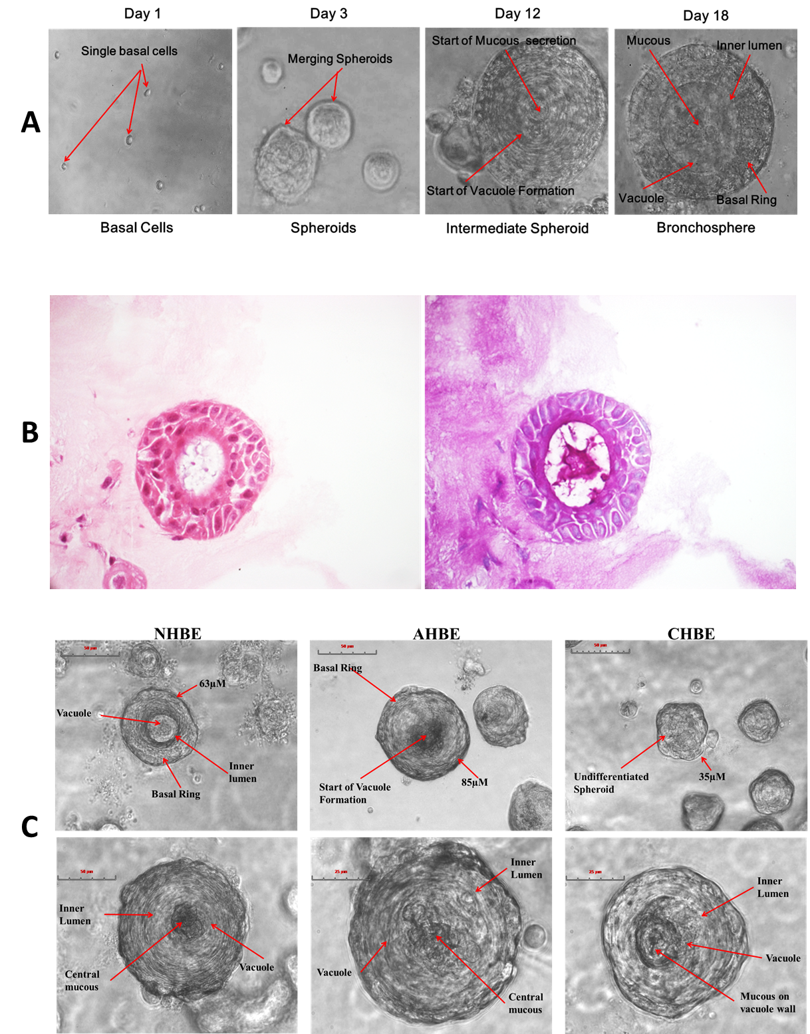
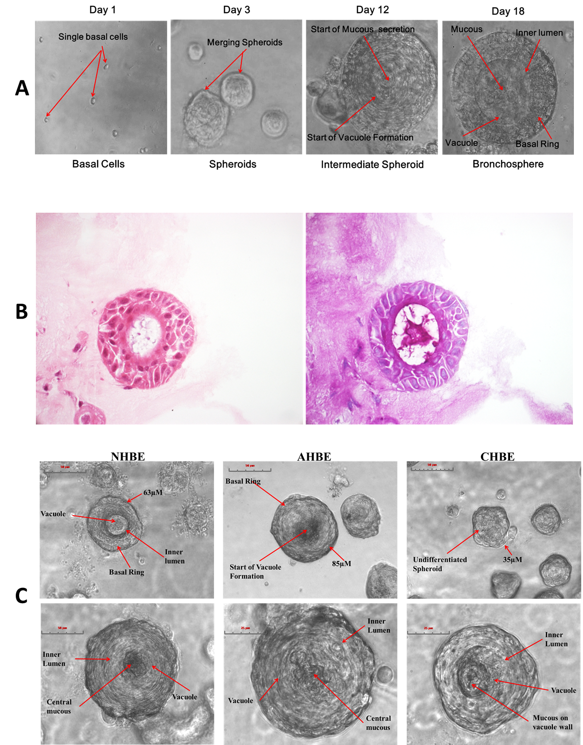
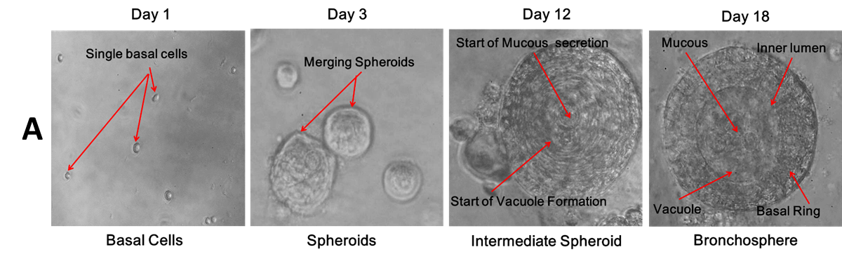
B
Figure 1. A) Basal cells aggregate to form spheroids on matrigel. Spheroids continue aggregating until day 14-18 when a vacuole is formed. Mucous secretion and cilial beating is then observed from the luminal surface. B) Bronchosphere visualised under light microscope (left), PAS stained bronchosphere section(right). Columnar cells can be seen in the bronchosphere and mucous producing goblet cells can be seen in the luminal surface-stained dark purple.

