Contents
Supplemental figure 1: Baseline circumcision prevalence 2
Supplemental figure 2: Proportion of VMMC uptake 4
Supplemental Table 1: The effect of PopART intervention on VMMC uptake-Sensitivity analysis 4

Supplemental figure 1: Baseline circumcision prevalence
Baseline circumcision prevalence in Zambian communities by triplet
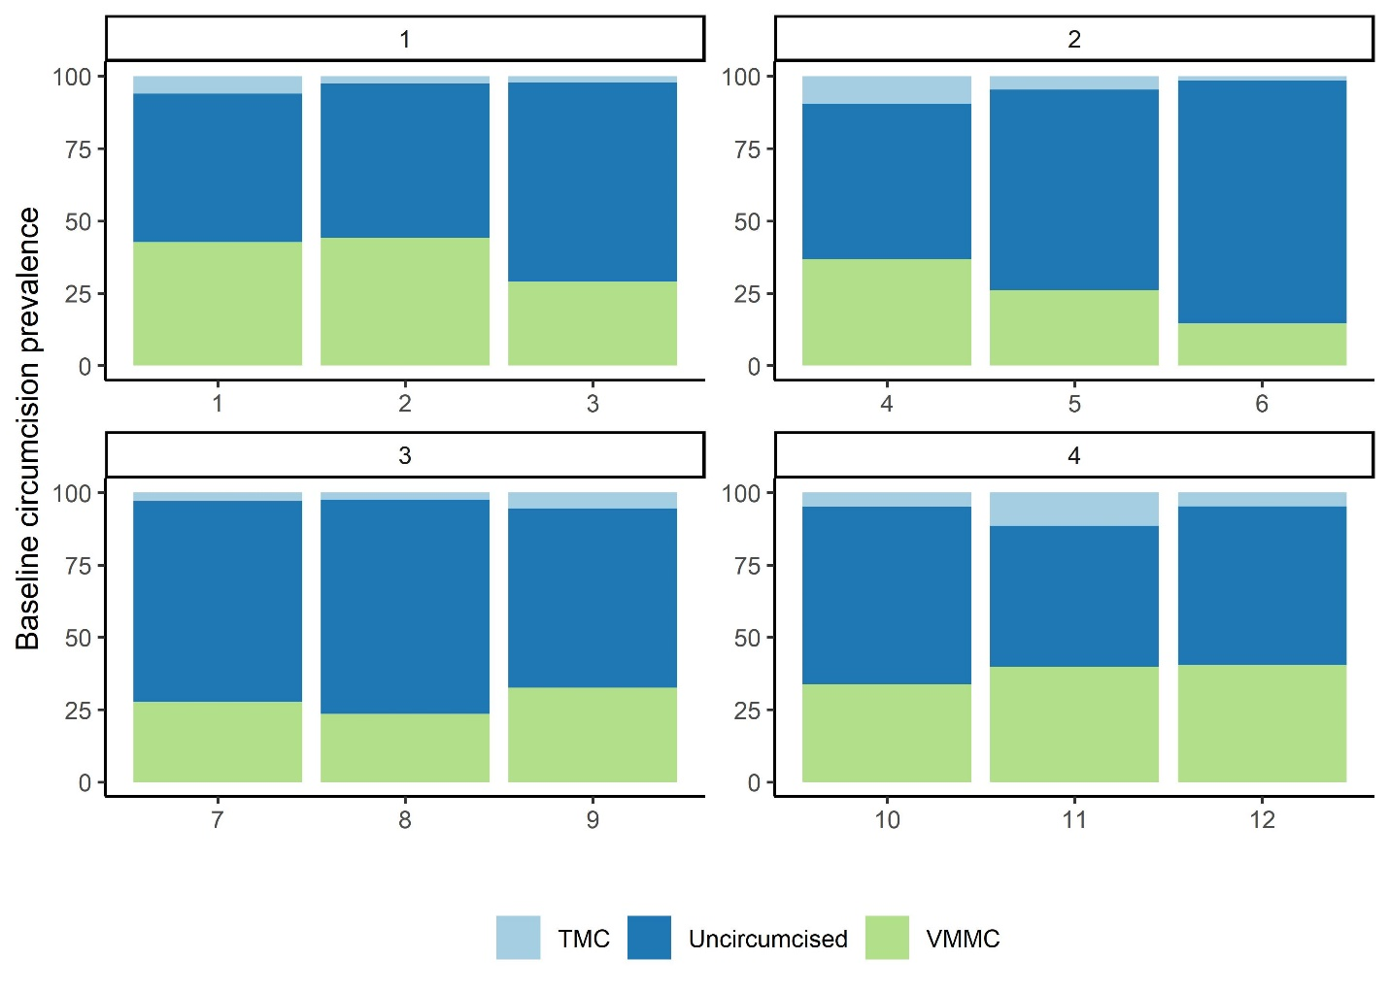
Baseline circumcision prevalence in South African communities by triplet
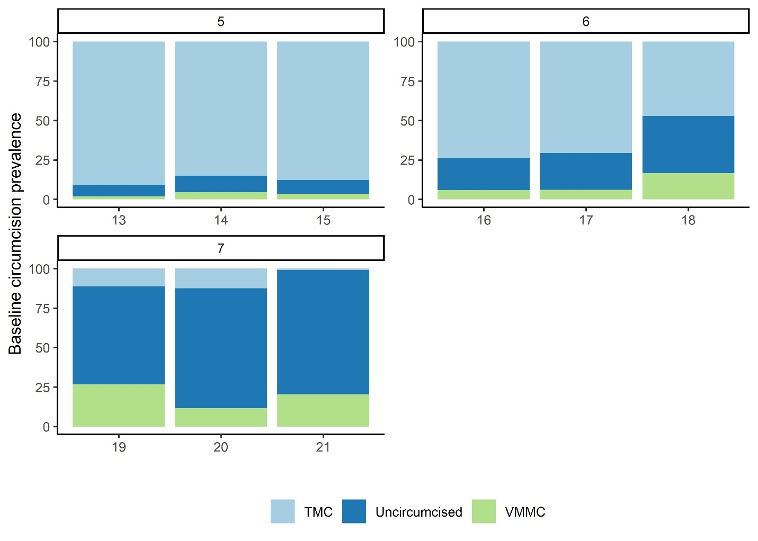

Supplemental figure 2: Proportion of VMMC uptake

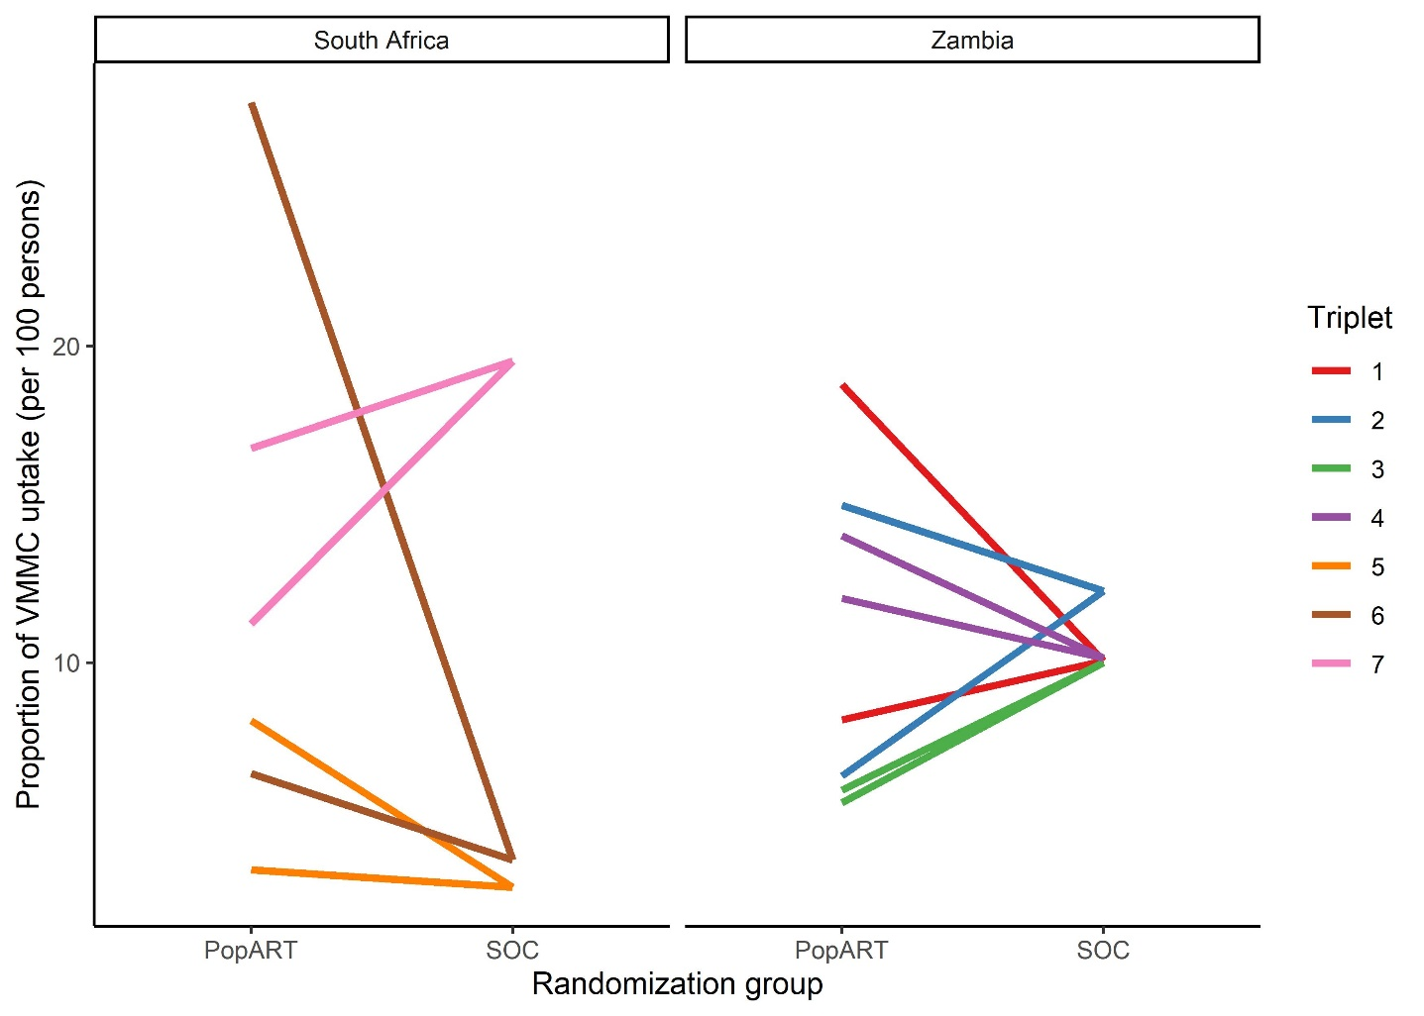
Figure 2: Proportion of VMMC uptake (per 100 persons) among uncircumcised men at baseline as a result of the PopART intervention within each triplet. Two PopART intervention communities are shown compared with the single standard of care (SOC) community in each triplet.

Supplemental Table 1: The effect of PopART intervention on VMMC uptake-Sensitivity analysis

Arm | VMMC uptake | Unadjusted rate ratio (95% CI) | Adjusted rate ratio (95% CI)¹ | P value
Among uncircumcised men (6166)
PopART communities | 540/3953 (13.6%) | 1.23 (0∙63-2.40) | 1∙24 (0∙65-2.37) | 0∙49
Standard of care communities | 303/2213 (13.67%) | Ref. | Ref.
Among uncircumcised and traditionally circumcised men (9122)
PopART | 753/6017(12.5%) | 1.00 (0∙57-1∙73) | 1.01 (0.61-1.65) | 0∙93
Standard of care | 403/3105 (12.9%) | Ref. | Ref.
¹Adjusted for age, baseline VMMC prevalence and triplet

