Virtual consultations for patients with Obstructive Sleep Apnoea: systematic review and meta-analysis

Online supplement

Section 1

Literature search strategy

MEDLINE (1946 to January 10, 2022)
Host: Ovid

The following search strategy was used to search MEDLINE via Ovid:

- (OSAHS or OSAS or OSA).mp. [Keyword]
- (Sleep* adj3 (apn?ea* or hypopn?ea*).mp. [Keyword]
- (Sleep* adj3 disorder* adj3 breath*).mp. [Keyword]
- "Sleep Apnea, Obstructive" [Subject heading]
- "Sleep Apnea Syndromes" [Subject heading]
- 1 OR 2 OR 3 OR 4 OR 5
- (CPAP OR PAP).mp. [Keyword]
- (Positive Airway Pressure.mp.).mp. [Keyword]
- "Continuous Positive Airway Pressure" [Subject heading]
- 7 OR 8 OR 9
- (Telemonitor* or Teleconsult* or Telemedicine or Telehealth or Tele monitor* or Tele consult* or Tele medicine or Tele health).mp. [Keyword]
- (Virtual consult* or Remote consult* or Remote review* or Video consult* or Telephone consult*).mp
- Telemedicine [Subject heading]
- Remote consultation [Subject heading]
- 11 OR 12 OR 13 OR 14
- 6 AND 10 AND 15

The above search strategy was adapted to the other electronic databases.

Section 2

Secondary outcomes:

The additional outcomes that were explored in this review included clinical, patient and/or clinician-reported, and environmental impact outcomes.

Clinical outcomes:
• Change in quality of life (disease-specific or general scales: FOSQ, SAQLI, SF-36)
• Change in apnoea-hypopnoea index (AHI)

Process outcomes:
• Average of CPAP usage (minutes/hours)
• Proportion of patients compliant to therapy (%) at (>3 and >4 hr/night)
• Not attending an allocated consultation / Uncontactable patients

Patient and/or clinician-reported outcomes:
• Change in sleep quality
• Satisfaction and acceptability of virtual consultations
• Treatment side effects
• Number of patient-initiated follow-up appointments
• Number of healthcare contacts
• Total time saved

Environmental impact outcomes:
• Travel distances from home to the clinic
• Reduced travel
• Mode of transport
• Carbon-footprint emissions

Section 3

The studies below were excluded due to including at least one in-person consultation for patients randomised to virtual consultations:

 | Study author and title | Reason for exclusion | Notes
1 | Fox et al 2012  The Impact of a Telemedicine Monitoring System on Positive Airway Pressure Adherence in Patients with Obstructive Sleep Apnea: A Randomized Controlled Trial | TM group were asked to come to clinic (in-person) at 4-6 weeks and 3mo | “After 4-6 wk of therapy, patients returned to the clinic to see their regular doctor and information was reviewed (including CPAP pressure, mask leak, residual respiratory events, and compliance). Any problems with treatment were also addressed at this time.  After 3 mo of treatment patients came to see their sleep specialist, who reviewed the data received via the modem. Surveys and Epworth Sleepiness Scale score (ESS) were completed (same as the standard group).”
2 | Mendelson et al 2014  CPAP Treatment Supported by Telemedicine Does Not Improve Blood Pressure in High Cardiovascular Risk OSA Patients: A Randomized, Controlled Trial | TM group were also seen in-person at 4 weeks. | “After 4 weeks of treatment, patients met with their sleep specialist and information was reviewed. After 4 months of treatment, patients consulted their sleep specialist and were re-evaluated.”
3 | Hoet et al 2017  Telemonitoring in continuous positive airway pressure-treated patients improves delay to first intervention and early compliance: a randomized tria | TM group were asked to come to clinic in case of CPAP-related issues. | “Sleep laboratory technical staff were instructed to connect to the Web portal and to analyze individual patient's data each Tuesday and Friday. In case of air leaks >50 L/min, residual AHI >10/h, or CPAP use <3 h on 3 consecutive days, they were required to call the patient and to set up a visit with the staff of the sleep laboratory”
4 | Schoch et al 2019  Telemedicine for Continuous Positive Airway Pressure in Sleep Apnea. A Randomized, Controlled Study | TM group were also seen in clinic at 1 and 6 months after CPAP initiation | “At 1 and 6 months after CPAP initiation, scheduled follow-up visits in the sleep center were arranged for both groups.”
5 | Kotzian et al 2019  Proactive telemedicine monitoring of sleep apnea treatment improves adherence in people with strokee a randomized controlled trial (HOPES study) | TM group were also seen in-person at 3 months | “Patients were asked to return to the hospital after three months for evaluation of therapy”
6 | Murase et al 2019  A Randomized Controlled Trial of Telemedicine for Long-Term Sleep Apnea Continuous Positive Airway Pressure Management | TM group were followed up in-person at 3 months | “TM-group patients visited the clinic at 3-month intervals. In the months without a clinic visit, the physicians checked CPAP adherence data monthly using a telemonitoring system and called patients to improve adherence only when good adherence (percentage of days with >4 h/ night of CPAP use > 70%) was not achieved.”
7 | Turino et al 2021  Management and treatment of patients with obstructive sleep apnea using an intelligent monitoring system based on machine learning aiming to improve continuous positive airway pressure treatment compliance: randomized controlled trial | MiSAOS-platform group were also seen in-person at 3 and 6 months | “At 3 and 6 months all patients, regardless of the study arm, were visited at the sleep unit. Patients were checked about progress and compliance with therapy and any problems with their CPAP machine. During these visits we collected data on treatment compliance (number of hours/day), ESS score, OSA-related symptoms, EQ-5D, BP, and anthropometric variables”
8 | Contal et al 2021  One-Year Adherence to Continuous Positive Airway Pressure With Telemonitoring in Sleep Apnea Hypopnea Syndrome: A Randomized Controlled Trial | TM group were also seen in-person at 3 and 12 months | “Abstract: Face-to-face consultations were scheduled at 3 and 12 months after CPAP initiation.”  “all patients were scheduled for follow-up physical appointments with their pulmonologist 3 and 12 months after the beginning of CPAP therapy. CPAP usage data were collected and clinical evaluation (ESS and QD2A) was performed.”
9 | Chumpangern et al 2021  Efficacy of a telemonitoring system in continuous positive airway pressure therapy in Asian obstructive sleep apnea | TM group were also seen in clinic at 2 and 4 weeks. | “The patients were enrolled in the study for 4 weeks after randomization. Regular visits to the investigator were scheduled at 2 and 4 weeks after randomization’’
OSA; Obstructive Sleep Apnoea TM; Telemedicine, CPAP; Continuous Positive Airway Pressure, ESS; Epworth Sleepiness Scale.

Section 4

4.1 Subgroup analyses for patient-reported sleepiness

4.1A Mode of delivery of virtual consultation
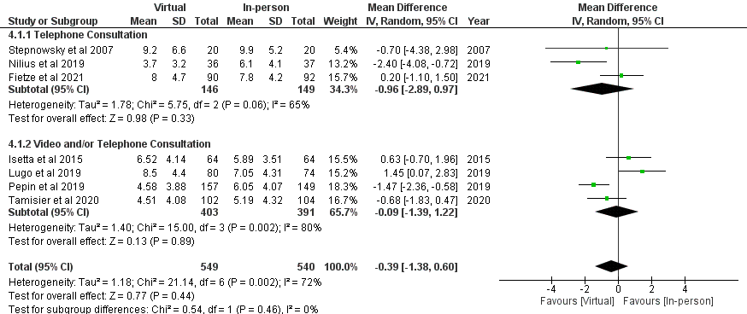

Figure S4.1A Forest plot of the subgroup analysis for the mode of delivery of virtual consultation in the included studies. The diamonds represent the 95% confidence interval (CI) of the pooled estimate of the mean differences in patient-reported sleepiness scores, assessed by Epworth Sleepiness Scale, in patients randomised to virtual compared to in-person consultations for the management of Obstructive Sleep Apnoea/Hypopnoea Syndrome.

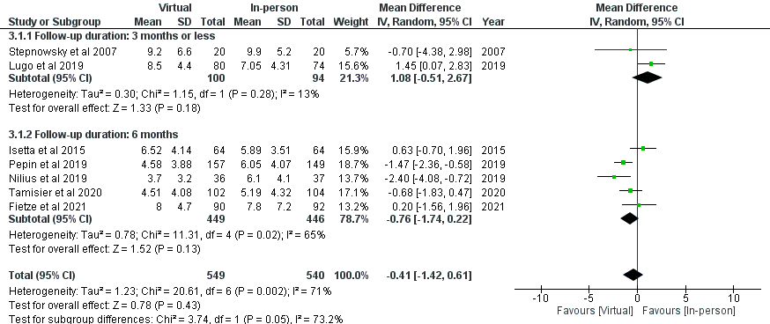
4.1B Follow-up duration

Figure S4.1B Forest plot of the subgroup analysis for the follow-up duration in the included studies. The diamonds represent the 95% confidence interval (CI) of the pooled estimate of the mean differences in patient-reported sleepiness scores, assessed by (Epworth Sleepiness Scale), in patients randomised to virtual compared to in-person consultations for the management of Obstructive Sleep Apnoea/Hypopnoea Syndrome.

4.2 Subgroup analyses for adherence to CPAP therapy

4.2A Mode of delivery of virtual consultation

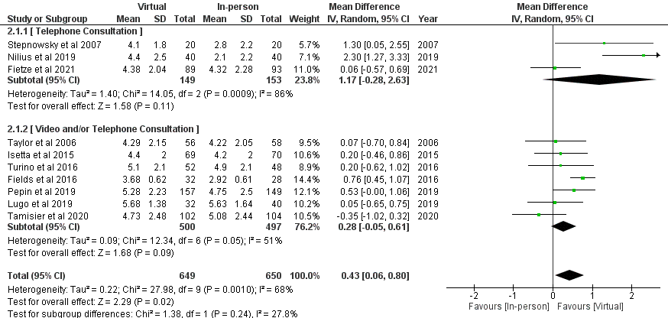

Figure S4.2A Forest plot of the subgroup analysis for the mode of delivery of virtual consultation in the included studies. The diamonds represent the 95% confidence interval (CI) of the pooled estimate of the mean differences in Continuous Positive Airway Pressure (CPAP) usage (hours/night) in patients randomised to virtual compared to in-person consultations for the management of Obstructive Sleep Apnoea/Hypopnoea Syndrome.

4.2B Follow-up duration

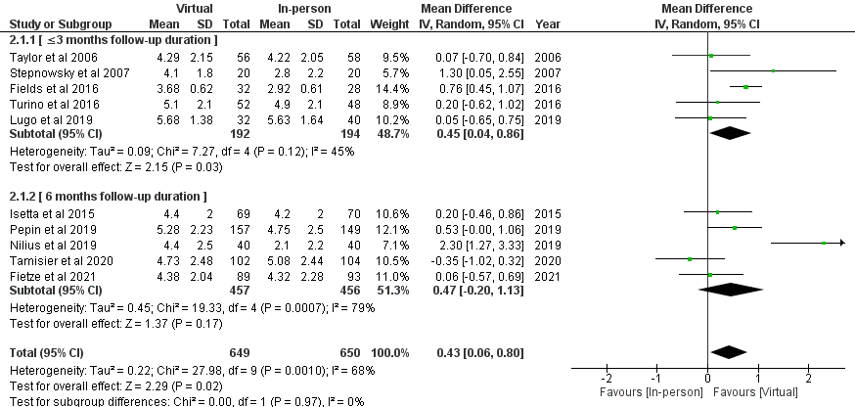

Figure S4.2B Forest plot of the subgroup analysis for the follow-up duration in the included studies. The diamonds represent the 95% confidence interval (CI) of the pooled estimate of the mean differences in Continuous Positive Airway Pressure (CPAP) usage (hours/night) in patients randomised to virtual compared to in-person consultations for the management of Obstructive Sleep Apnoea/Hypopnoea Syndrome.

