Life-threatening anaphylaxis to peanut – impossible to predict?
Paul J. Turner FRCPCH PhDª*, Adnan Custovic MD PhD FMedSciª

Affiliations:
ªNational Heart & Lung Institute, Imperial College London, London, United Kingdom

*Corresponding author:
Dr Paul Turner
National Heart & Lung Institute,
Imperial College London,
Norfolk Place
London, W2 1PG
Email: p.turner@imperial.ac.uk
Tel: +44 20 3312 7754

Funding: none declared

Declaration of interests
P.J. Turner and A. Custovic report grants from UK Medical Research Council, NIHR/Imperial BRC and UK Food Standards Agency relating to the assessment and prediction of severity in food allergy.
Life-threatening anaphylaxis to peanut – impossible to predict?

To the Editor:
Anxiety over the potential for severe reactions is one of the main drivers of impaired quality-of-life in patients with food allergies, and their families. The factors/mechanisms responsible for clinical reactivity may differ from those which impact on disease severity, and it is likely that potential biomarkers of each will also differ. The former are best addressed in population-based studies, preferably amongst peanut-sensitized individuals, to allow clear differentiation between those who are sensitized but tolerant from those who are truly allergic. For peanut allergy, allergen-specific IgE (sIgE) quantification (both serum and skin prick test (SPT)) and the basophil activation test (BAT) can help identify those with true clinical reactivity.¹ However, the question of severity and prediction of future risk is best addressed amongst those with confirmed clinical peanut allergy.
Santos et al¹ recently reported that BAT was able to identify individuals with severe life-threatening anaphylaxis reactions at peanut challenge with high specificity and high sensitivity, in children aged 5-6 years participating in the Learning Early about Peanut Allergy (LEAP) and Peanut Allergy Sensitization (PAS) studies. In contrast to the majority of other studies,² the authors found that SPT and sIgE to peanut were also predictive of severity, with high specificity and sensitivity.
During subsequent review of the data, it became apparent that the severity analyses included patients without peanut allergy in the “non-severe” group. In fact, the “non-severe” group of 532 children included 457 (86%) who did not react at challenge, of whom 368 (81%) had no evidence of IgE-sensitization to peanut. This could result in a significant over-estimate of the specificity of predictive biomarkers. We therefore undertook a re-analysis of the study data, which are freely available at www.itntrialshare.org (something we commend the authors for). Including only those who reacted at challenge (i.e. with confirmed clinical allergy), we found the area-under-ROC-curve (AUC) diagnostic characteristic to be of significantly lower than those reported in the original analysis (Figure 1). Using the same cut-offs as those identified by the authors, the inclusion of non-reactors in the original analysis significantly over-estimates the specificity of the biomarkers to predict life-threatening reactions (Table 1). For example, while BAT continues to outperform the other biomarkers, excluding non-reactive patients lowered the likelihood ratio from 33 to 4 (a “good” likelihood ratio is typically quoted as ≥10).
In summary, the predictive model used by Santos et al is valid for predicting severity in children aged 5/6 years with unknown allergy status (of whom - and is highly predictive of life-threatening reactions, as the authors state. However, the more common clinical scenario is where clinicians wish to predict risk of reaction in patients with known allergy. For this analysis, one must exclude non-reactors, as the research question is whether these tests predict severity, rather than clinical reactivity. Unfortunately, others have also undertaken similar analyses (including non-reactors as “non-severe” reactors) resulting in a similar over-estimate of predictive utility.³ Notably, while IgE to Ara h 2 had better diagnostic utility at differentiating individuals with true peanut allergy from those with asymptomatic sensitization,¹ amongst patients with true peanut allergy it was not significantly better than sIgE to (whole) peanut at predicting severity, consistent with other reports.^{2,4}
We therefore urge caution when extrapolating the data presented in this and other reports^{1,3} to clinical practice. Peanut-allergic individuals with a history of anaphylaxis do tend to have higher levels of IgE-sensitization than those without,² however the overlap is so extensive that in practice, these biomarkers are not helpful in predicting life-threatening allergic reactions. The risk is that patients with low levels of sIgE might be falsely reassured they cannot have anaphylaxis, while those with high levels are wrongly counselled that they are high risk of severe reactions. More work is needed to address this very significant knowledge gap as recently acknowledged in an expert consensus report.⁵

Paul J. Turner FRCPCH PhDª
Adnan Custovic MD PhD FMedSciª

Affiliations:
ªNational Heart & Lung Institute, Imperial College London, London, United Kingdom
REFERENCES
- Santos AF, Du Toit G, O'Rourke C, Becares N, Couto-Francisco N, Radulovic S, et al. Biomarkers of severity and threshold of allergic reactions during oral peanut challenges. J Allergy Clin Immunol. 2020;146(2):344-355.
- Turner PJ, Baumert JL, Beyer K, Boyle RJ, Chan CH, Clark AT, et al. Can we identify patients at risk of life-threatening allergic reactions to food? Allergy 2016;71(9):1241-55.
- Datema MR, Eller E, Zwinderman AH, Poulsen LK, Versteeg SA, van Ree R, et al. Ratios of specific IgG4 over IgE antibodies do not improve prediction of peanut allergy nor of its severity compared to specific IgE alone. Clin Exp Allergy. 2019 Feb;49(2):216-226.
- Kaur N, Mehr S, Katelaris C, Wainstein B, Altavilla B, Saad R, et al. Added Diagnostic Value of Peanut Component Testing: A Cross-Sectional Study in Australian Children. J Allergy Clin Immunol Pract. 2021 Jan;9(1):245-253.e4.
- Dribin TE, Schnadower D, Wang J, Camargo CA Jr, Michelson KA, Shaker M, et al. Anaphylaxis knowledge gaps and future research priorities: A consensus report. J Allergy Clin Immunol. 2021 Aug 12:S0091-6749(21)01209-4. doi: 10.1016/j.jaci.2021.07.035. Epub ahead of print.

FIGURE LEGENDS

Figure 1: Receiver operator characteristic (ROC) curve for BAT and other biomarkers to identify peanut-allergic subjects in the LEAP and PAS studies at high-risk of developing severe life-threatening reactions during food challenge, using the Common Terminology Criteria for Adverse Events score. BOLD lines represent re-analysis of reactors only; dashed lines represent original analysis, including non-reactors. AUC, Area under the ROC curve with 95% confidence intervals.

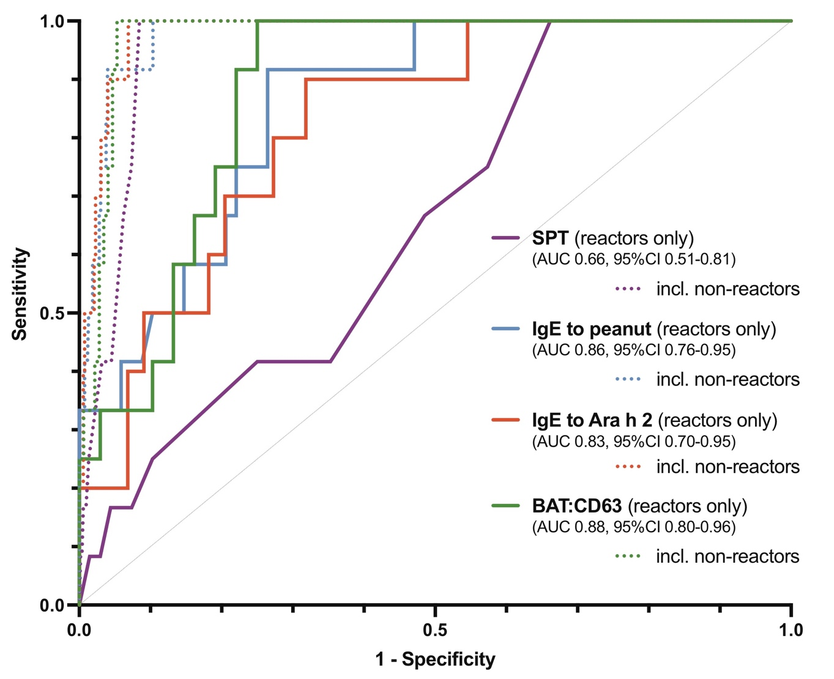

Table 1: Impact of including non-reactor patients when evaluating the diagnostic utility of different biomarkers to predicting the occurrence of life-threatening reactions to peanut in the LEAP and PAS studies. Diagnostic cut-offs as reported by Santos et al.²

Parameter | Diagnostic  Cut-off |  | AUC | Sensitivity (%) | Specificity (%) | LR
BAT (% CD63 basophils) | 48 | Incl. non-reactors | 0.98 | 100 (100-100) | 97 (95-98) | 33.3
BAT (% CD63 basophils) | 48 | Reactors only | 0.88 | 100 (76-100) | 75 (64 to 0.84) | 4
IgE to Ara h 2 | 1.4 kU/L | Incl. non-reactors | 0.98 | 100 (100-100) | 93 (91-98) | 14.3
IgE to Ara h 2 | 1.4 kU/L | Reactors only | 0.83 | 100 (73-100) | 46 (32-60) | 1.8
IgE to peanut | 5 kU/L | Incl. non-reactors | 0.98 | 100 (100-100) | 90 (87-98) | 10
IgE to peanut | 5 kU/L | Reactors only | 0.86 | 100 (76-100) | 53 (41-64) | 2.1
Peanut SPT | 8mm | Incl. non-reactors | 0.96 | 100 (100-100) | 92 (89-94) | 12.5
Peanut SPT | 8mm | Reactors only | 0.66 | 100 (76 to 100) | 34 (24-46) | 1.5

BAT, Basophil activation test; AUC, area under the ROC curve; LR, likelihood ratio; SPT, skin prick test.

