Establishing The Role Of Triflate Anion In H₂ Activation By A Cationic Triorganotin(IV) Lewis Acid
Joshua S. Sapsford,ª Dániel Csókás,^{b} Daniel J. Scott,^{c} Roland C. Turnell-Ritson,ª Adam D. Piascik,ª Imre Pápai*^{,b} and Andrew E. Ashley*^{,a}
ª Molecular Sciences Research Hub, Imperial College, White City Campus, 80 Wood Lane, London, W12 0BZ, UK.
b Institute of Organic Chemistry, Research Center for Natural Sciences, Magyar tudósok körútja 2, H-1117 Budapest, Hungary.
^{c} Institute of Inorganic Chemistry, University of Regensburg, Universitätsstraße 31, 93051 Regensburg, Germany.
KEYWORDS frustrated Lewis pair, hydrogen activation, anion, tin, stannylium

ABSTRACT: Cationic Lewis acids are gaining interest as targets for frustrated Lewis pair (FLP) mediated catalysis. Unlike neutral boranes, which are the most prevalent Lewis acids for FLP hydrogenations, the Lewis acidity of cations can be tuned through modulation of the counteranion, however detailed studies on such anion effects are currently lacking in the literature. Herein we present experimental and computational studies which probe the mechanism of H₂ activation using iPr₃SnOTf (1-OTf) in conjunction with a coordinating (quinuclidine; qui) and non-coordinating (2,4,6-collidine; col) base, and compare the reactivity with {iPr₃Sn·base}{Al[OC(CF₃)₃]₄} (base = qui/col) systems which lack a coordinating anion, to investigate the active species responsible for H₂ activation and hence resolve any mechanistic roles for OTf⁻ in the iPr₃SnOTf-mediated pathway.
Introduction
Frustrated Lewis pairs (FLPs), where bulky Lewis acid (LA) and Lewis base (LB) partners are sterically precluded from forming strong classical adducts, are now well-established systems for small molecule activation with main-group compounds.^{1,2} Perhaps most notably, H₂ heterolysis can be effected by FLPs to form H⁺ and H⁻ equivalents, which can be delivered to unsaturated bonds to form a reduced compound and the original FLP. Accordingly, FLP-catalyzed hydrogenations of organic compounds containing C=X (X = C, N, O) bonds have received widespread attention, and been thoroughly studied.³ The LAs used in these reactions are predominantly triarylboranes BAr₃, particularly B(C₆F₅)₃ and similar derivatives⁴ thereof where the electronic and steric profile has been tuned by variation of aryl substituents (although these are predominantly confined to H, F and Cl),⁵ which can afford systematic manipulation of BAr₃ Lewis acidity. Accordingly, novel BAr₃ have recently been developed that can catalyse hydrogenations of substrate classes previously inaccessible by FLPs, or display catalytic activity in the presence of alcohols/moisture, yet accessing such heteroleptic boranes requires laborious multi-step syntheses.^{5e,6} While some aspects of the H₂ activation mechanism between BAr₃ and N- or P-centered bases are still being debated,⁷ it is generally assumed that facile H₂ heterolysis is associated with the initial formation of a non-covalent LA⸾LB ‘encounter complex’, which subsequently reacts with H₂ in a cooperative manner (i.e. a concerted mechanism via a single transition state).⁸ Important exceptions are ‘frustrated radical pairs’, which activate substrates via single electron pathways.⁹ Recently, the range of LAs displaying FLP-like reactivity has expanded to encompass a number of cationic species (or neutral species that act as surrogates for the active cationic LA) based on B(III),¹⁰ Si(IV),¹¹ C(IV),¹² N(III),¹³ P(V)¹⁴ and Sb(V).^{15,16}
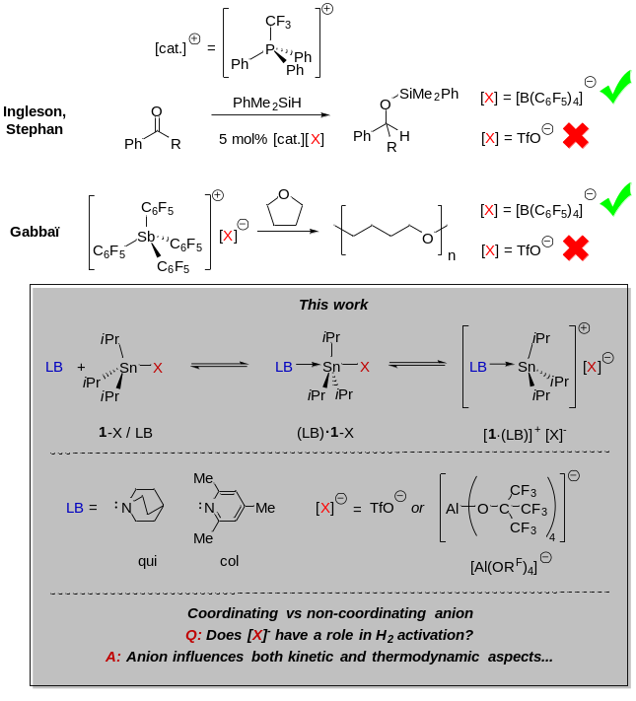 Figure 1. Examples of cationic Lewis acids where reactivity was promoted by using a weakly coordinating counteranion (top), and the stannylium-based Lewis acid/base systems investigated for H₂ activation in this study (bottom). R^{F} = C(CF₃)₃
Tuning the Lewis acid strength, and hence reactivity, of these LAs may also be achieved through ligand design within the formally cationic fragment, akin to BAr₃ compounds, however their anions also provide an additional locus for variation and hence a comparatively simple route to optimise the Lewis acidity of cationic species. For instance, replacement of [TfO]⁻ for [B(C₆F₅)₄]⁻ in phosphonium or stibonium LAs can switch on otherwise absent reactivity (see Figure 1), which has been rationalised only by reference to the relative sequestration of the cation by more strongly coordinating anions, resulting in weaker LAs. A detailed analysis of any intimate effects the anion may exert during a reaction (for example by its coordination within a transition state, which could perturb its energy) have not been previously undertaken for cationic LAs.
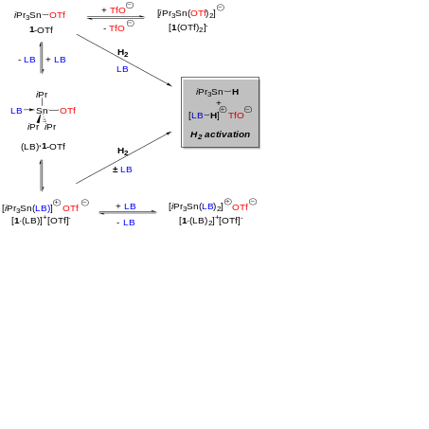
Scheme 1. Possible Sn-containing species in 1-OTf + Lewis base (LB) combinations, and mechanistic pathways for H₂ activation.
We reported previously that iPr₃SnOTf (1-OTf; Tf = O₂SCF₃), which acts as a surrogate for the stannylium ion [iPr₃Sn]⁺ ([1]⁺), activates H₂ in conjunction with LBs (e.g. 2,4,6-collidine; col) and catalyses the hydrogenation of imines and ketones, and the reductive amination of carbonyls.¹⁷ Despite the diversity of hydrogenation substrates accessible by 1-OTf, which can operate in the presence of moisture and strong LBs, productive hydrogenation using 1-OTf/col is rather slow and requires forcing conditions (> 120 °C, 10 bar H₂). A thorough understanding of the factors affecting 1-OTf/LB catalytic hydrogenations would clearly aid the development of superior R₃SnX LA hydrogenation catalysts, although it should be borne in mind that this will require a more complicated treatment cf. B-based FLPs. This is predominantly due to the presence of the (hemi-labile) TfO anion, and the fact that [R₃Sn]⁺ species are known to readily bind two anionic/neutral donors (as opposed to only one for BAr₃); such 5-coordinate adducts may also be important off-cycle entities in catalysis. A previous computational study by Pati et al. suggested that weakly-associated complexes of 1-OTf and either DABCO (1,4-diazabicyclo[2.2.2]octane) or col cleave H₂ via an FLP-type concerted mechanism¹⁸ analogous to that seen in the FLP reactivity of electrophilic [(C₆F₅)₃P-X]⁺ species.^{14a-d} Pati et al. assumed that 1-OTf was the only active LA despite experimental evidence for the formation of [1·(LB)]⁺ adducts (e.g. ¹¹⁹Sn NMR shifts) in 1-OTf /LB mixtures;^{17a} accordingly any role of [1·(LB)]⁺ species was not investigated, nor the potential impact of charged hypervalent Sn species upon reductions mediated by 1-OTf, all of which could arise from displacement of labile [TfO]– during the reaction pathway (see Scheme 1). Clearly, ascertaining the correct catalytic speciation in these more complex systems is crucial if targeted improvements in activity/selectivity are to proceed in a logical and predictive manner. Herein we report a comprehensive study into the mechanism of H₂ activation using 1-OTf/LB pairs, using complementary experimental and theoretical methods, which reveal the non-innocent nature of [TfO]– in influencing both kinetic and thermodynamic factors. These results provide fundamental insight into how heavier-element cationic Lewis pairs activate H₂ which will help guide the design of new cationic p-block LA catalysts, by encouraging further research into the role and tunability of the anion in reactions featuring such LAs.
Results & discussion
Identifying ground-state speciation in 1-OTf/quinuclidine (qui) Lewis pairs
Since DABCO contains two donor atoms, which in theory could both interact with LAs and accordingly complicate identification of equilibria speciation in 1-OTf/LB pairs, we chose instead to study the interaction of 1-OTf with quinuclidine (qui) due to its similar basicity (pK_{a}(MeCN): [DABCO-H]⁺ 18.3;¹⁹ [qui-H]⁺ 19.5)²⁰ and steric profile. 1-OTf exhibits a broad peak in its ¹¹⁹Sn{¹H} NMR spectrum at δ = 166 ppm in 1,2-difluorobenzene (DFB)²¹ which moves to 34 ppm and sharpens upon addition of 1 eq. of qui at room temperature, suggesting a spontaneous association to form (qui)·1-OTf and/or formation of the ion pair [1·(qui)]⁺[OTf]⁻.
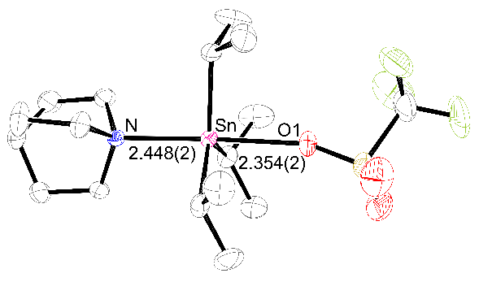
Figure 2. ORTEP diagram of (qui)·1-OTf. Thermal ellipsoids set at 50% probability. C atoms black, F atoms green, N atom blue, O atoms red, S atom yellow, Sn atom pink. The Sn–N and Sn–O bond lengths are given in Å with estimated standard deviations (ESDs) in parentheses. H atoms omitted for clarity.
Gratifyingly, slow cooling of this solution yielded single crystals that were analyzed by X-ray diffraction; the solved structure (Figure 2) reveals the former species: a 5-coordinate adduct in which OTf– and qui coordinate trans across the [1]⁺ core, with a trigonal bipyramidal geometry for the Sn atom [bond angles (°): C−Sn−N = 91.41(9), 93.73(9), 93.76(9); O1−Sn−N = 177.40(7)]. While this (qui)·1-OTf adduct represents the ground state structure in the solid phase, it is possible that [1·(qui)]⁺[OTf]⁻ is accessible at room temperature in solution. In order to spectroscopically identify [1·(qui)]⁺ as a distinct moiety it was necessary to characterise it in the absence of any exchange equilibria, which was achieved by exchanging [OTf]⁻ for the much more weakly coordinating aluminate {Al[OC(CF₃)₃]₄}– ([Al(OR^{F})₄]–); this was chosen because it is particularly robust to strongly Lewis and Brønsted acidic media.²² Thus, reaction of K[Al(OR^{F})₄], [1]OTf and qui (1:1:1) in DFB resulted in precipitation of KOTf, with the ¹⁹F NMR spectrum of the filtrate showing only a single signal for the aluminate anion, demonstrating clean anion metathesis (Scheme 2). Layering this solution with pentane yielded crystals suitable for X-ray diffraction studies; the structural solution to these data is represented in Figure 3 and corresponds to the salt [1·(qui)]⁺[Al(OR^{F})₄]⁻.²³
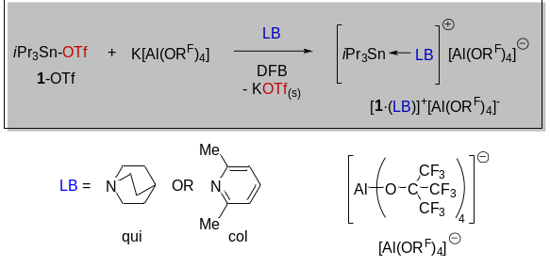
Scheme 2. Syntheses of [1·(LB)]⁺[Al(OR^{F})₄]⁻; LB = qui (quinuclidine) or col (collidine, 2,4,6-trimethylpyridine).
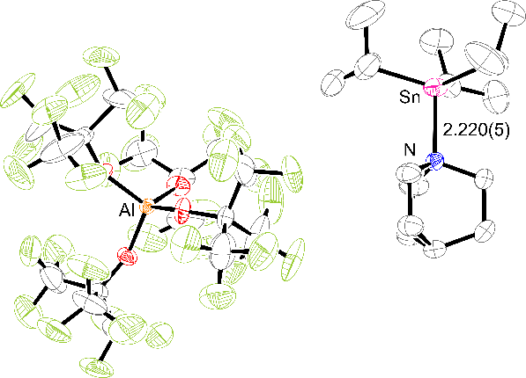
Figure 3. ORTEP diagram of [1·(qui)]⁺[Al(OR^{F})₄]⁻. Thermal ellipsoids set at 50% probability. Al atom orange, C atoms black, F atoms green, N atom blue, O atoms red, Sn atom pink. The Sn–N bond length is given in Å with the ESD in parentheses. H atoms omitted for clarity.
As anticipated, the [Al(OR^{F})₄]⁻ ion does not display any close contacts to the [1]⁺ unit, and therefore does not coordinate to the Lewis acid Sn atom. Consequently, the [1·(qui)]⁺ assembly adopts a distorted tetrahedral geometry around the Sn center [N–Sn–C bond angles (°) = 103.7(2), 102.8(2), 102.9(3)]. The Sn–N bond distance is considerably shorter than that observed for the qui·1-OTf adduct [2.448(2) Å], which is consistent with a Sn−N weakening in the latter due to a trans-labilizing effect of the OTf⁻ and/or increased steric encumbrance. ¹H NMR spectroscopic analysis of DFB solutions of [1·(qui)]⁺[Al(OR^{F})₄]⁻ showed that the observed chemical shifts and couplings for the iPr groups are similar to those for 1-OTf in DFB; relative integration of these with the signals for qui confirm a 1:1 ratio between [iPr₃Sn]⁺ and qui. The ¹¹⁹Sn{¹H} NMR spectrum, however, conclusively shows the formation of a new stannylium adduct with a sharp resonance at δ = 113 ppm, which is upfield from 1-OTf (δ = 166 ppm), but notably downfield of that seen for 1-OTf/qui mixtures (δ = 34 ppm). Taken together these spectroscopic data confirm that the gross solid-state structure of [1·(qui)]⁺[Al(OR^{F})₄]⁻ is retained in solution. Curiously, the ¹¹⁹Sn{¹H} NMR spectroscopic data for the adduct formed from 1-OTf and qui in situ, or by redissolution of (qui)·1-OTf crystals obtained thereof, are inconsistent with those of either authentic 1-OTf or [1·(qui)]⁺. This suggests that neither compound is present exclusively. It is plausible that a rapid equilibrium containing 1-OTf, (qui)·1-OTf and [1·(qui)]⁺, exists in solution. To understand better the speciation we assessed the relative energies of these species computationally (Scheme 3), with our DFT calculations²⁴ predicting the formation of a ternary complex (qui)·1-OTf to be clearly favored thermodynamically with respect to qui + 1-OTf, in contrast with previously obtained results for the related DABCO + 1-OTf system.^{18,25} Additionally, dissociation of adduct (qui)·1-OTf into [1·(qui)]⁺ + [OTf]– is also found to be thermodynamically feasible, with the latter computed to be 4.8 kcal/mol more stable than the original qui + 1-OTf reference state.
Scheme 3. Possible reactant-state species in the solution phase for the 1-OTf + qui Lewis pair. Computed relative stabilities (in kcal/mol at 298 K) are shown in parentheses.²⁴
Figure 4. Optimized structures of possible binary and ternary adducts in the solution phase for the 1-OTf + qui Lewis pair. Selected bond distances in Å. All hydrogen atoms are omitted for clarity.
We also probed two other possible adducts: one where the dissociated [OTf]– binds to 1-OTf, and another where a further qui molecule coordinates to [1·(qui)]⁺; of these two ternary adducts, [1(OTf)₂]– is stabilized notably with respect to the dissociated form, whereas [1·(qui)₂]⁺ is predicted to be an unstable species (see Scheme 3). The optimized structures of possible binary and ternary adducts are depicted in Figure 4, and the computed bond distances suggest considerably weakened Sn–ligand bonds in the ternary species. The notable difference between the computationally and X-ray crystallography determined Sn-N/O bond lengths in the (qui)·1-OTf complex is likely due to intramolecular forces in the crystal structure, which appreciably influences the character of the Sn-N/O dative bonds. Of note, one of the Sn–N bonds in [1·(qui)₂]⁺ is particularly elongated which results in asymmetry across the equatorial plane, and is likely due to steric effects.²⁶ Having predicted that 1-OTf, (qui)·1-OTf and [1·(qui)]⁺ are thermally accessible in solution at room temperature, we sought to identify each species experimentally by manipulating the equilibria between them. Upon portion-wise addition of qui to 1-OTf in DFB, the ¹H NMR iPr methine resonance (δ = 2.15 ppm) moves upfield to a limiting value of δ = 1.94 ppm (5.5 eq. qui), after which further qui results in no further change. Similarly, the ¹¹⁹Sn{¹H} NMR resonance moves upfield from that observed for pure 1-OTf (δ = 166 → 0 ppm; see SI). Only a single resonance attributable to the [1]⁺ fragment was observed for any qui:1-OTf ratio in the ¹¹⁹Sn{¹H} NMR spectra (the same is true for the iPr resonances in the ¹H NMR spectra), indicating that the observed shifts are weighted averages of multiple species all of which are in rapid exchange.
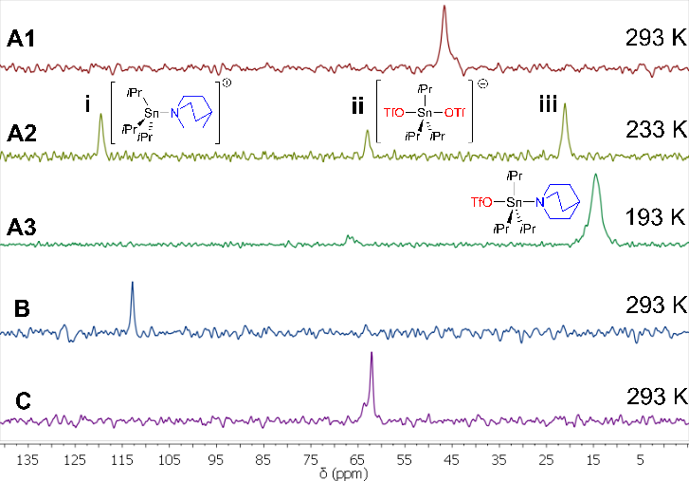
Figure 5. A1-A3: Stacked ¹¹⁹Sn{¹H} NMR spectra of a 1:1 mixture of 1-OTf + qui in CD₂Cl₂ at selected temperatures. B: ¹¹⁹Sn{¹H} NMR spectrum of authentic [1·(qui)][Al(OR^{F})₄] in DFB. C: ¹¹⁹Sn{¹H} NMR spectrum of 1-OTf + [nBu₄N][OTf] in DFB.
A variable temperature ¹¹⁹Sn{¹H} NMR experiment of a 1:1 mixture of 1-OTf and qui (CD₂Cl₂)²⁷ was undertaken to slow the exchange between the adducts (Figure 5, spectra A1 and A2),²⁸ which revealed the broad room-temperature resonance (δ = 34 ppm) to split into three distinct peaks (i-iii) below 263 K. Resonance i (δ = 119 ppm, 233 K) is very similar to that seen for authentic [1·(qui)]⁺[Al(OR^{F})₄]⁻ (δ = 113 ppm, 293 K; Figure 5, spectrum B) and accordingly it is assigned to the cation fragment therein. The existence of the latter implies that dissociation of [OTf]⁻ from (qui)·1-OTf has occurred, which is computationally predicted to bind spontaneously to 1-OTf and form [1·(OTf)₂]⁻ (ΔG = −3.2 kcal/mol).²⁹ To verify this an equimolar solution of [nBu₄N][OTf] and 1-OTf (DFB, 293 K) was prepared which displayed a broad peak at δ = 62.5 ppm in the ¹¹⁹Sn{¹H} spectrum (Figure 5, spectrum C); this is significantly upfield from the chemical shift of either 1-OTf or [1·(qui)]⁺, and is almost identical to that observed for ii (62.9 ppm, 233 K), so it is attributed to [1(OTf)₂]⁻. Notably at temperatures below 203 K only one peak at δ = 14 ppm is observed (Figure 5, spectrum A3); DFT calculations predict the 1:1 adduct between qui and 1-OTf to be the most stable species at low temperatures (for details see SI, section 6.1), and accordingly we ascribe resonance iii to (qui)·1-OTf.
Mechanism for the activation of H₂
Admission of 4 bar H₂ to [1·(qui)][Al(OR^{F})₄] in DFB led to no reaction by ¹H or ¹¹⁹Sn{¹H} NMR spectroscopy at room temperature after several days, nor after heating at 100 °C for 10 h. Furthermore, this salt did not scramble HD to H₂, D₂ and HD, which would detect rapidly reversible heterolysis. These results exclude a simple mechanism by which the Sn−N bond can elongate (with or without complete cleavage) to activate H₂, in a manner akin to that reported for the related classical adduct [iPr₃Si–PtBu₃][B(C₆F₅)₄].^{11a} In support of this conclusion computations predict the activation energy for H₂ cleavage via this mechanism to be prohibitively high (ΔG‡ = 36.4 kcal/mol, see SI section 6.4 for transition state structure).
Since 1-OTf and [1·(qui)]⁺ are both present at room temperature in solutions of the 1-OTf /qui LP, either could feasibly engage with qui to mediate H₂ cleavage; accordingly, we sought to elucidate whether they could act as LAs for FLP-mediated H₂ activation. [1·(qui)][Al(OR^{F})₄] is a valid model compound to study the reactivity of [1·(qui)]⁺ as a LA fragment, so using [1·(qui)][Al(OR^{F})₄] + qui (hereafter referred to as the ‘[1·(qui)]⁺/qui’ LP) allows the investigation of H₂ activation where [OTf]⁻ cannot be involved at any point in the reaction.
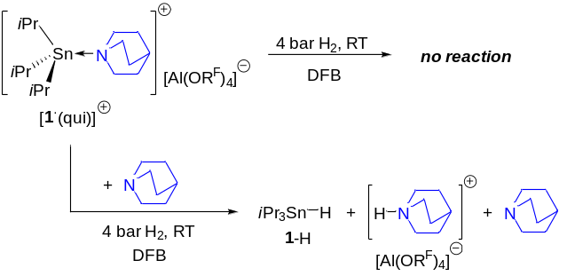
Scheme 4. H₂ activation by [1·(qui)]⁺ only occurs when free qui Lewis base is present. R^{F} = C(CF₃)₃.
When one equivalent of qui is added to [1·(qui)][Al(OR^{F})₄] evidence of H₂ activation is observed immediately after H₂ admission by the appearance of NMR spectroscopic resonances attributable to 1-H [SnH: δ (¹H) = 5.10 ppm, ¹J(¹H-¹¹⁷Sn) = 1404 Hz, ¹J(¹H-¹¹⁹Sn) = 1470 Hz; δ (¹¹⁹Sn{¹H}) = –47.3 ppm] and [qui-H]⁺ [qui-H⁺: δ (¹H) = 10.14 ppm] (Scheme 4).^{17a} The ²⁷Al and ¹⁹F NMR spectra remain unchanged, indicating that [Al(OR^{F})₄]– remains intact and does not participate in H₂ activation, as expected. Based on these observations, we propose the mechanism shown in Scheme 5, which is supported computationally.³⁰ H₂ is cleaved via a termolecular transition state as illustrated in Figure 6, which requires the addition of free qui, akin to H₂ activation mediated by Ar₃B and N/P-centered FLPs. Here, the qui coordinated in [1·(qui)]⁺ acts as a leaving group, while the external qui is the LB for H₂ activation.

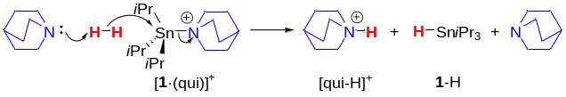
Scheme 5. Proposed mechanism for H₂ activation with the [1·(qui)]⁺/qui Lewis pair, via a ternary TS. [Al(OR^{F})₄] counteranion omitted; R^{F} = C(CF₃)₃.
Computations reveal that H₂ splitting and dissociation of the departing qui molecule take place concertedly, yet in an asynchronous manner (after TS_{K-qui}, the dissociation of qui lags behind H₂ cleavage). Thus a weakly bound termolecular intermediate [qui-H]⁺∙(1-H)∙(qui) is produced in this process (lying at 9.4 kcal/mol in free energy, see SI section 6.2 for ternary intermediate structure), however, the separation of 1-H and the formation of the H-bonded [qui-H-qui]⁺ species result in significant stabilization on the product side (the reaction is exergonic by 4.3 kcal/mol). Computations predict the free energy barrier of this H₂ cleavage reaction to be 19.5 kcal/mol, which is consistent with the observed rate at the applied reaction conditions.
Figure 6. Transition state TS_{K-qui} identified computationally for H₂ activation with [1·(qui)]⁺/qui and the species corresponding to the most stable product state (1-H + [qui-H∙(qui)]⁺). Relative stabilities (in kcal/mol) are shown in parentheses, and selected bond distances are in Å. All hydrogen atoms except those from H₂ are omitted for clarity.
Interestingly, while the qui-mediated hydrogenolysis of [1·(qui)][Al(OR^{F})₄] with H₂ is quantitative after 48 h (RT), the analogous reaction with 1-OTf reaches only ca. 50% conversion to 1-H, albeit much more quickly (2 h). Figure 7 shows the time evolution of the respective ¹H NMR spectra for these reactions, to illustrate their differing rates. Initially, as H₂ activation by 1-OTf/qui proceeds, the ¹¹⁹Sn{¹H} NMR spectra show the expected resonance at δ = −47 ppm for 1-H growing in intensity, and a peak at δ = 40 ppm corresponding to the aforementioned fast equilibrium between 1-OTf, (qui)·1-OTf, [1·(qui)]⁺[OTf]– and [1(OTf)₂]– species; the latter moves upfield and sharpens as the reaction approaches completion, reaching a limiting value of δ = 19 ppm which we attribute to the generation of [1(OTf)₂]⁻.
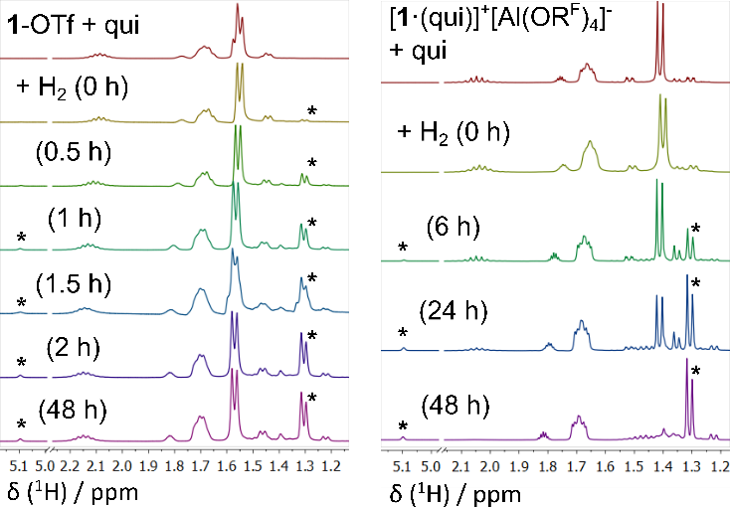
Figure 7. ¹H NMR spectra at selected time points (shown in parentheses in h) during the activation of H₂ with 1-OTf/qui and [1·(qui)]⁺/qui LPs at RT. The initial rate of H₂ activation with 1-OTf/qui is much faster than [1·(qui)]⁺/qui, however the former reaches only ca. 50% conversion to 1-H. Contrastingly, the comparable reaction with [1·(qui)]⁺/qui LP is slower, although it eventually forms 1-H quantitatively. * denotes resonances associated with 1-H.
This result implies that as H₂ activation proceeds [qui-H]⁺[OTf]⁻ accumulates, and the [OTf]⁻ is concomitantly sequestered by 1-OTf to produce inactive [1(OTf)₂]⁻ (Scheme 3); this association quenches the electrophilicity of 1-OTf since the 5-coordinate anionic adduct is not Lewis acidic enough to participate in H₂ heterolysis. Therefore, the attainable conversion of H₂ cleavage is impaired by the increasing concentration of [1(OTf₂)]⁻. In support of this hypothesis, the incremental addition of [nBu₄N]⁺[OTf]– to 1-OTf in DFB reproduces the upfield movement of the ¹¹⁹Sn{¹H} NMR shift for the 1-OTf/qui/H₂ reaction exactly, confirming that the binding of [OTf]⁻ to 1-OTf occurs in situ during H₂ activation (see SI). Conversely, during H₂ activation by [1·(qui)]⁺/qui, the non-interacting counteranion in the [qui-H]⁺[Al(OR^{F})₄]⁻ product cannot coordinate and quench the [1·(qui)]⁺ LA, so the reaction can proceed to quantitative conversion.
It is notable that for this latter LP system the concentration of uncoordinated qui should remain constant throughout the reaction with H₂ (Scheme 5); indeed it is found that the [1·(qui)]⁺/qui LP is actually catalytic with respect to qui, and H₂ activation proceeds with sub-stoichiometric amounts of added qui, albeit at correspondingly reduced rates. For the 1-OTf/qui LP, however, the concentration of free qui is reduced by its association with 1-OTf, and decreases further as the reaction proceeds. The concentration of free qui is therefore expected to be lower at all times for H₂ cleavage reactions employing 1-OTf/qui vs [1·(qui)]⁺/qui; this difference makes a direct quantitative kinetic comparison extremely difficult. Nevertheless, the initial H₂ activation rate is clearly higher for the 1-OTf/qui LP in spite of the lower concentration of free qui available, which supports the conclusion that H₂ activation is inherently faster at the beginning of the reaction for 1-OTf/qui than [1·(qui)]⁺/qui. In order to rationalize our observations regarding the rates and yields of H₂ heterolysis induced by these two qui-dependent systems, we additionally examined the basic mechanistic features of the latter reaction, computationally (Figure 8).
Consistent with our experiment results, the transition state identified for the H₂ splitting process (TS_{OTf-qui}) possesses a significantly lower barrier with respect to the 1-OTf + qui + H₂ state³¹ (13.5 kcal/mol) when compared to that obtained for the [1·(qui)]⁺ + qui + H₂ reaction (19.5 kcal/mol). When the ground state of the reactants in the former case is factored in, corresponding to [1·(qui)]⁺ + [OTf]⁻ + H₂, the overall kinetic barrier is actually 18.3 kcal/mol (see Scheme 3 and Figure 8). These computed barriers are in agreement with the measured reaction times.³² Our computational analysis suggests that the differing energies of TS_{OTf-qui} and TS_{K-qui} relative to their corresponding reactant states could be associated with solvent effects (for a more detailed analysis of solvation effects see SI section 6.6). The reactant state of:
1-OTf + qui + H₂ → 1-H + [qui-H]⁺ + [OTf]⁻
involves only neutral components, whereas the H₂ heterolysis yields two ionic species. The charge separation is notable already in TS_{OTf-qui}, which has a relatively late character, so it is stabilized more by solvent polarity than the reactant state. On the other hand, no charge variation occurs in the reaction:
[1·(qui)]⁺ + qui + H₂ → 1-H + [qui-H]⁺ + qui
Interestingly, on the product side of the reaction with the 1-OTf/qui Lewis pair, the 1-H + [qui-H]⁺[OTf]⁻ state is predicted to be the most stable form lying at −4.9 kcal/mol in free energy, which is close to that of the reactant state (−4.8 kcal/mol) and suggests that, even in the absence of subsequent capture of [OTf]⁻ by 1-OTf to form [1(OTf)₂]– (predicted to be exergonic by 3.2 kcal/mol; vide supra), the reaction would in fact still only reach approximately 50% conversion.
Figure 8. Transition state TS_{OTf-qui} identified computationally for H₂ activation with 1-OTf/qui and the species corresponding to the most stable product state (1-H + [qui-H]⁺[OTf]⁻). Relative stabilities (in kcal/mol) are shown in parentheses, and selected bond distances are in Å.³³
Employing collidine as the LB partner
To provide further context, we also studied the analogous system using col as a LB partner for [1]⁺-based LAs, since it was found to be the optimally-performing base surveyed for catalytic hydrogenations using 1-OTf, and also to resolve any reactivity effects due to its different steric profile vs qui.^{17a,b} All attempts to isolate samples (col)·1-OTf or [1·(col)]⁺[OTf]–, from mixtures of the LPs by analogy with qui experiments, were unsuccessful. This indicates that the association between 1-OTf and col is weaker compared with qui, which is consistent given that col exhibits a lower basicity [pK_{a}(MeCN) col-H⁺ = 14.98]³⁴ and that its N center is hindered by the flanking 2,6-Me substituents. The datively-bound adduct (col)·1-OTf, analogous to (qui)·1-OTf, could be identified computationally, however, an appreciable Sn–N bonding interaction is sterically prevented with only a weak col···1-OTf association evident from DFT calculations (see SI section 6.7. for ternary complex structure). A mixture of 1-OTf and col (1:1, DFB) displays a broad signal in the room temperature ¹¹⁹Sn{¹H} NMR spectrum at δ = 142 ppm, which is significantly downfield from that observed for 1-OTf/qui (δ = 34 ppm), and moves upon warming to a limiting value at 353 K that is identical to authentic 1-OTf. When the solution is cooled, the peak moves upfield (δ = 116 ppm at 243 K), indicating that col is binding to 1-OTf more strongly.³⁵ Our computations suggest that the small change in chemical shift (24 ppm), can be ascribed to the [1·(col)]⁺ complex formed in low concentration. While several different species might be contributing to the observed average chemical shift these could not be resolved; nonetheless it is clear that association between 1-OTf and col is significantly less favored than for qui.
Fortunately, [1·(col)]⁺[Al(OR^{F})₄]⁻ can be prepared by an analogous route to [1·(qui)]⁺[Al(OR^{F})₄]⁻ (Scheme 2), as a yellow oil that unfortunately resisted attempts at crystallization. Its ¹¹⁹Sn{¹H} NMR spectrum exhibits a broad resonance at δ = 128 ppm which is slightly downfield from the qui counterpart (δ = 113 ppm). Similar to [1·(qui)]⁺, [1·(col)]⁺[Al(OR^{F})₄]⁻ does not react with H₂ unless additional col is added, resulting in the appearance of resonances attributable to 1-H + [col-H]⁺ by ¹H and ¹¹⁹Sn{¹H} NMR spectroscopy. This strongly suggests that [1·(qui/col)]⁺ LAs activate H₂ with their corresponding LB partners via the same mechanism. Notably, however, elevated pressure (10 bar H₂) is required for H₂ activation to proceed effectively by [1·(col)]⁺/col, and the rate to reach quantitative conversion is considerably slower (28 days) under analogous equimolar conditions. These latter results are consistent with previous observations^{17a,b} and are commensurate with the lower basicity of col relative to qui. For H₂ activation with the 1-OTf/col LP, once again only partial conversion to 1-H and [col-H]⁺ is observed (ca. 50% in 4 days at RT) by ¹H NMR spectroscopy, due to the formation of [1(OTf)₂]⁻; however, the initial reaction rate is faster when 1-OTf is the LA, compared with [1·(col)]⁺.
To shed light on the similarities and differences between qui and col systems thus far, the energetics of H₂ activation for the [1·(col)]⁺/col and 1-OTf/col LPs were assessed computationally; key structures and their relative stabilities are shown in Figures 9 and 10. The principal mechanistic features of these reactions are quite similar to those of the analogous reactions with qui as LB (concerted-asynchronous H₂ splitting and base-dissociation processes, formation of H-bonded species with the protonated base), yet there are profound differences in the computed energetics. For instance, H₂ activation with [1·(col)]⁺/col is predicted to be more favored thermodynamically as compared to [1·(qui)]⁺/qui, which appears counterintuitive in light of the relative basicities; the computed proton affinities (kcal/mol) are −160.9 and −155.4 for qui and col, respectively.
Figure 9. Transition state TS_{K-col} identified computationally for H₂ activation with [1·(col)]⁺/col and the species corresponding to the most stable product state (1-H + [col-H∙(col)]⁺). Relative stabilities (in kcal/mol) are shown in parentheses, and selected bond distances are in Å.
However, the strained nature of the [1·(col)]⁺ binary complex implies substantial reactant state destabilization with a dissociation free energy into [1]⁺ + col of only 17.6 kcal/mol, so the reaction becomes more exergonic vs qui (for a detailed energy decomposition analysis, see SI section 6.8). Destabilizing steric effects are even more enhanced in the transition state for H₂ splitting (TS_{K-col} in Figure 9), which in combination with the reduced basicity of col results in a higher barrier compared to that obtained for [1·(qui)]⁺/qui + H₂ (25.7 vs 19.5 kcal/mol, respectively).
Figure 10. Transition state TS_{OTf-col} identified computationally for H₂ activation with 1-OTf/col and the species corresponding to the most stable product state (1-H + [col-H]⁺[OTf]⁻). Relative stabilities (in kcal/mol) are shown in parentheses, and selected bond distances are in Å.
For the 1-OTf/col system, computational results predict the 1-OTf + col state to be clearly favored over the ionic [1·(col)]⁺[OTf]– alternative (Figure 10), and the H₂ activation reaction is found to be less favored (both kinetically and thermodynamically) than the analogous reaction with 1-OTf/qui. The latter trend for the predicted energetics of these two reactions follows the difference in the proton affinity of the two bases, which is also in line with our experimental observations. Importantly, H₂ activation by 1-OTf/col is predicted to have a much lower activation energy (20.2 kcal/mol) than the [1·(col)]⁺/col LP (25.7 kcal/mol), which is consistent with the observed reaction rates. We attribute this to the stabilization of TS_{OTf-col} by the polar solvent relative to the neutral ground state (1-OTf + col + H₂), and the destabilizing steric effects in TS_{K-col}, which are weaker in TS_{OTf-col}.
Relevance to catalytic hydrogenations using 1-OTf/col
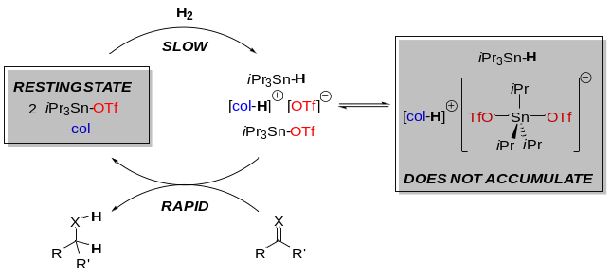
Scheme 6. Simplified catalytic cycle for hydrogenations mediated by 1-OTf/col. The reduction step is rapid relative to H₂ cleavage, making 1-OTf + col the resting state under catalytic conditions. Since [OTf]⁻ does not accumulate in sit, 1-OTf is not sequestered (as [1(OTf)₂]–) during catalytic hydrogenations. X = NR’’, O.
Our previous observations in the catalytic hydrogenation of imine and carbonyl compounds by 1-OTf + col (our optimum LB for catalysis) showed that the reduction steps involved reaction of 1-H with protonated imines and (carbonyl)·1-OTf species (i.e. activated substrates), respectively. These were much more rapid than H₂ activation, and notably 1-H was observed neither by ¹H nor ¹¹⁹Sn{¹H} NMR spectroscopy at any point during catalysis, hence it was proposed that H₂ cleavage was the rate-determining step.^{17a,b} The current results show that [1(OTf)₂]– forms as H₂ heterolysis by 1-OTf/col proceeds and, due to sequestration of active LA 1-OTf, it would therefore be expected to affect the reaction rate deleteriously in catalytic reactions. It should be noted, however, that in catalytic reactions the direct H₂ cleavage products 1-H and [col-H]⁺[OTf]⁻ are almost immediately consumed during proton and hydride transfers to the substrate; since H₂ cleavage is the rate-determining step, the accumulation of [1(OTf)₂]– will be suppressed and/or it will form reversibly. The latter postulate is reinforced by the calculated small free energy difference between formation of 1-H + [col-H][OTf] from 1-OTf + col + H₂ (+ 1.7 kcal/mol) and binding of 1-OTf with [OTf]– (-3.2 kcal/mol); this implies that all of these species would co-exist in a readily-perturbed equilibrium, as 1-H + [col-H][OTf] are consumed in substrate hydrogenation. Indeed [1(OTf)₂]– is not observed by ¹¹⁹Sn{¹H} NMR spectroscopy during catalytic reactions,^{17a,b} verifying that this species plays an insignificant role under the conditions of hydrogenation catalysis. Taking the results together, we propose that lowering the activation energy of H₂ cleavage is the most important factor to improve the rate of hydrogenation by triorganostannylium-based catalysts. Because [OTf]⁻ explicitly interacts with [1]⁺ in the reactants and the lowest energy TS possible for H₂ heterolysis by 1-OTf/col, this anion affects their stabilities; variation of this anion should consequently affect the activation energy as long as it remains associated in such a manner.
Conclusions
In conclusion, we have elucidated that 1-OTf is the LA involved in the lowest energy TS for H₂ activation with both coordinating (qui) and non-coordinating (col) LBs. 1-OTf and qui associate to form the dative adduct (qui)·1-OTf, which was characterised by single crystal X-ray crystallography; solution-phase NMR studies and DFT calculations reveal that this adduct is in equilibrium with 1-OTf, [1·(qui)]⁺ and [1(OTf)₂]⁻ at room temperature. By contrast, 1-OTf and col show a far lesser degree of association due to the greater steric protection of the LB. Ionic salts [1·(LB)]⁺[Al(OR^{F})₄]⁻ permitted examination of the reactivity of an alternative LA adduct in the absence of a coordinating anion, where it was found that additional extraneous LB was necessary to promote H₂ activation. This indicates that these reactions proceed via a (LB)·H₂·[1·(LB)]⁺ TS, which is supported by computational results that also predict analogous mechanisms for H₂ heterolysis by 1-OTf/LB pairs. Although the [1·(LB)]⁺/LB systems do activate H₂, their initial reaction rates are significantly slower than the corresponding 1-OTf/LB pairs, which is attributed to differing degrees of charge separation along the respective reaction pathways; in the latter case this is more pronounced, resulting in relative stabilisation of the TS by highly polar solvent media (e.g. DFB), and hence a lower barrier to H₂ cleavage. The activation energies for H₂ cleavage for both 1-OTf/LB and [1·(LB)]⁺/LB pairs are found to be significantly higher when LB = col, which is due to its lower basicity and the higher steric strain in the TS, vs qui. A surprising finding is that while [1·(LB)]⁺/LB LPs activate H₂ quantitatively, the catalytically relevant 1-OTf/LB pairs achieve only ~50% conversion. This is rationalised by the liberation of [OTf]⁻ during H₂ activation which is subsequently sequestered by 1-OTf to form [1(OTf)₂]⁻, as well as by the modest thermodynamic driving force of H₂ activation.
Taken together, these results reveal that the triflate ion in 1-OTf/LB LPs exerts a considerable effect on both the thermodynamics (the relative stabilities of ground-state species prior to H₂ activation, and the products thereafter) and kinetics (the TS energy barriers) of H₂ activation. Our present work highlights the importance of how the counteranion can impact the reactivity of cationic LAs beyond a simple modulation of Lewis acidity, and we anticipate that these findings will translate to the reactivity of other systems. Encouragingly, the ability to vary the anion partner of LA cations offers a design principle unavailable to neutral LAs. We expect that this will encourage further research into anion tunability for the tailoring of LA reactivity, especially towards the reactions of important small molecules.

AUTHOR INFORMATION
Corresponding Author
Andrew E. Ashley - Molecular Sciences Research Hub, Imperial College, White City Campus, 80 Wood Lane, London, W12 0BZ, UK. * Email: a.ashley@imperial.ac.uk
Imre Pápai - Institute of Organic Chemistry, Research Center for Natural Sciences, Magyar tudósok körútja 2, H-1117 Budapest, Hungary. * Email: papai.imre@ttk.mta.hu

Author Contributions
Joshua S. Sapsford - Molecular Sciences Research Hub, Imperial College, White City Campus, 80 Wood Lane, London, W12 0BZ, UK.
Roland C. Turnell-Ritson - Molecular Sciences Research Hub, Imperial College, White City Campus, 80 Wood Lane, London, W12 0BZ, UK.
Adam D. Piascik - Molecular Sciences Research Hub, Imperial College, White City Campus, 80 Wood Lane, London, W12 0BZ, UK.
Daniel J. Scott - Institute of Inorganic Chemistry, University of Regensburg, Universitätsstraße 31, 93051 Regensburg, Germany.
Dániel Csókás - Institute of Organic Chemistry, Research Center for Natural Sciences, Magyar tudósok körútja 2, H-1117 Budapest, Hungary.
The manuscript was written through contributions of all authors.
Funding Sources
We wish to thank Imperial College for a President's PhD Scholarship award (R. C. T.-R.); the EPSRC for PhD (J. S. S. and A. D. P.) and grant funding (EP/N026004), including a Doctoral Prize Fellowship (EP/N509486/1, D. J. S.); and the Royal Society for a University Research Fellowship (A. E. A.; UF/160395). This work was also supported by the NKFIH (K-115660). Computational resources provided by the NIIF Supercomputer Center are acknowledged.
Notes
The authors declare no competing financial interest. CCDC 1998683 and CCDC 1998684 contain the supplementary crystallo-graphic data for this paper. These data can be obtained free of charge via www.ccdc.cam.ac.uk/data_request/cif.brief.
ASSOCIATED CONTENT
Supporting Information. The Supporting Information is available free of charge on the ACS Publications website at DOI: 10.1021/acscatal.xxxxxxx.

Full synthetic and computational details, NMR spectra of the reported reactions and crystallographic data are contained therein (PDF)
X-ray structure for (qui)·1-OSO₂CF₃ (CIF)
X-ray structure for [1·(qui)]⁺{Al([OC(CF₃)₃]₄}⁻ (CIF)
ACKNOWLEDGMENT
We would like to thank Pete Haycock for providing support and assistance during the collection of NMR data. In addition, we would like to thank Andrea Hamza for her technical assistance in the handling of the many conformers studied herein.
REFERENCES
(1) For key publications see: (a) Welch, G. C.; Juan, R. R. S.; Masuda, J. D.; Stephan, D. W. ‘Reversible, Metal-Free Hydrogen Activation’ Science 2006, 314, 1124–1126. (b) Welch, G. C.; Stephan, D. W. ‘Facile heterolytic cleavage of dihydrogen by phosphines and boranes’ J. Am. Chem. Soc. 2007, 129, 1880–1881. (c) Chase, P. A.; Welch, G. C.; Jurca, T.; Stephan, D. W. ‘Metal-Free Catalytic Hydrogenation’ Angew. Chem. Int. Ed. 2007, 46, 8050–8053. (d) Chase, P. A.; Jurca, T.; Stephan, D. W. ‘Lewis acid-catalyzed hydrogenation: B(C₆F₅)₃-mediated reduction of imines and nitriles with H₂’ Chem. Commun. 2008, 1701–1703. (e) Chen, D.; Klankermayer, J. ‘Metal-free catalytic hydrogenation of imines with tris(perfluorophenyl)borane’ Chem. Commun. 2008, 2130–2131. (f) Ashley, A. E.; Thompson, A. L.; O’Hare, D. ‘Non-metal Mediated Homogeneous Hydrogenation of CO₂ to CH₃OH’ Angew. Chem. Int. Ed. 2009, 48, 9839–9843. (g) Chernichenko, K.; Madarász, Á.; Pápai, I.; Nieger, M.; Leskelä, M.; Repo, T. ‘A frustrated-Lewis-pair approach to catalytic reduction of alkynes to cis-alkenes’ Nat. Chem. 2013, 5, 718–723. (h) Légaré, M.-A.; Courtemanche, M.-A.; Rochette, E.; Fontaine, F.-G. ‘Metal-free catalytic C-H bond activation and borylation of heteroarenes’ Science 2015, 349, 513–516.
(2) For overviews of FLPs see: (a) Erker, G.; Stephan, D. W. “Frustrated Lewis Pairs”, Top. Curr. Chem, Vols. I and II, Springer, Berlin, 2013. (b) Stephan, D. W. ‘Frustrated Lewis pairs: From concept to catalysis’ Acc. Chem. Res. 2015, 48, 306–316. (c) Stephan, D. W.; Erker, G. ‘Frustrated Lewis Pair Chemistry: Development and Perspectives’ Angew. Chem. Int. Ed. 2015, 54, 6400–6441. (d) Stephan, D. W. ‘Frustrated Lewis Pairs’ J. Am. Chem. Soc. 2015, 137, 10018–10032.
(3) For reviews of FLP-catalyzed hydrogenations see: (a) Stephan, D. W.; Greenberg, S.; Graham, T. W.; Chase, P.; Hastie, J. J.; Geier, S. J.; Farrell, J. M.; Brown, C. C.; Heiden, Z. M.; Welch, G. C.; Ullrich, M. ‘Metal-Free Catalytic Hydrogenation of Polar Substrates by Frustrated Lewis Pairs’ Inorg. Chem. 2011, 50, 12338–12348. (b) Paradies, J. ‘Metal-Free Hydrogenation of Unsaturated Hydrocarbons Employing Molecular Hydrogen’ Angew. Chem. Int. Ed. 2014, 53, 3552–3557. (c) Hounjet, L. J.; Stephan, D. W. ‘Hydrogenation by Frustrated Lewis Pairs: Main Group Alternatives to Transition Metal Catalysts?’ Org. Process Res. Dev. 2014, 18, 385–391. (d) Scott, D. J.; Fuchter, M. J.; Ashley, A. E. ‘Designing effective ‘frustrated Lewis pair’ hydrogenation catalysts’ Chem. Soc. Rev. 2017, 46, 5689–5700. (e) Lam, J.; Szkop, K. M.; Mosaferi, E.; Stephan, D. W. ‘FLP catalysis: main group hydrogenations of organic unsaturated substrates’ Chem. Soc. Rev. 2019, 48, 3592–3612. (f) Paradies, J. ‘Mechanisms in Frustrated Lewis Pair-Catalyzed Reactions’ Eur. J. Org. Chem. 2019, 2019, 283–294.
(4) (a) Scott, D. J.; Fuchter, M. J.; Ashley, A. E. ‘Nonmetal Catalyzed Hydrogenation of Carbonyl Compounds’ J. Am. Chem. Soc. 2014, 136, 15813–15816. (b) Mahdi, T.; Stephan, D. W. ‘Enabling Catalytic Ketone Hydrogenation by Frustrated Lewis Pairs’ J. Am. Chem. Soc. 2014, 136, 15809–15812. (c) Scott, D. J.; Simmons, T. R.; Lawrence, E. J.; Wildgoose, G. G.; Fuchter, M. J.; Ashley, A. E. ‘Facile Protocol for Water-Tolerant “Frustrated Lewis Pair”-Catalyzed Hydrogenation’ ACS Catal. 2015, 5, 5540–5544. (d) Mahdi, T.; Stephan, D. W. ‘Facile Protocol for Catalytic Frustrated Lewis Pair Hydrogenation and Reductive Deoxygenation of Ketones and Aldehydes’ Angew. Chem. Int. Ed. 2015, 54, 8511–8514.
(5) (a) Erős, G.; Mehdi, H.; Pápai, I.; Rokob, T. A.; Király, P.; Tárkányi, G.; Soós, T. ‘Expanding the Scope of Metal-Free Catalytic Hydrogenation through Frustrated Lewis Pair Design’ Angew. Chem. Int. Ed. 2010, 49, 6559–6563. (b) Ashley, A. E.; Herrington, T. J.; Wildgoose, G. G.; Zaher, H.; Thompson, A. L.; Rees, N. H.; Krämer, T.; O’Hare, D. ‘Separating Electrophilicity and Lewis Acidity: The Synthesis, Characterization, and Electrochemistry of the Electron Deficient Tris (aryl)boranes B(C₆F₅)_{3–n}(C₆Cl₅)_{n} ( n = 1–3)’ J. Am. Chem. Soc. 2011, 133, 14727–14740. (c) Erős, G.; Nagy, K.; Mehdi, H.; Pápai, I.; Nagy, P.; Király, P.; Tárkányi, G.; Soós, T. ‘Catalytic Hydrogenation with Frustrated Lewis Pairs: Selectivity Achieved by Size-Exclusion Design of Lewis Acids’ Chem. Eur. J. 2012, 18, 574–585. (d) Sivaev, I. B.; Bregadze, V. I. ‘Lewis acidity of boron compounds’ Coord. Chem. Rev. 2014, 270–271, 75–88. (e) Scott, D. J.; Fuchter, M. J.; Ashley, A. E. ‘Metal-Free Hydrogenation Catalyzed by an Air-Stable Borane: Use of Solvent as a Frustrated Lewis Base’ Angew. Chem. Int. Ed. 2014, 53, 10218–10222. (f) Lawson, J. R.; Melen, R. L. ‘Tris(pentafluorophenyl)borane and Beyond: Modern Advances in Borylation Chemistry’ Inorg. Chem. 2017, 56, 8627–8643. (g) Paradies, J. ‘From structure to novel reactivity in frustrated Lewis pairs’ Coord. Chem. Rev. 2019, 380, 170–183. (e) Carden, J. L., Dasgupta, A., Melen R. L. ‘Halogenated triarylboranes: synthesis, properties and applications in catalysis’ Chem. Soc. Rev., 2020, 49, 1706–1725
(6) (a) Fasano, V.; Ingleson, M. ‘Recent Advances in Water-Tolerance in Frustrated Lewis Pair Chemistry’ Synthesis 2018, 50, 1783–1795. (b) Gyömöre, Á.; Bakos, M.; Földes, T.; Pápai, I.; Domján, A.; Soós, T. ‘Moisture-Tolerant Frustrated Lewis Pair Catalyst for Hydrogenation of Aldehydes and Ketones’ ACS Catal. 2015, 5, 5366–5372. (c) Dorkó, É.; Szabó, M.; Kótai, B.; Pápai, I.; Domján, A.; Soós, T. ‘Expanding the Boundaries of Water-Tolerant Frustrated Lewis Pair Hydrogenation: Enhanced Back Strain in the Lewis Acid Enables the Reductive Amination of Carbonyls’ Angew. Chem. Int. Ed. 2017, 56, 9512–9516. (d) Bakos, M.; Gyömöre, Á.; Domján, A.; Soós, T. ‘Auto-Tandem Catalysis with Frustrated Lewis Pairs for Reductive Etherification of Aldehydes and Ketones’ Angew. Chem. Int. Ed. 2017, 56, 5217–5221. (e) Sitte, N. A.; Bursch, M.; Grimme, S.; Paradies, J. ‘Frustrated Lewis Pair Catalyzed Hydrogenation of Amides: Halides as Active Lewis Base in the Metal-Free Hydrogen Activation’ J. Am. Chem. Soc. 2019, 141, 159–162. (f) Hoshimoto, Y.; Kinoshita, T.; Hazra, S.; Ohashi, M.; Ogoshi, S. ‘Main-Group-Catalyzed Reductive Alkylation of Multiply Substituted Amines with Aldehydes Using H₂’ J. Am. Chem. Soc. 2018, 140, 7292–7300.
(7) For a recent overview of unsettled mechanistic issues, see: J. Daru, I. Bakó, A. Stirling and I. Pápai ‘Mechanism of Heterolytic Hydrogen Splitting by Frustrated Lewis Pairs: Comparison of Static and Dynamic Models’ ACS Catal., 2019, 9, 6049−6057.
(8) For a review on relevant computational studies, see: T. A. Rokob, I. Pápai, ‘Hydrogen Activation by Frustrated Lewis Pairs: Insights from Computational Studies’ Top. Curr. Chem. 2013, 332, 157–211.
(9) We excluded the possibility of radical-mediated H₂ cleavage by Lewis pairs comprising [iPr₃Sn]⁺ fragments in our previous studies; see reference 15. For examples of ‘frustrated radical pairs’ see: (a) Liu, L. L.; Cao, L. L.; Shao, Y.; Stephan, D. W. ‘Single Electron Delivery to Lewis Pairs: An Avenue to Anions by Small Molecule Activation’, J. Am. Chem. Soc., 2017, 139, 10062–10071. (b) Liu, L. L.; Cao, L. L.; Shao, Y.; Ménard, G.; Stephan, D. W. ‘A Radical Mechanism for Frustrated Lewis Pair Reactivity’, Chem, 2017, 3, 259–267. (c) Liu, L. L.; Cao, L. L.; Zhu, D.; Zhou, J.; Stephan, D. W. ‘Homolytic cleavage of peroxide bonds via a single electron transfer of a frustrated Lewis pair’, Chem. Commun., 2018, 54, 7431–7434. (d) Merk, A.; Großekappenberg, H.; Schmidtmann, M.; Luecke, M.-P.; Lorent, C.; Driess, M.; Oestreich, M.; Klare, H. F. T.; Müller, T. ‘Single-Electron Transfer Reactions in Frustrated and Conventional Silylium Ion/Phosphane Lewis Pairs’, Angew. Chem. Int. Ed., 2018, 57, 15267–15271. (e) Liu, L. L.; Stephan, D. W. ‘Radicals derived from Lewis acid/base pairs’, Chem. Soc. Rev., 2019, 48, 3454–3463. (f) Bennett, E. L.; Lawrence, E. J.; Blagg, R. J.; Mullen, A. S.; MacMillan, F.; Ehlers, A. W.; Scott, D. J.; Sapsford, J. S.;Ashley, A. E.; Wildgoose G. G.; Slootweg, J. C. ‘A New Mode of Chemical Reactivity for Metal-Free Hydrogen Activation by Lewis Acidic Boranes’, Angew. Chem. Int. Ed., 2019, 58, 8362–8366. (g) Soltani, Y.; Dasgupta, A.; Gazis, T. A.; Ould, D. M. C.; Richards, E.; Slater, B.; Stefkova, K.; Vladimirov, V. Y.; Wilkins, L. C.; Willcox, D.; Melen, R. L. ‘Radical Reactivity of Frustrated Lewis Pairs with Diaryl Esters’, Cell Reports Phys. Sci., 2020, 1, 100016.
(10) (a) Eisenberger, P.; Bailey, A. M.; Crudden, C. M. ‘Taking the F out of FLP: Simple lewis acid-base pairs for mild reductions with neutral boranes via borenium ion catalysis’ J. Am. Chem. Soc. 2012, 134, 17384–17387. (b) Farrell, J. M.; Hatnean, J. A.; Stephan, D. W. ‘Activation of Hydrogen and Hydrogenation Catalysis by a Borenium Cation’ J. Am. Chem. Soc. 2012, 134, 15728–15731. (c) Eisenberger, P.; Bestvater, B. P.; Keske, E. C.; Crudden, C. M. ‘Hydrogenations at Room Temperature and Atmospheric Pressure with Mesoionic Carbene-Stabilized Borenium Catalysts’ Angew. Chem. Int. Ed. 2015, 54, 2467–2471. (d) Clark, E. R.; Del Grosso, A.; Ingleson, M. J. ‘The Hydride-Ion Affinity of Borenium Cations and Their Propensity to Activate H₂ in Frustrated Lewis Pairs’ Chem. Eur. J. 2013, 19, 2462–2466. (e) Lam, J.; Günther, B. A. R.; Farrell, J. M.; Eisenberger, P.; Bestvater, B. P.; Newman, P. D.; Melen, R. L.; Crudden, C. M.; Stephan, D. W. ‘Chiral carbene–borane adducts: precursors for borenium catalysts for asymmetric FLP hydrogenations’ Dalton Trans. 2016, 45, 15303–15316. (f) Mercea, D. M.; Howlett, M. G.; Piascik, A. D.; Scott, D. J.; Steven, A.; Ashley, A. E.; Fuchter, M. J. ‘Enantioselective reduction of N-alkyl ketimines with frustrated Lewis pair catalysis using chiral borenium ions’ Chem. Commun. 2019, 55, 7077–7080.
(11) (a) Herrington, T. J.; Ward, B. J.; Doyle, L. R.; McDermott, J.; White, A. J. P.; Hunt, P. A.; Ashley, A. E. ‘Bypassing a highly unstable frustrated Lewis pair: dihydrogen cleavage by a thermally robust silylium–phosphine adduct’ Chem. Commun. 2014, 50, 12753–12756. (b) Oestreich, M.; Hermeke, J.; Mohr, J. ‘A unified survey of Si–H and H–H bond activation catalysed by electron-deficient boranes’ Chem. Soc. Rev. 2015, 44, 2202–2220. (c) Weicker, S. A.; Stephan, D.W. ‘Activation of Carbon Dioxide by Silyl Triflate-Based Frustrated Lewis Pairs’ Chem. Eur. J. 2015, 21, 13027-13034. (d) Mallov, I.; Ruddy, A. J.; Zhu, H.; Grimme, S.; Stephan, D. W. ‘C−F Bond Activation by Silylium Cation/Phosphine Frustrated Lewis Pairs: Mono-Hydrodefluorination of PhCF₃, PhCF₂H and Ph₂CF₂’ Chem. Eur. J. 2017, 23, 17692–17696.
(12) (a) Clark, E. R.; Ingleson, M. J. ‘N-Methylacridinium Salts: Carbon Lewis Acids in Frustrated Lewis Pairs for σ-Bond Activation and Catalytic Reductions’ Angew. Chem. Int. Ed. 2014, 53, 11306–11309. (b) Mosaferi, E.; Ripsman, D.; Stephan, D. W. ‘The air-stable carbocation salt [(MeOC₆H₄)CPh₂][BF₄] in Lewis acid catalyzed hydrothiolation of alkenes’ Chem. Commun. 2016, 52, 8291–8293. (c) Fasano, V.; Radcliffe, J. E.; Curless, L. D.; Ingleson, M. J. ‘N-Methyl-Benzothiazolium Salts as Carbon Lewis Acids for Si−H Sigma-Bond Activation and Catalytic (De)hydrosilylation’ Chem. Eur. J. 2017, 23, 187–193.
(13) (a) Zhou, J.; Liu, L. L.; Cao, L. L.; Stephan, D. W. ‘An umpolung of Lewis acidity/basicity at nitrogen by deprotonation of a cyclic (amino)(aryl)nitrenium cation’ Chem. Commun. 2018, 54, 4390-4393. (b) Zhou, J.; Liu, L. L.; Cao, L. L.; Stephan, D. W. ‘Nitrogen‐Based Lewis Acids: Synthesis and Reactivity of a Cyclic (Alkyl)(Amino)Nitrenium Cation’ Angew. Chem. Int. Ed. 2018, 57, 3322-3326. (c) Waked, A. E.; Memar, R. O.; Stephan, D. W. ‘Nitrogen-Based Lewis Acids Derived from Phosphonium Diazo Cations’ Angew. Chem. Int. Ed., 2018, 57, 11934-11938.
(14) (a) Caputo, C. B.; Hounjet, L. J.; Dobrovestsky, R.; Stephan, D. W. ‘Lewis Acidity of Organofluorophosphonium Salts: Hydrodefluorination by a Saturated Acceptor’ Science, 2013, 341, 1374-1377. (b) Pérez, M.; Hounjet, L. J.; Caputo, C. B.; Dobrovetsky, R.; Stephan, D. W. ‘Olefin Isomerization and Hydrosilylation Catalysis by Lewis Acidic Organofluorophosphonium Salts’ J. Am. Chem. Soc., 2013, 135, 18308-18310 (c) Vom Stein, T.; Peréz, M.; Dobrovetsky, R.; Winkelhaus, D.; Caputo, C. B.; Stephan, D. W. ‘Electrophilic Fluorophosphonium Cations in Frustrated Lewis Pair Hydrogen Activation and Catalytic Hydrogenation of Olefins’ Angew. Chem. Int. Ed. 2015, 54, 10178–10182. (d) Fasano, V.; LaFortune, J. H. W.; Bayne, J. M.; Ingleson, M. J.; Stephan, D. W. ‘Air- and water-stable Lewis acids: synthesis and reactivity of P-trifluoromethyl electrophilic phosphonium cations’ Chem. Commun. 2018, 54, 662–665. (e) Postle, S.; Podgorny, V.; Stephan, D. W. ‘Electrophilic phosphonium cations (EPCs) with perchlorinated-aryl substituents: towards air-stable phosphorus-based Lewis acid catalysts’ Dalton Trans. 2016, 45, 14651-14657. (f) Barrado, A. G.; Bayne, J. M.; Johnstone, T. C.; Lehmann, C. W.; Stephan, D. W.; Alcarazo, M. ‘Dicationic phosphonium salts: Lewis acid initiators for the Mukaiyama-aldol reaction’ Dalton Trans., 2017, 46, 16216-16227 (g) Bayne, J. M.; Fasano, V.; Szkop, K. M.; Ingleson, M. J.; Stephan, D. W. ‘Phosphorous(V) Lewis acids: water/base tolerant P₃-trimethylated trications’ Chem. Commun. 2018, 54, 12467–12470.
(15) (a) Pan, B.; Gabbaï, F. P. ‘[Sb(C₆F₅)₄][B(C₆F₅)₄]: An Air Stable, Lewis Acidic Stibonium Salt That Activates Strong Element-Fluorine Bonds’ J. Am. Chem. Soc. 2014, 136, 9564–9567. (b) Tofan, D.; Gabbaï, F. P. ‘Fluorinated antimony(V) derivatives: strong Lewis acidic properties and application to the complexation of formaldehyde in aqueous solutions’ Chem. Sci. 2016, 7, 6768–6778.
(16) For a review of non-borane FLPs see: Weicker, S. A.; Stephan, D. W. ‘Main Group Lewis Acids in Frustrated Lewis Pair Chemistry: Beyond Electrophilic Boranes’ Bull. Chem. Soc. Jpn. 2015, 88, 1003–1016.
(17) (a) Scott, D. J.; Phillips, N. A.; Sapsford, J. S.; Deacy, A. C.; Fuchter, M. J.; Ashley, A. E. ‘Versatile Catalytic Hydrogenation Using A Simple Tin(IV) Lewis Acid’ Angew. Chem. Int. Ed. 2016, 55, 14738–14742. (b) Sapsford, J. S.; Scott, D. J.; Allcock, N. J.; Fuchter, M. J.; Tighe, C. J.; Ashley, A. E. ‘Direct Reductive Amination of Carbonyl Compounds Catalyzed by a Moisture Tolerant Tin(IV) Lewis Acid’ Adv. Synth. Catal. 2018, 360, 1066–1071. For research using the (PhCH₂)₃SnOTf LA see: (c) Cooper, R. T.; Sapsford, J. S.; Turnell-Ritson, R. C.; Hyon, D.-H.; White, A. J. P.; Ashley, A. E. ‘Hydrogen activation using a novel tribenzyltin Lewis acid’ Phil. Trans. R. Soc. A, 2017, 375, 20170008.
(18) (a) Das, S.; Mondal, S.; Pati, S. K. ‘Mechanistic Insights into Hydrogen Activation by Frustrated N/Sn Lewis Pairs’ Chem. Eur. J. 2018, 24, 2575–2579. (b) Das, S.; Pati, S. K. ‘Unravelling the mechanism of tin-based frustrated Lewis pair catalysed hydrogenation of carbonyl compounds’ Catal. Sci. Technol. 2018, 8, 5178–5189.
(19) Busca, G. ‘Bases and Basic Materials in Chemical and Environmental Processes. Liquid versus Solid Basicity’ Chem. Rev. 2010, 110, 2217–2249.
(20) Glasovac, Z.; Eckert-Maksić, M.; Maksić, Z. B. ‘Basicity of organic bases and superbases in acetonitrile by the polarized continuum model and DFT calculations’ New J. Chem. 2009, 33, 588–597.
(21) In the absence of donors 1-OTf is only sparingly soluble in 1,2-dichlorobenzene (DCB) at room temperature, which is the optimum solvent for hydrogenation catalysis. To ensure that all of the solutions studied were homogeneous, the solvent was changed to the more polar 1,2-difluorobenzene (DFB), in which 1-OTf is fully soluble (all H₂ activation reactions using 1-OTf/LB pairs described herein proceed in both DCB and DFB with no reactivity differences).
(22) (a) Krossing, I. ‘The Facile Preparation of Weakly Coordinating Anions: Structure and Characterisation of Silverpolyfluoroalkoxyaluminates AgAl(OR_{F})₄, Calculation of the Alkoxide Ion Affinity’ Chem. Eur. J. 2001, 7, 490–502. (b) Krossing, I.; Raabe, I. ‘Noncoordinating anions - Fact or fiction? A survey of likely candidates’ Angew. Chem. Int. Ed., 2004, 43, 2066-2090. (c) Krossing, I.; Reisinger, A. ‘Perfluorinated Alkoxyaluminate Salts of Cationic Brønsted Acids: Synthesis, Structure, and Characterization of [H(OEt₂)₂][Al{OC(CF₃)₃}₄] and[H(THF)₂][Al{OC(CF₃)₃}₄]’ Eur. J. Inorg. Chem. 2005, 1979–1989.
(23) [1·(LB)]⁺[Al(OR^{F})₄]⁻ salts were found to be extremely sensitive to moisture upon isolation, decomposing rapidly to (iPr₃Sn)₂O – (1)₂O – and [qui-H]⁺[Al(OR^{F})₄]⁻ (observed by ¹H and ¹¹⁹Sn{¹H} NMR spectroscopy). Consequently, this affected the activity of [1·(LB)]⁺ [Al(OR^{F})₄]⁻ in reactions with H₂, and frustratingly the resonances of (1)₂O obscured those of 1-H in the ¹H NMR spectra. To minimise the amount of contaminating (1)₂O, and maintain the reproducibility of experiments using [1·(LB)]⁺ [Al(OR^{F})₄]⁻, the salts were prepared freshly in situ in DFB and used immediately for all reactions reported herein. For characterisation of (1)₂O using NMR spectroscopy, see: Lockhart, T. P.; Manders, W. F.; Brinckman, F. E. ‘Spin Coupling Through Oxygen. Influence Of Structure And Solvent On ²J(¹¹⁹Sn,¹¹⁷Sn) In The ¹¹⁹Sn NMR Of Hexaorganodistannoxanes’ J. Organomet. Chem., 1985, 286, 153-158.
(24) The DFT calculations were carried out using the ωB97X-D functional along with the Def2SVP and Def2TZVPP basis sets. The reported relative stabilities were obtained from solution phase Gibbs free energies. For further computational details, see the SI. To model the global solvation eﬀects, the SMD implicit solvation model was employed. For further computational details, see the SI section 5.
(25) This seems to contradict the results obtained previously for DABCO/1-OTf.¹⁶ Pati et al. found the formation of the datively bound (DABCO)·1-OTf complex to be only marginally exergonic with respect to the 1-OTf + DABCO state. The orientation of the iPr groups in the most stable form of (qui)·1-OTf is different from that reported for the analogous (DABCO)·1-OTf complex (reference 18a), which may explain the difference found in the relative stabilities of the two complexes.
(26) Only one set of (unobscured) qui resonances are observed in the ¹H NMR spectrum (δ = 2.98 and 1.67 ppm) for a 1:1 mixture of [1·(qui)][Al(OR^{F})₄] and qui, in DFB. The corresponding resonances in [1·(qui)]⁺ are appreciably downfield at δ = 3.16 and 1.86 ppm, respectively. This is consistent with qui being bound to the electron deficient [1]⁺ fragment in the former, while in the mixture a weighted average of chemical shifts between coordinated and uncoordinated qui is seen, implying a fast exchange equilibrium. Although [1·(qui)₂]⁺ is calculated to be unstable relative to [1·(qui)]⁺ + qui (4.7 kcal/mol), this could be considered as an activation energy to degenerate exchange between bound and unbound qui, which will be readily surmountable at room temperature.
(27) The melting point of DFB (–35°C; 239 K) limits the utility of this solvent for low-temperature NMR studies. Accordingly CD₂Cl₂ was used instead.
(28) Although broadening of the ¹¹⁹Sn{¹H} NMR resonance is observed at 243 K in DFB, the solvent freezes below this temperature (m.p. = 239 K). The data are included in the SI.
(29) Spontaneous dissociation of [OTf]– from 1-OTf to form [1]⁺ is thought to be highly unlikely due to the very reactive and unstable nature of stannylium ions, especially in weak donor solvents such as DFB or CH₂Cl₂.
(30) [1·(qui)]⁺ and [Al(OR^{F})₄]⁻ are predicted to be separated in DFB (dissociation energy = −11.1 kcal/mol); [Al(OR^{F})₄]⁻ was therefore omitted from mechanistic calculations (for more details see SI section 6.3).
(31) In principle, the [1·(qui)]⁺/[OTf]⁻ pair may also induce FLP-type H₂ activation, however, the barrier of this process is predicted to be much higher (31.2 kcal/mol) than that of the 1-OTf/qui pair (see SI, section 6.5 for transition state structure).
(32) We note, however, that the level of agreement we find here should not be considered as a measure for the accuracy of the applied methodology.
(33) A direct comparison between the two systems [1·qui]⁺/qui and 1-OTf/qui is not straightforward because there is neither a common reference state, nor common reaction coordinate. We have attempted to make the best comparison possible using the two free energy profiles starting with their own reference states, including the H₂ activation transition states, and product states.
(34) Kaljurand, I.; Kütt, A.; Sooväli, L.; Rodima, T.; Mäemets, V.; Leito, I.; Koppel, I. A. ‘Extension of the Self-Consistent Spectrophotometric Basicity Scale in Acetonitrile to a Full Span of 28 pK_{a} Units: Unification of Different Basicity Scales’ J. Org. Chem. 2005, 70, 1019–1028.
(35) Further cooling of CD₂Cl₂ solutions beyond this temperature was uninformative due to precipitation of 1-OTf.

TOC Graphic

