Inferring extinctions II: A practical, iterative model based on records and surveys
Colin J. Thompsonª, Vira Koshkina^{b}, Mark A. Burgman^{c}, Stuart H. M. Butchart^{d,e} and Lewi Stone^{b,f}
ªDepartment of Mathematics and Statistics, University of Melbourne, 3010 Australia
^{b}School of Mathematical and Geospatial Sciences, RMIT University, Melbourne, Australia
^{c}Centre for Environmental Policy, Imperial College London, UK, and School of BioSciences, University of Melbourne, 3010 Australia
^{d}BirdLife International, David Attenborough Building, Pembroke Street, Cambridge, CB2 3QZ UK
^{e} Department of Zoology, University of Cambridge, Downing Street, Cambridge Cb23EJ, UK.
^{f}Biomathematics Unit, Department of Zoology, Faculty of Life Sciences, Tel-Aviv University, P.O. Box 39040, Tel-Aviv 69978, Israel

Corresponding author: Prof. Colin Thompson, Department of Mathematics and Statistics, University of Melbourne, Victoria, 3010 Australia
Phone: +61 3 8344 5550
Email: markab@unimelb.edu.au

Abstract
Extinctions are difficult to observe. Estimating the probability that a taxon has gone extinct using data from the field aids prioritisation of conservation interventions and environmental monitoring. There have been recent advances in approaches to estimating this probability from records. However, complete assessment requires consideration of the type, timing and certainty of records, the timing, scope and severity of threats, and the timing, extent and reliability of surveys. Until recently, no single method could integrate these different sources and qualities of data into a single measure. Here we describe a new, accessible method for estimating the probability that a taxon is extinct based on different kinds of both record and survey data, and accounting for data quality. The model takes into account uncertainties in input parameter estimates and provides bounds on estimates of the extinction probability. We illustrate application of the model using information for the Alaotra Grebe Tachybaptus rufolavatus. Application of this approach should facilitate more efficient allocation of conservation resources by enabling scenario analyses that inform investments in searches and management interventions for potentially extinct taxa. It should also provide more reliable estimates of recent extinction rates.
Key-words:
Extinct, probability of extinction, model, searches, threatened species, conservation, IUCN Red List

Contents
- Introduction
- Model description and inputs
- The iterative model
  - For ‘records’
  - For unsuccessful surveys
  - The iterative scheme
- Model justification
- Implementation
- Results
- Further applications
  - Global extinctions
  - Costs and benefits of surveys
- Discussion
Acknowledgments
References

- Introduction
Extinctions of plant and animal taxa are almost never observed directly (Diamond 1987). However, determining whether a taxon is extinct is important because it affects decisions about priorities for surveys and conservation interventions such as actions to abate threats, and establish and manage protected areas. Estimates of extinction rates are also used to measure biodiversity conservation effectiveness and for reporting on the state of the environment (e.g., Ministry of the Environment 1997, State of the Environment, 2005, Tittensor et al. 2014, CBD 2014, Pimm et al. 2014). The IUCN (2012) defines a taxon as extinct “when there is no reasonable doubt that the last individual has died. A taxon is presumed extinct when exhaustive surveys in known and/or expected habitat, at appropriate times (diurnal, seasonal, annual), throughout its historic range have failed to record an individual. Surveys should be over a time frame appropriate to the taxon’s life cycle and life form”. Solow (1993) introduced a quantitative way of inferring extinctions from data on the timing of observations. Others have subsequently adapted these ideas, for example, to consider the certainty of observations (Burgman et al. 1995, McCarthy 1996, Rout et al. 2009, Solow & Roberts 2003, Roberts et al. 2010, Elphick et al. 2010, Lee et al. 2014, Jaric & Roberts 2014). Rivadeneira et al. (2009) assessed some of these models in a comparative study.
However, these approaches do not incorporate information on the adequacy of surveys and searches for the taxon (as specified by IUCN 2012). There is a need to account for detectability, accessibility of habitat, timing, duration, extensiveness, sampling intensity, survey methods and observer skill (see Clements et al. 2013 & 2014). Butchart et al. (2006, see also Szabo et al. 2012) provided a conceptual framework to consider the likelihood that a taxon has gone extinct based on knowledge of the intensity and timing of threats that may have impacted it, and the likely susceptibility of the taxon to such threats, alongside information on the timing and reliability of records and the adequacy of searches. They introduced the concept of ‘Possibly Extinct’ taxa to recognise uncertainty in judgements of probability of being extinct. However, there is no quantitative approach that incorporates all the kinds of data that may contribute to this assessment.
Thompson et al. (2013) developed a single framework that accommodates certain and uncertain observations, together with information from targeted surveys, but the approach is theoretical and unfortunately not straightforward to apply. Lee (2014) published a simplified version of the model, but this requires parameter estimates that are not readily available in practice. Also, in certain cases that can arise in practice, Lee’s (2014) model can lead to model probabilities that exceed unity. Here we present a practical adaptation of the approach presented in Thompson et al. (2013) that uses the type of data that can be derived from commonly available information, integrating records and survey data. It may be used to contribute to subsequent benefit-cost analyses (Akçakaya et al. submitted 2017). It generates results that are consistent with the definition of probabilities, and we provide it in an accessible software package to facilitate straightforward application.
- Methods
In outline, our simplified model provides year-by-year updates for the probability $P(X_{t})$, that the taxon is extant in the year t, of a given record. Two types of “years” over a given time-frame are considered depending on whether or not there is a record (or observation) of the taxon in question. Thus for any year, there is either:
- a “record”; or
- an “unsuccessful survey” which may be dedicated or passive.
Dedicated surveys are planned surveys devoted to searching for the taxon, in an attempt to determine whether it persists. In the absence of dedicated surveys, it is assumed that there may nevertheless be sightings reported from interested professional or amateur ecologists who happen to observe the taxon in some unplanned way. We call the latter, passive surveys. Note that here we treat all successful survey years as record years.
The model requires experts to provide estimates for inputs. This includes an “initial” $P(X_{0})$ (with bounds) that the taxon is extant at the beginning of the time series of records (and independent of them). The initial probability could be based on the severity and pervasiveness of threats and the taxon’s likely susceptibility to them. Inputs are required concerning the probability that the taxon was correctly identified. Inputs are also required for the probability that the taxon could have been identified correctly and would have been recorded, were it present, in years when unsuccessful surveys were conducted. In addition to these inputs, the approach also accounts for the proportion of the taxon’s remaining range covered by targeted surveys and their extensiveness, sampling intensity, survey methods and observer skill. Uncertainties in these inputs can be accounted for by providing lower and upper bounds on estimates. The bounds represent uncertainties in observations given the type and quality of evidence, the ease of distinguishing the taxon from taxa with which it could potentially be confused, circumstances of the record and the skill and experience of the recorder.
Our iterative model makes it possible to determine the probability that the taxon is extant $P(X_{t})$ in any year t of a record period, from the input data and uncertainty bounds. We are not aware of any other model in the literature that is designed from a practical standpoint and that incorporates the key features here accommodating for surveys (successful and unsuccessful) and timing of records, including their uncertainties. Recent work, however, is beginning to move in this direction. Caley and Barry (2014), for example, present a carefully designed model that introduces varying and density-dependent detection probabilities.
Finally we note that the iterative model presented here is not based on Bayes rule. The probability that the taxon is extant$P(X_{t})$, is defined as an (absolute) probability that the taxon is extant in year t. The probability is neither a Bayesian prior nor a conditional probability. It is updated each year according to simple rules that we justify below.
- Model description and inputs
A useful way to visualise our model is with reference to Table 1, which illustrates an implementation of the model (software code in R provided as a Supplementary Information File). We have used data for the Alaotra Grebe Tachybaptus rufolavatus derived from information held by BirdLife International, for illustrative purposes. The data consist of years in which there were plausible records of the taxon, and years in which the taxon was deemed absent with reasonable reliability, as concluded from dedicated ecological surveys. There are also years in which there were no records of the taxon (despite passive surveillance) and in which there were no dedicated surveys. The input column entitled ‘Calendar Year’ shows years in which the taxon was either ‘recorded’ (1929, 1947, 1960, 1963, 1969, 1970, 1971, 1972, 1982, 1985) or not recorded during years of dedicated (but unsuccessful) surveys (1986, 1988, 1989, 1999, 2000, 2004, 2009).
The input variables for p(ci), $ε$, p(i) and p(r) in Table 1 are defined as:
1. For “Records”
p(ci) = the probability that the taxon is correctly identified as extant.
That is, it is the probability that the taxon is extant given that it has been identified in a record. This parameter depends on the type and quality of evidence, similarity of the individual recorded to taxa with which it could potentially be confused, circumstances of the record and the skill and experience of the recorder. Note that this parameter only applies in years in which there is a record.
2. For unsuccessful “Dedicated Surveys”
$ε$ = the proportion of the taxon’s habitat within its likely entire range that was surveyed
(0 $≤ε≤$1).
p(i) = the probability that the taxon, or recent evidence of it, could have been reliably identified in the survey if it had been recorded.
This requires assessors to consider the verifiability of the record, that is, the likelihood that the recorded taxon could be distinguished from a similar taxon (e.g., a congener) given its distinctiveness (e.g., in appearance, morphology, vocalizations, behaviour etc), and the identification skill of the observers. Assessors must consider all signs of recent evidence (e.g. scat, spoor, nests, owl pellets, woodpecker bark peelings, shells, etc) and all life-stages at the time of the survey; for example, the mature life-form may be highly distinctive, but the juvenile/seed/larval/dormant life-stages may be extremely difficult to distinguish from similar taxa.
p(r) = the probability that the taxon, or recent evidence of it, would have been recorded in the survey.
This requires assessors to consider aspects of detectability, including body size, behaviour (e.g., activity and movement patterns, shyness, tendency to skulk, phenology, vocality, sociality), degree of crypsis, local abundance, and accessibility to / searchability of its habitat and microhabitat. Assessors should also consider the adequacy of the survey considering: i) its timing (seasonality, diurnality, time since disturbance); ii) its duration; iii) sampling and detection skill of the observers; iv) appropriateness of the techniques used (e.g., trap style, mist-net, sound recording, playback) and their application (e.g., height of mist-nets, location of cameras, positioning of malaise traps); and v) sampling intensity (e.g., length of transects, density of cameras) and design (e.g., sample stratification).
Note that it is assumed implicitly in the model that when a survey is successful it is treated as a record and assigned a $p\left(ci\right)$ value as in Table 1. Lower and upper bound estimates for the above input variables, which are provided by the user, depend on many factors, as noted above. In order to assign values to the above input variables, assessors need to consider and evaluate many possible environmental inputs. These considerations are discussed at length by Keith et al. (2017).
In the main columns of the spreadsheet (Table 1) it will be noted that there are (gap) years in which there were no records or dedicated surveys. To model these gap years the user can either insert further (unsuccessful) survey years with corresponding estimates for $ε$, p(i) and p(r) (which would typically differ from those in dedicated surveys) and/or accept the default passive (unsuccessful) survey estimates for coverage $ε'$, and probabilities p′(i) and p′(r) given in Table 1. These default estimates are assumed to apply in all (remaining) gap years, reflecting random processes in which people may record the taxon serendipitously, generally termed passive surveillance, without specific targeted searches. Finally, if desired, the user can insert their own default estimates for$ε'$, p′(i) and p′(r), including$ε'$=0, meaning there was no passive surveillance or effectively zero background probability of detection.

- The Iterative Model
To model the time dependence of probabilities of extinction as data comes to hand, it is natural to consider Bayes Rule (e.g., as in Thompson et al. (2013)) to determine the “posterior” probability of extinction given (or conditional on) the data from a “prior” estimate of extinction, which should be independent of data. One also needs estimates of various conditional probabilities e.g., for detection and identification. In the present case however, the required inputs to Bayes Rule are difficult to express in terms of the input variables defined above which are complex compound conditional probabilities. There is a complex interplay between recordings, identifications being correct or incorrect; surveys, both passive and dedicated, being either successful or unsuccessful (the former becoming a record). Additional data and modelling would also be needed to estimate extinction rates. Given the nature and definition of the input variables described above, we propose an alternative rigorous, non-Bayesian iterative model for $P(X_{t})$. In this formulation, we treat years in which there are records differently from years in which there are unsuccessful surveys. The models for these two types of years have different inputs.
3.1 For “Records”
From a biological perspective one would expect $P(X_{t+1})$ to be always larger or equal to $P(X_{t})$, when there is a recording in year t. The assumption that $P\left(X_{t+1}\right)≥P(X_{t})$ is important in our modelling approach. If there is a record, it is assumed that the probability of being extant $P(X_{t})$ increases by an amount that is proportional to $p(ci)$ (given in that year), and the deviation of $P(X_{t})$ from its maximum possible value (of unity). This idea suggests the following simple linear updating or iterative model, as formally justified in the next section (see: Model Justification):
$P\left(X_{t+1}\right)=P\left(X_{t}\right)+p(ci)( 1-P\left(X_{t}\right))$ . (1)
We note that at the extremes: $p\left(ci\right)=0$ we have $P(X_{t+1})$ = $P(X_{t})$, and when $p\left(ci\right)=1$, i.e., perfect identification in year t, $P\left(X_{t+1}\right)=1$, as one would expect.
In the next section we present a formal justification of eqn (1) using plausible assumptions and the standard definition of conditional probability (Feller 1958). In our iterative model eqn (1), the probability $P\left(E_{t+1}\right)$ that the species is extinct in year t+1 is defined by conservation of probabilities i.e. from eqn (1),
$P\left(E_{t+1}\right)≡1-P\left(X_{t+1}\right)=\left[1-p\left(ci\right)\right]P\left(E_{t}\right)$ . (2)
Eqn (2) makes intuitive sense when one notes that the term in square brackets on the rhs is the probability that in a record year, the taxon was incorrectly identified as extant. Also at the extremes:$p\left(ci\right)=0$ we have $P(E_{t+1})$ = $P(E_{t})$, and when $p\left(ci\right)=1$, i.e., perfect identification in year t, $P\left(E_{t+1}\right)=0$, as one would expect.
3.2 For “Unsuccessful Surveys”
In this case, we reverse the roles of “extant” and “extinct” and from eqn (2) write
$P\left(X_{t+1}\right)=p(u)P\left(X_{t}\right)$ (3)
where p(u) is the probability that the survey conducted in year t was unsuccessful. In terms of the parameters $ε$, p(i) and p(r) defined above we have,
$p\left(u\right)=1-εp\left(r\right)p(i)$. (4)
Eqns (3) and (4) have some appealing features. Firstly, when $ε=0$, i.e., there was no survey, $P\left(X_{t+1}\right)$= $P\left(X_{t}\right)$ as required. Secondly, at the extreme value$εp\left(r\right)p(i)$=1 implying $ε=p\left(r\right)=p\left(i\right)=1,$i.e., the entire habitat was surveyed ($ε=1)$, there was perfect detection and identification and nothing was found, $P\left(X_{t+1}\right)=0,$again as required.
We note in passing a close formal similarity between eqn (3) and survival theory (Miller 1998) with hazard function 1 – p(u). Assuming there are no recordings after a particular year, this theory enables one to estimate the mean time to extinction. We will return to this point later.
Finally, in gap years where there are no records or (unsuccessful) dedicated surveys we assume that there are (unsuccessful) passive surveys where the iterative rule (3) applies with inputs ε, p(r) and p(i) replaced by their primed counterparts ε′, p′(r) and p′(i).
3.3 The Iterative Scheme
Putting it all together, the combination of the updating rules (2) for records and (4) for unsuccessful surveys gives the iterative scheme:
$P\left(X_{t+1}\right)=\left\{\begin{aligned}p\left(ci\right)+\left[1-p\left(ci\right)\right]P\left(X_{t}\right) when t is a record year \\ \left[1-εp\left(r\right)p\left(i\right)\right] P\left(X_{t}\right) when t is an unsuccessful survey year \end{aligned}\right.$ (5)
with given values for p(ci), p(r) and p(i) in year t (as in Table 1 for example). As mentioned above, in gap years where we assume passive surveys, the lower equation in (5) should be used with inputs ε, p(r) and p(i) replaced by their primed counterparts.
Eqn (5) provides a simple iterative scheme to determine $P\left(X_{t}\right)$ in any year (t) of a record period given an “initial” $P\left(X_{0}\right)$at the start of the record period. We stress again that while the iterative equations (5) themselves are conditional on whether the year t is a record year or an unsuccessful survey year, the probabilities $P\left(X_{t+1}\right)$ are not Bayesian posteriors. The $P\left(X_{t+1}\right)$ derived from eqn (5) of course depends parametrically on the inputs ε, p(ci), p(r) and p(i) in all years preceding year t+1 through the iteration process. They should not, however, be interpreted as conditional probabilities as defined by Feller (1958) for example.
In many, if not most instances, data to parameterize the model will be unavailable. Expert judgement will be required to provide best estimates, together with bounds that reflect the uncertainty surrounding each estimate. Even when data are available, they will be inexact and incomplete. We outline approaches to the estimation of model parameters and their uncertainties under ‘Implementation’ below, and describe how they may be used to enhance decision making.

- Model justification
Here we derive the iterative rule eqn (1) for “records”. Similar arguments apply to eqn (3) for unsuccessful surveys. However, readers who might not be interested in studying the formal mathematical details behind the derivation of the model may skip this section without loss of continuity. Firstly, we need a precise mathematical definition of $p(ci)$, the probability of correct identification of a particular taxon (G), as described in the text. Thus, when we have a recording (r) of a taxon (G’) that is identified as G (iG), denoted by the event rG’iG, $p\left(ci\right)$can be expressed as the conditional probability
$p\left(ci\right)=Prob\left\{G^{'}=G \right|rG'iG\}$ . (6)
Similarly, the complementary (conditional) probability that the taxon is not correctly identified $(\overline{ci}),$ given the event rG’iG can be expressed as:
$p\left(\overline{ci}\right)=Prob\left\{G^{'}≠G \right|rG'iG\}=1-p(ci)$ . (7)
We now define:
$X_{t}$ = the event that the taxon (G) is extant at “time” t i.e., at the beginning of year t.
ci ($\overline{ci}$)= the event that the taxon was (was not) correctly identified in year t.
$P\left(X_{t}\right)$ = the probability that the taxon G is extant at the beginning of year t.
From the definition of conditional probability we have:
$P\left(ci|X_{t+1}\right)P\left(X_{t+1}\right)=P\left(X_{t+1}|ci\right)p(ci)$ (8)
and
$P( \overline{ci}|X_{t+1})P\left(X_{t+1}\right)=P\left(X_{t+1}|\overline{ci}\right)p(\overline{ci})$ . (9)
From conservation of probabilities the sums of the pre-factors (post-factors) in the lhs (rhs) of (8) and (9) are unity. It then follows on summing eqns (8) and (9) that
$P\left(X_{t+1}\right)=P\left(X_{t+1}|ci\right)p\left(ci\right)+ P\left(X_{t+1}|\overline{ci}\right)[1-p\left(ci\right)]$ (10)
Eqn (10) is an exact mathematical identity. While its derivation above is similar to conventional derivations of Bayes Rule (McCarthy 2007), we stress that in our model the probability $P\left(X_{t}\right)$ is not a Bayesian prior and that the (parametric) probabilities $p(ci)$ are not conventional Bayesian (likelihood) inputs. To proceed we impose the conditions:
$P\left(X_{t}\right)≤P\left(X_{t+1}\right)≤1$ for any $0< p\left(ci\right)<1$ (11)
i.e., when there is a record of any type in year t, the probability $P\left(X_{t+1}\right)$ that the taxon is extant in years $t+1$ should not be less than $P\left(X_{t}\right).$ If we assume that the (limiting) extreme values of $p\left(ci\right)=1$ and $p\left(ci\right)=0$ in year t correspond to the upper and lower limits of $P\left(X_{t+1}\right)=1$ and$P\left(X_{t+1}\right)=P\left(X_{t}\right)$ respectively in eqn (11), it follows from eqn(10) that
$P\left(X_{t+1}|ci\right)=1$ and $P\left(X_{t+1}|\overline{ci}\right)=P\left(X_{t}\right)$ . (12)
As a consequence
$P\left(X_{t+1}\right)=p\left(ci\right)+ P\left(X_{t}\right)[1-p\left(ci\right)]$ , (13)
which is equivalent to our iterative model eqn (1).
The first equation in (12) is obvious i.e., if the taxon is correctly identified in year t it must be extant in year t+1. The second equation in (12) says that if the taxon is not correctly identified in year t there is no reason to change our estimate that the taxon is extant in the following year. This is a plausible assumption. Note in addition that if either or both of the equations in (12) are invalid it is possible to construct scenarios (i.e., choices of $p(ci)$) where eqns(11) are not satisfied. Eg., if $P\left(X_{t+1}|\overline{ci}\right)<P(X_{t})$ one can always choose a (sufficiently small) $p(ci)$ such that$P\left(X_{t+1}\right)<P\left(X_{t}\right)$.

- Implementation
To implement the iterative scheme eqn (5), we need to take account of underlying uncertainties in the input parameters. In the present model, these uncertainties are expressed in terms of bounds on p(ci), ε, p(r) and p(i), ε′, p′(r) and p′(i), as shown in Table 1 for example. We model uncertainty in the input parameters statistically. We interpret the bounds for each parameter in two ways;
- as upper and lower limits for interval arithmetic. These bounds set the maximum and minimum values of the input parameters.
- the 5th and 95th quantiles of a normal distribution. Thus, the uncertainties in the input parameters are interpreted as statistical distributions.
These interpretations only approximate what experts may mean by the limits they provide, and should thus be viewed as only a broad indication of the underlying uncertainties. This approach provides a platform for combining and propagating the uncertainties through the chains of calculations in the iterative analysis. We use Monte Carlo sampling of independent normal distributions to generate a distribution for $P\left(X_{t}\right)$.
As an illustration, we have shown in Figure 1 the mid-point estimate, and the two interpretations of the upper and lower bounds for $P\left(X_{t}\right)$ derived from eqn (5) and the Aloatra Grebe data in Table 1, for each year (t) over the record period from 1929 to 2009. At the beginning of the record period in 1929 (t=1) the taxon with p(ci) in the range 0.95 to 0.99 suggests that the taxon was almost certainly extant in 1928 (t=0). A reasonable choice for $P\left(X_{0}\right)$would then be some number in the same range 0.95 to 0.99. We have used this assumption in Figure 1. Notice that this a priori estimate for $P\left(X_{0}\right)$ is independent of the subsequent observation record (t>1).
As noted above, in most applications, the data required to parameterize the models will be unavailable or incomplete. Expert judgements will be required to fill data gaps. Recently, methods for eliciting relatively reliable expert estimates of ecological parameters have been developed, tested and deployed in a range of practical settings (O’Hagan et al. 2006, McBride et al. 2011, Martin et al. 2012, Burgman 2015). These methods rely on a group of experts with diverse backgrounds and expertise. Usually, they the experts are required to make an initial, private judgement, and after deliberation, make a second private and anonymous estimate. These are combined mathematically to generate group estimates of parameters and their bounds that relatively accurate well calibrated.

- Results
Based on the input estimates, the probability that Alaotra Grebe is extant,$P\left(X_{t}\right)$ derived from eqn (5) is plotted in Figure 1 over the record period as t progresses through the 81 years from 1929 to 2009. These results express the change in$P\left(X_{t}\right)$ as data come to hand over time. The outer bounds shown in Fig. 1 for$P\left(X_{t}\right)$ correspond to the results of interval arithmetic and represent the extreme values permissible based on the allowed intervals for the inputs. The inner-bounds enclosing the dark shaded region corresponds to the 5th and 95th quantiles of $P\left(X_{t}\right)$ when the same bounds are instead treated as the 5th and 95th quantiles of a normal distribution. We discuss the results further in the Discussion section.
The model can be used to investigate hypothetical scenarios, which can address questions such as whether one should invest more time searching and if so, how much, for different hypotheses. As an example of the possibilities, we show how the inferences for the Alaotra Grebe would change if there had been a record in 2000 instead of the unsuccessful survey (in Table 1). This is easily achieved by including p(ci) values for 2000 and removing the p(i) and p(r) values for that year. Keeping all other inputs in the given ranges (in Table 1) results in Fig. 2.
Finally, to illustrate its behaviour further, the model is initiated from data beginning in 1960 where $P\left(X_{t}\right)≈1,$in the earlier analysis of the full dataset (Fig.1). Note that for the recording in 1960, the estimates for $p\left(ci\right)$ according to Table 1, are $0.95<0.99.$ Fig. 3 shows that the output of the model following 1960 is very similar to that seen in Fig. 1, indicating that the history previous to this almost certain sighting has little influence on the future predictions.

- Further Applications
7.1 Global Extinction
The prior estimate for the probability of global extinction discussed in the paper by Keith et al. (2017) is not the analogue of our $P\left(E_{0}\right)= 1-P\left(X_{0}\right)$. Rather it is the probability of extinction “now” based on considerations of threats that have influenced the persistence of the taxon such as land clearance and the incursion of predators, invasive competitors and disease, independent of any considerations given to the observational record. Thus, for the Grebe, if “now” is taken to be 2009, it is useful to compare $P\left(E_{T}\right)$, calculated from eqn (5) in the year T = 2009, with the corresponding estimate of the probability of global extinction in Keith et al. (in press, 2017). From Figure 1 our value for P(E_{T}) in 2009 is in the range 1 to 0.85, with a best estimate of 0.99 compared with the value of P(E) of 0.9 estimated by Keith et al. (in press, 2017).
These assessments do not necessarily agree and we don’t expect them to do so. In this case, while the interval for P(E_{T}) encloses P(E), the best estimate of P(E_{T}) is higher than P(E), which may suggest that our knowledge of the spatio-temporal pattern of threats and their intensity is incomplete or uncertain, or that the factors we are aware of that influence the persistence of the taxon may not account for all the drivers of extinction. In other situations, a very recent record of high reliability may provide reasonable confidence that a particular taxon exists, whereas the evidence from the changes in the taxon’s habitat and other pressures may imply that there is a high probability that these have could have driven the taxon extinct. These inferences are not in conflict, instead reflecting the fact that the last few members of the taxon may have been lucky in avoiding extinction to this point. We stress again that our iterative scheme provides an independent estimate for the probability of global extinction. In other words, there is no quantitative connection between our approach and that of Keith et al. (in press, 2017). Rather, these different approaches summarize independent lines of evidence that may be considered together and that may inform an assessment of the status of the taxon.
7.2 Costs and Benefits of Surveys
Reflecting the focus of the work of Akçakaya et al. (in press, 2017), we note that our scheme can be used to estimate the number of years one would need to wait before classifying a taxon extinct, assuming, for example, that there were only unsuccessful surveys after the last record of the taxon. Our $P\left(X_{0}\right)$ in this case could be taken to be the estimated probability that the taxon is extant at some time after the last record, e.g. 2009 for Grebe with “$P\left(X_{0}\right)$” in the range 0 to 0.15.
As an example, if we assume there are only passive surveys after (the revised) t=0 with constant α=ε′p′(r) p′(i), iteration of eqn (5) gives
$P\left(X_{t}\right)={(1-α)}^{t} P\left(X_{0}\right)$ (6)
In order to classify the taxon as extinct (with probability exceeding 0.95 say) we would require$P\left(X_{t}\right)≤0.05$, i.e., from eqn(6)
$t≥|log⁡(0.05/P\left(X_{0}\right))|/|log⁡(1-α)|$ (7)
As a numerical example if we have a 5% passive coverage ($ε^{'}$=0.05) and assume that p′(r)=p′(i)=0.8 and $P\left(X_{0}\right)=0.10$, eqn (7) implies that we would have to wait at least 21 years before classifying the taxon extinct (when, with a $P\left(X_{0}\right)=0.10$, the taxon was classified “now” as “possibly extinct”). One could of course reduce this waiting time by conducting some dedicated surveys (with coverage ε>0.05) with obvious benefits, but with a cost depending on the nature of the surveys. Using these kinds of numerical explorations (based on eqn (5)) one would then quantify the cost / benefit relations for decision making and setting priorities among competing objectives.

- Discussion
Several features of the model, which are apparent in Table 1, should be noted. Firstly it distinguishes between records and unsuccessful surveys. There may be different kinds of records (specimens, field observations, photographs etc.) over the period with different ranges of values for p(ci). Thus in Table 1 Alaotra Grebe records were made in years 1929 and 1947 with vastly different ranges for p(ci). In this case the record in year 1929 was considered to be much more reliable than the record in year 1947. On the other hand the (unsuccessful) dedicated survey years between 1986 and 2009 p(i) and p(r) were assigned the same range (0.70-0.95). In general, however, one would expect $p\left(i\right)≠p\left(r\right).$
In “gap” years in which there were no records or dedicated surveys, the model assumes that some low-level passive surveillance in fact occurred, owing to the presence of birdwatchers and conservationists at known localities. The user can either insert their own estimates for $ε$, p(i) and p(r), in chosen gap years or accept the default values or$ε'$, p′(i) and p′(r) in all gap years as indicated in Table 1 (with$ε'$=0 representing no passive surveillance). Technical details of these features and related equations are presented in the Methods section.
Our examples above explore the application of this approach to issues of global extinction. Of course, the analytical approach could be applied equally to issues of local extinction or extirpation. The analysis would have to define the domain of application, the areal extent over which the data should be compiled and interpreted. Otherwise, the application would be entirely analogous. Assessments in different regions may be related to large scale and historical patterns of threat.
The bounds on inputs for a single year incorporate a range of different kinds of uncertainties. They may encompass an assessment of combinations of multiple sightings based on sounds, photographs, visual observations, specimens etc., throughout the year. Of course, the analysis could accommodate time rendered on any interval, from days to decades and could be applied to any taxonomic unit, including local populations and other management units.
Simulated data could be used to assess the model’s performance and to quantify biases under various assumptions. Such approaches have been used to assess the advantages and disadvantages of other models, including extinction models (see for example, Rivadeneira et al. 2009). Such analyses could provide insight into how model results are sensitive to input parameters and the estimates of their uncertainties.
In the results above, we presented a simple example of how the model can be used to investigate hypothetical scenarios. One of the primary potential benefits of this is that it will allow users to explore the potential value of information that may be derived from additional surveys. Those that make little difference to the estimated probability that a taxon is extinct may not be worth conducting. Alternative investments in targeted surveys may be assessed, as may be the potential value of improving the capacity of local people to correctly identify and record the taxon, enhancing the probability of correct record from passive surveillance. Such evaluations may include considerations of costs, providing a means for setting priorities among alternative conservation investments.
As noted above, Keith et al. (in press, 2017) estimate the probability that the taxon is extinct globally, based only on a consideration of all the threats to the taxon and their timing, and the likely susceptibility of the taxon to those threats (often inferred from close relatives) and excluding consideration of records or surveys. The analysis we propose here could be used independently of theirs.
The uncertainties in the input parameters are propagated through the calculations with Monte Carlo simulation and interval arithmetic. As outlined above, we assumed independent normal distributions for the Monte Carlo simulations. Other dependency and shape assumptions are possible. However, the outputs here provide a guide for the nature and magnitude of uncertainties associated with the estimates of extinction probability and provide a robust envelope within which the true uncertainties lie.
This method provides, for the first time, a relatively complete and pragmatic way of combining evidence of different kinds into an overall estimate of the probability that a taxon is extinct. One of its benefits is that it explicitly quantifies the uncertainty associated with this estimate that derives from the underlying observational errors. Application of this approach should help to avoid accusations that agencies ‘cry wolf’ when presumed extinct taxa are then rediscovered, or that extinction rates are under-estimated when taxa listed as threatened are eventually shown to have been long extinct. It may also help to avoid the ‘Romeo error’ whereby conservationists may give up on a taxon too early, thereby missing opportunities to avoid extinction (Collar 1998).
In many circumstances, targeted surveys are difficult or expensive to conduct. Management agencies, conservation organisations and funders have to make decisions about the allocation of scarce resources, often without a means to quantify the potential value of the information that the survey may produce. In some circumstances, such surveys may add little to knowledge of the status of the taxon, even if conducted by skilled professionals. The tool provided here can provide decision makers with a means to explore the contribution to extinction risk assessments that may be gained by surveys of different kinds and with different coverage of the taxon’s habitat, potentially leading to more efficient use of scarce conservation resources.

Acknowledgements: LS and VK acknowledge the support of the Australian Research Council grant DP 150102472. We thank the following participants of a workshop that discussed these issues, created the overall analytical framework, and inspired the development of mathematical solution presented here: Resit Akçakaya, Elizabeth Boakes, Ben Collen, Ian Harrison, Mike Hoffmann, David Keith, Helen Regan, David Roberts, Tracey Rout and Andrew Solow. We are grateful to Erica Kecorius, Jess Holliday and Tracey Holling for their editorial assistance. We are also grateful to three anonymous reviewers for their comments.

References
Akçakaya, H.R., Keith, D.A., Burgman, M.A., Butchart, S.H.M, Hoffmann, M., Regan, H. M., Harrison, I., Boakes, E. (submitted, 2017). Inferring Extinctions III: A cost-benefit framework for listing extinct species.
BirdLife International. 2015. Species factsheet: Tachybaptus rufolavatus. Downloaded from http://www.birdlife.org on 18/02/2015.
Burgman, M.A. 2015. Trusting judgements: how to get the best out of experts. Cambridge University Press, Cambridge.
Burgman, M.A., Grimson, R.C., Ferson, S. 1995. Inferring threat from scientific collections. Conservation Biology 4, 923–928.
Butchart, S. H. M., Stattersfield, A. J., Brooks, T. M. 2006. Going or gone: defining ‘Possibly Extinct’ species to give a truer picture of recent extinctions. Bull. Brit. Orn. Club. 126A, 7–24.
Clements C.F., Worsfold N., Warren P., et al. 2013. Experimentally testing an extinction estimator: Solow's Optimal Linear Estimation model. J. Anim. Ecol. 82(2), 345-354.
Clements C.F., Collen B., Blackburn T.M., Petchey O.L. 2014. Effects of recent environmental change on accuracy of inferences of extinction status. Conserv. Biol. 28(4), 971-981. doi:10.1111/cobi.12329.
Collar, N.J. 1998. Extinction by assumption; or, the Romeo Error on Cebu. Oryx 32, 239–244.
Diamond, J.M. 1987. Extant unless proven extinct? Or, extinct unless proven extant? Conserv. Biol. 1, 77–79.
Elphick, C.S., Roberts, D.L., Reed, J. M. 2010. Estimated dates of recent extinctions for North American and Hawaiian birds. Biological Conservation 143, 617-624.
Feller W. 1958. An Introduction to Probability Theory and its Applications. Vol. 1. John Wiley & Sons Inc. New York.
IUCN. 2012. IUCN Red List Categories and Criteria: Version 3.1. Second edition.
Gland, Switzerland and Cambridge, UK: IUCN
Jaric, I., Roberts, D.L. 2014. Accounting for observation reliability when inferring extinction based on sighting records. Biodiversity and Conservation 23, 2801-2815.
Keith, D. A., Butchart, S.H.M., Regan, H.M., Harrison, I., Akçakaya, H.R., Solow, A.R., Burgman, M.A. (submitted 2017). Inferring extinctions I: A structured method using information on threats.
Lee, T.E. 2014. A simple numerical tool to infer whether a species is extinct. Methods in Ecology and Evolution 5, 791-796.
Martin, T.G., Burgman, M.A., Fidler, F., Kuhnert, P.M., Low-Choy, S., McBride, M., Mengersen, K. 2012. Eliciting expert knowledge in conservation science. Conservation Biology 26, 29-38.
McBride, M.F., Garnett, S.T., Szabo, J.K., Burbidge, A.H., Butchart, S.H.M., Christidis, L., Dutson, G., Ford, H.A., Loyn, R.H., Watson, D.M., Burgman, M.A. 2012. Structured elicitation of expert judgments for threatened species assessment: a case study on a continental scale using email. Methods in Ecology and Evolution 3, 906-920.
McCarthy, M.A. 1997. Identifying declining and threatened species with museum data. Biological Conservation 83, 9–17.
McCarthy, M. A. 2007. Bayesian methods for ecology. Cambridge University Press, Cambridge.
Miller, R. G. 1998. Survival analysis. 2nd edition. Wiley.
Ministry of the Environment 1997. The State of New Zealand’s Environment 1997, Report Ref. ME612, Ministry for the Environment, Wellington, New Zealand.
O'Hagan, A., Buck, C.E., Daneshkhah, A., Eiser, J.R., Garthwaite, P.H., Jenkinson, D.J., Oakley, J.E., Rakow, T. 2006. Uncertain judgements: eliciting experts' probabilities. John Wiley & Sons, West Sussex.
Pimm, S.L., Jenkins, C.N., Abell, R., Brooks, T.M., Gittleman, J.L., Joppa, L.N. et al. 2014. The biodiversity of species and their rates of extinction, distribution, and protection. Science 344, 1246752.
Rivadeneira M.M., Hunt G., Roy K. 2009. The use of sighting records to infer species extinctions: an evaluation of different methods. Ecology 90, 1291-1300.
Roberts, D.L., Elphick, C.S., Reed, J.M. 2010. Identifying anomalous reports of putatively extinct species and why it matters. Conservation Biology 24, 189– 196.
Rout, T.M., Y. Salomon, M.A., McCarthy. 2009. Using sighting records to declare eradication of an invasive species. Journal of Applied Ecology 46, 110–117.
SoE. 2006. State of the Environment 2006 Australian Government Department of the Environment, Water, Heritage and the Arts, Canberra, Australia.
Solow, A. 1993. Inferring extinction from sighting data. Ecology 74, 962–964.
Solow, A., Roberts, D.L. 2003. A nonparametric test for extinction based on a sighting record. Ecology 84, 1329–1332.
Thompson, C.J., T.E. Lee, L. Stone, M.A. McCarthy, M.A., Burgman. M.A. 2013. Inferring extinction risks from sighting records. Journal of Theoretical Biology 338, 16–22
Szabo, J.K., Khwaja, N., Garnett, S.T., Butchart, S.H.M. 2012, Global patterns and drivers of avian extinctions at the species and subspecies level. PloS ONE 7 e47080.
Tittensor, D. P., Walpole, M., Hill, S. L. L., Boyce, D. G., et al. 2014. A mid-term analysis of progress towards international biodiversity targets. Science 346, 241-244.
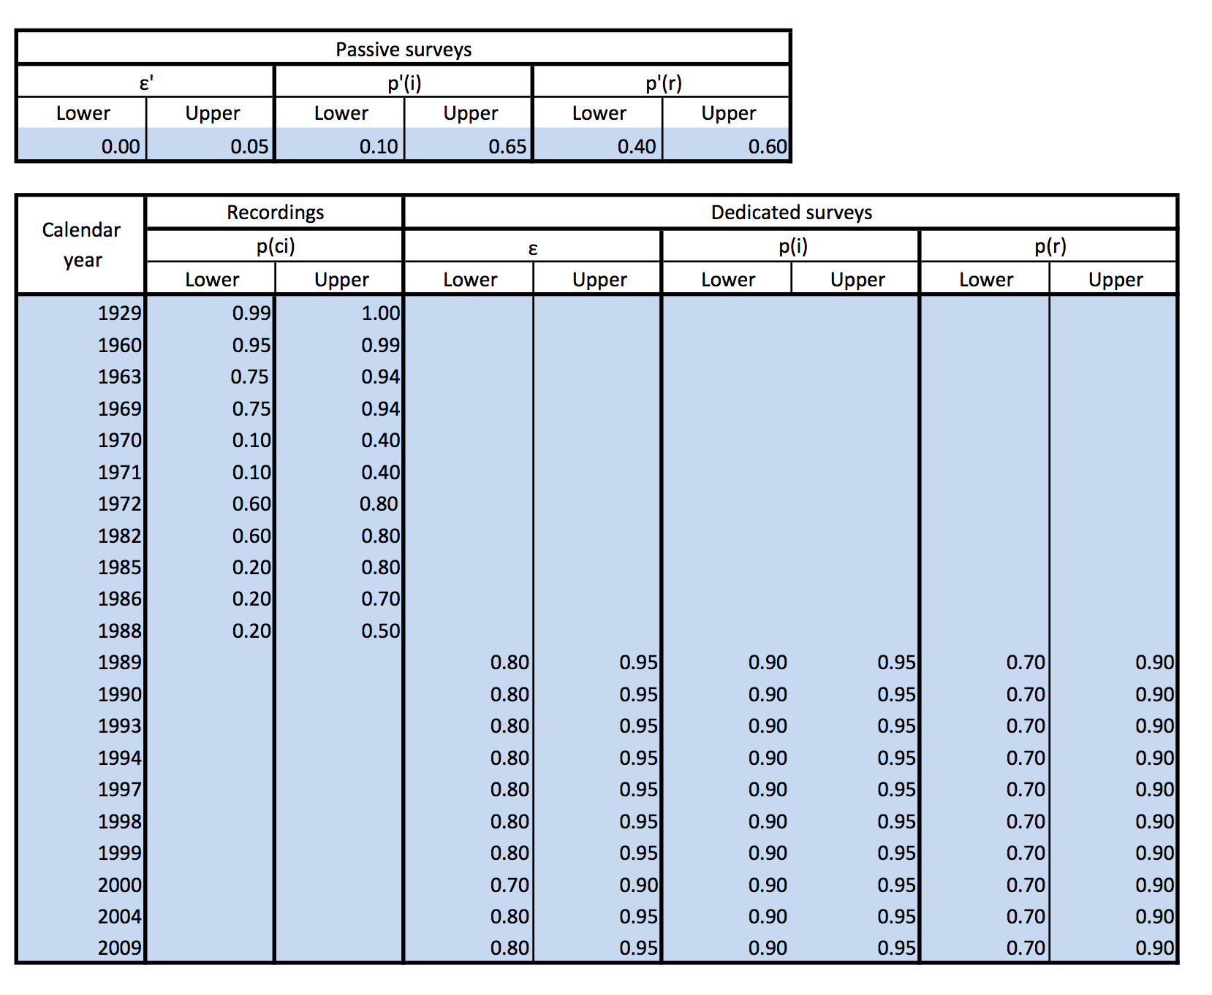

Table 1: Screenshot of a spreadsheet implementation of the model, using data for the Alaotra Grebe Tachybaptus rufolavatus. The total number of years T in the observational record is 81 (1929 to 2009 inclusive). For an explanation of the parameters, see the text.

Legends
Fig. 1. The estimated probability of being extant $P\left(X_{t}\right)$ given the observation record 1929-2017, plotted as a function of time. The estimate of the probability changes as data come to hand, as it is collected over the years for the Alaotra Grebe. The solid line is derived from midpoint estimates of input variables. The boundaries of the light shaded region are upper and lower bounds on$P\left(X_{t}\right)$ derived from interval arithmetic applied to the data in Table 1. The boundaries of the dark shaded region are 5% and 95% intervals derived from a Monte Carlo projection of the associated density functions, assuming normality and independence.

Fig. 2. The estimated probability of being extant$P\left(X_{t}\right)$ given the observation record 1929-2017, plotted as function of calendar year, with an additional hypothetical record. As in Fig. 2, the estimate of the probability changes as data come to hand, as it is collected over the years for the Alaotra Grebe. The data are the same as those that generated Figure 1, except for the addition of a single hypothetical record. The boundaries of the light shaded region are upper and lower bounds on$P\left(X_{t}\right)$ derived from interval arithmetic applied to the data in Table 1. The boundaries of the dark shaded region are 5% and 95% intervals derived from a Monte Carlo projection of the associated density functions, assuming normality and independence. The probabilities assigned to the hypothetical record are p(ci) = 0.2 - 0.5. The record occurs in 2000 and the probability of persistence reaches a peak in 2001.

Fig. 3 The probability of being extant$P\left(X_{t}\right)$ given the observation record, now beginning in 1960 (as opposed to 1929 in Fig.1), plotted as function of calendar year. As in Figs 1 and 2, the solid line is derived from midpoint estimates of input variables. The boundaries of the light shaded region are upper and lower bounds on$P\left(X_{t}\right)$ derived from interval arithmetic applied to the data in Table 1 and the boundaries of the dark shaded region are 5% and 95% intervals derived from a Monte Carlo projection of the associated density functions, assuming normality and independence.

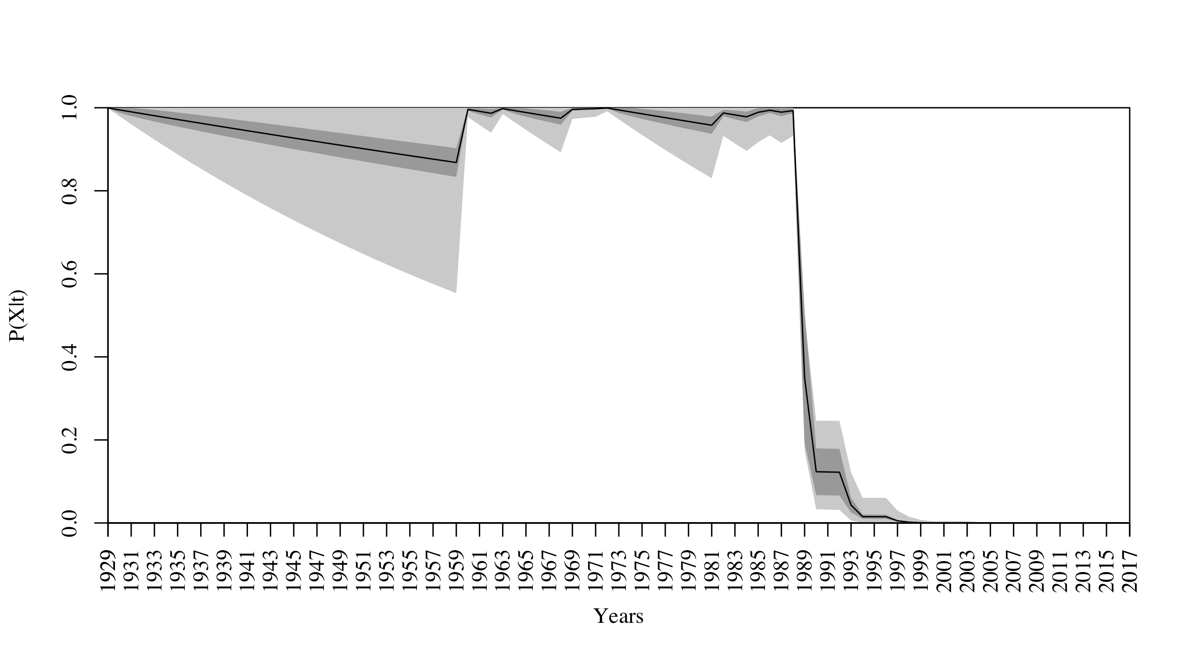

Figure 1

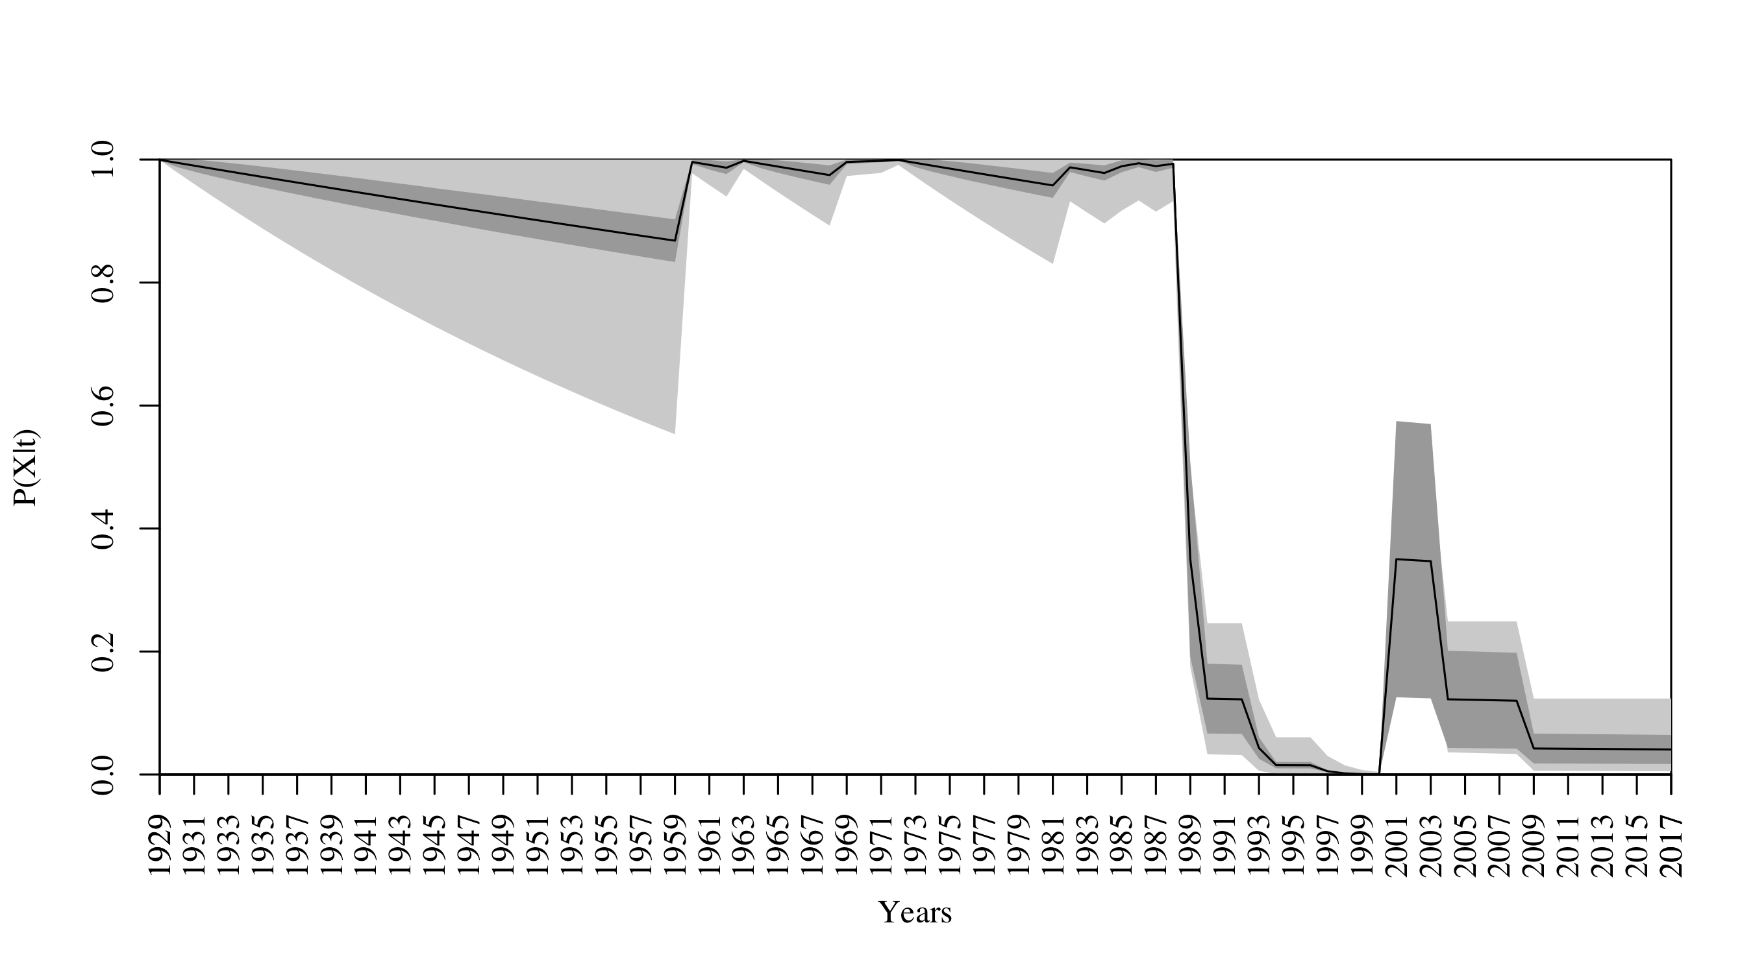
Figure 2

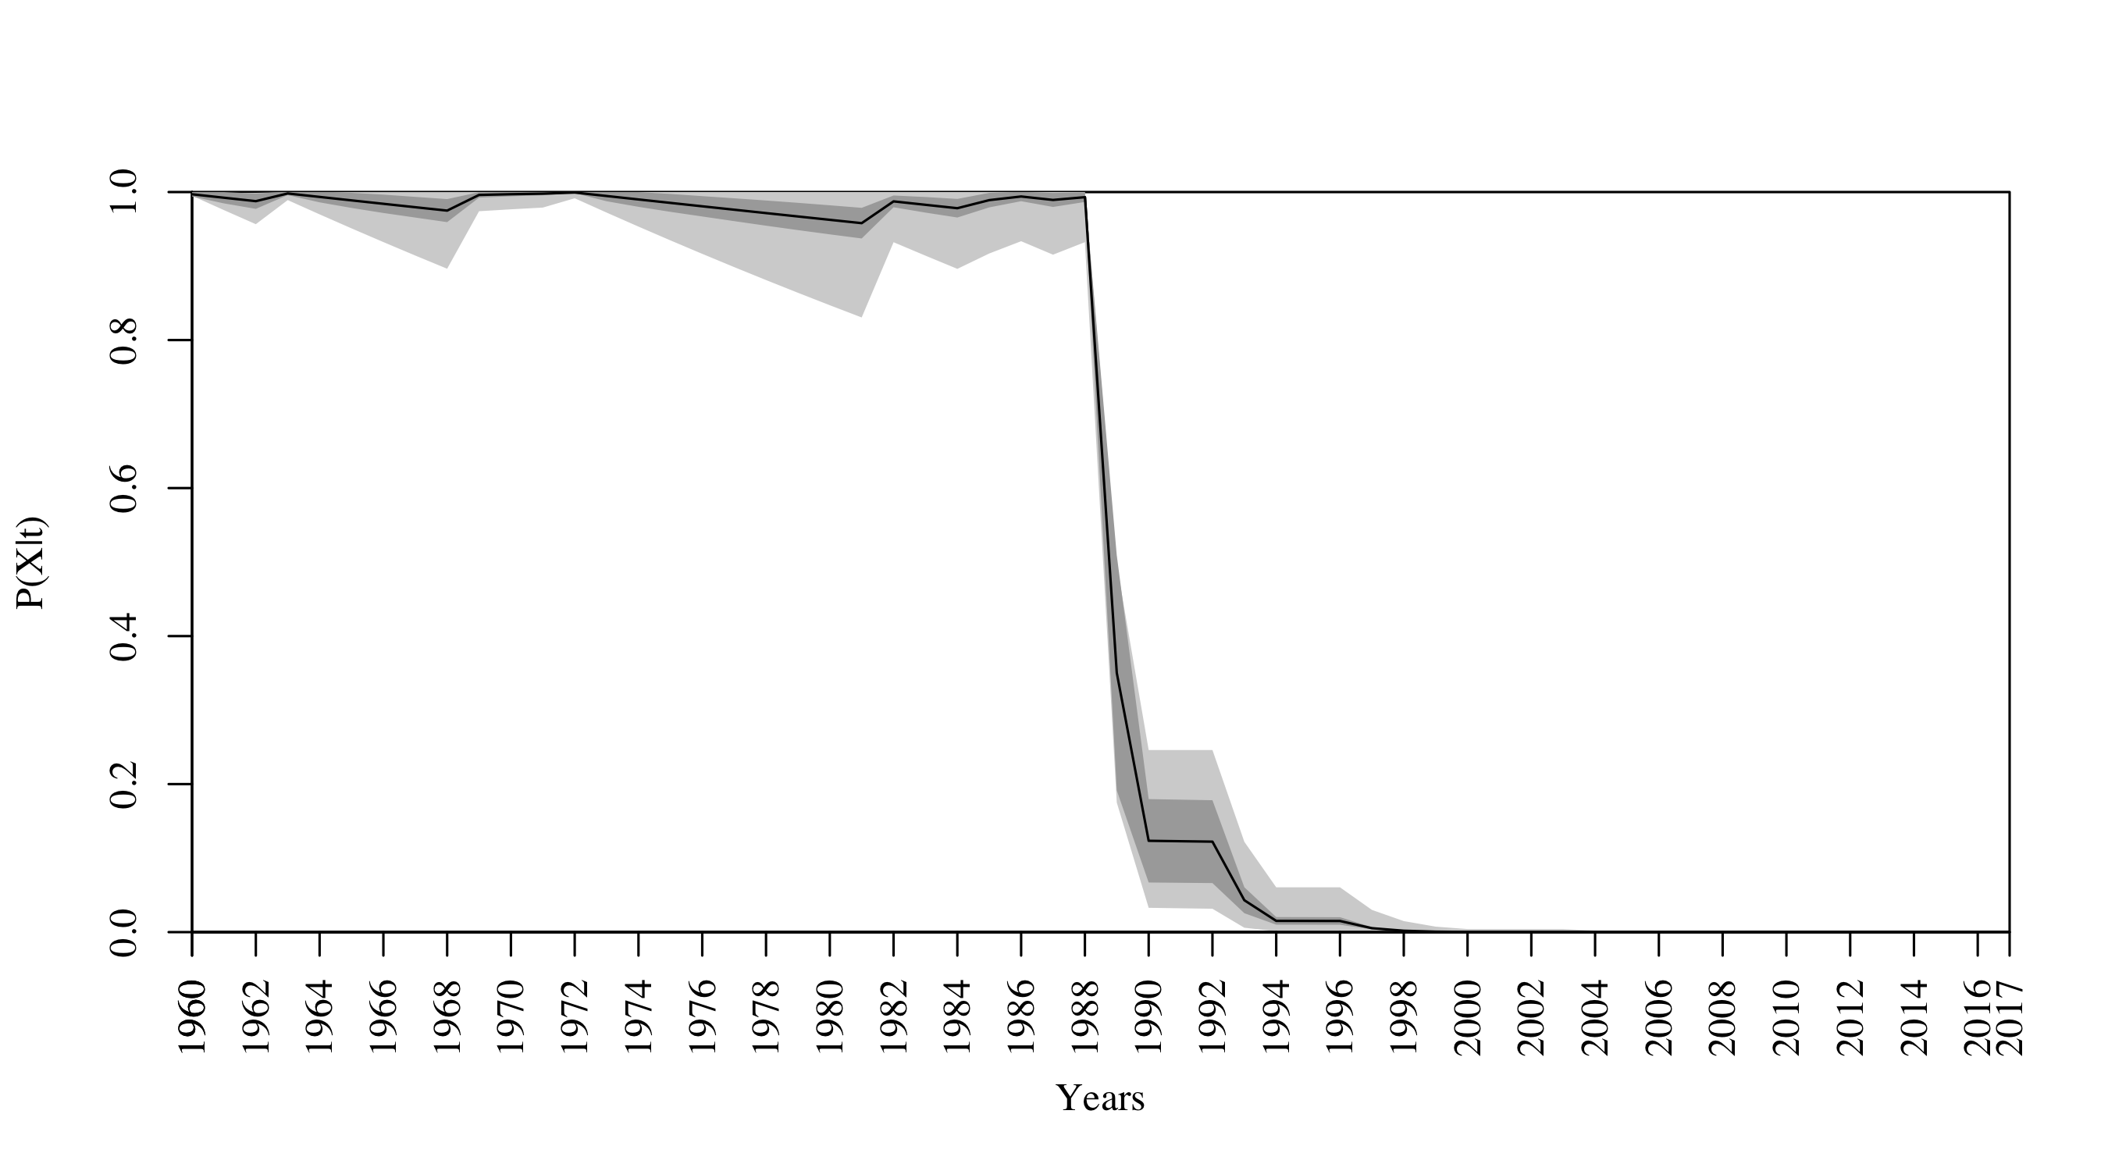
Figure 3

