Construction and Building Materials, 159 (2018) 361–375

Behaviour of rubberised concrete members in asymmetric shear tests
B. Xu, D.V. Bompa¹, A.Y. Elghazouli, A.M. Ruiz-Teran, P.J. Stafford
Department of Civil and Environmental Engineering, Imperial College London, UK

Abstract
This paper deals with the experimental behaviour of rubberised concrete members subjected to asymmetric four-point shear loading. A detailed account of tests on 15 prismatic members using conventional concrete as well as rubberised concrete, with relatively high replacement ratios of both fine and coarse mineral aggregates with rubber particles, is given. The results enable direct assessment of strength and complete deformation characteristics including the post-peak response for ultimate behaviour governed both by shear and mixed-mode tensile-shear. After describing the material properties, mix designs and member details, the main observations from detailed measurements of the crack kinematics through a digital image correlation monitoring system, with focus on members developing shear-governed response, are reported. Complementary numerical studies are undertaken using nonlinear finite element procedures which are validated against tests developing shear-governed failures. In order to provide further insight into the key response characteristics, particularly those related to ultimate strength, a number of numerical sensitivity studies employing constitutive parameters are also carried out. Moreover, comparative assessments in terms of shear resistance, toughness and force transfer across the cracked interfaces are performed and discussed. The detailed test measurements, coupled with the results obtained from the numerical simulations, permit the definition of expressions for representing the shear resistance as a function of the rubber content and concrete compressive strength.
Keywords: rubberised concrete; recycled rubber; crack kinematics; ultimate shear resistance.

_____________________
¹Corresponding author: Dr D.V. Bompa
Email: d.bompa@imperial.ac.uk

Introduction
The management of waste rubber resulting from end-of-life tyres have involved various solutions including their use in asphalt mixtures for road constructions, reuse of ground tyre in plastic and rubber products [1], incineration of tyres for the production of steam or energy and in rubberised Portland cement concrete [2,3]. Early studies on the use of rubber particles in concrete materials have focused on the basic properties of rubberised concrete by replacing various portions of aggregates with rubber particles. Since aggregates represent the major part of the concrete mixture, their properties and mix ratio affect the properties of the material [2,4,5,6]. Amongst other parameters, the geometry of the aggregates determines the fresh properties of concrete while the mineralogical composition influences its mechanical properties such as strength, elastic modulus, and ductility [7].
Rubberised concrete mixtures show relatively lower compressive and tensile strengths, indicating a lower elastic energy capacity compared to normal concrete [2]. On the other hand, rubberised concrete mixtures exhibit a more ductile post-peak behaviour that shows the ability to absorb a larger amount of plastic energy under compressive and tensile loads in comparison with conventional concrete [4]. The reduction in compressive strength, elastic modulus and axial crushing strain are all functions of the increase of rubber content, as well as the lateral crushing strain and energy dissipation that may be enhanced by the presence of rubber particles [8]. Although, the mechanical properties show reductions with increase in rubber content, in structural rubberised concrete, the interface behaviour shows
Although, the quantity of rubber in concrete has a notable influence on the rubberised concrete mechanical properties, this has less detrimental effect on the reinforcement – rubberised concrete bond properties, with bond coefficients exhibiting largely constant trends irrespective of the rubber content up to replacement ratios of 60% [9].
Recent applications have focused on the use of rubberised concrete in structural members. These applications have varied from unconfined and FRP confined columns [10,11], rubberised-concrete filled steel tubes [12,13], push-off specimens provided with shear studs replicating composite beams [14], flexural RC beams [15], standard wall panels used as exterior cladding on building systems [16], and wall panels under near-field blast load and ballistic impact [17,18]. It is however important to note that previous studies have focused on the axial and bending behaviour of rubberised concrete materials and members, with less attention given to shear behaviour despite its importance as a possible governing the failure mode under various loading situations [19-21]. Although some studies have examined the impact behaviour of rubberised concrete at the material level [18,22, 23] investigations on rubberised concrete under direct shear are lacking.
To obtain an insight into the shear behaviour of rubberised concrete, this paper describes an experimental programme carried out on members subjected to asymmetric four-point loading. A full account of 15 prismatic members made of conventional concrete, as well as rubberised concrete with 20%, 45% and 60% replacement of both fine and coarse mineral aggregates with rubber particles, is given. To capture crack kinematics and crack patterns at failure, a digital image correlation monitoring system is used to track the member displacements throughout the tests. After characterising the members according to their failure modes, a detailed analysis is carried out on members developing shear-governed failures, with focus on the influence of the rubber content on the shear capacity and resistance to cracking. The main observations related to the shear transfer across the cracked interfaces are also discussed. Additionally, complementary numerical simulations and parametric investigations are performed in order to assess the shear resistance for a wider range of constitutive configurations. Finally, representative expressions are proposed in order to relate the shear resistance, rubber content and mechanical properties of concrete.

Experimental programme
A total of 15 specimens were prepared to assess the shear behaviour of normal concrete as well as rubberised concrete with various replacement ratios of both fine and coarse aggregates in equal quantities. Two normal concrete types (C35 Grade and C70 Grade) and three rubberised concrete mixes (with the volumetric replacement ratios varying in the range of $ρ_{vr}$= 0-0.6) were considered.

Materials
The coarse and fine aggregates used in the rubberised concrete mixes were obtained from natural deposits with various mineral compositions [24]. The fine aggregates had sizes up to 5 mm with specific gravity of 2.65 and initial moisture content of 5%, whilst the coarse aggregate had sizes of 5-10 mm with a specific gravity of 2.65 and moisture content of 3%. The rubber particles used in the rubberised concrete mixes were acquired from two sources. Smaller rubber particles with diameters between 0-4 mm and 4-10 mm, were manufactured from recycled car tyres [25]. As illustrated in Figure 1a, larger rubber particles with a size range of 10 to 20 mm were obtained from shredded truck tyres [26]. The results of a sieve analysis carried out for both mineral aggregates and rubber particles are presented in Table 1. The proportions employed in the rubberised concrete mixes were optimised for balancing the workability and strength loss in a previous study carried out by Raffoul et al. (2016) [8] as part of a wider European research project [27].

Mix design and sample details
The rubberised concrete mixes prepared for assessment of shear behaviour, are referred to herein as R20, R45 and R60, representing 20%, 45% and 60%, respectively, in terms of volumetric replacement of both fine and coarse aggregates. As described in Table 2, the mix details were derived from reference high strength concrete mixes. From the total quantity of binders reported in the table, 80% was CEM I 52,5 [28], 10% was EN 450-1 [29] fineness category S fly ash and 10% was Grade 940 silica fume [30]. Besides 0-5 mm sand and 5-10 mm gravel, the mixes included tap water and 2.5 L/m³ of plasticiser as well as 5.1 L/m³ of superplasticiser [31,32] to ensure workability.
A rotary mixing machine with a 40 litre container was used for the rubberised concrete mixes described herein. In the first phase, the fine and coarse aggregates with half of the total water were mixed together for 1 min. The rubber particles were then added and mixed for another 1 min. Subsequently, the binders (i.e. cement, silica fume and fly ash) and admixtures were added in the mixer with the remaining half of the water and mixed for more than 3 mins. The compaction procedure was carried out on a vibrating table until the air content in the fresh concrete was at a minimum. The vibration time varied with the mix, with shorter vibration time for higher rubber content to avoid potential floating of the rubber particles.
Prismatic samples of size 150×150×600 mm were prepared for testing. As shown in Figure 1b, the specimens were provided with 5 mm wide notches at the top and bottom surfaces of the samples to create a weak section at the middle of the member. Cylindrical samples of Ø100×200 mm and 100 mm cube samples were also prepared according to codified provisions [33, 34] to assess the compression strength of concrete. Additionally, Ø100×254 mm samples were prepared to assess the splitting strength of the investigated concrete materials. All the prisms, cylinders and cubes were cast in plastic or cast-iron forms in the sizes required and covered with plastic sheets for 48 hours before de-moulding. The specimens were then cured in water tanks for up to 28 days. Prior to testing, the cylinders were ground and capped to ensure full contact between the samples and loading platens. The exact dimensions of each sample (prisms, cylinders and cubes) were measured before testing on at a minimum of three different locations. The exact dimensions of fracture planes were measured using a calliper device on both front and back surfaces of the prisms. The cross-sectional areas of the fracture planes A_{f} are given in Table 3.

Testing configuration
Although there is no commonly agreed configuration for shear testing, typical arrangements for brittle materials such as concrete include: (i) four point asymmetric test with v-shaped indentations at the top and bottom sides of the member [35] (Figure 2a), (ii) four-point asymmetric test with one or two opposite notches [19] (Figure 2b), (iii) double shear-test [36, 37] (Figure 2c), (iv) double-shear tests for cylindrical specimens [20] (Figure 2d), (v) double-edge notched compression test [38] (Figure 2e), (vi) push-off compression test derived from RC testing [39] (Figure 2f), (vii) axisymmetric punch-through specimen [40] (Figure 2g), (viii) off-centre notched beam specimen [41].
In all the test methods illustrated in Figure 2, the key factor is to create a pure shear force over the cross section without any other action. Despite efforts to obtain pure shear (referred as Mode II) situations in testing, in all cases, mixed-mode behaviour in which tensile crack growth (referred as Mode I) takes over before Mode II failure occurs. Some testing arrangements may favour shear crack propagation against tensile crack propagation in comparison to others. However, as mentioned, there is no common agreement on the most appropriate technique for obtaining pure shear behaviour. Hence, the choice of the testing arrangement and specimen geometry comes down to practicality regarding ease of preparation and the stress conditions at the fracture plane. An attractive option, which is employed in this paper, is the asymmetric four-point test since constant shear action and zero bending moment develops at the fracture plane [35]. The symmetrical beam specimen is simply supported at the bottom, and two compression forces are applied from the top two points which are anti-symmetrical to the loading points. To ensure beam failure along the middle section, notches are required at the top and bottom, without creating additional stress concentrations. The testing configuration in Figure 2a [35], with v-shaped 90-degree notches is more complex; hence, the angular notches are replaced with vertical cuts in this study (Figure 2b) [19].

The key factor for obtaining shear-governed failures in testing concrete members without reinforcement is to create a ‘pure’ shear force at a cross-section with minor or no influence from any other action (e.g. bending). Any tensile stresses along the cross-section may contribute to the crack propagation in a mixed-mode way. It was shown that if the zone between the middle loading points is not narrow enough, the crack starts to propagate from the notch and grows away from the shear band, thus facilitating a tensile-governed response [19, 42]. Hence, the response obtained through testing in four-point asymmetric configurations is influenced by the shear-band width, position of the loading and reaction plates, and notch alignment. Besides the loading arrangement, the two notches need to be perfectly aligned in the middle section (with minimal or no deviation) to produce high shear force and zero bending moment along the notch-to-notch section. Also, when the crack width is large enough, the test specimen may start to rotate, shifting the behaviour towards a mixed-mode response [43].
The asymmetric four-point tests on prism specimens were carried out in a stiff four-post testing machine with a maximum load capacity of 3500 kN, as illustrated in Figure 3a,b. The specimens and supports were placed on the bottom platform of the testing machine. A stiff load transfer beam was bolted directly to the actuator. Two roller sets were placed on the top of the test specimen without being connected to the transfer beam for load distribution onto the two loading points. The side roller was placed at the very end of the specimen whereas the middle one was placed on the other half of the specimen near the notch. The top roller assemblies consisted of stiff 90 mm wide top plates hinged to rollers with a diameter of 40 mm, and 50 mm wide plates in direct contact with the specimen. The distance between the displacement application points was around P₂/P₁ = 1/11 to enforce a shear bandwidth higher than shear action at the critical section (Figure 3b).
The bottom support rollers were connected to 200×210 mm steels girders. These girders were also bolted together to avoid rotation of the supports. The prismatic specimens were connected to supports through two 50 mm wide steel plates. All 50 mm plates connecting the test rig to the samples were positioned to prevent any local crushing. A displacement rate of 0.05mm/min was applied from the machine to the transfer beam. In the absence of a standard test procedure, the displacement rate was chosen to allow detailed recording of crack width during loading. Besides the load cells located at each of the four posts of the testing machine, that recorded the load corresponding to applied displacement, two 600kN load cells were located between each support (200 mm girder) and the testing machine bed to record the reactions at the bottom.
As shown in Figure 3c, a Digital Image Correlation (DIC) system, consisting of two 5MP cameras provided with 35mm f/2D lenses positioned 2.0 m away from the specimen and 0.65 m apart from each other and a controller, was used to capture crack propagation and member displacements [44]. High contrast black/white patterns were provided to the front face of the specimens by applying two layers of water-based white paint and, subsequently, a fine black speckle pattern with dots of size 0.5-2.0 mm to ensure smooth detection of surface deformations during testing. This was also required to allow the post-processing software to compute surface strain vector fields. The monitored area (field of view) was clear of obstacles so that both cameras could record surface deformations, and the test environment was vibration-free over the testing time to avoid recording of spurious data. A recording rate of 1Hz was used throughout testing to achieve a balance between the amount of collected data and required post-processing time. Before the start of the recording, a calibration procedure was performed to ensure measurement accuracy as required by the testing recommendations [44]. Throughout calibration and testing, homogenous illumination of the monitored surface of the specimen (150 mm × 600 mm) was guaranteed.
The resulting surface deformations are also dependent on the input parameters in the post-processing software [44], especially parameters such as subset size that directly influences the level of accuracy. For instance, when the subset size is set to be 9 pixels, the accuracy is 0.02 pixels and the uncertainty is 1.5%, whereas when the subset size is increased to 121 pixels, the accuracy becomes 0.0012 pixels with an uncertainty of 0.0035%. For assessment of the strain vectors from the recorded images for the tests described here, the chosen subset size was 21 pixels which cover an area in the range of 1.50 mm²; hence, the accuracy was in the range of 0.007 pixels (0.4μm), whilst the uncertainty was around 0.15%. For all tests, the back face of the members was instrumented with linear potentiometers to record crack mouth opening displacement (CMOD) and crack mouth shear displacement (CMSD). Two other transducers were placed on the left and right sides of the samples to check the member expansion during the test. For assessments of CMOD and crack widths, the DIC is preferred against linear potentiometers since it could detect fine cracks and offer detailed information about the crack pattern and growth.

Test results
Asymmetric four-point tests were carried out to assess the influence of rubber content on the shear resistance and crack kinematics. In the first phase, the shear bandwidth represented by edge-to-edge distance between loading plates in the vicinity of the notches, was varied from l_{s} = 5mm to l_{s} = 50 mm to obtain an optimal testing configuration, with a focus on the crack kinematics rather than member strength. The results of these comparative tests are shown in Figure 4 which illustrates both the crack pattern at failure and the load-displacement response (P-δ) as recorded by the testing machine. The P-δ responses of the remaining tests are depicted in Figure 5, whereas the crack patterns prior to failure, as obtained from the digital image correlation system, are shown in Figure 6. The specimens described here are defined by Rxxy-z notation in which xx is the rubber content in percentage, y is used to show the type of concrete for members provided with concrete without rubber (N – normal strength, H – high), whilst z is the sequence of member testing.
For Specimens R00N-0 and R60-0, the width of the shear band l_{s}, defined as the distance between the edges of the 50 mm wide transfer plates, was set to 50 mm. In contrast, for their counterparts, Specimens R00N-1 and R60-1, the edges of the 50 mm transfer plates were placed at the notches (l_{s}=5mm). The latter specimens had tensile-dominated behaviour with failure due to the formation of double inclined cracks that propagated outside the support, showing that the wider shear band introduces extra bending at the critical region. In contrast, Specimens R00N-1 and R60-1 had shear-governed failures, in which a critical crack formed directly between the top and bottom notches, which is in agreement with other investigations confirming that such failures occur only for very small l_{s} (e.g. Ingraffea and Panthaki, 1985 [45]). Hence, l_{s} = 5mm was considered for the remaining tests.
For the remaining members l_{s} = 5mm, the response obtained may be divided into three categories: (i) Tensile-Governed Failure (TGF) with the formation of two independent cracks at both notches that propagated towards the supports on the opposite side was recorded for 5 specimens (R00N-0, R60-0 with l_{s} = 50 mm and R20-2, R20-3, R45-3 with l_{s} = 5mm), (ii) secondly, a Mixed Mode Failure (MMF) which initiates with the formation of a single crack, dominated by shear action, but deviating from the fracture plane due to the influence of tensile actions was obtained for 5 specimens (R00H-1, R00H-2, R00N-2, R45-1, R60-2), (iii) thirdly, Shear-Governed Failures (SGF) with the formation of a single crack along the critical section were observed in 5 specimens (R00N-1, R20-1, R45-2, R60-1 and R60-3). The response and crack kinematics of these members are described below.

Tensile-goverened and mixed-mode responses
Figure 5a shows the P-δ relationships recorded from the actuator at mid-point of Specimens R20-2, R20-3 and R45-3 with TGF. In this case, flexural actions produced two inclined fracture planes resulting from crack propagations from both notches to the supports (Figure 6). The failure of the two R20 specimens was sudden without post-peak softening, resembling that in the shear-governed normal concrete Specimen R00N-1 described in the following section. These had a similar response in terms of stiffness K, maximum load P_{u} and displacement at failure δ_{Pu} (P_{u} = 52.4 kN, δ_{Pu} = 0.70 mm and P_{u} = 50.7 kN, δ_{Pu} = 0.71 mm respectively). From the three R45 specimens, only R45-3 developed TGF, showing increased stiffness and strength (P_{u} = 50.2 kN at δ_{Pu} = 0.82 mm) in comparison to other R45-1 and R45-2 members.
Crack slips and average crack widths as processed from DIC data using virtual gauges are plotted for Specimens R20-2 and R45-3 in Figure 7. In several cases, the crack width of the bottom notch w_{bot} was larger than the width of top notch w_{top}, in which the behaviour was generally governed by the crack width at the top notch only. Hence, the crack widths are reported as average values of the top and bottom notch separations w=(w_{top}+w_{bottom})/2. The crack slip s is determined from the sliding of the two crack faces between the right edge of the top notch and the left edge of the bottom notch, to obtain the slip vector component from the DIC virtual gauge. Although the crack slip s and opening w exhibited similar trends, the width w precedes the slip s through the loading process, after crack initiation. For R20-2 and R20-3, w_{top} was always positive indicating a continuous expansion up to failure, whereas the bottom notches were closing. On the other hand, for R45-3, the w_{top} was negative while the bottom w_{bot} was positive in tension up to 0.7×P_{u}, followed by compression until failure.
Figure 5b shows the P-δ relationships of the specimens exhibiting MMF (R00N-2, R00H-1, R00H-2, R45-1 and R60-2). Both R00H members failed in MMF with notable scatter in terms of P_{u} and δ_{Pu,} mostly due to significant brittleness of the high strength concrete employed in these specimens, in comparison to other members within the same group. R00H-1 reached P_{u} = 63.1 kN and δ_{Pu} = 0.65 mm, whilst R00H-2 showed the lowest stiffness and failed at the lowest P_{u} = 50.8 kN at corresponding δ_{Pu} = 0.98 mm. R00N-2 had a similar behaviour to R00H-2 which failed at a peak load of P_{u} = 49.9 kN with δ_{Pu} = 0.91 mm. Similarly to specimens failing in the other two modes, all specimens with no rubber content showed a sudden drop in strength after their P_{u} was attained. R60-2 showed slightly higher stiffness compared to R45-1 and failed at similar loads and displacements. R60-2 reached P_{u} = 26.0 kN and δ_{Pu} = 1.76 mm, whilst R45-1 failed at P_{u} = 22.2 kN and the corresponding δ_{Pu} = 1.38 mm. The crack widths and slips derived from the DIC data for R00H-1 and R00N-2 in Figure 8a indicate behaviours governed by slip prior to failure, followed by a response dominated by tensile cracking. On the other hand, for R60-2 in Figure 8b, crack opening dominates the response after initiation around 0.86×P_{u}.
As illustrated Figure 5a, the increase of rubber content from 20% to 45% did not influence significantly the P-δ response of the specimens with TGF illustrating minimal contribution from the rubber content to the post-peak softening and energy dissipation. After reaching P_{u}, these showed a sudden loss of strength and fractured in three parts without exhibiting a ductile response post-fracture. This allowed free rotation of the two extreme bodies, hence limiting the influence of secondary shear actions such as aggregate interlock and rubber particle clamping on the post-peak response. Besides the free rotation of the fractured parts, TGF and MMF may occur due to the slight misalignment of the top and bottom notches that produce a non-symmetric testing configuration in which the bending moment at the extremities of the shear bands is not negligible, allowing supplementary tensile actions to develop. Hence, the shear mode crack growth is in this case followed by tensile cracking which eventually dominates the post-cracking and ultimate response.

Shear-governed response
Specimens R00N-1, R20-1, R45-2, R60-1 and R60-3 exhibited SGF failures in which the fracture occurred at the critical section (Figure 6). As depicted in Figure 5c, Specimen R00N-1 showed a stepped behaviour in which the P-δ response was characterised by a slight decrease in strength at the crack opening, followed by an increase, primarily due to the stress redistribution and aggregate interlock. Specimen R00N-1 reached P_{u} = 49.4 kN at a corresponding δ_{Pu}= 0.88 mm. This was followed by a sudden drop in strength when the specimen fractured in two parts. Specimen R20-1 also failed in a similar manner. Since it had the lowest rubber replacement ratio from the tested range, R20-1 had stiffness similar to that of the normal concrete specimen R00N-1.
Similarly to R00N-1, the strength of R20-1 dropped when the crack opened, increasing slightly afterwards until it reached P_{u} = 39.4 kN at δ_{Pu}= 0.75 mm. After failure, the strength dropped instantaneously showing that 20% of rubber replacement did not significantly influence the overall behaviour. The specimen with ρ_{vr}=0.45, R45-2, showed a lower P_{u} and stiffness compared with R00N-1 and R20-1. It failed at an applied δ_{Pu}= 0.72 mm and a corresponding load of P_{u} = 32.8 kN. The post-peak curve of Specimen R45-2 had a much more ductile behaviour than R00N-1 and R20-1 since it showed a more gradual decrease in strength and relatively soft response. With further increase in rubber content, R60-1 and R60-3 members showed the lowest stiffness, yet significant post-peak energy dissipation, compared to other shear-governed members by reaching P_{u} = 30.1 kN at δ_{Pu}= 0.94 mm and P_{u} = 24.1 kN, δ_{Pu} = 1.2 mm, respectively. As for R20-1, Specimen R60-3 also had a second branching crack propagating towards the supports, its width was consistently smaller than that of the notch-to-notch critical crack (Figure 6c).
In Figure 9, the crack widths are plotted at five locations of the critical section at various fractions of the load P corresponding to an applied actuator displacement δ as indicated in the plots. These allow detailed observation of the crack kinematics throughout the loading procedure, and enables comparative assessments between the response of the investigated normal and rubberised concrete materials. Specimens R00N-1, R20-1 and R45-2 had responses in which the top notch separated constantly, while the bottom notch was closing for maximum top crack widths of about 0.30-0.35mm (Figure 10a,b). This corresponds to a load level near ultimate. For R45-2, such crack widths were obtained in the post-peak regime at a load corresponding to 92% of P_{u}, representing the second peak of the stepped P-δ recorded (Figure 5c). The second ascending branch represents strength enhancement due to secondary shear actions. On the other hand, Specimen R60-1 had a similar response. Specimen R60-3 had a comparable response to the other SGF rubberised concrete specimens, hence, for compactness, the kinematics are not described in detail. As seen in Figure 5c, for all the specimens developing SGF, consistent reductions of P_{u} developed with the increase of ρ_{vr}.
For member R60-1, the bottom notch had crack widths of 0.35mm, whilst the top notch was in compression. This contrasting behaviour occurs due to the difficulty in achieving perfect symmetry in the testing arrangement. For R00N-1, R20-1, R45-2, the right-hand side of the member acted more like a cantilever with the extreme load application point, including the self-weight of the supports, taking more of the actuator load. In contrast, for R60-1, the left-hand side of the member was subjected to higher load through the central load application point. However, the post-peak response of all rubberised concrete shear-governed members had post-peak responses with crack propagations with similar ductile kinematics (Figures 9b-d). Specimen R00N-1 had no recorded information regarding the crack kinematics in the post-peak regime since its failure was brittle.
The crack slips and average crack widths of the shear-governed members are plotted in Figure 10a,b. They show an increase in the crack opening before the peak, up to values of 0.1 mm, while the slip had a largely linear behaviour. The gradual shift in the P-w curves between R00N-1, R20-1, R45-2 and R60-1 in Figure 10a may be directly linked to the increase in rubber content and the clamping effect of the crack interfaces. Except R60-3, for the same level of load in the post-peak range, members with higher rubber content have smaller crack widths in comparison to specimens with little or no rubber content.
It is worth noting that the post-peak behaviour typically exhibits increased softening with the increase of rubber content and the rubber particles contribute to the softer post-fracture. Except for R60-3, the P-δ curves show a stepped behaviour, indicating an increase in strength (R00N-1, R60-1) or in residual strength (R20-1, R45-2) after the crack initially opened and prior to fracture. From a kinematics point of view, it seems that the fracture of the concrete matrix was followed by secondary effects such as the interlock of mineral aggregates, and for rubberised concrete members by an additional clamping effect between the two crack interfaces. Due to aggregate interlock-rubber clamping actions, some enhancement in behaviour is observed for specimens with higher amounts of ρ_{vr}.

Numerical simulations
The numerical investigations presented in this section were carried out using the nonlinear finite element program ABAQUS [46] to assess in a more detailed manner the influence of rubber content on the shear response of rubberised concrete. The numerical models are first validated against test results from members developing shear-governed failures in terms of strength and elastic stiffness. Moreover, parametric investigations, in which the reference concrete and rubber contents are varied, were performed for assessing the influence of the rubberised concrete constitutive behaviour on the shear resistance.

Modelling details
As shown in Figure 11, to simulate the response of test specimens, the numerical models employed account for the full geometry of the testing arrangement. The 150×150×600mm concrete prisms provided with two 5mm wide notches were connected through four 50mm loading plates and rollers at the top to a block element replicating the load transfer beam and at the bottom to the boundary condition reference points. The side supporting plate had frictionless property contact with the roller which allowed the movement of the specimen after its fracture. The displacements of the middle supporting plate were restricted, while the rotations were allowed. A tri-dimensional full-sized geometry consisting of eight noded solid elements with reduced integration (C3D8R) was adopted in all model elements. The Newton-Raphson method was used as for the integration procedure and a displacement control procedure was considered in which a vertical displacement δ was applied at the middle of the transfer beam and distributed onto the concrete member through loading plates.
The transfer beam, support plates and rollers were assigned linear elastic steel material whereas the compression damage plasticity (CDP) model was chosen for the concrete specimen. Surface-to-surface interactions, represented through a penalty friction steel-concrete interaction, were created between the loading plates and concrete specimen as well as the steel transfer beam. The mesh size l_{m} of the model was determined from sensitivity studies performed on the test geometry of the Reference Specimen R00N-1. Since the SGF occur along the notch-to-notch critical section, l_{m} was varied only along that region. A baseline l_{m} = 5mm, equal to the notch width, was initially chosen and compared with a finer l_{m}=1.25mm (Figure 11). As shown in Figure 12a, the fine mesh size shows a close estimation of the peak load P_{u,num} in comparison to the test P_{u,test} result with a difference of 6.4%, whereas a coarse mesh represented by a single line of elements (l_{m}=5mm) does not provide correct damage propagation along the critical area. Hence, the finer mesh size (l_{m}=1.25mm) along the critical section was chosen for all models described in this study.

Constitutive properties
The CDP model, accounting for a non-associated potential plastic flow with a default eccentricity ϵ=0.1, was chosen to simulate the tri-axial behaviour of the concrete material. The tri-dimensional yield surface is controlled by a shape parameter K_{c}=0.667 and the ratio between the biaxial and uniaxial compressive strength f_{b}/f_{c}=1.16. A relatively low viscosity parameter of 4×10⁻⁶ was chosen for the analysis. The non-associative plastic volumetric deformations of the material are not directly proportional to the changes in stresses and these are represented by a dilation angle ψ with commonly agreed ranges for 20-50°; e.g. ψ = 10° for RC corbels [47]; ψ = 25° for RC and hybrid RC beams [48]; ψ=40° for RC flat slabs [49]; ψ=49° for hybrid RC flat slabs [50]. A sensitivity study with ψ=20-40°on the R00N-1 configuration showed that the estimated strength increases with the increase of the dilation angle and both ψ=28° and 30° offer good agreement with the test result in terms of strength (Figure 12b). The former value (ψ=28°) was finally chosen since it showed consistent agreement for the other configurations considered (i.e. R20, R45, R60).
The CDP model requires two independent material functions to describe the uniaxial stress-strain σ-ε relationships of concrete under compression and tension, considering the damage parameters d_{i} (i=c, t) to represent the stiffness degradation of the material. In this investigation, a plastic degradation model was applied based on the assumption that the damage occurs in concrete only in the softening range [51]. As described in Equation (1), there is no damage before concrete reaches its compression and tensile strength while d_{i} has a linear relationship with the strength degradation in the softening range. The uniaxial constitutive model in Equation (2-4) proposed previously by the authors [9], which considers the presence of rubber in concrete, was adopted in this study with due account of the material strength at testing. Additionally, a linear representation of the softening branch was taken into consideration for computational efficiency. The ultimate compressive strain ε_{rcu} was calculated based on an energy-based formulation [52] in which the crushing energy G_{cl}/l_{m} (as illustrated in Figure 13) represents the area under the softening stress-strain curve and l_{m} is the characteristic length (Equation 5).
where i=c, t (1)
(2a)
whereand (2b)
(2c)
(3a)
where and (3b)
(4a)
where (4b)
(5)
A linear σ-ε relationship up to the tensile strength f_{ct}, and an exponential decay function for the softening behaviour, were considered for the concrete uniaxial tensile behaviour [53] with f_{ct}=0.3×f_{c}^{1/2} [54]. In this formulation, the tensile stress-crack opening width w relationship is a function of both f_{ct} and the maximum crack opening w_{max,r}. The latter was determined using Equation (6) which considers the influence of ρ_{vr} on the crack opening width and transformed to strain accounting for the characteristic length l_{m} [9].
(in mm), where mm (6)
According to previous research performed by the authors [8], analytically, the uniaxial behaviour of rubberised concrete materials can be represented in a similar manner as conventional concrete materials considering the influence of the rubber content on stiffness, strength and softening. In general, the constitutive response of rubberised concrete may be regarded as low-strength conventional concrete. Consequently, the fundamentals of CDP from ABAQUS may be directly applicable for rubberised concrete [46]. As for conventional concrete, the CDP constitutive parameters (e.g. dilation angle, viscosity parameter) need to be validated for each different modelling configuration by carrying out sensitivity studies for these parameters. The above-mentioned analytical uniaxial compression and tension representations may be directly used as input, with mesh-dependent corrections for the softening regime for modelling the characteristic rubberised concrete behaviour.

Validations and parametric assessments
The configurations R00N-1, R20-1, R45-2, R60-1 and R60-3 which had shear-governed failures (SGF) were simulated using the material parameters and modelling configuration discussed above. The numerical simulations of the load-crack opening displacement P-w relationship compared with the corresponding test results as obtained from the DIC data are shown in Figure 14 and Figure 15, and the results are summarised in Table 4. The elastic stiffness, initial crack opening displacement w, as well as the predicted ultimate strength are in close agreement with the test results for all cases with an average test-to-simulated ratio of 1.03 and a coefficient of variation of 0.09. Although the capacities are well predicted, due to intrinsic nature of continuum modelling that does not allow for separation of the model geometry at cracked interfaces the deformations at peak are conservatively estimated for R00N and R60 models since in tests the crack widths exhibited jumps resulting from sudden crack propagation (Figure 10).
Following the numerical validation of the shear-governed members, a series of parametric assessments accounting for varying reference concrete strengths f_{c0} and different rubber content ρ_{vr} were conducted using the CDP constitutive parameters described above. An identical tri-dimensional model having the same geometry and mesh as the models used for validations was employed for the parametric studies. Four different reference concrete materials with strengths f_{c0}=20, 40, 60 and 70MPa and variations of the rubber replacement ratios of ρ_{vr}=0, 0.2, 0.4 and 0.6 were modelled analytically using the constitutive models and recommendations from Bompa et al (2017) with the basic material properties listed in Table 4 [9].
As shown in Table 5 and Figure 16, the increase of rubber content, concrete with different reference strengths f_{c0} exhibit similar reduction of strength for members developing shear governed response. All predictions show reductions around 40% in estimated capacities for 20% of rubber replacements. The reduction rate in strength is much smaller when the rubber content is increased further: 60% for ρ_{vr}=0.4 and about 70% for ρ_{vr}=0.6. It can be noted from the parametric study that the rubber content influences the member shear resistance in a comparable way to the compressive strength. Further discussion on the influence of rubber content on the shear resistance of rubberised concrete based on the numerical models and test results are discussed in the following section.

Comparative assessments
The term ‘shear strength’ is used to refer to several concepts in previous studies, ranging from the resistance of a material subjected to pure shear stress to the capacity of a reinforced concrete beam under external shear action. On the other hand, shear resistance τ_{u} refers to the ultimate shear stress imposed on the plane of fracture A_{f} in the absence of a normal force [55]. In this study, shear strength is defined as the ratio between the ultimate load P_{u} and the corresponding fracture surfaces, where A_{f,} is used as a metric for comparisons. From the tested specimens, members having shear-governed failures (SGF) are considered for detailed analysis and comparison with discussions regarding the influence of ρ_{vr} on τ_{u}, material toughness, and qualitative observations regarding the shear transfer between cracked concrete interfaces.
Figure 17a illustrates the relationship between the ultimate shear stress τ_{u} against the rubber replacement ratio ρ_{vr}, whilst Figure 17b depicts the influence of the concrete compressive strength f_{c} on τ_{u.} It can be observed that with the increase of ρ_{vr}, τ_{u} decreases in a non-linear manner. When ρ_{vr} is increased from 0 to 20% and 45%, the τ_{u} decreases considerably, while the rate of strength loss lessens when moving from ρ_{vr}=45-60%. This stands mostly for members which developed SGF through testing. In a more practical, as indicated in Figure 17b, τ_{u} increases with f_{c} for all failure cases including both normal and rubberised concrete members. Additionally, the parametric investigations carried out on 16 simulations in which the reference concrete f_{c0} and ρ_{vr} were varied, led to similar reductions of τ_{u} in relationship to ρ_{vr} (Figure 17c). These enable the definition of τ_{u-}ρ_{vr} expressions with material configurations covering wider ranges.
Based on the results obtained from the tests as well as the numerical parametric assessments described in this paper, a relationship to assess the shear resistance τ_{u} as a function of the concrete strength f_{c} (f_{c0} for normal concrete or f_{rc} for rubberised concrete) is proposed. Equation (7a) may be used for assessing τ_{u} both for normal and rubberised concrete materials. The relationship between τ_{u} for rubberised concrete materials and ρ_{vr} can be expressed indirectly through the rubberised concrete compressive strength f_{rc} using Equations (7b,c), in which f_{c0} is the concrete compressive strength of the reference normal concrete from which the rubberised concrete material is derived, whilst λ is a function of the type of mineral aggregate replaced (Equation 2c) [9].
(7a)
(7b)
(7c)
Figure 17d depicts predictions of Equation (7) using the concrete strengths given in Tables 3-5 for the SGF test specimens described in Section 3.2 and numerical models from Section 4.3, as well as the τ_{u} curve predicted for f_{c} varying in the range 5-90 MPa. As illustrated in the box at the bottom of the figure, the proposed equation may be an option for estimating τ_{u} since the average test and numerically assessed-to-predicted τ_{u} is 1.00, whilst the COV is 14.1%.
The material toughness T_{s} is a property representing the resistance to crack propagation, directly governed by mechanical properties of the material and its geometry. The flexural toughness of members is typically determined from the P-δ relationship obtained from flexural loading tests (e.g. ASTM C1609, 2013 [56]). Flexural toughness and material toughness indices are defined as ratios between the areas under the P-δ curve at deflection limits as defined by the codified procedure [57]. Recently, this approach was employed for the assessment of toughness in shear failures of push-off fibre reinforces tests [58]. In this paper, the results from the DIC measurements in terms of load-slip (P-s) are used to assess the absolute toughness T_{s} defined as the area below the shear stress-slip (τ-s) curve considering slip limits s_{lim} of 0.25, 0.5, 1.0, 2.0 (Equation 8).
(8)
Table 6 depicts the T_{s} values obtained for the s_{lim} described previously for rubberised concrete members with SGF, residual shear strengths τ_{res}, and equivalent shear strengths τ_{eq} as a ratio between T_{s} at a slip limit, and the s_{lim} itself (s_{0.25}, s_{0.5}, s_{1.0}, s_{2.0}). The normal concrete specimen R00N-1 reached slip values below the minimum s_{lim} considered. Figure 17e illustrates the capacity of the member to resist cracking. From the T_{s}-s_{lim} curves, it can be observed that all members had an essentially identical response up to s_{lim}=0.50, with R60-1 and R60-3 showing higher toughness at s_{lim}=1.0 - as all plotted series are showing an increase in T_{s} with increase in s_{lim}.
For R45-2, the lack of data for s>0.62 did not permit assessment of T_{s} afterwards. However, at s=0.62, it had the same T_{s} as R20-1. Specimen R20-1, with ρ_{vr}=0.2, had similar T_{s} with R45-2 and R60-1 at s_{lim}=0.25, with a slight enhancement for higher slip limits. In addition to the crack kinematics illustrated in Figure 9, the results of the T_{s} assessment depict minimal influence on ρ_{vr} hence the crack growth of shear-governed rubberised concrete members.
Key observations from the tests combined with the strength results obtained from numerical simulations on four-point asymmetric configurations with shear-governed responses, show notable impact of the ρ_{vr} on τ_{u} and the post-peak response of rubberised concrete in comparison with the reference normal concrete. Experimental results showed that, while normal concrete and rubberised concrete with low rubber content (ρ_{vr}=0.2) are typically represented by rather brittle shear responses with low or no energy dissipated in the post-peak regime, the rubberised concrete with higher amounts of rubber (ρ_{vr} =0.4-0.6) exhibits increased post-peak softening response with rubber particles contributing to the softer post-fracture. The rubberised concrete cracked interfaces are inherently subjected to other forms of friction than cracked interfaces in normal concrete, with the clamping effect of the rubber particles offering different energy dissipation mechanisms in addition to the conventional interlock of the mineral aggregates.
In the case of SGF members developing vertical cracked interfaces as those described in Section 3.2, the load transfer is limited to aggregate interlock and the concrete residual stresses, whilst the vertical component of the shear force transferred through the concrete compressive zone tends to be negligible as the crack inclination is around 90° [59, 60]. The residual stresses transferred through the fracture process zone are a function of the tensile strength of the concrete f_{ct} and the maximum crack opening w_{max,r,} both being a function of ρ_{vr}. On the other hand, in conventional concrete, the aggregate interlock is a function of the maximum aggregate size d_{g,max}, strength of the cement matrix σ_{pu} and aggregate distribution within the cracked interface [61]. For rubberised concrete, d_{g,max} and σ_{pu} are the same as for the reference conventional concrete from which it is derived, since both, the mineral aggregate gradation, the water-to-binder ratios are the same.
Based on the above discussion, the forces transferred through interlocking particles come down to their distribution at the cracked interfaces. As this distribution is fairly proportional to the rubber content ρ_{vr} and the ratio between mineral aggregates to rubber particles, ρ_{vr} effectively determines the forces transferred through the crack interfaces including the level of post-peak softening. These observations and assumptions, combined with obtained test load-deformation responses, suggest that both at cracking and in the post-cracking regime, a higher amount of rubber at the cracked interface produces a softer response due to a notable clamping effect of the rubber particles, whilst low amounts of rubber are linked to aggregate interlock resulting in a less ductile response.

Concluding remarks
This paper described an experimental programme carried out on rubberised concrete members subjected to asymmetric four-point loading to obtain a detailed insight into the shear behaviour of rubberised concrete. A full account of 15 prismatic members made of conventional concrete, rubberised concrete with relatively high replacement ratios of both fine and coarse mineral aggregates with rubber particles, was given. After describing the materials, mix designs and member details, key observations resulting from detailed measurements of the crack kinematics, with focus on members developing shear governed responses, were reported. Complementary numerical simulations were conducted and validations against the test members developing shear-governed failures, enabled supplementary parametric investigations accounting for material constitutive parameters covering wider ranges to be carried out. Moreover, comparative assessments in terms of shear resistance, toughness and force transfer across the cracked interfaces were performed. These permitted the definition of representative expressions for the shear resistance as a function of the rubber content and concrete compressive strength. Based on the experimental and numerical investigations coupled with the key observations described in this paper the following concluding remarks can be drawn:
- Asymmetric four-point tests may be used to obtain shear-governed failures, yet these are very sensitive to the alignment of the predefined fracture plane and characteristics of testing arrangement with slight non-symmetry allowing for tensile-governed responses to develop.
- The tested specimens showed three distinct types of ultimate behaviour: (i) tensile-governed failures (TGF) with the formation of two independent cracks at both top and bottom notches that propagated towards supports on the opposite sides, (ii) mixed mode failures (MMF) that initiate with the formation of a single crack, dominated by shear action, but deviating from the predefined fracture plane due to the influence of the tensile actions, and (iii) shear-governed failures (SGF) with the formation of a single crack along the critical section.
- Test results coupled with numerical predictions show a decrease of around 40% in the estimated member strengths for 20% of rubber content, 60% reduction for 40% rubber content and about 70% less strength for 60% rubber content in comparison with strengths obtained for the reference SGF cases, suggesting a decreasing member strength-rubber content relationship which is much similar to the compressive strength-rubber content relationship.
- Typical load-deformation curves showed stepped responses characterised by a slight decrease in strength at the crack opening, followed by an enhancement, primarily due to the interlock of mineral aggregates and clamping of rubber particles.
- Detailed measurements of the crack kinematics showed that the fracture of the concrete matrix is followed by secondary effects such as the conventional interlock of mineral aggregates, and for rubberised concrete members by an additional rubber clamping effect between the two crack interfaces, directly influencing the post-cracking range, with members including higher rubber content having smaller crack widths in comparison to specimens with no or low rubber content.
- Although a higher amount of rubber at the cracked interface produces a softer post-peak response due to the clamping effect of the rubber particles and, in contrast, low amounts of rubber are linked to aggregate interlock governing a less ductile response, the assessed resistance to cracking through toughness parameters showed similar responses for all tested rubberised members with a slight enhancement for cases with 60% rubber content.
- The expressions proposed in this paper offer reliable representations for the assessment of the shear resistance of rubberised concrete as a function of the rubber content and the compressive strength of the reference non-rubberised concrete, which have been lacking to date and allow for employment of such materials, not only in non-structural applications, but also in structural members.

Acknowledgements
The authors would like to thank the technical staff of the Structures Laboratories at Imperial College London, particularly Mr Trevor Stickland, for their assistance with testing of the experimental specimens. The work described in this paper follows on from research carried out within the project ‘Anagennisi: Innovative Use of all Tyre Components in Concrete’, funded by the European Union Seventh Framework Programme FP7/2007- 2013 under grant agreement No 603722; the discussions with collaborators within the project, particularly from the University of Sheffield, are gratefully acknowledged. The support of Adria Abruzzo, Hope Construction Materials, Elkem and Sika through the provision of materials is also gratefully acknowledged.

References
- Siddique, R., & Naik, T. R. (2004). Properties of concrete containing scrap-tire rubber–an overview. Waste management, 24(6), 563-569.
- Topcu, I. B. (1995). The properties of rubberized concretes. Cement and concrete research, 25(2), 304-310.
- Azmi, N. J., Mohammed, B. S., & Al-Mattarneh, H. M. A. (2008). Engineering properties of concrete containing recycled tire rubber. In International Conference on Construction and Building Technology (pp. 373-382).
- Eldin, N. N., & Senouci, A. B. (1993). Rubber-tire particles as concrete aggregate. ASCE Journal of materials in civil engineering, 5(4), 478-496.
- Benazzouk, A., Mezreb, K., Doyen, G., Goullieux, A., & Quéneudec, M. (2003). Effect of rubber aggregates on the physico-mechanical behaviour of cement–rubber composites-influence of the alveolar texture of rubber aggregates. Cement and Concrete Composites, 25(7), 711-720.
- Li, L. J., Chen, Z. Z., Xie, W. F., & Liu, F. (2009). Experimental study of recycled rubber-filled high-strength concrete. Magazine of Concrete Research, 61(7), 549-556.
- Raffoul, S., Garcia, R., Pilakoutas, K., Guadagnini, M., & Medina, N. F. (2016). Optimisation of rubberised concrete with high rubber content: An experimental investigation. Construction and Building Materials, 124, 391-404.
- Bompa, D. V., Elghazouli, A. Y., Xu, B., Stafford, P. J., & Ruiz-Teran, A. M. (2017). Experimental assessment and constitutive modelling of rubberised concrete materials. Construction and Building Materials, 137, 246-260.
- Bompa, D.V. and Elghazouli, A.Y., (2017) Bond-slip response of deformed bars in rubberised concrete. Construction and Building Materials, 154, 884-898.
- Elghazouli A.Y., Bompa D.V., Xu B., Stafford P.J., Ruiz-Teran A.M. (2017), Inelastic behaviour of RC members incorporating high deformability concrete. In ‘High Tech Concrete: Where Technology and Engineering Meet – Proceedings of the 2017 fib Symposium’ Maastricht, The Netherlands (Hordjik DA and Lukovic M(eds)), Springer, vol. 1, 2399-2406,
- Youssf, O., ElGawady, M. A., & Mills, J. E. (2015). Experimental investigation of crumb rubber concrete columns under seismic loading. In Structures 3, 13-27
- Silva, A., Jiang, Y., Castro, J. M., Silvestre, N., & Monteiro, R. (2016). Experimental assessment of the flexural behaviour of circular rubberized concrete-filled steel tubes. Journal of Constructional Steel Research, 122, 557-570.
- Abendeh, R., Ahmad, H. S., & Hunaiti, Y. M. (2016). Experimental studies on the behavior of concrete-filled steel tubes incorporating crumb rubber. Journal of Constructional Steel Research, 122, 251-260.
- Han, Q., Wang, Y., Xu, J., & Xing, Y. (2015). Static behavior of stud shear connectors in elastic concrete–steel composite beams. Journal of Constructional Steel Research, 113, 115-126.
- Ismail, M. K., & Hassan, A. A. (2016). Ductility and Cracking Behavior of Reinforced Self-Consolidating Rubberized Concrete Beams. ASCE Journal of Materials in Civil Engineering, 29(1), 04016174.
- Naito, C., States, J., Jackson, C., & Bewick, B. (2013). Assessment of crumb rubber concrete for flexural structural members. Journal of Materials in Civil Engineering, 26(10), 04014075.
- Bewick, B. T., Salim, H. A., Saucier, A., & Jackson, C. J. (2010). Crumb rubber-concrete panels under blast loads. Air Force Research Lab Tyndall AFB FL, Material and Manufacturing Directorate, Report ADA523338, Florida FL, USA, pp. 1-14
- Naito, C., States, J., Jackson, C., & Bewick, B. (2013). Crumb Rubber Concrete Performance under Near-Field Blast and Ballistic Demands. Journal of Materials in Civil Engineering, 26(9), 04014062.
- Bažant, Z. P., & Pfeiffer, P. A. (1986). Shear fracture tests of concrete. Materials and Structures, 19(2), 111-121.
- Luong, M. P. (1990). Tensile and shear strengths of concrete and rock. Engineering fracture mechanics, 35(1-3), 127-135.
- Luong, M. P. (1992). Fracture testing of concrete and rock materials. Nuclear engineering and design, 133(1), 83-95.
- Ismail, M. K., & Hassan, A. A. (2016). Impact Resistance and Acoustic Absorption Capacity of Self-Consolidating Rubberized Concrete. ACI Materials Journal, 113(6):725-736
- Xue, J., & Shinozuka, M. (2013). Rubberized concrete: A green structural material with enhanced energy-dissipation capability. Construction and Building Materials, 42, 196-204.
- TARMAC, Tarmac Trupak building aggregates, http://www.tarmac.com/building-aggregates/
- AD.RI.A Abruzzo SRL, Adriatica Riciclaggio e Ambiente, Granulato di Gomma, http://www.adria-abruzzo.it/ADRIA/index.html
- CONICA, Recycled Rubber from Used Tyres, http://www.conica.com/en/commodities/black-granules/rubber-granules/recycled-tyre-rubber/
- Anagennisi Project, 'Innovative Use of all Tyre Components in Concrete': http://www.anagennisi.org/
- HOPE Construction Materials, High Strength 52.5N Cement, http://hopecement.com/product/high-strength-52-5n-cement/
- CEN (European Committee for Standardization) EN 450-1:2012 Fly ash for concrete - Part 1: Definition, specifications and conformity criteria. CEN, Brussels (Belgium); 2012
- ELKEM, Elkem Microsilica Grade 940 for Concrete, https://www.elkem.com/silicon-materials/high-performance-concrete/microsilica-concrete-grades/microsilica-grade-940-construction/
- Sika ViscoFlow 1000, High range water reducing/superplasticing concrete admixture with enhanced workability retention, Product data sheet, Edition 21/5/2015, Sika Limited, UK.
- Sika ViscoFlow 2000, High range water reducing/superplasticing concrete admixture with enhanced workability retention, Product data sheet, Edition 17/2/2016, Sika Limited, UK.
- CEN (European Committee for Standardization) (EN 206-1:2000 Concrete — Part 1: Specification, performance, production and conformity. CEN, Brussels (Belgium); 2000
- CEN (European Committee for Standardization) EN 12390-2:2009 Testing hardened concrete. Making and curing specimens for strength tests, CEN, Brussels (Belgium); 2009
- Iosipescu, N., & Negoita, A. (1969). A new method for determining the pure shearing strength of concrete. Concrete (London) (3)1, 63
- JSCE-SF6 (1990) “Method of Test for Shear Strength of Steel Fiber Reinforced Concrete (SFRC),” Japan Society of Civil Engineers, Tokyo, 67-69.
- Tuan H.N, Otsuka H, Ishikawa Y, Takeshita E (2006), Study on shear strength under direct shear of concrete test, Japan Concrete Institute, 28(1), 1529-1534
- Reinhardt, H. W., Ošbolt, J., Shilang, X., & Dinku, A. (1997). Shear of structural concrete members and pure mode II testing. Advanced cement based materials, 5(3), 75-85.
- Mattock, A. H., & Hawkins, N. M. (1972). Shear transfer in reinforced concrete—recent research. Pci Journal, 17(2), 55-75.
- Watkins, J. (1983). Fracture toughness test for soll-cement samples in mode II. International Journal of Fracture, 23(4), 135-138.
- Jenq, Y. S., & Shah, S. P. (1988). Mixed-mode fracture of concrete. International Journal of Fracture, 38(2), 123-142.
- Arrea, M. and Ingraffea, A. (1982). Mixed Mode Crack Propagation in Mortar and Concrete, Report 81-13, Dpt. of Structural Engineering, Cornell University.
- Schlangen, H. E. J. G. (1993). Experimental and numerical analysis of fracture processes in concrete. Heron, 38 (2), 1993.
- LaVision - DaVis digital image correlation software http://www.lavision.de/en/products/davis-software/index.php
- Ingraffea, A. R., Panthaki, M. J. (1985). Analysis of shear fracture tests of concrete beams. In Finite Element Analysis of Reinforced Concrete Structures May 21-24 Tokyo, Japan (Meyer C and Okamura H(eds)), ASCE, New York, NY; 151-173
- DSS (Dassault Systèmes Simulia Corp.) (2010) Abaqus Analysis Users‘ Manual, Version 6.10. DSS, Providence, RI, USA.
- Syroka E., Bobiński J., Tejchman J. (2011) FE analysis of reinforced concrete corbels with enhanced continuum models, Finite Elements in Analysis and Design 47 (9) 1066–1078.
- Moharram, M.I., Bompa, D.V., Elghazouli, A.Y. (2017) Experimental and numerical assessment of mixed RC beam and steel column systems. Journal of Constructional Steel Research 131, 51–67
- Bompa, D.V., Oneţ, T. (2016) Punching shear strength of RC flat slabs at interior connections to columns. Magazine of Concrete Research 68(1), 24–42
- Bompa, D.V., Elghazouli, A.Y. (2017) Numerical modelling and parametric assessment of hybrid flat slabs with steel shear heads. Engineering Structures 142, 67–83
- Lubliner, J., Oliver, J., Oller, S., Oñate, E. (1989) A plastic-damage model for concrete. International Journal of Solids and Structures 25, 299–326
- Feenstra, P.H. (1993) Computational aspects of biaxial stress in plain and reinforced concrete. Doctorate dissertation, Delft University of Technology, Delft, Netherlands
- Hordijk, D.A. (1991) Local approach to fatigue of concrete. Doctorate dissertation. Delft, Netherlands: Delft University of Technology;
- ACI (American Concrete Institute) (2014) ACI 318-14: Building code requirements for structural concrete and commentary. ACI, Farmington Hills, MI, USA.
- Everling, G. (1964). Comments upon the definition of shear strength. In International Journal of Rock Mechanics and Mining Sciences & Geomechanics Abstracts (Vol. 1, No. 2, pp. 145-154). Pergamon.
- ASTM C1609/C1609M – 12 (2013) Standard test method for flexural performance of fiber-reinforced concrete (using beam with third-point loading), ASTM International, 9 pages
- Gopalaratnam, V. S., & Gettu, R. (1995). On the characterization of flexural toughness in fiber reinforced concretes. Cement and concrete composites, 17(3), 239-254.
- Barragan, B., Gettu, R., Agullo, L., & Zerbino, R. (2006). Shear failure of steel fiber-reinforced concrete based on push-off tests. ACI materials journal, 103(4), 251-257.
- Campana, S., Fernández Ruiz, M., Anastasi, A., Muttoni, A., (2013) Analysis of shear transfer actions on one-way RC members based on measured cracking pattern and failure kinematics. Magazine of Concrete Research, 56(6):,386–404
- Bompa, D.V., Elghazouli, A.Y., (2015) Ultimate shear behaviour of hybrid reinforced concrete beam-to-steel column assemblages. Engineering Structures, 101, 318–36.
- Walraven, J.C., Reinhard, H.W., (1981) Theory and experiments on the mechanical behaviour of cracks in plain and reinforced concrete subjected to shear loading. Heron, 26(1a), 5–68.

List of Figures
Figure 1 a) Materials used in rubberised concrete mixes, b) Rubberised concrete sample,
Figure 2 Test methods for assessment of shear resistance a) Iosipescu and Negoita (1969) [34], b) Bažant and Pfeiffer (1986) [18], c) JSCE-SF6 (1990) [35], Tuan et al (2016) [36], d) Luong (1990, 1992) [19,20], e) Reinhard et al. (1997) [37], f) Mattock & Hawkins (1972) [38], g) Watkins (1972) [39]
Figure 3 Testing arrangement a) General view, b) Layout, c) Digital image correlation system (DIC)
Figure 4 Pilot tests a) R00N-0, b) R00N-1, c) R60-0, d) R60-1
Figure 5 Load – displacement response for tests a) Tensile-governed failures (TGF), b) Mixed-mode failure (MMF), c) Shear-governed failures (SGF)
Figure 6 Crack patters prior to failure as obtained from the digital image correlation system a) Tensile governed failures (TGF), b) Mixed mode failures (MMF), c) Shear governed failures (SGF)
Figure 7 Crack with and slip for R20-2 and R45-3 with tensile-governed failures (TGF)
Figure 8 Crack with and slip for a) R00H-1, R00N-2 and b) R60-2 with mixed-mode failures (MMF)
Figure 9 Crack kinematics for shear-governed members (SGF) a) R00N-1, b) R20-1, c) R45-2, d) R60-1; The figure legends represent the ratio between the load at which the measurement is assessed and the maximum load P/P_{u}, whist (P) – pre-peak, (I) - inter-peak and (A) - post peak represent the stage on the P-δ curve
Figure 10 SGF members a) Average crack width, b) Crack slip
Figure 11 Tri-dimensional numerical modelling configuration
Figure 12 Sensitivity studies on R00N-1 configuration a) Mesh size, b) Dilation angle
Figure 13 Rubberised concrete constitutive model (adapted from Bompa et al., 2017)
Figure 14 Validation of numerical models with test specimen a) R00N-1, b) R20-1, c) R45-2, d) R60-1
Figure 15 Predicted load reduction compared to corresponding test results
Figure 16 Influence of rubber contents on the shear governed load capacity of concrete with reference compressive strength of a) 20MPa, b) 40MPa, c) 60MPa, d) 70 MPa
Figure 17 Relationships between a) τ_{u} and ρ_{vr} from tests, b) τ_{u} and f_{c} from tests, c) τ_{u} and ρ_{vr} from SGF numerical simulations; d) Prediction of the shear resistance τ_{u} (Equation 7) e) member toughness T_{s},

List of Tables
Table 1 Sieve analysis
Table 2 Concrete mixes
Table 3 Specimen details and test results
Table 4 Test results and numerical simulation of the shear governed failure cases
Table 5 Details and results of the numerical parametric studies
Table 6 Residual shear strength and equivalent shear strength

Nomenclature
Greek letters
δ – displacement (mm)
δ_{Pu} - displacement at failure (mm)
ε – strain (mm/mm)
ε_{rc,el} - strain proportionality limit (mm/mm)
ε_{rc1 -} uniaxial crushing strain (mm/mm)
ε_{cru} - ultimate compressive strain(mm/mm)
ε_{u} – ultimate tensile strain (mm/mm)
λ ₋ mineral aggregate size factor (-)
σ – stress (MPa)
σ_{pu} cement matrix strength (MPa)
ρ_{vr} – rubber replacement ratio (-)
τ – shear stress (MPa)
τ_{res -} residual shear strength (MPa)
τ_{u} - shear resistance (MPa)
τ_{res -} residual shear strength (MPa)
ψ – dilation angle (degrees)
ϵ - potential eccentricity (-)
Lowercase latin letters
d_{i} – damage parameter (-)
d_{g,repl} – size of the replaced mineral aggregate (mm)
d_{g,max} – maximum aggregate size (mm)
f_{c} – cylinder concrete compressive strength (MPa)
f_{ct} – tensile concrete strength (MPa)
f_{rct -} tensile rubberised concrete strength (MPa)
f_{rc} - compressive rubberised concrete strength (MPa)
f_{c0} - compressive reference concrete strength (MPa)
l_{m} - mesh size (mm)
l_{s} - shear bandwidth (mm)
s - crack slip (mm)
s_{lim} - slip limit (mm)
w - crack width (mm)
w_{bot} - crack width at the bottom notch (mm)
w_{top} - crack width at the top notch (mm)
w_{max,0} – maximum crack size for normal concrete (mm)
w_{max,r} - maximum crack size for rubberised concrete (mm)
Uppercase latin letters
A_{f} - area of the critical section (mm²)
E_{rc} – elastic modulus of rubberised concrete (MPa or GPa)
K_{c} – factor for the shape of the deviatoric plane (-)
G_{cl} – total crushing energy (N/mm)
P₂/P₁ – load ratio (-)
P - load (kN)
P_{cr} – cracking load (kN)
P_{u} - maximum load (kN)
P_{u,num} – numerical ultimate strength (kN)
P_{u,test} – test ultimate strength (kN)
T_{s} - toughness (N/mm)

Tables

Table 1 Sieve analysis
Sieves of square aperture (mm) | Percentage %
Sieves of square aperture (mm) | Rubber blend | Sand | Gravel
0 | 0 | 0 | 0
0.15 | 1.82 | 2.43 | 0.39
0.30 | 4.78 | 24.0 | 1.06
0.60 | 8.21 | 64.9 | 1.95
1.25 | 15.4 | 84.7 | 2.95
2.50 | 35.4 | 91.7 | 4.71
5.00 | 48.7 | 97.6 | 16.1
10.0 | 95.5 | 100 | 85.5
14.0 | 100 | 100 | 99.5
20.0 | 100 | 100 | 100

Table 2 Concrete mixes
 |  | R20 | R45 | R60
Compressive strength per mix (MPa) | Reference | 73 | 59 | 73
Compressive strength per mix (MPa) | Rubberised concrete | 20.8 | 9.6 | 7.3
Binders (kg) |  | 425 | 314 | 425
Aggregates (kg) | 5-10 mm | 800 | 740 | 400
Aggregates (kg) | 0-5 mm | 656 | 479 | 328
Rubber (kg) | 0/5 mm | 49.5 | 110 | 149
Rubber (kg) | 5/10 mm | 11.0 | 24 | 33.0
Rubber (kg) | 10/20 mm | 49.45 | 110 | 148
Admixture (l) | (PL+SPL) | 7.6 | 7.6 | 7.6
w/c (-) |  | 0.35 | 0.35 | 0.35

Table 3 Specimen details and test results
Specimen |  | P_{u} (kN) | P_{cr} (kN) | δ_{Pu} (mm) | f_{c,28d}¹⁾ (MPa) | Age (days) | f_{c,test}²⁾ (MPa) | A_{f} (×10³) mm | τ_{u} (MPa) | Failure Mode²⁾
R00N-0³⁾ |  | 53.4 | - | - | 42.6 | 224 | 46.1 | 16.0 | 3.35 | TGF
R20-2 |  | 52.4 | 29.8 | 0.70 | 20.8 | 31 | 21.0 | 15.1 | 3.46 | TGF
R20-3 |  | 50.7 | 46.2 | 0.71 | 20.8 | 31 | 21.0 | 14.9 | 3.41 | TGF
R45-3 |  | 50.2 | 47.3 | 0.82 | 9.6 | 78 | 10.3 | 16.2 | 3.10 | TGF
R60-0³⁾ |  | 23.2 | - | - | 6.6 | 219 | 7.5 | 15.9 | 1.46 | TGF
R00H-1 |  | 63.1 | 59.5 | 0.65 | 72.9 | 29 | 73.2 | 16.0 | 3.94 | MMF
R00H-2 |  | 50.8 | 49.7 | 0.98 | 72.9 | 30 | 73.4 | 16.1 | 3.16 | MMF
R00N-2 |  | 49.9 | 46.9 | 0.91 | 42.6 | 229 | 46.3 | 16.2 | 3.07 | MMF
R45-1 |  | 26.0 | - | 1.76 | 9.6 | 72 | 10.2 | 15.8 | 1.64 | MMF
R60-2 |  | 22.2 | 17.2 | 1.38 | 7.3 | 28 | 7.3 | 15.2 | 1.46 | MMF
R00N-1 |  | 49.4 | 35.5 | 0.88 | 42.6 | 224 | 46.1 | 15.9 | 3.11 | SGF
R20-1 |  | 39.4 | 37.8 | 0.75 | 20.8 | 31 | 21.0 | 15.4 | 2.55 | SGF
R45-2 |  | 32.8 | 29.1 | 0.72 | 9.6 | 78 | 10.3 | 16.4 | 2.00 | SGF
R60-1 |  | 30.1 | 20.7 | 0.94 | 7.3 | 28 | 7.3 | 15.0 | 2.01 | SGF
R60-3 |  | 24.1 | 22.2 | 1.2 | 7.3 | 28 | 7.3 | 15.4 | 1.56 | SGF
- 28 days compressive strength on Ø100×200 mm cylinders
- TGF – tensile governed failure, SGF – shear governed failure, MMF – mixed mode failure
- pilot tests with the band width of l_{s}=50 mm

Table 4 Test results and numerical simulation of the shear governed failure cases
Specimen | f_{c} ¹⁾ (MPa) | f_{ct} (MPa) | P_{u,test} (kN) | ρ_{vr} | P_{u,num} (kN) | P_{u,test}/ P_{u,num}
R00N-1 | 46.1 | 2.04 | 49.4 | 0 | 53.8 | 0.92
R20-1 | 21.0 | 1.37 | 39.4 | 0.20 | 38.9 | 1.01
R45-2 | 10.3 | 1.06 | 32.8 | 0.45 | 31.5 | 1.04
R60-1 | 7.30 | 0.81 | 30.1 | 0.60 | 24.4 | 1.16 ¹⁾
R60-3 | 7.30 | 0.81 | 24.1 | 0.60 | 24.4 | 1.16 ¹⁾
Average |  |  |  |  |  | 1.03
COV |  |  |  |  |  | 0.09
- In the case of R60-1 and R60-3, P_{u,test} is the average value of the two test results.

Table 5 Details and results of the numerical parametric studies
f_{c0} (MPa) | 20 |  |  |  | 40
ρ_{vr} (-) | 0 | 0.20 | 0.40 | 0.60 | 0 | 0.20 | 0.40 | 0.60
Name | F20R0 | F20R20 | F20R40 | F20R60 | F40R0 | F40R20 | F40R40 | F40R60
f_{rc} (MPa) | 20.0 | 7.58 | 3.56 | 2.21 | 40.0 | 15.2 | 7.12 | 4.21
f_{rct} (MPa) | 1.34 | 0.82 | 0.57 | 0.44 | 1.89 | 1.17 | 0.80 | 0.62
E_{rc} (GPa) | 19.0 | 9.98 | 6.02 | 4.27 | 30.1 | 15.8 | 9.56 | 6.75
P_{u} (kN) | 33.7 | 19.9 | 13.0 | 9.32 | 48.6 | 29.0 | 19.6 | 14.5
ΔP_{ur} (%) ¹⁾ | 0 | 41.0 | 61.3 | 72.3 | 0 | 40.4 | 60.0 | 70.0
f_{c0} (MPa) | 60 |  |  |  | 70
ρ_{vr} (-) | 0 | 0.20 | 0.40 | 0.60 | 0 | 0.20 | 0.40 | 0.60
Name | F60R0 | F60R20 | F60R40 | F60R60 | F70R0 | F70R20 | F70R40 | F70R60
f_{rc} (MPa) | 60.0 | 22.7 | 10.7 | 6.32 | 70.0 | 26.5 | 12.5 | 7.37
f_{rct} (MPa) | 2.32 | 1.43 | 0.98 | 0.75 | 2.50 | 1.55 | 1.06 | 0.90
E_{rc} (GPa) | 39.5 | 20.8 | 12.5 | 8.84 | 43.8 | 23.0 | 13.9 | 9.79
P_{u} (kN) | 60.7 | 35.8 | 24.5 | 18.3 | 66.1 | 36.4 | 26.6 | 20.1
ΔP_{ur} (%) ¹⁾ | 0 | 41.1 | 59.7 | 69.8 | 0 | 44.9 | 59.7 | 69.6
- The reduction of load capacity is calculated between rubberised concrete mixes and the corresponding reference mix.

Table 6 Residual shear strength and equivalent shear strength
Specimen | Residual shear strength (MPa) |  |  |  | Equivalent shear strength (MPa)
 | τ_{u} | τ_{res0.25} | τ_{res0.50} | τ_{res1.0} | τ_{0.25} | τ_{0.50} | τ_{1.0}
R20-1 | 2.55 | 1.04 | 0.94 | 0.67 | 1.54 | 1.77 | 1.28
R45-2 | 2.00 | 1.44 | 0.96 | 0.00 | 1.53 | 1.41 | 1.30*
R60-1 | 2.01 | 1.35 | 1.01 | 0.75 | 1.58 | 1.42 | 1.19
R60-3 | 1.56 | 1.55 | 1.37 | 1.10 | 1.42 | 1.45 | 1.32
* assessed at s_{lim}=0.63

Figures
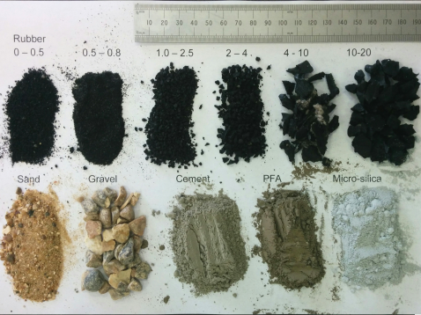a)
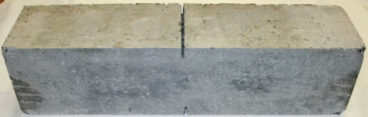b)

Figure 1 a) Materials used in rubberised concrete mixes, b) Rubberised concrete sample,

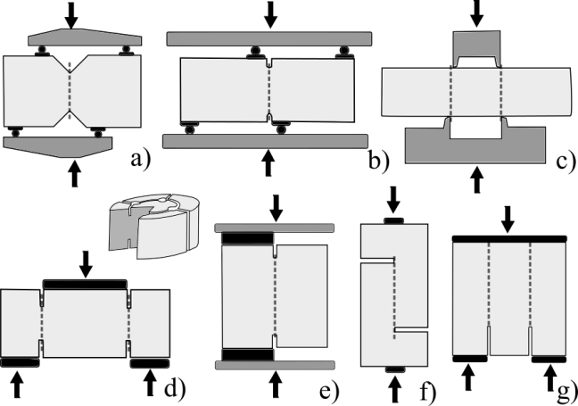

Figure 2 Test methods for assessment of shear resistance a) Iosipescu and Negoita (1969) [34], b) Bažant and Pfeiffer (1986) [18], c) JSCE-SF6 (1990) [35], Tuan et al (2016) [36], d) Luong (1990, 1992) [19,20], e) Reinhard et al. (1997) [37], f) Mattock & Hawkins (1972) [38], g) Watkins (1972) [39]

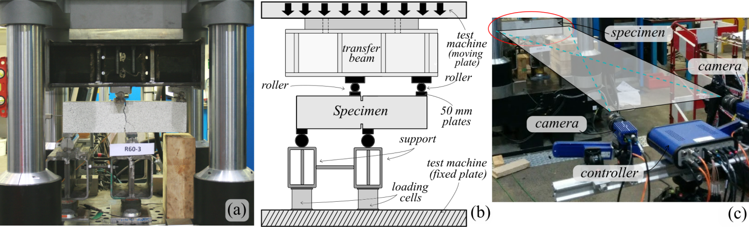

Figure 3 Testing arrangement a) General view, b) Layout, c) Digital image correlation system (DIC)

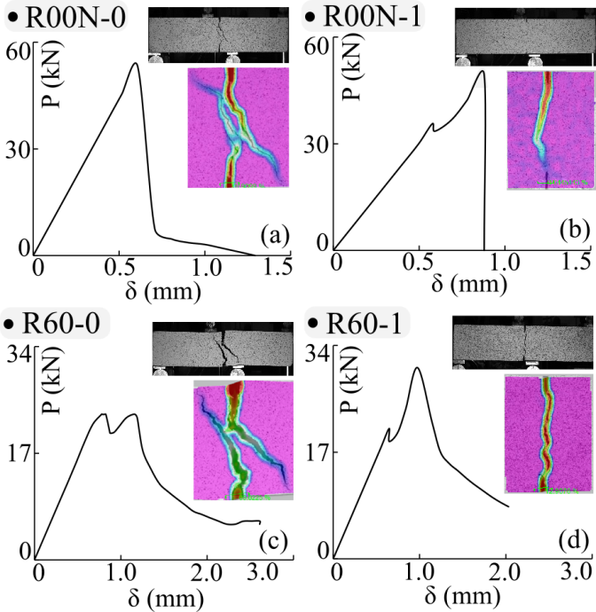

Figure 4 Pilot tests a) R00N-0, b) R00N-1, c) R60-0, d) R60-1

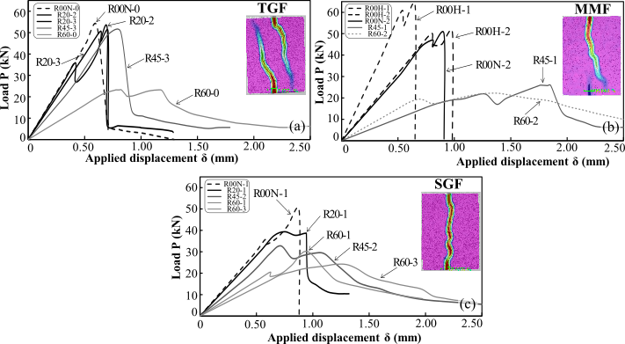

Figure 5 Load – displacement response for tests a) Tensile-governed failures (TGF), b) Mixed-mode failure (MMF), c) Shear-governed failures (SGF)

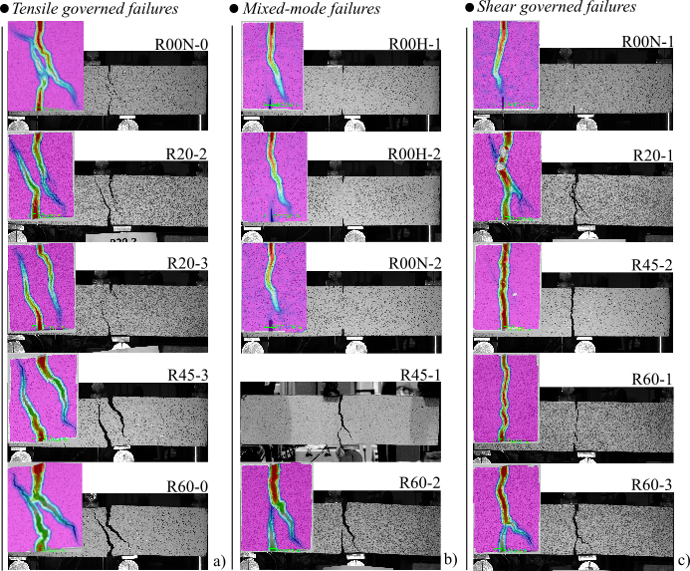

Figure 6 Crack patters prior to failure as obtained from the digital image correlation system a) Tensile governed failures (TGF), b) Mixed mode failures (MMF), c) Shear governed failures (SGF)

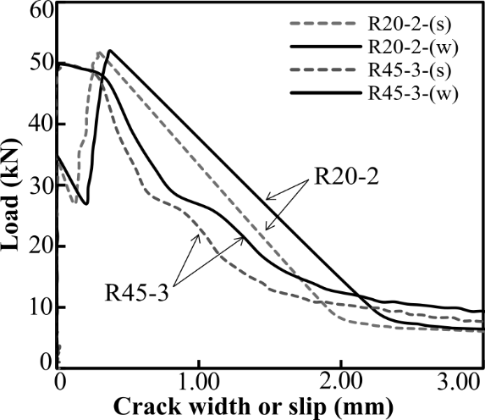

Figure 7 Crack with and slip for R20-2 and R45-3 with tensile-governed failures (TGF)

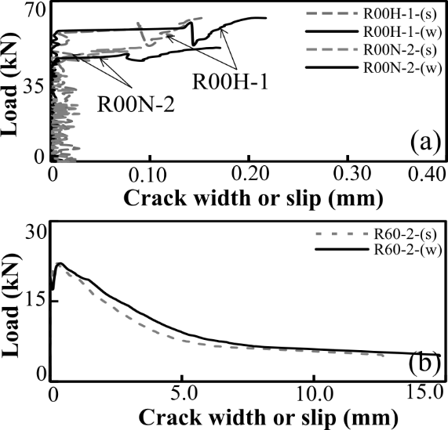

Figure 8 Crack with and slip for a) R00H-1, R00N-2 and b) R60-2 with mixed-mode failures (MMF)

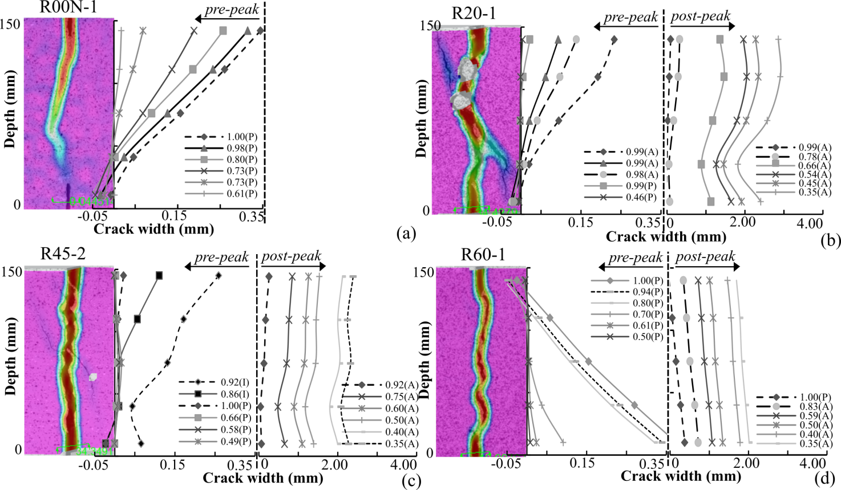

Figure 9 Crack kinematics for shear-governed members (SGF) a) R00N-1, b) R20-1, c) R45-2, d) R60-1; The figure legends represent the ratio between the load at which the measurement is assessed and the maximum load P/P_{u}, whist (P) – pre-peak, (I) - inter-peak and (A) - post peak represent the stage on the P-δ curve

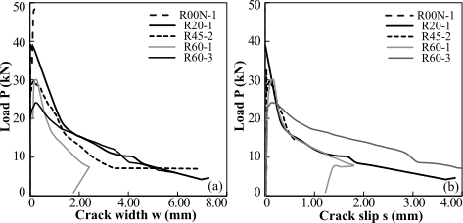

Figure 10 SGF members a) Average crack width, b) Crack slip

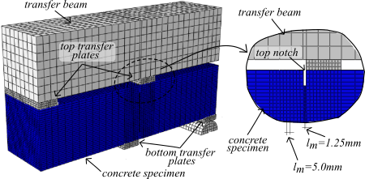

Figure 11 Tri-dimensional numerical modelling configuration

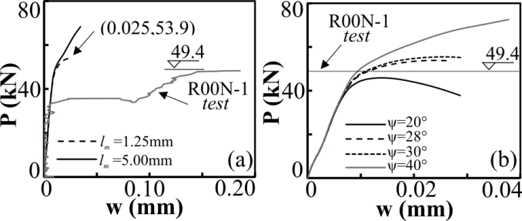

Figure 12 Sensitivity studies on R00N-1 configuration a) Mesh size, b) Dilation angle

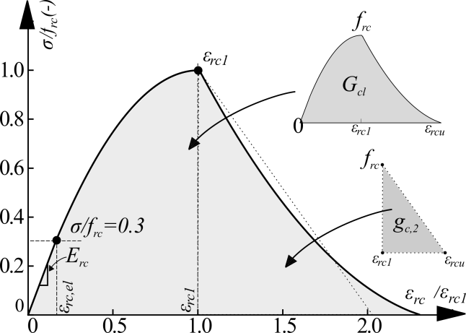

Figure 13 Rubberised concrete constitutive model (adapted from Bompa et al., 2017)

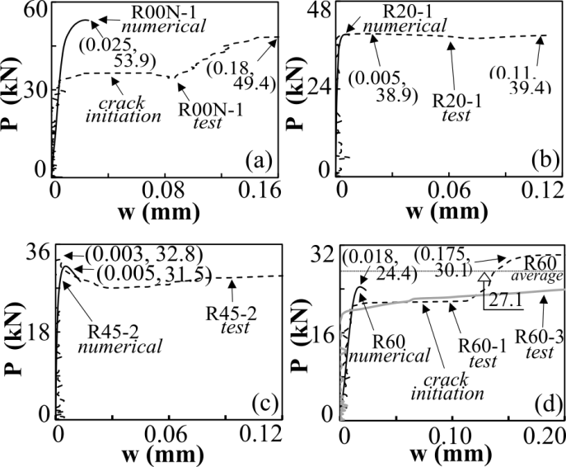

Figure 14 Validation of numerical models with test specimen a) R00N-1, b) R20-1, c) R45-2, d) R60-1

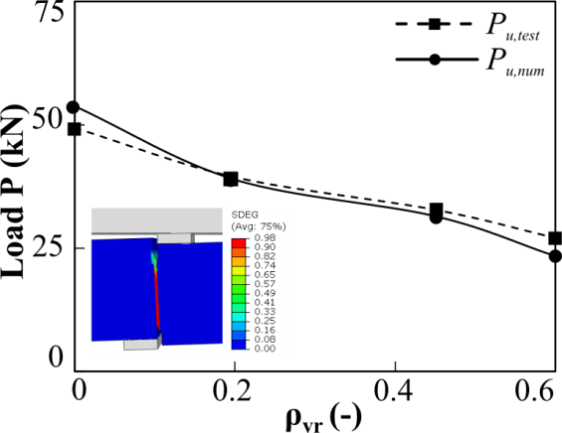

Figure 15 Predicted load reduction compared to corresponding test results

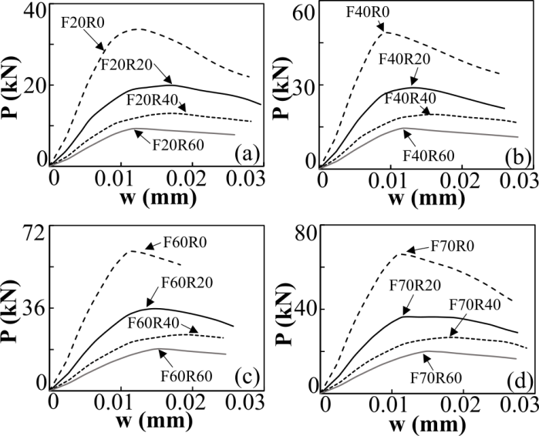

Figure 16 Influence of rubber contents on the shear governed load capacity of concrete with reference compressive strength of a) 20MPa, b) 40MPa, c) 60MPa, d) 70 MPa

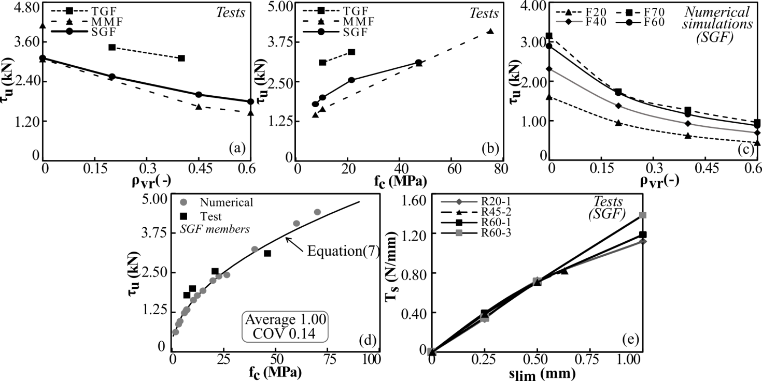

Figure 17 Relationships between a) τ_{u} and ρ_{vr} from tests, b) τ_{u} and f_{c} from tests, c) τ_{u} and ρ_{vr} from SGF numerical simulations; d) Prediction of the shear resistance τ_{u} (Equation 7) e) member toughness T_{s},

