Graphene oxide membranes in fluid separations
JY Chong, B Wang and K Li
Address: Department of Chemical Engineering, Imperial College London, London SW7 2AZ, UK
Corresponding author: Li, K (kang.li@imperial.ac.uk)
Abstract
Recently, considerable work has been performed to explore the potential of graphene-based materials for various membrane applications. Graphene oxide (GO) membranes have shown excellent performance in gas and liquid separations. The transport phenomena and microstructures of GO membranes are some interesting fundamentals in GO membranes. In this article, we would highlight the milestones achieved by GO membranes and briefly discuss some fundamental understandings of the membranes in fluid separations. The challenges and prospects of GO membranes for scale-up applications will also be presented.
Introduction
Graphene-based materials have been studied extensively for various thin film and membrane applications due to their unique two dimensional structure, one atomic thickness, strong mechanical strength and high flexibility [1-3]. Graphene oxide (GO), a chemical derivative of graphene has attracted immense interest for developing ultra-thin and high performance membranes. With high area-to-thickness ratio and large number of surface functional groups, GO flakes can be stacked on top of each other to form large area thin films or membranes [2,4]. GO membranes have shown good performance in gas separation and water filtration [5-7]. Due to the chemically inert property of GO membranes, they have also been studied for solvent nanofiltration and pervaporation [8-10]. There are a few recent reviews discussing graphene-based membranes, including graphene, GO, reduced GO (rGO) and graphene-based composites, in various applications [11-14]. In this article, we will focus our discussion on pure GO membranes in fluid separations. We will briefly review the preparation, microstructures and current achievements of GO membranes, and discuss the modifications, challenges and future prospects of the membranes.
Preparation of GO membranes
Graphene oxide is commonly synthesized from the modified Hummer’s method where graphite is used as the starting material [15,16]. In this process, graphite is first oxidized using strong oxidizing agents such as KMnO₄, NaNO₃ and concentrated sulphuric acid, and monolayer GO sheets can then be exfoliated by prolonged stirring or ultrasonification [17]. Compared to graphene, these chemically exfoliated GO flakes have many surface functional groups such as -COOH and -OH groups on the surface and at the edge of the GO flakes [18]. Hydrophilic GO flakes can be dispersed in water and in some polar solvents, and is a convenient precursor for cost-effective large scale production of graphene-based materials including thin film GO membranes [3,18,19].
Depending on the initial crystal size of graphite and the purification step, the diameter of GO flakes can vary from a few hundred nanometres to a few micrometres. To form continuous GO membranes, GO flakes are stacked on top of each other through a self-assembly process, forming a uniform laminar structure. With hydrogen bonds formed between the GO flakes, GO membranes or papers show excellent mechanical strength [2]. Though thick free-standing GO membranes can be fabricated [20], ultrathin GO membranes are normally supported on porous substrates for easy handling and to improve mechanical strength. GO membranes have been fabricated on both polymeric and inorganic substrates, and in both flat sheet and hollow fibre geometries [5,6,8]. Examples of GO membranes supported ceramic and polymer substrates are shown in Figure 1a-c.
There are several methods to fabricate GO membranes and the simplest is by vacuum filtration. In this method, GO suspension is filtered on a substrate and the thickness of the membranes can be controlled easily by the amount of GO filtered. Some studies found that the driving force during filtration may affect the arrangement of GO flakes in the membranes. High pressure filtration has also been applied in order to determine a more well-stacked GO membrane [9]. Besides the pressure assisted methods, some GO membrane preparation methods utilize the surface tension of liquid for the self-assembly of GO flakes. The evaporation method was first shown by Chen et al., where GO suspension was heated to 80°C [4]. Rapid evaporation happened at the air-liquid interface, driving GO flakes to self-assemble, forming a thin layer of GO film or membrane. Dip coating, spray coating and drop casting were other commonly used methods, in which GO suspension was dispersed on the substrate surface and GO membranes formed after drying [6,20].
Applications of GO membranes
In an early study carried out by Nair et al., GO membranes with sub-micrometer thickness were tested for gas permeation [20]. Their study found that pristine GO membranes were impermeable to various gases including helium. The gas tightness of GO membranes was later tested by Chong et al. at a higher pressure and for a longer period, where similar results were observed [21]. Defect free GO membranes are impermeable to gases, which could be similar to continuous graphene monolayer and may be useful as a protective barrier [1]. However, defect free GO membranes are difficult to obtain and the imperfectness of GO membranes could be useful for membrane separations. Although thick GO membranes were found impermeable, thin GO membranes with thickness less than 20 nm showed high gas permselectivity at considerable fluxes. In a study conducted by Li et al., ultrathin GO membranes with thickness reaching 1.8 nm were prepared on an anodic aluminium oxide (AAO) support by vacuum filtration [5]. The selectivities of the membranes for H₂/CO₂ and H₂/N₂ mixture were as high as 3400 and 900, respectively, which were unusually high compared to most of the microporous membranes. The major transport of gas molecules was speculated to be through the selective structure defects on GO. However, in a study conducted by Kim et al., Knudsen selectivity was observed for GO membranes (thickness <10 nm) prepared by dip-spin casting [6]. When improving the GO packing, well-interlocked dry GO membranes prepared by drop-spin casting showed a high CO₂/N₂ selectivity of 20, but with a lower permeation (Figure 1d). Though GO membranes demonstrated remarkable performance in gas separation, the results were inconsistent: for example, the CO₂/N₂ selectivity in the two studies mentioned above. The results might be difficult to reproduce by others due to the huge challenge in fabricating continuous GO membranes of such thickness and with controllable microstructures.
GO membranes have shown tremendous performance in water filtration application [7]. The interlayer space between GO flakes in GO membranes varies from 6 to 12 Å, enlarging with the increase in water content in the membranes [20]. With their well-arranged laminar structure and well-defined interlayer space, GO membranes can be used to separate molecules through size exclusion. The diffusion of molecules in water across GO membranes was studied by Joshi et al. GO membranes showed a clear cut-off at hydrated radius ∼4.5 Å, as shown in Figure 1e, where molecules with larger diameter were sieved out [22]. GO membranes have been applied for nanofiltration rejecting organic dyes, such as methyl orange and brilliant blue, and the molecular cut-off of the membranes could reach as low as 250 Da [8,21]. Besides the high rejection rates, GO membranes also showed high water permeability and one of the highest fluxes reported was 71 L m⁻² h⁻¹ bar⁻¹ [7]. During filtration, water molecules transport through the membranes via the narrow interspace between the GO flakes (Figure 1f). It was proposed that the ultrafast water transport was due to a low friction between the water and the wall in the hydrophobic pristine graphene channels [20]. Deuterium oxide (D₂O) was used as a tracer to study the ultrafast transmembrane diffusion of water in GO membranes, where the diffusion coefficients of water through the nanocapillaries in GO membranes were found 4-5 orders of magnitude larger than through the sub-micrometer cellulose pores in a microfilter [23]. Besides, confined water between two graphene sheets was observed using high-resolution electron microscopy imaging, which further supported the nanocapillary ultrafast transport of water [24]. However, a study conducted by Wei et al. found that the side-pinning effects from the hydrophilic areas of GO membranes may slow down the transport of water molecules [25]. In addition, the high aspect ratio of GO flakes may create a very high tortuosity for the transport route. The transport path could be longer than 1 mm in a submicron GO membrane, which would result in a very low water permeation rate. Defect-free GO membranes were observed having a very low water flux, lower than 0.1 L m⁻² h⁻¹ bar⁻¹ through a 150 nm thick GO membrane [21]. Therefore, porous microstructure attributed to the stacking or the defects in GO membranes may also contribute to the high water flux of GO membranes. Microstructural defects could serve as shortcuts for water to permeate through the membranes with shorter transport path, as illustrated in Figure 1f [8,21].
GO membranes are stable in various organic solvents such as acetone, methanol, toluene and n-hexane, making them suitable for organic solvent nanofiltration [8,26]. As when immersed in water, the interlayer space of GO membrane enlarges when immersed in organic solvent [26]. Methanol and acetone flux of GO membranes could reach 3.97 and 6.35 LMH bar⁻¹, retaining methyl orange with molecular weight of 327.3 Da [8]. The permeation fluxes were higher than most commercial membranes with a molecular weight cut-off lower than 300 Da [27]. Besides, GO membranes have demonstrated good performance in pervaporation, an economical alternative to distillation, to separate water from organic solvents such as ethanol, butanol and dimethyl carbonate [9,10,28].
Though GO membranes demonstrated promising results in nanofiltration, they showed limitation in reverse osmosis for salt rejection. Na⁺, K⁺ and Mg²⁺ were found diffused through GO membranes in studies by Joshi et al. and Sun et al. [22,29]. The limitation of GO membranes in desalination is mainly due to the large interlayer space compared to the size of ions. Mi proposed that the interlayer distance of GO membranes may need to be reduced to 7 Å in order to reject Na⁺ [30], which could be done by reducing GO to rGO. However, the more hydrophobic rGO may not be favourable for water filtration. Previous studies also found that water could not fill the capillary channels between the GO flakes and permeate through the membrane if the interlayer distance of GO is lower than 6 Å [31]. Besides considering the interlayer distance, the interactions between the solutes with the surface functional groups and the cation−π interactions are also important as charge repulsion may assist in rejecting charged solutes [29,32]. Further modifications such as fine tuning the interlayer distance and cross linking the GO flakes may be necessary in order to apply GO membranes in desalinations. However, given the property of ion permeation, GO membranes were shown to be effective in recovering acids from iron-based electrolytes, which makes them potential in cation-exchange in waste water treatment applications [33].
Microstructures of GO membranes
The microstructures of GO membranes, such as the stacking of GO flakes and the defects within membranes, were found affected by different membrane preparation methods used, which consequently influenced the performance of GO membranes. Kim et al. showed that GO membranes prepared by drop-spin casting were more densely packed and had a higher selectivity of CO₂, compared to those prepared by dip-spin casting (Figure 2a) [6]. Tsou et al. studied GO membranes fabricated by 3 different methods: pressure assisted filtration, vacuum assisted filtration and evaporation (Figure 2b) [28]. Among them, GO membranes fabricated by pressure assisted filtration showed the best performance in butanol dehydration, mainly due to the more ordered laminar structure. Surface roughness and surface hydrophilicity of GO membranes were also shown affected by the membrane microstructures. However, in a study by Sheath and Majumder on rGO membranes, membranes were found to have a more ordered laminar structure in an evaporative self-assembly method compared to vacuum filtration [34], which was contradictory to the study by Tsou et al. The more ordered rGO membrane showed a higher rejection rate and a higher water permeability. While the more well-arranged GO membranes in gas separation showed a high selectivity but a lower gas permeation, the opposite phenomenon was observed in water filtration where the more well-ordered GO membranes not only showed better rejection properties, but also an improved water flux. This higher water flux, as explained by some studies, was due to the low friction flow in the well-ordered GO interspace galleries. The other interesting observation was the variation in interlayer space of GO membranes with different microstructures as the result of different preparation methods used [28]. GO membranes prepared from filtration were also shown having a smaller interlayer space when a high pressure, instead of vacuum was applied [9]. However, these results should be treated with caution. The interlayer space of GO membranes was created from the hydrogen bonding formed between GO flakes, and in principle, such strong bonding may not be affected by external forces like the filtration pressure during the membrane fabrication.
The formation of GO membranes during vacuum assisted self-assembly was studied by Putz et al. [35]. A semi-ordered accumulation mechanism was identified as being dominant during GO membrane preparation. During filtration, the removal of water brought GO flakes closer to one another, forming a loose aggregate of GO mass. Though roughly aligned with each other, the adhesion between the flakes was still weak and the interlayer space was significantly larger than the final membranes. When excess water or solvent was removed, compression from the lowering water-air interface aligned the GO flakes, closing gaps between the GO flakes and producing a structure with a higher degree of order. The final water removal process was an important step to determine GO membranes with well-packed microstructures. The same research group later showed that GO membranes may have hierarchical structures especially when the thickness was approaching a micron length scale [36]. The hierarchical structure may not be favourable for GO membranes if the large space or defects in the membranes would affect the rejection properties. The mechanism of GO membrane formation was recently studied using a stop motion animation to further observe the evolution of membrane microstructures using an imaging technique [37]. Figure 2c-h showed SEM pictures taken at different percentage of water filtered during the membrane preparation process: 50, 90 and 100%. An interconnected proto-lamellar network was observed during filtration, which was slowly compressed into dense GO lamellae when water was removed. Similar formation was observed for GO membranes prepared via evaporation in the same study. However, the growth of dense lamellae started from the water-air interface and was at a lower rate, which may affect the mechanical integrity. Due to the hierarchical microstructure, GO membranes may be subject to a compaction problem when operated under high pressure. The compaction problem in rGO membranes was previously reported even for sub-100 nm membranes [38].
The size of GO flakes was also found to affect the microstructures and the performance of GO membranes [32]. GO membranes prepared using GO flakes in nano-size showed fewer wrinkles on the membrane surface compared to those prepared using flakes in micron-size. Though the interlayer space remained similar, the corresponding XRD absorption peak was broader for the nano-sized GO membranes. Ion permeation through diffusion across the nano-sized GO membranes also increased, which could be due to the less densely packed laminar structure. However, the effect of GO flake size on the water permeation in GO membranes has not been presented so far. Besides, in a study by Chen et al., GO papers prepared from large GO flakes (diameter >13 µm) were found to have fewer structural defects, as well as denser and more ordered microstructures than those prepared from small GO flakes (diameter <7 µm), and therefore had better mechanical properties [39]. The effect of GO flake sizes in GO thin film formation via evaporation was studied by Luo et al. [40]. Large micron-sized GO flakes tended to migrate to the water surface leading to a continuous GO thin film formed after drying. In contrast, nano-sized GO flakes preferred to disperse in bulk water, leaving “coffee ring stain” type of drying pattern. The different behaviour of GO flakes could be due to the increase in surface charge density as a result of the increase in the edge-to-area ratio.
A recent study by Akbari et al. demonstrated that the concentration of GO suspension used for membrane preparation would affect the alignment of GO flakes in GO membranes [41]. GO suspension was shown underwent an isotropic to nematic phase transition at ~5 mg ml⁻¹ and became fully nematic phase at concentration higher than 16 mg ml⁻¹. At such a high concentration, the viscous discotic nematic phase of GO suspension could be shear aligned using a casting method to form highly ordered, continuous thin GO membranes. The highly ordered GO membrane was showed to have enhanced water permeability 71 LMH bar⁻¹ due to the organized channels.
Modifications, Challenges and Prospects
Many modifications have been carried out to improve the performance of GO membranes. Strategies such as pore creations on GO flakes and microstructural channel generations have been tested to create extra transport paths in GO membranes, which would shorten the water transport path and therefore increase the water permeability (Figure 3a) [42,43]. However, the rejection rates of the membranes may be compensated, losing the nanofiltration property of GO membranes. There were also several studies on crosslinking of GO flakes and intercalation of GO interlayers with nanoparticles or polymers, an example is illustrated in Figure 3b [44-49]. The interlayer of GO membranes could be fine-tuned and modified to achieve different separation purposes. The stability of GO membranes may also be improved with stronger interactions between the GO flakes. Though GO membranes are hydrophilic, further increasing the surface hydrophilicity by surface modification showed an improvement in the membrane performance in butanol dehydration (Figure 3c) [50]. In some studies, GO flakes or GO membranes were reduced to produce rGO membranes and the membranes have shown excellent performance in nanofiltration and forward osmosis [38,51]. GO mixed matrix membranes have also been studied and GO flakes assembled in polyether block amide (PEBA) demonstrated a high CO₂/N₂ selectivity of 91 with a CO₂ permeability of 100 Barrer [52].
Despite all the interesting findings from the current research on GO membranes, there are still some challenges before the membranes can be applied at a larger scale. The stability of GO membranes is one of the major concerns. A recent study revealed that ceramic substrates released multi-valent cations, which could help to crosslink GO flakes and stabilise GO membranes in water, while GO membranes prepared with polymeric substrates were unstable in water [53]. Besides, GO membranes were found unstable in air due to shrinkage after drying. The shrinkage problem could be overcome by storing the membranes in water to avoid excess drying [8], or by using a sacrificial layer during membrane fabrication [21]. More effort is needed to overcome the stability problem of GO membranes especially when the membrane thickness is in the sub-micron level. Besides that, there were some shortcomings in how GO membranes were tested in some studies. Although molecules or ion diffusion data are important for initial material studies, pressure driven measurement would be more relevant for industrialized membrane applications. Nevertheless, there remains much potential in this material due to the easy formation of thin films. Applications other than fluid separations can also be further explored.
Conclusions
GO membranes have shown some exciting results in fluid separation applications. The microstructures of GO membranes are affected by the membrane preparation methods, which may result in variable membrane performance. Modifications of GO membrane using various methods have enhanced the membrane performances. However, the stability of GO membranes will still need to be further tested and improved before they can be used for large scale applications.

Acknowledgements
The authors would like to thank EPSRC (EP/K01658X/1) for the support on work on GO membranes. This research was also supported by a Marie Curie International Incoming Fellowship for Bo Wang within the 7th European Community Framework Programme (Grant No. 627591).
References
1. Bunch JS, Verbridge SS, Alden JS, van der Zande AM, Parpia JM, Craighead HG, McEuen PL: Impermeable Atomic Membranes from Graphene Sheets. Nano Letters 2008, 8:2458-2462.
2. Dikin DA, Stankovich S, Zimney EJ, Piner RD, Dommett GHB, Evmenenko G, Nguyen ST, Ruoff RS: Preparation and characterization of graphene oxide paper. Nature 2007, 448:457-460.
3. Zhu Y, Murali S, Cai W, Li X, Suk JW, Potts JR, Ruoff RS: Graphene and Graphene Oxide: Synthesis, Properties, and Applications. Advanced Materials 2010, 22:3906-3924.
4. Chen C, Yang Q-H, Yang Y, Lv W, Wen Y, Hou P-X, Wang M, Cheng H-M: Self-Assembled Free-Standing Graphite Oxide Membrane. Advanced Materials 2009, 21:3007-3011.
5. Li H, Song Z, Zhang X, Huang Y, Li S, Mao Y, Ploehn HJ, Bao Y, Yu M: Ultrathin, Molecular-Sieving Graphene Oxide Membranes for Selective Hydrogen Separation. Science 2013, 342:95-98.
• This paper reports an exceptional performance of ultrathin GO membranes in hydrogen separation.
6. Kim HW, Yoon HW, Yoon S-M, Yoo BM, Ahn BK, Cho YH, Shin HJ, Yang H, Paik U, Kwon S, et al.: Selective Gas Transport Through Few-Layered Graphene and Graphene Oxide Membranes. Science 2013, 342:91-95.
•• This paper reports GO membranes synthesized using different methods, which show different performance in gas separation. Graphene membranes were also synthesized in the study.
7. Huang H, Mao Y, Ying Y, Liu Y, Sun L, Peng X: Salt concentration, pH and pressure controlled separation of small molecules through lamellar graphene oxide membranes. Chemical Communications 2013, 49:5963-5965.
8. Aba NFD, Chong JY, Wang B, Mattevi C, Li K: Graphene oxide membranes on ceramic hollow fibers – Microstructural stability and nanofiltration performance. Journal of Membrane Science 2015, 484:87-94.
9. Tang YP, Paul DR, Chung TS: Free-standing graphene oxide thin films assembled by a pressurized ultrafiltration method for dehydration of ethanol. Journal of Membrane Science 2014, 458:199-208.
10. Huang K, Liu G, Lou Y, Dong Z, Shen J, Jin W: A Graphene Oxide Membrane with Highly Selective Molecular Separation of Aqueous Organic Solution. Angewandte Chemie International Edition 2014, 53:6929-6932.
11. Liu G, Jin W, Xu N: Graphene-based membranes. Chemical Society Reviews 2015, 44:5016-5030.
12. Hegab HM, Zou L: Graphene oxide-assisted membranes: Fabrication and potential applications in desalination and water purification. Journal of Membrane Science 2015, 484:95-106.
13. Huang H, Ying Y, Peng X: Graphene oxide nanosheet: an emerging star material for novel separation membranes. Journal of Materials Chemistry A 2014, 2:13772-13782.
14. Sun P, Wang K, Zhu H: Recent Developments in Graphene-Based Membranes: Structure, Mass-Transport Mechanism and Potential Applications. Advanced Materials 2016.
•• This review paper provides a comprehensive review of GO membranes in various applications including proton conductor and energy-related applications. The paper also discusses many work on the modifications of GO membranes.
15. Hirata M, Gotou T, Horiuchi S, Fujiwara M, Ohba M: Thin-film particles of graphite oxide 1: High-yield synthesis and flexibility of the particles. Carbon 2004, 42:2929-2937.
16. Hummers WS, Offeman RE: Preparation of Graphitic Oxide. Journal of the American Chemical Society 1958, 80:1339-1339.
17. Li D, Muller MB, Gilje S, Kaner RB, Wallace GG: Processable aqueous dispersions of graphene nanosheets. Nature Nanotechnology 2008, 3:101-105.
18. Dreyer DR, Park S, Bielawski CW, Ruoff RS: The chemistry of graphene oxide. Chemical Society Reviews 2010, 39:228-240.
19. Park S, Ruoff RS: Chemical methods for the production of graphenes. Nature Nanotechnology 2009, 4:217-224.
20. Nair RR, Wu HA, Jayaram PN, Grigorieva IV, Geim AK: Unimpeded Permeation of Water Through Helium-Leak–Tight Graphene-Based Membranes. Science 2012, 335:442-444.
•• This paper reports the gas-tight impermeable property of GO membranes. The paper also shows water permeates through GO membranes in a low friction flow in the GO interlayer channels.
21. Chong JY, Aba NFD, Wang B, Mattevi C, Li K: UV-Enhanced Sacrificial Layer Stabilised Graphene Oxide Hollow Fibre Membranes for Nanofiltration. Scientific Reports 2015, 5:15799.
•• This paper shows an alternative to overcome shrinkage problem of GO membranes on ceramic hollow fibre. The authors also shows how microstructural defects can serve as shortcuts for the transport of water molecules in GO membranes.
22. Joshi RK, Carbone P, Wang FC, Kravets VG, Su Y, Grigorieva IV, Wu HA, Geim AK, Nair RR: Precise and Ultrafast Molecular Sieving Through Graphene Oxide Membranes. Science 2014, 343:752-754.
• This paper reveals the well-defined pores of GO membranes can retain solutes through size exclusion in water filtration.
23. Sun P, Liu H, Wang K, Zhong M, Wu D, Zhu H: Ultrafast liquid water transport through graphene-based nanochannels measured by isotope labelling. Chemical Communications 2015, 51:3251-3254.
24. Algara-Siller G, Lehtinen O, Wang FC, Nair RR, Kaiser U, Wu HA, Geim AK, Grigorieva IV: Square ice in graphene nanocapillaries. Nature 2015, 519:443-445.
25. Wei N, Peng X, Xu Z: Understanding Water Permeation in Graphene Oxide Membranes. ACS Applied Materials & Interfaces 2014, 6:5877-5883.
• This paper provides some understanding of the transport phenomenon within GO membranes. The effect of hydrophilic part of GO in water transport in the membrane is discussed.
26. Huang L, Li Y, Zhou Q, Yuan W, Shi G: Graphene Oxide Membranes with Tunable Semipermeability in Organic Solvents. Advanced Materials 2015, 27:3797-3802.
27. Marchetti P, Jimenez Solomon MF, Szekely G, Livingston AG: Molecular Separation with Organic Solvent Nanofiltration: A Critical Review. Chemical Reviews 2014, 114:10735-10806.
28. Tsou C-H, An Q-F, Lo S-C, De Guzman M, Hung W-S, Hu C-C, Lee K-R, Lai J-Y: Effect of microstructure of graphene oxide fabricated through different self-assembly techniques on 1-butanol dehydration. Journal of Membrane Science 2015, 477:93-100.
29. Sun P, Zhu M, Wang K, Zhong M, Wei J, Wu D, Xu Z, Zhu H: Selective Ion Penetration of Graphene Oxide Membranes. ACS Nano 2012, 7:428-437.
30. Mi B: Graphene Oxide Membranes for Ionic and Molecular Sieving. Science 2014, 343:740-742.
31. Boukhvalov DW, Katsnelson MI, Son Y-W: Origin of Anomalous Water Permeation through Graphene Oxide Membrane. Nano Letters 2013, 13:3930-3935.
32. Sun P, Zheng F, Zhu M, Song Z, Wang K, Zhong M, Wu D, Little RB, Xu Z, Zhu H: Selective Trans-Membrane Transport of Alkali and Alkaline Earth Cations through Graphene Oxide Membranes Based on Cation−π Interactions. ACS Nano 2014, 8:850-859.
33. Sun P, Wang K, Wei J, Zhong M, Wu D, Zhu H: Effective recovery of acids from iron-based electrolytes using graphene oxide membrane filters. Journal of Materials Chemistry A 2014, 2:7734-7737.
34. Sheath P, Majumder M: Flux accentuation and improved rejection in graphene-based filtration membranes produced by capillary-force-assisted self-assembly. Philosophical Transactions of the Royal Society of London A: Mathematical, Physical and Engineering Sciences 2016, 374.
35. Putz KW, Compton OC, Segar C, An Z, Nguyen ST, Brinson LC: Evolution of Order During Vacuum-Assisted Self-Assembly of Graphene Oxide Paper and Associated Polymer Nanocomposites. ACS Nano 2011, 5:6601-6609.
36. Wood CD, Palmeri MJ, Putz KW, An Z, Nguyen ST, Catherine Brinson L: Hierarchical Structure and Properties of Graphene Oxide Papers. Journal of Applied Mechanics 2013, 80:040913-040913.
37. Nandy K, Palmeri MJ, Burke CM, An Z, Nguyen ST, Putz KW, Brinson LC: Stop Motion Animation Reveals Formation Mechanism of Hierarchical Structure in Graphene Oxide Papers. Advanced Materials Interfaces 2016.
•• This paper shows the evolution of GO membranes during the fabrication process. The change in microstructures during the membrane synthesis was captured clearly, which was important observation to understand the formation of GO membranes.
38. Han Y, Xu Z, Gao C: Ultrathin Graphene Nanofiltration Membrane for Water Purification. Advanced Functional Materials 2013, 23:3693-3700.
• This is one of the early work showing an excellent performance of rGO membranes in nanofiltraion.
39. Chen J, Li Y, Huang L, Jia N, Li C, Shi G: Size Fractionation of Graphene Oxide Sheets via Filtration through Track-Etched Membranes. Advanced Materials 2015, 27:3654-3660.
40. Luo J, Cote LJ, Tung VC, Tan ATL, Goins PE, Wu J, Huang J: Graphene Oxide Nanocolloids. Journal of the American Chemical Society 2010, 132:17667-17669.
41 Akbari A, Sheath P, Martin ST, Shinde DB, Shaibani M, Banerjee PC, Tkacz R, Bhattacharyya D, Majumder M: Large-area graphene-based nanofiltration membranes by shear alignment of discotic nematic liquid crystals of graphene oxide. Nat Commun 2016, 7.
42. Ying Y, Sun L, Wang Q, Fan Z, Peng X: In-plane mesoporous graphene oxide nanosheet assembled membranes for molecular separation. RSC Advances 2014, 4:21425-21428.
43. Huang H, Song Z, Wei N, Shi L, Mao Y, Ying Y, Sun L, Xu Z, Peng X: Ultrafast viscous water flow through nanostrand-channelled graphene oxide membranes. Nature Communications 2013, 4.
44. Hu M, Mi B: Enabling Graphene Oxide Nanosheets as Water Separation Membranes. Environmental Science & Technology 2013, 47:3715-3723.
45. Zhang Y, Zhang S, Chung T-S: Nanometric Graphene Oxide Framework Membranes with Enhanced Heavy Metal Removal via Nanofiltration. Environmental Science & Technology 2015, 49:10235-10242.
46. Xu C, Cui A, Xu Y, Fu X: Graphene oxide–TiO2 composite filtration membranes and their potential application for water purification. Carbon 2013, 62:465-471.
47. Han Y, Jiang Y, Gao C: High-Flux Graphene Oxide Nanofiltration Membrane Intercalated by Carbon Nanotubes. ACS Applied Materials & Interfaces 2015, 7:8147-8155.
48. Hung W-S, An Q-F, De Guzman M, Lin H-Y, Huang S-H, Liu W-R, Hu C-C, Lee K-R, Lai J-Y: Pressure-assisted self-assembly technique for fabricating composite membranes consisting of highly ordered selective laminate layers of amphiphilic graphene oxide. Carbon 2014, 68:670-677.
49. Putz KW, Compton OC, Palmeri MJ, Nguyen ST, Brinson LC: High-Nanofiller-Content Graphene Oxide–Polymer Nanocomposites via Vacuum-Assisted Self-Assembly. Advanced Functional Materials 2010, 20:3322-3329.
• The paper shows the synthesis of intercalated GO membranes with both hydrophilic and hydrophobic polymers. The study displays the importance of hydrogen bonding for the mechanical properties of GO membranes.
50. Huang K, Liu G, Shen J, Chu Z, Zhou H, Gu X, Jin W, Xu N: High-Efficiency Water-Transport Channels using the Synergistic Effect of a Hydrophilic Polymer and Graphene Oxide Laminates. Advanced Functional Materials 2015, 25:5809-5815.
51. Liu H, Wang H, Zhang X: Facile Fabrication of Freestanding Ultrathin Reduced Graphene Oxide Membranes for Water Purification. Advanced Materials 2015, 27:249-254.
52. Shen J, Liu G, Huang K, Jin W, Lee K-R, Xu N: Membranes with Fast and Selective Gas-Transport Channels of Laminar Graphene Oxide for Efficient CO2 Capture. Angewandte Chemie International Edition 2015, 54:578-582.
53. Yeh C-N, Raidongia K, Shao J, Yang Q-H, Huang J: On the origin of the stability of graphene oxide membranes in water. Nat Chem 2015, 7:166-170.
• This paper discusses the stability of GO membranes on two different types of substrates: ceramic and polymeric.

Figure captions
Figure 1. (a) An SEM image of GO membrane on yttria-stabilized zirconia hollow fibre substrate; Cross-sectional TEM images of ultrathin GO membranes on polyethersulfone support prepared from (b) dip-spin casting and (c) drop-spin casting; (d) Relation between CO₂ permeability and CO₂/N₂ selectivity of GO membranes. Reproduced from ref. 6 with permission from American Association of Advancement of Science; (e) Permeation rates of 1 M feed solution through 5-µm-thick GO membranes as a function of hydrated radius. Reproduced from ref. 22 with permission from American Association of Advancement of Science; (f) Left: Water molecules transport through the interlayer channels in GO membranes. Right: Microstructural defects in GO membranes serve as shortcuts for water to permeate through the membrane. (a, f) Reproduced from ref. 21 with permission from Nature Publishing Group.

Figure 2. (a) GO membranes prepared from Method 1: Dip-spin casting and Method 2: Drop-spin casting, showing different degrees of order. Reproduced from ref. 6 with permission from American Association of Advancement of Science; (b) Schematic of GO membranes prepared using different methods: Pressure-assisted, vacuum-assisted and evaporation-assisted self-assembly. Reproduced from ref. 28 with permission from Elsevier; SEM images of GO membranes as a function of percentage of water filtered (c, d) 50% (e, f) 90% and (g, h) 100% (SOA: semiordered aggregate). Reproduced from ref. 37 with permission from John Wiley and Sons.

Figure 3. (a) Schematic view of mass transport through pristine GO membrane and mesoporous GO membrane after pore creation on GO flakes. Reproduced from ref. 41 with permission from The Royal Society of Chemistry; (b) Illustration of GO membrane with crosslinking of 1,3,5-benzenetricarbonyl trichloride (TMC). Reproduced from ref. 43 with permission from American Chemical Society; (c) Schematic of surface modified GO membrane with a hydrophilic polymer for water-organic separation. Reproduced from ref. 49 with permission from John Wiley and Sons.

Figures
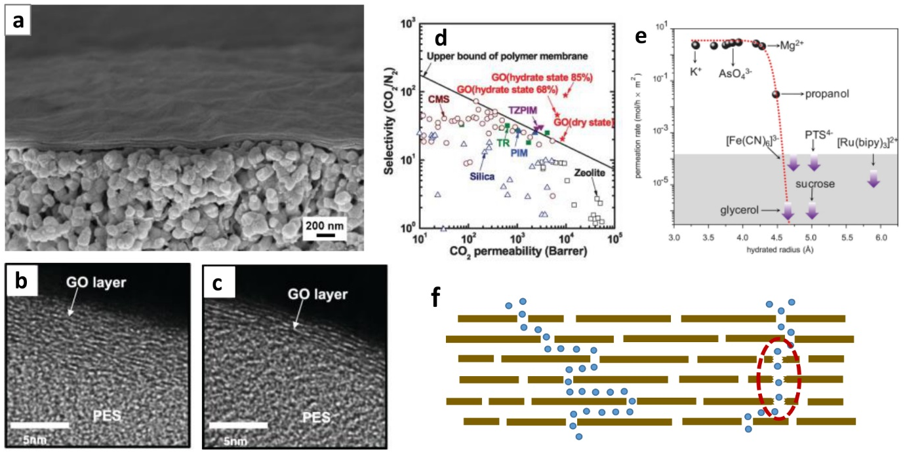

Figure 1. (a) An SEM image of GO membrane on yttria-stabilized zirconia hollow fibre substrate; Cross-sectional TEM images of ultrathin GO membranes on polyethersulfone support prepared from (b) dip-spin casting and (c) drop-spin casting; (d) Relation between CO₂ permeability and CO₂/N₂ selectivity of GO membranes. Reproduced from ref. 6 with permission from American Association of Advancement of Science; (e) Permeation rates of 1 M feed solution through 5-µm-thick GO membranes as a function of hydrated radius. Reproduced from ref. 22 with permission from American Association of Advancement of Science; (f) Left: Water molecules transport through the interlayer channels in GO membranes. Right: Microstructural defects in GO membranes serve as shortcuts for water to permeate through the membrane. (a, f) Reproduced from ref. 21 with permission from Nature Publishing Group.

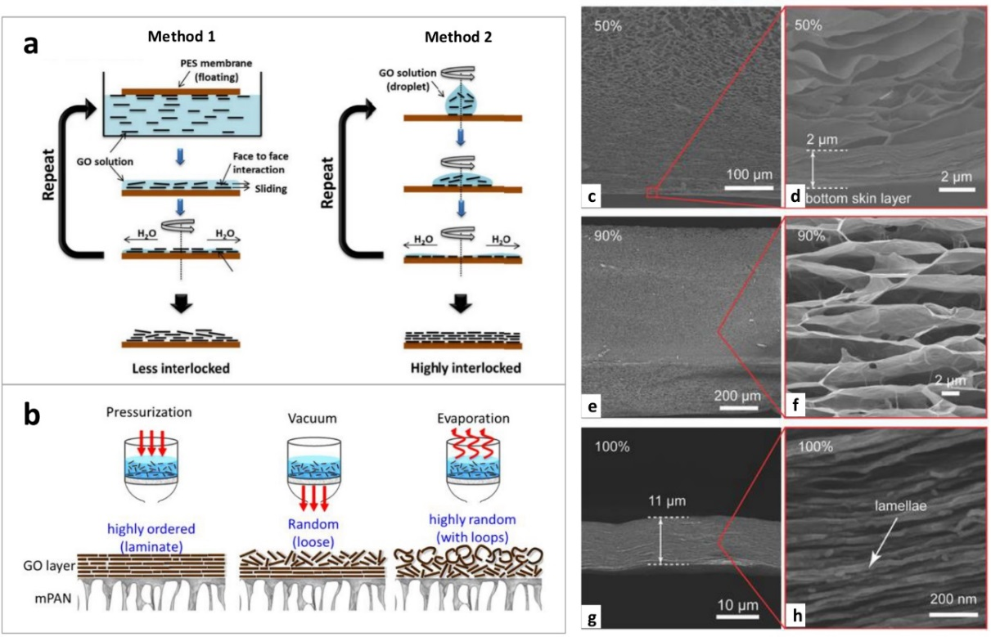

Figure 2. (a) GO membranes prepared from Method 1: Dip-spin casting and Method 2: Drop-spin casting, showing different degrees of order. Reproduced from ref. 6 with permission from American Association of Advancement of Science; (b) Schematic of GO membranes prepared using different methods: Pressure-assisted, vacuum-assisted and evaporation-assisted self-assembly. Reproduced from ref. 28 with permission from Elsevier; SEM images of GO membranes as a function of percentage of water filtered (c, d) 50% (e, f) 90% and (g, h) 100% (SOA: semiordered aggregate). Reproduced from ref. 37 with permission from John Wiley and Sons.

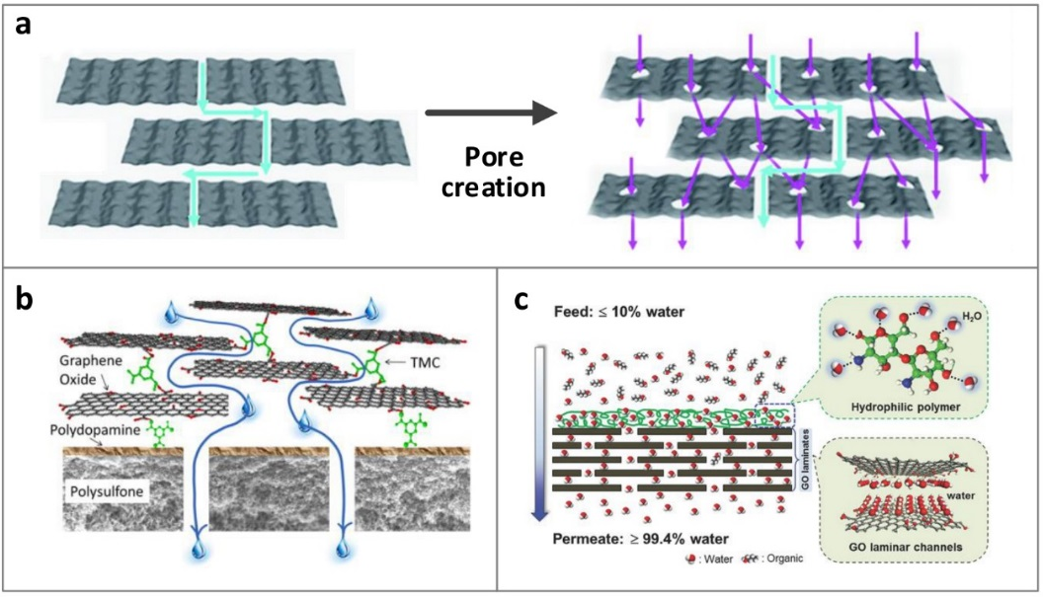

Figure 3. (a) Schematic view of mass transport through pristine GO membrane and mesoporous GO membrane after pore creation on GO flakes. Reproduced from ref. 42 with permission from The Royal Society of Chemistry; (b) Illustration of GO membrane with crosslinking of 1,3,5-benzenetricarbonyl trichloride (TMC). Reproduced from ref. 44 with permission from American Chemical Society; (c) Schematic of surface modified GO membrane with a hydrophilic polymer for water-organic separation. Reproduced from ref. 50 with permission from John Wiley and Sons.

