Journal Title: Journal of Medical Biography 23(2) 108–114

Article Title: Walter Mercer’s (1891 – 1971) contribution to the surgical treatment of low back pain

Author: SPF Hughes

Walter Mercer’s (1891–1971) contribution to the surgical treatment of low back pain

SPF Hughes

Abstract
In 1936, Walter Mercer described a new method for the operative treatment of patients with spondylolisthesis. Using a transabdominal approach in two patients he inserted iliac crest bone graft into the intervertebral disc. His publication in the Edinburgh Medical Journal caused a furore as the levels operated on did not reflect the description and one of the two patients died post-operatively. However, Mercer continued to promote the operation in his textbooks. The anterior approach to the lumbar spine is now performed routinely. This paper explores Mercer’s contribution to anterior spinal surgery.

Keywords
Walter Mercer, anterior lumbar spinal fusion, spondylolisthesis

Introduction
In 1936, Sir Walter Mercer published an article describing a new method for the operative treatment of spondylolisthesis1 (Figure 1). Mercer’s description was of a novel anterior transabdominal approach to the lumbar spine with bone graft inserted in the space between the lumbosacral vertebrae. The paper was severely criticised by contemporary orthopaedic surgeons because of the high mortality from the operation, and the fact that operation was apparently performed at a diﬀerent level from the patients he described. Mercer responded forcefully to these attacks but nevertheless it appears he never repeated the operation although he continued to describe the procedure in his textbook, which was published in six editions during his lifetime.2 Since Mercer’s initial report where the anterior abdominal approach has been used extensively in spinal surgery and modiﬁca- tions of his original description are now commonly used for treating patients with low back pain due to a variety of diﬀerent causes including those with spondylolisthesis.3 This paper explores the background to Mercer’s development of this ground- breaking operation. It also examines the reasons why he developed this approach to the lumbar spine, looks at whether he was in reality the ﬁrst person to use this technique and considers why other con- temporary surgeons were concerned about the approach.

Walter Mercer
To understand how Walter Mercer came to choose the transabdominal anterior approach for the treatment of spondylolisthesis, it is necessary to consider his career. The son of a tweed mill owner, Mercer, born in 1890, studied medicine at the University of Edinburgh. His career was interrupted by the outbreak of war in 1914. Joining the Royal Army Medical Corps, he served in the trenches including at the Battles of the Somme (1916), Messines Ridge (1917) and the First and Second Battles of Ypres (1915–1917),4,5 an experience that both enhanced his surgical skills and gave him extensive experience in war injuries. Invalided home from the front, he was elected a Fellow of the Royal College of Surgeons of Edinburgh in 1921. He went on to become a Clinical Tutor at the Royal Inﬁrmary of Edinburgh and was given the responsibility for managing fractures, elective orthopaedics and undergraduate orthopaedic teaching. In 1925, he was appointed to the Edinburgh City Hospital and he developed a thoracic unit for the East of Scotland.5 By this point in his career Mercer had developed extensive surgical experience,

Department of Surgery and Cancer, Imperial College London,
London, UK 1
Corresponding author:
Sean P F Hughes, 5 Meadow Place, Edensor Road, London W4 2SY, UK.
Email: seanfrancishughes@imperial.ac.uk

2

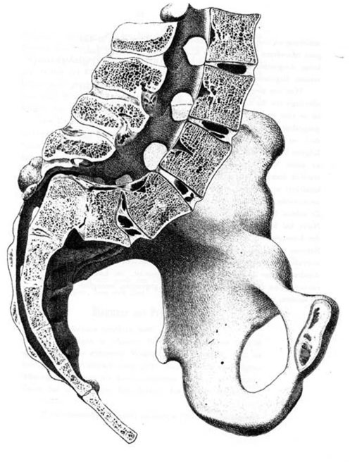
spondylolisthesis and outlined the aetiology of the dis- order, radiographic appearances, diﬀerential diagnosis and treatment. Mercer discussed the treatment that was available at that time, including conservative methods such as bracing the spine and surgical methods in which he outlined both the posterior and anterior approaches to the lumbar spine. He went on to describe in detail his approach to the lumbar spine:

Figure 1. Spondylolisthesis from Kilian 185426 showing a slip of the fifth lumbar vertebra on the sacrum. Dr Hermann Fredrich Kilian devised the term spondylolisthesis from the Greek.

especially of musculoskeletal injuries and tuberculosis but, crucially, also of abdominal surgery. Among his particular interests were patients with vascular disease and he performed operations, including lumbar sym- pathectomy, through a transabdominal approach.6 By the 1930s Walter Mercer was an accomplished gen- eral surgeon, operating on a range of conditions, and he was also interested in the management of tuberculosis. In the 1930s, the dexterity and speed of the surgeon was paramount in order to prevent serious complications from the operation. Mercer demonstrated both these qualities:

I remember well the ﬁrst list of [Mercer’s] operations I witnessed. It began with a meniscectomy, then an operation to the patent ductus arteriosus of a young girl and after that a partial gastrectomy. ‘‘He will ﬁnish these in two and half hours’’ said the house surgeon. Indeed he did without giving the slightest hint of urgency or haste.7

The new method
In September 1936, Walter Mercer published a descrip- tion of the clinical condition and presentation of
The patient is placed on his back and the table raised at its lower end to produce an exaggerated Trendelenburg position. A long mid-line incision is made to just above the umbilicus. The abdominal contents are packed oﬀ from the area of operation, and a self-retaining retrac- tor inserted. The subluxated vertebra is now inspected and its relation to the iliac vessels ascertained. The gap between the sacrum and the slipping vertebral body is now exposed by dividing the posterior peritoneum over it, ligating some small veins and the middle sacral artery, and freed of overlying fatty ﬁbrous tissue with a gauze swab. An osteotome is now used and driven in an antero posterior direction into the lower margin of the ﬁfth lumbar vertebra, an eighth of an inch from its lower edge. In this way a rectangular hole is produced after the pieces of bone and the intervertebral disc have been removed. Autogenous bone grafts are now taken from the crest of the ilium to wedge into this gap. Two pieces are taken since a single piece cannot be got broad enough to wedge ﬁrmly. The grafts are now hammered tight into the gap between the sacrum and the ﬁfth lumbar vertebra and further screwed into place to ensure their retention. If they are not screwed in it has been found that when the patient is lifted oﬀ the table the lumbo-sacral gap may be opened up and the wedges of bone spring out. To avoid this, in addition to screwing the grafts in, the operation is usually carried out with the patient in a posterior plaster shell. The patient remains in the shell for four months, and then
lies free, resting in bed for another month. Thereafter he is allowed up in a Goldthwaite brace.1 (Figure 2)

The transabdominal approach is diﬃcult for both the patient and the surgeon. Less experienced, less versatile surgeons might have thought twice about using this method. In his article, Mercer went on to include a report of ‘Ten Cases’.1
Four patients were treated with a back brace, one patent had a foot arch support ﬁtted, two underwent posterior spinal fusion, one underwent anterior spinal fusion by the Burn’s method19 and two underwent anterior spinal fusion by the author’s new method and were recorded as cases numbered 9 TA and 10 AF. Case 9. (TA) aged 52, was a miner from Mussleborough who was admitted on 26 March 1934 to Ward 11 at the RIE with a diagnosis of a

3

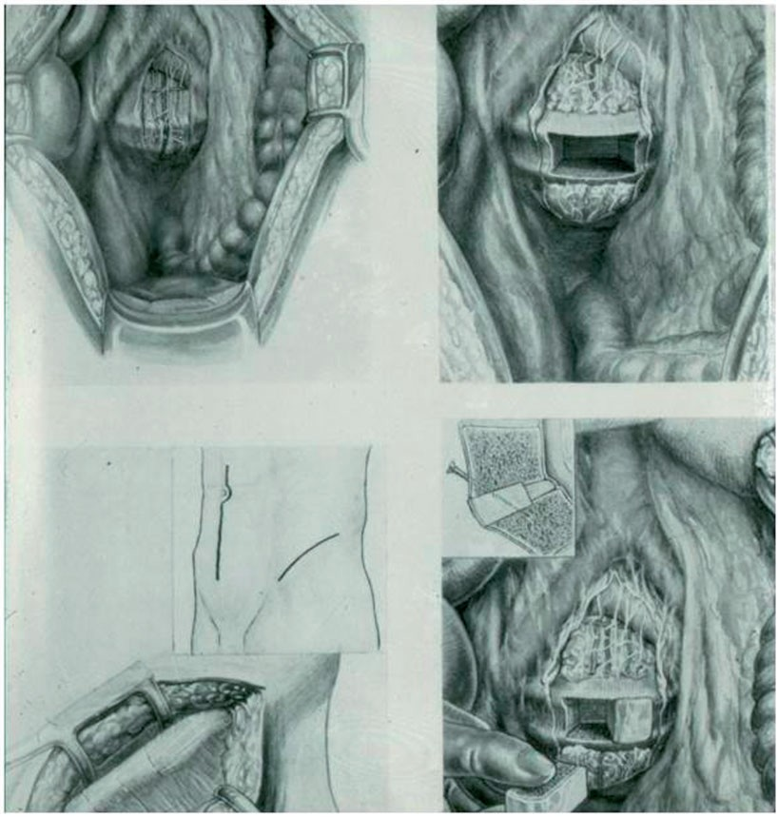
Figure 2. From Mercer1 showing his new method, an anterior transabdominal approach with a single iliac crest bone graft in place with a screw across the graft. The level drawn is the lumbosacral level.

spondylolisthesis. He had suﬀered from back pain for 5 years following an accident from falling a compara- tively small height. For 1 year before his operation, he had been complaining of increasing pain in his back and into his right leg. Examination revealed an increase in the lumbar lordosis but he had good spinal movement. X-rays showed a subluxation of L4 on the sacrum. A spinal graft was inserted on 23 March 1934 by Mercer’s new approach. TA made a good recovery from the operation but on the eighth post- operative day passed red blood in his stools. A blood transfusion was given, but the patient died on 1 April 1934, 8 days after the operation. A post-mortem examination revealed a thrombosis of the superior mesenteric artery.1,8
Case 10. (AF) 11567, aged 35, was a miner who had a diagnosis of spondylolisthesis. He had been complain- ing of pain in his lower back for 3 years which followed being struck in his back by a large stone. The pain radiated into both legs. Examination revealed limited
spinal movement and x-rays showed a forward dis- placement of the fourth lumbar vertebra on the sacrum. A bone graft was inserted into the spine using Mercer’s new approach on 12 May 1934. He was discharged from hospital on 23 May 1934. Following his operation, the patient wore a back brace for a year. The pain had completely disappeared by the 1-year follow-up and he was noted to be back at work.1,8
Although Mercer stated that it was essential for patients who underwent this procedure to be placed in a plaster shell for 4 months, the one patient who did successfully survive the operation was discharged home after 11 days, nor was a screw used to hold any of the grafts in place.

The debate
Mercer was not prepared for the furor that followed publication of his paper. Sir Herbert Seddon

4

(1903–1977), at this time Medical Superintendent at the Royal National Orthopaedic Hospital (RNOH) Stanmore,9 found several problems with Mercer’s paper.

A paper on ‘‘Spondylolisthesis; with a description of a New Method of operative Treatment and notes of Ten Cases’’, by Mr Walter Mercer has appeared in a recent number of the Edinburgh Medical Journal (1936). In this article I am concerned only with the new operation that he has described. In brief, it consists in placing blocks of bone (taken from the ilium) into a broad slot cut in the L5-S1 disk and the adjoining vertebral surfaces – a most attractive operation. It is, however, a little disappointing to ﬁnd that of the cases operated on only two were dealt with by this method. The illustra- tions depict the operation as performed at the usual level that is, L5-S1. Mr Mercer tells us that he has never actually done this: in his two the cases the lux- ation was between L4 and L5. (In the case noes it is stated that in these two cases 9 and 10, the x-ray ﬁlms showed displacement of the fourth lumbar vertebra on the sacrum – a serious misprint). The author assumes that his operation could be performed with equal ease at the usual level, though surely it would be almost impossible if the forward luxation of L5 were at all marked. Mr Mercer advises the use of two blocks of bone from the ilium, which are to be ‘‘screwed into place’’ to ensure their retention. If they are not screwed in it has been found that when the patient is lifted oﬀ the table the bone springs out’’. How does Mr Mercer know this seeing that he has not yet operated on the lumbosacral joint? If a comparable accident happened in one of his L4-5 cases, why is there no mention of it in the notes? If it happened in a case operated on by a colleague, this should be mentioned. Here is new and perhaps valuable operation; but no dates are given in the case notes and no preoperative or postoperative x-ray ﬁlms shown. It is a pity, too that one patient died ‘‘and that for this the trauma of the operation must be blamed’’ – a high mortality rate in an operation for such a benign condition. If this operation had been described only in a medical journal these criticisms would not have been made public. But it appears in the second edition of Mr Mercer’s textbook with no indication of the insecurity of the foundations of the operation not even a reference to the full paper to be published subsequently. This is a serious lapse in a text book that is now well known and should stand above all else for sound teaching. Surely one is entitled to expect little less of the fond parent in the author of
such a work’’.10

Seddon took issue with the fact that only two patients out of the 10 listed actually underwent the anterior
transabdominal approach that the level in the diagram in the paper is not at the same level as the two patients Mercer describes and, crucially, that one of the two patients operated on by this method died 8 days after the operation. A mortality of 50% for an operation on a benign condition can hardly be ignored. Furthermore, the fact that the operation depicted is not the operation Mercer undertook on his two patients is critical as it means that no one reading Mercer’s work could be sure if the operation can actually be carried out as illustrated.
Further criticism of the operation came from Capener11 who stated that he was the ﬁrst to suggest anterior ﬁxation for spondylolisthesis. Capener in his 1936 letter to the British Medical Journal deplored the fact that Mercer had taken one of his original diagrams without due acknowledgement and he had previously concluded that the mortality rate from the transabdom- inal approach was too high for such a benign condition. Capener stated ‘I was probably wrong to have incited the operative technicians thus, but it does appear that the technical risks of such procedures preclude their further use’.12
Undaunted, Mercer13 replied that since he had not found any current operation to be mechanically sound, after trial of various procedures in the post mortem room he decided his approach was reasonably easy. However, he did notice when operating on a cadaver that the bone graft became loose so he advocated the
use of a screw. Mercer went on to regret that one of the two patients he operated on had died but blamed the operator and not the operation. He also expressed his hope to publish a larger series but he felt it import- ant to describe this approach in his textbook, in part to make textbooks more interesting. Finally he acknowl- edged Capener’s contribution. In response Seddon gra- ciously accepted Mercer’s reply, adding that he was looking forward to his more detailed paper and agree- ing that every eﬀort should be made to prevent text- books being dry or uninteresting. Seddon also accepted that individualism was permissible in textbooks but could not prevent himself from adding ‘it should not occur at the expense of judicial detachment that should be the hallmark of the teacher’.14
Mercer never published the proposed paper describ- ing further patients undergoing surgical treatment for spondylolisthesis by his new method. However, he did continue to use the diagrams and description of the operation in his textbook for an operation at a level he appeared never to have actually operated upon.2 In turn, Seddon seems to have had no further concerns after his initial criticism and appears to have accepted Mercer’s explanations that there had been a trial of the operation in the post-mortem room, that the 50% mortality may have been due to the operator not the

5
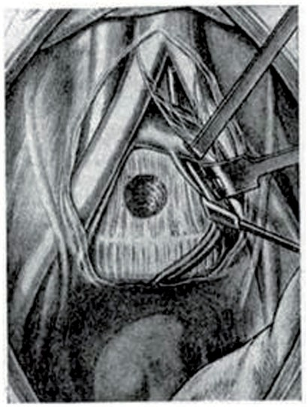
Operation, that the paper describes the operation being carried out at the lower lumbosacral level rather than at L4-5 and that Mercer planned to publish a more detailed description of patients when a larger number had been treated. Apparently, Capener was also satisﬁed that Mercer had acknowledged one of his drawings and further correspondence ceased. Mercer’s blithe decision to continue including the treatment in his text- book suggests he had no real fear of the surgical establishment. It remains the case, however, that he never repeated the operation but whether because of the excessive mortality rate or because of the points raised by Seddon remains unclear.

Anterior approaches to the lumbar spine
In the early 20th century, most spinal surgery was car- ried out for tuberculosis. The method was decompres- sion and posterior spinal fusion as described by Albee (1911),15 Hibbs (1912)16 and Girdlestone (1923).17 Many surgeons considered the anterior approach for patients with tuberculosis of the spine was too hazard- ous although not unheard of.
In 1906, Muller18 reported on his experience of transabdominal access to the spine in patients with tuberculosis. He described a 35-year-old mother who presented with increasing pain in her lower back which he thought was due to a malignant tumour. An operation was performed on 27 July 1906 using a mid-line incision, the abdominal cavity was packed with gauze and the peritoneum opened. A large abscess was found and aspirated. The back wall of the abscess was incised and the cavity curetted to remove the pyogenic membrane. Muller states ‘thus a surprisingly good view of the area of the pathological vertebrae is obtained’. The operation took 40 minutes and post- operatively the patient made a good recovery and was mobilised a month later in a Plaster of Paris corset. A review at 3 months reported that the disc between the L5 and S1 vertebrae had fused completely. Muller concluded that this transperitoneal approach may seem too daring but he was surprised and satisﬁed with the relatively easy access and good visualisation achieved. In 1933, Burns19 described a boy aged 14 years who had pain in his back and calves after jumping from a height 3 months previously. X-rays showed a fracture of the lamina of L5 and that the body of L5 had slipped forward on the sacrum. Burns drilled a hole almost vertically downwards from L5 to the sacrum and inserted a cortical bone graft taken from the tibia (Figure 3). The boy was allowed home 2 months after the operation without pain. X-rays were taken at
7 weeks but there was no further follow up. Burns does not appear to have performed this operation again. However, the approach is important because it

Figure 3. Diagrammatic drawing to illustrate the Burns19 operation (drawn by Miss WM Barclay Smith). The figure shows the hole drilled in the fifth lumbar vertebra, having exposed the spine via a transabdominal approach is the ﬁrst recorded operation to expose the lumbar spine by the transabdominal approach for a patient with spondylolisthesis and it has been said that Burns was the ‘First to approach the lumbar spine through the abdomen’.20 Mercer knew of this procedure because he performed the Burns operation on two occasions for patients with spondylolisthesis.1,21
In 1934, Ito et al.22 described a new radical operation for the treatment of Pott’s disease of the spine which was based on their experience with lumbosacral sym- pathectomy. They also used an anterior midline
approach but proceeded by a retroperitoneal approach to arrive at the lumbar vertebrae. In one of the ten patients, a bone graft from the tibia was inserted into the defect at the lumbosacral level. Over the next few decades the anterior transabdominal approach to the spine was used mainly for the treatment of tuberculosis of the spine. The leaders in the ﬁeld, Hodgson and Stock,23 showed that the spine could be exposed by the anterior route without causing major problems to the patient, especially using the retroperitoneal approach, which gave conﬁdence to surgeons in the anterior exposure of the lumbar spine. Current innovations have used a combination of anterior and posterior fusion, which is now the standard operation for patients with low back pain, particularly spondylolisthesis.24
Mercer’s innovative but technically demanding approach to the lumbar spine using the anterior

6

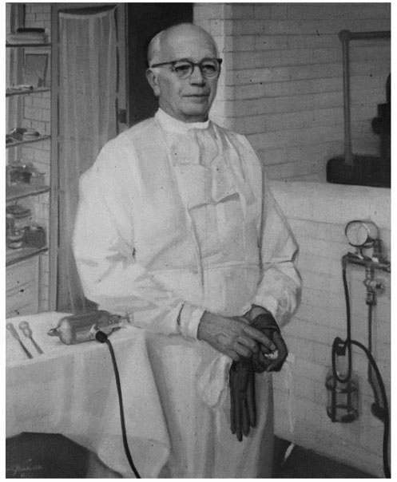
- ‘You are dealing with an individual full of hopes and fears and you must never aﬀront their dignity as individuals’.
- ‘They will come to you full of anxieties and full of
trust’.6

A set of guidelines that remains relevant to the medical profession today.
There is no doubt that Mercer was a truly great sur- geon who developed and enhanced the speciality of orthopaedics. The current trends for subspecialisation in surgery mean that it would be extremely unlikely that a man with his breadth of knowledge and practice could easily appear again. Sadly he was probably among the last of an extraordinary surgical era.

Figure 4. Sir Walter Mercer from the slide collection of Princess Margaret Rose Orthopaedic Hospital probably around 1948.

transabdominal route blazed the way for future devel- opments in anterior lumbar spinal surgery. Keystone bone grafts as advocated by Mercer continue to be used. However, Mercer was not the ﬁrst surgeon to use the transabdominal approach to the lumbar spine to treat patients with a spondylolisthesis since that honour must go to Brian Hartop Burns. However, while he might not have been the pioneer of the trans- abdominal approach, Mercer’s contribution to the development of spinal surgery cannot be underesti- mated (Figure 4). His ideas were original as he advocated the use of iliac crest bone in preference to a foreign material such as ivory. Burns’ method has never been developed any further but iliac crest bone graft has been used extensively, supplemented now by bone morphogenic protein.25 Mercer, who was later President of the Royal College of Surgeons of Edinburgh, was foremost a practising surgeon. In his Promoter’s address at the graduation ceremony at the University of Edinburgh on 18 July 1956 he stated:

- ‘Always respect your patients and never treat them as guinea pigs’.
- ‘Give them [the patient] credit for some intelligence
even if there are occasions when you have to mask your language’.
Acknowledgements
The author records gratefully his thanks to Ms Marianne Smith, College Librarian Royal College of Surgeons of Edinburgh; to Ms Louise Williams, Archivist Lothian Health Services Archives, University of Edinburgh; to Dr Hugh Thomas, St George’s Hospital Archives; to Mrs Sarah Glynn, Historian, Miss Ines Reichert, for the translation from the German of Muller and Kilian papers; and to Professor David Hamblin, Archivist at the British Orthopaedic Association.

References
- Mercer W. Spondylolisthesis: With a description of a new method of operative treatment and notes of ten cases. Edinburgh Medical Journal 1936; 43a: 545–572.
- Mercer W. Orthopaedic surgery second, 3rd, 4th, 5th 6th edition. London: Edward Arnold, 1936, 1944, 1950, 1959, 1964.
- Campbell WC. Operative orthopaedics. In: Canale ST and Beaty JH (eds) The spine, 11th edition. Philadelphia, PA: Mosby, 2008, pp.1747–1751.
- Keegan J. The First World War. London: Hutchinson, 1998, pp. 308, 381, 383.
- Macintyre IMC. A memorial to Sir Walter Mercer (1890–1971). Journal of the Royal College of Surgeons of Edinburgh 1971; 16: 239–243.
- Royal College of Surgeons Edinburgh Archives, notes File GD 12/8.
- Robinson W. Walter Mercer birthday volume. Journal of Bone and Joint Surgery 1970; 52B: 7.
- Lothian Health Services Archive, Centre for Research Collection, Edinburgh University Library.
- Cholmeley JA. History of the Royal National Orthopaedic Hospital. London: Chapman and Hall, 1985, p.129.
- Seddon HJ. Letter. British Medical Journal 1936; 31 October: 894.
- Capener N. Letter. British Medical Journal 1936; 7 November: 946.

7

- Capener N. Spondylolisthesis. British Journal of Surgery
1932; X1X: 374–386.
- Mercer M. Letter. British Medical Journal 1936; 7 November: 945.
- Seddon HJ. Letter. British Medical Journal 1936; 21 November: 1053.
- Albee FH. Transplantation of a portion of the Tibia into the spine for Pott’s disease: A preliminary report. Journal of the American Medical Association 1911; LVII: 885–886.
- Hibbs RA. An operation for Pott’s disease of the spine. Journal of the American Medical Association 1912; LIX: 433–436.
- Girdlestone GR. The place of operations for spinal fusion in the treatment of Potts’s disease. British Journal of
2 Surgery 1923; 22: 372–379.
- Muller W. Transperitoneale Freilegung der Wirbelsaule
bei tuberkuloser Spondylitis. (Transperitoneal access to the spine with tuberculosis). Deutsche Zeitschrift fur Chirurgie 1906; LXXXV: 128–135.
- Burns BH. An operation for spondylolisthesis. Lancet
1933; 221(originally published vol. 1): 1233.
- St George’s Hospital potted biographies of St George’s Men 1733–1983, p. 17.

- Mercer W. Spondylolisthesis: Suggestions for treatment.
American Journal of Surgery 1939; XLIII: 367–378.
- Ito H, Tsuchiya J and Asami GA. New radical operation for Potts disease. Report of ten cases. Journal of Bone and Joint Surgery 1934; 16: 499–515.
- Hodgson AR and Stock FE. Anterior spinal fusion: A preliminary communication on the radical treatment of Pott’s disease and Pott’s paraplegia. British Journal of Surgery 1956; XLIV: 266–274.
- Swan J, Hurwitz F, Malek F, et al. Surgical treatment for unstable low grade isthmic spondylolisthesis in adults: A prospective controlled study of posterior instrumented fusion compared with combined anterior-posterior fusion. The Spine Journal 2006; 6: 606–614.
- Burkus JK, Transfeldt EE, Kitchell SH, et al. Clinical and radiographic outcomes of anterior lumbar interbody fusion using recombinant human bone morphogenic Protein-2. Spine 2002; 27: 2396–2408.
- Kilian HF. Schilderungen neuer Beckenformen und ihres Verhaltens im Leben (Forms and shapes of the pelvis and their behaviour in life. 1. The shifting vertebral body). Mannheim: Verlag von Bassermann & Mathy, 1854, pp. 51, 52, 54.

Author biography
3 Sean Hughes is Emeritus Professor of Orthopaedic Surgery, Imperial College London. His clinical practice was in spinal surgery. He was Professor of Orthopedic Surgery at University of Edinburgh and was a past Vice President of the Royal College of Surgeons Edinburgh.

