Systematic Review, Meta-Analysis and Population Study to Determine the Biological Sex Ratio in Dilated Cardiomyopathy
Running Title: Establishing the Sex Ratio in Monogenic DCM

Supplementary Materials
Methods
PRISMA Details
The original protocol for this investigation can be found on PROSPERO. The systematic review was registered under the register name Natalie Bergan and is connected to the registration number CRD42023451944. The only change made to the original protocol was that the measure of effect was changed to a proportion. This change was made because the findings were easier to interpret as a proportion compared to an odds ratio. The only other deviance from the original protocol was that the investigation did not compare the effect of age, LVEF, and variant carrying gene on the sex ratio due to cohort size in available datasets, limiting power. No other changes were made to the original protocol.
Literature Search Strategy
The literature review was performed in accordance with the Preferred Reporting Items for Systematic Reviews and Meta-Analyses (PRISMA) guidelines (see supplementary methods) (Figures 1, S1, and S2)¹³. The review question for this investigation was: How does the male to female sex ratio of prevalent DCM compare to subgroups defined by the presence or absence of pathogenic variants within the defined DCM-associated genes? To answer this question, the literature search strategy aimed to identify papers containing DCM patient cohorts by focusing on three subject areas: DCM, the 12 genes with strong or definitive-evidence for causing DCM, and the desired clinical characteristics of the study participants⁹.
The final systematic search was performed on June 26, 2023. Search results were extracted from PubMed, MEDLINE Ovid, EMBASE, the Cochrane Central Register of Controlled Trials, and Web of Science. For each search both keywords and Medical Subject Heading terms were included. The final search strategy described DCM using the full condition name and the equivalent DCM subgroup hypokinetic non-dilated cardiomyopathy². The interest in genetic DCM was defined using the term ‘gene*’ and by listing the 12 genes given a ‘definitive’ or ‘strong’ association by the ClinGen Gene Curation Expert Panel^{9,14}. In line with this, we based our definition of genetic DCM on the genes in which there is high evidence that pathogenic variants clearly cause DCM. The desired clinical features were inquired by specifying for DCM studies that discussed adult, late onset, and non-syndromic forms. Within each subject of interest the search terms were combined with ‘OR’ and each subject area was added to the search strategy using ‘AND’. The narrowing of the search strategy was accomplished by listing exclusionary criteria such as paediatric DCM and other DCM inheritance patterns using ‘NOT’. For the Web of Science search, the exclusionary terms ‘in vivo’, ‘in vitro’, and ‘autosomal recessive’ were not included in the search strategy, as their inclusion generated no search results. The full search strategies for each of the searched online databases can be seen in the Supplemental Materials (Table S2). The results of each search were downloaded into EndNote and subsequently uploaded into Covidence for filtering¹⁵⁰.
Study Eligibility
When looking for exclusion criteria during the full text filtering process, the first aspects of the paper that were assessed were the cohort size and the full text publication language. If the described cohort was under 100 participants or the full text was not provided in the English language, the study was excluded. If both criteria were met, the cohort itself was assessed. The first point of assessment was the inclusion of the number of male and female participants in the study. If the sex ratio was not provided, the paper was excluded. Then more specific clinical details were assessed. It was first established that the described population consisted of participants with a clinical diagnosis of DCM. If the described cohort consisted solely of samples from patients instead of cohort data, the paper was excluded. If the paper described any patients who had syndromic, X-linked, mitochondrial, or AR forms of DCM, the paper was excluded. Additionally, if patients with ischaemic DCM or peripartum cardiomyopathy were included, the paper was excluded¹⁵. The final aspect of the eligible studies that was assessed was the inclusion of patients under the age of 18. If the paper contained less than 2% of patients under the age of 18, the paper was included. This was chosen because many of the papers did not state whether or not paediatric patients were included, and this bandwidth prevented the exclusion of key DCM cohorts.
Data Extraction
For each included paper, identification details such as the study ID and author were extracted along with cohort details. The cohort details that were extracted included: (1) the years of participant collection, (2) cohort source, (3) inclusion and exclusion criteria, (4) participant recruitment method, (5) total number of participants, and (6) whether familial DCM patients were included. The extracted clinical data encompassed the number of female and male participants, the average age, and the average left ventricle ejection fraction (LVEF). For the age and LVEF values, the standard deviation and interquartile range values were also recorded depending on whether the mean or median values were reported. If the characteristics were stratified by sex or by DCM subgroup, this was reflected in the extracted data. If the sex ratio was reported by percentage, the recorded numbers of males and females were rounded to the nearest whole number. Supplementary data were also reviewed for data extraction. The extracted data were exported from Covidence in a comma separated value (CSV) file format for further analysis. These cohort isolates were then sorted into their respective DCM groups: general DCM, those who had a pathogenic variant within one of the 12 defined genes (genetic DCM), and those who received genetic testing but did not have a pathogenic variant identified (gene-elusive DCM). A patient was determined to be gene-elusive only if they had genetic testing and if they had been tested for variants in at least 9 of the 12 ClinGen genes and no pathogenic or likely pathogenic variants had been identified⁹.
Data Analysis CSV Preparation
To allow for a smooth analytical process, the extracted data from Covidence was simplified by only including certain details in new CSV files. The included data for each analytical step was modified to fit the needs of that step. Each step at least included the study ID (author name and year of publication), the number of total included participants, the number of male participants, and the number of female participants. The data were also stratified by whether the participants belonged to the all-cause, genetic, gene-elusive, or gene-specific cohorts. For the gene-specific cohort, the gene where the pathogenic variant was found was also included in the data file.
For the quality assessment data, the extract was simplified to only include the study ID and the Low/Some Concerns/High rating for each of the assessed risks of bias. In order to generate the summary plot, an additional column was included with the title ‘extra’ so that the plot would display all of the assessed columns. This column title was removed for the generation of the traffic plot. This was done in order to generate proper data visualization using the ‘robvis’ package²⁰.
Sex and ancestry stratified analysis
The influence of ancestry on the proportion of female participants was assessed using meta-regressions where self reported ethnicity data were available for each cohort subtype – general, genetic, gene-elusive, and gene-specific. Of the 99 papers included in this study, 42 papers provided the details on self reported ethnicity34,41,52,55,60–65,67–70,73,75,77,78,82,85,86,97,99–102,105,107,109,110,113–116,119,120,124–126,128–130. The ethnicities that had extractable data included European^{67,68,70,73,97,99,109,110,113}, Asian41,52,55,60–62,64,65,69,75,78,82,85,86,101,102,107,114–116,120,124–126,128–130, African^{105,119}, Middle Eastern^{63,77}, Finnish³⁴, and Icelandic¹⁰⁰. An issue that was encountered while extracting the data was that the ethnicity of the participants across some cohorts was provided using percentages, but the number of male and female participants was not provided for each ethnicity individually. To maximize the number of papers that were able to be used in this comparison, an additional comparator was generated from the papers whose cohorts were noted to be comprised of >90% white/European individuals. This allowed for an additional 9 papers to be included in this investigation^{33,40,43,80,83,94,95,108,111}. To investigate the significance of ethnicity, the proportion (sex ratio) for each individual ethnicity was compared to the proportion for all the ethnicities in each cohort. This included all 42 papers for the general cohort, while the genetic cohort’s assessment contained data from 15 papers33,40,43,75,78,80,86,97,99,107,108,111,113,120,126. The meta-regression for the gene-elusive group contained data from 7 papers^{40,43,78,107,108,120,126}while the gene-specific cohort used data from 11 papers33,40,43,75,78,80,86,107,111,113,126. Due to the small number of papers included in the gene-specific cohort, the individual genes could not be compared by ethnicity.
Cardiac Imaging Phenotyping UKB
The UKB study recruited 500,000 participants aged 40 to 69 years old from across the United Kingdom between 2006 and 2010 (National Research Ethics Service, 11/NW/0382)¹⁵¹. This study was conducted under terms of access approval number 40616. In each case, written informed consent was provided. A sub-study of UK Biobank invited participants for CMR for assessment of cardiac chamber volumes and function using a standard protocol (1.5T, Siemens Aera, Siemens Medical Systems, Erlangen, Germany).
Segmentation of the cine images of CMR in UK Biobank was performed using a deep learning neural network algorithm developed in-house, as previously described^{22–24} for 47,549 subjects in the imaging sub-study cohort. Wall thickness was measured along radial line segments connecting the endocardial and epicardial surfaces perpendicular to the myocardial centreline and excluding trabeculae, and chamber volumes, mass and ejection fraction were calculated from the resulting segmentations¹⁵². Ventricular volumes (LVEDV) were indexed to Body Surface Area (BSA) using Du Bois formula.
Missing data were imputed using mice package in R. The full dataset used for the UK Biobank study consisted of 47,549 participants and 110 features, including cMRI features, clinical measures (height, weight, blood pressure), and demographic features. In total 1.71% of the data were missing. This is due to either a failure in the image segmentation tool for cMRI features, or information was not recorded for clinical measures/ demographic features at time of assessment at the UK Biobank centre. From these features, only Sex (0% missingness), BSA (0% missingness), LVEDV(i) (0.351% missingness) and LVEF (0.351% missingness) were used to create the DCM diagnostic 'imaging' label. Genetic variants labels and participant level ICD-10 codes were then linked to this dataset and were not subject to any imputation. Due to the minimal degree of missingness for the analysed fields (0.35%), and for computational efficiency, we opted to use the complete() function to extract the first imputed dataset for analysis.
DCM ‘Imaging Phenotype’ Label in UKB Subjects
An ‘imaging phenotype’ label for DCM was derived using sex-specific abnormal cut-off values for LVEDVi (F > 93 , M > 107, ml/m2) and LVEF ( F < 52, M <51, %)²⁵, in the absence of ischaemic heart disease and valve disease. The First Occurrences dataset from the UK Biobank project was using to identify subjects with diagnostic code for ischaemic heart disease (p131296, p131298, p131300, p131302, p131304, p131306) or valve disease (p131276, p131278, p131280, p131282, p131322, p131324, p131326, p131328). The HES dataset was used to ascertain subjects with an ICD-10 code for DCM (I420, I426, I427).
DCM P/LP Variant Curation Pipeline
Variants in 19 DCM-associated genes with definitive, strong, or moderate evidence for disease were extracted from the whole exome sequencing data of 454,756 UKB participants to identify genetic negative participants from the imaging sub-study cohort used in this analysis. MANE, protein-altering variants that had a MAF <0.1% in gnomAD and UKBB were identified. Intron variants that were pathogenic in ClinVar were manually curated for functional evidence of splicing. Splice region variants and other splice variants (excluding essential splice and splice donor 5th base), were included if they were predicted to cause splicing through SpliceAI (threshold >0.8). Only TTNtvs in PSI>90% exons or variants with a splice prediction or curation of pathogenic (with assessment) were included.
The variant list was then shortened to only include the 12 definitive or strong evidence DCM genes (BAG3, DES, DSP, FLNC, LMNA, MYH7, PLN, RBM20, SCN5A, TNNC1, TNNT2, TTN). LOFTEE was used to identify low confidence pLoF variants and identify protein-altering variants (PAVs) that are mislabelled (e.g. NAGNAG sites). All predicted pLoF variants were annotated for prediction of NMD escaping; using the NMD plugin, a threshold of 55bp into the penultimate exon of the genes, and additional curation of frameshift variants upstream to the 55bp threshold but where the PTC is predicted to be within the threshold using HGVSp. Additionally, "missense_variant, splice_region_variants” were only flagged as NMD escaping if they also had a prediction of splicing by SpliceAI. The variants were then filtered for disease-causing mechanisms; all BAG3, LMNA, PLN, SCN5A, RBM20, and DSP, PAVs were kept; only variants influencing gene product structure (indels, missense, start and stop lost) or gene product level but NMD escaping, were kept for MYH7, DES, TNNC1, and TNNT2; only variants predicted to influencing gene product level (e.g. frameshift, essential splice, stop gained) were kept for TTN and FLNC. The variant list was then shortened to only include variants that met a filtering allele frequencing (faf) of <0.00004 in gnomAD popmax faf and as a MAF in UK Biobank. Additionally, compound heterozyogous carriers of common TTNtvs (same two TTN variants identified in >10 individuals) were removed from the analysis as these were likely rescued. The variant list was then shortened to only include variants that would be called pathogenic/likely pathogenic if identified in a patient with DCM; using Cardioclassifier and ClinVar, the variants were manually curated if they had any evidence of pathogenicity.
The UKBB exome data were annotated using Ensembl Variant Effect Predictor (VEP; version 105; https://doi.org/10.1093/bioinformatics/btq330) with a plugin for gnomAD (version r2.1; https://doi.org/10.1038/s41586-020-2308-7), LOFTEE (https://doi.org/10.1038/s41586-020-2308-7), and SpliceAI (https://doi.org/10.1016/j.cell.2018.12.015).

Supplemental Tables
Table S1: Genes Associated with Dilated Cardiomyopathy.

Cardiomyocyte Component | Associated DCM-Related Gene | Evidence for association with DCM | Primary Inheritance Pattern
Cytoskeleton | Desmin (DES) | Definitive | AD
Cytoskeleton | Filamin C (FLNC) | Definitive | AD
Desmosome | Desmoplakin (DSP) | Strong | AD
Ion Channels | Sodium Voltage-Gated Channel Alpha Subunit 5A (SCN5A) | Definitive | AD
Nuclear Envelope | Lamin A/C (LMNA) | Definitive | AD
Sarcomere | Myosin Heavy Chain 7 (MYH7) | Definitive | AD
Sarcoplasmic Reticulum | Phospholamban (PLN) | Definitive | AD
Sarcoplasmic Reticulum | Titin (TTN) | Definitive | AD
Sarcoplasmic Reticulum | Troponin C1 (TNNC1) | Definitive | AD
Sarcoplasmic Reticulum | Troponin T (TNNT2) | Definitive | AD
Signalling and Other Pathways | BAG Chaperone 3 (BAG3) | Definitive | AD
Spliceosome | RNA Binding Motif Protein 20 (RBM20) | Definitive | AD
The included genes were ordered by the cardiomyocyte structure they affect, followed by alphabetical order. The genes listed are restricted to those that have had definitive or strong evidence of an association with DCM^{6,9}. The associated protein and associated inheritance pattern have been provided^{2,9}. AD = autosomal dominant; DCM = dilated cardiomyopathy

Table S2: Full Search Strategy for the Literature Review. This table includes the full search terms used to generate the selection of literature analysed for this literature review. The table includes the database, the search term in the appropriate format, and the number of results that were produced from the search on June 26, 2023.
Database | Search Term | Number of Results
PubMed | ((dilated cardiomyopathy) OR (hypokinetic non-dilated cardiomyopathy)) AND ((gene*) OR (BAG3) OR (DES) OR (FLNC) OR (LMNA) OR (MYH7) OR (PLN) OR (RBM20) OR (SCN5A) OR (TNNC1) OR (TNNT2) OR (TTN) OR (DSP)) AND ((adult) OR (delayed*onset) OR (late*onset) OR (non-syndromic)) AND ((sex) OR (male) OR (female)) NOT (p*ediatric) NOT (early*onset) NOT (x-linked) NOT (mitochondrial) NOT (cardiomyopathy, dilated, autosomal recessive) NOT (in vivo) NOT (in vitro) NOT (ischemic) NOT (ischaemic) | 1,698
MEDLINE Ovid | ((dilated cardiomyopathy.mp.) OR (hypokinetic non-dilated Ovid cardiomyopathy.mp)) AND ((gene*.mp.) OR (BAG3.mp.) OR (DES.mp.) OR (FLNC.mp.) OR (LMNA.mp.) OR (MYH7.mp.) OR (PLN.mp.) OR (RBM20.mp.) OR (SCN5A.mp.) OR (TNNC1.mp.) OR (TNNT2.mp.) OR (TTN.mp.) OR (DSP.mp.)) AND ((adult.mp.) OR (delayed*onset.mp.) OR (late*onset.mp.) OR (non- syndromic.mp.)) AND ((sex.mp.) OR (male.mp.) OR (female.mp.)) NOT (p*ediatric.mp.) NOT (early*onset.mp.) NOT (x-linked.mp.) NOT (mitochondiral.mp.) NOT (autosomal recessive.mp.) NOT (in vivo.mp.) NOT (in vitro.mp.) NOT (schemic.mp.) NOT (ischaemic.mp.) | 1,254
EMBASE | ((dilated cardiomyopathy.mp.) OR (hypokinetic non-dilated cardiomyopathy.mp.)) AND ((gene*.mp.) OR (BAG3.mp.) OR (DES.mp.) OR (FLNC.mp.) OR (LMNA.mp.) OR (MYH7.mp.) OR (PLN.mp.) OR (RBM20.mp.) OR (SCN5A.mp.) OR (TNNC1.mp.) OR (TNNT2.mp.) OR (TTN.mp.) OR (DSP.mp.)) AND ((adult.mp.) OR (delayed*onset.mp.) OR (late*onset.mp.) OR (non-syndromic.mp.)) AND ((sex.mp.) OR (male.mp.) OR (female.mp)) NOT (p*ediatric.mp.) NOT (early*onset.mp.) NOT (x-linked.mp.) NOT (mitochondrial.mp.) NOT (autosomal recessive.mp.) NOT (in vivo.mp.) NOT (in vitro.mp.) NOT (ischemic.mp.) NOT (ischaemic.mp.) | 2,732
Cochrane | ((dilated cardiomyopathy):ti,ab,kw OR (hypokinetic non- dilated cardiomyopathy):ti,ab,kw AND ((DES):ti,ab,kw OR (FLNC):ti,ab,kw OR (LMNA):ti,ab,kw OR (MYH7):ti,ab,kw OR (PLN):ti,ab,kw OR (RBM20):ti,ab,kw OR (SCN5A):ti,ab,kw OR (TNNC1):ti,ab,kw OR (TNNT2):ti,ab,kw OR (TTN):ti,ab,kw OR (DSP):ti,ab,kw) AND ((adult):ti,ab,kw OR (delayed*onset):ti,ab,kw OR (late*onset):ti,ab,kw OR (non-syndromic):ti,ab,kw) AND ((sex):ti,ab,kw OR (male):ti,ab,kw OR (female):ti,ab,kw) NOT (p*ediatric):ti,ab,kw NOT (early*onset):ti,ab,kw NOT (x-linked):ti,ab,kw NOT (mitochondrial):ti,ab,kw NOT (autosomal recessive):ti,ab,kw NOT (in vivo):ti,ab,kw NOT (in vitro):ti,ab,kw NOT (ischemic):ti,ab,kw NOT (ischaemic):ti,ab,kw | 8
Web of Science | (((ALL=(dilated cardiomyopathy) OR ALL=(hypokinetic non- 95 dilated cardiomyopathy)) AND (ALL=(gene*) OR ALL=(BAG3) OR ALL=(DES) OR ALL=(FLNC ) OR  ALL=(LMNA) OR ALL=(MYH7) OR ALL=(PLN) OR ALL=(RBM20 ) OR ALL=(SCN5A) OR ALL=(TNNC1) OR ALL=(TNNT2 ) OR ALL=(TTN ) OR ALL=(DSP))) AND (ALL=(adult) OR ALL=(delayed*onset) OR ALL=(late*onset) OR ALL=(non-syndromic)) AND (ALL=(sex) OR ALL=(male) OR ALL=(female)) NOT ALL=(p*ediatric) NOT ALL=(early*onset) NOT ALL=(x-linked) NOT ALL=(mitochondrial) NOT ALL=(ischemic) NOT ALL=(ischaemic)) | 95

Table S3: Data Extracted from DCM Cohorts. This table displays the relevant data extracted from the included studies. The presented data includes the country that sourced the cohort, the size of the overall DCM cohort, and the number of genetic and gene- elusive participants.
Study | Country | Cohort Size | Number of Genetic Participants | Number of Gene-Elusive Participants
Akhtar 2020 ³³ | UK | 317 | 317 | -
Akinrinade 2015³⁴ | Finland | 145 | - | -
Arvanitis 2008³⁵ | Greece | 123 | - | -
Badorff 1997³⁶ | Germany | 134 | - | -
Begay 2015³⁷ | USA | 147 | 13 | -
Biagi 2012³⁸ | Brazil | 186 | - | -
Brownrigg 2021³⁹ | UK | 1840 | - | -
Cannata 2022⁴⁰ | Australia, Italy, UK, USA | 184 | 66 | 118
Chen 2015⁴¹ | China | 399 | - | -
DalFerro 2017⁴² | Italy | 152 | 87 | 66
Gigli 2019⁴³ | Italy, USA | 487 | 178 | 309
Gimeno 2021⁴⁴ | Europe | 1260 | 76 | 96
Gong 2022⁴⁵ | China | 126 | - | -
Grunig 2003⁴⁶ | Germany | 434 | - | -
Grzybowski 1996⁴⁷ | Poland | 144 | - | -
Gu 2021⁴⁸ | China | 241 | - | -
Guan 2014⁴⁹ | China | 115 | - | -
Herrmann 2001⁵⁰ | Germany | 125 | - | -
Hey 2020⁵¹ | Denmark | 109 | 60 | -
Huang 2009⁵² | China | 233 | - | -
Huggins 2022⁵³ | USA | 1220 | - | -
Hussain 2016⁵⁴ | Pakistan | 250 | - | -
Ichihara 1998⁵⁵ | Japan | 122 | - | -
Jansweijer 2017⁵⁶ | The Netherlands | 133 | 73 | -
Jullière 1988⁵⁷ | France | 105 | - | -
Kuethe 2007⁵⁸ | Germany | 188 | - | -
Kuhl 2008⁵⁹ | Germany | 317 | - | -
Li 2015⁶⁰ | China | 240 | - | -
Li 2020⁶¹ | China | 488 | - | -
Li 2023⁶² | China | 600 | - | -
Liaquat 2015⁶³ | Pakistan | 250 | - | -
Lin 2007⁶⁴ | China | 117 | - | -
Liu 2016⁶⁵ | China | 270 | - | -
Luk 2017⁶⁶ | Canada | 141 | - | -
Magnusson 2005⁶⁷ | Sweden | 374 | - | -
Mahon 2000⁶⁸ | UK | 207 | - | -
Marume 2020⁶⁹ | Japan | 514 | - | -
Mazzaccara 2018⁷⁰ | Italy | 135 | - | -
Mazzarotto 2020⁷¹ | UK | 863 | - | -
McKenna 1998⁷² | Ireland | 100 | - | -
Meder 2014⁷³ | Europe | 4,143 | - | -
Meyer 2013⁷⁴ | Germany | 255 | - | -
Miyamoto 2001⁷⁵ | Japan | 265 | 3 | -
Mohananey 2023⁷⁶ | USA | 356 | - | -
Mollanoori 2018⁷⁷ | Iran | 300 | - | -
Nguyen 2021⁷⁸ | Vietnam | 230 | 54 | 176
Not 2003⁷⁹ | Italy | 238 | - | -
Paldino 2022⁸⁰ | Italy, USA | 224 | 224 | -
Pawlak 2012⁸¹ | Poland | 195 | - | -
Peng 2022⁸² | China | 418 | - | -
Piers 2020⁸³ | The Netherlands | 115 | - | -
Pugh 2014⁸⁴ | USA | 487 | 72 | 415
Qu 2015⁸⁵ | China | 220 | - | -
Rani 2022⁸⁶ | India | 137 | 11 | -
Rao 2022⁸⁷ | USA | 162 | - | -
Refaat 2012⁸⁸ | USA | 283 | 8 | -
Riad 2012⁸⁹ | Germany | 156 | - | -
Rodriguez 2011⁹⁰ | USA | 383 | - | -
Ruppert 2010⁹¹ | Germany | 223 | - | -
Sarzani 2007⁹² | Italy | 202 | - | -
Shah 2019⁹³ | Pakistan | 352 | - | -
Shah 2022⁹⁴ | UK | 1,415 | - | -
Shrivastava 2021⁹⁵ | USA | 421 | - | -
Sousa 2016⁹⁶ | Spain | 188 | - | -
Sousa 2019⁹⁷ | Portugal | 107 | 28 | -
Staudt 2010⁹⁸ | Germany | 103 | - | -
Stava 2022⁹⁹ | Europe | 1,439 | 207 | -
Sveinbjornsson 2018¹⁰⁰ | Iceland | 424 | - | -
Takai 1999¹⁰¹ | Japan | 136 | - | -
Tang 2016¹⁰² | China | 873 | - | -
Tayal 2017¹⁰ | UK | 716 | 83 | -
Taylor 2007¹⁰³ | UK | 309 | - | -
Telgmann 2007¹⁰⁴ | Germany | 124 | - | -
Tiago 2002¹⁰⁵ | South Africa | 157 | - | -
Tiret 2000¹⁰⁶ | France | 433 | - | -
Tobita 2018¹⁰⁷ | Japan | 120 | 37 | 42
Verdonschot 2020¹⁰⁸ | The Netherlands | 689 | 129 | 449
Verdonschot 2021¹⁰⁹ | Spain | 352 | - | -
Villard 2011¹¹⁰ | France | 1,920 | - | -
Vissing 2021¹¹¹ | Denmark | 115 | 115 | -
Vissing 2022¹¹² | Denmark | 124 | - | -
Waldmüller 2011¹¹³ | Germany | 608 | 96 | -
Wang 2010¹¹⁴ | China | 430 | - | -
Wang 2016¹¹⁵ | China | 283 | - | -
Wang 2019¹¹⁶ | China | 146 | - | -
Wiklund 1996¹¹⁷ | Sweden | 345 | - | -
Wojciechowska 2014¹¹⁸ | Poland | 169 | - | -
Woodiwiss 2008¹¹⁹ | South Africa | 403 | - | -
Xiao 2022¹²⁰ | China | 363 | 91 | 272
Yin 2015¹²¹ | China | 198 | - | -
Yoshihisa 2018¹²² | Japan | 102 | - | -
Zeng 2009¹²³ | China | 362 | - | -
Zhang 2008¹²⁴ | China | 151 | - | -
Zhang 2018¹²⁵ | China | 279 | - | -
Zhang 2020¹²⁶ | China | 118 | 41 | 77
Zhang 2023¹²⁷ | China | 117 | - | -
Zhao 2014¹²⁸ | China | 150 | - | -
Zhou 2016¹²⁹ | China | 115 | - | -
Zhou 2023¹³⁰ | China | 142 | - | -

Table S4: Cohort Sources. This table provides the details of the cohort source provided for each of the included papers and their study design. Details are provided as they were written and any cohorts that appear more than once had different years of participant collection or recruitment.
Included Paper | Study Design | Described Cohorts
Akhtar 2020 ³³ | Cohort Study | 13 European and 1 Australian cohort
Akinrinade 2015³⁴ | Cohort Study | Fin-DCM
Arvanitis 2008³⁵ | Cohort Study | Second Department of Cardiology, Onassis Cardiac Surgery Center Athens; the Second Department of Cardiology, Attikon Hospital, University of Athens
Badorff 1997³⁶ | Cohort Study | Department of Cardiology, Benjamin Franklin-Hospital, Free University of Berlin, Germany
Begay 2015³⁷ | Cohort Study | International Familial Cardiomyopathy Registry
Biagi 2012³⁸ | Cohort Study | Heart Institute (InCor), University of São Paulo Medical School
Brownrigg 2021³⁹ | Cohort Study | Clinical Practice Research Datalink
Cannata 2022⁴⁰ | Cohort Study | Cardiovascular Department, Azienda Sanitaria Universitaria Integrata Giuliano Isonita, University of Trieste, Trieste, Italy; University of Colorado Denver, Anzchutz Medical Campus, Aurora; Victor Chang Cardiac Research Institute, Sydney, Australia; Brigham and Women’s Hospital, Harvard Medical School, Boston, Massachusetts; Pauley Heart Center, Virginia Commonwealth University Health System, Richmond; Stanford University Medical Center, Stanford, California; and Guys and St. Thomas Hospital, London, UK
Chen 2015⁴¹ | Cohort Study | GeneID
DalFerro 2017⁴² | Cohort Study | Trieste Heart Muscle Disease Registry
Gigli 2019⁴³ | Cohort Study | Family Cardiomyopathy Registry
Gimeno 2021⁴⁴ | Cohort Study | EURObservational
Gong 2022⁴⁵ | Case Control study | Second Xiangya Hospital
Grunig 2003⁴⁶ | Cohort Study | University of Heidelbery, Department of Cardiology
Grzybowski 1996⁴⁷ | Cohort Study | National Institute of Cardiology, Warsaw
Gu 2021⁴⁸ | Cohort Study | Jiangyin People’s Hospital, Cardiology Department
Guan 2014⁴⁹ | Cohort Study | The Second People’s Hospital of Huaian, Jiangsu
Herrmann 2001⁵⁰ | Cohort Study | Benjamin Franklin Medical Center, Freie Universität Berlin, Germany
Hey 2020⁵¹ | Cohort Study | University Hospital
Huang 2009⁵² | Case Control study | Liaocheng City
Huggins 2022⁵³ | Cohort Study | DCM precision medicine study
Hussain 2016⁵⁴ | Case Control study | Federal Government Polyclinic Hospital, Pakistan
Ichihara 1998⁵⁵ | Cohort Study | 14 Japanese Hospitals
Jansweijer 2017⁵⁶ | Cohort Study | Clinical Genetics at the Academic Medical Center Amsterdam (AMC); University Medical Center Groningen (UMCG) in the Netherlands
Jullière 1988⁵⁷ | Cohort Study | University Hospital, France
Kuethe 2007⁵⁸ | Cohort Study | Clinic of Internal Medicine I of the University Hospital of Jena
Kuhl 2008⁵⁹ | Cohort Study | Campus Benjamin Franklin, Charité, Department of Cardiology and Pneumology, Universitätsmedizin Berlin, Berlin, Germany
Li 2015⁶⁰ | Case Control study | First Affiliated Hospital to Xinjiang Medical University, Urumiqi, Xinjiang, China; Pacing and Electrophysiology Department
Li 2020⁶¹ | Cohort Study | Honghui Hospital of Xi’an Jiaotong University and Xi’an Central Hospital
Li 2023⁶² | Case Control study | Cardiology Division of Panzhihua Central Hospital in Schuan
Liaquat 2015⁶³ | Cohort Study | The Armed Forces Institute of Cardiology/National Institute of Heart Diseases, Rawalpindi, Pakistan
Lin 2007⁶⁴ | Case Control study | Wenzhou Medical College (Taizhou Hospital of Zhejiang province)
Liu 2016⁶⁵ | Case Control study | Department of Cardiology, Zhengzhou Central Hospital, Zhengzhou University, Zhengzhou, China
Luk 2017⁶⁶ | Cohort Study | Heart Failure Clinic of the McGill University Health Centre in Montreal, Quebec, Canada
Magnusson 2005⁶⁷ | Case Control study | 7 Swedish Hospitals
Mahon 2000⁶⁸ | Case Control study | St George’s Hospital Medical School
Marume 2020⁶⁹ | Cohort Study | National Cerebral and Cardiovascular Center, Suits, Japan
Mazzaccara 2018⁷⁰ | Cohort Study | Department of Cardiomyopathy and Inherited Heart Diseases Clinic, UOC Cardiology, University of Campania ‘Luigi Vanvitelli’ of Naples; the Department of Translational Medicine, University Federico II of Naples
Mazzarotto 2020⁷¹ | Case Control study | NIHR Biobank from Royal Brompton Hospital
McKenna 1998⁷² | Case Control study | National Cardiac Centre at the Master Misericordiae Hospital
Meder 2014⁷³ | Case Control study | NGFN
Meyer 2013⁷⁴ | Cohort Study | Department of Cardiology at the University of Marburg
Miyamoto 2001⁷⁵ | Case Control study | Kobe University; Himeji Cardiovascular Center
Mohananey 2023⁷⁶ | Cohort Study | MayoClinic, Minnesota
Mollanoori 2018⁷⁷ | Case Control study | Rajaie Cardiovascular Medical and Research Center
Nguyen 2021⁷⁸ | Cohort Study | Heart Institute and Tam Duc Heart Hospital
Not 2003⁷⁹ | Case Control study | Department of Cardiology at the I.R.C.C.S. Policlinico San Mateo of Pavia
Paldino 2022⁸⁰ | Cohort Study | Familial Cardiomyopathy Registry
Pawlak 2012⁸¹ | Cohort Study | Central Clinical Hospital of Ministry of Internal Affairs and Administration, Warsaw; Mossakowski Medical Research Centre, Academy of Sciences, Warsaw; The Children’s Memorial Health Institute, Warsaw, Poland; Community Medical Centers, Fresno, CA, USA
Peng 2022⁸² | Case Control study | West China Hospital of Sichuan University
Piers 2020⁸³ | Cohort Study | Leiden Nonischemic Cardiomyopathy Study
Pugh 2014⁸⁴ | Cohort Study | Massachusetts General Hospital and Harvard Medical School, Brigham and Women’s Hospital and Harvard Medical School, Boston
Qu 2015⁸⁵ | Case Control study | Shanghai Chest Hospital
Rani 2022⁸⁶ | Case Control study | CARE Hospitals, Hyderabad; Government Rajaji Hospital, Madurai, Tamil Nadu
Rao 2022⁸⁷ | Cohort Study | Indiana School of Medicine, Indiana University Health
Refaat 2012⁸⁸ | Cohort Study | GRADE
Riad 2012⁸⁹ | Cohort Study | Universitätsmedizin Greifswald
Rodriguez 2011⁹⁰ | Case Control study | Center for Cardiovascular Genetics, Institute of Molecular Medicine, The University of Texas Health Sciences Center, Houston
Ruppert 2010⁹¹ | Case Control study | University Hospital Charité in Berlin
Sarzani 2007⁹² | Case Control study | Bari’s Institute of Cardiology
Shah 2019⁹³ | Case Control study | COMSATS University Islamabad, Park Road Chak Shehzad
Shah 2022⁹⁴ | Cohort Study | UK Biobank
Shrivastava 2021⁹⁵ | Cohort Study | Rochester Epidemiology Project; Heart Failure Clinic and Heart Transplant databases
Sousa 2016⁹⁶ | Cohort Study | Heart Failure and Heart Transplant Section of the Hospital Universitario Puerta de Hierro, Madrid, Spain
Sousa 2019⁹⁷ | Cohort Study | 10 Portuguese hospitals
Staudt 2010⁹⁸ | Cohort Study | Ernst-Moritz-Arndt-University, Greifswald, Germany
Stava 2022⁹⁹ | Cohort Study | Unit for Cardiac and Cardiovascular Genetics, Oslo
Sveinbjornsson 2018¹⁰⁰ | Cohort Study | Iceland
Takai 1999¹⁰¹ | Cohort Study | First Department of Internal Medicine, Kobe University School of Medicine, Kobe, Japan
Tang 2016¹⁰² | Case Control study | Taizhou Hospital of Zhejiang Province, Wenzhou Medical College
Tayal 2017¹⁰ | Cohort Study | Royal Brompton Hospital
Taylor 2007¹⁰³ | Cohort Study | BEST Cohort
Telgmann 2007¹⁰⁴ | Cohort Study | Franz-Volhard Klinik
Tiago 2002¹⁰⁵ | Case Control study | Black South Africans
Tiret 2000¹⁰⁶ | Cohort Study | CARDIGENE
Tobita 2018¹⁰⁷ | Cohort Study | Tokyo Women’s Medical University
Verdonschot 2020¹⁰⁸ | Cohort Study | Maastricht Cardiomyopathy Registry
Verdonschot 2021¹⁰⁹ | Cohort Study | Madrid Cohort
Villard 2011¹¹⁰ | Cohort Study | University Hospital Regensburg, EHF Germany
Vissing 2021¹¹¹ | Cohort Study | Copenhagen University Hospital and the Department of Cardiology, Aarhus University Hospital
Vissing 2022¹¹² | Cohort Study | The Capital Region‚Äôs Units for Inherited Cardiac Diseases, Copenhagen University Hospital
Waldmüller 2011¹¹³ | Cohort Study | German Competence Network, Heart Failure
Wang 2010¹¹⁴ | Case Control study | Shanghai Jiaotong University School of Medicine
Wang 2016¹¹⁵ | Case Control study | Chinese Han population
Wang 2019¹¹⁶ | Case Control study | Chinese Han population
Wiklund 1996¹¹⁷ | Case Control study | Metoprolol in Dilated Cardiomyopathy Trial
Wojciechowska 2014¹¹⁸ | Cohort Study | Medical University of Silesia, Ulica M.C.
Woodiwiss 2008¹¹⁹ | Case Control study | South Africa
Xiao 2022¹²⁰ | Case Control study | Han ethnicity
Yin 2015¹²¹ | Case Control study | Taishan Medical College Affiliated Hospital of Laiwu City People’s Hospital
Yoshihisa 2018¹²² | Cohort Study | Fukushima Medical University Hospital
Zeng 2009¹²³ | Case Control study | Xiangya Hospital Central South University, Changsha, China
Zhang 2008¹²⁴ | Cohort Study | Northern China, Beijing
Zhang 2018¹²⁵ | Case Control study | Fuwai Hospital
Zhang 2020¹²⁶ | Cohort Study | Drum Tower Hospital, Nanjing University School of Medicine
Zhang 2023¹²⁷ | Case Control study | Hospital of Jilin University
Zhao 2014¹²⁸ | Case Control study | Yuntaishan Hospital
Zhou 2016¹²⁹ | Case Control study | Yangpu Hospital, Renji Hospital, Shanghai Jiao Tong University, and Shanghai Chest Hospital
Zhou 2023¹³⁰ | Case Control study | Hospital of Jining Medical College, Shandong Province, China

Table S5: Retrospective Enrollment Sensitivity Analysis. This table displays the results of the meta-regression performed to determine if the inclusion of studies found to have a high risk of retrospective enrollment bias had a significant influence on the calculated pooled proportion of female participants. The table displays the proportions of female participants found for each of the 4 described DCM cohorts including and excluding the studies with a risk of bias. The significance of the difference between the two proportions is displayed through the p-value.
Cohort | General Cohort Proportion | Genetic Cohort Proportion | Gene-Elusive Cohort Proportion | Gene-Specific Cohort Proportion
High risk of bias  Included | 0.30 (0.28-0.32)  (n=99) | 0.31 (0.26-0.36)  (n=23) | 0.30 (0.24-0.37)  (n=10) | 0.34 (0.28-0.40)  (n=18)
High risk of bias Excluded | 0.28 (0.25-0.30)  (n=42) | 0.33 (0.26-0.40)  (n=13) | 0.34 (0.27-0.43)  (n=6) | 0.32 (0.22-0.43)  (n=9)
P-value of difference | 0.29 | 0.70 | 0.47 | 0.66

Table S6: Gene-Specific Genetic DCM Patient Data. This table contains the extracted data of participants who have DCM caused by variants within the ClinGen genes found to have a ‘distinct’ or ‘strong’ association with DCM⁹. The study, gene, and number of participants per gene are presented in this table.

Study | Gene | Number of Participants
Akhtar 2020³³ | TTN | 317
Begay 2015³⁷ | TTN | 13
Cannata 2022⁴⁰ | BAG2 | 2
Cannata 2022⁴⁰ | DSP | 2
Cannata 2022⁴⁰ | FLNC | 4
Cannata 2022⁴⁰ | LMNA | 4
Cannata 2022⁴⁰ | MYH7 | 2
Cannata 2022⁴⁰ | TNNT2 | 3
Cannata 2022⁴⁰ | TTN | 46
DalFerro 2017⁴² | LMNA | 7
DalFerro 2017⁴² | TTN | 28
Gigli 2019⁴³ | LMNA | 19
Gigli 2019⁴³ | TTN | 54
Hey 2020⁵¹ | LMNA | 22
Hey 2020⁵¹ | RBM20 | 38
Jansweijer 2017⁵⁶ | LMNA | 28
Jansweijer 2017⁵⁶ | TTN | 45
Miyamoto 2001⁷⁵ | DES | 3
Nguyen 2021⁷⁸ | TTN | 26
Paldino 2022⁸⁰ | BAG3 | 5
Paldino 2022⁸⁰ | DES | 7
Paldino 2022⁸⁰ | RBM20 | 3
Paldino 2022⁸⁰ | TTN | 95
Pugh 2014⁸⁴ | DES | 3
Pugh 2014⁸⁴ | DSP | 3
Pugh 2014⁸⁴ | LMNA | 26
Pugh 2014⁸⁴ | MYH7 | 8
Pugh 2014⁸⁴ | PLN | 1
Pugh 2014⁸⁴ | TNNT2 | 10
Pugh 2014⁸⁴ | TTN | 15
Rani 2022⁸⁶ | MYH7 | 11
Refaat 2012⁸⁸ | RBM20 | 8
Tayal 2017¹⁰ | TTN | 83
Tobita 2018¹⁰⁷ | LMNA | 13
Tobita 2018¹⁰⁷ | TTN | 20
Vissing 2021¹¹¹ | TTN | 115
Waldmüller 2011¹¹³ | MYH7 | 28
Zhang 2020¹²⁶ | LMNA | 6
Zhang 2020¹²⁶ | TTN | 13

Table S7: Sensitivity Analysis. This table compares results using Generalised linear mixed model (GLMM) and a random effects meta-analysis. Results are similar irrespective of the approach taken.

 | GLMM | Random effects model
Proportion | 0.2960 | 0.2978
95% CI | 0.2767-0.3159 | 0.2804-0.3159

Table S8: General DCM Cohort Meta-Analysis. This table displays the results of the primary GLMM meta-analysis. It shows the proportions of female participants amongst all DCM cohorts.

 | Calculated Value
Proportion of Female Participants | 0.2960
95% Confidence Interval | 0.2767 - 0.3159
p-value (vs. proportion=0.5) | <0.0001
Tau² | 0.2044
I² | 93.87%

Table S9: Genetic Cohort Meta-Analysis. This table displays the results of the GLMM meta-analysis in the subset of studies with an identified DCM genetic cause.

 | Calculated Value
Proportion of Female Participants | 0.3105
95% Confidence Interval | 0.2625 - 0.3631
p-value (vs. proportion=0.5) | <0.0001
Tau² | 0.2315
I² | 80.56%

Table S10: Meta-Analysis Results for the Gene-Elusive Cohort. This table displays the results of the GLMM meta-analysis amongst patients within the gene-elusive DCM cohort.
 | Calculated Value
Proportion of Female Participants | 0.3037
95% Confidence Interval | 0.2425 - 0.3728
p-value (vs. proportion=0.5) | <0.0001
Tau² | 0.2081
I² | 88.95%

Table S11: Reduced Genetic DCM Meta-Analysis. This table displays the results of the GLMM meta-analysis on patients with an identified genetic DCM cause, restricted to the 10 studies that described patients with both genetic and gene-elusive DCM populations.
 | Calculated Value
Proportion of Female Participants | 0.2962
95% Confidence Interval | 0.2115 - 0.3979
p-value (vs. proportion=0.5) | 0.0002
Tau² | 0.4440
I² | 87.69%

Table S12: Gene-Specific DCM Cohort Meta-Analysis. This table displays the results of the meta-analysis performed on the cohort of patients with autosomal dominant genetic DCM.
 | Calculated Value
Proportion of Female Participants | 0.3356
95% Confidence Interval | 0.2752 - 0.4021
p-value (vs. proportion=0.5) | <0.0001
Tau² | 0.4099
I² | 68.60%

Table S13: TTNtv and LMNA DCM Cohort Meta-Analyses. This table displays the results of the meta-analysis performed on the cohorts of TTNtv and LMNA genetic DCM patients.

 | LMNA Calculated Value | TTNtv Calculated Value
Proportion of Female Participants | 0.3520 | 0.2847
95% Confidence Interval | 0.2734 - 0.4395 | 0.2164 - 0.3645
p-value (vs. proportion=0.5) | 0.0011 | <0.0001
Tau² | 0 | 0.2811
I² | 0.00% | 76.83%

Table S14: Determination of the Influence of Ancestry using Meta-Regressions. This table displays the proportions of female participants (with 95% confidence intervals) for the studies that provided information on the self-reported ethnicities of their cohorts. The p-value indicates the significance of the difference between the proportion for the specific ethnicity from the combined ethnicity cohort. N represents the number of studies. The asterisk indicates that the difference is statistically significant.

Ethnicity | General Cohort | Genetic Cohort | Gene-Elusive Cohort | Gene-Specific Cohort
All | 0.32 (0.29-0.35)  (n=51, I²=94.26%) | 0.28 (0.22-0.36)  (n=15, I²=86.68%) | 0.32 (0.25-0.40)  (n=7, I²=88.57%) | 0.23 (0.14-0.35)  (n=11, I²=88.33%)
African | 0.44 (0.34-0.54)  (n=2, p=0.10, I²=78.21%) | - | - | -
Asian | 0.34 (0.30-0.38)  (n=27, p=0.42, I²=92.14%) | 0.19 (0.12-0.29)  (n=6, p=0.12, I²=51.80%) | 0.26 (0.19-0.35)  (n=4, p=0.27, I²=72.23%) | 0.12 (0.06-0.22)  (n=5, p=0.09, I²=20.60%)
Finnish | 0.26 (0.13-0.46)  (n=1, p=0.54) | - | - | -
Icelandic | 0.22 (0.11-0.40)  (n=1, p=0.26) | - | - | -
Middle Eastern | 0.30 (0.26-0.34)  (n=2, p=0.73, I²=0.00%) | - | - | -
European | 0.25 (0.21-0.29)*  (n=9, p=0.024, I²=93.91%) | 0.29 (0.17-0.45)  (n=3, p=0.99, I²=81.82%) | - | 0.10 (0.02-0.39)  (n=1, p=0.16)
Mostly White (>90%) | 0.34 (0.29-0.40)  (n=9, p=0.51, I²=91.07%) | 0.35 (0.27-0.43)  (n=6, p=0.26, I²=85.39%) | 0.40 (0.31-0.49)  (n=3, p=0.24, I²=84.02%) | 0.35 (0.25-0.46)  (n=5, p=0.26, I²=85.36%)

Table S15: Meta-Regression Comparing Genetic Testing Methodologies. This table displays the results of the meta-regressions to assess the influence of the genetic testing methodology on the proportion of female participants. The table displays the proportion for each of the 4 DCM subtypes, along with the proportions within the subset of studies for each of the genetic testing methodologies. The 95% CI and the p-value of the difference between the individual method proportion from the ‘all methods’ proportion is displayed. N represents the number of studies.
.
Genetic Testing Method | General Cohort | Genetic Cohort | Gene-Elusive Cohort | Gene-Specific Cohort
All Methods | 0.31 (0.27-0.35)  (n=23, I²=94.16%) | 0.31 (0.26-0.36)  (n=23, I²=80.56%) | 0.30 (0.24-0.37)  (n=10, I²=88.95%) | 0.29 (0.22-0.37)  (n=18, I²=82.40%)
Next-Generation Sequencing | 0.31 (0.27-0.36)  (n=14, p=0.98, I²=88.68%) | 0.32 (0.25-0.39)  (n=14, p=0.84, I²=84.20%) | 0.30 (0.22-0.38)  (n=8, p=0.93, I²=89.79%) | 0.30 (0.21-0.39)  (n=12, p=0.86, I²=85.40%)
Sanger Sequencing | 0.33 (0.31-0.36)  (n=2, p=0.49, I²=0.00%) | 0.35 (0.29-0.41)  (n=2, p=0.77, I²=0.00%) | - | 0.30 (0.07-0.69)  (n=1, p=0.96)
Whole Exome Sequencing | 0.36 (0.22-0.54)  (n=1, p=0.53) | 0.30 (0.14-0.53)  (n=1, p=0.92) | 0.37 (0.19-0.59)  (n=1, p=0.56) | -
De novo Sequencing | 0.42 (0.33-0.52)  (n=2, p=0.09, I²=72.89%) | 0.42 (0.23-0.64)  (n=2, p=0.41, I²=0.00%) | - | 0.42 (0.23-0.64)  (n=2, p=0.38, I²=0.00%)
Single-Strand Conformation Poly-morphism | 0.22 (0.12-0.37)  (n=1, p=0.22) | 0.00 (0.00-1.00)  (n=1, p=0.99) | - | 0.00 (0.00-1.00)  (n=1, p=0.98)
Dideoxy Chain Termination Sequencing | 0.18 (0.10-0.31)  (n=1, p=0.0523) | 0.14 (0.06-0.32)  (n=1, p=0.0682) | - | 0.10 (0.02-0.37)  (n=1, p=0.1373)
Not Specified/ Centralized | 0.26 (0.24-0.29)  (n=2, p=0.5075, I²=0.00%) | 0.31 (0.26-0.35)  (n=2, p=0.8535, I²=0.00%) | 0.27 (0.12-0.50)  (n=1, p=0.7462) | 0.29 (0.11-0.57)  (n=1, p=0.9885)

Table S16: Patient Recruitment Time Period Meta-Regression. This table displays the proportions of female participants for studies published before and after the most recent revision of DCM diagnostic criteria published in 2016. The proportions and their 95% CIs are displayed for each group, along with the p-value of the variance between the two proportions. For both genetic and gene-specific cohorts, a person with genetic or gene-specific DCM was more likely to be male if they were diagnosed after 2016. N represents the number of studies.

Years Recruited | General Cohort (n= 82) | Genetic Cohort (n=18) | Gene-Elusive Cohort (n=8) | Gene-Specific Cohort (n=15)
Pre 2016 | 0.28 (0.26-0.31) (n=72, I²=92.47%) | 0.32 (0.27-0.38) (n=14, I²=63.37%) | 0.27 (0.20-0.34)  (n=5, I²=79.04%) | 0.30 (0.24-0.37)  (n=12, I²=60.74%)
Post 2016 | 0.34 (0.28-0.40) (n=10, I²=93.58%) | 0.18 (0.10-0.29) (n=4, I²=56.30%) | 0.28 (0.19-0.38)  (n=3, I²=77.37%) | 0.13 (0.05-0.30)  (n=3, I²=47.11%)
p-value | 0.073 | 0.0090* | 0.87 | 0.022*

Table S17: Meta-Regression Assessing Age of Cohort. This table displays the results for the meta-regression that assessed the influence of average cohort age on the proportion of female participants. Studies were divided into those with an average age above and below 50 years, the median age of onset of DCM. The proportions and their 95% CIs are displayed for each assessed group, along with the number of included studies. The studies that included participant cohorts with average ages under and above 50 were compared for each of the described DCM cohorts, and the p-value for the difference in the two proportions is provided. There is insufficient evidence based on these results to conclude that age influences the sex proportion.

Cohort Average Age | General Cohort (n= 91) | Genetic Cohort (n=21) | Gene-Elusive Cohort (n=9) | Gene-Specific Cohort (n=16)
Under 50 | 0.27 (0.24-0.31)  (n=33, I²=92.62%) | 0.28 (0.23-0.33)  (n=16, I²=75.04%) | 0.29 (0.24-0.34)  (n=5, I²=47.54%) | 0.27 (0.21-0.33)  (n=13, I²=68.35%)
Over 50 | 0.32 (0.29-0.34)  (n=58, I²=93.75%) | 0.38 (0.27-0.49)  (n=5, I²=78.85%) | 0.37 (0.28-0.48)  (n=4, I²=86.21%) | 0.33 (0.12-0.64)  (n=3, I²=79.03%)
p-value | 0.062 | 0.088 | 0.092 | 0.28

Table S18: Meta-Regression comparing Geographic Location. This table displays the proportions of female participants by geographical location for the 4 DCM cohorts. The proportion, 95% CI, and I² values are provided for each cohort. Each of the geographic location subgroup proportion was compared to a proportion for the entire DCM subtype, and the p-value of the difference between the two proportions is also provided. A significant difference between the two proportions is identified by an asterisk.

Location | General Cohort | Genetic Cohort | Gene-Elusive Cohort | Gene-Specific Cohort
All | 0.30 (0.28-0.32)  (n=99, I²=93.87%) | 0.31 (0.26-0.36)  (n=23, I²=80.56%) | 0.30 (0.24-0.37)  (n=10, I²=88.95%) | 0.29 (0.22-0.37)  (n=18, I²=82.40%)
Europe | 0.27 (0.25-0.29)  (n=42, p=0.099 I²=89.70%) | 0.31 (0.26-0.36)  (n=10, p=0.98, I²=65.47%) | 0.37 (0.33-0.41)  (n=2, p=0.32, I²=0.00%) | 0.31 (0.27-0.36)  (n=7, p=0.90, I²=21.80%)
Asia | 0.31 (0.28-0.35)  (n=34, p=0.34, I²=93.28%) | 0.19 (0.12-0.29)*  (n=6, p=0.026, I²=51.80%) | 0.26 (0.19-0.35)  (n=4, p=0.42, I²=72.23%) | 0.12 (0.06-0.22)*  (n=5, p=0.0099, I²=20.60%)
North America | 0.38 (0.33-0.43)*  (n=9, p=0.018, I²=88.81%) | 0.44 (0.34-0.54)  (n=3, p=0.19, I²=0.00%) | 0.18 (0.09-0.32)  (n=1, p=0.095) | 0.45 (0.35-0.55)  (n=3, p=0.18, I²=0.00%)
Other | 0.28 (0.22-0.35)  (n=8, p=0.69, I²=91.88%) | - | - | -
Multiple | 0.29 (0.21-0.39)  (n=6, p=0.96, I²=97.52%) | 0.39 (0.27-0.52)  (n=4, p=0.20, I²=86.96%) | 0.37 (0.26-0.50)  (n=3, p=0.29, I²=85.10%) | 0.38 (0.22-0.57)  (n=3, p=0.29, I²=87.19%)

Supplemental Figures
Figure S1: Completed Abstract PRISMA Checklist.
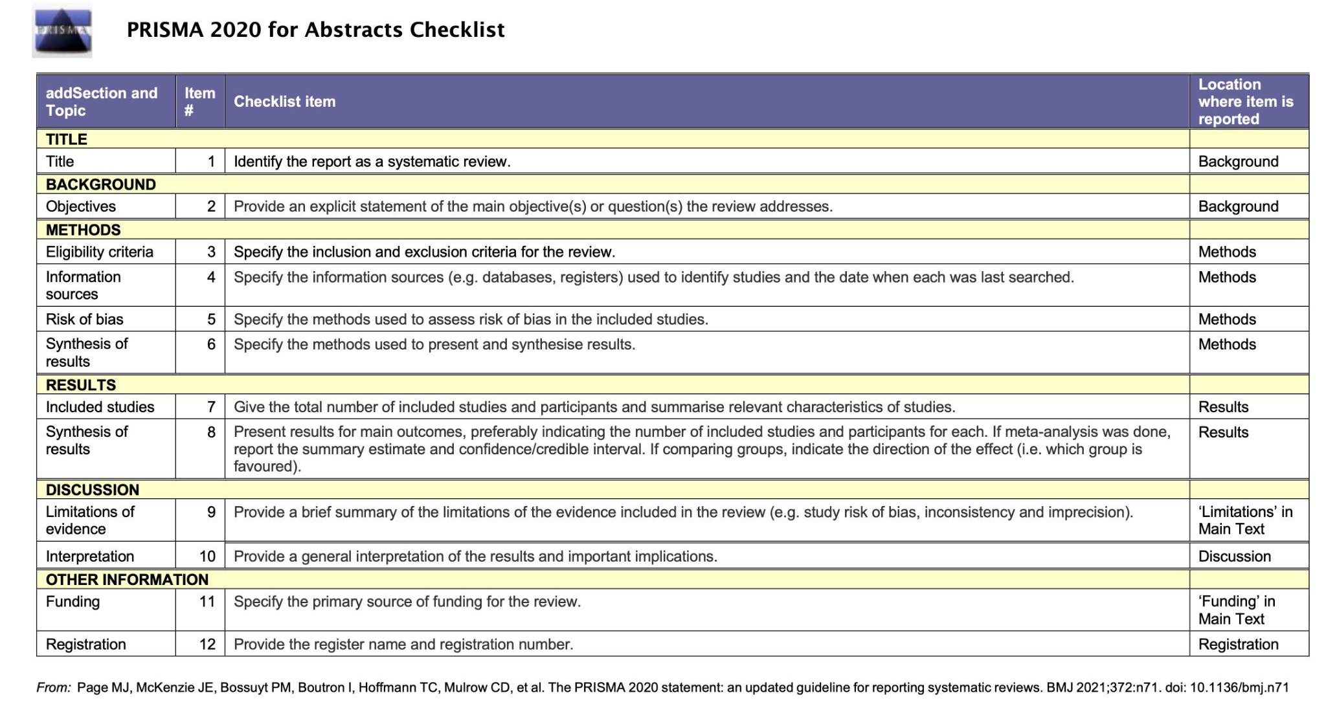

Figure S2: Completed Manuscript PRISMA 2020 Checklist.
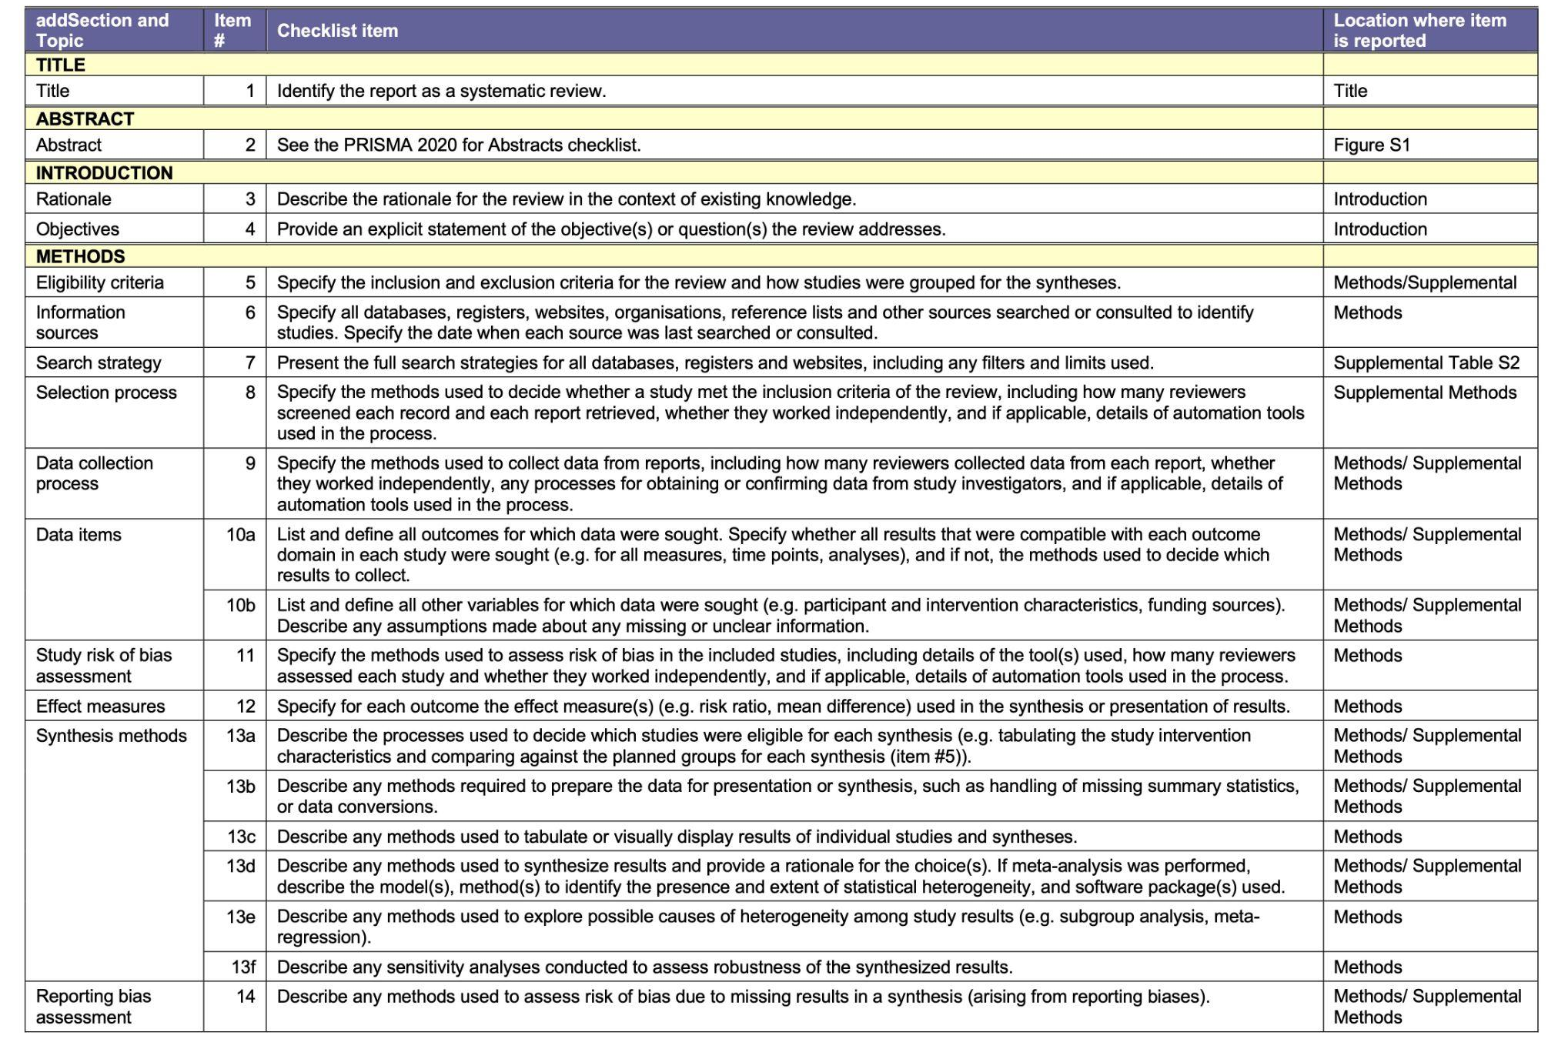
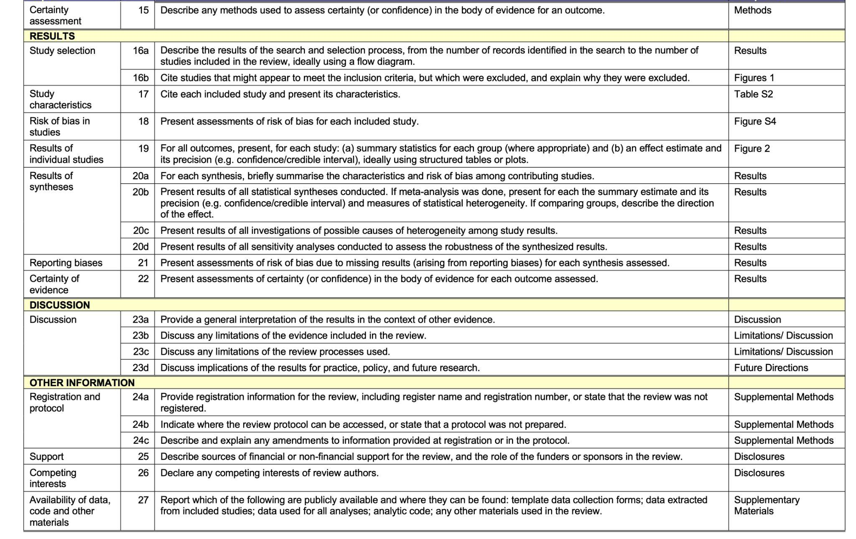
From: Page MJ, McKenzie JE, Bossuyt PM, Boutron I, Hoffmann TC, Mulrow CD, et al. The PRISMA 2020 statement: an updated guideline for reporting systematic reviews. BMJ 2021;372:n71. doi: 10.1136/bmj.n71

Figure S3: Quality Assessment Summary Plot. This figure displays the summary results from the quality assessment performed on each of the included studies. The figure displays the percentage breakdown of studies that received the high, low, and some concerns risk ratings for each assessed risk of bias. The gray portion of the ‘ascertainment of the genetic cohort’ risk of bias represents the papers that did not contain genetic data.
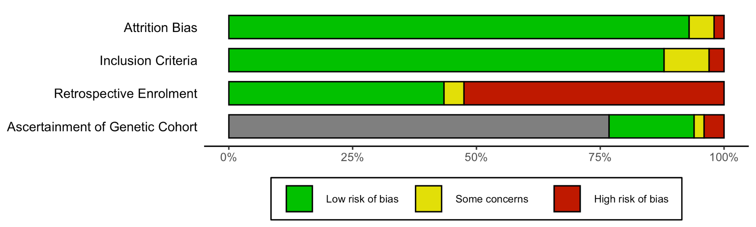

Figure S4: Quality Assessment Traffic Plot. This figure displays the results of the quality assessment for each individual study. The studies were each assessed on the ascertainment of the genetic cohort, retrospective enrolment, the stated inclusion criteria, and the risk of attrition bias.
Key:  D1: Attrition bias  D2: Inclusion Criteria bias  D3: Retrospective Enrollment bias  D4: Ascertainment of Genetic Cohort bias | 