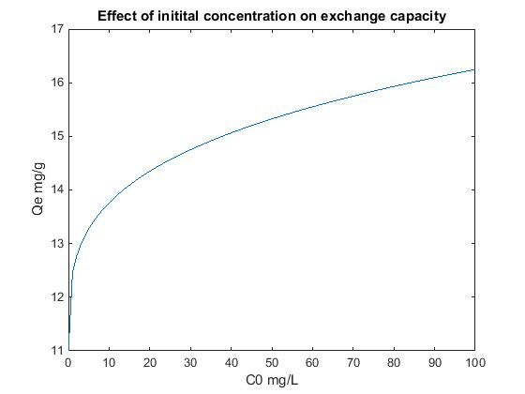
Figure S1 Ion Exchange model basis - relationship between zeolite exchange capacity of natural zeolite Q_{e} and the NH₄⁺ initial concentration C₀

Construction Stage of WWTP Process Units
Construction Material inputs
Production of Concrete
Production of Zeolite
Operation Stage of WWTP Process Units
Production of NaCl
Atmospheric Emissions
Organic Fertiliser for Agricultural land
NH₄⁺ Recovery
Avoided Chemical Fertiliser Production
Production of Pumps/ Motors/ Blowers etc.
Production of Steel
Production of Grid Electricity
Atmospheric Emissions
Energy Recovery Options
Avoided Production of Grid Electricity
Biogas Combustion
End-of-Life Stage of WWTP Process Unit
1st Order
2nd Order
3rd Order
LEGEND

Figure S2 System boundary definition of N removal and recovery routes for municipal waste water

A
COD 750 mg/L
TN 60 mg N/L
PO₄³⁻ 10 mg P/L
COD 35.8 mg/L
TN 12.4 mg N/L
PO₄³⁻ 0.2 mg P/L
COD 45.9 mg/L
TN 12.4 mg N/L
PO₄³⁻ 0.2 mg P/L
Influent
Effluent
Denitrification
Nitrification
Clarifier

B

COD 750 mg/L
TN 60 mg N/L
PO₄³⁻ 10 mg P/L
COD 21.1 mg/L
TN 13.1 mg N/L
PO₄³⁻ 3.2 mgP/L
COD 20.8 mg/L
TN 12.6 mg N/L
PO₄³⁻ 2.9 mg P/L

Influent
Effluent

Anaerobic Digestion

SHARON

ANAMMOX

Clarifier

COD 38.9 mg/L
TN 44.5 mg N/L
PO₄³⁻ 11.2 mg P/L
COD 33 mg/L
TN 41.4 mg N/L
PO₄³⁻ 0.3 mg P/L

C

COD 38.9 mg/L
TN 0 mg N/L
PO₄³⁻ 11.2 mg P/L
COD 38.9 mg/L
TN 44.5 mg N/L
PO₄³⁻ 11.2 mg P/L
COD 750 mg/L
TN 60 mg N/L
PO₄³⁻ 10 mg P/L
Influent
Regeneration
Anaerobic Digestion

Ion Exchange

Effluent

Figure S3 COD/N/P flows for conventional pathway (A), Anammox (B) and anaerobic route with ion exchange (C) Notes: COD=Chemical oxygen demand; TN=total nitrogen

Figure S4 LCA sensitivity analysis on the exchange capacity of zeolite

