Supplementary material
1. The MUSE model
MUSE is a global, bottom-up, technology-rich Integrated Assessment Model (IAM) designed to simulate alternative long-term energy system changes on a global scale. The model aims to simulate the real decision-making processes occurring in each sector of the energy system. It is a partial equilibrium model based on microeconomic foundations. It applies a modular approach to the modelling of the energy systems to represent the key agents’ investment behaviour in each energy sector. The modular structure allows modelling flexibility as each module represents a specific sector of the energy system and it is characterized by a methodology for investments in asset and operation which is sector-specific.
The global version of MUSE (MUSE Global) is geographically disaggregated into twenty-eight regions:
- ASEAN (the Association of Southeast Asian Nations),
- ATE (Eurasia),
- AUS (Australia and New Zealand),
- BRA (Brazil),
- CAN (Canada),
- CHL (Chile),
- CHN (China),
- DNK (Denmark),
- EU18,
- EU7 (Eastern Europe),
- FIN (Finland),
- IND (India),
- ISL (Iceland),
- ISR (Israel),
- JPN (Japan),
- KOR (South Korea),
- MEA (Middle East),
- MEX (Mexico),
- NOR (Norway),
- OAFR (all Africa except South Africa),
- OCSA (Central and South America),
- ODA (Developing Asia),
- OE2 (Switzerland, Turkey),
- OETE (i.e. Albania, Belarus, Bosnia and Herzegovina, Macedonia, Gibraltar, Montenegro, Kosovo, Moldova, Serbia, Ukraine),
- RUS (Russia),
- SWE (Sweden),
- USA (United States of America)
- ZAF (South Africa).
Figure a shows the basic structure of the MUSE modelling environment. In its modular architecture, MUSE includes supply sectors (upstream oil, upstream gas, coal extraction, renewables uptake, and uranium uptake); conversion sectors (power sector, refinery, and bio-refinery) as well as demand sectors (agriculture, buildings, industry, and transport). The climate model is based on a global carbon budget.
A limited foresight approach applies to the modelling of the trajectory of future energy prices and demand trajectories, which implies that the actual trend of these quantities is known until a certain point in the simulated time horizon but unknown after that, thus kept constant. At the next time period the trajectory of demands and prices would be updated including one more time period. The limited foresight approach is closer to the actual investors’ context of decision-making where the future prices are a high source of uncertainty.
Each sector module (i.e. supply, conversion, and demand) simulates capital investment and operational decision in order to meet the demand for a certain commodity or service in a specific region. MUSE employs an iterative algorithm (Market Clearing Algorithm, MCA) to clear the market by balancing demand and supply of energy commodities among the sectors. As shown in Figure a, every sector module exchanges information with the MCA which iterates across all sectors and all commodities until a market equilibrium is reached.
The Industrial Sector Module (ISM) belongs to the demand side of MUSE. It iteratively receives energy and material commodity prices, and the price of CO₂, disaggregated into region, time period and timeslice (sub-yearly disaggregation) from the Market Clearing Algorithm (MCA, Figure a) which equilibrates demand and supply of each commodity in each region across all sectors in the model (i.e. over the entire energy system). As such, energy, material and CO₂ prices are exogenous inputs to the ISM, which then dynamically calculates material commodity demands, demand for energy commodities and emissions. These outputs are returned to the MCA, ready for the next iteration, and so on until energy supply and demand converge on an equilibrium. The ISM uses a three-timeslice disaggregation to break down commodity demand, fuel consumptions, and emissions, representing more closely the behaviour in the main three seasons (i.e. winter, spring-autumn, summer).
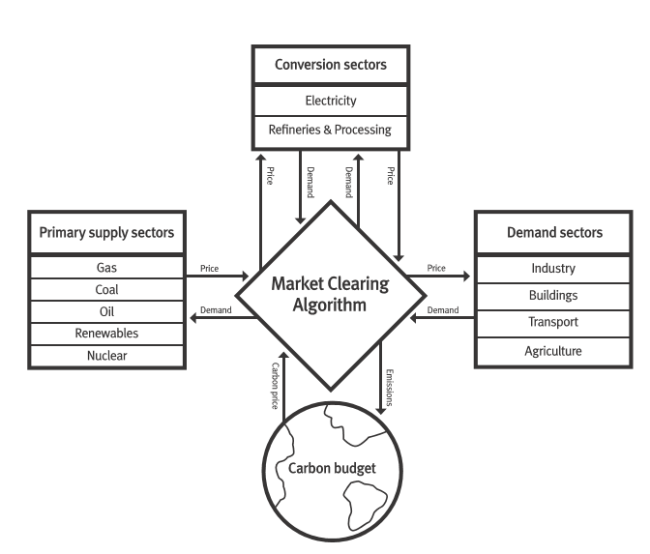
Figure a. General structure of the MUSE model (Giarola et al., 2019)
The ISM can also operate in a stand-alone mode, which is independent from the dynamic update in prices from the MCA. In this case, an external projection of prices is used.
The commodities modelled in MUSE are:
- energy vectors such as algae, animal residues, biodiesel, biomethane, biokerosene, diesel, electricity, energy crops, forestry energy crops, gas, gasoline, geothermal, halogens, hard coal, Heavy Fuel Oil (HFO), hydrogen, hydroelectric power, industrial waste, kerosene jet-fuel grade, naphtha jet-fuel grade, LNG, LPG, lignite, municipal solid wastes, methanol, NGL, naphtha, tidal power, oil, processed coal, processed gas, refinery gas, solar energy, solid fuels, nuclear and wind power
- material commodities include all the manufactured goods provided in the industrial sector and summarised in Table 1 by subsector
- residential, commercial and transport services, agricultural products
- environmental emissions

2. Industrial Sector Module (ISM): general modelling assumptions
The ISM models the five most-energy intensive industry subsectors: non-metallic minerals (cement), chemicals (ammonia, benzene, butadiene, ethylene, multi-nutrient fertilizers, halogens, methanol, propylene, toluene, xylenes), iron and steel, pulp and paper, and non-ferrous metals (aluminium). The remaining industry subsectors are lumped in a single subsector whose energy consumption and environmental emissions were estimated using a top-down approach, which relies on the projections provide by the IEA for the Reference Technology Scenario and for the 2 Degree Scenario (IEA, 2017).
The model projects the material commodity demand into the future using regressions of historical trends of regional commodity demand and historical trends of macroeconomic drivers. The demands of the material commodities have been derived by both broad-spectrum (Statista, 2017; UN and United Nations Statistics Division, 2017) and sector-specific (United Nations Environment Programme and UNEP, 2013; USGS, 2017) databases. Energy balances and technology-specific performances have been derived from the IEA (IEA, 2009) (IEA-ETSAP and IEA Energy Technology Systems Analysis Program, 2017). The historical trend of macroeconomic drivers is based on the Shared Socioeconomic Pathways (SSPs) retrieved from (IIASA, 2016).
The representative technologies (as reported in Table a) were selected according to readiness level, commercial availability and current market share. Priority has been given to commercially available, well established technologies, currently characterised by an adequate global market share (Budinis et al., 2018a).
For the production of cement, dry and wet technologies have been modelled (IEA-ETSAP, 2010a). For chemicals, aromatic extraction has been modelled to produce BTX (Benzene-Toluene-Xylenes) while steam cracking has been characterised as an alternative route to produce benzene, butadiene, ethylene and propylene. Propylene can also be produced via Fluid Catalytic Cracking (FCC). The production of ammonia and methanol has been characterised based on their feedstock (coal, natural gas, Heavy Fuel Oil (HFO), biomethane or water electrolysis) (IEA, 2009). Iron and steel making relies either on blast furnace technologies or reduction technologies (IEA-ETSAP, 2010b), while the production of pulp and paper can occur via either chemical or mechanical processes (IEA-ETSAP, 2010c). Finally, aluminium can be produced by means of prebaked or Soderberg technologies (IEA-ETSAP, 2012).

Table a. MUSE industrial subsectors and commodities
Subsector | Commodity | Technologies
Non-metallic minerals | Cement | Dry process  Wet process
Chemicals | Ammonia | Ammonia from coal  Ammonia from natural gas  Ammonia from Heavy Fuel Oil (HFO)  Ammonia from biomethane  Ammonia from water electrolysis
Chemicals | Benzene | Aromatic extraction  Steam cracking
Chemicals | Butadiene | C4 separation  Steam cracking
Chemicals | Ethylene | Steam cracking
Chemicals | Fertilizers (nitrogen N, phosphorus P and potassium K) | N-fertilizers from ammonia  P-fertilizers from phosphate minerals  K-fertilizers from potassium minerals
Chemicals | Halogens | Fluorine from hydrogen fluoride  Bromine by electrolysis  Iodine from SO2 and nitrate ores
Chemicals | Methanol | Methanol from coal  Methanol from natural gas
Chemicals | Propylene | Fluid catalytic cracking  Steam cracking
Chemicals | Toluene | Aromatic extraction  Toluene production for TDI
Chemicals | Xylenes (isomers) | Aromatic extraction
Iron and steel | Iron | Blast furnace  Smelting reduction
Iron and steel | Steel | Blast furnace  Smelting reduction
Pulp and paper | Pulp and paper | Chemical process  Mechanical process
Non-ferrous metals | Aluminium | Prebaked process  Soderberg process

Table b. Fuel and electricity consumption and process emissions for ammonia production in China (values have been scaled compared to the reference process “ammonia from coal”)
Technology | CCS | Year | Fuel consumption (-) | Electricity consumption (-) | CO₂ emission (-) | CO₂ capture (-) | N₂O emission (-)
Ammonia from biomethane | no | 2010 | 0.44 | 0.08 | 0.22 | 0.00 | 0.03
Ammonia from biomethane | yes | 2010 | 0.49 | 0.09 | -0.20 | 0.43 | 0.03
Ammonia from coal | no | 2010 | 1.00 | 1.00 | 1.00 | 0.00 | 1.00
Ammonia from coal | yes | 2010 | 1.12 | 1.12 | 0.11 | 1.00 | 1.12
Ammonia from HFO | no | 2010 | 0.91 | 0.14 | 0.80 | 0.00 | 0.37
Ammonia from HFO | yes | 2010 | 1.02 | 0.15 | 0.09 | 0.80 | 0.41
Ammonia from natural gas | no | 2010 | 0.44 | 0.08 | 0.42 | 0.00 | 0.03
Ammonia from natural gas | yes | 2010 | 0.49 | 0.09 | 0.04 | 0.40 | 0.03
Ammonia from water electrolysis | no | 2010 | 0.00 | 3.30 | 0.00 | 0.00 | 0.00
Ammonia from biomethane | no | 2050 | 0.41 | 0.08 | 0.20 | 0.00 | 0.03
Ammonia from biomethane | yes | 2050 | 0.46 | 0.09 | -0.19 | 0.40 | 0.03
Ammonia from coal | no | 2050 | 0.94 | 0.94 | 0.94 | 0.00 | 0.94
Ammonia from coal | yes | 2050 | 1.05 | 1.05 | 0.10 | 0.94 | 1.05
Ammonia from HFO | no | 2050 | 0.86 | 0.13 | 0.75 | 0.00 | 0.34
Ammonia from HFO | yes | 2050 | 0.96 | 0.14 | 0.08 | 0.75 | 0.38
Ammonia from natural gas | no | 2050 | 0.41 | 0.08 | 0.39 | 0.00 | 0.03
Ammonia from natural gas | yes | 2050 | 0.46 | 0.09 | 0.04 | 0.38 | 0.03
Ammonia from water electrolysis | no | 2050 | 0.00 | 3.09 | 0.00 | 0.00 | 0.00
Ammonia from biomethane | no | 2100 | 0.41 | 0.08 | 0.20 | 0.00 | 0.03
Ammonia from biomethane | yes | 2100 | 0.46 | 0.09 | -0.19 | 0.40 | 0.03
Ammonia from coal | no | 2100 | 0.94 | 0.94 | 0.94 | 0.00 | 0.94
Ammonia from coal | yes | 2100 | 1.05 | 1.05 | 0.10 | 0.94 | 1.05
Ammonia from HFO | no | 2100 | 0.86 | 0.13 | 0.75 | 0.00 | 0.34
Ammonia from HFO | yes | 2100 | 0.96 | 0.14 | 0.08 | 0.75 | 0.38
Ammonia from natural gas | no | 2100 | 0.41 | 0.08 | 0.39 | 0.00 | 0.03
Ammonia from natural gas | yes | 2100 | 0.46 | 0.09 | 0.04 | 0.38 | 0.03
Ammonia from water electrolysis | no | 2100 | 0.00 | 3.09 | 0.00 | 0.00 | 0.00

Table c. Capex and fixed opex for ammonia production in China (values have been scaled compared to the reference process from coal)
Technology | CCS | Year | CAPEX | FIXED OPEX
Ammonia from biomethane | no | 2010 | 0.88 | 0.88
Ammonia from biomethane | yes | 2010 | 1.72 | 1.72
Ammonia from coal | no | 2010 | 1.00 | 1.00
Ammonia from coal | yes | 2010 | 1.96 | 1.96
Ammonia from HFO | no | 2010 | 0.97 | 0.97
Ammonia from HFO | yes | 2010 | 1.91 | 1.91
Ammonia from natural gas | no | 2010 | 0.88 | 0.88
Ammonia from natural gas | yes | 2010 | 1.72 | 1.72
Ammonia from water electrolysis | no | 2010 | 1.49 | 1.49
Ammonia from biomethane | no | 2050 | 0.88 | 0.88
Ammonia from biomethane | yes | 2050 | 1.64 | 1.64
Ammonia from coal | no | 2050 | 1.00 | 1.00
Ammonia from coal | yes | 2050 | 1.86 | 1.86
Ammonia from HFO | no | 2050 | 0.97 | 0.97
Ammonia from HFO | yes | 2050 | 1.81 | 1.81
Ammonia from natural gas | no | 2050 | 0.88 | 0.88
Ammonia from natural gas | yes | 2050 | 1.64 | 1.64
Ammonia from water electrolysis | no | 2050 | 1.40 | 1.40
Ammonia from biomethane | no | 2100 | 0.88 | 0.88
Ammonia from biomethane | yes | 2100 | 1.54 | 1.54
Ammonia from coal | no | 2100 | 1.00 | 1.00
Ammonia from coal | yes | 2100 | 1.75 | 1.75
Ammonia from HFO | no | 2100 | 0.97 | 0.97
Ammonia from HFO | yes | 2100 | 1.71 | 1.71
Ammonia from natural gas | no | 2100 | 0.88 | 0.88
Ammonia from natural gas | yes | 2100 | 1.54 | 1.54
Ammonia from water electrolysis | no | 2100 | 1.40 | 1.40

3. An overview on budgeting techniques for Chinese firms
In the literature, there are a number of studies which have looked at the capital budgeting techniques of different Chinese firms, either comparing western versus eastern (Chan et al., 2010; Hermes et al., 2007), small versus large (Danielson and Scott, 2006) or private versus public enterprises (Poncet et al., 2010).
(Hermes et al., 2007) analysed the results from a survey involving 250 Dutch and 300 Chinese firms. The Netherlands was chosen as an example of a developed European economy, while China was chosen as an emerging Asian economy. The two countries were compared based on economic development (GDP per capita), financial development (stock market capitalisation to GDP), human development (gross enrolment ratio of tertiary education) and technological development (based on number of computers per capita and national expenditures on information and communication technology). The survey covered questions regarding the general characteristics of the firms (sales, foreign sales, type of industry, education and age of the CFO, ownership) and the use of specific capital budgeting metrics, either discounted (NPV, net present value) or non-discounted (PB, payback time). Additional questions covered the methods to measure the cost of capital (project dependent cost of capital; weighted average cost of capital; cost of debt) and the cost of equity (no estimation; average historical returns on common stock; capital asset pricing model). The results of the study highlighted how western firms tend to use discounted methods compared to Chinese firms, relying more on non-discounted methods. Hermes et al. (2007) attributed the disparity to the difference in the level of economic, financial, human and technological development between the two countries.
Chan et al. (2010) have analysed a small sample of Chinese firms (54) to understand their capital budgeting decisions in comparison with western (U.S. based) firms. The results of the analysis show how U.S. executives have moved away from non-discounted metrics, while they are as relevant as the discounted ones for Chinese firms. Moreover, Chinese firms make use of capital rationing, which is self-imposed by management for control purposes despite the fact that this practice may prevent investment in profitable projects.
Danielson and Scott (2006) focused on the capital budgeting decision of small enterprises, comparing them with large firms. The authors reported that project evaluation might differ for small and large enterprises due to reasons such as wealth maximization against other objectives (e.g. maintaining the independence of the business), lack of personnel and expertise for sophisticated project evaluation, and capital constraints. The results of their analyses highlight that small firms rely on less sophisticated, non-discounted cash flow metrics, such as payback time or even the “owner gut feeling”. According to (Danielson and Scott, 2006), this is due to multiple reasons including for instance a limited educational background of the owner, small staff size, and business reasons such as concerns related to liquidity and challenges in estimating the cash flow, especially for new production lines, where the firm does not have operational experience. In particular, almost half of the firms under analysis (45%) would delay a promising investment until it could be financed with internally generated funds (in this case, the capital constraint is therefore self-imposed). Moreover, for small enterprises the most important type of investment is maintenance, which leaves little space for flexibility regarding if and when it has to be performed.
Poncet et al. (2010) compared private versus publicly owned Chinese firms. The data collected shows how private Chinese firms are credit-constrained while state-owned firms and foreign-owned firms operating in China are not. Moreover, the geographical and sectoral presence of state firms aggravates financial constraints for private Chinese firms. Poncet et al. (2010) made use of an extremely extensive sample (covering 22,311 observations from 14,967 Chinese firms over the period 1998–2005) to understand if and under which circumstances Chinese firms are credit constrained.
The dataset (Bureau Van Dijk, 2019) contains detailed financial information (e.g. investment or lagged investment over capital; change in turnover over capital; cash flow over capital; employment over capital; total employment; total assets) and differentiates firms among state and collective-owned enterprises, foreign invested enterprises, and private Chinese companies. Overall, private Chinese firms appear heavily capital constrained, while public Chinese firms and foreign firms are not. The competition between privately-owned companies with foreign companies reduces the crowding-out effect.

4. Additional figures
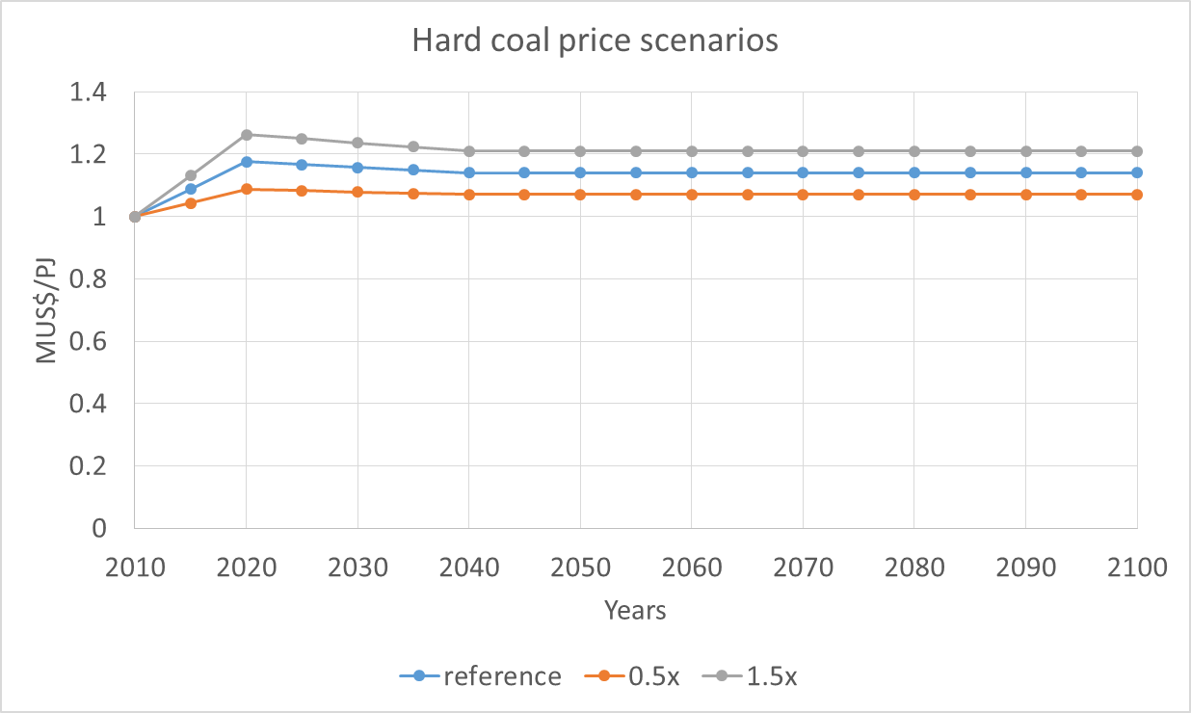
Figure b. Hard coal price scenarios

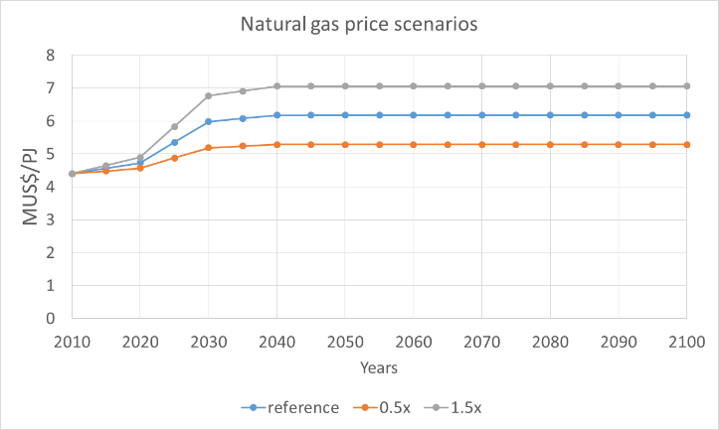
Figure c. Natural gas price scenarios

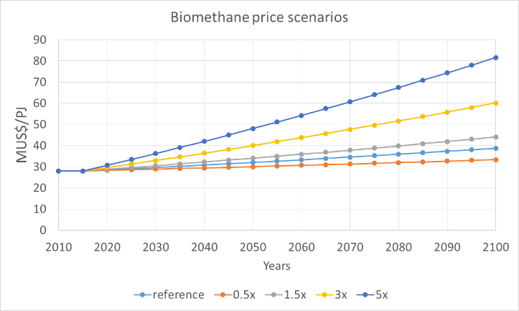
Figure d. Biomethane price scenarios

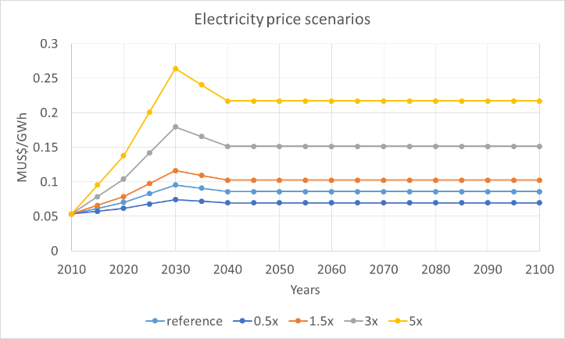
Figure e. Electricity price scenarios

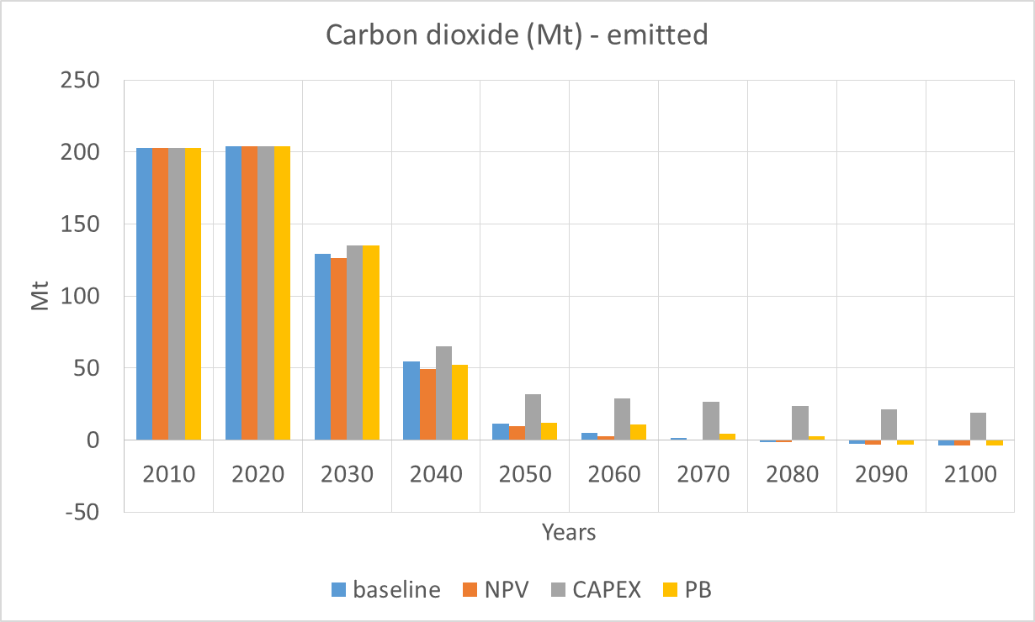 | 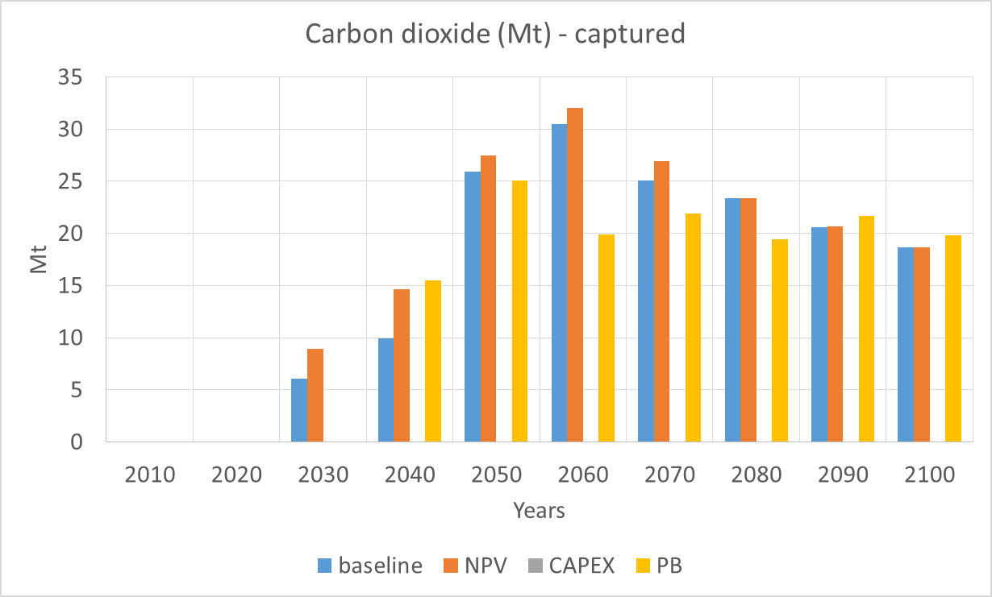
Figure f. Emissions (left) and capture (right) of CO₂ with a carbon price (Mt); sensitivity analysis on single versus multiple objective functions – case 2

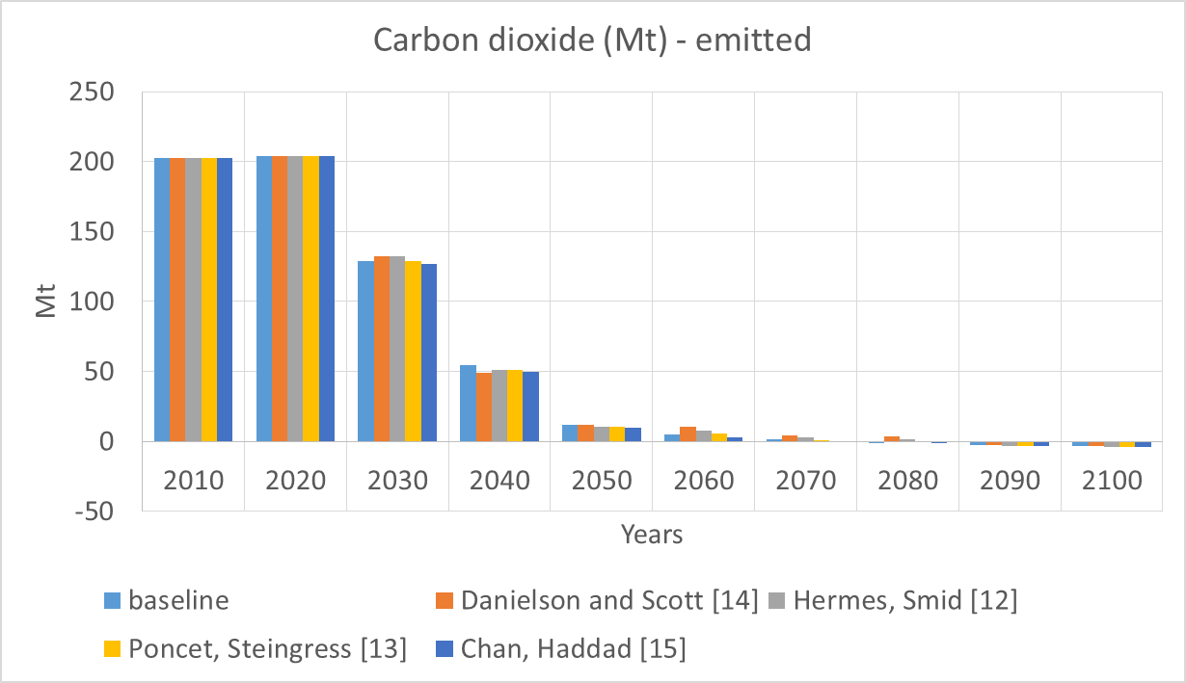 | 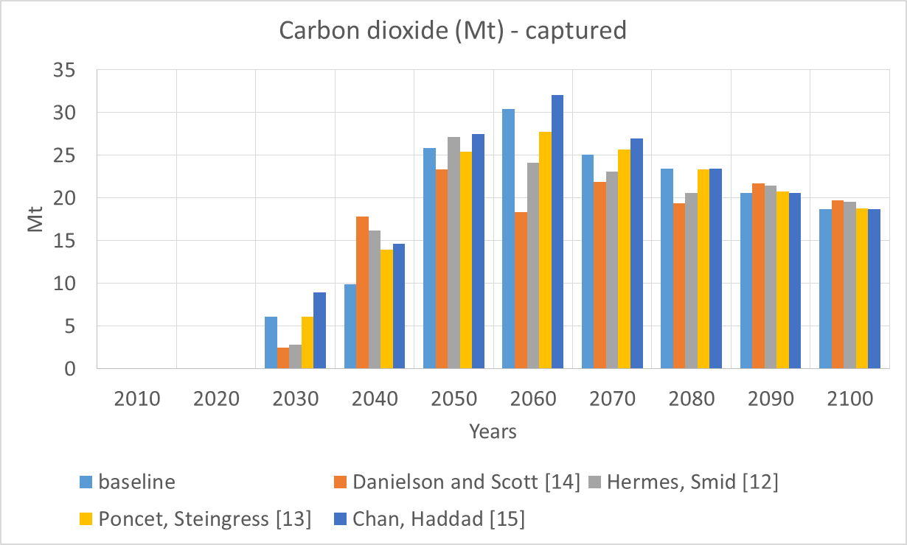
Figure g. Emissions (left) and capture (right) of CO₂ with a carbon price (Mt); sensitivity analysis on weights for multiple objective functions – case 2

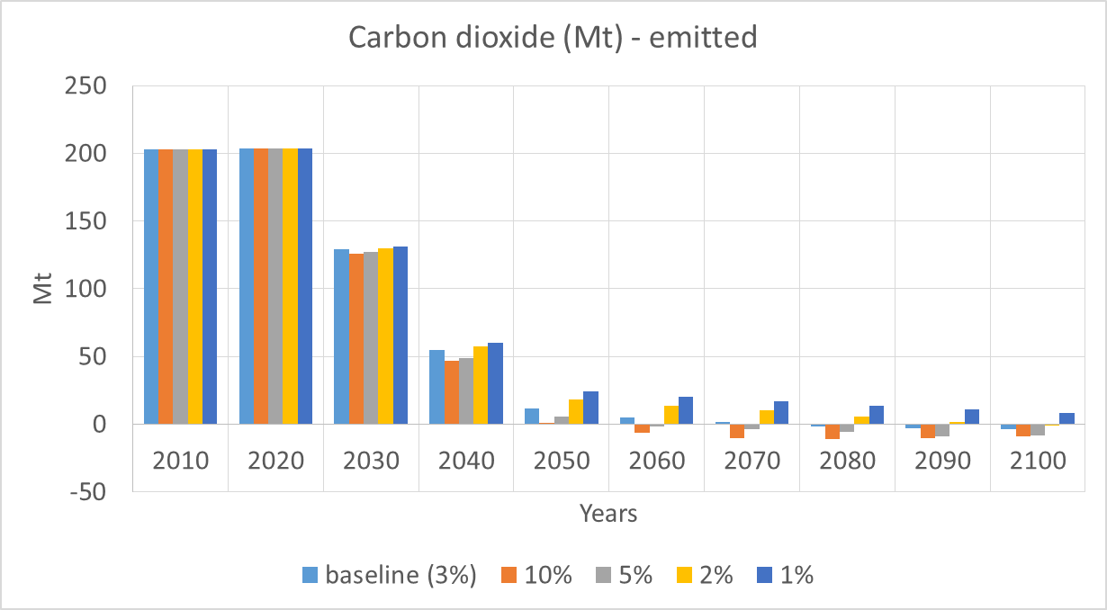 | 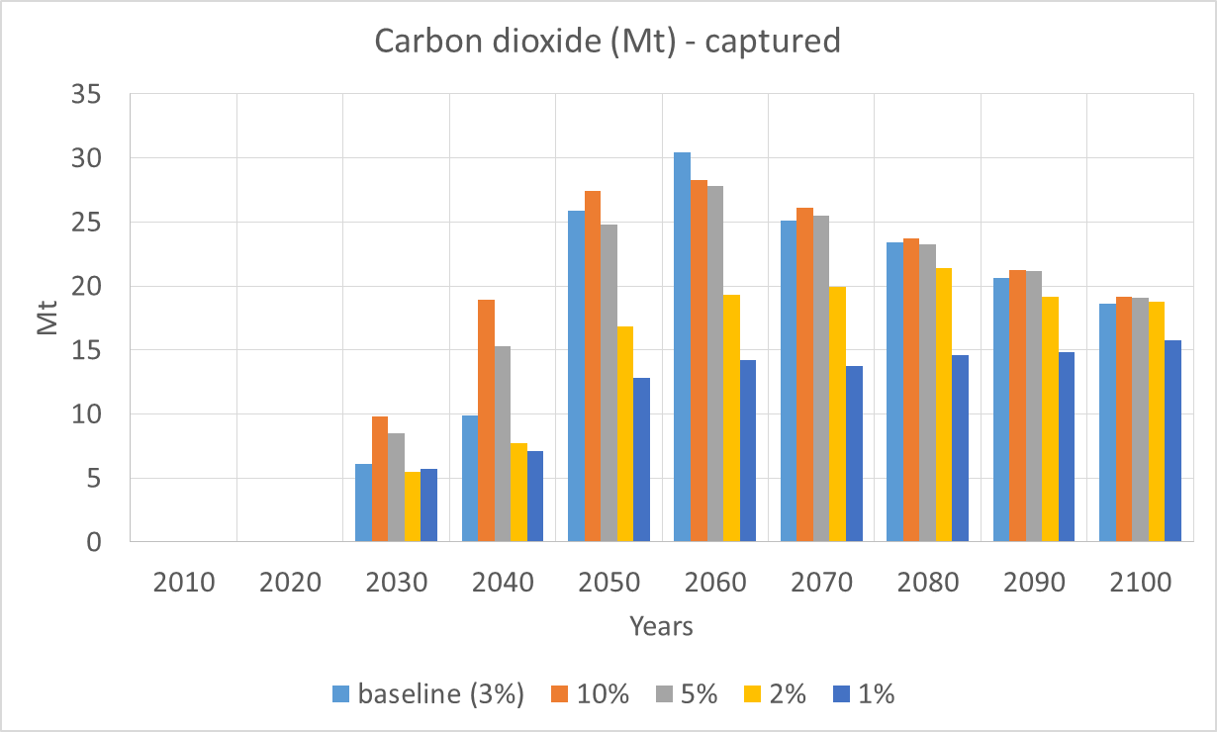
Figure h. Emissions (left) and capture (right) of CO₂ with a carbon price (Mt); sensitivity analysis on technologies growth rates – case 2

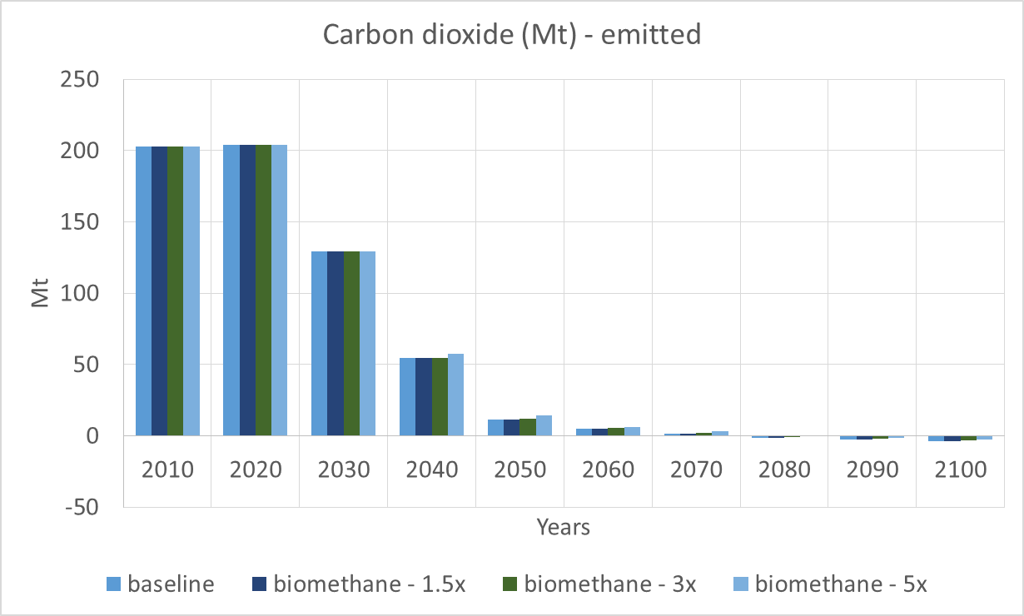 | 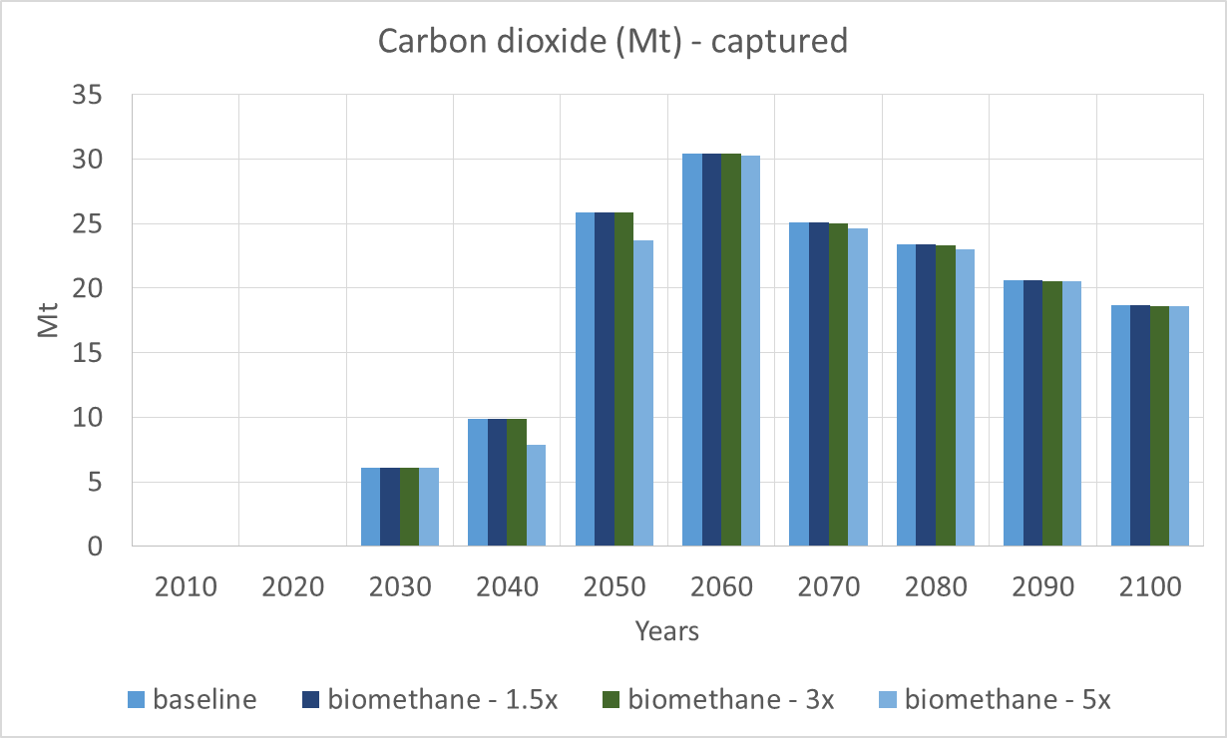
Figure i. Emissions (left) and capture (right) of CO₂ with a carbon price (Mt); sensitivity analysis on biomethane price – case 2

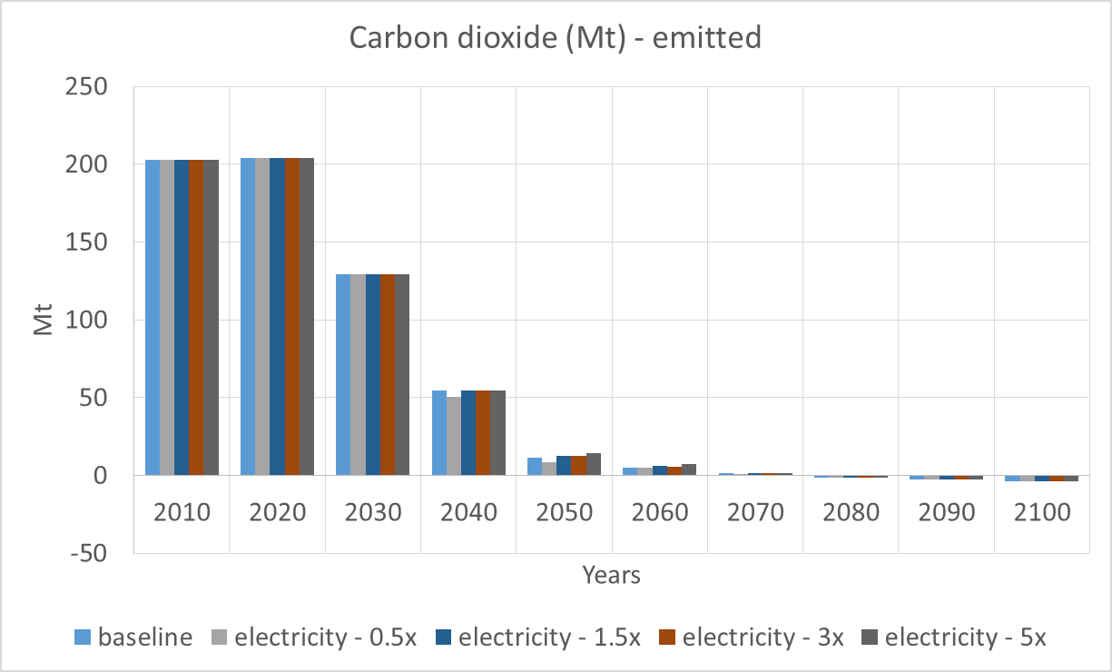 | 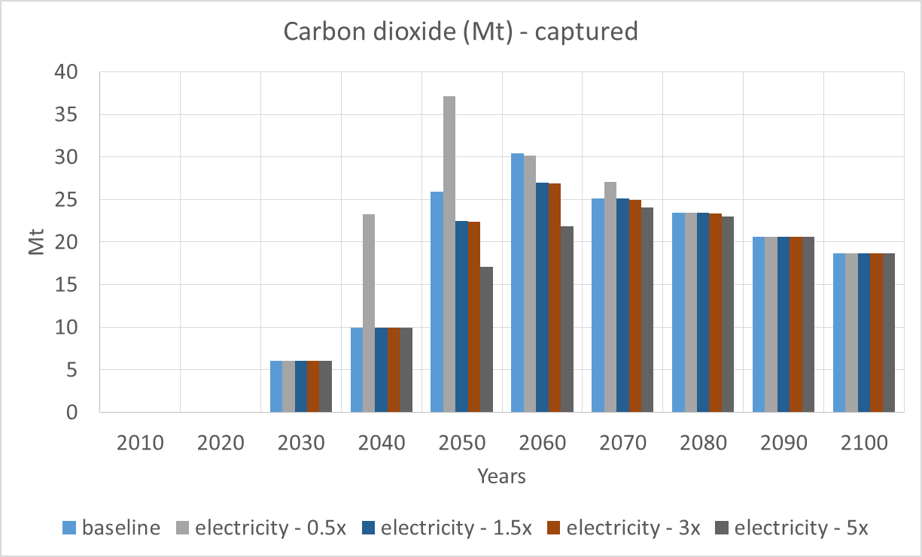
Figure j. Emissions (left) and capture (right) of CO₂ with a carbon price (Mt); sensitivity analysis on electricity price – case 2
Bibliography
Budinis, S., Giarola, S., Sachs, J., Hawkes, A., 2018a. Agent based modelling approach applied to the investment decision making of the industrial sector [WWW Document]. 37th Ed. Int. Energy Work. (IEW), . URL http://www.internationalenergyworkshop.org/meetings-11.html
Budinis, S., Krevor, S., Dowell, N.M.N.M., Brandon, N., Hawkes, A., 2018b. An assessment of CCS costs, barriers and potential. Energy Strateg. Rev. 22, 61–81. https://doi.org/10.1016/j.esr.2018.08.003
Bureau Van Dijk, 2019. Oriana [WWW Document]. URL https://www.bvdinfo.com/en-gb/our-products/data/international/oriana
Chan, H., Haddad, K.M., Sterk, W., 2010. Capital Budgeting Practices of Chinese Firms [WWW Document]. J. Glob. Bus. Manag. URL http://www.jgbm.org/page/18 Kamal M. Haddad .pdf
Danielson, M., Scott, J., 2006. The capital budgeting decisions of small businesses.
Giarola, S., Crow, D., Hawkes, A., 2019. Simulating the carbon price trajectory in energy systems with imperfect foresight, in: IEW Proceedings IEA (Eds). Paris, France.
Hermes, N., Smid, P., Yao, L., 2007. Capital budgeting practices: A comparative study of the Netherlands and China. Int. Bus. Rev. 16, 630–654. https://doi.org/http://dx.doi.org/10.1016/j.ibusrev.2007.05.002
IIASA, 2016. SSP Database (Shared Socioeconomic Pathways) - Version 1.1 [WWW Document]. URL https://tntcat.iiasa.ac.at/SspDb/dsd?Action=htmlpage&page=about
IEA, 2009. Chemical and Petrochemical Sector: Potential of best practice technology and other measures for improving energy efficiency [WWW Document]. URL https://www.iea.org/publications/freepublications/publication/chemical_petrochemical_sector.pdf
IEA, 2017. Energy Technology Perspectives 2017 Catalysing Energy Technology Transformations Together Secure Sustainable. https://doi.org/10.1787/energy_tech-2017-en
Statista, 2017. Statista.
IEA-ETSAP, 2012. Aluminium Production [WWW Document]. URL https://iea-etsap.org/E-TechDS/PDF/I10_AlProduction_ER_March2012_Final GSOK.pdf
IEA-ETSAP, 2010a. Cement Production [WWW Document]. URL https://iea-etsap.org/E-TechDS/PDF/I03_cement_June_2010_GS-gct.pdf
IEA-ETSAP, 2010b. Iron and Steel [WWW Document]. URL https://iea-etsap.org/E-TechDS/PDF/I02-Iron&Steel-GS-AD-gct.pdf
IEA-ETSAP, 2010c. Pulp and Paper Industry [WWW Document]. URL https://iea-etsap.org/E-TechDS/PDF/I07_Pulp&Paper_May2015OK.pdf
IEA-ETSAP, 2012. Aluminium Production [WWW Document]. URL https://iea-etsap.org/E-TechDS/PDF/I10_AlProduction_ER_March2012_Final GSOK.pdf
IEA-ETSAP, IEA Energy Technology Systems Analysis Program, 2017. Energy Demand Technologies Data [WWW Document]. URL https://iea-etsap.org/index.php/energy-technology-data/energy-demand-technologies-data (accessed 9.6.17).
IEA, (IEA), I.E.A., IEA/OECD, 2007. Tracking Industrial Energy Efficiency and CO2 Emissions. Paris.
IIASA, 2016. SSP Database (Shared Socioeconomic Pathways) - Version 1.1 [WWW Document]. URL https://tntcat.iiasa.ac.at/SspDb/dsd?Action=htmlpage&page=about
The State Council of the People’s Republic of China, 2011. National Bureau of Statistics of China [WWW Document]. URL http://www.stats.gov.cn/tjsj/ndsj/2011/indexeh.htm
Poncet, S., Steingress, W., Vandenbussche, H., 2010. Financial constraints in China: Firm-level evidence. China Econ. Rev. 21, 411–422. https://doi.org/10.1016/j.chieco.2010.03.001
United Nations Environment Programme, UNEP, 2013. Global Chemicals Outlook - Towards Sound Management of Chemicals [WWW Document]. URL https://sustainabledevelopment.un.org/index.php?page=view&type=400&nr=1966&menu=35
UN Statistics Division, 2019. UNSD — Industrial Statistics [WWW Document]. URL https://unstats.un.org/unsd/industry/Commodity/ (accessed 10.25.19).
UN, United Nations Statistics Division, 2017. UNdata [WWW Document]. URL http://data.un.org (accessed 12.2.17).
USGS, 2017. National Minerals Information Center [WWW Document]. URL https://minerals.usgs.gov/minerals/

Less than 250 employees.
A firm is classified as a state-owned enterprise if the ownership share of the state is more than 25%.

