Cationic Interdiffusion at the SOFC Electrolyte/Cathode Interface in La₂Mo₂O₉/La_{0.8}Sr_{0.2}MnO_{3-δ}

Dr. Uday K. Ravella ª, Dr. Jingjing Liu^{b}, Dr. Gwenaël Corbel ª, Prof. Stephen J. Skinner^{b*} and Dr. Philippe Lacorre ª
ª Institut des Molécules et Matériaux du Mans (IMMM), Univ. Bretagne-Loire, UMR CNRS 6283, Univ. Maine, avenue Olivier Messiaen, F-72085 Le Mans cedex 9, France.
^{b} Department of Materials, Imperial College London, Exhibition Road, London, SW7 2AZ, United Kingdom.

*To whom correspondence should be addressed at:
Stephen Skinner, Department of Materials, Imperial College London, Exhibition Road, London, SW7 2AZ UK. Tel: +44 (0)20 7594 6782
Email address: s.skinner@imperial.ac.uk

ABSTRACT
In this work cation diffusion between a La₂Mo₂O₉ (LM) ionic conductor and the conventional Solid Oxide Fuel Cell (SOFC) cathode material La_{0.8}Sr_{0.2}MnO_{3-δ} (LSM), was probed using secondary ion mass spectrometry (SIMS), and diffusion coefficients of Sr, Mo and Mn cations within both materials evaluated. Diffusion coefficients extracted from samples with a Sr solution deposited on the LM pellets and from a Mo solution deposited on LSM pellets were found to be orders of magnitude higher than the cross-diffusion through the interface between two dense pellets in direct contact. These differences may be due to uncertainty in determining the interface position, or to a real dependence on the source of the diffusing cation. In the most favorable case, that of pellets in direct contact, extrapolation of diffusion coefficients down to a typical SOFC operating temperature, 800°C, show that Mo diffusion in LSM (diffusion coefficient ~ 10⁻¹⁴ cm².s⁻¹) is much higher than Sr or Mn diffusion in LM, and incompatible with use in a SOFC device, unless an efficient buffer layer is used.

1. Introduction
Solid Oxide Fuel Cells (SOFC) are solid state electrochemical devices working at intermediate or high temperatures (600 – 1000˚C), converting fuel directly into electrical power while exhibiting higher efficiencies than traditional chemical/mechanical conversion devices. Like any other electrochemical device, an SOFC consists of three components: cathode, anode and electrolyte. The cathode should be a mixed ionic and electronic conductor which catalyzes oxygen dissociation and promotes oxygen ion transport towards the interface with the electrolyte. The electrolyte is typically a pure oxide ion conducting material which transports oxygen ions to the anode to react with the supplied fuel and generate power.
At high operating temperatures, it is required that all three components be thermodynamically stable (i.e. no abrupt changes in volume for any component occurs on thermal cycling and that the phases have compatible thermal expansion coefficients) as well as being chemically stable towards each other. If the components are not chemically compatible, they may react and form new phases at the interface leading to conductivity degradation, which in turn decreases the cell performance resulting in the collapse of the entire cell.
La₂Mo₂O₉ (LM) based electrolyte-type materials (the so-called LAMOX family) exhibit higher oxide ion conductivity than that of the traditionally used Yttrium Stabilized Zirconia (YSZ) in the intermediate temperature range above 500-550˚C.^{[1-11]} In order to evaluate the potential use of a La₂Mo₂O₉-derivative as a SOFC core material, several studies have been undertaken to investigate the chemical compatibility with common electrode materials, among which La_{0.8}Sr_{0.2}MnO_{3-δ} (LSM) is widely used.^{[12]} La₂Mo₂O₉ is known to have an α-β phase transition and this is typically mitigated by substitution for either La or Mo, with a rare earth or W, respectively. However these LM-based electrolytes have been shown to react with traditional electrodes, such as LSM, and to suffer from thermomechanical compatibility issues. Additionally LSM was found to be the least reactive perovskite-type/perovskite related cathode material with LM, leading to the formation of Sr(MoO₄) only above 700 ºC.^{[13,14]} In a previous paper,^{[15]} we have studied the reaction mechanism between LM and LSM by annealing the pellets of these two compositions in close contact to each other after coupling their polished faces together. Three different pellet couples were annealed at 1) 1050 ºC for 12 hours, 2) 1050 ºC for 36 hours and 3) 1150 ºC for 12 hours. On pellets annealed at 1050 ºC rod shaped LaMnO_{3+δ} grains were observed on the surface of the LM pellet, whereas SrMoO₄ type phases were observed on LSM pellets. On LM pellets annealed at 1150 ºC, a Mo deficient phase, La₂MoO₆, was observed. In a different configuration, a Sr(NO₃)₂ solution was deposited on LM pellets, and a (NH₄)₆Mo₇O₂₄.4H₂O solution on LSM pellets which were then annealed for 12 hours at 1050 ºC. On the Sr solution deposited LM pellets, La₆MoO₁₂, cubic β-La₂Mo₂O₉, SrMoO₄ and La₂MoO₆ phases were observed, and on Mo solution deposited LSM pellets, Mn₃O₄ and SrMoO₄ type phases were detected. For all configurations, reaction mechanisms were proposed as well as balanced reaction equations. From a qualitative point of view, the strongest driving force for cationic diffusion appeared to originate from Mo⁶⁺ and Mn³⁺ cations, rather than from Sr²⁺. The current paper is an attempt to quantify, by using Secondary Ion Mass Spectrometry (SIMS), the diffusion coefficients of these cationic species during these high temperature reactions.
Comparable studies were previously carried out on other SOFC cathode and electrolyte materials, such as that of Kilo et al.^{[16]} who coupled pellets of LSM-YSZ and annealed the samples, then observed the interdiffusion of elemental species from one pellet to the other using SIMS techniques. The diffusion coefficient of Sr in YSZ was reported to vary from 1 x 10⁻¹⁶ to 10⁻¹⁵ cm² s⁻¹ over the temperature range of 1325 to 1475 ºC. Horita et al.^{[17]} performed similar cationic diffusion studies by depositing a Sr(NO₃)₂ solution on La_{0.75}Ca_{0.25}CrO₃ (LCC) pellets and reported a diffusion coefficient for Sr in LCC as 1 x 10⁻¹⁷ to 10⁻¹³ cm² s⁻¹ in the temperature range of 900 to 1100 ºC.
In this paper we evaluate cationic diffusion coefficients of individual elemental species from LM to LSM and vice versa. Diffusive behavior of Sr in LM and Mo in LSM were studied on solution deposited pellets. The techniques used are Focused Ion Beam – Secondary Ion Mass Spectrometry (FIB-SIMS) and Time of Flight – Secondary Ion Mass Spectrometry (TOF-SIMS). The respective diffusion coefficients at high temperature are reported, and extrapolations are made down to SOFC operating temperatures in order to reach a conclusion on the suitability of LM/LSM electrolyte/cathode couples in such devices.
2. Results
2.1 Solutions deposited on La₂Mo₂O₉ and La_{0.8}Sr_{0.2}MnO_{3-δ} pellets
2.1.1 Sr diffusion in La₂Mo₂O₉, after deposition/annealing of Sr(NO₃)₂ solution
A Sr(NO₃)₂ solution was deposited on the LM pellets and annealed at 1150 ºC for 12 hours. After cooling, XRD was performed on the pellet at room temperature and four different phases La₆MoO₁₂, β-LM, SrMoO₄ and La₂MoO₆ were observed.^{[15]} As mentioned in section 2.1, samples were prepared for TOF-SIMS analysis and a line scan measurement was carried out on Side A of the pellet. The intensity of the Sr⁺, Mo⁺ and La⁺ signals were measured (Figure 1), and ratios of Mo⁺/La⁺ and Sr⁺/La⁺ plotted (Figure 2).

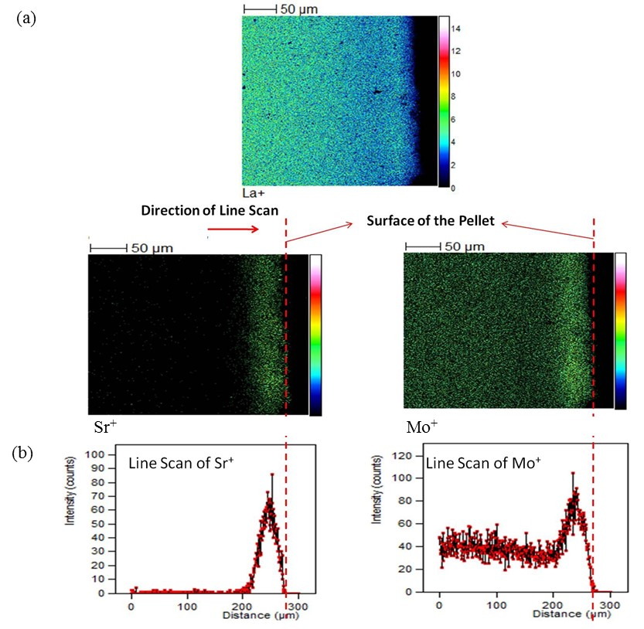
Figure 1 (a). TOF-SIMS "chemical" maps of a LM pellet (Side A: side of pellet where deposition was performed) after deposition with Sr(NO₃)₂ solution and annealing at 1150 ˚C for 12 hours. Ion images of La⁺, Sr⁺ and Mo⁺ counts can be seen, with an enriched area at the sample surface. (b) Line scan showing intensity of Sr⁺ and Mo⁺ signals is also presented. Notice the similarities in the profiles of Sr⁺ and Mo⁺.
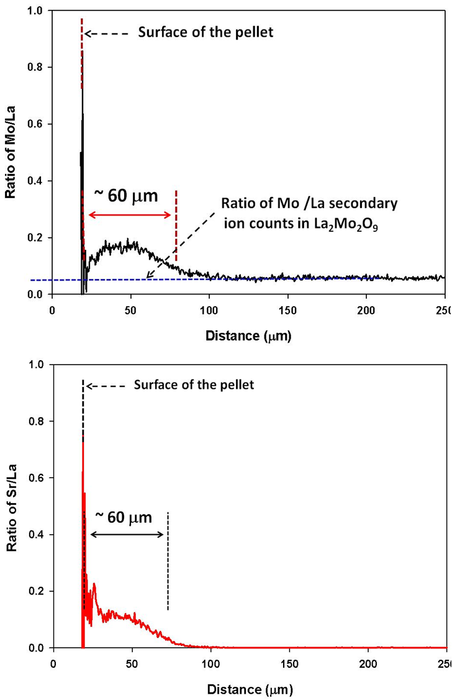
Figure 2. Ratio of Mo/La (top) and Sr/La (bottom) secondary ion yield signal as a function of distance from the surface of the pellet. These TOF-SIMS measurements were performed on LM pellet after deposition with Sr(NO₃)₂ solution and annealing at 1150˚C for 12 hours.

From the surface of the pellet until ~60 µm depth, a stronger Mo signal was observed, which then plateaued, indicating the constant composition of the bulk LM material had been reached. Similarly, the Sr signal was also strong for ~60 µm from the surface falling to a background level, indicating a Sr diffusion length in LM of ~60 µm. Both Mo and Sr signals show similar profiles, in agreement with a SrMoO₄ type material produced as a reaction product at the surface of the pellet (as confirmed by XRD^{[15]}). As shown in Figure 2, the Mo/La and Sr/La profiles are not linear, which indicates that the reaction product is not pure SrMoO₄ but also contains La, whose content varies over depth (as suggested in ref. 15).
Different lattices give different secondary ion yields and therefore quantification in mixed phase samples is more challenging than in the case of a tracer ion diffusion experiment. However, using the ~60 µm diffusion length of Sr in LM (at 1150 ºC for 12 h), an approximate chemical diffusion coefficient D can be estimated. Considering D as the diffusion coefficient, L as diffusion length and t as time (in seconds); it is known that the diffusion length is defined as L = 2 (Dt)^{½} .^{[16]} In this measurement, the diffusion length (L) of Sr in LM after annealing at 1150 ºC for 12 hours (t) was estimated at 60 µm from the SIMS profiles. Using these values in the above equation, a diffusion coefficient of Sr (D_{sr}) in LM is estimated as ~ 2 x 10⁻¹⁰ cm² s⁻¹. As a comparison, the Sr diffusion coefficient in a La_{0.75}Ca_{0.25}CrO₃ (LCC) pellet was reported to be distributed from 1 x 10⁻¹⁷ to 10⁻¹³ cm² s⁻¹ in the range of 900 to 1100 ºC^{[17]} and the diffusion coefficient of Sr in YSZ was observed to be in the range 10⁻¹⁶ - 10⁻¹⁵ cm² s⁻¹ between 1325-1475ºC.^{[16]} Compared to these diffusion coefficients reported in the literature, our estimate of a Sr diffusion coefficient in LM at 1150 ºC (~2 x 10⁻¹⁰ cm² s⁻¹) is significantly higher.

2.1.2 Mo diffusion in La_{0.8} Sr_{0.2}MnO_{3-δ}, deposited via (NH₄)₆Mo₇O₂₄ .4H₂O solution
After annealing the LSM pellet covered with (NH₄)₆Mo₇O_{24.}4H₂O solution for 12 hours at 1150 ºC, the presence of Mn₃O₄ and SrMoO₄ type phases was detected by XRD.^{[15]} Irregular grain distribution was reported, where the large grains were composed of a SrMoO₄ type phase and the small grains composed of a Mn₃O₄ phase.
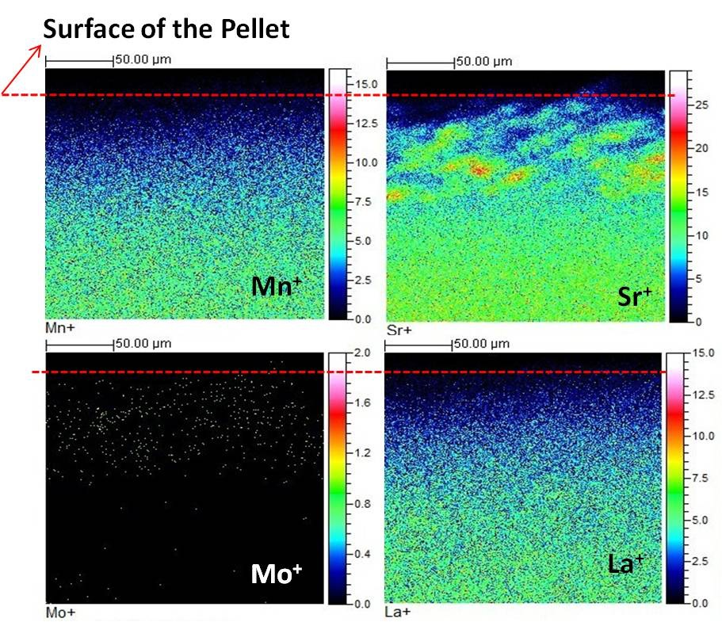
Figure 3. TOF-SIMS "chemical" maps of LSM pellet after deposition with (NH₄)₆Mo₇O₂₄.4H₂O solution and annealing at 1150˚C for 12 hours. Images of Mn⁺, Sr⁺, Mo⁺ and La⁺ content can be seen. Depletion of signal towards the sample surface is an artefact probably caused by sample curvature due to polishing and/or mounting of the sample.

TOF-SIMS measurements were performed on the side of the bar which was sectioned from the annealed pellet as described in the experimental section. The concentration of Mn and La was found to be low on the surface of the sample and increased with the depth of the pellet (Figure 3). Mo was observed on the surface of the pellet and its content gradually disappeared with depth. Mo was observed to penetrate to a depth of ~50 µm. Considering this as the diffusion length of Mo (~50 µm at 1150 ºC for 12 h), the bulk diffusion coefficient was estimated as ~ 10⁻¹⁰ cm².s⁻¹ (from L = 2 (Dt)^{½}, as above for Sr diffusion in LM. Some spots with a higher concentration of Sr were observed, due to the presence of SrMoO₄ type and Mn₃O₄ grains on the surface.^{[15]} Irregular surface roughness was also detected, which is likely to be the result of the appearance of both small and large grains as observed in the FIB-SIMS ion image.^{[15]} However, such high amounts of Sr (either from the presence of SrMoO₄ or irregular grain distribution) at the surface of the pellet gradually decreased with depth and remained constant in the bulk.
2.2.1 Cationic diffusion measurements on La₂Mo₂O₉ / La_{0.8}Sr_{0.2}MnO_{3-δ} pellet couples
Three different couples of LM/LSM were annealed at 1) 1050 ºC for 12 hours, 2) 1050 ºC for 36 hours and 3) 1150 ºC for 12 hours. After annealing, the coupled pellets were not adhered to each other and they split naturally. XRD analysis of the LM pellets from couples annealed at 1050 ºC (for 12 and 36 hours) and 1150 ºC, have shown the presence of both LaMnO_{3+δ} and LSM phases.^{[15]} On the LM pellet which was annealed at 1150 ºC, another phase was also observed. Rod shaped LaMnO_{3+δ} grains were found on the surface of the LM pellet. On all three LSM pellets, a SrMoO₄ type phase was detected.
FIB-SIMS depth profile analysis was carried out on all three couples, on both LM and LSM pellets (on the faces which were originally in contact, Figure 4). In Figure 4 the depth profiles have been plotted with the interface between the two halves of the couple assumed to be at 0 microns. Diffusion into LSM is then viewed as a positive number, whilst that into LM as a negative number.
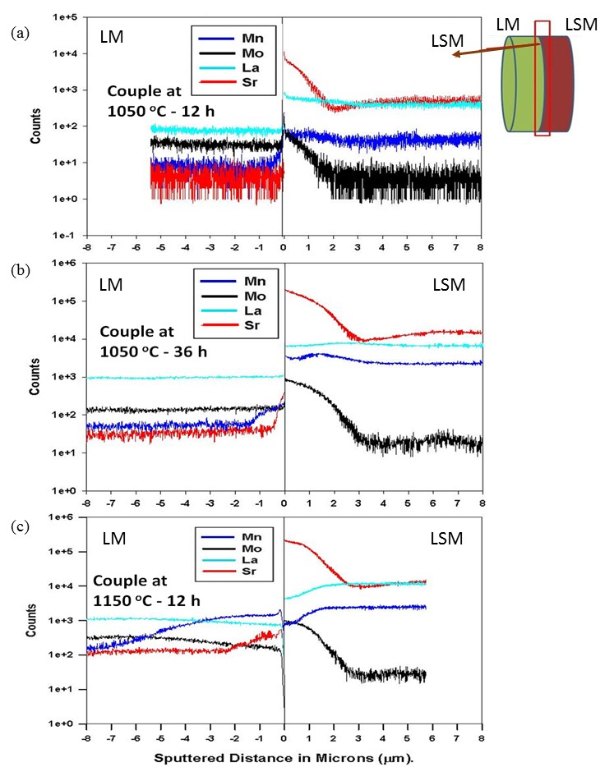
Figure 4. FIB-SIMS depth profile collected on couples of LM and LSM pellets which were annealed for (a) 12 hours at 1050 ºC, (b) 36 hours at 1050 ºC and (c)12 hours at 1150 ºC.
On the LM/LSM couple annealed for 12 hours at 1050 ºC (Figure 4a) no significant change in either La or Mn signals was detected in the LSM pellet. However, Mo diffused from the LM side of the couple and was found down to ~2 µm depth. Mo and Sr profiles were similar, in agreement with the formation of a SrMoO₄ type phase as detected by XRD¹⁵. A depth profile collected on the LM pellet did not reveal any Sr presence. However, a negligible amount of Mn was observed on the surface of the LM pellet. No change in the profiles of La and Mo were noticed, which suggests that most of the surface is bulk La₂Mo₂O₉.
For the couple annealed for 36 hours at 1050 ºC (Figure 4b) Sr and Mo signals present similar profiles (down to ~3 µm) for the LSM pellet, signifying the presence of a SrMoO₄ type phase^{[15]} as expected. No significant variation in the La profile was observed, which suggests the presence of La in the SrMoO₄ type matrix. A small variation in the Mn signal was observed at the beginning of the profile, equating to the region where SrMoO₄ would form. Below 3 µm depth the Mn signal became constant, equating to the bulk LSM composition. Depth profile analysis of the LM pellet showed the presence of Mn down to ~1.5 µm, whereas the Sr signal was observed to a depth of ~0.5 µm. No change in the profile of La and Mo was observed. The presence of rod shaped LaMnO₃ structures on the surface of the LM pellet^{[15]} and of Mn down to a depth of ~1.5 µm suggests that these rod-shaped structures are approximately 1.5 µm thick.
For the LSM/LM couple annealed for 12 hours at 1150 ºC (bottom of Figure 4) the Sr and Mo signal was observed to a depth of ~2.5 µm on the LSM side of the couple. La and Mn contents were low at the surface, which is due to either the presence of higher amounts of the SrMoO₄ type phase on the LSM pellet surface, or to diffusion towards the LM pellet. Mo decays to the background level on reaching ~2.5 – 3 µm. The signals for La, Mn and Sr are then constant from 3-6 µm in depth. In other words, LSM bulk material only appears below ~2.5 – 3 µm depth in the LSM pellet. In the depth profile of the LM pellet, Mn is seen down to ~6 µm from the interface. Since it was already known that rod shaped LaMnO_{3+δ} grains are present on the surface of LM pellets, it suggests that the thickness/depth of these grains would be ~6 µm. Changes in the Mo profile in the LM pellet could be due to Mo loss (or diffusion) towards the LSM side, to form the SrMoO₄ type phase. The La signal was almost constant whilst Sr was also seen in the LM pellet down to ~2 µm.
From the penetration depths of Mo into the LSM pellet, and of Sr and Mn into the LM pellet in the couples annealed for 36 h at 1050 °C and 12h at 1150 °C, diffusion coefficients were estimated using the relation L = 2(Dt)^{½}. All the corresponding data relative to penetration depths of the elements and their estimated bulk diffusion coefficients are given in Table 1.
Table 1. Penetration depths and estimated bulk diffusion coefficients of Mn, Sr and Mo observed by FIB-SIMS measurement in LM/LSM couples annealed 36h at 1050 ºC and 12h at 1150 ºC.
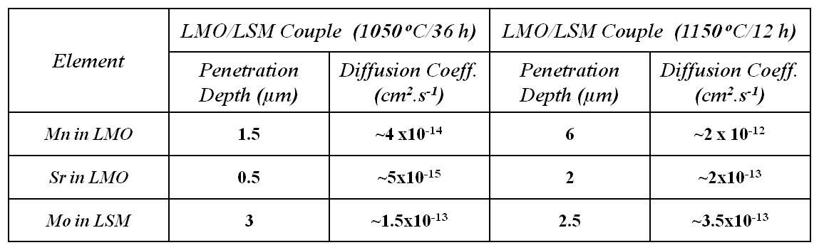
/
/

3. Discussion
Considering the results of the solution deposition experiments and analysis, it is clear that on annealing at 1150°C, the Sr bulk diffusion coefficient in LM could be estimated as ~2 x 10⁻¹⁰ cm² s⁻¹, and that the Mo diffusion coefficient in LSM was estimated at ~1 x 10⁻¹⁰ cm² s⁻¹. However, from the LM/LSM couples, bulk diffusion coefficients of Sr in LM were estimated as ~5x10⁻¹⁵ cm² s⁻¹ at 1050 ºC and as ~2x10⁻¹³ cm² s⁻¹ at 1150 ºC, while the Mo diffusion coefficient in LSM was determined to be ~1.5x10⁻¹³ cm² s⁻¹ at 1050 °C and ~3.5x10⁻¹³ cm² s⁻¹ at 1150 ºC, with the Mn diffusion coefficient in LM determined to be ~4x10⁻¹⁴ cm² s⁻¹ at 1050 °C and ~2x10⁻¹² cm² s⁻¹ at 1150 ºC. There is a clear difference in the estimated diffusion coefficients for the Sr species, depending on the route used to apply the Sr species. These differences will be discussed below.
Bulk diffusion coefficients of Sr determined from both the solution deposited LM pellet and from the LSM/LM couple in which Sr penetrated into the LM from the LSM source are plotted in Figure 5 and, assuming temperature independent activation energy, linearly extrapolated down to lower temperatures. A standard fuel cell based on YSZ/LSM usually operates in the 900-1000°C thermal range, whereas a fuel cell based on a LAMOX electrolyte would operate at a 150 °C lower temperature at least (around 750-850 ºC). For comparison, diffusion coefficients of Sr²⁺ in YSZ were adopted from Kilo et al.^{[16]} and such diffusion coefficients (of Sr in YSZ) were extrapolated to lower temperatures. The diffusion coefficient of Sr (from LSM) into YSZ would be around ~1x10⁻²⁰ cm² s¹ at 900-1000 ºC, and from L = 2(Dt)^{½}, such a coefficient would lead to a penetration depth of ~10 nm/year. A Sr diffusion coefficient for the transport of Sr from LSM to LM was extrapolated to be around ~1x10⁻²⁰ cm² s⁻¹ at ~ 800 ºC, the likely operating temperature of a LM based SOFC, and such a diffusion coefficient corresponds to the penetration depth of ~10 nm/year. i.e. the same range as for YSZ in its operating conditions. Such a conclusion relies on several assumptions, for instance, that our estimation of the diffusion coefficient is sufficiently accurate, that there are no lateral inhomogeneities in the diffusion couples, and that one can linearly extrapolate down to low temperature.
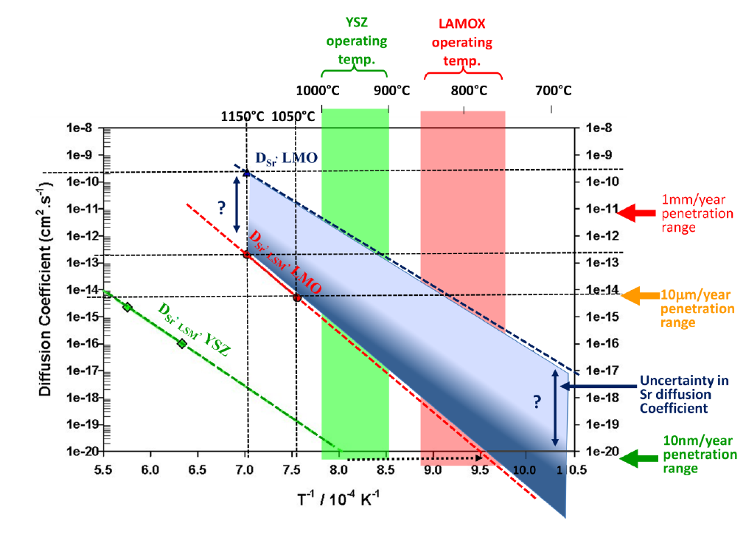
Figure 5. Evolution of bulk diffusion coefficients of Sr (from both LSM pellet (red line) and solution deposition (dark blue line)) in to LM. Sr diffusion values from LSM into YSZ (green line) are adopted from Kilo et al.^{[16]}
Above all, there is the uncertainty on the measurement of Sr diffusion coefficient depending on the Sr source. An underestimation of 3 orders of magnitude (as for Sr from solution deposition, see Figure 5, dark blue line) might result in an even larger underestimation at the operating temperature (depending on activation energy), which would be dramatic for Sr penetration.
The Sr penetration depth estimated from the FIB-SIMS depth profiles may be significantly underestimated due to the difficulty in identifying the pellets’ surface/interface. In these conditions, a penetration depth of ~0.5 µm of Sr at 1050 °C/36h may not be realistic. The uncertainty in the surface position can be as high as 5 µm, for instance, if our diffusion model^{[12]} is incorrect and SrMoO₄ grains originate from the LM pellet: these SrMoO₄-type grains might have adhered to the LSM pellet and be pulled out during separation. A penetration depth of 5 µm instead of ~0.5 µm is an order of magnitude higher, resulting in a diffusion coefficient 2 orders of magnitude higher. Sr diffusion coefficient values would be closer to the solution deposition values, and extrapolation would give much higher values.
One can alternatively assume that the discrepancy between the diffusion coefficients of Sr measured from solution deposition and from LSM/LM couple reflects a real difference due to the difference in Sr source. Since it is known that Sr tends to segregate out from LSM on cooling,^{[18, 19]} it would mean that this segregated Sr layer, possibly present as SrO at the reaction conditions, is much more likely to be a source of Sr cations, rather than the lattice Sr in the LSM phase. Since this segregated Sr is formed when the cell is under operating temperature, its presence at the electrolyte/cathode interface could be affected by cell cycling and this would lead to premature ageing of the cell.
Corbel et al.^{[14]} reported that LM and LSM are stable in contact at temperatures below 700 ºC and that a SrMoO₄ type phase appears at 800 ºC. With Sr diffusion kinetics as low as 1x10⁻²⁰ cm².s⁻¹ (extrapolated from our measurements), it is unlikely that a phase resulting from a 10nm/year Sr penetration depth would be detected by XRD after just 3 days. A sensible alternative would be that Mo (from LM) diffuses towards LSM rather than Sr (from LSM) diffusing towards LM, and it was observed that the estimated Mo diffusion coefficients for this scenario are significantly higher when extrapolated towards lower temperatures (Figure 6). The penetration depth of Mo was estimated to be ~3 µm/year at 800 ºC. Even though Sr diffusion is low, Mo cross diffusion is higher and hence the insulating SrMoO₄ layer is formed. Note that from the solution Mo deposition on LSM, the calculated Mo penetration depth would be even greater, as for solution deposition Sr diffusion in LM. The estimated diffusion coefficient of Mn from LSM into LM was found to be relatively low at ~1x10⁻²⁰ cm².s⁻¹at 800 ºC.
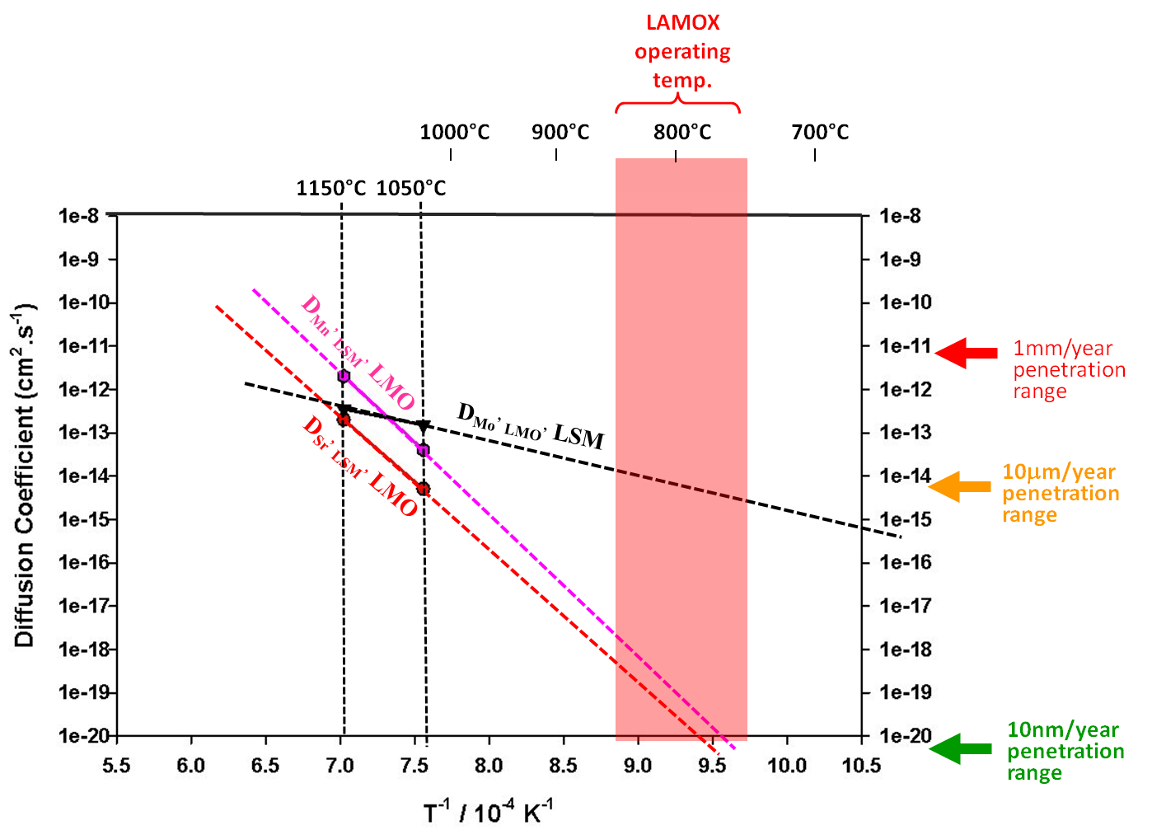
Figure 6. Evolution of bulk diffusion coefficients of Sr (red) and Mn (pink) from LSM to LM and Mo (black) from LM towards LSM.

4. Conclusions
Overall, these results show that the LM/LSM couple is reactive, and that such an electrolyte/cathode association is not suitable for SOFC applications without modification. Such reactions could be possibly triggered by the surface segregation behavior of Sr and the fast diffusion of Mo. However, both materials could be used with an appropriate buffer layer in between, so that cross cationic-diffusion of elements between LM and LSM would be stopped. Since it is known that ceria based materials do not react with LM,^{[14]} possible utilization of ceria based buffer layers would be a suitable route for device development.
5. Supporting Information Summary
Full details of the experimental methods are provided as supporting information, including a schematic of the TOF-SIMS method employed, Figure S1.
6. Acknowledgements
We gratefully acknowledge the useful discussion with Dr R. J. Chater, Department of Materials, Imperial College London, regarding the FIB-SIMS data. We further acknowledge the award of a Lee Family Scholarship that supported the research programme of Jingjing Liu, and finally the British Council and the CNRS PICS program for the award of an Alliance for Science grant that supported exchanges of personnel between London and Le Mans.
KEYWORDS
Diffusion lengths and coefficients, Fuel cells, La₂Mo₂O₉, La_{0.8}Sr_{0.2}MnO_{3-δ}, mass spectrometry.

REFERENCES
[1] P. Lacorre, F. Goutenoire, O. Bohnke, R. Retoux, Y. Laligant, Nature 2000, 404, 856-858.
[2] F. Goutenoire, O. Isnard, R. Retoux, P. Lacorre, Chem. Mater. 2000, 12, 2575-2580.
[3] A. Selmi, C. Galven, G. Corbel, P. Lacorre, Dalton Trans. 2010, 93-102.
[4] F. Goutenoire, O. Isnard, E. Suard, O. Bohnke, Y. Laligant, R. Retoux, P. Lacorre, J. Mater. Chem. 2001, 11, 119-124.
[5] S. Georges, O. Bohnke, F. Goutenoire, Y. Laligant, J. Fouletier, P. Lacorre, Solid State Ionics 2006, 177, 1715-1720.
[6] G. Corbel, Y. Laligant, F. Goutenoire, E. Suard, P. Lacorre, Chem. Mater. 2005, 17, 4678-4684.
[7] J.A. Collado, M.A.G. Aranda, A. Cabeza, P. Olivera-Pastor, S. Bruque, J. Solid State Chem. 2002, 167, 80-85.
[8] D. Marrero-Lopez, J. Canales-Vazquez, J.C. Ruiz-Morales, J.T.S. Irvine, P. Nunez, Electrochim. Acta 2005, 50, 4385-4395.
[9] S. Georges, F. Goutenoire, Y. Laligant, P Lacorre, J. Mater. Chem. 2003, 13, 2317-2321.
[10] M.-V. Le, D.-S. Tsai, C.-C. Yao, J.-C. Lo, T. Phung, G. Vo, J. Alloys Compd. 2014, 582, 780-785
[11] G. Buvata, E. Quareza, O. Joubert, J. Power Sources, 2016, 302, 107-113

[12] D. Marrero-López, J. Peña-Martínez, J.C. Ruiz-Morales, D. Pérez-Coll, M.C. Martín-Sedeño, P. Núñez, Solid State Ionics 2007, 178, 1366-1378

[13] G. Corbel, P. Lacorre, J. Solid State Chem. 2006, 179, 1339-1344.
[14] G. Corbel, S. Mestiri, P. Lacorre, Solid State Sci. 2005, 7, 1216-1224.
[15] U.K. Ravella, J. Liu, G. Corbel S.J. Skinner P. Lacorre, ChemSusChem, 2016, 8, 2182-2192.
[16] M. Kilo, Defects and Diffusion in Ceramics: an Annual Retrospective VII 2005, 242-244, 185-253.
[17] T. Horita, N. Sakai, T. Kawada, H. Yokokawa, M, Dokiya, J. Am. Ceram. Soc. 1998, 81, 315-320.

[18] W. Wang, S.P. Jiang, Solid State Ionics 2006, 177, 1361-1369

[19] N. Calliol, M. Pijolat, E. Siebert, Appl. Surf. Sci. 2007, 253, 4641-4648

Table of Contents Entry

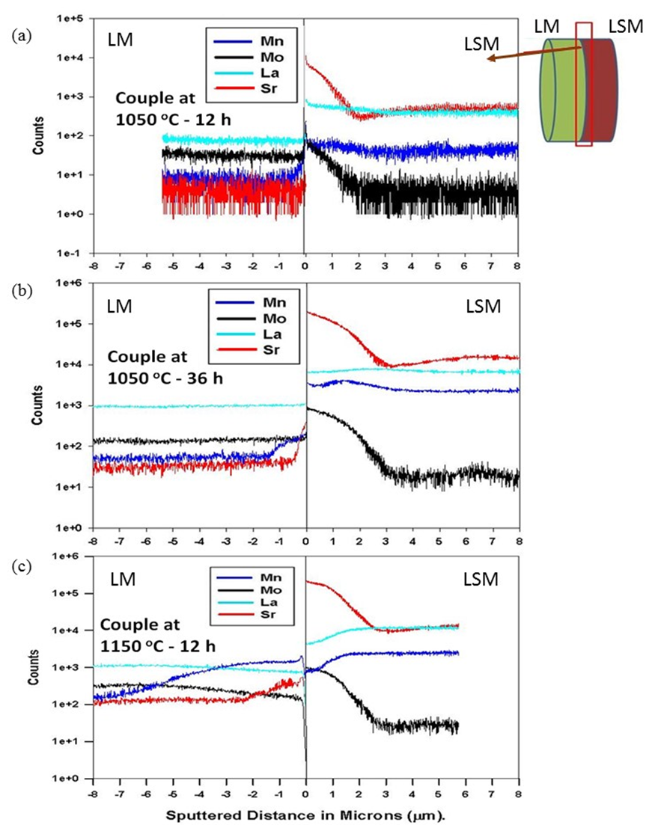

Interdiffusion of cation species between La₂Mo₂O₉ and La_{0.8}Sr_{0.2}MnO_{3-δ} is investigated using secondary ion mass spectrometry. Diffusion coefficients for Sr, Mn and Mo are estimated and related to the lifetime of devices.

