Organizing principles for vegetation dynamics

Authors
Oskar Franklin^{1*}, Sandy P. Harrison², Roderick Dewar^{3,4}, Caroline E. Farrior⁵, Åke Brännström^{1,6}, Ulf Dieckmann¹, Stephan Pietsch¹, Daniel Falster⁷, Wolfgang Cramer⁸, Michel Loreau⁹, Han Wang¹⁰, Annikki Mäkelä¹¹, Karin T. Rebel¹², Ehud Meron^{13,14}, Stanislaus J. Schymanski¹⁵, Elena Rovenskaya¹, Benjamin D. Stocker^{16,17}, Sönke Zaehle¹⁸, Stefano Manzoni^{19,20}, Marcel van Oijen²¹, Ian J. Wright²², Philippe Ciais²³, Peter M. van Bodegom²⁴, Josep Peñuelas^{17,25}, Florian Hofhansl¹, Cesar Terrer²⁶, Nadejda A. Soudzilovskaia²⁴, Guy Midgley²⁷, and I. Colin Prentice^{10,22,28}
1: International Institute for Applied Systems Analysis, Schlossplatz 1, 2361 Laxenburg, Austria
2: Department of Geography and Environmental Science, University of Reading, Reading, RG6 6AB, UK
3: Plant Sciences Division, Research School of Biology, The Australian National University, Canberra ACT 2601, Australia
4: Institute for Atmospheric and Earth System Research/Physics, University of Helsinki, 00014 Helsinki, Finland
5: Department of Integrative Biology, University of Texas at Austin, Austin, TX, USA
6: Department of Mathematics and Mathematical Statistics, Umeå University, SE-90187 Umeå, Sweden
7: Evolution and Ecology Research Centre, and School of Biological, Earth and Environmental Sciences, University of New South Wales, Sydney, NSW 2052, Australia
8: Institut Méditerranéen de Biodiversité et d’Ecologie Marine et Continentale (IMBE), Aix Marseille Université, CNRS, IRD, Avignon Université, Technopôle Arbois-Méditerranée, F-13545 Aix-en-Provence cedex 04, France
9: Centre for Biodiversity, Theory, and Modelling, Theoretical and Experimental Ecology Station, CNRS, Moulis, France
10: Ministry of Education Key Laboratory for Earth System Modeling, Department of Earth System Science, Tsinghua University, Beijing 100084, China
11: Forest Sciences, University of Helsinki, Yliopistonkatu 4, 00100 Helsinki, Finland
12: Copernicus Institute of Sustainable Development, Environmental Sciences, Faculty of Geosciences, Utrecht University, Utrecht, The Netherlands
13: Blaustein Institutes for Desert Research, Ben-Gurion University of the Negev, Sede Boqer Campus 8499000, Israel
14: Department of Physics, Ben-Gurion University of the Negev, Beer Sheva 8410501, Israel
15: Department of Environmental Research and Innovation, Luxembourg Institute of Science and Technology, Esch-sur-Alzette, Luxembourg
16: Institute for Atmospheric and Climate Science, ETH Zurich, Zurich, 8092, Switzerland
17: CREAF, Cerdanyola del Vallès, Catalonia, 08193, Spain
18: Biogeochemical Integration Department, Max Planck Institute for Biogeochemistry, Hans-Knöll-Str. 10, 07745 Jena, Germany
19: Department of Physical Geography, Stockholm University, 106 91 Stockholm, Sweden
20: Bolin Centre for Climate Research, 106 91 Stockholm, Sweden
21: Centre for Ecology and Hydrology (CEH-Edinburgh), Bush Estate, Penicuik EH26 0QB, United Kingdom
22: Department of Biological Sciences, Macquarie University, North Ryde, NSW 2109, Australia
23: Laboratoire des Sciences du Climat et de l’Environnement, CEA CNRS UVSQ, Gif-sur-Yvette 91190, France
24: Department of Environmental Biology, Leiden University, 2333 CC Leiden, The Netherlands
25: CSIC, Global Ecology Unit CREAF-CSIC-UAB, Bellaterra 08913, Catalonia, Spain
26: Physical and Life Sciences Directorate, Lawrence Livermore National Laboratory, Livermore, California 94550, USA
27: Department Botany & Zoology, Stellenbosch University, 7602, South Africa
28: AXA Chair of Biosphere and Climate Impacts, Department of Life Sciences, Imperial College London, Silwood Park Campus, Buckhurst Road, Ascot SL5 7PY, UK

Abstract
Plants and vegetation play a critical –but largely unpredictable- role in global environmental changes, due to the multitude of contributing processes at widely different spatial and temporal scales. In this Perspective we explore approaches to master this complexity and improve our ability to predict vegetation dynamics by explicitly taking account of principles that constrain plant and ecosystem behaviour: natural selection, self-organization, and entropy maximization. These ideas are increasingly being used in vegetation models, but we argue that their full potential has yet to be realized. We demonstrate the power of natural selection-based optimality principles to predict photosynthetic and carbon allocation responses to multiple environmental drivers, and how individual plasticity leads to the predictable self-organization of forest canopies. We show how models of natural selection acting on a few key traits can generate realistic plant communities, and how entropy maximization can identify the most probable outcomes of community dynamics in a space- and time-varying environment. Finally, we present a roadmap, indicating how these principles could be combined in a new generation of models – with stronger theoretical foundations, and an improved capacity to predict complex vegetation responses to environmental change.

The challenge of complexity
Vegetation dynamics involves processes operating at widely different spatial and temporal scales, from stomatal opening and closing (minutes to days, at the leaf level) to biome shifts (decades to centuries, across entire continents). Tremendous research efforts have been devoted to understanding and predicting how plant processes and functional traits of individuals combine to determine the structure, function and dynamics of vegetation on larger scales. To integrate process understanding from different disciplines, dynamic vegetation models (DVMs) have been developed that combine elements from plant biogeography, biogeochemistry, plant physiology, forest ecology and micrometeorology. The best-known DVMs, dynamic global vegetation models (DGVMs), have found a wide field of application including assessments of land-atmosphere carbon, water and trace gas exchanges; water resources; impacts of environmental change on plants and ecosystems; land management; and feedbacks from vegetation changes to regional and global climates ^{1, 2}. DVMs have also been applied on local scales for testing of ecological hypotheses, and to answer practical questions in forest management and agriculture. All DVMs have in common that they are based on the assumption of universally valid processes, which – in principle – enables them to make predictions under conditions outside the range of observations used for model development.
DVMs have become more complex as a growing community of developers have striven to represent an ever-greater number of processes. However, additional complexity has rendered models dependent on providing values of an ever-increasing number of parameters, many of them poorly constrained by observations. This tendency has created a “complexity trap”, whereby increases in realism are offset by decreases in transparency, robustness and predictive power due to accumulation of uncertainty³. Moreover, important limitations of current DVMs have become apparent over the past decade. Predictions of carbon (C) fluxes and vegetation cover have been shown to differ greatly among state-of-the-art DGVMs (Global DVMs), and these differences have not been reduced over time ^{3, 4, 5}. Possible underlying reasons for these divergences include contrasting or incomplete representations of nitrogen (N) uptake, responses to soil moisture, and mortality ^{6, 7, 8}. C allocation to different tissues is a key uncertainty in current DVMs ^{9, 10}, due to a lack of consensus as to how plants and vegetation adjust to variations in the availability of different resources (water, CO₂ and N). For example, DVMs underestimate the ability of plants to enhance N uptake through increased below-ground C allocation and at the same time they overestimate changes in leaf N ¹¹, resulting in overly strong projected nutrient limitations on future C uptake ¹².
Plant diversity is another challenge for modelling. The effects of trait diversity have been evaluated in some DVMs using observed plant trait variation as an input ^{13, 14} and some models have addressed the generation and dynamics of trait diversity ^{15, 16}. However, it remains a challenge to predict how diversity is maintained, and may change over time. Including diversity in DVMs, without sufficient understanding of its mechanistic basis, risks further aggravating the complexity trap.
In summary, substantial progress has been made in understanding individual plant processes and this understanding has been used to continually upgrade existing DVMs and to add new processes. While this approach improves predictions of current vegetation, the remaining problem (and the greater challenge) is to predict vegetation dynamics reliably in a changing environment. We argue here that consideration of three general organizing principles –natural selection, self-organization, and entropy maximization – can facilitate the development of more reliable vegetation models. These are not new ideas, but they have been explored so far primarily in small-scale and theoretical studies. Some are already in use in prognostic DVMs, but their full potential for explaining vegetation dynamics has not yet been realized. Here we aim to clarify the theoretical basis, and the potential and limitations, of these general organizing principles for improving our understanding of vegetation dynamics and our ability to predict vegetation change.

The concept of organizing principles
An organizing principle determines or constrains how components of a system, such as different plants in an ecosystem or different organs of a plant, behave together. Mathematically, an organizing principle can be envisaged as an additional equation added to a system of equations, allowing one or more previously unknown variables in the system to be determined and thereby reducing the uncertainty of the solution. We highlight three such principles that are valuable for understanding the complexity of organisms and ecosystems and, we argue, will help vegetation models to escape the complexity trap. The first is natural selection, operating on individuals (genotypes) to determine the traits of successful species, and among species to determine community composition. The second is self-organization, whereby the interactions of system components (including individual plants) lead to a predictable system structure. The third is entropy maximization, a statistical selection principle which expresses the aggregated outcome of a large number of underlying stochastic processes subject to a small number of system-level constraints.

Natural selection is a key source of predictability in plants
All persisting plant traits and behaviours must have passed the filter of natural selection. Acting on individuals of a species, natural selection eliminates unfit or uncompetitive traits and trait combinations rapidly and effectively. Natural selection is thus the main reason why species do not possess arbitrary combinations of functionally significant traits. Acting on differences among species, natural selection is a driver of population and community dynamics. It generates strong relationships among traits, and correlations between traits and environment, that are not mandated by physical laws alone. Therefore – and despite the underlying complex interactions among organisms, communities, and ecosystems – natural selection is a key source of predictability in biological systems. This simple and powerful idea allows models to predict more and require less input information (fewer uncertain parameters), which ultimately can improve both their predictive power, and our scientific understanding of the patterns they describe.
Given that traits and community composition are subject to natural selection for increasing fitness, the resulting trait combinations may be predictable – they will be those that maximise fitness. Modelling approaches based on this optimality principle are a shortcut to predicting evolved traits and how they vary with environmental conditions (functional biogeography and phenotypic plasticity), without simulating the underlying evolutionary dynamics or physiological mechanisms through which optimality is achieved. (Note that optimality here refers to the eco-evolutionary optimality of plants; not the method of optimization used to estimate model parameters.) Optimality reduces the amount of mechanistic detail needed in models, and expands the range of conditions under which they can be applied without re-parameterization. It does not imply the existence of a specific physiological control mechanism (e.g. hormones); optimality may be the result of bottom-up effects, such as local sink and source dynamics in each organ ¹⁷, or the coordination of different processes ¹⁸. Optimality hypotheses are thus concerned with the outcomes of plant mechanisms, rather than the mechanisms themselves.
Optimality approaches to modelling often make use of economic concepts ¹⁹, expressing the fitness proxy and the functional traits (FTs) optimized in terms of costs and benefits in a common currency, usually carbon. Thus, the optimality criterion is max[Fitness proxy (FTs) = Benefits (FTs) – Costs (FTs)] with respect to FTs (Fig. 1; Supplementary Table 1). The fitness function implicitly integrates the effect of all processes, and therefore does not have to be calibrated for different conditions or species. This property makes it well suited to address complex plant processes such as C allocation – which regulates, for example, how plants respond to increasing atmospheric CO₂ concentration in the presence of other resource limitations. An optimality hypothesis stating that trees maximize net biomass increment and reproduction explains the interacting effects of elevated CO₂ and nitrogen (N) availability on tree growth and allocation, as observed in Free Air Carbon Dioxide Enrichment (FACE) experiments ^{20, 21} (Fig. 1). Maximization of a related fitness proxy also explains water use responses to elevated CO₂ in FACE experiments ²². The optimality hypothesis that plants minimize the combined C costs of maintaining photosynthetic capacity and supporting water transport explains a global pattern of variation among biomes in leaf CO₂ uptake properties, requiring only two parameters that are common to all C₃ plants ^{23, 24} (Fig. 2).
Despite the power of eco-evolutionary optimality approaches to explain a wide range of observed phenomena (Supplementary Table 1), only a few have been applied in prognostic DVMs (e.g. DGVMs): notably formulations of optimal stomatal conductance ^{25, 26, 27, 28, 29} and leaf-level N allocation ³⁰. Optimal C allocation has been addressed in a prognostic DVM, but not in terms of optimal acclimation (as in Fig. 1) but rather as an outcome of competition between different plant types, each with a pre-determined C allocation strategy ³¹.
It is not straightforward to introduce optimal allocation in existing DGVMs because it requires a rethinking of the model structure, from a sequential C flux from one compartment to the next, to a linked regulation of leaves, stem, and roots based on the costs and benefits of all of the limiting resources. However, in addition to this technical challenge, some conceptual issues may have hampered the application of optimality in prognostic DVMs.
One argument against the optimality approach is that optimality in a variable environment may never be reached ³². This issue however calls for analysis of the appropriate temporal and spatial scale of the fitness proxies and the environmental variables and vegetation responses analysed ²². At the leaf scale, the cost efficiency of leaf photosynthesis in terms of water and C use has been used as a fitness proxy to predict regulation of stomatal conductance ^{33, 34, 35}. At the whole-plant scale, maximization of fitness proxies related to plant production has been used to predict CO₂ uptake, root distributions ^{36, 37, 38}, C allocation ³⁹, and tree height ⁴⁰. Organ-scale optimality, such as vertical leaf N distribution, can be nested within whole-plant optimality, such as whole-tree N and C allocation ²¹. By including survival in the fitness proxy, optimality models can address forest C storage under elevated CO₂ and water limitation ⁴¹, and explain patterns and relationships of growth rate, mortality, wood density, and drought response in trees ⁴².
Another conceptual issue is a perceived conflict between optimality and the evolutionary stable strategy (ESS: the combination of trait values that emerges from competition among alternative strategies) ^{32, 43}. Based on game theory, it has been argued that evolution does not result in optimal solutions, because the winning strategy in competition with others (the ESS) is not the same as the optimal strategy in the absence of competitors. However, this apparent conflict disappears if (i) optimality is defined at the individual level, and (ii) the impact of competition is included in the definition of the biotic environment. This is naturally done in individual-based models but can also be done in stand-based models, e.g. by maximizing height growth as the winning strategy under competition for light ⁴⁴, or by explicitly modelling competition for light and nutrients ^{39, 40}, water ⁴⁵, or mycorrhizal N supply ⁴⁶. Competition can have large effects on optimal behaviour. For example, competition for water reduces the benefits of saving water, leading to an optimal stomatal behaviour that differs from what would be optimal in the absence of competition ⁴⁷.
An important, but so far little-studied, question is to what extent trait variation along environmental gradients is due to phenotypic plasticity (acclimation within individuals) or genotypic differentiation. Traits differ in this respect ^{48, 49, 50} and the difference is critical for the time scale of changes, as trait acclimation is faster than mean-trait changes due to shifts in community composition, or genetic (or epi-genetic) evolution. Although often lumped together in observational studies, plasticity is not equivalent to intraspecific variation because the latter may also include non-plastic (genetic) variation. While plastic traits acclimate to the current environment, genetic variation has been shaped by the whole evolutionary history, which is significantly more challenging to represent and makes it precarious to predict non-plastic traits from the plant’s current local environment. However, some inter-relationships among traits (rather than trait versus environment) may be more predictable across variable environments, as indicated by trait economics spectra ^{51, 52, 53}. These relationships can be used to test optimality hypotheses, which can explain the mechanisms underlying trait relationships ^{54, 55} and can be used to predict how trait relationships vary across environments, in time as well as in space.
Fitness-based optimality is well-defined only at the individual level and usually predicts a single optimal strategy (a set of traits defining a plant type) for a given environment. Although real communities usually consist of many coexisting types, the single optimal strategy may be a good first-order approximation of the dominant plant type in a given environment. For example, a model that postulates that plants optimize the proportions of leaf, stem and root growth to compete with neighbours for N and C (resulting in an ESS) successfully reproduces observed global distributions of primary production and the allocation of N and C to leaves, stems and roots ⁵⁶. This finding suggests that maximization of individual competitiveness for resources is a useful optimality principle to explain the dominant vegetation type and traits in a given environment. It may also be possible to use an optimality approach to address diversity by generating a range of alternative optimal strategies ⁵⁷. An advantage of the optimality approach compared to empirical community-mean traits approaches, e.g. ⁵⁸, is that the fitness function implicitly accounts for covariation among traits ^{59, 60}.
In summary, eco-evolutionary optimality is a powerful concept to predict plant traits as a function of environmental conditions, especially for plastic processes such as C and N allocation, which represent a weak point in predictive DVMs ⁶¹. There is considerable potential to use optimality hypotheses to understand how and why different plant traits co-vary, and to apply them to improve predictions of how trait values and species distributions respond to environmental change.

Natural selection generates functional diversity
Plant-level optimality concepts help in predicting a single (or dominant) strategy or plant type in a given environment, but they do not predict biodiversity within a site (α-diversity). For vegetation dynamics, functional diversity – variation in functional traits among the plants in a community – is the most relevant aspect of biodiversity ⁶². Natural selection drives the evolution of traits and community dynamics by operating on functional diversity. The inability of many current DVMs to account realistically for functional diversity has been shown to cause underestimation of local acclimation and adaptation ⁶³, artificial threshold behaviour ^{64, 65}, and underestimation of the resilience of vegetation to environmental change ¹⁴. Functional trait diversity has been included as an input in a tropical forest model to improve its predictions of ecosystem processes ^{13, 14}, but this approach does not address the generation and maintenance of diversity. Diversity-generating approaches were pioneered in a simulation of the large-scale biogeography of marine phytoplankton ⁶⁶ and have been applied to theoretical analysis of vegetation dynamics ^{67, 68} and even to the prognostic modelling of tropical ecosystems (aDGVM2 ^{15, 16}). How best to represent functional diversity in DVMs nonetheless remains an open question.
Functional diversity can be understood as the outcome of two interacting effects: environmental filtering by the abiotic environment determines where a plant can potentially survive (the fundamental niche), while biotic interactions determine which plants can persist together (the realized niche). Environmental filtering is relatively straightforward to model ⁶⁹ but coexistence is much more difficult. One approach is to more-or-less explicitly model the process of natural selection to derive trait combinations (genotypes or species) corresponding to evolutionary stable strategies (ESS), i.e. an ESS-community that cannot be invaded by other strategies ^{68, 70}. By embedding the process of natural selection within models, functional diversity becomes an emergent property of ecosystems, thereby avoiding the need to pre-specify trait combinations or the number of types or species within a model. This approach may provide a framework for addressing evolutionary adaptation to a changing climate ^{71, 72}.
The community ESS concept provides a way to generate and test hypotheses on co-existence (mechanisms that prevent one species from out-competing another) that can be applied in predictive models. In such a model, successional processes involving size-structured competition for light and disturbance can maintain functional diversity in a plant community ⁶⁸. By allowing species to differentiate along two functional trade-offs, functional diversity could be recovered despite the absence of any imposed environmental heterogeneity (Fig. 3). However, without disturbance and the process of growing from seed, diversity in this model disappears. It follows that successional processes and individual dynamics need to be included in order to maintain diversity in vegetation models. Recent DVMs with explicit demography ^{31, 73, 74} could thus be further developed into DVMs able to generate and maintain realistic functional diversity (diversity-enabled models).
However, while the diversity-enabled models are advancing the science of vegetation dynamics, developing them into prognostic tools pose additional challenges compared to traditional DVMs, such as the testing and calibration of diversity maintaining mechanisms. In particular, the predictive ability of diversity-enabled models is potentially limited by the set of traits and coexistence mechanisms that are accounted for. In addition to trade-offs between costs and benefits of traits linked to resource (light) competition discussed above ⁶⁸ there are many potential mechanisms of coexistence, involving resources, natural enemies, spatial heterogeneity, and temporal variability ^{75, 76}, making species coexistence a high-dimensional problem ⁷⁷. Complementarity – the idea that more species can use the total resources more completely – has been shown to reduce competition and promote coexistence in theoretical and empirical studies ^{75, 78, 79, 80} and deserves more attention in DVMs. Explaining the basis and roles of biodiversity has long been at the centre of interest among theoretical and empirical ecologists ⁸¹. It is now also becoming critical for DVMs.

Self-organization simplifies forest structure
While plant processes and behaviours originate at the level of individuals that are subject to natural selection and environmental constraints, the collective actions of individuals also drive patterns and processes that can provide organizing principles at the ecosystem level. For example, the collective spatial behaviour of plants gives rise to patterns in vegetation structure that provide both scientific insights, and possible ways to reduce model complexity.
In forests, the plasticity of stem angles, leading to the collective organization of crown layers, is an excellent example of self-organization at the ecosystem level. The most computationally intensive aspect of many forest models is the calculation of plant light availability based on all individuals’ locations, heights, and shapes ^{82, 83}. Despite their detail, however, individual-based models often do not produce realistic-looking forest stands. There are too many gaps, and the emergent “jig-saw puzzle” canopy pattern is missing. The Perfect Plasticity Approximation (PPA) was developed to correct the problems of both computational intensity and unrealistic canopy patterns. The PPA is based on the observation that individuals can move their crowns horizontally towards sunlight (phototropism), which leads to a simple pattern (Fig. 4a-c): canopy trees fill the horizontal space and there is approximately one height above which individual crowns are sunlit and below which individuals are in the shade of those canopy trees ⁸⁴. There will be a single height of canopy closure, and information on the locations of stems is no longer needed to calculate access to light. A rule defined at the level of individual trees (the search for sunlight) thus leads to a simple, emergent pattern that greatly simplifies the modelling of forest stand dynamics ⁸⁵.
The PPA has made possible the analytical ESS analysis of allocation strategies and predictions of their variation across environmental gradients in temperate forests ^{41, 45, 86}. Although many tropical forests exhibit a different size structure, the same rule of phototropism, though with different growth rates for canopy trees and frequency of stand-level disturbance, predicts the emergent structure of tropical stands ⁸⁷.

Self-organization generates predictable patterns at the landscape scale
Spatial self-organization in a landscape is driven by feedbacks between vegetation and the environment. For example, when trees establish in grasslands, they shade and suppress light-demanding grasses, competitively favouring other trees and eventually stabilizing patches of forests ⁸⁸. Dryland landscapes provide a striking example of vegetation self-organization into regular spatial patterns (Fig. 4d) caused by positive feedbacks between local vegetation growth and water transport towards the growth location, by laterally extended roots, overland water flow, or soil-water diffusion ⁸⁹. Water transport helps vegetation growth, and that growth, in turn, enhances the water transport. The emergence of these patterns can be represented in continuous or high-resolution spatially explicit models, which reveal that the underlying positive feedback loop is a common organizing principle for spatial patterns across different locations and systems. Spatial self-reorganization in response to reduced rainfall slows desertification and results in successive state transitions to patterns of lower productivity (Fig. 4b), rather than in abrupt, direct collapse to bare soil ^{90, 91}. Vegetation patterning can also promote species coexistence and help mitigate biodiversity loss ^{91, 92}. However, this process is missing in general prognostic DVMs, perhaps due to the difficulty of representing spatial feedbacks in these spatially discrete (cell or gap-based) models. However, the regularity of the patterns across rainfall gradients suggests that it may be possible to find universal approximations of their impacts, such as scaling relationships between fraction of vegetation cover and NPP or biomass ⁹³. Such a relationship could readily be incorporated in large-scale DGVMs or land-surface models to account for the larger scale impacts of fine scale spatial feedbacks without modeling these explicitly.

Using Entropy maximization to make order from chaos
Ecosystems are complex systems with multiple interacting organisms and processes, yet there are obvious patterns in their macroscopic features, such as the emergence of biomes and their global relationships to macroclimatic patterns. This duality echoes the situation in physics where, for example, reproducible relationships among the pressure, temperature and volume of a large assembly of molecules emerge from the chaos of the underlying molecular collisions. The principle of Maximum Entropy (MaxEnt)⁹⁴ has proved successful in predicting those relationships from a statistical perspective, as the most likely outcome of the underlying microscopic variables treated as random noise within the imposed experimental constraints (e.g. fixed volume and temperature). MaxEnt can be applied at many scales but the most interesting from the point of view of vegetation dynamics is the ecosystem scale, where the aggregated behaviour of large numbers of interacting individuals may be treated stochastically within the limits imposed by community-level environmental constraints (such as the constraint that community resource use must equal resource availability). Stochasticity means that many ecosystem states can correspond to the same resource use (constraint). MaxEnt predicts the probability of each state based on the number of ways it can be realized. Thus, in contrast to both deterministic process-based models and empirical species distribution models, MaxEnt applied in this way does not ignore stochastic factors, but rather accounts for their effects.
The description of community resource use (e.g. water or N) within resource availability constraints requires some underlying biology to be modelled deterministically. MaxEnt enables us to test the assumed division between stochastic drivers (treated as random noise) and deterministic drivers, or mechanisms (treated as constraints). Agreement between MaxEnt predictions and observations indicates that the correct distinction has been identified; disagreement signals missing constraints or mechanisms. Extension to more than one resource constraint is straightforward.
An illustrative example is the use of MaxEnt to predict statistical patterns of tree-grass distribution over large areas of tropical savannas across a gradient in water availability ⁹⁵. The key constraint was assumed to be the mean annual community-scale water balance (evapotranspiration = water availability). A simple hierarchy of water use was assumed (trees > grasses > bare ground). The broad agreement between predictions and satellite-derived data (Fig. 5) suggests that a valid deterministic driver had been identified. Other processes, which include disturbances by fire and herbivory, contribute to the statistical spread of the data in Fig. 5 at any given water availability, and can be treated as random noise that has no systematic effect on the mean trends.
An important caveat is that, just as the laws of probability only predict the most likely frequency distribution of heads and tails in a long run of coin tosses and not the outcome of an individual toss, MaxEnt only predicts the most likely frequency distribution of tree-grass cover fractions across many sites, and not the tree-grass cover fractions at a given site (an individual data point in Fig. 5). The latter would require explicit representation of, and site-specific information about, other processes such as fire history and herbivory.
In this example, the link between MaxEnt and the underlying biology occurs through the assumed water use rates e_{i} of each cover type i (trees, grass, bare ground), which determine the community water use that appears in the water balance constraint. MaxEnt then predicts that the cover type with the highest (lowest) value of e_{i} dominates at high (low) water availability (Fig. 5). A natural generalisation of this approach would be to replace assigned values of e_{i} by an eco-physiological model, e(FTs), for the dependence of plant resource use on functional traits (FTs) and environmental conditions, such as climate. Then, at high (low) resource availability MaxEnt would predict a relative abundance distribution in trait space that follows the peaks (troughs) of e(FTs), thus establishing a link between diversity in FTs at the community level (the distribution) and optimal FTs (the expected values).
MaxEnt based approaches could potentially be developed to incorporate stochastic effects on coexistence in DVMs, and to identify the key deterministic drivers that generate and maintain diversity – an important challenge for understanding long-term vegetation dynamics.

A roadmap for the use of organizing principles in vegetation modelling
The three organizing principles discussed above could be combined in a hierarchical framework for vegetation modelling, from functional traits (FTs), to species (or functional types), to stand structure and community composition (Fig. 6). Fig. 6 represents a general framework within which current knowledge and future progress at different levels (plant, community, environment) can be integrated with help of the organizing principles. In the following subsections we suggest in general terms how this could be done, maintaining essential realism – while avoiding the complexity trap of accumulating uncertainty and lack of model transparency – in a new generation of DVMs.
Defining plants by functional traits. Plant species (or functional types) in DVMs are defined in terms of FTs for which there is substantial variation among plants; measured values are available for many plants; and one or more functions are known. Our perspective implies more precise criteria for how to select and use FTs. First, the finding that only two underlying dimensions of variation explains 75% of the global variation in key FTs ⁵¹ suggests that fewer FTs could be used, compared to most current DVMs. Second, a shift is required from using trait measurements (e.g. mean values for each functional type) directly in models, towards their use to test and calibrate the underlying principles and constraints, such as optimality principles, that control trait variation ³².
An efficient representation of species should be based on a few functionally important FTs that are as non-plastic (heritable) as possible (Fig. 6). Plastic traits that vary systematically with environmental conditions, such as leaf:stem:root ratios, relative growth rates, height, and photosynthetic capacity, should not be pre-determined but instead should be predicted, based on optimality principles. Observed trait variation and function can be analysed in new ways that separate plasticity from other sources of trait variation ⁹⁶. For example, SLA is commonly used to define species in terms of a mean value although it varies strongly with environmental conditions, even within individuals ⁹⁷. To resolve this problem, SLA could be separated into a non-plastic maximal SLA and a plastic component to be determined by optimization. Optimization might not be possible or computationally feasible for all plastic FTs, but instead optimality can be approximated by continuous adjustments in an optimal direction, as has been done for LAI ⁹⁸ and stomatal conductance ³⁶.
Once a set of non-plastic FTs have been identified, observed inter-relationships between them (trait spectra) could be used in two ways: (i) to constrain potential species in terms of possible (or more or less probable) trait combinations to generate potential species to select from when generating a community using a DVM with community dynamics or (ii), to evaluate community-ESS approaches that model the co-evolution of species and their FTs, such as the forest model by Falster et al. ⁶⁸.
Modelling vegetation structure and competition. Self-generating spatial structures have strong effects on vegetation dynamics by both generating and reducing heterogeneity. The latter effect is used in the PPA to simplify models of light competition in forest canopies. The PPA appears well suited to low-diversity canopies, whereas the PPA’s binary light availability might be expected to lead to artificial exclusion of species with low shade tolerance in more diverse communities. However, such problems can be resolved by a sufficiently high spatial resolution in the critical canopy height ⁸⁷. Although further quantification of its limitations is still needed, adoption of the PPA in models of forest dynamics has opened the door to computationally efficient representations of competition for light and succession also in large scale prognostic DVMs ^{31, 74}.
While competition for below ground can be readily modelled by assuming common pools of soil resources for all plants in a stand ⁸⁶, the validity of this “perfect mixing” assumption is not well known. The actual spatial extent of competition for nutrients and water is not well understood, despite potentially large implications for key processes such as root growth ⁹⁹, water use ⁴⁷ and whole-plant growth ³⁹.
In summary, modelling schemes that assemble individuals into communities become far more tractable (analytically and computationally) when processes promoting self-organization are taken into account. To support this development further quantitative evaluations of the accuracy of the PPA and other approximations of above- and below-ground vegetation structure and competition are strongly needed.
Dealing with the complexity of communities. DVMs that generate communities by modelling the natural selection process ^{67, 68} are referred to here as "diversity-enabled" models. Although their prognostic application has been limited so far ^{15, 16}, diversity-enabled models offer an improved potential to predict long-term ecosystem dynamics under climate change – including biome shifts, and the role of biodiversity in promoting ecosystem resilience. Complementing the species diversity in these models with individual plasticity could lead to novel insights in how plasticity and community dynamics interact and influence the rate of adaptation of vegetation to climate change, which is critical for projections of future vegetation processes and carbon balance ^{7, 100}. The need to model both individual plasticity and community dynamics is highlighted by the observation that they sometimes drive site-mean values for FTs in opposite directions along environmental gradients ¹⁰¹.
A critical question for the further development of diversity-enabled models is whether the relevant coexistence mechanisms are included. An important, but often neglected, factor in this context is demographic and environmental stochasticity, which makes community composition unpredictable for any particular point in space and time. MaxEnt has been used to account for randomness in predicting community composition, i.e. the abundance of each species, using mean trait values as site-level constraints ¹⁰². A similar approach could be applied with a diversity-enabled DVM that represents the hypothesized coexistence mechanisms, with resource availabilities providing additional constraints. For any given set of resource availabilities there is stochastic variation in environmental variables and plant demography (e.g. recruitment and mortality). Under realistic boundary conditions, therefore, a DVM can generate many communities with different species compositions. The mechanisms incorporated in the DVM, and the resource availabilities specified, influence the probability (or frequency) that a given community is generated. Based on the accumulated distribution of possible community compositions, MaxEnt can be used to find the most likely community composition (Fig. 6).
In conclusion, the principles and modelling approaches put forward here all address the same key challenge in the science of vegetation dynamics – how to make sense of complexity. During the initial development of DVMs in the 1980s, very few ecologists looked for general patterns in nature. Since then many promising, but sometimes diverging, approaches have emerged. With the perspectives on organizing principles presented here, we aim to contribute to a coherent theoretical basis for explaining and predicting interactions among plants and their environment. This proposed framework also implies a key role for empirical research in testing model hypotheses, and in exploring vegetation patterns to generate new hypotheses. Based on the organizing principles, progress in the study of plant processes and traits can be put into a consistent theoretical framework to improve model robustness and transparency and avoid the “the complexity trap”. This framework is required for a better understanding of vegetation dynamics and carbon cycling in a changing world.

References
1. Prentice IC, Cowling SA. Dynamic Global Vegetation Models. In: Levin SA (ed). Encyclopedia of Biodiversity (Second Edition). Academic Press: Waltham, 2013, pp 670-689.

2. Fisher JB, Huntzinger DN, Schwalm CR, Sitch S. Modeling the Terrestrial Biosphere. Annu Rev Environ Resour 2014, 39(1): 91-123.

3. Prentice IC, Liang X, Medlyn BE, Wang YP. Reliable, robust and realistic: the three R's of next-generation land-surface modelling. Atmos Chem Phys 2015, 15(10): 5987-6005.

4. Whitley R, Beringer J, Hutley LB, Abramowitz G, De Kauwe MG, Evans B, et al. Challenges and opportunities in land surface modelling of savanna ecosystems. Biogeosciences 2017.

5. Pugh TAM, Jones CD, Huntingford C, Burton C, Arneth A, Brovkin V, et al. A Large Committed Long-Term Sink of Carbon due to Vegetation Dynamics. Earth's Future 2018, 6(10): 1413-1432.

6. Huang Y, Gerber S, Huang T, Lichstein JW. Evaluating the drought response of CMIP5 models using global gross primary productivity, leaf area, precipitation, and soil moisture data. Global Biogeochem Cycles 2016, 30(12): 1827-1846.

7. Walker AP, Zaehle S, Medlyn BE, De Kauwe MG, Asao S, Hickler T, et al. Predicting long-term carbon sequestration in response to CO₂ enrichment: How and why do current ecosystem models differ? Global Biogeochem Cycles 2015, 29: 476– 495.

8. Thurner M, Beer C, Ciais P, Friend AD, Ito A, Kleidon A, et al. Evaluation of climate‐related carbon turnover processes in global vegetation models for boreal and temperate forests. Global Change Biol 2017, 23(8): 3076-3091.

9. Xia J, Yuan W, Wang Y-P, Zhang Q. Adaptive Carbon Allocation by Plants Enhances the Terrestrial Carbon Sink. Sci Rep 2017, 7(1): 3341.

10. Montané F, Fox AM, Arellano AF, MacBean N, Alexander MR, Dye A, et al. Evaluating the effect of alternative carbon allocation schemes in a land surface model (CLM4.5) on carbon fluxes, pools, and turnover in temperate forests. Geosci Model Dev 2017, 10(9): 3499-3517.

11. Zaehle S, Medlyn BE, De Kauwe MG, Walker AP, Dietze MC, Hickler T, et al. Evaluation of 11 terrestrial carbon–nitrogen cycle models against observations from two temperate Free-Air CO₂ Enrichment studies. New Phytol 2014, 202(3): 803-822.

12. Sulman BN, Shevliakova E, Brzostek ER, Kivlin SN, Malyshev S, Menge DN, et al. Diverse mycorrhizal associations enhance terrestrial C storage in a global model. Global Biogeochem Cycles 2019, 33(4): 501-523.

13. Fyllas N, Gloor E, Mercado L, Sitch S, Quesada C, Domingues T, et al. Analysing Amazonian forest productivity using a new individual and trait-based model (TFS v. 1). Geosci Model Dev 2014, 7(4): 1251-1269.

14. Sakschewski B, von Bloh W, Boit A, Poorter L, Peña-Claros M, Heinke J, et al. Resilience of Amazon forests emerges from plant trait diversity. Nat Clim Change 2016, 6: 1032-1036.

15. Gaillard C, Langan L, Pfeiffer M, Kumar D, Martens C, Higgins SI, et al. African shrub distribution emerges via a trade-off between height and sapwood conductivity. J Biogeogr 2018, 45(12): 2815-2826.

16. Langan L, Higgins SI, Scheiter S. Climate-biomes, pedo-biomes or pyro-biomes: which world view explains the tropical forest–savanna boundary in South America? J Biogeogr 2017, 44(10): 2319-2330.

17. Thornley JHM. Modelling Shoot:Root Relations: the Only Way Forward? Ann Bot 1998, 81(2): 165-171.

18. Chen JL, Reynolds JF. A coordination model of whole-plant carbon allocation in relation to water stress. Ann Bot 1997, 80(1): 45-55.

19. Bloom AJ. Plant economics. Trends Ecol Evol 1986, 1(4): 98-100.

20. Franklin O. Optimal nitrogen allocation controls tree responses to elevated CO₂. New Phytol 2007, 174(4): 811-822.

21. Franklin O, McMurtrie RE, Iversen CM, Crous KY, Finzi AC, Tissue DT, et al. Forest fine-root production and nitrogen use under elevated CO₂: Contrasting responses in evergreen and deciduous trees explained by a common principle. Global Change Biol 2009, 15: 132–144.

22. Schymanski SJ, Roderick ML, Sivapalan M. Using an optimality model to understand medium and long-term responses of vegetation water use to elevated atmospheric CO₂ concentrations. AoB PLANTS 2015, 7: plv060-plv060.

23. Wang H, Prentice IC, Keenan TF, Davis TW, Wright IJ, Cornwell WK, et al. Towards a universal model for carbon dioxide uptake by plants. Nat Plants 2017, 3(9): 734-741.

24. Bloomfield KJ, Prentice IC, Cernusak LA, Eamus D, Medlyn BE, Rumman R, et al. The validity of optimal leaf traits modelled on environmental conditions. New Phytol 2019, 221(3): 1409-1423.

25. Xu X, Medvigy D, Powers JS, Becknell JM, Guan K. Diversity in plant hydraulic traits explains seasonal and inter-annual variations of vegetation dynamics in seasonally dry tropical forests. New Phytol 2016, 212(1): 80-95.

26. Eller CB, Rowland L, Oliveira RS, Bittencourt PRL, Barros FV, da Costa ACL, et al. Modelling tropical forest responses to drought and El Niño with a stomatal optimization model based on xylem hydraulics. Philos Trans R Soc Lond B Biol Sci 2018, 373(1760): 20170315.

27. Kennedy D, Swenson S, Oleson KW, Lawrence DM, Fisher R, Lola da Costa AC, et al. Implementing Plant Hydraulics in the Community Land Model, Version 5. J ADV MODEL EARTH SY 2019, 11(2): 485-513.

28. De Kauwe MG, Kala J, Lin YS, Pitman AJ, Medlyn BE, Duursma RA, et al. A test of an optimal stomatal conductance scheme within the CABLE land surface model. Geosci Model Dev 2015, 8(2): 431-452.

29. Franks PJ, Bonan GB, Berry JA, Lombardozzi DL, Holbrook NM, Herold N, et al. Comparing optimal and empirical stomatal conductance models for application in Earth system models. Global Change Biol 2018, 24(12): 5708-5723.

30. Xu C, Fisher R, Wullschleger SD, Wilson CJ, Cai M, McDowell NG. Toward a Mechanistic Modeling of Nitrogen Limitation on Vegetation Dynamics. PLOS ONE 2012, 7(5): e37914.

31. Weng E, Malyshev S, Lichstein J, Farrior C, Dybzinski R, Zhang T, et al. Scaling from individual trees to forests in an Earth system modeling framework using a mathematically tractable model of height-structured competition. Biogeosciences 2015, 12(9): 2655-2694.

32. Fisher RA, Muszala S, Verteinstein M, Lawrence P, Xu C, McDowell NG, et al. Taking off the training wheels: The properties of a dynamic vegetation model without climate envelopes, CLM4.5(ED). Geosci Model Dev 2015, 8(11): 3593-3619.

33. Medlyn BE, Duursma RA, Eamus D, Ellsworth DS, Prentice IC, Barton CV, et al. Reconciling the optimal and empirical approaches to modelling stomatal conductance. Global Change Biol 2011, 17(6): 2134-2144.

34. Manzoni S, Vico G, Palmroth S, Porporato A, Katul G. Optimization of stomatal conductance for maximum carbon gain under dynamic soil moisture. Adv Water Resour 2013, 62: 90-105.

35. Dewar R, Mauranen A, Mäkelä A, Hölttä T, Medlyn B, Vesala T. New insights into the covariation of stomatal, mesophyll and hydraulic conductances from optimization models incorporating nonstomatal limitations to photosynthesis. New Phytol 2018, 217(2): 571-585.

36. Schymanski SJ, Sivapalan M, Roderick M, Hutley LB, Beringer J. An optimality‐based model of the dynamic feedbacks between natural vegetation and the water balance. Water Resour Res 2009, 45(1).

37. Guswa AJ. Effect of plant uptake strategy on the water− optimal root depth. Water Resour Res 2010, 46(9).

38. Yang Y, Donohue RJ, McVicar TR. Global estimation of effective plant rooting depth: Implications for hydrological modeling. Water Resour Res 2016, 52(10): 8260-8276.

39. Franklin O, Johansson J, Dewar RC, Dieckmann U, McMurtrie RE, Brännström Å, et al. Modeling carbon allocation in trees: a search for principles. Tree Physiol 2012, 32(6): 648-666.

40. King DA. The adaptive significance of tree height. Am Nat 1990, 135(6): 809-828.

41. Farrior CE, Rodriguez-Iturbe I, Dybzinski R, Levin SA, Pacala SW. Decreased water limitation under elevated CO2 amplifies potential for forest carbon sinks. Proc Natl Acad Sci USA 2015, 112(23): 7213-7218.

42. Franklin O, Palmroth S, Näsholm T. How eco-evolutionary principles can guide tree breeding and tree biotechnology for enhanced productivity. Tree Physiol 2014, 34(11): 1149-1166.

43. Hikosaka K, Anten NPR. An evolutionary game of leaf dynamics and its consequences for canopy structure. Funct Ecol 2012, 26(5): 1024-1032.

44. Valentine HT, Mäkelä A. Modeling forest stand dynamics from optimal balances of carbon and nitrogen. New Phytol 2012, 194(4): 961-971.

45. Farrior CE, Tilman D, Dybzinski R, Reich PB, Levin SA, Pacala SW. Resource limitation in a competitive context determines complex plant responses to experimental resource additions. Ecology 2013, 94(11): 2505-2517.

46. Franklin O, Näsholm T, Högberg P, Högberg MN. Forests trapped in nitrogen limitation – an ecological market perspective on ectomycorrhizal symbiosis. New Phytol 2014, 203(2): 657-666.

47. Wolf A, Anderegg WRL, Pacala SW. Optimal stomatal behavior with competition for water and risk of hydraulic impairment. Proc Natl Acad Sci USA 2016, 113(46): E7222-E7230.

48. Yang J, Cao M, Swenson NG. Why Functional Traits Do Not Predict Tree Demographic Rates. Trends Ecol Evol 2018, 33(5): 326-336.

49. Dong N, Colin Prentice I, Evans B, Caddy-Retalic S, Lowe A, Wright I. Leaf nitrogen from first principles: field evidence for adaptive variation with climate. Biogeosciences 2017, 14: 481–495.

50. Meng T-T, Wang H, Harrison SP, Prentice I, Ni J, Wang G. Responses of leaf traits to climatic gradients: adaptive variation versus compositional shifts. Biogeosciences 2015, 12(18): 5339-5352.

51. Díaz S, Kattge J, Cornelissen JHC, Wright IJ, Lavorel S, Dray S, et al. The global spectrum of plant form and function. Nature 2016, 529: 167-171.

52. Wright IJ, Reich PB, Westoby M, Ackerly DD, Baruch Z, Bongers F, et al. The worldwide leaf economics spectrum. Nature 2004, 428(6985): 821-827.

53. Reich PB. The world-wide 'fast-slow' plant economics spectrum: A traits manifesto. J Ecol 2014, 102(2): 275-301.

54. McMurtrie RE, Dewar RC. Leaf-trait variation explained by the hypothesis that plants maximize their canopy carbon export over the lifespan of leaves. Tree Physiol 2011, 31(9): 1007-1023.

55. Maire V, Gross N, Hill D, Martin R, Wirth C, Wright IJ, et al. Disentangling Coordination among Functional Traits Using an Individual-Centred Model: Impact on Plant Performance at Intra- and Inter-Specific Levels. PLoS ONE 2013, 8(10).

56. McNickle GG, Gonzalez-Meler MA, Lynch DJ, Baltzer JL, Brown JS. The world's biomes and primary production as a triple tragedy of the commons foraging game played among plants. Proc R Soc Lond, Ser B: Biol Sci 2016, 283(1842).

57. Marks CO. The causes of variation in tree seedling traits: the roles of environmental selection versus chance. Evolution 2007, 61(2): 455-469.

58. van Bodegom PM, Douma JC, Verheijen LM. A fully traits-based approach to modeling global vegetation distribution. Proc Natl Acad Sci USA 2014, 111(38): 13733-13738.

59. Laughlin DC, Messier J. Fitness of multidimensional phenotypes in dynamic adaptive landscapes. Trends Ecol Evol 2015, 30(8): 487-496.

60. Clark JS. Why species tell more about traits than traits about species: predictive analysis. Ecology 2016, 97(8): 1979-1993.

61. Achat DL, Augusto L, Gallet-Budynek A, Loustau D. Future challenges in coupled C–N–P cycle models for terrestrial ecosystems under global change: a review. Biogeochemistry 2016, 131(1-2): 173-202.

62. Tilman D, Knops J, Wedin D, Reich P, Ritchie M, Siemann E. The Influence of Functional Diversity and Composition on Ecosystem Processes. Science 1997, 277(5330): 1300-1302.

63. de Almeida Castanho AD, Galbraith D, Zhang K, Coe MT, Costa MH, Moorcroft P. Changing Amazon biomass and the role of atmospheric CO₂ concentration, climate, and land use. Global Biogeochem Cycles 2016, 30(1): 18-39.

64. Kleidon A, Fraedrich K, Low C. Multiple steady-states in the terrestrial atmosphere-biosphere system: a result of a discrete vegetation classification? Biogeosciences 2007, 4(5): 707-714.

65. Lavorel S, Díaz S, Cornelissen JHC, Garnier E, Harrison SP, McIntyre S, et al. Plant functional types: are we getting any closer to the Holy Grail? In: Canadell JG, Pataki DE, Pitelka LF (eds). Terrestrial ecosystems in a changing world. Springer: Berlin, 2007, pp 149-164.

66. Follows MJ, Dutkiewicz S, Grant S, Chisholm SW. Emergent biogeography of microbial communities in a model ocean. Science 2007, 315(5820): 1843-1846.

67. Scheiter S, Langan L, Higgins SI. Next-generation dynamic global vegetation models: Learning from community ecology. New Phytol 2013, 198(3): 957-969.

68. Falster DS, Brännström Å, Westoby M, Dieckmann U. Multitrait successional forest dynamics enable diverse competitive coexistence. Proc Natl Acad Sci USA 2017, 114(13): E2719-E2728.

69. Pavlick R, Drewry DT, Bohn K, Reu B, Kleidon A. The Jena Diversity-Dynamic Global Vegetation Model (JeDi-DGVM): a diverse approach to representing terrestrial biogeography and biogeochemistry based on plant functional trade-offs. Biogeosciences 2013, 10: 4137-4177.

70. Hofbauer J, Sigmund K. The theory of evolution and dynamical systems. Mathematical aspects of selection. Cambridge University Press: London/New York, 1988.

71. Franks SJ, Sim S, Weis AE. Rapid evolution of flowering time by an annual plant in response to a climate fluctuation. Proc Natl Acad Sci USA 2007, 104(4): 1278-1282.

72. Jump AS, Peñuelas J. Running to stand still: adaptation and the response of plants to rapid climate change. Ecol Lett 2005, 8(9): 1010-1020.

73. Medvigy D, Wofsy SC, Munger JW, Hollinger DY, Moorcroft PR. Mechanistic scaling of ecosystem function and dynamics in space and time: Ecosystem Demography model version 2. J Geophys Res Biogeosci 2009, 114(1).

74. Fisher RA, Koven CD, Anderegg WRL, Christoffersen BO, Dietze MC, Farrior CE, et al. Vegetation demographics in Earth System Models: A review of progress and priorities. Global Change Biol 2018, 24: 35– 54.

75. Loreau M. From populations to ecosystems: Theoretical foundations for a new ecological synthesis (MPB-46). Princeton University Press, 2010.

76. Adler PB, Fajardo A, Kleinhesselink AR, Kraft NJB. Trait-based tests of coexistence mechanisms. Ecol Lett 2013, 16(10): 1294-1306.

77. Clark JS, Dietze M, Chakraborty S, Agarwal PK, Ibanez I, LaDeau S, et al. Resolving the biodiversity paradox. Ecol Lett 2007, 10(8): 647-659.

78. Isbell F, Cowles J, Dee LE, Loreau M, Reich PB, Gonzalez A, et al. Quantifying effects of biodiversity on ecosystem functioning across times and places. Ecol Lett 2018.

79. Cardinale BJ, Duffy JE, Gonzalez A, Hooper DU, Perrings C, Venail P, et al. Biodiversity loss and its impact on humanity. Nature 2012, 486(7401): 59-67.

80. Craven D, Eisenhauer N, Pearse WD, Hautier Y, Isbell F, Roscher C, et al. Multiple facets of biodiversity drive the diversity–stability relationship. Nat Ecol Evol 2018, 2(10): 1579-1587.

81. García-Palacios P, Gross N, Gaitán J, Maestre FT. Climate mediates the biodiversity–ecosystem stability relationship globally. Proc Natl Acad Sci USA 2018.

82. Weiner J, Stoll P, Muller-Landau H, Jasentuliyana A. The effects of density, spatial pattern, and competitive symmetry on size variation in simulated plant populations. Am Nat 2001, 158(4): 438-450.

83. Moorcroft PR, Hurtt GC, Pacala SW. A method for scaling vegetation dynamics: The ecosystem demography model (ED). Ecol Monogr 2001, 71(4): 557-586.

84. Strigul N, Pristinski D, Purves D, Dushoff J, Pacala S. Scaling from trees to forests: Tractable macroscopic equations for forest dynamics. Ecol Monogr 2008, 78(4): 523-545.

85. Purves DW, Lichstein JW, Strigul N, Pacala SW. Predicting and understanding forest dynamics using a simple tractable model. Proc Natl Acad Sci U S A 2008, 105(44): 17018-17022.

86. Dybzinski R, Farrior C, Wolf A, Reich PB, Pacala SW. Evolutionarily stable strategy carbon allocation to foliage, wood, and fine roots in trees competing for light and nitrogen: An analytically tractable, individual-based model and quantitative comparisons to data. Am Nat 2011, 177(2): 153-166.

87. Farrior C, Bohlman S, Hubbell S, Pacala SW. Dominance of the suppressed: Power-law size structure in tropical forests. Science 2016, 351(6269): 155-157.

88. Favier C, Chave J, Fabing A, Schwartz D, Dubois MA. Modelling forest–savanna mosaic dynamics in man-influenced environments: effects of fire, climate and soil heterogeneity. Ecol Model 2004, 171(1-2): 85-102.

89. Meron E. Pattern-formation approach to modelling spatially extended ecosystems. Ecol Model 2012, 234: 70-82.

90. Rietkerk M, Dekker SC, De Ruiter PC, Van De Koppel J. Self-organized patchiness and catastrophic shifts in ecosystems. Science 2004, 305(5692): 1926-1929.

91. Meron E. Pattern formation – A missing link in the study of ecosystem response to environmental changes. Math Biosci 2016, 271: 1-18.

92. Gilad E, von Hardenberg J, Provenzale A, Shachak M, Meron E. A mathematical model of plants as ecosystem engineers. J Theor Biol 2007, 244(4): 680-691.

93. Glenn E, Huete A, Nagler P, G. Nelson S. Relationship Between Remotely-sensed Vegetation Indices, Canopy Attributes and Plant Physiological Processes: What Vegetation Indices Can and Cannot Tell Us About the Landscape. Sensors 2008, 8: 2136-2160.

94. Jaynes ET. Probability theory: the logic of science. Cambridge university press, 2003.

95. Bertram J, Dewar RC. Statistical patterns in tropical tree cover explained by the different water demand of individual trees and grasses. Ecology 2013, 94(10): 2138-2144.

96. Niinemets U, Keenan TF, Hallik L. A worldwide analysis of within-canopy variations in leaf structural, chemical and physiological traits across plant functional types. New Phytol 2015, 205(3): 973-993.

97. Scheepens JF, Frei ES, Stöcklin J. Genotypic and environmental variation in specific leaf area in a widespread Alpine plant after transplantation to different altitudes. Oecologia 2010, 164(1): 141-150.

98. Caldararu S, Purves DW, Palmer PI. Phenology as a strategy for carbon optimality: A global model. Biogeosciences 2014, 11(3): 763-778.

99. Farrior CE. Theory predicts plants grow roots to compete with only their closest neighbours. Proceedings of the Royal Society B: Biological Sciences 2019, 286(1912): 20191129.

100. Chevin L-M, Lande R, Mace GM. Adaptation, Plasticity, and Extinction in a Changing Environment: Towards a Predictive Theory. PLoS Biol 2010, 8(4): e1000357.

101. Kichenin E, Wardle DA, Peltzer DA, Morse CW, Freschet GT. Contrasting effects of plant inter- and intraspecific variation on community-level trait measures along an environmental gradient. Funct Ecol 2013, 27(5): 1254-1261.

102. Shipley B, Vile D, Garnier É. From Plant Traits to Plant Communities: A Statistical Mechanistic Approach to Biodiversity. Science 2006, 314(5800): 812-814.

103. Getzin S, Wiegand K, Schöning I. Assessing biodiversity in forests using very high‐resolution images and unmanned aerial vehicles. Methods Ecol Evol 2012, 3(2): 397-404.

Corresponding author: Oskar Franklin (franklin@iiasa.ac.at)

Acknowledgements
We gratefully acknowledge the participants at the workshop “Next generation vegetation modelling”, held at IIASA in March 2017: the idea for this perspective arose from the insights and excitement engendered by the community discussion at that meeting. We acknowledge IIASA, both for their financial support of the workshop and for continued support thereafter. We particularly thank IIASA’s former Director and CEO, Pavel Kabat, for his unfailing support for the next-generation vegetation modelling initiative. OF acknowledges funding provided by the Knut and Alice Wallenberg foundation. SPH acknowledges the support from the European Research Council (ERC) funded project GC2.0 (Global Change 2.0: Unlocking the past for a clearer future, grant number 694481). This research is a contribution to the AXA Chair Programme in Biosphere and Climate Impacts and the Imperial College initiative on Grand Challenges in Ecosystems and the Environment (ICP). ICP is supported by the ERC under the European Union’s Horizon 2020 research and innovation programme (grant agreement No: 787203, REALM: Re-inventing Ecosystem and Land-surface Models). Acknowledgment is also due to the Labex OTMed (no. ANR-11-LABX-0061) funded by the French Government Investissements d’Avenir program of the French National Research Agency (ANR) through the A*MIDEX project (no. ANR-11-IDEX-0001-02). SZ was supported by the European Research Council (ERC) under the European Union’s Horizon 2020 research and innovation programme (QUINCY; grant no. 647204). Jason Bertram supplied Fig. 5. SJS is supported by the Luxembourg National Research Fund (FNR) ATTRACT programme (A16/SR/11254288). ML was supported by the TULIP Laboratory of Excellence (ANR-10-LABX-41). PC and JP were supported by the European Research Council (ERC) under the European Union’s Horizon 2020 research and innovation programme (IMBALANCE-P; grant no. ERC-SyG-2013-610028). IJW was supported by the Australian Research Council (DP170103410). BDS was funded by the Swiss National Science Foundation grant no. PCEFP2_181115. SM is supported by the Swedish Research Councils VR (2016-04146) and Formas (2016-00998).
Competing Interests
The authors declare that they have no competing financial interests.
Authors’ Contributions
OF, SPH, ÅB, UD, SP, HW, WC, ER, and ICP contributed to the drafting of the paper, OF led the writing process, RD, CEF, DF, ML, HW, ICP, KTR, ÅB, EM and OF contributed display items or specific sections, and all authors contributed to the final version of the paper.

Figure legends

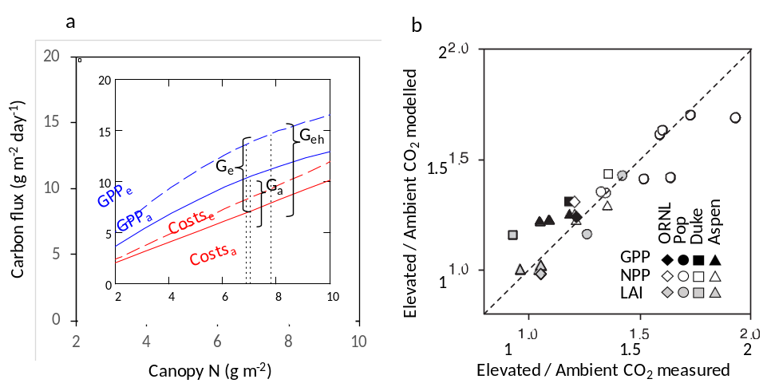
Figure 1. Optimality model of CO₂ and N availability effects in free air CO₂ enrichment (FACE) experiments. a) The hypothesis is that trees optimize canopy N (vertical dotted lines) by maximizing net C gain, G = GPP – Costs, where costs are carbon costs for maintaining the canopy (respiration + leaf and root turnover). Elevated CO₂ (subscript e) increases GPP compared to ambient CO₂ (subscript a), causing a potential large increase in optimal canopy N and net C gain (G_{eh}), which is not realized due to a simultaneous increase in C costs per N uptake (due to soil N limitation), resulting in a smaller net effect (G_{e}). b) Modelled versus measured CO₂ effects on productivity (GPP and NPP) and leaf area index (LAI) in forest FACE experiments with sweetgum (ORNL), loblolly pine (Duke), poplar (Pop), and aspen. r² = 0.83. Adapted from ²⁰.

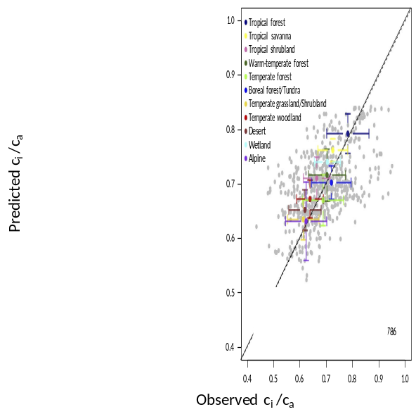
Figure 2. CO₂ uptake parameters predicted by an optimality principle. Using uniform parameters in conjunction with a cost-minimizing optimality hypothesis, a theoretical model predicts the ratio of leaf-internal to ambient CO₂ (c_{i}/c_{a}) – a key index of leaf-level C and water exchange – across the world’s biomes ²³. The inputs are growing-season temperature, vapour pressure deficit and elevation. Observations (based on leaf δ¹³C data) are compared with model predictions. Means and standard deviations are indicated for each biome. Although there is considerable unexplained variation among individual plants (grey points, r² = 0.26), biome means are well predicted by the model (r² = 0.72). The continuous line is the regression line (constrained through the origin); the dashed line is the 1:1 line.

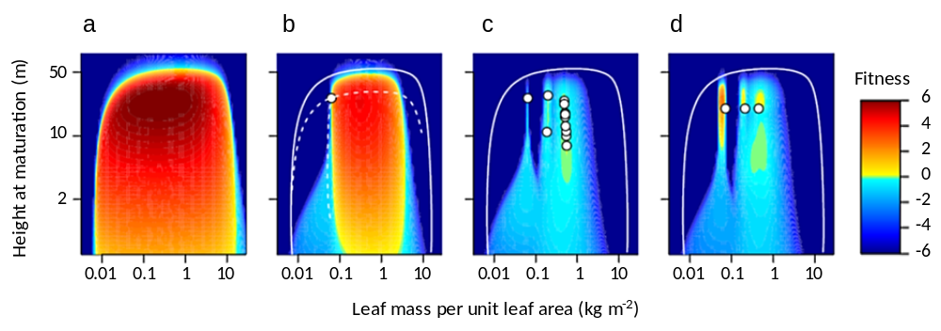
Figure 3. Modelling diverse communities based on evolutionary stable strategies. By modelling reproductive success in competition with existing types (white dots), ESS models estimate the fitness of potential invaders (coloured shading) and use this to guide community assembly. Here species are allowed to vary in two traits, underpinned by physiological trade-offs. a) Initially, a wide variety of trait combinations have positive fitness and could establish. b) Through directional selection, any single species is driven towards a local evolutionary attractor. However, this single species cannot prevent the invasion of other types, if regions of positive fitness occur elsewhere in trait space. c) Through repeated rounds of mutation and selection, an ESS mix may be established, i.e. existing residents all have positive abundance while fitness is zero or negative elsewhere. The ESS trait mixture represents a prediction for the system diversity. d) In traditional models with pre-specified trait combinations, species may coexist, but are not evolutionarily stable – i.e. they could be invaded if new plant types were allowed into the system. In each panel, the solid white line delimits trait combinations that are not viable even in the absence of any competition (pure environmental filtering, as indicated in panel a). In panel b, the dashed white line shows the evolutionary attractors for each trait when allowed to evolve in isolation ⁶⁸.

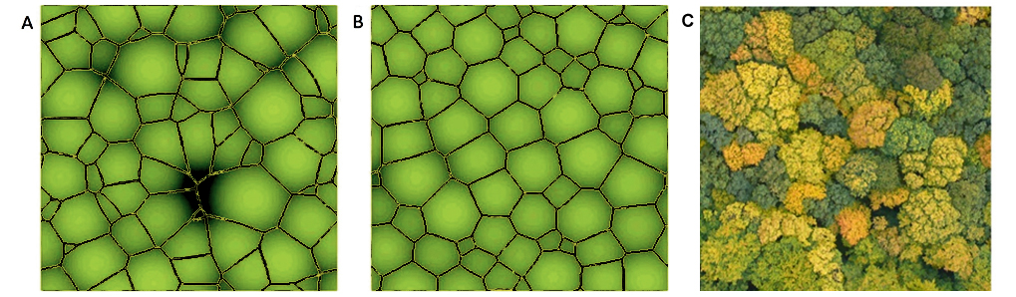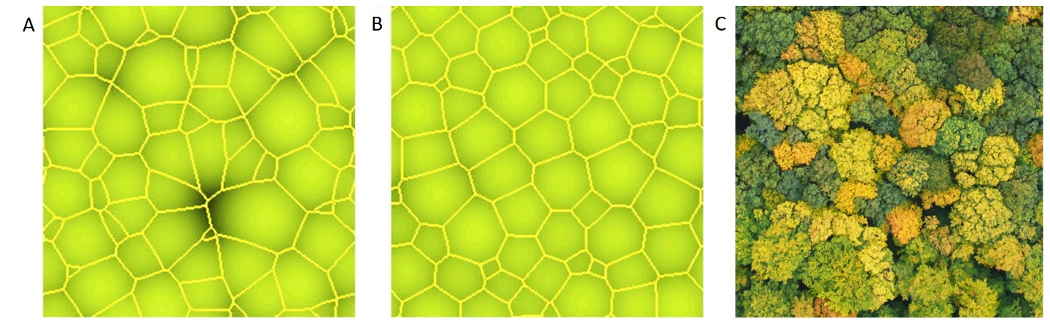
a
b
c
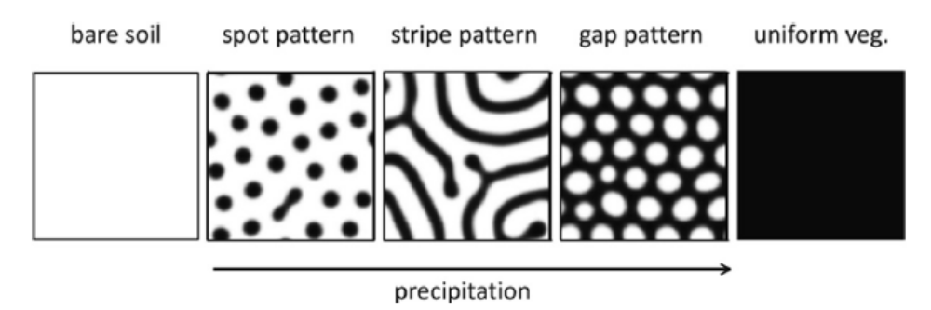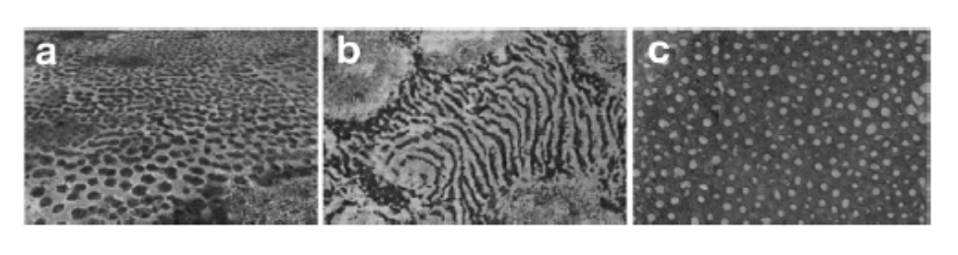
Increasing precipitation
d
Bare soil
Spot pattern
Stripe pattern
Gap pattern
Uniform veg.
Figure 4. Spatial self-organization in ecosystems. a-c) Individual level phototropism leads to emergent regularity in forest crown height and size. Model and forest images from above. a) A forest dynamics model without phototropism ⁸⁴. b) The same forest dynamics model with individual phototropism (individuals allowed a maximum of 5° lean in their trunks). Brightness indicates the height of the canopy. Note with phototropism, canopy height and crown size are more regular. c) Image of a near-natural forest in the Hainich National Park, Germany. Panel a and b are redrawn from ⁸⁴ Figure 7, and c from ¹⁰³ , Figure S1. d) Spatial self-organization in dry lands. Typical sequence of vegetation patterns along a rainfall gradient. Modeled (upper panels) and observed (lower panels), redrawn from ⁹¹.

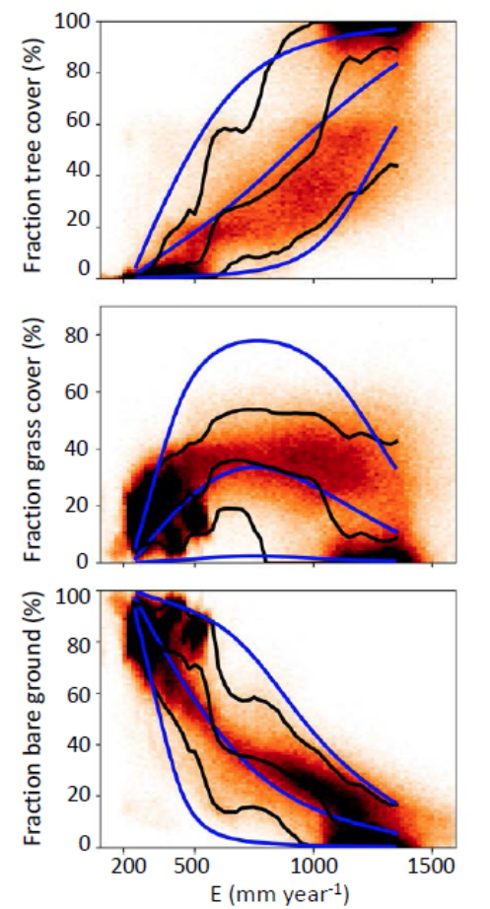
Figure 5. Vegetation distributions predicted by the principle of maximum entropy (MaxEnt). Observed and modelled frequency distributions of tree, grass and bare ground cover fractions vs. mean annual water availability (E) in tropical savannas at a 1 km² resolution. Points: frequency histogram of satellite-based (MODIS) fractional cover estimates sampled from Africa, South America and Australia. Black curves (from bottom to top): 5th percentile, mean, and 95th percentile of the observed sample frequency histogram vs. E. Blue curves (from bottom to top): 5th percentile, mean, and 95th percentile of the modelled frequency distributions vs. E. Adapted from ⁹⁵.

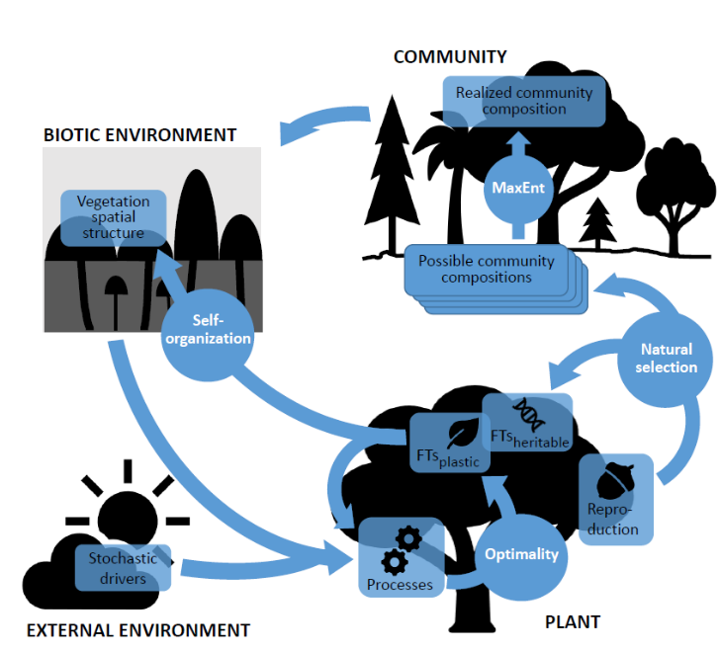
Figure 6. Framework for the use of organizing principles in vegetation modelling. The application of organizing principles (circles, white text) help predict (arrows) vegetation properties (boxes). Natural selection drives the evolution of species (or plant types) and their heritable functional traits, modelled as emergent evolutionary stable strategies. Natural selection is also the reason that phenotypic plasticity in response to environmental variation is predictable through fitness-proxy maximization (optimality). At the community level, collective self-organization among many plants results in predictable patterns of spatial structure at the stand level (e.g. due to plasticity of stem angle, the Perfect Plasticity Approximation). Self-organization influences the biotic environment, which, together with the abiotic (external) environment, feeds back on plant reproduction and survival, i.e. the natural selection of community composition. Many different community compositions may be possible and the most likely can be predicted by entropy maximization (MaxEnt). The external environment includes abiotic factors and all other external drivers, including disturbance regimes.

