Economic and Environmental Evaluation of Nitrogen Removal and Recovery Methods from Wastewater
Yanzi Lin^{ǂ, 1}, Miao Guo^{ǂ, 1}, Nilay Shah ¹, David C. Stuckey^{1,2}*
1. Department of Chemical Engineering, Imperial College London, London SW7 2AZ, UK
2. Nanyang Environment & Water Research Institute, Nanyang Technological University
^{ǂ} Equivalent contribution
*Corresponding author: d.stuckey@imperial.ac.uk;
Abstract
The driver for waste-based economic growth is long-term strategic design, and a paradigm-shift from waste treatment to resource recovery. This study aims to use an integrated modelling approach to evaluate the holistic economic and environmental profiles of three alternative nitrogen removal and recovery methods integrated into wastewater treatment systems, including conventional nitrification-denitrification, Anammox, and the anaerobic ion exchange route, to provide insights into N recovery system designs which are key elements in building a sustainable circular economy. Our results suggest that ion exchange is a promising technology showing high N removal-recovery efficiency from municipal wastewater and delivering competitive sustainability scores. In comparison with the well-developed conventional route, ion exchange and Anammox are undergoing significant research and development; as highlighted in sensitivity analyses, there is considerable room for process design and optimization of ion exchange systems to achieve economically and environmentally optimal performance.

Keywords: nitrification/denitrification; Anammox; Ion exchange; wastewater treatment; Life Cycle Analysis (LCA).

- Introduction
Driven by a range of sustainability challenges e.g. climate change, resource depletion, expanding populations, a novel bioeconomy is emerging which is expected to evolve progressively in the coming decades. The European Commission has adopted a new, ambitious circular economy strategy from late 2015 to transform Europe into a more competitive resource-efficient bioeconomy, where the waste economic sector will play an important role (Eurpean Commission, 2015). A waste-based bioeconomy will not only shift us towards environmental sustainability, but also bring investment opportunities into waste markets. For example, in the UK the potential of a circular bioeconomy is expected to be in £billion, where the significant role of waste-based resources and the future of a waste-based bioeconomy have been highlighted (Science and Technology Committee, 2014). Considerable waste resources (including wastewater and sewage sludge) generated annually in the UK provide significant opportunities, however, the driver for a waste-based bioeconomy is the long-term strategic design and paradigm shift in technology development from waste treatment to resource recovery. Due to the dominance of fossil fuels as the global primary energy supply, depleting non-renewable mineral deposits (e.g. phosphorus), and the increase in resource extraction and production costs e.g. increasing nitrogen fertiliser cost as a consequence of rising natural gas prices), considerable research attention has been paid to resource recovery from carbon-containing or nutrient-rich wastewaters (e.g. struvite recovery). In order to exploit the full potential of waste resources, including wastewater, a modelling approach is needed to effectively assess the holistic environmental and economic performance of diverse processes.
To tackle the environmental risks triggered by wastewater discharge (e.g. deterioration of the water body quality caused by excessive release of N nutrients), the EU has introduced regulations to limit the N level (to lower than 15 mg/L) contained in effluent released from wastewater treatment plant (WWTPs). There are a variety of technologies that can be used to remove nitrogen to meet these discharge regulations. One of the most commonly adopted conventional routes for nitrogen elimination is nitrification/ denitrification, where after carbon removal by aerobic oxidation (usually activated sludge), excess aeration is used to oxidise ammonia to nitrate followed by an anaerobic step to reduce the nitrate to harmless nitrogen gas. In the case of wastewater containing high nitrogen, the addition of an extra electron donor is required; however, this conventional technology is energy intensive and generates large amounts of sludge (Van Hulle et al., 2010). Since the Anammox process was discovered by Arnold Mulder et. al. in the 1990s (Kuenen, 2008), this pathway has resulted in considerable research efforts due to its economic and environmental benefits. Anammox is characterised by the partial oxidation of ammonia to nitrite, which is then used as an electron acceptor in a reduction reaction and converted to nitrogen gas under anoxic conditions. Compared to the conventional pathway discussed above, Anammox requires less energy and oxygen, and does not need an external electron donor. In addition, since the early 2000s, the WWT industry has become increasingly interested in ion exchange, and this technology can remove and recover nitrogen resources from the effluent after carbon removal via anaerobic treatment with an anaerobic membrane bioreactor (AnMBR) for instance.
Mathematical modelling approaches have been widely applied to WWTP process simulation and design, such as biodegradation models for bioreactors e.g. ADM1 (Batstone et al., 2002), or the complex crystallization, adsorption and filtration models for separation units. In this study, the commercial WWTP simulator GPS-X™ (Hydromantis Inc.) based on first principle models, and reliable costing software CAPDETWORKS™ (Hydromantis Inc.), were adopted to simulate alternative N removal processes and project their steady-state performance and costing. In this research, we consider such simulators to be representative of the WWTP operations but not capable of capturing certain complex dynamics – for instance, WWTP simulators use total and volatile suspended solids (TSS VSS) to address total microbial biomass concentration but without accounting for the co-relations between specific bacterial groups and given volatile fatty acids. Future research could be carried out to validate the simulation models by comparing the model outputs with actual WWTP operational data.
As a holistic environmental assessment approach, Life cycle analysis (LCA) quantifies the environmental impacts associated with all stages of a product, service or process from cradle-to-grave. The LCA method has been formalised by the International Organization for Standardization (ISO, 2006), and is becoming widely used to evaluate the holistic environmental aspects and improvement opportunities of various product systems and processes including wastewater treatment. Since the first LCA application to WWTPs by Emmerson et al.(1995), the LCA approach has been increasingly used as a decision-support tool in the field of wastewater treatment for different objectives such as comparing various wastewater and sludge treatment technologies (Foley et al., 2010; Rodriguez-Garcia et al., 2011), identifying improvement options for given processes (Pasqualino et al., 2009; Wang et al., 2012) and LCA-based modelling tool development (Fang et al., 2016). However, only a limited number of LCA studies have examined nutrient removal and recovery technologies (Ontiveros & Campanella, 2013; Rodriguez-Garcia et al., 2014), and there is a big knowledge gap on the comparison of new N removal/recovery routes e.g. ion exchange (Maul et al., 2014). This study aims to investigate the holistic economic and environmental profiles of three alternative N removal and recovery routes integrated into WWTPs, including conventional nitrification-denitrification, Anammox, and ion exchange, to provide scientific insights into N resource recovery options which are instrumental in resolving some environmental problems and building a sustainable circular economy.

2. Methodology
  - Wastewater Treatment Process Simulation
An average wastewater was assumed to flow into the WWTP, and this is detailed in Table 1. As presented in Fig 1A, three N removal and recovery routes for municipal waste water - conventional nitrification/denitrification, Anammox, and an anaerobic route with ion exchange were modelled in this study. The process configurations of the conventional nitrification/denitrification and Anammox pathways were simulated using ManTIS 3 built into GPS-X (v6.4.0), and are given in Figs 1B, 1C respectively, where wastewater treatment systems were assumed to operate at constant flow (assumed as 1000 m³/d). The conventional pathway consists of a nitrification aeration tank and an anoxic reactor where denitrification occurs. A closed-loop recycle was simulated for the conventional pathway, with 50% of the wastewater stream from the aeration tank and secondary clarifier sent back to the anaerobic reactor.
The Anammox pathway comprises three key reactors i.e. AnMBR, SHARON and Anammox reactor. An AnMBR was adopted to remove chemical oxygen demand (COD) under anaerobic conditions with the formation of biogas, whereas the SHARON process (NH₄⁺ converted into NO₂⁻ ), followed by an Anammox tank (NH₄⁺ and NO₂⁻ biologically oxidised/reduced to form N₂ gas) were designed to remove N. The pH of the AnMBR and Anammox tanks were regulated by alkali dosing (Ward et al., 2008) with NaHCO₃, while the pH of the SHARON tank was set at 8.0 by acid dosing with HCl (Van Hulle et al., 2007). To achieve the stoichiometric ratio of the Anammox reaction between NH₄⁺ and NO₂⁻ (molar ratio of 1:1.32), 80% of the AnMBR effluent was fed directly to the Anammox reactor, while the flow rate of clarifier return sludge was adjusted to 1000 m³/d to optimize Anammox.
Natural zeolites and their modified forms have been widely used as adsorbents in separation and purification processes in the past decades due to their low cost, high cation-exchange ability, as well as their molecular sieve properties. In this study, an ion exchange route with a zeolite adsorbent has been modelled although a wide range of other absorbents and their application in ion exchange could be explored in future research. As demonstrated in Fig 1A, the ion exchange route involves an AnMBR and a highly NH₄⁺-selective ion exchanger unit with a Na-form clinoptilolite absorbent. After removing COD and filtering particulate matter, the anaerobic digester supernatant from the AnMBR flowed through the ion exchanger with NH₄⁺ being adsorbed. The relationship between the total exchange capacity of natural zeolite (Q_{e}) and the initial concentration of NH₄⁺ (C₀), was obtained from regression analysis and curve fitting in Matlab from literature data (Wang & Peng, 2010) (Fig S1 in Supplementary Information (SI)). It was assumed that the life-time of zeolites was 20-times reuse without significant degradation in exchange capacity (Wang & Peng, 2010), and the exhausted zeolite resin was regenerated with 0.5 mol/L NaCl solution (Du et al., 2005) to recover NH₄⁺ that could be utilized as N fertilizer (or in conjunction with P to form struvite).
The excess sludge stream generated in WWTP can be disposed of or reused via various routes, e.g. landfill disposal, organic fertiliser for agricultural land, and utilisation for algae cultivation. The excess sludge disposal and reuse issue has not been included in the modelling scope in this current study, but should be explored in more details in further research.
  - Cost Analysis
Net present value (NPV) and cost were adopted as indicators to evaluate the economic performances of different N removal routes. As formulated in Eq.(1), NPV is determined by capital costs (CAPEX), operational costs (OPEX such as energy and labour inputs), value of the saleable products (SALE) and discount rate (i), where CAPEX and OPEX were primarily derived from the database built in CapdetWorks (v2.5), and supplemented by literature data for chemical costs. The costs for N removal systems were calculated based on Eq. (2), where the time-dependent cash flow OPEX was discounted back to the present value. The modelled life span of the WWTP was 20 years, with an operational lifetime of 360 days per year.
$$NPV=-CAPEX+\sum_{n}{\frac{SALE-OPEX}{{\left(1+i\right)}^{n}} (1)}$$
$$Cost=CAPEX+\sum_{n}{\frac{OPEX}{{\left(1+i\right)}^{n}}} (2)$$
where CAPEX, OPEX and SALE denote capital cost, operational cost and the value of saleable product, respectively, i refers to discount rate, equal to 8% in CapdetWorks; n represents year.
  - Life Cycle Analysis
An attributional LCA approach was adopted to compare the environmental footprints of three N removal and recovery pathways. The LCA functional unit was defined as ‘per unit (1kg) of nitrogen removed from municipal wastewater stream via a given N removal/recovery route integrated into a WWTP with a 20-year life span’ to enable different technology-driven WWTP systems to be comparable. The life-cycle stage and sub-systems modelled within the LCA system boundary for WWTP are illustrated in Fig S2 in Supplementary Information (SI), including the WWTP infrastructure, operational inputs and emissions over the WWTP life time (assumed as 20 years). The excess sludge disposal or reuse has been excluded from the system boundary. A ‘substitution’ allocation approach was applied where multiple-products occurred in the WWTP system stage, i.e. treated effluents plus nutrient recovered from WWTPs sold as fertiliser replacement, or green electrical power generated from the CHP system and exported to the UK national grid. The ‘functional equivalent’ quantity of UK national average inorganic fertilizers was allocated as an ‘avoided burden’ to the nutrient recovered, whereas the green electricity co-product was assumed to displace the need for that amount of electricity to be generated from fossil fuels within the UK national grid system. This allocation approach therefore assigns all the environmental burdens of the WWTP process treated water, but credits the WWTP system with an ‘avoided burdens’ credit of the emissions and fossil fuel consumption that would have been incurred by generating that amount of electricity or fertiliser conventionally.
A midpoint approach CML 2 baseline 2000 was applied as a characterisation method at the life cycle impact assessment (LCIA) stage. The LCA model was implemented in Simapro V 8.0, and the key parameters accounted for in the model are given in Table 1. The total environmental impacts of the WWTP system can be summarised as Eq. (3).
$$EI_{kpi}=\sum_{r}{\sum_{s}{{EIf}_{r,kpi}^{in}F_{r,s}^{in}}}X_{r,s}^{in}+\sum_{c}{\sum_{s}{{EIf}_{c,kpi}^{out}F_{c,s}^{out}X_{c,s}^{out} (3)}}$$
Where the variable $EI_{kpi}$denotes the total environmental impacts of the WWTP (per functional unit) expressed as environmental indicator kpi (e.g. Global Warming Potential). $EI_{kpi}$ is determined by the characterisation impact factors for input resource r (${EIf}_{r,kpi}^{in}$) or emitted/output compound c (${EIf}_{c,kpi}^{out}$), and the input-output flows ($F_{r,s}^{in} or F_{c,s}^{out}$) and concentration ($X_{r,s}^{in} orX_{c,s}^{out})$at life cycle stage s (e.g. operational stage, WWTP infrastructure production). The ‘avoided burdens’ flows (${EIf}_{c,kpi}^{out}$) are represented as negative values.
The LCA inventory was primarily based on the input-output flows simulated using Mantis 3 (built in GPS-X) where the chemical and energy production processes were derived from the Eco-invent database (built in Simapro 8.0). A scenario sensitivity analysis method was also applied in this study, which involves calculating different scenarios to analyse the influences of input parameters on either LCIA output results, or rankings (Guo & Murphy, 2012). A reversal of the rank order of counterparts for LCA comparisons, and an arbitrary level of a 10% change in the characterized LCIA profiles for a single product system were chosen as the sensitivity threshold, above which the influence of system boundary, zeolite exchange capacity was considered to be significant.

3. Results and Discussion
  - Process Simulation
The treatment of the influent wastewater via three N removal pathways at a constant flow rate of 1000 m³/d was simulated using GPS-X. The derived effluent components of the supernatant of the clarifiers, the amount of gases generated from the reactors, and the electrical energy input requirements are given in Table 2. The COD, N and P flows are illustrated in Fig S3 in SI. In contrast to the conventional route, COD removal in Anammox and ion exchange was achieved via anaerobic digestion occurring in the AnMBR, which leads to energy recovery via biogas production and combustion.
The biogas composition derived from simulations in this study (approximately 76% v/v CH₄ and 7% v/v of N₂) differ from most of the results reported in the literature, i.e. above 95% v/v of the biogas comprised of CH₄ and CO₂ with 65% v/v CH₄ (Liew Abdullah et al., 2005). This can be explained by a number of factors: 1) high CH₄ content in the gas phase due to a relatively low solubility (around 15 mL/ 1000mL water at 1 atm and 35℃) of CH₄ in the aqueous phase compared with CO₂ (dissolved in the bulk solution and partially generates bicarbonate ion (Hu & Stuckey, 2006); 2) a methane-rich biogas resulting from a favourable balance between methanogenic and acidogenic bacteria (Saddoud et al., 2007); 3) low CO₂ contents in the biogas caused by the pH controlled at 7.0, and the low alkalinity of the bulk liquor (about 1110 mg/L CaCO₃) (Lin et al., 2011); 4) very short HRTs leading to more soluble CO₂ exiting in the effluent and CH₄ contents increasing to around 75%. Similar biogas compositions with over 70% or even 80% v/v CH₄ have been reported in several studies (Hu & Stuckey, 2006; Weiland, 2009). The relatively high N₂ content may be caused by: 1) the sparging gas initially used in the headspace of reactor (Hu et al., 2006), or gas entering with the inlet feed and stripped out in the reactor; 2) possible N₂ generation from denitrification even at low NO₃⁻ concentration in the influent (Lin et al., 2011).
The anaerobic route with ion exchange demonstrated superior N removal performance (complete elimination of nitrogen) compared to the conventional and Anammox routes (Table 3), whereas Anammox is widely considered as cost-saving and energy-efficient compared with the conventional pathway (Zhao et al., 2015). Generally, conventional nitrification followed by denitrification is used for low-N wastewater due to the advantages of high process stability, relatively easy process control, low land requirements and moderate costs (Van Hulle et al., 2010). For high-N wastewater, an external carbon source is required, and oxygen requirements increase with the rise in N concentration. In contrast, Anammox requires much lower (60% lower) oxygen than conventional routes, and zero extraneous carbon sources. Thus, Anammox is usually employed in treating high concentration nitrogen streams with a C/N ratio lower than 1.0, and incurs lower costs than the conventional pathway to achieve the same N removal performance. However, the simulations in the current study demonstrated different research findings - Anammox underperformed in comparison with conventional treatment in terms of its costs and energy profiling (Table 2, and section 3.2). This can be explained by the high C/N ratio (12.5) and sufficient COD present in the influent wastewater for denitrification, which led to the simulated conventional pathway with a denitrification tank placed before nitrification treatment, requiring zero external carbon source and low oxygen inputs.
The high phosphorus concentrations in the effluent from ion exchange were caused by no phosphorus removal occurring (Table 2); in conventional and Anammox pathways, biological consumption of phosphorus takes place. Under anoxic conditions, phosphate- accumulating organisms (PAOs) convert readily available organics to polyhydroxyalkanoates (PHAs), while poly-phosphate degradation provides the energy for microbial synthesis, and hence phosphorus is released (United States Environmental Protection Agency, 2007); this could explain the increase in phosphorus concentrations after anaerobic digestion. In the subsequent aerobic environments (e.g. SHARON and nitrification tank), PAOs utilise the stored PHAs as an energy source to consume the phosphorus generated under anoxic conditions (United States Environmental Protection Agency, 2007). In addition, some denitrifying PAOs could take up nitrate as an electron acceptor instead of oxygen to consume phosphorus. These confirm the simulation results that the total phosphorus level dropped during Anammox, and decreased significantly after treatment by the conventional route, but slightly increased via ion exchange treatment (Tables 1 and 2, Fig S3 in SI).
  - Economic analyses
The NPV and cost breakdown of the three N-removal methods are listed in Tables 4-6, where the biogas produced via anaerobic digestion and ammonium recovered via ion exchange were considered as marketable products with the assumed price of $0.296/m³ biogas fuel and $0.882/kg N fertiliser, respectively. These led to Anammox and ion exchange with annual economic savings of $36,977.4 from biogas generation, and $14,033.6 due to ammonium fertiliser recovery.
As stated in section 2.2, CAPEX and OPEX were primarily derived from the database built in CapdetWorks (v2.5); whereas the ion exchange resin costs were estimated according to the reported industrial prices of zeolite and NaCl - $165/tonne and $50/tonne (US Geological Survey, 2014), which are equivalent to annual costs of $4807/yr, and $297/yr respectively.
As presented in Fig 2, although cost profiling differed between three N removal pathways, the CAPEX costs, particularly construction, dominate and account for over 50% of total costs, followed by operational and amortization costs. For treating per unit of N, the anaerobic route with ion exchange represents the most economically competitive option in comparison with the other two routes due to its favourable biogas yields and relatively low CAPEX and OPEX inputs (compared with Anammox). Our research findings suggested that further WWTP research should emphasise CAPEX planning and optimisation to improve the economic performance of N-removal and recovery systems, particularly for infrastructure-intensive routes such as Anammox simulated as in this study.
3.3 Environmental evaluation
The input-output flows simulated using Mantis 3 were fed into the LCA model for environmental performance evaluation. For ion exchange, the data obtained from process simulation detailed in section 2.1 have been used in the LCA where the synthetic zeolite production route has been used as a surrogate dataset for the Na-form clinoptilolite absorbent.
3.3.1 LCIA comparison of three N removal routes
As demonstrated in Fig 3, the conventional nitrification/denitrification route represents the most environmentally friendly N-removal option on most impact categories, except for global warming potential (GWP100) and ozone layer depletion (ODP) where the conventional route delivers higher impacts compared to other options due to high CO₂ emissions and zero resource recovery. Unlike ion exchange and Anammox which result in energy and fertiliser recovery potential, the conventional N-removal route focuses solely on waste treatment and pollutant removal, converting COD to CO₂ via oxidation reactions but without C and N recovery. Overall, the anaerobic route with ion exchange shows better environmental performance than Anammox in abiotic depletion, acidification, GWP100, ODP and photochemical oxidation (POCP), but cannot compete with Anammox in eco- and human toxicity impact categories, while ion exchange and Anammox incur similar eutrophication impacts (Fig 3).
The environmental footprints of ion exchange and Anammox in eutrophication were driven mainly by phosphorus emissions (Fig 4), particularly the high phosphorus concentrations in the effluent from ion exchange due to exclusion of a phosphorus removal unit (Table 2). However, only N removal was investigated under the current LCA system boundary; system boundary expansion with the inclusion of phosphorus removal might change these research findings, and this is explored in the sensitivity analysis (section 3.5.1).
3.3.2 LCA contributional analysis for the anaerobic route with ion exchange
20-45% of the total environmental burdens of the ion exchange route (above line) can be attributable to the infrastructure inputs (e.g. concrete, steel) due to the pollutants generated during the production of construction materials. These include the GHG (e.g. CO₂), acidification and eutrophication emissions (SOx and phosphate) due to energy consumption (e.g. fuel extraction and combustion), and chemical inputs (e.g. lime for concrete production) as well as the toxic compound release (e.g. chromium, mercury CBrClF₂ emitted to air and the cobalt, nickel ions, vanadium ions released to water). The zeolite adsorbent was another environment-damaging contributor to the ion exchange system, dominating most of the impact categories (Fig 4). Zeolite production incurred significant environmental burdens due to the energy-intensive synthetic process which represents most commercially-produced zeolite (production out of aluminium, sodium silicate and sodium hydroxide). These LCA findings highlight the importance of research on exchange capacity and zeolite recovery and reuse. However, it should be noted that such surrogate zeolite processes might not represent the natural occurring zeolite and its cradle-to-gate life cycle (extraction, purification, and other downstream processing). The effects of exchange capacity and zeolite re-use were explored in the sensitivity analysis (section 3.5.2).
Resource recovery (electricity and N fertiliser) brought environmental savings (negative credits below the line in Fig 4) to the ion exchange route by energy substitution and avoidance of making fossil fertilisers.
3.3.3 LCA contributional analysis for Anammox
The environmental impacts of Anammox were mainly caused by the operational related flows (e.g. high voltage electricity) and capital inputs (e.g. concrete and steel) (Fig 4). The former and latter contributed 10-50% and 40-90% of environmental burdens (above the line) on most impact categories, respectively, except for eutrophication, which was driven by the phosphorus present in discharged effluent.
10-50% of the total burdens across all impact categories can be attributable to the projected high electricity inputs for Anammox (839 kWh/day, five times higher than conventional route). The UK national grid electricity sourced mainly from coal and natural gas did not favour the Anammox route, which not only led to fossil fuel resource depletion, but also resulted in emissions from fuel production and combustion. These can be explained by: 1) atmospheric emissions (NH₃, SOx, NOx, CH₄ and CO) released from natural gas, fuel oil and coal combustion, and phosphorus emitted to water during coal production, contributing to the environmental burdens on acidification, eutrophication, GWP100 and POCP; 2) ODP emissions (CCl₄, CBrF₃, CBrClF₂) evolved from fuel extraction, production and natural gas transportation; 3) toxic compounds from fuel production and combustion processes or electricity transmission (e.g. barite, PAH released from natural gas production and combustion, mercury, arsenic and PAH emitted from hard coal burning, soil emission chromium from electricity transmission).
Anammox has been simulated as an infrastructure-intensive route where four tanks were employed, including one secondary clarifier and three bioreactors. The production of major infrastructure materials such as concrete (12% w/w Portland cement and 78% w/w aggregate (Wilson, 1993)) and steel are energy-intensive, pollutant-emitting processes, such as the waterborne emissions e.g. phosphate, nickel, vanadium from coal mining (fuel for electricity generation), GHGs and other gaseous (e.g. CO, NO_{x}) released from fuel combustion during steel production. Our LCA results highlighted the research needs for process design and optimisation to achieve the trade-off between N removal efficiency and minimised environmental impacts associated with operational and capital input-output flows. A reduction in the number of reactors involved in the process could be an option to decrease capital inputs e.g. substitution of Anammox and SHARON treatment with the OLAND process in a single reactor.
3.4 Integrated sustainability evaluation
A range of environmental issues, e.g. increasing GHG levels and the depleting fossil resources, have triggered global/regional/national regulations mandating environmental protection measures within industry, such as the EU Emission Trading System which introduced a GHG cap and trade scheme to combat climate change. Particularly for WWTP systems, high effluent water quality is generally accompanied by high expense, and vice versa. Thus it is important to adopt quantitative decision-making tools to consider multiple economic and environmental criteria, and evaluate the overall sustainability of WWTP pathways.
A normalized spider chart has been introduced in this study to illustrate the three pathways with seven indicators - cost, eutrophication, GWP100, ODP, POCP, acidification and abiotic depletion for the removal of per unit (1 kg) nitrogen. In future research, a weighting system could be explored to monetise the environmental issues and convert all the economic and environmental criteria into a single sustainability score. In the spider chart (Fig 5), environmental impacts and costs are normalised and represented as a percentage, where the highest score on each indicator is assigned as 100%. The route with the largest occupied area represents the inferior system. As shown in Fig 5, overall the ion exchange route performs best, with a superior costing profile, and environmental advantages on ODP, GWP100, and acidification despite its high eutrophication burdens.
3.5. Sensitivity Analysis
Sensitivity analyses were performed to understand the effects of varying key parameters on the LCIA profiles of ion exchange routes.
    - System Boundary expansion
In this section, an expanded system boundary, i.e. inclusion of P removal in the ion exchange route was investigated. The major form of phosphorus in wastewater is phosphate (PO₄³⁻), and it can be removed using another zeolite column (anion exchanger); the amount of zeolite required for phosphate elimination is based on engineering estimates. Regardless of the real exchange capacity of zeolite for phosphate, the total mass of zeolite required to remove both nitrogen and phosphorus is 1.25 times higher than that required for N removal. As shown in Figure 6, the inclusion of phosphorus treatment leads to a significant reduction (97% decrease) in the eutrophication impacts of ion exchange, and a reversal in the ranking in eutrophication and POCP. Benefiting from eliminating P release, ion exchange with N and P removal represented a superior system in eutrophication compared to other routes; however, the increase in zeolite inputs for P removal brought environmental disadvantages to ion exchange which shifted it to the inferior option in terms of POCP. Based on our chosen 10% sensitivity threshold, the environmental profile of the anaerobic ion exchange route in almost all impact categories is sensitive to the expanded system with P removal.
    - Exchange capacity of zeolite
As discussed in a previous section (3.3), increasing the exchange capacity and number of reuse times decreases the zeolite inputs, and the exchange capacity can vary from 0.64 meq/g to 2.29 meq/g (i.e. 11.5 mg/g to 41.2 mg/g (Wang & Peng, 2010)). The capacity range of 12.13 mg/g to 18.19 mg/g ($±$10-20%) were investigated in the sensitivity analysis – the results indicated that the influence of exchange capacity on LCIA profiles vary with scenarios and impact categories (as shown in Fig 6 and Fig S4 in SI). With an assumption of increased exchange capacity, the overall environmental profiles of ion exchange shifted dramatically (with 10-200% impact reduction, except for eutrophication), which is above our chosen sensitivity threshold; however, the eutrophication scores are not sensitive to the capacity change. The LCIA ranks in abiotic depletion shifted while exchange capacity increased by 20% - ion exchange moved to an advantageous position with regards to the other two routes. Our research outcome indicated that the greatest potential for ion exchange could be achieved via the addition of phosphorus eliminating unit, and selection of a high-performance zeolite adsorbent.

4. Conclusion
The study was carried out to evaluate three alternatives to remove and recover nitrogen from municipal wastewater i.e. conventional nitrification-denitrification, Anammox and anaerobic route with ion exchange. Our modelling results demonstrate that ion exchange as a promising technology has great potential to achieve high N removal efficiencies and deliver economically and environmentally optimal performance via process design and optimization. Our research highlights the insights such integrated modelling tools as proposed in this study could provide for decision-making on waste resource recovery system designs which will underpin the transition towards a sustainable circular economy.

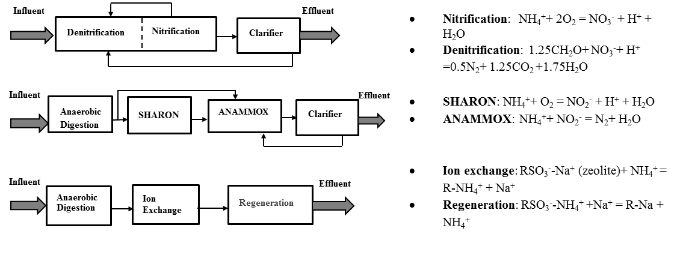
A
Aeration Tank:
Dissolved oxygen=2 mg/L ^{c}
Temperature=20°C ^{c}
PH=7.2-8.5 ^{c}
HRT= 2 hours ^{c}
SRT= 9 days ^{c}

B
Anoxic Tank:
Dissolved oxygen=0
Temperature=20°C ª
PH=7-8 ª
HRT= 4 hours ^{b}
SRT= 9 days ^{b}
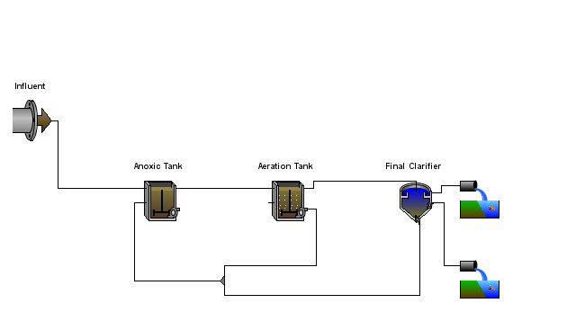
C
SHARON:
Temperature=35°C ^{d}
PH=8 ^{f}
HRT=1 day ^{h}
SRT= 1 days ^{h}
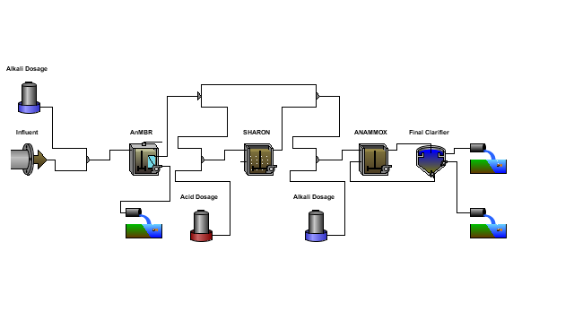
Anammox:
Temperature=35°C ^{d}
PH=7-8 ^{e}
HRT=6 hours ^{i}
SRT= 15 days ^{i}
AnMBR:
Temperature=35°C ^{d}
PH=7-8 ^{e}
HRT=6 hours ^{g}
SRT= 100 days ^{g}
Figure 1 Three N removal and recovery pathways (A) – GPS-X model configuration for conventional pathway (B) and Anammox (C) Notes a.(Fillos et al., 1996); b.(Kivaisi, 2001); c.(Metcalf and Eddy Inc., 2002; Randall & Buth, 1984); d. (Hu & Stuckey, 2006); e. (Ward et al., 2008); f. (Van Hulle et al., 2007); g.(Huang et al., 2010); h.(van Dongen et al., 2001); i. (Strous et al., 1999)

Figure 2. Cost profiles of three N removal and recovery pathways
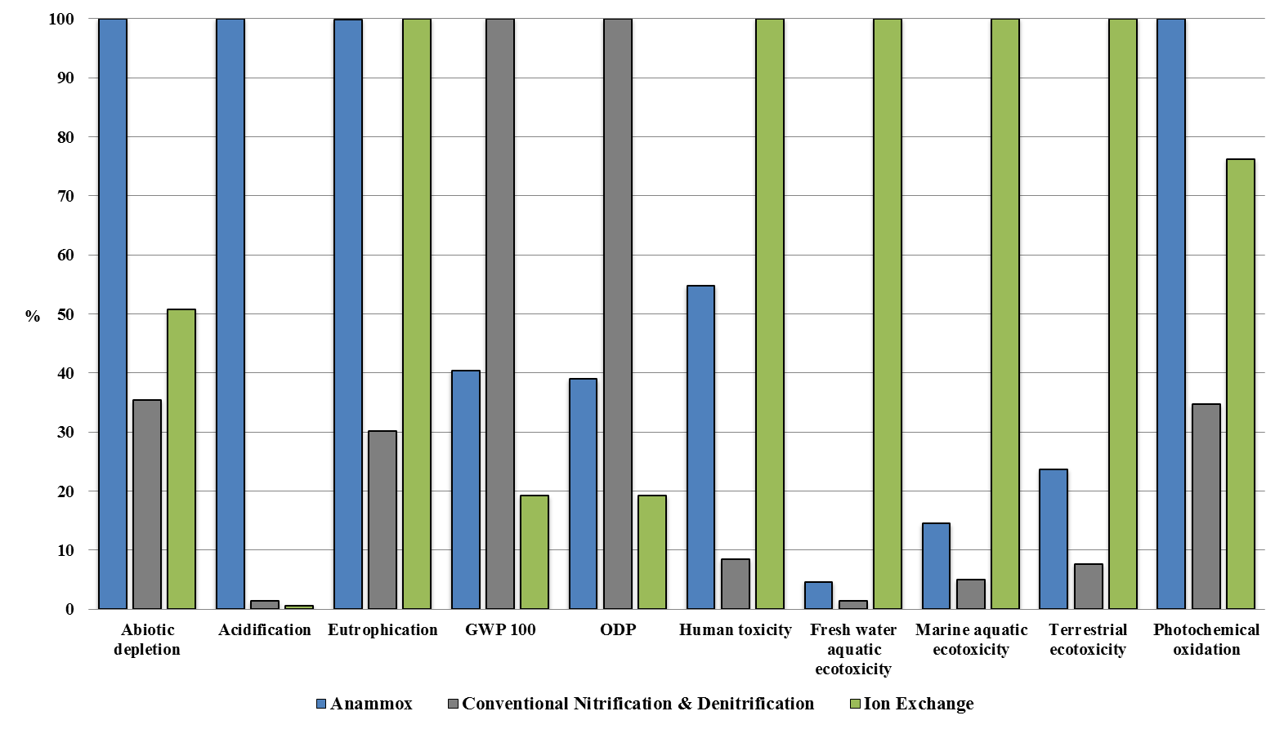
Figure 3 LCIA comparisons of three nitrogen removal and recovery pathways (per functional unit, Method: CML 2 baseline 2000 V2.05)

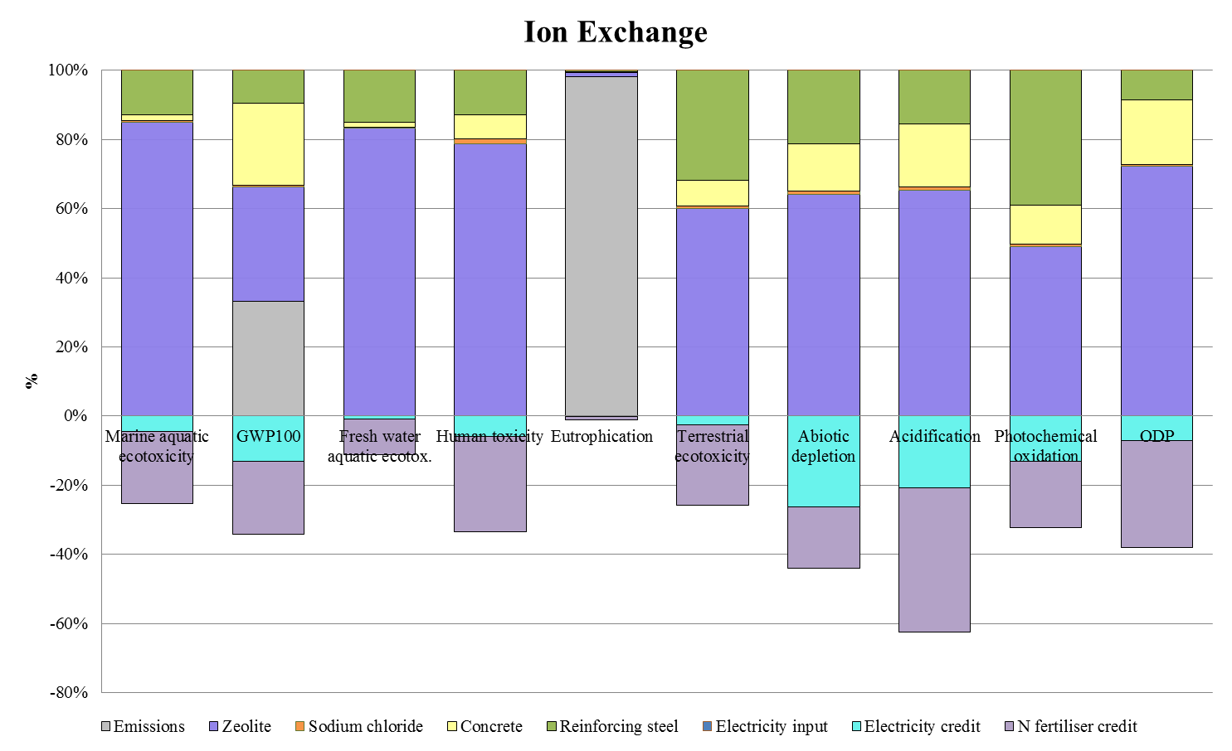
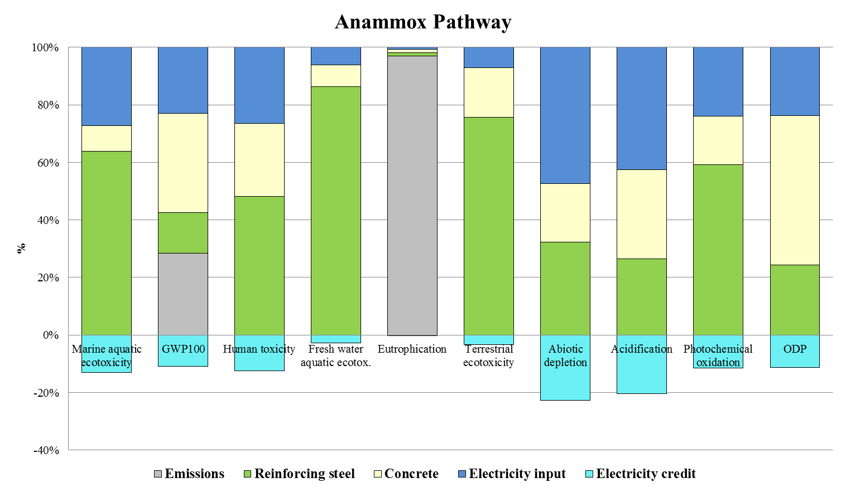
Figure 4 Contributional analysis - characterised LCIA profiles of N removal and recovery pathways (per functional unit, Method: CML 2 baseline 2000 V2.05)

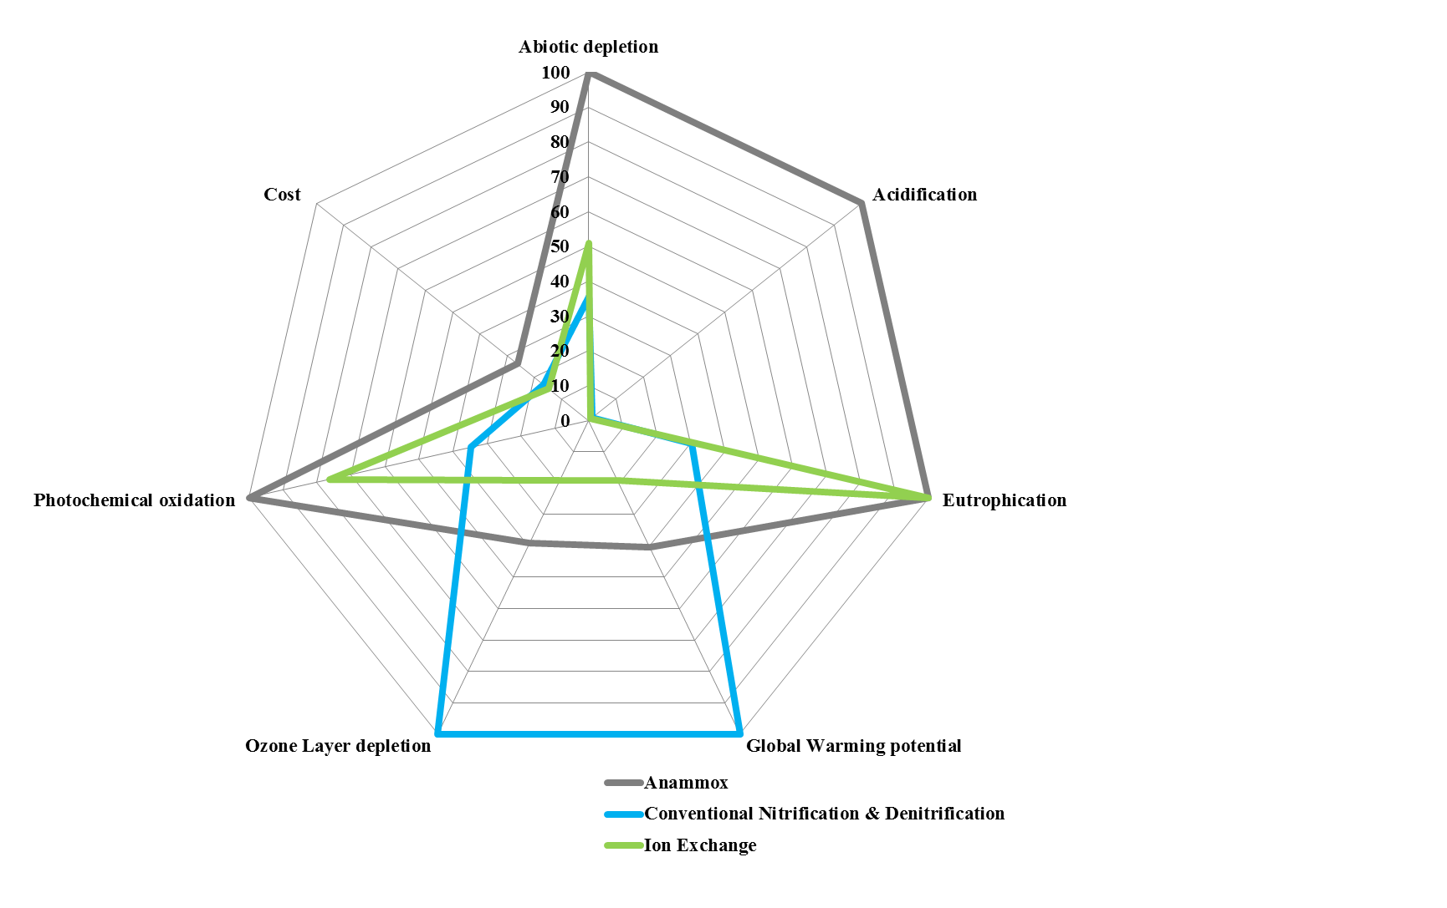
Figure 5 Sustainability of three nitrogen removal and recovery pathways

Figure 6 LCA sensitivity analysis on system boundary definition and ion exchange capacity (per functional unit, Method: CML 2 baseline 2000 V2.05)
Table 1 Wastewater characteristics and LCA model parameters
Wastewater composition(Henze & Comeau, 2008)
Component |  | Unit |  |  |  | Quantity
TSS |  | mg/L |  |  |  | 384
VSS |  | mg/L |  |  |  | 307
cBOD₅ª |  | mg/L |  |  |  | 367
COD |  | mg/L |  |  |  | 750
Soluble COD |  | mg/L |  |  |  | 294
Ammonia N |  | mg N/L |  |  |  | 45
Nitrite + Nitrate N |  | mg N/L |  |  |  | 0.2
TKN |  | mg N/L |  |  |  | 60
TN |  | mg N/L |  |  |  | 60
Soluble PO₄-P |  | mg P/L |  |  |  | 10
Organic P |  | mg P/L |  |  |  | 5
TP |  | mg P/L |  |  |  | 15
pH |  | - |  |  |  | 7.0
Parameter setting in LCA model
Pathway | Saving Credits |  | Input  (Material) | Input  (Energy) | Output  (Emission to water) |  | Output  (Emission to air)
Conventional Pathway | - |  | - | High voltage electricity | Wastewater treated by conventional pathway |  | CO₂
Anammox | Mixed electricity |  | - | High voltage electricity | Wastewater treated by Anammox |  | Combustion products of biogas
Ion Exchange | Mixed electricity |  | Zeolite | High voltage electricity | Wastewater treated by Ion exchange |  | Combustion products of biogas
Ion Exchange | Ammonium fertilizer |  | NaCl | High voltage electricity |  |  | Combustion products of biogas
Notes: a. CBOD=carbonaceous Biochemical Oxygen Demand
Table 2 Composition of effluent stream in three N removal/recovery pathways
Effluent Component | Conventional Pathway | Anammox Pathway | Ion Exchange Pathway
TSS ª | 9.6 mg/L | 13.3 mg/L | 0.5 mg/L
VSS ª | 6.8 mg/L | 0.1 mg/L | 0.3 mg/L
cBOD₅ ª | 7.3 mg/L | 2.2 mg/L | 39 mg/L
COD ª | 46 mg/L | 26 mg/L | 0
Ammonia N | 2 mg N/L | 7.3 mg N/L | 0
Nitrite N | 2.8 mg N/L | 6.2 mg N/L | 0
Nitrate N | 7.5 mg N/L | 0 | 0
TKN ª | 4.9 mg N/L | 8.6 mg N/L | 0
TN ª | 15.3 mg N/L | 18.4 mg N/L | 0
Soluble PO₄-P | 0.2 mg P/L | 4.6 mg P/L | 11.1 mg P/L
TP ª | 0.8 mg P/L | 4.8 mg P/L | 11.1 mg P/L
Biogas composition from ion exchange/Anammox and emissions from conventional route
CH₄ | - | 264 m³/d | 264 m³/d
CO₂ | 862 tonnes/ yr | 56 m³/d | 56 m³/d
H₂ | - | 2.6 m³/d | 2.6 m³/d
N₂ | - | 25 m³/d | 25 m³/d
Emissions from Biogas (use V_{m}=22.4 L/mol at 298K)
CO₂ | - | 628 g/d | 628 g/d
H₂O | - | 531 m³/d | 531 m³/d
NO_{x} (as NO₂) | - | 51.4 g/d | 51.4 g/d
Electricity input-output
Electricity generation | - | 416.8 kWh/d | 416.8 kWh/d
Electricity inputs | 174 kWh/d | 839 kWh/d | 0.6 kWh/d^{b}
Notes a) TSS=total suspended solids; VSS= volatile suspended solids; CBOD=carbonaceous Biochemical oxygen demand; COD=Chemical oxygen demand; TN=total nitrogen; TKN=total Kjehldahl nitrogen; TP=total phosphorus. b) Electricity inputs for AnMBR simulated using GPS-X

Table 3 The system performance of three nitrogen removal and recovery pathways
Pathway | Influent TN Concentration (mg/L) | Effluent TN Concentration (mg/L) | Mass of Nitrogen Removed per day (kg) | Nitrogen Removal Efficiency
Conventional Pathway | 60 | 15.3 | 44.7 | 74.4%
Anammox Pathway | 60 | 18.4 | 41.6 | 69.3%
Ion Exchange | 60 | 0 | 60 | 100%

Table 4 Economic analysis of conventional pathway
NPV | Construction | Operation (per year) | Maintenance (per year) | Material  (per year) | Chemical  (per year) | Energy  (per year) | Amortization  (per year)
-$5,326,937 | $2,840,000 | $107,000 | $28,100 | $17,000 | - | $25,800 | $75,400
Total cost for eliminating 1 kg nitrogen = $16.6/ kg N
Process Summary
Pre-nitrificatioin | $480,000 | $49,000 | $21,300 | $15,700 | - | $25,100 | $45,000
Secondary  Clarifier | $143,000 | $14,700 | $6,840 | $1,340 | - | $778 | $13,500
Blower  System | $201,000 | - | - | - | - | - | -
Other Costs | $2,010,000 | $43,100 | - | - | - | - | -

Table 5 Economic analysis of Anammox pathway
NPV | Construction | Operation  (per year) | Maintenance  (per year) | Material  (per year) | Chemical  (per year) | Energy  (per year) | Amortization  (per year)
-$7,498,319 | $4,210,000 | $112,000 | $29,000 | $57,100 | - | $26,800 | $147,000
Cost for eliminating 1 kg nitrogen = $26.2/ kg N
Process Summary
Anaerobic Digestion  Tank | $583,000 | $30,900 | $13,200 | $26,900 | - | $20,500 | $53,100
SHARON  Tank | $246,000 | $14,000 | $5,350 | $12,700 | - | $2,980 | $21,800
Anammox  Tank | $201,000 | $12,000 | $4,960 | $9,070 | - | $1,150 | $17,900
Filtration | $182,000 | $924 | $456 | $6,610 | - | $219 | $18,200
Blower  System | $217,000 | - | - | - | - | - | $182,000
Other Costs | $2,600,000 | $43,100 | - | - | - | - | -

Table 6 Economic analysis of ion exchange pathway
NPV | Construction |  | Operation (per year) |  | Maintenance (per year) |  | Material  (per year) |  | Chemical  (per year) |  | Energy  (per year) |  | Amortization  (per year)
-$5,791,669 |  | $3,510,000 |  | $74,400 |  | $37,300 |  | $34,200 |  | $5,104 |  | $19,400 |  | $113,000
Cost for eliminating 1 kg nitrogen = $14.6/ kg N
Process Summary
Anaerobic  Digestion  Tank |  | $595,000 |  | $30,300 |  | $13,000 |  | $27,500 |  | - |  | $19,200 |  | $54,000
Cation Exchange |  | $240,000 |  | - |  | $23,800 |  | - |  | $5,103.83 |  | - |  | $24,400
Filtration |  | $182,000 |  | $924 |  | $458 |  | $6,610 |  | - |  | $219 |  | $18,200
Blower  System |  | $192,000 |  | - |  | - |  | - |  | - |  | - |  | $16,100
Other Costs |  | $2,300,000 |  | $43,100 |  | - |  | - |  | - |  | - |  | -

Acknowledgement
We gratefully acknowledge Dr Benoit Chachuat for kindly providing access to GPS-X and CapdetWorks. We wish to acknowledge Dr Channarong Puchongkawarin for kindly sharing his expertise in GPS-X simulation.
References
- Batstone, D.J., Keller, J., Angelidaki, I., Kalyuzhnyi, S.V., Pavlostathis, S.G., Rozzi, A., Sanders, W.T.M., Siegrist, H., Vavilin, V.A. 2002. Anaerobic Digestion Model No. 1 (ADM1), IWA task group for mathematical modelling of anaerobic digestion processes.
- Du, Q., Liu, S., Cao, Z., Wang, Y. 2005. Ammonia removal from aqueous solution using natural Chinese clinoptilolite. Separation and Purification Technology, 44(3), 229-234.
- Emmerson, R.H.C., Morse, G.K., Lester, J.N., Edge, D.R. 1995. The Life-Cycle Analysis of Small-Scale Sewage-Treatment Processes. Water and Environment Journal, 9(3), 317-325.
- Eurpean Commission. 2015. Moving towards a circular economy. Eupean Commission
- Fang, L.L., Valverde-Perez, B., Damgaard, A., Plosz, B.G., Rygaard, M. 2016. Life cycle assessment as development and decision support tool for wastewater resource recovery technology. Water Research, 88, 538-549.
- Fillos, J., Diyamandoglu, V., Carrio, L.A., Robinson, L. 1996. Full-Scale Evaluation of Biological Nitrogen Removal in the Step-Feed Activated Sludge Process. Water Environment Research, 68(2), 132-142.
- Foley, J., de Haas, D., Hartley, K., Lant, P. 2010. Comprehensive life cycle inventories of alternative wastewater treatment systems. Water Research, 44(5), 1654-1666.
- Guo, M., Murphy, R.J. 2012. LCA data quality: Sensitivity and uncertainty analysis. Science of The Total Environment, 435–436, 230-243.
- Henze, M., Comeau, Y. 2008. Wastewater Characterization. in: Biological Wastewater Treatment: Principles Modelling and Design, (Eds.) M. Henze, M.C.M. van Loosdrecht, G.A. Ekama, D. Brdjanovic, IWA Publishing, . London, UK.
- Hu, A.Y., Stuckey, D.C. 2006. Treatment of Dilute Wastewaters Using a Novel Submerged Anaerobic Membrane Bioreactor. Journal of Environmental Engineering, 132(2), 190-198.
- Huang, H., Xiao, X., Yan, B., Yang, L. 2010. Ammonium removal from aqueous solutions by using natural Chinese (Chende) zeolite as adsorbent. J Hazard Mater, 175(1-3), 247-52.
- ISO. 2006. Environmental management —Life cycle assessment —Principles and framework, (Ed.) ISO, British Standards Institution.
- Kivaisi, A.K. 2001. The potential for constructed wetlands for wastewater treatment and reuse in developing countries: a review. Ecological Engineering, 16(4), 545-560.
- Kuenen, J.G. 2008. Anammox bacteria: from discovery to application. Nat Rev Micro, 6(4), 320-326.
- Liew Abdullah, A.G., Idris, A., Ahmadun, F.R., Baharin, B.S., Emby, F., Megat Mohd Noor, M.J., Nour, A.H. 2005. A kinetic study of a membrane anaerobic reactor (MAR) for treatment of sewage sludge. Desalination, 183(1–3), 439-445.
- Lin, H., Chen, J., Wang, F., Ding, L., Hong, H. 2011. Feasibility evaluation of submerged anaerobic membrane bioreactor for municipal secondary wastewater treatment. Desalination, 280(1–3), 120-126.
- Maul, G.A., Kim, Y., Amini, A., Zhang, Q., Boyer, T.H. 2014. Efficiency and life cycle environmental impacts of ion-exchange regeneration using sodium, potassium, chloride, and bicarbonate salts. Chemical Engineering Journal, 254, 198-209.
- Metcalf and Eddy Inc. 2002. Wastewater Engineering: Treatment and Reuse. McGraw-Hill Higher Education, New York.
- Ontiveros, G.A., Campanella, E.A. 2013. Environmental performance of biological nutrient removal processes from a life cycle perspective. Bioresource Technology, 150, 506-512.
- Pasqualino, J.C., Meneses, M., Abella, M., Castells, F. 2009. LCA as a Decision Support Tool for the Environmental Improvement of the Operation of a Municipal Wastewater Treatment Plant. Environmental Science & Technology, 43(9), 3300-3307.
- Randall, C.W., Buth, D. 1984. Nitrite Build-Up in Activated Sludge Resulting from Temperature Effects. Journal (Water Pollution Control Federation), 56(9), 1039-1044.
- Rodriguez-Garcia, G., Frison, N., Vázquez-Padín, J.R., Hospido, A., Garrido, J.M., Fatone, F., Bolzonella, D., Moreira, M.T., Feijoo, G. 2014. Life cycle assessment of nutrient removal technologies for the treatment of anaerobic digestion supernatant and its integration in a wastewater treatment plant. Science of The Total Environment, 490, 871-879.
- Rodriguez-Garcia, G., Molinos-Senante, M., Hospido, A., Hernández-Sancho, F., Moreira, M.T., Feijoo, G. 2011. Environmental and economic profile of six typologies of wastewater treatment plants. Water Research, 45(18), 5997-6010.
- Saddoud, A., Ellouze, M., Dhouib, A., Sayadi, S. 2007. Anaerobic membrane bioreactor treatment of domestic wastewater in Tunisia. Desalination, 207(1–3), 205-215.
- Science and Technology Committee. 2014. Waste or resource? Stimulating a bioeconomy (Ed.) A.o.t.H.o. Lords. UK Parliament
- Strous, M., Kuenen, J.G., Jetten, M.S. 1999. Key physiology of anaerobic ammonium oxidation. Appl Environ Microbiol, 65(7), 3248-50.
- United States Environmental Protection Agency. 2007. Biological Nutrient Removal Processes and Costs. Office of Water.
- US Geological Survey. 2014. Mineral commodity summaries 2014. U.S. Geological Survey.
- van Dongen, U., Jetten, M.S., van Loosdrecht, M.C. 2001. The SHARON-Anammox process for treatment of ammonium rich wastewater. Water Sci Technol, 44(1), 153-60.
- Van Hulle, S.W.H., Vandeweyer, H.J.P., Meesschaert, B.D., Vanrolleghem, P.A., Dejans, P., Dumoulin, A. 2010. Engineering aspects and practical application of autotrophic nitrogen removal from nitrogen rich streams. Chemical Engineering Journal, 162(1), 1-20.
- Van Hulle, S.W.H., Volcke, E.I.P., Teruel, J.L., Donckels, B., van Loosdrecht, M.C.M., Vanrolleghem, P.A. 2007. Influence of temperature and pH on the kinetics of the Sharon nitritation process. Journal of Chemical Technology & Biotechnology, 82(5), 471-480.
- Wang, S., Peng, Y. 2010. Natural zeolites as effective adsorbents in water and wastewater treatment. Chemical Engineering Journal, 156(1), 11-24.
- Wang, X., Liu, J., Ren, N.Q., Duan, Z. 2012. Environmental profile of typical anaerobic/anoxic/oxic wastewater treatment systems meeting increasingly stringent treatment standards from a life cycle perspective. Bioresource Technology, 126, 31-40.
- Weiland, P. 2009. Biogas production: current state and perspectives. Applied Microbiology and Biotechnology, 85(4), 849-860.
- Zhao, J., Zuo, J., Lin, J., Li, P. 2015. The performance of a combined nitritation-anammox reactor treating anaerobic digestion supernatant under various C/N ratios. J Environ Sci (China), 30, 207-14.

