The synthesis of a luminescent arsolo[2,3-d:5,4-d]bis(thiazole) building block and comparison to its phosphole analogue
Joshua P. Green, Samuel J. Cryer, Jameel Marafie, Andrew J.P. White, and Martin Heeney*
Department of Chemistry, Imperial College London, London, SW7 2AZ (UK)
Supporting Information Placeholder
ABSTRACT: The synthesis of 4-phenyl-4H-arsolo[2,3-d:5,4-d']bis(thiazole) is reported and its properties are compared to the previously prepared phosphole analogue. By comparison of their single crystal structures, the harmonic oscillator model of heterocyclic electron delocalization (HOMHED) was used to directly compare the aromatic character of the two systems. The findings demonstrate that although both compounds can be considered aromatic, the phosphole-containing compound had a greater degree of aromatic character than its arsole analogue. The arsole derivative exhibited excellent stability in ambient air with no formation of the arsole oxide observed upon storage. The absorption and photoluminescence spectra of the arsole derivate were subtly altered compared to the phosphole derivative, suggesting that changing pnictogenic atoms in such fused ring systems to heavier analogues could be a viable way of tuning both the ambient stability and optoelectronic properties of such materials.

Introduction
Over the past decade, there has been a significant interest in the use of phosphole-containing compounds for various applications, particularly as highly tunable materials for organic electronics.^{1–3} This is in part due to the σ-π hyperconjugation observed in the phosphole ring, whereby the σ*-orbital of the exocyclic P-C bond can interact with the π-orbitals of the main ring system.⁴ This allows the energy levels of phospholes to be modified by reaction at the P lone pair using either oxidizing agents or Lewis acids.⁵ Inspired in part by the success of this approach, several groups have begun to investigate substituting P with As, generating arsole analogues of these materials.^{6–8}
There has long been discussion in the literature regarding the relative aromaticities of arsoles and phospholes, with some debate whether arsoles can even be considered aromatic.^{9,10} This is related to the distortion of the 5-membered heterocycle upon inclusion of the P or As heteroatom. Compared to pyrrole, in which the nitrogen lone pair is fully within the plane of the ring system, in phospholes and arsoles the heteroatom adopts a more tetrahedral shape, pushing the lone pair out of the plane of the p-orbitals and so decreasing the aromaticity of the system. Unfortunately, due to both the limited number of arsole-containing materials that have been synthesized and the difficulty of directly measuring aromaticity, the debate regarding the aromaticity of arsoles has been predominantly based on theoretical work utilizing techniques such as density functional theory (DFT) and nuclear independent chemical shift (NICS) values.^{11,12} However, relative aromaticity can be compared by using experimental methods, for example by comparing bond length alternation in ring systems.
The harmonic oscillator measure of aromaticity (HOMA) is once such commonly used method to assess aromaticity.¹³ It is based upon the concept that in non-aromatic systems, the single and double bonds have distinctly different bond lengths with well-defined positions whereas in aromatic systems, both nominal bonds have similar or equal length. The HOMA of a material is a number between 0 and 1 that gives an indication of the degree of aromaticity, with the 1 and 0 values fixed at the aromaticities of benzene and its theoretical Kekulé form respectively. It is generally agreed that compounds with HOMA values > 0.5 show aromatic character, whilst those with values between 0.5 and 0.0 do not, and that compounds with negative values show anti-aromatic behaviour.¹⁴
The HOMA model has been modified for aromatic heterocycles by Martins et al. and is referred to as the harmonic oscillator model of heterocyclic electron delocalization, or HOMHED.¹⁵ Through Equation 1, the HOMHED compares bond lengths as measured by X-ray crystallography (R_{i}) with “optimal” bond lengths (R_{opt}), which are calculated by inputting reference single (R_{s}) and double (R_{d}) bonds into Equation 2, where ω is taken to be 2. The normalization constants, α, are used to account for the differences between the bond types, and n is the total number of C-C and C-heteroatom bonds being studied.
$$HOMHED=1-\frac{1}{n}\sum_{i=1}^{n}{α}{(R_{opt}-R_{i})}^{2}$$ | (1)
$$R_{opt}=\frac{\left(R_{S}+ωR_{d}\right)}{1+ω}$$ | (2)
$$α=2{\left[{\left(R_{opt}-R_{s}\right)}^{2}+{\left(R_{opt}-R_{d}\right)}^{2}\right]}^{-1}$$ | (3)

As with the HOMA, the HOMHED provides a number that indicates the relative aromaticity of the compound, again with 0 and 1 being fixed to the aromaticities of benzene and its individual resonance structures.
As part of our longstanding interest in fused thiazole containing building blocks monomers,¹⁶ we were interested to prepare the thiazole analogue of the recently reported 4-phenyl-4H-arsolo[3,2-b:4,5-b']dithiophene derivative. The replacement of thiophene with the more electron deficient thiazole typically leads to alterations in the optoelectronic properties without a significant change in the molecular structure. In polymeric systems, where torsional twisting between adjacent aromatic monomers can have a significant impact on the polymer properties, this offers an interesting route to fine-tune properties.¹⁷ This study describes the synthesis and characterization of a novel 4-phenyl-4H-arsolo[2,3-d:5,4-d']bis(thiazole) derivative, as well as its structural parameters as determined by X-ray crystallography. This information is then compared to data obtained by Baumgartner et al. for the phosphole analogue,¹⁸ using the HOMHED approach to provide an experimental answer to the debate regarding the relative aromatic character of the overall systems. The optical properties of the compounds are then compared to show that the reduced aromaticity conferred by arsole rings can be used to fine tune the optoelectronics of such ring systems.
REsults and discussion
The synthesis of 4-phenyl-4H-arsolo[2,3-d:5,4-d']bis(thiazole) (3) was performed from 4,4’-dibromo-2,2’-bis(triisopropylsilyl)-5,5’-bithiazole (1), as shown in Scheme 1. The dibromobithiazole was prepared according to a previously reported method,¹⁶ then dilithiated using n-BuLi at −78 °C and quenched with dichlorophenylarsine to produce the triisopropylsilyl (TIPS) protected arsolo[2,3-d:5,4-d']bis(thiazole) 2 as a low melting point yellow solid in a 76% yield. The TIPS groups were removed using tetrabutyl ammonium fluoride (TBAF) at 0 °C, and the product was recrystallized from acetone to afford 3 as brown crystals in 47% yield. Note that here, to avoid confusion, we use the formal IUPAC name for 3, rather than adopt the naming convention based upon the analogous phosphole system.^{18,19} The structure of 3 was confirmed using a combination of ¹H and ¹³C NMR, elemental analysis, mass spectrometry, and X-ray crystallography. In agreement with previous studies, we find that 3 is stable in ambient atmosphere, and no oxidation of the bridging arsenic was observed upon storage over 6 months.^{6,8,20–22}
Scheme 1. Synthesis of 4-phenyl-4H-arsolo[2,3-d:5,4-d']bis(thiazole). Reaction conditions: (a) n-BuLi (2.1 equivalents), −78 to 0 to −78 °C, PhAsCl₂; (b) TBAF, 0 °C.
Recrystallization of 3 from hot acetone provided a single crystal sample that was suitable for structural determination using X-ray crystallography, which both provided confirmation of the structure and allowed a comparison of the crystal structure of the arsolo-bis(thiazole) compound with that of the phospholo-bis(thiazole) analogue, which has previously been reported by Baumgartner et al.¹⁸ The crystal structure of 3 is shown in Figure 1, and some important bond lengths and angles for 3 and its phosphole analogue are listed in Table 1, while full crystallographic information for 3 can be found in the Supporting Information.
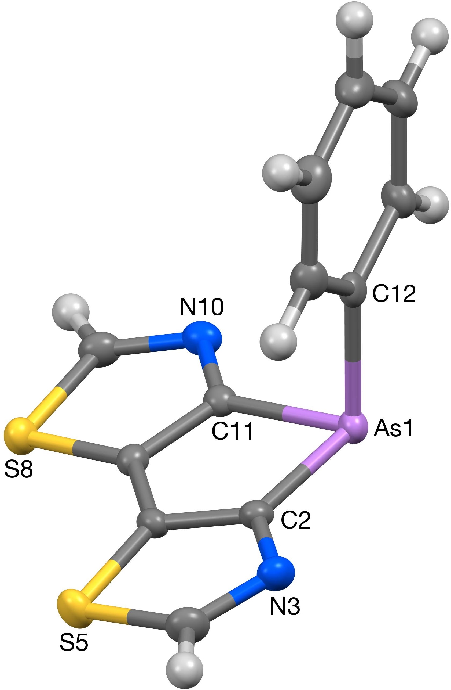
Figure 1. The crystal structure of 3 (50% probability ellipsoids).
The arsolo-bis(thiazole) shows a great degree of similarity with the arsolo-dithiophene analogue, the crystal structure of which has been reported by Naka and coworkers.²⁰ It exhibits a highly planar ring system with the exocyclic phenyl group protruding almost perpendicularly from the central metallole ring, with bond lengths and angles in the arsole ring being comparable with those observed by Naka. There is also a great deal of similarity with the phospholo-bis(thiazole) analogue reported by Baumgartner. However, differences do exist between the crystal structures that provide important information regarding the nature of 3 and how it compares to its phosphole equivalent. Some of these relate to the fact that C-As bonds are longer than C-P bonds. For example, the longer endocyclic C-As bonds (As1-C2 and As1-C11) result in the As-centered angle being closer to 80° than 90° (83.85(9)° compared to 87.21(1)° for the phospholo-bis(thiazole) analogue). However, other differences give signs of the reduced aromaticity of the arsole analogue – the decreased angle between the arsole ring and the exocyclic phenyl group gives an indication that the arsenic lone pair is likely to be further outside the plane of the major ring system than that of the phosphorus atom, decreasing its aromaticity. This can be quantified using the HOMHED equation to provide numerical estimates of the relative aromaticities of the arsolo-bis(thiazole) and its phosphole analogue.

Table 1: Selected bond lengths (Å) and bond angles (°) for phospholo-bis(thiazole) and arsolo-bis(thiazole) (3) as determined by X-ray crystallography.
Bond/Angle | Phospholo-bis(thiazole)^{[a]} | Arsolo-bis(thiazole) (3)
X1-C2 | 1.815(3) | 1.955(2)
X1-C11 | 1.815(3) | 1.960(2)
X1-C12 | 1.817(6) | 1.954(2)
C2=C6 | 1.371(4) | 1.368(3)
C7=C11 | 1.371(4) | 1.370(3)
C6-C7 | 1.442(4) | 1.443(3)
N3=C4 | 1.297(4) | 1.300(3)
N10=C9 | 1.302(4) | 1.306(3)
C2-N3 | 1.366(4) | 1.369(3)
C11-N10 | 1.370(4) | 1.370(3)
θ(C2-X1-C12) | 102.7(2) | 99.91(9)
θ(C11-X1-C12) | 103.4 (2) | 97.89(9)
θ(C2-X1-C11) | 87.21(13) | 83.85(9)
θ_{sum}(C-X-C) | 293.3 | 281.7
Atomic labels are as shown in Figure 1, with X indicating P/As atoms. ^{[a]}Information for phospholo-bis(thiazole) is from the Baumgartner et al. paper entitled Dithiazolo[5,4-b:4′,5′-d]phosphole: A Highly Luminescent Electron-Accepting Building Block.¹⁸
Table 2 shows the values of R_{s}, R_{d}, R_{opt}, and α for the five bond types seen in the dithiazolometallole structures, as well as the final HOMHED values of phospholo-bis(thiazole) and arsolo-bis(thiazole), which are 0.8015 and 0.6863, respectively. These values suggest that although both systems can be considered aromatic, with HOMHED values of greater than 0.5, the inclusion of the bridging arsenic results in an overall reduction in aromatic character, compared to the phosphole derivative. This direct experimental evidence is in line with the predicted trends of the aromaticities of pnictogen-containing heterocycles, which are expected to decrease as heavier group 15 elements are used in the rings.^{10,23}

Table 2: Calculation parameters and HOMHED values for phospholo-bis(thiazole) and arsolo-bis(thiazole).
 | C-C |  | C-N |  | C-S | C-P | C-As
R_{s} (Å) | 1.530^{[a]} |  | 1.474^{[a]} |  | 1.819^{[a]} | 1.855^{[b]} | 1.963^{[b]}
R_{d} (Å) | 1.316^{[a]} |  | 1.271^{[a]} |  | 1.599^{[a]} | 1.698^{[c]} | 1.847^{[c]}
R_{opt} (Å) | 1.387 |  | 1.339 |  | 1.672 | 1.750 | 1.886
α | 78.6 |  | 87.4 |  | 74.4 | 146.1 | 267.5
HOMHED_{phos} |  | 0.8015
HOMHED_{ars} |  | 0.6863
R_{opt} and α were calculated using Equations 2 and 3, respectively, while HOMHED values were calculated using Equation 1. Bond lengths were obtained as follows: ^{[a]}taken from Martins et al.,¹⁵ ^{[b]}taken from Tables of Bond Lengths by Watson et al.,²⁴ ^{[c]}averages of 10 C=As bonds and 19 C=P bonds taken from crystal structures available from the Cambridge Structural Database (listed in Supporting Information).
Another feature of the arsolo-bis(thiazole) crystal structure that shows a significant difference from that of the phosphole analogue is in the molecular packing. Baumgartner and coworkers observed π-π stacking between both the tricyclic rings (with the phenyl groups pointing away from the stacked ring systems) and between the orthogonal phenyl rings, with the stacking distances of these two interactions being 3.57 and 3.96 Å, respectively. However, the dominant packing motif in the structure of 3 is the formation of dimer pairs of C_{i}-related molecules held together by a π-π stacking interaction between the S8-based thiazole rings [centroid···centroid and mean interplanar separations of ca. 3.66 and 3.55 Å, rings perfectly parallel], and by a pair of S···π contacts between S8 in one molecule and the phenyl ring in the centrosymmetrically related counterpart [S···π distance ca. 3.27 Å, S···π vector inclined by ca. 83° to the phenyl ring plane], as shown in Figure 2.

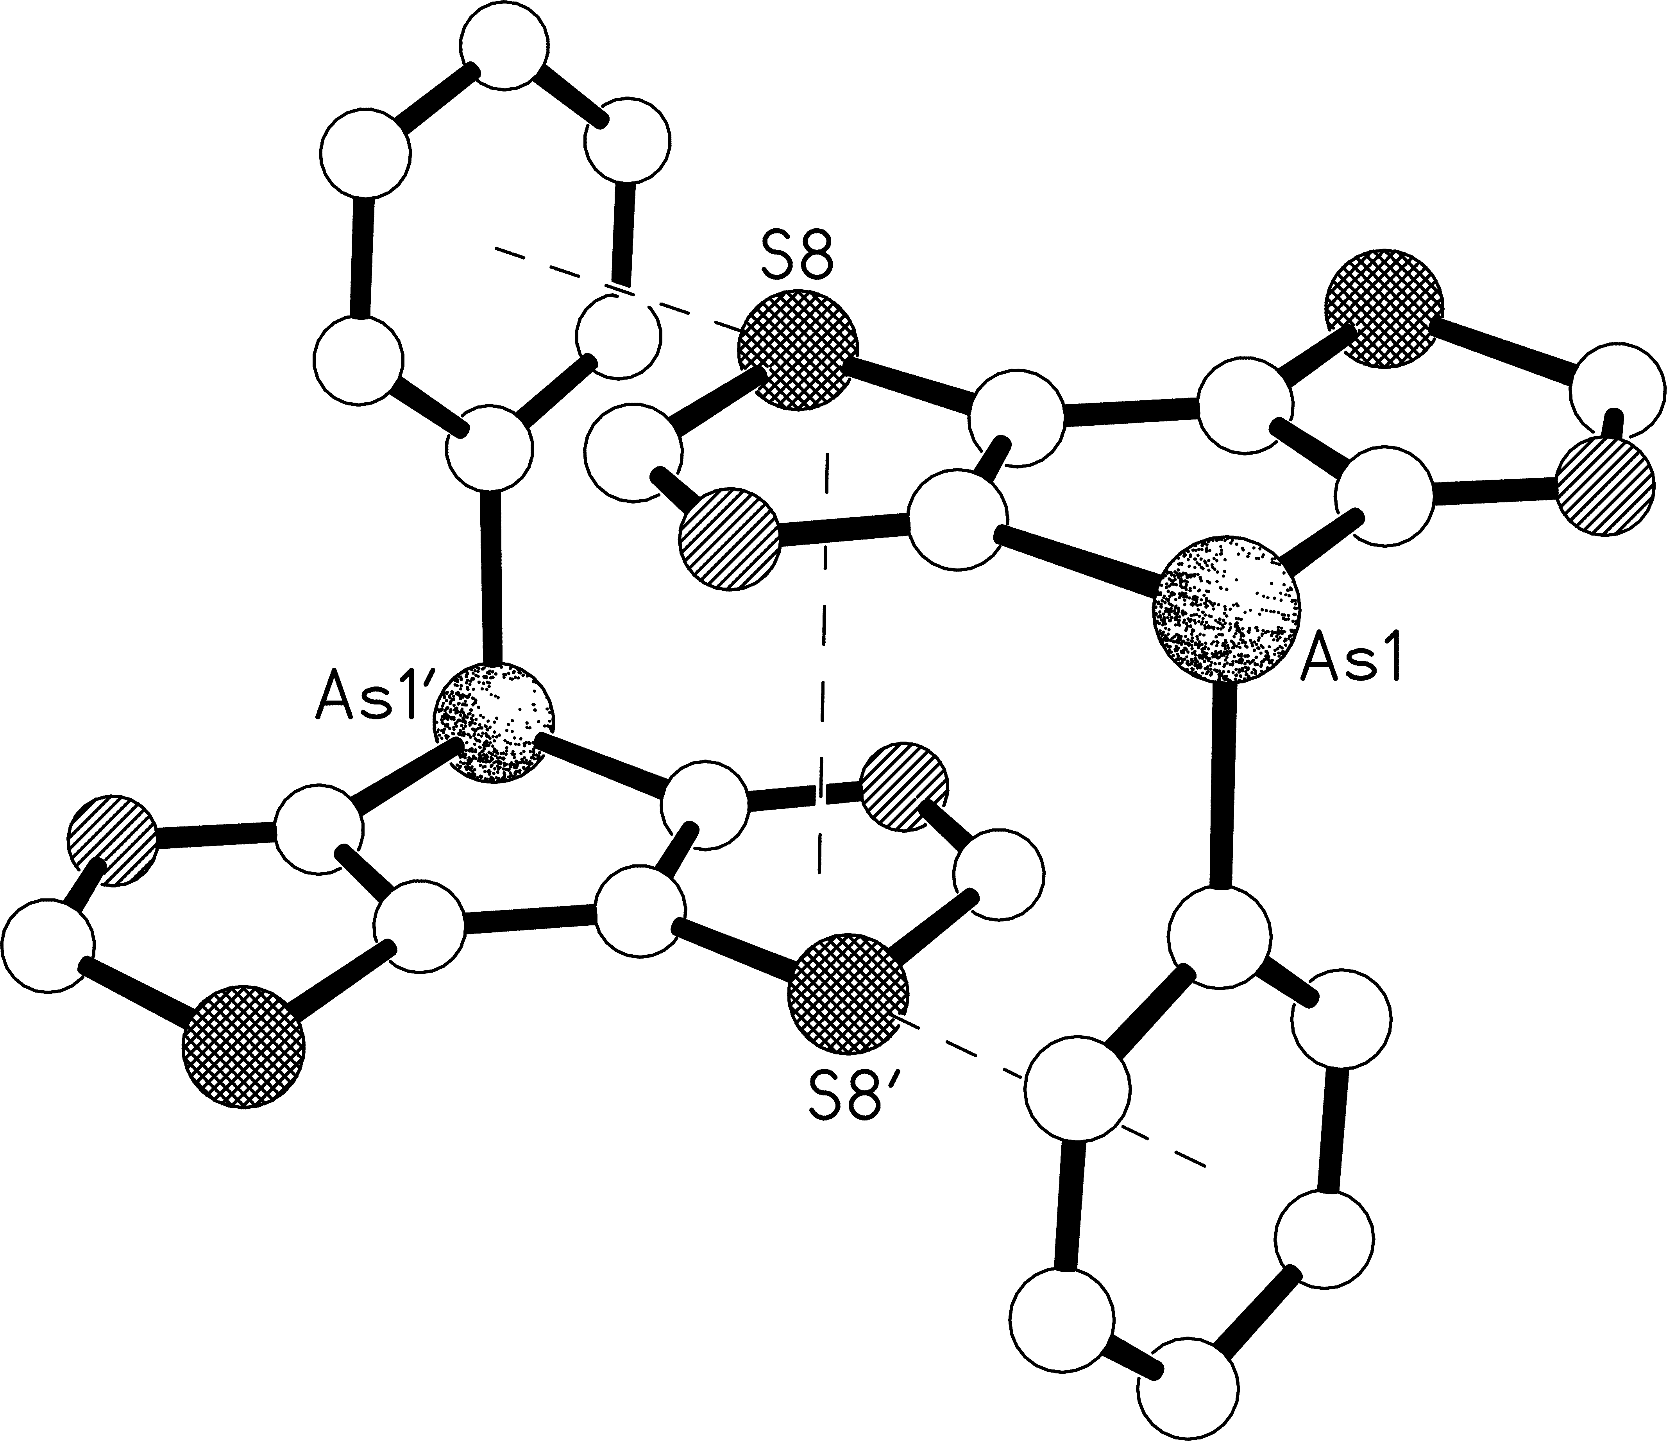
Figure 2. One of the dimers of C_{i}-related molecules held together by π-π and S···π interaction present in the crystal structure of 3. The π-π interaction has centroid···centroid and mean interplanar separations of ca. 3.66 and 3.55 Å, whilst the S···π distance is ca. 3.27 Å.
The optical properties of the arsolo-bis(thiazole) compound were measured using UV-Vis and photoluminescent (PL) spectroscopy, again providing information that could be compared to the findings of Baumgartner et al.¹⁸ The spectra of 3 are shown in Figure 3, while Table 3 lists key optical properties of both 3 and the phospholo-bis(thiazole) analogue. It can be seen that the two materials show subtly different values for λ_{abs} and λ_{em}, with those of the arsole compound being red- and blue-shifted from the values of the phosphole by 5 nm. The PL quantum yield (Φ_{PL}) of 3 in dichloromethane solution was 4%, as measured by the integrating sphere method. This is substantially lower than the reported Φ_{PL} of phospholo-bis(thiazole)¹⁸, which was 22% as measured against quinine sulfate. These results are in agreement with the trend observed for analogous arsolodithiophene (Φ_{PL} 7%)²⁰ versus phospholodithiophene (Φ_{PL} 78%)²⁵, although we note that some non-fused arsole containing materials are reported to be highly emissive.^{8, 26}
Figure 3. Normalized UV-Vis absorption and emission spectra for solutions of 3 in dichloromethane (excitation wavelength 330 nm).
Table 3. Optical properties of phospholo-bis(thiazole) and arsolo-bis(thiazole) in DCM.
Compound | λ_{abs} (nm) | ε (dm³ mol⁻¹ cm⁻¹) | λ_{em} (nm)
3 | 327 | 8378 | 391
Phosphole^{[a]} | 322 | 7230 | 396
^{[a]}Information for phospholo-bis(thiazole) is from the Baumgartner et al. paper entitled Dithiazolo[5,4-b:4′,5′-d]phosphole: A Highly Luminescent Electron-Accepting Building Block.¹⁸
COnclusion
The convenient preparation of a novel air-stable arsole-containing building block 4-phenyl-4H-arsolo[2,3-d:5,4-d']bis(thiazole) (3) was reported. Comparison of its crystal structure with the previously reported phosphole analogue allowed a direct comparison of their respective aromaticities using the harmonic oscillator model of heterocyclic electron delocalization (HOMHED) values. It was found that both the phosphole- and arsole-containing molecules were aromatic, but that the phospholo-bis(thiazole) material was more so, with their HOMHED values being 0.8015 and 0.6863, respectively. The replacement of phosphorus with arsenic was also shown to have a subtle effect on the optical properties, with a slight red-shift observed in the absorption maxima, and a blue shift in the emission peak. The replacement of a pnitcogenic atom for a heavier analogue therefore serves as an interesting strategy to increase air stability as well as fine tune the optoelectronic properties of fused ring systems, which may serve as useful building blocks for future polymeric systems.
EXPERIMENTAL SECTION
Materials and Measurements. Reagents were purchased from Sigma Aldrich and VWR and were used with no additional purification, and all reactions were performed using oven-dried glassware under argon using standard Schlenk techniques. Thin layer chromatography (TLC) was performed on silica plates (Merck Kieselgel 60 F₂₅₄ aluminum sheets) and visualized using UV light (254 and 365 nm). ¹H and ¹³C NMR spectra were recorded using Bruker AV-400 spectrometers (¹H = 400 MHz, ¹³C = 101 MHz, ³¹P = 162 MHz) at 298 K. UV-visible spectroscopy was carried out using a UV-1800 Shimadzu UV-vis spectrometer. The solution PLQY was measured in air by the method reported by de Mello et al²⁷ using a Horiba FluoroMax 4 instrument equipped with an integrating sphere and a solution concentration of 1 x 10⁻⁴ M in DCM..
Caution: PhAsCl₂ is highly toxic and a vesicant, and as such should be handled with extreme care. Proper safety equipment should be used at all times, and reactions should be carried out in a well-ventilated fumehood. Treat any spillages and all glassware with dilute bleach to prevent accidental contamination and injury.
2,6-Bis(triisopropylsilyl)- 4-Phenyl-4H-arsolo[2,3-d:5,4-d']bis(thiazole) (2). To a degassed solution of 2,2'-bis(triisopropylsilyl)-4,4'-dibromo-5,5'-dithiazole (1) (3.00 g, 4.70 mmol) in anhydrous THF (150 ml) at −78 °C was added n-BuLi (2.5 M in hexane, 4 ml, 9.87 mmol, 2.1 eq) dropwise over 10 min. The solution was stirred at this temperature for 30 min, then warmed to 0 °C over 10 min, and finally cooled back down to −78 °C. Dichlorophenylarsine (0.63 ml, 4.70 mmol, 1 eq) was added slowly, and the reaction was allowed to warm to room temperature over the course of 1 h. After a further 1 h of stirring at room temperature, the reaction was quenched with methanol (10 ml), stirred for 30 min, and the solvent was removed under reduced pressure. The resulting brown oil was dissolved in hexane and filtered through basic alumina (eluent: hexane) to remove salts, after which the solvent was removed in vacuo to afford 2,6-bis(triisopropylsilyl)-4-phenyl-dithiazolo[5,4-b:4’,5’-d]arsole (2) as a low melting point pale brown solid (2.24 g, 3.55 mmol, 76%). ¹H NMR (400 MHz, CDCl₃) δ 7.54 – 7.50 (m, 2H), 7.21 – 7.17 (m, 3H), 1.49 (sept, J = 7.5 Hz, 6H), 1.16 (m, 36H). ¹³C NMR (101 MHz, CDCl₃) δ 172.03 (2C), 168.67, 137.97 (2C), 137.16 (2C), 132.24 (2C), 128.64 (2C), 128.24, 18.66 (36 C), 11.89 (6C). HRMS (EI⁺) calculated for C₃₀H₄₈N₂Si₂S₂As [M⁺+H], 631.2013; found, 631.2020. Anal. Calcd for C₃₀H₄₇N₂Si₂S₂As: C, 57.11; H, 7.51; N, 4.44. Found: C, 56.97; H, 7.56; N, 4.29.
4-Phenyl-4H-arsolo[2,3-d:5,4-d']bis(thiazole) (3). To a solution of 2,6-bis(triisopropylsilyl)-4-phenyl-dithiazolo[5,4-b:4’,5’-d]arsole (2) (2.01 g, 3.18 mmol) in anhydrous THF (60 ml) at 0 °C was added a solution of TBAF (1 M in THF, 9.5 ml, 3 eq) in three portions, and the resulting solution was stirred for 5 min. After allowing the reaction to warm to room temperature over the course of 1 h, the reaction was quenched with water (10 ml) then extracted with diethyl ether (3 × 20 ml). The combined organic layers were washed with water (2 ×10 ml) and brine (10 ml), then dried over sodium sulfate. The solvent was removed under reduced pressure and the product was recrystallized (acetone) to afford 4-phenyl-4H-arsolo[2,3-d:5,4-d']bis(thiazole) (3) as brown, needle-like crystals (0.48 g, 1.50 mmol, 47%). m.p. 150–151 °C. ¹H NMR (400 MHz, CDCl₃) δ 8.88 (s, 2H), 7.41 – 7.36 (m, 2H), 7.26 – 7.21 (m, 3H). ¹³C NMR (101 MHz, CDCl₃) δ 166.71 (2C), 153.58, 135.86 (2C), 134.33 (2C), 132.48 (2C), 129.18, 129.15 (2C). HRMS (EI⁺) calculated for C₁₂H₈N₂S₂As [M⁺+H], 318.9345; found, 318.9348. Anal. Calcd for C₁₂H₇N₂S₂As: C, 45.29; H, 2.22; N, 8.80. Found: C, 45.21; H, 2.25; N, 8.71.

ASSOCIATED CONTENT
Supporting Information
NMR spectra of compounds 2 and 3, the emission coefficient calculation for 3, lists of the structures used to determine C=P and C=As bonds lengths, and crystallographic information relating to 3 including the CIF file can all be found in the Supporting Information files.
AUTHOR INFORMATION
Corresponding Author
* Prof. M. Heeney, Department of Chemistry, Imperial College London, London, SW7 2AZ (UK) E-mail: m.heeney@imperial.ac.uk
ACKNOWLEDGMENT
We thank the UK's Engineering and Physical Sciences Research Council (EPSRC) for financial support via the Doctoral Training Centre in Plastic Electronics EP/G037515/1.
REFERENCES
(1) Duffy, M. P.; Delaunay, W.; Bouit, P.-A.; Hissler, M. Chem. Soc. Rev. 2016, 45, 5296–5310.
(2) Stolar, M.; Baumgartner, T. Chem. Asian J. 2014, 9, 1212–1225.
(3) Shameem, M. A.; Orthaber, A. Chem. - A Eur. J. 2016, 22, 10718–10735.
(4) Ren, Y.; Baumgartner, T. Dalton Trans. 2012, 41, 7792–7800.
(5) Dienes, Y.; Durben, S.; Kárpáti, T.; Neumann, T.; Englert, U.; Nyulászi, L.; Baumgartner, T. Chem. - A Eur. J. 2007, 13, 7487–7500.
(6) Green, J. P.; Han, Y.; Kilmurray, R.; McLachlan, M. A.; Anthopoulos, T. D.; Heeney, M. Angew. Chemie Int. Ed. 2016, 55, 7148–7151.
(7) Matsumura, Y.; Ishidoshiro, M.; Irie, Y.; Imoto, H.; Naka, K.; Tanaka, K.; Inagi, S.; Tomita, I. Angew. Chemie Int. Ed. 2016, 55, 15040–15043.
(8) Ishidoshiro, M.; Imoto, H.; Tanaka, S.; Naka, K. Dalton Trans. 2016, 45, 8717–8723.
(9) Epiotis, N. D.; Cherry, W. J. Am. Chem. Soc. 1976, 98, 4365–4370.
(10) Johansson, M. P.; Juselius, J. Lett. Org. Chem. 2005, 2, 469–474.
(11) Cyrañski, M. K.; Krygowski, T. M.; Katritzky, A. R.; Schleyer, P. V. R. J. Org. Chem. 2002, 67, 1333–1338.
(12) Vessally, E. J. Struct. Chem. 2008, 49, 979–985.
(13) Raczyńska, E. D.; Hallman, M.; Kolczyńska, K.; Stępniewski, T. M. Symmetry 2010, 2, 1485–1509.
(14) Mrozek, A.; Karolak-Wojciechowska, J.; Amiel, P.; Barbe, J. J. Mol. Struct. 2000, 524 , 151–157.
(15) Frizzo, C. P.; Martins, M. A. P. Struct. Chem. 2012, 23, 375–380.
(16) Al-Hashimi, M.; Labram, J. G.; Watkins, S.; Motevalli, M.; Anthopoulos, T. D.; Heeney, M. Org. Lett. 2010, 12 , 5478–5481
(17) Su, H.-L.; Sredojevic, D. N.; Bronstein, H.; Marks, T. J.; Schroeder, B. C; Al-Hashimi, M.. Macromol. Rapid Commun. 2017, DOI: 10.1002/marc.201600610
(18) He, X.; Woo, A. Y. Y.; Borau-Garcia, J.; Baumgartner, T. Chem. - A Eur. J. 2013, 19, 7620–7630.
(19) Rasmussen, S. C. ChemTexts 2016, 2, 16.
(20) Kato, T.; Imoto, H.; Tanaka, S.; Ishidoshiro, M.; Naka, K. Dalton Trans. 2016, 45, 11338–11345.
(21) Parke, S. M.; Boone, M. P.; Rivard, E. Chem. Commun. 2016, 52, 9485–9505.
(22) Imoto, H.; Tanaka, S.; Kato, T.; Watase, S.; Matsukawa, K.; Yumura, T.; Naka, K. Organometallics 2016, 35, 364–369.
(23) Pelzer, S.; Wichmann, K.; Wesendrup, R.; Schwerdtfeger, P. J. Phys. Chem. A 2002, 106, 6387–6394.
(24) Allen, F. H.; Kennard, O.; Watson, D. G.; Brammer, L.; Orpen, A. G.; Taylor, R. J. Chem. Soc. Perkin Trans. 2 1987, S1–S19.
(25) Baumgartner, T.; Neumann, T.; Wirges, B. Angew. Chem. Int. Ed. 2004, 43, 6197-6201.
(26) Ishidoshiro, M.; Matsumura, Y.; Imoto, H.; Irie, Y.; Kato, T.; Watase, S.; Matsukawa, K.; Inagi, S.; Tomita, I.; Naka, K. Org. Lett. 2015, 17, 4854-4857.
(27) de Mello, J. C.; Wittmann, H. F.; Friend, R. H. Adv. Mater. 1997, 9, 230-232.

Table of Contents (TOC)

