Title

Association of Body Mass Index with Fecal Microbial Diversity and Metabolites in the Northern Finland Birth Cohort

Running Title

BMI associations with fecal microbiome and metabolome

Authors

Erikka Loftfield^{1*}†, Karl-Heinz Herzig^{2*}†, J Gregory Caporaso^{1,3}, Andriy Derkach⁴, Yunhu Wan¹, Doratha Byrd¹, Emily Vogtmann¹, Minna Männikkö⁵, Ville Karhunen⁶, Rob Knight^{7,8,9}, Marc J. Gunter¹⁰, Marjo-Riitta Jӓrvelin^{6,11}†, Rashmi Sinha¹†

Affiliations

¹Metabolic Epidemiology Branch, Division of Cancer Epidemiology and Genetics, National Cancer Institute
²Research Unit of Biomedicine, Medical Research Center (MRC), University of Oulu, University Hospital, Oulu, Finland and Department of Gastroenterology and Metabolism, Poznan University of Medical Sciences, Poznan, Poland
³Center for Applied Microbiome Science, Pathogen and Microbiome Institute, Northern Arizona University
⁴Biostatistics Branch, Division of Cancer Epidemiology and Genetics, National Cancer Institute
⁵ Northern Finland Birth Cohorts, Infrastructure for population studies, Faculty of Medicine, University of Oulu, Oulu, Finland
⁶Department of Epidemiology and Biostatistics, MRC–PHE Centre for Environment & Health, School of Public Health, Imperial College London
⁷Department of Pediatrics, University of California San Diego, San Diego, California
⁸Department of Computer Science and Engineering, University of California San Diego, San Diego, California
⁹ Department of Bioengineering, and Center for Microbiome Innovation, University of California San Diego, San Diego, California
¹⁰Section of Nutrition and Metabolism, International Agency for Research on Cancer-WHO, Lyon, France
¹¹Center for Life Course Health Research, Faculty of Medicine, University of Oulu, Finland

* Corresponding author: Erikka Loftfield; mailing address: National Cancer Institute, 9609 Medical Center Drive 6E320, Rockville, MD 20850; email: erikka.loftfield@nih.gov; phone (240) 276-7310

† These authors contributed equally to this work

Conflicts of interest: None to disclose.

Abstract

Background: Obesity is an established risk factor for multiple cancer types. Lower microbial richness has been linked to obesity, but human studies are inconsistent and associations of early-life BMI with the fecal microbiome and metabolome are unknown.

Methods: We characterized the fecal microbiome (n=563) and metabolome (n=340) in the Northern Finland Birth Cohort 1966 using 16S rRNA gene sequencing and untargeted metabolomics. We estimated associations of adult BMI and BMI history with microbial features and metabolites using linear regression and Spearman correlations (r_{s}) and computed correlations between bacterial sequence variants and metabolites overall and by BMI category.

Results: Microbial richness, including number of sequence variants (r_{s}=-0.21, P-value<0.0001), decreased with increasing adult BMI but was not independently associated with BMI history. Adult BMI was associated with 56 metabolites but no bacterial genera. Significant correlations were observed between microbes in 5 bacterial phyla, including 18 bacterial genera, and metabolites in 49 of the 62 metabolic pathways evaluated. The genera with the strongest correlations with relative metabolite levels (positively and negatively) were Blautia, Oscillospira, and Ruminococcus in the Firmicutes phylum, but associations varied by adult BMI category.

Conclusions: BMI is strongly related to fecal metabolite levels, and numerous associations between fecal microbial features and metabolite levels underscores the dynamic role of the gut microbiota in metabolism.

Impact: Characterizing the associations between the fecal microbiome, the fecal metabolome, and BMI, both recent and early life exposures, provides critical background information for future research on cancer prevention and etiology.

MAIN TEXT

Introduction

Obesity is an increasingly common, and costly disease that confers substantial negative health consequences. The World Health Organization (WHO) estimates that worldwide obesity rates rose from approximately 3% to 11% in men and from 6% to 15% in women from 1975 to 2016 ¹, and in some countries the prevalence of obesity is markedly higher. For example, in the United States the prevalence of adult obesity was nearly 40% in 2016 ². Obesity is a major risk factor for some cancers and other chronic diseases, including cardiovascular disease and type 2 diabetes, ³ making it an important cause of preventable death. A recent study estimated that overall and class 3 obesity were associated with shortening of life expectancy by 4.2 and 9.1 years in men, respectively, and by 3.5 and 7.7 years for women, respectively ⁴.

Although weight gain has largely been attributed to excess energy intake and physical inactivity, animal ⁵⁻⁷ and some human ^{8,9} studies have also indicated that the gut microbiota play a key role in weight gain and loss. Researchers have shown that the gut microbiota in obese, as compared with lean, mice release more energy from food during digestion⁵ and that in a mouse model of recurrent obesity the microbiome contributes to reduced energy expenditure and faster weight regain following successful diet-induced weight loss, suggesting an important role of the microbiome in weight-cycling induced obesity ¹⁰. Despite considerable interest in the role of the gut microbiome in obesity, there is little clinical evidence supporting weight loss as a direct consequence of changes to the gut microbiota. A few small randomized clinical trials of fecal microbiota transplantation (FMT) from lean donors using direct administration of fresh stool suspensions via endoscopic procedures have shown short-lived effects of FMT on insulin sensitivity in obese men with metabolic syndrome ^{11,12}, but a recent double-blind randomized placebo-controlled pilot trial of oral FMT capsules found no improvements in insulin sensitivity or body composition in obese adults with mild to moderate insulin resistance despite engraftment of donor bacterial groups among FMT recipients ¹³. Observational studies have found that microbial diversity is lower in obese than in lean individuals and that diversity tends to increase as individuals lose weight ^{8,9,14,15}. However, results from human studies, both clinical and observational, have been inconsistent ^{11-13,16-18} and the potential mechanisms linking the human gut microbiota to obesity and related chronic diseases are speculative ¹⁹.

Gut microbes produce and modify many biologically active compounds, including hormones ²⁰, carbohydrates, and lipids ²¹; yet, few large human studies have described the relationships between obesity, fecal microbial composition, and fecal metabolite levels ²². Several observational studies have explored associations of circulating metabolite levels with body mass index (BMI), characterizing metabolic profiles of adiposity and providing potential avenues of exploration for mechanistic links between obesity and disease risk ²³⁻³⁰. Moreover, one epidemiological study estimated fecal metabolite associations with adiposity and gut microbial composition and found that fecal metabolites were strongly associated with abdominal obesity and explained nearly 68% of the variance in gut microbial composition ²². Additional studies, particularly those with longitudinal data, investigating the links between obesity and the gut microbiome and metabolome are needed to replicate and extend these findings.

The aim of our study was to investigate the relationships between early-life and adult BMI and the fecal microbiome and metabolome among a subset of individuals enrolled in the Northern Finland Birth Cohort 1966 (NFBC1966), a population-based birth cohort, with longitudinal data on height and weight collected during adolescence and adulthood. In addition, we surveyed the cross-sectional associations of adult BMI with the fecal microbiome and metabolome.

Materials and Methods

Study Design

The NFBC1966 included 12,055 expectant mothers within two Finnish provinces, Oulu and Lapland, with expected delivery dates between January 1st and December 31st, 1966. A total of 12,058 children, representing 96% of live births were included in the cohort and have been followed prospectively from birth up to 46 years of age (https://www.oulu.fi/nfbc/) ³¹. At ages 14, 31 and 46, questionnaire or clinical outcome data, including anthropometric measures, were documented. Fecal samples were collected at 46 years of age. Samples were collected by participants at home, immediately frozen at -20○C, brought to the study laboratory, and frozen without preservative in -70○C freezers within days of collection. Written informed consent was obtained from all participants in-person or by mail at ages 31 and 46 years. Ethical approval for the NFBC1966 project was obtained from the Ethical Committee of the Medical Faculty of University of Oulu and Northern Ostrobothnia Hospital District.

We conducted a sub-study within the NFBC1966 to explore the associations of BMI history and current BMI at 46 years of age with fecal microbial diversity and metabolite levels. Among individuals with available fecal specimens as well as complete data on height and weight at ages 14, 31, and 46 (n=3,102), we randomly selected 517 individuals from the following three BMI history strata: 1) normal BMI (i.e., >18.5 and <25 kg/m²) at ages 14, 31, and 46 years (n=172); 2) normal BMI at ages 14 and 31 but overweight or obese (i.e., ≥25 kg/m²) at age 46 years (n=173); and 3) normal BMI at age 14 but overweight or obese at ages 31 and 46 years (n=172). For the fourth strata, we selected 70 participants who were overweight or obese at ages 14, 31, and 46 years. Following processing of microbiome data, our final analytic sample for BMI-microbiome analyses included n=563 individuals (Figure S1).

Covariate Assessment

Adolescent and adult height and weight were assessed three times during follow-up at ages 14, 31 and 46 years. BMI was calculated using self-reported height and weight at age 14, either measured or self-reported height and weight at age 31, and measured height and weight at age 46. Smoking status and frequency of intake of major food groups (e.g., fruit, vegetables, cereals, dairy, fish, red and processed meats, and poultry) as well as alcohol were ascertained by self-administered questionnaires at age 46.

Microbiome Analysis

The fecal microbiome was characterized using 16S rRNA gene sequencing. DNA extraction, PCR amplification, and amplicon preparation for sequencing were performed as described by Vogtmann et al ^{32,33}. In brief, DNA was extracted with the MO-BIO PowerSoil® DNA isolation kit and the V4 region of the 16S rRNA gene was amplified using barcoded 515F/806R primers. DNA was then sequenced using the MiSeq (Illumina, San Diego, CA) in a 2x150 run, with an average of 111,848 (SD = 35,369) sequences per sample.

Microbiome bioinformatics was performed using QIIME 2 2017.8 ³⁴. The sequence quality control was performed on forward reads only with DADA2 ³⁵ using the q2-dada2 plugin to QIIME 2 (parameter setting for trim-left was 0, and trunc-len was 150). Paired end reads were not joined, because shorter 16S rRNA gene sequences would be dropped because they cannot be joined with 150 base reads, resulting in systematic bias in community composition. Diversity metrics were calculated using QIIME 2 at an even sampling (rarefaction) depth of 29,000 sequences per sample, resulting in an analytic sample of n=563 individuals that were included in microbiome analyses. Taxonomy was assigned to amplicon sequence variants (ASVs) using q2-feature-classifier classify-sklearn against the Greengenes 13_8 reference database ³⁶. A phylogenetic tree was constructed by aligning ASV sequences with MAFFT (q2-alignment mafft) ³⁷, filtering highly variable positions with q2-alignment mask, building an unrooted tree with FastTree (q2-phylogeny fasttree) ³⁸, and rooting the resulting tree by midpoint rooting with q2-phylogeny midpoint-root.

Study samples were randomly ordered and batched and replicate fecal samples from three individuals (n=62) were distributed within and across batches. The replicate fecal samples were used to estimate technical reproducibility by means of intraclass correlation coefficients (ICCs). ICCs were high (>0.85) for most alpha (e.g., Faith’s Phylogenetic Diversity index ³⁹ and observed sequence variants) and beta diversity metrics ^{40,41} (e.g., Bray-Curtis and Unweighted UniFrac) (Table S1). In addition, two types of replicate QC samples (i.e., artificial community and chemostat) as well as extraction and PCR blanks were included in every batch. We used principal coordinates analysis (PCoA) to plot QC samples by the first and second principal coordinates of each beta diversity distance matrix to visually inspect that QCs clustered by type, and we used bar plots of the relative abundance of the top five taxa grouped by QC type to evaluate potential batch effects (data not shown). Overall, inspection of QC data suggested good reproducibility within and across batches.

Metabolomics Analysis

In a subset of fecal samples (n=340), global biochemical profiles were measured using Metabolon’s non-targeted platform ⁴². Metabolon’s procedures for sample preparation and mass spectrometry analysis of fecal samples and identification and quantification of metabolites have been described in detail elsewhere ^{22,42}. In brief, lyophilized fecal samples were extracted at a constant per-mass basis and recovery standards were added prior to methanol extraction. To remove proteins, dissociate small molecules bound to proteins or trapped in the precipitated protein matrix, and to recover chemically diverse metabolites, proteins were precipitated with methanol under vigorous shaking for two minutes followed by centrifugation. Samples were placed briefly on a TurboVap® (Zymark) to remove the organic solvent, and sample extracts were stored overnight under nitrogen before preparation for analysis. The extract was divided into fractions, and four were used for analysis by two separate reverse phase (RP)/UPLC-MS/MS methods with positive ion mode electrospray ionization (ESI) or negative ion mode ESI. The fourth fraction was analyzed by HILIC/UPLC-MS/MS with negative ion mode ESI. The sample extract was dried then reconstituted in solvents compatible with each of the four methods. Each reconstitution solvent contained a series of standards at fixed concentrations to ensure injection and chromatographic consistency. One aliquot was analyzed using acidic positive ion conditions, chromatographically optimized for more hydrophilic compounds. In this method, the extract was gradient eluted from a C18 column (Waters UPLC BEH C18-2.1x100 mm, 1.7 µm) using water and methanol, containing 0.05% perfluoropentanoic acid (PFPA) and 0.1% formic acid (FA). Another aliquot was also analyzed using acidic positive ion conditions; however, it was chromatographically optimized for more hydrophobic compounds. In this method, the extract was gradient eluted from the same afore mentioned C18 column using methanol, acetonitrile, water, 0.05% PFPA and 0.01% FA and was operated at an overall higher organic content. The third aliquot was analyzed using basic negative ion optimized conditions using a separate dedicated C18 column. The basic extracts were gradient eluted from the column using methanol and water, however with 6.5mM Ammonium Bicarbonate at pH 8. The fourth aliquot was analyzed via negative ionization following elution from a HILIC column (Waters UPLC BEH Amide 2.1x150 mm, 1.7 µm) using a gradient consisting of water and acetonitrile with 10mM Ammonium Formate, pH 10.8.

Raw data was extracted and peak-identified by Metabolon ⁴². Compounds were identified by comparison to library entries of purified standards or recurrent unknown entities. Metabolon maintains a library based on authenticated standards that contains the retention time/index (RI), mass to charge ratio (m/z), and chromatographic data (including MS/MS spectral data). In our sample, Metabolon identified a total of 1,143 compounds. Of these 65% of identifications were confirmed with chemical reference standards, 10% were putatively annotated, and 25% were of unknown identity (Table S2) ⁴³. Peaks were quantified using the area-under-the-curve. To correct variation resulting from instrument inter-day tuning differences, a data normalization step was performed in whch each compound was corrected in run-day blocks by registering the medians to equal one (1.00) and normalizing each data point proportionately.

Study samples were randomized across the platform run with QC samples spaced evenly among the injections. We blinded and randomized all study samples and distributed blinded study sample duplicates (n=16) within and across batches. Using our blinded duplicate samples, we calculated the technical reproducibility for metabolites that were detected in ≥80% of study samples (n=606 annotated metabolites) using the mass normalized, log-transformed metabolite values. Technical reproducibility was high with a median ICC of 0.84 (interquartile range: 0.68-0.92).

Statistical Analysis

BMI and Microbiome

We computed partial Spearman correlations (r_{s}) to estimate correlations between alpha diversity metrics and BMI at age 46. We also used multivariable linear regression models, to estimate the associations of BMI history (categorical)) and current BMI with alpha diversity metrics. We estimated the association of BMI (continuous, kg/m²) at age 46 with relative abundance of genera that were present in at least 50% of the study samples using multivariable zero-inflated beta regression using the function “BEINF0” as implemented in R package “gamlss” ⁴⁴ corrected for multiple comparisons at a false discovery rate (FDR) corrected alpha of 0.01. All BMI-microbiome regression models and partial Spearman correlations described above were adjusted for age, sex, smoking status, and for BMI history models, current BMI at age 46; indicator variables were used to account for missing covariate data.

To assess associations of BMI with beta diversity, we transformed each distance matrix to a kernel similarity matrix and conducted the microbiome regression-based kernel association test (MiRKAT), using exact methods, to estimate P-values for the multivariable association of each BMI category and history, each categorized as indicator variables, with each kernel similarity matrices, individually and overall. For associations with P-values < 0.05, we repeated the corresponding MiRKAT models with 10,000 permutations to check that the P-value remained statistically significant under the empirical null distribution of the test statistic. Furthermore, we estimated the multivariable association of BMI, as categories and BMI histories, with the first three PCoA vectors for Bray-Curtis, unweighted UniFrac, and weighted UniFrac distance matrices ⁴⁵.

BMI and Metabolites

Linear regression models were used to estimate the associations between BMI (continuous, kg/m²) at age 46 (i.e., current BMI) or BMI history, adjusting for current BMI, with metabolites detected in at least 50% of study samples (n=797 metabolites), adjusting for age, sex, smoking status, and batch effects. Correction for multiple comparisons was performed using an FDR-corrected alpha of 0.01. We also considered the associations of sub- and super- metabolic pathways, based on KEGG pathways as defined by Metabolon, with BMI at age 46. The dataset was limited to metabolites detected in at least 50% of study samples and to named compounds with information on chemical class (n=603 metabolites). Using linear regression models, we modeled metabolite values as a function of BMI (continuous, kg/m²) at age 46, adjusting for age, sex, smoking status, and batch, followed by Fisher’s Method to combine individual metabolite P-values across 83 sub pathways or 8 super pathways to evaluate the overall combination of P-values using parametric bootstrap (n=10⁶ permutations).

Microbiome and Metabolites

We computed Pearson and Spearman correlations between relative abundances of bacterial 16S rRNA sequence variants, observed in at least 50% of the samples, and metabolome features, also observed in at 50% of samples, overall and stratified by current (i.e., age 46) BMI group. The correlations, both Pearson and Spearman, that remained statistically significant at an FDR-corrected alpha of 0.001 and were in the same direction⁴⁶ were illustrated using circos plots⁴⁷ overall and by current BMI category (i.e., normal, overweight, or obese).

Results

Of the 563 NFBC1966 participants in our analytic sample set, 217 or 38.5% participants were male. Weight history categories 3 (i.e., normal BMI at age 14 but overweight or obese at ages 31 and 46 years) and 4 (i.e., overweight or obese at ages 14, 31, and 46 years) had higher percentages of males and current smokers than categories 1 (i.e., normal BMI at ages 14, 31, and 46 years) and 2 (i.e., normal BMI at age 14 and 31 but overweight or obese at age 46 years), and those in categories 1 and 2 tended to be more formally educated than those in categories 3 and 4 (Table 1). Participants included in our analytic sample (n=563) did not differ markedly in terms of demographic and lifestyle characteristics from the larger sample of 587 participants who were randomly selected for microbiome analysis (Figure S1; Table S3).
Table 1. Descriptive characteristics for participants in analytic microbiome sample at age 46 (N=563)*
 | BMI History†
 | 1 | 2 | 3 | 4
n | 167 | 167 | 163 | 66
BMI, mean kg/m² (±SD) | 22.8 (1.4) | 27.6 (2.0) | 31.2 (5.0) | 34.3 (6.1)
BMI category
Normal weight (i.e., <25 kg/m²), n (%) | 167 (100) | 0 (0) | 0 (0) | 0 (0)
Overweight (i.e., ≥25 and <30 kg/m²), n (%) | 0 (0) | 149 (89.2) | 84 (51.5) | 20 (30.3)
Obese (i.e., ≥30 kg/m²), n (%) | 0 (0) | 18 (11.0) | 79 (48.5) | 46 (69.7)
Male, n (%) | 38 (22.3) | 60 (35.9) | 94 (57.7) | 25 (37.9)
Smoking status
Never smoker, n (%) | 109 (65.7) | 99 (58.2) | 78 (48.5) | 30 (44.1)
Former smoker, n (%) | 32 (19.9) | 41 (25.0) | 40 (26.0) | 17 (26.2)
Current smoker, n (%) | 25 (15.5) | 25 ( 15.2) | 41 (26.6) | 18 (27.7)
Matriculation exam (i.e., ≥secondary education), n (%) | 90 (56.3) | 86 (52.4) | 51 (32.9) | 26 (40.0)
Alcohol drinker, n (%) | 153 (93.9) | 153 (93.3) | 148 (94.3) | 57 (87.7)
Alcohol intake, mean drinks/day (±SD) | 0.6 (0.8) | 0.8 (1.1) | 0.8 (1.2) | 0.4 (0.6)
Fruit, mean frequency/day(±SD) | 1.6 (1.1) | 1.3 (1.1) | 1.1 (1.0) | 1.0 (1.0)
Vegetables, mean frequency/day (±SD) | 2.6 (1.1) | 2.7 (1.4) | 2.4 (1.4) | 2.5 (1.3)
Cereals, mean frequency/day (±SD) | 3.4 (1.5) | 3.2 (1.7) | 3.2 (1.5) | 3.1 (1.6)
Fish, mean frequency/day (±SD) | 0.3 (0.2) | 0.3 (0.3) | 0.3 (0.3) | 0.2 (0.1)
Red and processed meat, mean frequency/day (±SD) | 1.3 (0.9) | 1.4 (1.1) | 1.7 (1.1) | 1.5 (0.9)
Poultry, mean frequency/day (±SD) | 0.5 (0.5) | 0.6 (0.6) | 0.5 (0.4) | 0.6 (0.5)
Dairy, mean frequency/day (±SD) | 2.6 (1.4) | 2.3 (1.4) | 2.4 (1.4) | 2.1 (1.4)
*N may not total 563 due to missing data
†BMI history strata: 1) normal BMI (i.e., >18.5 and <25 kg/m²) at ages 14, 31, and 46 years (n=167); 2) normal BMI at ages 14 and 31 but overweight or obese (i.e., ≥25 kg/m²) at age 46 years (n=167); 3) normal BMI at age 14 but overweight or obese at ages 31 and 46 years (n=163); and 4) overweight or obese at ages 14, 31, and 46 (n=66).

BMI and Microbiome

Measures of microbial richness, including Faith’s phylogenetic diversity index, number of observed sequence variants, and Shannon index, decreased with increasing BMI at age 46; adjustment for age (months), sex and smoking status (Tables 2, Figure S2) and further adjustment for dietary variables (data not shown) did not meaningfully alter associations between measures of microbial richness and BMI. No genera were statistically significantly associated BMI, defined continuously (kg/m²) or categorically (i.e., obese vs normal BMI), at age 46 at an FDR-corrected alpha of 0.01; however, at a less stringent FDR-corrected alpha of 0.05, we observed 8 associations with continuous BMI and 3 associations when comparing obese to normal BMI (Table S4). For continuous BMI, higher BMI was most strongly positively associated with Roseburia and Blautia and most strongly inversely associated with the family Rikenellaceae and phylum Bacteroidetes. For categorical analyses, comparing obese to normal weight participants, associations were generally similar to those observed for continuous BMI; we found that obesity was inversely associated with the families Rikenellaceae and Oscillospira (Table S4). After adjusting for adult BMI, we found no independent associations between bacterial genera and BMI history.

Table 2. Associations of BMI at age 46 with measures of alpha diversity (n=563)
 | BMI at age 46
Alpha diversity measure | Spearman correlation (r_{s}) | P-Value | Partial r_{s}* | P-Value
Observed ASVs | -0.21 | <0.0001 | -0.18 | <0.0001
Faith’s phylogenetic diversity index | -0.18 | <0.0001 | -0.16 | 0.0001
Shannon index | -0.13 | 0.001 | -0.12 | 0.003
*Adjusted for exact age, sex, and smoking status (never, former, current or missing)

Table 3. Associations of BMI category at age 46 and BMI history with Bray Curtis, unweighted UniFrac, and weighted UniFrac distance matrices using MiKRAT models (n=563)
 | Beta diversity measure
 | Bray-Curtis | Unweighted Unifrac | Weighted Unifrac | Omnibus
BMI Category | P-Value† | P-Value† | P-Value† | P-Value†
Obese vs. normal BMI* | 0.0002 | 0.001 | 0.01 | 0.002
Overweight vs. normal BMI* | 0.79 | 0.80 | 0.92 | 0.96
BMI History
History 4 vs. 1* | 0.41 | 0.15 | 0.48 | 0.45
History 3 vs. 1* | 0.16 | 0.13 | 0.18 | 0.34
History 2 vs. 1* | 0.26 | 0.21 | 0.20 | 0.39
*MiKRAT models adjusted for exact age, sex, and smoking status (never, former, current or missing), and BMI at age 46 (for history models only)
† For statistically significant p-values (<0.05), after repeating the MiRKAT models with 10,000 permutations they remained statistically significant under the empirical null distribution of the test statistic

In MiRKAT models estimating associations of BMI and beta diversity (Table 3, Figure S2), we found that being obese compared to having a normal BMI at age 46 was statistically significantly associated with Bray-Curtis, unweighted UniFrac, and weighted UniFrac distances (all P-values ≤ 0.001); whereas, overweight BMI and BMI history were not statistically significantly associated with the beta diversity matrices. Similarly, in models estimating the associations of BMI category and history with the first three PCoA components of Bray-Curtis, unweighted UniFrac, and weighted UniFrac distances (Table S5), we found that obesity, but not overweight BMI or BMI history, was statistically significantly associated with pairwise distance for all beta-diversity metrics.

BMI and Metabolites

BMI at age 46 was positively associated with 46 metabolites and inversely associated with 10 metabolites at an FDR-corrected alpha of 0.01 (Figure 1). After adjusting for dietary variables BMI remained statistically significantly associated with 30 of the 46 metabolites (Table S6). There were no significant associations between BMI history and metabolite levels following adjustment for BMI at age 46.

We found that BMI was associated with 21 sub- (Table S7) and 3 super- (Table S8) pathways at an FDR-corrected alpha of 0.01. Of the sub pathways significantly associated with BMI at age 46, the food component/plant pathway (P-value=3.16x10⁻⁵), which falls under the super pathway xenobiotics, contained the greatest number of contributing metabolites (n=46). Finally, many BMI-associated metabolites were highly correlated with each other, and we observed a number of distinct clusters, including clusters of metabolites related to sphingolipid metabolism (i.e., sphingosine, sphingadienine, hexadecasphingosine, hexadecasphingosine, and ceramide), lysine degradation (i.e., cadaverine, n-acetyl-cadaverine, and piperidine), and fatty acid metabolism (i.e., eicosenoylcarnitine, margaroylcarnitine, stearoylcarnitine, palmitoylcarnitine, and oleoylcarnitine) (Figure 2).

Microbiome and Metabolites

Significant correlations were observed between microbes in five bacterial phyla, including 18 bacterial genera, and metabolites in all eight metabolic super-pathways, including 49 of the 62 sub-pathways. The genera with the strongest correlations with relative metabolite levels (positively and negatively) were Blautia, Oscillospira, and Ruminococcus in the Firmicutes phylum (Table S9). The super-pathways most strongly correlated with microbial taxonomic relative abundances were lipids and amino acids. Circos plots illustrate the large number of statistically significant correlations between microbiome and metabolite features. Correlations between microbiome and metabolome features overlapped for those who were normal weight and overweight at age 46 and for those who were overweight and obese at age 46; however, there was no observable overlap in correlations between the normal weight and obese groups (Figure 3; Table S9).

Discussion

The gut metabolome and microbiome are modifiable exposures that have been cross-sectionally associated with adiposity ²², and prior research indicates that early life exposures, such as mode of delivery and breast feeding, impact the infant gut microbiota ⁴⁸ and risk of childhood obesity ⁴⁹⁻⁵¹. Therefore, we investigated whether BMI history from adolescence to middle age was independently associated with fecal microbial diversity in adulthood. Despite our selection of participants with diverse BMI histories, we did not observe associations of BMI history with measures of fecal microbial diversity or metabolite levels following adjustment for contemporaneously measured BMI. Rather, our results suggest more dynamic associations of BMI with the fecal microbiome and metabolome that reflect an individual’s current phenotype. Nevertheless, studies with serially collected stool samples as well as longitudinal data on BMI and potential confounders are needed to replicate and extend these observations.

Human studies have indicated that gut microbial diversity is lower in obese than in normal weight individuals and that weight loss increases diversity ^{8,9,14,15}. However, results from human studies have been inconsistent and have been criticized for small sample sizes and insufficient statistical power to detect modest associations¹⁶⁻¹⁹. In fact, one study by Sze and Schloss that pooled data from ten studies with BMI and 16S rRNA gene sequence data found that effect sizes were small with obese individuals, which the investigators defined as a BMI >35 kg/m², having, on average, 2.1% lower diversity, 0.9% lower evenness, and 7.5% lower richness as compared with nonobese individuals ¹⁷. However, it is important to note that effect sizes in the study by Sze and Schloss may have been attenuated because the comparison, “nonobese”, group included individuals who are considered overweight (i.e., 25≤ BMI<30 kg/m²) and class I obese (i.e., 30≤BMI<35 kg/m²) according to the WHO classification of BMI. Among the 563 participants in the NFBC1966 with diverse weight histories, we found that adult BMI, measured proximate to stool collection, was negatively correlated with measures of microbial richness and that differences in community structure, estimated with measures of beta diversity, were observable when comparing obese individuals (i.e., ≥30 kg/m²) to those with a normal BMI (i.e., ≥18.5 and <25 kg/m²) but not when comparing overweight individuals (i.e., ≥25 and <30 kg/m²) to those with a normal BMI.

We did not observe any statistically significant associations between adult BMI and bacterial genera at a more conservative FDR-corrected threshold of 0.01, but at an FDR-corrected level of 0.05, we found that increasing BMI was cross-sectionally associated with higher or lower relative abundances of several genus-level taxa. More specifically, higher BMI was linked to higher abundances of genera in the phylum Firmicutes, including Roseburia, Blautia, Dorea and Ruminococcus, but lower abundances of Rikenellaceae (Bacteroidetes) and Oscillospira (Firmicutes). In a study of nearly 600 US adults, Peters et al. found that obesity was characterized by greater abundance of several sub-taxa within Firmicutes, namely bacteria belonging to the Streptococcaceae and Lactobacillaceae families but lower abundance of others, including Clostridiaceae and Dehalobacteriaceae families ⁵². In genus-level analyses, Peters et al reported associations with obesity that generally agreed with our findings for both continuous and categorical measures of BMI; they found that obesity was positively associated with Blautia and Ruminococcus and inversely associated Rikenellaceae with Oscillospira. However, they found no association between obesity and Roseburia and found that the genus Dorea was inversely, not positively, associated with BMI. Despite differences in BMI-taxa associations, both studies found that microbial composition was altered and that richness was reduced in obese as compared with normal weight individuals ⁵². The genera Blautia has also been linked to diet-related exposures. A recent randomized controlled-feeding trial studying the effects of dietary fat on the fecal microbiota and metabolite profiles found that a low-fat diet increased abundance of Blautia, which includes known butyrate-producing bacteria, and that a higher relative abundance of Blautia was negatively correlated with serum low-density lipoprotein cholesterol ⁵³. However, a study of Swedish adults found that both Blautia and Ruminococcus were cross-sectionally associated with higher BMI ⁵⁴ while a longitudinal study of healthy women from the TwinsUK Study found that the family Ruminococcaceae was protective of long-term weight gain ⁵⁵. In line with our findings, a weight loss trial in obese, post-menopausal women found that the relative abundance of the genus Roseburia decreased with calorie-restricted induced weight loss ⁵⁶. Overall, evidence linking BMI to specific microbial families and genera is often contradictory. There are many possible reasons for such inconsistencies including, but not limited to, differences in study design, population demographics and exposures, and analytical methods. Large human studies of diverse populations are needed to systematically describe associations between the gut microbiota and obesity.

Our analysis of BMI and fecal metabolites revealed strong positive and negative associations, which apart from a few carnitine-related metabolites ^{57,58}, did not overlap with previously observed associations between BMI and circulating metabolite levels, measured in serum or plasma ²³⁻³⁰. Of the 56 statistically significant associations that we observed between BMI and fecal metabolite levels, two positive associations with the lipids arachidonate and stearoylcarnitine, replicated earlier findings by Zierer et al ²². In addition, 7 of the 56 BMI-associated fecal metabolites in our study were also positively associated with visceral fat in the TwinsUK Study ²²; these included five lipids (i.e., arachidonate, dihomo-linolenate, docosapentaenoate, sphingosine, stearoyl ethanolamide), one peptide (i.e., gamma-glutamyl-epsilon-lysine), and one unidentified compound (i.e., Metabolon unknown 24766). We also observed positive associations between BMI and two polyamines, putrescine and cadaverine. Interestingly, elevated levels of serum and urinary putrescine as well as urinary cadaverine have been observed in colon cancer patients as compared with healthy controls ⁵⁹. Prior studies have also demonstrated that the expression of several polyamine metabolic genes is impacted by two commonly mutated genes in colon cancer ⁶⁰⁻⁶² and that inhibition of spermine oxidase, a highly inducible polyamine catabolic enzyme, activity reduces colon tumorigenesis in mice ⁶³. The strong association between BMI and these microbial metabolites of polyamines which may play a role in the obesity-colon cancer relationship warrants further investigation.

We observed many statistically significant correlations between microbial features and metabolite levels illustrating the dynamic and complex relationship between the gut microbiota and metabolism. Moreover, we found evidence that the strength of these associations depends on other phenotypic factors such as BMI. Understanding how microbiome-metabolome associations relate to chronic disease risk factors, such as obesity, could help elucidate disease etiology and identify targets for intervention. Interestingly, we found substantial overlap, in terms of statistically significant correlations, between microbial and metabolomic features between adjacent BMI groups (i.e., normal weight and overweight as well as overweight and obese) but no overlap in correlations between non-adjacent BMI categories (i.e., normal weight and obese). This may be explained in part by the larger sample size for overweight (n=253) versus normal weight (n=167) or obese (n=143) at age 46, which afforded greater power to detect statistically significant correlations. Nevertheless, the strongest correlations between microbial and metabolomic features were distinct for normal weight and obese individuals, which reflects earlier suggestions that obese but not overweight individuals have lower microbial diversity and different community structures as compared with normal weight individuals. Among normal weight individuals, we observed strong positive correlations between Firmicutes, namely Blautia, and lipid metabolites related to secondary bile acid metabolism as well as amino acid metabolites related to lysine and alanine/aspartate metabolism. Whereas among obese individuals, we observed strong positive correlations between Firmicutes (unknown genus) and lipid metabolites, namely dicarboxylic acids, which are involved in fatty acid metabolism.

A major strength of our study is that it is nested within a birth cohort; therefore, we have longitudinal measures of height and weight, which allowed us to study fecal microbiome and metabolome associations, accounting for diverse BMI histories. Additionally, the NFBC1966 is a homogenous population, having expanded from recent bottlenecks, with a similar genetic background ⁶⁴, making it well-suited to study nongenetic correlates of obesity. However, our study is observational, and our analyses of adult BMI, fecal metabolites, and fecal microbiome are cross-sectional since stool samples were collected at a single time point when participants were 46 years old; thus, the temporality of these associations cannot be established and should be interpreted with caution. In addition, possible selection bias or residual confounding by unmeasured or poorly measured confounders, such as dietary intake, may have inflated or attenuated associations of BMI variables with microbiome and metabolite measures. Although we used cutting-edge bioinformatics tools for our microbiome analyses, our 16S rRNA gene sequencing data does not provide sufficient resolution for species-level analyses. We did, however, survey the fecal metabolome, using a nontargeted approach, which allowed us to explore the myriad connections between the gut microbiota and metabolome. Such integrated analyses provide insight into complex chronic disease-linked phenotypes like obesity and promise to generate novel hypotheses for studies of disease etiology.

In conclusion, we found that BMI associations with measures of the fecal microbiota and metabolome were driven by recent rather than earlier-life BMI. Moreover, we found that cross-sectional associations between fecal microbial features and metabolites differed by current BMI category such that there was no observable overlap in significant correlations between obese and normal weight adults. Understanding how these associations relate to cancer risk could provide valuable insight for future research on cancer prevention and etiology.

References

1 Jaacks, L. M. et al. The obesity transition: stages of the global epidemic. Lancet Diabetes Endocrinol 7, 231-240, doi:10.1016/S2213-8587(19)30026-9 (2019).
2 Hales, C. M., Carroll, M. D., Fryar, C. D. & Ogden, C. L. Prevalence of obesity among adults and youth: United States, 2015–2016. (National Center for Health Statistics, Hyattsville, MD, 2017).
3 Bianchini, F., Kaaks, R. & Vainio, H. Overweight, obesity, and cancer risk. Lancet Oncol 3, 565-574 (2002).
4 Bhaskaran, K., dos-Santos-Silva, I., Leon, D. A., Douglas, I. J. & Smeeth, L. Association of BMI with overall and cause-specific mortality: a population-based cohort study of 3.6 million adults in the UK. Lancet Diabetes Endo 6, 944-953, doi:10.1016/S2213-8587(18)30288-2 (2018).
5 Ley, R. E. et al. Obesity alters gut microbial ecology. Proc Natl Acad Sci U S A 102, 11070-11075, doi:10.1073/pnas.0504978102 (2005).
6 Turnbaugh, P. J. et al. An obesity-associated gut microbiome with increased capacity for energy harvest. Nature 444, 1027-1031, doi:10.1038/nature05414 (2006).
7 Turnbaugh, P. J., Baeckhed, F., Fulton, L. & Gordon, J. I. Diet-induced obesity is linked to marked but reversible alterations in the mouse distal gut microbiome. Cell Host Microbe 3, 213-223, doi:10.1016/j.chom.2008.02.015 (2008).
8 Turnbaugh, P. J. et al. A core gut microbiome in obese and lean twins. Nature 457, 480-484, doi:10.1038/nature07540 (2009).
9 Ley, R. E., Turnbaugh, P. J., Klein, S. & Gordon, J. I. Microbial ecology: human gut microbes associated with obesity. Nature 444, 1022-1023, doi:10.1038/4441022a (2006).
10 Thaiss, C. A. et al. Persistent microbiome alterations modulate the rate of post-dieting weight regain. Nature 540, 544-551, doi:10.1038/nature20796 (2016).
11 Kootte, R. S. et al. Improvement of Insulin Sensitivity after Lean Donor Feces in Metabolic Syndrome Is Driven by Baseline Intestinal Microbiota Composition. Cell Metab 26, 611-619 e616, doi:10.1016/j.cmet.2017.09.008 (2017).
12 Vrieze, A. et al. Transfer of intestinal microbiota from lean donors increases insulin sensitivity in individuals with metabolic syndrome. Gastroenterology 143, 913-916 e917, doi:10.1053/j.gastro.2012.06.031 (2012).
13 Yu, E. W. et al. Fecal microbiota transplantation for the improvement of metabolism in obesity: The FMT-TRIM double-blind placebo-controlled pilot trial. PLoS Med 17, e1003051, doi:10.1371/journal.pmed.1003051 (2020).
14 Mahowald, M. A. et al. Characterizing a model human gut microbiota composed of members of its two dominant bacterial phyla. Proc Natl Acad Sci U S A 106, 5859-5864, doi:10.1073/pnas.0901529106 (2009).
15 Le Chatelier, E. et al. Richness of human gut microbiome correlates with metabolic markers. Nature 500, 541-546, doi:10.1038/nature12506 (2013).
16 Finucane, M. M., Sharpton, T. J., Laurent, T. J. & Pollard, K. S. A taxonomic signature of obesity in the microbiome? Getting to the guts of the matter. PLoS One 9, e84689, doi:10.1371/journal.pone.0084689 (2014).
17 Sze, M. A. & Schloss, P. D. Looking for a Signal in the Noise: Revisiting Obesity and the Microbiome. MBio 7, doi:10.1128/mBio.01018-16 (2016).
18 Walters, W. A., Xu, Z. & Knight, R. Meta-analyses of human gut microbes associated with obesity and IBD. FEBS Lett 588, 4223-4233, doi:10.1016/j.febslet.2014.09.039 (2014).
19 Sinha, R. et al. Next steps in studying the human microbiome and health in prospective studies, Bethesda, MD, May 16-17, 2017. Microbiome 6, 210, doi:10.1186/s40168-018-0596-z (2018).
20 Clarke, G. et al. Minireview: Gut microbiota: the neglected endocrine organ. Mol Endocrinol 28, 1221-1238, doi:10.1210/me.2014-1108 (2014).
21 Vrieze, A. et al. Impact of oral vancomycin on gut microbiota, bile acid metabolism, and insulin sensitivity. J Hepatol 60, 824-831, doi:10.1016/j.jhep.2013.11.034 (2014).
22 Zierer, J. et al. The fecal metabolome as a functional readout of the gut microbiome. Nature Genetics 50, 790-+, doi:10.1038/s41588-018-0135-7 (2018).
23 Moore, S. C. et al. Human metabolic correlates of body mass index. Metabolomics 10, 259-269, doi:10.1007/s11306-013-0574-1 (2014).
24 Carayol, M. et al. Blood Metabolic Signatures of Body Mass Index: A Targeted Metabolomics Study in the EPIC Cohort. J Proteome Res 16, 3137-3146, doi:10.1021/acs.jproteome.6b01062 (2017).
25 Floegel, A. et al. Linking diet, physical activity, cardiorespiratory fitness and obesity to serum metabolite networks: findings from a population-based study. Int J Obes (Lond) 38, 1388-1396, doi:10.1038/ijo.2014.39 (2014).
26 Kim, J. Y. et al. Metabolic profiling of plasma in overweight/obese and lean men using ultra performance liquid chromatography and Q-TOF mass spectrometry (UPLC-Q-TOF MS). J Proteome Res 9, 4368-4375, doi:10.1021/pr100101p (2010).
27 Newgard, C. B. et al. A branched-chain amino acid-related metabolic signature that differentiates obese and lean humans and contributes to insulin resistance. Cell Metab 9, 311-326, doi:10.1016/j.cmet.2009.02.002 (2009).
28 Oberbach, A. et al. Combined proteomic and metabolomic profiling of serum reveals association of the complement system with obesity and identifies novel markers of body fat mass changes. J Proteome Res 10, 4769-4788, doi:10.1021/pr2005555 (2011).
29 Wurtz, P. et al. Metabolic signatures of adiposity in young adults: Mendelian randomization analysis and effects of weight change. PLoS Med 11, e1001765, doi:10.1371/journal.pmed.1001765 (2014).
30 Zhang, A., Sun, H. & Wang, X. Power of metabolomics in biomarker discovery and mining mechanisms of obesity. Obes Rev 14, 344-349, doi:10.1111/obr.12011 (2013).
31 Rantakallio, P. The longitudinal study of the northern Finland birth cohort of 1966. Paediatr Perinat Epidemiol 2, 59-88 (1988).
32 Vogtmann, E. et al. Comparison of collection methods for fecal samples in microbiome studies Am J Epidemiol (2016).
33 Vogtmann, E. et al. Comparison of Fecal Collection Methods for Microbiota Studies in Bangladesh. Appl Environ Microbiol 83, doi:10.1128/AEM.00361-17 (2017).
34 Bolyen, E. et al. Reproducible, interactive, scalable and extensible microbiome data science using QIIME 2. Nat Biotechnol 37, 852-857, doi:10.1038/s41587-019-0209-9 (2019).
35 Callahan, B. J. et al. DADA2: High-resolution sample inference from Illumina amplicon data. Nat Methods 13, 581-583, doi:10.1038/nmeth.3869 (2016).
36 Bokulich, N. A. et al. Optimizing taxonomic classification of marker-gene amplicon sequences with QIIME 2's q2-feature-classifier plugin. Microbiome 6, 90, doi:10.1186/s40168-018-0470-z (2018).
37 Katoh, K. & Standley, D. M. MAFFT multiple sequence alignment software version 7: improvements in performance and usability. Mol Biol Evol 30, 772-780, doi:10.1093/molbev/mst010 (2013).
38 Price, M. N., Dehal, P. S. & Arkin, A. P. FastTree 2--approximately maximum-likelihood trees for large alignments. PLoS One 5, e9490, doi:10.1371/journal.pone.0009490 (2010).
39 Faith, D. P. Conservation Evaluation and Phylogenetic Diversity. Biol Conserv 61, 1-10, doi:Doi 10.1016/0006-3207(92)91201-3 (1992).
40 Sorenson, T. A method of establishing groups of equal amplitude in plant sociology based on similarity of species content. Kongelige Danske Videnskabernes Selskab 5, 1-34 (1948).
41 Lozupone, C. A., Hamady, M., Kelley, S. T. & Knight, R. Quantitative and qualitative beta diversity measures lead to different insights into factors that structure microbial communities. Appl Environ Microb 73, 1576-1585, doi:10.1128/Aem.01996-06 (2007).
42 Evans, A. M., DeHaven, C. D., Barrett, T., Mitchell, M. & Milgram, E. Integrated, nontargeted ultrahigh performance liquid chromatography/electrospray ionization tandem mass spectrometry platform for the identification and relative quantification of the small-molecule complement of biological systems. Anal Chem 81, 6656-6667, doi:10.1021/ac901536h (2009).
43 Sumner, L. W. et al. Proposed minimum reporting standards for chemical analysis Chemical Analysis Working Group (CAWG) Metabolomics Standards Initiative (MSI). Metabolomics 3, 211-221, doi:10.1007/s11306-007-0082-2 (2007).
44 Rigby, R. A. & Stasinopoulos, D. M. Generalized additive models for location, scale and shape. J R Stat Soc C-Appl 54, 507-544, doi:DOI 10.1111/j.1467-9876.2005.00510.x (2005).
45 Zhao, N. et al. Testing in Microbiome-Profiling Studies with MiRKAT, the Microbiome Regression-Based Kernel Association Test. Am J Hum Genet 96, 797-807, doi:10.1016/j.ajhg.2015.04.003 (2015).
46 Weiss, S. et al. Correlation detection strategies in microbial data sets vary widely in sensitivity and precision. ISME J 10, 1669-1681, doi:10.1038/ismej.2015.235 (2016).
47 Krzywinski, M. et al. Circos: an information aesthetic for comparative genomics. Genome Res 19, 1639-1645, doi:10.1101/gr.092759.109 (2009).
48 Rutayisire, E., Huang, K., Liu, Y. & Tao, F. The mode of delivery affects the diversity and colonization pattern of the gut microbiota during the first year of infants' life: a systematic review. BMC Gastroenterol 16, 86, doi:10.1186/s12876-016-0498-0 (2016).
49 Mueller, N. T. et al. Prenatal exposure to antibiotics, cesarean section and risk of childhood obesity. Int J Obes (Lond) 39, 665-670, doi:10.1038/ijo.2014.180 (2015).
50 Kuhle, S., Tong, O. S. & Woolcott, C. G. Association between caesarean section and childhood obesity: a systematic review and meta-analysis. Obesity Reviews 16, 295-303, doi:10.1111/obr.12267 (2015).
51 Ho, N. T. et al. Meta-analysis of effects of exclusive breastfeeding on infant gut microbiota across populations. Nat Commun 9, 4169, doi:10.1038/s41467-018-06473-x (2018).
52 Peters, B. A. et al. A taxonomic signature of obesity in a large study of American adults. Sci Rep 8, 9749, doi:10.1038/s41598-018-28126-1 (2018).
53 Wan, Y. et al. Effects of dietary fat on gut microbiota and faecal metabolites, and their relationship with cardiometabolic risk factors: a 6-month randomised controlled-feeding trial. Gut 68, 1417-1429, doi:10.1136/gutjnl-2018-317609 (2019).
54 Ottosson, F. et al. Connection Between BMI-Related Plasma Metabolite Profile and Gut Microbiota. J Clin Endocr Metab 103, 1491-1501, doi:10.1210/jc.2017-02114 (2018).
55 Menni, C. et al. Gut microbiome diversity and high-fibre intake are related to lower long-term weight gain. Int J Obes (Lond) 41, 1099-1105, doi:10.1038/ijo.2017.66 (2017).
56 Aleman, J. O. et al. Fecal microbiota and bile acid interactions with systemic and adipose tissue metabolism in diet-induced weight loss of obese postmenopausal women. J Transl Med 16, 244, doi:10.1186/s12967-018-1619-z (2018).
57 Romero-Ibarguengoitia, M. E. et al. Family history and obesity in youth, their effect on acylcarnitine/aminoacids metabolomics and non-alcoholic fatty liver disease (NAFLD). Structural equation modeling approach. PLoS One 13, e0193138, doi:10.1371/journal.pone.0193138 (2018).
58 Fazelzadeh, P. et al. Weight loss moderately affects the mixed meal challenge response of the plasma metabolome and transcriptome of peripheral blood mononuclear cells in abdominally obese subjects. Metabolomics 14, 46, doi:10.1007/s11306-018-1328-x (2018).
59 Loser, C., Folsch, U. R., Paprotny, C. & Creutzfeldt, W. Polyamines in colorectal cancer. Evaluation of polyamine concentrations in the colon tissue, serum, and urine of 50 patients with colorectal cancer. Cancer 65, 958-966 (1990).
60 Gerner, E. W. & Meyskens, F. L., Jr. Polyamines and cancer: old molecules, new understanding. Nat Rev Cancer 4, 781-792, doi:10.1038/nrc1454 (2004).
61 Sjoblom, T. et al. The consensus coding sequences of human breast and colorectal cancers. Science 314, 268-274, doi:10.1126/science.1133427 (2006).
62 Gerner, E. W., Meyskens, F. L., Jr., Goldschmid, S., Lance, P. & Pelot, D. Rationale for, and design of, a clinical trial targeting polyamine metabolism for colon cancer chemoprevention. Amino Acids 33, 189-195, doi:10.1007/s00726-007-0515-2 (2007).
63 Goodwin, A. C. et al. Polyamine catabolism contributes to enterotoxigenic Bacteroides fragilis-induced colon tumorigenesis. Proc Natl Acad Sci U S A 108, 15354-15359, doi:10.1073/pnas.1010203108 (2011).
64 Locke, A. E. et al. Exome sequencing of Finnish isolates enhances rare-variant association power. Nature 572, 323-328, doi:10.1038/s41586-019-1457-z (2019).

Acknowledgments

General: We wish to thank all the NFBC1966 participants and research personnel who have participated in the data collections. Where authors are identified as personnel of the International Agency for Research on Cancer / World Health Organization, the authors alone are responsible for the views expressed in this article and they do not necessarily represent the decisions, policy or views of the International Agency for Research on Cancer / World Health Organization.

Funding: The latest NFBC1966 data collection at 46y received financial support from the University of Oulu (Grant no. 24000692), Oulu University Hospital (Grant no. 24301140), and the European Regional Development Fund (Grant no. 539/2010 A31592). QIIME 2 analysis was funded in part by NSF Award 1565100 to JGC. This work was supported by the Intramural Research Program of the National Cancer Institute at the National Institutes of Health.

Author contributions: EL, KHH, EV, MJG, MRJ, and RS contributed to the study conception and design. EL, KHH, MM, VK, RK, MRJ, and RS contributed to the acquisition of data. EL, JGC, AD, YW, and DB contributed to the analysis of data. EL and KHH drafted the first version of the manuscript. All authors contributed to the interpretation of the data and critically revised the manuscript and approved the final text.

Data and materials availability: Data can be accessed via application to the NFBC study.

Figures and Tables

Figure 1
Increasing β
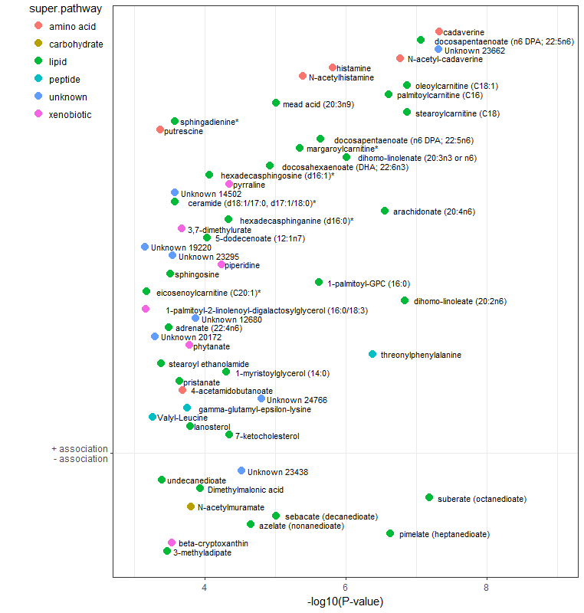
Decreasing β
Increasing β
Fig. 1. Fecal metabolite and BMI associations. 56 fecal metabolites were associated at an FDR-corrected P-value<.01 with BMI (continuous, kg/m²) at age 46 with adjustment for age, sex, smoking status and batch

Figure 2

Fig. 2. Fecal metabolite-metabolite associations. Spearman correlation plot, with hierarchical clustering, of 56 fecal metabolites associated at an FDR-corrected P-value<.01 with BMI at age 46 with adjustment for age, sex, smoking status and batch

Figure 3
(A) | (B)
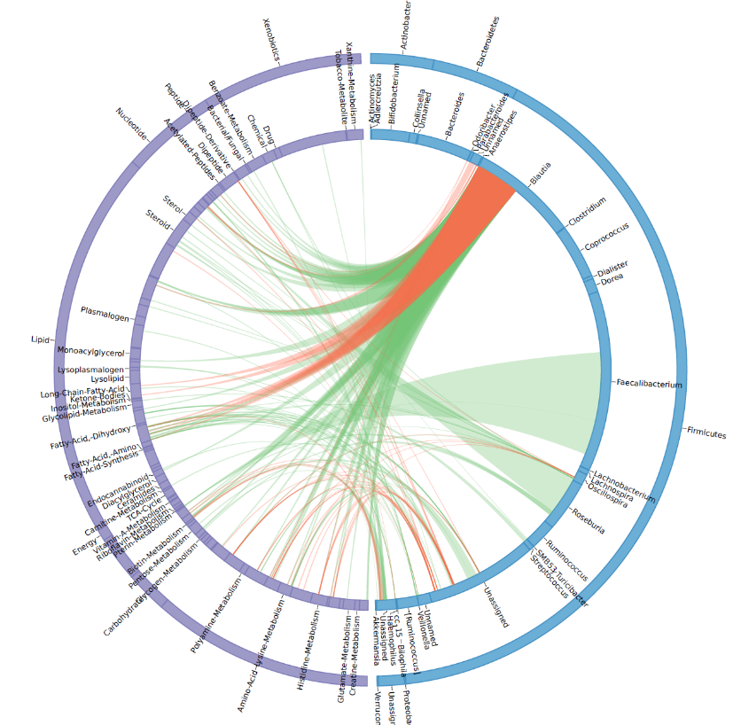 | 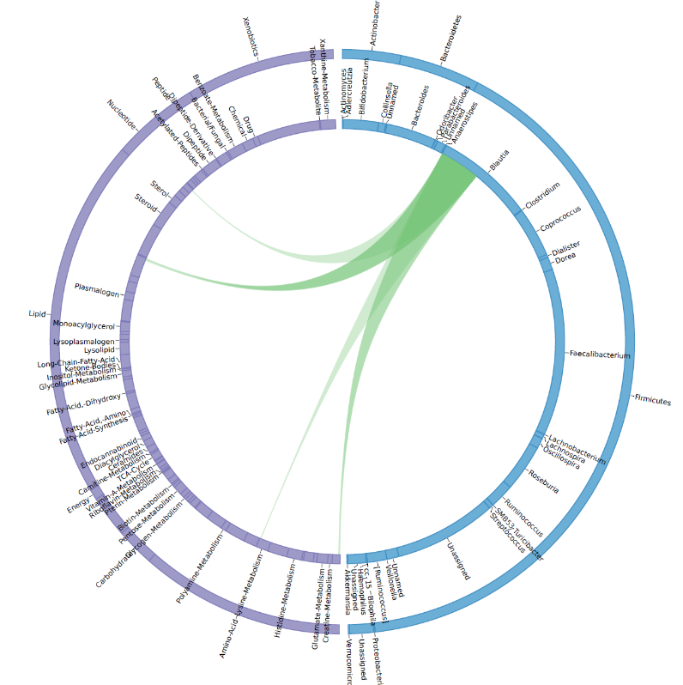
(C) | (D)
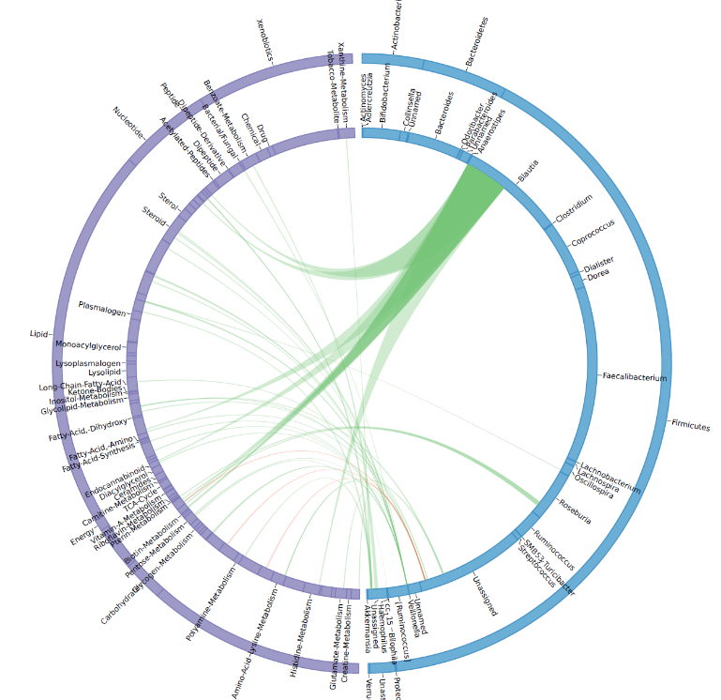 | 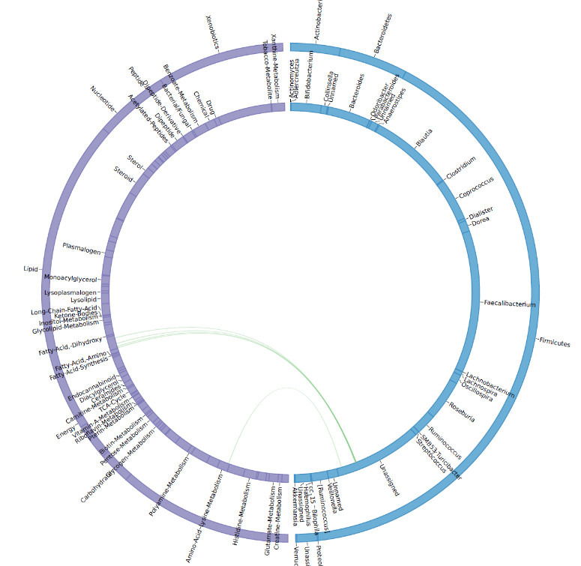

Fig. 3. Microbiome-metabolome associations. Circos plot of microbiome feature-metabolite level associations.
Significant Spearman correlations (FDR-corrected alpha: 1x10-3) between microbiome features (16S rRNA gene sequence variants) and metabolome features (individual metabolites). Outer circle contains high level feature descriptions (super pathway for metabolites; phylum for microbiome features) and inner circle contains low level feature descriptions (sub-pathway for metabolites; genus for microbiome features). Positive correlations are illustrated in green and negative correlations are illustrated in red. Width of line indicates relative abundance of microbiome features. Lines are are not scaled on the metabolome end of the plot. Panel A illustrates correlations identified for all samples (n=293 subjects), while panels B-D represent correlations identified within normal weight, overweight and obese individuals, respectively. Microbiome features were included in this analysis if they were observed in 50% or more of samples, to reduce issues with computing correlations on sparse data.

