Cell-free protein synthesis as a prototyping platform for mammalian Synthetic Biology
Margarita B. Kopniczky¹, Caoimhe Canavan¹, David W. McClymont^{1,2}, Michael A. Crone^{1,3}, Lorna Suckling², Bruno Goetzmann¹, Velia Siciliano¹, James T. MacDonald¹, Kirsten Jensen^{1,2,3} and Paul S. Freemont^{1,2,3}
¹Section of Structural and Synthetic Biology, Department of Infectious Disease, Imperial College London, London, SW7 2AZ, UK
²London Biofoundry, Imperial College Translation & Innovation Hub, White City Campus, 80 Wood Lane, London W12 0BZ, UK
³UK Dementia Research Institute Care Research and Technology Centre, Imperial College London, Hammersmith Campus, Du Cane Road, London, W12 0NN

Abstract
The field of mammalian synthetic biology is expanding quickly and technologies for engineering large synthetic gene circuits are increasingly accessible. However, for mammalian cell engineering, traditional tissue culture methods are slow and cumbersome, and are not suited for high-throughput characterisation measurements. Here we have utilised mammalian Cell-Free Protein Synthesis (CFPS) assays using HeLa cell extracts and liquid handling automation as an alternative to tissue culture and flow cytometry-based measurements. Our CFPS assays take a few hours and we have established optimised protocols for small-volume reactions using automated acoustic liquid handling technology. As a proof-of-concept, we characterised diverse types of genetic regulation in CFPS including T7 constitutive promoter variants, internal ribosomal entry sites (IRES) constitutive translation-initiation sequence variants, CRISPR/dCas9-mediated transcription repression and L7Ae-mediated translation repression. Our data shows simple regulatory elements for use in mammalian cells can be quickly prototyped in a CFPS model system.
Key words
Cell-free, automation, high-throughput, prototyping.

Synthetic Biology aims to engineer biological systems at the genetic level, with predictable ‘human-defined’ functions. A long-standing goal is to break down complex genetic systems into interchangeable parts that can carry out high-level biological functions in a predictable fashion¹. The importance of well-characterised parts, mathematical modelling tools and design automation software have led to these features becoming significant in the field ^{2,3}. Some of the most complex genetic designs to date have been realised using engineering design principles⁴. However, rational forward-engineering is not yet fully established and the validity of the approach has been subject to debate⁵. Semi-rational design has become an increasingly popular alternative, where a diverse set of variants of the target system are generated and directed evolution is used to screen for suitable genetic architectures⁶.
In order to enable both approaches, the importance of reliable measurement methods and automation has been recognised ⁷. Although plate readers are commonly used to characterise gene circuits, critical sample preparation and measurement settings are rarely reported ⁸. Furthermore, results obtained in arbitrary units using undocumented plate reader settings are not comparable between experiments and across labs. Therefore, efforts towards better measurement practices and unit conversion from arbitrary units are currently being promoted in order to ensure reproducibility across labs⁹. Automation implicitly permits precise definition of liquid handling steps and thus increases reproducibility and reduces human error. Furthermore, automation makes it easier to test large numbers of replicates giving more accurate estimates of experimental error. Wider use of automation is also becoming accessible as biological foundries and ‘cloud-labs’ are being established across institutions worldwide¹⁰, however robust measurement methods on automation platforms are still lacking and further developments for genetic circuit testing are needed.
Cell-free protein synthesis (CFPS) has been proposed as a useful prototyping method, as measurements in vitro have been shown to have direct relevance to in vivo data^{11,12}. CFPS systems can be classified according to their originating cell-type (e.g. bacterial, yeast, mammalian) and reaction type (e.g. batch or continuous) and have many advantages over traditional cell-based methods including cost, speed, throughput and automatability. There are several alternative approaches to CFPS automation, including reactions run in microchips¹³, microfluidic chambers^{14,15} and even on paper¹⁶. Acoustic liquid handling with microplates is an increasingly popular choice as high-throughput transfers of small volumes (nL range) can be achieved with multiple assays performed simultaneously ¹⁷. Furthermore, CFPS can accept linear as well as plasmid DNA allowing PCR products to be tested directly¹⁸. The precise control over the components and the simplicity of the reaction (no cell division, no adaptation) also provide additional advantages for mathematical modelling in terms of model parameterisation¹⁷.
Various mammalian CFPS systems have been developed including CHO cell, HeLa cell and Rabbit Reticulocyte extracts¹⁹, with applications typically aiming to produce otherwise difficult-to-express proteins²⁰. Mammalian CFPS has also been used in proteomic research for generating arrays of protein antigens²¹. Although earlier work using a FRET-based biosensor has demonstrated that genetic regulation can be reproduced in mammalian CFPS extracts¹⁶, the applicability of mammalian CFPS for synthetic biology prototyping has not been fully established. Here, we have tested and characterised a series of mammalian genetic regulators using a HeLa cell lysate-based CFPS and a semi-automated workflow, making new molecular tools available for mammalian synthetic biology design.
Results
Establishing an automated workflow for CFPS
CFPS reactions were setup using the 1-Step Human Coupled IVT Kit (Thermo Fisher Scientific) which is commonly used for high-yield protein expression studies. It contains all components necessary for cell-free protein synthesis, including DNA, transcription and translation machinery and energy regeneration components (Figure 1A). The manufacturer’s recommended protocol was adapted to measure gene expression using a fluorescent reporter protein. Changes to the protocol included alteration of the reaction composition, optimisation of specific assay steps including reagent mixing and centrifugation, the use of sealed 96-well plates, development of automation software and identification of suitable quality control steps for sample preparation.
Specifically, the total volume of CFPS reactions was decreased from 25 µL to 2 µL, the minimum volume needed to cover the bottom of the V-shaped wells. The relative composition of the reaction was also changed with lysate, accessory proteins and energy mix decreased from 80% to 60% of the total reaction volume, maintaining a 5:1:2 ratio of components. This allowed a 0.8 µL reaction volume for other components to be added to the CFPS reaction (e.g. DNA, RNA, proteins). Blank reactions (no DNA) and positive controls (10 nM pCFE-GFP control plasmid) were included in all experiments (Supplementary Figure 1). We also measured z-factors as a statistical measure of assay reproducibility (Zhang et al., 1999). The z-factor calculated from the blank and positive controls was found to be consistently above 0.5 for each experiment set (Supplementary Table 1). After optimisation, fluorescent signals of 100-fold above background were observed to produce 0.4 µM GFP at maximum capacity (Figure 1B-C). GFP production saturated after 3 hours and highest measured expression levels were reached at 10 nM DNA concentration (Figure 1B).
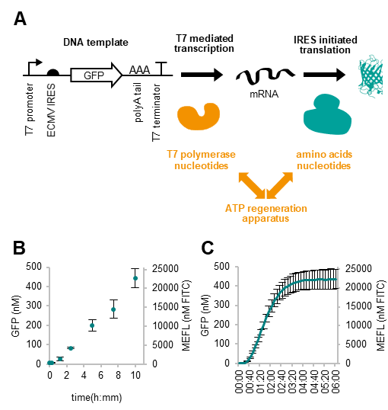
Figure 1 Properties of the HeLa CFPS assay. (A) The DNA template used contains a T7 promoter and an EMCV IRES for expression as well as a T7 terminator following a polyA sequence after the GFP coding region. The lysate of HeLa cells is supplemented with purified T7 polymerase, along with nucleotides, ATP other accessory protein components facilitating ATP regeneration, transcription and translation. (B) GFP expression as a function of DNA template concentration. Endpoint GFP levels at 6h are shown. Mean values of 5 replicates are shown with error bars representing standard deviations. (C) Typical time course of GFP expression using 10 nM of pCFE-GFP DNA template. GFP concentration was calculated by unit conversion from arbitrary fluorescent units using purified GFP as a standard. Mean values of 5 replicates are shown with error bars representing standard deviations.
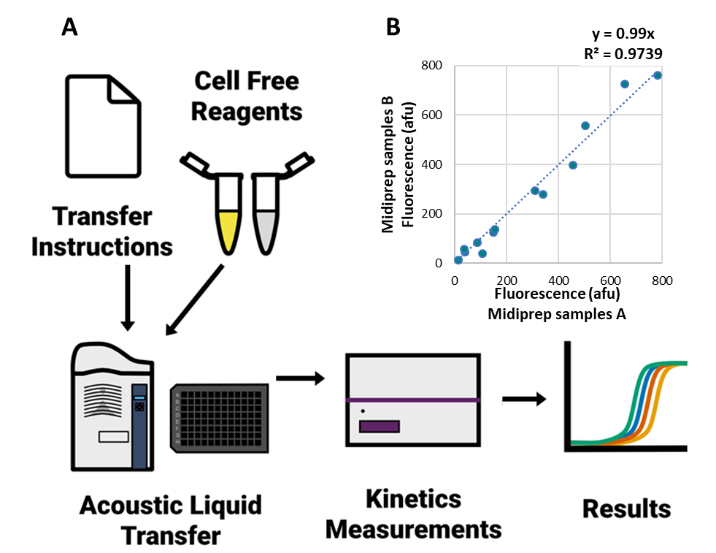
DNA preparation variability was also optimised by implementing strict DNA quantification measures using an automated workflow (Figure 2A). This optimisation resulted in a linear correlation between DNA midiprep samples (R²=0.9739 between DNA preparations, Figure 2B). Spectrophotometric quantification of DNA was replaced by a PicoGreen dye-based method with the manufacturer’s protocol adapted for the Echo 550 and 525 acoustic liquid handlers. This method overcame any potential issues with liquid transfers due to DNA length and viscosity and could be automated instead of manual spectrophotometric measurements. Furthermore, the PicoGreen dye-based method of quantification was determined to be more accurate in previous studies (Supplementary Figure 2).
Figure 2 Automated HeLa CFPS workflow. (A) In the automated workflow, the reactions are assembled using the Labcyte acoustic liquid handler. The machine instructions are given as a list of individual transfer steps produced by a python script, giving high-level parameters such as samples, test conditions and number of replicates. A maximum of 384 reactions at 2 µL volume can be run simultaneously in a plate reader detecting fluorescence intensity. (B) Correlation between measurements using different plasmid DNA preparations within the same experimental run. Measurements are from the T7 and IRES library experiments with R² of the fit indicated.

Experimental automation
The CherryPick software for the Echo liquid handler allows inputs from Comma-Separated Values (CSV) file formats containing a list of liquid transfer steps. By generating method-specific code (written in Python) tailored to our CFPS experiments, we were able to generate CSV files that contained the necessary liquid handling instructions that consider parameters, such as the number of replicates and DNA constructs, and additional instructions for preparing the experiment. The automated design of experiments allowed each given DNA construct to be tested in combination with additional factors at specified concentrations. Blank reactions with no DNA and positive controls with specified DNA concentrations were also added automatically to the list of reaction types. A key feature was the random assignment of each CFPS reaction to wells on a 384-well-plate considering potential position-associated effects, such as different evaporation because of the time difference (minutes) between the transfer of the first and the last sample. FITC standards were also included for unit conversion (Molecules of Equivalent Fluorescein) similar to the iGEM inter-lab study ⁹. Finally, the amounts of each reagent needed for a given experiment were calculated, and the feasibility of the experiment checked based on availability of wells and reagents. The developed software tools are available on Github (https://github.com/margaritakop/CFPS_echo).

Characterising a range of T7 promoters and CMV IRES variants
We next tested a series of gene regulatory elements in our CFPS assays. The aim was to establish whether different levels of transcription and translation activity (repression and activation) can be detected and whether the activity is comparable to previously reported in vivo experiments. For this we chose a tested library of T7 promoters and ECMV IRES element variants^{22–25} Five T7 promoter variants, including wild type, were chosen (Figure 3A). Variants of the ECMV IRES have also been used to drive gene expression. For example, 24 ECMV IRES variants were tested for optimised expression of a monoclonal antibody in CHO cells, with four chosen to demonstrate an unchanged ranking order across diverse mammalian cell-lines²⁵. Four IRES variants were chosen along with wild type IRES for characterisation in our CFPS assays. The variants contain mutations in the 11th and 12th AUG where translation initiation primarily occurs²⁵. (Figure 4A).
The regulatory elements were cloned into the control plasmid pCFE-GFP (Figure 3B and Figure 4B) and GFP expression was measured across a range of DNA concentrations (Figure 3C-J and Figure 4C-J). Each DNA template was tested from two independent DNA preparations using five replicates, with variability shown as box-plots (Figure 3C-J and Figure 4C-J). All the data were collected at the same time in one experimental run on the same multi-well plate. A positive control was included on each plate using one DNA preparation at the highest tested concentration (10 nM).
The relative activity of T7 promoter variants was found to be dependent on the DNA concentration. Variants T7-1, -2 and -3 exhibited gradually increasing activity across the tested concentration range. In contrast, variant T7-4 and T7-WT reached their peak activity at 5 nM concentration (Figure 3G) and demonstrated lower GFP expression at higher concentrations (Figure 3H-I). The maximum overall GFP expression was produced by the T7-3 variant at 10 nM DNA concentration, although T7-3 also exhibited lower expression levels at <5 nM compared to T7-4 and -WT.
In contrast, IRES sequence variants had the same rank order for all tested DNA plasmid concentrations (Figure 4C-J). Maximum expression was achieved by IRES-WT, which also ranked as the highest across different DNA concentrations. However, compared to the T7 promoter set, more variability was observed within replicates and between DNA preparations for IRES variants, especially at higher DNA concentrations.
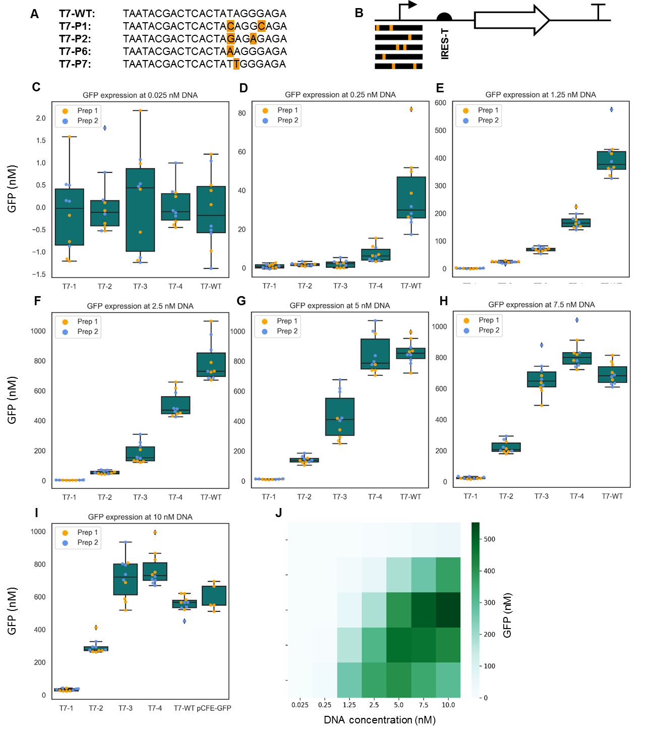Figure 3 HeLa CFPS expression testing of a range of T7 promoter variants. (A) T7 promoter sequence variants. (B) Schematic overview of the DNA construct used for testing T7 promoter variants. (C to I) Expression from the pT7-IRES-GFP construct at various DNA concentrations using a range of T7 promoter strengths. DNA concentrations tested were: 0.025 nM (C), 0.25 nM (D), 1.25 nM (E), 2.5 nM (F), 5 nM (G), 7.5 nM (H) and 10 nM (I). Data points represent two plasmid DNA preparations. All data was collected in one experimental run with the positive control (pCFE-GFP) run at the highest 10 nM plasmid concentration. (J) Summary of expression patterns from parts (C) to (I). The endpoint fluorescence for the reactions is converted to GFP units.
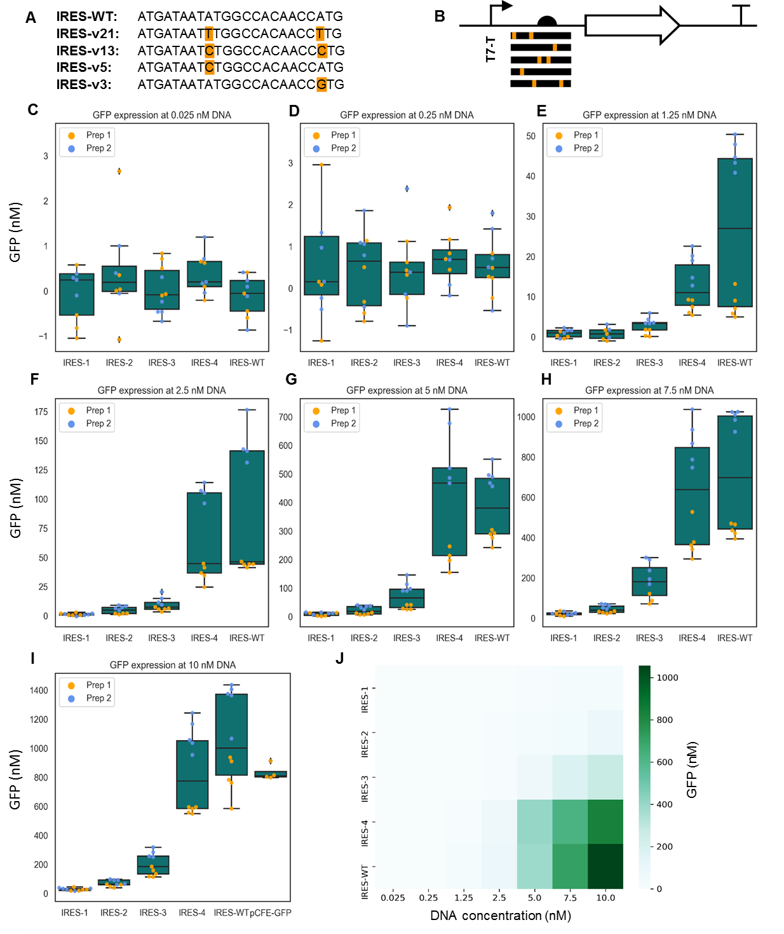Figure 4 HeLa CFPS expression testing of a range of EMCV IRES variants. (A) EMCV IRES variants. (B) Schematic overview of the DNA construct used for testing the IRES variants. (C-I) Expression from the pT7-IRES-GFP construct at various DNA concentrations using a range of IRES strengths. DNA concentrations tested were: 0.025 nM (C), 0.25 nM (D), 1.25 nM (E), 2.5 nM (F), 5 nM (G), 7.5 nM (H) and 10 nM (I). Data points represent two plasmid DNA preparations. All data was collected in one experimental run with the positive control (pCFE-GFP) run at the highest 10 nM plasmid concentration. (J) Summary of expression pattern from parts (C) to (I). The endpoint fluorescence for reactions is converted to GFP units.

Characterising repression dynamics in HeLa CFPS assays
We next characterised more complex regulatory elements and chose a dCas9 transcriptional repression module²⁶ and an L7Ae translational repression module²⁷ as examples. Both regulators are widely used in mammalian synthetic biology and are continuously being developed. The modified and catalytically inactive Cas9 (dCas9) inhibits transcription by binding sgRNA target sites inserted upstream of start codons (Figure 5A). For dCas9 characterisation, we used a promoter architecture with two outward-facing sgRNA target sites flanking the core promoter²⁶. The sequences of the orthogonal binding sites were designed using R2O software²⁸. Sequence-specific repression was observed in our CFPS assays with IC50 values of approximately 35 nM and 29 nM for variant A and B respectively (Figure 5B, Figure 5D and Supplementary Table 2) with full repression observed at 75 nM complex concentration (Figure 5C and Figure 5E).

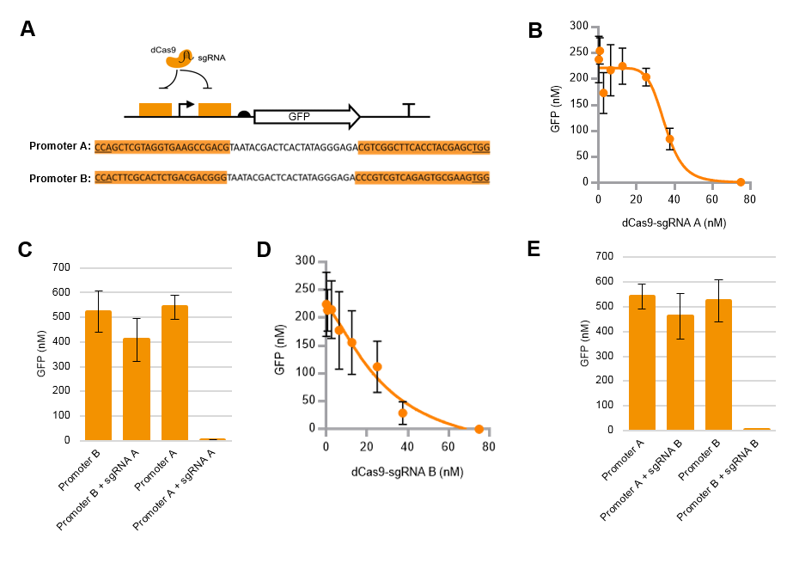
Figure 5 Transcriptional repression by dCas9-sgRNA in HeLa CFPS assays. (A) Synthetic promoters A and B contain two outward-facing sgRNA target sites around a T7 core promoter. The catalytically inactive dCas9 represses this promoter by steric hindrance. (B) Titration of dCas9-sgRNA-A complex on GFP expression. (C) GFP expression in presence or absence of dCas9 and sgRNA-A from control (orthogonal binding sites) and target plasmids (promoter flanked by sequences complementary to sgRNA-A) with 75 nM dCas9-sgRNA-A complex added to the CFPS reaction. (D) Titration of dCas9-sgRNA-B complex on GFP expression. (E) GFP expression in presence or absence of dCas9 and sgRNA-B from control (orthogonal binding sites) and target plasmids (promoter flanked by sequences complementary to sgRNA-B) with 75 nM dCas9-sgRNA-B complex added to the CFPS reaction.

L7Ae is a small (119 amino acids) archaeal protein that specifically recognises a kink-turn (Kt) RNA sequence motif²⁹ also used in negative autoregulation of L7Ae³⁰. The L7Ae archaeal protein is commonly used in mammalian synthetic gene circuits, where in the simplest implementation the L7Ae protein specifically binds to an RNA aptamer upstream of the start codon²⁷ , sterically inhibiting the binding of the translational machinery at the IRES element (Figure 6A). To test the L7Ae repressor module, the Kt aptamer was inserted upstream of the GFP coding sequence, following the IRES element. Recombinant L7Ae was expressed in E. coli and purified using a hexa-histidine tag and titrated into CFPS assays in which GFP expression was monitored (Figure 6B). Reactions either containing a Kt aptamer or the positive control plasmid without the aptamer were used. Interestingly, the background level of GFP expression decreased to approximately 25% when the Kt aptamer was inserted into the pCFE-GFP backbone with no L7Ae added (Figure 6C). Addition of L7Ae resulted in a 10-fold repression compared to negative controls (Figure 6C). Full repression was achieved at 15 nM L7Ae and half repression at approximately 5 nM (Figure 6B) (7.3-fold repression was calculated with an IC50 of 4.9 nM; Supplementary Table 3).
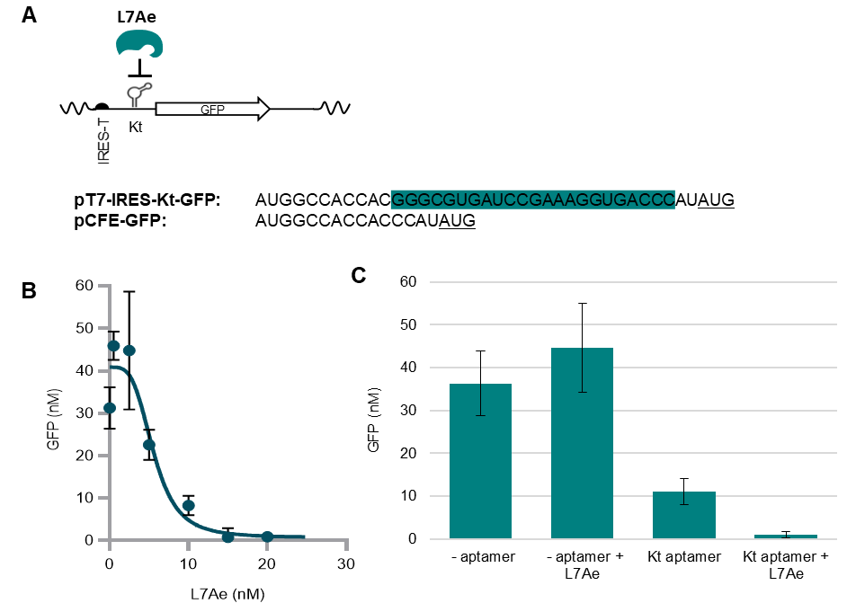Figure 6 Transcriptional repression by L7Ae RNA binding protein in HeLa CFPS assays. (A) The L7Ae RNA binding protein binds to a Kt aptamer placed upstream of the start codon of GFP where L7Ae binding inhibits GFP translation via steric hindrance. The Kt aptamer sequence is highlighted in turquoise blue. (B) Titration of recombinant L7Ae on GFP expression. (C) GFP expression from target plasmids in CFPS assays with or without the Kt aptamer and in the presence or absence of 25 nM L7Ae.
Characterising gene expression in HeLa CFPS assays
To characterise in vitro mammalian gene expression, a construct containing the malachite green aptamer³¹ was designed in accordance with previously synthesised aptamers for use in bacterial CFPS systems³² The designs varied the linker sequences and incorporated the aptamer within a tRNA scaffold to prevent steric hindrance caused by the aptamer’s secondary structure (Supplementary Figure 3)³². The two constructs successfully cloned vary only in the linker regions (Supplementary Figure 3 and Supplementary Table 4).
Malachite green aptamer mRNA levels briefly plateaued between 50-75 minutes, before reaching peak expression at 125 mins and subsequently declining (Figure 7A). pCFE-GFP-MGapt21bp consistently showed higher peak expression, lower degradation rate and higher end-point measurements. After 10 hours mRNA production had plateaued to the same concentration as t=0 for pCFE-GFP-MGapt15bp, whereas mRNA levels for pCFE-GFP-MGapt21bp were still approximately 2-fold higher than the corresponding t=0 level. GFP production was consistent between all constructs and plateaued around 8 hours (Figure 7B).
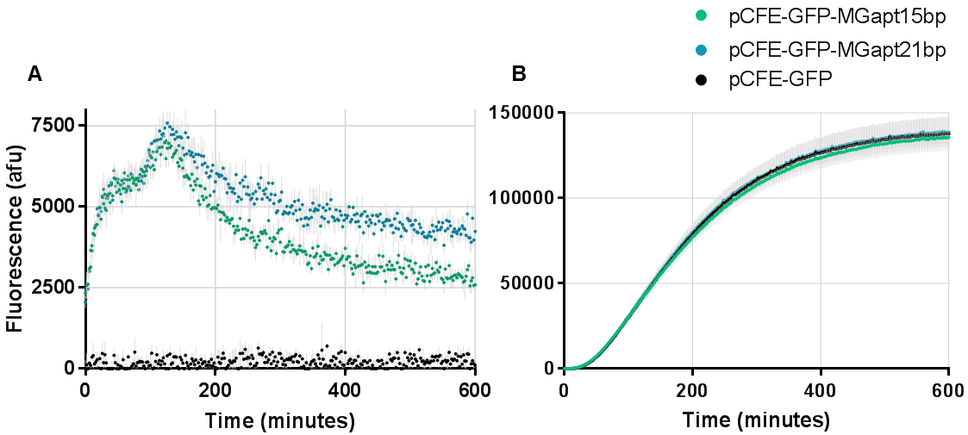Figure 7 Measuring transcription and translation using the malachite green aptamer constructs. Detection of mRNA production (A) and protein production (B) in HeLa IVT kit using the malachite green aptamer constructs (pCFE-GFP-MGapt15bp/21bp).

Reproducibility of CFPS measurements
Experiments were repeated twice on different days using different IVT Kit batches but the same DNA, RNA and protein samples. To assess variability, experimental datasets from the characterisation of T7 promoters, IRESs, dCas9 and L7Ae were used to plot the average GFP expression levels obtained from 4-6 replicates on one day versus values obtained on another day (Figure 8).
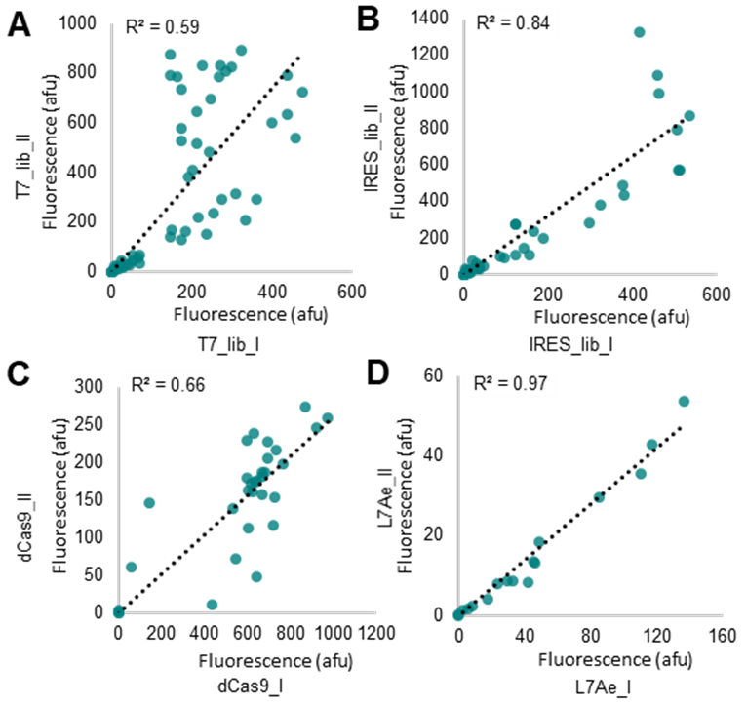
Perfect reproducibility would give rise to a linear correlation with a high correlation coefficient (R² =1). A good level of correlation was observed between CFPS measurements across all experiments. Interestingly, less variation was found in experiments investigating translational regulation (Figure 8B, R² = 0.84 and Figure 8D, R² = 0.97) compared to transcriptional regulation (Figure 8A, R² = 0.59 and Figure 8C, R² = 0.66). The experiment characterising T7 promoter variants was the least reproducible (Figure 8A, R²=0.59) with measurements clustered together by sequence variant (Supplementary Figure 4A). In the experimental run represented on the x axis, the T7-WT and T7-4 expression saturated at intermediate concentrations and only reached maximum of 200-300 afu. In contrast, in the experimental run represented on the y axis, expression from T7-WT and T7-4 promoters did not reach saturation. In contrast, characterisation data from IRES measurements (Supplementary Figure 4B) showed more reproducibility (Figure 8B; R² = 0.84). The overall correlation between the dCas9 characterisation experiments was R² = 0.66 (Figure 8C), with observed variability corresponding to 20-60 nM dCas9-sgRNA (Figure 8C). Out of the four analysed experiments, the L7Ae repression experiments showed the best correlation with R²=0.97 (Figure 8D). Our results show the importance of carrying out multiple replicates using different batches of CFPS extracts.
Figure 8 Reproducibility of HeLa CFPS assays. Comparison between repeat measurements of experiments carried out on different days using different batches of IVT Kit. Experiments corresponding to Figures 3-6 were repeated and the data plotted so that average measurements obtained on one day were plotted against measurements obtained from a different day. Data points represent the mean of 5 replicates from one experimental condition and one plasmid DNA preparation. Linear correlations are shown.

Discussion
CFPS has been established as a useful prototyping method for genetic regulatory elements, as data measured in vitro has direct relevance to in vivo activity¹². In mammalian synthetic biology, the need for tissue culture, manual sample preparation and sophisticated measurement instruments (e.g. fluorescent microscopy) precludes high-throughput measurements in most academic laboratories. In this study we optimised a commercially available HeLa CFPS system for automated prototyping of commonly used mammalian transcription and translation regulatory elements. We chose elements that are widely used to drive gene expression in cell-culture transient transfection experiments in order to establish a CFPS prototyping method for mammalian systems.
To develop our prototyping platform, several key assay parameters were explored. For example, we developed a PicoGreen dye-based assay using an Echo acoustic liquid handling robot to measure DNA concentrations. Our assay also identified genomic DNA contamination, due to an impact on sample transfer, leading to ‘apparent’ low measurements which are highlighted in the error log of the instrument. This prevents wasteful experiments with contaminated DNA preparations. We also explored per-reaction costs for mammalian CFPS at high-throughput. By reducing the total reaction volume and relative composition of cofactors and components, we were able to achieve a 25-fold reduction in reagents per reaction.
To facilitate high-throughput experimentation, we used python modules accessible through scripts to generate machine and experimental instructions for carrying out semi-automated experiments. This allowed combinatorial design of DNA constructs and corresponding regulators, allowing many variants and experimental conditions to be explored. The input specifications include lists of DNA and regulator samples, the number of replicates and options for randomising the plate positions of reactions and inclusion of standards for unit conversion. A graphical user interface was developed to make the corresponding design automation accessible online (http://experimentr.herokuapp.com/). In this study we optimised our CFPS reactions using 384-well plates but 1536-well plates could be used for experiments that required higher throughput.
In order to simultaneously detect mRNA and proteins in our CFPS assays we tested a malachite green aptamer and showed RNA detection over the time course of a reaction. Interestingly, we observed an apparent transcriptional plateau around 50-75 mins, followed by subsequent reversal to the higher rate of transcription before reaching peak expression, the reasons for which are unclear. Furthermore, we also saw differences in decay rates for our pCFE-GFP-MGapt15bp aptamer. This is potentially due to the shorter linker regions resulting in steric hindrance of the downstream polyadenylation sequence, preventing recognition and leading to degradation at a higher rate. Although additional testing of linker regions would be needed to investigate this further, we found that a malachite green aptamer can be used to measure transcriptional dynamics in real-time in a mammalian CFPS system.
Using the IVT HeLa CFPS kit we were able to test four types of commonly used mammalian genetic regulator systems. These were the T7 promoter and IRES transcriptional activation elements, repression of transcription using dCas9 and repression of translation using the viral L7Ae protein-RNA complex. As some of these regulators have been previously characterised in cell-culture systems, we were able to compare our in vitro CFPS characterisation with published in vivo measurements^{24,25,33,34}. The T7 promoter is often used in mammalian transient transfection systems, often in combination with the EMCV IRES, but to our knowledge no quantitative assessment of T7 variants in mammalian cells is available^{35,36}. Surprisingly, our measurements of the T7 promoter variants in mammalian CFPS assays showed similar rank order to measurements in E. coli^{22,24} although full characterisation in mammalian cells would still be required. Interestingly, EMCV IRES variants showed similar relative strengths and rank order of repression using CFPS compared to measurements in CHO cells²⁵. Furthermore, the relative rank order of IRES variants appears cell-type independent, as measurements of the same IRES variants in CHO K1, HEK293, BHK, 373 and COS7 cells are similar²⁵. Characterisation of IRES variants showed the most robustness across experimental repeats. In contrast, measurements of promoter variants showed the most variability, with differing saturation points for GFP expression in different batches of the IVT Kit. This could be due to either transfer problems caused by genomic DNA contamination, or batch-to-batch variability in the extract. A transfer problem is unlikely as the DNA purity was verified using PicoGreen quantification, eliminating the possibility of genomic DNA contamination (Supplementary Figure 2). It is therefore more likely to be due to differences in the activity of extracts. Our results clearly highlight variations in yields and activities using different CFPS extracts, and further studies would be needed to identify the causes of variability. Detailed modelling techniques could also facilitate cross-comparison of experimental replicates and provide insights into sources of variability¹⁷.
Various models have been developed for predicting dCas9/sgRNA binding to DNA^{37,38} and it would be interesting to use our CFPS method to test and refine these models. The dCas9 measurements also showed variability at intermediate expression levels, although we still observe partial repression and GFP expression levels will be sensitive to small differences in repressor concentration. We observe similar binding constants for L7Ae mediated translational repression in our CFPS assays (approximately 5 nM versus 2 nM) to published biochemical measurements using SPR³⁹. We also observe similar fold-repression (approximately 18-fold) to reported L7Ae repression in cells (approximately 10-fold)³³. Interestingly, our data show that a protein-mediated mRNA binding and repression event can be recapitulated in CFPS assays providing a basis for large-scale screening and testing of RNA binding proteins. Given that L7Ae is a versatile RNA binding protein, it also might be possible to establish a programmable L7Ae RNA binding module, similar to TALE and Zinc-finger regulators^{40–42}. Furthermore, this work opens up the possibility to model the combinations of translation and transcription regulators in CFPS. However, the experimental approach might need to be modified to allow for longer reactions which may only be possible using a continuous microfluidic approaches⁴³.
It is important to note that this model expression system is limited to the study of cytoplasmic events. In the absence of the nucleus, transcription is mediated by a viral polymerase and nuclear RNA processing steps do not happen either. While this limitation excludes the study of some of the commonly used mammalian elements such as the CMV or U6 promoters, we believe that it is ideal for the study of cytoplasmic vector systems⁴⁴.
In summary, our results establish an initial proof-of concept study for the utility of a mammalian CFPS in prototyping commonly used regulatory elements. Our method shows that systematic measurements and replicate analyses are required to ensure accurate interpretations in a high-throughput context and that prototyping in HeLa extracts can be relevant to activity in transfected mammalian cell lines. Furthermore, our methods can be expanded to test large combinatorial libraries and prototype different regulatory modules before use in mammalian cell lines. We can also obtain simultaneous measurements of transcription and translation from the same plasmid design which allows the opportunity for detailed mathematical modelling^{15,17,45}. We believe that a mammalian high-throughput prototyping platform using CFPS will facilitate a wider range of mammalian synthetic biology tools and applications to be developed and tested.
Materials and Methods
Cloning of PT7-IRES-turboGFP constructs
Site-directed mutagenesis via PCR was used to generate the T7 promoter and EMCV IRES mutants (Supplementary Table 5) and the Kt aptamer construct (Figure 6A) using the pCFE-GFP control plasmid provided by Thermo Fisher Scientific as a template. The pCFE-GFP control plasmid contains a T7 promoter for transcription labelled the T7-P variant (for positive control), Encephalomyocarditis virus (EMCV) IRES element version labelled IRES-P (for positive control) for translation initiation and the TurboGFP variant of GFP. In the mutants generated, only either the promoter or the IRES variant was changed.
Cloning of dCas9 promoters containing dCas9 binding sites
A total of four oligos including two dCas9 binding sites and the T7-WT promoter were designed for each promoter construct (Table 1). Oligos were annealed by heating to 80°C for 10 minutes, cooled to room temperature slowly over three hours by turning off the heat block. The annealed oligos were phosphorylated and ligated into the previously digested (SacI and BamHI) and dephosphorylated pCFE-GFP backbone.
Table 1 Oligonucleotides used for the dCas9 promoter constructs. Binding sites are underlined, T7-WT core promoter is bold, and overhangs are plain.
Variant | Forward Oligos | Reverse Oligos
Cas9 target A | CCCAGCTCGTAGGTGAAGCCGACGTAATACGACTCACTATAG | GTATTACGTCGGCTTCACCTACGAGCTGGGAGCT
Cas9 target A | GGAGACGTCGGCTTCACCTACGAGCTGGG | GATCCCCAGCTCGTAGGTGAAGCCGACGTCTCCCTATAGTGAGTC
Cas9 target B | CCCACTTCGCACTCTGACGACGGGTAATACGACTCACTATAG | GTATTACCCGTCGTCAGAGTGCGAAGTGGGAGCT
Cas9 target B | GGAGACCCGTCGTCAGAGTGCGAAGTGGG | GATCCCCACTTCGCACTCTGACGACGGGTCTCCCTATAGTGAGTC
DNA Purification and Quantification
All DNA plasmids were purified from 100 mL cultures using the QIAGEN Plasmid Plus Kit using a vacuum manifold according to manufacturer's specifications. The PicoGreen Kit (Thermo Fisher P11496) was used to measure the DNA concentration. 50 nL PicoGreen reagent was added to wells of a black 384-well plate with flat clear bottom, then 19900 nL TE was added plus 100 nL DNA sample. The plate was centrifuged briefly to mix the reagents and kept in the dark for an additional 3 minutes. Fluorescence was measured using 485 excitation and 520 emission wavelength settings on a Biotek Synergy™MX plate reader. A standard curve was obtained by transferring serial dilutions of genomic λ phage DNA and used for unit conversion.

Cloning of the L7Ae construct
The pT7-RBS-L7Ae-6His plasmid (used for L7Ae expression in E.coli and protein purification) was cloned from Level 0 MoClo parts, including synthetic DNA fragments encoding L7Ae coding sequence, a fragment encoding T7 promoter - RBS - hexahistidine tag and pTU1-A backbone⁴⁶. The Level 0 plasmids were assembled with BsaI-HFv2 (New England Biolabs Inc.) and T4 DNA Ligase (Promega). Linkers were designed and the reaction carried out according to the specifications of previously published EcoFlex standard⁴⁶.
L7Ae protein expression and purification
KRX E. coli cells transformed with the pT7-RBS-L7Ae-6His plasmid were used to express the L7Ae protein. A 10 ml starter culture was grown overnight in LB medium supplemented with antibiotics. The overnight culture was diluted 1:100 in 1 L LB media containing 0.1% Rhamnose and grown for 5 hours at 37°C (shaking) and then transferred to a 25°C shaking incubator overnight. Cells were harvested by centrifugation at 2500 rpm for 20 minutes and resuspended in Binding buffer (20 mM Tris-HCl pH 8, 500 mM NaCl, 5 mM Imidazole) and sonicated on ice. The lysate was incubated at 85°C for 20 min to denature other endogenous proteins, centrifuged and the supernatant loaded on a Nickel column for His-tag purification and eluted with 20 nM Tris-HCl pH 8, 500 mM NaCl and 400 mM Imidazole. The eluted fractions containing the purified protein were dialyzed against buffer containing 20 mM HEPES-KOH (pH 7.5), 150 mM KCl, 1.5 mM MgCl₂, and 5% glycerol using a 3.5 kDa MWCO GeBaFlex-Maxi tube (Generon) at 16°C overnight. L7Ae was buffer-exchanged into storage buffer (20 mM HEPES-KOH at pH 7.5, 150 mM KCl, 1.5 mM MgCl₂, and 40% glycerol), snap frozen in liquid nitrogen and stored at -80°C. The purification method was previously described by Saito et al., 2011.

Cloning of the dCas9 construct
The dCas9 expression vector was made by introducing the D10A (RuvC) and H840A (HNH) mutations into the amino acid sequence of Cas9 encoded on pCas9-CR4 vector using Circular Polymerase Extension Cloning (Quan and Tian, 2011). pCas9-CR4 was a gift from Kristala Prather (Addgene plasmid # 62655). dCas9 was then PCR-amplified and cloned into form pBP-dCas9 before being assembled together with a T7 promoter, His-tag and Ribosome Binding Site, and a BB0015 terminator to create pTU1A-T7_His6_dCas9_BB0015 using a MoClo assembly method⁴⁶.
dCas9 protein expression and purification
dCas9 was expressed from pTU1A-T7_His6_dCas9_BB0015 in Rosetta 2(DE3) cells (EMD Biosciences) grown in Terrific Broth supplemented with 5052 autoinduction media⁴⁷. The culture was grown in a shaking incubator at 180 rpm at 37°C until an OD of 1 and the temperature was then decreased to 25°C overnight. Protein purification was performed using an affinity chromatography method described previously⁴⁸ with a modified storage buffer (10 mM Tris pH 7.4, 500 mM NaCl, 0.1 mM EDTA, 1 mM DTT).
sgRNA annealing
Synthetic crRNA and tracrRNA oligos (Table 2) were annealed at a 1:1 molecular ratio according to Alt-R CRISPR-Cas9 System specifications (IDT). The annealed oligos were incubated with a 1:1 molecular ratio of dCas9 in Cas9 buffer (New England Biolabs Inc.; 1x composition: 20 mM HEPES, 100 mM NaCl, 5 mM MgCl₂, 0.1 mM EDTA, pH 6.5 at 25°C) for 10 minutes at room temperature before being added to the CFPS reactions.
 | Source | Sequence
Alt-R® CRISPR-Cas9 tracrRNA | IDT | Proprietary
crRNA_A | IDT | rCrGrUrCrGrGrCrUrUrCrArCrCrUrArCrGrArGrCrGrUrUrUrUrArGrArGrCrUrArUrGrCrU/AlTR2
crRNA_B | IDT | rCrCrCrGrUrCrGrUrCrArGrArGrUrGrCrGrArArGrGrUrUrUrUrArGrArGrCrUrArUrGrCrU/AlTR2
Table 2 Synthetic sgRNA oligos.
Cloning of pCFE-GFP-MGapt constructs
Two malachite green aptamer sequences were synthesised as DNA fragments by Integrated DNA Technologies (IDT), varying only in the linker sequences flanking the aptamer encoding region (Supplementary Figure 3 and Supplementary Table 4). The aptamer DNA was ligated into pCFE-GFP using the restriction enzymes XhoI and BglII (New England BioLabs Inc.).
Testing pCFE-GFP-MGapt constructs
1-Step Human Coupled IVT Kit (Thermo Fisher Scientific, #88881) was used to test the malachite green aptamer constructs. Reaction components were used in accordance with the manufacturer's protocol with two alterations; 25 μM malachite green dye (final concentration) and 68 nM of plasmid DNA was added. Fluorescence output was detected using the CLARIOstar platereader (BMG LABTECH) at excitation 610 nm and emission 650 nm for malachite green detection and excitation 483 nm and emission 530 nm for GFP detection. Reactions were run at 30°C with measurements taken every 2 minutes for 10 hours.
CFPS
The CFPS reactions were prepared using a master mix of the 1-Step Human Coupled IVT Kit (Thermo Fisher Scientific, #88881) components (lysate, accessory proteins, energy mix). Dilutions of the other components such as DNA, protein or RNA were prepared in 384-polypropylene plates and equal volumes of these diluted samples were transferred to the wells in the 384-destination plate (Small VolumeTM, LoBase, Greiner Bio-One) to achieve a range of concentrations. The location of the reactions was randomly allocated on the plate using Python scripts. The DNA, protein and RNA components were transferred first, using the AQ_BP setting of the Echo 525 (Labcyte Inc.). MilliQ water was used in blank reactions. Then, the master mix was transferred using the GSPA liquid setting and the plate was briefly centrifuged for mixing, sealed to minimise evaporation and put into a plate reader pre-heated to 37°C. The plate reader used for measurement of GFP fluorescence in automated experiments was the BioTek Synergy™ MX, at 470/515 nm excitation and emission settings, bottom optic reading, normal read speed, 100 ms delay, 10 measurements and 8 mm read height.
For constitutive expression (T7 library and IRES library) experiments, DNA samples were quantified using the PicoGreen method and adjusted to a 100 ng/µL stock concentration. A range of dilutions were then prepared in 384-polypropylene plates and used for transfer to 384-Small VolumeTM plates at 500 nL total volume for each CFPS reaction.
For L7Ae regulated expression, L7Ae protein in storage buffer (20 mM HEPES-KOH at pH 7.5, 150 mM KCl, 1.5 mM MgCl₂, and 40% glycerol) was defrosted on ice, diluted 10-fold in buffer (20 mM HEPES-KOH at pH 7.5, 150 mM KCl, 1.5 mM MgCl₂, and 5% glycerol) and dilutions for experiments were prepared. The DNA samples and L7Ae were transferred in one run from the same source-plates, the DNA accounted for 250 nL and L7Ae for 250 nL volume in the reaction.
For dCas9 regulated expression, dCas9 protein in storage buffer was defrosted on ice, diluted 10-fold in dCas9 storage buffer and used for the preparation of the dCas9-sgRNA complex. Annealed sgRNA and dCas9 were mixed at equimolar concentrations and incubated at room temperature for 10 minutes. Dilutions of the complex were prepared in 384-polypropylene plates and used for transfer to 384-V bottom plates. CFPS reactions contained 125 nL DNA and 375 nL dCas9-sgRNA complex in terms of volume.
Unit conversion and data analysis
A GFP unit conversion curve was obtained with various concentrations of purified TurboGFP (Evrogen #FP552) spiked into blank CFPS reactions. The blank corrected arbitrary fluorescent units were converted to nM GFP equivalent units using the obtained standard curve (1 afu = 0.015 nM GFP). Z’ values were calculated using: http://www.screeningunit-fmp.net/tools/z-prime.php.
Supporting Information
This material is available free of charge via the internet at http://pubs.acs.org.
- Supplementary Tables 1-5 (including sequences)
- Supplementary Figures 1-4
Author Contributions
M. B. K., C. C., K. J. and P. S. F. designed the research. M. B. K. and C. C. carried out experiments and analysed data. M. A. C. in vitro transcribed sgRNAs and purified dCas9 protein used in experiments corresponding to Figure 5. L. S. developed the method for accurate DNA concentration quantification. B. G. made the DNA constructs used in experiments corresponding to Figure 5. D. W. M. advised on acoustic liquid handling. J. T. M. designed sgRNA sequences and purified dCas9 protein and advised on automation. V. S. advised on CRISPR/Cas9 technologies and mammalian synthetic biology. M. B. K., C. C., K. J. and P. S. F. wrote the manuscript.
Funding Sources
The research was in part supported by the Engineering and Physical Sciences Research Council (EPSRC) [EP/L011573/1, EP/M006700/1, EP/N023854/1] and the DNA Synthesis Capital Award [BB/M025632/1]. MBK was supported by an EPSRC PhD studentship awarded to Imperial College DTP.
The authors declare no competing financial interest or conflict of interest.

Acknowledgements
We thank members of the Freemont group for helpful comments but specifically Ke Yan Wen, Loren P. Cameron, Richard Kelwick and Simon J. Moore.

References
(1) M Purnick, P. E.; Weiss, R. The Second Wave of Synthetic Biology: From Modules to Systems. Nat. Rev. Mol. Cell Biol. 2009, 10 (6), 410–422.
(2) Myers, C. J.; Beal, J.; Gorochowski, T. E.; Kuwahara, H.; Madsen, C.; McLaughlin, J. A.; Mısırlı, G.; Nguyen, T.; Oberortner, E.; Samineni, M.; et al. A Standard-Enabled Workflow for Synthetic Biology. Biochem. Soc. Trans. 2017, 45 (3), 793–803.
(3) Appleton, E.; Densmore, D.; Madsen, C.; Roehner, N.; Ellis, T.; Jewett, M. Needs and Opportunities in Bio-Design Automation: Four Areas for Focus. Curr. Opin. Chem. Biol. 2017, 40, 111–118.
(4) Bhatia, S. P.; Smanski, M. J.; Voigt, C. A.; Densmore, D. M. Genetic Design via Combinatorial Constraint Specification. ACS Synth. Biol. 2017, 6 (11), 2130–2135.
(5) Porcar, M.; Peretó, J. Nature versus Design: Synthetic Biology or How to Build a Biological Non-Machine. Integr. Biol. Integr. Biol 2016, 8, 451–455.
(6) Rogers, J. K.; Church, G. M. Multiplexed Engineering in Biology. Trends Biotechnol. 2016, 34 (3), 198–206.
(7) De Lorenzo, V.; Schmidt, M. Biological Standards for the Knowledge-Based BioEconomy: What Is at Stake. N. Biotechnol. 2018, 40, 170–180.
(8) Chavez, M.; Ho, J.; Tan, C. Reproducibility of High-Throughput Plate-Reader Experiments in Synthetic Biology. ACS Synth. Biol. 2017, 6 (2), 375–380.
(9) Beal, J.; Haddock-Angelli, T.; Gershater, M.; de Mora, K.; Lizarazo, M.; Hollenhorst, J.; Rettberg, R.; Contributors, iGEM I. S. Reproducibility of Fluorescent Expression from Engineered Biological Constructs in E. Coli. PLoS One 2016, 11 (3), e0150182.
(10) Chao, R.; Mishra, S.; Si, T.; Zhao, H. Engineering Biological Systems Using Automated Biofoundries. Metab. Eng. 2017, 42, 98–108.
(11) Chappell, J.; Jensen, K.; Freemont, P. S. Validation of an Entirely in Vitro Approach for Rapid Prototyping of DNA Regulatory Elements for Synthetic Biology. 2013, 41 (5),
(12) Perez, J. G.; Stark, J. C.; Jewett, M. C. Cell-Free Synthetic Biology: Engineering Beyond the Cell. Cold Spring Harb. Perspect. Biol. 2016, 8 (12), a023853.
(13) Ueno, S.; Hirai, T.; Sato, S.; Biyani, M.; Kuramochi, H.; Iizuka, R.; Akagi, T.; Funatsu, T.; Ichiki, T. In Situ Synthesis and Immobilization of Enzyme Molecules on Microreactor Array Chips. J. Photopolym. Sci. Technol. 2015, 28 (5), 719–725.
(14) Jackson, K.; Jin, S.; Fan, Z. H. Optimization of a Miniaturized Fluid Array Device for Cell-Free Protein Synthesis. Biotechnol. Bioeng. 2015, 112 (12), 2459–2467.
(15) Niederholtmeyer, H.; Sun, Z. Z.; Hori, Y.; Yeung, E.; Verpoorte, A.; Murray, R. M.; Maerkl, S. J.; Fe, P. Rapid Cell-Free Forward Engineering of Novel Genetic Ring Oscillators. Elife 2015, 4.
(16) Pardee, K.; Green, A. A.; Ferrante, T.; Cameron, D. E.; Daleykeyser, A.; Yin, P. Paper-Based Synthetic Gene Networks. Cell 2014, 1–15.
(17) Moore, S. J.; MacDonald, J. T.; Wienecke, S.; Ishwarbhai, A.; Tsipa, A.; Aw, R.; Kylilis, N.; Bell, D. J.; McClymont, D. W.; Jensen, K.; et al. Rapid Acquisition and Model-Based Analysis of Cell-Free Transcription-Translation Reactions from Nonmodel Bacteria. Proc. Natl. Acad. Sci. U. S. A. 2018, 115 (19), E4340–E4349.
(18) Sun, Z. Z.; Yeung, E.; Hayes, C. A.; Noireaux, V.; Murray, R. M. Linear DNA for Rapid Prototyping of Synthetic Biological Circuits in an Escherichia Coli Based TX-TL Cell-Free System. ACS Synth. Biol. 2014, 3 (6), 387–397.
(19) Hartsough, E. M.; Shah, P.; Larsen, A. C.; Chaput, J. C. Comparative Analysis of Eukaryotic Cell-Free Expression Systems. Biotechniques 2015, 59 (3), 149–151.
(20) Thoring, L.; Dondapati, S. K.; Stech, M.; Wüstenhagen, D. A.; Kubick, S. High-Yield Production of “Difficult-to-Express” Proteins in a Continuous Exchange Cell-Free System Based on CHO Cell Lysates. Sci. Rep. 2017, 7 (1), 11710.
(21) Ayoglu, B.; Schwenk, J. M.; Nilsson, P. Antigen Arrays for Profiling Autoantibody Repertoires. Bioanalysis 2016, 8 (10), 1105–1126.
(22) Smanski, M. J.; Bhatia, S.; Zhao, D.; Park, Y.; B A Woodruff, L.; Giannoukos, G.; Ciulla, D.; Busby, M.; Calderon, J.; Nicol, R.; et al. Functional Optimization of Gene Clusters by Combinatorial Design and Assembly. Nat. Biotechnol. 2014, 32 (12), 1241–1249.
(23) Komura, R.; Aoki, W.; Motone, K.; Satomura, A.; Ueda, M. High-Throughput Evaluation of T7 Promoter Variants Using Biased Randomization and DNA Barcoding. PLoS One 2018, 13 (5).
(24) Temme, K.; Hill, R.; Segall-Shapiro, T. H.; Moser, F.; Voigt, C. A. Modular Control of Multiple Pathways Using Engineered Orthogonal T7 Polymerases. 2012, 40 (17).
(25) Koh, E. Y. C.; Ho, S. C. L.; Mariati; Song, Z.; Bi, X.; Bardor, M.; Yang, Y. An Internal Ribosome Entry Site (IRES) Mutant Library for Tuning Expression Level of Multiple Genes in Mammalian Cells. PLoS One 2013, 8 (12), e82100.
(26) Gilbert, L. a; Larson, M. H.; Morsut, L.; Liu, Z.; Brar, G. a; Torres, S. E.; Stern-Ginossar, N.; Brandman, O.; Whitehead, E. H.; Doudna, J. a; et al. CRISPR-Mediated Modular RNA-Guided Regulation of Transcription in Eukaryotes. Cell 2013, 154 (2), 442–451.
(27) Saito, H.; Kobayashi, T.; Hara, T.; Fujita, Y.; Hayashi, K.; Furushima, R.; Inoue, T. Synthetic Translational Regulation by an L7Ae-Kink-Turn RNP Switch. Nat. Chem. Biol. 2010, 6 (1), 71–78.
(28) Casini, A.; Christodoulou, G.; Freemont, P. S.; Baldwin, G. S.; Ellis, T.; Macdonald, J. T. R2oDNA Designer: Computational Design of Biologically Neutral Synthetic DNA Sequences. 2014.
(29) Huang, L.; Lilley, D. M. J. The Molecular Recognition of Kink-Turn Structure by the L7Ae Class of Proteins. RNA 2013, 19 (12), 1703–1710.
(30) Daume, M.; Uhl, M.; Backofen, R.; Randau, L. RIP-Seq Suggests Translational Regulation by L7Ae in Archaea. MBio 2017, 8 (4), e00730-17.
(31) Kolpashchikov, D. M. Binary Malachite Green Aptamer for Fluorescent Detection of Nucleic Acids. 2005.
(32) Pothoulakis, G.; Ceroni, F.; Reeve, B.; Ellis, T. The Spinach RNA Aptamer as a Characterization Tool for Synthetic Biology. ACS Synth. Biol. 2014, 3 (3), 182–187.
(33) Endo, K.; Stapleton, J. a; Hayashi, K.; Saito, H.; Inoue, T. Quantitative and Simultaneous Translational Control of Distinct Mammalian MRNAs. Nucleic Acids Res. 2013, 41 (13),
(34) Vigouroux, A.; Oldewurtel, E.; Cui, L.; Bikard, D.; van Teeffelen, S. Tuning DCas9’s Ability to Block Transcription Enables Robust, Noiseless Knockdown of Bacterial Genes. Mol. Syst. Biol. 2018, 14 (3), e7899.
(35) Elroy-Stein, O.; Moss, B. Cytoplasmic Expression System Based on Constitutive Synthesis of Bacteriophage T7 RNA Polymerase in Mammalian Cells. 1990, 87 (September), 6743–6747.
(36) Ghassemi, F.; Madadgar, O.; Roohvand, F.; Rasekhian, M.; Etemadzadeh, M. H.; Boroujeni, G. R. N.; Langroudi, A. G.; Azadmanesh, K. Translational Efficiency of BVDV IRES and EMCV IRES for T7 RNA Polymerase Driven Cytoplasmic Expression in Mammalian Cell Lines. Mol. Biol. 2017, 51 (2), 283–292.
(37) Farasat, I.; Salis, H. M. A Biophysical Model of CRISPR/Cas9 Activity for Rational Design of Genome Editing and Gene Regulation. PLOS Comput. Biol. 2016, 12 (1), e1004724.
(38) Boyle, E. A.; Andreasson, J. O. L.; Chircus, L. M.; Sternberg, S. H.; Wu, M. J.; Guegler, C. K.; Doudna, J. A.; Greenleaf, W. J. High-Throughput Biochemical Profiling Reveals Sequence Determinants of DCas9 off-Target Binding and Unbinding. Proc. Natl. Acad. Sci. U. S. A. 2017, 114 (21), 5461–5466.
(39) Stapleton, J. a; Endo, K.; Fujita, Y.; Hayashi, K.; Takinoue, M.; Saito, H.; Inoue, T. Feedback Control of Protein Expression in Mammalian Cells by Tunable Synthetic Translational Inhibition. ACS Synth. Biol. 2012, 1 (3), 83–88.
(40) Filipovska, A.; Rackham, O. Modular Recognition of Nucleic Acids by PUF, TALE and PPR Proteins. Mol. Biosyst. 2012, 8 (3), 699–708.
(41) Filipovska, A.; Razif, M. F. M.; Nygård, K. K. a; Rackham, O. A Universal Code for RNA Recognition by PUF Proteins. Nat. Chem. Biol. 2011, 7 (7), 425–427.
(42) Chen, Y.; Varani, G. Engineering RNA-Binding Proteins for Biology. FEBS J. 2013, 280 (16), 3734–3754.
(43) Hori, Y.; Kantak, C.; Murray, R. M.; Abate, A. R. Cell-Free Extract Based Optimization of Biomolecular Circuits with Droplet Microfluidics. Lab Chip 2017, 17 (18), 3037–3042.
(44) Schott, J. W.; Morgan, M.; Galla, M.; Schambach, A. Viral and Synthetic RNA Vector Technologies and Applications. Mol. Ther. 2016.
(45) Hu, C. Y.; Takahashi, M. K.; Zhang, Y.; Lucks, J. B. Engineering a Functional Small RNA Negative Autoregulation Network with Model-Guided Design. ACS Synth. Biol. 2018, 7 (6), 1507-1518.
(46) Moore, S. J.; Lai, H.-E.; Kelwick, R. J. R.; Chee, S. M.; Bell, D. J.; Polizzi, K. M.; Freemont, P. S. EcoFlex: A Multifunctional MoClo Kit for E. Coli Synthetic Biology. ACS Synth. Biol. 2016, 5 (10), 1059–1069.
(47) Studier, F. W. Protein Production by Auto-Induction in High-Density Shaking Cultures. Protein Expr. Purif. 2005, 41 (1), 207–234.
(48) Jinek, M.; Chylinski, K.; Fonfara, I.; Hauer, M.; Doudna, J. A.; Charpentier, E. A Programmable Dual-RNA-Guided DNA Endonuclease in Adaptive Bacterial Immunity. Science (80-. ). 2012, 337 (6096), 816–821.

Supplementary Information: Cell-free protein synthesis as a prototyping platform for mammalian Synthetic Biology

Margarita B. Kopniczky¹, Caoimhe Canavan¹, David W. McClymont^{1,2}, Michael A. Crone^{1,3}, Lorna Suckling², Bruno Goetzmann¹, Velia Siciliano¹, James T. MacDonald¹, Kirsten Jensen^{1,2,3} and Paul S. Freemont^{1,2,3}
¹Section of Structural and Synthetic Biology, Department of Infectious Disease, Imperial College London, London, SW7 2AZ, UK
²London Biofoundry, Imperial College Translation & Innovation Hub, White City Campus, 80 Wood Lane, London W12 0BZ, UK
³UK Dementia Research Institute Care Research and Technology Centre, Imperial College London, Hammersmith Campus, Du Cane Road, London, W12 0NN

Table of contents
Supplementary Tables 1-5
Supplementary Figures 1-4

Supplementary Tables
Supplementary Table 1: Quality of the CFPS measurement method. Z' is a statistical measure of a signal and takes into account both the fold-change and the variability of an assay. It is calculated given replicate measurements of a blank (or negative control) and that of the sample (or positive control). Its value can be 0-1 and an assay is commonly accepted as excellent above z’=0.5. The online tool used for the calculations is available at: http://www.screeningunit-fmp.net/tools/z-prime.php.
Experiment | Z’ standard
T7_lib_I | 0.590
T7_lib_II | 0.763
IRES_lib_I | 0.803
IRES_lib_II | 0.837
dCas9_I | 0.622
dCas9_II | 0.578
L7Ae_I | 0.612
L7Ae_II | 0.756

Supplementary Table 2: Best fit values of curves fitted to dCas9 repression data. Fitting was carried out using Graphpad Prism with the inbuilt function: “[Inhibitor] vs. response -- Variable slope (four parameters)”.
 | Cas9 promoter A |  | Cas9 promoter B
 | Best-fit values | Std. Error | Best-fit values | Std. Error
Bottom | 1.158 | 14.11 | -59.22 | 70.28
Top | 221.5 | 6.216 | 218.2 | 11.36
HillSlope | 7.268 | 2.382 | 1.461 | 0.5337
IC50 | 35.07 | 1.519 | 28.24 | 11.62
logIC50 | 1.545 |  | 1.451
Span | 220.3 | 15.61 | 277.4 | 75.22

Supplementary Table 3: Best fit values of curves fitted to L7Ae repression data. Fitting was carried out using Graphpad Prism with the in-built function “[Inhibitor] vs. response -- Variable slope (four parameters)”.
L7Ae | Best-fit values | Std. Error
Bottom | 0.7008 | 0.6964
Top | 12.31 | 0.6636
HillSlope | 3.143 | 1.155
IC50 | 4.875 | 0.5675
logIC50 | 0.688
Span | 11.6 | 1.043

Supplementary Table 4: Sequences for malachite green aptamer constructs. Linker sequence are highlighted grey, tRNA scaffold is highlighted yellow and MG aptamer sequence is highlighted blue.
Plasmid | Sequence
pCFE-GFP-MGapt15bp | CGTGTCCACCGTGGAGCCCGGATAGCTCAGTCGGTAGAGCAGCGGCCGGGATCCCGACTGGCGAGAGCCAGGTAACGAATGGATCCCGGCCGCGGGTCCAGGGTTCAAGTCCCTGTTCGGGCGCCATGTGGAATCAAGATC
pCFE-GFP-MGapt21bp | CGATAAGCAGCGGCTACCACCGCCCGGATAGCTCAGTCGGTAGAGCAGCGGCCGGGATCCCGACTGGCGAGAGCCAGGTAACGAATGGATCCCGGCCGCGGGTCCAGGGTTCAAGTCCCTGTTCGGGCGCCACTTAGCTACGCGGCGAAGATC

Supplementary Table 5: Oligonucleotides used for cloning. Mutations are underlined.
Variant | Forward primer | Reverse primer
T7-WT | GGAGAATTAATTCCGGTTATTTTCCACC | CTATAGTGAGTCGTATTACAATTCACTGGC
T7-1 | GCAGAATTAATTCCGGTTATTTTCCACC | CTGTAGTGAGTCGTATTACAATTCACTGGC
T7-2 | AGAGAATTAATTCCGGTTATTTTCCACC | CTCTAGTGAGTCGTATTACAATTCACTGGC
T7-3 | GGAGAATTAATTCCGGTTATTTTCCACC | CTTTAGTGAGTCGTATTACAATTCACTGGC
T7-4 | GGAGAATTAATTCCGGTTATTTTCCACC | CAATAGTGAGTCGTATTACAATTCACTGGC
IRES-WT | ACAACCATGGAGAGCGACGAGAGCG | GGCCATATTATCATCGTGTTTTTCAAAGGAAAAC
IRES-1 | ACAACCTTGGAGAGCGACGAGAGCG | GGCCAAATTATCATCGTGTTTTTCAAAGGAAAAC
IRES-2 | ACAACCCTGGAGAGCGACGAGAGCG | GGCCAGATTATCATCGTGTTTTTCAAAGGAAAAC
IRES-3 | ACAACCATGGAGAGCGACGAGAGCG | GGCCAGATTATCATCGTGTTTTTCAAAGGAAAAC
IRES-4 | ACAACCGTGGAGAGCGACGAGAGCG | GGCCATATTATCATCGTGTTTTTCAAAGGAAAAC
Kt | CGAAAGGTGACCCATATGGAGAGCGACGAG | GATCACGCCCGTGGTGGCCATATTATCATCGTG

Supplementary Figures
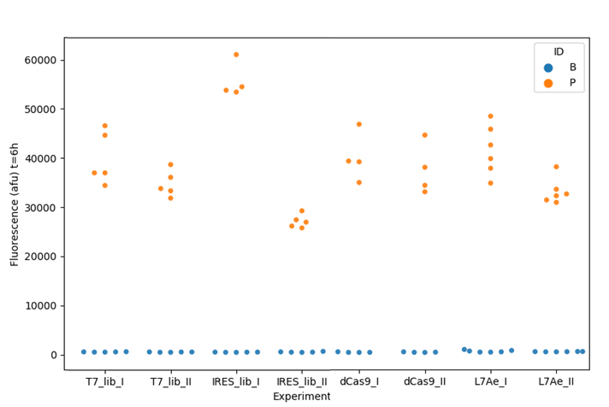
Supplementary Figure 1: Positive controls and blank reactions across experimental datasets. The raw fluorescence of blank (B) and positive control (P) samples represented as one dot for one replicate measurement. Blank reactions contain 500nL water, positive reactions contain 500nL DNA pCFE-GFP, at a 10nM final concentration in the reaction. Raw fluorescence is given in arbitrary fluorescent units (afu) at the 6-hour time point. This data was used to calculate z’ values in Supplementary Table IV below.

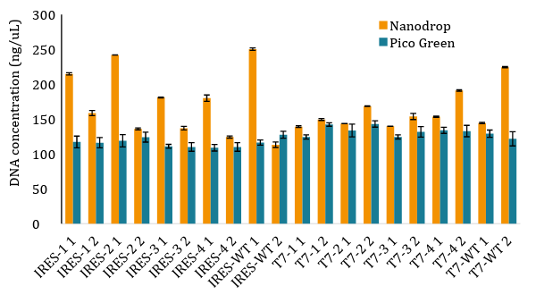
Supplementary Figure 2: Quantification of DNA preparations. DNA samples were diluted to 100ng/uL target concentrations based on previous measurement using the Picogreen method. The samples were measured via the spectrophotometric method, using a Nanodrop instrument thrice, in a manner such that all samples were measured consecutively and the whole set measured again (the measurements were not taken directly following each other). The orange bars represent the mean and the error bars represent standard deviation of the measurements taken with the Nanodrop instrument. The same samples were quantified with dsDNA-specific PicoGreen fluorescent dye and each sample was measured thrice within the same measurement run. A standard curve was obtained using purified genomic λ phage DNA for unit conversion to absolute units from arbitrary fluorescence. The teal coloured bars represent averages of calculated concentration based on the PicoGreen method, and the error bars represent standard deviations.
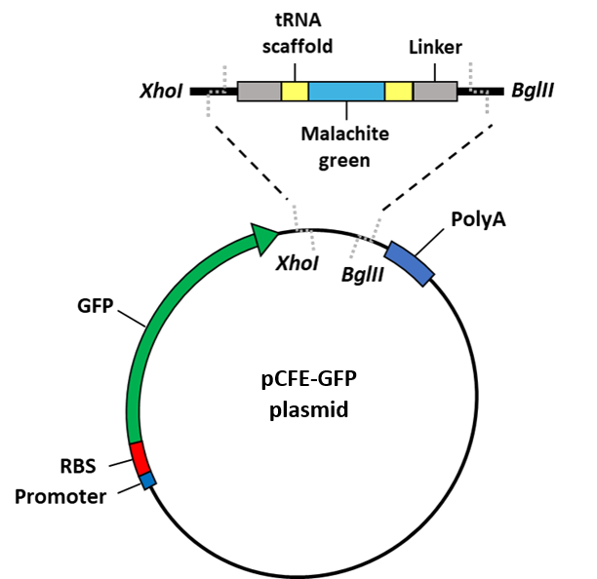

Supplementary Figure 3: Schematic of pCFE-GFP-MGapt15/21bp aptamer. Aptamer sequences were ligated into the previously digested pCFE-GFP backbone.

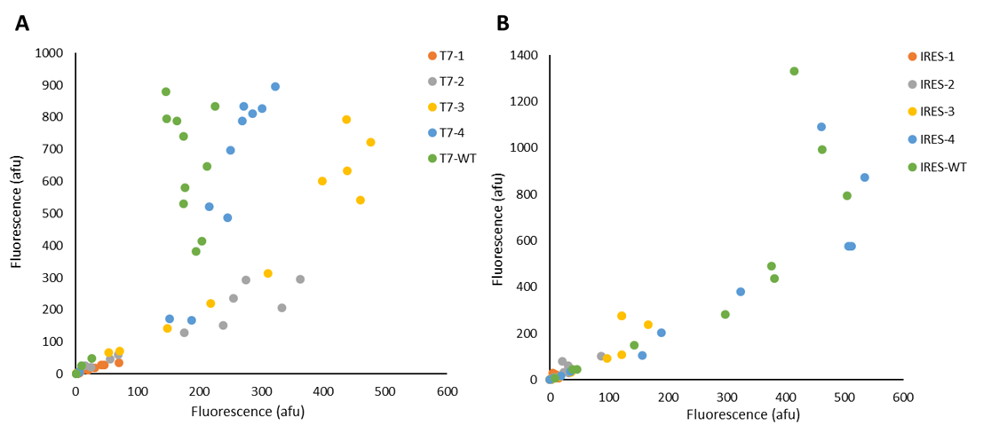
Supplementary Figure 4: Reproducibility of CFPS measurements, by sequence variant. Each dot represents the average measurement corresponding to one DNA preparation at one concentration of one sequence variant. Measurements from one experimental run are represented on the x axis, and corresponding measurements obtained in a repeated experiment from a different day using a different IVT Kit batch are represented on the y axis. (A) T7 promoter variants, experiment corresponding to Figure 3. (B) EMCV IRES variants, experiment corresponding to Figure 4.

