The reduction properties of M-doped (M=Zr, Gd) CeO₂/YSZ scaffolds co-infiltrated with nickel.

Dr. R. C. Maher,
The Blackett Laboratory, Imperial College London, Prince Consort Road, London, SW7 2BZ, United Kingdom

Dr. G. Kerherve, Dr. D.J. Payne
Department of Materials, Imperial College London, London, SW7 2AZ, United Kingdom

Dr. X. Yue, Dr P.A. Connor, Prof. J. Irvine
University of St Andrews, School of Chemistry St Andrews KY16 9ST, Fife, Scotland

Prof. L. F. Cohen
The Blackett Laboratory, Imperial College London, Prince Consort Road, London, SW7 2BZ, United Kingdom

Abstract
In recent years infiltration of materials into porous ceramic scaffolds has been shown to be an effective way of creating catalytically active components for solid oxide fuel cells (SOFCs). However, the redox properties of these novel structures are not well understood. Here, we use X-ray photoelectron spectroscopy (XPS) and in-situ Raman spectroscopy to investigate the oxidation properties of yttria-stabilised zirconia (YSZ) scaffolds infiltrated with ceria (CeO₂), gadolinium-doped ceria (GDC) and zirconia-doped ceria (ZDC), with and without Ni. XPS shows that doping ceria with zirconia increases the ratio of Ce³⁺ to Ce⁴⁺, while gadolinium doping results in a decrease of Ce³⁺. The presence of Ni increases the Ce³⁺/Ce⁴⁺ ratio for CeO₂ and GDC, but had little effect on ZDC. We used the shift of the F_{2g} Raman peak to monitor in-situ, the oxidation state of ceria. In the as-made compounds, we show that while the gadolinium and zirconium dopants significantly change the oxidation characteristics of ceria, the resulting materials are only significantly reduced above 500 ˚C when co-infiltrated with Ni. In-situ Raman monitoring during reduction as a function of temperature showed that while ZDC reduces much more readily than undoped ceria or GDC, the presence of Ni dominated the reduction dynamics.

1. Introduction
The redox properties of ceria and doped ceria remains an area of importance given their use within a wide range of applications ^{[1]}. The high oxygen storage capacity of ceria has been exploited within catalytic converters for three-way catalysis for many years, where pollutants resulting from incomplete fuel combustion are removed ^{[1-2]}. Ceria is also of interest in solid oxide electrolysis cells ^{[3]} and more recently in the thermochemical redox cycling using concentrated solar thermal energy ^{[4]}, for the production of CO and H₂. Partially reduced ceria is readily reoxidised in the presence of O₂ or oxygen containing molecule such as carbon dioxide or water leading to the production of CO and H₂. The high oxygen mobility of doped ceria at relatively low temperatures have made them of interest as electrolytes and electrode components within solid oxide fuel cells (SOFCs), particularly for the development of so called intermediate temperature SOFCs where operating temperatures are reduced to improve material stability and costs ^{[5]}.
As a result of the broad interest in ceria for technological applications, its redox properties have been extensively studied. Reduction of ceria by hydrogen is an endothermic reaction ^{[6]} which is strongly affected by a range of factors including the crystallinity ^{[7]}, specific surface area ^{[8]}, the presence of metals at the ceria surface ^{[9]} as well as any doping with suitable aliovalent dopants ^{[10]}. The effects of doping has been widely studied for a wide variety of dopants, both from an experimental ^{[11]} and theoretical perspective^{[12]}. In broad terms, Gd is an ionic dopant, in that for every two Gd³⁺ ions that replace two Ce⁴⁺ ions within the lattice, an oxygen vacancy is introduced with a resultant improvement in oxygen mobility. However, GDC is typically harder to reduce by hydrogen as a result of having excess stable vacancies. On the other hand, Zr-doping of ceria destabilises its fluorite structure as Zr is too small for this coordination. This induces significant strain into the structure which causes the formation of oxygen vacancies ^{[13]}. As a result ZDC loses oxygen more easily and even a small amount of Zr can significantly decrease the energy required for reduction ^{[14]}. Therefore, under any given condition the number of reducible vacancies and potential Ce³⁺ sites will increase from GDC to undoped ceria to ZDC.
Ceria is often combined with nickel as a composite material for the SOFC anodes and a number of methods for their fabrication have been developed such as infiltration of porous ceramic scaffolds using metal salt solutions^{[15]}. Hybrid systems consisting of not only ceria and nickel but also other oxide ion conductors such as zirconia^{[16]} and catalysts such as gold or molybdenum^{[17]} where the complementary characteristics of the materials can be combined are also of interest. Such methods allow for the electrode structure and chemical characteristics to be precisely engineered on a local scale. A number of investigations into the effect of NiO on the structural, surface and catalytic characteristics of ceria and doped cerias have been previously reported. Work investigating the influence of incorporating Ni into the CeO₂ lattice are not directly relevant in our case because at the synthesis temperatures we have used the solubility is minimal ^{[18]}. Cova et al. investigated the interaction of Ni with CeO₂-ZrO₂ solid solutions from a theoretical viewpoint using DFT+U quantum period calculations which shows that as the Ni will be preferentially adsorbed onto the O-O bridge site where the nearest neighbouring metallic atom is the Zr ^{[19]}. It was also shown that small clusters of Ni will form on surface, and will preferentially form around the Zr dopant.
Raman spectroscopy ^{[20]} is a powerful tool ideally suited to the study of catalytic materials including the characterisation of chemical processes occurring at active surfaces ^{[21]}. We have previously applied it to investigate the reduction dynamics of GDC, nickel oxide (NiO) and their cermets using peak intensities as a probe of localised oxidation states at the active surfaces in-situ ^{[22]}. We showed that the presence of NiO in the composite cermet promoted a number of chemical processes including the dissociation of adsorbed water and hydrogen spillover to the GDC lattice resulting in the catalyisation of GDC reduction. X-ray photoelectron spectroscopy is a workhorse technique, utilised widely in characterising the surfaces of materials. It is ideally suited to probing the effect that dopants have on the surface chemistry of CeO₂, despite the complicated nature of the spectra produced (due to a result of the range of final states available during the photoemeission process.
In the current work we further investigate the reduction properties of yttria-stabilised zirconia (YSZ) scaffolds infiltrated with ceria (CeO₂), gadolinium-doped ceria (GDC) and zirconia-doped ceria (ZDC) to understand better the oxidation states and reduction dynamics compared to the parent material both with and without Ni using a combination of in-situ Raman spectroscopy and XPS.

2. Results and discussion
2.1 X-ray Photoelectron Spectroscopy (XPS)
Figure 1(a) shows the Ce 3d XPS spectra for CeO₂, Zr_{0.1}Ce_{0.9}O₂ (ZDC), and Gd_{0.1}Ce_{0.9}O₂ (GDC) infiltrated on porous YSZ in which six main peaks are identified between 875 eV and 920 eV. This structure, well described by Kotani et al.^{[23]}, originates from the close proximity of the Ce 4f level to the O 2p valence band with which it hybridises. The ground state of CeO₂ is then a mixed state between 4f₀ and 4f₁L, where L represents a hole in the O 2p valence band. This can lead to three different configurations 4f⁰, 4f¹L and 4f²L² in the final state in the case of the tetravalent form of Ce and to two configurations 4f⁰, 4f¹L in the case of the trivalent Ce. These peaks are further doubled due to the effect of spin-orbit coupling, giving rise to 6 peaks for Ce⁴⁺ and 4 peaks for Ce³⁺, 10 peaks in total. In Figure 1(a), the three pairs of the tetravalent cerium are observed at a binding energy (B.E.) of 882.4 eV and 900.5 eV for the Ce 3d 4f²L, at 888.7 eV and 907.3 eV for the Ce 3d 4fL, and at 897.9 eV and 916.5 eV for the Ce 3d 4f⁰L. The two pairs of the trivalent cerium are found at peak position of 880.1 eV and 884 eV for the 4fL and at 898.7 eV and 902.5 eV for the 4f⁰L repectively. The peak designations are shown as dotted lines for the Ce³⁺ and dashed lines for the Ce⁴⁺ and have been well discussed in the literature ^{[24]}. The spin orbit splitting for all samples was measured to be 18.5 eV. These results clearly demonstrate that doping the cerium oxide with zirconium leads to the deviation away from the expected stoichiometric cerium oxide, and to the creation of more Ce³⁺ ions at surface sites which is in good agreement with previous work done on Zr-doped ceria by Hermansson et al,^{[25]} which shows that the addition of Zr reduces the size of the unit cell of CeO₂ and lowers the reduction energy of CeO₂ surfaces. While doping with gadolinium leads to more stoichiometric cerium oxide at the surface as the critical ionic radius (r_{c}) of the Gd(III) ion (r_{c} = 1.05 Ȧ) is very close to r_{c} of CeO₂ (r_{c} = 1.038 Ȧ)^{[26]}. As an example for quantitatively determined the Ce³⁺ concentration at the surface of the sample, a fitted spectrum of the Ce 3d core level is shown in Figure 2 for the CeO₂ infiltrated on porous YSZ. The details of the components used are given in Table S1 (Supplementary Information). From the peak fitting, the concentrations of Ce³⁺ (C_{Ce3+}) ions can be calculated from Eq. 1 ^{[27]}
$C_{{Ce}^{3+} = }\frac{\sum_{i}{ }{Ce}^{3+} {3d}_{5/2}f_{i}+{Ce}^{3+} {3d}_{3/2}f_{i}}{\sum_{i}{ }{Ce}^{4+} {3d}_{5/2}f_{i}+{Ce}^{4+} {3d}_{3/2}f_{i}+{Ce}^{3+} {3d}_{5/2}f_{i}+{Ce}^{3+} {3d}_{3/2}f_{i}}$ Eq. 1
and are used to calculate the deviation δ from the ideal stoichiometry of CeO₂. In the case of a mixture of Ce⁴⁺ and Ce³⁺, the stoichiometry of the cerium oxide at the surface can be expressed as $\left({Ce}_{a}^{4+}{Ce}_{b}^{3+}\right)O_{2-δ}$ where $a+b=1$ and $2-δ=2∙a+3/2∙b$ ^{[28]}. The calculation of the deviation for the four samples gives the following results shown in Table 1. This clearly demonstrates that doping the cerium oxide with zirconium leads to further deviation from the stoichiometric cerium oxide and to more Ce³⁺ ions at surface sites. Figure 1(b) provides a detailed view of the Ce 3d_{5/2} 4f¹ and 4f² regions. A shift of the Ce 3d spectrum towards lower B.E. is observed when doping the ceria with gadolinium and towards higher B.E. when doping the ceria with zirconium. For the GDC sample this phenomena is also observed in the valence band spectra (Figure S1) and is attributed to a decrease in the concentration of Ce³⁺ states present above the main valence band edge.

Table 1: Estimated deviation from stoichiometry measured by XPS of ceria, ZDC and GDC samples.
Material | δ | Measured stoichiometry
Ceria | 0.16 | CeO_{1.84}
ZDC | 0.17 | Zr_{0.1}Ce_{0.9}O_{1.83}
GDC | 0.10 | Gd_{0.1}Ce_{0.9}O_{1.90}

In the case of the samples doped with nickel, the additional peaks observed at the low B.E. side of the spectra between 850 eV and 880 eV are assigned to photoemission from the Ni 2p core levels. Similarly to results discussed previously, careful peak fitting of the Ce 3d spectra into Ce⁴⁺, Ce³⁺, and Ni 2p components was performed and resulted in the estimation of the concentration of nickel at the surface as well as the estimation of the deviation, δ, for each samples; Ni_{0.56}-CeO_{1.84}, Ni_{0.36}-Gd_{0.1}Ce_{0.9}O_{1.90}, and Ni_{0.35}-Zr_{0.1}Ce_{0.9}O_{1.83}. After the impregnation of nickel oxide, an increase of intensity is observed around Ce³⁺ 3d_{5/2}f₁ (B.E. of 884.2 eV) and Ce³⁺ 3d_{3/2}f₁ (B.E. of 902.5 eV) in the case of the undoped ceria and gadolinium doped ceria suggesting an increase of Ce³⁺ concentration. This increase is not observed in the case of zirconium doped ceria. First-principles electronic structures calculations show that there is an electron transfer from the adsorbed metal particles to the ceria surface which results in a positive charge on the adsorbed metal and a reduction of the Ce⁴⁺ to Ce³⁺ ^{[29]}. This phenomenon has been widely reported experimentally for Ce 3d and Ce 4f photoemission following adsorption of various metals ^{[30]}. The reason as to why zirconium doped ceria surface is not altered by the adsorption of nickel is unclear. The nickel found on the anode surface is Ni(II) and Ni(III), most likely from NiO, Ni(OH)₂ and Ni₂O₃ with the zirconium doped cerium oxide being more predominantly covered in the form of NiO ^{[31]}.

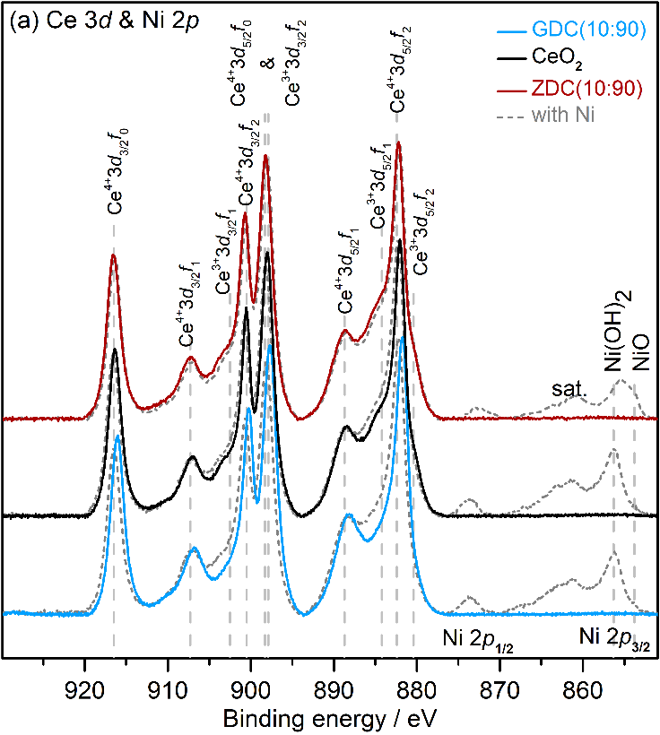
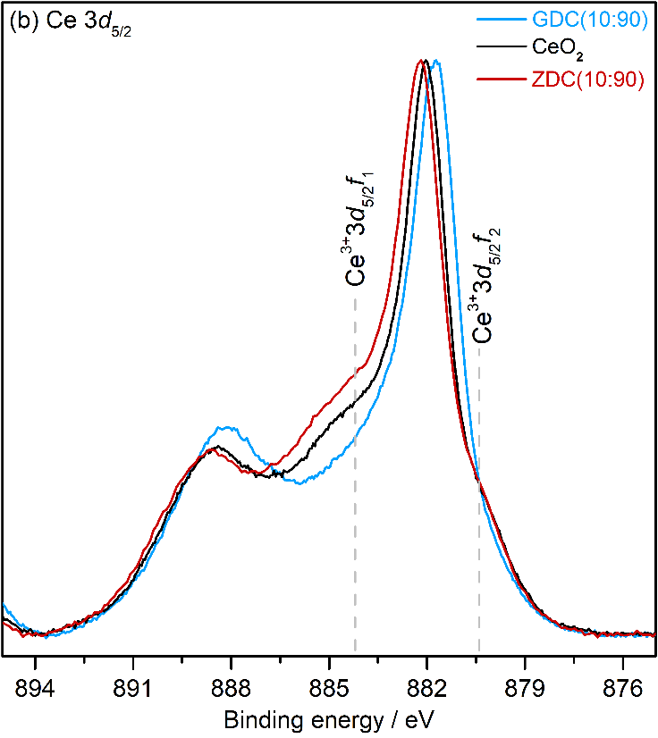
Figure 1 (a) Ce 3d XPS spectra from the CeO₂ (blue), GDC (black), ZDC (red), infiltrated on porous YSZ scaffold with and without depositing NiO. The position of the Ce⁴⁺ (dashed lines) and Ce³⁺ 3d peaks (dotted lines) are also shown for the case of the CeO₂ sample. (b) Low B.E. portion of the Ce 3d_{5/2} XPS spectra from the CeO₂ (blue), GDC (black), ZDC (red), on porous YSZ without depositing NiO.
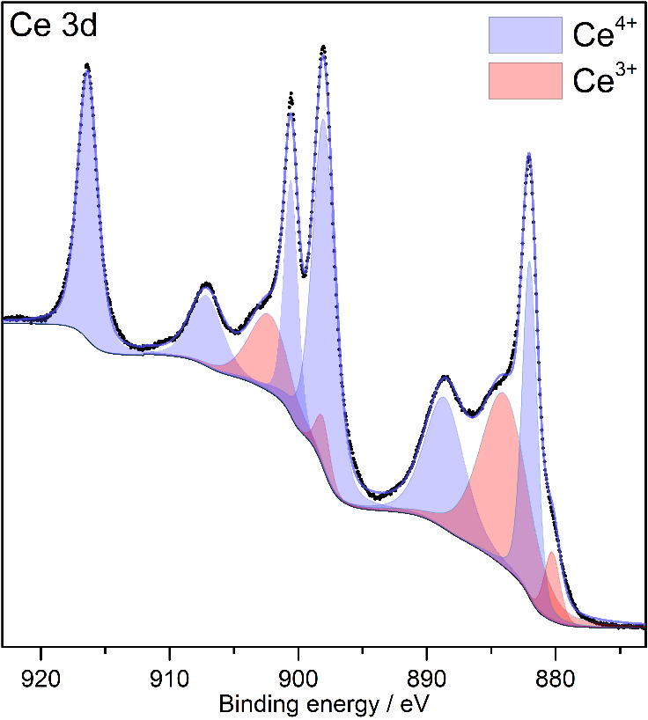
Figure 2. Ce 3d XPS spectra from the CeO₂ infiltrated on porous YSZ (dots), fit (solid blue line), Shirley-type background (dashed line), and components assign to Ce⁴⁺ (light blue) and Ce³⁺ (light red).

2.2 Raman Spectroscopy
Figure 3 shows example normalised Raman spectra of the YSZ scaffold infiltrated with the three different ceramics, CeO₂, ZDC and GDC. The normalisation process compenstates for the effects of varying sample volumes allowing spectra collected under different scattering conditions to be compared, enabling their relative structural properties to be investigated. The spectra shown are averages of spectra obtained from five different locations on each sample at 600 ˚C after the samples have been first reduced and then reoxidised. During the course of the investigations, the Raman spectrum obtained during the first redox cycle was found to give inconsistent results, that were not representative of the sample’s relative oxidation states. This was attributed to a non-uniformity of the initial oxidation state of the samples due to a variety of factors, such as any irregularities between conditions during cool down from sintering, time in ambient conditions before measurements and any difference in those ambient conditions each sample was exposed to. In order to remove these issues, samples were conditioned via an initial redox cycle which was accurately controlled for all samples. The main F_{2g} oxide peak of ceria is observed at approximately 450 cm⁻¹ while the vacancy peak is observed at approximately 600 cm⁻¹.^{[32]} No peaks associated with the tetragonal phase was observed in any of the spectra collected from the samples investigated, confirming that they were all in the cubic phase. The F_{2g} peak is used for all analysis of the measurements not only because it is directly related to the oxidation state of the material, but because it is the sharpest and provides the best signal to noise ratio and thus the lower error. The vacancy peak is much more difficult to use for analysis because it is a combination of two peaks that are also convolved with the Raman peak of the underlying YSZ scaffold. As a result all results presented hereafter refer to the main F_{2g} mode of ceria.
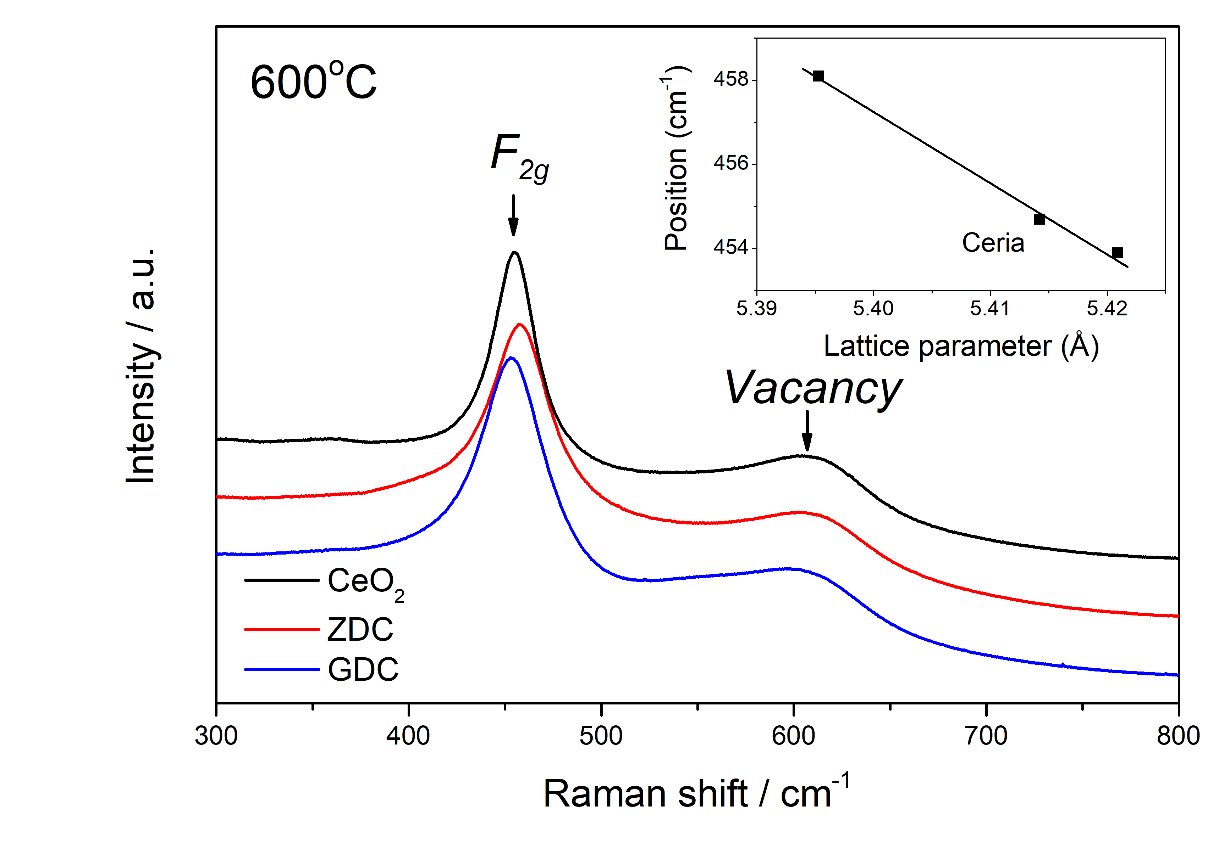
Figure 3. Normalised Raman spectra of YSZ scaffold infiltrated with either Ceria, ZDC, or GDC measured at 600 ˚C after an initial conditioning redox cycle has been applied. Note spectra have been offset for clarity. The F2g peak positions for the three compositions obtained without Ni vs the lattice parameter is shown in the inset. Spectra were collected using a 514 nm laser foccussed onto the sample using a long working distance ×20 objective.
The XPS is sensitive to the Ce valence state. The Zr addition, is a much lighter ion than Ce, and with a smaller radius. Substitution by 10% reduces the unit cell size^{[33]} and shifts the absolute F_{2g} peak position to a higher wavenumber. The Gd addition produces a shift in the absolute F_{2g} peak position to a lower wavenumber. Although the Gd and Ce ion are of similar ionic radius Gd is heavier than Ce and there is a measurable increase of the lattice parameter with 10% Gd substitution ^{[34]}, consistent with the peak position shift. The inset to Figure 3 shows the relationship between the F_{2g} peak position and the lattice parameter. The XPS also finds opposite trends for the changes of the binding energy of hybridised Ce 4f and the oxygen 2p with Gd and Zr substitution. The addition of Ni shifts the absolute position of the CeO₂ Raman F_{2g} peak to shorter wavenumbers in all cases as set out in Table 1, similarly for Ceria and GDC but most significantly in the case of the ZDC sample. The XPS also finds that the Ceria and the GDC samples behave comparably when Ni is added. But for the ZDC sample when doped with Ni, no change is observed in the XPS in contrast to the large Raman peak shift observed. This demonstrates the difficulty making a direct correlation between the electronic changes reflected in the XPS measurement in the near surface of the sample, and the absolute Raman peak position., The downward shift of the Raman CeO peak in all cases when Ni is added suggests lattice relaxation, more so for the ZDC which is the most heavily strained.
Table 1: Absolute peak position of the F_{2g} peak for the infiltrated sample compositions investigated.
Sample composition | Absolute F_{2g} peak position (cm⁻¹)
Ceria | 454.7± 0.3
GDC | 453.9 ± 0.3
ZDC | 458.1 ± 0.3
Ceria+Ni | 453.35 ± 0.3
GDC+Ni | 452.7 ± 0.1
ZDC+Ni | 454.9 ± 0.3

Figure 4 shows the integrated intensities of the normalised ceria F_{2g} peak as monitored for the three different ceria compositions, both with and without Ni, and when exposed to the reducing atmosphere at 600 ˚C. It is clear that these compositions do not reduce without the Ni present under these conditions. When Ni is present the intensity of the F_{2g} Raman mode decreases rapidly upon exposure to the reducing environment to around 50% of its original intensity where it stabilises. While there is a slight difference in the rate of the decrease in the pure ceria compared to that of the ZDC and GDC, there is very little difference in the overall behaviour of the different samples which all decrease to the same level within error – 50 ± 1 % for the ZDC, 52 ± 1 % for the ceria and 52 ± 2 % for the GDC of the initial intensity – providing very little information regarding the effect of the different dopants. The difference in the rate of the decrease in intensity of the ceria peak between the samples was not untypical of measurements even within the same sample and as a result were attributed to local variations in the nickel coverage.
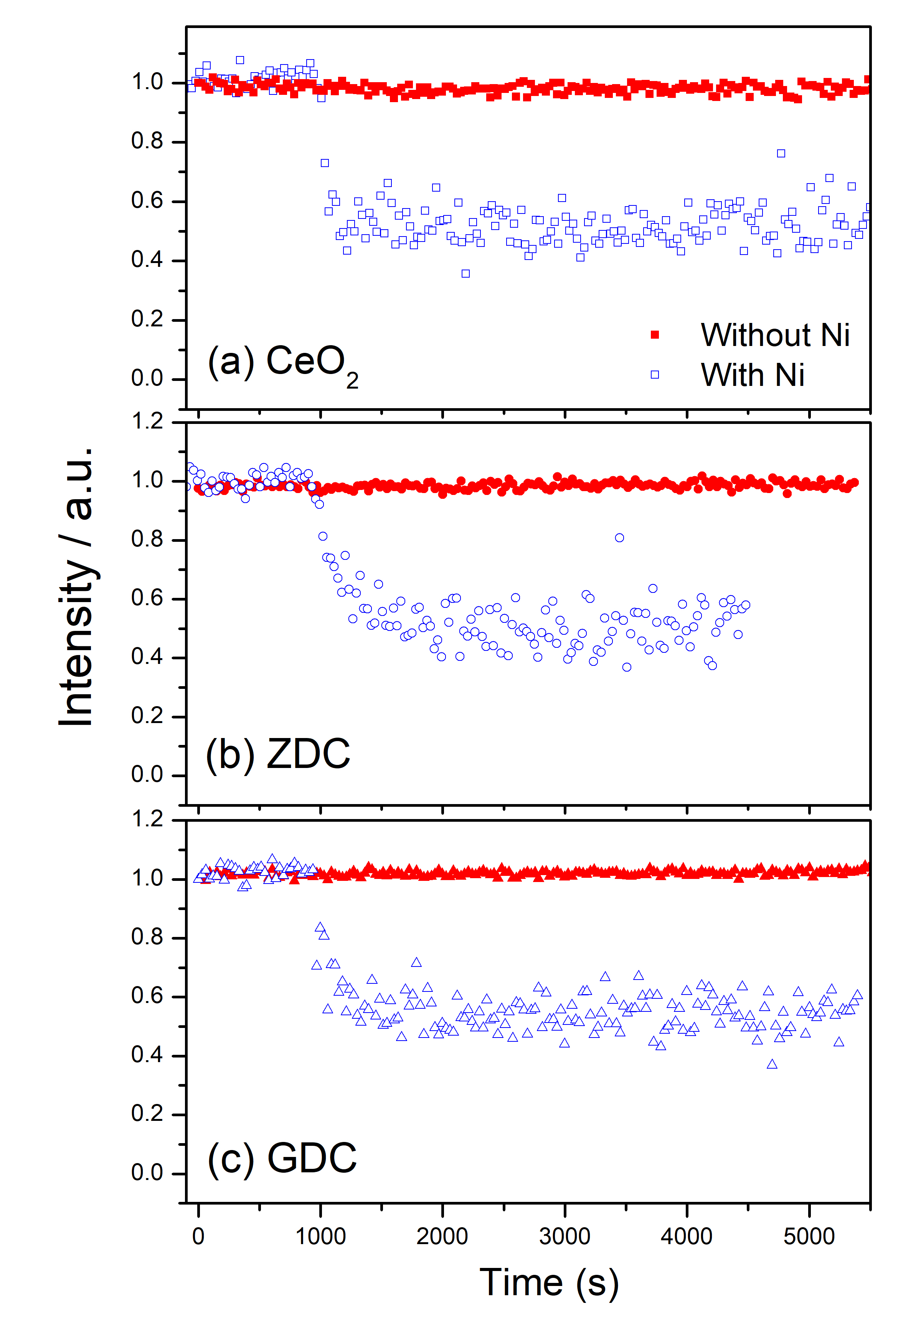
Figure 4. Integrated intensities of the ceria F_{2g} Raman peak monitored as a function of time from the three samples with and without Ni infiltration when exposed to wet 90 % N₂:10 % H₂ flowing at 100 cm³ min⁻¹ at 600 ˚C. Spectra were normalised before the integrated intensities were calculated and those intensities have been normalised to the initial values to allow for direct comparison. The GDC peak intensity drops very quickly upon exposure to the reducing environment and stabilises at approximately 50 % of the initial intensity. See text for further details.
However, peak intensity is not the only peak parameter that changes due to changes in the oxidation state. As oxygen is removed from the sample, the lattice becomes strained and this is reflected in a Raman response via a shift in the peak position. The more oxygen that is removed, the more the lattice becomes strained and the more the peak shifts as a result.
Figure 5 shows the normalised and averaged Raman spectra, including error bars reflecting the standard error of the mean, obtained from a YSZ scaffold infiltrated with (a) only GDC and (b) both GDC and Ni before (black) and after (red) reduction at 600 ˚C along with the difference in the spectra (green). Figure 5 (a) shows that there is no observable change in the spectra obtained from the YSZ scaffold infiltrated with GDC only upon exposure to the reducing environment. This clearly demonstrates that it is stable under these conditions confirming the results shown in Figure 4. Figure 5 (b) shows that there is a significant decrease in the intensity of both the F_{2g} and vacancy peak in the sample with Ni. The large decrease in the intensity of the F_{2g} mode indicates that the majority of the oxygen removed is from the crystal structure itself while the small decrease in the vacancy peak indicates there is some loss of interstitial oxygen ^{[22b]}. There is also a significant shift in the F_{2g} peak position – the peak shifts towards the laser by approximately 4.5 cm⁻¹ – on reduction of the sample. This is more evident when the spectra are normalised to the F_{2g} peak intensity and plotted together as shown in the inset to Figure 5 (b). This is a direct response to the strain induced in the lattice by the removal of oxygen during reduction.
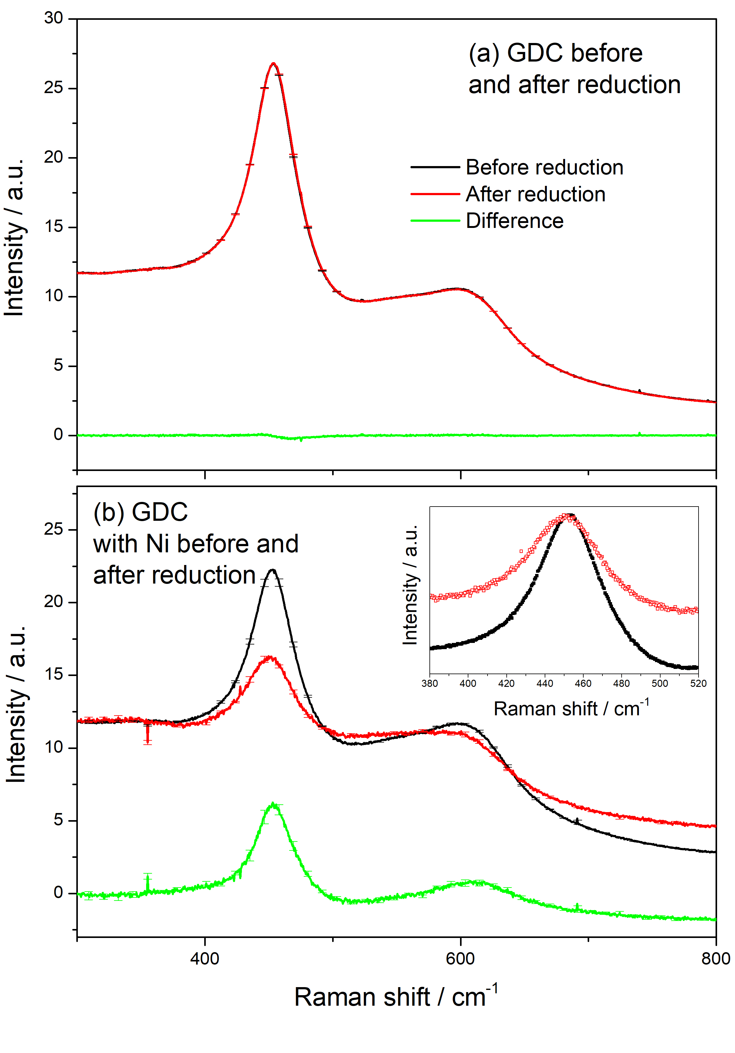
Figure 5. Normalised and averaged Raman spectra obtained from a YSZ scaffold infiltrated (a) with GDC only and (b) GDC and Ni. The black line is the initial material and the red line after reduction as well as the difference between the two (green) in wet 90 % N₂:10 % H₂ flowing at 100 cm³ min⁻¹ at 600 ˚C. Only when Ni is present is there a clear decrease in the intensity of the F_{2g} ceria peak and a shift of approximately 4.5 cm⁻¹ in its position on reduction. This shift is emphasised in the inset to (b) where the peaks have been normalised to the peak intensity for ease of comparison.. See text for further details.
Each Raman spectrum obtained from the samples before and after reduction were background subtracted and fitted using Voigt functions. All of the fitted data for the three investigated samples as a function of temperature are shown in Supplemental Tables S1, S2 and S3.
Figure 6 shows the F_{2g} peak shift between the peak before and after reduction for each of the samples investigated, plotted as a function of temperature. Peak shifts calculated for samples without Ni are shown as open symbols while those that have been co-infiltrated with Ni are solid. Those without Ni do not shift at the lower temperatures investigated, with only relatively small shifts observed at 700 ˚C. Samples that were infiltrated with Ni were observed to shift significantly at all temperatures investigated clearly indicating that Ni was strongly catalysing the reduction of the solid oxides. When comparing the behaviour of the three different ceria compositions co-infiltrated with Ni it is noticeable how much larger the shift in the peak position is for the ZDC sample compared to the undoped ceria and GDC . This is due to the increased lability of the oxygen in the ZDC compared to the other samples. On reduction, more oxygen is removed from the lattice compared to the other samples exposed to the same conditions. As a result the lattice becomes more strained and the peak shift is greater. Both the undoped ceria and GDC samples have similar shifts suggesting that similar amounts of oxygen are removed from the lattice for both samples.
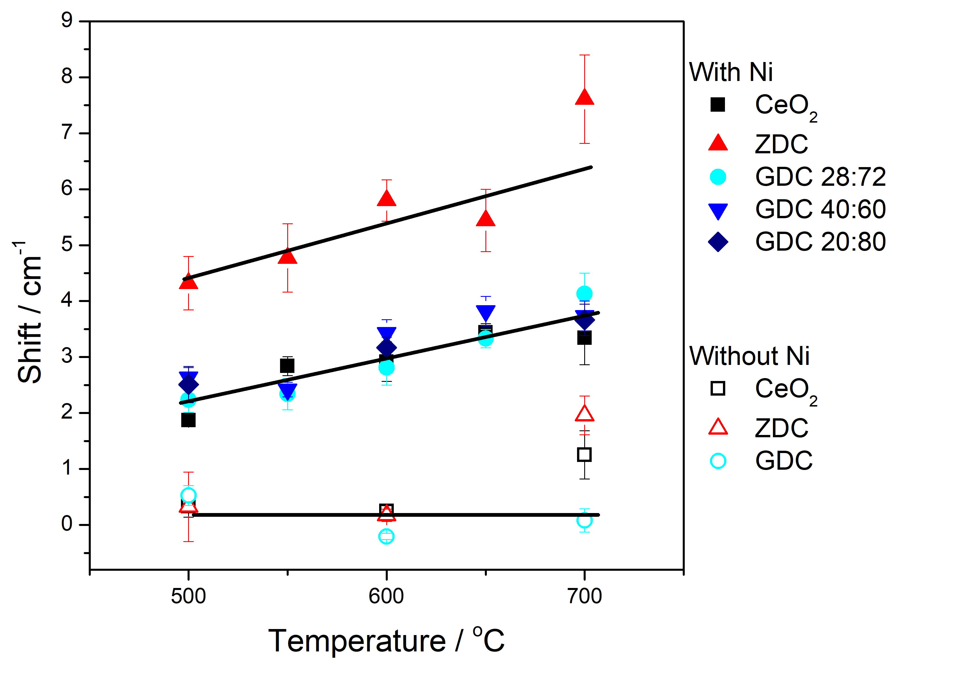
Figure 6: F_{2g} peak shifts calculated from spectra collected before and after exposure to the reducing environment as a function of temperature for the samples investigated. Samples without Ni (open symbols) do not reduce significantly below 700 ˚C. Samples co-infiltrated with Ni are significantly reduced at all temperatures investigated, which strains the crystal structure and induces a peak shift relative to the fully oxidised material. See text for further details. Lines are guide for the eye only. In the case of samples without Ni, the line indicates the baseline behaviour for the GDC sample only.
Second, it appears that the peak shifts follow a linear trend with temperature and that within error the slope is the same for each of the samples. This suggests that the dominant factor involved in the reduction process is the nickel itself.
To investigate the role of nickel further we made further measurements on GDC infiltrated YSZ scaffold that were co-infiltrated with differing amounts of nickel. The nickel content of the samples was characterised through the XPS data based on the Ni 2p_{3/2} peak intensity and averaged for each sample using 5 points on each surface. In order to create samples of differing nickel contents the number of infiltrations were modified and a piece of one sample was immersed into 1 M nitric acid which was heated to 80 ˚C for 90 s. GDC had an average Ni 2p_{3/2} / Ce 4d ratio of 28:72, GDC B had an average of 40:60 and GDC B after the acid treatment (GDC B AA) had an average of 20:80. It is clear from the data in Figure 6 that all the samples with different amount of Ni on GDC behave the same, within error, as a function of temperature. This clearly shows that the reduction process is largely independent of the amount of nickel present and that the nickel dominates the reduction process.

3. Conclusions
Here we have used in-situ Raman spectroscopy combined with XPS to investigate the oxidation and redox properties of porous YSZ scaffolds infiltrated with undoped ceria, GDC and ZDC both with and without Ni. Both characterisation methods provide valuable insight into the influence of the dopants and the catalyst on performance although a direct correlation of measurements would require a detailed theoretical framework beyond the scope of this paper. At room temperature the XPS showed that doping ceria with zirconia increases the ratio of Ce³⁺/Ce⁴⁺ at the surface sites, while gadolinium doping results in a decrease. The impregnation of NiO onto the scaffolds treated with undoped ceria and the GDC resulted in an increase in the Ce³⁺ concentration which was not observed for the ZDC. This increase in Ce³⁺ concentration is attributed to the reduction of the Ce⁴⁺ via an electron transfer from the adsorbed metal particles, although it is unclear as to why the ZDC was unaffected. In contrast the in-situ Raman investigation of the reduction of these structures showed that the ceria component of the infiltrated structures are only significantly reduced above 500 ˚C when co-infiltrated with Ni. The ZDC was observed to reduce much more readily than either the undoped ceria or GDC despite its valance state being unaffected by the Ni at room temperature. The greater reduction of the ZDC is thought to be a direct result of its greater oxygen mobility compared to the undoped ceria and GDC. Although the presence of Ni was necessary to reduce the materials investigated, the reduction process was found to be largely insensitive to the amount of Ni and that wherever Ni is present it dominates the reduction process. The study demonstrates the complementarity of information gained by using a combined XPS and Raman spectroscopy approach to study these complex structures where the catalyst geometry has been finely controlled.

Experimental
Sample preparation
The sample preparation was similar to preparing solid oxide fuel cells. Dense 8YSZ pellets were used as electrolyte and as support for the electrodes. Commercial 8YSZ powder (Pi-KEM) was weighed and uniaxially pressed. The green disks were then fired at 1500 ˚C to form dense pellets with 20 mm diameter and 2 mm thickness. The dense pellets were then polished and cleaned on both sides.
An YSZ scaffold were printed on one side of 8YSZ pellet. 8YSZ (Unitec, 3-5µm) powder, terpineol, dispersant and PVB binder were mixed by ball-milling, and the ink was screen-printed on one side of 8YSZ pellet and sintered at 1300 ˚C. After firing, the porosity of the resulting scaffold was ~35-40 %, and the thickness of the scaffold was roughly 30 µm.
Wet impregnation of different types of ceria, with and without Ni, into the scaffold were carried out. Pure cerium nitrate solution, a gadolinium and cerium nitrate solution (following the formula (Gd_{0.1}Ce_{0.9})O₂, abbreviated as GDC herein) and a zirconium and cerium nitrate solution (following the formula (Zr_{0.1}Ce_{0.9})O₂, abbreviated as ZDC herein) were prepared by dissolving the corresponding nitrates to make a 2 mol dm⁻³ solution in deionised water. Impregnation was conducted by adding nitrate solution dropwise into the YSZ scaffold, through which solution penetrated, driven by capillary force. The sample was then fired at 500 ˚C decompose the nitrate to an insoluble oxide. The impregnation and firing steps were repeated until the desired loading of ceria was reached, which is ~20wt% vs. scaffold. After the impregnation was completed, the ceria was sintered at 800 ˚C. For the samples containing Ni, nickel nitrate solution (0.25 mol dm⁻³) was infiltrated into YSZ scaffold, after ceria impregnation. The weight of Ni inserted was roughly 1wt% vs scaffold.

Sample characterisation

To confirm phase purity, ZDC powder was prepared through co-precipitation. Zirconium oxynitrate (99% Sigma Aldrich) and cerium nitrate hexahydrate (99%, Sigma Aldrich) were dissolved into deionised water and diluted into 1 dm³. Under vigorous stirring, diluted ammonia solution was added dropwise and yellowish precipitate was generated. When precipitation was finished, it was filtered and washed with deionized water until neutral pH value. The resulting paste was dried overnight and fired at 500-1000 ˚C. X-ray diffraction (XRD) patterns of the resulting powder were measured to confirm the desired doped ceria phases were present in the powder.
Raman measurements were performed using a Jobin-Jbvon LabRam HR-1000 confocal Raman microscope equipped with a 514 nm laser. Measurements were made with a ×20 long working distance objective which resulted in a laser spot with a diameter of approximately 4 µm at the focal point. The laser power and integration time was optimised prior to all real time measurements to ensure a good signal-to-noise ratio, while minimising any laser heating of the sample. As a result, the specific integration times used varied slightly between measurements, ranging from 5 to 30 seconds while the laser intensity was constant at approximately 4 mW. Specific integration times will be noted for the presented measurements.
In-situ, real time monitoring of the Raman response of the samples investigated was achieved using a high temperature catalytic stage from Linkam Scientific Instruments (UK). Raman spectra were collected between room temperature and 700 ˚C as reported by the stage controller. Controlled flows of N₂, H₂ and air were delivered to the sample in the stage through a system of calibrated mass flow controllers. All gases were humidified with 3% water vapor by being passed through a humidifier, which consisted of a bubble column situated inside a thermocirculator bath, before delivery to the sample. Samples were reduced using a mixture of 90 % N₂: 10% H₂, and oxidised using 100 % air. All gas mixtures were flowed through the system at a total rate of 100 cm³ min⁻¹.
Samples were subjected to two full reduction/oxidation cycles for each in-situ characterisation measurement between 500 and 700 ˚C in 50 ˚C increments. The system was purged by flowing 100% N₂ over the samples for 5 minutes when switching between the reducing and oxidising atmospheres. Long integration time Raman spectra were collected before and after each oxidation or reduction procedure from five random locations of each sample to assess changes in oxidation state. Raman spectra were also continuously collected from a single point of the sample surface during the purging, reduction and oxidation procedures to monitor changes in the relative oxidation state during the measurements.
Raman spectra were analysed using a combination of the JY Labram software, Peakfit v4 and OriginLab 8.6. Spectral features of the individual spectra collected before and after each procedure were normalised, background corrected and fitted to Voigt modes using Peakfit v4 with the resulting data further analysed using OriginLab 8.6. Raman spectra collected in real time during the oxidation and reduction procedures were analysed using the LabRam software with further analysis being performed using OriginLab 8.6. Integrated intensities were normalised to the intensity of the principle CeO peak of interest where necessary to allow different spectra to be compared directly.
The surface chemistry and the electronic structure of the ceria based oxides were characterized using high-resolution XPS. The spectra were recorded on a Thermo Scientific K-Alpha+ X-ray photoelectron spectrometer operating at 2×10⁻⁹ mbar base pressure. This system incorporates a monochromated, microfocused Al Kα X-ray source (hν = 1486.6 eV) and a 180° double focusing hemispherical analyser with a 2D detector. The X-ray source was operated at 6 mA emission current and 12 kV anode bias providing an X-ray spot size of 400 μm². Survey spectra were recorded at 200 eV pass energy, 20 eV pass energy for core level, and 15 eV pass energy for valence band spectra. A flood gun was used to minimize the sample charging that occurs when exposing an insulated sample to an x-ray beam. Charge neutralization was deemed to have been achieved by monitoring the C 1s signal of the adventitious carbon. All XPS spectra were recorded using the Avantage Data System software. All quantification analysis was performed using the Avantage software. Peak fitting of the Ce 3d core level was performed using the CASA XPSTM software package as it required a more complicated background subtraction.

Acknowledgements
The authors acknowledge support from the EPSRC (No. EP/M014304/1). D.J.P. acknowledges support from the Royal Society for his University Research Fellowship (No. UF100105). D.J.P. and G.K. acknowledge support from the EPSRC (Nos. EP/M014142/1 and EP/M014304/1).

References
[1] A. Trovarelli, Catalysis Reviews-Science and Engineering 1996, 38, 439-520.
[2] aK. C. Taylor, Catalysis Reviews 1993, 35, 457-481; bJ. Kaspar, P. Fornasiero, M. Graziani, Catalysis Today 1999, 50, 285-298.
[3] M. Ni, M. K. H. Leung, D. Y. C. Leung, International Journal of Hydrogen Energy 2008, 33, 2337-2354.
[4] W. C. Chueh, C. Falter, M. Abbott, D. Scipio, P. Furler, S. M. Haile, A. Steinfeld, Science 2010, 330, 1797-1801.
[5] aS. P. S. Badwal, K. Foger, Ceram. Int. 1996, 22, 257-265; bJ. B. Goodenough, Annual Review of Materials Research 2003, 33, 91-128; cL. Blum, W. A. Meulenberg, H. Nabielek, R. Steinberger-Wilckens, International Journal of Applied Ceramic Technology 2005, 2, 482-492; dD. J. L. Brett, A. Atkinson, N. P. Brandon, S. J. Skinner, Chemical Society Reviews 2008, 37, 1568-1578; eN. Mahato, A. Banerjee, A. Gupta, S. Omar, K. Balani, Progress in Materials Science 2015, 72, 141-337.
[6] B. Bulfin, A. J. Lowe, K. A. Keogh, B. E. Murphy, O. Lubben, S. A. Krasnikov, I. V. Shvets, J. Phys. Chem. C 2013, 117, 24129-24137.
[7] C. Padeste, N. W. Cant, D. L. Trimm, Catalysis Letters 1993, 18, 305-316.
[8] S. Bernal, J. J. Calvino, G. A. Cifredo, J. M. Gatica, J. A. P. Omil, J. M. Pintado, J. Chem. Soc.-Faraday Trans. 1993, 89, 3499-3505.
[9] V. Sharma, P. A. Crozier, R. Sharma, J. B. Adams, Catalysis Today 2012, 180, 2-8.
[10] P. Fornasiero, G. Balducci, R. DiMonte, J. Kaspar, V. Sergo, G. Gubitosa, A. Ferrero, M. Graziani, Journal of Catalysis 1996, 164, 173-183.
[11] S. J. Hong, A. V. Virkar, J Am Ceram Soc 1995, 78, 433-439.
[12] aD.-J. Kim, J Am Ceram Soc 1989, 72, 1415-1421; bY.-P. Fu, C.-W. Tseng, P.-C. Peng, Journal of the European Ceramic Society 2008, 28, 85-90; cS. Kuharuangrong, J Power Sources 2007, 171, 506-510; dD. A. Andersson, S. I. Simak, N. V. Skorodumova, I. A. Abrikosov, B. Johansson, Proceedings of the National Academy of Sciences of the United States of America 2006, 103, 3518-3521; eS. Sen, H. J. Avila-Paredes, S. Kim, Journal of Materials Chemistry 2008, 18, 3915-3917; fV. Esposito, M. Zunic, E. Traversa, Solid State Ionics 2009, 180, 1069-1075; gY.-P. Fu, S.-H. Chen, J.-J. Huang, International Journal of Hydrogen Energy 2010, 35, 745-752; hX. Sha, Z. Lü, X. Huang, J. Miao, Z. Ding, X. Xin, W. Su, Journal of Alloys and Compounds 2007, 428, 59-64; iH. J. Avila-Paredes, K. Choi, C.-T. Chen, S. Kim, Journal of Materials Chemistry 2009, 19, 4837-4842; jV. Prashanth Kumar, Y. S. Reddy, P. Kistaiah, G. Prasad, C. Vishnuvardhan Reddy, Materials Chemistry and Physics 2008, 112, 711-718; kM. Balaguer, C. Solís, J. M. Serra, The Journal of Physical Chemistry C 2012, 116, 7975-7982; lA. K. Lucid, P. R. L. Keating, J. P. Allen, G. W. Watson, J. Phys. Chem. C 2016, 120, 23430-23440.
[13] H. F. Wang, H. Y. Li, X. Q. Gong, Y. L. Guo, G. Z. Lu, P. Hu, Phys. Chem. Chem. Phys. 2012, 14, 16521-16535.
[14] Z. Yang, T. K. Woo, K. Hermansson, J. Chem. Phys. 2006, 124, 7.
[15] aS. P. Jiang, International Journal of Hydrogen Energy 2012, 37, 449-470; bR. Fernandez-Gonzalez, J. C. Ruiz-Morales, J. Canales-Vazquez, J. R. Jurado, A. Makradi, P. Nunez, International Journal of Hydrogen Energy 2016, 41, 19731-19736.
[16] F. J. Garcia-Garcia, A. M. Beltran, E. Yubero, A. R. Gonzalez-Elipe, R. M. Lambert, J Power Sources 2017, 363, 251-259.
[17] aS. Souentie, M. Athanasiou, D. K. Niakolas, A. Katsaounis, S. G. Neophytides, C. G. Vayenas, Journal of Catalysis 2013, 306, 116-128; bD. K. Niakolas, M. Athanasiou, V. Dracopoulos, I. Tsiaoussis, S. Bebelis, S. G. Neophytides, Appl Catal a-Gen 2013, 456, 223-232; cF. J. Garcia-Garcia, F. Yubero, A. R. Gonzalez-Elipe, R. M. Lambert, International Journal of Hydrogen Energy 2018, 43, 885-893.
[18] W. J. Shan, M. F. Luo, P. L. Ying, W. J. Shen, C. Li, Appl Catal a-Gen 2003, 246, 1-9.
[19] F. Cova, D. G. Pintos, A. Juan, B. Irigoyen, J. Phys. Chem. C 2011, 115, 7456-7465.
[20] J. R. Ferraro, Introductory raman spectroscopy, Academic press, 2003.
[21] aR. C. Maher, in Spectroscopic Properties of Inorganic and Organometallic Compounds, Vol. 43, The Royal Society of Chemistry, 2012, pp. 84–122; bR. C. Maher, V. Duboviks, G. J. Offer, M. Kishimoto, N. P. Brandon, L. F. Cohen, Fuel Cells 2013, 13, 455-469.
[22] aR. C. Maher, P. R. Shearing, E. Brightman, D. J. L. Brett, N. P. Brandon, L. F. Cohen, Adv. Sci. 2016, 3, 8; bC. Andriopoulou, A. Trimpalis, K. C. Petallidou, A. Sgoura, A. M. Efstathiou, S. Boghosian, The Journal of Physical Chemistry C 2017, 121, 7931-7943.
[23] A. Kotani, T. Jo, J. C. Parlebas, Advances in Physics 1988, 37, 37-85.
[24] aA. Pfau, K. D. Schierbaum, Surf Sci 1994, 321, 71-80; bT. Skála, F. Šutara, M. Škoda, K. C. Prince, V. Matolín, Journal of Physics: Condensed Matter 2009, 21, 055005.
[25] aZ. Yang, T. K. Woo, K. Hermansson, The Journal of Chemical Physics 2006, 124, 224704; bZ. Yang, Y. Wei, Z. Fu, Z. Lu, K. Hermansson, Surf Sci 2008, 602, 1199-1206.
[26] R. Shannon, Acta Crystallographica Section A 1976, 32, 751-767.
[27] M. Romeo, K. Bak, J. El Fallah, F. Le Normand, L. Hilaire, Surface and Interface Analysis 1993, 20, 508-512.
[28] M. A. Henderson, C. L. Perkins, M. H. Engelhard, S. Thevuthasan, C. H. F. Peden, Surf Sci 2003, 526, 1-18.
[29] aZ. S. Lu, Z. X. Yang, K. Hermansson, in Advanced Materials Research, Vol. 213 (Ed.: Y. Zhang), 2011, pp. 166-+; bW. Q. Li, S. Goverapet Srinivasan, D. R. Salahub, T. Heine, Phys. Chem. Chem. Phys. 2016, 18, 11139-11149.
[30] aE. L. Wilson, R. Grau-Crespo, C. L. Pang, G. Cabailh, Q. Chen, J. A. Purton, C. R. A. Catlow, W. A. Brown, N. H. de Leeuw, G. Thornton, The Journal of Physical Chemistry C 2008, 112, 10918-10922; bP. Luches, F. Pagliuca, S. Valeri, F. Illas, G. Preda, G. Pacchioni, The Journal of Physical Chemistry C 2012, 116, 1122-1132; cY. Zhou, J. Zhou, The Journal of Physical Chemistry C 2012, 116, 9544-9549; dY. Zhou, J. M. Perket, J. Zhou, The Journal of Physical Chemistry C 2010, 114, 11853-11860; eS. D. Senanayake, J. Evans, S. Agnoli, L. Barrio, T.-L. Chen, J. Hrbek, J. A. Rodriguez, Topics in Catalysis 2011, 54, 34-41.
[31] A. Davidson, J. F. Tempere, M. Che, H. Roulet, G. Dufour, The Journal of Physical Chemistry 1996, 100, 4919-4929.
[32] A. Banerji, V. Grover, V. Sathe, S. K. Deb, A. K. Tyagi, Solid State Commun 2009, 149, 1689-1692.
[33] R. Sharan, A. Dutta, Journal of Alloys and Compounds 2017, 693, 936-944.
[34] W. Y. Hernández, O. H. Laguna, M. A. Centeno, J. A. Odriozola, Journal of Solid State Chemistry 2011, 184, 3014-3020.

1To whom correspondence should be addressed: robert.maher99@imperial.ac.uk

