Radiation-induced Microcrystal Shape Change as a Mechanism of Wasteform Degradation
Michael I. Ojovan^{1,3}♦, Boris E. Burakov² and William E. Lee³
¹ Department of Radiochemistry, Lomonosov Moscow State University, Leninskie Gory, 1, Bd. 3, Moscow, 119991 Russia E-mail: m.ojovan@imperial.ac.uk
² V.G. Khlopin Radium Institute, 28, 2-nd Murinskiy Ave., St. Petersburg, 194021 Russia. E-mail: burakov@peterlink.ru
³ Centre for Nuclear Engineering and Department of Materials, Imperial College London, SW7 2AZ, London, U.K. E-mail: w.e.lee@imperial.ac.uk

ABSTRACT
Experiments with actinide-containing insulating wasteforms such as devitrified glasses containing ²⁴⁴Cm, Ti-pyrochlore, single-phase La-monazite, Pu-monazite ceramics, Eu-monazite and zircon single crystals containing ²³⁸Pu indicate that mechanical self-irradiation-induced destruction may not reveal itself for many years (even decades). The mechanisms causing these slowly-occurring changes remain unknown therefore in addition to known mechanisms of wasteform degradation such as matrix swelling and loss of solid solution we have modelled the damaging effects of electrical fields induced by the decay of radionuclides in clusters embedded in a non-conducting matrix. Three effects were important: (i) electric breakdown; (ii) cluster shape change due to dipole interaction, and (iii) cluster shape change due to polarisation interaction. We reveal a critical size of radioactive clusters in non-conducting matrices so that the matrix material can be damaged if clusters are larger than this critical size. The most important parameters that control the matrix integrity are the radioactive cluster (inhomogeneity) size, specific radioactivity, and effective matrix electrical conductivity. We conclude that the wasteform should be as homogeneous as possible and even electrically conductive to avoid potential damage caused by electrical charges induced by radioactive decay.
Keywords: Wasteform, ceramics, glass, actinide, destruction, radiophase, homogeneity

Introduction
Understanding long-term behaviour of actinide-containing host-matrices under self-irradiation is crucial in ensuring safety of nuclear waste storage and disposal. An important aspect of long-term matrix integrity is the resistance of material against damage caused by radiation. Radiation-induced damage of crystalline structures is usually, although not always, accompanied by reduced chemical durability, swelling and crack formation in poly- and single-phase crystalline ceramics [1] as well as in devitrified glasses containing large volumes (30 wt.%) of crystalline inclusions [2]. Under irradiation at room temperature (depending on cumulative dose and energy) the original crystalline structure may be (a) retained [3]; (b) converted into another type of crystalline structure [4]; or (c) amorphized (become amorphous or metamict) [1, 5, 6]. For example, the long-term stability and chemical durability of natural solid U-bearing Zr-silicate gel is assumed to be caused by two competing processes, first, crystallisation of the gel into U-doped zircon assisted by self-irradiation and, second, metamictisation of the crystallised zircon back to a gel-like state [7]. Extended experiments with actinide doped crystalline waste forms have however shown significant mechanical damage with crystal cracking within a decade of storage [1, 2]. Self-irradiation of materials over very long time scales, measured in the hundreds and thousands of years in the case of immobilized nuclear waste, creates continuous excitations and long-lived defects, which evolve in a medium that is changing with time. Slowly occurring processes that have hitherto not been the focus of attention may also result in significant consequences for the retention capacities of nuclear wasteforms. For example, the irradiation of insulators (e.g. glass and ceramics) causes intensification of surface diffusion processes and may result in surface instability [8-11]. Furthermore, although the amorphisation of crystalline materials is the most evident result of irradiation, the primary irradiation effects in glassy materials are volume changes and viscosity diminution [12-14]. Wasteform tolerance to radiation effects is most important for higher activity wastes which typically utilise glassy and crystalline wasteforms as well as glass-composite materials (GCM’s) which consist of both crystalline and glassy phases [15, 16]. Radiation effects in these materials have been intensively investigated with many overview reports available see e.g. [1, 17-19]. Moreover a Joint ICTP-IAEA Workshop on radiation effects in nuclear wasteforms and their consequences for storage and disposal was held in 2016 that involved experts in both experimental and theoretical (modelling) methods for radiation effects in materials to explore the potential of both experimental and theoretical/computational approaches to understand the consequences of irradiation of materials under extreme conditions, particularly focusing on long-term irradiation conditions envisaged for nuclear wasteforms containing long lived fission products and actinides. The following summaries on mechanical changes under self-irradiation in nuclear wasteforms briefly follow the reports presented at the Joint ICTP-IAEA Workshop [20].
Although radiation damage effects have been extensively examined in analogue minerals that naturally contain radionuclides and accumulate high doses of self-irradiation [1, 5, 6] the mechanisms of damage that cause alterations are not well understood. This paper aims after a brief summary of mechanical destruction effects observed to analyse an almost ignored mechanism of mechanical damage of non-conducting nuclear wasteforms caused by electrical fields [21] that are induced in the insulating materials by the decay of radionuclides. We will show that:
- This mechanism can eventually lead to nuclear wasteform destruction in conditions of non-uniform radionuclide distribution;
- The most important parameters that affect the matrix integrity are the radioactive cluster (inhomogeneity) size, specific radioactivity and effective electrical conductivity of matrix.

Nuclear wasteforms
Radioactive or nuclear waste is defined as waste that contains or is contaminated with radionuclides at concentrations or activities greater than established clearance levels [22]. It is a general safety requirement that waste packages shall be designed and produced so that the radioactive waste is appropriately contained both during normal operation and in accident conditions that could occur in the handling, storage, transport and disposal. Processing radioactive waste is applied to enhance safety by producing a wasteform that fulfils the acceptance criteria for safe processing, transport, storage and disposal. The wasteform is a component of the waste package and is defined as the waste in its physical and chemical form after treatment and/or immobilization resulting in a solid product prior to packaging. Radioactive and chemically hazardous constituents in the waste can be immobilized into a wasteform through two processes: (1) binding them into the material at atomic scale (chemical incorporation), or (2) physically surrounding and isolating the material (encapsulation).
A number of wasteform and container materials have been used for waste immobilization, including ceramic, glass, metal, cement, polymer and bitumen [1, 15, 16, 23-30]. In practice the more durable materials are used to host longer-lived and higher activity waste. The choice of the wasteform depends on the physical and chemical nature of the waste and the acceptance criteria for the storage and disposal facilities to which the waste will be consigned. When selecting a wasteform material several factors should be considered which include the following key considerations [26, 28, 31]:
- Waste loading: The waste form should be able to accommodate a significant amount of waste (typically 25–45 weight %) to minimize volume, thereby minimizing the space needed for storage, transportation and disposal.
- Ease of production: Fabrication of the waste form should be accomplished under reasonable conditions, including low temperatures and, ideally, in an air atmosphere, using well established methods to minimize worker dose and the capital cost of plant.
- Durability: The waste form should have a low rate of dissolution when in contact with water to minimize the release of radioactive and chemical constituents.
- Radiation stability: The wasteform should have a high tolerance to radiation effects from the decay of radioactive constituents. Depending on the types of constituents being immobilized, the waste form could be subjected to a range of radiation effects, including ballistic effects from alpha decay and ionizing effects from decay of fission product elements.
- Chemical flexibility: The waste form should be able to accommodate a mixture of radioactive and chemical constituents with minimum formation of secondary phases that can compromise its durability.
- Availability of natural analogues: Since direct laboratory testing of the waste forms over the relevant time scales for disposal (typically 10³–10⁶ years) is not possible, the availability of natural mineral or glass analogues may provide important clues about the long term performance of the material in the natural environment, thereby building confidence in the extrapolated behaviour of the waste form after disposal.
- Compatibility with the intended disposal environment: The wasteform should be compatible with the near field environment of the disposal facility. The near field environment provides the physical and chemical conditions that are favourable for maintaining wasteform integrity over extended periods, which helps to slow the release of constituents and their transport out of the facility.

Wasteform mechanical changes under self-irradiation
Vitreous materials have been used for several decades to immobilize nuclear waste and are planned to be used on an increasing scale in the forthcoming years [32, 33]. Detailed analyses of HLW vitreous wasteforms used in France have shown that ionizing radiation does not strongly affect the structure and properties of complex nuclear glass due to the positive effect of the glass chemical complexity on the defects formation and structural evolution [34-39]. Some specific effects like phase separation, bubble formation and level of swelling were observed for glasses under irradiation in TEM with very high dose rate (e.g. at currents above 0.1 – 0.5 A/cm²) , but these effects were never observed under electron irradiation in accelerators at lower dose rate [12-14, 17]. Alpha decay accumulation in nuclear glass induces slight changes of macroscopic properties (density and mechanical properties), although there is no modification of the glass microstructure which remains homogeneous without any phase separation and crystallization, apart from a slight modification of the glassy state, with modifications of both short and medium range orders [39]. The final structure seems to be the result of the ballistic melting in recoil nuclei tracks and the subsequent partial damage repair due to a thermal self-healing mechanism in the cluster tracks [39]. This results in a new homogeneous glassy state, similar to that obtained by a very high quenching rate (>10⁶ K/s), with slightly modified macroscopic properties such as diminished density by 0.6%, Young modulus by 15%, hardness by 30%, increased toughness by 50%, and practically unchanged radionuclide leaching rates. However it is noted that the lack of glass natural analogues samples containing actinides does not allow a validation of the effect of the slow rate accumulation of alpha decays and long time scale of aging.
A completely different behaviour was observed for partially devitrified glasses e.g. GCM’s that contained about 30 wt.% deliberately formed crystals under significant levels of self-irradiation caused by the decay of 2 wt.% ²⁴⁴Cm [2]. Large cracks about hundred micrometres long were formed in the GCM wasteform at cumulative doses of 2.4⋅10¹⁷ α-decays/g. More details about the GCM behaviour under irradiation would be useful however no additional data were found.
Recent extended experiments with actinide doped crystalline wasteforms have shown significant mechanical damage with crystal cracking within a decade of storage [1-3, 21]. Some samples of ceramic based on ²³⁸Pu-doped pyrochlore, (Ca_{1,16}Gd_{0,23}Hf_{0,30}Pu_{0,24}U_{0,42})Ti₂O₇, demonstrated crack formation even before amorphization of pyrochlore phase although zircon/zirconia ceramic did not crack under self-irradiation and preserved its initial light grey colour despite the zircon becoming completely amorphous (Fig.1).
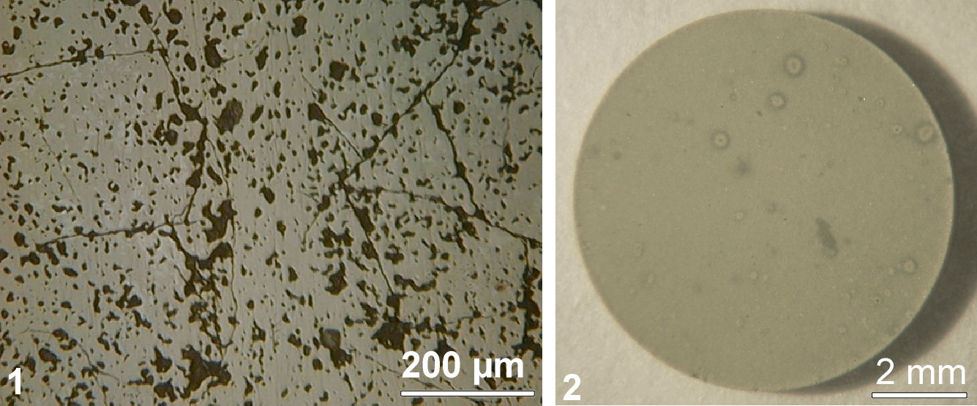
Fig. 1. Different behavior of crystalline ceramics containing ²³⁸Pu under self-irradiation: 1) formation of cracks in the ceramic based on (Ca_{1,16}Gd_{0,23}Hf_{0,30}Pu_{0,24}U_{0,42})Ti₂O₇ with pyrochlore structure in the beginning stage of amorphisation of solid solution after accumulated dose of 2.6⋅10²⁴ α-decay/m³; 2) absence of cracks in the zircon ceramics based on (Zr_{0,955}Pu_{0,045})SiO₄ after accumulated dose of 5.3⋅10²⁵ α-decay/m³ (or 1.4⋅10¹⁹ alpha-decays/g) and complete amorphisation of zircon solid solution phase.

Single phase cubic zirconia ceramic, Zr_{0.79}Gd_{0.14}Pu_{0.07}O_{1.93}, remained crystalline and mechanically intact after high doses (Fig. 2).
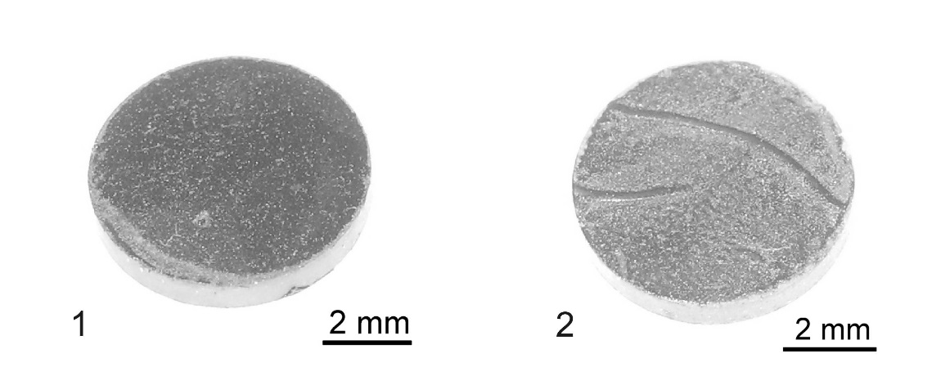
Fig. 2. Samples of ²³⁸Pu-doped ceramics, Zr_{0.79}Gd_{0.14}Pu_{0.07}O_{1.93,} at accumulated doses (in α-decay/m³ 10²⁴): 1) pellet #1 – 163 and 2) pellet #2 – 170 [40]

Polycrystalline ²³⁸Pu-bearing Pu-monazite, PuPO₄ underwent metamictisation at relatively low dose changed colour from blue to black and cracked into separate pieces. Single-phase ²³⁸Pu-doped La-monazite, La_{0.9}Pu_{0.1}PO₄, remained crystalline at high self-irradiation dose, however formation of microcracks in the matrix was also observed visually (Fig. 3).
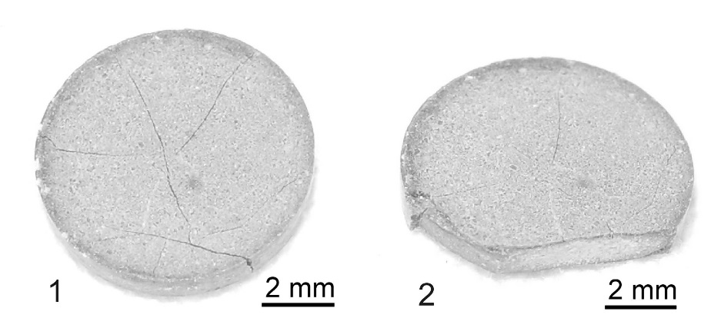
Fig. 3. Pellet of single-phase ²³⁸Pu-doped ceramic, La_{0.9}Pu_{0.1}PO₄, at accumulated dose approximately 10²⁶ α-decay/g /m³: 1) after extraction from XRD sealed holder; 2) self-induced destruction while taking picture over a period of several seconds [40]

A ²³⁸Pu-doped zircon single crystal examined over a 7-year period developed matrix cracking (Figs. 4 and 5). Formation of tiny (< 10 µm) particles near the crystals was also observed, possibly arising from fracture of the crystal surface under self-irradiation.

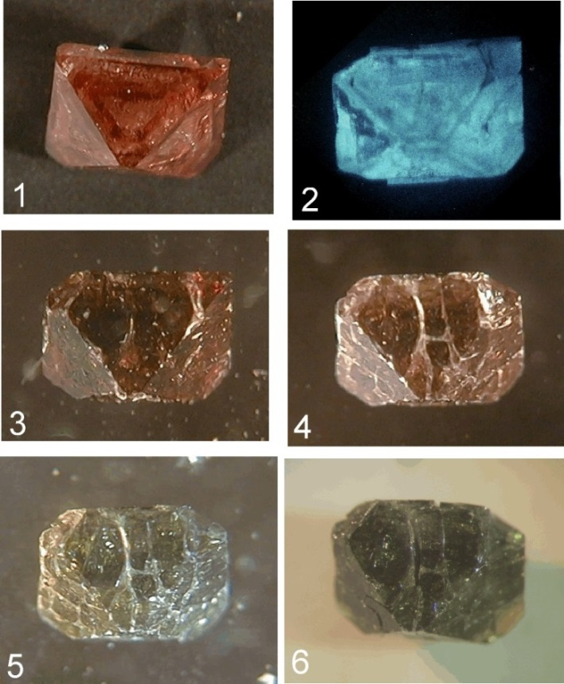
Fig. 4. Behaviour of crystalline synthetic zircon (Zr_{0.977}Pu_{0.023})SiO₄ containing 2.4 mass % of ²³⁸Pu and about 0.6 mass.% of other Pu isotopes under self-irradiation at accumulated dose (in α-decay/g /g 10¹⁷). Photos 1 and 2: 0.1; photo 3: 2; photo 4: 6; photo 5: 22; photo 6: 51. Photo 2 shows self-lighting of crystal in the dark which stopped after the accumulated dose 2⋅10¹⁷ alpha-decays/g [1].

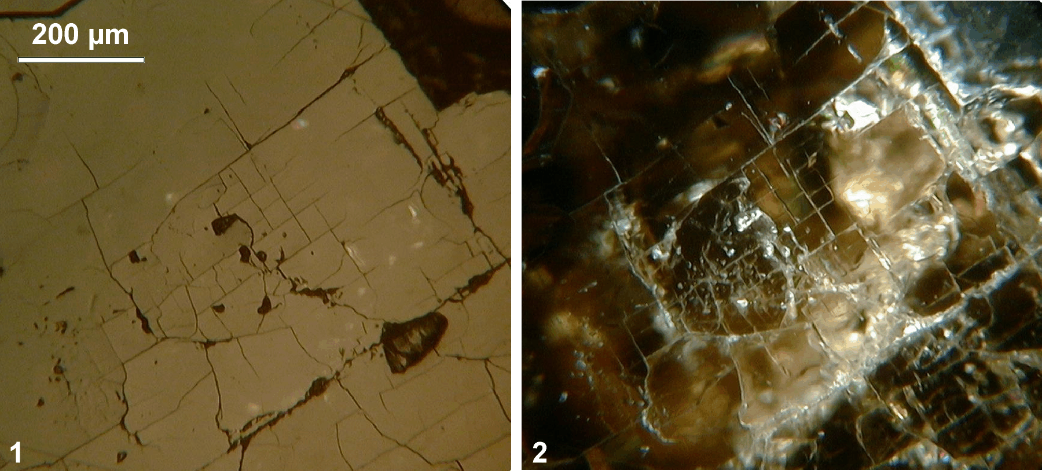
Fig. 5. Optical microphotograph of polished crystal of synthetic zircon (Zr_{0.977}Pu_{0.023})SiO₄, containing 2.4 mass % ²³⁸Pu and about 0.6 mass % of other Pu isotopes after self-irradiation accumulated dose of 7.5⋅10¹⁷ α-decay /g 10¹⁷): 1) in reflected light; 2) dark-field image.

Monocrystalline ²³⁸Pu-doped monazite, (Eu_{0.937}Pu_{0.063})PO₄, at the beginning of self-irradiation also demonstrated formation of tiny particles around crystals (Fig.6), but at high dose of irradiation formation of some shells on crystal surface was observed (Fig.7).

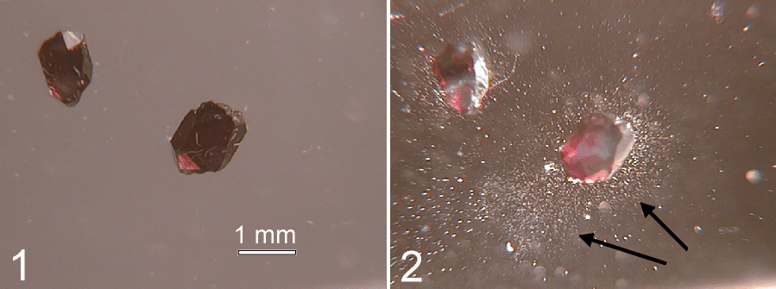
Fig. 6. Crystals of synthetic monazite (Eu_{0.937}Pu_{0.063})PO₄ containing 4.9 mass % ²³⁸Pu and about 1.1 mass % of other Pu isotopes: 1) initial state after synthesis; 2) formation of dispersed tiny particles around crystals after 14 months of storage – after accumulated dose of self-irradiation 1.1⋅10¹⁸ alpha-decays/g [1].

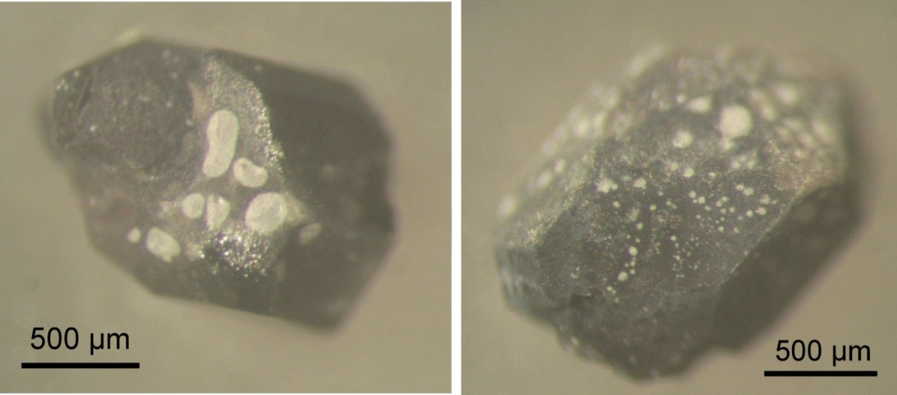
Fig. 7. Crystals of synthetic monazite (Eu_{0.937}Pu_{0.063})PO₄ containing 4.9 mass % of ²³⁸Pu and about 1.1 mass % of other Pu isotopes after accumulated dose of self-irradiation 5.2⋅10¹⁸ α-decay/g. Compared with initial state (Fig. 6 (1) note the loss of transparency, change of colour from crimson to grey-brown and surface peeling [1].

It is interesting to note that the monazite remained crystalline at this dose. The white newly-formed bubble-like phase was identified as polycrystalline monazite [41].
A summary table of crystalline wasteform behaviour under self-irradiation from ²³⁸Pu doping is shown in Table 1 (see also [1, 20, 21]).

Table 1. Summary of principal features of ceramics and crystals doped with ²³⁸Pu.
Wasteform (main phase) | Pu bulk content, its distribution (wt.% el.) | ²³⁸Pu content (wt.% el.) | Density, g/cm³ |  | Mechanical state
Wasteform (main phase) | Pu bulk content, its distribution (wt.% el.) | ²³⁸Pu content (wt.% el.) | Initial | At highest dose | Mechanical state
Ti-pyrochlore ceramic  (Ca,Gd,Hf,Pu,U)₂Ti₂O₇ | 10.5  Inhomogeneous from 3.4 to 26.8 | 8.7 | 4.8 | 4.3 | visually observed cracks at dose 2.6⋅10²⁴ α-decay/m³ (Fig.1)
Zircon/zirconia ceramic  (Zr,Pu)SiO₄/(Zr,Pu)O₂ | 5.7, homogeneous | 4.7 | 4.4 | no data | no cracks observed at dose 5.3⋅10²⁵ α-decay/m³ (Fig.1)
Single-phase cubic zirconia ceramic  Zr_{0.79}Gd_{0.14}Pu_{0.07}O_{1.93} | 12.2, homogeneous | 9.9 | 5.8 | 5.8 | no cracks observed at dose 1.7⋅10²⁶ α-decay/m³ (Fig. 2)
Single-phase La-monazite ceramic  La_{0.9}Pu_{0.1}PO₄ | 9.9, homogeneous* | 8.1 | 4.7 | No data | visually observed macro-cracks at dose 1.0⋅10²⁶ α-decay/m³ (Fig. 3)
Pu-monazite ceramic  PuPO₄ | 65.2, homogeneous* | 7.2 | 4.9 | no data | visually observed macro-cracks. Full destruction of ceramic pellet into separate pieces at dose 4.2⋅10²⁴ α-decay/m³
Zircon single crystal  Zr_{0.977}Pu_{0.023}SiO₄ | 3.3, inhomogeneous from 1.9 to 4.7 | 2.4 | no data | no data | Increase of visually observed cracks from dose 2.0⋅10¹⁷ to 2.2⋅10¹⁸ α-decay /g. Cracking stopped at dose 5.1 x 10¹⁸ α-decay/g (Figs. 4, 5)
Eu-monazite single crystal  Eu_{0.937}Pu_{0.063}PO₄ | 6.0, homogeneous | 4.9 | no data | no data | Particle formation at dose 1.1⋅10¹⁸ α-decay/g. Formation of polycrystalline separated thin bubble-like pieces on the surface at dose 5.2⋅10¹⁸ α-decay/g (Figs. 6, 7)
*These ceramics do not have separate PuO₂ inclusions and have homogeneous initial distribution of Pu. Cracking of PuPO₄ can be explained that there are actually two phases in these ceramics: PuPO₄ and another Pu-phosphate. Therefore, it is possible to expect different swelling among two phases. However, La_{0.9}Pu_{0.1}PO₄ is a single phase very homogeneous ceramic. Cracking can be caused by some segregation of Pu from solid solution into PuO₂ inclusions potentially as destruction of solid solution due to Pu+3 oxidation to Pu+4. which is evidenced by change of colour from blue to grey.
The first observation of real clusters induced by self-irradiation in ²³⁸Pu-doped pyrochlore ceramic was presented in [42]. It is worth noting that highly radioactive Chernobyl lava-like fuel-containing materials (LFCM) termed also Chernobyl “lava” (which is a GCM containing glass with signs of devitrification and inclusions of high-uranium zircon crystals, particles of molten stainless steel, uranium oxide dendrites and grains, and particles of Zr-U-O phases) is characterized by different stability against spontaneous destruction, with the pumice-like lava being the least stable, generating radioactive aerosols and particles with sizes up to 0.25 mm [43].
There is no clear understanding of mechanisms behind mechanical destruction of wasteforms briefly described above. Radiation induced amorphisation and phase transformations, as well as changes in the valence state of nuclides may be considered among potential contributors. We would like herewith to analyse an additional mechanism of mechanical damage of non-conducting nuclear wasteforms caused by electrical fields which are always induced in insulating materials by decaying radionuclides. Although there is no direct proof of relation of known mechanisms of destruction of wasteforms with the effects briefly overviewed above we consider that radiation-induced microcrystal shape change should also be considered among mechanism that can cause nuclear wasteform degradation.

Radioactive cluster charging/discharging
Apart from container materials nuclear wasteforms currently used for HLW immobilisation e.g. glasses, crystals and GCMs are highly-insulating materials which to large extent do not conduct electrical currents. Any charge imbalance that is introduced into such materials initially because of radioactive decay of waste radionuclides will require a relatively long relaxation time (seconds to hours) to a balanced (neutral) state. Typical α and β decay of radionuclides are associated with change of electric charge e.g. ionization so that electrical fields will inevitably build up due to radioactive decay and that will be permanently present until complete decay of waste radionuclides. The magnitudes of electrical field induced in wasteforms will depend on the specific activity of radionuclides and effective electrical conductivity of wasteform as well as on the homogeneity of the radionuclide distribution within the wasteform. Radionuclides are often inhomogeneously distributed in the wasteform particularly in composite (multiphase) materials such as GCM’s or multiphase crystalline ceramic such as Synroc with varying affinity of radionuclides to certain glassy or crystalline phases [1, 15, 16, 26-28]. For example, in GCM’s alkali elements tend to remain immobilised in the vitreous silicate phase whereas actinides concentrate in the crystalline phases such as zircon or zirconia [44-46].
In the case of radionuclides inhomogeneously distributed in a wasteform we can consider radioactive phase (radiophase) volumes containing decaying radionuclides as radiophase “clusters” surrounded by non-conducting material e.g. matrix. Consider a spherical radioactive particle with specific activity a₀ and radius R embedded in a non-conducting glassy or crystalline ceramic matrix with effective electrical conductivity σ (Fig. 8). The total cluster activity is A₀=4πa₀R³/3$A_{0}=4πa_{0}R^{3}/3$.
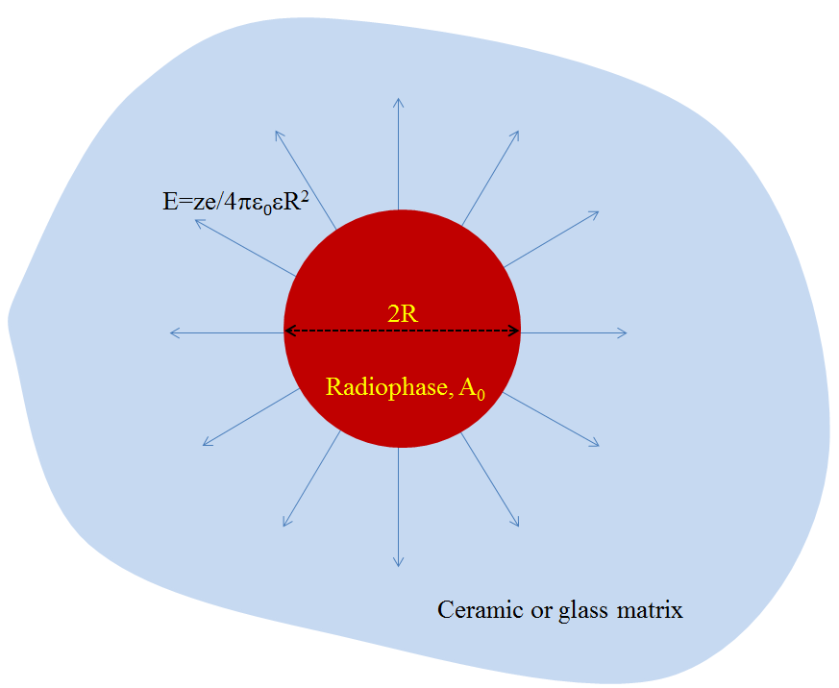
Fig. 8. Schematic of a radioactive cluster embedded in a non-conducting matrix which generates an electrical field E near it.
Practically all α and β particles generated by decay will leave the cluster in the case when the cluster size 2R is smaller than their mean free path. Thus, the decaying radionuclides will change the cluster electrical charge. The total electric current out of the cluster which is generated by radioactive decay is:
I_{out}=A₀e$I_{out}=A_{0}e$, (1)
where A₀ is the activity of radionuclides in the cluster and e is equal to the elementary charge e=e₀ in the case of β decay and e=2e₀ in the case of α decay. The cluster becomes charged with total electrical charge ze and that generates an electric field which on its surface is
E=ze/4πε₀εR², (2)
where ε₀ is the vacuum permittivity (8.85⋅10⁻¹² F/m) and ε is the dielectric constant which for a silicate glass matrix has the order of 5.
The electric field will cause a back-flowing electrical current to the cluster due to finite electrical conductivity of matrix
I_{in}=4πR²σE$I_{in}=4πR^{2}σE$. (3)
The cluster electric charge at any time therefore will be determined by the sum of these two currents which results in the equation for radiophase cluster charge z:
∂z/∂t=A₀e/e₀- σz/ε₀ε $\frac{∂z}{∂t}=A_{0}\frac{e}{e_{0}}-\frac{σz}{ε_{0}ε}$ (4)
That gives for the strength of electric field with time t
E(t)=E₀[1-exp(-t/τ)], (5)
where the maximal electric field on the cluster surface is given by
E₀=a₀eR/3σ, (6)
and the characteristic time of achieving that stationary electric field is
τ=ε₀ε/σ (7)
The smaller the matrix electric conductivity, the larger the cluster and radionuclide specific activity, the higher the stationary electrical field strength E₀. The higher the electric conductivity the smaller the characteristic time of charging. At typical glass electrical conductivity (σ) ranging from 10⁻¹¹ to 10⁻¹⁵ S/m the characteristic time of cluster charging τ will range from 4.5 s to 12.5 hours.
Note that in principle the electric field can be strong enough and even exceed the dielectric breakdown threshold of the matrix. E.g. the dielectric breakdown occurs in silica glass at an electric field strength of about E_{max} = 25 to 40 MV/m [47]. If the electrical field strength E₀ exceeds E_{max} the cluster will be repeatedly (almost periodically) charged due to radionuclide decay and discharged due to dielectric breakdown (Fig. 9).
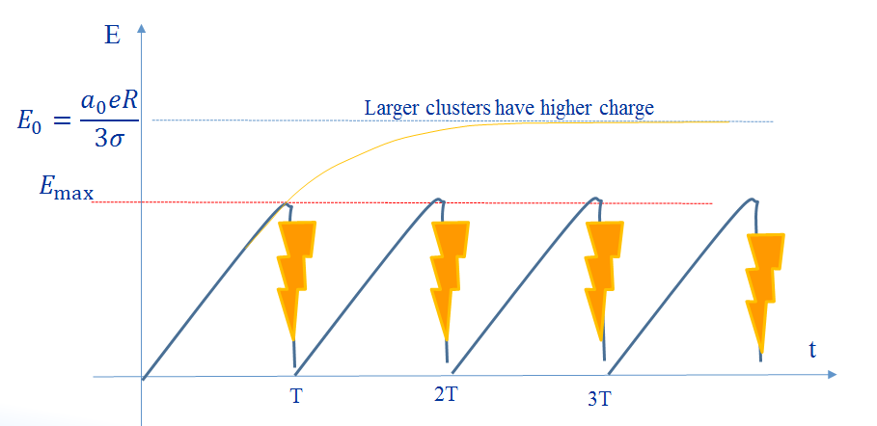
Fig. 9. Almost periodic charging-discharging of a radiophase cluster in a non-conducting matrix. The electrical field E(t) cannot achieve its maximum value E₀ because at t=T, 2T etc. dielectric breakdown of matrix occurs.
The characteristic time (period) of discharges is found from:
T=τln[E₀/(E₀-E_{max})] (8)
If E₀ is close to E_{max} then T →∞ and there is no repetitive charging-discharging of radioactive clusters, however if E₀>>E_{max} then T →0 and the frequency of charging-discharging can be high. Materials containing such charging/discharging radiophase clusters should be radiofrequency active and because of that the process occurrence should be readily detected.
We give here a numerical assessment for a ²⁴⁴Cm- containing radiophase immobilised in devitrified glass composite [2]. It has a half-live T_{1/2}=18.1 y and emits 5.8 MeV alpha particles to transform to ²⁴⁰Pu. ²⁴⁴Cm has the specific activity a₀=80.9 Ci/g e.g. 2.99∙10¹⁴ Bq/kg or 4.03∙10¹⁹ Bq/m³ accounting that ρ=13.5 g/cm³. A ²⁴⁴Cm- containing cluster of radius R = 1 μm embedded in a non-conducting wasteform (e.g. glass) with σ=10⁻¹⁴ S/m can generate a maximum electric field strength as high as E₀=400 MV/m. This field is an order of magnitude stronger than typical electric breakdown threshold of glass E_{max} and therefore the charging-discharging process will occur at intervals approximately equal to T ≈ 450 s. Since electrical discharges are accompanied by acoustic and electromagnetic signals the above effects can be detected using both acoustic emission and electromagnetic detectors [48-50]. The frequency of signals from charging/discharging radiophase will be given by
ω=N/T, (9)
where N is the number of radioactive clusters present in the wasteform.
There is a critical size R_{crit} for clusters containing radioactive material in a wasteform so that if they exceed that size R> R_{crit} then the dielectric breakdown will finally lead to matrix destruction:
R_{crit}=3σE_{max}/a₀e $R_{crit}=\frac{{3σE_{max}}_{ }}{a_{0}e}$ (10)
The critical size is dependent on both radiophase (a₀ and e) and matrix properties (σ and E_{max}). For ²⁴⁴Cm clusters in a glass matrix with σ=10⁻¹³ S/m and E_{max}=40 MV/m the critical radius is about 1 μm. The wasteform should therefore be fabricated to be as homogeneous as possible and not contain radionuclide-containing clusters with size exceeding R_{crit} to avoid damage by electrical breakdown of non-conducting matrices. More highly conducting matrices are less sensitive to electrical breakdown damage.
Clusters of sizes smaller than R_{crit} cannot cause dielectric breakdown of matrix however electric fields near clusters produce repulsive forces to any charged particles of similar sign charge. Therefore such radiation-ibdiced forces should be considered among possible causes of ejected sub-mm particles near the crystals observed (Fig. 6). Most important is that charged particles are unstable and with time will change their shape due to surface diffusion-controlled processes that although occurring very slowly (during many years to year decades) can induce strong mechanical strains in the matrix and finally break it. This process is considered below.

Radioactive cluster shape change
Effects caused by strong electrical fields near radioactive clusters are not limited to dielectric breakdown. We consider now the possibility of shape (morphology) change and matrix mechanical destruction due to self-diffusion of adatoms on the surfaces of radioactive clusters.
The effect of instability of conducting liquids in strong electric fields is well known as well as Rayleigh instability of small droplets [51-54]. Solid materials were considered stable in electrical fields because unlike fluids they do not flow, and so are apparently stable. However, it has been revealed that the surface of solids can also become unstable in electrical fields due to molecular diffusion-controlled material transport [8, 9, 11]. The concentration of surface molecules and atoms (adatoms) is modulated by the crystals curvature so that the higher the curvature the higher the concentration. Under normal conditions this leads to gradual flattening of surfaces via diffusion of adatoms to the lower curvature areas. However, in the presence of electric fields the situation can reverse. Indeed the higher the surface curvature the higher the electric field near it. Because of this the adatoms are effectively dragged into areas of higher curvature and the fluxes of adatoms so dragged can exceed the diffusion fluxes in the presence of strong electric fields. This will lead to slowly-occurring instability of solid materials surfaces. In contrast to fluids when the electrohydrodynamic instability evolves at minute fractions of a second the instability of solids in electrical fields occurs slowly and requires extended periods of time over many years and even decades and longer to be observed. However, the instability of solids in electrical fields also results in their eventual disruption and disintegration of small solid particles similar to that observed e.g. in Figure 6.2. Moreover in the case of radioactive materials the evolution of solid surface instability can occur at an accelerated rate because of additional defects induced by radiationAlthough in the material of Fig 6.2 (synthetic monazite with Pu), there is no evidence of the presence of clusters, tiny particles and “bubble-like” new-formed white material on the single crystal surface are related to polycrystalline (consisted of small crystallites) monazite [43] Therefore, transfer from single-crystal matrix to polycrystalline is one potential candidate for confirmation of instability although we still do not exclude possible separation of PuO₂.
We consider two cases for adatoms (or surface molecules) interaction with electric field –
(i) dipole interaction U_{int}=-(dE)$U_{int}=-(\vec{d}\vec{E)}$, and (11)
(ii) polarization interaction U_{int}=αE², (12)
where U_{int} is the energy of interaction. The dipole moment d = ⏐d⏐ can be assumed to be of the order of 3∙10⁻³⁰ C∙m whereas the polarisation of an adatom has the order of α∼4πε₀v_{m}=1.1∙10⁻¹⁰v_{m}, where v_{m} is the volume of diffusing adatom (molecule). Thus, for a 1 μm cluster with ²⁴⁴Cm which generates an electric field of the order of 40 MV/m we have U_{int} ∼ 10⁻²² J for dipole and U_{int} ∼ 10⁻²⁵ J for polarization mechanisms revealing that the dipole mechanism of interaction is much stronger. It can gradually drag the adatoms to areas of higher curvature and modify the cluster shape changing its morphology e.g. from spherical to an extended shape. The adatoms do also interact with the surface of the embedded matrix which can affect their mobility. However do not have data on contribution from this interaction and working models to be used for that.
Consider a particle (e.g. radiophase cluster) with initial undisturbed radius R₀ which has some small deviations from spherical, then its radius can be expressed in term of spherical harmonics as
(13)
$$R=R_{0}+\sum{α_{l,m}Y_{l}^{m}(θ,φ)}$$
where α_{l,m} are the amplitudes of deviations considered much smaller compared R₀, and $Y_{l}^{m}(θ,φ)$ are spherical functions. We assume that the characteristic diffusion time (which for solids is indeed long enough) is much longer that the mean lifetime of an adatom on the surface
τ₀ = τ⊥ exp(W/k_{B}T) (14)
where W is the energy of formation of an adatom, k_{B} – Boltzmann constant, T – temperature. In this case the surface concentration of adatoms c adiabatically follows the changes of surface curvature:
c = c₀ exp(HR_{s} – v_{m}E²/8πk_{B}T) (15)
where H is the local curvature, R_{s} = 2σ_{s}v_{m}/k_{B}T, and σ_{s} is the surface tension which for silicate glasses has the order of 0.3 J/m². The first term in the exponent shows the increase of surface concentration of adatoms – the higher the curvature the higher the concentration. The second term in the exponent is due to negative pressure caused by electrical field – the higher field strength the lower the concentration. We can express the surface concentration of adatoms as sum of a constant term c_{s} and small modulated term c₁ << c_{s}
c = c_{s} + c₁ (16)
where
c_{s} = c₀exp(R_{s}/R₀ – v_{m}E²/8πk_{B}T) (17)
c₁ = c_{s}∑[(R_{s}/2R₀)(l²+l-2) – v_{m}E²(l-1)/2k_{B}T] α_{l,m}Y_{l,m}(θ,φ) (18)
The electrical field E in (17) and (18) is taken from (2) at R = R₀. From (18) it is seen that the modulation of adatoms concentration on the surface occurs in the same phase with deviations from spherical form whereas at high field strengths the modulation is in antiphase. That can occur when the negative pressure caused by electrical field exceeds Laplace positive pressure however the instability of particle will occur at much lower electrical field due to drag of adatoms into the areas with higher curvature. The equation that governs the change of particle shape follows from linearization of continuity equation:
(c_{m}/δ)dR/dt = D_{s}Δ_{II}c₁ + μ_{s}c_{s}Δ_{II}U_{int} (19)
where c_{m} and δ are the concentration of molecules and the thickness of a molecular monolayer, D_{s} and μ_{s} are the surface diffusion coefficient and adatom mobility interrelated to each other via Einstein–Smoluchowski relation, and the operators Δ_{II} acts along the spherical surface. For adatoms with permanent dipole moments oriented at angle θ_{r} relative to particle radius the energy of interaction is:
U_{int} = - dEcos(θ_{r}) [1 + ∑α_{l,m} (l-1)Y_{l,m}(θ,φ)/R₀] (20)
In the case when the dipoles are not oriented and because of thermal fluctuations are chaotically distributed thermal averaging gives (accounting that dE<<k_{B}T)
U_{int} = - αE² [1 + ∑α_{l,m} (l-1)Y_{l,m}(θ,φ)/2R₀] (21)
The orientation polarisation in (21) is given by
α = d²/3k_{B}T (22)
In the case of adatoms without permanent dipole moment the energy of interaction is given by the equation (21) where α is the polarisation of an adatom.
From equation (19) it follows that the deviation amplitudes evolve with time as follows:
α_{l,m} (t) = α_{l,m} (0) exp(γ_{l} t) (23)
The constant that shows the increment (if γ_{l} > 0) or decrement (if γ_{l} < 0) of perturbation amplitudes evolution is given by
γ_{l} = δR_{s}c_{s}D_{s}(l₀ – l – 2)l(l² – 1)/2(R₀)⁴c_{m} (24)
We have designated the angular momentum l₀ as follows:
l₀ = R₀U/σ_{s}v_{m} (28)
where
U = U₀ + v_{m}E²/4π (25)
and U₀ takes the value
U₀ = dEcos(θ_{r}) for oriented dipoles, or (26)
U₀ = αE² for polarisation mechanism. (27)
Deviations (perturbations) with high momenta l >> 1 will always decrease in amplitude and disappear with time, however those with momenta 2 ≤ l ≤ l₀ – 2 will grow in amplitude with time which means development of instability of spherical shape due to surface diffusion-controlled processes. Some of perturbations grow faster and the highest growth rate in the case of l₀ >> 1 occurs for momentum
l_{opt} = 3l₀/4 (29)
which gives for characteristic time constant of development of shape instability:
τ_{opt} = 256R₀c_{m}k_{B}T(σ_{s}v_{m})²/27δD_{s}c_{s}U³$τ_{opt}=\frac{256σ_{s}^{3}v_{m}^{3}}{27δD_{s}U_{z}^{3}(c^{(0)}/c_{0)}}$ (30)
The larger the particle the longer the time of instability development, moreover this time is exponentially dependent on temperature because of Arrhenius dependence for both surface diffusion coefficient D_{s} and concentration of adatoms e.g. (c_{s}/c_{m}) ∼ exp(-W/k_{B}T). For a 1 μm size cluster containing ²⁴⁴Cm we obtain a time of the order of about 4 10⁷ s, e.g. about a year taking for estimations c_{m}/c_{s} ∼ 10⁴, k_{B}T ∼ 4 10⁻²¹ J, σ_{s} ∼ 0.3 J/m², v_{m} ∼ 10⁻³⁰ m³, δ ∼ 0.1 nm, D_{s} ∼ 10⁻¹⁴ m²/s, U ∼ 10⁻²² J. Gradual shape change will induce stress in the wasteform which can exceed the ultimate matrix tensile stress σ_{t} which for glasses is about 33 MPa. That will occur at times
t_{br}=τ_{opt}ln(2R₀σ_{t}/E_{m}δ) (31)
where E_{m} is the Young's modulus of matrix which for glass is about 55 GPa and. For a ²⁴⁴Cm radioactive cluster of R=1 μm size that will occur in about several years. Dimensional changes due to amorphisation or solid/solid phase transformation can also induce local stress and furthermore some cracking of materials however we have no data available on stresses for comparison with data presented here.

Impact on wasteform homogeneity
The process of radiophase particle form change and matrix damage can occur in the following way: first, radioactive clusters become charged due to radioactive decay, then, second, diffusing adatoms are gradually dragged to highest curvature areas, and then, third, areas with larger curvature grow inducing mechanical stress and finally damaging the matrix (Fig. 10).
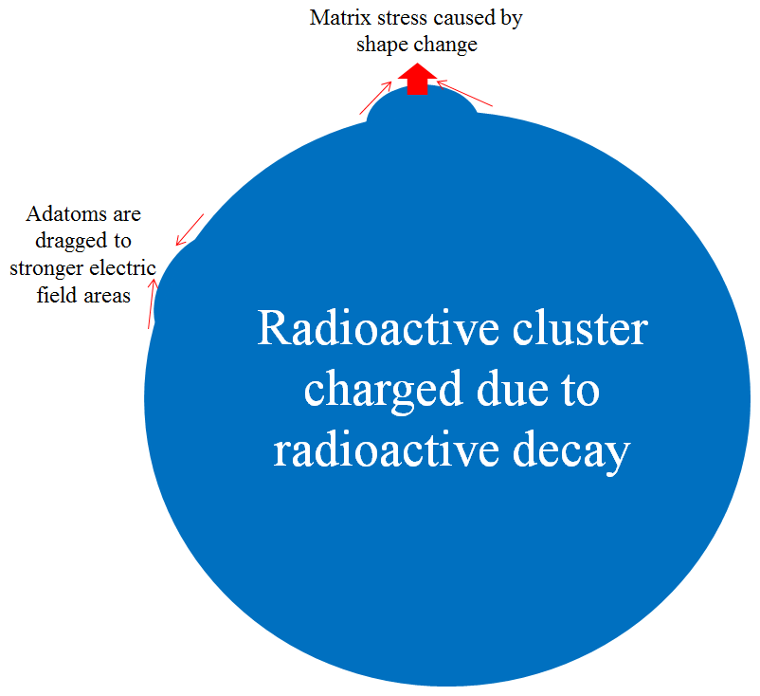
Fig. 10. Schematic of radioactive cluster shape change.
For a such damaging process to occur there is a critical size for clusters containing radioactive material in a wasteform which is given by condition γ_{l} > 0 which can exist only if l ≥ 2 as γ₀ = γ₁ = 0. This leads to definition of critical size for shape change to potentially occur at l = 2 e.g. when l₀ = 4:
R_{crit}=4σ_{s}v_{m}/U$R_{crit}=σ_{s}v_{m}/2U_{z}$, (32)
If radiophase particle sizes are less than R_{crit} then the diffusion instability of radioactive particles cannot occur and the wasteform is stable. However, if R> R_{crit} , then the radioactive cluster shape change will finally break the matrix. In practice the crystal structure is important and the stress will vary with orientation although these affects are not considered here. The larger the R_{crit} the more stable is the wasteform against diffusion-induced instabilities and damage caused by cluster shape change associated with radionuclides in the wasteform. In the cases of permanent dipole interaction, the critical size is:
R_{crit}= [12σσ_{s}v_{m}/dcos(θ_{r}) a₀e]^{1/2} (33)
In the case of polarization interaction we have for critical size another expression:
R_{crit} = [36σ²σ_{s}v_{m}/α(a₀e)²]^{1/3} (33)
The higher electrical conductivity of wasteform the larger critical size which means smaller sensitivity of wasteforms to radiophase inhomogeneity. The higher specific activity of waste the smaller the critical size which means higher sensitivity of HLW to presence of inhomogeneity in the distribution of radionuclides.
A summary table of assessed critical sizes of radioactive clusters for ²⁴⁴Cm, ²⁴¹Am, ^{238,239}Pu and ¹³⁷Cs in a glassy matrix is shown in Table 2 taken for typical values σ ∼ 10⁻¹³ S/m, σ_{s} ∼ 0.3 J/m², v_{m} ∼ 10⁻³⁰ m³, dcos(θ_{r}) ∼ 3∙10⁻³⁰ C∙m, α ∼ 10⁻⁴⁰ m³, and e₀ = 1.6 10⁻¹⁹ C. The critical sizes in this table are indicative and exact data should be found on specifying the matrix material and radionuclide physical parameters rather than using rough approximations as explained above.
Table 2. Summary of radionuclide-containing cluster critical sizes in a glass matrix
Radio-nuclide | Half-life, y | Density, g/cm³ | Specific activity a_{o}, Bq/m³ | Dielectric breakdown R_{crit}, μm | Shape change dipole R_{crit}, μm | Shape change polarisation R_{crit}, μm
²⁴⁴Cm | 18.1 | 13.5 | 4.04∙10¹⁹ | 1 | 0.2 | 1.9
²³⁸Pu | 87.7 | 19.8 | 1.25∙10¹⁹ | 3.2 | 0.36 | 4.2
²³⁹Pu | 24000 | 19.8 | 4.55∙10¹⁶ | 889 | 6 | 175
²⁴¹Am | 432.2 | 12 | 1.72∙10¹⁸ | 26.5 | 1 | 15.6
¹³⁷Cs | 30.17 | 1.93 | 6.21∙10¹⁸ | 13 | 0.7 | 10.5
Vitrified HLW typically contain various crystalline phases embedded in a predominantly glassy matrix [55]. Some of these crystalline particles can contain higher concentrations of radionuclides compared to glassy material. Radionuclide-containing particles in the non-conducting wasteform should be smaller than the minimal critical size to avoid both electric breakdown and diffusion controlled shape change that can lead to wasteform mechanical damage. It can be seen that the smallest radii are those due to shape change via dipole interaction with electrical fields induced by decay that will occur during extended time periods over many hundred thousand years – e.g. see Eqs. (30) and (31).

Conclusions
We briefly overviewed the mechanical destruction of wasteforms containing actinides - ceramics and crystals doped with ²³⁸Pu. Experiments with actinide-containing insulating wasteforms such as devitrified glasses containing ²⁴⁴Cm, Ti-pyrochlore, single-phase La-monazite, Pu-monazite ceramics, Eu-monazite and zircon single crystals containing ²³⁸Pu reveal that mechanical self-destruction occurs after some extended time which can last for several years. We then modelled the damaging effects caused by electrical fields induced by the decay of radionuclides in clusters embedded in a non-conducting matrix. Such a mechanism of mechanical destruction is in addition to recognised processes of matrix swelling and solid solution destruction. Three effects were important: (i) electric breakdown; (ii) cluster shape change due to dipole interaction, and (iii) cluster shape change due to polarisation interaction. We have revealed that there is a critical size of radioactive clusters in non-conducting matrices so that the matrix material can be damaged if clusters are larger than this critical size. The most important parameters that control the matrix integrity are the radioactive cluster (inhomogeneity) size, specific radioactivity, and effective matrix electrical conductivity. We conclude that the wasteform should be as homogeneous as possible and even electrically conductive to avoid potential damage caused by electrical charges induced by radioactive decay and their resulting effects.

Acknowledgements
Authors are grateful to Bill Weber, Sylvain Peuget, Kostya Trachenko, Maik Lang, Sergey Yudintcev, Neil Hyatt, and Ian Swainson for discussing the effects observed and potential mechanisms involved.

REFERENCES
- B.E. Burakov, M.I Ojovan, W.E. Lee. Crystalline Materials for Actinide Immobilisation, Imperial College Press, London (2010).
- W.J. Weber, R.P. Turcotte, L.R. Bunnell, F.P. Roberts, and J.H. Westsik, in “Ceramics in Nuclear Waste Management”, edited by T.D. Chikalla and J.E. Mendel, CONF-790420 (National Technical Information Service, Springfield, VA, 1979), p.294
- B.E. Burakov, M.A. Yagovkina, A study of accelerated radiation damage effects in PuO₂ and gadolinia-stabilized cubic zirconia, Zr_{0.79}Gd_{0.14}Pu_{0.07}O_{1.93}, doped with ²³⁸Pu. J. Nucl. Mater., 467, 534-536 (2016).
- S.X. Wang, B.D. Begg, L.M. Wang, R.C. Ewing, W.J. Weber and K.V. Govidan Kutty K.V., Radiation stability of gadolinium zirconate: A waste form for plutonium disposition, J. Nucl. Mater. 14, 4470–4473 (1999).
- R.C. Ewing, B.C. Chakoumakos, G.R. Lumpkin, T. Murakami, The metamict state. MRS Bulletin, 58-66 (1987).
- G.R. Lumpkin, Geisler-Wierwille T. (2012) Minerals and Natural Analogues. In: Konings R.J.M., (ed.) Comprehensive Nuclear Materials, Vol. 5, 563-600 (2012)
- B.E. Burakov, A.Ph. Smetannikov, E.B. Anderson, Investigation of Natural and Artificial Zr-silicate Gels. In P. Van Iseghem, Ed. Scientific Basis for Nuclear Waste Management XXIX, Materials Research Society Symposium Proceedings, Ghent, Belgium, Vol. 932, pp. 1017-1024(2006).
- I.A. Sobolev, Khomchik L.M., Timofeev E.M., Ojovan M.I., Poluektov P.P. Diffusional instability of solid surfaces. Phys. Chem. Mech. Surfaces, 3 (12), 3529-3540 (1985).
- I.A. Sobolev, Barinov A.S., Khomchik L.M., Ozhovan M.I., Timofeev E.M. Effect of High-Power Gamma Radiation on the Sr-90 Distribution in the Ground. At. Energ., 59, 697-698 (1985).
- J.-P. Riviere. Radiation Induced Point Defects and Diffusion. In: P. Misaelides (ed.), Application of Particle and Laser Beams in Materials Technology, 53-76. Kluwer Academic Publishers, Kallithea (1995).
- M.I. Ojovan, P.P. Poluektov. Surface self-diffusion instability in electric fields. Mat. Res. Symp. Proc., 648, P.3.1.1-6. (2001).
- M. Ojovan, G. Möbus. On radiation-induced fluidization (quasi-melting) of silicate glasses. Mater. Res. Soc. Symp. Proc. 1193, 275-282 (2009).
- G. Möbus, M. Ojovan, S. Cook, J. Tsai, G. Yang. Nano-scale quasi-melting of alkali-borosilicate glasses under electron irradiation. J. Nucl. Mater., 396 (2-3) 264-271 (2010).
- K. Zheng, C. Wang, Y.-Q. Cheng, Y. Yue, X. Han, Z. Zhang, Z. Shan, S.X. Mao, M. Ye, Y. Yin, E. Ma. Electron-beam-assisted superplastic shaping of nanoscale amorphous silica, Nature Comm., 1:24, 1–8 (2011).
- W.E. Lee, M.I. Ojovan, M.C. Stennett, N.C. Hyatt. Immobilisation of radioactive waste in glasses, glass composite materials and ceramics. Advances in Applied Ceramics, 105 (1), 3-12 (2006).
- M.I. Ojovan, W.E. Lee. An Introduction to Nuclear Waste Immobilisation, Second Edition, Elsevier, Amsterdam, 362 pp. (2014).
- W.J. Weber, R.C. Ewing, C.A. Angel, G.W. Arnold, A.N. Cormack, J.M. Delaye, D.L. Griscom, L.W. Hobbs, A. Navrotsky, D.L. Price, A.M. Stoneham, M.C. Weinberg. Radiation effects in glasses used for immobilization of high-level waste and plutonium disposition. J. Mater. Res., 12, 1946-1978 (1997).
- W.J. Weber, R.C. Ewing, C.R. A. Catlow, T. Diaz de la Rubia, L.W. Hobbs, C. Kinoshita, Hj. Matzke, A.T. Motta, M. Nastasi, E.K.H. Salje, E.R. Vance, S.J. Zinkle. Radiation effects in crystalline ceramics for the immobilization of high-level nuclear waste and plutonium. J. Mat. Res., 13, 1434 - 1484 (1998).
- M.I. Ojovan, W.E. Lee. New Developments in Glassy Nuclear Wasteforms. Nova Science Publishers, New York, 131 p. (2007).
- Joint ICTP-IAEA Workshop on Radiation Effects in Nuclear Waste Forms and their Consequences for Storage and Disposal. International Centre for Theoretical Physics, Trieste, Italy, 12-16.09.2016. http://indico.ictp.it/event/7633/ (2016).
- M.I. Ojovan, B.E. Burakov, W.E. Lee. Destruction of Micro-crystal Containing Wasteforms by Charge-induced Crystal Shape Change on Self-irradiation. MRS Advances, 1557, pp. 1-6 (2016).
- IAEA. Radiation Protection and Safety of Radiation Sources: International Basic Safety Standards, IAEA Safety Standards Series No. GSR Part 3, IAEA, Vienna (2014).
- IAEA. Improved Cement Solidification of Low and Intermediate Level Radioactive Wastes, Technical Reports Series No. 350, IAEA, Vienna (1993).
- IAEA. Immobilization of Low and Intermediate Level Radioactive Wastes with Polymers, Technical Reports Series No. 289, IAEA, Vienna (1988).
- IAEA. Bituminization Processes to Condition Radioactive Wastes, Technical Reports Series No. 352, IAEA, Vienna (1993).
- The National Academies Press, Waste Forms Technology and Performance: Final Report. Committee on Waste Forms Technology and Performance. National Research Council. ISBN: 0-309-18734-6, 340 p., Washington, D.C. (2011).
- M.I. Ojovan, W.E. Lee. Glassy wasteforms for nuclear waste immobilisation. Metallurgical and Materials Transactions A, 42 (4), 837-851 (2011).
- W.E. Lee, M.I. Ojovan, C.M. Jantzen. Radioactive waste management and contaminated site clean-up: Processes, technologies and international experience. Woodhead Publishing Series in Energy No. 48. Woodhead, Cambridge (2013).
- Abdel Rahman R.O., Rahimov R.Z., Rahimova N.R., Ojovan M.I. Cementitious materials for nuclear waste immobilisation, 258 pp., Wiley, Chichester (2015).
- IAEA. Interim Storage of Radioactive Waste Packages, Technical Reports Series No. 390, IAEA, Vienna (1998).
- IAEA. Selection of Technical Solutions for the Management of Radioactive Waste, IAEA TECDOC-1817, IAEA, Vienna (2017).
- M.I. Ojovan, J.C. Marra. Vitrification of Radioactive Wastes. Glass International, 37 (4), 19-21 (2014).
- R.A. Robbins, M.I. Ojovan. Vitreous Materials for Nuclear Waste Immobilisation and IAEA Support Activities. MRS Advances, 1557, 6p., https://doi.org/10.1557/adv.2017.209 (2017).
- S. Peuget, Noël, P.-Y.; Loubet, J.-L.; Pavan, S.; Nivet, P.; Chenet, A. Effects of deposited nuclear and electronic energy on the hardness of R7T7-type containment glass. Nuclear Instruments & Methods in Physics Research Section B-Beam Interactions with Materials and Atoms, 246 (2): p. 379-386 (2006).
- S. Peuget, Broudic, V.; Jégou, C.; Frugier, P.; Roudil, D.; Deschanels, X.; Rabiller, H.; Noel, P. Y. Effect of alpha radiation on the leaching behaviour of nuclear glass. J. Nucl. Mater., 362 (2–3): p. 474-479 (2007).
- S. Peuget, C. Mendoza, E.A. Maugeri, J.M. Delaye, R. Caraballo, T. Charpentier, M. Tribet, O. Bouty, C. Jégou. Alpha Decays Impact on Nuclear Glass Structure. Procedia Materials Science, 7, 252-261 (2014).
- S. Peuget, T. Fares, E.A. Maugeri, R. Caraballo, T. Charpentier, L. Martel, J. Somers, A. Janssen, T. Wiss, F. Rozenblum, M. Magnin, X. Deschanels, C. Jégou. Effect of B-10(n, alpha)Li-7 irradiation on the structure of a sodium borosilicate glass. Nuclear Instruments & Methods in Physics Research Section B-Beam Interactions with Materials and Atoms, 327, 22-28 (2014).
- J.M. Delaye, S. Peuget, G. Calas, L. Galoisy, Comparative effects of thermal quenching and ballistic collisions in SiO₂–B₂O₃–Na₂O glass. Nuclear Instruments & Methods in Physics Research Section B-Beam Interactions with Materials and Atoms, 326, 256-259 (2014).
- S. Peuget, J.-M. Delaye, C. Jegou. Specific outcomes of the research on the radiation stability of the French nuclear glass towards alpha decay accumulation. J. Nucl. Mater., 444 (1–3), 76-91 (2014).
- B.Yu. Zubekhina, B.E. Burakov, Leaching of plutonium from "old" samples of single phase ceramics based on Zr_{0.79}Gd_{0.14}Pu_{0.04}O_{1.93} and La_{0.9}Pu_{0.1}PO₄ Doped with ²³⁸Pu, MRS Advances, 1557, DOI: 10.1557/adv.2017.216, 4249-4253 (2017).
- A.A. Shiryaev, M.S.Nickolsky, A.A. Averin, Grigoriev M.S., Zubavichus Y.V., Vlasova I.E., V. G. Petrov V.G., Burakov B.E., Structural peculiarities of aged ²³⁸Pu-doped monazite, MRS Advances, 1557, DOI: 10.1557/adv.2017.220 (2017).
- M. V.Zamoryanskaya, Burakov B. E. (2004) Electron Microprobe Investigation of Ti-Pyrochlore Doped with Pu-238. Mater. Res. Soc. Symp. Proc, 824, pp. 231-236.
- A.A. Shiryaev, I.E. Vlasova, B.E. Burakov, B.I. Ogorodnikov, V.O. Yapaskurt, A.A. Averin, A.V. Pakhnevich, Y.V. Zubavichus. Physico-chemical properties of Chernobyl lava and their destruction products. Progress in Nuclear Energy, 92, 104-118 (2016).
- G.A. Petrov, S.V. Stefanovsky, M.I. Ojovan, B.S. Nikonov. Technology of formation of waste blocks from heterogeneous melts of highly energetic systems. Physics and Chemistry of Materials Treatment, 6, 78-84 (1998).
- Y.M. Kulyako, S.A. Perevalov, S.E. Vinokurov, B.F. Myasoedov, G.A. Petrov, M.I. Ozhovan, S.A. Dmitriev and I.A. Sobolev. Properties of host matrices with incorporated U and Pu oxides, prepared by melting of a zircon-containing heterogeneous mixture (by virtue of Exo Effect of burning metallic fuel). Radiochemistry, 43, 626-631 (2001).
- O.K. Karlina, G.A. Petrov, M.I. Ojovan, G.A. Varlakova, S.A. Dmitriev. Conditioning of ash residue in the reaction wave of glass-forming heterogeneous composition. Mat. Res. Soc. Symp. Proc., 506, 695-699 (1998).
- A. von Hippel, R. J. Maurer. Electric Breakdown of Glasses and Crystals as a Function of Temperature. Phys. Rev., 59, 820-824 (1941).
- L.M. Spasova, M.I. Ojovan, C.R. Scales. Acoustic emission technique applied for monitoring and inspection of cementitious structures encapsulating aluminium. J. Acoustic Emission, 25, 51-68 (2007).
- L.M. Spasova, M.I. Ojovan. Characterisation of Al corrosion and its impact on the mechanical performance of composite cement wasteforms by the acoustic emission technique. J. Nucl. Mater., 375, 347-358 (2008).
- L.M. Spasova, M.I. Ojovan, F.G.F. Gibb. Acoustic emission on melting/solidification of natural granite simulating very deep waste disposal. Nucl. Eng. Design, 248, 329-339 (2012).
- G. I. Taylor. Disintegration of water drops in an electric field. Proc. R. Soc. London A, 280, 383–397 (1964).
- L.D. Landau, E.M. Lifshitz. Electrodynamics of Continuous Media, 2nd Edition, Elsevier, 460 p. (1984),
- A.I. Grigor’ev, S.O. Shir’aeva. Mechanism of electrostatic polydispersion of liquid. J. Phys. D: Appl. Phys., 23, 1361-1370 (1990).
- C.-H. Chen. Electrohydrodynamic Stability. In: A. Ramos. Electrokinetics and Electrohydrodynamics in Microsystems. pp 177-220, Springer, Vienna (2011)
- P.B. Rose, D.I. Woodward, M.I. Ojovan, N.C. Hyatt, W.E. Lee. Crystallisation of a simulated borosilicate high-level waste glass produced on a full-scale vitrification line. J. Non-Cryst. Solids, 357, 2989-3001 (2011).

♦ Corresponding author. Tel.: +447478289098. Email: m.ojovan@imperial.ac.uk

