Supporting Information
Excessive ozonation stress triggers severe membrane biofilm accumulation and fouling

Li Zhang ª, Nigel Graham ^{b}, Guibai Li ^{c}, Yongguan Zhu ^{d}, Wenzheng Yu ^{a, *}
ª State Key Laboratory of Environmental Aquatic Chemistry, Research Center for Eco–Environmental Sciences, Chinese Academy of Sciences, Beijing 100085, China
^{b} Department of Civil and Environmental Engineering, Imperial College London, South Kensington Campus, London SW7 2AZ, United Kingdom
^{c} State Key Laboratory of Urban Water Resource and Environment (SKLUWRE), School of Environment, Harbin Institute of Technology, Harbin 150090, China
^{d} State Key Laboratory of Urban and Regional Ecology, Research Center for Eco–Environmental Sciences, Chinese Academy of Sciences, Beijing 100085, China
*Corresponding author: wzyu@rcees.ac.cn

Summary:
11 pages
4 figures
3 tables

This file includes:
Figure S1. Schematic diagram of membrane filtration system.
Figure S2. FT-ICR mass spectra of influent DOM in membrane filtration systems.
Figure S3. XPS full spectra of biofilms.
Figure S4. Variation in permeate flux of membrane filtration systems in the course of each experiment.
Table S1. Principal water quality parameters of surface water.
Table S2. Area percent of XPS spectral peaks.
Table S3. Biofilm surface texture of roughness dataset.

Supplementary Materials and Methods
ESI-FT-ICR-MS spectra acquirement, calibration, and peak assignment. Samples were continuously infused into the ESI unit by syringe at a low rate of 120 μL·h^{–1}. The ESI needle voltage was set to –3.8 kV and the ion accumulation time was set to 0.2 s. The lower and upper mass (m/z) limits were set to 100 and 800 Da, respectively. 4 M words of data were recorded per broadband mass scan and 100 mass spectra were averaged per sample. The spectra were externally linear calibrated with 10 mM sodium formate solution in 50% isopropyl alcohol and internally recalibrated by an in–house reference mass list. Peaks were identified with Bruker Data Analysis software. All possible formulae were calculated based on the requirement that the mass error for a given chemical formula between the measured mass and the theoretical mass was less than 0.5 ppm. Molecular formulae were assigned to peaks with a signal–to–noise ratio greater than four, according to the stringent criteria with elemental combinations of C_{≥1}H_{≥1}O_{≥1}N₀₋₃S₀₋₁. Element P was excluded in the formula assignment because HCl was used in the SPE process and element Cl may be the interference factor for element P. The formulae found in both the blank and water samples were removed.
High-throughput sequencing data analysis. Barcodes were added to distinguish the samples and a Phusion® High-Fidelity PCR Master Mix with GC Buffer (New England Biolabs, Inc., USA) was used for the amplification. After a series of reactions were completed, triplicate PCR products were combined and then visualized with 2% agarose gel electrophoresis to verify the target fragment. Thereafter, the PCR products were purified with a AxyPrep DNA Gel Extraction Kit (Axygen Biosciences, USA), quantified using a QuantusTM Fluorometer (Promega, USA), and pooled at equal molality for subsequent sequencing. Sample libraries were prepared with a NEXTFLEX® Rapid DNA-Seq Kit (NEXTFLEX, USA) and sequenced by a Illumina MiSeq platform using a pair-end method in Majorbio Bio-Pharm Technology Co., Ltd (Shanghai, China). Hence, the forward and reverse sequences were joined and assigned to different samples according to the barcodes. Primer sequences and barcodes were trimmed from the end of each read. Any joined sequences with ambiguous bases, a length <100 bp or mean quality score <20, were discarded. As compared to the reference dataset, the chimeric sequences were removed from the clean sequences. Only those effective sequences were adopted for further analysis.
Quantification of proteins and polysaccharides. Total polysaccharides in the biofilm were quantified using the phenol–sulfuric method, with glucose (Sigma–Aldrich, USA) as a standard. For proteins, these were determined by the Bradford method, in which bovine serum albumin (BSA; Sigma–Aldrich, USA) was used as a standard and Coomassie brilliant blue (G–250, Sangon Biotech, China) as a dye. At least three samples were measured for each biofilm. Significant differences were studied using the Kruskal-Wallis test.

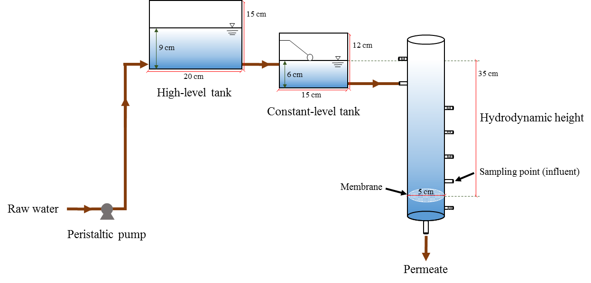
Figure S1. Schematic diagram of membrane filtration system.

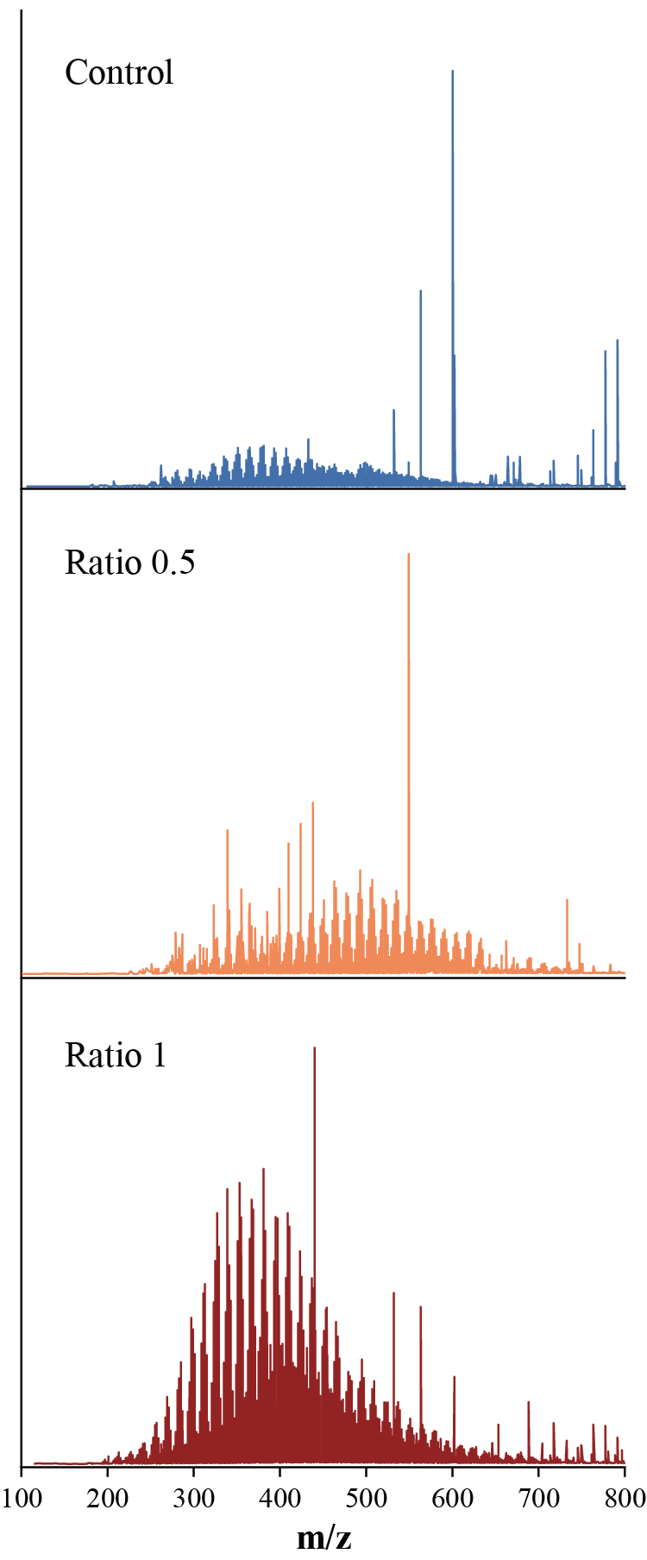
Figure S2. FT-ICR mass spectra of influent DOM in membrane filtration systems.

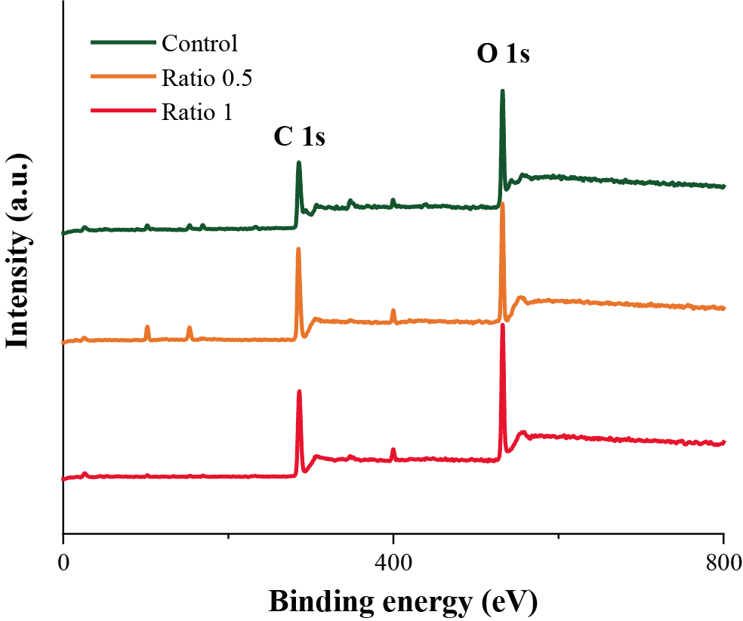
Figure S3. XPS full spectra of biofilms.

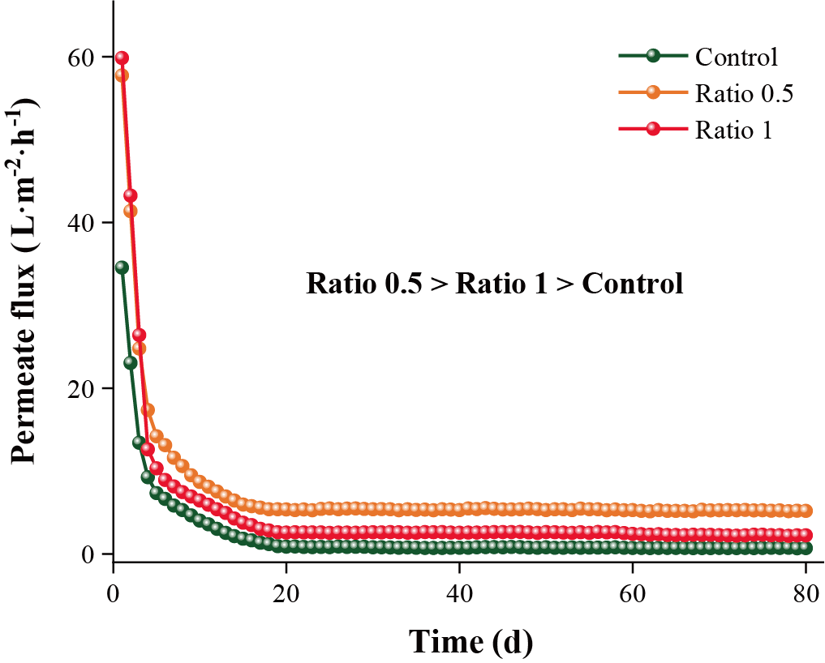
Figure S4. Variation in permeate flux of membrane filtration systems in the course of each experiment.

Table S1. Principal water quality parameters of surface water (mean ± standard deviation).
Parameter | Value
pH | 7.79±0.02
EC (μS·cm⁻¹) | 288.4±0.6
DOC (mg·L⁻¹) | 4.01±0.23
UV₂₅₄ (cm⁻¹) | 0.044±0.002
Turbidity (NTU) | 1.82±0.03
Ca (mg·L⁻¹) | 15.365±0.143
Mg (mg·L⁻¹) | 3.572±0.210
Fe (mg·L⁻¹) | 0.258±0.001
Mn (μg·L⁻¹) | 2.79±0.15

Table S2. Area percent of XPS spectral peaks.
Position (eV) | Area percent (%)
Position (eV) | Control | Ratio 0.5 | Ratio 1
284.8 | 43.0 | 64.7 | 29.6
286.6/286.4 | 41.3 | 27.8 | 49.9
288.1/288.3/288.4 | 15.7 | 7.5 | 20.5
532.1/532.2 | 50.5 | 55.4 | 26.6
532.9/533.0 | 49.5 | 44.6 | 73.4

Table S3. Biofilm surface texture of roughness dataset.
Parameter | Sample value |  |  | Unit | Description
Parameter | Control | Ratio 0.5 | Ratio 1 | Unit | Description
Sa | 1.760 | 1.188 | 0.670 | μm | Average height of selected area
Sq | 2.516 | 1.540 | 0.873 | μm | Root-Mean-Square height of selected area
Sp | 32.348 | 17.143 | 4.525 | μm | Maximum peak height of selected area
Sv | 12.794 | 9.214 | 7.423 | μm | Maximum valley depth of selected area
Sz | 45.142 | 26.357 | 11.949 | μm | Maximum height of selected area
S10z | 40.285 | 23.146 | 9.135 | μm | Ten point height of selected area
Ssk | 1.987 | 0.541 | 0.051 | / | Skewness of selected area
Sku | 16.078 | 6.449 | 4.843 | / | Kurtosis of selected area
Sdq | 0.193 | 0.116 | 0.102 | / | Root mean square gradient
Sdr | 1.648 | 0.650 | 0.519 | % | Developed interfacial area ratio
FLTt | 45.142 | 26.357 | 11.949 | μm | Flatness using least squares reference plane

