ADAMTS13 glycans and conformation-dependent activity

Nowak AA¹, O’Brien HER¹, Henne P¹, Doerr A¹, Vanhoorelbeke K², Laffan MA¹ and McKinnon TAJ^{1‡}

¹Department of Haematology, Faculty of Medicine, Hammersmith Hospital Campus, Imperial College London, UK
² Laboratory for Thrombosis Research, Katholic University Leuven, Leuven, Belgium

‡ to whom correspondence should be addressed
Centre for Haematology, Imperial College London, 5th Floor, Commonwealth Building,
Hammersmith Hospital Campus, Du Cane Road, London W12 0NN, UK
Email: t.mckinnon03@imperial.ac.uk
Tel ++44 (0) 20 8383 2299
Fax ++44 (0) 20 8383 2296

Running title: Glycosylation of ADAMTS13
Key words: ADAMTS13, Von Willebrand Factor, Glycosylation

Word count text: 4000
Word count abstract: 247
Figures: 7 (plus 2 supplementary)
References: 39

Essentials
● The impact of N-linked glycosylation on ADAMTS13 function has not been fully explored
● The activity of glycan modified ADAMTS13 was investigated under static and shear stress conditions
● Terminal sialic acid on the metalloprotease domain glycans are important for ADAMTS13 activity
● The CUB domain glycans modulate ADAMTS13 activity

Key words: ADAMTS13, Von Willebrand Factor, Glycosylation

Summary
Background: ADAMTS13 activity can be regulated by its conformation where interactions between the C-terminal CUB domains and the Spacer domain maintain ADAMTS13 in a closed conformation. ADAMTS13 contains 10 N-linked glycans, with four sites present in the TSP2 through CUB domains that may contribute to its conformation.
Objectives/Methods: We hypothesized that glycosylation contributes to ADAMTS13 conformation and function. The proteolytic activity of glycan modified ADAMTS13 was assessed under static and shear stress conditions.
Results: Enzymatic removal of terminal silaic acid or entire N-linked glycan chains decreased activity against FRETS-73 at pH7.4 and against full length VWF under shear stress. Using truncated ADAMTS13 we demonstrated this was due to loss of sialic acid from the glycans in the Metalloprotease domain and an effect of N-linked glycosylation in the TSP2 through CUB domains. Mutation of the N-linked glycan sites in the MDTCS domains reduced or abolished protein expression. However N707Q, N828Q, N1235Q and N1354Q (TSP2, TSP4, CUB1, and CUB2 domains respectively) expressed normally. Interestingly, N707Q and N828Q demonstrated reduced activity towards FRETS-73 but normal activity under flow conditions. In contrast, N1235Q and N1354Q had enhanced activity towards FRETS-73 and VWF under shear stress. Immunoprecipitation experiments confirmed that loss of N-linked glycans in the CUB domains significantly reduced the interaction with the Spacer domain and enhanced binding to the 6A6 anti-ADAMTS13 antibody that recognises a cryptic epitope in the Metalloprotease domain.

Conclusions: Together these data demonstrate that the N-linked glycans of ADAMTS13 play a crucial role in regulating ADAMTS13 activity.

Background
ADAMTS13 (a Disintegrin and Metalloprotease with Thrombospondin type I repeats) is responsible for the proteolysis of Von Willebrand Factor by cleavage at a specific site within the VWF A2 domain.[1, 2] This reduces the multimeric size of VWF and regulates its haemostatic function within the circulation. Deficiency of ADAMTS13 caused by genetic defect or an autoantibody results in the rare but potentially fatal condition thrombotic thrombocytopenic purpura, characterised by the presence of ultra-large VWF multimers and wide spread microvascular occlusions.[3] Cleavage of VWF by ADAMTS13 is a multi-step process in which the C-terminal domains of ADAMTS13 distal to the spacer domain first dock the ADAMTS13 molecule to the C-terminal D4-CK domains of VWF.[4, 5] Subsequently, unfolding of VWF presents binding sites in the VWF A2 domain for ADAMTS13 and ultimately allows cleavage of the Y1605-M1606 scissile bond in the A2 domain.[6-10] Thus the cleavage of VWF by ADAMTS13 requires the substrate to undergo a conformational change to allow access to the cleavage site. In vivo this may result from VWF binding to collagen or platelets, exposure of the VWF molecule to shear stress or some combination of these factors.[11-13] In vitro the unfolding can be mimicked by the use of urea or reproduced in various forms of shear-based assays.[1, 14, 15] Recent studies have shown that ADAMTS13 can undergo complementary conformational changes.[16, 17] Muia et al showed that binding ADAMTS13 to isolated D4-CK domains of VWF enhanced its activity towards the FRETS-73 substrate[16] and South et al demonstrated direct interaction of the CUB domains with the Spacer domain.[17] Furthermore, using electron microscopy, both studies found that ADAMTS13 exists in two conformations; a closed conformation and an open conformation, in which the ADAMTS13 molecule is more active and this is promoted by binding of the D4-CK domains of VWF to the ADAMTS13 CUB domains.
ADAMTS13 is a modular molecule comprising a signal peptide, a propeptide, a metalloprotease domain, a disintegrin domain, a thrombospondin type 1 repeat (TSP), a cysteine-rich region, a spacer domain, 7 additional TSRs (nos. 2-8), and 2 CUB (complement component Clr/Cls, Uegf, bone morphogenetic protein 1) domains.[18] Like its VWF substrate, a significant portion of the final molecular weight of ADAMTS13 is comprised of glycan residues with ten predicted N-linked glycosylation sites and potential O-fucosylation and C-mannosylation sites.[19] Mass spectroscopic analysis of plasma ADAMTS13 has recently confirmed that nine of the ten possible N-linked glycosylation sites are occupied and identified six O-fucosylation and two C-mannosylation sites and also six O-linked glycosylation sites.[19] [20] The roles of the sugar moiety of ADAMTS13 are not fully defined, although it has been previously shown that O-fucosylation is required for proper secretion of ADAMTS13[21] and Zhou et al showed that N-linked glycosylation at N146 in the MP domain, N552 in the spacer domain and N828 in the TSP-8 domain are also required for effective secretion.[22] Furthermore, the same study demonstrated that ADAMTS13 presenting only high mannose glycans, rather than fully processed glycan chains, had reduced activity against full length VWF under static conditions.[22] However, this study did not provide a mechanism for this effect, did not examine cleavage of VWF under shear stress and importantly did not explore the role of glycans in the CUB domains. Because it is now clear that the CUB domains play a critical role in regulation of ADAMTS13 function and that this function is also dependent on glycan structure, we have performed adetailed investigation into the role of N-linked glycosylation in mediating ADAMTS13 conformation and function.

Materials and Methods
Protein expression and purification
Recombinant full length ADAMTS13, the MDTCS, MD, CUB1/2 truncations, plasma derived VWF and recombinant VWF-D4CK were all prepared as previously described.[10, 17, 23, 24] ADAMTS13 variants lacking glycosylation at specific sites were created using the Quick change site directed mutagenesis kit, changing asparagine residues to glutamine. These were expressed in HEK293T cells and concentrated using Amicon Ultra centrifuge concentrators (molecular weight cut-off of 100kDa). The concentration of ADAMTS13 in the conditioned media was determined using an in-house ADAMTS13 ELISA.[25] An MDTCS construct with a C-terminal FLAG tag was generated using full length ADAMTS13 as template. Primers were designed using the NEBuilder® assembly tool and the NEBuilder® HiFi DNA assembly kit used to amplify the sequence for MDTCS and clone into the p3XFLAG-CMV-14 mammalian expression vector. MDTCS-FLAG was expressed in HEK293T cells and purified using magnetic anti-M2-FLAG beads (Sigma UK).
Glycan modification of ADAMTS13
rADAMTS13, final concentration 300nM was incubated overnight at 37°C with either 10U PNGAse-F or 1U α2-3,6,8,9 neuraminidase. ADAMTS13 was then centrifuged in Amicon Ultra centrifuge concentrators with a molecular weight cut-off of 100kDa to remove PNGase-F or neuraminidase and dialysed against 20mM Tris, 10mM CaCl₂ pH 7.4. A control sample was processed in the same way and all proteins were quantified by ELISA before use. The extent of glycan modification was assessed by lectin ELISA as previously described, using Concanavalin A (ConA) to detect N-linked glycan chains and elderberry bark lectin (EBL) to detect terminal sialic acid residues.[26, 27]
Cleavage assays
The proteolytic activity of ADAMTS13 and its variants was assessed using the FRETS-73 assay, static cleavage assays using urea and a shear based assays using a vortex mixer, all as previously described.[15, 28]. Cleavage of VWF by ADAMTS13 was also assessed using an in vitro flow chamber model as previously described.[15] In brief, Ibidi µ-slideVI^{0.1} flow chamber slides were coated overnight with 100µg/ml human type III collagen (Southern Biosciences) and then blocked with 2% BSA. Plasma free blood (PFB) was prepared as previously described and platelets rendered florescent by the addition of 1µM DiOC6.[29] PFB was supplemented with 7µg/ml VWF and recombinant ADAMTS13 or it variants and perfused over the collagen surface for 5mins at 1500s⁻¹ and platelet capture recorded in real-time. Platelet surface coverage was determined using ImageJ software as previously described.

Analysis of the MDTCS-CUB interaction by co-immunoprecipitation
Recombinant CUB1&2 domain containing a C-terminal myc tag (final concentration 100nM) was incubated with 10U Remove-iT® PNGase-F which is linked to a chitin binding domain (NEB, UK) overnight at 37°C. Remove-iT® PNGase-F was removed by incubation with magnetic chitin beads. Control samples not digested with PNGase-F were treated in the same way. Following PNGase-F digestion and removal, protein was re-quantified using by BCA assay. 50nM Control or PNGase-F treated CUB1&2 was incubated with 25nM MDTCS-FLAG in 20mM Tris, 50mM NaCl, pH 7.4 for 60mins at 37°C with up and over mixing. During the incubation 30µl magnetic anti-M2-FLAG beads were blocked with 5% powdered milk diluted in PBS then used to immunoprecipitate the MDTCS – CUB1&2 complexes for 30mins at room temperature. The beads were then washed 3 times with Tris buffered saline and proteins were eluted with 2 x LDS loading buffer supplemented with 7% v/v β-mercaptoethanol and heating for 15mins at 70°C. Proteins were analysed by SDS-PAGE, followed by western blotting and probing with anti-myc-HRP antibodies to detect the myc tagged CUB1&2 domain. Binding of ADAMTS13 to the 6A6 antibody was performed as previously described.[30] Statistical analysis was performed using GraphPad Prism, Students t-test.

Results
N-linked glycosylation and sialylation of ADAMTS13 determines activity towards VWF in an assay-dependent manner
To investigate the effects of ADAMTS13 N-linked glycans on its ability to proteolyse VWF, ADAMTS13 devoid of N-linked glycans was prepared by digestion with PNGaseF (PNG-AD13) and ADAMTS13 lacking terminal sialic acid residues was prepared by digestion with a broad spectrum neuraminidase (Neu-AD13). Lectin binding analysis with Con A and EBL demonstrated complete removal of entire N-linked glycan chains and terminal sialic residues respectively (supplementary data, figure 1). Initially cleavage assays were performed using the FRETS-VWF73 substrate. This assay is normally carried out a pH6.0, however it has recently been shown that ADAMTS13 proteolysis of this substrate is affected by pH due to conformational activation.[16] When used to cleave the VWF FRETS-73 substrate at pH6.0 both Neu- and PNG-AD13 digested the substrate to a similar extent to wtAD13 (Figure 1A). Interestingly, when the reaction was performed at physiological pH 7.4, Neu-AD13 demonstrated significantly reduced activity compared to wtAD13 and the activity of PNG-AD13 was significantly lower still (Figure 1B&C). To further determine the activity of glycan modified ADAMTS13, VWF cleavage assays were performed against full length VWF (FL-VWF) under static conditions in the presence of urea and using a high speed vortex mixer to generate mechanical shear stress. In the presence of urea there was no significant difference in the ability of Neu- or PNG-AD13 to cleave VWF multimers (Figure 1D). Interestingly, under mechanical shear stress conditions both Neu- and PNG-AD13 demonstrated reduced activity towards VWF (Figure 1E). However, unlike the cleavage of VWF-FRETS-73 at pH 7.4, no difference was seen in the loss of activity between Neu-AD13 and PNG-AD13.

N-linked glycosylation and sialylation of ADAMTS13 is required for full activity under shear stress
To determine ADAMTS13 function in a more physiological setting, we used a flow assay model to quantify the ability of glycan modified ADAMTS13 to reduce VWF mediated platelet capture to a collagen surface under high shear stress. In-keeping with our previously published data, when plasma free blood supplemented with VWF and wtAD13 was perfused over a collagen surface the extent of platelet capture was reduced compared to plasma free blood devoid of ADAMTS13 (Figure 2A).[15] Significantly, Neu- and PNG-AD13 were equally less effective than wtAD13 in reducing VWF mediating platelet capture, suggesting that sialic acid, presented on the N-linked glycans of ADAMTS13 is critical for proper enzyme function (Figure 2A and B).

Sialylation of N-linked glycans in the Metalloprotease domain are required for proper ADAMTS13 function
To determine whether the N-linked glycans and terminal sialic residues of ADAMTS13 modulate its function by altering its enzymatic activity or its substrate binding, we expressed ADAMTS13 MDTCS and MD constructs and treated these similarly with neuraminidase or PNGase-F and measured their activity against VWF-FRETS-73. Both Neu- and PNG-MDTCS had reduced activity towards FRETS-73 at pH 7.4 compared to normally glycosylated controls, this time with no difference between Neu- and PNG-AD13 (Figure 3B). Similarly, Neu- and PNG-MD had equally reduced activity towards FRETS-73 (Figure 3B). To further confirm this we examined cleavage of VWF under shear stress and similar to the data observed with full length ADAMTS13, Neu- and PNG-MDTCS were equally less effective at reducing VWF-mediated platelet capture to collagen under flow conditions (Figure 3C). The MD construct was unable to digest VWF in the flow assay, most likely due to its low affinity for VWF (data not shown). Since the MD construct contains only two N-linked glycosylation sites (N142 and N146 in the MP domain) and removal of terminal sialic acid reduces activity to the same extent as removal of the entire glycan chains, we conclude that sialylation of either or both of these glycans is required for proper ADAMTS13 proteolytic activity.

N-linked glycosylation of ADAMTS13 modulates the conformation of ADAMTS13
The observation that PNG-AD13 had a greater reduction in activity towards VWF-FRETS-73 than Neu-AD13 and that this difference was diminished when using C-truncated ADAMTS13 variants suggested that total de-glycosylation of full length ADAMTS13 had a further effect on ADAMTS13 function in addition to the loss of sialic acid from the metalloprotease domain glycans. To investigate this further we performed static plate binding assays to determine the binding of glycan modified ADAMTS13 to the VWF A2 domain. Both Neu-AD13 and PNG-AD13 bound to the A2 with similar affinity to Con-AD13 suggesting that firstly the reduced activity of Neu-ADAMTS13 is not due to altered substrate binding and secondly loss of the N-linked glycan chains does not alter the ability of ADAMTS13 to bind to VWF, at least under static conditions (Figure 4A).
It has previously been shown that incubation of FL-ADAMTS13 with the D4 domain of VWF induces a conformational change in ADAMTS13 that enhances its activity towards FRETS-73 by “activating” the ADAMTS13 molecule.[16] We therefore pre-incubated wild type or PNG-AD13 with VWF-D4CK and determined the effect on FRETS-73 cleavage. Consistent with previously published data pre-incubation with VWF-D4CK enhanced the activity of ADAMTS13 towards FRETS-73 (Figure 4B). Interestingly, VWF-D4CK also enhanced the activity of PNG-AD13 but only to the same level as ADAMTS13 that had not been pre-activated. The addition of increasing concentrations of VWF-D4CK could not further enhance the activity of PNG-ADAMTS13, presumably being limited by the loss of sialic acid from the MD (Figure 4B). To confirm this we activated Neu-AD13 with VWF-D4CK and assessed cleavage against VWF FRETS-73. As expected, this enhanced the activity of Neu-AD13, but not to the same extent as wtAD13 activated with VWF-D4CK (Figure 4B). These data suggests that the C-terminal domains of VWF are able to properly interact with the C-terminal domains of both Neu- and PNG-AD13 to evoke a conformational change and enhance activity.

Glycosylation of the C-terminal domains of ADAMTS13 determine activity
Since the reduced activity of PNG-AD13 towards FRETS-73 could be enhanced by the addition of VWF-D4CK we hypothesized that the removal of the C-terminal glycans of ADAMTS13 rendered the molecule less active, potentially by altering interactions between the N and C-terminal parts of the molecule. Because PNGase-F treatment non-selectively removes all glycans, we prepared ADAMTS13 mutants lacking glycosylation at each of the 10 N-linked glycan sites. Mutation of the glycosylation sites in the metalloprotease through to the spacer domain resulted in either totally abolished or significantly reduced secretion of ADAMTS13 indicating that these sites are essential for proper protein folding and processing within the cell (supplementary figure 2). Mutation of the glycosylation sites in the TSP2 (N707Q), TSP5 (N828Q) and the CUB1 (N1235Q) and CUB2 (N1354Q) domains did not significantly affect secretion. Interestingly, both N707Q and N828Q (TSP2 and TSP5) mutants had reduced activity towards VWF-FRETS-73 with N828Q demonstrating the greater reduction in activity (Figure 5A & B). However both mutants had normal activity under shear stress conditions (Figure 5C) and were activated by VWF-D4CK to the same extent as wtAD13 (Figure 5D). Intriguingly, and in contrast to the N707Q and N828Q variants, mutation of the N-linked glycans in the CUB domains (N1235Q and N1354Q) demonstrated approximately 2-fold enhanced activity towards VWF-FRETS-73 (Figure 5A & B). Significantly, both ADAMTS13 N1235Q and N1354Q mutants were also more effective at cleaving VWF under flow conditions highlighting their gain-of-function like activity (Figure 6A and B). Since the overall effect of PNGase treatment is to reduce cleavage it appears the effect of the TSP glycans is dominant; at least in the FRETS-73 assay.

N-linked glycosylation of the CUB domains is required for the Spacer-CUB interaction
Since mutation of the glycosylation sites in the CUB domains enhanced activity of ADAMTS13 we hypothesized that these molecules are already active possibly due to altered interactions between the CUB and Spacer domains. Consistent with this, when cleavage of FRETS-73 was performed at pH 6.0 the enhanced effect of the N1235Q and N1354Q mutations was lost (Figure 7A). Furthermore, at pH7.4 the addition of VWF-D4CK could not further enhance the activity of N1235Q and N1354Q (Figure 7B), suggesting these molecules had already adopted the open “active” conformation. Moreover, both mutants demonstrated enhanced binding to the anti-ADAMTS13 6A6 antibody that preferentially binds to “active” ADAMTS13, confirming that they are in a more open, active conformation (Figure 7C). Finally, immunoprecipitation experiments confirmed that isolated CUB domains devoid of N-linked glycosylation had reduced binding to the ADAMTS13 spacer domain, confirming that one or both of the N-linked glycan sites in the CUB domain are essential for the interaction between the CUB and Spacer domains and hence modulate the inactive and active conformations of ADAMTS13 (Figure 7D).

Discussion
Although a previous study has addressed the functional significance of the ADAMTS13 N-linked glycans, the activity towards VWF was not investigated under shear stress conditions and no data was provided on the role of the glycans in the CUB domain which have subsequently been shown to regulate ADAMTS13 activity. In the present study we have re-evaluated the effect of N-linked glycosylation on ADAMTS13 expression and function.
Removal of terminal sialic acid residues or whole N-linked glycan chains resulted in reduced ADAMTS13 function, when activity was assessed under physiological pH (in the case of the FRETS assay) and under shear stress conditions. In the case of the FRETS73 assay Muia et al have recently demonstrated that pH alters the cleavage of this substrate by full length ADAMTS13, reflecting its conformation. Interestingly, when used to digest FRETS-73 at pH 7.4 PNG-AD13 had reduced activity compared to Neu-AD13, however this was not observed under shear stress, with both Neu- and PNG-AD13 being equally less active, suggesting that loss of sialic acid was responsible for the reduction in activity. The pH sensitivity is consistent with studies showing that loss of sialic acid can significantly alter the protein pI.[31]
Some of these observations are consistent with Zhou et al in which PNGaseF treated ADAMTS13 demonstrated normal activity towards FL-VWF in the presence of guanidine chloride.[22] Similarly we did not observe any effect of glycan removal on ADAMTS13 activity when assays were performed using urea. It is likely that denaturants alter the conformation of ADAMTS13 as well as VWF. Interestingly, Zhou et al did observe decreased activity with ADAMTS13 lacking complex glycans (and therefore sialic acid) under static conditions. In our assays sialic acid removal did not affect activity at pH 6.0 or in the presence of urea. It is not fully understood why this is the case but we have previously observed the ability of high urea concentrations to obscure the effects of VWF glycosylation on susceptibility to ADAMTS13 cleavage,[32] and mutation of the VWF O-linked glycans resulted in different effects on cleavage in static and flow based assays.[15]
Nonetheless, assays performed under shear stress provide a more physiological measure of ADAMTS13 activity and it is clear that appropriate reaction conditions are essential for assessing ADAMTS13 function.
To investigate the roles of specific glycan modifications on ADAMTS13 function we used truncated ADAMTS13 molecules; MDTCS and MD. Against FRETS-73 both Neu- and PNG-MDTCS and MD were equally less effective than con-AD13 in digesting the substrate. Since there are two N-linked glycans in the Metalloprotease domain we conclude that sialylation of one or both of these glycans is essential for proper ADAMTS13 function. This is in-keeping with Zhou at al where an ADAMTS13 molecule comprised of the Metalloprotease through TSP-1 domain was less active when devoid of complex glycans (i.e. lacking sialic acid). Zhou et al also demonstrated that mutation of N146 but not N142 reduced ADAMTS13 activity, however we were unable to observe any secretion of N146Q, and N142Q demonstrated significantly reduced secretion indicating that both these glycans are crucial for proper folding within the cell. We were therefore unable to analyse the effect of these individual mutations on ADAMTS13 function.
It is unclear how terminal sialic acid residues modulate function of the Metalloprotease domain. Both N-linked glycosylation sites in the MP domain, (N142 and N146) are located in close spatial proximity to the high affinity calcium binding site mapped to E184, D187 and E212. Moreover, both glycans have been shown to present sialic acid residues.[20] Sialic acid has been previously shown to have calcium binding properties and may therefore facilitate efficient binding of calcium to ADAMTS13.[33-35]
These observation have potential clinical implications. It has been shown that release of bacterial neuraminidase in sepsis can result in significant desialylation of VWF and platelets resulting in increased clearance.[36] If ADAMTS13 is similarly desialylated then we would predict a reduction in ADAMTS13 activity. On the other hand protein sialylation is generally increased in liver disease which conceivably may also alter ADAMTS13 function.[37] In parallel, an effect on sialylation is seen in other diseases such primary pulmonary hypertension (PPH) in which VWF sialic acid levels are decreased;[38] a modification known to VWF alter susceptibility to ADAMTS13 cleavage.[26]
In the FRETS assay (at pH 7.4) PNGaseF treatment was able to reduce cleavage further than desialylation, but only using full length ADAMTS13, suggesting that the effect was linked to changes in conformation related to the closed and open conformations of ADAMTS13. We hypothesised that PNG-AD13 molecules more readily adopt the closed conformation which reduces their activity in the FRETS-73 assay. However this can be overcome by increasing concentrations of VWF-D4-CK.
Similarly, when used in shear based assays against FL-VWF the unravelling of VWF exposes binding sites in the A2 binding site which compete with the CUB for the spacer domain and again activate the ADAMTS13 molecule. As expected, the activity of Neu-AD13 could also be enhanced by the addition of VWF-D4CK but not to the level of con-AD13 due to the effect of lost sialic acid from the Metalloprotease glycans. These data confirm that in addition to loss of sialic acid, removal of N-linked glycan chains from ADAMTS13 favours its inactive closed conformation, but this does not prevent physiological activation of the molecule by the D4-CK region of VWF.
To identify the specific glycans responsible, we expressed ADAMTS13 glycosylation variants. Interestingly, the majority of the variants located in the N-terminal domains of ADAMTS13 had either abolished or reduced secretion which is in contrast to Zhou et al who found only two glycan mutants, N146Q and N828Q, had reduced secretion. The reason for this disparity is not clear, however Zhou et al analysed expression following concentration of the expression media and western blotting, whereas we performed an ADAMTS13 ELISA on non-concentrated samples.[22]
The C-terminal domains of ADAMTS13 contain 4 N-linked glycan sites N707 in the TSP1-2 domain, N828 in the TSP1-4 domain and N1235 and N1354 in the CUB 1 and 2 domains respectively. Interestingly both N707Q and N828Q mutations caused decreased activity towards FRETS-73, but had full activity in the in vitro flow assay. In keeping with our previous argument the FRETS-73 results suggest that loss of these glycans favours the closed conformation of ADAMTS13, but this is overcome upon activation with the VWF-D4 domain. A recent study has demonstrated that ADAMTS13 has three linker regions with two of these located between (1) TSP1-2 and TSP1-3, (2) TSP1-4 and TSP1-5. It was shown that these linker regions provide flexibility to the ADAMTS13 molecule allowing it to adopt its closed conformation and their deletion resulted in ADAMTS13 molecules favouring the more open active conformation.[30] Based on the primary amino acid sequence N707 and N828 lie close to these linker regions and their bulky configuration may therefore provide a degree of rigidity to the surrounding region. Loss of glycosylation renders the molecule more flexible and able to adopt its closed (inactive) conformation.
Conversely, mutation of the N-linked glycan sites in the CUB domains enhanced activity towards FRETS-73 and this was not increased by the addition of VWF-D4CK. Significantly, their increased activity was retained under shear stress. The FRETS-73 data imply that removal of glycans from the CUB domains allows ADAMTS13 to assume its active conformation more readily. Previously gain-of-function (GoF) mutations in the spacer domain (R568K/F592Y/R660K/Y661F/Y665F) have been shown to abolish binding to CUB domains.[17, 39] In an analogous fashion, immunoprecipitation experiments demonstrated that CUB domains lacking N-linked glycans had significantly reduced binding to the Spacer domain resulting in increased activity. Like the R568K/F592Y/R660K/Y661F/Y665F GoF variant, the enhanced activity may be due to the loss of CUB – Spacer binding or the result of increased interaction with binding epitopes within the A2 domain of VWF. Our data reveals an important and previously unrecognised role for N-linked glycosylation in promoting the CUB-Spacer interaction. The effect was confirmed by demonstrating that the N1235Q and N1354Q mutants also had increased binding to the previously described 6A6 anti-ADAMTS13 antibody that binds a cryptic epitope in the Metalloprotease domain. Further work is required to understand how the CUB glycans facilitate the interaction with the Spacer domain. Hypothetically they may do this by either promoting the correct configuration of the CUB domains or by directly mediating the interaction.
In conclusion this study demonstrates the importance of N-linked glycosylation for proper ADAMTS13 function under static and importantly shear stress conditions. Sialylation of the Metalloprotease domain is required for proper proteolytic function while glycosylation of the TSP 2 and 4 domains and CUB domains are critical modulators of ADAMTS13 conformation, with glycosylation of the CUB domains required for the interaction with the spacer domain.

Acknowledgements
The authors would like to thank Aline Vandenbulcke for her technical assistance and Dr Joshua Muia for his help preparing this manuscript. This work is supported by grants from the British Heart Foundation.

Author contribution
AAN and HERO performed experiments and wrote the manuscript, performed experiments and analysed data. PH, AD and KV performed experiments and read the manuscript. MAL designed the research, analysed data and wrote the manuscript. TAJM designed the research, performed experiments, analysed data and wrote the manuscript.

Disclosure of Conflicts of Interest
The authors declare no competing financial interest.

References
1. Furlan M, Robles R, Lammle B. Partial purification and characterization of a protease from human plasma cleaving von Willebrand factor to fragments produced by in vivo proteolysis. Blood. 1996;87:4223-34.
2. Tsai HM. Physiologic cleavage of von Willebrand factor by a plasma protease is dependent on its conformation and requires calcium ion. Blood. 1996;87:4235-44.
3. Moake JL, Rudy CK, Troll JH, Weinstein MJ, Colannino NM, Azocar J, Seder RH, Hong SL, Deykin D. Unusually large plasma factor VIII:von Willebrand factor multimers in chronic relapsing thrombotic thrombocytopenic purpura. The New England journal of medicine. 1982;307:1432-5.
4. Zanardelli S, Chion AC, Groot E, Lenting PJ, McKinnon TA, Laffan MA, Tseng M, Lane DA. A novel binding site for ADAMTS13 constitutively exposed on the surface of globular VWF. Blood. 2009.
5. Feys HB, Anderson PJ, Vanhoorelbeke K, Majerus EM, Sadler JE. Multi-step binding of ADAMTS-13 to von Willebrand factor. J Thromb Haemost. 2009;7:2088-95.
6. de Groot R, Bardhan A, Ramroop N, Lane DA, Crawley JT. Essential role of the disintegrin-like domain in ADAMTS13 function. Blood. 2009;113:5609-16.
7. de Groot R, Lane DA, Crawley JT. The ADAMTS13 metalloprotease domain: roles of subsites in enzyme activity and specificity. Blood. 2010;116:3064-72.
8. Pos W, Crawley JT, Fijnheer R, Voorberg J, Lane DA, Luken BM. An autoantibody epitope comprising residues R660, Y661, and Y665 in the ADAMTS13 spacer domain identifies a binding site for the A2 domain of VWF. Blood. 2010;115:1640-9.
9. Zhou M, Dong X, Baldauf C, Chen H, Zhou Y, Springer TA, Luo X, Zhong C, Grater F, Ding J. A novel calcium-binding site of von Willebrand factor A2 domain regulates its cleavage by ADAMTS13. Blood. 2011;117:4623-31.
10. Zanardelli S, Crawley JT, Chion CK, Lam JK, Preston RJ, Lane DA. ADAMTS13 substrate recognition of von Willebrand factor A2 domain. J Biol Chem. 2006;281:1555-63.
11. Shim K, Anderson PJ, Tuley EA, Wiswall E, Sadler JE. Platelet-VWF complexes are preferred substrates of ADAMTS13 under fluid shear stress. Blood. 2008;111:651-7.
12. Lippok S, Radtke M, Obser T, Kleemeier L, Schneppenheim R, Budde U, Netz RR, Radler JO. Shear-Induced Unfolding and Enzymatic Cleavage of Full-Length VWF Multimers. Biophys J. 2016;110:545-54.
13. Singh I, Themistou E, Porcar L, Neelamegham S. Fluid shear induces conformation change in human blood protein von Willebrand factor in solution. Biophys J. 2009;96:2313-20.
14. Zhang P, Pan W, Rux AH, Sachais BS, Zheng XL. The cooperative activity between the carboxyl-terminal TSP1 repeats and the CUB domains of ADAMTS13 is crucial for recognition of von Willebrand factor under flow. Blood. 2007;110:1887-94.
15. Nowak AA, McKinnon TA, Hughes JM, Chion AC, Laffan MA. The O-linked glycans of human von Willebrand factor modulate its interaction with ADAMTS-13. J Thromb Haemost. 2014;12:54-61.
16. Muia J, Zhu J, Gupta G, Haberichter SL, Friedman KD, Feys HB, Deforche L, Vanhoorelbeke K, Westfield LA, Roth R, Tolia NH, Heuser JE, Sadler JE. Allosteric activation of ADAMTS13 by von Willebrand factor. Proc Natl Acad Sci U S A. 2014;111:18584-9.
17. South K, Luken BM, Crawley JT, Phillips R, Thomas M, Collins RF, Deforche L, Vanhoorelbeke K, Lane DA. Conformational activation of ADAMTS13. Proc Natl Acad Sci U S A. 2014;111:18578-83.
18. Zheng X, Chung D, Takayama TK, Majerus EM, Sadler JE, Fujikawa K. Structure of von Willebrand factor-cleaving protease (ADAMTS13), a metalloprotease involved in thrombotic thrombocytopenic purpura. J Biol Chem. 2001;276:41059-63.
19. Sorvillo N, Kaijen PH, Matsumoto M, Fujimura Y, van der Zwaan C, Verbij FC, Pos W, Fijnheer R, Voorberg J, Meijer AB. Identification of N-linked glycosylation and putative O-fucosylation, C-mannosylation sites in plasma derived ADAMTS13. J Thromb Haemost. 2014;12:670-9.
20. Verbij FC, Stokhuijzen E, Kaijen PH, van Alphen F, Meijer AB, Voorberg J. Identification of glycans on plasma-derived ADAMTS13. Blood. 2016.
21. Ricketts LM, Dlugosz M, Luther KB, Haltiwanger RS, Majerus EM. O-fucosylation is required for ADAMTS13 secretion. J Biol Chem. 2007;282:17014-23.
22. Zhou W, Tsai HM. N-Glycans of ADAMTS13 modulate its secretion and von Willebrand factor cleaving activity. Blood. 2009;113:929-35.
23. Crawley JT, Lam JK, Rance JB, Mollica LR, O'Donnell JS, Lane DA. Proteolytic inactivation of ADAMTS13 by thrombin and plasmin. Blood. 2005;105:1085-93.
24. McKinnon TA, Goode EC, Birdsey GM, Nowak AA, Chan AC, Lane DA, Laffan MA. Specific N-linked glycosylation sites modulate synthesis and secretion of von Willebrand factor. Blood. 2010;116:640-8.
25. Chion CK, Doggen CJ, Crawley JT, Lane DA, Rosendaal FR. ADAMTS13 and von Willebrand factor and the risk of myocardial infarction in men. Blood. 2007;109:1998-2000.
26. McGrath RT, McKinnon TA, Byrne B, O'Kennedy R, Terraube V, McRae E, Preston RJ, Laffan MA, O'Donnell JS. Expression of terminal alpha2-6-linked sialic acid on von Willebrand factor specifically enhances proteolysis by ADAMTS13. Blood. 2010;115:2666-73.
27. McKinnon TA, Chion AC, Millington AJ, Lane DA, Laffan MA. N-linked glycosylation of VWF modulates its interaction with ADAMTS13. Blood. 2008;111:3042-9.
28. Han Y, Xiao J, Falls E, Zheng XL. A shear-based assay for assessing plasma ADAMTS13 activity and inhibitors in patients with thrombotic thrombocytopenic purpura. Transfusion. 2011;51:1580-91.
29. Nowak AA, Canis K, Riddell A, Laffan MA, McKinnon TA. O-linked glycosylation of von Willebrand factor modulates the interaction with platelet receptor glycoprotein Ib under static and shear stress conditions. Blood. 2012;120:214-22.
30. Deforche L, Roose E, Vandenbulcke A, Vandeputte N, Feys HB, Springer TA, Mi LZ, Muia J, Sadler JE, Soejima K, Rottensteiner H, Deckmyn H, De Meyer SF, Vanhoorelbeke K. Linker regions and flexibility around the metalloprotease domain account for conformational activation of ADAMTS-13. J Thromb Haemost. 2015;13:2063-75.
31. Barrabes S, Sarrats A, Fort E, De Llorens R, Rudd PM, Peracaula R. Effect of sialic acid content on glycoprotein pI analyzed by two-dimensional electrophoresis. Electrophoresis. 2010;31:2903-12.
32. O'Donnell JS, McKinnon TA, Crawley JT, Lane DA, Laffan MA. Bombay phenotype is associated with reduced plasma-VWF levels and an increased susceptibility to ADAMTS13 proteolysis. Blood. 2005;106:1988-91.
33. Ganss B, Hoffmann W. Calcium binding to sialic acids and its effect on the conformation of ependymins. European journal of biochemistry / FEBS. 1993;217:275-80.
34. Jaques LW, Brown EB, Barrett JM, Brey WSJWW, Jr. Sialic acid. A calcium-binding carbohydrate. J Biol Chem. 1977;252:4533-8.
35. Kouvonen I, Grasbeck R. The role of sialic acid in the binding of calcium ions to intrinsic factor and its intestinal receptor. Biochimica et biophysica acta. 1984;797:163-70.
36. Grewal PK, Uchiyama S, Ditto D, Varki N, Le DT, Nizet V, Marth JD. The Ashwell receptor mitigates the lethal coagulopathy of sepsis. Nat Med. 2008;14:648-55.
37. Yasukawa Z, Sato C, Kitajima K. Inflammation-dependent changes in alpha2,3-, alpha2,6-, and alpha2,8-sialic acid glycotopes on serum glycoproteins in mice. Glycobiology. 2005;15:827-37.
38. Collados MT, Sandoval J, Lopez S, Masso FA, Paez A, Borbolla JR, Montano LF. Characterization of von Willebrand factor in primary pulmonary hypertension. Heart and vessels. 1999;14:246-52.
39. Jin SY, Skipwith CG, Zheng XL. Amino acid residues Arg(659), Arg(660), and Tyr(661) in the spacer domain of ADAMTS13 are critical for cleavage of von Willebrand factor. Blood. 2010;115:2300-10.

Figure legends
Figure 1. Desialylation and N-linked glycan removal alter ADAMTS13 activity in an assay dependent manner. Unmodified control ADAMTS13 (Con-AD13) or ADAMTS13 lacking terminal sialic acid residues (Neu-AD13) or entire N-linked glycan chains (PNG-AD13), final concentration 0.5nM, was used to digest 4µM VWF-FRETS-73 substrate at pH 6.0 (A) or pH 7.4 (B). Data was normalised to control ADAMTS13. (Data shows the mean & SD, n=5) (C) End point analysis of FRETS-73 cleavage after 30mins. (*p=<0.05, **p=<0.005, ***p=<0.0005) (D) 5nM control and glycan modified ADAMTS13 was used to digest 10µg/ml full length VWF multimers in the presence of 1.5M urea. (E) Cleavage assays were repeated in the absence of urea using a high speed vortex mixer to generate mechanical shear stress. In both C and D reactions were stopped at given time points by the addition of 10mM EDTA and extent of proteolysis determined by collagen binding assay. (Data shows the mean & SD, n=3)
Figure 2. Activity of glycan modified ADAMTS13 under physiological shear stress conditions. (A) Plasma free blood consisting of washed red blood cells and DiOC6 labelled platelets was supplemented with 5µg/ml VWF and 10nM ADAMTS13 or its glycan modified variants and perfused through the channels of Ibidi VI^{0.1} slides coated with 100µg/ml human type III collagen. Platelet capture was recorded in real-time and platelet surface coverage plotted using ImageJ software. (Data shows the mean & SD, n=5). (B) Single representative images of platelet capture in the presence of control or glycan modified ADAMTS13 taken after 4mins of perfusion.
Figure 3. Terminal sialic acid expression on the N-linked glycan sites in the Metalloprotease domain is required for proper activity. (A) Cartoon of MDTCS and MD constructs used and relative position of N-linked glycan sites. (B) Full length ADAMTS13, MDTCS (final concentration 0.5nM and MD (final concentration 5nM) were desialylated or deglycosylated and used to digest 4µM VWF-FRETS-73 substrate at pH 7.4 Data was normalised to the maximal cleavage of the substrate by control ADAMTS13 after 40mins. (Data shows the mean & SD, n=3). (*p=<0.05). (C) Cleavage of VWF under shear stress in an in vitro flow based assay was repeated as in figure 2 using 5nM control or glycan modified ADAMTS13. (Data shows the mean & SD, n=4).
Figure 4. Glycan modification of ADAMTS13 does not alter substrate binding or activation of VWF. (A) Microtitre plates coated with 200nM purified VWF A2 domain were incubated with increasing concentrations of control or glycan modified ADAMTS13. Bound ADAMTS13 was detected with rabbit polyclonal anti-ADAMTS13 antibodies and mouse anti-rabbit IgG-HRP secondary antibody. (B) 4µM VWF-FRETS-73 was digested by glycan modified ADAMTS13 at pH 7.4 in the presence or absence of stated concentrations of purified VWF-D4CK. (Data shows the mean & SD, n=3).
Figure 5. Mutation of the C-terminal N-linked glycan sites of ADAMTS13 modulate proteolytic function. (A) Recombinant ADAMTS13 N-linked glycan mutants N707Q, N828Q, N1235Q and N1354Q (final concentration 0.5nM) were used to digest 4µM VWF-FRETS-73 substrate at pH 7.4. Data was normalised to control ADAMTS13. (Data shows the mean & SD, n=3. (B) End point analysis of FRETS-73 cleavage after 30mins. (*p=<0.05, **p=<0.005, ***p=<0.0005). (C) Cleavage of VWF in an in vitro flow assay was performed using wtAD13 and the N707Q and N828Q mutants, final concentration 5nM. (Data shows the mean & SD, n=3) (D) 4µM VWF-FRETS-73 was digested by wild type ADAMTS13 or the N707Q and N828Q variants at pH 7.4 in the presence or absence of 10nM VWF-D4CK. (Data shows the mean & SD, n=3)
Figure 6. Mutation of the CUB domain N-linked glycosylation sites enhances proteolytic function. (A) In vitro flow assays were performed using 5nM wtAD13 or N1235Q or N1354Q variants. Representative real-time screen shots of platelet capture were taken at 1 and 4mins. (B) Platelet surface coverage was plotted against time. (Data shows the mean & SD, n=5.)
Figure 7. Glycosylation of the CUB domains determine interaction with the spacer domain. (A) Recombinant ADAMTS13 N-linked glycan mutants N1235Q and N1354Q (final concentration 0.5nM) were used to digest 4µM VWF-FRETS-73 substrate at pH6.0. Data was normalised to control ADAMTS13 (Data shows the mean & SD, n=3). (B) The CUB domain glycan mutants N1235Q and N1354Q and wtAD13 were used to digest 4µM VWF-FRETS-73 at pH 7.4 in the absence or presence of 5nM VWF-D4CK (**p=<0.005). (C) The binding of wtAD13, N1235Q and N1354Q to the conformational specific 6A6 antibody that recognises a cryptic epitope in the metalloprotease domain was determined using a plate based ELISA (**p=<0.005). (D) MDTCS expressed with a C-terminal FLAG tag was incubated with control or PNGase-F treated recombinant CUB1-2 domain protein expressed with a C-terminal myc tag. Protein complexes were immunoprecipitated with magnetic anti-FLAG beads and run on 4-12% SDS-PAGE gels. Following western blotting CUB domain protein was detected with anti-myc-HRP antibodies.

Figure 1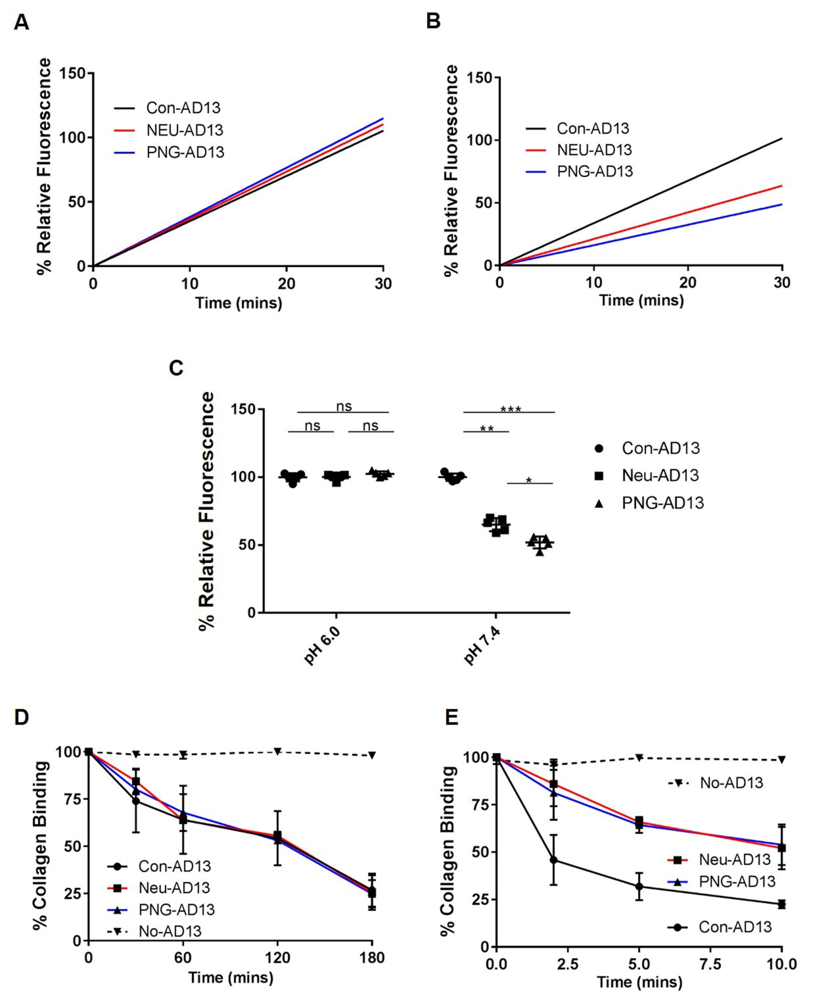

Figure 2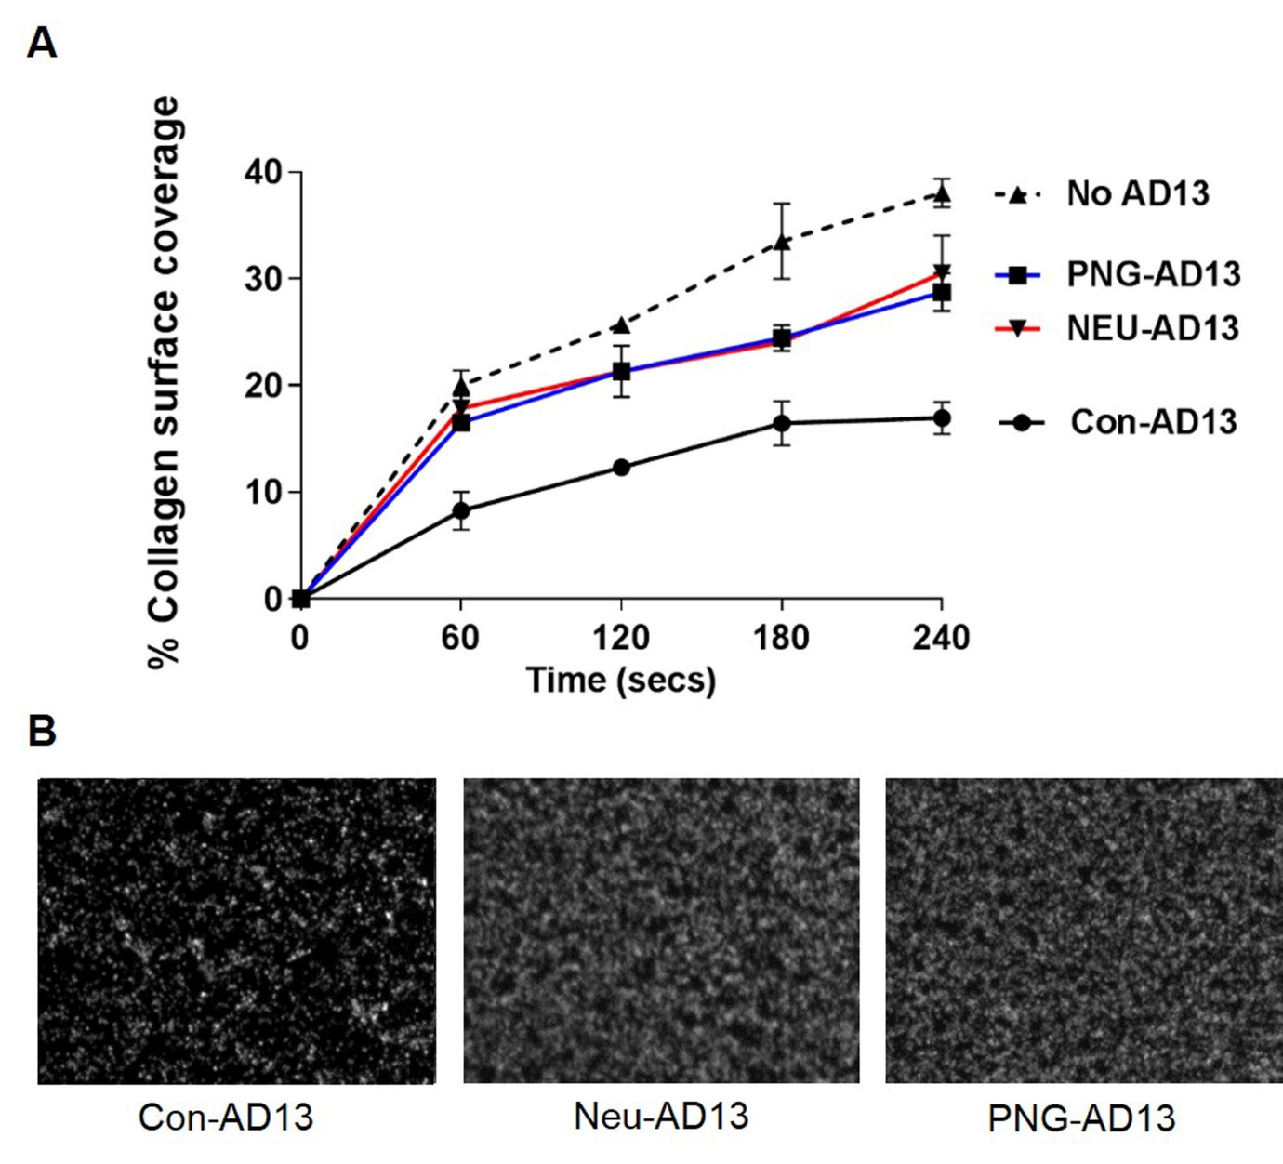

Figure 3

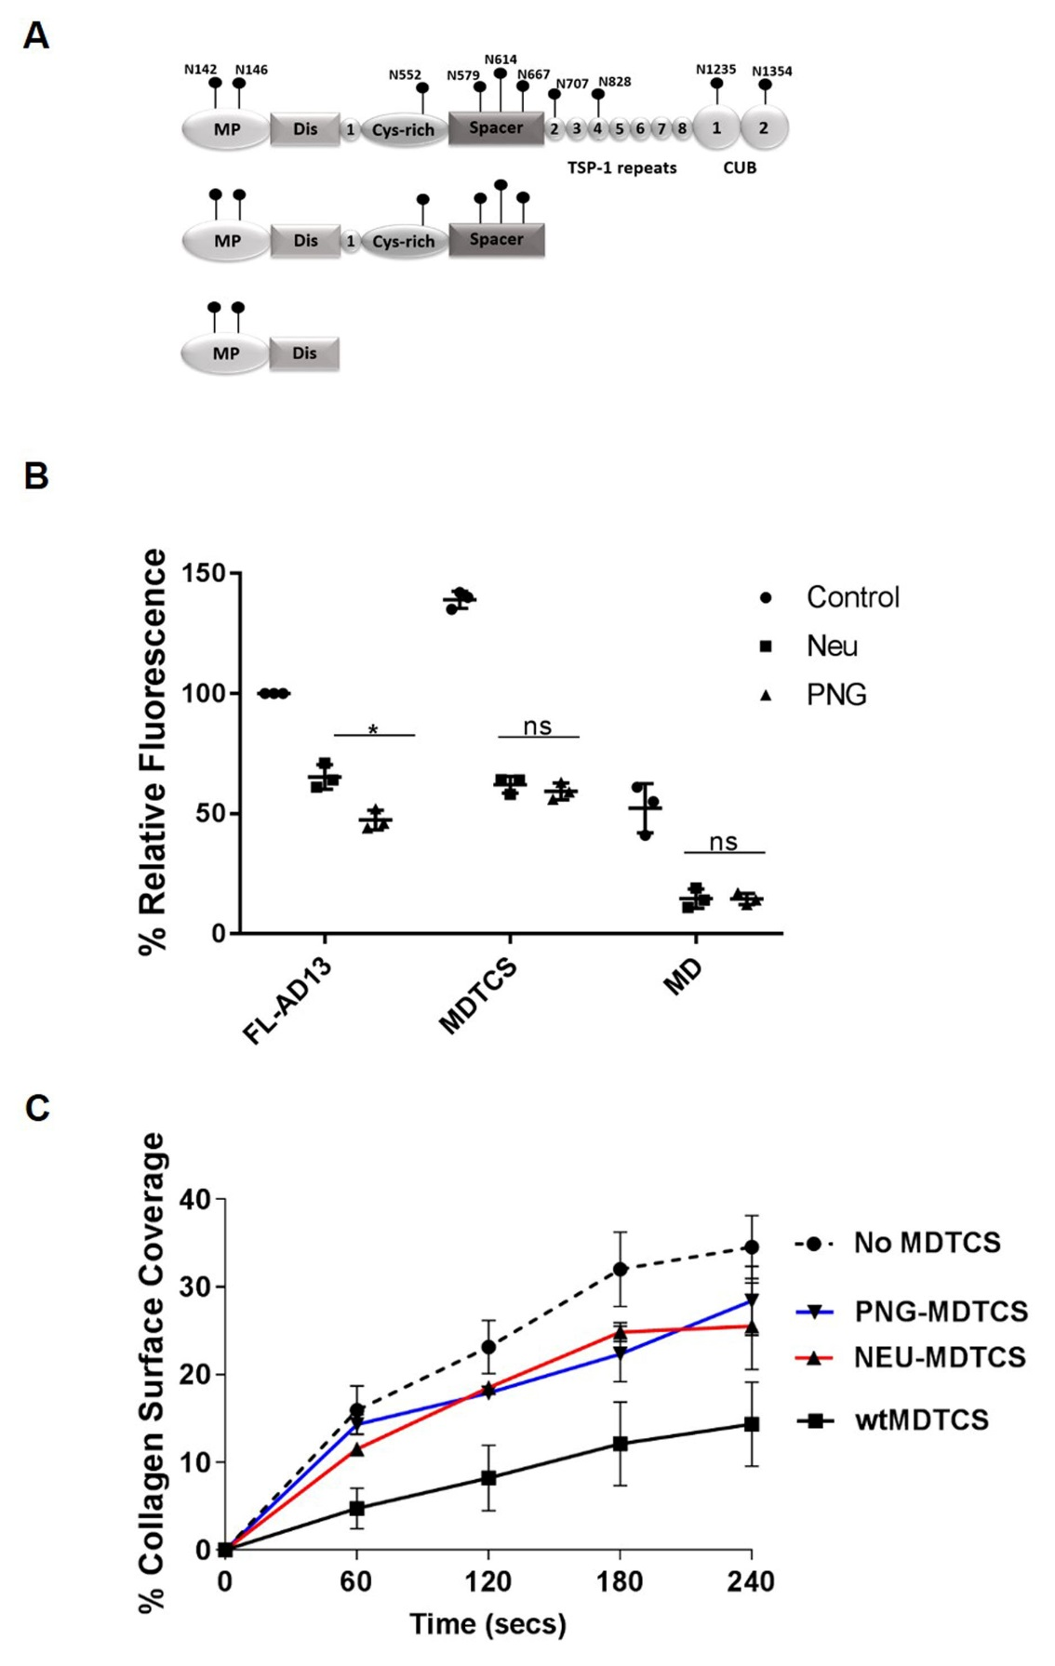

Figure 4
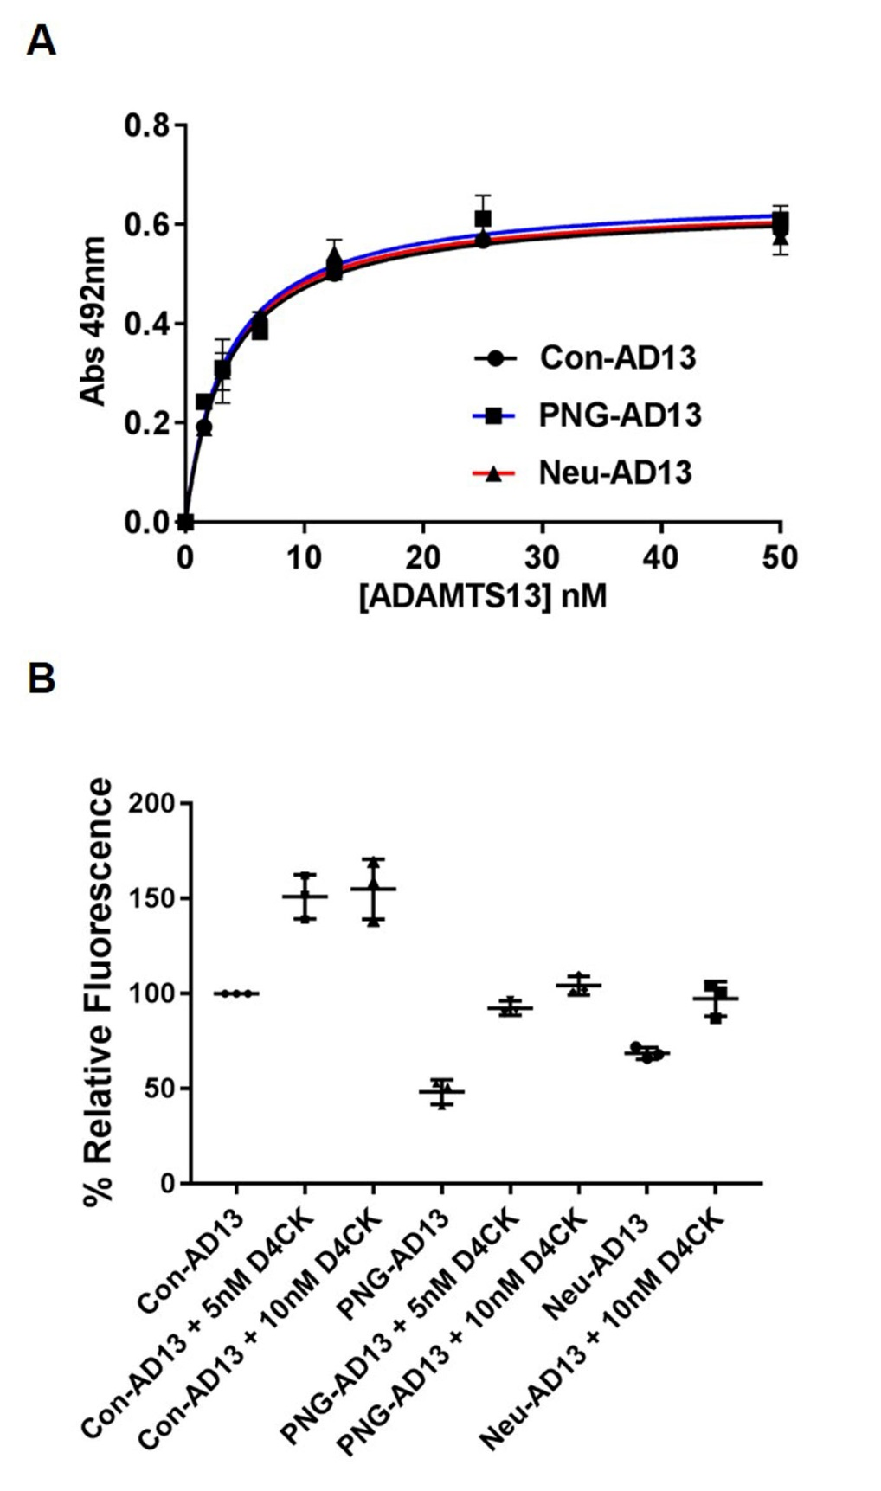

Figure 5
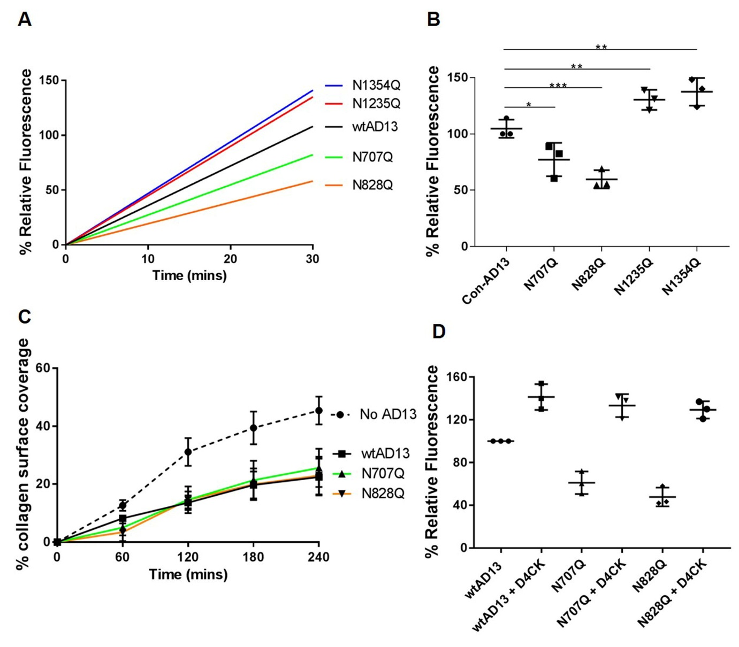

Figure 6
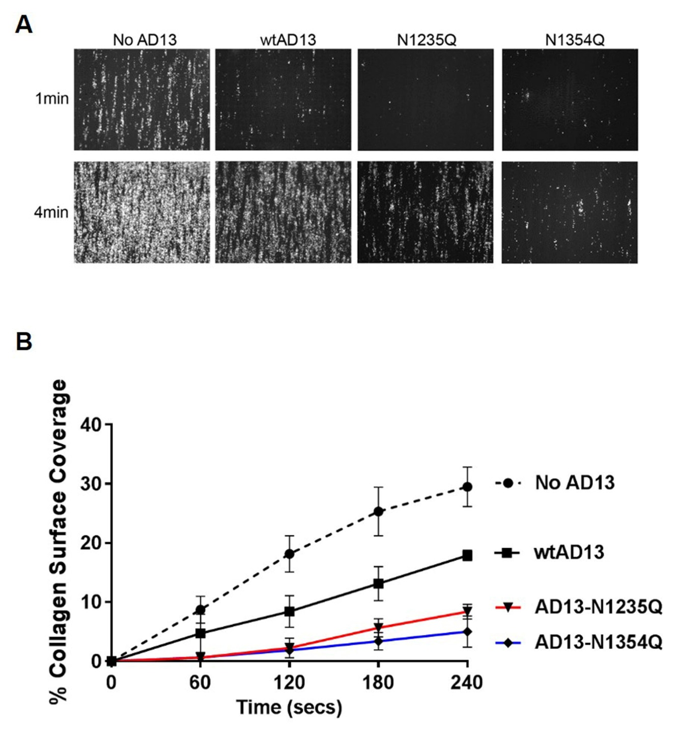

Figure 7


