CO₂ storage well rate optimisation in the Forties sandstone of the Forties and Nelson reservoirs using evolutionary algorithms and upscaled geological models
Masoud Babaei¹, Indranil Pan¹, Anna Korre¹, Ji-Quan Shi¹, Rajesh Govindan¹, Sevket Durucan¹ Martyn Quinn²

¹Department of Earth Science and Engineering, Royal School of Mines, Imperial College London, London SW7 2BP, United Kingdom
²British Geological Survey, Murchison House, Edinburgh, EH9 3LA, United Kingdom

Abstract
Optimisation is particularly important in the case of CO₂ storage in saline aquifers, where there are various operational objectives to be achieved. The storage operation design process must also take various uncertainties into account, which result in adding computational overheads to the optimisation calculations. To circumvent this problem upscaled models with which computations are orders of magnitude less time-consuming can be used. Nevertheless, a grid resolution, which does not compromise the accuracy, reliability and robustness of the optimisation in an upscaled model must be carefully determined. In this study, a 3D geological model based on the Forties and Nelson hydrocarbon fields and the adjacent saline aquifer, is built to examine the use of coarse grid resolutions to design an optimal CO₂ storage solution. The optimisation problem is to find optimal allocation of total CO₂ injection rate between existing wells. A simulation template of an area encompassing proximal-type reservoirs of the Forties-Montrose High is considered. The detailed geological model construction leads to computationally intensive simulations for CO₂ storage design, so that upscaling is rendered unavoidable. Therefore, an optimal grid resolution that successfully trades accuracy against computational run-time is sought after through a thorough analysis of the optimisation results for different resolution grids. The analysis is based on a back-substitution of the optimisation solutions obtained from coarse-scale models into the fine-scale model, and comparison between these back-substitution models and direct use of fine-scale model to conduct optimisation.

1 Introduction
Geological storage of CO₂ is regarded as a viable option for tackling climate change. The main types of geological systems considered for CO₂ storage are depleted oil and gas fields, saline aquifers and unmineable coal seams. In order to achieve long term trapping of the CO₂ in the storage system, it is necessary that an impermeable caprock exists above the storage formation and the geological structure allows for the CO₂ to be confined within the intended formation. In the actual design of CO₂ storage site operation it is important that potential risks are minimised or entirely avoided.
One such potential risk is CO₂ migration outside the targeted geological storage complex. This might occur if the CO₂ plume is allowed to reach the structural spill point of the targeted zone. Moreover, the CO₂ injection should not affect regions outside the licensed area boundaries and there should be no migration of CO₂ into the neighbouring fields. The crucial objectives of CO₂ storage are to utilise the storage capacity optimally, contain the CO₂ as a trapped phase and avoid the risks of leakage or spillage from the storage complex. These competing requirements necessitate that optimisation techniques are used in evaluating the performance of the proposed CO₂ injection system designs.
The objective of this paper is to illustrate the use of optimisation techniques in conjunction with upscaled models of heterogeneous storage complexes in the North Sea, with the aim to minimise the risk of lateral migration of injected CO₂ reaching the system spill point, while maximising the amount of CO₂ stored. One important aspect considered in this process is that the upscaled static models should account for reservoir heterogeneity while ensuring that the detailed system is represented adequately. The storage complex used to illustrate the approach comprises reservoirs of the Forties and Nelson oilfields and their surrounding aquifer within the UK Central North Sea. These two fields have already been cited in the literature for high potential for CO₂ storage (Cawley et al., 2005; Ketzer et al., 2005; SCCS, 2009) or CO₂-EOR (Kemp and Kasim, 2012). The two fields are assumed to be fully depleted and saturated with brine from the surrounding aquifers. The optimisation study presented here assumes that a fixed daily supply rate of CO₂ is available for injection. The optimisation variables are the injection rate at each well, namely the allocation of rate to each well from the total available CO₂. The optimisation objective is to minimise the fraction of CO₂ that is in free gaseous state outside the licensed regions and to maximise the fraction of CO₂ that is stored as dissolved CO₂ in the aqueous phase or residually trapped CO₂ in the gaseous phase.
An evolutionary optimisation algorithm is chosen to conduct the work as the objective functions are multimodal and the calculation of gradient or the use of a gradient-based optimisation algorithm would not be appropriate. Since the geological modelling of the site is very detailed and computationally expensive for CO₂ storage site assessment, the study focuses on the interplay of single and multi-objective Genetic Algorithm (GA) optimisation and upscaling for CO₂ storage. The upscaling method used is a numerical single-phase permeability upscaling. The optimisation result of upscaled model is exercised on the fine-scale grid, in a back-substitution procedure, to determine the reliability of the upscaled models for use in the optimisation. The outputs of optimisation from three upscaled levels of the realistic channelised aquifer model are compared with the outputs of the original fine-scale model and the effect of averaging of sub-grid flow on the optimisation output of the coarse-scale grid is assessed.

2 Background
Numerical simulation of CO₂ storage processes has been used widely to estimate the storage capacities of various sites (Doughty and Pruess, 2004; Flett et al., 2007; Kopp et al., 2009 and Pruess and Zhang, 2008). The estimation of CO₂ storage efficiency, i.e. the fraction of the available pore space that is utilised for CO₂ storage (van der Meer, 1995), is a crucial step in the evaluation of a candidate CO₂ storage site. Moreover, to achieve the highest storage efficiency and containment of CO₂ within the geological time-spans, it is important to fully understand and assess the mechanisms of CO₂ storage, which have been studied in great detail by Gunter et al. (1997), Holtz (2002), Xu et al. (2003), Holloway (2005) and IPCC (2005).
The dynamic methods, such as those developed by Doughty and Pruess (2004), Flett et al. (2007), Kopp et al. (2009) and Pruess and Zhang (2008), involve numerical simulation of physical phenomena that include a number of different mechanisms of trapping. These methods are more accurate than static methods and are widely applicable to real cases as they account for various flow dynamics, including multi-phase flow, density-dependent flow, heat transfer, ground-water hydrodynamics, CO₂ dissolution kinetics and geochemical reactions, which are fully described by the finite-element or finite-difference discretisation of the partial differential equations. More importantly, numerical models take into account the heterogeneity of the subsurface structures which is an important parameter influencing both migration patterns and trapping mechanisms for CO₂ injected in open saline aquifers (Gasda et al., 2013).
The detailed discretisation in large simulation models, however, leads to large number of unknowns and the computations become intensive (Aarnes et al., 2007; Matthäi and Nick, 2009). Furthermore, to account for the uncertainty in model parameters - such as permeability, porosity, temperature, brine salinity, fracture properties and relative permeability - multiple realisations should be considered. This adds significantly to the computational burden of CO₂ injection design so as to utilise the storage capacity. One well suited solution is upscaling. Upscaling has been used in the context of CO₂ storage in a number of studies such as Behzadi and Alvarado (2012); Gasda et al. (2013); Green and Ennis-King (2010); Juanes and MacMinn (2008); Mouche et al. (2010) and Saadatpoor et al. (2011).
However, upward migration of CO₂ has been particularly challenging in upscaling. Saadatpoor et al. (2011) studied the effect of permeability upscaling on buoyancy-driven vertical flow of CO₂ and the mechanism of CO₂ immobilisation by local trapping. Different degrees of coarsening were considered and, based on average gas saturation and mass of CO₂ in the storage aquifer, the upscaling methods were found to underestimate the extent of CO₂ trapping because upscaling averaged the map of capillary pressure.
Green and Ennis-King (2010) presented simple analytical expressions for the mean and variance of the upscaled vertical permeability distribution in a reservoir with randomly distributed impermeable barriers. Comparing the heterogeneous reservoir and a homogeneous reservoir with effective vertical permeability, CO₂ reached the top of the formation sooner for the heterogeneous medium. Additionally, convection began much sooner in the heterogeneous cases than in homogeneous case with the same effective permeabilities. A number of studies, such as that of Gasda et al. (2011), Juanes and MacMinn (2008) and Mouche et al. (2010) also focused on vertical-direction upscaling for CO₂ storage by vertical equilibrium assumption. Given the strong buoyancy forces, it is reasonable to assume that complete gravity segregation occurs quickly during and after the injection period. In addition, the large horizontal and thin vertical scales result in instantly developing vertical movement of the fluids (Gray et al. 2012), as if the vertical permeability is actually infinite. This assumption facilitates vertical integration of the governing three-dimensional flow equations to obtain a set of two-dimensional equations.
When the viscous force dominates the buoyancy, the upscaling methods that are used for oil reservoirs are considered to be applicable for upscaling CO₂ storage models in the lateral direction. For instance, Li et al. (2011) used a single‐phase steady state permeability upscaling method to create a coarse-scale model. The objective was to derive a resolution at which the coarse-scale model is sufficiently accurate for predicting gas migration, CO₂ storage, and pressure build-up in the absence of capillarity and viscous-dominated flow.
The difference between the comparative and evaluative analyses of upscaling for aquifer models and oil and gas reservoirs is that, for the latter, hydrocarbon production curves throughout the simulation exist and can be employed as a criterion of accuracy of the upscaled model. Simply put, the closer the curve obtained by the upscaled model is to that of the fine scale model, the more reliable the upscaled model is. However, this is not the case for the aquifers with no hydrocarbon production data. Therefore, other evaluative criteria should be employed. One criterion suggested and employed in this study is the performance of the upscaled models in optimisation. The convergence curves of the optimised solutions, the Pareto fronts of the multiple objective optimisation and the solutions are some of the outputs of the optimisation that are used for evaluation of the upscaled models in this work.
A number of researchers (Kovscek and Cakici, 2005; Bergmo et al., 2011; Leach et al., 2011; Cameron and Durlofsky, 2012; Shamshiri and Jafarpour, 2012; Babaei et al., 2015) have focused on single and multi-objective optimisation for CO₂ storage with different optimisation variables and performance measures. As the computationally expensive design procedure involved in optimising large subsurface models is a major concern, the use of upscaled models is more justified. In this line of research, Cameron and Durlofsky (2012) used a modest level of coarsening (by a factor of two in each direction) in their non-gradient-based optimisation and assessed the impact of grid resolution on the optimised solutions. They observed a reasonable correspondence in mobile CO₂ fraction between the models. Moreover, a study of gridding effects on CO₂ storage simulation has been performed by Yamamoto and Doughty (2011). The conclusion was that there is an underestimation of gravity override and maximum plume extent by a coarse grid. They also recommended near well upscaling for capturing salt precipitation near the wells.
The upscaling of the petrophysical model in this work is limited only to the lateral direction. One reason for not upscaling vertically is that the vertical resolution is more sensitive to upscaling in estimating the upward migration of CO₂. The other reason is that we only use one thin (1 meter thickness) layer of the geological model, representing a geological zone in a large multi-zonal aquifer with pressure and flow discontinuities in the vertical direction between the zones. The objective functions are dependent on the extent of CO₂ plume and the CO₂ storage mechanisms. The static model of the Central North Sea Paleocene/Eocene Forties Sandstone Member used in this study provides a sufficiently complex environment for evaluation of the upscaled models.

3 Description of the simulator and upscaling methodology
The compositional simulator ECLIPSE E300 (Schlumberger, 2010) is used to conduct the reservoir simulations. The CO2STORE option is activated to simulate injection and geological storage of CO₂ into the saline aquifer systems that were modelled. The estimates from the simulation are the molar mass of CO₂ that is dissolved, as well as the residually trapped and free CO₂ found in the gaseous state. For the simulations using the CO2STORE option, three phases are considered, a CO₂ rich phase, a H₂O rich phase and a solid phase. The mutual solubilities of CO₂ and H₂O are calculated to match experimental data for CO₂-H₂O systems under typical CO₂ storage conditions ranging between 12-100 °C and up to 600 bars. These are calculated following the procedure given by Spycher and Pruess (2005), based on fugacity equilibration between water and a CO₂-phase. Water fugacity is obtained by Henry's law, while CO₂ fugacity is calculated using a modified Redlich-Kwong equation of state (Redlich and Kwong, 1949). The components that can be considered in the CO2STORE option are CO₂ and H₂O present in water and gas phases and the salts NaCl, CaCl₂ and CaCO₃ present in either aqueous or solid phase (Schlumberger, 2010).
The upscaling algorithm used for porosity and the net-to-gross ratio is the arithmetic volumetric averaging. For permeability, the single-phase non-tensorial pressure solver method (Begg et al., 1989; Christie, 1996) is used, which is a simple method. More advanced upscaling methods for highly heterogeneous permeability fields such as methodologies presented by Chen and Durlofski (2006) and Evazi and Jessen (2014) could be implemented. The main expression for the upscaled permeability or the block equivalent permeability of coarse gridblock $E$ in the pressure solver method, denoted henceforth by $K_{E}^{*}$, is given by:
$\int_{E}{K∇pdV=K_{E}^{*}}\int_{E}{∇pdV}$ (1)
where $p$ is the pressure and $V$ represents the volume of gridblock $E$. This equation can either be solved numerically or, in special cases, it has an exact solution. The pressure solver method aims at obtaining and inverting the solution of Eq. (1) (calculated locally) over the domain of coarse gridblock $E$, to derive $K_{E}^{*}$. The solution is dependent on the choice of boundary condition. One common choice utilised here is to assume a generic axis-oriented boundary condition (two sides with a prescribed pressure gradient and two sides with no flow). Then, if $x$ is the direction of the pressure gradient, the total flow rate $q_{x}^{c}$ is computed by summation of outlet fluxes, thus, the diagonal element of $K_{E}^{*}$ in $x$ direction is ($K_{E,x}^{*}$):
$K_{E,x}^{*}=-\frac{q_{x}^{c}∆x}{A∆p}$ (2)
where $∆p$ is the assumed pressure gradient, $∆x$ is the length of the gridblock in $x$ direction, $A$ is the area from which the outlet fluxes exit. By alternating the boundary condition over the sides, $K_{E}^{*}$ is estimated for the $y$ and $z$ directions.

4 Evolutionary optimisation
In general, a wide variety of optimisation techniques using gradient descent methods may be used if the objective function is smooth and analytically tractable. However, this is not commonly the case for subsurface models. Additionally, if the functional form is known to be convex, then semi definite programming or other linear-matrix-inequality-based techniques will be more expedient, as commercial solvers that solve such problems in polynomial time exist.
From the optimisation point of view, simulators such as ECLIPSE needs to be treated as black box models. Therefore, the traditional methods of optimisation are not suitable in general. Intelligent bio-inspired optimisation techniques like Genetic Algorithm (GA) or Particle Swarm Optimisation are well suited to this kind of problems and, unlike the traditional gradient-based optimisers, can handle discontinuous, noisy and stochastic objective functions.
The GA encodes the solution variables as genes and initialises a population randomly within the lower and upper bounds of the search space. The fitness of each of the genes is evaluated by using the user specified objective function. The algorithm then uses crossover and mutation operators to evolve the next generation of the population. A few elite genes with the highest fitness function values are directly passed on to the next generation to preserve the best obtained solutions. The algorithm iteratively performs these operations to produce a newer population of genes until a specified number of generations are completed. The best gene in the last generation represents the optimised solution obtained by the algorithm.
The multi-objective non-dominated sorting GA algorithm (Deb et al., 2002) is used in this study to produce the Pareto front solution. The algorithm uses the same basic principles of mutation and crossover as the single objective GA. However it utilises a sorting scheme to rank the Pareto fronts in the order of their non-domination. A crowding distance assignment algorithm is used which gives more importance to solutions in sparsely populated regions of the Pareto front and, hence, helps in obtaining a better spread of the Pareto solutions. These mechanisms assist in applying selection pressure on the solutions and the approximate Pareto front evolves towards the true Pareto front over the generations.

Objective functions for optimisation
The optimisation problem is defined using two objective functions:
$J_{1}\left(x.Q\right)=\frac{\sum_{t=0}^{t_{max}}{\sum_{i=1}^{M_{b}}{(v_{F}^{i,t}\left(x.Q\right))}}}{\sum_{t=0}^{t_{max}}{\sum_{i=1}^{N_{b}}{({v_{F}^{i,t}\left(x.Q\right)+v}_{D}^{i,t}\left(x.Q\right)+v_{R}^{i,t}\left(x.Q\right))}}}$ (3)
$J_{2}\left(x.Q\right)=\frac{\sum_{t=0}^{t_{max}}{\sum_{i=1}^{N_{b}}{(v_{D}^{i,t}\left(x.Q\right)+v_{R}^{i,t}\left(x.Q\right))}}}{\sum_{t=0}^{t_{max}}{\sum_{i=1}^{N_{b}}{({v_{F}^{i,t}\left(x.Q\right)+v}_{D}^{i,t}\left(x.Q\right)+v_{R}^{i,t}\left(x.Q\right))}}}$ (4)
where $v_{D}^{i,t}\left(x.Q\right)$, $v_{R}^{i,t}\left(x.Q\right)$ and $v_{F}^{i,t}\left(x.Q\right)$ are the dissolved, residually trapped and mobile CO₂ present in gridblock $i$ at time $t$ respectively, therefore $J_{1}$ is the fraction of injected CO₂ as free gas present in the $M_{b}$ gridblocks of region $M_{b}⊂N_{b}$ at the end of simulation. Region $M_{b}$ is the region of the aquifer lying outside the licensed regions of the Forties and Nelson reservoirs and $N_{b}$ is the entire gridblocks of the system. The second optimisation function, $J_{2}$, is the fraction of injected CO₂ stored by dissolution or residual entrapment in the entire $N_{b}$ gridblocks of the domain, calculated as the summation over time of simulation ${(t}_{max})$. In the multi-objective optimisation setting, the goal is to minimise free gas outside the boundaries of the reservoir (J₁) and maximise trapped CO₂ (J₂). For the single objective case only J₁ is minimised. The reservoir simulator outputs ($v_{D}^{i,t}\left(x.Q\right)$, $v_{R}^{i,t}\left(x.Q\right)$ and $v_{F}^{i,t}\left(x.Q\right)$) depend on the total flow rate, $Q$, and the allocation vector of injection rates, $x$, for the wells that are present in the system.
The dissolution and residual trapping are enhanced by accessibility of fresh brine to gaseous CO₂. A better sweep efficiency helps this process and can be achieved through better engineering design of CO₂ injection. However, with larger extent of CO₂ plume and maximised sweep efficiency, leakage or spillage may induce a risk of CO₂ migrating outside the licensed storage areas. In other words, the objective functions defined are in fact contradicting each other.

5 Model development and upscaling

5.1 The study area
The site modelled is located on the Forties-Montrose High in the UK Central North Sea and includes the Forties and Nelson hydrocarbon fields (Figure 1; Wills, 1991). The hydrocarbon reservoir consists of submarine fan deposits of the Paleocene/Eocene Forties Sandstone Member overlain by Lower Eocene shales (Hughes et al., 1990; Whyatt et al., 1992). The reservoir is located in the proximal inner (interbedded sand/shale) to middle (mainly massive sand) part of the Forties Fan system (Hughes et al., 1990) and is mostly channelised and characterised by high net to gross sandstone ratios, good porosities and high permeabilities (Hempton et al., 2005).
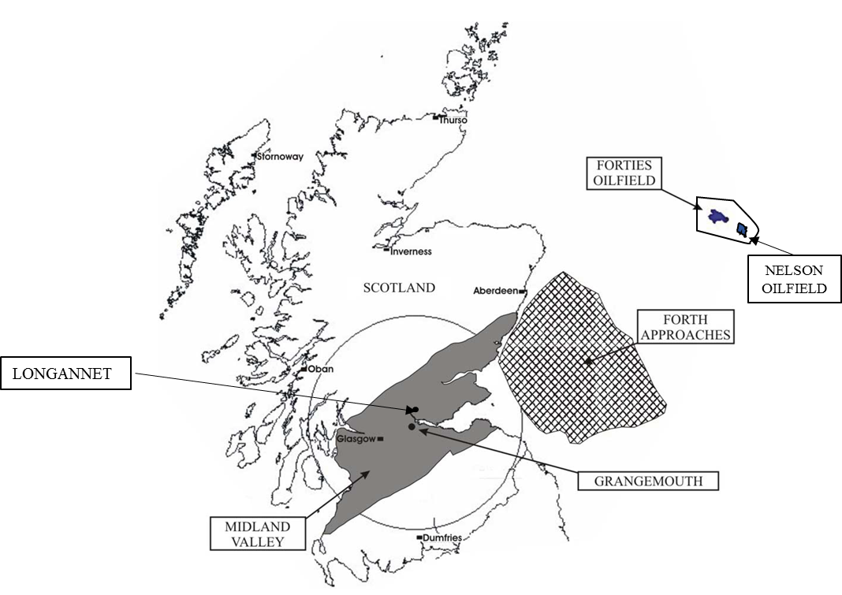
Figure 1. The geographic location of Forties and Nelson oil fields in the Central North Sea (modified from Cawley et al. 2005). The polygon around the two fields represents the boundaries of the aquifer area used in the simulations. Also shown are the location of the Grangemouth refinery and petrochemical complex (emitting 4 Mt of CO₂ annually), the Longannet coal-ﬁred power plant which emitted 9.51 Mt CO2, in 2014, and the Forties and Nelson oilﬁelds).
The reservoir comprising the geological model was subdivided into 8 Zones, Zone M, the overlying top seal, an ‘Upper Sand’ (Zones L, K, J, H, F, and E) separated by a continuous and uninterrupted mudstone layer from the ‘Lower Sand’ (Zone D). The mudstone layer is a barrier to fluid flow within the reservoir and results in a vertical pressure discontinuity between the Upper and Lower sands (Wills and Peattie, 1990). In addition, an extremely effective and laterally extensive permeability barrier, referred to as the ‘Charlie Shale’ (Denny and Heusser-Maskell, 1984) exists within the upper part of Zone H that effectively separates the Upper Sand Zones L, K, J above (only existing in the western parts of the Forties Field) and Zones H(lower part), F, and E beneath. Pressure communication within the Zone J overlying the Charlie Shale is good, with very little indication of vertical permeability barriers. In the reservoir zones beneath the Charlie Shale, minor permeability barriers have been indicated. The flanks of the structure have fairly gentle dip over the reservoir section (Hughes et al., 1990). It is assumed that the reservoirs are fully depleted and saturated with aquifer brine before CO₂ injection starts.
Reservoir pressure in both fields was initially maintained by basal aquifer influx (Simpson and Paige, 1991). Since 1976, aquifer support has been supplemented by peripheral seawater injection (Mitchell, 1978) so that the pressure was sustained throughout the oil production stage. With such evidence, the assumption that the whole system is an open boundary aquifer is appropriate.

5.2 Geological model and attribution
The geology of the Forties and Nelson hydrocarbon fields in the UK sector of the North Sea has been widely studied (e.g., Kulpecz and van Geuns, 1990; Kunka et al., 2003). The geological model developed in this study broadly captures and represents the heterogeneities present within what is a very complex submarine fan environment. Large amalgamated stacked channel systems of the Late Paleocene/Early Eocene Forties Sandstone Member within a four-way dip-closed anticlinal structure comprise the main hydrocarbon producing fairways of the two hydrocarbon fields (Figure 2(a)). The amalgamated channels and their associated channel margins and interchannel areas migrated laterally through time resulting in the variation in relative dominance and position of the different parts of the submarine fan system and a high degree of lateral and vertical variation in the reservoir. This is represented in the lithologies found in the system and their associated petrophysical parameters.
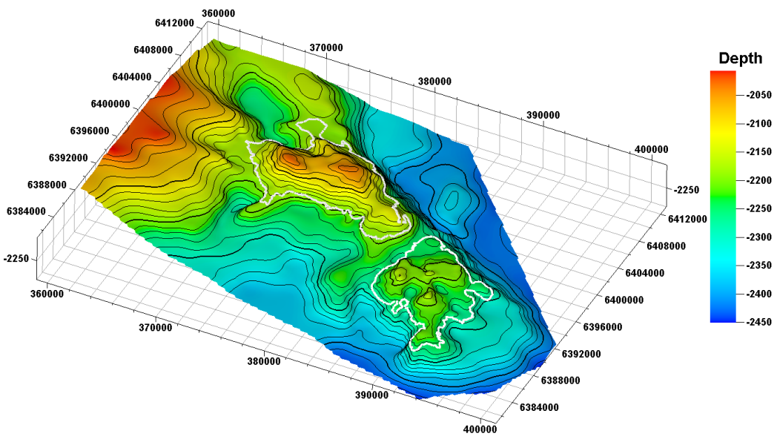
(a)
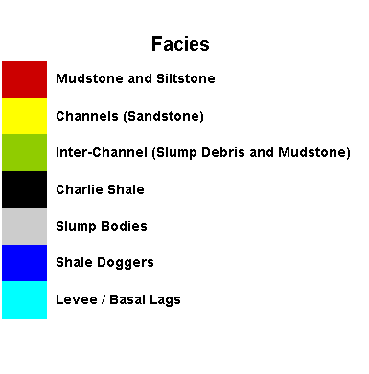
(b)
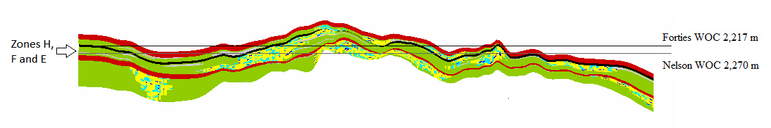
(c)
Figure 2. (a) Top surface depth of the aquifer in metres, with Forties and Nelson oil fields indicated by white polygons (b) Facies map used in geological modelling, injection wells indicated by W1 to W4 in Forties and W5 to W8 in Nelson, and flow line polygons indicated by blue lines. (c) Cross sectional view of the Forties Field structural closure and facies distribution. Zones H, F and E are capped by the Charlie Shale (in black) and overlie a mudstone layer (in red).

The geological modelling was carried out in three parts: (a) modelling the amalgamated channels in the fairways; (b) modelling the interchannel areas; and (c) attributing the model with petrophysical properties. A typical cross-section of amalgamated channels and channel margins consists of the channel sands, low permeability basal lags, high permeability basal lags and the intrachannel doggers.
Considering each zone of the model separately, the first step in building the static model was to construct a reasonable fairway structure in the zone using the interpreted channel boundaries. Figure 2 (b) shows the flow line for channels in one zone, constructed to represent the maximum sediment transport line. This was followed by modelling of the amalgamated channels inside the fairway volume using Object Modelling in the PETREL software and the attributes specified in Table 1 for each of the zones. This allowed to stochastically model the channel complex based on parameters such as facies associations, the number or percentage of channels and shale doggers, channel layout and section parameters. Figure 2 (b) illustrates the facies associations in Zone E.
Table 1. Channel model parameter values used for object modelling.
 | Attribute | Minimum | Mean | Maximum
Channel Layout | Amplitude (m) | 700 | 800 | 900
Channel Layout | Wavelength (m) | 5,000 | 6,000 | 7,000
Channel Section | Width (m) | 600 | 800 | 1,000
Channel Section | Thickness (m) | 30 | 45 | 60
Levee (basal lags) | Width (m) | 30 | 80 | 200
Levee (basal lags) | Thickness (m) | 30 | 45 | 60
Shale Doggers | Width (m) | 100 | 150 | 200
Shale Doggers | Thickness (m) | 2 | 3.5 | 5
In order to model the interchannel slump bodies, the fairway polygons were inflated to include buffer areas around the polygons, assuming distances varying between 2 and 5 km. Ellipsoidal shapes were assumed typical for slump bodies owing to their generally elongated shapes. Table 2 summarises the ellipsoidal body parameters used.
Table 2. Slump deposits modelling parameters for the interchannel areas.
 | Attribute | Minimum | Mean | Maximum
Rounded ellipsoidal bodies  (35 % of channel margin) | Orientation | -30° | -40° | -50°
Rounded ellipsoidal bodies  (35 % of channel margin) | Minor Axis (m) | 4000 | 4500 | 5000
Rounded ellipsoidal bodies  (35 % of channel margin) | Major to Minor Axis Ratio | 1 | 1.3 | 1.5
Rounded ellipsoidal bodies  (35 % of channel margin) | Thickness (m) | 10 | 13 | 15

The attribution of the geological model with petrophysical properties, namely porosity, permeability and net-to-gross (NTG) ratio, was carried out using Gaussian random functions (Lifshits, 1995). The ranges of values used, including their mean values, are summarised in Table 3 for the different geological facies. Some of these values are based on generalisations from sparse literature references such as Kunka et al. (2003) and Wills (1991) and, in the absence of data, some assumptions were made by the authors based on geological expert judgement.
Table 3. Petrophysical properties for different facies types from Kunka et al. (2003) and Wills (1991) and well log analyses; values indicated as mean (minimum, maximum).
Petrophysical property | Channel sands | Basal lags  (low permeability) | Basal lags  (high permeability) | Shale doggers | Interchannel (slump debris and mudstones) | Slump bodies
Porosity (%) | 25  (21, 38) | 25  (21, 38) | 25  (21, 38) | < 12 | 24.6  (3, 32.9) | 13  (3, 32.9)
Horizontal Permeability (mD) | 376  (31, 1,610) | 376  (31, 1,610) | 376  (31, 1,610) | < 1 | 163  (0.01, 1,769) | 50  (0.01, 1,769)
Vertical Permeability (Multiplier) | 0.1 | 0.01 | 0.1 | 1 | 0.001-0.01 | 0.001-0.01
NTG | 0.72  (0.21, 1) | 0.72  (0.21, 1) | 0.72  (0.21, 1) | 0.21  (0.21, 1) | 0.33  (0.11, 0.89) | 0.11  (0.11, 0.89)

5.3 Upscaling
The geologically detailed fine-scale model is laid out on a 844 × 640 lateral resolution grid with an average gridblock length of 50 metres in x and y directions. An average thickness of one metre is used for layering the model. The geological model is referred to as the Fine-scale Model (FM) from this point on. This resolution is appropriate as it allows us to describe the channel and slump deposits’ extent and the lateral and vertical heterogeneity within channels. As vertical heterogeneity within the individual channels is much more significant, considering the mode of presence for levee and shale dogger facies, it was decided to use the maximum of width variation for basal lags and doggers and much finer thickness for the individual facies objects.
Here only the top layer of Zone E that comprises 392,155 active gridblocks is chosen for optimisation study. This layer is upscaled in x and y directions into three coarser resolution girds to have 4 resolution grids in total:
- Coarse-scale Model 1 (CM1): with lateral resolution of 420 × 318 with average gridblock length of 100 metres in x and y directions, with 96,300 active gridblocks.
- Coarse-scale Model 2 (CM2): with lateral resolution of 280 × 211 with average gridblock length of 150 metres in x and y directions, with 42,658 active gridblocks.
- Coarse-scale Model 3 (CM3): with lateral resolution of 210 × 158 with average gridblock length of 200 metres in x and y directions, with 23,904 active gridblocks.
As mentioned the directional absolute permeabilities (Permeability I, J, K in x, y and z directions respectively) are upscaled by flow-based upscaling whereas porosity and net-to-gross ratio (NTG) are upscaled by volume averaging. To illustrate, Permeability I and Permeability J for FM and CM3 are shown in Figure 3, and Porosity and NTG for FM and CM3 are shown in Figure 4. The upscaling has made no visually identifiable difference to the petrophysical properties of interest.
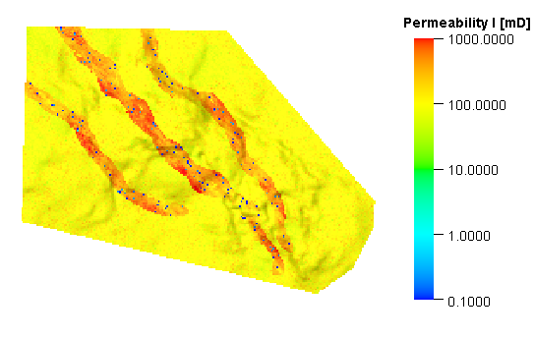(a) | 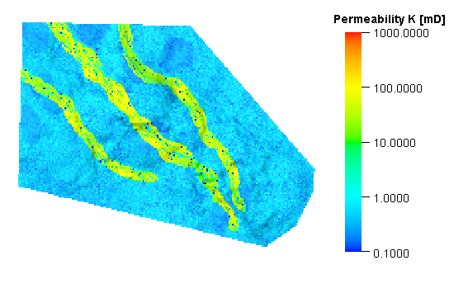 (b)
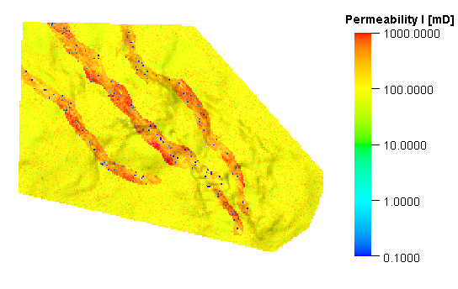 (c) | 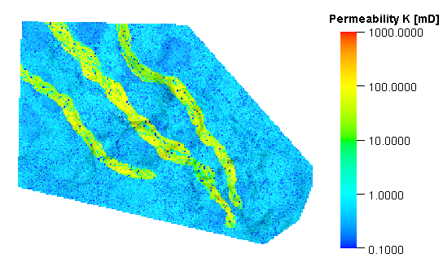(d)
Figure 3. Permeability I (K_{x}) for FM (a) and CM3 (c), and Permeability K (K_{z}) for FM (b) and CM3 (d)

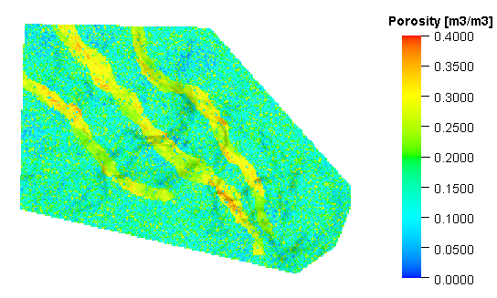(a) | 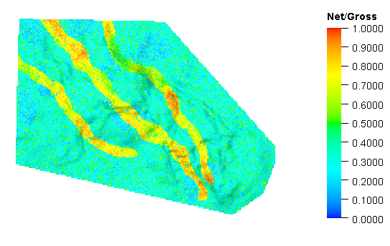(b)
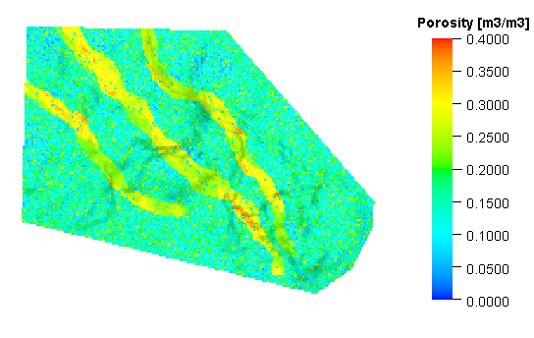(c) | 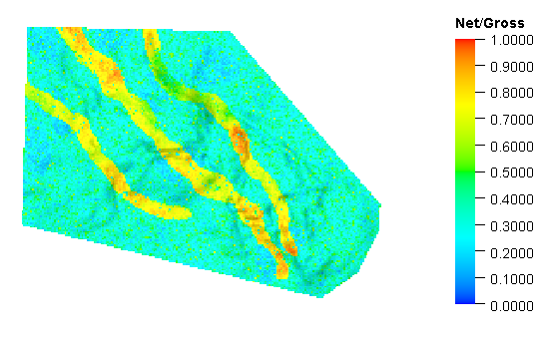(d)
Figure 4. Porosity for FM (a) and CM3 (c), and NTG for FM (b) and CM3 (d)

6 Injection simulations
The eight wells used for CO₂ injection simulation are shown in Figure 2 (b). Two of the four wells in Forties (vertical wells) were used for peripheral water injection during oil production and two others (deviated wells) were used to produce oil at platform FC (Forties Charlie) located in the western flank of the oilfield. Four wells in Nelson (all deviated) were all oil production wells drilled from a single platform located in the middle of the oilfield. These wells were selected because they were drilled in the channel area of Zone E.
The brine properties used in simulations assume an initial molar composition of 0.05 NaCl, 0.04 CaCl₂ and 0.91 water. The normal diffusion coefficients were set to 0.001 cm²/sec for water and CO₂ components in the gaseous phase, and 0.0001 cm²/sec for all components present in the aqueous phase. CO₂ density at gaseous state is obtained by Redlich-Kwong equation of state which is tuned following Spycher and Pruess (2005) in ECLIPSE E300 to accurately give the density of the compressed gas phase. The CO₂ gas viscosity is calculated in ECLIPSE E300 from Vesovic et al. (1990) and Fenghour et al. (1998).
Formation brine properties, either obtained from literature or in the absence of data set to ECLIPSE E300 default values, are summarised in Table 4. It should be noted that the properties that exhibit different values for each oilfield are averaged and applied for the whole aquifer study area.
Table 4. Formation brine properties.
Property | Forties | Nelson
Salinity (ppm of NaCl) | 55,500 (Wills, 1991) | 84,000 (Kunka et al., 2003)
Resistivity (ohm m) | 0.034 (Wills, 1991) | 0.034
Formation volume factor (rm³/sm³) | 1.24-1.32 (Wills, 1991) | 1.357 (Kunka et al., 2003)
Density at surface conditions (kg/m³⁾ | 999.014 | 999.014
Compressibility (bar⁻¹) | 4.0×10⁻⁵ | 4.0×10⁻⁵
Viscosity at reference pressure of 205 bar (cP) | 0.3 | 0.3
Viscosibility (bar⁻¹) | 0.0 | 0.0
Temperature (°C) | 96 (Wills, 1991) | 107 (Kunka et al., 2003)
Initial fluid pressure (bar) | 222 (Wills, 1991) | 229 (Kunka et al., 2003)

The relative permeability curves, shown in Figure 5, were derived for gas-water system from a three phase oil-brine-CO₂ system in an investigation of CO₂₋EOR potentials for a segment of the Forties field by Cawley et al. (2005). Based on these curves, connate water saturation (S_{wc}) is 0.2 but the relative permeability of water does not increase significantly until water saturation reaches 0.4. This implies that CO₂ saturation can achieve large values of maximum gas saturation (Sg_{max} = 1-S_{wc} = 0.8) only near wells. In the absence of field data, the capillary pressure is neglected and is set to zero and no hysteresis is considered for the relative permeability curves.

Figure 5. The relative permeability curves derived for gas-water system after Cawley et al. (2005).
The CO₂ storage license regions were assumed to be the reservoirs. It should be noted that the reservoir boundaries used are approximate and are not considered accurate delineations of either depth or fluid contacts. Although the particular choice of boundaries affects the optimal solution obtained as a result of the analysis, it does not affect the applicability of the combined modelling and optimisation methods proposed in this paper.
A total rate of 0.7 million sm³ per day, approximately equivalent to 0.5 million tonnes of CO₂ per year is injected into the aquifer for 30 years and an additional 50 years are allowed for stabilisation and investigation of possible migration of CO₂. During the injection period, a total of 15 million tonnes of CO₂ are injected.
Although, the time period investigated for the aquifer injection and stabilisation in the geological sense is limited, nonetheless, this CO₂ storage model is adequate to study the trade-offs in the design and the effect of upscaling in the optimisation process, which is the objective of the methodology illustrated here. Larger scale models and simulation over longer injection periods would only require additional simulation time.
The simulations were run on a Windows based operating system with an Intel Core i7-4820K 3.70GHz CPU and 32.0 GB RAM. Each of FM, CM1, CM2 and CM3 takes 4,830, 555, 179 and 96 seconds to run, respectively. These numbers must be multiplied by 800 (20 populations × 40 generations) to indicate the time required for optimisation of each model and each grid. As shown in Figure 6, the difference in run times between FM and CM1 is higher than run times between CM1 and CM2 and between CM2 and CM3, suggesting that the run time does not scale linearly with the size of the model. As the optimisation for FM requires 800 × 4,830 seconds or in other words 44.72 days, we used parallel computing allowing the runtime reduction to order of 6 days instead. However the parallelisation has not taken into account in Figure 6.
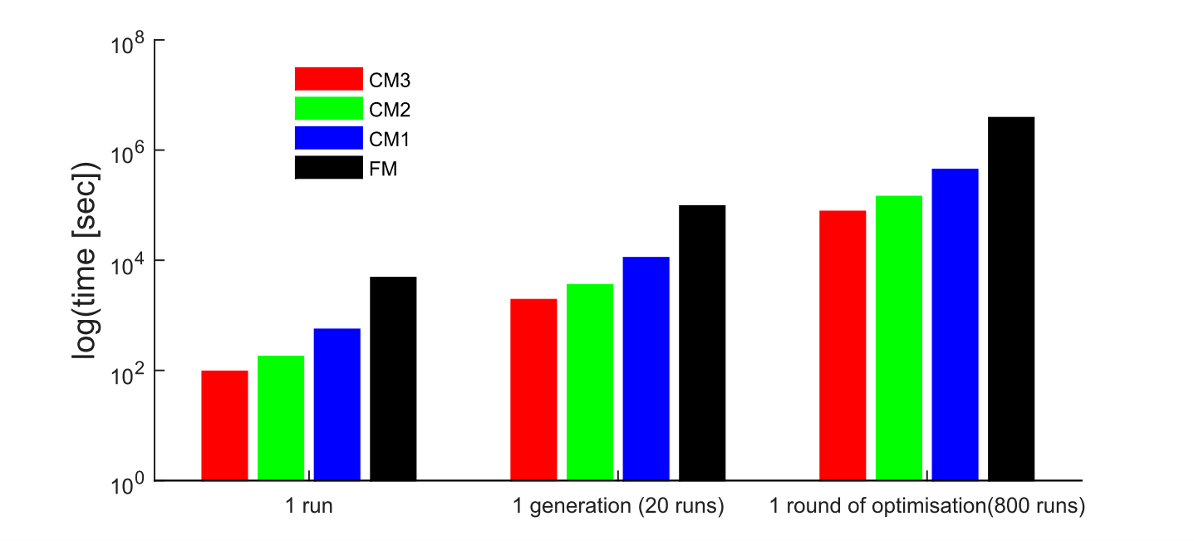
Figure 6. A comparison of the run times required for a single run, a generation of GA algorithm including 20 runs and a round of GA algorithm including 800 runs of ECLIPSE simulations.

7 Optimisation results

7.1 Single objective optimisation
Starting with the single objective optimisation, the convergence profiles of the final optimum solution from one generation to another for different grids are shown in Figure 7(a). The convergence is assured only when the best fits do not vary significantly over the iterations. It is obvious that CM3 with the coarsest resolution grid has led to loss of variation in the solution for objective function and consequently the profile is flat with no comparability of the final solution after 40 generations with that of FM, CM1 and CM2. In contrast, CM1 and CM2 have preserved the variation and “optimisability” of the objective function compared to FM and as such the final values for J₁ after 40 generations is close to that obtained by FM.
The final converged injection rates for different resolution grids after 40 generations are shown in Figure 7(b). Again we observe no comparability of CM3 solution for injection wells with that of FM. Order of highest injection rates for FM is: W6, W4, W7, W5, W2, W8, W3, and W1. This order for CM1 is: W6, W4, W7, W5, W8, W2, W3 and W1. The order for CM2 is: W6, W3, W7, W5, W4, W2, W1 and W8. The order for CM3 is: W6, W2, W5, W3, W1, W7, W8 and W4.
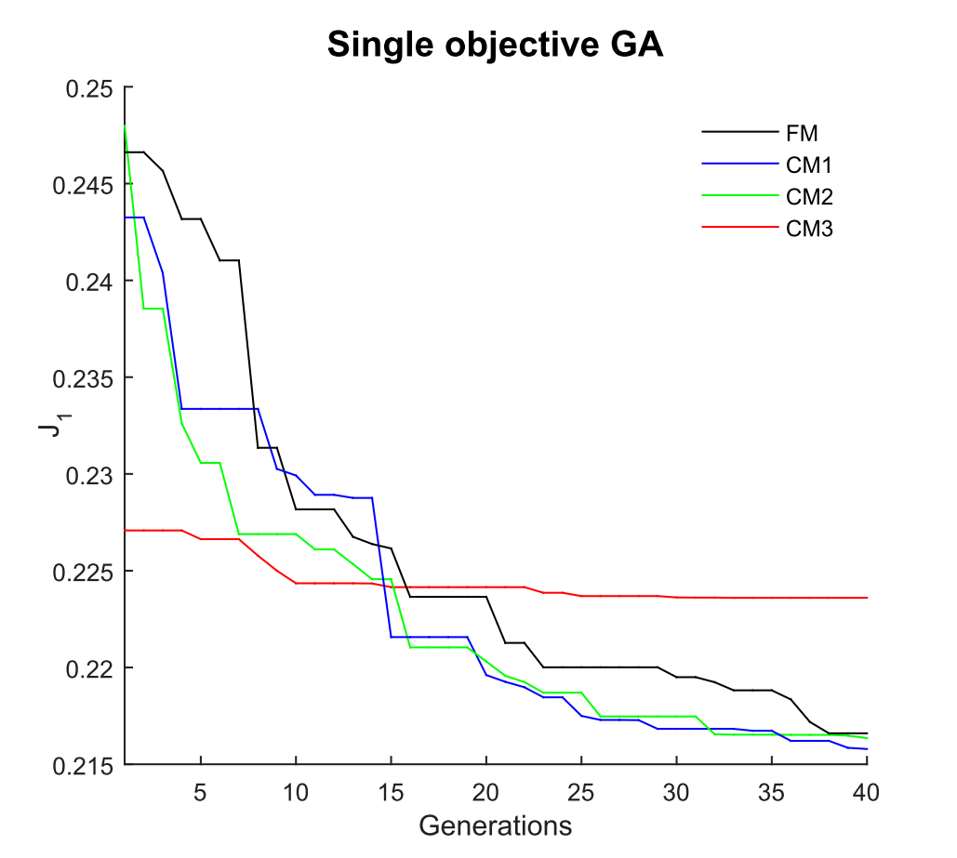
(a)
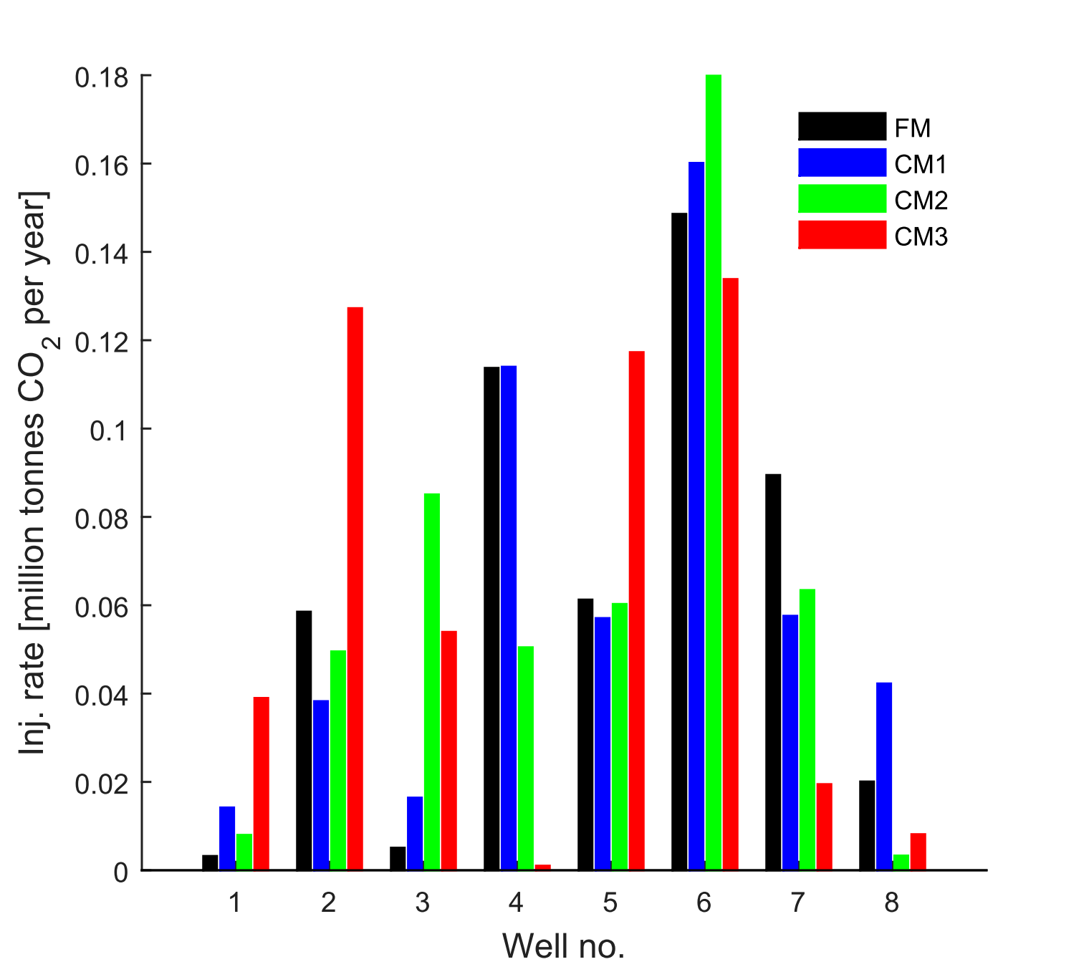
(b)
Figure 7. (a) The convergence of the optimum solutions for FM, CM1, CM2 and CM3 after 40 generations of GA. (b) The comparison of FM, CM1, CM2 and CM3 final solutions (injection rates of the eight injection wells) for the single objective optimisation
It is interesting to see the change in the order compared to FM increases from CM1 to CM3, with CM3 only having W6 as the highest share-taker similar to FM. In order to assess the degree of reliability of the coarse-scale solutions of optimisation obtained from CM1, CM2 and CM3, these solutions are used in fine-scale simulation. In other words we substitute the solutions onto FM resolution grid. These substituting simulation are denoted as CM1-in-FM, CM2-in-FM and CM3-in-FM hereafter.
Figure 8 shows how optimised solutions reduce the fraction of mobile CO₂ outside the licensed regions (J₁) at the end of simulation. Compared to the base case scenario–where the total rate is equally divided between the eight wells, the final result of optimisation, referred to as optimal solutions, reduce fraction of mobile CO₂ from 0.2733 to 0.2166 for FM. In terms of convergence of the results from coarse resolution grids to fine resolution grid, J₁ at the end of simulation for CM3, CM2, CM1 and FM are respectively 0.2871, 0.2710, 0.2764 and 0.2733, showing a relative error of 5% for CM3 to around 1% for CM1 and CM2.
Also shown in Figure 8 are the values of J₁ throughout the simulation obtained by CM1-in-FM, CM2-in-FM and CM3-in-FM cases. The results are very reassuring, showing that the CM1-in-FM and CM2-in-FM cases both are “almost” reproducing the FM optimal solution: J₁ from CM1-in-FM at the end of simulation is 0.2224 and J₁ from CM2-in-FM at the end of simulation 0.2226. This confirms that the solutions for the injection rates shown in Figure 7 for CM2 and CM3 both are actually optimal for FM. The solution for CM2 is of course less computationally intensive to obtain than that of CM1. Finally J₁ from CM3-in-FM at the end of simulation is as high as 0.2384, and therefore the solution can be deemed sub-optimal.
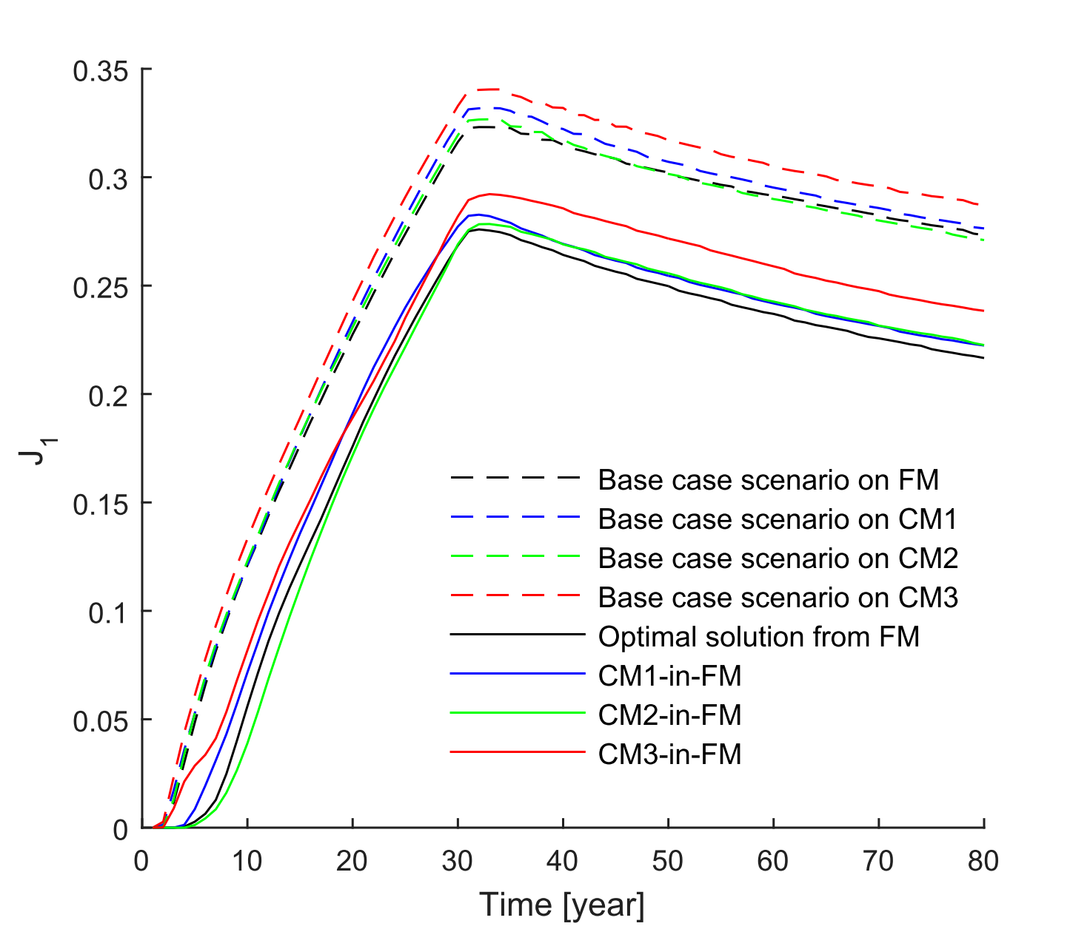
Figure 8. The fraction of mobile CO₂ outside the licensed regions (J₁) obtained by fine-scale simulations in the single objective optimisation case.
Finally, Figure 9 illustrates the CO₂ saturation for base case and the optimal solution at the end of injection time that exhibits the larger spread of mobile CO₂ outside the license area for base case northern and southern boundaries of Forties. In the optimal case a higher injection share for W6 has led to a better filling-up of Nelson compared to base case scenario.

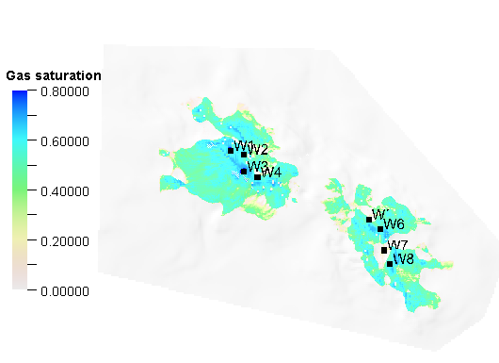
(a)
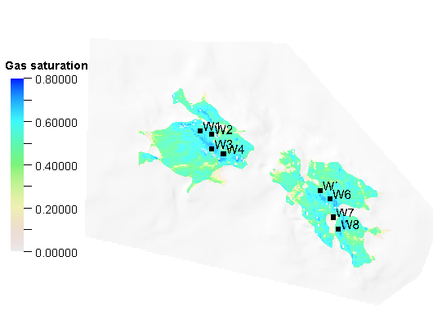
(b)
Figure 9. The CO₂ saturation at the end of injection period for the base case (a), and optimal solution (b) of FM in the simulations.

7.2 Multi-objective optimisation
For the multi-objective optimisation, the pareto fronts of different resolution grids, with 20 populations per generation and 40 generations, are shown in Figure 10(a). In addition to four sets of Pareto fronts and feasible (sub-optimal) solutions for FM, CM1, CM2 and CM3, the substitution of CM1, CM2 and CM3 pareto front solutions onto FM resolution grid are conducted, and denoted by CM1-in-FM, CM2-in-FM and CM3-in-FM cases. The results are compared with FM pareto front in Figure 10(b).
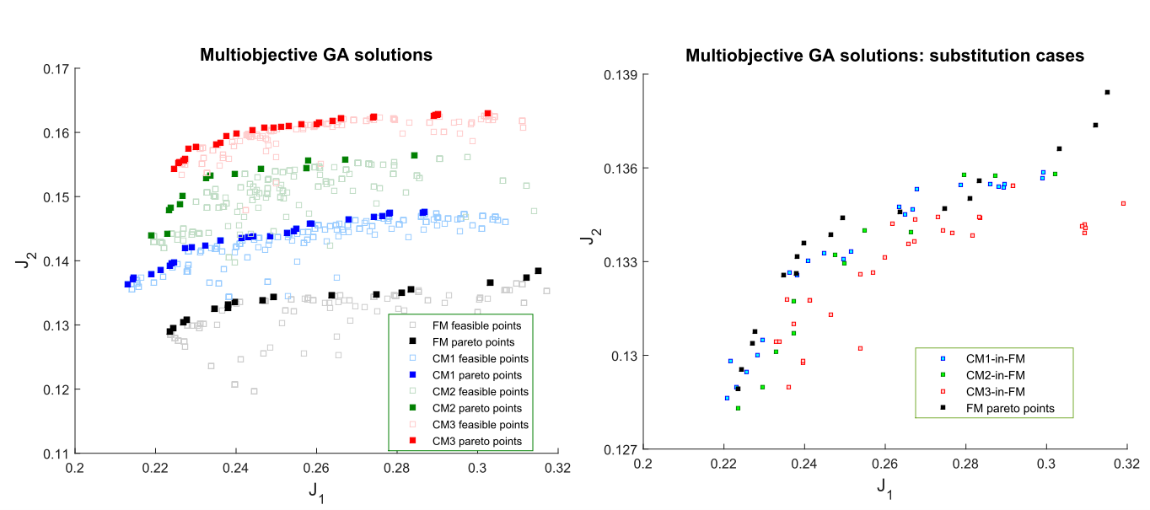
(a)
(b)
Figure 10. The multi-objective pareto fronts for different resolution grids (a) and the substitution-based pareto fronts (b).
The figure shows:
- The conflicting situation at which maximising the fraction of dissolved CO₂ (J₂) will lead to an unfavourable increase in the fraction of mobile CO₂ outside the licensed region (J₁).
- The coarse resolution grids lead to a systematic overestimation of J₂, and as such the dissolved amount of CO₂ will be more and more unreliable by increasing the coarsening factor.
- The optimisation problem defined in this paper has not allowed a significant variation in J₂ (around 1 percent difference between lower and upper bounds of the pareto fronts in any of the resolution grids.)
- The substitution cases in Figure 10(b) show sub-optimal situations for CM3-in-FM, whereas the substitutions from CM1 and CM2 are regenerating the pareto front of FM by negligible error. Unfortunately there is no way to define an error metric between these points as they are not compared one-to-one and the number of pareto front solution vary from one resolution grid to another.
- As of single objective optimisation, CM2 is showing a good level of reliability compared to CM1, and since the optimisation with CM2 entails less computation intensity, this resolution grid is more favourable.

8 Conclusions and future works
This study showed that the use of upscaled models for the optimisation of well rate allocation in designing CO₂ storage operations is feasible only if a careful preliminary assessment of the upscaled models’ performances against that of geologically detailed fine scale model is carried out. A methodology was proposed for determining the accuracy of upscaled models based on back-substitution of the solutions of the optimisation from the upscaled model into the fine grid model. This procedure was used to assess the reliability of the upscaled models for the optimisation and design of a CO₂ storage operation in a heterogeneous aquifer system in the North Sea. Our results for both single and multiple objective optimisation showed that a resolution grid of 150 m by 150 m could be used safely to run optimisation reliably replacing the geologically fine resolution of 50 m by 50 m. This conclusion is only specific with the facies types of the present model and could not be readily extended to other geological models or even other geometrical systems with different vertical resolutions.
There are a few issues that remain to be addressed and can be pursued in future research. We only considered a two-dimensional model and therefore the effects of vertical resolution in upscaling were not considered. Uncertainty has not been thoroughly investigated in the present study. A methodology to handle uncertainty in the optimisation framework needs to be considered and the effect of these upscaled models with the quantification of uncertainty needs to be investigated. Other surrogate modelling techniques - similar to the use of upscaled models - to reduce the run time complexity of these large aquifer models can be studied and compared with the upscaled models. There are several other performance objectives that may be considered for the design of the storage site. For example, from the licensing point of view, minimising the pressure build-up can be a potential objective in optimisation. Moreover, CO₂-EOR, where oil production can be used as another objective function, is an attractive field of study to investigate the applicability of the upscaled models.
Finally, the state variable for the optimisation used in this work was the allocation of a fixed total CO₂ injection rate. In a complete operational design of a storage site many other design parameters, such as the number and locations of wells, the maximum allowable bottomhole pressure during injection, need to be defined. In all such cases, the upscaling needs to be quantitatively re-evaluated and the approach presented in this work can be used for this purpose.
Acknowledgements
This research was carried out as part of the UK Research Councils' Energy Programme funded consortium projects "Multiscale Whole Systems Modelling and Analysis for CO2 Capture, Transport and Storage", Grant Reference: NE/H01392X/1 and “CO2 Injection and Storage - Short and Long-term Behaviour at Different Spatial Scales, Grant Reference: EP/K035967/1.
References
Aarnes, J. E., Gimse. T. and Lie, K.-L., 2007. An introduction to the numerics of flow in porous media using MATLAB Geometric Modelling, Numerical Simulation, and Optimization. Springer Berlin Heidelberg. 265-306.

Babaei, M., Pan, I. and Alkhatib, A., 2015. Robust optimization of well location to enhance hysteretical trapping of CO₂: Assessment of various uncertainty quantification methods and utilization of mixed response surface surrogates. Water Resources Research, DOI: 10.1002/2015WR017418.

Begg, S.H., Carter, R.R. and Dranfield, P., 1989. Assigning effective values to simulator gridblock parameters for heterogeneous reservoirs. SPE Reservoir Engineering, 4(4), pp.455–463.

Behzadi, H. and Alvarado, V., 2012. Upscaling of upward CO₂ migration in 2D system. Advances in Water Resources, 46, pp.46–54.

Bergmo, P.E.S., Grimstad, A.-A. and Lindeberg, E., 2011. Simultaneous CO₂ injection and water production to optimise aquifer storage capacity. International Journal of Greenhouse Gas Control, 5(3), pp.555–564.

Brown, C.J., 2011. Graphical planning envelopes for estimating the surface footprint of CO₂ plumes during CO₂ injection into saline aquifers. Natural Resources Research, 20(4), pp.263–277.

Cameron, D.A. and Durlofsky, L.J., 2012. Optimization of well placement, CO₂ injection rates, and brine cycling for geological carbon sequestration. International Journal of Greenhouse Gas Control, 10, pp.100–112.

Carr, T., Frailey, S., Reeves, S.R., Rupp, J., and Smith, S., 2008, Methodology for Development of Geologic Storage Estimates for Carbon Dioxide, Capacity and Fairways Subgroup, Geologic Working Group, DOE Regional Carbon Sequestration Partnerships, U.S. Department of Energy, NETL Carbon Sequestration Program, p. 36.

Cawley, S., Saunders, M., Le Gallo, Y., Carpentier, B., Holloway, S., Kirby, G.A., Bennison, T., Wickens, L., Wikramaratna, R., Bidstrup, T., Arkley S.L.B., Browne M.A.E. and Ketzer J.M., 2005. The NGCAS Project-Assessing the potential for EOR and CO₂ storage at the Forties Oil field, Offshore UK-Results from the CO₂ Capture Project, v. 2: Geologic Storage of Carbon Dioxide with Monitoring and Verification, SM Benson, Elsevier Science, London.

Chen, Y. and Durlofsky, L.J., 2006. Adaptive local--global upscaling for general flow scenarios in heterogeneous formations, Transport in Porous Media, 62(2), pp.157–185.

Christie, M.A., 1996. Upscaling for reservoir simulation. Journal of Petroleum Technology, 48(11), pp.1004–1010.

Deb, K., and Pratap, A., Agarwal, S., and Meyarivan, T., 2002. A fast and elitist multiobjective genetic algorithm: NSGA-II. Evolutionary Computation, IEEE Transactions on, 6(2), pp.182–197.

DECC, 2013a. UK Monthly Oil Production Data, Department of Energy and Climate Change. Available at: https://www.og.decc.gov.uk/pprs/full_production.htm.

DECC, 2013b. UKCS infrastructure wallmap showing oil and gas activity. Available at: https://www.gov.uk/government/uploads/system/uploads/attachment_data/file/316138/UKCS_Offshore_Infrastructure.pdf.

DECC, 2007. Well Production Data, Department for Business, Enterprise and Regulatory Reform. Available at: https://www.og.decc.gov.uk/information/wells/pprs/welldataindex.htm.

Denny, M.J. and Heusser-Maskell, J., 1984. Reservoir performance monitoring techniques used in the Forties field. Journal of Petroleum Technology, 36(3), pp.457–465.

Doughty, C. and Pruess, K., 2004. Modeling supercritical carbon dioxide injection in heterogeneous porous media. Vadose Zone Journal, 3(3), pp.837–847.

Evazi, M. and Jessen, K., 2014. Dual-porosity coarse-scale modeling and simulation of highly heterogeneous geomodels, Transport in Porous Media, pp. 1–23

Fenghour, A., Wakeham, W.A. and Vesovic, V., 1998. The viscosity of carbon dioxide. Journal of Physical and Chemical Reference Data, 27, p.31.

Flett, M., Gurton, R. and Weir, G., 2007. Heterogeneous saline formations for carbon dioxide disposal: Impact of varying heterogeneity on containment and trapping. Journal of Petroleum Science and Engineering, 57(1), pp.106–118.

Gasda, S.E., Nordbotten, J. and Celia, M., 2011. Vertically averaged approaches for CO₂ migration with solubility trapping. Water Resources Research, 47(5), W05528, doi:10.1029/2010WR009075.

Gasda, S.E., Nilsen, H.M. and Dahle, H.K., 2013. Impact of structural heterogeneity on upscaled models for large-scale CO₂ migration and trapping in saline aquifers. Advances in Water Resources, 62, 520–532.

Gray, W. G., Herrera, P., Gasda, S. E., and Dahle, H. K., 2012. Derivation of vertical equilibrium models for CO₂ migration from pore scale equations. International Journal of Numerical Analysis & Modeling, 9(3), pp.745–776.

Green, C.P. and Ennis-King, J., 2010. Effect of vertical heterogeneity on long-term migration of CO₂ in saline formations. Transport in Porous Media, 82(1), pp.31–47.

Gunter, W.D., Wiwehar, B. and Perkins, E.H., 1997. Aquifer disposal of CO₂-rich greenhouse gases: extension of the time scale of experiment for CO₂-sequestering reactions by geochemical modelling. Mineralogy and Petrology, 59(1-2), pp.121–140.

Hempton, M., Marshall, J., Sadler, S., Hogg, N., Charles, R., and Harvey, C., 2005. Turbidite reservoirs of the Sele Formation, Central North Sea: geological challenges for improving production. In Proceedings of the 6th Petroleum Geology Conference, Geological Society, London, pp. 449–459.

Holloway, S., 2005. Underground sequestration of carbon dioxide—a viable greenhouse gas mitigation option. Energy, 30(11-12), pp.2318–2333.

Holtz, M., 2002. Residual gas saturation to aquifer influx: A calculation method for 3D computer reservoir model construction. Paper presented at the SPE Gas Technology Symposium, Calgary, Alberta, Canada, 30 April–2 May.

Hughes, D.S., Teeuw, D., Cottrell, C.W. and Tollas, J.M., 1990. Appraisal of the use of polymer injection to suppress aquifer influx and to improve volumetric sweep in a viscous oil reservoir. SPE Reservoir Engineering, 5(1), pp.33–40.

IPCC, 2005. Intergovernmental Panel on Climate Change: Special Report on Carbon Dioxide Capture and Storage, Cambridge University Press, Cambridge.

Juanes, R. and MacMinn, C., 2008. Upscaling of capillary trapping under gravity override: application to CO₂ sequestration in aquifers. Paper presented at the SPE/DOE Symposium on Improved Oil Recovery, Tulsa, Oklahoma, U.S.A., 19–23 April.

Kemp, A.G. and Kasim, S., 2012. The Economics of CO₂-EOR Cluster Developments in the UK Central North Sea/Outer Moray Firth. North Sea Study Occasional Paper, No. 123, pp 1–64.

Ketzer, J.M., Carpentier, B., Le Gallo, Y., and Le Thiez, P., 2005. Geological sequestration of CO₂ in mature hydrocarbon fields. Basin and reservoir numerical modelling of the Forties Field, North Sea. Oil and Gas Science and Technology, 60(2), pp.259–273.

Kopp, A., Class, H. and Helmig, R., 2009. Investigations on CO₂ storage capacity in saline aquifers—Part 2: Estimation of storage capacity coefficients. International Journal of Greenhouse Gas Control, 3(3), pp.277–287.

Kovscek, A. and Cakici, M., 2005. Geologic storage of carbon dioxide and enhanced oil recovery. II. Cooptimization of storage and recovery. Energy Conversion and Management, 46(11), pp.1941–1956.

Kulpecz, A.A. and van Geuns, L.C., 1990. Geological Modeling of a Turbidite Reservoir, Forties Field, North Sea. In Barwis, John H. and McPherson, John G. and Studlick, Joseph R.J., ed. Sandstone Petroleum Reservoirs. Springer New York, pp. 489–507.

Kunka, J.M., Williams, G., Cullen, B., Boyd-Gorst, J., Dyer, G.R., Garnham, J.A., Warnock, A., Wardell, J., Davis, A. and Lynes, P, 2003. The Nelson Field, Blocks 22/11, 22/61, 22/7, 22/12a, UK North Sea. Geological Society, London, Memoirs, 20(1), pp.617–646.

Leach, A., Mason, C.F. and van ‘t Veld, K., 2011. Co-optimization of enhanced oil recovery and carbon sequestration. Resource and Energy Economics, 33(4), pp.893–912.

Li, S., Zhang, Y. and Zhang, X., 2011. A study of conceptual model uncertainty in large-scale CO₂ storage simulation. Water Resources Research, 47(5), W05534, doi:10.1029/2010WR009707.

Lifshits, M., 1995. Gaussian random functions, Kluwer Academic Publications.
van der Meer, L., 1995. The CO₂ storage efficiency of aquifers. Energy Conversion and Management, 36(6), pp.513–518.

Matthäi, S. K. and Nick, H. M. 2009, Upscaling two-phase flow in naturally fractured reservoirs. AAPG bulletin, 93.11: 1621-1632.

Mitchell, R., 1978. The Forties Field Sea-Water Injection System. Journal of Petroleum Technology, 30(6), pp.877–884.

Mouche, E., Hayek, M. and Mügler, C., 2010. Upscaling of CO₂ vertical migration through a periodic layered porous medium: The capillary-free and capillary-dominant cases. Advances in Water Resources, 33(9), pp.1164–1175.

Nordbotten, J.M., Celia, M.A. and Bachu, S., 2005. Injection and storage of CO₂ in deep saline aquifers: Analytical solution for CO₂ plume evolution during injection. Transport in Porous media, 58(3), pp.339–360.

Okwen, R.T., Stewart, M.T. and Cunningham, J.A., 2010. Analytical solution for estimating storage efficiency of geologic sequestration of CO₂. International Journal of Greenhouse Gas Control, 4(1), pp.102–107.

Pruess, K. and Zhang, K., 2008. Numerical modeling studies of the dissolution-diffusion-convection process during CO₂ storage in saline aquifers. Earth Sciences Division, Lawrence Berkeley National Laboratory, University of California, Berkeley, CA 94720, U.S.A.

Redlich, O. and Kwong, J.N.S., 1949. On the Thermodynamics of Solutions: V. An Equation of State: Fugacities of Gaseous Solutions, Chemical Reviews, 44(1), pp 233–244, DOI: 10.1021/cr60137a013.

Saadatpoor, E., Bryant, S.L. and Sepehrnoori, K., 2011. Effect of upscaling heterogeneous domain on CO₂ trapping mechanisms. Energy Procedia, 4, pp.5066–5073.

SCCS, 2009. Opportunities for CO₂ Storage around Scotland — an integrated strategic research study. Available at: http://carbcap.geos.ed.ac.uk/website/publications/regionalstudy/CO2-JointStudy-Full.pdf.

Schlumberger, 2010. Eclipse Technical Description 2010.1.

Shamshiri, H. and Jafarpour, B., 2012. Controlled CO₂ injection into heterogeneous geologic formations for improved solubility and residual trapping. Water Resources Research, 48(2), W02530, doi:10.1029/2011WR010455.

Simpson, A.J. and Paige, R.W., 1991. Advances in Forties field water injection. Paper presented at the Offshore Europe Conference, Aberdeen, 3-6 September, doi: http://dx.doi.org/10.2118/23140-MS.

Spycher, N. and Pruess, K., 2005. CO₂-H₂O mixtures in the geological sequestration of CO₂. II. Partitioning in chloride brines at 12-100° C and up to 600 bar. Geochimica et Cosmochimica Acta, 69(13), pp.3309–3320.

Szulczewski, M. and Juanes, R., 2009. A simple but rigorous model for calculating CO₂ storage capacity in deep saline aquifers at the basin scale. Energy Procedia, 1(1), pp.3307–3314.

Vesovic, V, Wakeham, W.A., Olchowy, G.A., Sengers, J.V., Watson, J.T.R. and Millat, J., 1990. The transport properties of carbon dioxide. Journal of Physical and Chemical Reference Data, 19, p.763.

Whyatt, M., Bowen, J. and Rhodes, D., 1992. The Nelson Field: a successful application of a development geoseismic model in North Sea exploration. Geological Society, London, Special Publications, 67(1), pp.283–305.

Wills, J.M, 1991. The Forties Field, Block 21/10, 22/6a, UK North Sea. Geological Society, London, Memoirs, 14(1), pp.301–308.

Wills, J.M. and Peattie, D.K., 1990. The Forties Field and the Evolution of a Reservoir Management Strategy. In Buller, A.T. and Berg, E. and Hjelmeland, O. and Kleppe, J. and Torsæter, O. and Aasen, J.O., ed. North Sea Oil and Gas Reservoirs—II. Springer Netherlands, pp. 1–23.

Xu, T., Apps, J.A. and Pruess, K., 2003. Reactive geochemical transport simulation to study mineral trapping for CO₂ disposal in deep arenaceous formations. Journal of Geophysical Research, 108(B2), 2071, doi:10.1029/2002JB001979.
Yamamoto, H. and Doughty, C., 2011. Investigation of gridding effects for numerical simulations of CO₂ geologic sequestration. International Journal of Greenhouse Gas Control, 5(4), pp.975–985.

Zhou, Q., Birkholzer, J.T., Tsang, C.-F. and Rutqvist, J., 2008. A method for quick assessment of CO₂ storage capacity in closed and semi-closed saline formations. International Journal of Greenhouse Gas Control, 2(4), pp.626–639.

current address: the University of Manchester, School of Chemical Engineering and Analytical Sciences, telephone: +44 (0)161 306 4554, email: masoud.babaei@manchester.ac.uk

