Cite this: ACS Appl. Mater. Interfaces 2021, 13, 32, 38499–38507
Publication Date: August 7, 2021
https://doi.org/10.1021/acsami.1c09750
Determining out-of-plane hole mobility in CuSCN via the time-of-flight technique to elucidate its function in perovskite solar cells
Lokeshwari Mohan^{1,2}, Sinclair R. Ratnasingham^{1,2}, Julianna Panidi³, Matyas Daboczi³, Ji-Seon Kim³, Thomas D. Anthopoulos⁴, Joe Briscoe^{2*}, Martyn A. McLachlan^{1*} and Theo Kreouzis^{5*}
¹ Department of Materials and Centre for Processable Electronics, Imperial College London, Molecular Sciences Research Hub, White City Campus, London W12 0BZ, United Kingdom
² School of Engineering and Materials Science and Materials Research Institute, Queen Mary University of London, Mile End Road, London E1 4NS, United Kingdom
³ Department of Physics and Centre for Processable Electronics, Imperial College London, South Kensington, London SW7 2AZ, United Kingdom
⁴ Division of Physical Sciences and Engineering, King Abdullah University of Science and Technology (KAUST), Thuwal 23955-6900, Saudi Arabia
⁵ School of Physics and Astronomy, Queen Mary University of London, Mile End Road, London E1 4NS, United Kingdom
*t.kreouzis@qmul.ac.uk, martyn.mclachlan@imperial.ac.uk, j.briscoe@qmul.ac.uk
Keywords: Copper(I) thiocyanate, hole transport material, out-of-plane hole mobility, time-of-flight technique, perovskite solar cells
Abstract
Copper (I) thiocyanate (CuSCN) is a stable, low-cost, solution processable p-type inorganic semiconductor used in numerous optoelectronic applications. Here, we employ time-of-flight (ToF) technique to measure the out-of-plane hole mobility of CuSCN films for the first time, enabled by the deposition of 4 µm thick films using AACVD. A hole mobility of ~10⁻³ cm²/Vs was measured with a weak electric field dependence of 0.005 (cm/V)^{1/2}. Additionally, by measuring several 1.5 µm CuSCN films, we show the mobility is independent of thickness. To further validate the suitability of our AACVD prepared 1.5 µm thick CuSCN film in device applications, we demonstrate its incorporation as a hole transport layer (HTL) in methylammonium lead iodide (MAPbI₃) perovskite solar cells (PSCs). Our AACVD films result in devices with measured power conversion efficiencies of 10.4 %, which compares favourably with devices prepared using spin coated CuSCN HTLs (12.6 %), despite the AACVD HTLs being an order of magnitude thicker than their spin coated analogues. Improved reproducibility and decreased hysteresis was observed, owing to a combination of excellent film quality, high charge carrier mobility and favourable interface energetics. In addition to providing a fundamental insight into charge carrier mobility in CuSCN, our work highlights the AACVD methodology as a scalable, versatile tool suitable for film deposition for use in optoelectronic devices.
Introduction
Since Miyasaka et al. introduced organic-inorganic halide perovskites as photoactive layers in solar cells these materials have continued to gain vast interest ¹. Their evolution has been remarkable with device power conversion efficiencies (PCEs) increasing from 3.8 % to over 25 % in a little over a decade ^{1,2}. Extensive research has been conducted into improving every aspect of perovskite solar cells (PSCs) including; architecture ³, composition ^{4,5}, charge transport layers ^{6,7}, interlayers ^{8,9} and scalability ^{10–13}, which have resulted in this being a truly disruptive technology.
One significant area of research has been around identifying alternative hole transport layers (HTLs) to the commonly used organic HTLs that include (2,2’,7,7’-tetrakis(N,Npdimethoxyphenylamino)-9,9’-spirobifluorene (spiro-MeOTAD) and poly[bis(4-phenyl)(2,4,6-trimethylphenyl)amine] (PTAA) which yield the highest PCEs ^{14–16}. The need for alternatives stems from their high cost (> $170 g⁻¹) and low thermal stability which raise doubts over their lifetime and commercial viability ^{14,17}. Inorganic p-type semiconductors such as copper thiocyanate (CuSCN), copper iodide (CuI) and nickel oxide (NiO) are attractive alternatives due to their relatively low cost (< $10 g⁻¹), dopant-free high conductivity, and high chemical and thermal stability ^{18–21}. Among these, CuSCN is the most efficient HTL for use in n-i-p architectures ²². The wide bandgap (>3.5 eV), favourable valence band alignment to MAPbI₃ (-5.3 eV) and high field-effect hole mobility (~10⁻²-10⁻¹ cm²/Vs) have further made CuSCN an attractive option ^{23,24}. Moreover, its application is not only limited to conventional (n-i-p) and inverted (p-i-n) PSCs but also its use in organic solar cells, thin-film transistors and UV photodetectors have been reported ^{25–31}. To optimise for these various applications, it is essential to understand the intrinsic charge carrier dynamics of CuSCN. To date values for hole mobility have been obtained via field-effect transistor (FET) measurements and depend on several parameters such as channel length, dielectric layer and FET configuration. For example, Pattanasattayavong et al. reported an order of magnitude lower mobility was measured using CYTOP instead of poly (vinylidene fluoride-trifluoroethylene-chlorofluoroethylene) [P(VDF-TrFE-CFE)] dielectric layers due to Fermi level pinning at the CuSCN/ dielectric interface, which impedes hole transport and influences the final mobility value achieved ³². Typical undoped FET mobilities for CuSCN are in the range of ~10⁻²-10⁻¹ cm²/Vs and increase to 0.3 cm²/Vs when doped ^{33,34}. However, these FET measurements are not conducted under conditions that represent solar cell performance as they elucidate in-plane mobility, perpendicular to the direction of charge transport in solar cells.
CuSCN as a HTL in PSCs was first reported by Chavhan et al. with devices achieving a PCE of 6.4 % ²⁰. Since then, CuSCN has been incorporated in various n-i-p and p-i-n architectures resulting in champion PCEs of 20.4 % and 16.6 %, respectively ^{25,35}. Due to the ease of processing, CuSCN has been deposited by various techniques including spin coating ^{36,37}, spray coating ³⁸, drop casting ³⁹, doctor blading ⁴⁰ and electrodeposition ⁴¹. Most recently, we have shown a scalable technique, aerosol-assisted chemical vapour deposition (AACVD) can be used to deposit CuSCN with a minimum thickness of 1.5 µm ⁴². Until now there have been no reports of PSC device performance when AACVD is employed for CuSCN deposition, whereas PCEs have been reported for CuSCN deposited by each of the other techniques stated above ranging from 6.4 % for drop cast CuSCN to 20.4 % for spin coated CuSCN ^{20,25}. It should be noted, 20.4 % PCE was achieved by incorporating a triple-cation perovskite and reduced graphene oxide interlayer ²⁵.
As highlighted above, previously reported charge carrier mobility values calculated from FETs measure in-plane mobility. ToF measurements require thick films for an accurate measurement of the time taken for charge carriers to transit the material. Thus, here we exploit AACVDs unique advantage of creating ultra-thick (> 1.5 µm) CuSCN films to determine the out-of-plane charge carrier mobility for two different film thicknesses for the first time, which is a more representative value for the direction of charge transport in solar cells. We report the incorporation of 1.5 µm AACVD deposited CuSCN into n-i-p PSCs, achieving a PCE of 10.4 %. In addition to providing a fundamental insight into the charge transport properties of this intriguing semiconductor material our results enable us to understand the performance of our AACVD-prepared CuSCN HTLs in PSC devices to determine if it can be used in scalable applications.
To summarise, AACVD is a large area scalable fabrication technique for CuSCN which produces relatively thick films (≥ 1.5 μm). We observe long range charge transport in the out-of-plane direction and measure thickness independent hole mobility of order ~10⁻³ cm²/ Vs in 1.5 and 4 μm thick films and incorporated the layer in a working perovskite solar cell. Although the AACVD CuSCN hole transport layer is 75 times thicker than the spin coated reference CuSCN layer, the PCE shows a very modest drop from 12.6 % to 10.4 %, demonstrating the excellent charge transport properties of the high quality layer produced by the method.
Experimental Section
ToF device fabrication: 2 cm x 2 cm fluorine doped tin oxide (FTO) coated glass (TCO 16-15, Solaronix) was used to make the ToF devices. Zinc powder and 2 mol dm⁻³ hydrochloric acid (HCl) solution was used to etch the substrates to expose a 1 cm FTO strip at the centre of the substrates. The resistivity of the etched area was in the order of MΩ. The substrates were washed with a detergent, acetone, isopropanol and dried using N₂ prior to UV-Ozone cleaning for 20 minutes. For the perovskite layer, a 1.5 mol dm⁻³ MAPbI₃ solution was prepared using lead iodide (TCI 99%, LO279) and methylammonium iodide (Greatcell Solar Materials, MS101000) in a mixture of N,N-dimethylformamide: dimethyl sulfoxide solvent at a ratio of 9:1 in a N₂ filled glovebox. The solution was stirred at 60 °C for 2 hours and filtered prior to spin coating. 50 µl of the 1.5 mol dm⁻³ MAPbI₃ solution was spun at 4000 rpm for 15 s in a N₂ filled glovebox and diethyl ether antisolvent was added 7 s into spin coating. Films were annealed at 60 °C for 1 min and 100 °C for 10 mins. To form 1.5 µm and 4 µm CuSCN layers for ToF, filtered 20 ml and 40 ml solutions of 35 mg/ml copper (I) thiocyanate (CuSCN 99%, Sigma-Aldrich) in diethyl sulfide (DES 98 %, Sigma-Aldrich) were deposited in a custom-made AACVD reactor in a well-ventilated fume hood at 60 °C and a N₂ flow rate of 0.5 dm³/min ⁴². Full details are reported in reference 42. 100 nm gold (Au) was thermally evaporated to form the counter electrode. ToF devices 1 and 2 are built on a common 4 μm CuSCN layer substrate, whereas devices 3, 4 and 5 are formed on 1.5 μm CuSCN layer substrate.
ToF device testing: The ToF setup (Figure S1) consisted of an excitation source, sample holder, signal generator and oscilloscope. The excitation source was a frequency-tripled Big Sky Nd: YAG laser (355 nm wavelength) with a pulse width of 8 ns and was directed at the sample at 5 Hz controlled by a Q-switch. To apply a bias on the sample, an Aim-TTi TGA 1241 (2-10 V) and BNC 6040 universal power generator (10-30 V) was used to generate the voltage pulse. The bias was applied in pulsed mode as its difficult to discern the transit time using DC field due to increased ionic drift screening charges. The voltage drop across a 50 Ω resistor was monitored and resulting signals were collected using a Wavesurfer 3024 oscilloscope. An example of the timing sequence and typical currents can be found in Figure S2a. For improved accuracy, an average of 64 signals was calculated. The background current was subtracted from the final data (Figure S2b). To determine hole mobility, the illuminated FTO was biased positive. The ToF sample holder consisted of 5 pins, 4 for each of the gold contacts and 1 which is in contact with the underlying FTO layer. The sample was mounted face down to be in contact with the pins and the holder was sealed under vacuum. The sample was mounted such that the laser enters through the glass side of the device and the setup is connected to the signal generator and oscilloscope. The measurements were conducted at room temperature.
Solar cell fabrication: 1.2 cm x 1.2 cm pre-patterned FTO coated glass substrates (TCO 10-10, Solaronix) were washed sequentially with detergent, acetone, isopropanol then dried under a flow of N₂. The substrates were subjected to UV-Ozone cleaning for 20 minutes before deposition of 40 nm compact and ~150 nm mesoporous titanium dioxide (TiO₂) electron transport layers. The compact TiO₂ layer was formed by spin coating a solution of 0.2 mol dm⁻³ titanium (IV) isopropoxide (99%, Sigma-Aldrich) and 0.02 mol dm⁻³ HCl in ethanol at 5000 rpm for 60 s, followed by heating at 120 °C for 10 minutes. The same spin coating parameters were used to deposit the mesoporous TiO₂ layer using a solution of 18-NRT Titania paste (27 wt. %, Sigma-Aldrich) diluted in ethanol at a ratio of 1:7 wt. % with subsequent annealing at 500 °C for 1 hour. For the ~400 nm perovskite layer, 30 µl of 1.5 mol dm⁻³ filtered MAPbI₃ solution was spun onto substrates at 4000 rpm for 15 s, with an addition of 400 µl diethyl ether antisolvent 7 s into spin coating. Substrates were then annealed at 60 °C for 1 min and 100 °C for 10 mins. For the AACVD preparation of the HTL a 20 ml solution of 35 mg/ml CuSCN in DES was prepared and stirred overnight. The solution was filtered prior to deposition. Deposition was conducted at 60 °C and a N₂ flow rate of 0.5 dm³/min was used ⁴². Post-deposition, substrates were transferred to a N₂ filled glovebox and left for 12 hours to dry. Finally, 100 nm of counter electrode Au was thermally evaporated onto the substrates. To enable a comparison CuSCN films were also prepared using spin coating, here 35 µl of 35 mg/ ml CuSCN in DES was deposited onto the MAPbI₃ layer via dynamic spin coating at 5000 rpm for 30 s.
Solar cell testing: PSCs were stored in a N₂ filled glovebox prior to testing. Current density-voltage (J-V) measurements were conducted using a Keithley 2400 source meter. PSCs were illuminated during testing by an AM 1.5 filtered Xenon lamp (Oriel instruments) at 100 mW/cm² calibrated using a Si reference photodiode. PSCs were scanned in the forward and reverse directions at a rate of 30 mV s⁻¹.
Materials and device characterisation: Scanning electron microscopy (SEM) was used to study the cross-sectional morphology of the devices. Films were coated with 10 nm of Cr and imaged via an in-lens detector using a LEO Gemini 1525 field emission SEM operated at 3 kV. Surface roughness and topography were analysed using an Agilent 5500 atomic force microscope (AFM) in tapping mode. The data was analysed using Gwyddion software. UV-Vis spectra were acquired using a Perkin Elmer Lambda 25 UV-Vis spectrometer and analysed over the range 200-900 nm. Structural properties were determined using X-ray diffraction (XRD) obtained using a PANalytical X’Pert-Pro diffractometer. Valence band edges (E_{v}) were obtained using ambient photoemission spectroscopy (APS) measurements using an APS04 system (KP Technology). A linear fit was used in the cube root photoemission plot to determine the value of E_{v}.

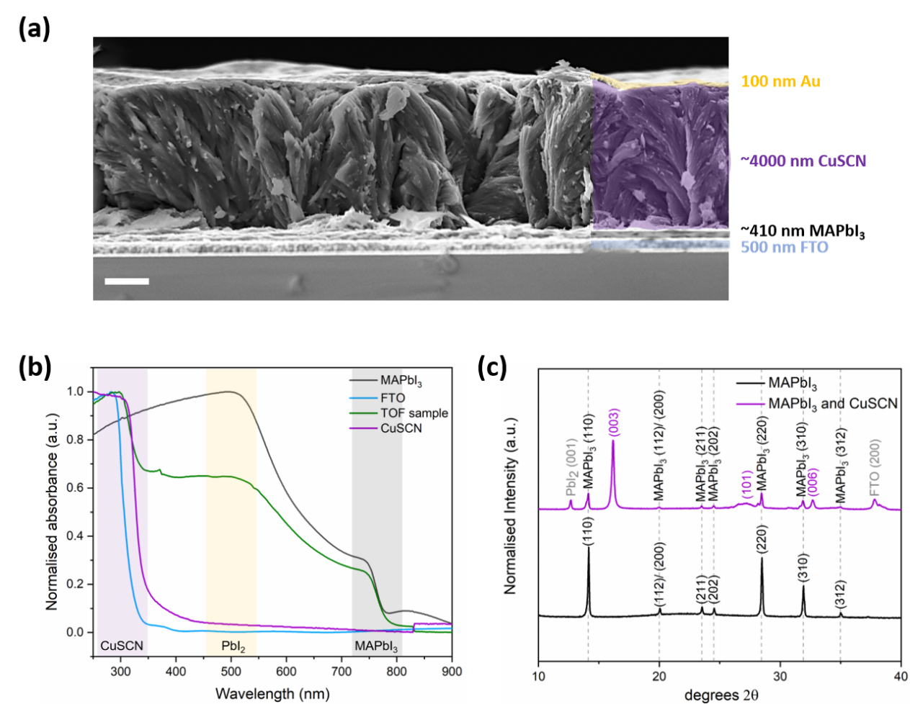
Results and Discussion
Figure 1. (a) Cross-sectional SEM image (scale bar = 1 µm), (b) UV-Vis absorption spectra and (c) Indexed XRD patterns for MAPbI₃ and 4 µm CuSCN on MAPbI₃.
The ToF device architecture is shown in Figure 1a. SEM cross-section images show a uniform 4 µm CuSCN film deposited via AACVD on a ~410 nm MAPbI₃ layer. The reason for incorporating a MAPbI₃ layer is three-fold. Firstly, the MAPbI₃ acts as a sensitizer layer, absorbing the laser of wavelength 355 nm and generating the charge carriers which drift through the bulk of the thick CuSCN layer to the counter electrode. The optical absorption spectrum (Figure 1b) shows the absorption onset for the different layers in the ToF device. CuSCN has an absorption onset of 320 nm and therefore does not absorb the laser used for ToF measurements (355 nm wavelength), thus requiring the use of a sensitizer layer. Ideally, a small absorption depth and high charge generation efficiency is needed for ToF ⁴³. MAPbI₃ has an absorption onset of ~770 nm and serves as the source of photogenerated charge carriers. Secondly, smoother films of CuSCN form on MAPbI₃ reducing the thickness error on the final measurement. Through AFM measurements (Figure S3), it was found that a CuSCN layer with 30% lower root mean square (RMS) roughness (64 nm) was formed on MAPbI₃ in comparison to the CuSCN layer deposited on FTO, which had an RMS roughness of 92 nm ⁴². Lastly, the addition of MAPbI₃ better represents the PSC structure. Based on the absorption coefficient at 355 nm wavelength (~10⁵ cm⁻¹, Figure S4), the laser penetrates less than 1/4th of the MAPbI₃ thickness (90 nm) indicating all the light is absorbed within the MAPbI₃ layer. The raw absorbance data, absorption coefficients data and thickness information for the different material layers can be found in the supporting information Figure S4 and Table S1. Therefore, charge generation is limited to the MAPbI₃ sensitizer layer. The MAPbI₃ and CuSCN layers are sandwiched between two electrodes, FTO and Au (Figure 1a). Short laser pulses are used to generate charge carriers in the MAPbI₃ layer, with holes transferred to CuSCN due to the conduction band offset. To identify the hole mobility in CuSCN, the FTO is biased positive so that the photogenerated holes drift towards the Au counter electrode ⁴⁴. The time taken for holes to drift across the bulk thickness ($d$) of CuSCN at each applied bias ($V$) is identified as the transit time ($t_{tr}$) and is used to calculate the mobility ($μ$) according to equation (1).
$$μ= \frac{d^{2}}{t_{tr}V} (1)$$
The absorption spectrum (Figure 1b) also indicates the presence of lead iodide (PbI₂), a degradation product of MAPbI₃ (indicated by the yellow region, ~500 nm). The sample was analysed via XRD to confirm this (Figure 1c, Figure S5). The XRD patterns indicate the presence of some PbI₂ along with the main peaks corresponding to MAPbI₃, CuSCN and FTO. This degradation may have occurred when the devices were exposed to air during transfer of samples to conduct measurements and because of the longer deposition timeframe required to deposit 4 µm CuSCN. It should be noted, the presence of PbI₂ does not influence the ToF measurement as the measurement only requires sufficient charge carriers to be generated by the MAPbI₃ to be detected after transit through the CuSCN layer.
For the 4 µm CuSCN device, ToF measurements were conducted over a range of 2-30 V. Typical ToF transients plotted on a double logarithmic scale measured at 5 V, 10 V and 20 V are shown in Figure 2a-c, they indicate the general trend of decreasing t_{tr} with increasing bias. The complete range of ToF transients is shown in Figure S6.
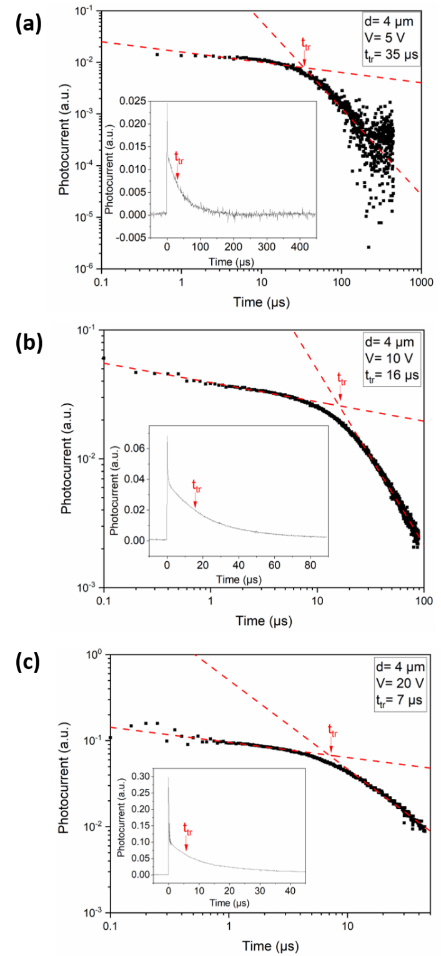
As it is difficult to identify the location of t_{tr} on the linear plot (Figure 2 insets) a double logarithmic plot was used to identify the t_{tr}. The t_{tr} was obtained from the intersection of the linear regions shown in Figure 2a-c. Figure 2a-c show a decrease in t_{tr} from 35 µs to 7 µs with an increase in voltage from 5 V to 20 V. The trend follows what is expected, as an increase in electric field should result in the charge carriers drifting through the bulk at a faster speed. To determine the effect of altering the film thickness on the out-of-plane hole mobility, additional ToF measurements were conducted on three 1.5 µm CuSCN film devices over a range of electric fields comparable to the 4 μm film measurements.
Figure 2. ToF transients measured at different voltages of (a) 5 V, (b) 10 V and (c) 20 V, plotted on a double logarithmic scale (transit time t_{tr} is indicated on the plots). Insets show the same data plotted on a linear scale.
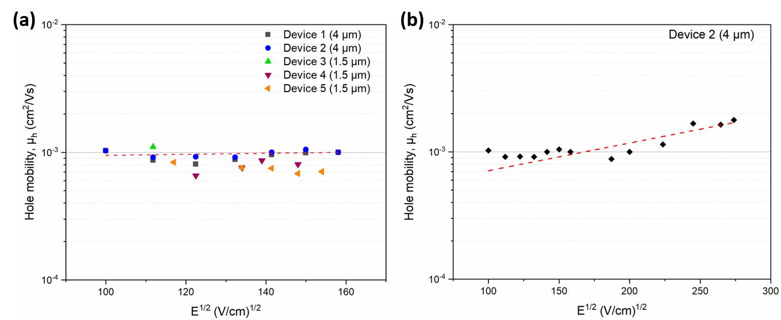
Poole-Frenkel plots (Figure 3a-b) are used to identify the relationship between CuSCN hole mobility and applied electric field. Figure 3a indicates a CuSCN hole mobility of ~10⁻³ cm²/Vs is reproducibly measured across devices with varying thickness of 4 µm and 1.5 µm CuSCN with weak field dependence at lower electric fields. The effect of higher electric fields on CuSCN hole mobility is analysed in Figure 3b. Here, a slight increase in field dependence can be seen at higher electric fields, but mobility remains within the order of 10⁻³ cm²/Vs. The average mobility across the range of electric fields studied can also be calculated using a 1/t_{tr} vs. V plot and is shown for the 4 µm CuSCN devices in Figure S7.
Figure 3. (a) Poole-Frenkel plots for 4 µm and 1.5 µm CuSCN devices. (b) Device 2 measured across a broad range of electric fields. The dashed line in a and b indicates an exponential fit to the data points of device 2.
Poole-Frenkel-type electric field dependence allows calculation of the electric field dependence parameter ($γ$) according to equation (2) ⁴⁵. Mobility, zero field mobility and electric field are denoted as $μ$, $μ_{0}$ and $E$, respectively.
$$μ= μ_{0}\exp\left(γ\sqrt{E}\right) (2)$$
Here, $μ_{0}$ takes the value 4.3 x 10⁻⁴ cm²/ Vs allowing calculation of $γ$ via an exponential fit of the data in Figure 3b (Figure S8), resulting in an average value of 0.005 ± 0.0016 (cm/V)^{1/2} over the range of fields measured. $μ_{0}$ is calculated by extrapolating the fit to find the mobility when no electric field is applied. For comparison, the field dependence of CuSCN at room temperature matches that of other HTLs such as PTAA ⁴⁶.
Given the overlap between the 1.5 μm data and the 4μm data in Figure 3a, we can conclude that the out-of-plane mobility of AACVD CuSCN is thickness independent and ~10⁻³ cm²/Vs with a weak field dependence of 0.005 (cm/V)^{1/2}. This value is at least an order of magnitude lower than the CuSCN FET mobility values stated in literature (~10⁻²-10⁻¹ cm²/Vs) ⁴⁷. It is important to consider slight differences in mobility do arise from different measurement techniques primarily due to device geometry ⁴⁸. For a more like-for-like comparison, ToF mobilities of commonly used HTLs PTAA and Spiro-OMeTAD have been reported as 10⁻⁵-10⁻³ cm²/Vs and 10⁻⁵-10⁻⁴ cm²/Vs, respectively ^{46,49,50}. Thus, the out-of-plane ToF mobility value we have measured for CuSCN is equal to or higher than the maximum ToF mobility values reported for other HTMs used in PSCs. We conclude that ~10⁻³ cm²/Vs is a more realistic measurement of CuSCN out-of-plane mobility found in devices than FET mobility measurements.
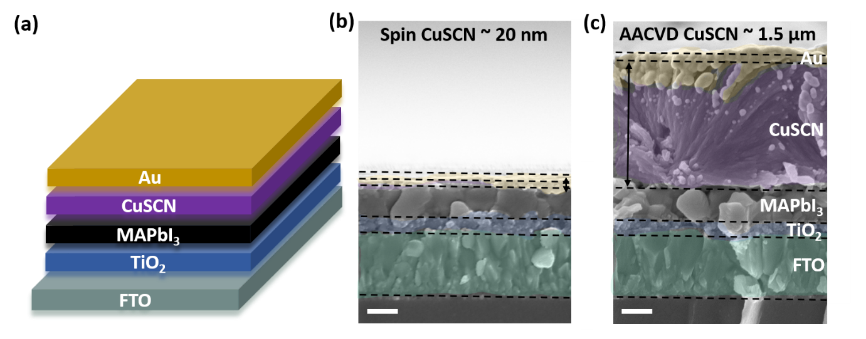
Figure 4. (a) Schematic of the n-i-p PSC structure. Figures b-c show SEM cross-sections of complete PSCs involving (b) spin coated and (c) AACVD CuSCN (scale bar = 200 nm).
To investigate how this measured mobility translates to device performance, the performance of CuSCN deposited by AACVD was compared to spin coated CuSCN in PSCs, using n-i-p architectures (Figure 4a). Figure 4b-c show SEM cross-sections of spin coated CuSCN and AACVD CuSCN incorporated into PSCs. The SEM images show that the AACVD CuSCN layer is approximately 75 times thicker than the spin coated CuSCN layer. As previously reported, a thickness of at least 1.5 µm was required to ensure CuSCN films formed by AACVD were continuous and pinhole free ⁴².
Figure 5a-b show J-V curves and PCE values for each scan direction for the champion spin-coated CuSCN and AACVD CuSCN PSCs. Solar cell parameters for each scan are given in Table 1. Incorporation of AACVD CuSCN in PSCs results in working devices with PCEs of 10.4 % in reverse and 7.9 % in forward bias. In comparison, 20 nm of spin coated CuSCN in the reference cells results in PCEs of 12.6 % in reverse bias, but slightly lower (7.5%) in forward bias.
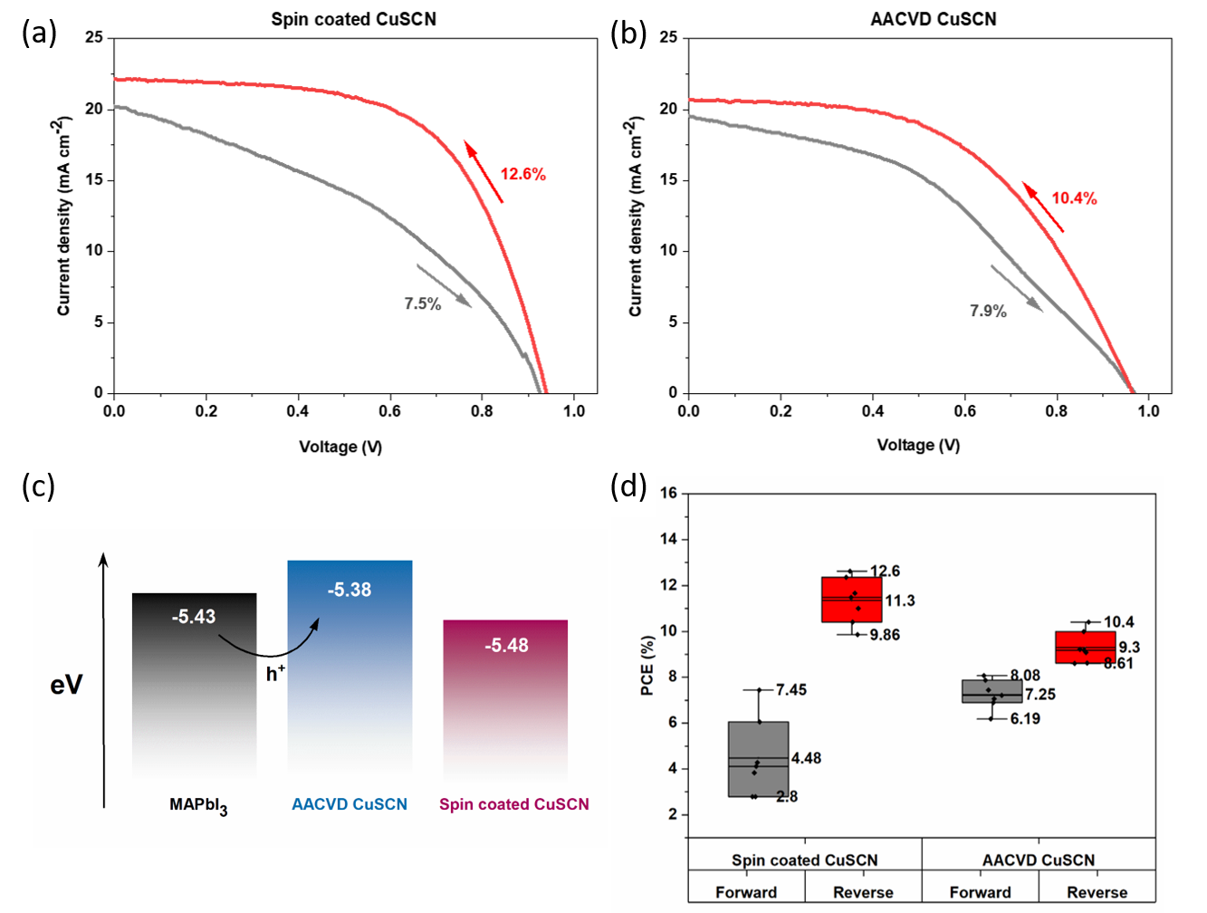
Figure 5. J-V curves of champion cells prepared by (a) spin coating CuSCN, (b) and AACVD CuSCN. Energy level diagram (c) showing ideal valence band alignment of AACVD CuSCN with MAPbI₃ for efficient hole extraction and (d) shows a boxplot of PCE achieved in forward and reverse scan directions for seven cells.
Table 1. Summary of solar cell parameters for champion cells (Figures 5a-b)
PSC architecture (scan direction) | Jsc  (mA cm⁻²) | Voc (V) | FF | PCE (%) | HI
FTO/ TiO₂/ MAPbI₃/spin coated CuSCN/Au (forward) | 20.3 | 0.93 | 0.40 | 7.5 | 0.41
FTO/ TiO₂/ MAPbI₃/ spin coated CuSCN/ Au (reverse) | 22.1 | 0.94 | 0.61 | 12.6 | 0.41
FTO/ TiO₂/ MAPbI₃/ AACVD CuSCN/ Au (forward) | 19.6 | 0.97 | 0.42 | 7.9 | 0.24
FTO/ TiO₂/ MAPbI₃/ AACVD CuSCN/ Au (reverse) | 20.7 | 0.97 | 0.52 | 10.4 | 0.24

The spin coated CuSCN PSC efficiency is comparable to reported values of 12.4 % PCE for solution processed CuSCN with the same n-i-p configuration ⁴⁰. The absolute drop of only ~2% PCE indicates the greater thickness of the AACVD CuSCN layer does not compromise the efficiency as much as may be expected for such a thick HTL layer. This is consistent with the long-range hole transport measured via ToF and proves AACVD is a promising technique for depositing scalable CuSCN layers. Series and shunt resistance values for champion cells are stated in Table S2. The lower PCE of the AACVD CuSCN device in the reverse scan direction is associated with an increased series resistance of 15.3 Ω cm², which is higher than the series resistance of the spin coated CuSCN device (9.2 Ω cm²), lowering the fill factor. This indicates that although the mobility of CuSCN is high, the overall conductance of the layer is low due to its thickness. It should be noted, although the AACVD CuSCN layer is 75 times thicker than the spin coated CuSCN layer, the series resistance has only increased by ~66%. The increase in shunt resistance for the AACVD CuSCN cell is consistent with the thickness and uniformity of the layer. Through APS measurements it was found that the E_{v} of AACVD CuSCN (-5.38 eV) was shallower than spin coated CuSCN (-5.48 eV) and well aligned with the E_{v} value of MAPbI₃ (5.43 eV) which may allow improved charge transfer at the MAPbI₃/ AACVD CuSCN interface (Figure 5c, S9) ⁵¹. This suggests that the efficiency loss due to the increased series resistance in the AACVD CuSCN may be offset by the improved interfacial energetics. Furthermore, the spin coated CuSCN cell has a larger hysteresis than the AACVD CuSCN cell. Hysteresis index is affected by various parameters but as in this case all scans were measured using the same conditions (i.e. identical scan speeds and voltage range), with no previous light soaking, the hysteresis index (HI) was calculated using equation (3) to quantify this ⁵²:
$$Hysteresis Index \left(HI\right)= \frac{PCE \left(reverse\right)-PCE (forward)}{PCE (reverse)} (3)$$
Table 1 compares the HI values for cells incorporating the spin coated and AACVD CuSCN layers. Overall, the AACVD CuSCN layer shows ~40% lower hysteresis. It is known that redistribution of mobile halide ions originating from MAPbI₃ at each of the interfaces screens the built-in field. This impedes charge extraction leading to hysteresis ⁵². However, this effect is reduced using AACVD CuSCN instead of spin coated CuSCN. Hysteresis has also been linked to interfacial recombination and asymmetry in the charge extraction at the HTL and ETL ⁵³. The improved interfacial energetics of AACVD CuSCN to MAPbI₃ leads to efficient hole extraction, reducing interfacial recombination resulting in the decreased hysteresis.
The distribution of PCEs achieved for spin coated and AACVD CuSCN cells is shown in Figure 5d. The range of PCEs achieved for AACVD CuSCN cells and spin coated CuSCN cells overlap in both scan directions indicating there are only small differences in performance achieved between the two layer types. Incorporation of AACVD CuSCN results in a smaller spread of data in both scan directions, indicating it is more reproducible, and the reduced hysteresis can clearly be seen when comparing the full ranges of PCEs achieved in both scan directions.
Conclusion
We have measured an out-of-plane ToF hole mobility for CuSCN for the first time, facilitated by the deposition of > 1.5 µm CuSCN films by AACVD, giving values of ~10⁻³ cm²/Vs at room temperature with a weak electric field dependence of 0.005 (cm/V)^{1/2}. By conducting the ToF measurement using varying film thicknesses of 1.5 and 4 µm CuSCN, we conclude the mobility is independent of the layer thickness. Although the mobility is lower than CuSCN in-plane FET mobility values stated in the literature, it is equal or higher than other commonly used HTLs such as PTAA and Spiro-OMeTAD measured using ToF. The performance of 1.5 µm CuSCN deposited via AACVD in MAPbI₃ PSCs was compared to that of spin coated CuSCN of 20 nm thickness. PCEs of 10.4 % were achieved, which were only slightly below spin coated CuSCN, indicating the greater thickness of AACVD CuSCN did not compromise the efficiency much. Moreover, a ~40 % decrease in hysteresis was found by incorporating AACVD CuSCN compared with devices using spin coated CuSCN. This performance is attributed to the high hole mobility and long-range charge transport, with favourable CuSCN/ MAPbI₃ interfacial properties also identified, which allows efficient hole extraction. These results indicate the potential to use thicker layers of CuSCN in PSCs, which would be more compatible with large-scale processing techniques.
Supporting Information
Additional ToF information such as a schematic of ToF set-up, sample oscilloscope traces, hole transients ranging 2-30 V for the 4 µm CuSCN sample and an alternative method to calculate the hole mobility of CuSCN is outlined. In addition to this, extra characterisation such as AFM, UV-Vis, XRD, APS data and parasitic solar cell resistance values are supplied as Supporting Information.
Acknowledgements
The authors acknowledge EPSRC Centre for Doctoral Training in Plastic Electronic Materials EP/L016702/1 for their support. TK wishes to acknowledge STFC (ST/V000039/1) for financial support.

References
(1) Kojima, A.; Teshima, K.; Shirai, Y.; Miyasaka, T. Organometal Halide Perovskites as Visible-Light Sensitizers for Photovoltaic Cells. J. Am. Chem. Soc. 2009, 131 (17), 6050–6051. https://doi.org/10.1021/ja809598r.
(2) Best Research-Cell Efficiency Chart | Photovoltaic Research | NREL https://www.nrel.gov/pv/cell-efficiency.html (accessed Jul 15, 2021).
(3) Jena, A. K.; Kulkarni, A.; Miyasaka, T. Halide Perovskite Photovoltaics: Background, Status, and Future Prospects. Chem. Rev. 2019, 119 (5), 3036–3103. https://doi.org/10.1021/acs.chemrev.8b00539.
(4) Suarez, B.; Gonzalez-Pedro, V.; Ripolles, T. S.; Sanchez, R. S.; Otero, L.; Mora-Sero, I. Recombination Study of Combined Halides (Cl, Br, I) Perovskite Solar Cells. J. Phys. Chem. Lett. 2014, 5 (10), 1628–1635. https://doi.org/10.1021/jz5006797.
(5) Eperon, G. E.; Stranks, S. D.; Menelaou, C.; Johnston, M. B.; Herz, L. M.; Snaith, H. J.; Mhaisalkar, S.; Sum, T. C.; Snaith, H. J.; Moser, J. E.; Grätzel, M.; Park, N.-G. Formamidinium Lead Trihalide: A Broadly Tunable Perovskite for Efficient Planar Heterojunction Solar Cells. Energy Environ. Sci. 2014, 7 (3), 982. https://doi.org/10.1039/c3ee43822h.
(6) Le Corre, V. M.; Stolterfoht, M.; Perdigón Toro, L.; Feuerstein, M.; Wolff, C.; Gil-Escrig, L.; Bolink, H. J.; Neher, D.; Koster, L. J. A. Charge Transport Layers Limiting the Efficiency of Perovskite Solar Cells: How To Optimize Conductivity, Doping, and Thickness. ACS Appl. Energy Mater. 2019, 2 (9), 6280–6287. https://doi.org/10.1021/acsaem.9b00856.
(7) Heo, J. H.; Han, H. J.; Kim, D.; Ahn, T. K.; Im, S. H. Hysteresis-Less Inverted CH 3 NH 3 PbI 3 Planar Perovskite Hybrid Solar Cells with 18.1% Power Conversion Efficiency. Energy Environ. Sci. 2015, 8 (5), 1602–1608. https://doi.org/10.1039/C5EE00120J.
(8) Deng, W.; Liang, X.; Kubiak, P. S.; Cameron, P. J. Molecular Interlayers in Hybrid Perovskite Solar Cells. Adv. Energy Mater. 2018, 8 (1), 1701544. https://doi.org/10.1002/aenm.201701544.
(9) Cai, F.; Yang, L.; Yan, Y.; Zhang, J.; Qin, F.; Liu, D.; Cheng, Y.-B.; Zhou, Y.; Wang, T. Eliminated Hysteresis and Stabilized Power Output over 20% in Planar Heterojunction Perovskite Solar Cells by Compositional and Surface Modifications to the Low-Temperature-Processed TiO 2 Layer. J. Mater. Chem. A 2017, 5 (19), 9402–9411. https://doi.org/10.1039/C7TA02317K.
(10) Grancini, G.; Roldán-Carmona, C.; Zimmermann, I.; Mosconi, E.; Lee, X.; Martineau, D.; Narbey, S.; Oswald, F.; De Angelis, F.; Graetzel, M.; Nazeeruddin, M. K. One-Year Stable Perovskite Solar Cells by 2D/3D Interface Engineering. Nat. Commun. 2017, 8 (1), 15684. https://doi.org/10.1038/ncomms15684.
(11) Yang, M.; Li, Z.; Reese, M. O.; Reid, O. G.; Kim, D. H.; Siol, S.; Klein, T. R.; Yan, Y.; Berry, J. J.; van Hest, M. F. A. M.; Zhu, K. Perovskite Ink with Wide Processing Window for Scalable High-Efficiency Solar Cells. Nat. Energy 2017, 2 (5), 17038. https://doi.org/10.1038/nenergy.2017.38.
(12) Ono, L. K.; Leyden, M. R.; Wang, S.; Qi, Y. Organometal Halide Perovskite Thin Films and Solar Cells by Vapor Deposition. Journal of Materials Chemistry A. Royal Society of Chemistry May 3, 2016, pp 6693–6713. https://doi.org/10.1039/c5ta08963h.
(13) Mohamad, D. K.; Griffin, J.; Bracher, C.; Barrows, A. T.; Lidzey, D. G. Spray-Cast Multilayer Organometal Perovskite Solar Cells Fabricated in Air. Adv. Energy Mater. 2016, 6 (22), 1600994. https://doi.org/10.1002/aenm.201600994.
(14) Nair, S.; Gohel, J. V. A Review on Contemporary Hole Transport Materials for Perovskite Solar Cells. In Green Energy and Technology; Springer, 2020; pp 145–168. https://doi.org/10.1007/978-3-030-33774-2_6.
(15) Li, X.; Bi, D.; Yi, C.; Décoppet, J.-D.; Luo, J.; Zakeeruddin, S. M.; Hagfeldt, A.; Grätzel, M. A Vacuum Flash–Assisted Solution Process for High-Efficiency Large-Area Perovskite Solar Cells. Science (80-. ). 2016, 353 (6294), 58–62. https://doi.org/10.1126/science.aaf8060.
(16) Bi, C.; Wang, Q.; Shao, Y.; Yuan, Y.; Xiao, Z.; Huang, J. Non-Wetting Surface-Driven High-Aspect-Ratio Crystalline Grain Growth for Efficient Hybrid Perovskite Solar Cells. Nat. Commun. 2015, 6 (1), 7747. https://doi.org/10.1038/ncomms8747.
(17) Pashaei, B.; Bellani, S.; Shahroosvand, H.; Bonaccorso, F. Molecularly Engineered Hole-Transport Material for Low-Cost Perovskite Solar Cells. Chem. Sci. 2020, 11 (9), 2429–2439. https://doi.org/10.1039/c9sc05694g.
(18) Patel, S. B.; Patel, A. H.; Gohel, J. V. A Novel and Cost Effective CZTS Hole Transport Material Applied in Perovskite Solar Cells. CrystEngComm 2018, 20 (47), 7677–7687. https://doi.org/10.1039/C8CE01337C.
(19) Christians, J. A.; Fung, R. C. M.; Kamat, P. V. An Inorganic Hole Conductor for Organo-Lead Halide Perovskite Solar Cells. Improved Hole Conductivity with Copper Iodide. J. Am. Chem. Soc. 2014, 136 (2), 758–764. https://doi.org/10.1021/ja411014k.
(20) Chavhan, S.; Miguel, O.; Grande, H.-J.; Gonzalez-Pedro, V.; Sánchez, R. S.; Barea, E. M.; Mora-Seró, I.; Tena-Zaera, R. Organo-Metal Halide Perovskite-Based Solar Cells with CuSCN as the Inorganic Hole Selective Contact. J. Mater. Chem. A 2014, 2 (32), 12754–12760. https://doi.org/10.1039/C4TA01310G.
(21) Zhu, Z.; Bai, Y.; Zhang, T.; Liu, Z.; Long, X.; Wei, Z.; Wang, Z.; Zhang, L.; Wang, J.; Yan, F.; Yang, S. High-Performance Hole-Extraction Layer of Sol-Gel-Processed NiO Nanocrystals for Inverted Planar Perovskite Solar Cells. Angew. Chemie Int. Ed. 2014, n/a-n/a. https://doi.org/10.1002/anie.201405176.
(22) Yin, X.; Song, Z.; Li, Z.; Tang, W. Toward Ideal Hole Transport Materials: A Review on Recent Progress in Dopant-Free Hole Transport Materials for Fabricating Efficient and Stable Perovskite Solar Cells. Energy Environ. Sci. 2020, 13 (11), 4057–4086. https://doi.org/10.1039/D0EE02337J.
(23) Er, U.; Icli, K. C.; Ozenbas, M. Spin-Coated Copper(I) Thiocyanate as a Hole Transport Layer for Perovskite Solar Cells. J. Solid State Electrochem. 2020, 24 (2), 293–304. https://doi.org/10.1007/s10008-019-04430-2.
(24) Wijeyasinghe, N.; Anthopoulos, T. D. Copper(I) Thiocyanate (CuSCN) as a Hole-Transport Material for Large-Area Opto/Electronics. Semicond. Sci. Technol. 2015, 30 (10), 104002. https://doi.org/10.1088/0268-1242/30/10/104002.
(25) Arora, N.; Dar, M. I.; Hinderhofer, A.; Pellet, N.; Schreiber, F.; Zakeeruddin, S. M.; Grätzel, M. Perovskite Solar Cells with CuSCN Hole Extraction Layers Yield Stabilized Efficiencies Greater than 20%. Science (80-. ). 2017, 358 (6364), 768–771. https://doi.org/10.1126/science.aam5655.
(26) Treat, N. D.; Yaacobi-Gross, N.; Faber, H.; Perumal, A. K.; Bradley, D. D. C.; Stingelin, N.; Anthopoulos, T. D. Copper Thiocyanate: An Attractive Hole Transport/Extraction Layer for Use in Organic Photovoltaic Cells. Appl. Phys. Lett. 2015, 107 (1), 013301. https://doi.org/10.1063/1.4926408.
(27) Yaacobi-Gross, N.; Treat, N. D.; Pattanasattayavong, P.; Faber, H.; Perumal, A. K.; Stingelin, N.; Bradley, D. D. C.; Stavrinou, P. N.; Heeney, M.; Anthopoulos, T. D. High-Efficiency Organic Photovoltaic Cells Based on the Solution-Processable Hole Transporting Interlayer Copper Thiocyanate (CuSCN) as a Replacement for PEDOT:PSS. Adv. Energy Mater. 2015, 5 (3), 1401529. https://doi.org/10.1002/aenm.201401529.
(28) Fakharuddin, A.; Vasilopoulou, M.; Soultati, A.; Haider, M. I.; Briscoe, J.; Fotopoulos, V.; Di Girolamo, D.; Davazoglou, D.; Chroneos, A.; Yusoff, A. R. bin M.; Abate, A.; Schmidt-Mende, L.; Nazeeruddin, M. K. Robust Inorganic Hole Transport Materials for Organic and Perovskite Solar Cells: Insights into Materials Electronic Properties and Device Performance. Sol. RRL 2021, 5 (1), 2000555. https://doi.org/10.1002/solr.202000555.
(29) Petti, L.; Pattanasattayavong, P.; Lin, Y.-H.; Münzenrieder, N.; Cantarella, G.; Yaacobi-Gross, N.; Yan, F.; Tröster, G.; Anthopoulos, T. D. Solution-Processed p-Type Copper(I) Thiocyanate (CuSCN) for Low-Voltage Flexible Thin-Film Transistors and Integrated Inverter Circuits. Appl. Phys. Lett. 2017, 110 (11), 113504. https://doi.org/10.1063/1.4978531.
(30) Hatch, S. M.; Briscoe, J.; Dunn, S. A Self-Powered ZnO-Nanorod/CuSCN UV Photodetector Exhibiting Rapid Response. Adv. Mater. 2013, 25 (6), 867–871. https://doi.org/10.1002/adma.201204488.
(31) Li, S.; Guo, D.; Li, P.; Wang, X.; Wang, Y.; Yan, Z.; Liu, Z.; Zhi, Y.; Huang, Y.; Wu, Z.; Tang, W. Ultrasensitive, Superhigh Signal-to-Noise Ratio, Self-Powered Solar-Blind Photodetector Based on n -Ga 2 O 3 / p -CuSCN Core–Shell Microwire Heterojunction. ACS Appl. Mater. Interfaces 2019, 11 (38), 35105–35114. https://doi.org/10.1021/acsami.9b11012.
(32) Pattanasattayavong, P.; Mottram, A. D.; Yan, F.; Anthopoulos, T. D. Study of the Hole Transport Processes in Solution-Processed Layers of the Wide Bandgap Semiconductor Copper(I) Thiocyanate (CuSCN). Adv. Funct. Mater. 2015, 25 (43), 6802–6813. https://doi.org/10.1002/adfm.201502953.
(33) Wijeyasinghe, N.; Regoutz, A.; Eisner, F.; Du, T.; Tsetseris, L.; Lin, Y.; Faber, H.; Pattanasattayavong, P.; Li, J.; Yan, F.; McLachlan, M. A.; Payne, D. J.; Heeney, M.; Anthopoulos, T. D. Copper(I) Thiocyanate (CuSCN) Hole-Transport Layers Processed from Aqueous Precursor Solutions and Their Application in Thin-Film Transistors and Highly Efficient Organic and Organometal Halide Perovskite Solar Cells. Adv. Funct. Mater. 2017, 27 (35), 1701818. https://doi.org/10.1002/adfm.201701818.
(34) Ji, Y.; Lee, H. J.; Lee, S.; Cho, K. G.; Lee, K. H.; Hong, K. High‐Performance P‐Type Copper(I) Thiocyanate Thin Film Transistors Processed from Solution at Low Temperature. Adv. Mater. Interfaces 2019, 6 (19), 1900883. https://doi.org/10.1002/admi.201900883.
(35) Ye, S.; Sun, W.; Li, Y.; Yan, W.; Peng, H.; Bian, Z.; Liu, Z.; Huang, C. CuSCN-Based Inverted Planar Perovskite Solar Cell with an Average PCE of 15.6%. Nano Lett. 2015, 15 (6), 3723–3728. https://doi.org/10.1021/acs.nanolett.5b00116.
(36) Zhao, K.; Munir, R.; Yan, B.; Yang, Y.; Kim, T.; Amassian, A. Solution-Processed Inorganic Copper(I) Thiocyanate (CuSCN) Hole Transporting Layers for Efficient p–i–n Perovskite Solar Cells. J. Mater. Chem. A 2015, 3 (41), 20554–20559. https://doi.org/10.1039/C5TA04028K.
(37) Perumal, A.; Faber, H.; Yaacobi‐Gross, N.; Pattanasattayavong, P.; Burgess, C.; Jha, S.; McLachlan, M. A.; Stavrinou, P. N.; Anthopoulos, T. D.; Bradley, D. D. C. High‐Efficiency, Solution‐Processed, Multilayer Phosphorescent Organic Light‐Emitting Diodes with a Copper Thiocyanate Hole‐Injection/Hole‐Transport Layer. Adv. Mater. 2015, 27 (1), 93–100. https://doi.org/10.1002/adma.201403914.
(38) Hatch, S. M.; Briscoe, J.; Dunn, S. Improved CuSCN–ZnO Diode Performance with Spray Deposited CuSCN. Thin Solid Films 2013, 531, 404–407. https://doi.org/10.1016/j.tsf.2012.12.114.
(39) Li, X.; Zhou, D.; Hao, H.; Chen, H.; Weng, Y.; Bian, H. Vibrational Relaxation Dynamics of a Semiconductor Copper(I) Thiocyanate (CuSCN) Film as a Hole-Transporting Layer. J. Phys. Chem. Lett. 2020, 11 (2), 548–555. https://doi.org/10.1021/acs.jpclett.9b03480.
(40) Qin, P.; Tanaka, S.; Ito, S.; Tetreault, N.; Manabe, K.; Nishino, H.; Nazeeruddin, M. K.; Grätzel, M. Inorganic Hole Conductor-Based Lead Halide Perovskite Solar Cells with 12.4% Conversion Efficiency. Nat. Commun. 2014, 5 (1), 3834. https://doi.org/10.1038/ncomms4834.
(41) Ghosh, S.; Sarkar, S. K. Controlled Morphology of Electrochemically Deposited CuSCN by Variation of Applied Bias Voltage. Energy Procedia 2014, 54, 777–781. https://doi.org/10.1016/j.egypro.2014.07.320.
(42) Mohan, L.; Ratnasingham, S. R.; Panidi, J.; Anthopoulos, T. D.; Binions, R.; McLachlan, M. A.; Briscoe, J. Low Temperature Scalable Deposition of Copper(I) Thiocyanate Films via Aerosol-Assisted Chemical Vapor Deposition. Cryst. Growth Des. 2020, 20 (8), 5380–5386. https://doi.org/10.1021/acs.cgd.0c00605.
(43) Liu, S.-W.; Lee, C.-C.; Su, W.-C.; Yuan, C.-H.; Lin, C.-F.; Chen, K.-T.; Shu, Y.-S.; Li, Y.-Z.; Su, T.-H.; Huang, B.-Y.; Chang, W.-C.; Liu, Y.-H. Downscaling the Sample Thickness to Sub-Micrometers by Employing Organic Photovoltaic Materials as a Charge-Generation Layer in the Time-of-Flight Measurement. Sci. Rep. 2015, 5 (1), 10384. https://doi.org/10.1038/srep10384.
(44) Kreouzis, T.; Poplavskyy, D.; Tuladhar, S. M.; Campoy-Quiles, M.; Nelson, J.; Campbell, A. J.; Bradley, D. D. C. Temperature and Field Dependence of Hole Mobility in Poly(9,9-Dioctylfluorene). Phys. Rev. B 2006, 73 (23), 235201. https://doi.org/10.1103/PhysRevB.73.235201.
(45) Bässler, H. Charge Transport in Disordered Organic Photoconductors a Monte Carlo Simulation Study. Phys. status solidi 1993, 175 (1), 15–56. https://doi.org/10.1002/pssb.2221750102.
(46) Barard, S.; Heeney, M.; Chen, L.; Cölle, M.; Shkunov, M.; McCulloch, I.; Stingelin, N.; Philips, M.; Kreouzis, T. Separate Charge Transport Pathways Determined by the Time of Flight Method in Bimodal Polytriarylamine. J. Appl. Phys. 2009, 105 (1), 013701. https://doi.org/10.1063/1.3054180.
(47) Pattanasattayavong, P.; Yaacobi-Gross, N.; Zhao, K.; Ndjawa, G. O. N.; Li, J.; Yan, F.; O’Regan, B. C.; Amassian, A.; Anthopoulos, T. D. Hole-Transporting Transistors and Circuits Based on the Transparent Inorganic Semiconductor Copper(I) Thiocyanate (CuSCN) Processed from Solution at Room Temperature. Adv. Mater. 2013, 25 (10), 1504–1509. https://doi.org/10.1002/adma.201202758.
(48) Myronov, M. Molecular Beam Epitaxy of High Mobility Silicon, Silicon Germanium and Germanium Quantum Well Heterostructures. In Molecular Beam Epitaxy; Elsevier, 2018; pp 37–54. https://doi.org/10.1016/B978-0-12-812136-8.00003-7.
(49) Poplavskyy, D.; Nelson, J. Nondispersive Hole Transport in Amorphous Films of Methoxy-Spirofluorene-Arylamine Organic Compound. J. Appl. Phys. 2003, 93 (1), 341–346. https://doi.org/10.1063/1.1525866.
(50) Meng, G.; Shi, Y.; Song, X.; Ji, M.; Xue, Y.; Hao, C. Theoretical Insight into the Carrier Mobility Anisotropy of Hole Transport Material Spiro-OMeTAD. Curr. Appl. Phys. 2017, 17 (10), 1316–1322. https://doi.org/10.1016/j.cap.2017.06.004.
(51) Daboczi, M.; Kim, J.; Lee, J.; Kang, H.; Hamilton, I.; Lin, C.; Dimitrov, S. D.; McLachlan, M. A.; Lee, K.; Durrant, J. R.; Kim, J. Towards Efficient Integrated Perovskite/Organic Bulk Heterojunction Solar Cells: Interfacial Energetic Requirement to Reduce Charge Carrier Recombination Losses. Adv. Funct. Mater. 2020, 30 (25), 2001482. https://doi.org/10.1002/adfm.202001482.
(52) Habisreutinger, S. N.; Noel, N. K.; Snaith, H. J. Hysteresis Index: A Figure without Merit for Quantifying Hysteresis in Perovskite Solar Cells. ACS Energy Lett. 2018, 3 (10), 2472–2476. https://doi.org/10.1021/acsenergylett.8b01627.
(53) Calado, P.; Telford, A. M.; Bryant, D.; Li, X.; Nelson, J.; O’Regan, B. C.; Barnes, P. R. F. Evidence for Ion Migration in Hybrid Perovskite Solar Cells with Minimal Hysteresis. Nat. Commun. 2016, 7 (1), 13831. https://doi.org/10.1038/ncomms13831.

For Table of Contents Only

Title: Determining out-of-plane hole mobility in CuSCN via the time-of-flight technique to elucidate its function in perovskite solar cells

