Seasonal temperature and moisture changes in interior semi-arid Spain from the last interglacial to the late Holocene: Supplementary Information

Dongyang Wei^{1, 2}, Penélope González-Sampériz³, Graciela Gil-Romera³, Sandy P. Harrison¹, I. Colin Prentice⁴

1: Department of Geography and Environmental Science, University of Reading, Whiteknights, Reading, RG6 6AB, UK
2: Masters Programme in Ecosystem and Environmental Change, Department of Life Sciences, Imperial College London, Ascot, SL5 7PY, UK
3: Instituto Pirenaico de Ecología-CSIC, Avda. Montañana 1005, 50059, Zaragoza, Spain
4: AXA Chair Programme in Biosphere and Climate Impacts, Department of Life Sciences, Imperial College London, Ascot, SL5 7PY, UK

This supplementary contains the following figures and tables:

SI Figure 1. The impact of removing Poaceae and Polypodiales from the taxon set on reconstructions of (a) mean temperature of the coldest month (MTCO, °C) and (b) growing degree days above a base level of 0°C (GDD0) during MIS 4 and MIS 5a. The red line (without P/P) is the reconstructed values once Poaceae and Polypodiales are removed. The comparison shows that removing these two taxa reduces anomalous peaks, where they were particularly abundant, but has little impact on the reconstructions for the rest of the samples.

SI Figure 2. Reconstructed mean temperature of the coldest month (MTCO, °C), growing degree days above a base level of 0°C (GDD0) and square root of the moisture index (the ratio of annual precipitation to annual potential evapotranspiration, MI) after CO₂ correction. This plot differs from Figure 5 in the main text because the reconstructions for all of the samples are shown, and we show the full uncertainties rather than the sample-specific (v1, rioja) uncertainties. The Marine Isotope Stages (MIS) and substages are shown by vertical dotted lines and labeled; we also show the transition interval between MIS 6 and MIS 5e. Red dots indicate the modern climate calculated from the elevation-corrected climate data from the Climate Research Unit (CRU) 2.0 data set.

SI Figure 3: Identification of reconstructed climate changes during selected Dansgaard-Oeschger and Heinrich events. Reconstructed mean temperature of the coldest month (MTCO, °C), growing degree days above a base level of 0°C (GDD0) and CO2 corrected moisture index (the ratio of annual precipitation to annual potential evapotranspiration, MI). Only samples with a Hill’s N2 biodiversity index >2 are plotted. The Marine Isotope Stages (MIS) and substages are shown by vertical dotted lines and labeled; we also show the transition interval between MIS 6 and MIS 5e. Red dots indicate the modern climate calculated from the elevation-corrected climate data from the Climate Research Unit (CRU) 2.0 data set.

SI Table 1: Information on the 195 taxa from the SMPDS modern data set used in the TWA-PLS reconstructions, including the number of sites at which they occur and their taxonomic resolution.

SI Table 2: Leave-one-out cross-validated predictions of the weighted averaging-partial least squares (WA-PLS) regression models for 195 taxa (including Poaceae and Polypodiales). The P values are derived from a randomisation t-test. Selected components are marked in bold.
SI Table 3: Reconstructed mean temperature of the coldest month (MTCO, °C), growing degree days above a base level of 0°C (GDD0) and the square root of the moisture index (the ratio of annual precipitation to annual potential evapotranspiration, MI) for each of the samples. We give the depth and age for each sample. For the reconstructions of √MI, we give values before and after the [CO2] correction. Only samples with a Hill’s N2 biodiversity index >2 are listed. We include the sample-specific errors on the reconstructions based on V1 from the rioja package.

SI Table 4: Reconstructed average values of mean temperature of the coldest month (MTCO, °C), growing degree days above a base level of 0° C (GDD₀) and moisture index (the ratio of annual precipitation to annual potential evapotranspiration, MI) for Marine Isotope Stages (MIS ) and substages, calculated from the interpolated yearly values of each variable. The transitional phase at the beginning of MIS 5 corresponding to the Zeifen-Kattegat Oscillation is labelled Zeifen in the column showing the Marine Isotopic Stages.

SI Figure 1. The impact of removing Poaceae and Polypodiales from the taxon set on reconstructions of (a) mean temperature of the coldest month (MTCO, °C) and (b) growing degree days above a base level of 0°C (GDD0) during MIS 4 and MIS 5a. The red line (without P/P) is the reconstructed values once Poaceae and Polypodiales are removed. The comparison shows that removing these two taxa reduces anomalous peaks, where they were particularly abundant, but has little impact on the reconstructions for the rest of the samples.
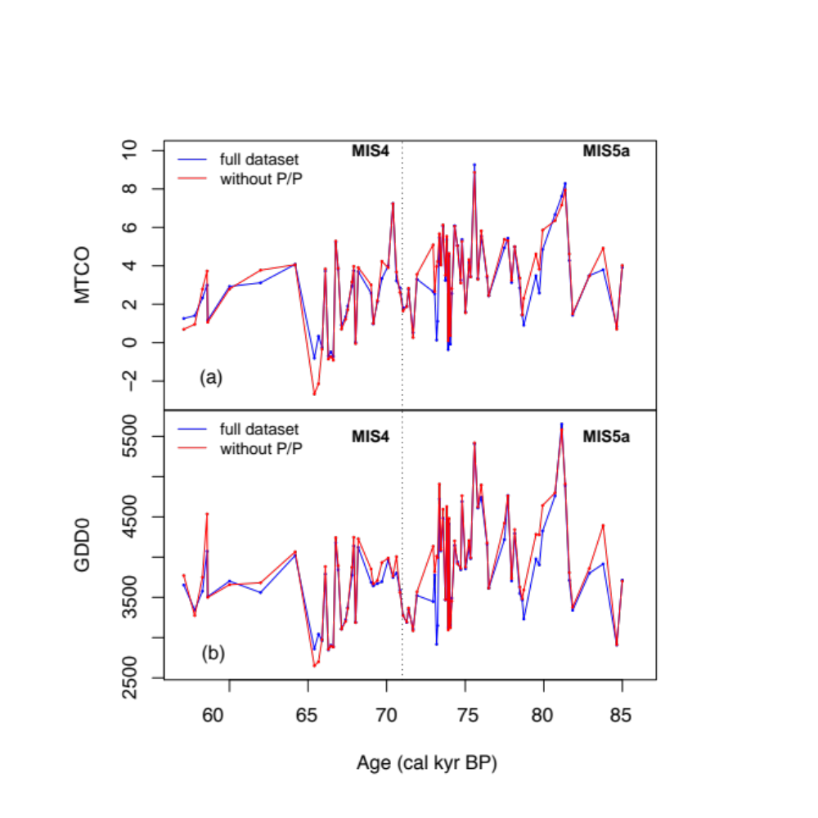

SI Figure 2. Reconstructed mean temperature of the coldest month (MTCO, °C), growing degree days above a base level of 0°C (GDD0) and square root of the moisture index (the ratio of annual precipitation to annual potential evapotranspiration, MI) after CO₂ correction. This plot differs from Figure 5 in the main text because the reconstructions for all of the samples are shown, and we show the full uncertainties rather than the sample-specific (v1, rioja) uncertainties. The Marine Isotope Stages (MIS) and substages are shown by vertical dotted lines and labeled; we also show the transition interval between MIS 6 and MIS 5e. Red dots indicate the modern climate calculated from the elevation-corrected climate data from the Climate Research Unit (CRU) 2.0 data set.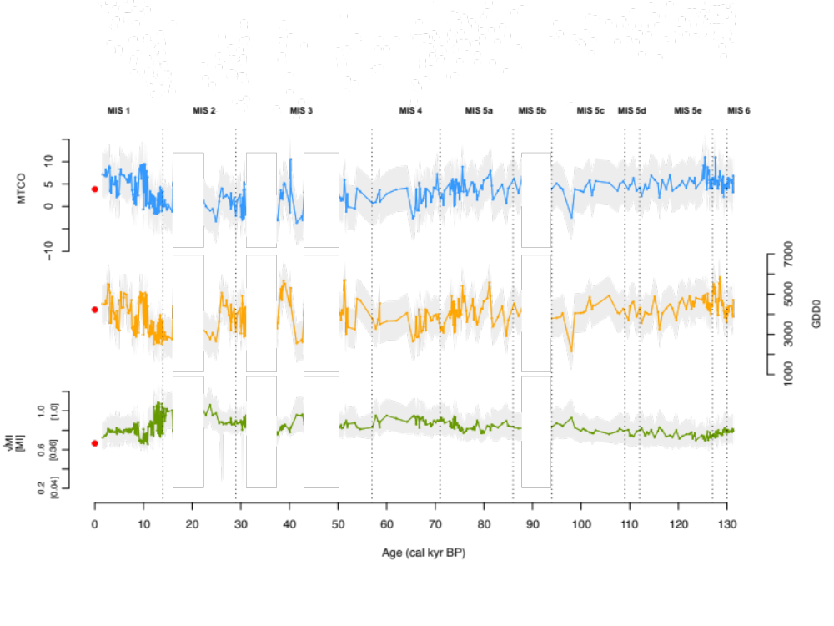
SI Figure 3: Identification of reconstructed climate changes during selected Dansgaard-Oeschger and Heinrich events. Reconstructed mean temperature of the coldest month (MTCO, °C), growing degree days above a base level of 0°C (GDD0) and CO2 corrected moisture index (the ratio of annual precipitation to annual potential evapotranspiration, MI). Only samples with a Hill’s N2 biodiversity index >2 are plotted. The Marine Isotope Stages (MIS) and substages are shown by vertical dotted lines and labeled; we also show the transition interval between MIS 6 and MIS 5e. Red dots indicate the modern climate calculated from the elevation-corrected climate data from the Climate Research Unit (CRU) 2.0 data set.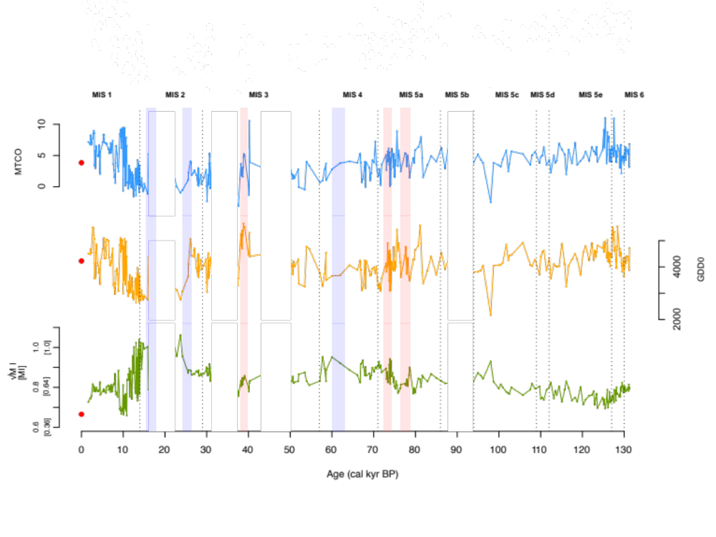

SI Table 1: Information on the 195 taxa from the SMPDS modern data set used in the TWA-PLS reconstructions, including the number of sites at which they occur and their taxonomic resolution.

Taxon name | Number of sites | Taxonomic resolution
Abies | 2410 | Genus
Acer | 981 | Genus
Aconitum | 110 | Genus
Adonis | 25 | Genus
Aesculus | 70 | Genus
Alnus | 4863 | Genus
Alnus.alnobetula | 511 | Species
Amaranthaceae | 4612 | Family
Amaryllidaceae | 47 | Family
Amygdaloideae | 49 | Subfamily
Andromeda | 28 | Genus
Apiaceae | 3784 | Family
Aquilegia | 29 | Genus
Arbutus | 179 | Genus
Arctostaphylos | 78 | Genus
Argania | 82 | Genus
Artemisia | 4522 | Genus
Asparagaceae | 42 | Family
Asteraceae | 462 | Family
Asteroideae | 4149 | Subfamily
Astragalus | 183 | Genus
Berberis | 26 | Genus
Betula | 4309 | Genus
Betula.Chamaebetula | 375 | Subgenus
Boraginaceae | 840 | Family
Brassicaceae | 3233 | Family
Bruckenthalia | 28 | Genus
Buxus | 216 | Genus
Calluna | 1293 | Genus
Campanulaceae | 687 | Family
Caprifoliaceae | 793 | Family
Caragana | 20 | Genus
Carduoideae | 1692 | Subfamily
Carpinus.betulus | 2210 | Species
Carpinus.orientalis+Ostrya | 604 | Species plus genus
Caryophyllaceae | 2998 | Family
Cassiope | 11 | Genus
Castanea | 1671 | Genus
Cedrus | 457 | Genus
Celastraceae | 114 | Family
Celtis | 27 | Genus
Ceratonia | 36 | Genus
Cichorioideae | 3160 | Subfamily
Cistaceae | 148 | Family
Cistus | 687 | Genus
Clematis | 66 | Genus
Colchicaceae | 13 | Family
Convolvulaceae | 290 | Family
Cornus | 190 | Genus
Corylus | 3812 | Genus
Cotinus | 17 | Genus
Crassulaceae | 433 | Family
Crataegus | 157 | Genus
Cupressaceae | 2961 | Family
Cyperaceae | 4078 | Family
Cytinaceae | 11 | Family
Daphne | 151 | Genus
Delphinium | 18 | Genus
Dennstaedtiaceae | 898 | Family
Diapensia | 12 | Genus
Dryas | 65 | Genus
Empetrum | 431 | Genus
Ephedra | 765 | Genus
Equisetum | 701 | Genus
Erica | 707 | Genus
Ericaceae | 1602 | Family
Euonymus | 12 | Genus
Euphorbiaceae | 393 | Family
Fabaceae | 1924 | Family
Fabaceae.herbs | 980 | Group
Fagus | 2247 | Genus
Frangula | 189 | Genus
Fraxinus | 2443 | Genus
Genisteae | 587 | Tribe
Gentianaceae | 312 | Family
Geraniaceae | 498 | Family
Halimium | 53 | Genus
Hedera | 270 | Genus
Helianthemum | 775 | Genus
Helleborus | 13 | Genus
Hippophae | 87 | Genus
Huperzia | 218 | Genus
Hypericaceae | 253 | Family
Ilex | 171 | Genus
Impatiens | 38 | Genus
Iridaceae | 96 | Family
Jasminum | 20 | Genus
Juglans | 1639 | Genus
Juncaceae | 558 | Family
Kalmia | 34 | Genus
Lamiaceae | 1671 | Family
Larix | 979 | Genus
Lavandula | 144 | Genus
Ledum | 48 | Genus
Liguliflorae | 432 | Group
Ligustrum | 120 | Genus
Liliaceae | 1024 | Family
Linaceae | 17 | Family
Linnaea | 42 | Genus
Linum | 72 | Genus
Lonicera | 119 | Genus
Lycopodium | 826 | Genus
Lysimachia | 108 | Genus
Lythraceae | 67 | Family
Malus | 15 | Genus
Malvaceae | 108 | Family
Melanthiaceae | 42 | Family
Mercurialis | 380 | Genus
Montiaceae | 11 | Family
Moraceae | 21 | Family
Myrica | 224 | Genus
Myrtaceae | 233 | Family
Nartheciaceae | 40 | Family
Nerium | 16 | Genus
Nitrariaceae | 66 | Family
Olea | 1968 | Genus
Oleaceae | 476 | Family
Onagraceae | 256 | Family
Ononis | 17 | Genus
Ophioglossaceae | 295 | Family
Orobanchaceae | 664 | Family
Osmundaceae | 49 | Family
Oxalidaceae | 73 | Family
Oxyria+Rumex | 3911 | Group
Paliurus | 47 | Genus
Papaveraceae | 463 | Family
Parrotia | 15 | Genus
Phillyrea | 940 | Genus
Picea | 3144 | Genus
Picea.orientalis | 65 | Species
Pinus.diploxylon | 5422 | Subgenus
Pinus.haploxylon | 1319 | Subgenus
Pistacia | 767 | Genus
Plantaginaceae | 4205 | Family
Platanus | 391 | Genus
Plumbaginaceae | 555 | Family
Poaceae | 5258 | Family
Polemoniaceae | 724 | Family
Polygalaceae | 52 | Family
Polygonaceae | 449 | Family
Polygonum | 1137 | Genus
Polypodiales | 3493 | Order
Populus | 714 | Genus
Portulacaceae | 12 | Family
Potentilla | 898 | Genus
Primulaceae | 350 | Family
Prunus | 202 | Genus
Pteridaceae | 174 | Family
Pterocarya | 58 | Genus
Quercus.deciduous | 4674 | Group
Quercus.evergreen | 2129 | Group
Quercus.intermediate | 45 | Group
Ranunculaceae | 1871 | Family
Ranunculus | 1622 | Genus
Resedaceae | 30 | Family
Rhamnaceae | 76 | Family
Rhamnus | 176 | Genus
Rhododendron | 145 | Genus
Rhus | 69 | Genus
Ribes | 44 | Genus
Rosaceae | 3082 | Family
Rosmarinus | 43 | Genus
Rubiaceae | 2054 | Family
Rubus | 438 | Genus
Ruscus | 13 | Genus
Salix | 3224 | Genus
Salvia | 16 | Genus
Sambucus | 834 | Genus
Sanguisorba.group | 666 | Group
Santalaceae | 65 | Family
Saxifragaceae | 481 | Family
Scrophulariaceae | 1407 | Family
Solanaceae | 219 | Family
Sorbus | 402 | Genus
Styrax | 30 | Genus
Tamarix | 78 | Genus
Taxus | 182 | Genus
Teucrium | 81 | Genus
Thalictrum | 693 | Genus
Thymelaeaceae | 95 | Family
Tilia | 1505 | Genus
Tofieldia | 21 | Genus
Trollius | 150 | Genus
Ulmus | 2041 | Genus
Ulmus+Zelkova | 31 | Group
Urticaceae | 2318 | Family
Vaccinium | 765 | Genus
Valerianaceae | 266 | Family
Verbenaceae | 19 | Family
Viburnum | 266 | Genus
Violaceae | 149 | Family
Viscum | 74 | Genus
Vitex | 11 | Genus
Ziziphus | 19 | Genus
Zygophyllaceae | 254 | Family

SI Table 2: Leave-one-out cross-validated predictions of the weighted averaging-partial least squares (WA-PLS) regression models for 195 taxa (including Poaceae and Polypodiales). The P values are derived from a randomisation t-test. Selected components are marked in bold.

TWA-PLS component | RMSEP | r² | P
MTCO
1 | 5.51 | 0.67 | 0.001
2 | 5.4 | 0.7 | 0.009
3 | 5.97 | 0.64 | 1
4 | 6.55 | 0.6 | 1
GDD₀
1 | 958.35 | 0.66 | 0.001
2 | 982.51 | 0.68 | 0.987
3 | 1091.43 | 0.65 | 1
4 | 1186.17 | 0.62 | 1
√MI
1 | 0.49 | 0.45 | 0.001
2 | 0.48 | 0.52 | 0.001
3 | 0.49 | 0.5 | 1
4 | 0.51 | 0.46 | 1

SI Table 3: Reconstructed mean temperature of the coldest month (MTCO, °C), growing degree days above a base level of 0°C (GDD0) and the square root of the moisture index (the ratio of annual precipitation to annual potential evapotranspiration, MI) for each of the samples. We give the depth and age for each sample. For the reconstructions of √MI, we give values before and after the [CO2] correction. Only samples with a Hill’s N2 biodiversity index >2 are listed. We include the sample-specific errors on the reconstructions based on V1 from the rioja package.
Depth (cm) | Age (cal yr BP) | Mean temperature of the coldest month (°C) | Growing degree days above zero | Reconstructed √MI | Corrected √MI | Upper limit corrected √MI | Lower limit  corrected √MI
40 | 1655.9 | 7.17±0.59 | 4515±36 | 0.58±0.02 | 0.73 | 0.02 | 0.02
49 | 2093.5 | 6.77±0.59 | 4482±34 | 0.6±0.01 | 0.75 | 0.01 | 0.01
52 | 2239.4 | 8.26±0.42 | 4676±35 | 0.57±0.02 | 0.75 | 0.02 | 0.02
55 | 2385.3 | 6.74±0.25 | 4542±27 | 0.61±0.01 | 0.76 | 0.01 | 0.01
62 | 2725.7 | 7.77±0.56 | 5510±51 | 0.57±0.02 | 0.82 | 0.02 | 0.02
65 | 2871.7 | 8.58±0.83 | 5471±71 | 0.56±0.02 | 0.81 | 0.02 | 0.02
67 | 2968.9 | 8.97±0.96 | 5205±75 | 0.55±0.03 | 0.78 | 0.03 | 0.03
69 | 3066.1 | 8.6±1.12 | 5073±90 | 0.59±0.03 | 0.79 | 0.03 | 0.03
71 | 3163.4 | 3.38±0.22 | 3562±21 | 0.76±0.01 | 0.80 | 0.01 | 0.01
74 | 3309.3 | 5.79±0.39 | 4142±26 | 0.68±0.01 | 0.78 | 0.01 | 0.01
75 | 3358 | 2.96±0.21 | 3579±22 | 0.74±0.01 | 0.79 | 0.01 | 0.01
77 | 3455.3 | 6.47±0.43 | 4530±30 | 0.64±0.01 | 0.78 | 0.01 | 0.01
80 | 3601.1 | 6.43±0.3 | 4866±29 | 0.62±0.01 | 0.80 | 0.01 | 0.01
85 | 3844.3 | 4.94±0.28 | 4138±22 | 0.68±0.01 | 0.78 | 0.01 | 0.01
89 | 4038.9 | 4.84±0.29 | 4050±23 | 0.69±0.01 | 0.78 | 0.01 | 0.01
90 | 4087.5 | 4.98±0.38 | 3772±24 | 0.71±0.01 | 0.78 | 0.01 | 0.01
93 | 4233.3 | 6.64±0.9 | 3944±50 | 0.7±0.02 | 0.78 | 0.03 | 0.03
97 | 4427.9 | 2.06±0.24 | 3347±25 | 0.8±0.01 | 0.83 | 0.01 | 0.01
99 | 4525.1 | 5.6±0.46 | 4168±27 | 0.65±0.01 | 0.76 | 0.01 | 0.01
112 | 5157.3 | 7.18±0.79 | 4689±52 | 0.6±0.02 | 0.78 | 0.02 | 0.02
114 | 5254.5 | 8.31±0.86 | 4715±57 | 0.6±0.02 | 0.78 | 0.03 | 0.02
116 | 5351.9 | 8.33±0.74 | 5097±55 | 0.56±0.02 | 0.79 | 0.02 | 0.02
119 | 5497.7 | 7.07±0.65 | 4318±39 | 0.64±0.02 | 0.78 | 0.02 | 0.02
127 | 5886.7 | 6.96±0.5 | 4338±30 | 0.63±0.02 | 0.77 | 0.02 | 0.02
128 | 5935.4 | 6.91±0.32 | 4835±28 | 0.58±0.01 | 0.79 | 0.01 | 0.01
129 | 5984.1 | 6.84±0.33 | 5049±29 | 0.58±0.01 | 0.80 | 0.01 | 0.01
139 | 6470.4 | 6.01±0.3 | 4990±28 | 0.59±0.01 | 0.81 | 0.01 | 0.01
141 | 6567.6 | 6.02±0.23 | 4455±21 | 0.62±0.01 | 0.79 | 0.01 | 0.01
144 | 6713.5 | 5.36±0.35 | 4359±26 | 0.64±0.01 | 0.79 | 0.01 | 0.01
146 | 6810.9 | 5.72±0.55 | 4067±32 | 0.69±0.01 | 0.81 | 0.02 | 0.02
150 | 7005.4 | 6.97±0.96 | 4057±52 | 0.66±0.02 | 0.78 | 0.03 | 0.03
152 | 7102.6 | 5.43±0.46 | 4160±28 | 0.69±0.01 | 0.81 | 0.02 | 0.02
154 | 7199.9 | 5.98±0.52 | 4228±32 | 0.67±0.01 | 0.80 | 0.02 | 0.02
157 | 7345.8 | 6.81±0.54 | 4454±34 | 0.61±0.02 | 0.78 | 0.02 | 0.02
160 | 7491.9 | 7.36±0.71 | 4703±48 | 0.61±0.02 | 0.80 | 0.02 | 0.02
163 | 7637.8 | 3.61±0.49 | 3309±23 | 0.77±0.01 | 0.81 | 0.02 | 0.02
166 | 7783.9 | 2.66±0.4 | 3407±24 | 0.76±0.01 | 0.81 | 0.01 | 0.01
168 | 7881.1 | 1.5±0.28 | 3210±23 | 0.79±0.01 | 0.82 | 0.01 | 0.01
171 | 8027.1 | 1.91±0.6 | 2969±28 | 0.86±0.01 | 0.87 | 0.02 | 0.02
173 | 8124.3 | 0.6±0.26 | 3020±24 | 0.84±0.01 | 0.86 | 0.01 | 0.01
174 | 8173 | 3.8±0.64 | 3360±29 | 0.73±0.01 | 0.78 | 0.02 | 0.02
177 | 8319 | 6.53±1.2 | 3839±65 | 0.66±0.03 | 0.76 | 0.04 | 0.04
182 | 8562.3 | 5.23±0.81 | 3933±40 | 0.67±0.02 | 0.77 | 0.02 | 0.02
184 | 8659.5 | 3.31±0.54 | 3720±28 | 0.67±0.01 | 0.75 | 0.01 | 0.01
188 | 8854.2 | 2.42±0.61 | 3080±32 | 0.87±0.01 | 0.88 | 0.03 | 0.03
195 | 9194.8 | 8.44±1.05 | 4836±58 | 0.42±0.04 | 0.69 | 0.03 | 0.03
198 | 9340.7 | 8±0.97 | 5100±55 | 0.39±0.03 | 0.70 | 0.02 | 0.02
199 | 9389.3 | 9.14±1.24 | 4967±69 | 0.38±0.05 | 0.68 | 0.04 | 0.03
200 | 9437.9 | 8.25±1.14 | 4574±56 | 0.46±0.05 | 0.68 | 0.04 | 0.04
202 | 9535.1 | 6.16±0.89 | 4764±48 | 0.4±0.03 | 0.67 | 0.02 | 0.02
203 | 9583.8 | 7.26±0.92 | 4680±47 | 0.44±0.04 | 0.68 | 0.03 | 0.03
205 | 9681 | 9.34±1.09 | 5039±61 | 0.39±0.05 | 0.69 | 0.03 | 0.03
208 | 9827 | 9.12±1.24 | 5008±67 | 0.38±0.05 | 0.68 | 0.04 | 0.03
211 | 9973.1 | -0.66±0.21 | 2987±23 | 0.81±0.01 | 0.81 | 0.01 | 0.01
213 | 10070 | 9.46±1.4 | 4791±71 | 0.39±0.06 | 0.66 | 0.04 | 0.04
216 | 10216 | 3.26±0.33 | 3504±24 | 0.71±0.01 | 0.76 | 0.02 | 0.02
219 | 10362 | 9.42±1.18 | 5065±66 | 0.39±0.05 | 0.69 | 0.04 | 0.03
222 | 10508 | 0.16±0.23 | 3336±25 | 0.73±0.01 | 0.76 | 0.01 | 0.01
225 | 10654 | 7.89±1.04 | 4966±57 | 0.39±0.04 | 0.68 | 0.03 | 0.03
227 | 10751 | 3.91±0.49 | 3676±28 | 0.7±0.01 | 0.77 | 0.02 | 0.02
229 | 10848 | 6.54±0.99 | 4394±46 | 0.46±0.04 | 0.66 | 0.03 | 0.03
231 | 10945 | 0.61±0.28 | 3100±28 | 0.83±0.01 | 0.84 | 0.02 | 0.02
235 | 11140 | 0.73±0.27 | 3065±27 | 0.83±0.01 | 0.84 | 0.02 | 0.02
237 | 11237 | -0.3±0.31 | 2884±29 | 0.87±0.01 | 0.87 | 0.02 | 0.02
240 | 11383 | 3.37±0.24 | 3441±32 | 0.79±0.01 | 0.84 | 0.02 | 0.02
242 | 11481 | 0.54±0.45 | 2995±42 | 0.89±0.01 | 0.90 | 0.03 | 0.02
244 | 11578 | 2.37±0.45 | 3685±35 | 0.67±0.01 | 0.75 | 0.02 | 0.02
246 | 11675 | 2.73±0.45 | 3294±40 | 0.79±0.02 | 0.83 | 0.03 | 0.03
249 | 11821 | -0.01±0.3 | 3044±34 | 0.86±0.01 | 0.88 | 0.02 | 0.02
252 | 11967 | -0.1±0.35 | 3339±31 | 0.72±0.01 | 0.78 | 0.02 | 0.02
254 | 12064 | 2.3±0.6 | 3600±42 | 0.65±0.02 | 0.74 | 0.03 | 0.03
259 | 12307 | -0.31±0.4 | 2826±47 | 0.94±0.02 | 0.96 | 0.03 | 0.03
261 | 12404 | 1.9±0.57 | 3075±42 | 0.83±0.02 | 0.87 | 0.04 | 0.04
264 | 12505 | -1.57±0.34 | 2765±42 | 0.94±0.01 | 0.95 | 0.03 | 0.03
267 | 12605 | -0.46±0.41 | 2791±52 | 0.98±0.02 | 1.00 | 0.03 | 0.03
269 | 12672 | -0.56±0.28 | 2968±28 | 0.84±0.01 | 0.87 | 0.02 | 0.02
274 | 12839 | 1.41±0.53 | 3432±41 | 0.7±0.02 | 0.80 | 0.03 | 0.03
279 | 13006 | 2.88±0.71 | 3563±36 | 0.65±0.03 | 0.77 | 0.03 | 0.03
281 | 13073 | -1.39±0.39 | 2637±49 | 1.01±0.02 | 1.02 | 0.03 | 0.03
288 | 13307 | 2.99±0.67 | 3746±38 | 0.6±0.03 | 0.75 | 0.03 | 0.03
290 | 13374 | 2.8±0.58 | 3619±32 | 0.63±0.02 | 0.76 | 0.03 | 0.02
291 | 13408 | 0.36±0.37 | 2945±44 | 0.91±0.02 | 0.95 | 0.03 | 0.03
293 | 13475 | 4.28±0.9 | 3964±51 | 0.55±0.04 | 0.73 | 0.04 | 0.03
296 | 13575 | 0.78±0.42 | 2815±51 | 0.96±0.02 | 0.99 | 0.04 | 0.04
299 | 13675 | 3.64±0.64 | 3708±38 | 0.63±0.03 | 0.77 | 0.03 | 0.03
303 | 13809 | -0.88±0.42 | 2656±54 | 1.03±0.02 | 1.04 | 0.04 | 0.04
306 | 13909 | 2.41±0.59 | 3096±52 | 0.86±0.03 | 0.91 | 0.05 | 0.04
308 | 13976 | 3.34±0.57 | 3655±32 | 0.64±0.02 | 0.77 | 0.03 | 0.02
311 | 14077 | 0.44±0.32 | 2898±39 | 0.91±0.01 | 0.94 | 0.02 | 0.02
316 | 14244 | -0.04±0.42 | 2741±56 | 1±0.02 | 1.02 | 0.04 | 0.04
321 | 14411 | 1.36±0.45 | 3105±49 | 0.83±0.02 | 0.89 | 0.03 | 0.03
326 | 14578 | 0.19±0.37 | 2882±47 | 0.91±0.02 | 0.95 | 0.03 | 0.03
332 | 14779 | -0.75±0.43 | 2743±55 | 0.99±0.02 | 1.02 | 0.04 | 0.04
335 | 14879 | -0.56±0.36 | 2872±48 | 0.96±0.02 | 1.00 | 0.03 | 0.03
339 | 15012 | -0.23±0.3 | 2837±38 | 0.95±0.01 | 0.99 | 0.02 | 0.02
340 | 15046 | 0.49±0.4 | 2899±49 | 0.94±0.02 | 0.99 | 0.03 | 0.03
366 | 15918 | -1.17±0.31 | 2755±40 | 0.95±0.01 | 1.00 | 0.02 | 0.02
371 | 16085 | 5.25±0.59 | 4363±42 | 0.52±0.02 | 0.79 | 0.02 | 0.02
581 | 22328 | 1.31±0.34 | 3194±35 | 0.84±0.01 | 1.00 | 0.02 | 0.02
604 | 22836 | 0±0.22 | 3118±25 | 0.8±0.01 | 0.96 | 0.01 | 0.01
643 | 23698 | -0.95±0.3 | 2761±38 | 0.94±0.01 | 1.06 | 0.02 | 0.02
666 | 24206 | -0.53±0.21 | 3072±25 | 0.8±0.01 | 0.96 | 0.01 | 0.01
728 | 25578 | 1.11±0.29 | 3646±27 | 0.63±0.01 | 0.87 | 0.01 | 0.01
731 | 25644 | 2.24±0.3 | 4107±39 | 0.6±0.01 | 0.89 | 0.01 | 0.01
751 | 26087 | 4.05±0.43 | 5064±59 | 0.45±0.02 | 0.89 | 0.01 | 0.01
759 | 26264 | 3.94±0.38 | 4848±52 | 0.49±0.02 | 0.88 | 0.01 | 0.01
770 | 26414 | 1.89±0.31 | 4422±38 | 0.51±0.01 | 0.86 | 0.01 | 0.01
811 | 26897 | 2.26±0.32 | 4404±41 | 0.53±0.01 | 0.87 | 0.01 | 0.01
823 | 27039 | 2.64±0.34 | 4707±43 | 0.48±0.01 | 0.87 | 0.01 | 0.01
867 | 27558 | 1.85±0.27 | 3949±35 | 0.61±0.01 | 0.88 | 0.01 | 0.01
894 | 27876 | 0.3±0.25 | 3665±30 | 0.64±0.01 | 0.88 | 0.01 | 0.01
905 | 28006 | 2.98±0.32 | 4486±43 | 0.53±0.01 | 0.87 | 0.01 | 0.01
911 | 28077 | 0.16±0.24 | 3615±30 | 0.66±0.01 | 0.89 | 0.01 | 0.01
919 | 28171 | 0.56±0.21 | 3856±28 | 0.59±0.01 | 0.86 | 0.01 | 0.01
957 | 28619 | 1.94±0.31 | 4276±39 | 0.55±0.01 | 0.87 | 0.01 | 0.01
967 | 28737 | 0.42±0.27 | 3905±34 | 0.59±0.01 | 0.86 | 0.01 | 0.01
1019 | 29301 | 1.42±0.29 | 4052±36 | 0.58±0.01 | 0.87 | 0.01 | 0.01
1117 | 29877 | 2.7±0.33 | 4294±40 | 0.58±0.01 | 0.88 | 0.02 | 0.02
1141 | 30018 | 0.09±0.21 | 3407±24 | 0.71±0.01 | 0.90 | 0.01 | 0.01
1153 | 30088 | -2.37±0.16 | 3049±22 | 0.73±0.01 | 0.87 | 0.01 | 0.01
1177 | 30228 | 0.36±0.22 | 3712±28 | 0.62±0.01 | 0.86 | 0.01 | 0.01
1201 | 30367 | 1.91±0.28 | 4524±41 | 0.5±0.01 | 0.86 | 0.01 | 0.01
1211 | 30426 | 0.32±0.27 | 3764±32 | 0.62±0.01 | 0.87 | 0.01 | 0.01
1223 | 30495 | 1.73±0.25 | 3580±25 | 0.68±0.01 | 0.89 | 0.01 | 0.01
1233 | 30555 | 3.68±0.28 | 3915±25 | 0.64±0.01 | 0.90 | 0.01 | 0.01
1235 | 30567 | 1.96±0.2 | 3948±29 | 0.61±0.01 | 0.87 | 0.01 | 0.01
1245 | 30624 | 3.37±0.23 | 4055±25 | 0.61±0.01 | 0.88 | 0.01 | 0.01
1253 | 30671 | 5.33±0.43 | 4242±27 | 0.64±0.01 | 0.92 | 0.01 | 0.01
1263 | 30768 | 4.89±0.34 | 4241±25 | 0.6±0.01 | 0.90 | 0.01 | 0.01
1268 | 30897 | -0.27±0.31 | 4349±48 | 0.48±0.01 | 0.83 | 0.01 | 0.01
1280 | 31203 | 3.8±0.6 | 3783±33 | 0.66±0.01 | 0.90 | 0.02 | 0.02
1540 | 37482 | -2.82±0.24 | 3302±28 | 0.63±0.01 | 0.78 | 0.01 | 0.01
1546 | 37551 | -3.13±0.26 | 3567±32 | 0.56±0.01 | 0.76 | 0.01 | 0.01
1603 | 38202 | 3.66±0.41 | 5264±51 | 0.39±0.02 | 0.83 | 0.02 | 0.01
1613 | 38313 | 1.76±0.31 | 4797±44 | 0.42±0.02 | 0.81 | 0.01 | 0.01
1624 | 38433 | 1.84±0.46 | 5217±54 | 0.36±0.02 | 0.82 | 0.01 | 0.01
1626 | 38458 | 3.04±0.29 | 4697±38 | 0.45±0.01 | 0.81 | 0.01 | 0.01
1632 | 38523 | 2.18±0.4 | 5378±50 | 0.4±0.02 | 0.85 | 0.01 | 0.01
1643 | 38643 | 1.61±0.53 | 5209±58 | 0.35±0.03 | 0.82 | 0.02 | 0.01
1653 | 38756 | 3.12±0.34 | 5392±49 | 0.38±0.02 | 0.84 | 0.01 | 0.01
1659 | 38822 | 4.78±0.37 | 5659±54 | 0.33±0.02 | 0.85 | 0.01 | 0.01
1666 | 38899 | 5.25±0.52 | 5514±57 | 0.34±0.03 | 0.84 | 0.02 | 0.01
1683 | 39089 | 5.01±0.38 | 5522±55 | 0.39±0.02 | 0.86 | 0.01 | 0.01
1766 | 40011 | 0.32±0.28 | 4454±43 | 0.45±0.01 | 0.80 | 0.01 | 0.01
1777 | 40128 | -1.34±0.38 | 4501±56 | 0.4±0.01 | 0.78 | 0.01 | 0.01
1785 | 40214 | 10.55±1.84 | 5307±96 | 0.32±0.07 | 0.82 | 0.04 | 0.03
1796 | 40328 | 3.93±0.46 | 4403±34 | 0.51±0.02 | 0.83 | 0.01 | 0.01
2038 | 43112 | 3.11±0.21 | 4470±34 | 0.57±0.01 | 0.86 | 0.01 | 0.01
2501 | 50103 | 2.7±0.28 | 4269±35 | 0.56±0.01 | 0.83 | 0.01 | 0.01
2516 | 50328 | 2.08±0.22 | 3994±29 | 0.61±0.01 | 0.83 | 0.01 | 0.01
2527 | 50495 | 1.86±0.19 | 4067±29 | 0.6±0.01 | 0.84 | 0.01 | 0.01
2537 | 50645 | 1.25±0.2 | 3716±27 | 0.67±0.01 | 0.85 | 0.01 | 0.01
2547 | 50795 | 1.85±0.27 | 4209±31 | 0.57±0.01 | 0.82 | 0.01 | 0.01
2564 | 51054 | 1.39±0.22 | 4018±30 | 0.6±0.01 | 0.83 | 0.01 | 0.01
2621 | 51917 | 2.8±0.36 | 4286±48 | 0.57±0.01 | 0.83 | 0.02 | 0.02
2630 | 52051 | -0.07±0.25 | 3357±31 | 0.73±0.01 | 0.87 | 0.01 | 0.01
2724 | 53475 | -0.45±0.22 | 3251±26 | 0.75±0.01 | 0.88 | 0.01 | 0.01
2753 | 53908 | 4.01±0.35 | 4773±49 | 0.51±0.02 | 0.83 | 0.01 | 0.01
2790 | 54567 | 3.35±0.39 | 4694±44 | 0.48±0.02 | 0.81 | 0.02 | 0.02
2924 | 57095 | 0.69±0.18 | 3771±27 | 0.64±0.01 | 0.83 | 0.01 | 0.01
2961 | 57791 | 0.96±0.26 | 3273±33 | 0.84±0.01 | 0.95 | 0.02 | 0.02
2987 | 58279 | 2.79±0.26 | 3749±32 | 0.72±0.01 | 0.89 | 0.01 | 0.01
3003 | 58577 | 3.73±0.33 | 4536±42 | 0.54±0.02 | 0.83 | 0.02 | 0.02
3005 | 58616 | 1.06±0.22 | 3500±28 | 0.74±0.01 | 0.89 | 0.02 | 0.01
3079 | 60003 | 2.8±0.31 | 3657±31 | 0.8±0.01 | 0.95 | 0.01 | 0.01
3185 | 61979 | 3.77±0.23 | 3680±28 | 0.75±0.01 | 0.92 | 0.02 | 0.02
3319 | 64182 | 4.06±0.19 | 4066±29 | 0.67±0.01 | 0.89 | 0.01 | 0.01
3460 | 66100 | 3.84±0.49 | 3883±45 | 0.66±0.01 | 0.86 | 0.02 | 0.02
3511 | 66764 | 5.29±0.62 | 4243±36 | 0.57±0.02 | 0.82 | 0.02 | 0.02
3522 | 66916 | 3.87±0.43 | 3893±44 | 0.74±0.01 | 0.92 | 0.02 | 0.02
3538 | 67125 | 0.7±0.24 | 3105±26 | 0.82±0.01 | 0.92 | 0.01 | 0.01
3558 | 67391 | 1.22±0.21 | 3201±26 | 0.82±0.01 | 0.93 | 0.01 | 0.01
3567 | 67520 | 1.71±0.27 | 3361±28 | 0.77±0.01 | 0.90 | 0.01 | 0.01
3587 | 67794 | 3.17±0.29 | 3874±32 | 0.7±0.01 | 0.88 | 0.01 | 0.01
3595 | 67905 | 3.98±0.21 | 4248±29 | 0.62±0.01 | 0.86 | 0.01 | 0.01
3604 | 68028 | -0.05±0.17 | 3185±24 | 0.79±0.01 | 0.90 | 0.01 | 0.01
3616 | 68194 | 3.92±0.22 | 4227±29 | 0.63±0.01 | 0.86 | 0.01 | 0.01
3675 | 69007 | 3.01±0.21 | 3852±27 | 0.69±0.01 | 0.87 | 0.01 | 0.01
3685 | 69145 | 1±0.26 | 3667±28 | 0.67±0.01 | 0.84 | 0.01 | 0.01
3705 | 69417 | 2.18±0.22 | 3710±24 | 0.69±0.01 | 0.86 | 0.01 | 0.01
3725 | 69697 | 4.23±0.2 | 3932±26 | 0.72±0.01 | 0.90 | 0.01 | 0.01
3754 | 70098 | 3.9±0.2 | 3988±31 | 0.69±0.01 | 0.88 | 0.01 | 0.01
3779 | 70401 | 7.24±0.51 | 3763±55 | 0.74±0.03 | 0.90 | 0.04 | 0.04
3799 | 70623 | 3.68±0.28 | 4006±31 | 0.71±0.01 | 0.90 | 0.02 | 0.02
3819 | 70849 | 2.62±0.24 | 3561±27 | 0.76±0.01 | 0.90 | 0.01 | 0.01
3837 | 71044 | 1.65±0.19 | 3274±24 | 0.8±0.01 | 0.91 | 0.01 | 0.01
3858 | 71279 | 1.88±0.21 | 3192±24 | 0.83±0.01 | 0.93 | 0.01 | 0.01
3868 | 71393 | 2.83±0.39 | 3368±24 | 0.78±0.01 | 0.90 | 0.01 | 0.01
3894 | 71681 | 0.26±0.18 | 3086±23 | 0.82±0.01 | 0.91 | 0.01 | 0.01
3916 | 71931 | 3.56±0.42 | 3569±25 | 0.74±0.01 | 0.88 | 0.01 | 0.01
4007 | 72957 | 5.1±0.25 | 4134±41 | 0.71±0.01 | 0.89 | 0.01 | 0.01
4016 | 73060 | 2.66±0.17 | 3817±23 | 0.68±0.01 | 0.84 | 0.01 | 0.01
4027 | 73179 | 3.96±0.26 | 4011±23 | 0.67±0.01 | 0.86 | 0.01 | 0.01
4033 | 73248 | 4.23±0.2 | 3994±29 | 0.7±0.01 | 0.88 | 0.01 | 0.01
4043 | 73356 | 5.67±0.3 | 4907±31 | 0.52±0.01 | 0.83 | 0.01 | 0.01
4051 | 73444 | 4.04±0.28 | 4088±23 | 0.62±0.01 | 0.82 | 0.01 | 0.01
4063 | 73581 | 6.13±0.47 | 4595±33 | 0.56±0.01 | 0.83 | 0.01 | 0.01
4077 | 73737 | 3.51±0.42 | 3471±49 | 0.8±0.02 | 0.91 | 0.03 | 0.03
4085 | 73827 | 5.54±0.32 | 4627±28 | 0.59±0.01 | 0.85 | 0.01 | 0.01
4093 | 73915 | 0.1±0.4 | 3095±58 | 0.87±0.02 | 0.94 | 0.03 | 0.03
4098 | 73970 | 4.65±0.24 | 4481±34 | 0.57±0.01 | 0.82 | 0.01 | 0.01
4105 | 74049 | 0.36±0.37 | 3120±55 | 0.85±0.02 | 0.93 | 0.03 | 0.03
4114 | 74151 | 2.81±0.31 | 3452±55 | 0.83±0.01 | 0.93 | 0.02 | 0.02
4130 | 74328 | 6.06±0.68 | 4201±45 | 0.66±0.01 | 0.86 | 0.02 | 0.02
4146 | 74503 | 5.04±0.42 | 3919±39 | 0.71±0.01 | 0.87 | 0.01 | 0.01
4165 | 74714 | 3.1±0.36 | 3860±25 | 0.66±0.01 | 0.83 | 0.01 | 0.01
4172 | 74796 | 5.27±0.21 | 4763±25 | 0.59±0.01 | 0.85 | 0.01 | 0.01
4192 | 75018 | 1.55±0.34 | 3876±30 | 0.63±0.01 | 0.80 | 0.01 | 0.01
4213 | 75239 | 4.33±0.35 | 4207±30 | 0.57±0.01 | 0.79 | 0.01 | 0.01
4223 | 75345 | 3.42±0.29 | 3991±28 | 0.65±0.01 | 0.83 | 0.01 | 0.01
4246 | 75588 | 8.87±0.91 | 5419±63 | 0.41±0.04 | 0.81 | 0.03 | 0.03
4267 | 75805 | 3.3±0.27 | 4622±38 | 0.48±0.01 | 0.77 | 0.01 | 0.01
4287 | 76022 | 5.82±0.61 | 4896±41 | 0.45±0.02 | 0.78 | 0.02 | 0.02
4321 | 76389 | 3.45±0.33 | 4174±30 | 0.59±0.01 | 0.80 | 0.01 | 0.01
4331 | 76495 | 2.45±0.33 | 3615±24 | 0.68±0.01 | 0.81 | 0.02 | 0.02
4424 | 77497 | 5.38±0.36 | 4421±26 | 0.59±0.01 | 0.82 | 0.01 | 0.01
4444 | 77713 | 5.31±0.3 | 4762±38 | 0.53±0.01 | 0.81 | 0.01 | 0.01
4466 | 77951 | 3.25±0.25 | 3734±25 | 0.7±0.01 | 0.84 | 0.01 | 0.01
4484 | 78145 | 5±0.51 | 4343±34 | 0.59±0.01 | 0.81 | 0.01 | 0.01
4514 | 78469 | 3.36±0.24 | 3629±19 | 0.74±0.01 | 0.86 | 0.01 | 0.01
4529 | 78625 | 1.45±0.35 | 3483±42 | 0.8±0.01 | 0.90 | 0.02 | 0.02
4539 | 78728 | 2.31±0.41 | 3591±41 | 0.77±0.01 | 0.88 | 0.02 | 0.02
4612 | 79502 | 4.62±0.56 | 4283±37 | 0.54±0.02 | 0.77 | 0.02 | 0.02
4632 | 79708 | 3.83±0.23 | 4278±31 | 0.58±0.01 | 0.80 | 0.01 | 0.01
4652 | 79926 | 5.86±0.58 | 4642±37 | 0.49±0.02 | 0.77 | 0.02 | 0.02
4726 | 80714 | 6.35±0.23 | 4799±25 | 0.59±0.01 | 0.84 | 0.01 | 0.01
4765 | 81138 | 7.17±0.32 | 5584±49 | 0.47±0.01 | 0.84 | 0.01 | 0.01
4785 | 81359 | 7.95±0.63 | 4907±50 | 0.51±0.03 | 0.80 | 0.02 | 0.02
4809 | 81623 | 4.62±0.3 | 3807±43 | 0.72±0.01 | 0.86 | 0.01 | 0.01
4828 | 81835 | 1.49±0.21 | 3376±22 | 0.76±0.01 | 0.85 | 0.01 | 0.01
4924 | 82894 | 3.47±0.28 | 3859±23 | 0.68±0.01 | 0.83 | 0.01 | 0.01
5004 | 83776 | 4.92±0.21 | 4393±29 | 0.67±0.01 | 0.87 | 0.01 | 0.01
5063 | 84991 | 4.02±0.33 | 3701±39 | 0.72±0.01 | 0.85 | 0.02 | 0.02
5120 | 86231 | 6.24±0.29 | 4541±40 | 0.61±0.01 | 0.83 | 0.01 | 0.01
5161 | 87106 | 2.92±0.19 | 3911±23 | 0.67±0.01 | 0.82 | 0.01 | 0.01
5198 | 87895 | 6.63±0.44 | 4290±35 | 0.62±0.02 | 0.82 | 0.02 | 0.02
5430 | 93809 | 3.74±0.34 | 3800±29 | 0.69±0.01 | 0.83 | 0.02 | 0.02
5473 | 94979 | 5.16±0.41 | 3817±40 | 0.74±0.02 | 0.87 | 0.03 | 0.03
5500 | 95717 | 4.26±0.28 | 3869±38 | 0.72±0.01 | 0.86 | 0.01 | 0.01
5518 | 96188 | 3.84±0.29 | 4049±49 | 0.69±0.01 | 0.84 | 0.01 | 0.01
5586 | 98028 | -2.49±0.21 | 2164±21 | 0.97±0.01 | 0.93 | 0.02 | 0.02
5611 | 98710 | 3.85±0.2 | 4046±32 | 0.67±0.01 | 0.83 | 0.01 | 0.01
5657 | 99963 | 3.44±0.23 | 4066±26 | 0.63±0.01 | 0.79 | 0.01 | 0.01
5675 | 100449 | 3.22±0.19 | 4088±24 | 0.65±0.01 | 0.82 | 0.01 | 0.01
5692 | 100905 | 4.41±0.27 | 4154±23 | 0.63±0.01 | 0.80 | 0.01 | 0.01
5724 | 101774 | 5.83±0.32 | 4850±32 | 0.5±0.01 | 0.78 | 0.01 | 0.01
5741 | 102241 | 2.44±0.25 | 4251±27 | 0.58±0.01 | 0.77 | 0.01 | 0.01
5750 | 102482 | 3.67±0.23 | 4442±30 | 0.55±0.01 | 0.77 | 0.01 | 0.01
5768 | 102963 | 5.67±0.34 | 4451±29 | 0.6±0.01 | 0.80 | 0.01 | 0.01
5871 | 105756 | 5.25±0.47 | 4918±43 | 0.48±0.01 | 0.76 | 0.01 | 0.01
5936 | 107516 | 3.5±0.17 | 4078±27 | 0.65±0.01 | 0.79 | 0.01 | 0.01
5951 | 107923 | 5.02±0.25 | 4032±24 | 0.69±0.01 | 0.82 | 0.01 | 0.01
5979 | 108683 | 5.59±0.33 | 4276±23 | 0.64±0.01 | 0.79 | 0.01 | 0.01
6020 | 109722 | 3.79±0.34 | 3707±23 | 0.72±0.01 | 0.80 | 0.01 | 0.01
6035 | 110046 | 4.79±0.5 | 4398±35 | 0.57±0.01 | 0.74 | 0.01 | 0.01
6051 | 110411 | 5.02±0.51 | 4563±33 | 0.55±0.01 | 0.75 | 0.01 | 0.01
6066 | 110749 | 6.33±0.78 | 4625±47 | 0.53±0.02 | 0.74 | 0.02 | 0.02
6096 | 111418 | 3.5±0.33 | 3874±32 | 0.69±0.01 | 0.79 | 0.01 | 0.01
6126 | 112079 | 4.26±0.52 | 4323±36 | 0.66±0.02 | 0.80 | 0.02 | 0.02
6143 | 112459 | 2.27±0.22 | 3557±28 | 0.77±0.01 | 0.82 | 0.01 | 0.01
6175 | 113175 | 5±0.42 | 4107±32 | 0.62±0.02 | 0.74 | 0.02 | 0.02
6190 | 113513 | 3.82±0.21 | 4049±22 | 0.68±0.01 | 0.78 | 0.01 | 0.01
6206 | 113867 | 4.18±0.22 | 4009±23 | 0.66±0.01 | 0.76 | 0.01 | 0.01
6230 | 114397 | 6.93±0.41 | 4022±26 | 0.71±0.01 | 0.81 | 0.01 | 0.01
6260 | 115063 | 5.99±0.36 | 4882±33 | 0.49±0.01 | 0.73 | 0.01 | 0.01
6296 | 115781 | 5.14±0.66 | 4105±42 | 0.68±0.01 | 0.79 | 0.02 | 0.02
6312 | 116113 | 1.97±0.37 | 3255±28 | 0.81±0.01 | 0.83 | 0.02 | 0.02
6342 | 116716 | 5.95±0.38 | 4051±38 | 0.69±0.01 | 0.80 | 0.01 | 0.01
6380 | 117485 | 3.74±0.32 | 4283±32 | 0.59±0.01 | 0.73 | 0.01 | 0.01
6419 | 118272 | 7.04±0.25 | 4496±31 | 0.58±0.01 | 0.75 | 0.01 | 0.01
6443 | 118761 | 3.51±0.29 | 4299±30 | 0.58±0.01 | 0.73 | 0.01 | 0.01
6482 | 119547 | 4.14±0.17 | 3701±20 | 0.74±0.01 | 0.80 | 0.01 | 0.01
6515 | 120191 | 4.65±0.35 | 4561±39 | 0.52±0.01 | 0.71 | 0.01 | 0.01
6553 | 120787 | 5.66±0.3 | 4795±32 | 0.53±0.01 | 0.74 | 0.01 | 0.01
6606 | 121607 | 4.14±0.28 | 4252±27 | 0.62±0.01 | 0.76 | 0.01 | 0.01
6649 | 122274 | 6.35±0.3 | 4906±33 | 0.54±0.01 | 0.76 | 0.01 | 0.01
6675 | 122671 | 5.71±0.42 | 4259±42 | 0.65±0.01 | 0.78 | 0.02 | 0.02
6693 | 122943 | 5.59±0.4 | 4627±36 | 0.5±0.01 | 0.71 | 0.01 | 0.01
6711 | 123214 | 5.12±0.45 | 4379±33 | 0.59±0.01 | 0.75 | 0.01 | 0.01
6721 | 123364 | 6.38±0.47 | 4577±38 | 0.59±0.01 | 0.77 | 0.01 | 0.01
6735 | 123573 | 4±0.35 | 4815±41 | 0.44±0.01 | 0.70 | 0.01 | 0.01
6827 | 124849 | 5.9±0.37 | 4721±34 | 0.54±0.01 | 0.75 | 0.01 | 0.01
6847 | 125110 | 9.14±1.17 | 4924±68 | 0.45±0.05 | 0.72 | 0.04 | 0.04
6854 | 125206 | 6.24±0.41 | 4577±40 | 0.54±0.02 | 0.74 | 0.02 | 0.02
6874 | 125476 | 10.99±1.75 | 4961±97 | 0.4±0.07 | 0.69 | 0.06 | 0.05
6897 | 125786 | 3.74±0.23 | 4358±37 | 0.57±0.01 | 0.74 | 0.01 | 0.01
6911 | 125976 | 5.27±0.26 | 4331±35 | 0.64±0.01 | 0.79 | 0.01 | 0.01
6912 | 125989 | 8.75±1.23 | 5028±71 | 0.45±0.05 | 0.73 | 0.04 | 0.04
6923 | 126137 | 7.21±1.23 | 4210±56 | 0.53±0.05 | 0.70 | 0.05 | 0.04
6935 | 126304 | 8.01±1.06 | 4543±54 | 0.52±0.04 | 0.73 | 0.04 | 0.04
6942 | 126391 | 5.89±0.66 | 4187±38 | 0.59±0.02 | 0.74 | 0.03 | 0.03
6946 | 126449 | 4.07±0.31 | 4276±31 | 0.63±0.01 | 0.78 | 0.01 | 0.01
6961 | 126654 | 4.09±0.45 | 4019±31 | 0.62±0.02 | 0.75 | 0.02 | 0.02
6964 | 126690 | 5.99±0.67 | 4453±43 | 0.53±0.02 | 0.73 | 0.02 | 0.02
6968 | 126747 | 5.58±0.68 | 4511±38 | 0.53±0.03 | 0.73 | 0.02 | 0.02
6982 | 126937 | 3.98±0.22 | 4405±26 | 0.55±0.01 | 0.73 | 0.01 | 0.01
6985 | 126980 | 5.95±0.61 | 4381±35 | 0.56±0.01 | 0.74 | 0.01 | 0.01
6991 | 127060 | 6.39±0.49 | 5114±53 | 0.46±0.02 | 0.75 | 0.02 | 0.01
7006 | 127265 | 6.14±0.44 | 5507±64 | 0.42±0.02 | 0.76 | 0.01 | 0.01
7021 | 127458 | 4.86±0.4 | 5044±55 | 0.47±0.02 | 0.75 | 0.01 | 0.01
7025 | 127505 | 6.01±0.62 | 5007±50 | 0.45±0.02 | 0.73 | 0.02 | 0.02
7028 | 127542 | 6.61±0.68 | 5334±56 | 0.41±0.02 | 0.74 | 0.02 | 0.02
7029 | 127553 | 10.93±1.63 | 5338±91 | 0.37±0.07 | 0.73 | 0.05 | 0.04
7039 | 127678 | 6.34±0.23 | 4615±31 | 0.6±0.01 | 0.79 | 0.01 | 0.01
7050 | 127814 | 5.73±0.27 | 4750±32 | 0.57±0.01 | 0.78 | 0.01 | 0.01
7067 | 128021 | 3.98±0.25 | 4199±31 | 0.57±0.01 | 0.73 | 0.01 | 0.01
7071 | 128072 | 5.72±0.36 | 4320±31 | 0.62±0.01 | 0.78 | 0.01 | 0.01
7075 | 128118 | 4.34±0.27 | 3962±35 | 0.67±0.01 | 0.79 | 0.01 | 0.01
7082 | 128204 | 3.92±0.25 | 3966±36 | 0.69±0.01 | 0.80 | 0.01 | 0.01
7086 | 128254 | 4.85±0.18 | 4648±32 | 0.56±0.01 | 0.77 | 0.01 | 0.01
7093 | 128341 | 4.81±0.34 | 4779±44 | 0.54±0.01 | 0.77 | 0.01 | 0.01
7097 | 128392 | 6.61±0.47 | 5543±65 | 0.42±0.02 | 0.77 | 0.01 | 0.01
7132 | 128828 | 5.74±0.42 | 4686±31 | 0.53±0.01 | 0.75 | 0.01 | 0.01
7142 | 128950 | 5.62±0.33 | 4683±32 | 0.53±0.01 | 0.75 | 0.01 | 0.01
7147 | 129007 | 3.02±0.25 | 4435±37 | 0.58±0.01 | 0.77 | 0.01 | 0.01
7152 | 129070 | 6.11±0.37 | 4580±37 | 0.54±0.02 | 0.75 | 0.02 | 0.02
7163 | 129203 | 6.72±0.55 | 4518±32 | 0.62±0.01 | 0.80 | 0.02 | 0.02
7173 | 129329 | 2.13±0.25 | 4188±34 | 0.63±0.01 | 0.78 | 0.01 | 0.01
7178 | 129389 | 4.62±0.21 | 4121±28 | 0.67±0.01 | 0.81 | 0.01 | 0.01
7185 | 129476 | 4.85±0.3 | 4037±29 | 0.68±0.01 | 0.81 | 0.02 | 0.01
7189 | 129527 | 4.17±0.15 | 3827±26 | 0.72±0.01 | 0.82 | 0.01 | 0.01
7214 | 129828 | 4.94±0.38 | 4325±29 | 0.6±0.01 | 0.77 | 0.01 | 0.01
7224 | 129954 | 3.72±0.24 | 3636±25 | 0.72±0.01 | 0.81 | 0.01 | 0.01
7234 | 130075 | 5.37±0.46 | 3983±27 | 0.65±0.02 | 0.78 | 0.02 | 0.02
7245 | 130212 | 6.38±0.34 | 4352±38 | 0.63±0.01 | 0.80 | 0.02 | 0.02
7259 | 130382 | 4.24±0.24 | 4128±27 | 0.64±0.01 | 0.79 | 0.01 | 0.01
7264 | 130454 | 6.21±0.34 | 4404±31 | 0.6±0.01 | 0.78 | 0.01 | 0.01
7295 | 130909 | 5.26±0.2 | 4403±28 | 0.62±0.01 | 0.80 | 0.01 | 0.01
7304 | 131044 | 5.93±0.48 | 4251±31 | 0.61±0.01 | 0.78 | 0.01 | 0.01
7309 | 131119 | 5.15±0.34 | 4000±35 | 0.68±0.01 | 0.81 | 0.02 | 0.01
7314 | 131192 | 3.14±0.21 | 3875±27 | 0.67±0.01 | 0.79 | 0.01 | 0.01
7319 | 131271 | 6.82±0.25 | 4714±27 | 0.58±0.01 | 0.80 | 0.01 | 0.01

SI Table 4: Reconstructed average values of mean temperature of the coldest month (MTCO, °C), growing degree days above a base level of 0° C (GDD₀) and moisture index (the ratio of annual precipitation to annual potential evapotranspiration, MI) for Marine Isotope Stages (MIS) and substages, calculated from the interpolated yearly values of each variable. The transitional phase at the beginning of MIS 5 corresponding to the Zeifen-Kattegat Oscillation is labelled Zeifen in the column showing the Marine Isotopic Stages.

 | MTCO | GDD0 | MI
MIS 1 | 4.74 | 4016 | 0.64
MIS 2 | 0.82 | 3549 | 0.87
MIS 3 | 2.21 | 4276 | 0.71
MIS 4 | 3.17 | 3779 | 0.81
MIS 5a | 4.29 | 4116 | 0.71
MIS 5b | 4.71 | 4154 | 0.68
MIS 5c | 3.96 | 4106 | 0.67
MIS 5d | 4.57 | 4185 | 0.6
MIS 5e | 5.13 | 4384 | 0.57
Ziefen | 5.43 | 4339 | 0.6
MIS 6 | 5.62 | 4324 | 0.63

