Long-term safety and efficacy of lumacaftor/ivacaftor therapy in children aged 6–11 years with cystic fibrosis homozygous for the F508del-CFTR mutation: a phase 3, open-label extension study

Mark A Chilvers, Jane C Davies, Carlos Milla, Simon Tian, Zifei Han, Alexandra G Cornell, Caroline A Owen, Felix Ratjen
BC Children’s Hospital, Vancouver, British Columbia, Canada (M A Chilvers MD); National Heart and Lung Institute, Imperial College London, and Royal Brompton & Harefield NHS Foundation Trust, London, UK (Prof J C Davies MD); Center for Excellence in Pulmonary Biology, Stanford University School of Medicine, Palo Alto, California, USA (Prof C Milla MD); Vertex Pharmaceuticals Incorporated, Boston, Massachusetts, USA (S Tian MD, A G Cornell MD, C A Owen MD); formerly of Vertex Pharmaceuticals Incorporated, Boston, Massachusetts, USA (Z Han); and The Hospital for Sick Children, Toronto, Ontario, Canada (Prof F Ratjen MD)
Correspondence to:
Dr Mark Chilvers,
BC Children’s Hospital,
4500 Oak St,
Vancouver, BC V6H 3N1,
Canada (604) 875-2345 ext. 4930
mchilvers@cw.bc.ca

Summary
Background: The safety and efficacy of 24 weeks of lumacaftor/ivacaftor combination therapy in children aged 6–11 years with cystic fibrosis homozygous for the F508del-CFTR mutation was previously demonstrated in two phase 3 studies. Here, we report long-term safety and efficacy data in children who rolled over from these two parent studies into a 96-week lumacaftor/ivacaftor open-label extension study (NCT02544451).
Methods: The primary endpoint was safety. Secondary endpoints included change from baseline in lung clearance index 2∙5% (LCI_{2·5}), sweat chloride concentration, body mass index, and Cystic Fibrosis Questionnaire–Revised respiratory domain score.
Findings: Of 239 children who enrolled in the study and received at least one dose of lumacaftor/ivacaftor, 215 completed 96 weeks of treatment. Most children had adverse events (AEs) that were mild or moderate in severity, and there was a low rate of AEs leading to treatment discontinuation. The most frequently reported AEs were common manifestations or complications of cystic fibrosis or were consistent with the known safety profile of lumacaftor/ivacaftor in older children and adults. No new safety concerns were identified with extended lumacaftor/ivacaftor treatment. Children treated with placebo in the parent study and who began lumacaftor/ivacaftor in this extension study had improvements in efficacy endpoints consistent with those observed in the parent studies. Improvements observed in lumacaftor/ivacaftor-treated children in the parent studies were generally maintained in the extension study.
Interpretation: Lumacaftor/ivacaftor therapy in children homozygous for F508del-CFTR who initiated treatment at ages 6–11 years was generally safe and well tolerated, and efficacy was sustained for up to 120 weeks in this open-label extension study. These data support the long-term use of lumacaftor/ivacaftor to treat children aged ≥6 years homozygous for the F508del-CFTR mutation.
Funding: Vertex Pharmaceuticals Incorporated.

Panel: Research in context

Evidence before this study
From a search of PubMed on 13 March 2020 using (“ivacaftor” OR “VX-770”) AND (“lumacaftor” OR “VX-809”) and no restrictions on publication date or language, we identified five relevant clinical trials conducted on participants aged ≥6 years. Two phase 3 trials (TRAFFIC and TRANSPORT), and their related phase 3, open-label extension study (PROGRESS), assessed the safety and efficacy of lumacaftor and ivacaftor combination therapy in people with cystic fibrosis aged ≥12 years who are homozygous for the F508del-CFTR mutation. Two phase 3 studies assessed the safety and efficacy of lumacaftor/ivacaftor combination therapy over 24 weeks in children with cystic fibrosis aged 6 to 11 years who are homozygous for the F508del-CFTR mutation, an open-label study (OL study) and a randomised, placebo-controlled study (RCT study).
Lumacaftor is a corrector and ivacaftor a potentiator of the cystic fibrosis transmembrane conductance regulator (CFTR) anion channel. TRAFFIC and TRANSPORT demonstrated that lumacaftor/ivacaftor improved lung function and nutritional status, decreased rates of pulmonary exacerbation, and had an acceptable safety profile over 24 weeks in people with cystic fibrosis aged ≥12 years who are homozygous for the F508del-CFTR mutation. The 96-week open-label extension study, PROGRESS, demonstrated that the safety profile of lumacaftor/ivacaftor remained consistent with that of the parent studies and that the improvements in efficacy endpoints observed in TRAFFIC and TRANSPORT were generally maintained for up to 120 weeks of treatment in people with cystic fibrosis 12 years of age and older.
The OL and RCT studies showed that lumacaftor/ivacaftor therapy was also generally safe and well tolerated over 24 weeks in children with cystic fibrosis homozygous for the F508del-CFTR mutation who initiated treatment between 6 and 11 years of age. In addition, lumacaftor/ivacaftor improved lung function (as assessed by sustained reductions in the lung clearance index 2∙5% [LCI_{2∙5}]; higher LCI_{2·5} values reflect greater severity of small airway disease), sweat chloride concentrations (as assessed by reductions in this direct in vivo measure of CFTR function; higher sweat chloride values reflect greater CFTR dysfunction), Cystic Fibrosis Questionnaire–Revised (CFQ-R) respiratory domain score (a validated measure of respiratory symptom burden; higher scores reflect a reduced respiratory symptom burden), and body mass index (BMI; increases in BMI for age z score).

Added value of this study
The safety of lumacaftor/ivacaftor therapy over >24 weeks has not been explored previously in children who began treatment between ages 6 and 11 years. This phase 3, open-label, extension study (Study 110) evaluated the safety, tolerability, and efficacy of lumacaftor/ivacaftor therapy over 96 weeks in children with cystic fibrosis homozygous for the F508del-CFTR mutation who initiated treatment between ages 6 and 11 years in either the OL or RCT studies and completed the study. The findings of this study confirm the results of the previous 24-week parent studies that lumacaftor/ivacaftor therapy is generally safe and well tolerated and leads to multisystem clinical benefits in this age group up to 120 weeks of treatment. Improvements in LCI_{2∙5} (a more sensitive measure of lung function in early cystic fibrosis lung disease than percent predicted forced expiratory volume in 1 second), sweat chloride concentrations, CFQ-R respiratory domain scores, and BMI were demonstrated over the additional 96 weeks of treatment. Participants transitioning from placebo in the RCT study to active treatment in Study 110 had improvements in efficacy outcomes similar to those observed in the lumacaftor/ivacaftor treatment group in the RCT study; these improvements were also sustained for up to 96 weeks of treatment.

Implications of all the available evidence
Lumacaftor/ivacaftor combination therapy was generally safe and well tolerated for up to 120 weeks in children with CF aged 6-11 years homozygous for F508del-CFTR. No new safety concerns were identified. Improvements in lung function (LCI_{2·5}), sweat chloride concentration, BMI, and CFQ-R respiratory domain scores that were first demonstrated in lumacaftor/ivacaftor-treated participants in the OL and RCT studies persisted for up to 120 weeks of treatment in Study 110 and were also observed in participants who initiated lumacaftor/ivacaftor treatment in Study 110. These data, together with those from TRAFFIC, TRANSPORT, and PROGRESS, support the long-term use of lumacaftor/ivacaftor in treating the underlying cause of cystic fibrosis in people aged ≥6 years who are homozygous for the F508del-CFTR mutation.

Introduction
Cystic fibrosis is a hereditary disease that is progressive, systemic, and life shortening and affects more than 70,000 individuals worldwide.¹⁻⁴ It is characterised by pancreatic insufficiency and associated fat malabsorption, chronic lung infection and inflammation leading to structural lung damage, progressive loss of lung function, and, ultimately, respiratory failure, resulting in premature death or the need for lung transplant.²
Cystic fibrosis is caused by defects in the cystic fibrosis transmembrane conductance regulator (CFTR) protein, an epithelial anion channel that regulates salt and water absorption and secretion in various tissues.^{5,6} The defects arise from mutations in the CFTR gene, with the most common disease-causing CFTR mutation being F508del-CFTR; approximately 45% of people with cystic fibrosis are homozygous for this mutation.⁴ The F508del-CFTR variant causes misfolding of the CFTR protein, which triggers its degradation in the proteasome before it can be transported to the apical surface of the cell membrane.⁷ In addition to reducing the amount of CFTR protein at the cell surface, the F508del-CFTR–mutant protein also has a defect in channel opening that impairs the function of the small amount of protein that reaches the cell surface.^{8,9}
Lumacaftor (VX-809), a CFTR corrector, corrects the F508del-CFTR–induced misfolding of CFTR protein, reducing its intracellular degradation and improving its transport to the cell membrane.¹⁰ Ivacaftor (VX-770) is a CFTR potentiator that increases the probability of channel opening of F508del-CFTR protein on cell surfaces.¹¹ While neither of these drugs alone are effective in treating people with cystic fibrosis homozygous for F508del-CFTR,^{12,13} the combination of these drugs has been shown to be generally safe and well tolerated and to lead to clinical benefit for up to 120 weeks in people with CF aged ≥12 years and for up to 24 weeks in children who initiate therapy between the ages of 2 and 11 years.¹⁴⁻¹⁸
Two 24-week clinical studies (TRAFFIC/TRANSPORT) demonstrated that lumacaftor/ivacaftor treatment was generally safe and well tolerated, improved lung function and nutritional parameters, and reduced the rate of pulmonary exacerbations in people aged ≥12 years with cystic fibrosis who are homozygous for the F508del-CFTR mutation.¹⁴ Lumacaftor/ivacaftor was generally safe and well tolerated in participants in TRAFFIC and TRANSPORT who rolled over into a 96-week open-label extension study (PROGRESS), and no new safety concerns were identified.¹⁵ In addition, improvements in lung function and other clinical benefits were generally maintained for up to 120 weeks of treatment.¹⁵ In two subsequent studies (the open-label VX13-809-011B [NCT01897233; OL study] and the placebo-controlled VX14-809-109 [NCT02514473; RCT study] parent studies), 24 weeks of lumacaftor/ivacaftor therapy was generally safe and well tolerated in children with cystic fibrosis homozygous for F508del-CFTR who initiated treatment between ages 6 and 11 years, and lumacaftor/ivacaftor treatment improved lung function, sweat chloride concentration, respiratory symptom burden (as assessed by the Cystic Fibrosis Questionnaire–Revised [CFQ-R] respiratory domain score), and BMI.^{16,17}
The safety and efficacy of lumacaftor/ivacaftor have not been evaluated in studies longer than 24 weeks in children aged 6–11 years at commencement of therapy. Here, we report the results of VX15-809-110 (Study 110), which was a phase 3, multicentre, extension study that evaluated the long-term safety and efficacy of lumacaftor/ivacaftor treatment over 96 weeks (up to 120 weeks of treatment in total) in children homozygous for the F508del-CFTR mutation who initiated treatment with lumacaftor/ivacaftor or placebo between ages 6 and 11 years in the phase 3 OL and RCT parent studies. The RCT study was conducted in response to requests for placebo-controlled data for regulatory review (by the European Medicines Agency in particular). As there was considerable overlap in the study protocols, participants from both parent studies were offered the opportunity to enrol in the rollover study to maximize collection of longer-term safety and efficacy data.

Methods

Study design and participants
Study 110 was a phase 3, open-label, multicentre study evaluating the long-term safety, tolerability, and efficacy of lumacaftor and ivacaftor combination therapy (supplementary figure S1 and supplementary figure S2). The two parent studies for this extension study have been previously reported^{16,17} and are briefly described in the online supplement (appendix 1, p 1).
Children from either parent study were eligible to enrol in Study 110 if they had completed study visits up to Week 26 in the OL study or Week 24 in the RCT study. Children aged 6 to 11 years received lumacaftor 200 mg/ivacaftor 250 mg every 12 hours; those ≥12 years of age received lumacaftor 400 mg/ivacaftor 250 mg every 12 hours. Both regimens were delivered as two film-coated, fixed-dose oral tablets given every 12 hours. Children were treated with lumacaftor/ivacaftor for up to 96 weeks in Study 110, with those who initiated lumacaftor/ivacaftor in the parent study receiving up to 120 weeks of treatment in total.
The study protocol and protocol amendment, informed consent, and other necessary documents were reviewed and approved by an independent ethics committee or institutional review board for each study site before initiation of the study at that site. Written informed consent was obtained from each child’s legally appointed representative before study participation. This study was conducted in accordance with the International Conference on Harmonisation Guideline for Good Clinical Practice, the Declaration of Helsinki, and applicable regional laws and regulations. Safety and tolerability data were monitored by an independent data monitoring committee to ensure the safety of the participants in the study. The study protocol and statistical analyses plan are here: https://clinicaltrials.gov/ct2/show/NCT02544451. Outcomes
Safety and efficacy were assessed in all children who entered the extension study and received at least one dose of lumacaftor/ivacaftor. The primary endpoint was the safety and tolerability of lumacaftor/ivacaftor as assessed by adverse events (AEs; using the Medical Dictionary for Regulatory Activities, version 21.0), clinical laboratory values (serum chemistry, haematology, coagulation studies, and urinalysis), standard 12-lead electrocardiograms, vital signs, pulse oximetry, ophthalmological examinations, and spirometry. Adverse events of special interest were defined a priori as elevated transaminases, respiratory symptoms, and respiratory events (supplementary table S1). Efficacy was evaluated as a secondary objective of the study. Secondary endpoints included absolute change from parent study baseline in lung clearance index 2∙5% (LCI_{2·5}), sweat chloride concentration, BMI, and the CFQ-R respiratory domain score. Participants used the same version of the CFQ-R that was used in the parent study. Other secondary endpoints included absolute change in percent predicted forced expiratory volume in 1 second (ppFEV₁); absolute changes in height, weight, and associated z scores; and absolute change in BMI z score; additional secondary endpoints are described in the supplementary materials.

Statistical analyses
Based on the similar parent study designs (appendix 1, p 1), as well as similar baseline characteristics of the parent study populations,^{16,17} data on children treated with lumacaftor/ivacaftor in the RCT study were pooled with those from the OL study for analysis. The full analysis set for Study 110 thus included two groups, children who received lumacaftor/ivacaftor in a parent study and continued to receive lumacaftor/ivacaftor in the extension study (L/I→L/I) and those who received placebo in the RCT study and switched to lumacaftor/ivacaftor in the extension (P→L/I).
AEs were summarised, and exposure-adjusted AE rates were calculated. Assessments of LCI parameters included children from the RCT study and the children who participated in the LCI substudy in the OL study (the LCI set). The secondary efficacy endpoints were summarised and/or analysed within group. No between-group comparisons were performed. For the analysis of LCI_{2·5}, a mixed-effects model for repeated measures (MMRM) was fitted, with absolute change from parent study baseline (which was the most recent measurement [scheduled or unscheduled] before the first dose of the parent study) as the dependent variable; treatment group, visit, and treatment-by-visit interaction were included as fixed effects. The subject was included as a random effect with adjustments for parent study (RCT study vs OL study), weight (<25 kg vs ≥25 kg), and ppFEV₁ (<90% vs ≥90%) at screening in the parent studies and baseline LCI_{2·5} from the parent studies as a continuous variable. The weight and ppFEV₁ categories had been used to stratify the participants in the RCT study and were indicative of more (low weight, low ppFEV₁) or less (higher weight, higher ppFEV₁) severe disease. Sweat chloride concentrations and CFQ-R respiratory domain scores were analysed using MMRM similarly, with the baseline LCI_{2·5} replaced by their respective baseline values as a continuous variable. BMI and ppFEV₁ were analysed similarly using MMRM but with the baseline LCI_{2·5} removed.
This study is registered with ClinicalTrials.gov, NCT02544451.

Role of the funding source
Vertex Pharmaceuticals Incorporated provided funding for this study and for editorial support in manuscript development. Vertex Pharmaceuticals Incorporated was involved in study design, data collection, data analysis, and data interpretation, and reviewed and provided feedback on this manuscript. All authors had full editorial control of this manuscript, access to all the data in the study, provided their final approval of all content, and had final decision to submit for publication.

Results
The extension Study 110 was initiated on 13 August 2015 and completed on 17 August 2018. The study was conducted at 61 sites in North America, Europe, and Australia.
A total of 240 children were enrolled, and 239 received at least one dose of lumacaftor/ivacaftor during the extension study (figure 1). The baseline characteristics of the two parent study populations^{16,17} were considered comparable and acceptable for pooled analysis. Overall, 94 children treated with lumacaftor/ivacaftor in the RCT study were pooled for analysis with 49 children from the OL study, forming the L/I→L/I group. The 96 children randomised to the placebo arm in the RCT study made up the P→L/I group. Baseline characteristics for the L/I→L/I and P→L/I groups and overall study population are shown in table 1. Lung function, as measured by spirometry, from the parent study baseline was high in both groups, with a mean overall baseline ppFEV₁ of 89·9 (standard deviation [SD; 12·5]). Overall, LCI_{2·5} was abnormal, with a baseline mean of 10·2 (SD, 2·3) (upper limit of normal 7·91 in healthy children¹⁹). The mean overall BMI z score (−0·12; SD 0·9) was close to the mean of the age-matched general paediatric population (without CF).
The most common concomitant medications (used by >50% of children during the extension study) were dornase alfa, salbutamol, hypertonic saline, and pancreatic enzyme replacement, which reflect standard of care for the underlying cystic fibrosis.
A total of 215 of 239 children (90·0%) completed treatment. Among 24 of 239 children (10·0%) who discontinued lumacaftor/ivacaftor, nine (3·8%) discontinued due to AEs (figure 1). Additional reasons for discontinuation (not related to AEs) included refusal of further dosing, physician decision, requirement of a prohibited medication, noncompliance with study drug, and “other” reasons. Of participants who discontinued for “other” reasons, one discontinued to screen for a different interventional study, while the remaining six discontinued the study because they chose to transition to commercially available lumacaftor and ivacaftor, which had been approved to treat children with CF in this age range during the conduct of Study 110.
Most children (236/239; 98·7%) experienced at least one AE, the majority of which were considered mild (49/239; 20·5%) or moderate (148/239; 61·9%) in severity. The most common AEs are shown in table 2. There were no deaths. Seventy-two of 239 children (30·1%) had at least one serious AE. Most of the serious AEs were consistent with manifestations or complications of the underlying cystic fibrosis and were considered by the investigator to be not related or unlikely related to study drug (table 2). Exposure-adjusted analyses showed that AE rates in Study 110 were generally similar to or lower than those in the parent studies (table 3). No new safety concerns were identified with extended lumacaftor/ivacaftor treatment.
A total of nine of 239 children (3·8%) discontinued treatment due to AEs (supplementary table S2). Four children discontinued due to AEs of transaminase elevations, one due to autoimmune hepatitis, one due to progression of cystic fibrosis liver disease, one due to gastrointestinal events (abdominal pain, diarrhoea, and vomiting), one due to urticaria and hot flush, and one child discontinued due to multiple respiratory events (FEV₁ decreased, respiration abnormal, and asthma).
Respiratory AEs of special interest were reported in 44 of 239 children (18·4%) (supplementary table S3); all were mild or moderate in severity. During Study 110, the median time of onset for respiratory AEs was 11·5 days, and the median duration was 4 days.
Analyses of transaminase elevations (alanine aminotransferase [ALT] and/or aspartate aminotransferase [AST]) showed that 44 of 239 children (18·4%) had transaminase elevations >3× the upper limit of normal (ULN), 16 (6·7%) had elevations >5× ULN, and nine (3·8%) had elevations >8× ULN. No transaminase elevation (AST or ALT >3× ULN) was associated with a concurrent elevation in total bilirubin level (>2× ULN). Forty-six of 239 children (19·2%) had an AE of elevated transaminases (supplementary table S3). Four of 239 children (1·7%) discontinued treatment due to AEs of transaminase elevations.
At Week 96 of Study 110, the mean changes (increases) in blood pressure (BP) observed from the baselines of the OL and RCT studies were consistent with normal growth of the children. AEs related to BP findings during Study 110 were increased BP in 3 of 239 children (1·3%) and increased systolic BP in 2 children (0·8%). None of these AEs were SAEs or led to lumacaftor/ivacaftor treatment discontinuation; all were mild or moderate in severity and did not require treatment.
No clinically meaningful changes were observed in other laboratory, electrocardiogram, or vital sign measurements.
In children who received lumacaftor/ivacaftor in the parent study, improvements (ie, decreases) in LCI_{2·5} observed in the parent study were sustained during Study 110 (figure 2A). In the P→L/I group, LCI_{2·5} improved by a similar magnitude following treatment with lumacaftor/ivacaftor as that observed in lumacaftor/ivacaftor-treated children in the parent studies. The least squares (LS) mean absolute change from parent study baseline in LCI_{2·5} at week 96 of Study 110 was −0·85 (95% CI, −1·25 to −0·45; Standard error [SE], 0·20) in the L/I→L/I group and −0·86 (95% CI, −1·33 to −0·38; SE, 0·24) in the P→L/I group, respectively. A similar pattern was observed for improvements (ie, decreases) in sweat chloride concentration (figure 2B). In children who received lumacaftor/ivacaftor in the parent study, improvements (ie, decreases) in sweat chloride levels were sustained throughout Study 110. In the P→L/I group, sweat chloride levels decreased after beginning treatment with lumacaftor/ivacaftor in Study 110, and this reduction was sustained. The LS mean absolute change from parent study baseline in sweat chloride concentration at Week 96 of Study 110 was −22·9 mmol/L (95% CI, −25·5 to −20·3; SE, 1·3) in the L/I→L/I group and −22·8 mmol/L (95% CI, −26·3 to −19·3; SE, 1·8) in the P→L/I group.
Clinically significant improvements in CFQ-R respiratory domain scores (increases of >4·0, which is the minimal clinically important difference [MCID] for this assessment²⁰) were seen in both treatment groups compared with parent study baseline (figure 2C). The LS mean absolute change from parent study baseline in CFQ-R respiratory domain score at Week 96 of Study 110 was 7·4 points (95% CI, 4·8 to 10·0; SE, 1·3) in the L/I→L/I group and 6·6 points (95% CI, 3·1 to 10·0; SE, 1·8) in the P→L/I group.
BMI increased throughout Study 110 in both treatment groups (figure 3). In the L/I→L/I and P→L/I groups, the LS mean absolute change from parent study baseline in BMI at week 96 of Study 110 was 1·78 kg/m² (95% CI, 1·56 to 1·99; SE, 0·11) and 2·04 kg/m² (95% CI, 1·77 to 2·31, SE 0·14), respectively. BMI z scores, which were slightly negative at baseline (−0·09 and −0·16), improved by 0·17 and 0·31 in the L/I→L/I and P→L/I groups, respectively.
Additional efficacy endpoints, which are summarised in table 4, remained stable or improved with lumacaftor/ivacaftor treatment (additional secondary endpoints are reported in appendix 2, p 2 and supplementary table S4). In addition to BMI and BMI z score, other growth parameters (weight and height and respective z scores) also demonstrated improvements after initiation of treatment with lumacaftor/ivacaftor that were maintained during Study 110. Overall baseline ppFEV₁ was approximately 90 in both groups, and ppFEV₁ remained stable over 96 weeks of treatment. The LS mean absolute change in ppFEV₁ from parent study baseline to week 96 of Study 110 was 3·1 percentage points (95% CI, 1·0 to 5·1; SE, 1·0) and 0 percentage points (95% CI, −2·7 to 2·7; SE, 1·4) in the L/I→L/I and P→L/I groups, respectively. Details on the lung function rate of change are provided in appendix 2, p 2.

Discussion
This is the first study that has evaluated the longer-term (>24 weeks) safety, tolerability, and efficacy of lumacaftor/ivacaftor combination therapy in children with cystic fibrosis homozygous for F508del-CFTR who initiated treatment between ages 6 and 11 years. The results demonstrated that lumacaftor/ivacaftor treatment was well tolerated for up to 120 weeks and led to multisystem clinical benefits. The children treated in this study had sustained improvements in lung function (as assessed by LCI_{2·5}), sweat chloride concentrations (a measure of CFTR function), and growth parameters.
Lumacaftor/ivacaftor was generally safe for an additional 96 weeks of treatment. Most children had AEs that were mild or moderate in severity, and there was a low rate of AEs leading to treatment discontinuation. The most frequently reported AEs were mostly common manifestations or complications of cystic fibrosis or were consistent with the known safety profile of lumacaftor/ivacaftor in older children and adults.^{14,15}
Exposure-adjusted analyses showed that AE rates in Study 110 were generally similar to or lower than AE rates in the parent studies. A generally similar or reduced rate of AEs in extension studies vs parent studies has been reported in other, long-term trials of CFTR modulators.^{15,21} For the AEs occurring in ≥15% of participants in Study 110, the P→L/I group had higher rates for 9 of 15 AEs and lower rates for 6 of 15 AEs vs the L/I→L/I group. The AE rates for the P→L/I group were generally similar to or lower than the rates for the L/I participants in the parent studies, with the exception of the rates of nasopharyngitis and positive bacterial tests, which were higher. Several possible factors may have contributed to the differences observed between the parent studies and Study 110. Although the rates are adjusted for the longer duration of exposure in Study 110, seasonal variability can contribute to reported AEs (e.g., nasopharyngitis, nasal congestion, and rhinorrhoea) that would be captured more frequently over the course of the 96-week (2-year) extension study but possibly less frequently in the shorter 24-week parent study. Another possible explanation for these findings is that recurrent AEs may be less likely to be captured over longer-term treatment.
Intermittent elevations in transaminases (ALT, AST, and/or γ-glutamyltransferase) are relatively common in cystic fibrosis, more so in younger children,^{22,23} and likely reflect underlying liver involvement due to cystic fibrosis and are of unclear clinical significance. To date, no prospective studies have been conducted that capture transaminases as frequently as in studies of CFTR modulators such as this one. In Study 110, the exposure-adjusted rate of AEs of transaminase elevations was lower than that in the parent studies, and the nature and severity of these AEs were consistent with those in the parent studies. It is possible that the exposure-adjusted rate of AEs of transaminase elevations in Study 110 was artificially reduced vs the parent studies by the lower frequency of liver function tests between Week 24 and Week 96 (done every 12 weeks as opposed to every 4 weeks for the duration of the parent studies and the first 24 weeks of Study 110). However, the transaminase elevation data were not exposure adjusted and were thus more likely to favour the shorter-duration parent studies. In the RCT parent study, ALT or AST elevations of >3×, >5×, and >8× the ULN were observed in 12·6%, 4·9%, and 1·0%, respectively, of lumacaftor/ivacaftor-treated children and in 7·9%, 3·0%, and 2·0%, respectively, of placebo-treated children. These rates were generally consistent with known rates in children with cystic fibrosis.¹⁷ In Study 110 (during which almost twice as many liver function tests were done as in the parent studies), rates of transaminase elevations were somewhat higher than in the RCT study: ALT or AST elevations of >3×, >5x, and >8x the ULN were observed in 18·4%, 6·7%, and 3·8% of children, respectively. Additional studies are needed to fully understand the significance of elevated transaminases in children with cystic fibrosis. The ongoing studies of CFTR modulators in children aged <6 years will provide more data and may increase our understanding of this phenomenon.
Respiratory events have led to the discontinuation of lumacaftor/ivacaftor treatment in people with cystic fibrosis aged 12 years and older in previous clinical trials and in a large real-world study, with reported rates of discontinuation due to respiratory events ranging from 1% to 9%.^{14,15,24} In Study 110, these events (which were strictly defined as respiratory adverse events of special interest) were less common, and all were mild or moderate in severity, with only one leading to treatment discontinuation.
Efficacy in the age group studied here was definitively established in the pivotal, placebo-controlled RCT study, which demonstrated statistically significant improvements in small airway disease (assessed as reductions in LCI_{2∙5}) and sweat chloride concentration (assessed as reductions towards normal levels) in the lumacaftor/ivacaftor vs placebo group, and statistically significant within-group improvements (increases) in BMI and BMI for age z score at Week 24, and the CFQ-R respiratory domain score through Week 24, in lumacaftor/ivacaftor-treated children.¹⁷ In Study 110, efficacy was maintained for the main efficacy endpoints (LCI_{2·5}, sweat chloride concentration, BMI, and CFQ-R respiratory domain score), demonstrating durability of the treatment effect in these clinically relevant endpoints.
Lung function as measured by spirometry (ppFEV₁) is a well-established endpoint in studies of adolescents and adults with cystic fibrosis. In younger children with cystic fibrosis, spirometry is generally better preserved than in adults with cystic fibrosis, making it challenging to detect changes attributable to study drug. Consistent with the age of the population in Study 110, the mean ppFEV₁ at baseline was normal (approximately 90) and remained so over 96 weeks. Previous studies have reported that ppFEV₁ decreases after the initial administration of lumacaftor/ivacaftor.^{17,25,26} Generally, this initial decline in ppFEV₁ was found to reverse after approximately a month of treatment with lumacaftor/ivacaftor, as in the RCT parent study¹⁷ and a study in adults with severe disease (ppFEV₁ <40%).²⁶
LCI_{2·5} (a measure of ventilation inhomogeneity) is a more sensitive method for lung function than spirometry in detecting early or mild lung disease in children with cystic fibrosis; this measure was abnormal at parent study baseline in participants in Study 110 in the setting of relatively normal ppFEV₁.^{27,28} Children who first received lumacaftor/ivacaftor in Study 110 (ie, the placebo group from the RCT study) had a rapid improvement in LCI_{2·5} (as early as 2 weeks after the first dose) that was similar in magnitude to that observed in lumacaftor/ivacaftor-treated children in the OL and RCT studies. This improvement in LCI_{2·5} was sustained over 96 weeks of treatment. In children who continued on lumacaftor/ivacaftor in Study 110 from their respective parent studies (ie, the lumacaftor/ivacaftor-treated participants in the OL and RCT studies), the improvements in LCI_{2·5} observed in the parent studies were generally maintained over an additional 96 weeks, for a total of up to 120 weeks of treatment.
Lumacaftor/ivacaftor also resulted in sustained improvements in other efficacy endpoints over 96 weeks. In children who received lumacaftor/ivacaftor in the parent studies, the substantial reductions in sweat chloride concentrations, a direct in vivo measure of CFTR function, that were observed in the parent studies were maintained in Study 110. Children who first received lumacaftor/ivacaftor in Study 110 (ie, the placebo group from the RCT study) had substantial reductions in sweat chloride concentration as early as 2 weeks after the initiation of lumacaftor/ivacaftor treatment in Study 110; these decreases in sweat chloride concentration were similar in magnitude to those observed in lumacaftor/ivacaftor-treated children in the parent studies and were sustained through Week 96 of Study 110.The CFQ-R respiratory domain score is a validated patient-reported outcome measure of respiratory symptom burden in people with cystic fibrosis. Consistent with the improvements in lung function demonstrated in this study, improvements in the CFQ-R respiratory domain scores were seen in both treatment groups (7·4 and 6·6 in the L/IL/I and PL/I groups, respectively) compared with the parent study baseline, and exceeded the minimal clinically important difference in cystic fibrosis populations (4·0 points).²⁰ Overall, lumacaftor/ivacaftor treatment was associated with reductions in the respiratory symptom burden as measured by increases in the CFQ-R respiratory domain score.
Achieving normal growth is an important goal in the management of children with cystic fibrosis, as poor growth and low BMI are associated with worse lung function in children with cystic fibrosis^{29,30} and are independent predictors of mortality in this population.³¹⁻³³ At baseline, children who enrolled in Study 110 had mean growth parameter-for-age z scores that were all slightly below the population mean (ie, slightly negative). BMI, weight, and height increased during Study 110, as expected, as children grow over time. Moreover, weight-for-age and BMI-for-age z scores increased from slightly negative values at baseline to slightly positive values at Week 96 in Study 110, indicating that there was a mild improvement in these growth parameters with lumacaftor/ivacaftor treatment. The change from baseline in mean height-for-age z score was minimal, indicating that there were age-appropriate increases in stature over 96 weeks but no catch-up in stature.
The current study has several limitations. Prior to entering the extension study, there was a 2-week washout period at the end of the OL study but not the RCT study. However, it is unlikely that this difference affected the analyses: In the parent^{16,17} and other prior studies¹⁴ of lumacaftor/ivacaftor, the time needed to observe a response to treatment (e.g., in sweat chloride and ppFEV₁) was relatively short (approximately 15 days) relative to the duration of Study 110. In addition, the trajectory of endpoints such as growth parameters would not be expected to be significantly altered by a 2-week washout period. As this was a voluntary extension study, there is the possibility of bias due to self-selection of the participants. However, of the 247 children who could have participated, 239 (97%) chose to do so and were dosed. It is also possible that the long-term outcome data could be biased by discontinuations. However, of 24 children who discontinued from Study 110, only nine did so due to AEs (six chose to transition to commercially available lumacaftor/ivacaftor). Therefore, we believe that the findings are representative of the whole group: The 215 participants who completed treatment in Study 110 represented 90% of the initial treatment group, and the MMRM analysis that was conducted was a robust approach to account for the missing at random data.
In conclusion, lumacaftor/ivacaftor was generally safe and well tolerated for up to 120 weeks in children with cystic fibrosis aged 6 through 11 years. The safety outcomes following long-term lumacaftor/ivacaftor treatment were consistent with underlying cystic fibrosis disease and the established safety profile of lumacaftor/ivacaftor treatment, and no new safety concerns were identified. The efficacy of lumacaftor/ivacaftor, as measured by LCI_{2·5}, sweat chloride concentration, BMI, and CFQ-R respiratory domain score, was maintained for up to 120 weeks of treatment. Children with cystic fibrosis who transitioned from placebo in the RCT study to lumacaftor/ivacaftor in Study 110 had similar improvements in efficacy outcomes compared with those observed in the lumacaftor/ivacaftor-treated group in the RCT study. These data support the long-term use of lumacaftor/ivacaftor in treating the underlying cause of cystic fibrosis in children aged ≥6 years homozygous for the F508del-CFTR mutation.

Contributors
The study sponsor (Vertex Pharmaceuticals Incorporated) designed the protocol in collaboration with the academic authors. Site investigators collected the data, which were analysed by the sponsor. All authors had full access to the study data. All authors guided the initial drafting of the manuscript. All authors participated in subsequent revisions and the decision to submit the manuscript for publication.

Declaration of interests
All authors received nonfinancial support (assistance with manuscript preparation) from ArticulateScience LLC, which received funding from Vertex Pharmaceuticals Incorporated. AGC, CAO, and ST are employees of Vertex Pharmaceuticals Incorporated and may own stock or stock options in Vertex Pharmaceuticals Incorporated; ZH was employed by Vertex Pharmaceuticals Incorporated at the time the study was conducted. MAC has received personal fees from Vertex Pharmaceuticals Incorporated. JCD has been on advisory boards for AlgiPharma AS, Bayer AG, Boehringer Ingelheim Pharma GmbH & Co. KG, Galapagos NV, ImevaX GmbH, Nivalis Therapeutics, Inc., ProQR Therapeutics III B.V., Proteostasis Therapeutics, Inc., Raptor Pharmaceutical, Inc, Vertex Pharmaceuticals (Europe) Limited, Enterprise, Novartis, Pulmocide, and Flatley; performed educational activities for Teva; and received research funding from the Cystic Fibrosis Trust. FR has received grants and personal fees from Vertex and personal fees from Novartis, Bayer, Roche, and Genentech. CM has received grants and personal fees from Vertex Pharmaceuticals and grants from Eloxx Pharmaceuticals.

Acknowledgments
This study was funded by Vertex Pharmaceuticals Incorporated. The study was supported by the National Institutes for Health Research through the Royal Brompton Hospital/Imperial College London Biomedical Research Unit and Clinical Research Facility. The authors thank the children with cystic fibrosis and their families, the study investigators, the study coordinators. Medical writing and editorial support were provided by Amos Race, PhD, of ArticulateScience LLC, which received funding from Vertex Pharmaceuticals Incorporated.

Data sharing
Vertex is committed to advancing medical science and improving the health of people with cystic fibrosis. This includes the responsible sharing of clinical trial data with qualified researchers. Proposals for the use of these data will be reviewed by a scientific board. Approvals are at the discretion of Vertex and will be dependent on the nature of the request, the merit of the research proposed, and the intended use of the data. Please contact CTDS@vrtx.com if you would like to submit a proposal or need more information.

References
1. MacKenzie T, Gifford AH, Sabadosa KA, et al. Longevity of patients with cystic fibrosis in 2000 to 2010 and beyond: survival analysis of the Cystic Fibrosis Foundation patient registry. Ann Intern Med 2014; 161(4): 233-41.
2. O'Sullivan BP, Freedman SD. Cystic fibrosis. Lancet 2009; 373(9678): 1891-904.
3. Bell SC, Mall MA, Gutierrez H, et al. The future of cystic fibrosis care: a global perspective. Lancet Respir Med 2020; 8(1): 65-124.
4. Marshall B, Faro A, Fink AK, et al. Cystic Fibrosis Patient Registry. 2017 Annual Data Report. Bethesda, MD; Cystic Fibrosis Foundation. 2018.
5. Berger HA, Anderson MP, Gregory RJ, et al. Identification and regulation of the cystic fibrosis transmembrane conductance regulator-generated chloride channel. J Clin Invest 1991; 88(4): 1422-31.
6. Choi JY, Muallem D, Kiselyov K, Lee MG, Thomas PJ, Muallem S. Aberrant CFTR-dependent HCO3- transport in mutations associated with cystic fibrosis. Nature 2001; 410(6824): 94-7.
7. Farinha CM, Amaral MD. Most F508del-CFTR is targeted to degradation at an early folding checkpoint and independently of calnexin. Mol Cell Biol 2005; 25(12): 5242-52.
8. Lukacs GL, Chang XB, Bear C, et al. The delta F508 mutation decreases the stability of cystic fibrosis transmembrane conductance regulator in the plasma membrane. Determination of functional half-lives on transfected cells. J Biol Chem 1993; 268(29): 21592-8.
9. Dalemans W, Barbry P, Champigny G, et al. Altered chloride ion channel kinetics associated with the delta F508 cystic fibrosis mutation. Nature 1991; 354(6354): 526-8.
10. Van Goor F, Hadida S, Grootenhuis PD, et al. Correction of the F508del-CFTR protein processing defect in vitro by the investigational drug VX-809. Proc Natl Acad Sci U S A 2011; 108(46): 18843-8.
11. Van Goor F, Hadida S, Grootenhuis PD, et al. Rescue of CF airway epithelial cell function in vitro by a CFTR potentiator, VX-770. Proc Natl Acad Sci U S A 2009; 106(44): 18825-30.
12. Flume PA, Liou TG, Borowitz DS, et al. Ivacaftor in subjects with cystic fibrosis who are homozygous for the F508del-CFTR mutation. Chest 2012; 142(3): 718-24.
13. Clancy JP, Rowe SM, Accurso FJ, et al. Results of a phase IIa study of VX-809, an investigational CFTR corrector compound, in subjects with cystic fibrosis homozygous for the F508del-CFTR mutation. Thorax 2012; 67(1): 12-8.
14. Wainwright CE, Elborn JS, Ramsey BW, et al. Lumacaftor-ivacaftor in patients with cystic fibrosis homozygous for Phe508del CFTR. N Engl J Med 2015; 373(3): 220-31.
15. Konstan MW, McKone EF, Moss RB, et al. Assessment of safety and efficacy of long-term treatment with combination lumacaftor and ivacaftor therapy in patients with cystic fibrosis homozygous for the F508del-CFTR mutation (PROGRESS): a phase 3, extension study. The Lancet Respiratory Medicine 2017; 5(2): 107-18.
16. Milla CE, Ratjen F, Marigowda G, et al. Lumacaftor/Ivacaftor in Patients Aged 6-11 Years with Cystic Fibrosis and Homozygous for F508del-CFTR. Am J Respir Crit Care Med 2017; 195(7): 912-20.
17. Ratjen F, Hug C, Marigowda G, et al. Efficacy and safety of lumacaftor and ivacaftor in patients aged 6-11 years with cystic fibrosis homozygous for F508del-CFTR: a randomised, placebo-controlled phase 3 trial. The Lancet Respiratory Medicine 2017; 5(7): 557-67.
18. McNamara JJ, McColley SA, Marigowda G, et al. Safety, pharmacokinetics, and pharmacodynamics of lumacaftor and ivacaftor combination therapy in children aged 2–5 years with cystic fibrosis homozygous for F508del-CFTR: an open-label phase 3 study. Lancet Respir Med 2019; 7(4): 325-35.
19. Anagnostopoulou P, Jensen R, Kranz N, Yammine S, Latzin P, Ratjen F. New reference values for N2 multiple breath washout outcomes in pre-school and school-aged children. European Respiratory Journal 2016; 48(suppl 60): PA371.
20. Quittner AL, Modi AC, Wainwright C, Otto K, Kirihara J, Montgomery AB. Determination of the minimal clinically important difference scores for the Cystic Fibrosis Questionnaire-Revised respiratory symptom scale in two populations of patients with cystic fibrosis and chronic Pseudomonas aeruginosa airway infection. Chest 2009; 135(6): 1610-8.
21. McKone EF, Borowitz D, Drevinek P, et al. Long-term safety and efficacy of ivacaftor in patients with cystic fibrosis who have the Gly551Asp-CFTR mutation: a phase 3, open-label extension study (PERSIST). Lancet Respir Med 2014; 2(11): 902-10.
22. Cystic Fibrosis Foundation Patient Registry 2018 Annual Data Report. Bethesda, Maryland, 2019.
23. Flass T, Narkewicz MR. Cirrhosis and other liver disease in cystic fibrosis. J Cyst Fibros 2013; 12(2): 116-24.
24. Burgel PR, Munck A, Durieu I, et al. Real-Life Safety and Effectiveness of Lumacaftor-Ivacaftor in Patients with Cystic Fibrosis. Am J Respir Crit Care Med 2020; 201(2): 188-97.
25. Labaste A, Ohlmann C, Mainguy C, et al. Real-life acute lung function changes after lumacaftor/ivacaftor first administration in pediatric patients with cystic fibrosis. J Cyst Fibros 2017; 16(6): 709-12.
26. Popowicz N, Wood J, Tai A, Morey S, Mulrennan S. Immediate effects of lumacaftor/ivacaftor administration on lung function in patients with severe cystic fibrosis lung disease. J Cyst Fibros 2017; 16(3): 392-4.
27. Gustafsson PM, De Jong PA, Tiddens HA, Lindblad A. Multiple-breath inert gas washout and spirometry versus structural lung disease in cystic fibrosis. Thorax 2008; 63(2): 129-34.
28. Owens CM, Aurora P, Stanojevic S, et al. Lung Clearance Index and HRCT are complementary markers of lung abnormalities in young children with CF. Thorax 2011; 66(6): 481-8.
29. Sanders DB, Li Z, Laxova A, et al. Risk factors for the progression of cystic fibrosis lung disease throughout childhood. Ann Am Thorac Soc 2014; 11(1): 63-72.
30. Cogen J, Emerson J, Sanders DB, et al. Risk factors for lung function decline in a large cohort of young cystic fibrosis patients. Pediatric pulmonology 2015; 50(8): 763-70.
31. Vieni G, Faraci S, Collura M, et al. Stunting is an independent predictor of mortality in patients with cystic fibrosis. Clin Nutr 2013; 32(3): 382-5.
32. Hulzebos EH, Bomhof-Roordink H, van de Weert-van Leeuwen PB, et al. Prediction of mortality in adolescents with cystic fibrosis. Med Sci Sports Exerc 2014; 46(11): 2047-52.
33. Sharma R, Florea VG, Bolger AP, et al. Wasting as an independent predictor of mortality in patients with cystic fibrosis. Thorax 2001; 56(10): 746-50.

Tables

Table 1. Participant baseline characteristics
 | L/I →L/I  (N=143) | P→L/I  (N=96) | Overall  (N=239)
Male, n (%) | 60 (42·0) | 40 (41·7) | 100 (41·8)
Age, mean (SD), years | 8·9 (1·6) | 9·0 (1·5) | 8·9 (1·6)
White, n (%) | 140 (97·9) | 92 (95·8) | 232 (97·1)
LCI_{2·5}, mean (SD) | 10·2 (2·4) [N=117] | 10·2 (2·2) [N=96] | 10·2 (2·3) [N=213]
BMI, mean (SD), kg/m² | 16·56 (1·8) | 16·58 (2·0) | 16·57 (1·9)
BMI z score, mean (SD)ª | −0·09 (0·9) | −0·16 (0·9) | −0·12 (0·9)
Sweat chloride concentration, mean (SD), mmol/L | 103·6 (10·7) | 103·4 (10·0) | 103·5 (10·4)
ppFEV₁, mean (SD), percentage points | 89·3 (13·7) | 90·7 (10·7) | 89·9 (12·5)
BMI, body mass index; LCI_{2·5}, lung clearance index (turnovers required to reduce the concentration of tracer gas to 2·5% of its starting concentration); L/IàL/I, lumacaftor/ivacaftor to lumacaftor/ivacaftor group; P→L/I, placebo to lumacaftor/ivacaftor group; ppFEV₁, percent predicted forced expiratory volume in 1 second.
ª The z scores were calculated using the National Center for Health Statistics growth charts.

Table 2. Proportion of participants experiencing treatment-emergent adverse events (occurring in ≥15% of participants) and serious adverse events (occurring in >2 participants)
Participants
(N=239)
Most frequent adverse events (occurring in ≥15% of participants), n (%)
Overall | 236 (98·7)
Cough | 155 (64·9)
Infective PEx of CF | 118 (49·4)
Pyrexia | 72 (30·1)
Headache | 55 (23·0)
Nasal congestion | 55 (23·0)
Oropharyngeal pain | 50 (20·9)
URTI | 49 (20·5)
Positive bacterial testª | 46 (19·2)
Increased ALT | 45 (18·8)
Vomiting | 45 (18·8)
Abdominal pain upper | 42 (17·6)
Nasopharyngitis | 37 (15·5)
Rhinorrhoea | 37 (15·5)
Abdominal pain | 36 (15·1)
Viral URTI | 36 (15·1)
Serious adverse events (occurring in >2 participants), n (%)
Overall | 72 (30·1)
Infective PEx of CF | 49 (20·5)
Constipation | 4 (1·7)
Pulmonary function test decreased | 4 (1·7)
ALT, alanine aminotransferase; CF, cystic fibrosis; PEx, pulmonary exacerbation; URTI, upper respiratory tract infection.
ª Sputum samples were only collected (at Day 1 and Weeks 24, 48, 72, and 96, and at the early termination visits) for participants from the RCT study. Per the protocol, only expectorated sputum samples were collected (no throat swabs were done), thus limiting the analysis to those few participants who were able to produce sputum at their study visits.

Table 3. Rate of occurrence of treatment-emergent adverse events per 100 years of participant exposure (for adverse events occurring in ≥15% of participants)

 | OL/RCT Studies  (24 weeks) |  | Study 110  (96 weeks)
 | L/I  (N=161) | Placebo  (N=101) | L/I →L/I  (N=143) | P→L/I  (N=96) | Overall  (N=239)
Preferred Term, Events/100 PY
Cough | 143·66 | 146·64 | 70·54 | 93·90 | 79·65
Infective PEx of CF | 50·93 | 59·07 | 58·96 | 53·74 | 56·92
Pyrexia | 28·73 | 50·92 | 23·15 | 23·76 | 23·39
Headache | 47·01 | 20·37 | 15·55 | 20·36 | 17·43
Nasal congestion | 49·63 | 18·33 | 21·70 | 16·40 | 19·64
Oropharyngeal pain | 30·04 | 24·44 | 21·34 | 16·40 | 19·42
URTI | 23·51 | 26·48 | 18·81 | 11·88 | 16·11
Positive bacterial testª | 10·45 | 18·33 | 16·28 | 26·02 | 20·08
ALT increased | 24·81 | 22·40 | 9·77 | 15·84 | 12·14
Vomiting | 24·81 | 22·40 | 13·02 | 10·18 | 11·91
Abdominal pain upper | 28·73 | 14·26 | 13·75 | 16·97 | 15·00
Nasopharyngitis | 9·14 | 26·48 | 12·30 | 16·40 | 13·90
Rhinorrhoea | 23·51 | 12·22 | 14·11 | 10·18 | 12·58
Abdominal pain | 24·81 | 24·44 | 8·32 | 13·58 | 10·37
Viral URTI | 9·14 | 18·33 | 10·13 | 11·88 | 10·81
ALT, alanine aminotransferase; CF, cystic fibrosis; L/I, lumacaftor/ivacaftor; PEx, pulmonary exacerbation; PY, patient-year; URTI, upper respiratory tract infection.
ª Sputum samples were only collected (at Day 1 and Weeks 24, 48, 72, and 96, and at the early termination visits) for participants from the RCT study. Per the protocol, only expectorated sputum samples were collected (no throat swabs were done), thus limiting the analysis to those few participants who were able to produce sputum at their study visits.

Table 4. Other secondary endpoints
 | L/I→L/Iª  (N=143) | P→L/Iª  (N=96)
Absolute change from parent study BL at Week 96 of the extension study, LS mean (95% CI)
ppFEV₁ percentage points | 3·1 (1·0 to 5·1) | 0·0 (−2·7 to 2·7)
BMI-for-age z score | 0·17 (0·08 to 0·26) | 0·31 (0·19 to 0·42)
Weight, kg | 10·3 (9·6 to 11·0) | 11·0 (10·1 to 11·8)
Weight-for-age z score | 0·12 (0·04 to 0·20) | 0·24 (0·14 to 0·34)
Height, cm | 13·4 (12·9 to 14·0) | 13·5 (12·8 to 14·1)
Height-for-age z score | −0·01 (−0·08 to 0·07) | 0·02 (−0·07 to 0·11)
BL, baseline; BMI, body mass index; L/I→L/I, lumacaftor/ivacaftor to lumacaftor/ivacaftor group; LS, least squares; P→L/I, placebo to lumacaftor/ivacaftor group; ppFEV₁, percent predicted forced expiratory volume in 1 second.
ª Calculated from the children with data available at both time points.

Figures

Figure 1. Participant disposition
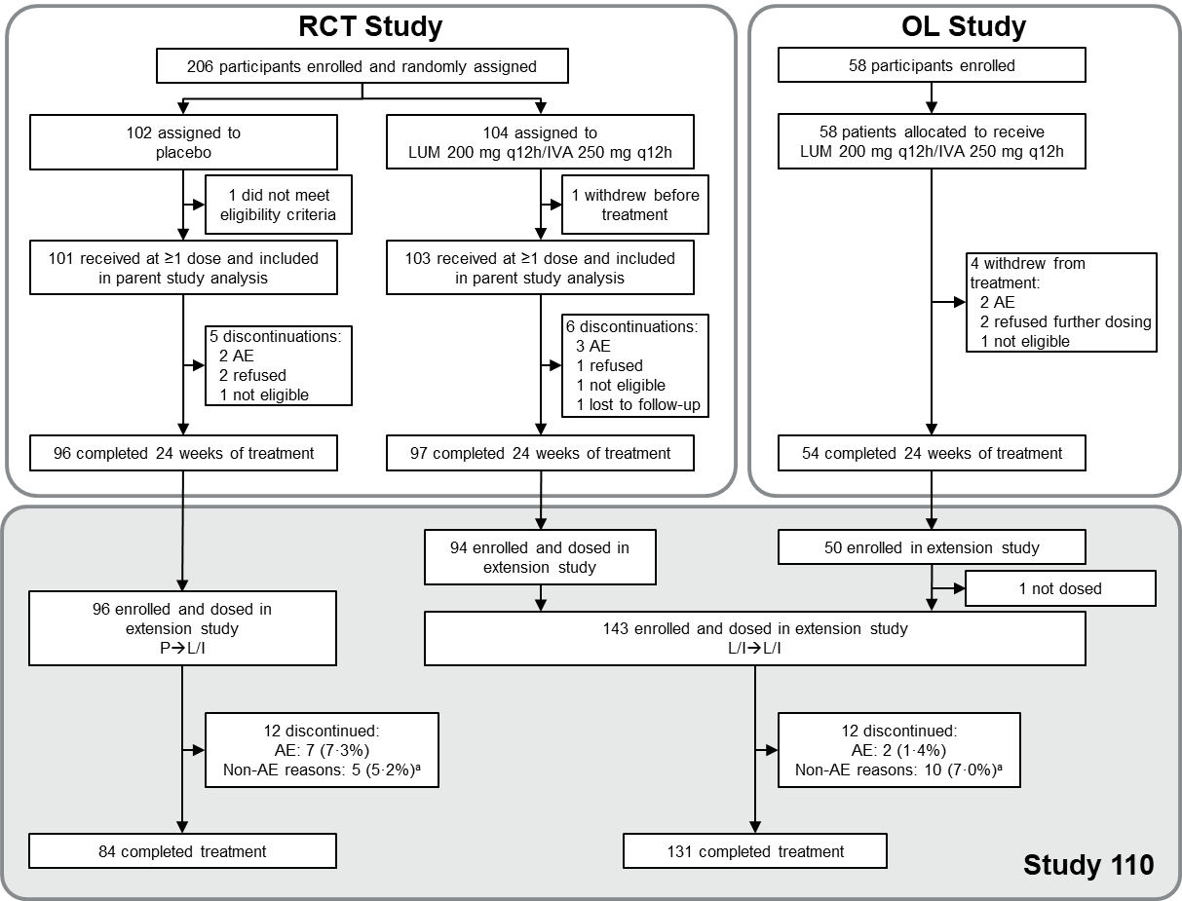
AE, adverse event; IVA, ivacaftor; L/I→L/I, lumacaftor/ivacaftor to lumacaftor/ivacaftor group; LUM, lumacaftor; OL, open label; P→L/I, placebo to lumacaftor/ivacaftor group; PBO, placebo; q12h, every 12 hours; RCT, randomised controlled trial.
ª In Study 110, reasons for discontinuation not related to AEs included refusal of further dosing, physician decision, requirement of a prohibited medication, noncompliance with study drug, and “other” reasons. Most children who discontinued study drug for “other” reasons began taking the commercial drug.

Figure 2. Change in LCI_{2·5} (A), sweat chloride concentration (B), and CFQ-R respiratory domain score (C) from baseline of parent study
A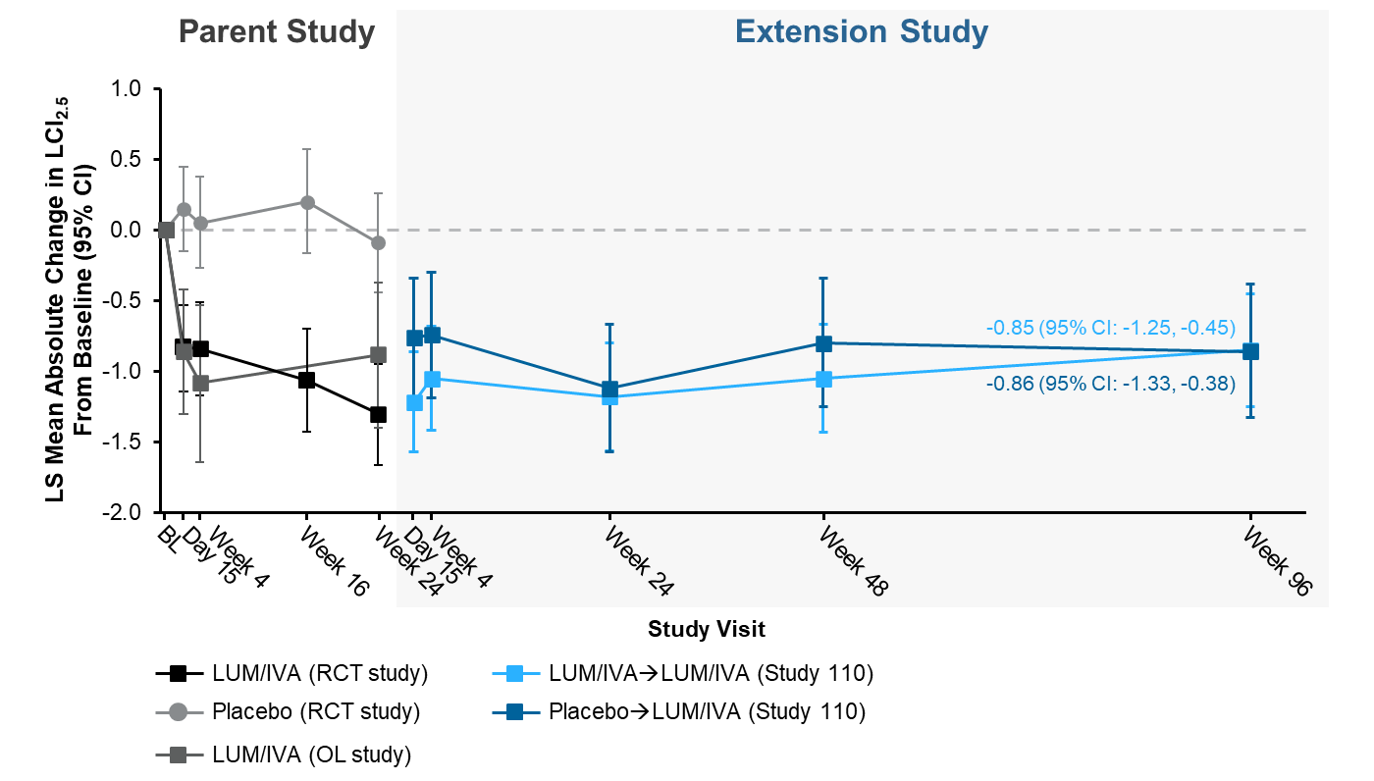

B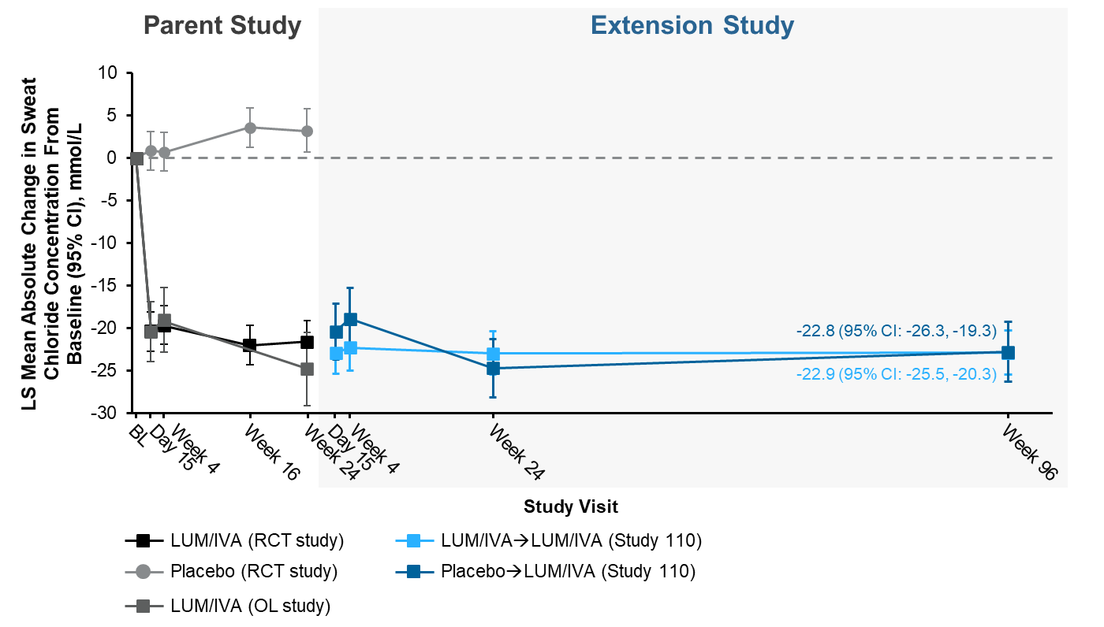

C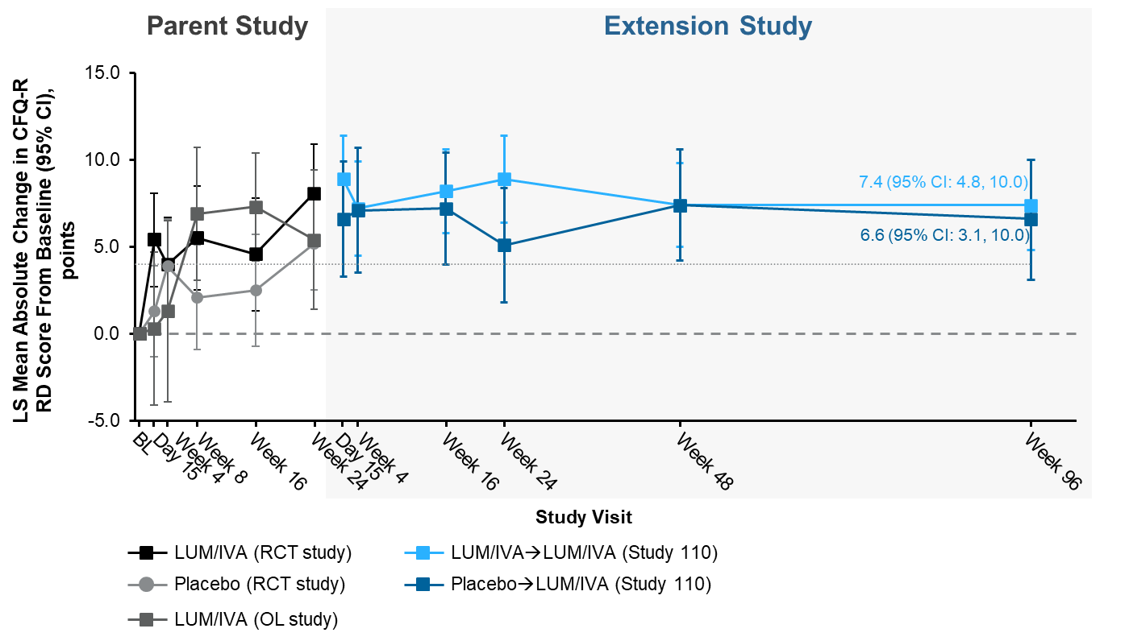
The grey dotted line shows the minimal clinically important difference of 4·0.
BL, baseline; CFQ-R, Cystic Fibrosis Questionnaire–Revised; LCI_{2·5}, lung clearance index (turnovers required to reduce the concentration of tracer gas to 2·5% of its starting concentration); LS, least squares; LUM/IVA, lumacaftor/ivacaftor; OL, open label; RCT, randomised controlled trial; RD respiratory domain.

Figure 3. Change from baseline of parent study in BMI (A) and BMI for age z score (B)
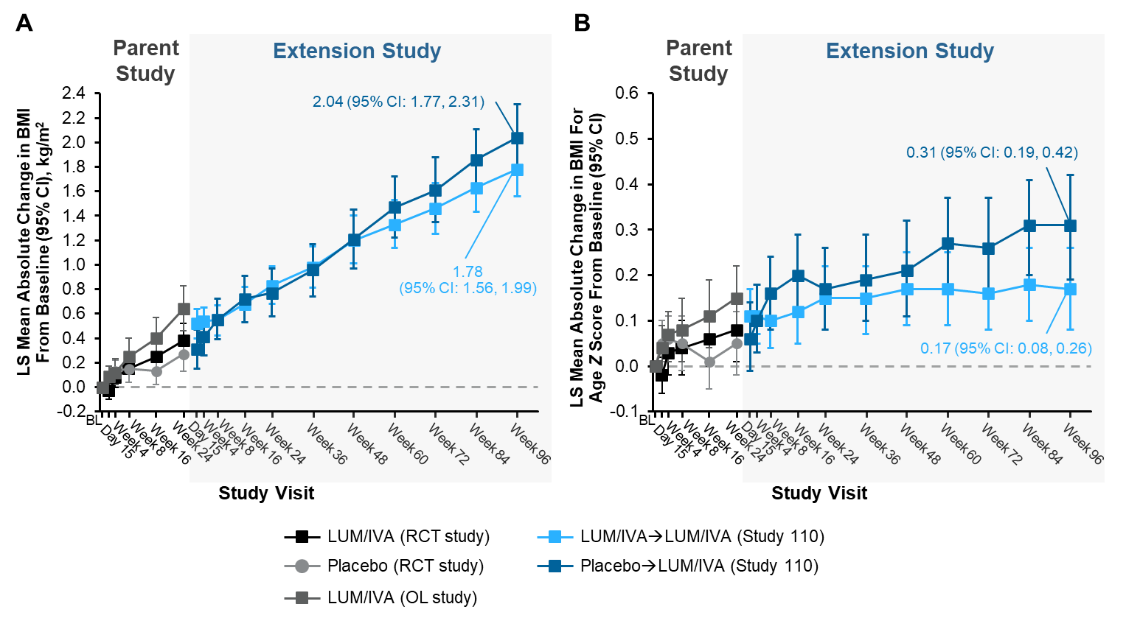
BL, baseline; BMI, body mass index; LS, least squares; LUM/IVA, lumacaftor/ivacaftor; OL, open label; RCT, randomised controlled trial.

