Mining the plasma proteome for insights into the molecular pathology of pulmonary arterial hypertension
Lars Harbaum, MD*, Christopher J. Rhodes, PhD*, John Wharton, PhD, Allan Lawrie, PhD, Jason H. Karnes, PhD, Ankit A. Desai, MD, Prof. William C. Nichols, PhD, Prof. Marc Humbert, MD, David Montani, MD, PhD, Barbara Girerd, MD, Olivier Sitbon MD, PhD, Mario Boehm, PhD, Prof. Ralph T. Schermuly, PhD, Prof. H. Ardeschir Ghofrani, MD, Mark Toshner, MD, Prof. David G. Kiely, MD, Luke S. Howard, MD, Emilia M. Swietlik, MD, Stefan Gräf, PhD, Maik Pietzner, PhD, Prof. Nicholas W. Morrell, MD, Prof. Martin R. Wilkins, MD
*Joint first authors

Online Data Supplement (Figures E1 to E6, and Text)
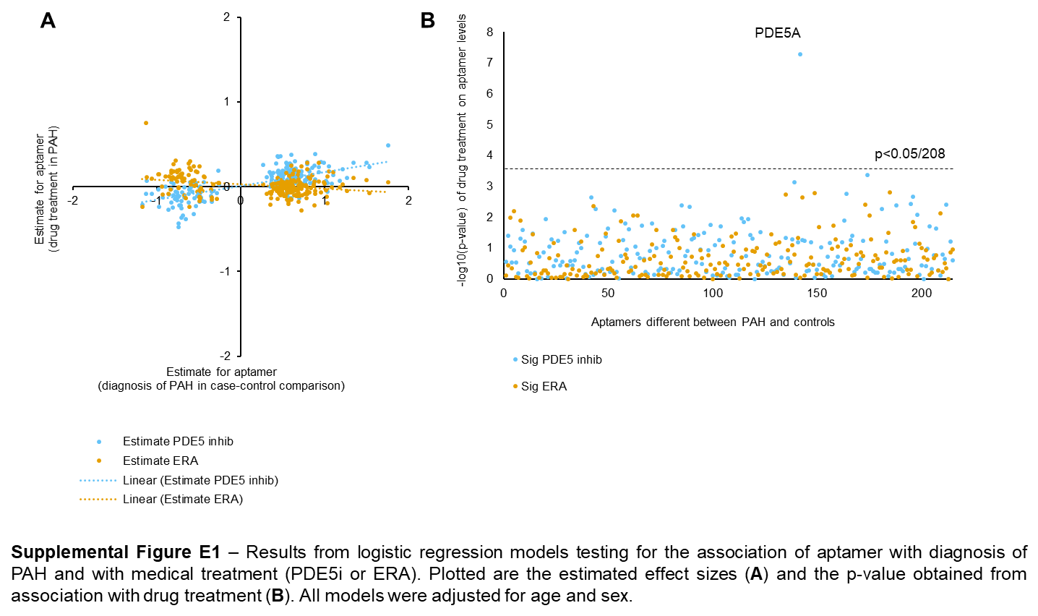
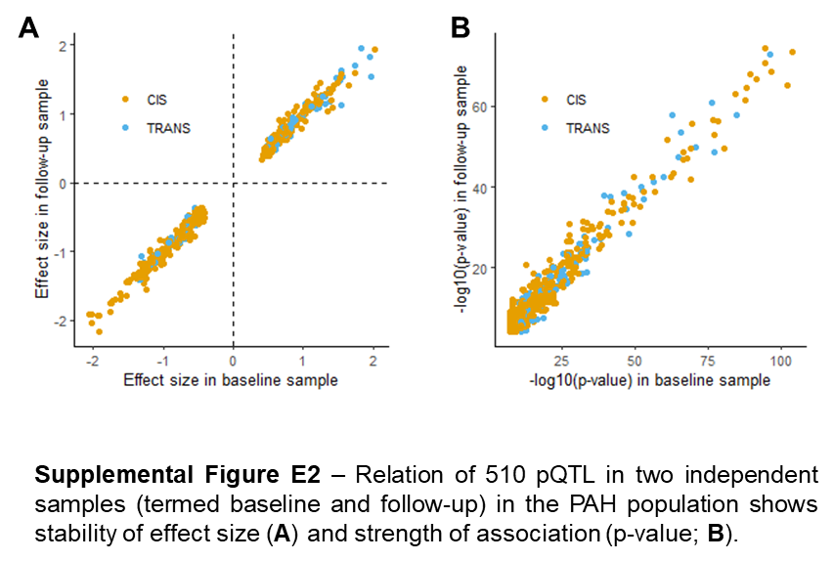
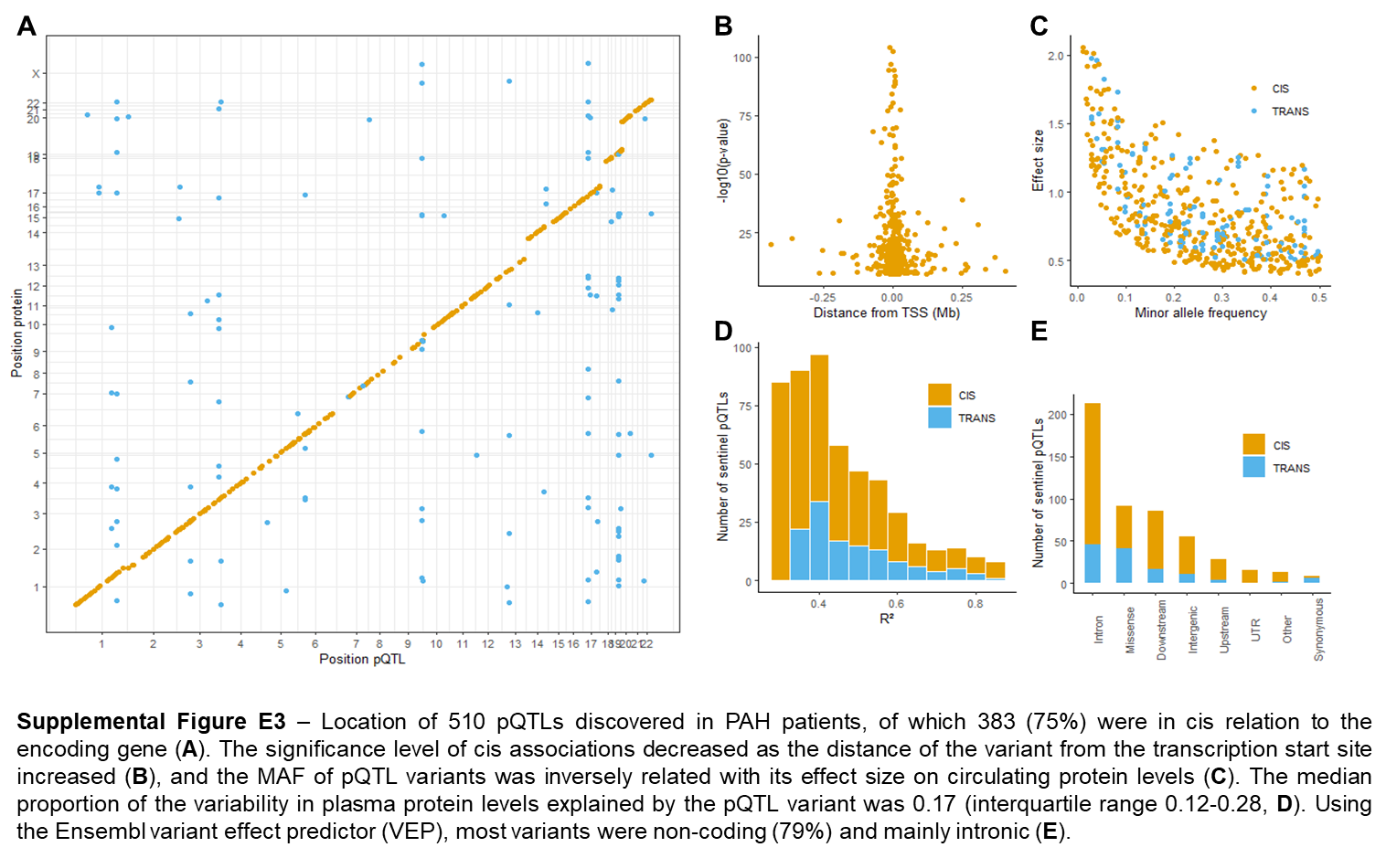
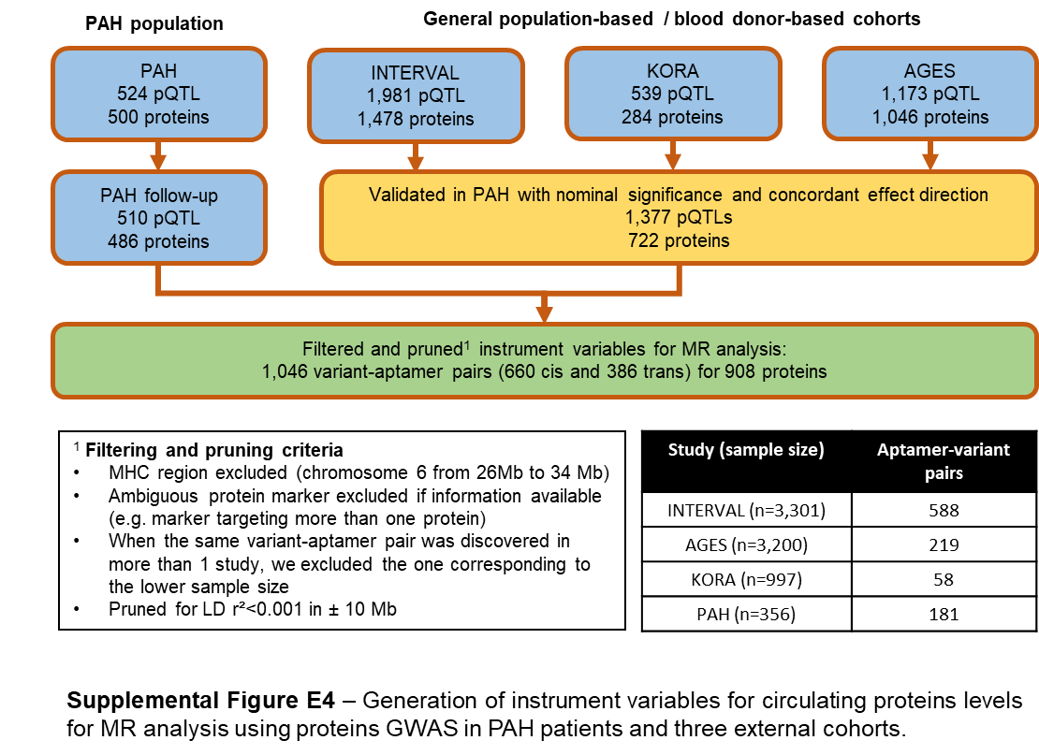
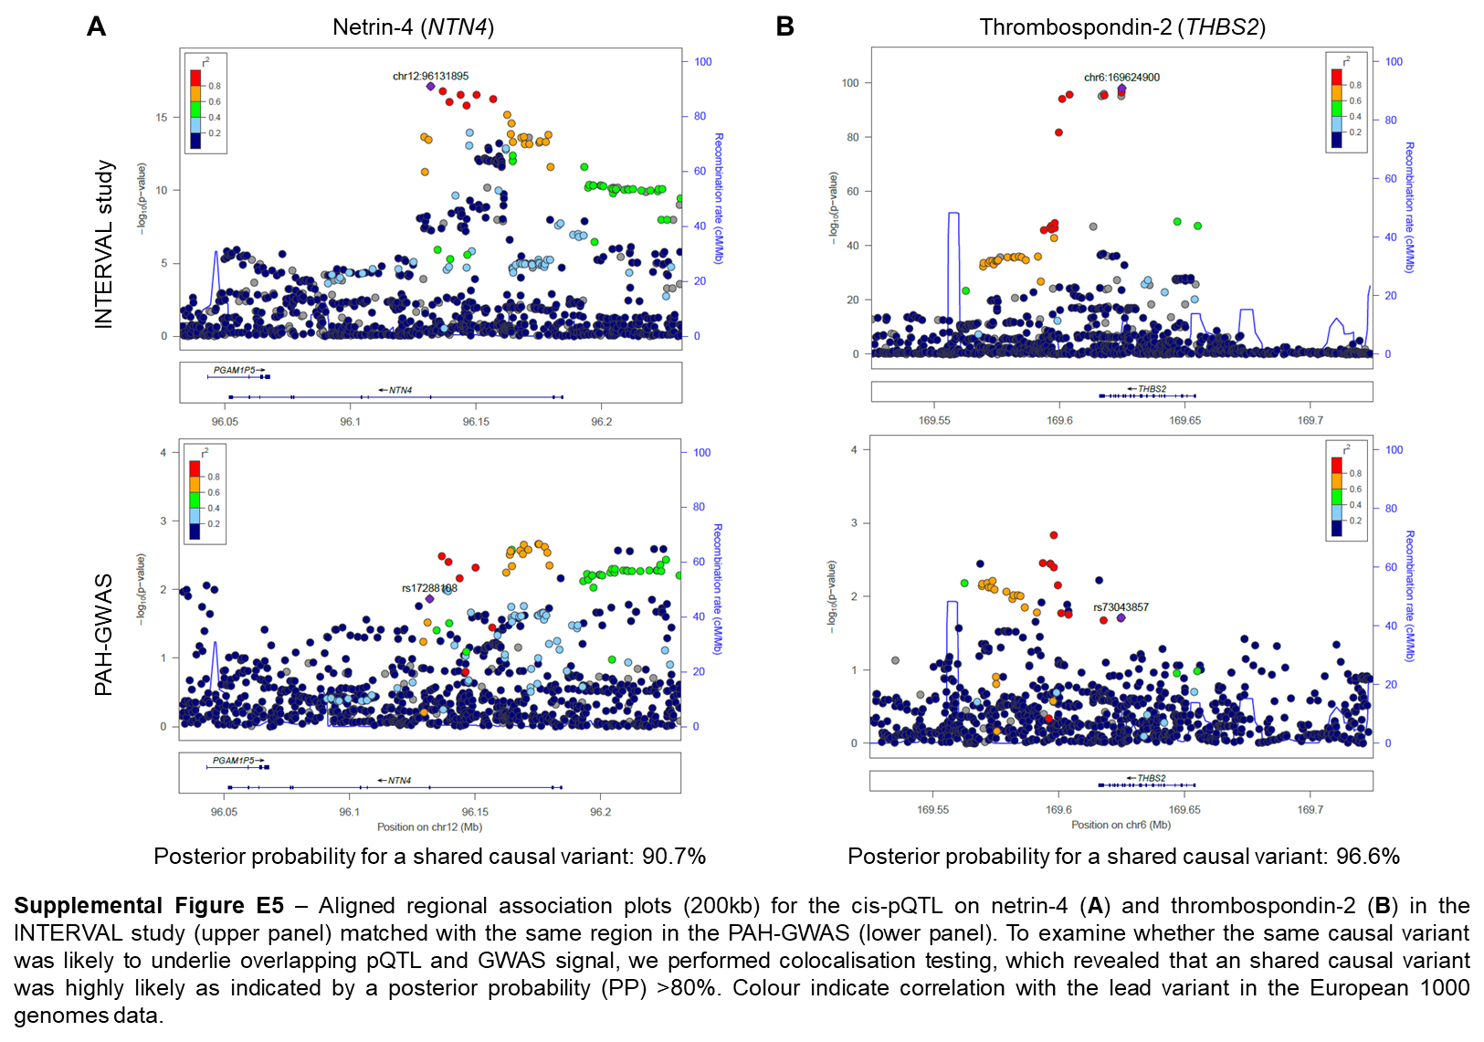

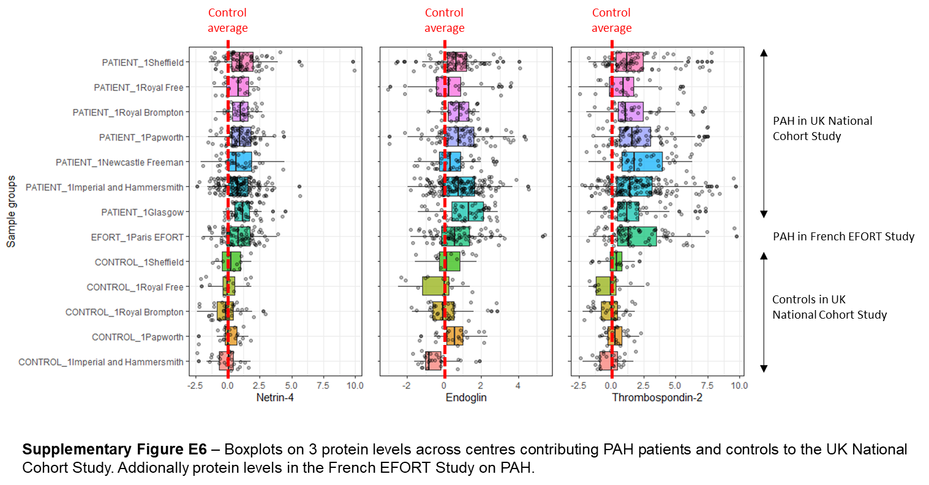

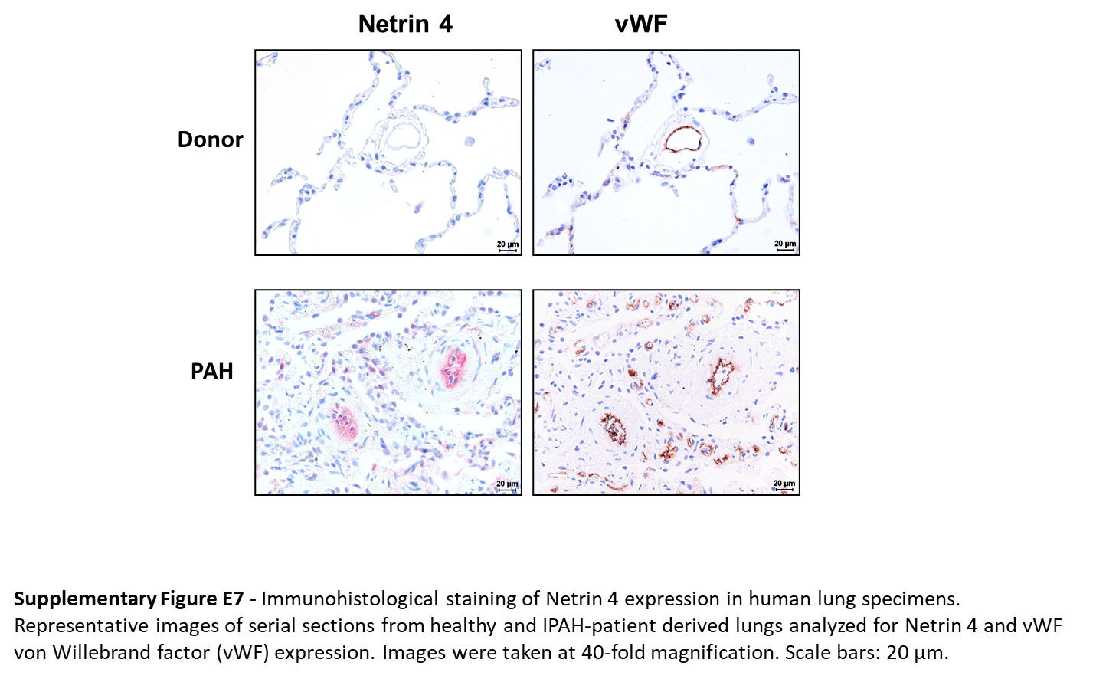
Supplemental Text
Association of the plasma proteome with use of PAH-targeted medication
We tested for the association of 208 circulating proteins (measured by 215 aptamers) that were found to be independently associated with PAH with PAH-targeted drug treatments in logistic regression models, adjusting for age and sex (drug class yes or no as dependent variable). The effect of targeted PAH therapy with endothelin receptor antagonists (ERA) and phosphodiesterase 5 (PDE5) inhibitors in the patient population on circulating levels was small compared to the effect of the PAH-control differences (mean ratio of effect sizes of drug treatment and PAH diagnosis was 0.22 for PDE5 inhibitor and 0.15 for ERA). Apart from PDE5 inhibitors and circulating PDE5A levels, no strong effect of targeted PAH therapies on protein levels was observed (Figure E1).
Cross-validation of pQTLs with external populations
We first attempted to replicate all 510 pQTLs discovered in PAH in publicly available protein GWAS through querying three GWAS studies directly¹⁻³ (for 2 studies full summary level results were available^{1,2}) and a curated database holding publicly available results (PhenoScanner V2 release; accessed 06/09/2020).⁴ We identified an external source for the replication of 396/510 pQTLs (77%), using either the aptamer or the protein label as identifier. For replication we accepted variants that correlated highly with our sentinel variant (LD r²>0.8) and reproduced 321/394 (81%) of the pQTLs externally with a Bonferroni-adjusted level of significance and concordant effect directions, targeting 314 distinct proteins (P<1.3x10-4 = 0.05/396; Supplementary Table 3). An additional 7 pQTLs replicated with nominal significance and concordant effect direction (Supplemental Table 3). This included 6 cis-pQTL (for protein levels of STAT3, PDK1, APOL1, MTRF1L, A4GALT and CBL) and 1 trans-pQTL (for protein levels of S100A11). Sixty-eight variant-aptamer pairs could not be validated externally at this point, mostly due to low LD with other sentinel variants, and 117 variant-aptamer pairs were not investigated in the databases queried (69 in cis and 48 in trans).
Effects on transcript levels of newly discovered pQTLs
We evaluated the extent to which pQTLs matched effects at the transcriptional level and queried our 69 newly identified cis pQTLs in publicly available expression QTL (eQTL) databases using PhenoScanner (V2 release; accessed 06/09/2020).⁴ We accepted correlated variants in high LD (LD r²>0.8). Seventy five percent (52/69) of the newly discovered cis pQTLs were eQTLs for the same gene, reaching genome-wide significance (P<5x10-8) in one or more tissue or cell type (Supplemental Table 4). The greatest overlaps were in whole blood (n = 44), lymphoblastoid cell lines (n = 21), subcutaneous adipose tissue (n=18), tibial artery (n=18), monocytes (n=18) and lung (n=16), which, in part, could be driven by the larger eQTL study sample sizes for these tissue/cell types. Colocalization testing was performed on eQTL association data from the Genotype-Tissue Expression (GTEx) project (V7 release) using the coloc package.⁵ We used the default priors and colocalization was assessed based on the posterior probability (PP) testing the hypothesis of a same causal variant. 40/52 pQTLs overlapped with eQTL in the GTEx data and colocalization of the same causal variant in one or more tissue or cell type was very likely (PP > 0.8) for 36/40 (90%; Supplemental Table 4).
Immunohistochemistry
Paraffin-embedded tissue sections (2µm thickness) were stained for Netrin 4 antibody (1:50, Sigma, HPA049832, Lot000017630). After dehydration (by xylol and ethanol), the antigen-retrieval for Netrin 4 staining was achieved by the heating of the pulmonary sections with the Tris-EDTA buffer (pH 9.0). Sections were immersed in blocking buffer (10% BSA) for 15min, washed with PBS, and stained with Netrin 4 antibody. Detection was performed using a ZytoChem-Plus AP Polymer-Kit (POLAP-006, Zytomed Systems, Berlin, Germany) according to the manufacturer’s instructions. Serial section staining with von Willebrand factor (vWF, an endothelial marker) was additionally carried out. For the detection of vWF, after the dehydration human paraffin tissue sections were treated with proteinase K (Novocastra-RE-7160, Leica Mikrosysteme Vertrieb GmbH, Wetzlar, Germany). After blocking with 10% BSA, a rabbit anti-vWF antibody (A0082, Fa DAKO, Hamburg, Germany) was applied in 1:1000 dilution. After incubation with secondary antibody (anti-rabbit Ig peroxidase, ImmPRESS reagent), sections were stained with diaminobenzidine (DAB) substrate kit (SK-4100, Vector Laboratories, Inc. Burlingame, CA, USA) and staining progression was observed under the microscope.

References for the supplemental text
1. Suhre K, Arnold M, Bhagwat AM, et al. Connecting genetic risk to disease end points through the human blood plasma proteome. Nature communications 2017; 8: 14357.
2. Sun BB, Maranville JC, Peters JE, et al. Genomic atlas of the human plasma proteome. Nature 2018; 558(7708): 73-9.
3. Emilsson V, Ilkov M, Lamb JR, et al. Co-regulatory networks of human serum proteins link genetics to disease. Science (New York, NY) 2018; 361(6404): 769-73.
4. Kamat MA, Blackshaw JA, Young R, et al. PhenoScanner V2: an expanded tool for searching human genotype-phenotype associations. Bioinformatics (Oxford, England) 2019; 35(22): 4851-3.
5. Giambartolomei C, Vukcevic D, Schadt EE, et al. Bayesian test for colocalisation between pairs of genetic association studies using summary statistics. PLoS genetics 2014; 10(5): e1004383.

