Beyond Triphos – New Hinges for a Classical Chelating Ligand

Andreas Phanopoulos, Philip W. Miller,* Nicholas J. Long*

Department of Chemistry, Imperial College London, South Kensington, London, SW7 2AZ, United Kingdom

*Corresponding authors tel.: PWM: +44 (0)20 7594 2847, NJL:+44 (0)20 7594 5781
Email addresses: AP: a.phanopoulos11@imperial.ac.uk, PWM: philip.miller@imperial.ac.uk, NJL: n.long@imperial.ac.uk

Abstract

Branched triphosphine ligands have been less widely studied than mono- and bi-dentate analogues. The most studied ligand of this type is Triphos^{Ph} (CH₃C(CH₂PPh₂)₃). Substitution of the apical C–CH₃ moiety with boron, silicon, tin, nitrogen or phosphorus fragments has generated a new family of ligands, in some cases displaying varying coordination chemistry and reactivity to the parent carbon-based system. This review includes the synthetic strategies implemented to afford these ligands, as well as derivatives by way of varying the phosphine substituents. Although not exhaustive, relevant types of reported complexes featuring these ligands are discussed, as well as their reactivity and catalytic applications. Through critical analysis, common themes and chemical trends across this family of apical heteroatomic, branched triphosphines can be identified, leading to improvements in current chemical applications, as well as new areas that remain underdeveloped.

Keywords

Triphos, Coordination Chemistry, Reactivity, Catalysis, Small Molecule Activation

1. Introduction

Triphosphine based ligands continue to attract much attention for both coordination chemistry and applications in catalysis [1-5]. Unlike the better known and more kinetically labile mono- and di-phosphine ligand systems, tridentate ligands can generally provide greater kinetic and thermal stability due to greater chelation, in addition to giving very well-defined coordination modes to transition metal centers [6]. Ligands based around the triphos scaffold (R’E(CH₂PR₂)₃, Figure 1) are amongst the most commonly studied facially coordinating triphosphine ligands (not to be confused with similar linear triphosphines such as Ph₂CH₂CH₂P(Ph)CH₂CH₂PPh₂, also commonly called triphos). This facially capping scaffold incorporates an apical atom from which three coordinating phosphine ‘arms’ originate, and a fourth ancillary arm that typically does not coordinate but may be used for further functionalization. The eponymous Triphos ligand has an apical carbon atom with three diphenylphosphino coordinating groups plus an ancillary methyl group, CH₃C(CH₂PPh₂)₃ (MeCP₃^{Ph}). Triphos itself is the most studied analogue, with more than 900 publications at the time of writing. This review aims to summarize the classes of Triphos-type ligands where the apical atom is not a carbon atom, and will cover the synthetic aspects, coordination chemistry, reactivity and catalytic applications of the resulting complexes.

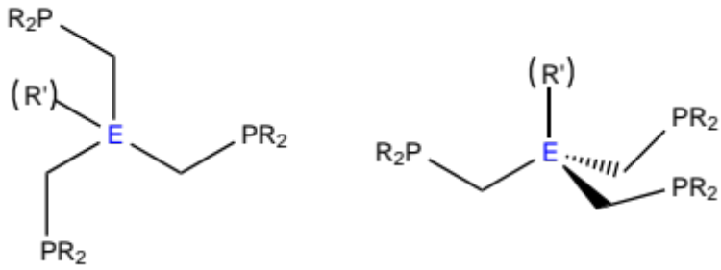
Figure 1. General structure of the Triphos ligand scaffold (E = apical atom, PR₂ = phosphine coordinating moiety, R’ = ancillary arm).

The Triphos ligand scaffold (Figure 1) is highly versatile with possible variations at every part: apical atom, heteroatomic arm linkages [7], chain length of coordinating arms [1,2c,5,8], coordinating moieties [9,10] and ancillary arm [11,12]. Although all these modifications have been reported, in the interest of conciseness, this review will be limited to (i) phosphine coordinating ‘arms’ (others include sulfur, oxygen, nitrogen etc.) [5,10] and (ii) only ligands featuring a methylene bridge between the apical ‘hinge’ atom and the phosphine groups. Additionally, only ligands featuring heteroatomic apical atoms (i.e. not carbon) will be reviewed, as there already exists several reviews that cover the chemistry of the carbon-centered ligand [1,6]. From its modular synthesis, the phosphine groups are easily varied by reaction with the appropriate phosphine precursors. This allows the facile generation of a family of related compounds.

Several heteratomic apical derivatives of Triphos have been reported, allowing changes not only to electronic and steric properties of the ligand, but also allowing the inclusion of a formal charge. Elements from Group 13 (boron), 14 (silicon and tin) and 15 (nitrogen and phosphorus) have all been utilized, leading to a sizeable group of ligands displaying varied functionality and diverse chemistry. This review aims to highlight the most recent advances in the chemistry of Triphos-analogue ligands, as well as giving insight into potentially new areas of research that may benefit from implementation of these ligand motifs. As will become evident, there is somewhat of a dichotomy between the relatively large number of reported complexes, and the amount of these that have formally been applied to catalytic applications. It is our hope that by highlighting those areas that are well explored, as well as those that are not, future investigations can productively focus their research to maximize impact. Although this review will not directly discuss the carbon-centered Triphos ligand, complexes of MeCP₃^{Ph} will be referred to for completion and/or comparative reasons.

2. Synthesis and Coordination Chemistry

In general there is a ‘standard’ procedure for synthesising derivatives of each Triphos-analogue. The modular nature of these strategies allows substitution of various substituents on the phosphines by simply using (or synthesising) the appropriate phosphine reagent. Some ligands are more easily synthesized and isolated than others, and where possible the difficulties will be highlighted, as well as explanations of how these problems may be circumvented.

Apical heteroatomic Triphos-analogues display rich coordination chemistry, with both transition metal and main group complexes having been reported. A detailed analysis of bonding motifs via spectroscopic and/or computational studies will not be explicitly explained for every complex, despite this being the focus of many of the primary reports [13-15]. On the other hand, interesting spin-states and/or geometries will be mentioned as these characteristics often lead to, or influence, the observed reactivity.

2.1. Boron (R’B(CH₂PR₂)₃–)

The Triphos derivative featuring an apical boron atom is by far the most studied analogue after the classic carbon-containing ligand, with general formula R’B(CH₂PR₂)₃– (abbreviated to R’BP₃^{R}). To date there are almost 50 papers that have utilized this ligand in some form. There have been seven reported analogues within this subsection that adhere to the limitations imposed within this review. Changing the phosphine substituents (R) from phenyl (PhBP₃^{Ph}, 1) [16] to iso-propyl (PhBP₃^{iPr}, 2) [17], methyl cyclohexyl (PhBP₃^{CH2Cy}, 3) [18], meta-terphenyl (PhBP₃^{mter,} 4) [19] or para-trifluoromethylphenyl groups (PhBP₃^{p-CF3Ph}, 5) [20] accounts for five of these, with the remaining two being derivatives of the phenyl and iso-propyl ligands but after substituting the normal phenyl ancillary group (R’) with a butyl moiety (^{n}BuBP₃^{Ph}, 6 and ^{n}BuBP₃^{iPr}, 7) [21].

In general, these ligands are produced first by formation of the desired disubstituted phosphinomethide reagent as a lithium salt (R’₂PCH₂Li or R’₂PCH₂Li(TMEDA)) from the corresponding methyl phosphine (R’₂PCH₃) (Scheme 1A) [22]. Reaction of three equivalents of the phosphinomethide reagent with the desired dichloroborane compound initially gives borate salt formation before the chlorides undergo substitution with two more methides to afford the final ligand as a lithium salt [16-20]. It was found that subsequent metathesis to the thallium salt (using either TlPF₆ or TlNO₃) facilitated work up and isolation, as well as acting as a better reagent for further coordination (Scheme 1B) [23]. Only ligands 6 and 7 were not isolated as the thallium salts, instead the lithium salts were used directly in aerosol-assisted chemical vapour deposition experiments [21].

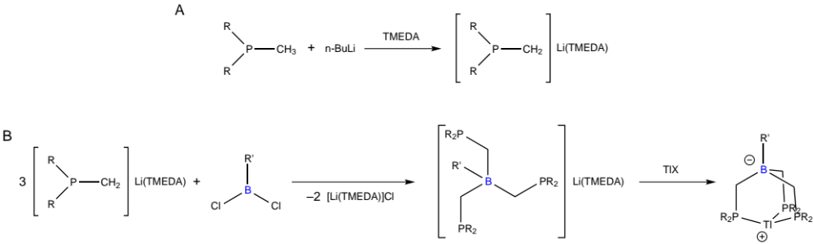
Scheme 1. A) Synthesis of phosphinomethide reagent, B) General synthetic scheme for the preparation of R’BP₃^{R} ligands [22].

B-Triphos ligands have been coordinated to many late transition metals, as well as tin. Transition metal complexes of iron, ruthenium, cobalt, rhodium, iridium, nickel, platinum, copper and silver have all been reported. Especially pertinent is the work of the Peters and Tilley groups, who have extensively studied the coordination and reactivity of late transition metals. Namely, iron, cobalt, nickel, ruthenium and iridium complexes of ligands 1-4 have been prepared and characterized, as well as being assessed for their electronic structure, spin-state and ability to stabilize low coordinate geometries. Although the following descriptions of complexes are by no means exhaustive, they will provide an overview of the types of complexes formed across several relevant metal centers.

PhBP₃^{Ph} (1) was first synthesized in 1999 independently by the Nocera [16a] and Tilley groups [16b]. Initial studies on the coordination chemistry of 1 were performed with tin [16a] and iridium [16b], respectively, demonstrating a facially-capping coordination mode similar to that of the well-known cyclopentadienyl (Cp–) and trispyrazolylborate (Tp–) ligands, plus their derivatives. The most striking feature of the reported tin complexes (8 and 9, Scheme 2) is that one phosphine arm coordinates more weakly than the others [16a]. This is evident from the Sn–P bond distances obtained from X-ray diffraction analysis of the complex [SnCl(κ³-PhBPh₃^{Ph})], which has two short Sn–P bonds (2.6746(14) and 2.690(2) Å) and one long bond (3.036(2) Å) which sits beyond the standard covalent bonding distance for tin and phosphorus.

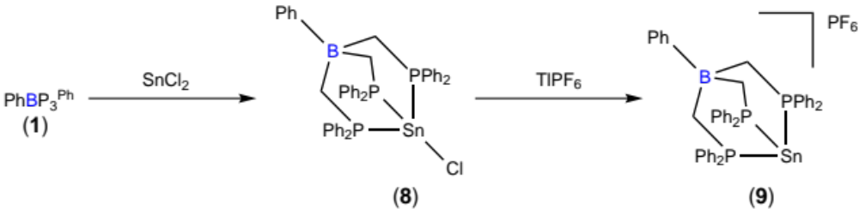
Scheme 2. Synthesis of tin complexes using PhBP₃^{Ph} [16a].

The first iridium complexes featuring ligand 1 were reported in 1999, and initial investigations were focused on the activation of silanes [16b]. The initial report established iridium complexes as good targets for reactions with silanes via the allyl complex [IrH(η³-C₈H₁₃)(κ³-PhBPh₃^{Ph})] (10), which afforded the silyl product [IrH₂(SiMes₂)(κ³-PhBPh₃^{Ph})] (Mes = 2,4,6-Me₃C₆H₂) upon reaction with H₂SiMes₂. Subsequent structural reports from the same group identified an alternative allyl complex [IrH(η³-C₃H₅)(κ³-PhBPh₃^{Ph})] (11) as a better reagent for reactivity studies due to its easier isolation and purification [24]. Both complexes 10 and 11 were used to extensively explore the chemistry of the “Ir(κ³-PhBPh₃^{Ph})” fragment, affording hydride (12, 15, 16, 18–20, 23 and 24), dicarbonyl (17), dimethyl (14), halide (13, 15, 21 and 22), phosphino (16, 18 and 19), cyclometalated (16 and 19) and bridged dimer species (20), as well as mixtures thereof (Scheme 3) [16b,24].

Analysis of the CO stretching frequency in the dicarbonyl complex [Ir(CO)₂(κ³-PhBPh₃^{Ph})] (17) suggested that 1 is more electron donating than either pentamethylcyclopentadienyl (Cp*) or hydridotris(3,5-dimethylpyrazolyl)borate (Tp^{Me2}) by comparison to the corresponding complexes [24]. The relative electron-donation strength of 1, Cp* and Tp^{Me2} (1 ≥ Cp* > Tp^{Me2}) may also explain why 1 and Cp* can accommodate three classical hydride ligands when bound to a formal iridium(V) metal center (e.g. [IrH₃(SiMe₃)(κ³-PhBPh₃^{Ph})], 24), while Tp’ ligands will preferentially form non-classical hydrides to maintain a 3+ oxidation state on iridium. It is noteworthy as well to highlight the unexpected monomeric stability of the trivalent, five-coordinate species, for instance [Irl₂(κ³-PhBPh₃^{Ph})] (13). This is presumably due to the steric bulk imposed by 1, but when the halides are substituted for smaller hydrides in [IrH₂(κ³-PhBPh₃^{Ph})]₂ (20), dimerization is observed [24].

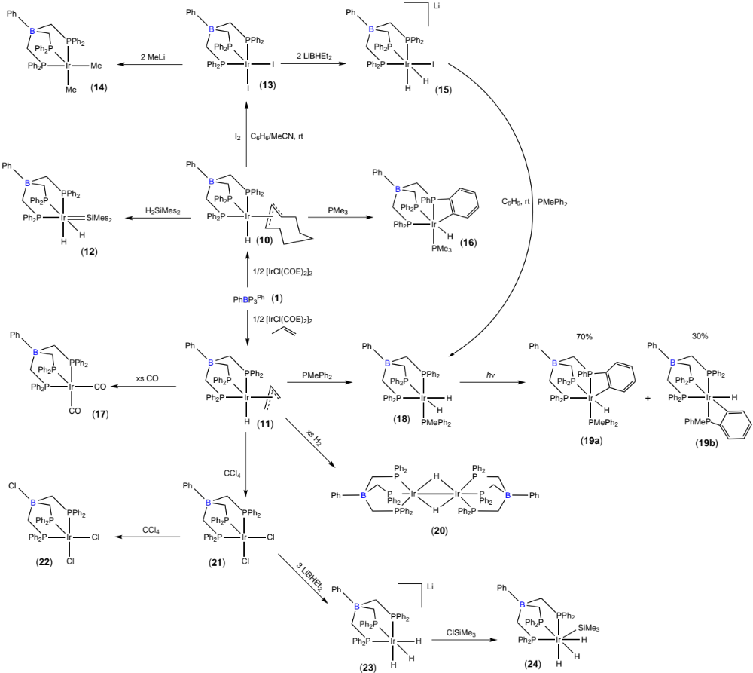
Scheme 3. Selected complexes featuring the “Ir(κ³-PhBPh₃^{Ph})” fragment [16b,24].

Iron [17], cobalt [25] and nickel [14] complexes featuring ligands 1-4 have been studied extensively, and display many common coordination motifs. In general (κ³-PhBP₃^{R})M=E and (κ³-PhBP₃^{R})M$≡$E (M = Fe, Co, Ni; E = π-basic ligands such as O^{2–}, NR^{2–} and N^{3–}) structures were targeted, as prior to this, ligands coordinated with formally double or triple bonds to late first row transition metals were rarely observed [25]. Structures of this type are proposed intermediates in a number of catalytic reactions of both synthetic and biocatalytic significance, and consequently represent an interesting area of academic research. By studying the activation of small molecules such as N₂, mechanistic insight into important processes such as the Haber-Bosch process and the mode of action of nitrogenase enzymes may yet be elucidated [26,27].

Initially, pseudo-tetrahedral halide complexes of general formula (PhBP₃^{R})M–X (R = Ph, ^{i}Pr, CH₂Cy, mter; M = Fe, Co, Ni; X = Cl, Br, I) were synthesized as a convenient way to access the “M(PhBP₃^{R})” fragment (25–38, Scheme 4) [13,14,17-19,28]. In general these complexes were obtained in high yields (>83%) except for [CoCl(κ³-PhBP₃^{Ph})] (28a) and [CoBr(κ³-PhBP₃^{Ph})] (29a) (when synthesized from CoCl₂ and CoBr₂, respectively) which were obtained in yields of around 27%. Alternatively, these complexes could be synthesized via a metathesis reaction from [CoI(κ³-PhBP₃^{Ph})] (30) using TlPF₆ and then either excess NaCl or KBr, respectively, which increased the yield to over 80% [13]. It should be noted that in solution these complexes exist in equilibrium between their monomeric and dimeric (28b and 29b) forms, but only as dimers in the solid state (Scheme 5). Similar to the tin complexes, each complex has one modestly elongated, and two short Co–P bonds.

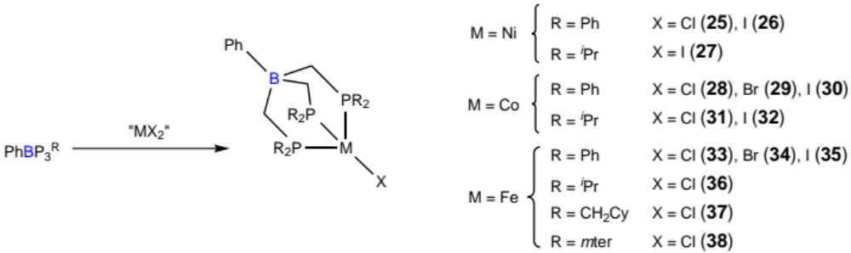
Scheme 4. Synthesis of (κ³-PhBP₃^{R})M–X (M = Ni, Co, Fe; R = Ph, ^{i}Pr, CH₂Cy, mter; X = Cl, Br, I) complexes [13,14,17-19,28].

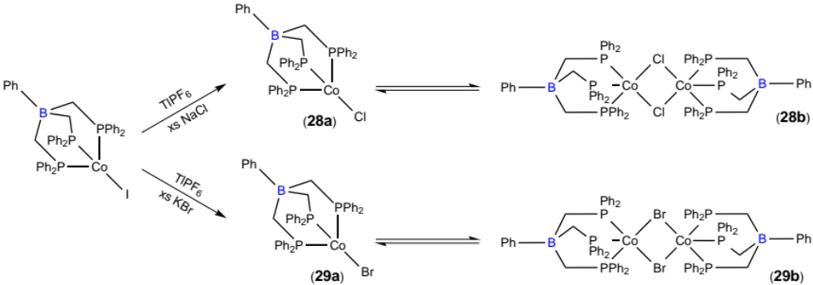
Scheme 5. Solution equilibrium of complexes 28 and 29 [13].

Electronic analysis of iodo complex 30 shows it adopts an anomalous low spin doublet configuration, attributed to a pronounced axial distortion [29]. This distortion also suggests that installing a divalent strong π-donating ligand (such as an imido) should be possible [13]. In contrast, the complexes featuring the iso-propyl ligand 2 show the expected high-spin behavior expected of pseudo-tetrahedral late transition metal complexes [17]. This may be due to the increased rigidity around the phosphine substituents compared to 1, which prohibits axial Jahn-Teller distortion. This rigidity is also observed in the M–P bond distances which are all identical when 2 is coordinated in a tridentate mode. Reduction and replacement of the halide ligand with phosphines (39–43, Scheme 6) [14,18,25,28], or substitution of the halide with carbonyls, methyl or isocyanide groups, –OR or –SR groups (44–54, Scheme 7) has been achieved using appropriate reagents [13,14,17,19,30]. These complexes were predominantly used for complexation studies, as well as to determine electron-donating abililty via CO stretching frequency analysis.

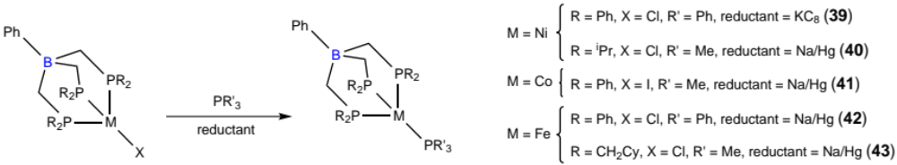
Scheme 6. Synthesis of (κ³-PhBP₃^{R})M–PR’₃ complexes (M = Ni, Co, Fe; R = Ph, ^{i}Pr, CH₂Cy; R’ = Ph, Me) [14,18,25,28].

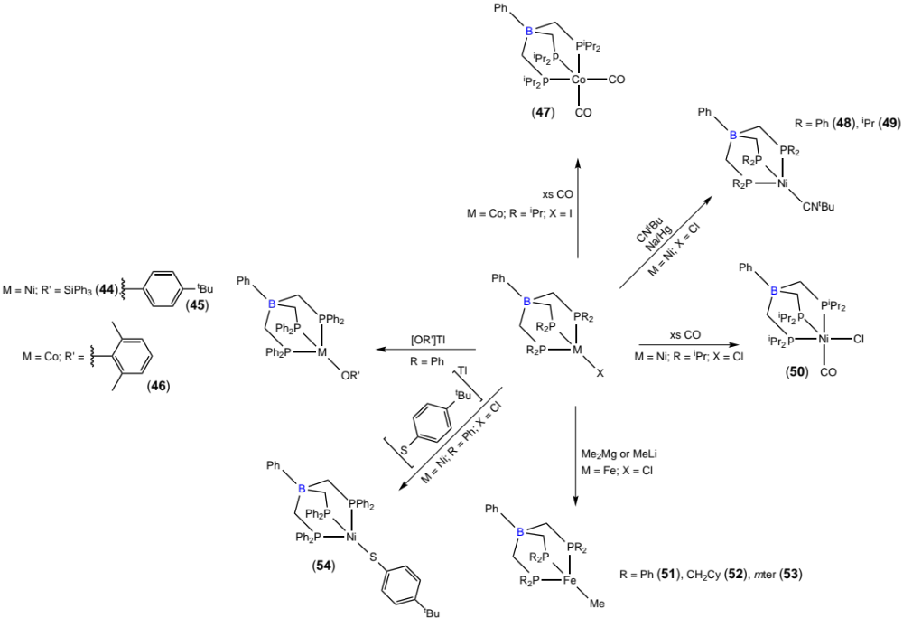
Scheme 7. Synthesis of (κ³-PhBP₃^{iPr})M(CO)(Cl), (κ³-PhBP₃^{iPr})Co(CO)₂, (κ³-PhBP₃^{R})Fe–Me, (κ³-PhBP₃^{R})Ni–CN^{t}Bu, (κ³-PhBP₃^{Ph})M–OR’ and (κ³-PhBP₃^{Ph})Ni–S-p-^{t}Bu-Ph complexes from (κ³-PhBP₃^{R})M–X [13,14,17,19,30].

The pseudo-tetrahedral cobalt and iron phosphine complexes [Co(PMe₃)(κ³-PhBP₃^{Ph})] (41) and [Fe(PPh₃)(κ³-PhBP₃^{Ph})] (42) were successfully used to synthesize terminal imido complexes [Co(N-p-tolyl)(κ³-PhBP₃^{Ph})] (55) and [Fe(N-p-tolyl)(κ³-PhBP₃^{Ph})] (56) (Scheme 8) [25,28]. Both complexes 55 and 56 display very short M–N bonds (around 1.66 Å), indicative of multiple bond character and a preliminary density function theory (DFT) study on 55 suggests the bonding between the metal and nitrogen is best described as a triple bond [25]. The iron complex 56 is much more reactive than cobalt-based 55 as evident from the relative ease of reaction with CO and H₂ [26,28]. Upon oxidation of 42 with p-tolyl azide, a transition from a high-spin to a low-spin electronic configuration also occurred. Additionally, an interesting bridging nitride species, [{(κ³-PhBP₃^{Ph})Fe}₂(μ-N)][Na(THF)₅] (58) was formed upon sodium amalgam reduction of a terminal azide dimer [Fe(μ-1,3-N₃)(κ³-PhBP₃^{Ph})]₂ (57) (itself formed from the reaction of NaN₃ with [FeCl(κ³-PhBP₃^{Ph})] (33), Scheme 9) [27]. Similar species are proposed as important intermediates in nitrogen fixation cycles. Attempting to synthesize other possible intermediates, several hydrazine, hydrazido, diazine, amide and imide containing species were isolated (59–62, Scheme 10) [30].

Attempts to generate nickel-imide complexes were not met with the same success as cobalt and iron analogues [14]. Two attempted synthetic strategies involved either photolysis or thermolysis of the divalent azide complex [Ni(N₃)(κ³-PhBP₃^{Ph})] (63), or direct synthesis via reaction between [NiCl(κ³-PhBP₃^{iPr})] and Li(dbabh) (Hdbabh = 2,3:5,6-dibenzo-7-azabicyclo[2.2.1]hepta-2,5-diene). The first strategy resulted in no reaction under photolytic conditions, while extended heating of 63 gave a mixture of products, with no spectroscopic evidence to suggest formation of the desired imido complex. The second strategy failed due to the unexpected stability of the amide linkage formed initially upon reaction (Scheme 11) [14]. It was hoped that by implementing 2 as the ligand, the high electron-donating ability of the di-iso-propylphosphino groups would facilitate the loss of anthracene with concomitant nitride transfer to generate the desired Ni$≡$N subunit, but this did not occur.

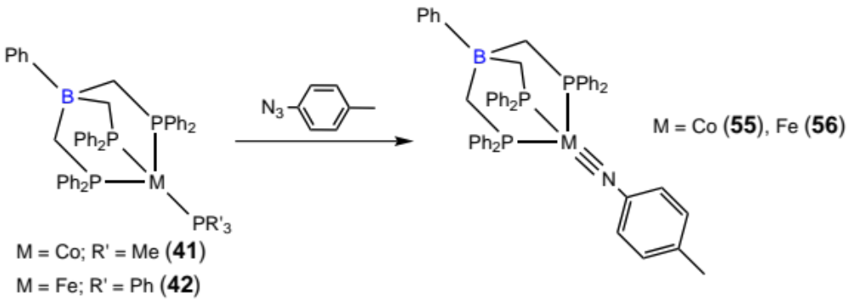
Scheme 8. Synthesis of cobalt– and iron–imido complexes [25,28].

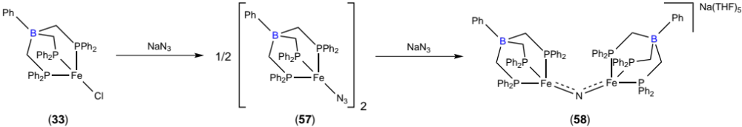
Scheme 9. Synthesis of bridging nitride complex [27].

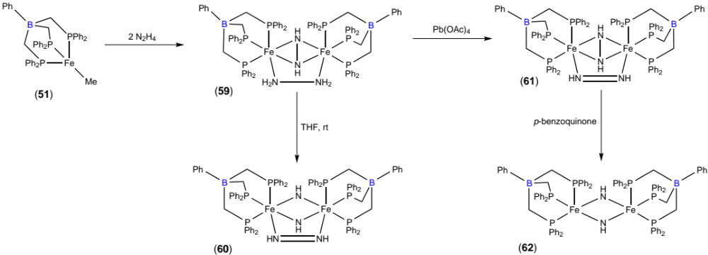
Scheme 10. Synthesis of hydrazine, hydrazido, diazine, amide and imide containing species that represent potential intermediates during nitrogen fixation cycles [30].

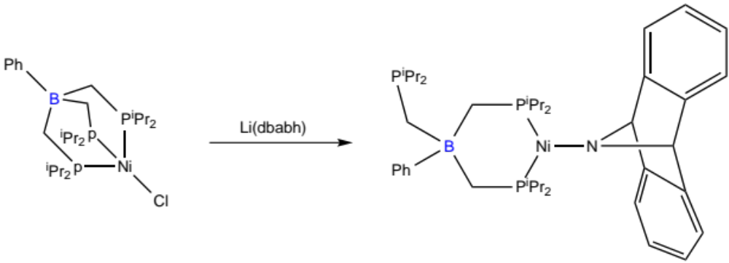
Scheme 11. Synthesis of an unexpectedly stable nickel–amide complex [Ni(dbabh)(κ²-PhBP₃^{iPr})] [14].

More recent work has focused on second row transition metals such as rhodium [31,32] and ruthenium [32,33]. Rhodium derivatives have displayed a wide range of chemistry, with many reported complexes (64–76, Scheme 12) [32,34,35]. As these complexes have been studied as hydrogenation and hydrogen transfer catalysts, several complexes feature Rh–H fragments (67, 68, 72 and 74). Imido complexes similar to the cobalt- and iron-complexes previously discussed have been synthesized, and all show identical reactivity with CO, forming their respective dicarbonyl complexes [M(CO)₂(κ³-PhBP₃^{R})] [35]. Rhodium–imido complexes were additionally reacted with (i) azides to give a tetrazene (75), (ii) acids to give tris solvent ligated complexes (76), and (iii) molecular hydrogen to afford dihydride species (74).

Ruthenium species have been extensively studied for silane activation, and consequently there are not many reports of uniquely different initial complex geometries or types, as the resultant complexes are similar. The most utilized precursor ruthenium complex for evaluating silane activation is the dimeric [Ru(μ-Cl)(κ³-PhBP₃^{Ph})]₂ (77) featuring two bridging chloride ligands [17]. This complex, as well as its analogue with 2 instead of 1 capping each end of the dimer [Ru(μ-Cl)(κ³-PhBP₃^{iPr})]₂ (78), are prepared from reaction of the corresponding ligand with RuCl₂(PPh₃)₃. When either 77 or 78 are exposed to CO, the monomeric dicarbonyl chloride complexes are formed [17]. The dimers can additionally be split using PMe₃ to afford [RuCl(PMe₃)(κ³-PhBP₃^{R})]; or AgPF₆ in acetonitrile to afford [Ru(NCMe)₃(κ³-PhBP₃^{iPr})] [17,36].

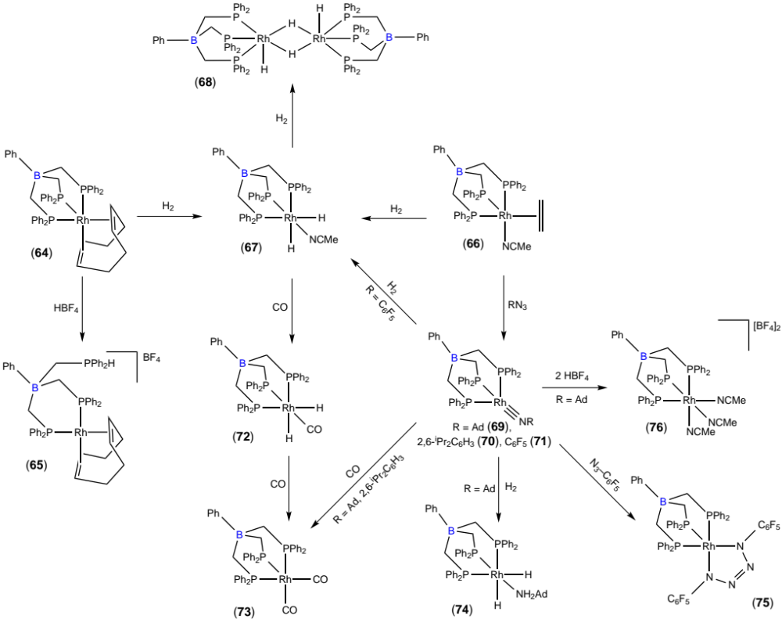
Scheme 12. Selected complexes featuring the “Rh(κ³-PhBPh₃^{Ph})” fragment [32,34,35].

Other reported complexes featuring ligands 1 and 5–7 include platinum, silver and copper metals. Several platinum–alkyl and hydride complexes have been prepared [37]. The initially prepared octahedral platinum(IV) complex was is highly stable with all three arms of 1 coordinating (79), precluding further reactivity studies. On the other hand, the square-planar platinum(II) complex [Pt(Me)₂(κ²-PhBP₃^{Ph})][^{n}Bu₄N] (80) with only two bound phosphine arms reacted at both the free arm and metal center. Notably, reaction of 80 with two equivalents of BH₃ afforded a hydride-bridged platinum(I) dimer (81), where the BH₃ was acting as both a reductant and a hydrogen donor (Scheme 13). Silver complexes featuring ligands 6 and 7 (with different ancillary groups bound to boron) were synthesized for use as chemical vapour deposition precursors [21], while copper and silver complexes with the relatively electron withdrawing ligand 5 were prepared to be evaluated as nitrene-transfer catalysts [20]. Each silver and copper complex was pseudo-tetrahedral with all three phosphine arms of the tripodal ligand coordinating, as well as an additional phosphine to fill the fourth coordination site.

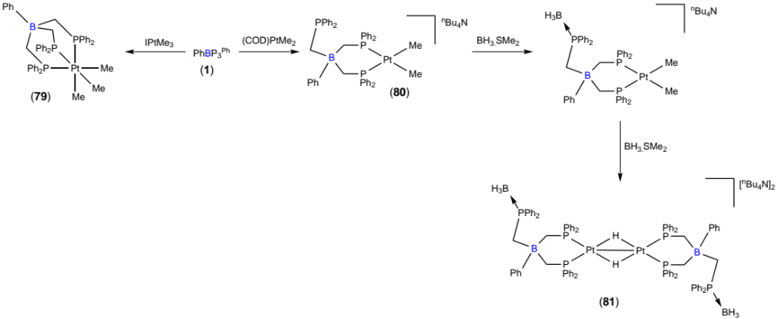
Scheme 13. Synthesis of platinum–PhBP₃^{Ph} complexes [37].

2.2. Silicon (R’Si(CH₂PR₂)₃)

Karsch and Appelt first published a silicon derivative of Triphos in 1983 which featured an ancillary methyl group and dimethylphosphino moieties: MeSi(CH₂PMe₂)₃ (MeSiP₃Me, 82) [38]. This was synthesized by substitution of three chlorine groups of methyltrichlorosilane with LiCH₂PMe₂ (Scheme 14). Similar to the preparation of the classical carbon-based Triphos, this substitution suffers from poor yields and the ligand was only obtained in 32% yield.

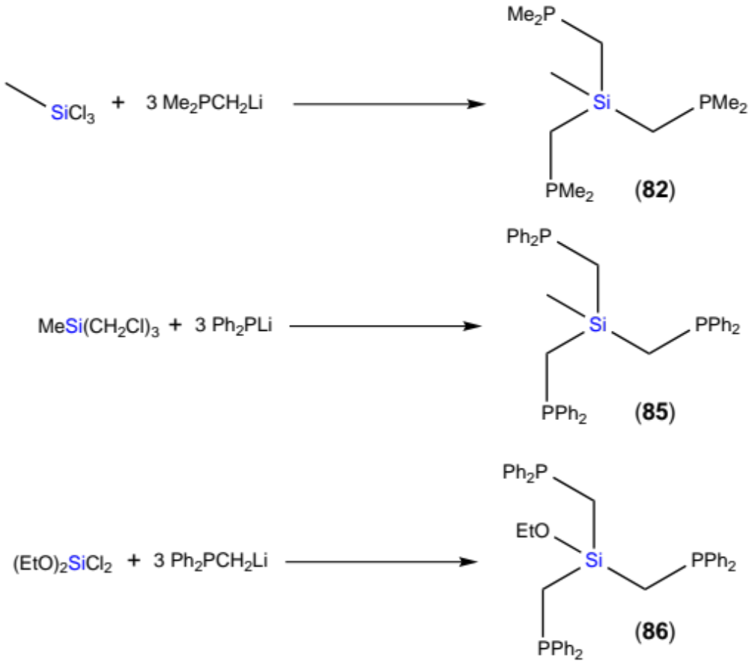
Scheme 14. Synthetic schemes to produce symmetric silicon-centered ligands R’SiP₃^{R} [38,41].

Coordination studies were not undertaken using 82 until the synthesis and study of a ruthenium complex in 1991: [RuCl₂(PMe₃)(MeSiP₃Me)] (83), synthesized by reaction of 82 with [RuCl₂(PMe₃)₄] [39]. Complex 83 was reduced by sodium amalgam in a benzene solution, leading to C–H activation of the solvent and affording the ruthenium hydride complex [RuH(C₆H₅)(PMe₃)(MeSiP₃Me)]. Additionally, complex 83 was also studied as a precursor for the synthesis of metallocyclobutanes [40]. These underwent step-wise C–C and C–H bond activation to eventually afford the trimethylenemethane (tmm) ligand (84) (Scheme 15).

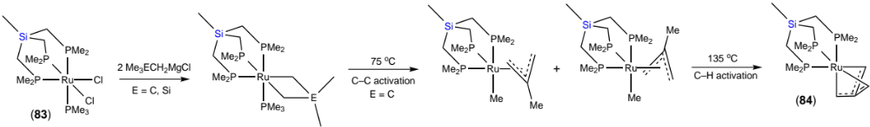
Scheme 15. Synthesis of metallocyclobutanes and subsequent thermolysis to trimethylenemethane (tmm) [40].

The diphenylphosphino derivative of 82 MeSi(CH₂PPh₂)₃ (MeSiP₃^{Ph}, 85) was prepared by reaction of MeSi(CH₂Cl)₃ with three equivalents of Ph₂PLi (generated in situ from Ph₂PCl and lithium) (Scheme 14) [41]. Ligand 85 was compared to analogues featuring apical carbon and tin (see section 2.3) atoms. Based on an X-ray crystallographic study of a series of rhodium complexes, a lengthening of the E–C bond between the apical atom and the methylene carbon situated on the arm of the ligand was observed that resulted in increasing steric bulk at the metal center following the trend C < Si < Sn [41].

Subsequent reports involving R’SiP₃^{R} derivatives developed the ancillary group [42] and phosphine substituents [43,44]. By substituting the ancillary methyl group in ligand 85 for an ethoxy moiety (86), this allowed the ligand to be anchored to silica via an ether linkage (88) and form tungsten tricarbonyl complexes (87) (Scheme 16). Anchored complexes of this variety are currently used for catalytic applications that have both homogeneous and heterogeneous characteristics. The well-defined structure of the complex provides the control and tenability of homogeneous catalysts, while its immobilization host allows for ease of work-up and recovery.

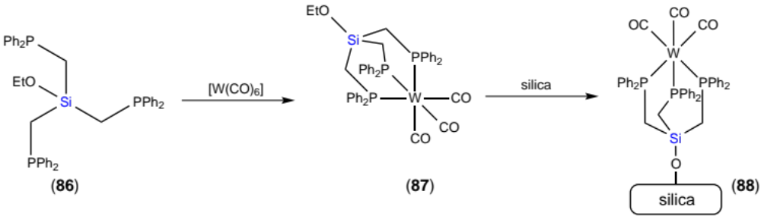
Scheme 16. Tungsten complexation and immobilization on silica of EtOSiP₃^{Ph} [42].

Two separate groups adapted the phosphine moieties of the parent ligand 82. Two such derivatives involve the substitution one of the PMe₂ groups for either a PPh₂ (MeSiP₂MeP^{Ph}, 89) or P^{i}Pr₂ group (MeSiP₂MeP^{iPr}, 90) [44]; while a separate group achieved asymmetric deprotonation of PMe₂(^{t}Bu)(BH₃) with s-BuLi/(–)-sparteine, followed by treatment with methyltrichlorosilane to give a mixture of C₃- and C₁-symmetric triphosphine–boranes MeSi(CH₂PMe(^{t}Bu)(BH₃))₃ [43]. Repeated recrystallization of these phosphine–borane compounds gave diastereomerically and enantiomerically enriched samples of the C₃-symmetric ligand, which was subsequently deprotected with morpholine to afford (R)-MeSi(CH₂PMe(^{t}Bu))₃ (MeSiP₃^{MT}, 91).

Ligands 82, 89 and 90 were coordinated to molybdenum(III) and subsequently studied for molecular nitrogen activation [44,45]. In general, the tripodal MeSiP₂MeP^{R} ligands were complexed with [MoCl₃(THF)₃] forming [MoCl₃(κ³-PhBP₂MeP^{R})] (92–94), and then subsequently reduced using a Na_{x}Hg amalgam in the presence of a secondary bidentate phosphine ligand (95–100, Scheme 17). This synthetic procedure was implemented to form molybdenum(0) complexes incorporating five coordinating phosphines possessing a mixture of diaryl and dialkyl substituents. When the reduction was carried out in the presence of monodentate rather than bidentate phosphines, invariably a mixture of complexes containing either one or two coordinated dinitrogen ligands was obtained.

The P-stereogenic triphosphine 91 was coordinated to several late transition metals: rhodium (101), ruthenium (102 and 103), palladium (104), platinum (105) and copper (106 and 107) (Scheme 18) [43]. These complexes are mostly unremarkable, forming expected structures with standard bond lengths and angles. The monomeric ruthenium complex [RuCl₂(DMSO)(κ³-PhBP₃^{MT})] (102) could only be isolated with an inseparable impurity, thought to be the dimeric species [Ru₂(μ-Cl)₃(κ³-PhBP₃^{MT})₂]Cl, but treatment of this mixture with two equivalents of AgOTf afforded [Ru(NCMe)₃(κ³-PhBP₃^{MT})](OTf)₂ (103a) which could be isolated. In acetonitrile this complex exists in equilibrium between a tris- and bis-acetonitrile, mono-triflate complex (103b). The copper complex [CuCl(κ³-PhBP₃^{MT})] (106) is monomeric in solution, but upon recrystallization underwent phosphine dissociation to form polymeric [Cu₂Cl₂(μ-κ²,κ¹-PhBP₃^{MT})]∞ (107) [43]. Polymer 107 represents the only well-defined polymer incorporating R’E(CH₂PR₂)₃ ligands.

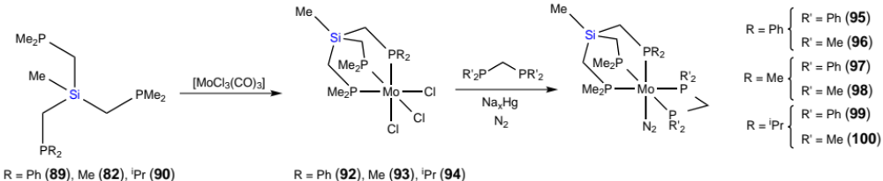
Scheme 17. Synthesis of pentaphosphine coordinated molybdenum–N₂ complexes [44,45].

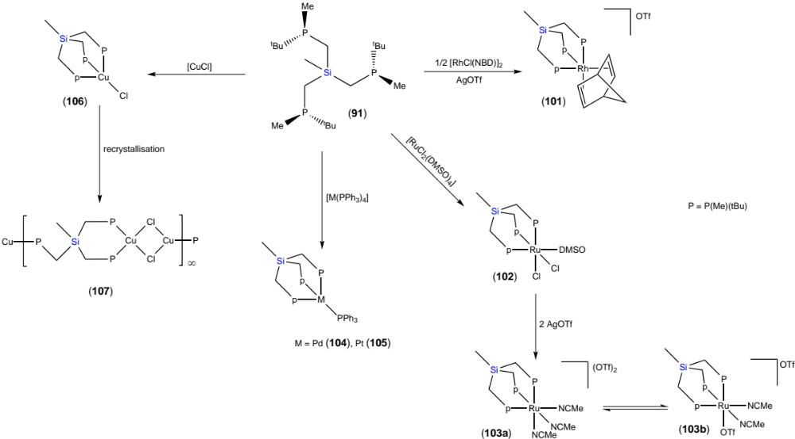
Scheme 18. Coordination study with MeSiP₃^{MT} [43].

2.3. Tin (MeSn(CH₂PR₂)₃)

To the best of our knowledge there are only two reports of tin-centered Triphos derivatives, both of which were reported alongside their silicon-analogues (see Section 2.2). First published for comparison to the silicon-centered analogous ligand 82, the tin derivative was prepared using an identical method: reaction of three equivalents of LiCH₂PMe₂ with MeSnCl₃ to afford MeSn(CH₂PMe₂)₃ (MeSnP₃Me, 108) in a slightly greater yield (42%) than 82 (32%) [38]. No coordination was undertaken with 108, but in 1995 an alternative tin-centered ligand featuring diphenyl substituents on phosphorus, ^{n}BuSn(CH₂PPh₂)₃ (^{n}BuSnP₃^{Ph}, 109), was reported [41]. Two rhodium(I) complexes of 109 were synthesized (110 and 111, Scheme 19), but their isolation was more problematic than for related complexes with the silicon-centered ligand 82 due to significant formation of oligomeric compounds.

Additionally, a ruthenium(II) compound was reported featuring one monodentate, and one bidentate CF₃CO₂ ligand (112, Scheme 19) [41]. This was compared to the classical carbon based Triphos analogue as it was thought that the increased steric bulk of 109 could potentially facilitate the stabilization of monometallic, dichloride, penta-coordinate ruthenium complexes, instead of the well-documented bimetallic species with bridging chlorides. Unfortunately these monomeric complexes were inaccessible, with only mixtures of products obtained.

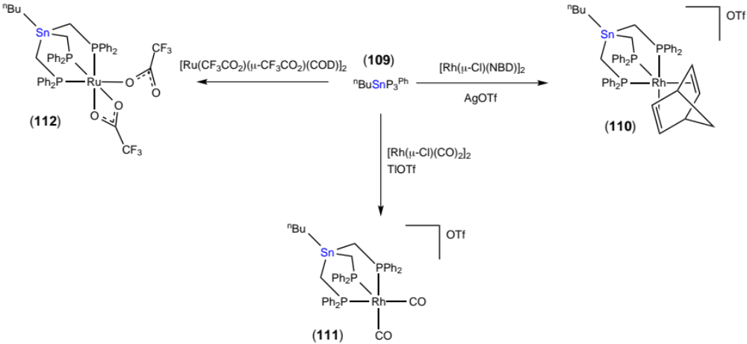
Scheme 19. Coordination study of ^{n}BuSnP₃^{Ph} to rhodium and ruthenium [41].

2.4. Nitrogen (N(CH₂PR₂)₃)

Although the tridentate ligand with a central nitrogen and ethylene bridges between the apical atom and phosphine moieties is very well studied, the methylene-bridged ligand is less well known. The ligand was first reported in 1983, alongside the synthesis of three derivatives, differing by the identity of the phosphine groups, including two that featured two different substituents on the same phosphorus atom: N(CH₂PRR’)₃ (R = R’ = Ph, NP₃^{Ph}, 113; R = Ph, R’ = C₁₀H₇, NP₃^{PhNaphth}; R¹ = Ph, R’ = CH₃, NP₃^{PhMe}) [46]. These were synthesized from the respective hydroxymethylphosphine with ammonia in moderate to high yields (61-94%). Each ligand was coordinated to molybdenum starting from [Mo(CO)₆], in each case affording the tridentate, tricarbonyl complex [Mo(CO)₃(κ³-NP₃^{R})] (114–116, Scheme 20).

An alternative synthesis involving the reaction of N(CH₂Cl)₃ with freshly prepared LiPPh₂ was published, ultimately to produce 113 [47]. The same molybdenum tricarbonyl complex was prepared (114), starting from the more labile precursor [Mo(CO)₃(NCMe)₃], and subsequently protonated at the nitrogen with HBF₄ (117, Scheme 20). Comparison of the spectral data obtained for the unprotonated- and protonated-complexes, showed that an interaction between the nitrogen and the metal center is likely. This is surprising as a distance of more than 3.5 Å separates the two atoms, whose combined atomic radii are in the region of 2.1 Å! There are no reported complexes with a formal bond between the coordinated metal and apical atom of Triphos derivatives, but such tetradentate coordination modes are observed for ligands with longer ‘arm’ lengths that separate the coordinating moieties from the apical hinge atoms [48]. Although the bond angles at the methylene bridge carbon could not support apical atom coordination, it appears that these atoms should not be considered innocent, and may impose considerable electronic contributions to the overall structure of the complex.

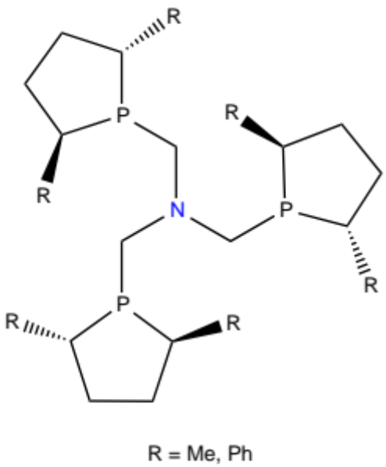
Figure 2. Phospholane ligands 126 and 127 [50-52].

The steric bulk of the phosphines was increased in two new derivatives by replacement of the phenyl substituents at phosphorus with cyclohexyl (N(CH₂PCy₂)₃, NP₃^{Cy}, 118) and tert-butyl groups (N(CH₂P^{t}Bu₂)₃, NP₃^{tBu}, 119) [49]. Additionally, these ligands were synthesized via a conveniently air-stable phosphonium intermediate, which improved the yield and allowed long-term storage of otherwise air-sensitive phosphines. In this case, coordination of 118 to Mo(0) and W(0) exclusively afforded the bidentate, tetracarbonyl complexes with one arm of the tripodal ligand remaining uncoordinated (120 and 121, Scheme 20). It was argued that this was due to the increased steric demand around the metal center and demonstrated via space-filling models this increase in steric encumberment. The pendant arm was used to coordinate to different metals (gold (122), platinum (123 and 124) and silver (125)), affording hetero-multimetallic complexes (Scheme 20) [49].

Further derivatization of the phosphine moieties was achieved through the use of chiral phospholane substituents. Two such ligands were reported with either 2,5-dimethyl (NP₃^{DMP}, 126) or 2,5-diphenyl (NP₃^{DPP}, 127) substituents on the phospholane ring (Figure 2) [50-52]. Complexation of these ligands to the rhodium(I) precursor [Rh(cod)₂]BF₄ showed different coordination modes, with the less bulky 126 coordinating through all three phosphine groups to afford [Rh(cod)(κ³-NP₃^{DMP})] (128), while the sterically cumbersome 127 only through two: [Rh(cod)(κ²-NP₃^{DPP})] (129, Scheme 21). DFT calculations confirmed this discrepancy to be steric in nature, as the analogous tridentate complex of 129 sits 65.7 kJ mol⁻¹ higher in energy, while the bidentate analogue of 128 sits 25.9 kJ mol⁻¹ higher in energy than its tridentate counterpart [50]. The pendant arm of 129 was coordinated to various gold salts, accessing hetero bimetallic systems similar to those previously reported [49]. Moreover, two trimetallic gold complexes of ligands 126 and 127 were synthesized, where each phosphine was coordinated to a separate AuCl unit (Scheme 21) [51]. Both inter- and intra-molecular aurophilic interactions were found for [Au₃Cl₃(μ₃-κ¹,κ¹,κ¹-NP₃^{DMP})] (130) and [Au₃Cl₃(μ₃-κ¹,κ¹,κ¹-NP₃^{DPP})] (131), respectively. The metallophilic interactions lead to a zig-zag arrangement in the solid-state of crystalline 130 and intramolecular aggregation of 131 in solution, even at low temperatures.

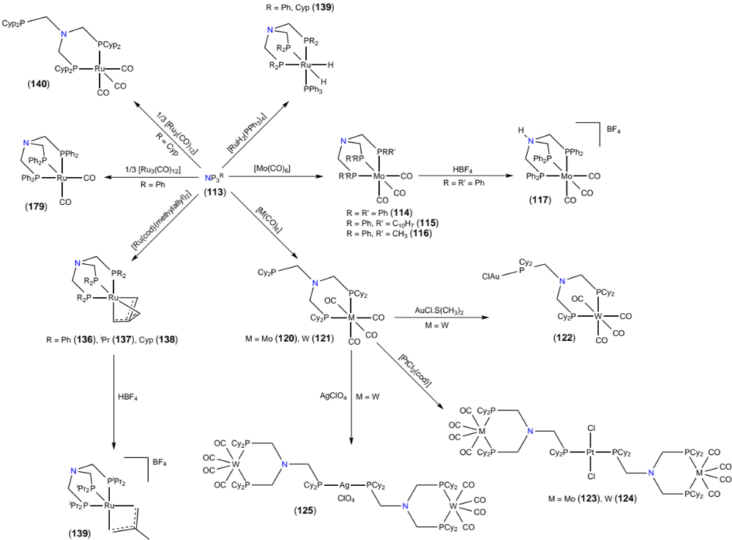
Scheme 20. Complexes of NP₃^{R} ligands [46,47,49,54,55].

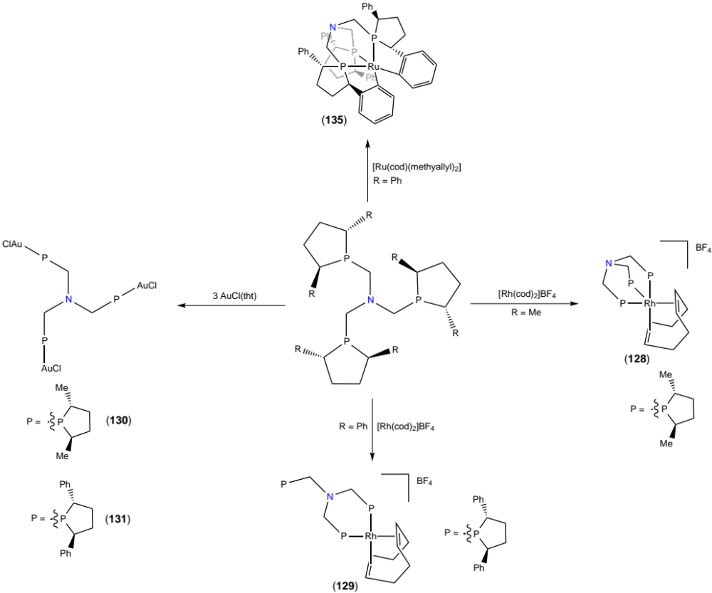
Scheme 21. Complexes of phospholane NP₃^{R} ligands [50-52].

The steric bulk of ligands 118, 119 and 127 appeared to prohibit tridentate coordination, which is useful for enhancing overall stability and potentially retarding decomposition during catalytic applications. Consequently derivatives with less sterically demanding phosphines, or more forcing conditions were implemented to enforce a κ³-coordination mode. NP₃^{R} derivatives bearing ethyl (N(CH₂PEt₂)₃, NP₃^{Et}, 132) [53], isopropyl (N(CH₂P^{i}Pr₂)₃, NP₃^{iPr}, 133) [54] and cyclopentyl (N(CH₂PCyp₂)₃, NP₃^{Cyp}, 134) [55] substituents were synthesized to satisfy the former, while increasing the temperature and reaction time allowed κ³-coordination of 127 to ruthenium(II) [52]. Reaction of 127 with [Ru(cod)(methylallyl)₂] in toluene at sub-reflux temperatures afforded the bidentate species [Ru(methylallyl)₂(κ²-NP₃^{DPP})], while subsequent extended heating under reflux resulted in chelation of the third arm and tandem release of isobutene via C–H activation and cyclometalation of two phenyl groups, affording [Ru(κ³P,κ²C-NP₃^{DPP})] (135) (Scheme 21). The same ruthenium(II) precursor was utilized for a complexation study of 133, which similarly coordinated via all three phosphine donors. Upon coordination of 133 to [Ru(cod)(methylallyl)₂], cod is simply displaced, while an intramolecular deprotonation of one methylallyl group by the other causes the release of isobutene with concomitant formation of trimethylenemethane (tmm), which remains coordinated in the final complex [Ru(tmm)(κ³-NP₃^{iPr})] (137). Similar compounds were also formed upon reaction of 113 and 134 with [Ru(cod)(methylallyl)₂] (136–138, Scheme 20) [54]. Treatment of 137 with HBF₄ did not lead to protonation of the apical nitrogen as with [Mo(CO)₃(κ³-NP₃^{Ph})] (114), instead protonating the dianionic tmm ligand back to methylallyl, and forming a more reactive 16-electron complex (139). This shows the apical nitrogen of coordinated NP₃^{R} ligands is stable to acids when other nucleophilic groups are present, potentially due to the interaction between the nitrogen and metal center, which would stabilize the lone pair.

The cyclopentyl ligand 134 was coordinated to three different ruthenium precursors (137, 139 and 140, Scheme 20) and its complexation chemistry was compared to that of the parent NP₃^{Ph} ligand [55]. The more bulky alkylphosphine ligand coordinates in a tridentate mode to ruthenium(II) centers (137 and 139), but ruthenium(0) complexes that possessed carbonyl ligands afforded the bidentate species exclusively (140). It was argued that the increased electron-donating ability of 134 compared to 113 could account for the disparity, as steric crowding was ruled out [55]. The superior electron-donating ability of 134 may disfavour coordination of all three phosphine groups, as this would also presumably strengthen the N–Ru interaction and greatly increase electron density focused at the already electron-rich ruthenium(0) center.

2.5. Phosphorus (P(CH₂PR₂)₃)

The phosphorus analogue was first reported during an investigating of the reactivity of LiCH₂PMe₂ with various substrates. Reaction of LiCH₂PMe₂ with P(OPh)₃ resulted in tri-substitution to afford the P-centered ligand P(CH₂PMe₂)₃ (Scheme 22, PP₃Me, 141) [56].

This ligand motif was next reported 20 years later, when the phenyl derivative P(CH₂PPh₂)₃ (PP₃^{Ph}, 142) was synthesized and coordinated to manganese in order to study their cyclic voltammetric responses [57]. The manganese complexes had PP₃^{Ph} binding in a meridional mode, the only such example in all the ligands discussed, through two arms and the central phosphine: cis,mer-[MnBr(CO)₂(PP₃^{Ph})] and trans-[MnBr(CO)₂(PP₃^{Ph})]BF₄. As different isomers and oxidation states were investigated, this allowed rates of isomerization to be investigated in the solid state. Ligand 142 was likewise quantitatively prepared by reaction of Ph₂PCl with P(CH₂SiMe₃)₃, but no coordination studies were undertaken (Scheme 22) [58].

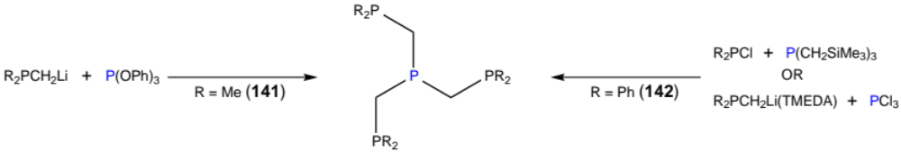
Scheme 22. Synthetic strategies to afford PP₃^{R} (R = Me, Ph) [56-59].

Blümel utilized an alternative synthetic scheme that more closely resembles the synthetic strategy used to synthesize the boron-centered ligands (Section 2.1). Reaction of three equivalents of Ph₂PCH₂Li(TMEDA) with PCl₃ resulted in formation of 142 in good yield (87%, Scheme 22) [59]. In order to immobilize 142 on silica via electrostatic interactions for use in catalysis (similar to work carried out using EtOSiP₃^{Ph}), the apical phosphorus needed to be quaternized into a phosphonium moiety. To achieve this quaternization with related diphosphine ligands, methyl iodide was utilized [60], but this lead to a mixture of products when adapted for 142. Instead, the more selective methyl triflate was used, as this only reacted with the most basic site, being the trialkylphosphine moiety, ultimately affording (MeP(CH₂PPh₂)₃)OTf (MeP⁺P₃^{Ph}, 143). The newly prepared cationic ligand was coordinated via the three remaining phosphines to rhodium, with no interference from the phosphonium moiety (144). This complex was subsequently immobilized on silica (145, Scheme 23) [59].

Finally, some homo- and hetero-metallic tetra-clusters were prepared with 142: [M₄(PP₃^{Ph})₂]⁴⁺ (M = Ag (146), Au (147)), [AuAg₃(PP₃^{Ph})₂]⁴⁺ (148) and [Au₂Cu₂(PP₃^{Ph})₂(NCMe)₄]⁴⁺ (149) [60]. Structurally these clusters arranged as two parallel PP₃^{Ph} ligands, with the four metal ions positioned in a planar star formation and bis-coordinated by two opposite phosphines from each ligand, except for 149 which adopts a different structural motif (Figure 3). These complexes were studied for their dynamic solution behavior by variable-temperature NMR, as well as for their photoluminescence, which in one case gave quantum yields as high as 64%. It was found that an increase of the gold content within the cluster core gradually improved the quantum efficiency of these luminophores in the solid state [60].

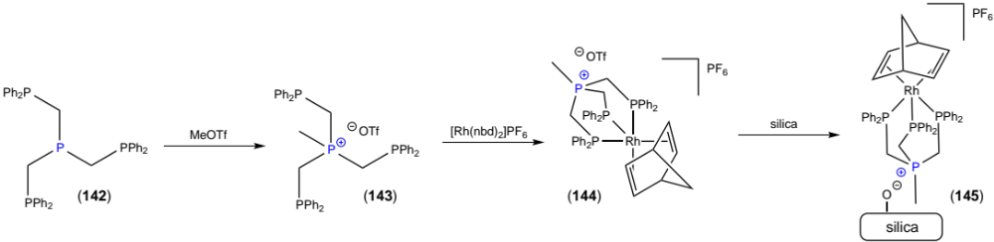
Scheme 23. Immobilization of MeP⁺P₃^{Ph} on silica via electrostatic interactions [59].

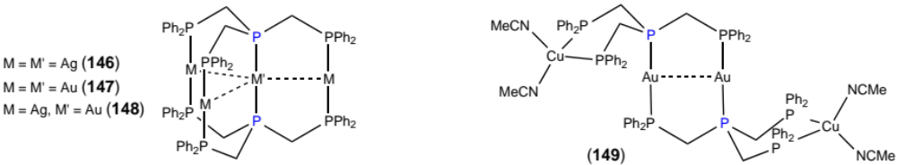
Figure 3. Structural motifs of multimetallic arrays featuring PP₃^{Ph} [60].

3. Reactivity and Applications

3.1. Boron

Complexes featuring R’B(CH₂PR₂)₃ ligands have been widely used across many applications, ranging from hydrogenation [32] reactions to their use as precursors for metallic silver aerosol-assisted chemical vapour deposition [21]. These complexes have displayed a rich chemistry for the stabilization of reactive species via activation of small molecules, as well as mediating their subsequent reactivity. The activation chemistry of primary, secondary and tertiary silanes to generate catalytically important silylene fragments has been developed on both iridium [61] and ruthenium centered complexes [33,62]. Catalytic and stoichiometric reactions of organosilanes are thought to occur via intermediate silylene complexes (e.g. olefin hydrosilation reactions), making the study of these species important for the development of organosilicon chemistry.

Both iridium and ruthenium complexes can activate secondary silanes, though to different degrees. Reaction of the iridium complex [IrH(η³-C₈H₁₃)(κ³-PhBPh₃^{Ph})] (10) with secondary silanes H₂SiRR’ (R = R’ = Mes, Ph, Et, Me) in each case afforded the desired silylene complexes (150–153), presumably resulting from initial oxidative addition of H–SiHR₂, before 1,2-H migration occurs to give the final products (Scheme 24, reaction i) [61]. Identical reactivity was also observed with secondary germanes but not stannanes or alkanes. On the other hand, the reaction between [Ru(μ-Cl)(κ³-PhBP₃^{Ph})]₂ (77) with excess secondary silanes afforded [RuH(η³-H₂SiRR’)(κ³-PhBP₃^{Ph})] (R,R’ = Me,Ph (154); Ph₂ (155)), featuring a rarely observed η³-H₂Si coordination mode (Scheme 24, reaction ii) [33]. This differs from the reactivity observed for iridium in that the silicon moiety still contains directly bound hydrogens. The electrophilic character of the silicon atom in 154 and 155 is evident from the reaction of these complexes with Lewis bases such as THF (156) and 4-(dimethylamino)pyridine (DMAP) (157 and 158) which resulted in adduct formation (Scheme 24, reaction iii) [33]. The reactivity of 154 and 155 was further studied by reaction with 2,6-xylylisocyanide (Scheme 24, reaction iv) [63] and 2,6-xylylsilane (Scheme 24, reaction v) [62], the former resulting in silane–isocyanide coupling (159 and 160), and the latter in formation of a dimeric species featuring an extremely rare central η⁴,η⁴-[SiH₆]^{2–} moiety [{Ru(κ³-PhBP₃^{Ph})}₂{μ-η⁴,η⁴-H₆Si}] (161) [62]. The only other reported synthesis of this species involved extreme pressure and high temperature (>4 GPa, >450 °C) [64], making this mild and high yielding synthesis notable. This stability was proposed to be due to the ability of each flanking [Ru(κ³-PhBP₃^{Ph})] moiety to uniformly remove electron density from each Si–H bond.

Primary silanes displayed different reactivity towards iridium and ruthenium complexes 10 and 77 (Scheme 25) [61,62,65]. The expected silylene complex from the reaction between 10 and 2,4,6-triisopropylphenylsilane (TripSiH₃) was observed spectroscopically and featured a coordinated =SiHR moiety, but the in situ generated cyclooctene underwent hydrosilylation to afford the final complex 162 (Scheme 25, reaction i) [61]. The ruthenium complex 22 formed other exotic dimers, containing one bridging chloride as well as a hydrosilicate σ-complex (163–165), when reacted with various primary silanes (Scheme 25, reaction ii) [62]. The activation of tertiary silanes has been explored on iridium, which afforded symmetrical, silyl-capped iridium(V) species (166 and 167, Scheme 25, reaction iii) [61]. It is interesting to note that when considering the activation of silanes on iridium, 10 can behave as a source of “[PhBP]Ir” or “[PhBP]IrH₂” depending on the reaction conditions.

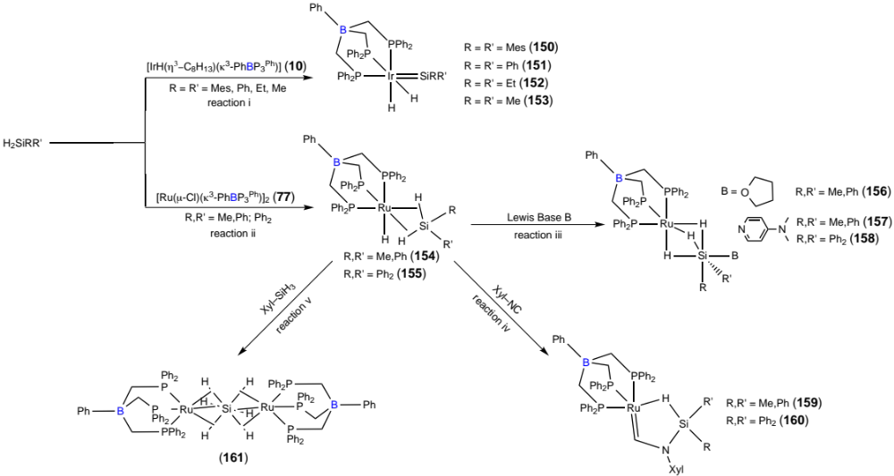
Scheme 24. Activation of secondary silanes on iridium and ruthenium centered complexes [33,61-63].

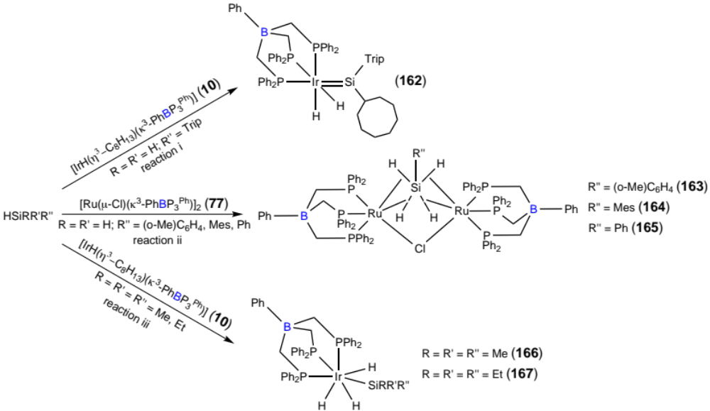
Scheme 25. Activation of primary and tertiary silanes on iridium and ruthenium centered complexes [61,62,65].

Cobalt–, iron– and rhodium–imide complexes described in Section 2.1 exhibit similar reactivity towards CO and H₂, producing isocyanate and primary amines, respectively (Scheme 26) [25,26,28,35]. The fate of the metal fragment was identical for each metal upon exposure to excess CO; namely, the formation of dicarbonyl complexes (73, 168 and 169, Scheme 26) via a reductive two-electron group-transfer process that delivers the bound imido group to the substrate. Conversely, upon exposure to molecular hydrogen, the metallic components behaved differently. In both cases, the imido group is converted into a primary amine, but in the case of rhodium complexes, dihydride species are formed with the in situ generated amine remaining coordinated (74) [35]. On the other hand the iron complex released the generated amine and activate the benzene solvent by protonation (170, Scheme 26) [26]. The bimetallic iron system featuring a bridging nitride ligand [{(κ³-PhBP₃^{Ph})Fe}₂(μ-N)][Na(THF)₅] (58) heterolytically split H₂ instead of undergoing a similar hydrogenation process observed in the terminal imido complexes. Instead, a bridging amide and hydride is produced from the net 1,2 H–H addition across the Fe–N–Fe linkage (171, Scheme 27) [27,66].

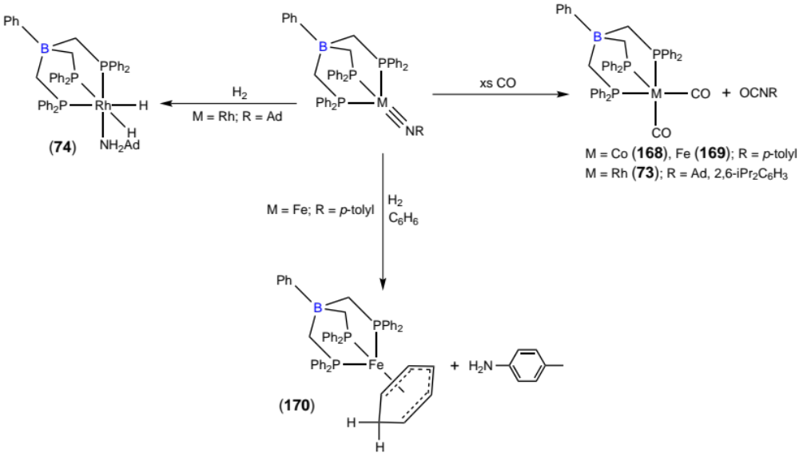
Scheme 26. Reaction of cobalt–, iron– and rhodium–imide complexes with CO and H₂ [25,26,28,35].

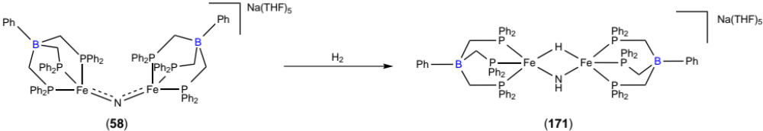
Scheme 27. Heterolytic activation of H₂ using an iron dimer containing a bridging nitride [27,66].

Na_{x}Hg amalgam reduction of the iron(II) complex [FeCl(κ³-PhBP₃^{CH2Cy})] (37) afforded an iron(I) species with elemental analysis data suggesting an empirical formula of [Fe(κ³-PhBP₃^{CH2Cy})] (172) [18]. The true nature of 172 was not established, but it may exist in equilibrium between a monomeric, cyclometalated iron hydride species, and a dimer analogue with bridging hydrides. Exposure of the iron(I) species to CO₂ resulted in a mixture of products, with the major product being identified as a dimeric complex that resulted from a net two-electron reductive cleavage of CO₂ to CO and O^{2–}, [{Fe(κ³-PhBP₃^{CH2Cy})}₂(μ-CO,μ-O) (173, Scheme 28). A paramagnetic side product was also identified and characterized as the CO₂ coupled oxalato compound [{Fe(κ³-PhBP₃^{CH2Cy})}₂(μ-η²:η²-oxalato)] (174) [18]. This reaction is highly solvent dependent, and correct solvent choice could push the product mixture to predominantly 173 (methylcyclohexane) or 174 (benzene or THF) [67].

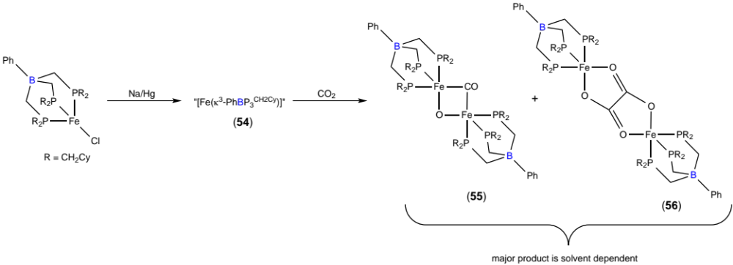
Scheme 28. Activation of CO₂ with an iron(I) species to give a mixture of reductively cleaved or coupled CO₂ products [18,67].

PhBP₃^{R} ligands have also been implemented in more classical catalytic reactions. The dihydridorhodium(III) complex [RhH₂(NCMe)(κ³-PhBP₃^{Ph})] (67) is extremely efficient at the selective dimerization of both aliphatic and aromatic aldehydes, as well as enolizable and non-enolizable analogues (Scheme 29) [68]. A mechanism involving the insertion of the carbaldehyde group into the Rh–H bond to generate an alkoxo group, with insertion of a second aldehyde into the resulting rhodium alkoxide appeared to be essential for the observed high activity. All reactions proceeded very rapidly, with complete conversion being observed in less than four minutes, giving initial turnover frequencies (TOFs) as high as 2830 h⁻¹. Notably, 67 showed catalytic activity for the coupling of biomass-derived furfural, a reaction that had previously required long reaction times or harsh conditions utilizing heterogeneous catalysts [69]. Rhodium(I) species were ineffective catalysts for the coupling of aldehydes, exclusively leading to decarbonylation products, but they were active for the selective hydrogenation of cinnamaldehye to the corresponding α,β-unsaturated alcohol (Scheme 29) [32]. The ruthenium dimer 77 also catalysed this reaction as well as the related hydrogenation of crotonaldehyde with greater selectivity and under milder conditions, leading to considerably faster TOFs, and represents one of the most active and selective ruthenium catalysts reported for these reactions [32].

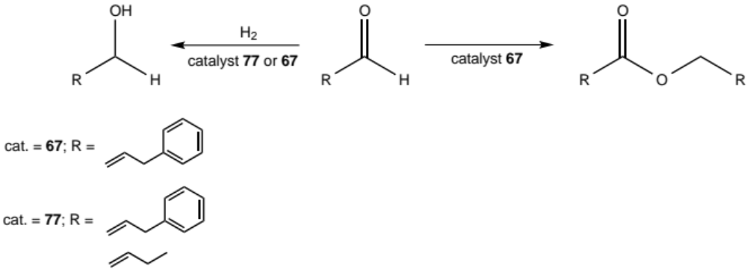
Scheme 29. Selective dimerization of aldehydes to esters with 67 and selective hydrogenation of α,β-unsaturated aldehydes to alcohols using 77 and 67 [32,68].

A number of catalytic reactions for copper and silver complexes of 1 and the newly described 5 (differing from 1 by the presence of para-trifluoromethyl groups situated on the phenyl rings) have been reported. Four-coordinate copper complexes of 1 with PPh₃ as the fourth ligand [Cu(PPh₃)(κ³-PhBP₃^{Ph})] (175) are good surrogates for the already described “Tp^{Me2}CuL” systems (Tp^{Me2} = hydrotris(3,5-methylpyrazolyl)borate), as the coordinated phosphine readily dissociates in solution to deliver the “Cu(κ³-PhBP₃^{R})” subunit into the catalytic cycle [70]. The comparative catalytic study between 175 and [Tp^{Me2}CuL] systems involved i) cyclopropanation and cyclopropenation reactions, ii) insertion of N–C–CO₂Et generated from ethyl diazoacetate (EDA) into N–H and O–H bonds, iii) addition of a nitrene unit derived from PhINTs across unsaturated hydrocarbons, and iv) atom-transfer radical addition (ATRA) and polymerization (ATRP) reactions (Scheme 30). In each case, 175 showed slightly less but comparable activity to [Tp^{Me2}CuL], except during ATRA and ATRP reactions where 175 afforded higher yields, and lower polydispersity indicies (PDIs), respectively [70].

Despite promising catalytic results obtained for complex 175, the catalyst underperformed where a more electrophilic metal center would be advantageous. Ligand 5 was conceived as an analogue of 1 that would help reduce the electron density at the metal upon coordination. The pseudo-tetrahedral copper and silver complexes of 5 [M(PPh₃)(κ³-PhBP₃^{p-CF3Ph})] (M = Cu, 176; Ag, 177) were evaluated for activity towards nitrene transfer reactions [20]. Complex 176 very efficiently catalysed the nitrene addition across unsaturated C–C bonds, and was even more active than 175. A further 20 examples were studied, and the catalyst showed a tolerance towards electron-withdrawing and donating groups, as well as being stereoselective with retention of conformation. A series of competition and radical trapping experiments suggest the mechanism for this reaction to be the same as that proposed for the analogous Tp^{x}Cu-based system, involving both singlet and triplet states. The silver complex 177 displayed considerably greater activity for the insertion of a nitrene moiety into a C–H bond than 176, the latter of which affords almost no product [20].

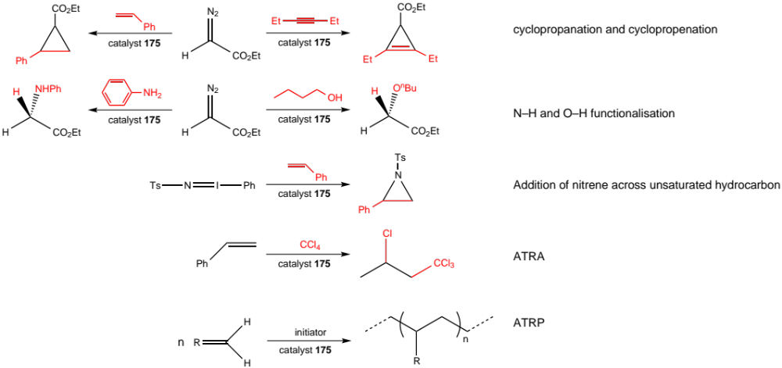
Scheme 30. Scope of comparative catalytic study to compare 175 with [Tp^{Me2}CuL] systems [70].

Finally, silver complexes [Ag(PEt₃)(κ³-RBP₃^{Ph})] (R = Ph; ^{n}Bu, 178) were evaluated as precursors for aerosol-assisted chemical vapour deposition (AACVD) onto MgO(100) and 52100 steel surfaces [21]. In general 178 gave better results with fewer impurities (due to decomposition of ligand) and higher growth rates of silver films having electrical resistivities approaching that of bulk silver. These silver complexes offered significant improvements for non-fluorinated silver precursors, not just for efficient film deposition, but additionally their air- and light-stability offers ease of handling. The conformational coverage obtained on 52100 steel makes 178-derived silver films grown in this manner promising as solid lubricant coatings [21].

3.2. Silicon

Complexes featuring silicon-centered triphos ligands have not been extensively studied for reactivity or applications, and no formal catalytic studies have been reported. Recently however, several molybdenum complexes have been investigated for the activation of molecular nitrogen [44,45].

A series of pseudo-octahedral molybdenum(0) complexes featuring a single coordinated dinitrogen ligand were synthesized. The remaining five coordination sites are occupied by a tridentate MeSiP₂^{R}P^{R’} ligand as well as a secondary diphosphine. For comparison, three complexes featuring carbon-centered triphos ligands MeCP₃^{Ph} [71] and MeCP₂^{Ph}P^{iPr} [72] will be included within the discussion for completion. In total, five different triphosphine ligands (Figure 4) and two different diphosphine ligands (1,1-bis(diphenylphosphino)methane (dppm) and 1,1-bis(dimethylphosphino)methane (dmpm)) were implemented, and when coordinated in various combinations, led to nine unique complexes [44]. The extent of nitrogen activation was determined by evaluation of the N–N stretching frequency obtained from the infrared spectrum of each compound. It was found that with increasing number of bound dialkylphosphines and with increasing steric bulk, the N–N stretching frequency was shifted to lower wavenumbers indicating a weakening of the bond and hence activation (Figure 5). The complex that most activates dinitrogen (ν_{(N–N)} 1932 cm⁻¹) was [Mo(N₂)(dmpm)(κ³-MeSiP₂MeP^{iPr})] featuring five bound dialkylphosphines including a bulky diisopropylphosphino moiety. This apparently simple trend should allow the tuning of molybdenum–phosphine based catalysts for the activation of nitrogen and subsequent transformation, for example in nitrogen fixation to ammonia.

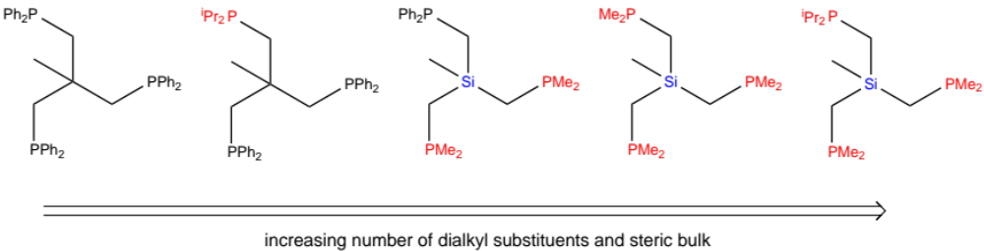
Figure 4. Triphosphine ligands used in N₂ activation study [44].

Figure 5. Correlation of N₂ activation and number of alkylphosphine donors in Mo–N₂ complexes with pentaphosphine coordination [44].

3.3. Nitrogen

The diphenyl- (NP₃^{Ph}, 113) and diethyl-phosphino nitrogen-centered ligands (NP₃^{Et}, 132) were evaluated for their ability to hydrogenate the industrially relevant ester dimethyl oxalate (DMO) to ethane-1,2-diol (ED) via methyl glycolate (MG) (Scheme 31), but it was found that both of these ligands underperformed when compared to MeCP₃^{Ph} [53]. The catalysts were formed in situ from [Ru(acac)₃] (acac = acetylacetone) and triphosphine, and N-centered ligands all displayed longer induction periods, where hydrogen was being consumed but no DMO conversion was observed by analysis of sampled aliquots and headspace gas.

Furthermore, a first-order rate dependence in DMO was observed during the reactions performed with NP₃^{R} ligands, but this was zero-order when MeCP₃^{Ph} was utilized. This discrepancy in kinetic profile suggests DMO binding to ruthenium is facile during the carbon-centered regime, but becomes rate determining when nitrogen-centered ligands are employed [53]. Further differences between the two ligand regimes were identified, in that the MeCP₃^{Ph} system was much slower at the hydrogenation of DMO to MG than MG to ED, with significant quantities of both MG and ED being detected throughout the reaction. On the other hand ED was only produced once the majority of DMO had been converted to MG in the NP₃^{R} systems. The use of [Ru(CO)₂(NP₃^{Ph})] (179) as a well-defined molecular catalyst did not enhance catalyst efficacy, presumably as the carbonyl-stabilized ruthenium(0) center could not undergo the prerequisite oxidative process to afford the proposed 16-electron ruthenium(II) active species [RuH₂(NP₃^{R})] [53]. The 14-electron ruthenium(0) species [Ru(P₃^{R})] (P₃^{R} = MeCP₃^{Ph}, NP₃^{Ph}, NP₃^{Et}) is proposed to exist prior to oxidative addition of hydrogen to reproduce the catalytically active 16-electron ruthenium dihydride. The increased stability inferred from tridentate ligands facilitates this process where mono- and bidentate ligands would fail, causing catalyst decomposition to ruthenium(0) metal [53].

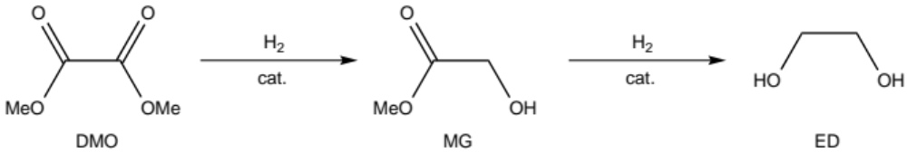
Scheme 31. Catalytic hydrogenation of dimethyl oxalate (DMO) to ethane-1,2-diol (ED) via methyl glycolate (MG) [53].

The rhodium complexes [Rh(cod)(κ³-NP₃^{DMP})] (128) and [Rh(cod)(κ²-NP₃^{DPP})] (129) were evaluated for their activity in enantioselective hydrogenation of a series of prochiral olefins (Scheme 32) [50]. The tridentate complex 128 required higher hydrogen pressures and longer reaction times to achieve complete substrate conversion than related mono- or bi-dentate systems, as decoordination of one phospholane unit may be required as the first step of the catalytic cycle. This complex also displayed only moderate enantioselectivies (55-95% ee). On the other hand, the bidentate complex 129 was much more active and led to high enantioselectives in four of the five substrates studied (92-98% ee). This was further optimized by coordination of the pendant phospholane arm of 129 with gold salts (AuCl, AuC₆F₅ and AuMes), with 129–AuC₆F₅ giving the best results (>99% ee). In general, increasing the steric bulk around the free phospholane arm (129 < 129–AuCl < 129–AuC₆F₅) lead to increasing enantioselectivities, but additional bulk past a certain threshold was detrimental (129–AuMes) [50].

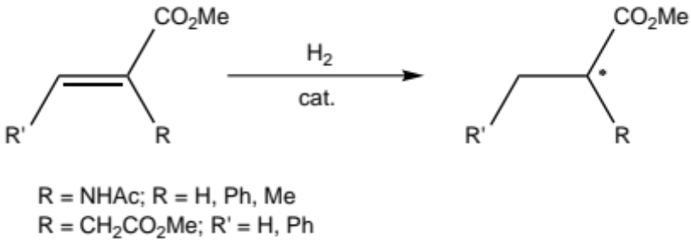
Scheme 32. Hydrogenation of prochiral olefins [50].

The activation of allene groups towards nucleophilic attack is becoming a powerful organic transformation in natural-product synthesis and pharmaceutrical chemistry [73]. The use of the trinuclear C₃-symmetric gold(I) complex [Au₃Cl₃(μ₃-κ¹,κ¹,κ¹-NP₃^{DPP})] (131) was reported for the asymmetric intramolecular cyclohydroamination of N-protected -allenyl sulfonamides, in conjunction with silver(I) salts as hydride abstraction agents (Scheme 33) [51]. When silver salts with rigorously non-coordinating anions were studied for this reaction, racemic mixtures were obtained, but moving to the slightly more coordinating benzoate anion (OBz), resulted in high conversions with high enantioselectivities (up to 95% ee). The reaction time required for complete conversion could be significantly reduced by substitution of the benzoate anion with the more electron withdrawing para-nitrobenzoate or 3,5-dinitrobenzoate, but this also resulted in slightly lower stereocontrol. For each -allenyl sulfonamide substrate studied, moving from mono- to bi- to tri-dentate phospholane ligands (with one, two and three coordinated AuCl units, respectively) gave greater catalytic activity and enantioselectivity. Aurophilic interactions may be responsible for this behavior (Section 2.4) [51].

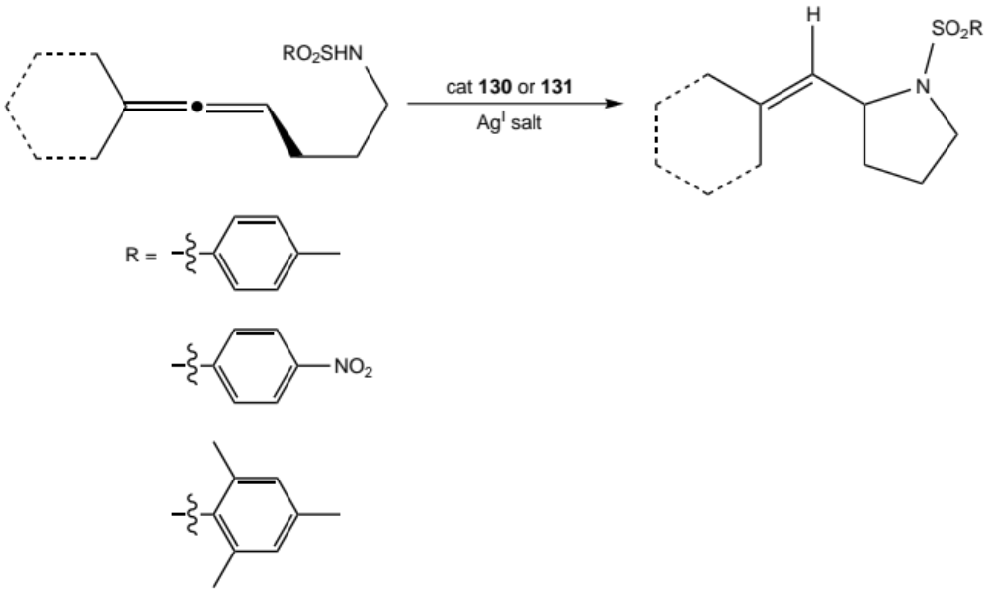
Scheme 33. Asymmetric cyclohydroamination of N-protected γ-allenyl sulphonamides [51].

As Ru–C bonds in cyclometalated complexes are easily cleaved, the bis-cyclometalated ruthenium complex [Ru(κ³P,κ²C-NP₃^{DPP})] (135) was investigated for reactivity with both H₂ and Ph₂SiH₂ [52]. Under pressures of H₂, 135 rapidly establishes an equilibrium between two species featuring both classical and non-classical hydrides (Scheme 34). In the first instance, one Ru–C bond is cleaved and the vacant coordination site is filled with one hydride, and one dihydrogen ligand (180). The second, major species is formed from cleavage of both Ru–C bonds and their replacement with two hydrides and a single dihydrogen ligand (181). The equilibrium between the two compounds can be shifted toward the main component by increasing the H₂ pressure. At 10 bar, a ratio of 95:5 in favour of 181 was observed [52]. Interestingly, upon release of H₂ pressure and purging with argon, the starting complex 135 was obtained quantitatively, indicating complete reversibility of Ru–C bond cleavage.

Treatment of 135 with Ph₂SiH₂ cleanly afforded the silyl dihydrido complex [Ru(η³-H₂SiPh₂)(κ³P,κ¹C-NP₃^{DPP})] (182), where the silane has inserted into the one Ru–C bond and coordinated to ruthenium in a rare η³-H₂Si binding mode. The structure of 182 is similar to the ruthenium hydrides 154 and 155 (Section 3.1), which contain boron-centered PhBP₃^{Ph} ligands [62,63]. In these compounds, complete oxidative addition of the silane has not occurred, suggesting that ruthenium complexes of EP₃^{R}-type ligands (E = PhB, N) can efficiently stabilize these transient species, but whether this is steric or electronic in nature is not certain. Similar to the reaction between 135 and molecular hydrogen, pressurization of 182 with H₂ resulted in cleavage of the remaining Ru–C bond with reversible formation of a dihydrogen bound complex (183) [52].

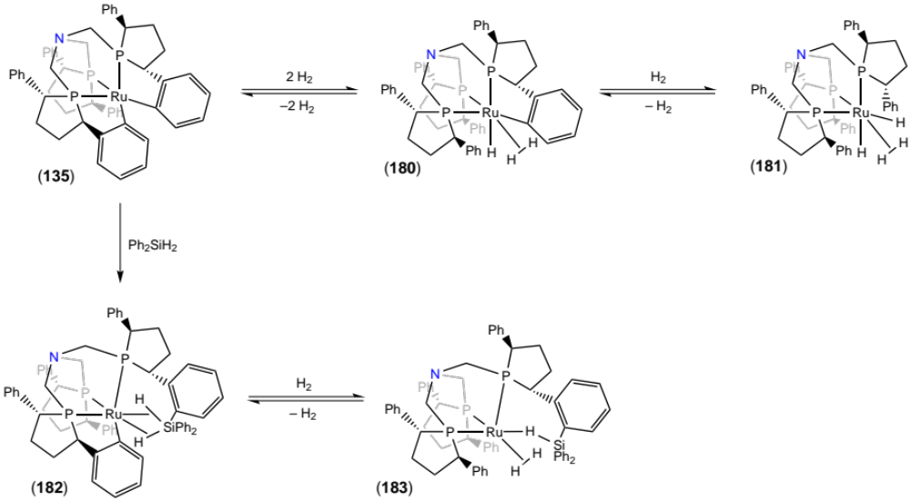
Scheme 34. Reactivity of [Ru(κ³P,κ²C-NP₃^{DPP})] (135) with H₂ and Ph₂SiH₂ [52].

Carbon-centered Triphos ligands have shown great promise in high pressure/temperature catalytic reactions that are not normally accessible using mono- and bi-dentate phosphine ligands [74]. This is especially important for the valorization of biomass-derived compounds to value-added platform chemicals, fuels and solvents, as these generally require harsh reaction conditions [75]. To extend this chemistry beyond complexes of MeCP₃^{Ph}, the reactivity of the ruthenium dihydride complex [RuH₂(CO)(κ³-NP₃^{Ph})] (184) was investigated for its reactivity with the biomass-derived levulinic acid (LA), which is a promising feedstock for various platform chemicals including 2-methyltetrahydrofuran [55]. Although the complex originally showed no reactivity towards LA directly, in the presence of the proton donor NH₄PF₆ and a coordinating solvent (MeCN) an intermediate complex [RuH(NCMe)(CO)(κ³-NP₃^{Ph})] (185) reacted cleanly with LA, which coordinated to ruthenium in a bidentate fashion with tandem release of molecular hydrogen (186, Scheme 35).

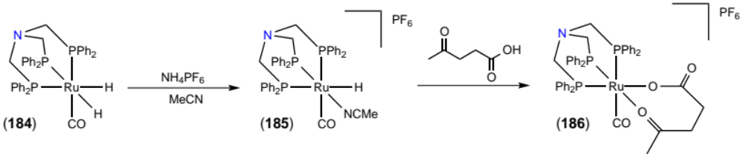
Scheme 35. Reactivity of [RuH₂(CO)(κ³-NP₃^{Ph})] with NH₄PF₆ and levulinic acid [55].

3.4. Phosphorus

The silica immobilized rhodium catalyst 145 featuring a methyl-quaternized analogue of PP₃^{Ph} (MeP(CH₂PPh₂)₃⁺) was tested as a Wilkinson’s catalyst analogue for the hydrogenation of 1-dodecene (Figure 6) [59]. The recyclability of this catalyst was better than expected, with 14 batch cycles being required before conversion no longer reached 100% within 35 hours. After observing a decoloration to black upon catalytic cycling, it was discovered that this coincided with the formation of nanoparticulate rhodium(0). The presence of surface bound nanoparticles was determined by catalyst poisoning experiments and TEM imaging. Through separate nanoparticle synthesis experiments, the pressure of hydrogen during catalytic cycles was determined to be key in reducing the well-defined rhodium(I) species to rhodium(0) and subsequent nanoparticle formation. By pre-depositing freshly prepared rhodium nanoparticles on silica, it was demonstrated that these are the active catalytic species, not the desired monomeric Wilkinson’s analogue featuring MeP⁺P₃^{Ph} [59].

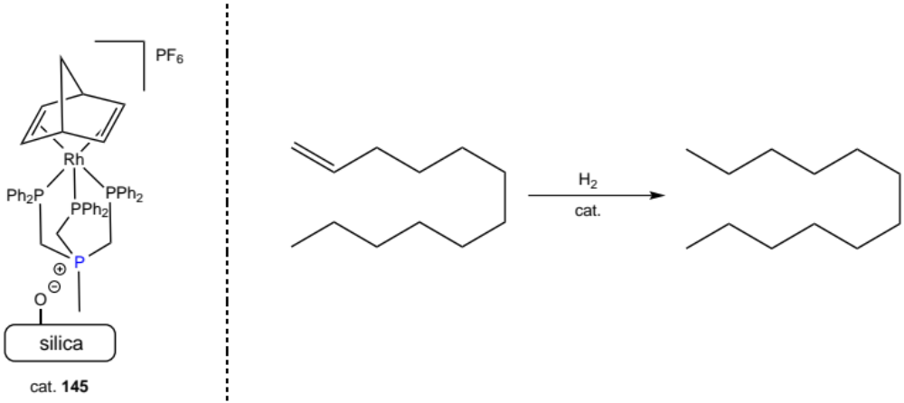
Figure 6. Hydrogenation of 1-dodecene using silica immobilized Wilkinson’s catalyst analogue featuring MeP⁺P₃^{Ph} ligand [59].

4. Summary and Outlook

In general it should be noted that despite the relatively simple and highly adaptable synthetic strategies implemented to afford R’E(CH₂PR₂)₃ ligands, this scaffold remains under-investigated in comparison to other tripodal ligands. The modular synthesis of each apically derived analogue allows facile substitution of the phosphine moieties to encompass homo-dialkyl and -diaryl, as well as several hetero-alkyl/aryl examples. This offers an extremely broad scope of tunability that, if correctly implemented, has been demonstrated to allow access to a wide range of chemical structures and functionality.

Coordination studies have, as expected for softer phosphorus donors, predominantly featured mid to late transition metals, with a single example of main group complexes. Although only a minor portion of the periodic table has been utilized, complexes with many oxidation states (M⁰-M⁵⁺) and geometries have been isolated and characterized, including pseudo-tetrahedral species that have a biological relevance as mimics to Nature’s [FeMo] cofactor in nitrogenase enzymes. Common structural motifs are found throughout the described complexes, including monomeric and dimeric compounds, the latter of which often contain bridging chlorides. Similar reactivity across different ligand platforms was also identified, for instance the stabilization of the η³-H₂Si coordination mode with both boron- and nitrogen-centered ligands, suggesting comparable electronic and steric properties. This infers that close study and comparison of related systems may lead to intriguing future opportunities.

Another notable property of this ligand scaffold that can be accessed through heteroatomic apical atoms is the inclusion of a formal ligand-based charge. As anionic ligands, this has allowed the stabilization of neutral complexes of metals in their +1 oxidation state. Especially pertinent is the work focused on the reactivity of iron(I) species. Due to iron’s ideal economic and environmentally benign attributes, this element is poised to be the catalytic metal of choice in the near future. On the other hand, a positively charged ligand has provided complexes with the required electrostatic interactions for their immobilization on solid catalyst supports.

New and exciting chemical applications have recently been realized, such as silane and CO₂ activation, which are of great social and economic importance. Society’s current petroleum-based habits have created a situation whereby an increasingly larger number of the population is turning to chemical technologies to alleviate environmental problems. At the forefront is the chemical inclusion and recycling of greenhouse gases such as CO₂ as useful compounds. The notorious stability of CO₂ makes subsequent transformations difficult, and any potential activation mechanisms, should be investigated, especially when these are as controlled as those reported for the iron-based PhBP₃^{CH2Cy} system. Additionally, several complexes have been implemented as well-defined pre-catalytic species; displaying enhanced activity over other previously reported systems.

Of the ligands that fall within the remit of this review, the boron-centered ligands PhB(CH₂PR₂)₃ have been most extensively studied, with more publications than the other derivatives combined. As silicon-, tin-, nitrogen- and phosphorus-centered ligands currently remain on the periphery of academic and industrial research, inspiring progress may be anticipated from this promising ligand class, especially in the field of catalytic transformations. The versatility and tunability of this ligand family, as well as their inherent adaptability to adopt various coordination modes and structures will surely lead to far-reaching and as-of-yet unexplored opportunities.

Acknowledgements

We thank Imperial College London for funding a studentship to AP. Johnson Matthey plc are also thanked for the loan of precious-metal salts used during the work contributed by the authors.

References

- a) C. Bianchini, A. Meli, M. Peruzzini, F. Vizza, F. Zanobini, Coord. Chem. Rev. 120 (1992) 193-208; b) H. A. Mayer, W. C. Kaska, Chem. Rev. 94 (1994) 1239-1272; c) J.-C. Hierso, R. Amardeil, E. Bentabet, R. Broussier, B. Gautheron, P. Meunier, P. Kalck, Coord. Chem. Rev. 236 (2003) 143-206; d) F.A. Cotton, B. Hong, Prog. Inorg. Chem. 40 (2007) 179-289.
- a) K. Beydoun, T. vom Stein, J. Klankermayer, W. Leitner, Angew. Chem. Int. Ed. 52 (2013) 9554-9557; b) J. Coetzee, D.L. Dodds, J. Klankermayer, S. Brosinski, W. Leitner, A.M.Z. Slawin, D.J. Cole-Hamilton, Chem. Eur. J. 19 (2013) 11039-11050; c) I. Mellone, M. Peruzzini, L. Rosi, D. Mellmann, H. Junge, M. Beller, L. Gonsalvi, Dalton Trans. 42 (2013) 2495-2501.
- a) L. Söncksen, C. Gradert, J. Krahmer, C. Näther, F. Tuczek, Inorg. Chem. 52 (2013) 6576-6589; b) M. Rosales, R. Vallejo, J.J. Soto, L.J. Bastidas, K. Molina, P.J. Baricelli, Catal. Lett. 134 (2010) 56-62.
- a) S. Alidori, D. Heift, G. Santiso-Quinones, Z. Benkő, H. Grützmacher, M. Caporali, L. Gonsalvi, A. Rossin, M. Peruzzini, Chem. Eur. J. 18 (2012) 14805-14811; b) S.J. Kyran, S. Muhammad, M. Knestrick, A.A. Bengali, D.J. Darensbourg, Organometallics 31 (2012) 3163-3170; c) A.B. Chaplin, P.J. Dyson, J. Organomet. Chem. 696 (2011) 2485-2490.
- C.E. MacBeth, S.B. Harkins, J.C. Peters, Can. J. Chem. 83 (2005) 332-340.
- a) L. Sacconi, Coord. Chem. Rev. 8 (1972) 351-367; b) R. Morassi, I. Bertini, L. Sacconi, Coord. Chem. Rev. 11 (1973) 343-402.
- M.S. Balakrishna, P. Chandrasekaran, P.P. George, Coord. Chem. Rev. 241 (2003) 87-117.
- C. Mealli, C.A. Ghilardi, A. Orlandini, Coord. Chem. Rev. 120 (1992) 361-387.
- a) P. Ge, B.S. Haggerty, A.L. Rheingold, C.G. Riordan, J. Am. Chem. Soc. 116 (1994) 8406-8407; b) P.J. Schebler, C.G. Riordan, I.A. Guzei, A.L. Rheingold, Inorg. Chem. 37 (1998) 4754-4755; c) B. Boardman, M.J. Hanton, H. van Rensburg, R.P. Tooze, Chem Commun. (2006) 2289-2291.
- I. Kuzu, I. Krummenacher, J. Meyer, F. Armbruster, F. Breher, Dalton Trans. (2008) 5836-5865.
- a) C. Bianchini, A. Meli, V. Patinec, V. Sernau, F. Vizza, J. Am. Chem. Soc. 119 (1997) 4945-4954; b) C. Bianchini, V. Dal Santo, A. Meli, W. Oberhauser, R. Psaro, F. Vizza, Organometallics 19 (2000) 2433-2444.
- C. Bianchini, M. Frediani, F. Vizza, Chem. Commun. (2001) 479-480.
- D.M. Jenkins, A.J. Di Bilio, M.J. Allen, T.A. Betley, J.C. Peters, J. Am. Chem. Soc. 124 (2002) 15336-15350.
- C.E. MacBeth, J.C. Thomas, T.A. Betley, J.C. Peters, Inorg. Chem. 43 (2004) 4645-4662.
- D.M. Jenkins, J.C. Peters, J. Am. Chem. Soc. 127 (2005) 7148-7165.
- a) A.A. Barney, A.F. Heyduk, D.G. Nocera, Chem. Commun. (1999) 2379-2380; b) J.C. Peters, J.D. Feldman, T.D. Tilley, J. Am. Chem. Soc. 121 (1999) 9871-9872.
- T.A. Betley, J.C. Peters, Inorg. Chem. 42 (2003) 5074-5084.
- C.C. Lu, C.T. Saouma, M.W. Day, J. C. Peters, J. Am. Chem. Soc. 129 (2007) 4-5.
- C.T. Saouma, C.C. Lu, J.C. Peters, Inorg. Chem. 51 (2012) 10043-10054.
- I. Arenas, M.Á. Fuentes, E. Álvarez, Y. Díaz, A. Caballero, S. Castillón, P.J. Pérez, Inorg. Chem. 53 (2014) 3991-3999.
- M.N. McCain, S. Schneider, M.R. Salata, T.J. Marks, Inorg. Chem. 47 (2008) 2534-2542.
- N.E. Schore, L.S. Benner, B.E. LaBelle, Inorg. Chem. 20 (1981) 3200-3208.
- I.R. Shapiro, D.M. Jenkins, J.C. Thomas, M.W. Day, J.C. Peters, Chem. Commun. (2001) 2152-2153.
- J.D. Feldman, J.C. Peters, T.D. Tilley, Organometallics 21 (2002) 4050-4064.
- D.M. Jenkins, T.A. Betley, J.C. Peters, J. Am. Chem. Soc. 124 (2002) 11238-11239.
- S.D. Brown, J.C. Peters, J. Am. Chem. Soc. 126 (2004) 4538-4539.
- a) S.D. Brown, M.P. Mehn, J.C. Peters, J. Am. Chem. Soc. 127 (2005) 13146-13147; b) S.D. Brown, J.C. Peters, J. Am. Chem. Soc. 127 (2005) 1913-1923.
- S.D. Brown, T.A. Betley, J.C. Peters, J. Am. Chem. Soc. 125 (2003) 322-323.
- D.M. Jenkins, J.C. Peters, J. Am. Chem. Soc. 125 (2003) 11162-11163.
- a) C.T. Saouma, P. Müller, J.C. Peters, J. Am. Chem. Soc. 131 (2009) 10358-10359; b) C.T. Saouma, R.A. Kinney, B.M. Hoffman, J.C. Peters, Angew. Chem. Int. Ed. 50 (2011) 3446-3449.
- C. Tejel, M.A. Ciriano, S. Jiménez, V. Passarelli, J.A. López, Angew. Chem. Int. Ed. 47 (2008) 2093-2096.
- S. Jiménez, J.A. López, M.A. Ciriano, C. Tejel, A. Martínez, R.A. Sánchez-Delgado, Organometallics 28 (2009) 3193-3202.
- M.C. Lipke, T.D. Tilley, J. Am. Chem. Soc. 133 (2011) 16374-16377.
- C. Tejel, A.M. Geer, S. Jiménez, J.A. López, M.A. Ciriano, Organometallics 31 (2012) 2895-2906.
- A.M. Geer, C. Tejel, J.A. López, M.A. Ciriano, Angew. Chem. Int. Ed. 53 (2014) 5614-5618.
- J.M. Walker, A.M. Cox, R. Wang, G.J. Spivak, Organometallics 29 (2010) 6121-6124.
- J.C. Thomas, J.C. Peters, Polyhedron 23 (2004) 489-497.
- H.H. Karsch, A. Appelt, Z. Naturforsch. 38b (1983) 1399-1405.
- L. Dahlenburg, S. Kerstan, D. Werner, J. Organomet. Chem. 411 (1991) 457-469.
- K. McNeill, R.A. Andersen, R.G. Bergman, J. Am. Chem. Soc. 119 (1997) 11244-11254.
- S. Herold, A. Mezzetti, L.M. Venanzi, A. Albinati, F. Lianza, T. Gerfin, V. Gramlich, Inorg. Chim. Acta. 235 (1995) 215-231.
- M. Bogza, T. Oeser, J. Blümel, J. Organomet. Chem. 690 (2005) 3383-3389.
- M.F. Cain, D.S. Glueck, J.A. Golen, A.L. Rheingold, Organometallics 31 (2012) 775-778.
- H. Broda, J. Krahmer, F. Tuczek, Eur. J. Inorg. Chem. (2014) 3564-3571.
- H. Broda, S. Hinrichsen, J. Krahmer, C. Näther, F. Tuczek, Dalton Trans. 43 (2014) 2007-2012.
- G. Märkl, G.Y. Jin, Tetrahedron 22 (1983) 1105-1108.
- O. Walter, G. Huttner, R. Kern, Z. Naturforsch. 51b (1996) 922-928.
- a) M.M.T. Khan, E.R. Rao, Polyhedron 7 (1988) 29-36; b) C. Mealli, C.A. Ghilardi, A. Orlandini, Coord. Chem. Rev. 120 (1992) 361-387.
- P.W. Miller, A.J.P. White, J. Organomet. Chem. 695 (2010) 1138-1145.
- J.L.Fillol, A. Kruckenberg, P. Scherl, H. Wadepohl, L.H. Gade, Chem. Eur. J. 17 (2011) 14047-14062.
- L.-I. Rodríguez, T. Rothe, J.L. Fillol, H. Wadepohl, L.H. Gade, Chem. Eur. J. 18 (2012) 3721-3728.
- P. Scherl, H. Wadepohl, L.H. Gade, Organometallics 32 (2013) 4409-4415.
- M.J. Hanton, S. Tin, B.J. Boardman, P. Miller, J. Mol. Catal. A 346 (2011) 70-78.
- P. Scherl, A. Kruckenberg, S. Mader, H. Wadepohl, L.H. Gade, Organometallics 31 (2012) 7024-7027.
- A. Phanopoulos, N.J. Brown, A.J.P. White, N.J. Long, P.W. Miller, Inorg. Chem. 53 (2014) 3742-3752.
- H.H. Karsch, H. Schmidbaur, Z. Naturforsch. 32b (1977) 762-767.
- A.M. Bond, R. Colton, F. Marken, J.N. Walter, Organometallics 16 (1997) 5006-5014.
- J. Cámpora, C.M. Maya, I. Matas, B. Claasen, P. Palma, E. Álvarez, Inorg. Chim. Acta. 359 (2006) 3191-3196.
- J. Guenther, J. Reibenspies, J. Blümel, Adv. Synth. Catal. 353 (2011) 443-460.
- M.Y. Dau, J.R. Shakirova, A.J. Karttunen, E.V. Grachova, S.P. Tunik, A.S. Melnikov, T.A. Pakkanen, I.O. Koshevoy, Inorg. Chem. 53 (2014) 4705-4715.
- J.D. Feldman, J.C. Peters, T.D. Tilley, Organometallics 21 (2002) 4065-4075.
- M.C. Lipke, T.D. Tilley, Angew. Chem. Int. Ed. 51 (2012) 11115-11121.
- a) M.C. Lipke, T.D. Tilley, J. Am. Chem. Soc. 135 (2013) 10298-10301; b) M.C. Lipke, F. Neumeyer, T.D. Tilley, J. Am. Chem. Soc. 136 (2014) 6092-6102.
- K. Puhakainen, D. Benson, J. Nylén, S. Konar, E. Stoyanov, K. Leinenweber, U. Häussermann, Angew. Chem. Int. Ed. 124 (2012) 3210-3214.
- C.M. Thomas, J.C. Peters, Angew. Chem. Int. Ed. 45 (2006) 776-780.
- R.A. Kinney, C.T. Saouma, J.C. Peters, B.M. Hoffman, J. Am. Chem. Soc. 134 (2012) 12637-12647.
- C.T. Saouma, C.C. Lu, M. W. Day, J.C. Peters, Chem. Sci. 4 (2013) 4042-4051.
- C. Tejel, M.A. Ciriano, V. Passarelli, Eur. Chem. J. 17 (2011) 91-95.
- T. Seki, K. Akutsu, H. Hattori, Chem. Commun. (2001) 1000-1001.
- M.Á. Fuentes, E. Álvarez, A. Caballero, P.J. Pérez, Organometallics 31 (2012) 959-965.
- J. Krahmer, H. Broda, C. Näther, G. Peters, W. Thimm, F. Tuczek, Eur. J. Inorg. Chem. (2011) 4377-4386.
- L. Söncksen, C. Gradert, J. Krahmer, C. Näther, F. Tuczek, Inorg. Chem. 52 (2013) 6576-6589.
- a) C. Mukai, F. Inagaki, S. Kitagaki, Synlett. (2011) 594-614; b) F. López, J.L. Mascareñas, Chem. Eur. J. 17 (2011) 418-428.
- F.M.A. Geilen, B. Engendahl, A. Harwardt, W. Marquardt, J. Klankermayer, W. Leitner, Angew. Chem. Int. Ed. 49 (2010) 5510-5514.
- a) A. Corma, S. Iborra, A. Velty, Chem. Rev. 107 (2007) 2411-2502; b) J. Zakzeski, P.C.A. Bruijnincx, A.L. Jongerius, B.M. Weckhuysen, Chem. Rev. 110 (2010) 3552-3599.

