The hydrogen economy: a pragmatic path forward

Niall Mac Dowell,^{1,}* Nixon Sunny,¹ Nigel Brandon,¹ Howard Herzog,² Anthony Y. Ku,³ Wilfried Maas,⁴ Andrea Ramirez,⁵ David M. Reiner,⁶ Gaurav N. Sant,⁷ Nilay Shah,¹
¹ Imperial College London, South Kensington, London SW7 1NA, UK
² Massachusetts Institute of Technology, Cambridge, Massachusetts 02139, USA
³ National Institute of Clean and low carbon Energy (NICE), Beijing 102209, P. R. China, NICE America Research, Mountain View, CA, USA
⁴ Carbon-Direct, New York, NY 10004, USA
⁵ Section Energy & Industry, Faculty of Technology, Policy and Management, Delft University of Technology, the Netherlands
⁶ Energy Policy Research Group, Judge Business School, University of Cambridge, Cambridge, UK
⁷ Departments of Civil and Environmental Engineering, Materials Science and Engineering, the California Nanosystems Institute, and the Institute for Carbon Management, University of California, Los Angeles, CA 90095
*Correspondence: niall@imperial.ac.uk
Context & Scale
There is an increased focus on the potential roles that hydrogen might play in a future, net zero energy system. However, the magnitude of hydrogen use remains uncertain. Blue hydrogen can play a role, but only if methane and CO₂ emissions are tightly controlled across the entire supply chain. This is an important regulatory challenge. Green hydrogen is promising, but is currently more costly than blue, and needs reliable sources of near-zero carbon power. Until the broader power system is deeply decarbonised, there is an opportunity cost associated with using renewable power to produce green hydrogen. Scaling green hydrogen production implies the very significant scale up of the production of critical raw materials, and we must also be cognisant of any environmental impacts that subsequently arise.

SUMMARY
For hydrogen to play a meaningful role in a sustainable energy system, all elements of the value chain must scale coherently. Advocates support electrolytic (green) hydrogen or (blue) hydrogen that relies on methane reformation with carbon capture and storage, however, efforts to definitively choose how to deliver this scaling up are premature. For blue hydrogen, methane emissions must be minimised. Best in class supply chain management in combination with high rates of CO₂ capture can deliver a low carbon hydrogen product. In the case of electrolytic hydrogen, the carbon intensity of power needs to be very low for this to be a viable alternative to blue hydrogen. Until the electricity grid is deeply decarbonised, there is an opportunity cost associated with using renewable energy to produce hydrogen, as opposed to integrating this with the power system. To have a realistic chance of success, net zero transition pathways need to be formulated in a way that is coherent with socio-political-economic constraints.
Keywords: Energy system transitions, net zero, hydrogen, blue hydrogen, green hydrogen, natural gas, methane emissions
INTRODUCTION – A CASE FOR HYDROGEN?
The recent IPCC 6th Assessment Report has unequivocally stated that, without urgent reductions of greenhouse gas emissions, the mean global temperature will inevitably increase by more than 2 ºC.

Time is therefore of the essence, and all options must be deployed to preserve and enhance the provision of energy services throughout the global economy.

At the time of writing, the world is still impacted by the COVID-19 pandemic. Near-term priorities are focused on economic recovery – economic decline is unlikely to be a viable option. Simultaneously, combatting climate change has retained its saliency and challenges associated with energy poverty persist – climate solutions must concurrently ensure affordable provision of energy services.

Arguably, power is the most readily addressable challenge. Regardless of source, the knowledge, infrastructure, and experience for electricity infrastructure is available and can be scaled up. “All” we need to do is replace existing power generation assets with decarbonised alternatives, ensure that future additions are decarbonised, whilst delivering affordability and security of supply.

Mobility and heating are more complex.

In the case of mobility, user behaviour varies significantly by demographic and region, and not all options will translate into practicable solutions. Aviation, shipping, and freight are inherently international activities, and their decarbonisation would require explicit coordination across nations, and most technical solutions are at the pre-commercial stage. By contrast, passenger vehicles are easier both because of the increase in the availability of electric vehicles and because individual jurisdictions can develop their positioning independently, for example, through bans on the sale of new fossil-fuel vehicles.

Heating is more complicated – notoriously seasonal, heating demand varies substantially throughout the year and by sector. Moreover, demand for heating services varies not only in quantity, but also quality. While electric heating, for instance electric boilers and heat pumps, is a straightforward and readily available option for decarbonising domestic heating, the high temperatures required for much of industrial heating are an inherent challenge.

What all these sectors have in common is that hydrogen can, in theory, play an important role in their decarbonisation. Calls for hydrogen to play a significantly larger role in our energy economy are growing worldwide. This is not the first time a “hydrogen economy” has been touted and there are good reasons for one to believe that hydrogen’s role in the energy economy will grow. However, we have been down this path before, and each time hydrogen has fallen well short of expectations. Will this time be different? Whilst hydrogen will likely play a role, the real question is just how big a role will it assume.

Delivering a hydrogen economy relies upon four interdependent elements: demand, production, storage, and distribution, with every link in this value chain needing to be developed and scaled coherently. Without a clear plan to deliver every element, the entire project will fail.

ROUTES TO HYDROGEN PRODUCTION
As the most abundant element in the universe, hydrogen is readily available, and can be produced via gasification of coal or biomass, reforming of fossil- or bio-methane, methane pyrolysis, or water electrolysis.

Each of these pathways for hydrogen production are at distinct levels of technical and commercial maturity. In a net zero context, arguably the leading options are the methane reforming with CO₂ capture and storage (CCS) and water electrolysis using electricity generated by zero-carbon sources.

Technically, none of these options are new.

Electrolytic production of hydrogen was first demonstrated in 1789 by the Dutch merchants Jan Rudolph Deiman and Adriaan Paets van Troostwijk. By the 1920s, the technology had been brought to the 100 MW scale, primarily in Canada and Norway using hydroelectricity. In the 1960s, General Electric introduced the proton exchange membrane (PEM), initially to store energy, and subsequently to produce hydrogen.

Methane reforming was originally proposed in 1868 by Tessié du Motay and Maréchal and was commercially deployed in the 1910s. The most mature reforming process is steam methane reforming (SMR), with the autothermal reforming (ATR) alternative a relatively recent innovation.

Technologies for CO₂ separation were first developed in the late 19th century. By the 1930s these concepts had been adopted for natural gas sweetening and have since been widely deployed around the globe in this context. CO₂ injection for enhanced oil recovery began in the 1970s, and today there are more than 5,000 miles of high-pressure CO₂ pipeline in the US. Perhaps the best-known example of CO₂ sequestration for the exclusive purpose of climate change mitigation is the Sleipner project in Norway, active since 1996.

Popularly, H₂ produced via methane reforming without CCS is referred to as grey hydrogen, when CCS is included, this is referred to as blue hydrogen, and electrolytic hydrogen is assigned a green designation. However, the lifecycle carbon intensity and broader environmental impact of these processes depends heavily on their configuration.

Whilst hydrogen, however produced, emits no CO₂ when combusted, there are significant differences associated with the upstream production and supply chain emissions.

The global warming potential of electrolytic hydrogen (GWP_{H2,e}) depends primarily on the carbon intensity of the power used to operate the electrolysis process, and to a lesser extent, the energy required to deliver the deionised¹ water for use as feedstock. The analysis presented in Figure 1a indicates that, unless the carbon intensity of electricity used for electrolysis is at least in the range 30 - 140 kg_{CO2}/MWh_{e}, the carbon intensity of electrolytic hydrogen is greater than that produced by an SMR+CCS process.

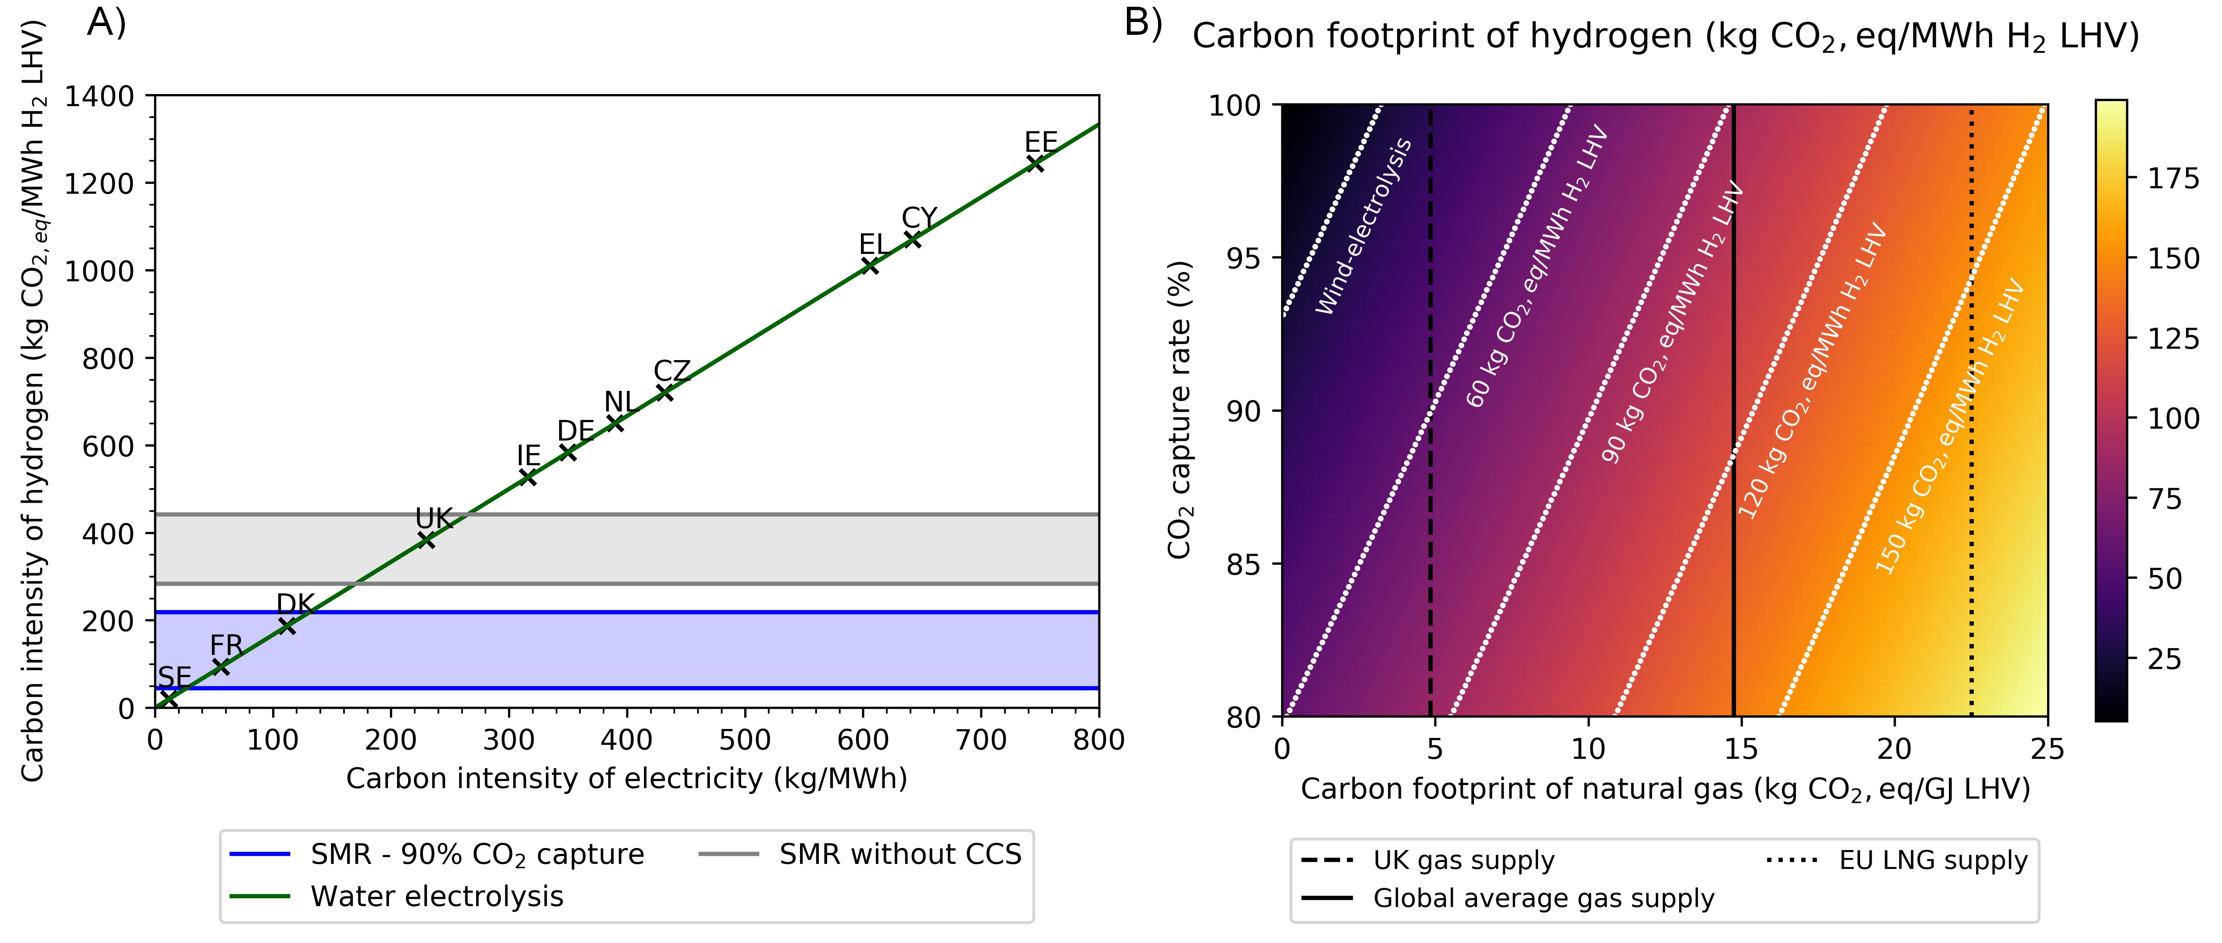
Figure 1: Subplot a presents a comparison between blue and green hydrogen, without consideration of natural gas supply chain emissions. As can be observed, the carbon intensity of the power used for electrolysis must be substantially lower than the European average for electrolytic hydrogen to be competitive with blue hydrogen in terms of carbon intensity. Subplot b presents a comparison between green and blue hydrogen where the impact of CO₂ capture and natural gas supply chain emissions are evaluated. As can be observed, where methane emissions from the natural gas supply chain are low, e.g., those of the UK, and CO₂ capture rates are greater than 90%, the GWP of blue hydrogen approaches that of green hydrogen.
For context, the UK’s 2020 grid average intensity was 181 kg_{CO2}/MWh_{e} – the lowest on record and represents a 66% reduction in carbon intensity since 2014, but still some way off the 30 - 140 kg_{CO2}/MWh_{e} range. Similarly, the EU average for 2020 was 215 kg_{CO2}/MWh_{e}, the US was 352.5 kg_{CO2}/MWh_{e}, and China was 580 kg_{CO2}/MWh_{e}². Thus, whilst all these figures represent significant reductions in carbon intensity relative to a 2000 baseline, it is evident that low-carbon electrolytic hydrogen produced via grid connection remains some way off.

In the case of blue hydrogen, greenhouse gases can be emitted throughout the methane extraction, purification, transport, and reforming stages. In terms of CO₂ process emissions, high rates of CO₂ capture at the reformer are feasible, and it is notable that performance guarantees of greater than 95% are already available³.

Methane emissions from venting, flaring and other fugitive emissions are an important source of GHG emissions in the context of blue hydrogen value chain, next to utilities process emissions for compressors and for LNG from liquefaction and shipping. Globally, methane leakage is reported to be in the range of 2.9 – 35.75 kg_{CO2,eq}/GJ_{LHV}⁴ with an average of 14.9 kg_{CO2,eq}/GJ_{LHV}. If, per Figure 1b, one takes a value of approximately 60 kg_{CO2,e}/MWh_{H2} as being a measure of “good” for blue hydrogen, we can see that this is achievable with the current best in class management of the methane supply chain in combination with high levels of CO₂ capture. However, as can also be observed from Figure 1b, the global average carbon intensity of the methane supply chain will not deliver adequately clean hydrogen, regardless of the extent to which CO₂ is captured at the reforming stage. Thus, for blue hydrogen to be a viable option, best-in-class natural gas supply chain management is vital.

Thus, for now, the route to environmentally benign electrolytic hydrogen production appears to rest upon a dedicated supply of energy with a low, or zero, carbon footprint, with wind and solar power typically being viewed as leading options. However, even if a dedicated renewable energy supply is available, with associated electricity or hydrogen storage as appropriate to match energy supply with hydrogen demand, this hydrogen product cannot be considered to be a true “net zero product”, owing to the carbon emissions currently associated with the production and installation of wind turbines, solar panels, batteries, electrolysers, and hydrogen storage. As illustrated in Figure 2a, until this supply chain is itself decarbonised, a residual GWP of approximately 20 kgCO₂/MWh_{H2} will remain.

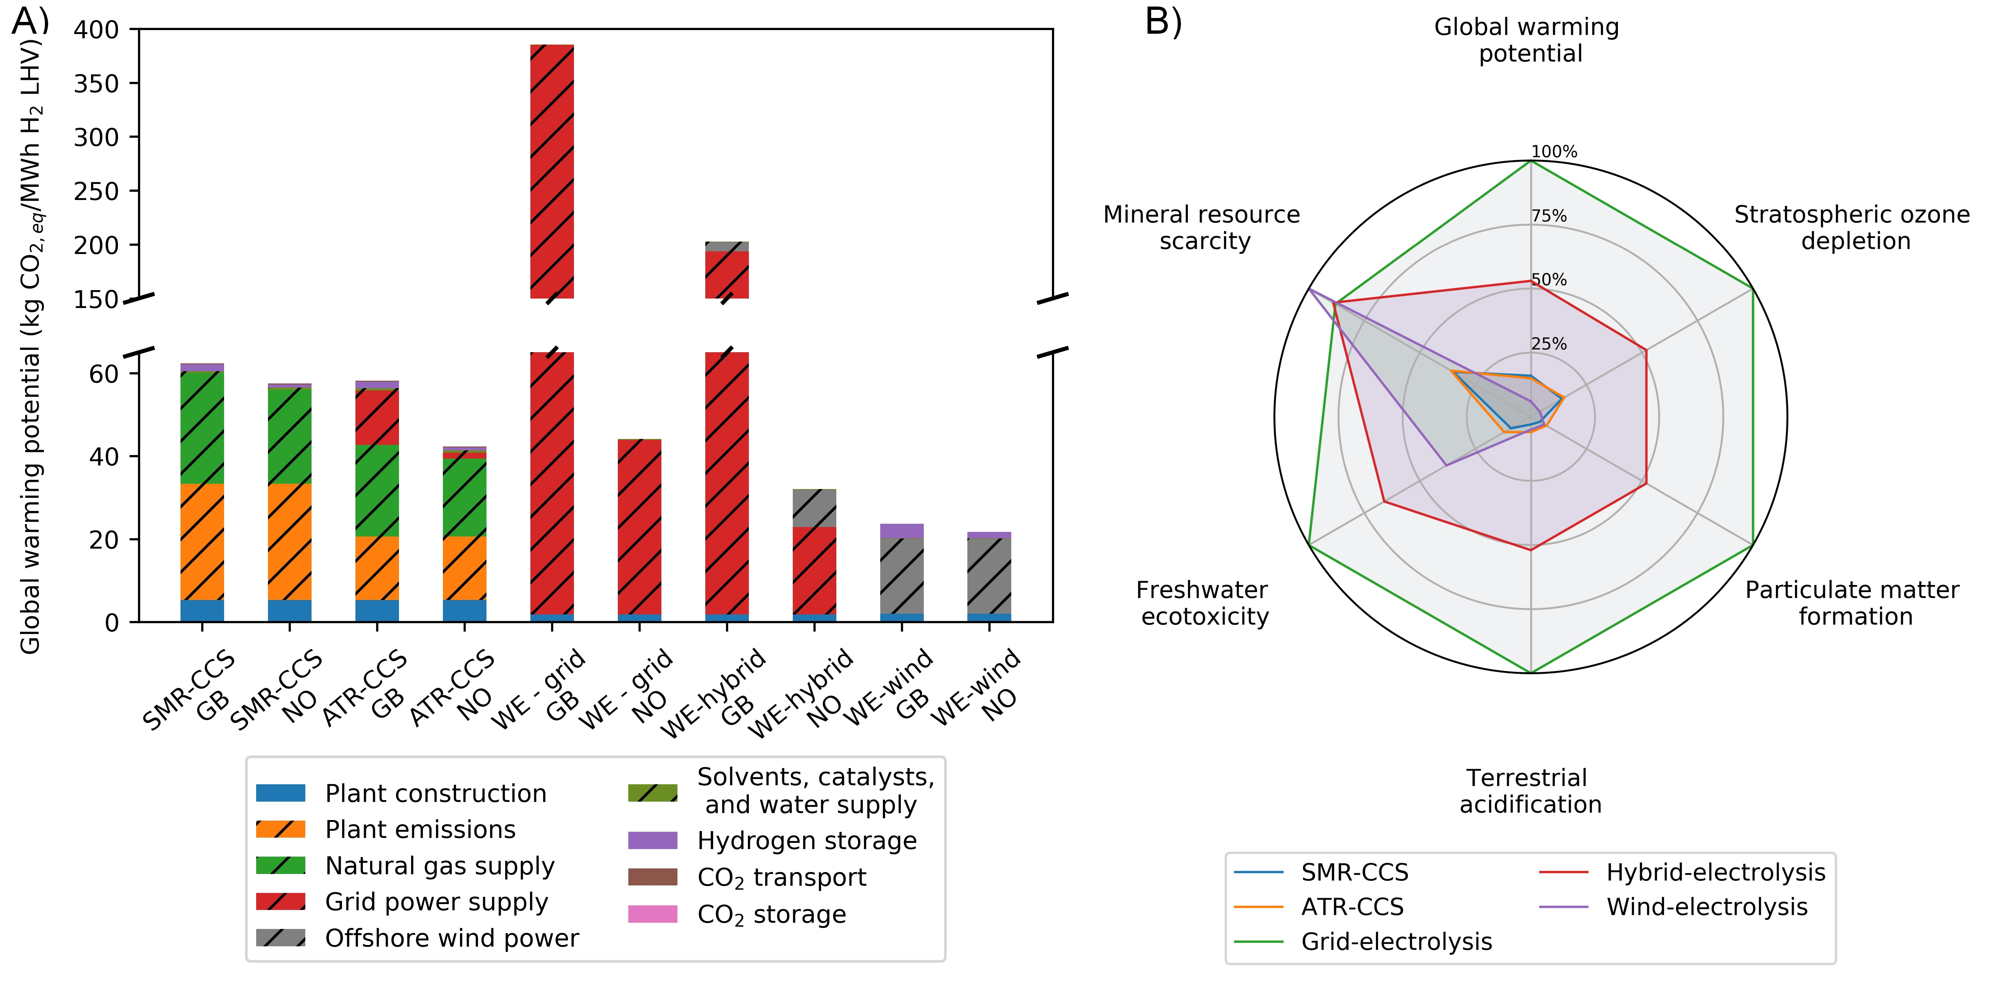
Figure 2: Cradle-to-gate LCA comparison of a range of hydrogen production routes. In this analysis, GB refers to Great Britain, NO refers to Norway, SMR refers to steam methane reforming, ATR refers to autothermal reforming, CCS refers to CO₂ capture and storage, WE refers to water electrolysis, and hybrid refers to an electricity supply that is a combination of wind power and grid power. Subplot a presents a cradle-to-gate life cycle analysis wherein a range of options hydrogen production are compared. It can be observed that, with high rates of CO₂ capture, and tight control over methane emissions from the natural gas supply chain, the GWP of blue hydrogen can be limited to approximately 60 kg_{CO2,e}/MWh_{H2,LHV} – substantially less than grey hydrogen today. This analysis finds that electrolytic hydrogen powered with wind power has a carbon intensity of approximately 20 kg_{CO2,e}/MWh_{H2,LHV}. For both blue and green hydrogen, residual emissions can be further reduced via the decarbonisation of the supply chain that delivers the hydrogen.
Finally, there is more to the environment than CO₂, and, as illustrated in Figure 2b, whilst a wind-electrolysis configuration outperforms an ATR-SMR process on GWP and ozone depletion, and is approximately equivalent in terms of particulate matter formation and terrestrial acidification, it is noticeably poorer on a basis of mineral resource scarcity and freshwater ecotoxicity.

Thus, a comparative evaluation of blue and green hydrogen is far from straightforward, and as these technologies are deployed, care will have to be taken to avoid an outcome where environmental burdens are simply shifted between sectors or environmental categories.

THE PEOPLE’S FRONT OF JUDEA AND THE JUDEAN PEOPLE'S FRONT

Several nations have set out a hydrogen strategy^{5,6,7,8} as an important element of a net zero future energy system. Importantly, China’s 14th Five Year Plan⁹ has introduced a focus on hydrogen as an element of their “forward-looking plans for the future industry”. All recognize the uniquely versatile nature of hydrogen, the diverse pathways for its production, and that a portfolio approach for deployment will likely be required – albeit one which focuses primarily on methane-derived and electrolytic hydrogen. Moreover, many strategies avoid picking winners, and recognise that the simultaneous deployment of both blue and green hydrogen is important to rapidly reduce emissions from existing hydrogen production, and to support the creation of a broader hydrogen economy.

It is the core contention of this contribution that this "twin track" approach is appropriate, and in the following text, we will attempt to set out our reasoning.

As has been emphasized, the significant reduction of anthropogenic CO₂ emissions is a matter of urgency – the social, political, economic, and environmental consequences of failing to do so are formidable¹⁰.

For low carbon hydrogen to make a material impact on CO₂ emissions, it needs to scale rapidly. Globally, hydrogen production in 2019 was approximately 70 Mt_{H2}¹². Of this, the vast majority was produced from fossil fuels, with less than 0.1% being produced via water electrolysis. Today, most electrolysers are at the 10 MW_{e} scale; this can produce perhaps 50 tpd of hydrogen, if operated constantly at nameplate capacity. The scale up of electrolytic hydrogen production will also increase the demand for key rare earth metals, such as platinum and iridium. Current platinum production is approximately 180 tpa and iridium production is in the range of 5 – 7 tpa. PEM electrolysers currently require an average of 0.3 kg Pt and 0.7 kg Ir/MW¹³. Thus, current Pt production, if entirely dedicated to PEM will allow 600 GW of electrolyser production. This is reduced to 7 – 10 GW in the case of Ir. This would amount to 0.4 – 1.8 Mtpa of electrolytic hydrogen production, as a function of load factor, or between 0.5 – 2.5% of current demand. Whilst a reduction in materials intensity is anticipated, supplies of these materials will need to be simultaneously and significantly increased to facilitate material deployment of electrolytic hydrogen in the context of a hydrogen economy.

Whilst blue hydrogen facilities at the 315 kt/yr scale can be built today with a construction time of 2 – 3 years and be connected to known CO₂ storage sites, the current, nascent, CO₂ capture and storage industry is the order of 40 Mtpa¹¹. Delivering 70 Mtpa of hydrogen with CCS would require the capture and storage of approximately 630 Mpta of CO₂ – or a scale up by a factor of more than 15 relative to today. However, doing this in a manner coherent with the overall net zero goal implies close monitoring and reduction of upstream GHG emissions, maximizing CO₂ capture rates at the H₂ production site, and finally incorporating credible and permanent greenhouse gas removal (GGR) to compensate for any residual emissions.

To meet the targets set out in the aforementioned strategy documents, hydrogen production will have to rapidly scale up. To meet this demand via electrolytic hydrogen would require 3,600 TWh of zero carbon power – more than the EU’s total demand today¹². Delivering an on-schedule supply of blue hydrogen at the right pressure and composition will require a combination of hydrogen and CCS transport and storage infrastructure. Similarly, delivering an equivalent supply of green hydrogen will require appropriate renewable energy capacity, electrolysers, and some form of hydrogen or electricity storage. This is perfectly achievable but needs careful thought to get right.

There is also the matter of cost. Currently, the cost of grey hydrogen is between $ 0.9 – 1.75/kg_{H2} depending on location – the US, Russia, and the Middle East are at the low end, with Europe and China at the high end. The addition of CCS to these processes is anticipated to increase costs by roughly $0.50/kg_{H2} to the range of $1.45 – 2.38/kg_{H2}¹². Set against this, the costs of electrolytic hydrogen are reported to be in the range of $3.0 – 12/kg_{H2}^{12,14}. Given the scale of the challenge, there is a clear imperative to effectively mitigate climate change at the lowest possible cost – energy and fuel poverty remain pressing global challenges.

Thus, it is imperative that we do not get distracted by doctrinal arguments, worthy of a Monty Python sketch, and remain focused on achieving cost and resource effective, near term, and material reductions in CO₂ emissions.

Finally, it is a matter of choice. It takes finite time to deploy any industrial assets. Notwithstanding some niche applications, the near- and medium-term deployment of electrolytic hydrogen with dedicated renewable power means choosing not to use that renewable power in the electricity system. As illustrated in Figure 3, until the electricity grid is deeply decarbonized, this is a wasteful choice.

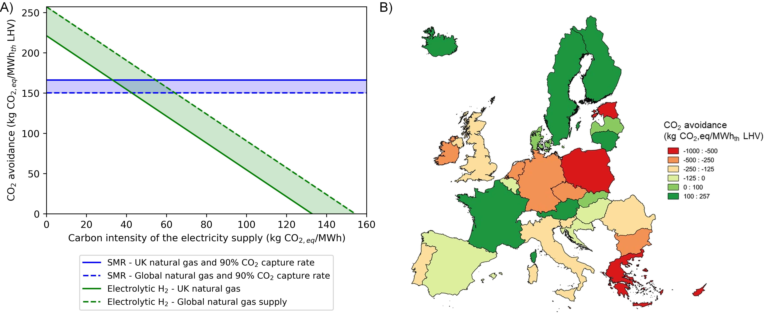
Figure 3: Subplot A compares the carbon avoided by substituting blue H₂ for natural gas (horizontal band) with the carbon avoided by using wind power to produce green H₂ as a CH₄ substitute, as opposed to integrating that renewable energy capacity to the electricity grid. As can be observed, as long as the carbon intensity of the electricity grid is greater than 30 – 70 kg_{CO2,eq}/MWh, incorporation in the electricity grid is a better use of the renewable energy capacity. As can be observed from figure 3b, in relatively few European countries is using grid electricity for electrolysis is a plausible option.

PREDICTING RAIN DOESN’T COUNT; BUILDING ARKS DOES.
One lesson from the COVID-19 pandemic is that the rapid development and deployment of new infrastructure is profoundly challenging but also feasible over short time scales with enough political will and the mobilisation of the needed scientific and technical efforts. One can generally be more confident of success if we first start by scaling up existing infrastructure.

Conceiving and presenting the basic challenge of the net zero transition to policy makers, the general public, and other stakeholders as an “either or” choice is a fundamental mistake.

In achieving the overall net zero goal, it is vital to define attainable goals, and link them in a way that is sustainable in the context of a broader national, regional, or international political process.

Recently, there have been arguments about “the best” way to produce affordable, low-carbon hydrogen. At this point in time, we find these arguments an unhelpful distraction. With uncertainties in all parts of the hydrogen value chain, we should welcome all possibilities that enable low carbon hydrogen to play a role in decarbonising our energy systems and build confidence across the value chain, especially for end-uses.

Delivering meaningful quantities of low-carbon hydrogen into applications and in nations where zero-carbon hydrogen is required will support the deployment of distribution and utilisation infrastructure which will be ultimately agnostic as to the source of the protons. An early focus on blue hydrogen will also deliver material reductions in CO₂ emissions whilst providing a market into which electrolytic hydrogen can grow. Thus, early efforts on blue hydrogen in the 2020s may enable a much more rapid rollout of green hydrogen in the 2030s. However, this can only make sense in a context where the maximum amount of CO₂ is captured and permanently stored, and GHG emissions from the natural gas supply chain are minimised, with residual emissions compensated for.

We must also learn from the French “gilets jaunes” experience – initiatives to reduce emissions must be equitable and cost-effective. Assuming that the public is willing to support a net zero transition at a cost greater than absolutely necessary seems courageous. The Paris Agreement focuses on GHG reduction and removals “on the basis of equity, and in the context of sustainable development and efforts to eradicate poverty".

From a global perspective, it is key to recognise that national contexts are important in this debate. Some regions, like the US and the UK, with a history of oil and gas production may well pursue a twin track approach. Others, such as India¹⁵, may prioritise energy independence, leading them to emphasise green hydrogen. Regions, such as China, may seek to balance several considerations – such as environmental stewardship, energy independence, and economic advantage, and will not invest in one at the expense of the other two.

Importantly, hydrogen, of any hue, is itself a greenhouse gas with a GWP of 4 - 9 over a 100-year horizon. Given its propensity to leak, this impact must also be accounted for. Similarly, it is unlikely that complete elimination of gross emissions associated with hydrogen production will ever be cost-effective. Thus, GGR will be required to compensate for any residual emissions. This burden will likely be greater in the case of blue hydrogen than for green and should be accounted for in techno-economic analyses.

Enabling a hydrogen economy will involve the sustained efforts of several stakeholders. There is a role for the public sector to enable the deployment of distribution and utilisation infrastructure, providing a destination for both blue and green hydrogen. The onus is also on the public sector to ensure adequate standards on the integrity of both the natural gas supply chain and hydrogen distribution system. The co-deployment of CO₂ transport and storage infrastructure will also enable the deployment of the CCS technology that is required in the power and industry sector, in addition to the bioenergy with CCS and direct air CO₂ capture and storage technologies that that the IPCC has highlighted as integral to meeting the medium-term net zero goals, and the longer-term net negative goals. The commercial production of blue hydrogen can be delivered at scale by industry today, with appropriate support and regulation from the public sector. There is a role for the private sector to invest in production, utilisation, and infrastructure within the emerging policy framework.

SUPPLEMENTAL INFORMATION

ACKNOWLEDGMENTS

AUTHOR CONTRIBUTIONS
NMD conceived and led the writing. NSy performed the analysis and prepared the graphics. All authors contributed content.

DECLARATION OF INTERESTS
NMD is a member of TotalEnergies’ Scientific Advisory Board on CCUS and is also a member of Joule’s Advisory Board. GNS is a Co-Founder of SeaChange Inc. ARR is the Editor-in-Chief of the International Journal of Greenhouse Gas Control. NB is a founder of CERES Power and RFC Power. AYK is leading an effort at NICE America to commercialize a hydrogen refuelling technology for fuel cell vehicles.

REFERENCES

1. Barbir, F. (2009). Transition to renewable energy systems with hydrogen as an energy carrier. Energy 34, 308–312.
2. International Energy Agency (2020). Development of CO2 emission intensity of electricity generation in selected countries, 2000-2020 – Charts – Data & Statistics - IEA. https://www.iea.org/data-and-statistics/charts/development-of-co2-emission-intensity-of-electricity-generation-in-selected-countries-2000-2020.
3. French, S. (2020). Low-Carbon Hydrogen Production. In H2FC Supergen Hydrogen Research Conference 2020.
4. Balcombe, P., Anderson, K., Speirs, J., Brandon, N., and Hawkes, A. (2015). Methane and CO2 emissions from the natural gas supply chain: an evidence assessment.
5. U.S. Department of Energy (2020). Department of Energy Hydrogen Program Plan.
6. European Commission (2020). A hydrogen strategy for a climate-neutral Europe.
7. Her Majesty’s Government (2021). UK Hydrogen Strategy.
8. COAG Energy Council (2019). Australia’s National Hydrogen Strategy.
9. The State Council of the People’s Republic of China (2021). The 14th Five-Year Plan for the National Economic and Social Development of the People’s Republic of China and the Outline of the Long-term Goals for 2035. http://www.gov.cn/xinwen/2021-03/13/content_5592681.htm.
10. Dyer, G. (2008). Climate Wars: The Fight for Survival as the World Overheats (Oneworld Publications).
11. Global CCS Institute (2020). Global Status of CCS 2020.
12. International Energy Agency (2019). The Future of Hydrogen.
13. International Energy Agency (2021). The Role of Critical Minerals in Clean Energy Transitions.
14. Fan, Z., Ochu, E., Braverman, S., Lou, Y., Smith, G., Bhardwaj, A., Brouwer, J., Mccormick, C., and Friedmann, J. (2021). Green Hydrogen in a Circular Carbon Economy: Opportunities and Limits.
15. RECHARGE (2021). Modi pledges massive green hydrogen “quantum leap” to Indian energy independence | Recharge. https://www.rechargenews.com/energy-transition/modi-pledges-massive-green-hydrogen-quantum-leap-to-indian-energy-independence/2-1-1052701.

