Improving Prescribing Outcomes in Undergraduate Medical Training
Authors
Chee Yeen Fung¹, MRCGP, MBBS, BSc (Hons), PGCert Med Ed
0000-0002-8425-2832, c.fung@imperial.ac.uk
Anna Coulson¹, MBChB (Hons), DRCOG PGCert ULT
0009-0007-3451-579X, a.coulson@imperial.ac.uk
Celia Brown², BSocSci(Hons), PhD, SFHEA, QTS
0000-0002-7526-0793, celia.brown@warwick.ac.uk
Anjali Amin¹, MBBS, PhD, MRCP, MEd
0000-0002-0416-6505, a.amin@imperial.ac.uk
Omid Halse¹, MRCP, MBBS
0000-0003-0202-0083, o.halse@imperial.ac.uk
*David Owen¹, PhD, MRCP, MBBS
0000-0002-1198-7563, d.owen@imperial.ac.uk
*Amir H Sam¹, PhD, FRCP, MBBS
0000-0002-9599-9069, a.sam@imperial.ac.uk
- Imperial College School of Medicine, London, UK
- Warwick Medical School, Coventry, UK (Honorary association)
* Joint senior authors

Corresponding author
Amir H Sam
a.sam@imperial.ac.uk
Imperial College School of Medicine, Reynolds Building, St Dunstan's Road, London, W6 8RP, UK

Author Contributions
CYF, AC, DO and AHS contributed to the conception, analysis, data interpretation and drafting and final approval of the work.
CB, AA and OH contributed to the analysis, data interpretation and drafting of the work.
All authors edited and approved the manuscript.

Word Count
645

Ethical Approval
EERP2324-095

Conflict of Interest
None declared

Data Sharing
Data available upon reasonable request

Abstract
Medication errors cause preventable patient harm with annual costs of USD$42 billion globally. In England, 237 million errors occur annually, accounting for 1700 deaths, with trainee doctors being responsible for the highest proportion of errors. The UK introduced the national Prescribing Safety Assessment (PSA) in 2013 to ensure prescribing competency. Imperial College School of Medicine (ICSM) sought to increase learning opportunities and reduce errors through a monthly Prescribing Practice Questions (PPQs) programme.
PSA scores from 2020 (prior to PPQ introduction) to 2024 (first cohort to receive entire PPQ programme), the prescription writing skills (PWS) subsection and applied knowledge test (AKT) scores in 2020 and 2024 were analysed.
1505 students sat the PSA between 2020 and 2024. PSA fails significantly reduced from 2.51% in 2020 to 0% in 2024 (p=0.0054). Median PSA scores significantly improved from 78.5% in 2020 to 84.0% in 2024 (p<0.0001). Median AKT scores decreased between 2020 and 2024 (78.0% vs 74.5%, p<0.0001). Absolute increase in PSA scores from lowest to highest quintiles was 10 percentage points (pp), 7pp, 5pp, 4pp and 1pp, respectively, between 2020 and 2024. Median PWS scores significantly improved from 76.3 % (61/80) in 2020 to 87.5% (70/80) in 2024 (p<0.0001).
Since introducing PPQs, PSA and PWS scores have statistically significantly improved, with progressively greater impact on students at the bottom of the performance distribution. Early, targeted and repeated opportunities for authentic prescribing activities, such as PPQs, in undergraduate training may lead to significant improvement in prescribing competency as determined by the PSA.

Improving Prescribing Outcomes in Undergraduate Medical Training

Dear Editor,
We read with interest the article by Magavern et al (2024) regarding the development, implementation and outcomes of the UK Prescribing Safety Assessment (PSA).¹ Their article notes that passing the PSA should be a requirement for UK medical practice in order to prioritise patient safety.
Medication errors cause preventable patient harm with estimated annual costs of USD$42 billion globally.² In England, annually an estimated 237 million medication errors occur, accounting for 1700 preventable deaths.³ Human and systematic errors arise throughout the prescribing chain, with 20% occurring in prescription writing.^{2,3} In 2009, trainee doctors were responsible for the highest proportion of errors amongst UK prescribers⁴. Despite the importance of good prescribing practice, opportunities for medical students to practise prescribing skills are restricted. This is further exacerbated by the lack of vigorous, summative prescribing assessments.
Summative examinations, including the US Medical Licensing Examination and UK final medical assessments, comprise mostly multiple-choice question (MCQs) and practical clinical examinations, which are poorly suited to assessing prescribing. MCQs assess selection of correct prescriptions amongst options, but not prescription writing - where most errors occur.⁵ Practical examinations may provide prescribing opportunities, but breadth is often insufficient to determine proficiency.
The UK introduced the national Prescribing Safety Assessment (PSA) in 2013 to ensure competency in prescribing skills, including prescription writing skills (PWS).^{1,6}
Imperial College School of Medicine (ICSM) sought to increase prescribing learning opportunities and reduce errors through a novel prescribing programme. In 2020, monthly Prescribing Practice Questions (PPQs) were introduced for students in years 3, 5 and 6 (final year), with a focus on PWS. PPQs, delivered digitally, consist of prescribing tasks across clinical specialties tailored per academic year. Following completion, students received comprehensive, individualised feedback. For final year students in 2024, completion of PPQs was mandatory for sitting the PSA.
PSA scores from 2020 (prior to PPQ introduction) to 2024 (first cohort to receive entire PPQ programme) were analysed using Kruskal-Wallis and Fisher’s exact tests on GraphPad Prism (V5). The PWS subsection and final year applied knowledge test (AKT) scores in 2020 and 2024 were analysed using Mann-Whitney U test.
1505 students sat the PSA between 2020 and 2024. PSA fails significantly reduced from 2.51% in 2020 to 0% in 2024 (p=0.0054) [Fig 1a].
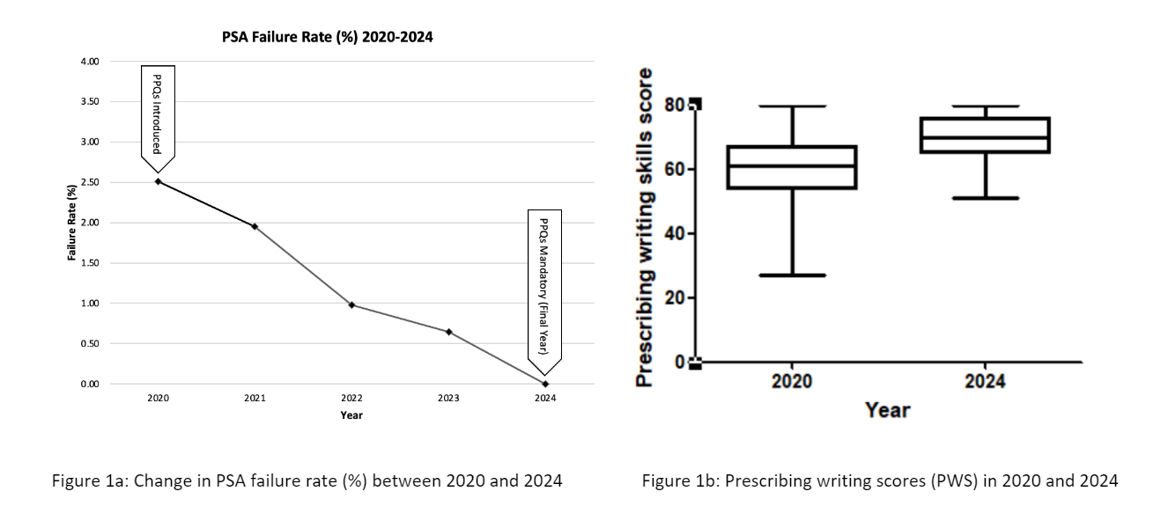
Median PSA scores significantly improved from 78.5% in 2020 to 84.0% in 2024 (p<0.0001). In contrast, median AKT scores decreased between 2020 and 2024 (78.0% vs 74.5%, p<0.0001).
Absolute increase in PSA scores from lowest to highest quintiles was 10 percentage points (pp), 7pp, 5pp, 4pp and 1pp, respectively, between 2020 and 2024. Median PWS scores significantly improved from 76.3 % (61/80) in 2020 to 87.5% (70/80) in 2024 (p<0.0001) [Fig 1b].
Since introducing PPQs, PSA scores have statistically significantly improved, with failure rate reducing to 0% in 2024. PPQs appeared to have progressively greater impact on the students at the bottom of the performance distribution. Furthermore, PWS scores showed significant improvement. These improvements cannot be attributed to overall improvement in students’ performance as the same trend was not observed in AKT median scores.
The PSA aims to assess skills, judgement and knowledge required to prescribe and supervise the use of medicines.¹ Improved median scores and reduced failure rates indicate enhanced attainment of these competencies, which is suggested to improve prescribing safety.¹
The digital PPQ platform permitted authentic learning, allowing demonstration of skills used in paper and electronic prescribing. Tailoring tasks by academic year likely allowed spiral learning throughout the curriculum. The focus on PWS further targets the most challenging prescribing skill.^{1,3}
Early, targeted and repeated opportunities for authentic prescribing activities as recommended by Magavern et al (2024), such as the PPQs, in undergraduate training may lead to significant improvement in prescribing competency as determined by the PSA. Implementation of PPQs for all prescribing learners, such as training prescribing pharmacists and other non-medical prescribers, may support reduction of prescription-related errors and improve patient safety.
References
- Magavern EF, Hitchings A, Bollington L, Wilson K, Hepburn D, Westacott RJ, Sam AH, Caulfield MJ, Maxwell S. UK Prescribing Safety Assessment (PSA): The development, implementation and outcomes of a national online prescribing assessment. Br J Clin Pharmacol. 2024 Feb;90(2):493-503. doi: 10.1111/bcp.15919. Epub 2023 Nov 9. PMID: 37793701
- Medication Without Harm – Global Patient Safety Challenge on medication Safety. Geneva: World health organization, 2017. Licence: CC BY-NC-SA 3.0 IGO. https://www.who.int/publications/i/item/WHO-HIS-SDS-2017.6
- Elliott RA, Camacho E, Jankovic D, et al. Economic analysis of the prevalence and clinical and economic burden of medication error in England. BMJ Quality & Safety 2021;30:96-105. https://qualitysafety.bmj.com/content/30/2/96
- Dornan T, Ashcroft D, Heathfield H, et al. An in depth investigation into causes of prescribing errors by foundation trainees in relation to their medical education. EQUIP study. London: General Medical Council; 2009. https://www.gmc-uk.org/-/media/documents/final-report-prevalence-and-causes-of-prescribing-errors_pdf-28935150.pdf
- Sam AH, Fung CY, Wilson RK, Peleva E, Kluth DC, Lupton M, Owen DR, Melville CR, Meeran K. Using prescribing very short answer questions to identify sources of medication errors: a prospective study in two UK medical schools. BMJ Open. 2019 Jul 9;9(7):e028863. doi: 10.1136/bmjopen-2018-028863. PMID: 31289084; PMCID: PMC6629393.
- Maxwell SRJ, Coleman JJ, Bollington L, Taylor C, Webb DJ. Prescribing Safety Assessment 2016: Delivery of a national prescribing assessment to 7343 UK final-year medical students. Br J Clin Pharmacol. 2017 Oct;83(10):2249-2258. doi: 10.1111/bcp.13319. Epub 2017 Jun 13. PMID: 28449302; PMCID: PMC5595977.

