Self-purification of Rural Polluted Water in the Dashi River: Insights from Multidimensional Water Quality Profiling
Jin Xieª, Nigel Graham^{b}, Qiuye Zhu ^{c}, Wenzheng Yu ^{d}, Ting Liuª*
ª School of Chemistry and Chemical Engineering, Beijing Key Laboratory for Chemical Power Source and Green Catalysis, Beijing Institute of Technology, Beijing 100081, China (liuting@bit.edu.cn)
^{b} Department of Civil and Environmental Engineering, Imperial College London, South Kensington Campus, London SW7 2AZ, UK (n.graham@imperial.ac.uk)
^{c} Ningbo Institute of Surveying, Mapping and Remote Sensing , NingBo 315042, China; xinye1031@163.com
^{d} Key Laboratory of Drinking Water Science and Technology, Research Center for Eco-Environmental Sciences, Chinese Academy of Sciences, Beijing 100085, China
(wzyu@rcees.ac.cn)
(*Corresponding author: Ting Liu Email: liuting@bit.edu.cn)

Supplementary Texts
Text S1. EEM processing, optical index calculation and PARAFAC analysis
Three-dimension excitation emission matrix (3D-EEM) was acquired with excitation (Ex)and emission (Em) wavelengths in the ranges of 200-500 nm and 250-550 nm, respectively, both at an increment of 5 nm and a scan speed of 2400 nm min⁻¹. EEM data were processed using the R package staRdom with the following procedures: (1) Deduct the Milli-Q water background; (2) Correct inner-filter effect; (3) Normalize the fluorescence intensity by Raman peak integral of Milli-Q water; (4) Remove the Rayleigh and Raman scattering; and (5) Interpolate the missing regions.
Three optical indices were calculated to assess the properties of fluorescent DOM, which included the humification index (HIX), biological index (BIX) and fluorescence index (FI)(Fellman et al., 2010). These indices were calculated as follows:
$$\begin{aligned}HIX=\frac{F_{Ex254, Em435-480}}{F_{Ex254,Em300-345}+F_{Ex254,Em435-480}}\#\end{aligned}(1)$$
where F_{Ex254, Em300-345} and F_{Ex254, Em300-345} are the fluorescence intensities (R.U.) at an Ex of 254 nm and Em in the range of 300-345 and 435-480 nm, respectively.
$$\begin{aligned}BIX=\frac{F_{Ex310, Em380}}{F_{max\left(Ex310, Em420-345 \right)}}\#\end{aligned}(2)$$
where F_{Ex310, Em380} is the fluorescence intensity (R.U.) at Ex of 310 nm and at an Em of 380; F_{max} _{(Ex310, Em420-345)} is the maximum fluorescence intensity at an Ex of 310 nm and Em in the range of 420-345 nm.
$$\begin{aligned}FI=\frac{F_{Ex370,Em470}}{F_{Ex370,Em520}}\#\end{aligned}(3)$$
where F_{Ex370, Em470} and F_{Ex370, Em520} are the fluorescence intensities (R.U.) at an Ex of 370 nm and Em at 470 and 520 nm, respectively.
PARAFAC modelling decomposes data into independent fluorescent components based on the following equation:
$$\begin{aligned}x_{ijk}=\sum_{f=1}^{F}{a_{if}b_{ij}c_{ik}}+ε_{ijk} , i=1,…, I; j=1,…, J; k=1,…, K \#\end{aligned}(4)$$
where x, i, j, k represents the fluorescence intensity of sample i at an Em of j and Ex of k; a, b and c are proportional to the concentration, Em spectra, and Ex spectra of the underlying fluorescent components; F is the number of components; and ε, i, j, k is the residual of unexplained signal. A four-component model was built with non-negative model parameters and was validated with the following steps: 1) Comparison of models with 3-7 components; 2) Outlier identification and elimination; 3) Residual analysis; and 4) Split-half analysis and validation.
Four fluorescent components (C1-C4) in grassland soils were identified from the PARAFAC modelling (Figure S5). C1 and C2 were assigned to terrestrial humic-like or fulvic-like organics with high aromaticity, molecular weight (MW) and conjugation degree (Du et al., 2019; Kida et al., 2019; Panettieri et al., 2020; Yamashita et al., 2021). C3, with higher Ex wavelength, represented an uncommon terrestrial humic-like component with more aromatic and conjugated structures and less microbial signatures than C1 and C2 (Chen et al., 2018; Panettieri et al., 2020). The C4 component was related to a combination of proteinaceous compounds (e.g., amino acids, peptides and proteins) and small soluble microbial product-like compounds originated from microbial activities (Andersson et al., 2018; Kida et al., 2019; Stedmon et al., 2003).
Text S2. DBPs extraction
The procedures of liquid-liquid extraction for DBP quantification were as follows:
1. THMs (EPA Method 551.1)(EPA., 1995){EPA, 1995 #46} (Table S1)
20 mL of chlorinated sample is placed in a 40 mL brown glass vial, saturated with 8.0 g pre-muffled sodium sulfate (Na₂SO₄) and extracted by 4 mL methyl tert-butyl ether (MTBE). The solution is mixed uniformly with vortex for 2 min and stratified for 30 min. Finally, 1 mL of organic phase is taken from the upper layer solution and placed into a 1.5 mL brown vial. The four THM species are quantified by gas chromatography with an electron capture detector (GC-ECD).
2. HAAs (EPA Method 552.3)(EPA, 1995) (Table S2)
20 mL of chlorinated sample is placed in a 40 mL brown bottle, acidified by 1 mL of concentrated sulfuric acid (H₂SO₄), saturated with 8.0 g pre-muffled Na₂SO₄ and mixed with 4 mL MTBE. The solution is thoroughly mixed with vortex for 2 min and stratified for 30 min. Then, 2 mL of the upper organic phase is taken into a 10 mL brown glass bottle, followed by the addition of 2 mL acidified methanol solution (methanol:H₂SO₄=9:1, v/v). After sealing and mixing, the bottle is placed into 50 ℃ water and incubated for 2 h. Then, after cooling to the room temperature, 5 mL of 150 g·L-1 Na₂SO₄ solution is added, followed by vortex for 30 s and stratification for 20 min. Subsequently, the aqueous layer is removed, and 1 mL of saturated sodium bicarbonate solution (NaHCO₃) is added. Finally, after thorough mixing and stratification for 5 min, 1 mL of the organic phase is taken into a 1.5 mL brown vial for determination of the nine HAA species using GC-ECD.

Supplementary Tables

Table S1. Properties of THMs
THM (Abbreviation) | Molecular formula | Structure | MW (g mol⁻¹)
Trichloromethane  (TCM) | CHCl₃ | 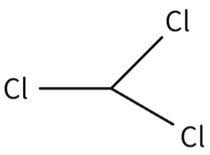 | 119.38
Bromodichloromethane  (BDCM) | CHCl₂Br | 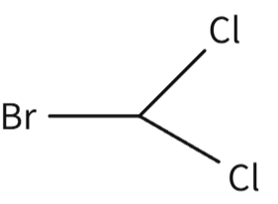 | 163.80
Dibromochloromethane  (DBCM) | CHBr₂Cl | 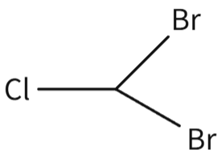 | 208.30
Tribromomethane  (TBM) | CHBr₃ | 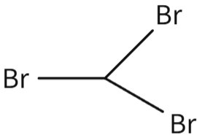 | 252.77

Table S2. Properties of HAAs
HAA (Abbreviation) | Molecular  formula | Structure | MW (g mol⁻¹)
Monochloroacetic acid  (MCAA) | C₂H₃ClO₂ | 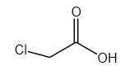 | 94.49
Monobromoacetic acid  (MBAA) | C₂H₃BrO₂ | 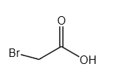 | 138.95
Dichloroacetic acid  (DCAA) | C₂H₂Cl₂O₂ | 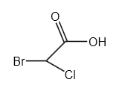 | 128.94
Trichloroacetic acid  (TCAA) | C₂HCl₃O₂ | 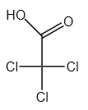 | 163.40
HAA(Abbreviation) | Molecular  formula | Structure | MW (g mol⁻¹)
Bromochloroacetic acid  (BCAA) | C₂H₂BrClO₂ | 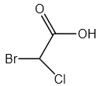 | 173.39
Dibromoacetic acid  (DBAA) | C₂H₂Br₂O₂ | 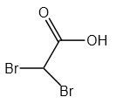 | 217.84
Bromodichloroacetic acid  (BDCAA) | C₂HBrClO₂ | 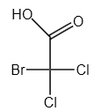 | 207.83
Chlorodibromoacetic acid  (CDBAA) | C₂HBr₂ClO₂ | 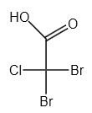 | 252.29
Tribromoacetic acid  (TBAA) | C₂HBr₃O₂ | 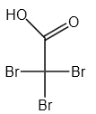 | 296.74

Table S3. Geographic coordinates of sampling sites.
Sample | Longitude (E) | Latitude (N)
1 | 115.7501561° | 39.7313090°
2 | 115.7548992° | 39.7357342°
3 | 115.7506951° | 39.7420177°
4 | 115.7617802° | 39.7530854°
5 | 115.7677809° | 39.7693785°
6 | 115.7810039° | 39.7877884°
7 | 115.7869328° | 39.7984883°
8 | 115.7985568° | 39.8243441°
9 | 115.8242663° | 39.8280291°
10 | 115.8498321° | 39.8276966°
11 | 115.8657501° | 39.8137037°
12 | 115.8893575° | 39.8142857°
13 | 115.9066050° | 39.8241502°
14 | 115.9245352° | 39.8184699°
15 | 115.9673664° | 39.8295529°

Table S4. Alpha diversity indices for microbial communities across selected sampling sites.
Site | ace | chao | coverage | shannon | simpson | sobs
1 | 622.0675 | 607 | 0.997956 | 3.842621 | 0.057326 | 561
2 | 796.5748 | 753.7876 | 0.997517 | 4.149969 | 0.037919 | 721
13 | 595.9696 | 553.902 | 0.99756 | 2.591067 | 0.184866 | 514
14 | 794.8728 | 757.8837 | 0.99767 | 2.996184 | 0.14361 | 732

Supplementary Figures
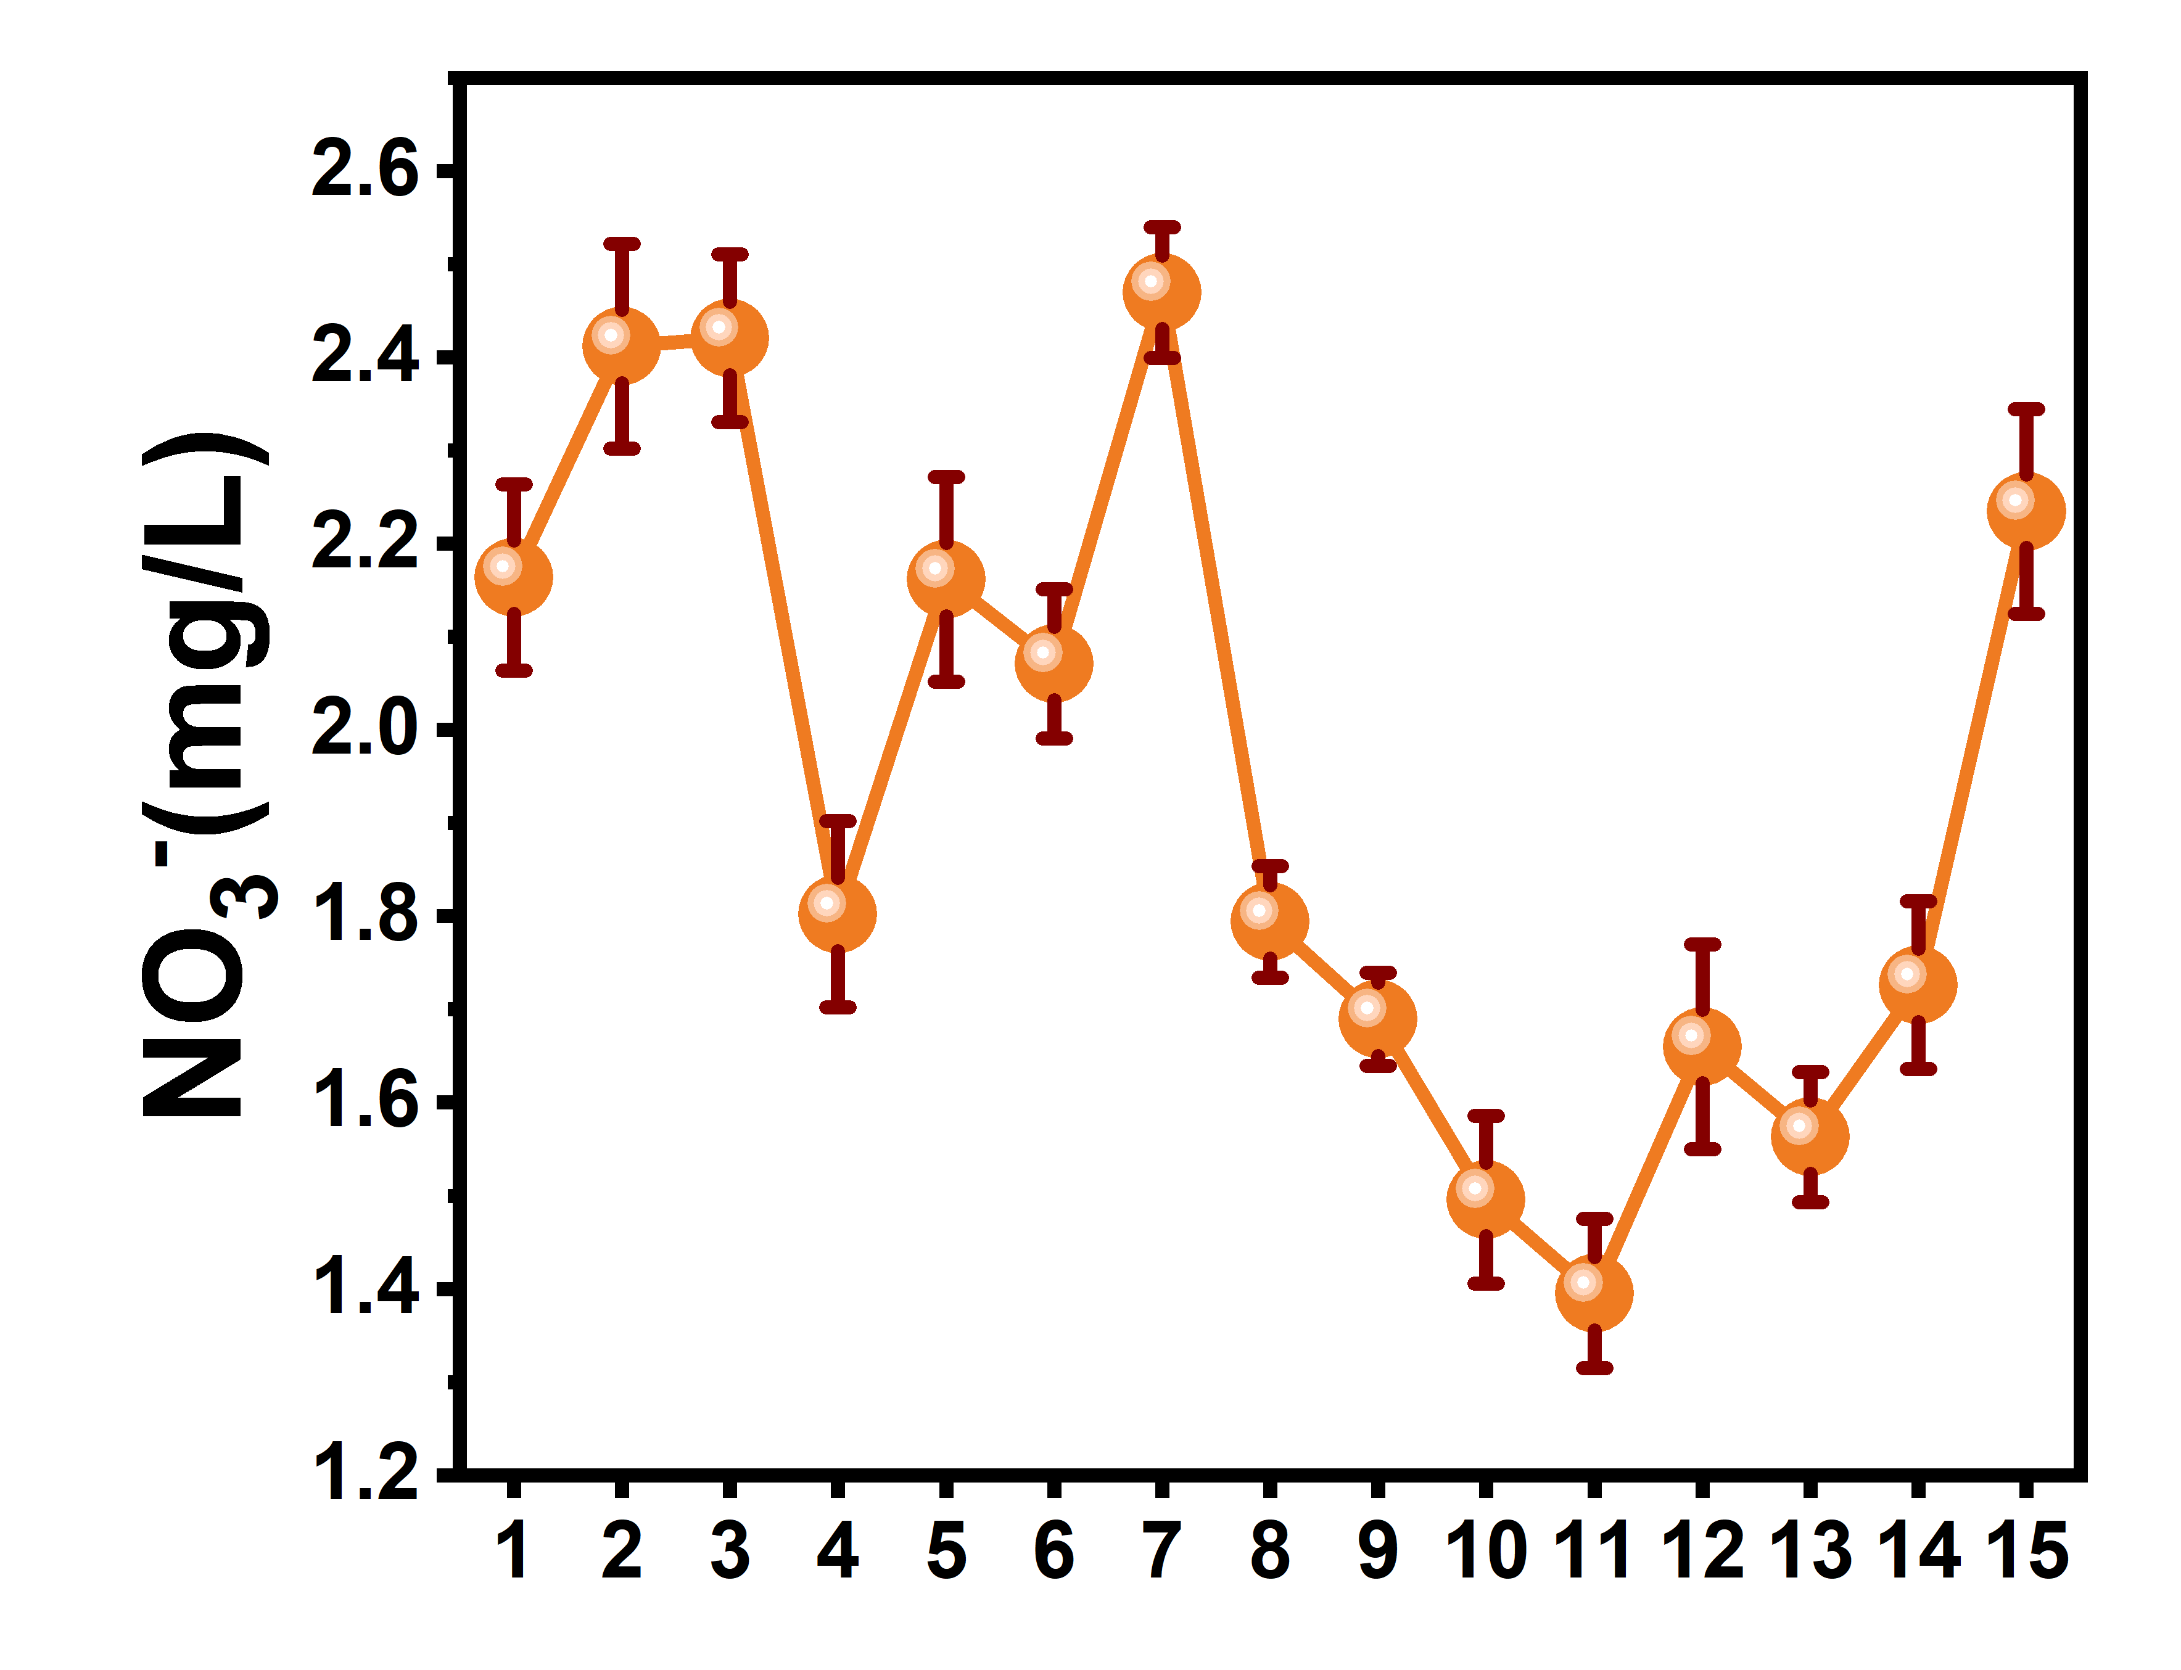
Figure S1. Longitudinal variations in nitrate concentrations NO₃⁻ (mg L⁻¹) at sample locations along the Dashi River.
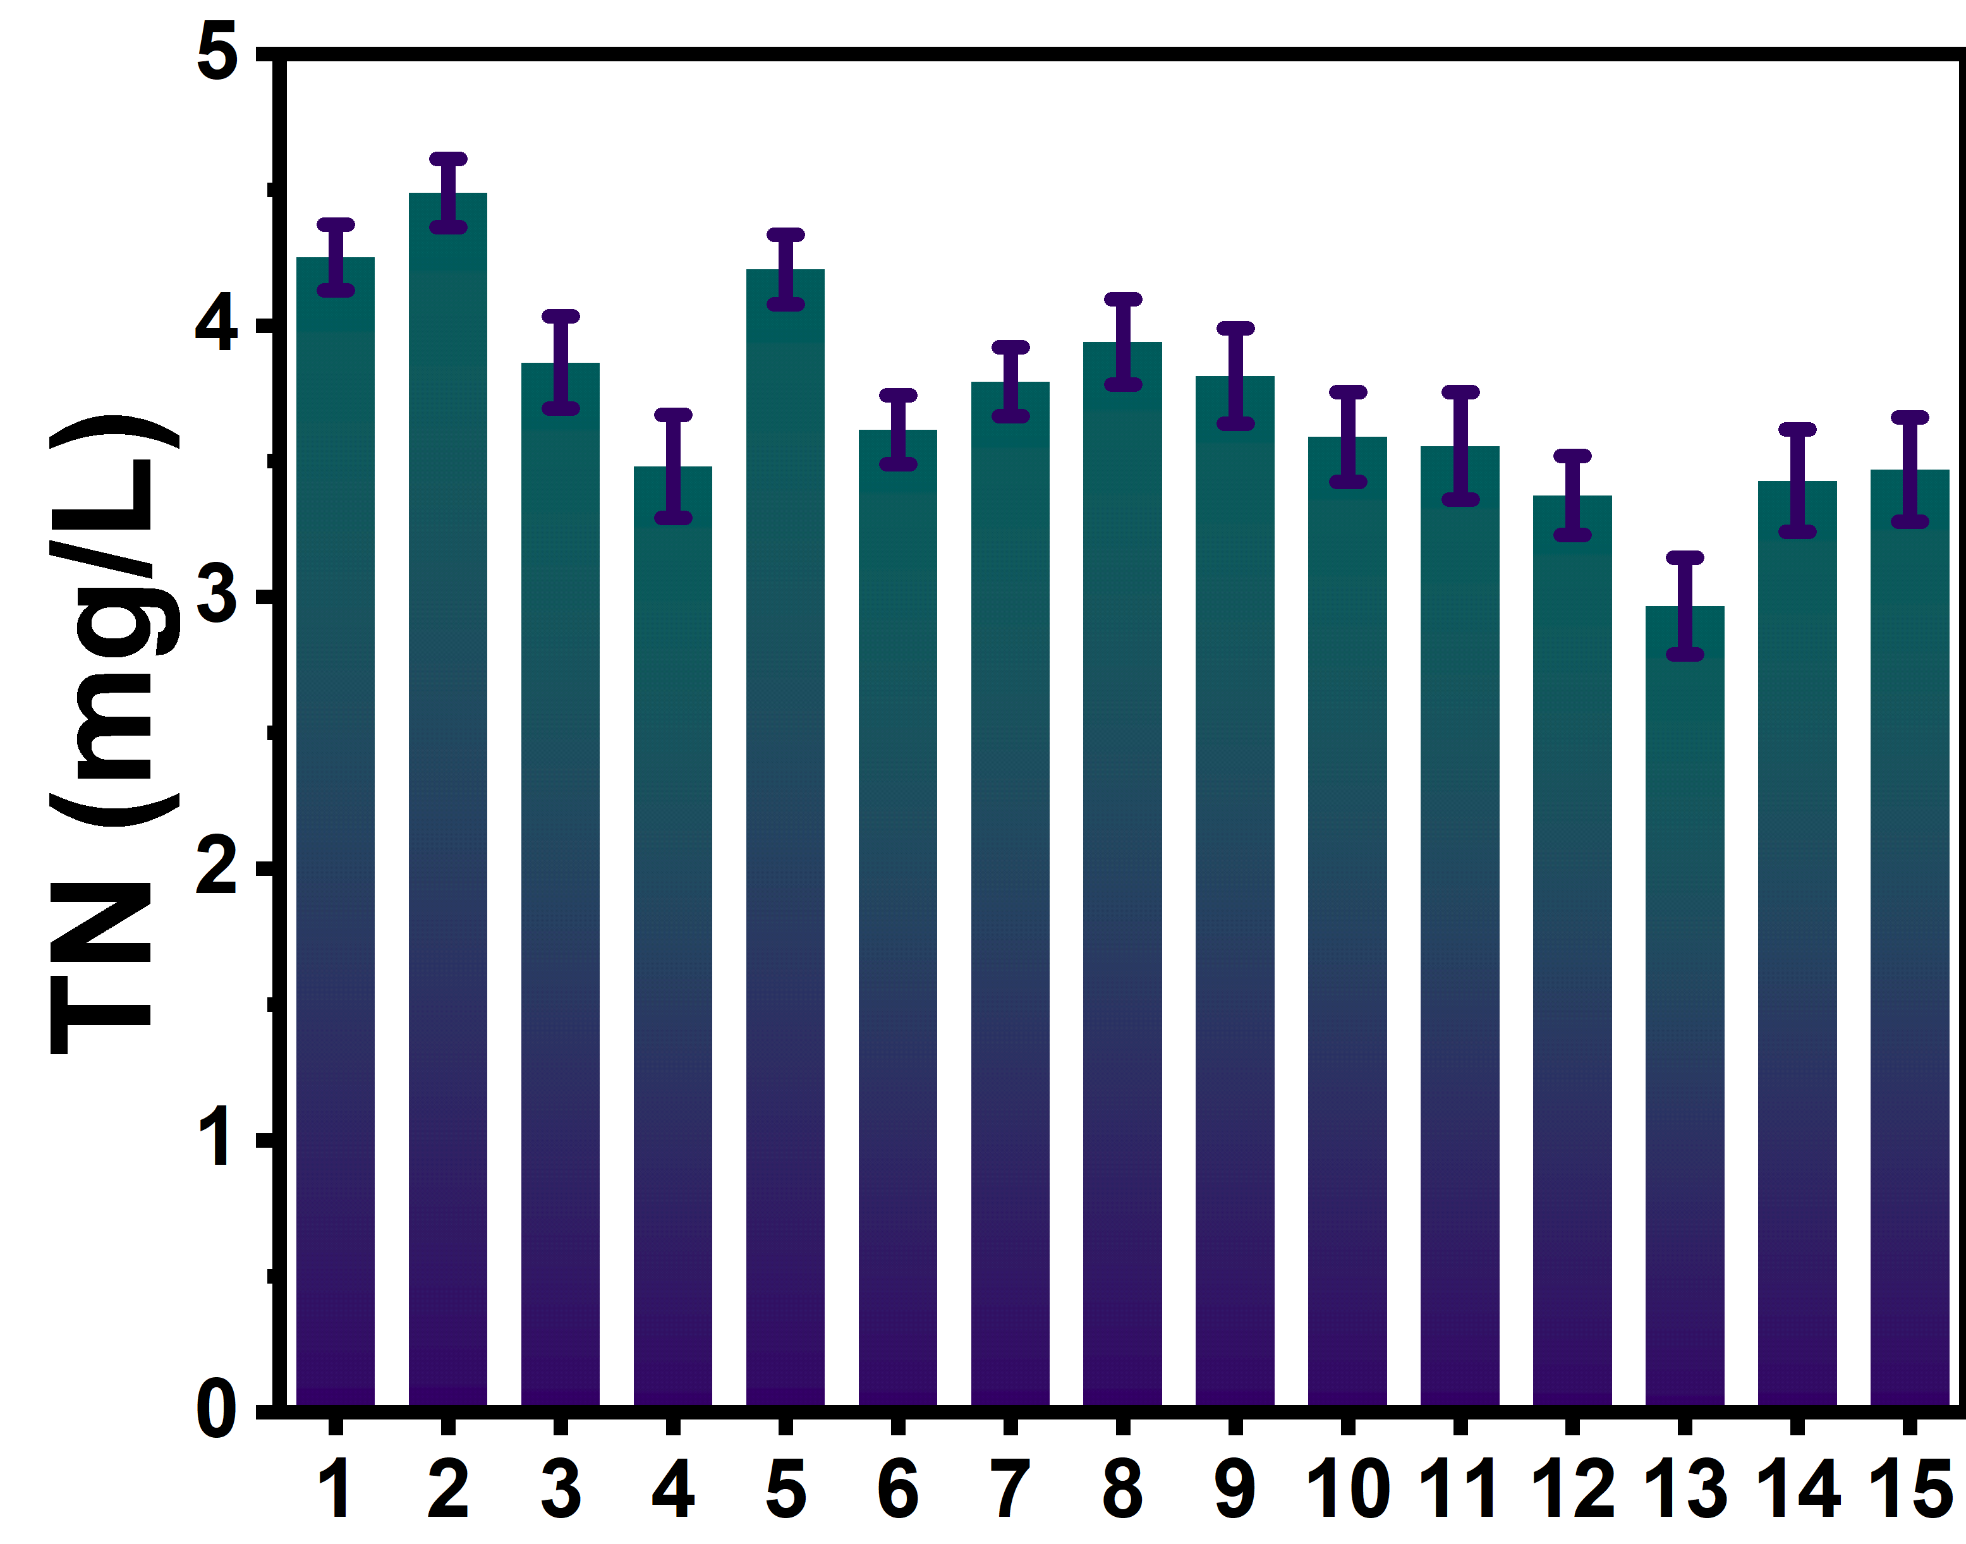
Figure S2. Longitudinal variations in total nitrogen (TN (mg L⁻¹) at sample locations along the Dashi River.
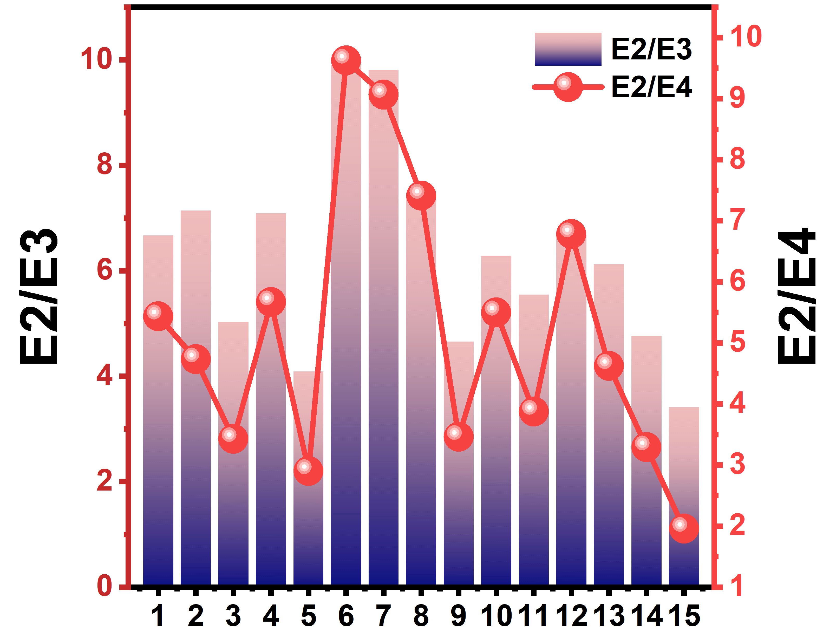
Figure S3. Variation of UV-visible absorption spectra of DOM with sample location. E2/E3 and E2/E4 ratios denote absorbance at 250/365 nm and 250/465 nm respectively.
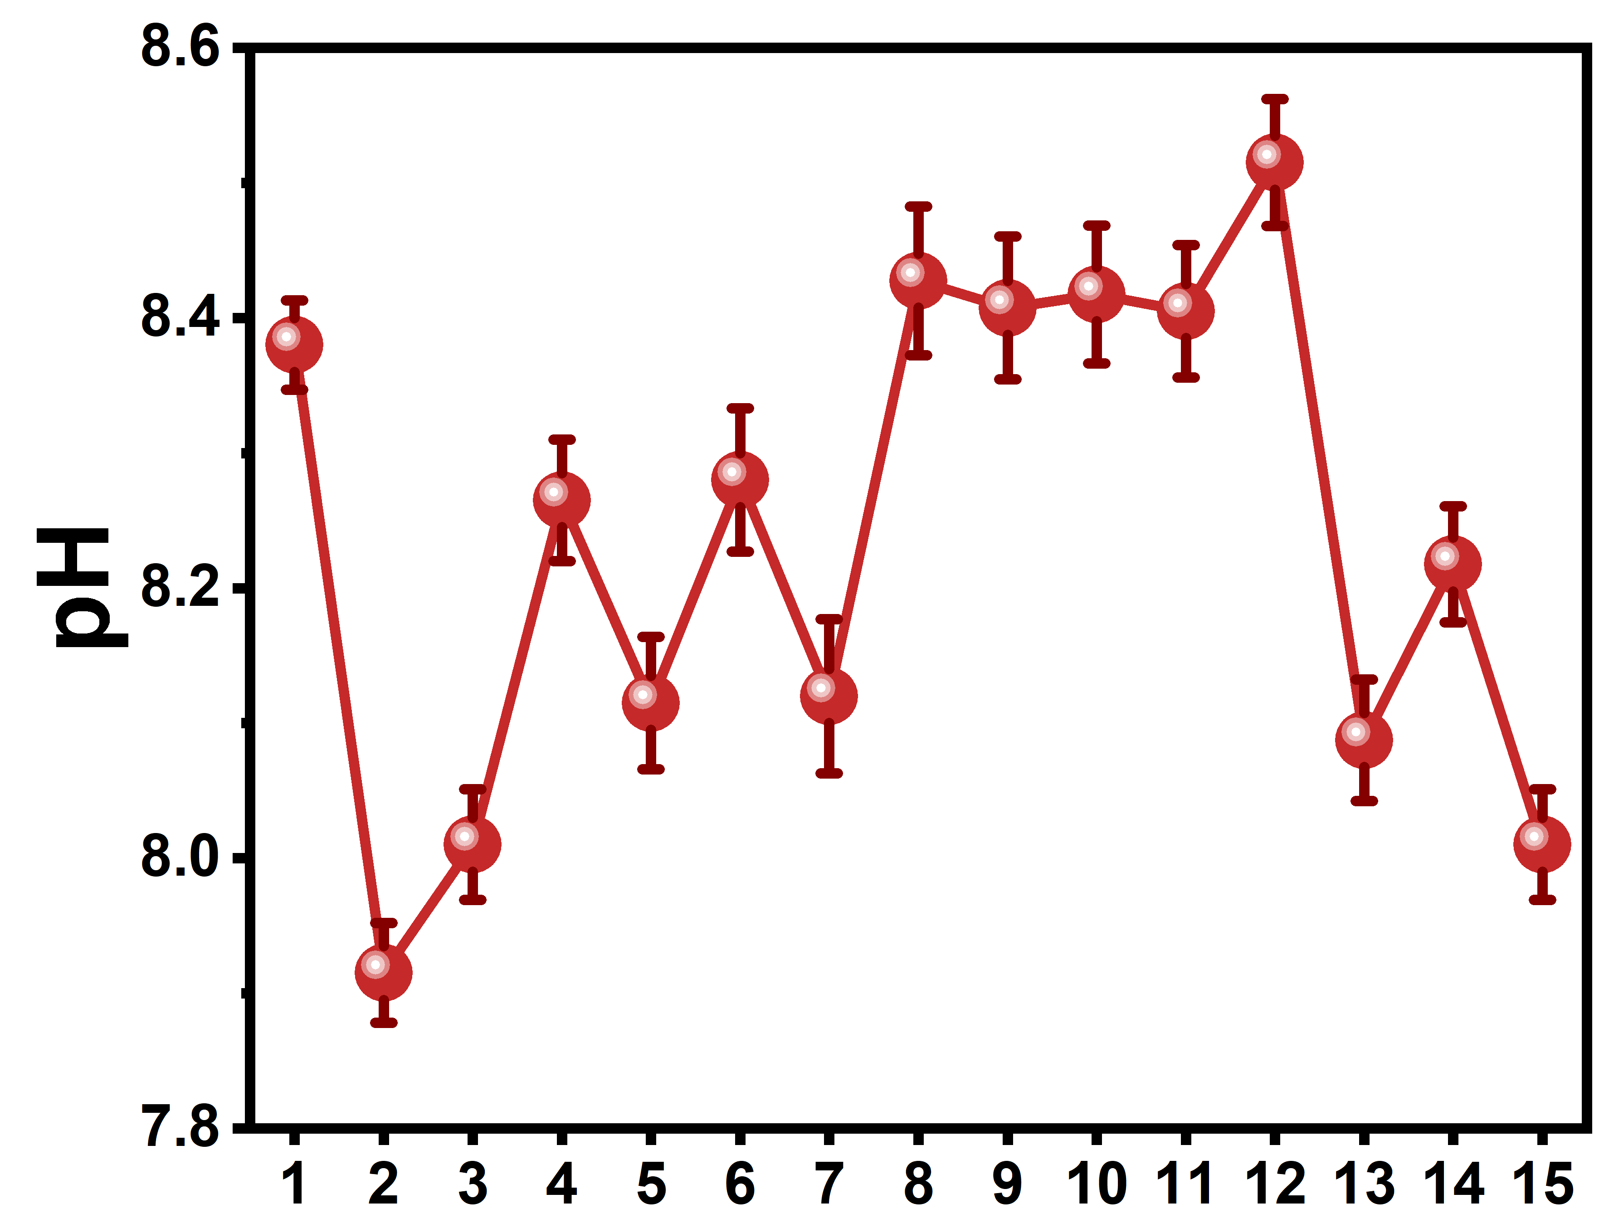
Figure S4. Variation of pH values with sample location along the Dashi River.
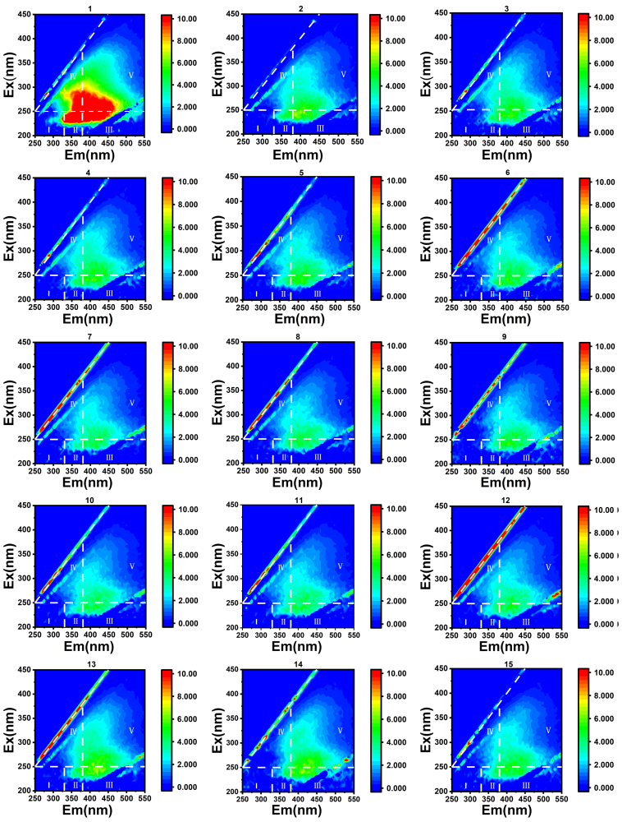
Figure S5. Three-dimensional excitation-emission matrix (3D-EEM) fluorescence profiles of dissolved organic matter at sample locations along the Dashi River. The visual evolution of peaks illustrates the downstream shift from terrestrial humic-like signals to microbial protein-like signals.
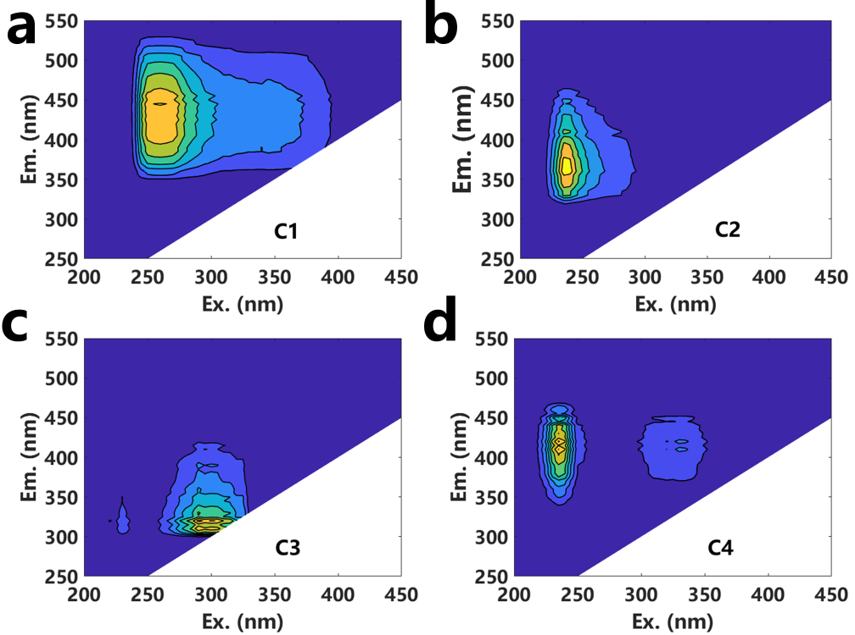
Figure S6. Longitudinal evolution of DOM composition and source revealed by EEM-PARAFAC and optical indices: Spectral loadings and proposed characterization of the four validated PARAFAC components.
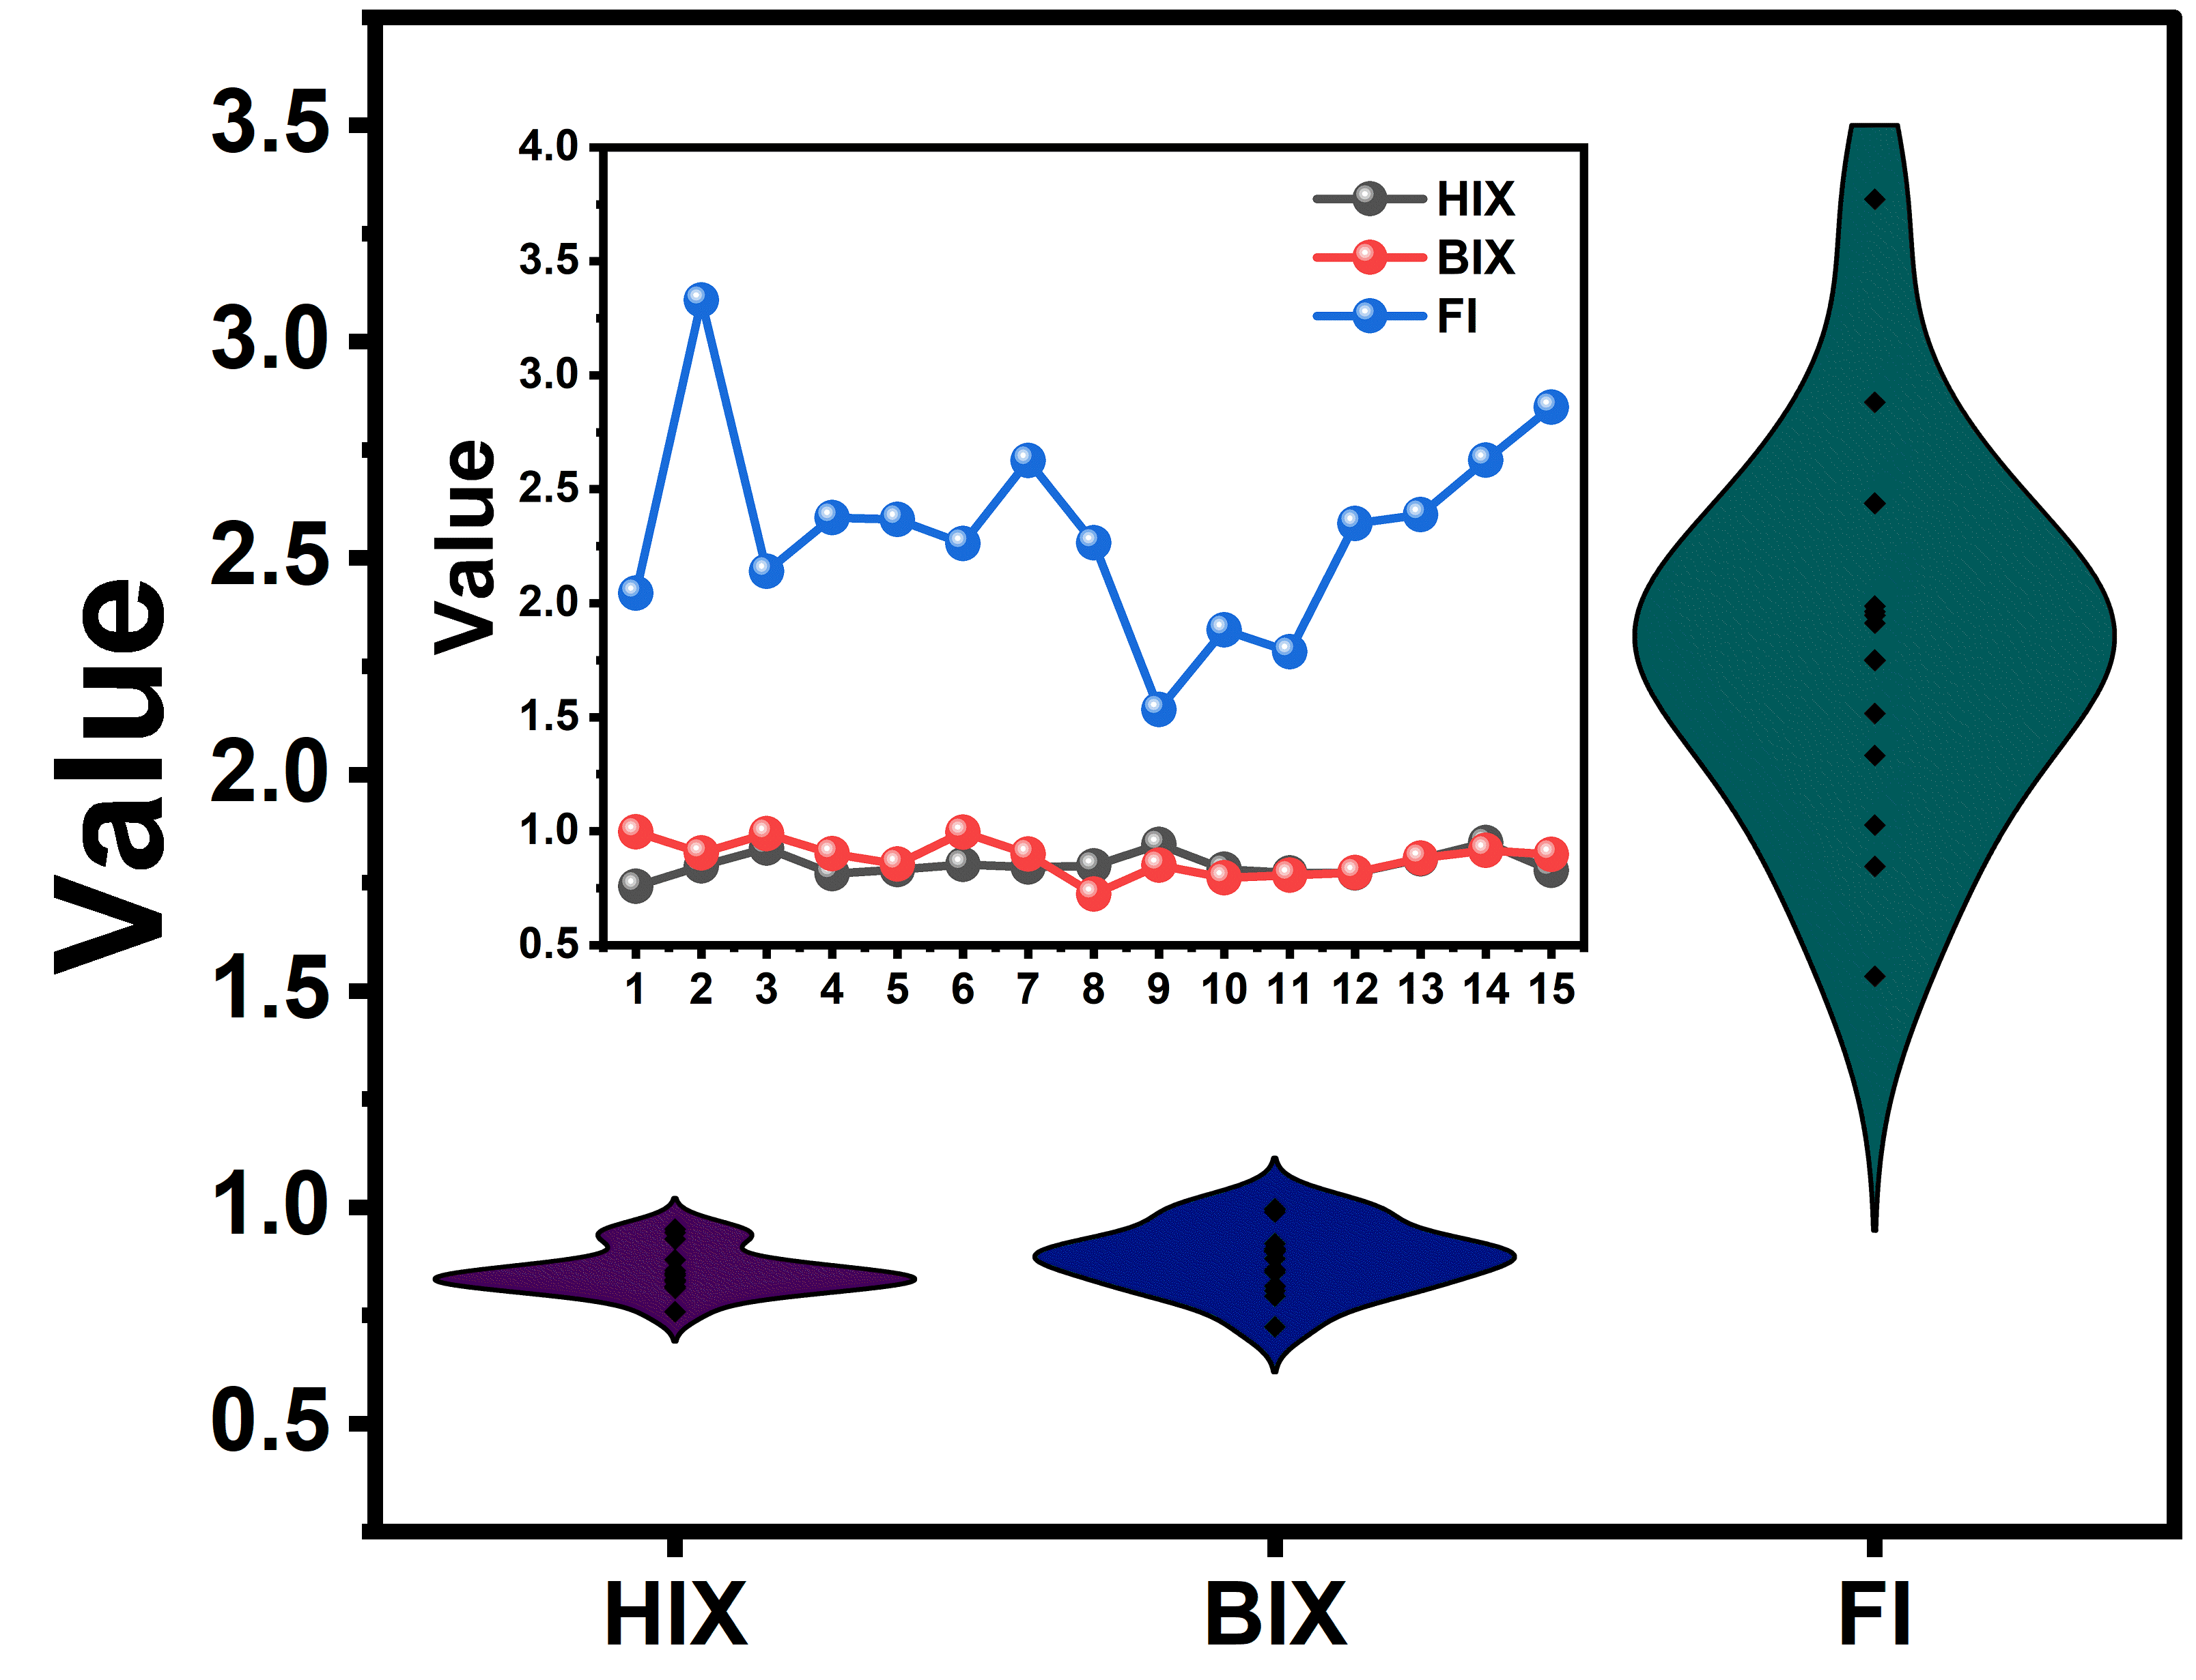
Figure S7. Longitudinal evolution of DOM composition and source revealed by fluorescence index (FI), biological index (BIX), and humification index (HIX).
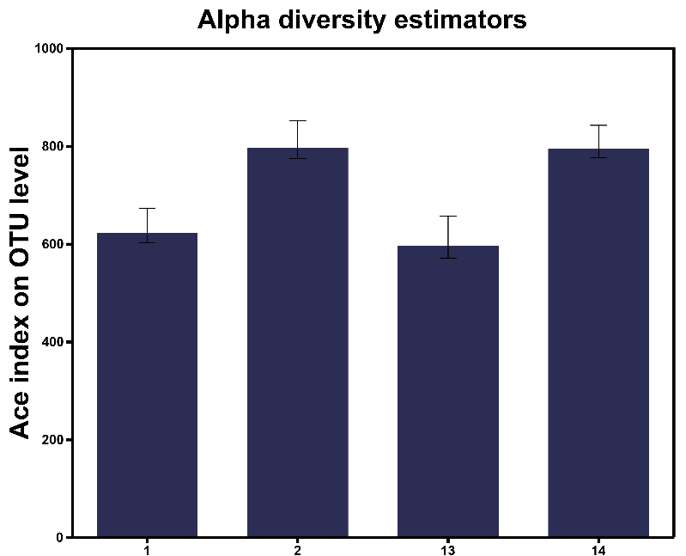
Figure S8. Alpha diversity comparisons of microbial communities at selected sampling sites.

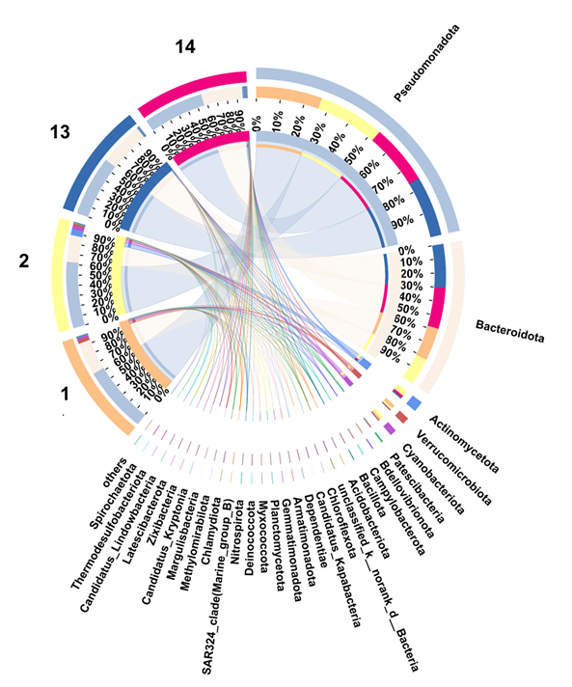
Figure S9. Distribution of microbial species at selected sample sites. The small semicircle (left half) in the figure represents the species composition of the sample. The color of the outer band indicates the group it belongs to, the color of the inner band represents the species, and the length indicates the relative abundance of that species in the corresponding sample; the larger semicircle (right half) represents the distribution proportion of species at that taxonomic level across different samples, the outer band represents the species, the color of the inner band indicates different groups, and the length represents the distribution proportion of that species in the sample.

References
Andersson, M.G.I., Catalán, N., Rahman, Z., Tranvik, L.J. and Lindström, E.S. 2018. Effects of sterilization on composition and bacterial utilization of dissolved organic carbon from lakes. Aquatic Microbial Ecology.
Chen, B., Huang, W., Ma, S., Feng, M., Liu, C., Gu, X. and Chen, K. 2018. Characterization of Chromophoric Dissolved Organic Matter in the Littoral Zones of Eutrophic Lakes Taihu and Hongze during the Algal Bloom Season. Water.
Du, Y., Zhang, Q., Liu, Z., He, H., Lürling, M., Chen, M. and Zhang, Y. 2019. Composition of dissolved organic matter controls interactions with La and Al ions: Implications for phosphorus immobilization in eutrophic lakes. Environmental Pollution.
EPA, U.S. 1995. Method 552.3 Determination of Haloacetic Acids and Dalapon in Drinking Water by Liquid-Liquid Microextraction, Derivatization, and Gas Chromatography with Electron Capture Detection.
EPA., U.S. 1995 EPA Method 551.1: Determination of Chlorination Disinfection Byproducts, Chlorinated Solvents, and Halogenated Pesticides/Herbicides in Drinking Water by Liquid-Liquid Extraction and Gas Chromatography With Electron-Capture Detection.
Fellman, J.B., Hood, E. and Spencer, R.G.M. 2010. Fluorescence spectroscopy opens new windows into dissolved organic matter dynamics in freshwater ecosystems: A review. Limnology and Oceanography.
Kida, M., Kojima, T., Tanabe, Y., Hayashi, K., Kudoh, S., Maie, N. and Fujitake, N. 2019. Origin, distributions, and environmental significance of ubiquitous humic-like fluorophores in Antarctic lakes and streams. Water Research.
Panettieri, M., Guigue, J., Chemidlin Prevost-Bouré, N., Thévenot, M., Lévêque, J., Le Guillou, C., Maron, P.-A., Santoni, A.-L., Ranjard, L., Mounier, S., Menasseri, S., Viaud, V. and Mathieu, O. 2020. Grassland-cropland rotation cycles in crop-livestock farming systems regulate priming effect potential in soils through modulation of microbial communities, composition of soil organic matter and abiotic soil properties. Agriculture, Ecosystems & Environment.
Stedmon, C.A., Markager, S. and Bro, R. 2003. Tracing dissolved organic matter in aquatic environments using a new approach to fluorescence spectroscopy. Marine Chemistry.
Yamashita, Y., Kojima, D., Yoshida, N. and Shibata, H. 2021. Relationships between dissolved black carbon and dissolved organic matter in streams. Chemosphere.

