Changes in clinical and imaging variables during withdrawal of heart failure therapy in recovered dilated cardiomyopathy
Brian P Halliday PhD MRCP¹, Ruth Owen MSc², John Gregson PhD², Ali Vazir PhD FRCP¹, Rebecca Wassall MSc¹, Zohya Khalique MD MRCP¹, Amrit S Lota MBBS MRCP¹, Upasana Tayal PhD MRCP¹, Daniel J Hammersley MBBS MRCP¹, Richard E Jones MBBS MRCP¹, Dudley J Pennell MD FRCP¹, Martin R Cowie MD FRCP^{1,3}, John G F Cleland MD FRCP^{1,4}, Sanjay K Prasad MD FRCP¹

¹ Cardiovascular Research Centre, Royal Brompton Hospital, Guy’s & St Thomas’ NHS Trust & National Heart Lung Institute, Imperial College, London, UK
² Department of Medical Statistics, London School of Hygiene and Tropical Medicine, London, UK
³ Faculty of Life Sciences & Medicine, King’s College London, London, UK
⁴ Robertson Centre for Biostatistics, University of Glasgow, Glasgow, UK

Address for correspondence
Dr Brian P Halliday
Cardiovascular Research Centre
Royal Brompton Hospital, SW3 6NP, UK
Email: b.halliday@rbht.nhs.uk
Phone: (+44) 207 352 8121 Ext 82928
Fax: (+44) 207 351 8146

Word count: 3284

Abstract
Aims: To profile the changes in non-invasive clinical, biochemical and imaging markers during withdrawal of therapy in patients with recovered dilated cardiomyopathy, providing insights into the pathophysiology of relapse.
Methods: Clinical, biochemical and imaging data from patients during phased withdrawal of therapy in the randomised or single-arm cross-over phases of TRED-HF were profiled. Clinical variables were measured at each study visit and imaging variables were measured at baseline, 16 weeks and 6 months.
Results: Amongst the 49 patients (35% women, mean age 53.6 years [standard deviation 11.6]) who withdrew therapy, 20 relapsed. Increases in mean heart rate (7.6 beats per minute [95% CIs 4.5,10.7]), systolic blood pressure (6.6mmHg [95% CI 2.7,10.5]) and diastolic blood pressure (5.8mmHg [95% CI 3.1,8.5]) were observed within 4-8 weeks of starting to withdraw therapy. A rise in mean LV mass (5.1g/m² [95%CI 2.8,7.3]) and LV end-diastolic volume (3.9ml/m² [95% CI 1.1,6.7]) and a reduction in mean LV ejection fraction (-4.2 [95% CI -6.6, -1.8]) were seen by 16 weeks, the earliest imaging follow-up. Plasma NT-pro-BNP fell immediately after withdrawing beta-blockers and only tended to increase 6 months after beginning therapy withdrawal (mean change in log NT-pro-BNP at 6 months: 0.2, 95% CI -0.1,0.4).
Conclusion: Changes in plasma NT-pro-BNP are a late feature of relapse, often months after a reduction in LV function. A rise in heart rate and blood pressure are observed soon after withdrawing therapy in recovered dilated cardiomyopathy, typically accompanied or closely followed by early changes in LV structure and function.

Keywords: dilated cardiomyopathy, myocardial recovery, remission, remodelling

Introduction
Left ventricular reverse remodelling frequently occurs amongst patients with dilated cardiomyopathy (DCM)^{1, 2}. With increasing therapeutic success, the number of patients with heart failure and improved left ventricular ejection fraction (LVEF) is growing. Although improvement in LVEF is associated with a much better prognosis, these patients remain at risk of adverse outcomes, including a relapse of cardiac dysfunction and symptoms of heart failure ³⁻⁵. This is more likely to occur if medication is withdrawn but also in a minority who continue on therapy ³⁻⁵. Priorities for future research include identifying markers of true and sustained recovery as well as features of early relapse. This may provide insights into the drivers of relapse allowing therapy to be tailored appropriately and identifying those most at risk. Understanding the sequence of changes that occur during adverse remodelling and relapse is an important step towards these goals.
A previous report from the TRED-HF trial suggested that a greater rise in heart rate during therapy withdrawal was associated with a higher risk of relapse ⁶. Changes in other clinical, imaging, or biochemical markers during therapy withdrawal will provide useful insights into the pathophysiology of remodelling as well as possible indicators of relapse that may be used in clincial practice; whether such variables are effective monitoring options is unknown. Whether changes in natriuretic peptides precede or parallel structural remodelling in this population will inform the use of this marker in future studies and clinical practice.
In this study, we profiled the serial changes in non-invasive clinical, biochemical and imaging markers during withdrawal of therapy in patients with recovered DCM to provide insights into the sequence of changes that occur during adverse remodelling and relapse.

Methods
TRED-HF was an open-label, randomised trial examining the safety and feasibility of phased withdrawal of pharmacological therapy for heart failure in asymptomatic patients with DCM and improved LVEF and low plasma concentrations of natriuretic peptides (NCT02859311) ^{3, 6}. All patients provided informed consent. The study was approved by the London-Surrey Borders National Research Ethics Committee and authorised by the Medicine and Healthcare Products Regulatory Agency.
Overall, 51 patients with a previous diagnosis of DCM, whose LVEF had improved from <40% to ≥50% and who now had normal left ventricular end diastolic volume (LVEDV), plasma NT-pro-BNP <250ng/L and who were still taking at least one heart failure therapy (loop diuretic, beta-blocker, angiotensin converting enzyme [ACE] inhibitor, angiotensin receptor blocker [ARB] or mineralocorticoid receptor antagonist [MRA]) were included. Patients were randomised 1:1 to phased withdrawal or continuation of heart failure therapy for 6 months. After 6 months, patients assigned to the control arm subsequently entered a single-arm cross-over phase. Between months 6 and 12, they had therapy withdrawn in the same fashion as the randomised phase of the study.
Therapy withdrawal was done in a step-wise fashion over a maximum of 16 weeks. Changes were made every 2 weeks following review by the study team. Heart rate, blood pressure and plasma concentration of NT-pro-BNP were measured every 4 weeks with interim reviews taking place via telephone, if feasible and safe. All patients had cardiovascular magnetic resonance (CMR) at baseline, 16 weeks and 6 months with gold-standard volumetric assessment of cardiac chambers by two EACVI Level 3 accredited operators^{3, 7}. Serial scans from the same participant were analysed by the same operator. Two patients with devices had imaging follow-up with 3-dimensional echocardiography. Serial LVEF and LVEDVi are included. Two patients who initially had CMR, were unable to continue follow-up with this modality due to new contraindications. Follow-up LVEF is included from 3-dimensional echocardiography for these patients. No other volumetric measures are included given the poor between modality reproducibility ^{8, 9}.
Loop diuretics were withdrawn first, followed by MRAs, beta-blockers and finally ACE inhibitors or ARBs at separate visits. The medication was stopped if the participant was taking 40mg or less of furosemide (or equivalent), 50mg or less of spironolactone, or 25% or less of the recommended dose of beta-blocker or ACE inhibitor or ARB. If participants were prescribed larger doses of any of the above, these were reduced by 50%, rather than stopped, every two weeks.
The primary relapse end-point was defined by any one of the following: 1) a reduction in LVEF by >10% and to <50%, or 2) an increase in LVEDV by >10% and to above the normal range, or 3) a two-fold rise in NT-pro-BNP from baseline and to >400ng/L, or 4) clinical evidence of heart failure. Treatment was restarted if any of the primary end-point criteria were met. The management of patients who suffered adverse events but did not meet the primary end-point, was determined by the research team and the patient’s physicians.
Statistical analysis
The mean and mean change from baseline are presented at the different time-points for each variable with 95% confidence intervals (CIs). Patient data were included until the end of the study which was defined as the final follow-up visit or the time at which the primary end-point was first met. Change from baseline was analysed using paired t-tests. Percentage change in variables from baseline along with 95% CIs are presented at different time points. The same data are presented stratified by the occurrence of relapse in the supplementary data for those variables not included in the primary end-point composite. Serial changes in clinical variables collected at each study visit were modelled using fractional polynomial models with four knots. We also examined changes in NT-pro-BNP before, during and after the withdrawal of beta-blockers and ACE inhibitors/ARBs, individually.
Statistical analyses were performed using Stata version 16.0 (StatCorp, College Station, TX, USA). The investigators had complete access to all raw and derived datasets.

Results
Of the 51 patients enrolled and randomised, 49 attempted withdrawal of therapy during the study; 25 patients were randomised to have therapy withdrawn between 0-6 months, whilst 24 of 26 patients initially randomised to continue therapy, attempted to withdraw therapy in the single arm-crossover phase between 6-12 months. Of the 49 patients who withdrew therapy, 20 (41%) met the primary end-point for relapse. Of the 20 patients who relapsed, 10 fulfilled more than one element of the primary composite relapse end-point; 12 (60%) met the LVEF criterion, 11 (55%) the LVEDVi criterion, 9 (45%) the NT-pro-BNP criterion and one (5%) developed peripheral oedema. Four participants restarted therapy without meeting the primary end-point, two for hypertension, one following an episode of AF and one following an episode of non-sustained ventricular tachycardia. Baseline characteristics are presented in Table 1. Around half of participants were neither on a loop diuretic nor MRA at baseline and consequently, beta-blockers were the first treatment to be withdrawn.
Clinical variables
There was a rise in mean heart rate between baseline and 4 weeks (66.1 beats per minute [bpm] [95% CI 63.0, 69.3] to 73.7bpm [95% CI 70.3, 77.2]; change from baseline 7.6bpm [95% CI 4.5, 10.7]; p<0.0001 ) which was followed by a rise in systolic and diastolic blood pressure between baseline and 8 weeks (systolic: 124.0mmHg [95% CI 120.7, 127.3] to 130.8mmHg [95% CI 126.9, 134.7], change from baseline 6.6mmHg [95% CI 2.7, 10.5]; p=0.001; diastolic 72.3mmHg [95% CI 69.5, 75.1] to 77.7mmHg [95% CI 74.5, 80.9], change from baseline 5.8mmHg [95% CI 3.1, 8.5]; p<0.001) (Supplementary Figure 1 & Supplementary Table 1).
Mean log NT-pro-BNP remained similar over 6 months (4.2 [95% CI 4.0, 4.4] to 4.2, [95% CI 3.8, 4.5]), with a non-significant trend to increase from baseline seen at 6 months (0.2, 95% CI -0.1, 0.4; p=0.18) (Figure 1). As expected, the mean change from baseline in log NT-pro-BNP was most pronounced in those who met the primary relapse end-point (0.9, 95% CI 0.0, 1.8) (Supplementary Figure 1, Supplementary Table 1). However, of those who met the relapse end-point, 7 had a reduction NT-pro-BNP at the point of relapse compared to baseline, five of whom had a reduction in LVEF of >10%.
Imaging variables
There was a reduction in LVEF between baseline and 16 weeks (59.9% [95% CI 58.2, 61.6] to 55.2% [52.7, 57.6]; change from baseline -4.2% [95% CI -6.6, -1.8], p<0.001) which was accompanied by an increase in LVEDVi (79.0ml/m² [95% CI 74.7, 83.3] to 81.40ml/m² [95% CI 76.9, 85.9]; change from baseline 3.9ml/m² [95% CI 1.1, 6.7], p=0.008) and LVMi (67.8g/m² [95% CI 63.2, 72.3] to 72.7g/m² [95% CI 67.9, 77.5], change from baseline 5.1g/m² [95%CI 2.8, 7.3], p<0.001) (Figure 2& Table 2). Mean left atrial volume indexed to body surface area (LAVi) and right ventricular ejection fraction (RVEF) remained similar over 6 months, although, there was an increase in mean LAVi amongst those who relapsed at 6 months (Supplementary Table 1 & Supplementary Figure 1). There was a reduction in right ventricular end diastolic volume indexed to BSA (RVEDVi) that was greatest after 6 months (change from baseline -5.8ml/m² [95% CI -9.9, -1.6], p=0.009) (Figure 2 & Table 2).

NT-pro-BNP changes during withdrawal of specific therapies
There was a reduction in mean log NT-pro-BNP during withdrawal of beta-blocker therapy (change in log NT-pro-BNP during withdrawal of beta-blocker: -0.25 [95% CI -0.39, -0.10]) (Figure 3, Table 3), followed by a rise thereafter (change in log NT-pro-BNP following withdrawal of beta-blocker: 0.46 [95%CI 0.18, 0.73]). As expected, the rise following withdrawal of beta-blocker was greatest in those patients who relapsed compared to those who did not (0.85 [95%CI 0.39, 1.30] vs 0.18 [95%CI -0.13, 0.50]; p =0.01).
There were trends towards increases in mean log NT-pro-BNP during and after withdrawal of ACE inhibitors or ARBs, although this did not reach statistical significance (change in log NT-pro-BNP: during withdrawal of ACE inhibitor/ARB: 0.20 [95% CI -0.01, -0.41]; following withdrawal of ACE inhibitor/ARB: 0.17 [95% CI -0.06, -0.41]) The change in log-NT-pro-BNP following withdrawal of ACE inhibitor/ARB was not different between those who relapsed and those who did not (0.21 [95%CI -0.20, 0.62] vs 0.15 [95%CI -0.15, 0.46]; p =0.82).

Discussion
The TRED-HF trial provides a unique opportunity to evaluate patients with DCM remission undergoing therapy withdrawal, prospectively and serially, using a standardised protocol with gold-standard imaging investigations including CMR ³. The results provide a novel into the sequence of events during withdrawal of therapy and early adverse remodelling. This has important implications for how patients with DCM remission are monitored, supporting the use of simple clinical variables and imaging investigations to detect structural changes which occur early in the remodelling cascade. A rise in NT-pro-BNP, a biomarker of congestion, typically occurs later. Reliance on natriuretic peptides to detect relapse, may therefore miss a proportion of patients with deteriorating LV systolic function and left ventricular hypertrophy. Indeed, over a third of patients who relapsed had a reduction in NT-pro-BNP at this point and the majority had a reduction in LVEF >10% at this point.
A rise in heart rate and blood pressure within 4-8 weeks after the start of therapy withdrawal reflects withdrawal of neurohormonal blockade and increasing sympathetic stimulation. The resulting increase in heart rate and afterload place greater workload on a vulnerable myocardium and appears likely to be the initial driver for relapse. Deterioration in LV systolic dysfunction and LV hypertrophy closely follow. It is possible that systolic dysfunction is caused by impaired energetic function, with insufficient adenosine triphosphate delivery caused by mitochondrial dysfunction and driven by increasing sympathetic stimulation ^{10, 11}. Alternatively, sarcomeres may be vulnerable to myocardial loading with around 1 in 5 patients carrying truncating variants in TTN ¹². The rapid increase in LV mass is unexpected. Only a few patients developed overt hypertension that was promptly treated with alternative anti-hypertensives. This suggests that there was rapid up-regulation of hypertrophic pathways and is in-keeping with the findings of our analysis based on CMR relaxometry ¹³.
The demonstration that NT-pro-BNP typically rises months after the development of LV systolic dysfunction and hypertrophy is important for clinical practice. Increases in NT-pro-BNP were seldom observed until a drop in LVEF of >10%. This suggests that the left ventricle can compensate for changes in systolic function for a prolonged period before ventricular and atrial stretch occurs and intracardiac pressures begin to rise. The late increase in LAVi, that was only found in patients who had met criteria for relapse, is in-keeping with this concept.
The fall in NT-pro-BNP after withdrawal of beta-blockers is interesting. This supports the concept that beta-blockers chronically increase plasma concentrations of NT-pro-BNP, either due to delayed myocardial relaxation, negative inotropic effects or slower heart rate with consequent increase in left atrial volume and wall stress. We stress, however, that this does not support the withdrawal of beta-blockers in such patients. These medications are likely to play an important role in the maintenance of heart failure remission. It is possible that increased secretion of natriuretic peptides might even contribute to the therapeutic action of beta-blockers. Moreover, following the withdrawal of beta-blockers, we observed a secondary increase in NT-pro-BNP that was greatest amongst patients who relapsed. A similar observation was not seen following the withdrawal of ACEi/ARB. As heart failure therapy was not standardised at baseline and withdrawal of agents followed in quick succession, it is difficult to reliably determine the effects of withdrawing individual agents on different variables. We also recognise the limitations of these analyses with small numbers of patients and stress the exploratory nature of them.
The absence of clear changes in RVEF is in-keeping with primary LV pathology. However, we have previously reported reduction in RV global longitudinal strain amongst patients who had therapy withdrawal compared to those who continued therapy ¹³. Strain may be a more sensitive measure of early RV dysfunction to detect subtle changes in the RV. The reduction in RVEDVi seen at 6 months is interesting. Whether this is due to a change in LV geometry and increased LVEDVi is unclear.
The use of CMR to detect imaging changes provides gold-standard reproducibility that affords the ability to detect subtle structural and functional changes in both the LV and RV within small numbers of patients. It is possible that more subtle changes in some measures, such as RVEF, may have been missed due to the relatively small sample size. Whilst it was not feasible to perform imaging at the same frequency as clinical examination and blood sampling, our protocol enabled us to demonstrate changes in mean LVMi and LVEF that clearly preceded change in NT-pro-BNP. We have reported randomised comparisons of ventricular strain and tissue characterisation markers, however the current report is the first to demonstrate the time course of serial changes in LV and RV structure and function and how these relate to other clinical and biochemical variables ¹³. The same applies for the relationship between serial changes in heart rate and other clinical and imaging variables, which was not reported in previous work ⁶. This manuscript is therefore complementary and allows us to better understand the sequence of changes that occur during adverse remodelling and relapse. Clearly, variables used to define relapse cannot be used to predict relapse as that would be a self-fulfilling prophecy. We have observed the sequence of events leading to changes in cardiac function that would lead most cardiologists to be concerned about the risk of relapse. This should help thoughtful physicians and patients to make better informed decisions about the management of DCM.
Conclusion
We report for the first time that withdrawing therapy from asymptomatic patients with DCM and improved cardiac function leads to rapid increases in heart rate and blood pressure, that are accompanied or closely followed by changes in LV structure and function. Increases in NT-pro-BNP, typically occur later in the remodelling cascade, with increases in LAVi only seen amongst those with the most marked changes in ventricular structure or function. This confirms that tracking of simple clinical variables, such as heart rate, accompanied by regular imaging may be more effective than serial measurement of natriuretic peptides in detecting relapse.

Sources of Funding
TRED-HF was an investigator-led trial sponsored by Royal Brompton and Harefield NHS Trust. The study was funded by a Clinical Research Training Fellowship from the British Heart Foundation (FS/15/29/31492) awarded to BPH and SKP and received additional support from the Alexander Jansons Foundation, the Cardiovascular Research Centre and NIHR Biomedical Research Unit at Royal Brompton Hospital, the NIHR Imperial College Biomedical Research Centre and grants from Rosetrees Trust awarded to SKP. BPH is also supported by a BHF Intermediate Fellowship (FS/ICRF/21/26019) and a Clinical Lecturer Starter Grant from the Academy of Medical Sciences (SGL021\1025). JGFC received support from a Centre of Research Excellence award from the British Heart Foundation (RE/18/6/34217).

Disclosures
Prof Pennell has received research support from Siemens, speaker’s fees from Chiesi and Bayer, and is a Director and owns stocks in Cardiovascular Imaging Solutions. Prof Cowie reports consultancy work for Astra Zenca, Servier, Roche Diagnostics and Amgen. Prof Cleland reports personal fees from Abbott, grants and personal fees from Amgen, grants and personal fees from Bayer, personal fees and non-financial support from Medtronic, grants and personal fees from Novartis, grants and personal fees from Pharmacosmos, grants and personal fees from Vifor, grants and personal fees from BMS, grants and personal fees from Servier, outside the submitted work. All other authors have nothing to declare.

Acknowledgements
We wish to thank Professor Theresa McDonagh for acting as trial data monitoring chair. We thank all the research nurses in the Cardiovascular Research Centre for their support, particularly Kevin Kirby and Geraldine Sloane. We wish to thank Cardiomyopathy UK and the Pumping Marvellous Foundation who have provided important support throughout the study. We would like to thank all of our colleagues and Guy’s and St Thomas’ NHS Foundation Trust, King’s College Hospital NHS Foundation Trust, St George’s NHS Foundation Trust, London Northwest NHS Healthcare Trust, Epsom and St Helier University Hospitals and Basildon and Thurrock University Hospitals for their help in identifying potential participants.

References
1. Merlo M, Pyxaras SA, Pinamonti B, Barbati G, Di Lenarda A and Sinagra G. Prevalence and prognostic significance of left ventricular reverse remodeling in dilated cardiomyopathy receiving tailored medical treatment. J Am Coll Cardiol. 2011;57:1468-76.
2. Tayal U, Wage R, Newsome S, Manivarmane R, Izgi C, Muthumala A, Dungu JN, Assomull R, Hatipoglu S, Halliday BP et al. Predictors of left ventricular remodelling in patients with dilated cardiomyopathy - a cardiovascular magnetic resonance study. Eur J Heart Fail. 2020.
3. Halliday BP, Wassall R, Lota AS, Khalique Z, Gregson J, Newsome S, Jackson R, Rahneva T, Wage R, Smith G et al. Withdrawal of pharmacological treatment for heart failure in patients with recovered dilated cardiomyopathy (TRED-HF): an open-label, pilot, randomised trial. Lancet. 2019;393:61-73.
4. Basuray A, French B, Ky B, Vorovich E, Olt C, Sweitzer NK, Cappola TP and Fang JC. Heart failure with recovered ejection fraction: clinical description, biomarkers, and outcomes. Circulation. 2014;129:2380-7.
5. Florea VG, Rector TS, Anand IS and Cohn JN. Heart Failure With Improved Ejection Fraction: Clinical Characteristics, Correlates of Recovery, and Survival: Results From the Valsartan Heart Failure Trial. Circ Heart Fail. 2016;9:1-6.
6. Halliday BP, Vazir A, Owen R, Gregson J, Wassall R, Lota AS, Khalique Z, Tayal U, Jones RE, Hammersley D et al. Heart Rate as a Marker of Relapse During Withdrawal of Therapy in Recovered Dilated Cardiomyopathy. JACC Heart Fail. 2021;9:509-517.
7. Bellenger NG, Davies LC, Francis JM, Coats AJ and Pennell DJ. Reduction in sample size for studies of remodeling in heart failure by the use of cardiovascular magnetic resonance. J Cardiovasc Magn Reson. 2000;2:271-8.
8. Dorosz JL, Lezotte DC, Weitzenkamp DA, Allen LA and Salcedo EE. Performance of 3-dimensional echocardiography in measuring left ventricular volumes and ejection fraction: a systematic review and meta-analysis. J Am Coll Cardiol. 2012;59:1799-808.
9. Hoffmann R, von Bardeleben S, ten Cate F, Borges AC, Kasprzak J, Firschke C, Lafitte S, Al-Saadi N, Kuntz-Hehner S, Engelhardt M et al. Assessment of systolic left ventricular function: a multi-centre comparison of cineventriculography, cardiac magnetic resonance imaging, unenhanced and contrast-enhanced echocardiography. Eur Heart J. 2005;26:607-16.
10. Rayner JJ, Peterzan MA, Clarke WT, Rodgers CT, Neubauer S and Rider OJ. Obesity modifies the energetic phenotype of dilated cardiomyopathy. Eur Heart J. 2021.
11. Neubauer S, Horn M, Cramer M, Harre K, Newell JB, Peters W, Pabst T, Ertl G, Hahn D, Ingwall JS et al. Myocardial phosphocreatine-to-ATP ratio is a predictor of mortality in patients with dilated cardiomyopathy. Circulation. 1997;96:2190-6.
12. Herman DS, Lam L, Taylor MR, Wang L, Teekakirikul P, Christodoulou D, Conner L, DePalma SR, McDonough B, Sparks E et al. Truncations of titin causing dilated cardiomyopathy. N Engl J Med. 2012;366:619-28.
13. Halliday BP, Owen R, Gregson J, V SV, Chen X, Wage R, Lota AS, Khalique Z, Tayal U, Hammersley DJ et al. Myocardial remodelling after withdrawing therapy for heart failure in patients with recovered dilated cardiomyopathy: insights from TRED-HF. Eur J Heart Fail. 2021;23:293-301.

Figure Legends
Figure 1: Mean percentage change from baseline in clinical and biochemical variables modelled using fractional polynomials until the end of the study or relapse
SBP – systolic blood pressure; DBP – diastolic blood pressure

Figure 2: Mean percentage change from baseline in cardiovascular magnetic resonance variables until the end of the study or relapse
LAVi: left atrial volume indexed to body surface area; LVEF: left ventricular ejection fraction; LVEDVi: left ventricular end-diastolic volume indexed to body surface area; LVMi: left ventricular mass indexed to body surface area; RVEDVi – right ventricular end-diastolic volume indexed to body surface area; RVEF – right ventricular ejection fraction

Figure 3: Mean log NT-proBNP before, during and immediately after withdrawal of beta-blockers and ACE inhibitors or ARBs

Table 1: Baseline characteristics
 | All patients who had therapy withdrawn
 | N=49
Demographics
Age (years) | 53.6 (11.6)
Women | 17 (35)
Heart rate (bpm) | 66.4 (11.0)
Systolic BP (mmHg) | 124 (12)
Diastolic BP (mmHg) | 72 (10)
Weight (kg) | 86 (22)
Co-morbidities
Previous AF | 11 (22)
Hypertension | 4 (8)
Diabetes mellitus | 1 (2)
Aetiology
Idiopathic | 34 (69)
Familial | 6 (12)
Environmental insult | 9 (18)
TTNtv | 10 (20)
Medications
ACE inhibitor/ARB | 49 (100)
Beta-blocker | 43 (88)
MRA | 23 (47)
Loop diuretic | 6 (12)
Imaging
LVEF (%) | 60 (6)
LVEDVi (ml/m²) | 79 (15)
RVEF (%) | 58 (6)
RVEDVi (ml/m²) | 78 (17)
LAVi (ml/m²) | 40 (9)
LVMi (g/m²) | 68 (15)
Biomarkers and symptoms
NT-pro-BNP (ng/L) | 76 (40,127)

Data presented as mean (SD), median (IQR) or n (%)
Characteristics taken at baseline for patients in the randomised phase and at 6 months for those having therapy withdrawn in cross-over phase.
ACE – angiotensin converting enzyme; ARB: angiotensin receptor blocker; BP: blood pressure; LAVi: left atrial volume indexed to body surface area; LV: left ventricular; LVEDVi: left ventricular end diastolic volume indexed to body surface area; LVEF: left ventricular ejection fraction; LVMi: LV mass indexed to body surface area; MRA: mineralocorticoid receptor blocker; NT-pro-BNP – N-terminal propeptide of B-type natriuretic peptide; RVEDVi: right ventricular end diastolic volume indexed to BSA; TTNtv – truncating genetic variants in TTN;

Table 2: Clinical, biochemical and imaging variables at baseline and follow-up

 |  | Heart rate |  |  | SBP |  | DBP |  | Log NT-pro-BNP |  | LVEF
 | n | Mean (95% CI) | P |  | Mean (95% CI) | P | Mean (95% CI) | P | Mean (95% CI) | P | Mean (95% CI) | P
Baseline | 49 | 66.1 (63.0, 69.3) |  |  | 124.0 (120.7, 127.3) |  | 72.3 (69.5, 75.1) |  | 4.2 (4.0, 4.4) |  | 59.9 (58.2, 61.6)
28 days | 49 | 73.7 (70.3, 77.2) |  |  | 125.0 (121.0, 129.1) |  | 72.9 (69.9, 75.8) |  | 4.2 (3.9, 4.5)
Change from baseline | 49 | 7.6 (4.5, 10.7) | <0.001 |  | 1.0 (-2.5, 4.6) | 0.55 | 0.6 (-2.3, 3.4) | 0.69 | -0.0 (-0.2, 0.2) | 0.89
% change from baseline | 49 | 12.7 (7.7, 17.8) |  |  | 1.1 (-1.9, 4.1) |  | 1.7 (-2.5, 6.0) |  | -0.2 (-5.2, 4.8)
56 days | 42 | 76.9 (73.3, 80.6) |  |  | 130.8 (126.9, 134.7) |  | 77.7 (74.5, 80.9) |  | 4.1 (3.8, 4.4)
Change from baseline | 42 | 9.5 (5.6, 13.5) | <0.001 |  | 6.6 (2.7, 10.5) | 0.001 | 5.8 (3.1, 8.5) | <0.001 | -0.1 (-0.3, 0.1) | 0.27
% change from baseline | 42 | 15.9 (9.4, 22.3) |  |  | 5.7 (2.5, 9.0) |  | 8.8 (4.8, 12.7) |  | -2.6 (-7.3, 2.1)
84 days | 34 | 82.0 (77.4, 86.6) |  |  | 133.9 (130.2, 137.7) |  | 80.5 (77.2, 83.8) |  | 4.3 (4.0, 4.6)
Change from baseline | 34 | 15.7 (11.4, 20.1) | <0.001 |  | 9.6 (5.8, 13.3) | <0.001 | 7.8 (4.3, 11.4) | <0.001 | -0.0 (-0.3, 0.3) | 1.00
% change from baseline | 34 | 25.3 (18.0, 32.5) |  |  | 8.1 (5.0, 11.3) |  | 11.9 (6.7, 17.1) |  | 0.3 (-5.6, 6.2)
112 days | 42 | 80.6 (76.6, 84.6) |  |  | 133.7 (129.9, 137.6) |  | 78.1 (75.4, 80.8) |  | 4.0 (3.7, 4.3) |  | 55.2 (52.7, 57.6)
Change from baseline | 42 | 13.7 (10.0, 17.4) | <0.001 |  | 9.1 (4.9, 13.3) | <0.001 | 6.1 (2.7, 9.4) | <0.001 | -0.1 (-0.3, 0.1) | 0.43 | -4.2 (-6.6, -1.8) | <0.001
% change from baseline | 42 | 21.7 (16.2, 27.3) |  |  | 7.8 (4.3, 11.3) |  | 10.0 (4.8, 15.1) |  | -2.1 (-7.9, 3.7) |  | -6.8 (-10.8, -2.8)
180 days | 32 | 75.8 (72.0, 79.5) |  |  | 135.1 (130.8, 139.4) |  | 79.9 (76.5, 83.2) |  | 4.2 (3.8, 4.5) |  | 55.7 (53.3, 58.1)
Change from baseline | 32 | 11.9 (8.0, 15.8) | <0.001 |  | 10.8 (6.0, 15.5) | <0.001 | 8.5 (4.1, 12.8) | <0.001 | 0.2 (-0.1, 0.4) | 0.18 | -4.5 (-7.1, -1.9) | 0.001
% change from baseline | 32 | 20.1 (13.4, 26.7) |  |  | 9.1 (5.1, 13.1) |  | 13.4 (6.7, 20.2) |  | 4.4 (-1.4, 10.2) |  | -7.1 (-11.3, -2.8)
 |  | LVEDVi |  |  | LVMi |  | LAVi |  | RVEF |  | RVEDVi
 | n | Mean (95% CI) | P | n | Mean (95% CI) | P | Mean (95% CI) | P | Mean (95% CI) | P | Mean (95% CI) | P
Baseline | 49 | 79.0 (74.7, 83.3) |  | 47 | 67.8 (63.2, 72.3) |  | 41.0 (38.2, 43.7) |  | 58.6 (56.9, 60.4) |  | 76.8 (71.8, 81.8)
28 days
Change from baseline
% change from baseline
56 days
Change from baseline
% change from baseline
84 days
Change from baseline
% change from baseline
112 days | 42 | 81.4 (76.9, 85.9) |  | 40 | 72.7 (67.9, 77.5) |  | 40.0 (37.2, 42.7) |  | 57.9 (55.3, 60.4) |  | 72.1 (68.1, 76.1)
Change from baseline | 42 | 3.9 (1.1, 6.7) | 0.008 | 40 | 5.1 (2.8, 7.3) | <0.001 | -0.1 (-2.4, 2.2) | 0.95 | -0.6 (-3.2, 2.0) | 0.64 | -2.5 (-5.9, 0.9) | 0.15
% change from baseline | 42 | 6.2 (2.1, 10.3) |  | 40 | 8.9 (5.1, 12.7) |  | 2.0 (-4.7, 8.8) |  | -0.5 (-4.9, 3.9) |  | -1.0 (-6.2, 4.2)
180 days | 30 | 82.3 (77.0, 87.5) |  | 29 | 73.4 (67.5, 79.3) |  | 40.7 (37.0, 44.5) |  | 57.7 (55.3, 60.0) |  | 70.8 (66.0, 75.6)
Change from baseline | 30 | 4.8 (0.1, 9.5) | 0.05 | 29 | 4.1 (1.1, 7.2) | 0.01 | -0.3 (-3.4, 2.8) | 0.84 | 0.9 (-1.3, 3.1) | 0.41 | -5.8 (-9.9, -1.6) | 0.009
% change from baseline | 30 | 8.1 (1.1, 15.1) |  | 29 | 7.6 (3.0, 12.2) |  | 1.3 (-6.3, 8.8) |  | 2.0 (-1.9, 5.8) |  | -4.9 (-12.0, 2.1)

DBP: diastolic blood pressure; LAVi: left atrial volume indexed to body surface area; LVEF: left ventricular ejection fraction; LVEDVi: left ventricular end-diastolic volume indexed to body surface area; LVMi: left ventricular mass indexed to body surface area; RVEDVi – right ventricular end-diastolic volume indexed to body surface area; RVEF – right ventricular ejection fraction; SBP – systolic blood pressure

Table 3. Change in log NT-pro-BNP during and after withdrawal of specific medications
 | Log NT-proBNP |  |  |  |  |  | P*
 | All patients |  | Relapse |  | No relapse |  | P*
 | N | Mean (95% CI) | N | Mean (95% CI) | N | Mean (95% CI) | P*
Beta-blockers
Before withdrawal | 39 | 4.2 (4.0, 4.5) | 16 | 4.5 (4.2, 4.9) | 23 | 4.0 (3.7, 4.4)
After withdrawal | 39 | 4.0 (3.7, 4.3) | 16 | 4.2 (3.7, 4.6) | 23 | 3.9 (3.5, 4.2)
Relapse/end of follow-up | 39 | 4.4 (4.1, 4.8) | 16 | 5.0 (4.4, 5.7) | 23 | 4.0 (3.7, 4.4)
Change during withdrawal | 39 | -0.2 (-0.4, -0.1) | 16 | -0.4 (-0.6, -0.1) | 23 | -0.2 (-0.4, -0.01) | 0.19
Change following withdrawal | 39 | 0.5 (0.2, 0.7) | 16 | 0.9 (0.4, 1.3) | 23 | 0.2 (-0.1. 0.5) | 0.01
ACE-i/ARB
Before withdrawal | 46 | 4.0 (3.8, 4.2) | 17 | 4.3 (3.8, 4.7) | 29 | 3.9 (3.7, 4.1)
After withdrawal | 46 | 4.2 (3.9, 4.5) | 17 | 4.8 (4.3, 5.4) | 29 | 3.9 (3.6, 4.2)
Relapse/end of follow-up | 46 | 4.4 (4.1, 4.7) | 17 | 5.0 (4.4, 5.7) | 29 | 4.0 (3.7, 4.3)
Change during withdrawal | 46 | 0.2 (-0.01, 0.4) | 17 | 0.6 (0.2, 1.0) | 29 | -0.02 (-0.2, 0.2) | 0.005
Change following withdrawal | 46 | 0.2 (-0.06, 0.4) | 17 | 0.2 (-0.2, 0.6) | 29 | 0.2 (-0.2, 0.5) | 0.82

* P-value from 2-sample t-test comparing change in log NT-pro-BNP between patients who relapsed and those who did not

Figure 1

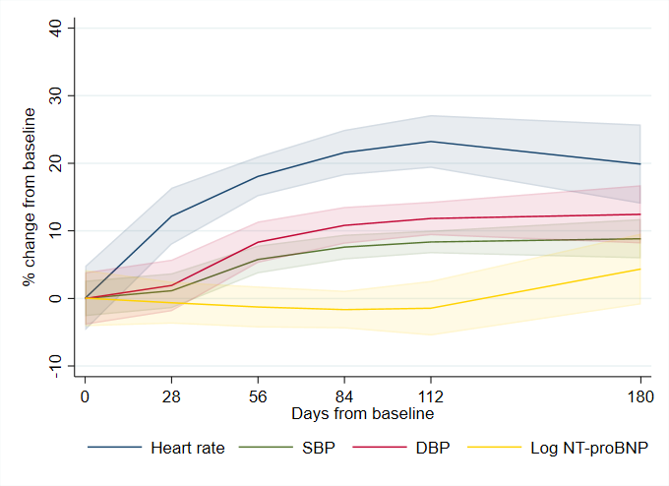
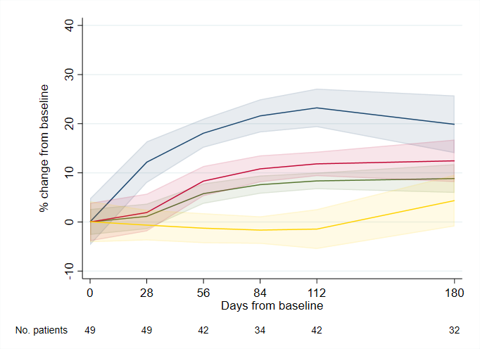

Figure 2
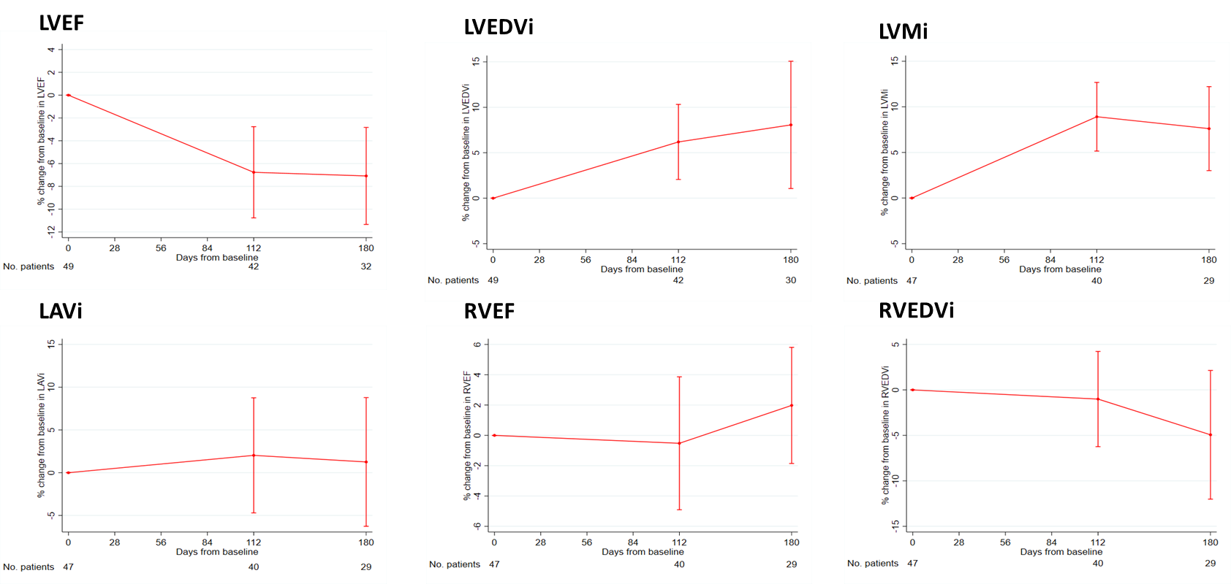

Figure 3
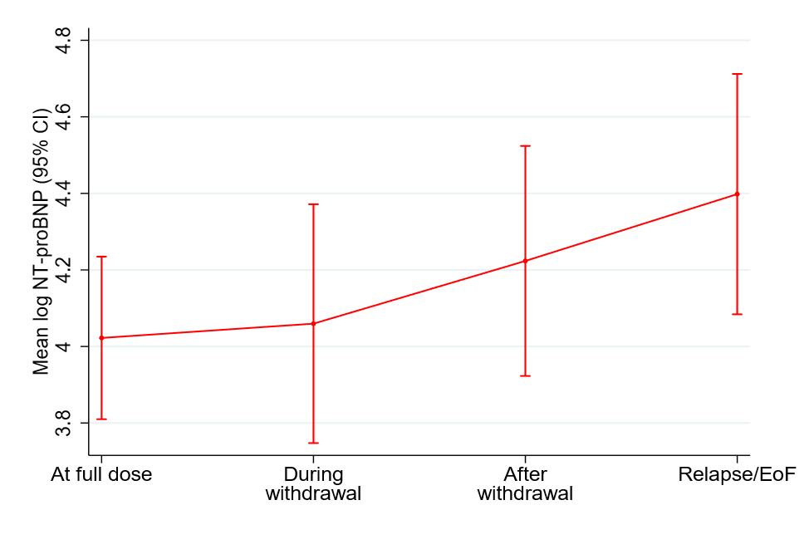
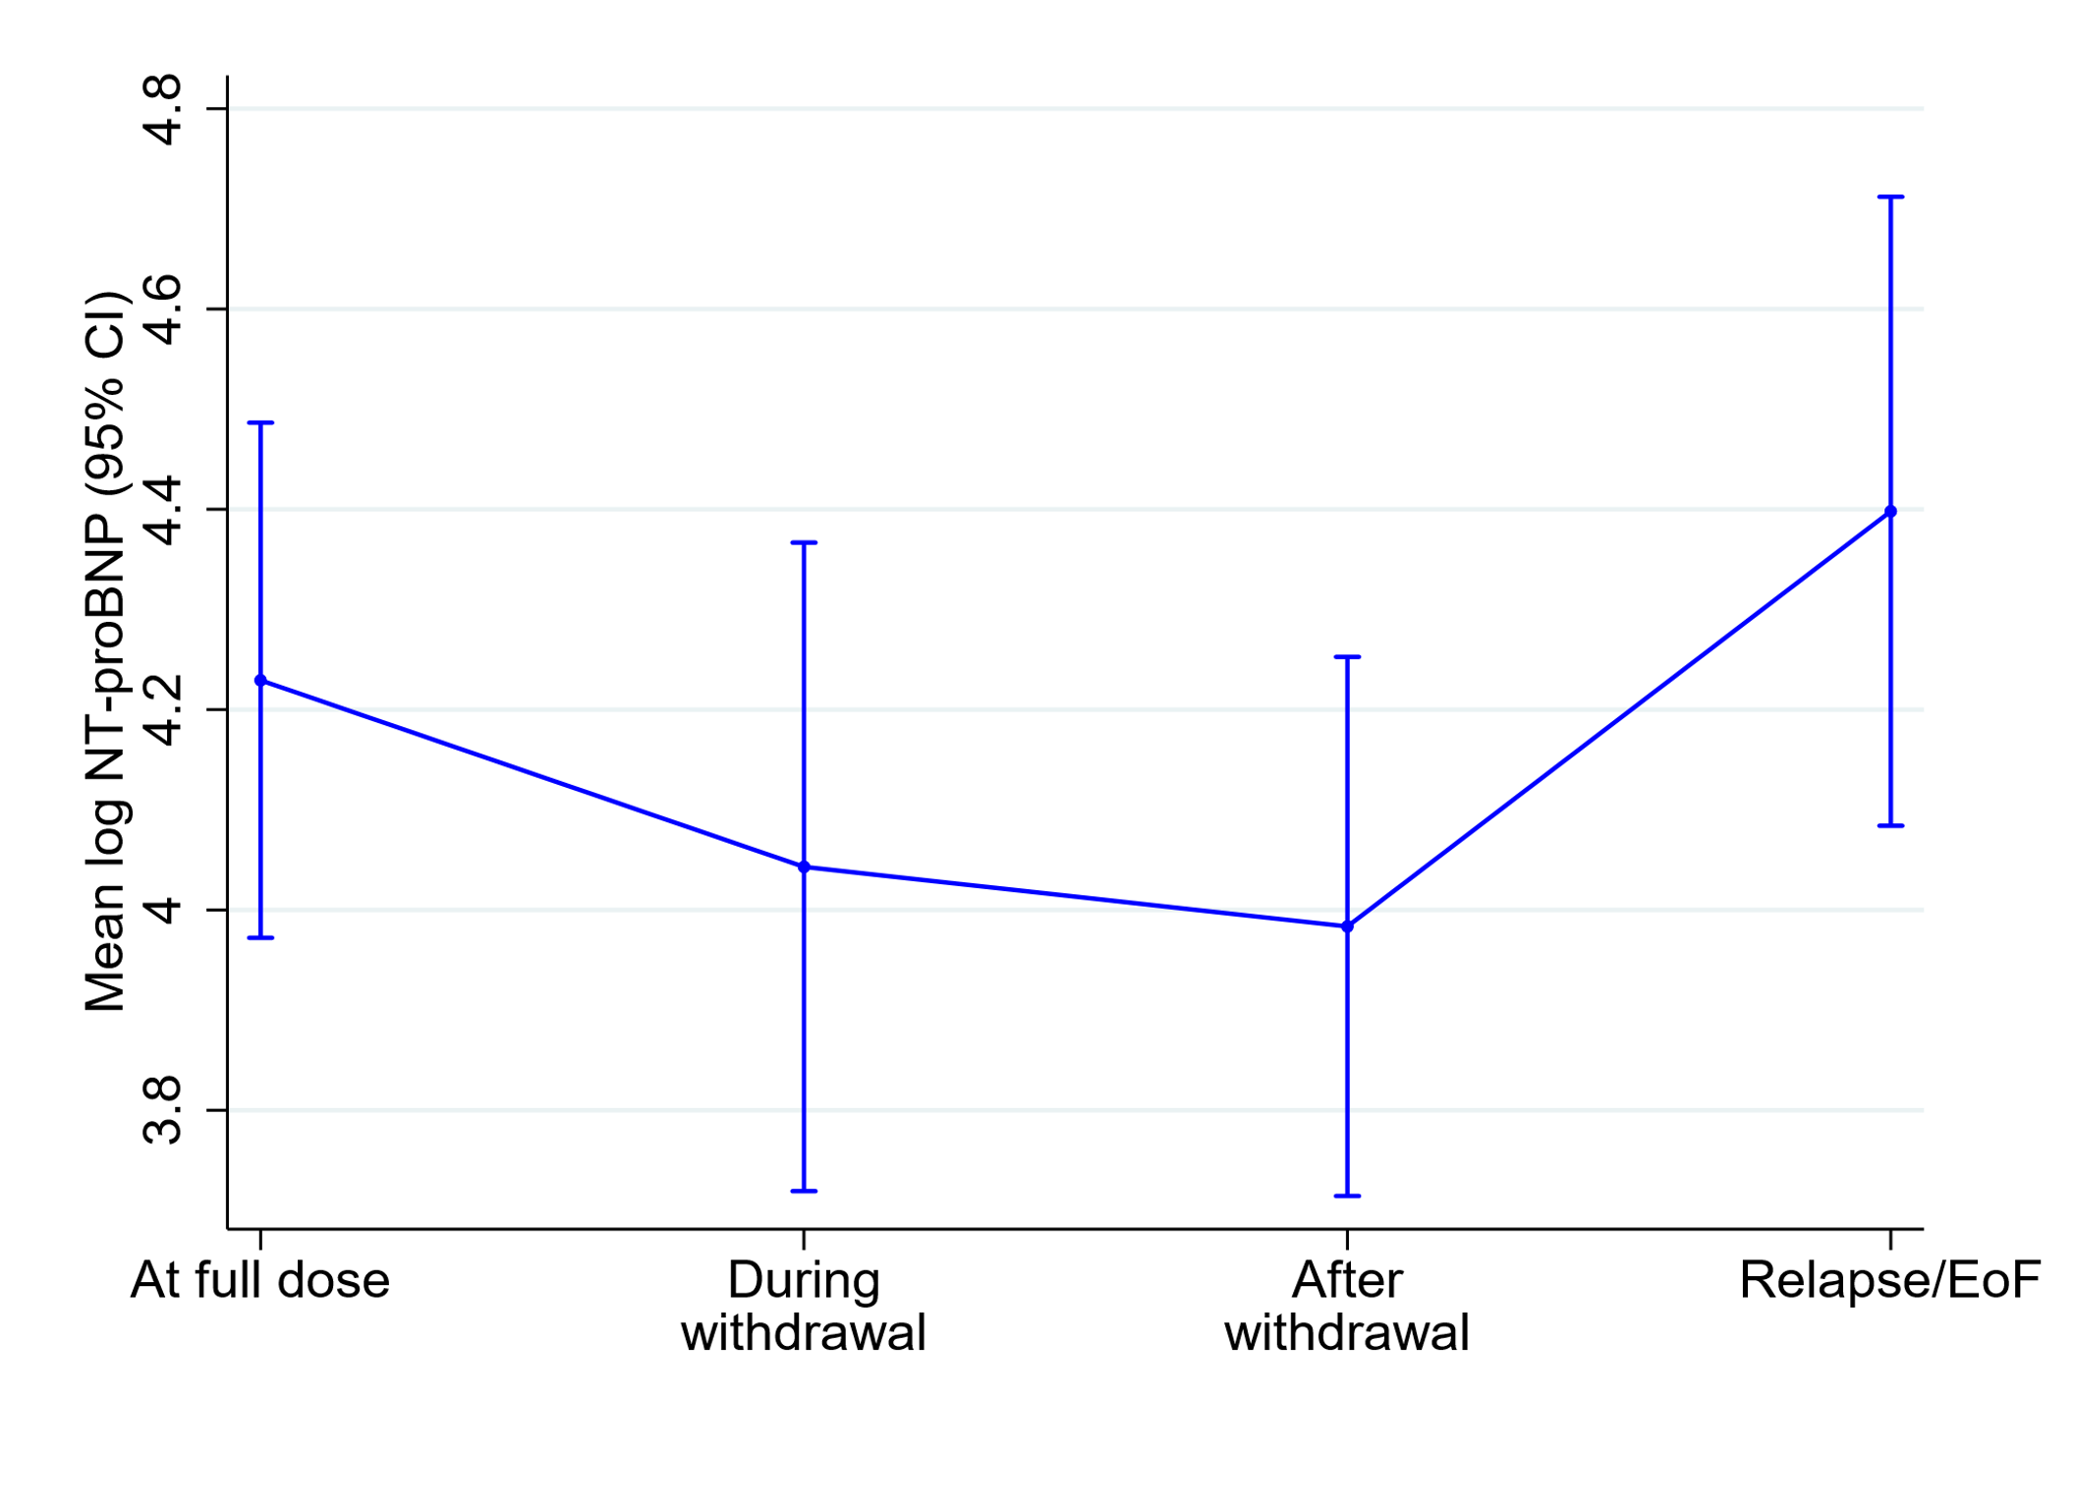
Relapse/End of follow-up
ACE inhibitors/ARB
Relapse/End of follow-up
Beta-blockers

